[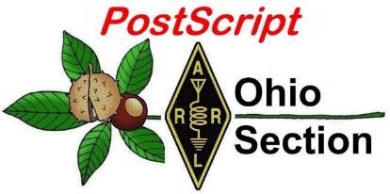](http://arrl-ohio.org/news/) ***July 8th***

***Edition***

🡪 National News 🡪 The Handbook Give Away

🡪 Club Corner 🡪 Hamfests

🡪 DX This Week 🡪 One Question Questionnaire

🡪 VE Testing 🡪 ARES Connect

🡪 Final.. Final..

***National News***

(from arrl and other sources)

***ARRL Announces “Happy 150!” Hiram Percy Maxim Birthday Celebration***

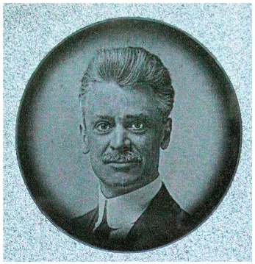This year marks the 150th anniversary of the birth of ARRL’s first president and cofounder Hiram Percy Maxim (HPM), W1AW, born on September 2, 1869. ARRL will hold an operating event this summer to celebrate HPM’s legacy from 0000 UTC on August 31 and continue until 2359 UTC on September 8. It is open to all radio amateurs.

The event goal is straightforward: Contact as many participating stations as possible. W1AW and all ARRL members will append “/150” to their call signs during this event (DX operators who are ARRL members may operate as <call sign>/150, if permitted by their country of license.) Participating stations will exchange a signal report and their [ARRL/RAC Section](http://www.arrl.org/contest-sections-list). DX stations will send a signal report and “DX.” Those taking part may use all Amateur Radio bands, excluding 60, 30, 17, and 12 meters.

The event will recognize three mode groups: CW, phone (any voice modes), and digital. Submit Cabrillo log files. ARRL will calculate all final scores based on participant uploads to the ARRL event web app (link not yet active).

There are 84 multipliers, which only count once. These include the 83 ARRL/RAC Sections (RAC sections include the Canadian Northern Territories, encompassing VE8, VY1, and VY0), and DX. The W1AW operating schedule during this period may be adjusted as necessary to accommodate on-air celebration operating activities. Contacts with W1AW/150 will earn 3 points apiece. Contacts with any ARRL member will earn 2 points each. These stations will also identify as <call sign>/150. Contacts with nonmembers will earn 1 point each.

Participants can earn 150 bonus points by:

* Contacting W1AW/150 on each band and mode.
* Uploading entries (ARRL members only).
* Using social media to publicize this event and/or participation before, during, and/or after the event.
* Operating with 5 W PEP output or less throughout the event.
* Making at least 20 contacts while operating portable.
* Completing at least 150 contacts.

Online certificates will be awarded, and available [via download](http://contests.arrl.org/certificates.php) only. Updates and results will be [publicized](http://www.arrl.org/hpm150-birthday-celebration).

This event has no power or operator categories. Participating ARRL members who use Logbook of The World (LoTW) are encouraged to [create a separate LoTW certificate](https://lotw.arrl.org/lotw-help/multiple-callsigns-locations/?lang=en) for uploading <call sign>/150 contacts. Members should upload their logs for this event using their /150 certificate. This event requires online web app submissions. No email or paper submissions will be accepted.

#########

TOP ^

***Historic Amateur Radio Contact Reported via Moon-Orbiting Satellite***

A contact between a radio amateur in Germany and China took place on July 1 via the moon-orbiting LO-94 satellite, DSLWP-B, launched in May 2018. The two-way exchange between Reinhard Kuehn, DK5LA, in Soerup, Germany, and Harbin Institute of Technology club station BY2HIT (operated by Wei Mingchuan, BG2BHC), in Harbin, China, occurred between 0551 and 0728 UTC, according to reports. The GMSK-to-JT4G repeater onboard DSLWP-B was used to make the contact, the first ever made via a lunar-orbiting repeater.

“Using the GMSK-to-JT4G repeater is not easy, in terms of the signal power needed for the uplink,” [commented](https://destevez.net/2019/07/analysis-of-dslwp-b-eclipse-test-run-again/) radio amateur and engineer Daniel Estévez, EA4GPZ, whose blog includes images of the lunar surface downloaded via DSLWP-B. “There were plans to make a QSO between BY2HIT and Reinhard since many months ago, but previous attempts didn’t work out. My congratulations to the people at both sides of the QSO, who have achieved it a month before [DSLWP-B crashes against the lunar surface](https://destevez.net/2019/05/dslwp-b-deorbit-and-mission-end/).”

As Estévez explained it, the GMSK-to-JT4G repeater works by sending commands to the satellite that embed a 13-character message, using the same frequency and a similar protocol to the one that commands the camera and other satellite functions. He said sending a message in this fashion takes a little longer than 1 minute.

An open telecommand protocol allows radio amateurs to take and download images, and DSLWP-B transmitted images of the moon and Earth during this week’s solar eclipse. DSLWP-B was launched as a secondary payload with the Quequiao relay satellite as part of the Chang’e 4 mission to the far side of the moon. Last September, some earthbound radio amateurs and sky watchers received images from the tiny satellite as it orbited the moon.

DSLWP stands for “Discovering the Sky at Longest Wavelengths Pathfinder,” and was designed to test low-frequency radio astronomy and space-based interferometry. The repeater uplink is on 2 meters and the downlink is on 70 centimeters.

#########

***Restraint Urged in Response to 2-Meter Reallocation Proposal***

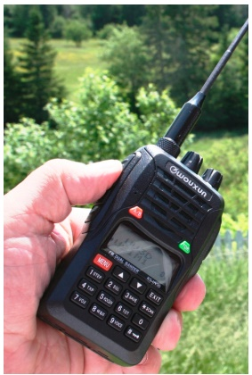Representatives of International Amateur Radio Union (IARU) member-societies in Europe are advising restraint in the wake of a proposal to consider the allocation of 146 – 148 MHz to the Aeronautical Mobile Service (AMS) at World Radiocommunication Conference 2023 (WRC-23). France recently raised the prospect during a European Conference of Postal and Telecommunications Administrations ([CEPT](https://cept.org/)) meeting in Prague, held in advance of WRC-19. A WRC-19 agenda item would call for studying a range of frequencies for AMS applications, including 144 – 146 MHz, and a decision could be made at WRC-23.

The French draft resolution seeks studies of possible new AMS primary allocations in several bands in the range from 144 MHz to 22.2 GHz on a primary basis, “while ensuring the protection of existing services in those bands and, as appropriate, adjacent bands, and not constraining future development of these services.”

The Radio Society of Great Britain (RSGB) released a [statement](https://rsgb.org/main/blog/front-page-news/2019/07/01/144-mhz-and-the-wrc-process/) this week, in part pointing that as proposed, the French resolution “is not an eviction or re-allocation of amateurs, but nonetheless is unwelcome and presents significant challenges. Unlike some other bands where amateurs do share, aeronautical applications are amongst the most difficult due to the altitudes and long free-space distances involved.”

TOP ^

Any consideration to allocate additional services in a band that’s already allocated on a primary basis to an incumbent service — Amateur Radio, in this case — must begin with a sharing/compatibility study. The IARU has expressed “grave concern” to any proposal that would include 144 – 146 MHz in a WRC agenda item and has pledged to make every effort to fully protect Amateur Radio interests and seek the support of regulators.

At the Prague meeting, only Germany opposed the proposal, which has been carried forward to the higher-level CEPT Conference Preparatory Group (CPG) meeting in August. Support from at least 10 CEPT administrations and fewer than six in opposition would move the issue forward as a CEPT resolution, making it highly likely that it would appear on the agendas of WRC-19 and WRC-23.

In a post to the Moon-Net news group, Deutscher (German) Amateur Radio Club (DARC) Frequency Manager Bernd Mischlewski, DF2ZC, stressed the importance that Amateur Radio speak with a single voice and asked the Amateur Radio community to refrain from contacting individual administrations or the EU.

“This would weaken our position and take away power and vigor from the systematic approach by IARU and country Amateur Radio societies,” Mischlewski said. “This particularly applies [to] online petitions.” One frantic petition that’s collecting both signatures and donations calls on hams to “Stop the 2 Meter Band (144 – 146 MHz) being taken away from Radio Amateurs,” which is not what the draft French resolution would do. Mischlewski speculated that the primary reason for the scant opposition at Prague was the revised French proposal’s last-minute arrival. “Consequently, most other European countries had no time for internal discussions, let alone formulating their position,” Mischlewski said.

With the support of regulatory experts among its member-societies, IARU “is intensively working on executing their influence within the current process and trying to keep the 2-meter band as it is now,” Mischlewski said. He pointed out that funding for these activities comes from IARU member-societies. “So, those who left their country’s Amateur Radio society should perhaps reconsider their decision,” he added. “Without the commitment and the funds, the Amateur Radio community would have little influence in that process, let alone could be present at the relevant meetings.”

RSGB VHF Manager John Regnault, G4SWX, in a related Moon-Net post, said the flood of “fake news” on the issue propagated via social media and online petitions does not help Amateur Radio’s position.

“All IARU member societies have been briefed on a common position and messages for Amateur Radio,” Regnault said. “This message is not helped by the many wrong messages abounding on social media. IARU represents Amateur Radio in the various CEPT forums and ITU, and [it] will fight to maintain the best position it can for Amateur Radio. Progress will be slow, but I am hopeful that, in the end we will get a good result.”

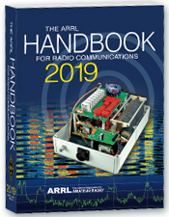***The Handbook Give Away***

Hey Gang,

The “Handbook Giveaway” drawing will soon be returning for another big “Give Away”

Many of you ask me just how do I know when the drawing is on? Well, that’s easy all you need to do is check in on the Ohio Section Website on a regular basis and watch for the big [**RED**](http://arrl-ohio.org/handbook.html)Arrow that will appear on the left side of the page. This is the sign that the drawing is on and you need to get registered. So, keep a sharp eye out on the website and check in often! <http://arrl-ohio.org>

TOP ^

What’s the catch? I want to get everyone checking in to the Ohio Section website as often as possible, and in order to register each month, you have to visit the website often! There’s nothing else to it. I pay all expenses, and from time to time, I Give Away more than just a Handbook. And, you’ll never know just what months will be those special times that I will have more than just a Handbook to Give Away!!

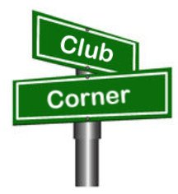***Club Corner***

This is YOUR cornner of the newsletter. Send me what your club is doing and I’ll make sure that it gets in. Got a special event or club project that you want everyone to know about? Send it to me!. Need help with a project? Send it to me.

Let me know what you club is up to. Are you going to have a special guest at your meeting or are you having a special anniversary? Just sent it to:

[n8sy@n8sy.com](mailto:n8sy@n8sy.com)

#########

***Need Help Desperately for Operation Vigilant Guard***

It's been a bear trying to get the mission requirements locked down for Operation Vigilant Guard. At this point in time we could need up to eight ARES volunteers for the **Wednesday, August 07** operation.

Please, if you have some time to volunteer to help me make this mission a great success for Amateur Radio, contact Rick Kruis [k8cav.coms@gmail.com](mailto:k8cav.coms@gmail.com)

#########

***USAF Marathon Needs Help***

Approximately 70 amateur radio operators are needed to support the USAF Marathon at Wright Patterson Air Force Base on **Saturday, September 21, 2019** to provide the USAF Marathon Staff with emergency and logistic communications. This world class event has over 20,000 participants, volunteers, and spectators in attendance every year.

Amateur radio operators are indispensable in rapidly communicating information on runner’s locations and status, heat index settings, severe weather notifications, as well as emergencies and logistic issues. Plus, APRS is utilized to track lead runners and “Tail End Charlie’s”, thus allowing race officials and emergency services to more accurately monitor the race progression.

According to Brandon Hough, the USAF Marathon Race Director, the senior base leaders rely on the communication skills of our amateur radios operators and use them as a vital resource.

Multiple races are held on this day including: 10K, Half Marathon, Full Marathon, and Wheelchair. The volunteer registration website for the USAF Marathon is now open.

TOP ^

If you will be in the Dayton, Ohio area on Saturday, September 21, 2019 and would like to take part in this world class event, please go to the USAF Marathon website at <http://www.usafmarathon.com/volunteer>  and click the volunteer now link, scroll down to the amateur radio section to register. Training will be provided prior to the event.

How to register online:

1. Go to the website above.
2. Click on the Volunteer Now button.
3. Acknowledge that you’re going to a new website.
4. On the new website, ignore the “password” entry box near the top of the page. Scroll down to the “Amateur Radio Operator” section and click the check box for the Amateur Radio Operator Position and only that position.
5. Scroll to the bottom, past all the other volunteer positions, and fill in your name and other required data.
6. Check the box below the waiver paragraph and then type in your name for a digital signature.
7. Click the “Sign Up to Volunteer” button.
8. You’re done!
9. You should get an automated email response from Jeanette Monaghan acknowledging your registration.
10. Contact Phil Verret if you have any questions or concerns.

**Registration closes August 31, 2019**.

If you have any questions please email to: Phil Verret, [KA8ZKR@ARRL.NET](mailto:KA8ZKR@ARRL.NET)

#########

***Dave Kalter Youth DX Adventure***

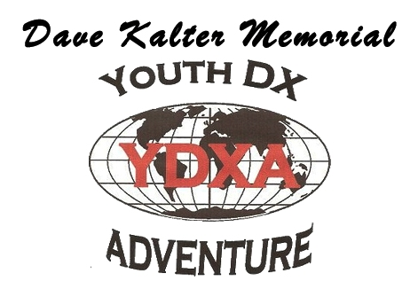

The Dave Kalter Youth DX Adventure is returning to the PJ2T Contest Station in Curacao again this year.  Thanks to our host Uli - DL8OBQ and the Caribbean Contesting Consortium we will be live beginning late **July 14-18, 2019**.  Once again, we have applied for the PJ2Y special call sign that we had last year.

This year’s youth team includes a veteran of the 2017 team (due to an emergency fill) of Bryant Rascoll KG5HVO so look for some great CW contacts.  Also, on the team is Audrey McElroy KM4BUN and her brother Jack KM4ZIA.

Depending on conditions we plan to be on all bands and modes, SSB, CW, FT8 and possibly some satellites.  Watch our website [www.qsl.net/n6jrl](http://www.qsl.net/n6jrl) for updates while on site.

#########

TOP ^

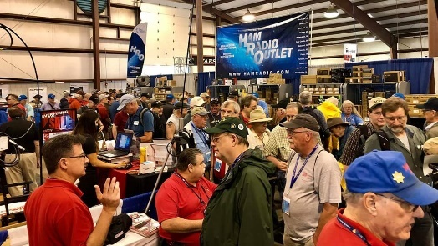[***Upcoming Hamfests***](http://arrl-ohio.org/hamfests.html)

**07/20/2019 |**[**NOARSFEST**](http://www.arrl.org/hamfests/noarsfest-7)

Location: Elyria, OH  
Sponsor: Northern Ohio Amateur Radio Society  
Website: <http://noars.net/hamfests/noarsfest>

|  |  |
| --- | --- |
| **07/21/2018 | Van Wert Hamfest** Location: Van Wert, OH Sponsor: Van Wert Amateur Radio Club Website: [http://w8fy.org](http://w8fy.org/) | **07/28/2019 |**[**Portage Hamfair '19**](http://www.arrl.org/hamfests/portage-hamfair-19)  Location: Ravenna, OH Sponsor: Portage Amateur Radio Club Website: [http://hamfair.com](http://hamfair.com/) |
| **08/03/2019 | Columbus, Ohio Hamfest** Location: Grove City, OH Sponsor: Voice of Aladdin Amateur Radio Club Website: [http://www.columbushamfest.com](http://www.columbushamfest.com/) | **08/10/2019 | DX Engineering Hamfest**  Location: Tallmadge, OH  Sponsor: DX Engineering  Website: <https://www.dxengineering.com/> |
| **08/17/2019 | GARS 2019 HamFest**  Location: Germantown , OH Sponsor: Germantown Amateur Radio Society  Website: [http://www.WG8ARS.org](http://www.wg8ars.org/) | **09/08/2019 | Findlay Hamfest**  Location: Findlay, OH Sponsor: Findlay Radio Club Website: [http://www.findlayradioclub.org](http://www.findlayradioclub.org/) |

**07/20/2019 | NOARSFEST**

Location: Elyria, OH  
Sponsor: Northern Ohio Amateur Radio Society  
Website: <http://noars.net/hamfests/noarsfest>

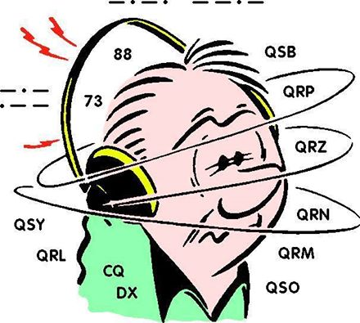***DX This Week***

*(from Bill, AJ8B)*

***DX This Week – Support and Reference #2***

Bill AJ8B ([aj8b@arrl.net](mailto:aj8b@arrl.net), @AJ8B, [www.aj8b.com](http://www.aj8b.com) or [www.swodxa.org](http://www.swodxa.org) )  
 CWOPs Member #1567

Last week I passed along some details about Blogs, Podcasts, and YouTube. These are all great sources of information. I hope you took a minute to check them out. If so, just drop me a note and let me know what you thought!

This week, I wanted to mention Websites, Phone Apps, and books.

Websites **–** I know there are countless websites for all topics ham radio related. However, one of the challenges is to sort through all the data and find those sites that constantly deliver information. I have a couple that I always have open:

TOP ^

|  |  |
| --- | --- |
| Site | Comment |
| <https://www.qrz.com/> | Log search and Call Lookup |
| <https://cwops.org/> | Home for the CWOPs organization |
| <http://dxsummit.fi/#/> | Great site for researching spots on a global basis |
| <https://dx-world.net/> | Information on DXPeditions |
| <https://dxnews.com/articles/> | Information on DXPeditions |
| <http://www.dailydx.com/> | Home of the Daily DX – QSL Routes, managers and other information |
| <https://lotw.arrl.org/lotw/login> | ARRL LoTW |
| <http://www.dxmarathon.com/> | Home of the CQ DX Marathon |
| <https://www.contestcalendar.com/> | Most Comprehensive Contest Calendar |
| <https://www.3830scores.com/index.php> | 3830 Scores Summary Page – Preliminary Results for ALL contests |
| <http://arrl-greatlakes.org/8th_bureau.htm> | 8th Call Area QSL Buro |
| <http://www.arrl-ohio.org/> | Our OH Section Home! |
| <http://www.dxuniversity.com/> | DX University Home – Great articles & Info |
| [https://www.contestuniversity.com](https://www.contestuniversity.com/) | Contest University – Great Articles & Info |

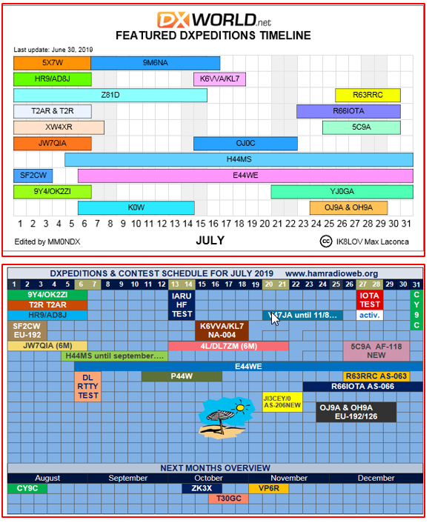Once a month I combine data from DX-World.net and Hamradioweb.org to create a comprehensive month at a glance calendar. I will include it each month in this column if you think it is useful. July of 2019 is shown below:

Phone Apps – Although there are hundreds of phones apps that pertain to Ham radio, I have only utilized a few. I have listed those below. Let me know which ones I missed.

TOP ^

|  |  |
| --- | --- |
| App | Comment |
| Compass 360 Pro | Very useful for headings and direction |
| NKCCluster | On the phone DX Cluster – Watch the data charges! |
| QRZ Assistant | Useful for looking up callsigns |
| DX Pocket | DX Cluster monitor with a few more options |
| HamClock | Easy to use worldwide clock |
| Voice Recorder | I use this when operating Mobile as my logbook. |
| Music Player | I listen to CW Audio files to keep my speed up! |
| NCDXF Beacon | This is great to show what beacons are transmitting. You can then listen to quickly determine what band(s) are open. |
| Grid Square Locator | This is a great tool if you are travelling and operating. |

Books – I have a few books that I keep around as a reference or an inspiration. Please pass your list back to me!

|  |  |
| --- | --- |
| Title | Comment |
| ARRL: Propagation & Radio Science | Excellent coverage of electromagnetic waves |
| ARRL : Antenna Physics : An Introduction | Takes me back to my high school and college classes – I use this often |
| Low Band DXing – ON4UN | Widely considered the bible on Low band antennas and DXing |
| The Complete DXer – W9KNI | Excellent overall review of techniques and terms |
| A Year of DX – W9KNI | Review of Bob’s year attempting to win the CQ DX Marathon. I read this every other year for inspiration |
| AC6V’s Amateur Radio & DX Reference Guide | This complete book covers every aspect of ham radio pertaining to DX |
| DXA – The Real Time online radio log server – KK6EK | Bob goes in to great details the other side of the pileup and his creation of the DXA software. Great and informative read. |

+ --------------------------------------------------------------------------------------------------------------------+

Here is an update from Bernie, W3UR, of the DailyDX and the WeeklyDX,

the best source for DX information. (<http://www.dailydx.com/> ) Bernie has this to report:

+ --------------------------------------------------------------------------------------------------------------------+

**HB0 – Liechtenstein -** HB0/DL4APJ, HB0/DJ2AX and HB0/DL5ARG will be an upcoming trip September 12 to 18 for a holiday style operation. They plan 80-10 CW, SSB and digital modes PSK, RTTY, FT8, FT4 and maybe others. They plan to give a try to VHF/UHF, 2M up to 23cm, and will be in the WAE SSB Contest September 14-15. QSL through the DARC Bureau or direct to DL4APJ. eQSL and LoTW will also work.

TOP ^

**PJ4 – Bonaire -** PJ4EVA, Eva Telenius-Lowe is the wife of PJ4DX and is the only resident YL operator on Bonaire and, she and husband Steve believe, the first resident YL operator there. She has the N class license with privileges on 7050-7150, 1400-14250 and 2800-29700, plus 2, 1.25 meters and 70 cm bands. Eva says she is an "indie" writer/publisher who loves traveling and exploring the world. She does not yet have QSL cards. <http://evabooks.weebly.com> .

**VP9 – Bermuda -** KU9C/VP9, KL7SB/VP9 and VP9HQ will be by these two ops, both named Steve, July 7-15. QSL KU9C/VP9 to his home call and KL7SB/VP9 via N4GNR. They will be at the VP9GE QTH. The VP9HQ callsign will represent the RSB HQ station during the weekend IARU HF Contest. QSL VP9HQ via KU9C.

**9H – Malta -** 9H3IK will be the callsign there July 5-12 for IK0PUL, Andrea, operating on 30, 20 and 17M CW and SSB on those higher two bands. QSL to his home QTH or use OQRS.

**KH0 - Mariana Islands -** From Saipan, callsign K0W will be a "Dairy Cow Special Event Station" July 5-14 by KC0W. QSL direct to KC0W. Operator Tom notes how unusual cows are, in appearance and in their benefits to humans.

**8P – Barbados -** 8P2K will be in the CQWW CW DX event November 23-24 with 8P6SH operating single op single band 160 meters with his inverted L and lower noise receiving antenna. QSL via KU9C.

***A******RLD000 DX news***

This week's bulletin …

No Report this week due to the holiday

***Special Events***

**07/14/2019 | 50 Years - First Man on the Moon**

**Jul 14-Jul 28, 1700Z-2000Z, N1A**, Milford, OH. Milford Amateur Radio Club. SSB: 28.350 14.260 7.240 3.840; CW: 14.045, 7.045, 3.545; FT8 standard frequencies. QSL. Milford Amateur Radio Club, P.O. Box 100, Milford, OH 45150-0100. Email qsl@w8mrc.com for QSL requests. [www.w8mrc.com](http://www.w8mrc.com/)

**07/20/2019 | Honoring the 50th Anniversary of the Apollo 11 Moon Landing**

**Jul 20, 1400Z-2000Z, K8QYL**, Wapakoneta, OH. Reservoir Amateur Radio Association. 14.250 7.250. QSL. Rich Spencer, W8GZ, 05925 Vogel Rd., Saint Marys, OH 45885. From the Neil Armstrong Air and Space Museum

TOP ^

**07/22/2019 | Seneca County Fair**

**Jul 22-Jul 29, 1600Z-0200Z, W8ID**, Tiffin, OH. Seneca Radio Club. 7.225 3.895. QSL. Seneca Radio Club W8ID, P.O. Box 67, Tiffin, OH 44883. W8ID will be celebrating 177 years of the Seneca County Fair! Join us for the cotton candy! Join us for all the fun! We can’t wait! [www.w8id.org](http://www.w8id.org/)

**08/01/2019 | W8LKY Carnation Festival Special Event**

**Aug 1-Aug 11, 0000Z-2359Z, W8LKY**, Alliance, OH. Alliance Amateur Radio Club. 14.240 14.045 7.240 7.045. Certificate & QSL. Alliance Amateur Radio Club, P.O. Box 3344, Alliance, OH 44601. The Alliance ARC(W8LKY) will be on the air at various times throughout our Carnation festival festivities. We'll be on the air from various locations in the Carnation city. We may pop up on the bands at any time. Check the spotting networks, and our web page for upcoming activations. [www.w8lky.org](http://www.w8lky.org/)

**08/15/2019 | D-Day Conneaut**

**Aug 15-Aug 18, 1600Z-0400Z, W8D**, Conneaut, OH. Conneaut Amateur Radio Club. 14.285 7.190 3.996 3.885. QSL. Garret Scott W8D, 10236 Birch Hill Ln., Knoxville, TN 37932. D-Day Conneaut recognizes the 75th anniversary of the World War II Allied D-Day Landings on the beaches of France in 1944. Event will include the country's largest reenactment of the D-Day landings with more than 1,800 WWII reenactors from around the world participating. Radio operations will include vintage WWII equipment <https://www.facebook.com/W8BHZ>

***Need Your Field Day Pictures***

Now that Field Day is over and you’ve had a good night’s sleep, don’t forget to send me those great pictures of your Field Day! These pictures will be added into the Field Day gallery and some of them may even find their way to the next Ohio Section Banner as well.

***Please send your Field Day pictures to me for publication on the Ohio Section website!! Send them to:*** [n8sy@n8sy.com](mailto:n8sy@n8sy.com) and to view what I have received go to: <http://arrl-ohio.org/fd-19/>

**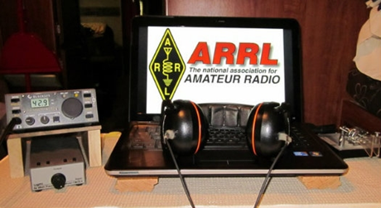*ARRL Contest Corner***

An expanded, downloadable version of *QST'*s [Contest Corral](http://www.arrl.org/contest-calendar) is available as a PDF. Check the sponsor's Web site for information on operating time restrictions and other instructions.

TOP ^

***One Question Questionnaire***

Hey Gang,

It seems that 55% of you feel that Field Day is a Contest! I’m really surprised at that, but I guess since they’ve added the points to the event it seems more like a contest to everyone. Either way, as long as you were able to show what you do to the public, that’s all that counts!!!

I’ve got another NEW – one question – questionnaire on the Ohio Section Website! Since it won’t quit raining and we’ve had thousands of lightning strikes all over Ohio, this next question should get you to thinking safety for sure. Go to: <http://arrlohio.org>

**“Does your home antenna system include any type of lightning protection??”**

These One Question questionnaires are all in fun and I hope that you are enjoying answering them.

You’ll find the “One Question” questionnaire on the Ohio Section Website! <http://arrlohio.org> It’s all in fun and it’s not a scientific survey in any way, but we are learning some things that we didn’t know from these questions. I hope that you are enjoying answering these “One Question” questionnaires.

*****V.E. Test Sessions***

For the latest testing site information please **>>** [**Click Here**](http://www.arrl.org/find-an-amateur-radio-license-exam-session) **<<** The ARRL site tracks all of the VE testing sites that register with them, including W5YI and Laurel. ARRL gives you a number of different ways of sorting to find that site that is closest to you as well.

***Incident Command System (ICS) Training Schedule***

All current trainings are listed on the Ohio EMA training calendar located at:

<https://webeoctraining.dps.ohio.gov/TrainingAndExercise/courselist.aspx>

I’ve been asked to also include a link to the Kentucky EMA training calendar as well..

<https://kyem.ky.gov/training/Pages/default.aspx>

<https://sites.google.com/site/ccoemtraining/home>

TOP ^

Please pay particular attention to these courses listed above, as that there’s a lot of ICS 300 & 400 classes listed that are very useful for all Amateurs to have under their belts. I will also state that G775 is also a very good course to take as well. These 3 courses are multiple day in class courses, so please be prepared to spend some time taking them.

We do recognize that IS-300/400 requires multiple days of actual classroom training that is not easily obtained. So, if you just can't find the time to fit these classroom courses in, we do have an alternative method for getting you to Level 3.

Completing the following **“FREE”** and **“ONLINE”** courses will act as substitute for you FEMA Leadership Development Course requirements. You absolutely will need to complete all **7** of these courses to get your ICS 300/400 credit.  Here are the courses that you need to take:  **IS-120, 230, 240, 241, 242, 244 & 288.**

***Now, if you are looking for wallpaper and have a little extra time, taking IS-235 in addition to the 7 listed courses above, you will get a really cool looking certificate from FEMA stating that you have completed the Professional Development Series. That’s impressive in itself!***

***Field Day 2019***

*(from Roy – W8REH)*

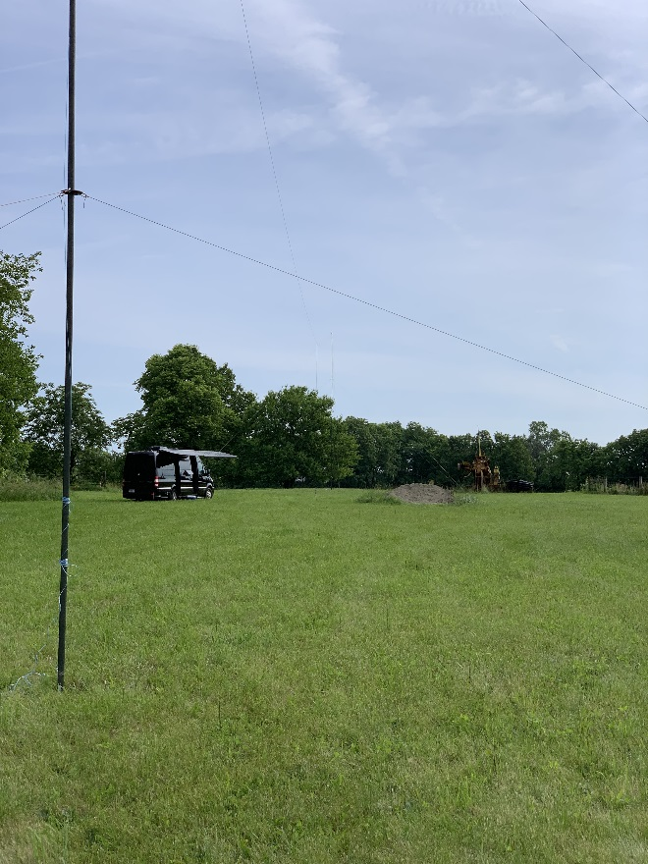

The seed for a dream was planted in the late 1960’s by fellow hams in the Clinton and Highland County area for two high school friends that would turn into this year’s event that was several years in the planning. Roy Hook, W8REH and Craig Nicholson, KW9R participated in the field day event of a lifetime at a rural farm location near the Delaware/Union County line just outside the Village of Ostrander June 22 and 23.

After high school, they went their separate ways, Craig pursuing a military career taking him all over the world and Roy living all of his life in Ohio. Craig has now settled in Wisconsin. They occasionally lost touch with each other, but several times regained contact via the Amateur Radio hobby they shared and for the last several years contact each other almost every week via ham radio.

Although the results will not be final until the ARRL publishes the final scores, both Craig and Roy are pleased with the preliminary scores.

TOP ^

Total CW QSO points: 1416

Total Phone QSO points: 693

Total QSO points: 2109

Power Multiplier: 2

Claimed Score: 4218

Expected bonus 650

Total 4868Total Contacts by Band and Mode:

Band CW Phone Total %

80 129 144 273 19

40 471 444 915 65

20 86 92 178 13

15 22 13 35 2

----- ----- ----- -----

Total 708 693 1,401 100

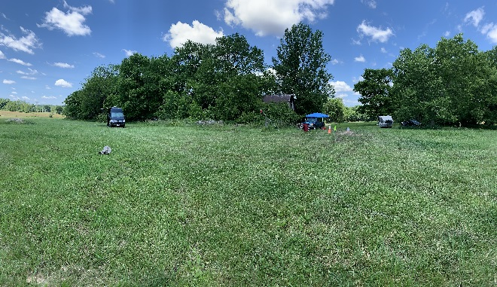

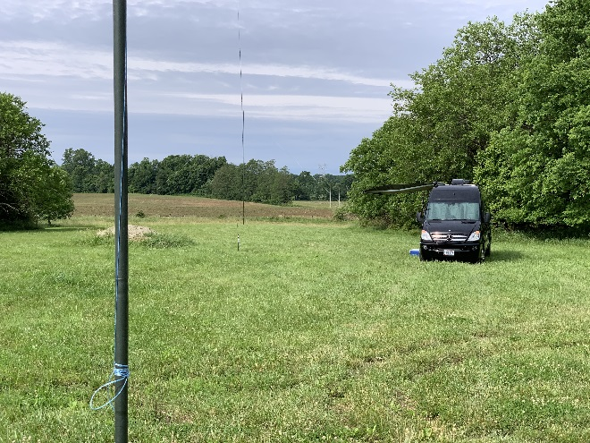

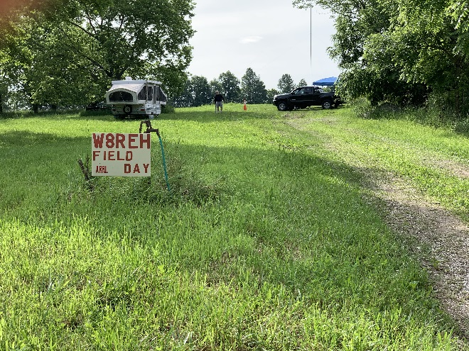

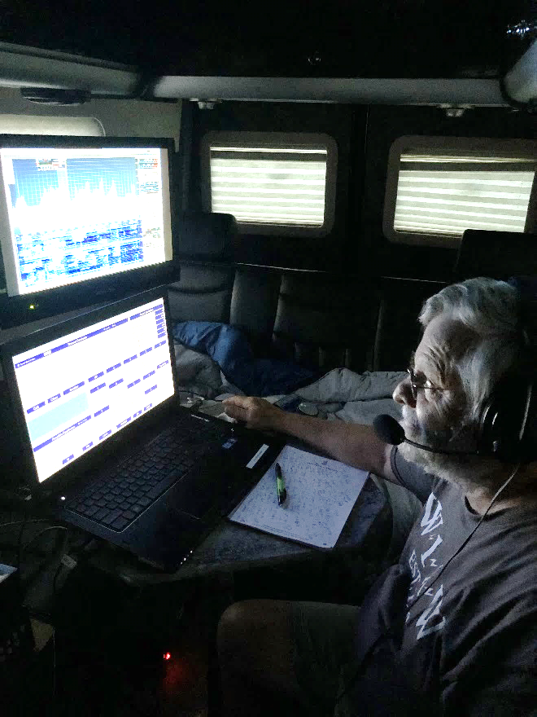

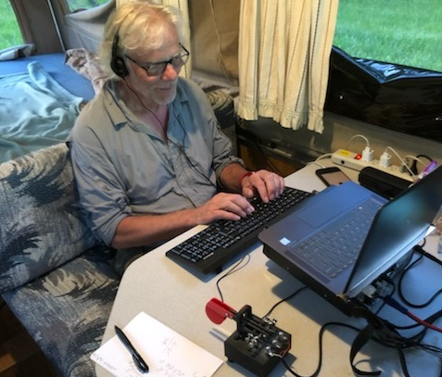

TOP ^

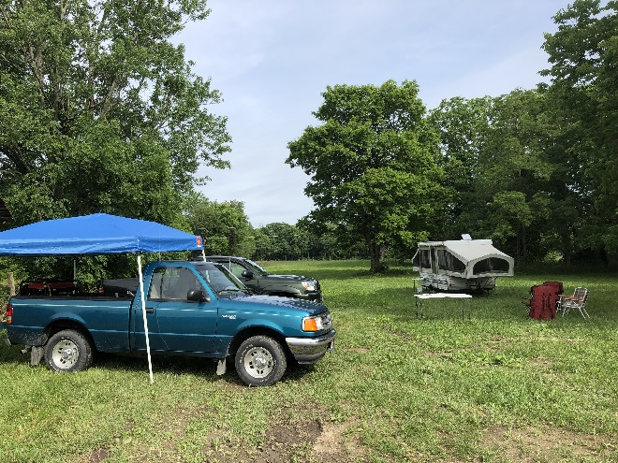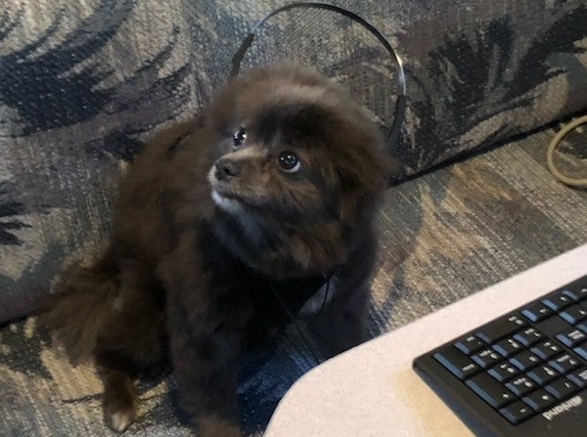

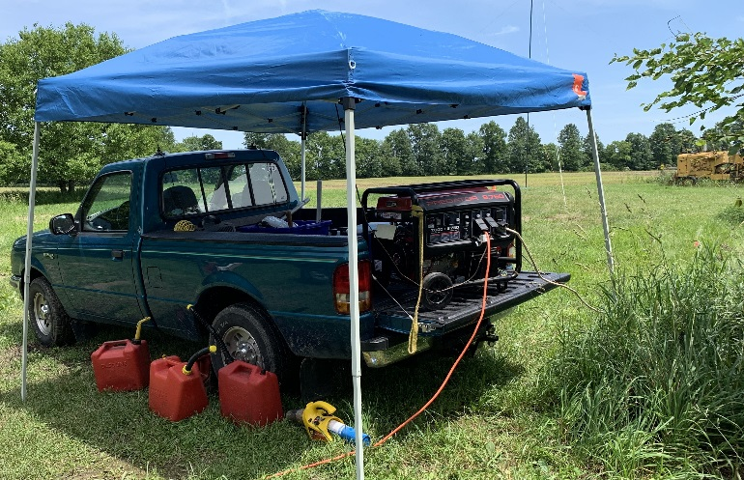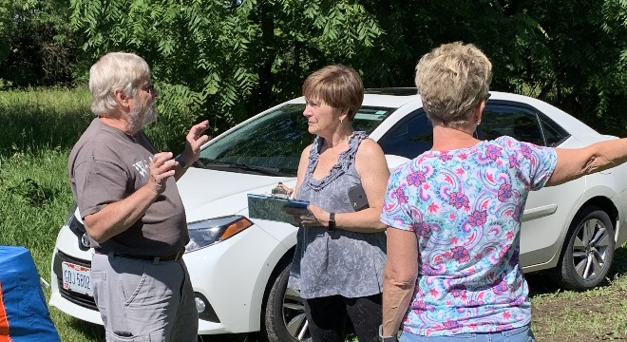

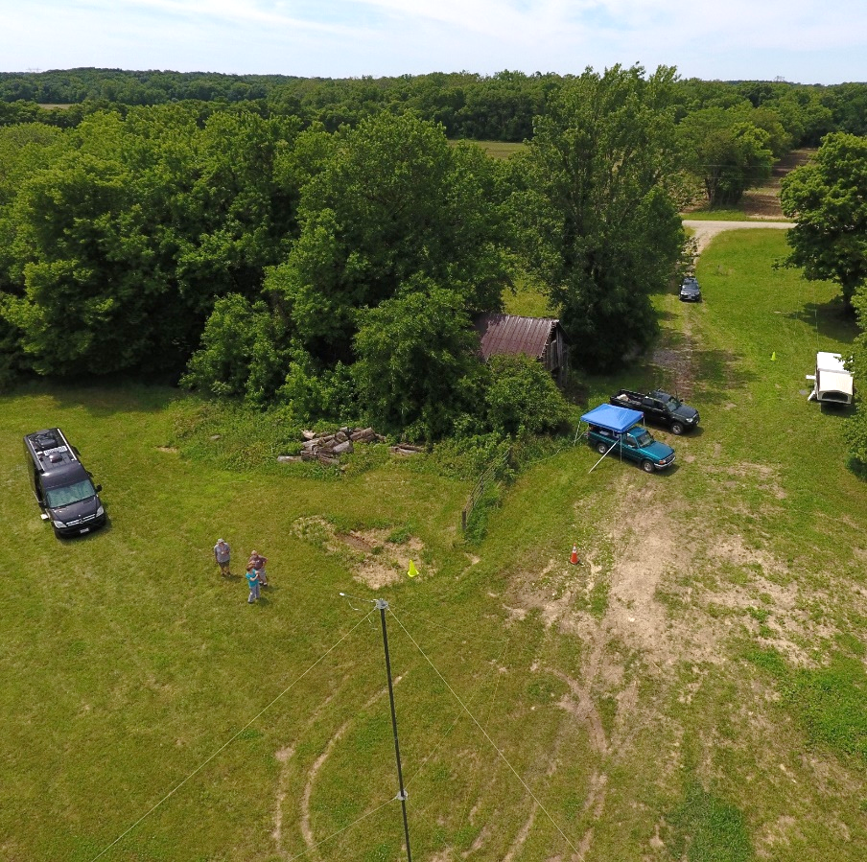

Phone operation on the left, 160-meter Windom supported by two 40’ masts (second mast 265’ left of the one shown) CW operation on the right, tree supported fan dipole Generator central

TOP ^

***ARES Connect***

It seems as though the name "ARES Connect" is getting folks confused about who all should be using this system. Maybe we should just call it **“Ham Radio Connect”** or how’s about just plain **“Connect”** instead! Whatcha’ think? Would you think the system was for everyone then?

Like FT 8, this system is new to everyone and it seems that the moniker hung on this new system is keeping a lot of folks from using it. Let’s clear the air on that right now. It’s not just for ARES events. I'm here to tell you that it's to be used for ANY event that involves Amateur Radio. It can be a RACES, CERT, Skywarn, Red Cross or just a few hams gathered at a table to talk about Amateur Radio. It all counts!

Club meetings, hamfests, working on that club trailer, repeater, website, field day, parades, newsletter or just having fun keeping track of all those spandex folks during every kind of race imaginable are perfect examples of hours that count that are not necessarily ARES directly related but do have an impact on your community. Any Amateur Radio related activity should be an event in ARES Connect and your hours recorded. Why? These hours will help demonstrate to the FCC and all of our government officials (local, state and federal), as well as all of our served agencies our willingness to volunteer and help our fellow citizens. These are not just hours; they are dollars that are given back to our communities, and we want our government officials to know just how much we give back to help keep the frequencies that we have, as well as future frequencies that may be available later. Showing them in dollars how much we give back is what keeps their attention and helps preserve our current frequencies.

Just because the name of this system has ARES in it, doesn't mean that we only record ARES events. If it involves Amateur Radio **IN ANY WAY** then it needs to have an event established and hours recorded for it.

Here’s the really great news about this system. It’s never too late to get those valuable hours recorded, even if the event has already passed. The Admins of this system can setup events anytime and add you and your hours to those events.

Yes, I agree, the name of this system may not necessarily fit what it’s all about, but what’s in a name anyway!!!

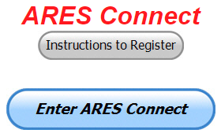Now, are you registered in the system yet? We need to make sure that no one is left behind.

If you live in **Ohio** and you haven’t registered yet, we need you to get registered now. We need you to only use this URL to get registered [**https://arrl.volunteerhub.com/lp/oh/**](https://arrl.volunteerhub.com/lp/oh/). Using any other entrance to register will only slow down your registration process. Again, this is for those living in Ohio only. If you are an out of state person (not Ohio), you can simply change the /oh/ to your 2-letter state designation. This will put you in the correct state for signing up

Your time adds up quickly. Now, since we’ve all just finished up a very great weekend of playing radio for Field Day, make sure that all that fun counts. Get your hours logged now!

TOP ^

***Here’s the top 10 hours earners for June:***

|  |  |  |  |
| --- | --- | --- | --- |
|  | **Name** | **Events** | **Hours** |
| 1 | TODD JOHNSON (KD8UND) | 9 | 174.00 |
| 2 | Bret Stemen (KD8SCL) | 49 | 157.00 |
| 3 | James Yoder (w8erw) | 19 | 145.25 |
| 4 | Christopher Domenick (KC8CAD) | 20 | 119.50 |
| 5 | Timothy Gray (KD8IZU) | 10 | 118.25 |
| 6 | Alan Rothweiler (N8CJ) | 33 | 112.00 |
| 7 | Elizabeth Klinc (KE8FMJ) | 35 | 104.50 |
| 8 | Larry Caskey (K8LPC) | 24 | 103.50 |
| 9 | Edward Kopcak (KB8BKE) | 18 | 103.50 |
| 10 | Dan Stahl (KC8PBU) | 54 | 101.15 |

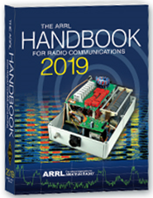Now… It’s been a little while since we’ve rewarded anyone for the most hours and I’m very proud to say that **Todd Johnson, KD8UND** has won the Handbook for the most hours logged in the system for June! Congrats to you and keep up the great reporting!

With this new reporting system, we can get real time information that shows how many hours, who volunteered and what did they volunteer for. There’s a ton of information that we can draw out of the system.

As of 06 July, we now have **1121** registered and growing every day in the system. What’s really interesting is as of this same date there are **8,765** registered in the entire country. This means that the Ohio Section makes up over 12.78% of those registered.

We have a set of instructions on how to get registered right above the button to enter ARES Connect. I would strongly suggest that if you haven’t registered yet, that you read these instructions first.

Here’s a link to get you started... <http://arrl-ohio.org/ares_connect_directions.pdf> Please, don’t just hurry through the questions, read them carefully, if you don’t understand something, please ask me, I’m here to answer your questions.

We know that you mean well by answering that you do have the needed courses in, but I will let you know that we are verifying what you say you have with what is showing for you in our statewide database when we are completing your registration. So, how can you find out if you are already listed in our statewide database? Easy, here’s a link: <http://arrl-ohio.org/SEC/special/ICS%20Complete%20by%20County%20and%20Name.pdf>

As you can see by the numbers above, we are now at the point where we will all need to be registered in this system for our hours to count. We will no longer need to depend on our EC’s and DEC’s to remember our hours of volunteering and report those hours for us on their monthly reports. The EC and DEC monthly numbers are no longer necessary, we will maintain a monthly reporting system for EC/DEC’s, but it will only be for them to submit a narrative only for the month!

The time that was spent in getting your information and making sure it is up-to-date and on file with the EC, as well as transferring all of those records when a new EC takes over is no longer be needed. This system takes care of all of that automatically.

TOP ^

Now, it has a lot of benefit for you too... Forget a meeting time or location? Just look it up on the calendar and there you have it. If set, you can even see the location on a map! I have attended many meetings and gatherings just because it was listed on ARES Connect and I found it just browsing around. I wouldn’t have known about it if it hadn’t been on the ARES Connect Calendar!

Why is this so important? These hours are what is shown to those we go to for funding as well as for more frequencies to operate on. Yes, we have to justify why we need the money or frequencies to those in government that want “just the facts.” This system allows us to show them the facts, anytime and with great accuracy.

***This and That’s***

**‘Old’ amateur radio technology still modern way to communicate after emergency**

*(By Don Coble, Managing Editor)*

<https://www.claytodayonline.com/stories/old-amateur-radio-technology-still-modern-way-to-communicate-after-emergency,17879>

ORANGE PARK, Florida – Amateur radio operators know that in a pinch a pair of Slinkys can be stretched between two trees as an antenna. But in the aftermath of a disaster, natural or otherwise, that kind of creativity often can bring some relief and comfort to the most-desperate situations.

Members of the Clay County Amateur Radio Operating Club and Orange Park Amateur Radio Club hosted their “Introduction to Amateur Radio” last weekend [June 29 and 30] at Orange Park High. Now that hurricane season is here, the group sponsored an open house to show their equipment and experience is ready for the worst.

“It may be old technology, but it’s very necessary,” said Scott Roberts, a coordinator with the local Amateur Radio Emergency Service.

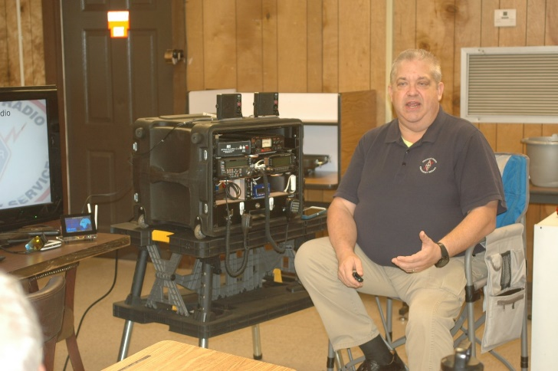During recent hurricanes in Florida, emergency offices relied on the older technology to coordinate rescue and relief.

Radio operators usually are capable to communicating when landlines and cell phone towers are down.

As long as there’s a power source, most often a gas-powered generator or batteries, and an antenna, they are able to rely much-needed information. Most of the time, they have retractable antennas that can tower well above the highest pile of debris. When nothing else is available, operators have used Slinkys to send and receive HF, VHF and UHF radio frequencies.

“We had a radio at every shelter in Clay County after Hurricane Irma,” Roberts said. “We were able to share information with everyone else when there wasn’t any way to communicate.”

TOP ^

The North Florida Chapter also sent members to Puerto Rico for three weeks in the aftermath of Hurricane Maria, and they dispatched nearly a dozen members to the Panhandle following Hurricane Michael.

“It was hard to believe the destruction in the Panhandle,” Roberts said. “There wasn’t anything left. Nothing. It was complete devastation. They didn’t have any cell towers, so they were isolated.

We came in and set up posts. We were able to talk to members back in Duval County, and they were on the phone to the state’s [Emergency Operations Center]. They were able to get help where help was needed most.”

The group also helped following hurricanes Matthew and Hermine, Roberts said.

Last month, radio amateurs participated in Field Day which simulates an emergency and gives operators a chance to test their equipment and “show people what we do,” Roberts said. The group talked to ham radio operators from 49 of 50 states, three Canadian providences and the International Space Station.

There also was one operator who worked solely in Morris code.

While cell phones and computer links play a prominent role in communicating now, there still are about 750,000 ham operators in the U.S. and more than 1.75 million worldwide.

And they’re anything but amateurs. “We are professional at being amateurs,” Roberts said.

The open house was designed to attract interest. Anyone interested in becoming a licensed amateur radio operator can take a free two-day course at Orange Park Medical Center on July 12-13.

**#########**

***SWODA DX Forum a Huge Success***

*(from “the exchange”)*

What a busy time for SWODXA; the DX Dinner®, DX Forum and W8DXCC have all occurred. This was an important time for SWODA as we held our most public outreach events. DX’ers look forward to these events that are the manifestation of our mission to promote excellence in DX’ing. All were a great success due to the planning, creativity and focus on execution of the club members involved.

The DX Dinner brought more than 350 DX’ers together for fellowship, learning, prizes and to recognize excellence in DX’ing. The DX-pedition of the Year® was awarded to the Baker Island DX-pedition for a job very well done under difficult conditions. We also welcomed the Island Radio Expedition Foundation for their first annual award and, as in the past, the CQ Hall of Fame.

Our first Annual W8DXCC convention in conjunction with the Milford Amateur Radio Club (MARC) was a success with over 100 hams in attendance. By holding the DX convention in the same facilities and on the same day as the MARC hamfest we realized a lot of synergies. The attendees were treated to four presentations from well-known and not so well-known DX’ers. The material ranged from a closeup tour of K3LR’s amazing superstation to what is going on with our quiet sun and future propagation from K9LA. We continue to so-licit feedback so we can make the second annual event even better.

#########

TOP ^

***Ohio a part of the new "tornado alley" ?***

**From**

COLUMBUS,Ohio–If it seems we have had more than our share of tornadoes  this year, you are correct.

According to the National Weather Service, thus far, 2019 is the second most active tornado year for the state of Ohio since records began.

Through the end of June, the state has seen 46 tornadoes. The state record is 61, which was set in 1992.    Almost half, twenty-one of those 46 tornadoes touched down as severe storms swept through 10 of Ohio’s counties between May 27 and May 28.

The majority of storms have been EF0/EF1 tornadoes, except for the May 27-28 outbreak of 21 tornadoes in Ohio that included three EF2 storms (111-135 mph), three EF3 tornadoes (136-165 mph), and EF4 (170 mph), which devastated a 19-mile swath in the Brookville-Trotwood-Dayton areas.    One other significant tornado (EF2) in the state earlier this year struck Shelby on April 14 in Richland County.

Ohio has already doubled the number of tornadoes confirmed in 2018 and is a few tornadoes less than the 2017 total of 37.  This, of course, does not include the numerous funnel clouds seen aloft which did not touch down, such as the two reported in Muskingum County last week.

—

One explanation of the increased number of tornadoes in the Buckeye State, could be part of what some weather experts are saying is an eastward shifting ‘Tornado Alley’ into the Midwest and Southeast, including Ohio.

According to a recent study, over the past four decades, the area known to storm watchers as “Tornado Alley” has been slowly shifting to the east. Research has shown that tornado frequency has increased over a large swath of the U.S. Midwest, Southeast and parts of the Ohio Valley, now being called “Dixie Alley” by some weather experts.    Meanwhile, reports indicate that tornado activity has decreased in Tornado Alley, which includes portions of the central and southern Great Plains, Texas and Oklahoma.

#########

***Nationwide EAS Test***

The Federal Emergency Management Agency, in coordination with the FCC, will be conducting a nationwide test of the Emergency Alert System (EAS) on August 7, 2019, at 2:20 p.m. EDT.  If conditions on the day of the test require the rescheduling of the test, a secondary test date is scheduled for Wednesday, August 21, 2019.

***Welcome New Subscribers***

Leslie, N8LES; Jennifer, N8JEN; Michael, N8MRB; David, N8RKC; Dwight, K4YJ

TOP ^

***Final.. Final..***

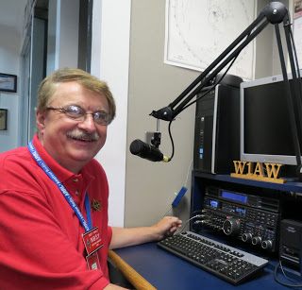

Hey Gang...

Wow.. This past week has been some of the hottest and wettest weather we’ve had a long time and it looks even more like we are in for even hotter weather coming up in August. Grab the garden hose folks, it’s time to get wet and just relax with a really cool brew and your favorite edition of QST.

As you know I had the trees trimmed around the house this past week. They were starting to look like the woods in the back and ruining my plans of moving my dipoles around a bit. So, I had some very good professional tree trimmers come and really do a great job of getting those limbs out of the way. Some of those limbs were over 40 feet long! Yes, sugar maples can be somewhat annoying with their big leaves, especially in the fall when the trees start dumping them, but they are also some of the most beautiful trees in the fall as well. There’s nothing more beautiful than to look out every morning as those big red, yellow, orange and brown leaves to remind you that nature has a way of making the world look so wonderful. Anyway, now that they are trimmed, I can get to work replacing and reworking the dipoles that I had up. Oh, I did get a new one this weekend while I was driving past DX Engineering. I’ll be working that that in the coming days for sure

This past weekend was also the 20/9 Hamfest. It’s always a great hamfest to attend and we had fun talking and renewing friendships there. Thanks, so much Dottie and George for inviting us to attend.

Sliding down the band a bit… Have you taken the time to get signed up in “Connect” yet? Please, don’t let the name ARES fool you, this new system is for everyone and not just for ARES. So, if you haven’t already signed up, now is the time. I know that this must sound like a broken record to most of you, but you won’t believe how many folks I meet every week that still tells me they haven’t heard of it yet.

Here in the Ohio Section we only require our Level 2 volunteers to have the 4 basic courses, IS 100, 200, 700 & 800. For our Level 3 volunteers we do require the additional ICS 300 / 400, or the equivalent professional series courses IS 120, 230, 240, 241, 242, 244 & 288. These equivalent courses are all on-line classes just like your basic 4 NIMS courses are and being offered as an alternative way for you to get credit for taking the professional series courses in the event you just cannot get scheduled into an ICS 300/400 class. By the way, if you decide to take these 7 on-line courses and complete them all, you will want to take just one more class **IS-235.** By completing this additional course, you will get a really great looking certificate from FEMA recognizing that you have completed the entire Professional Series courses. I do hope that this clears up the confusion that has been going around lately. As we have stated on the website and in this newsletter many times “We don’t want anyone left behind.”

Yes, the Ohio Section is extremely lucky to have the relationships that we do with Law Enforcement, EMA, fire and other government agencies, that’s why we’ve partnered with EMAO, OP3 and Ohio VOAD to show our support for them and our Ohio citizens.

TOP ^

Moving down the band one last time… We did have a couple of changes to the website this past week. Daniel, KB8LKH has updated his 3 code plugs and Greg, WD9FTZ updated the Net listing as well.

Whelp… That’s going to do it for this time around. Stay safe, enjoy the sunshine while we have it, and most of all… have FUN!!

73,

***Scott, N8SY***

***Back Issues of the PostScript and Ohio Section Journal (OSJ)***

Hey, did you know that PostScript and Ohio Section Journal (OSJ) are archived on the website? You can go back and look at any edition simply by clicking:

<http://arrl-ohio.org/news/index.html>

***Chit – Chat, and All That!***

Do you know someone that’s not getting these Newsletters? Please, forward a copy of this Newsletter over to them and have them “[Opt-In](http://arrl-ohio.org/forwarder/forwarding.html)” to start receiving them. Heck, just have them send me an email [n8sy@n8sy.com](mailto:n8sy@n8sy.com) and I’ll get them added to the Ohio Section Emailing list.

We now have many thousands of readers receiving these newsletters weekly. Quite impressive, I’d say! I urge all of you to make sure that everyone, regardless of whether they are a League member or not, get signed up to receive these weekly Newsletters.

You can always “[Opt-Out](http://arrl-ohio.org/forwarder/forwarding.html)” at any time if you feel this is not what you were expecting. It’s fun and very informative. All of your favorite past newsletters are now archived too.

You can go back at any time and read them. Just go to: <http://arrl-ohio.org/news/>

Got questions, concerns or would just like to sit and chat awhile? Heck, I’ll even buy the coffee!! Give me a call at (419) 512-4445 or email me at: [n8sy@n8sy.com](mailto:n8sy@n8sy.com)

The pictures on the front page are from various newsletters, Facebook posts and/or were sent directly to me in recent weeks. Take a good look at them, you just might be in one of the pictures! “SMILE… you’re on the Ohio Section News!!”

TOP ^

*PostScript is produced as a weekly newsletter. I want to thank everyone that has contributed articles and ideas to make this an even better news source. I sincerely hope that you have enjoyed this edition and will encourage your friends to join with you in receiving the latest news and information about the Ohio Section, and news and events happening around the world!*