[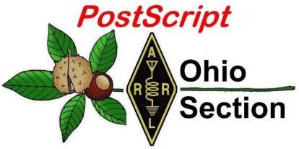](http://arrl-ohio.org/news/) ***Independence Day***

***Edition***

🡪 National News 🡪 The Handbook Give Away

🡪 Club Corner 🡪 Hamfests

🡪 DX This Week 🡪 One Question Questionnaire

🡪 VE Testing 🡪 ARES Connect

🡪 Final.. Final..

***National News***

*(from arrl and other sources)*

***No Strong Opposition to 144 – 146 MHz Reallocation Proposal at CEPT Meeting***

A World Radiocommunication Conference 2023 (WRC-23) agenda item proposing to study a range of frequencies, including potentially reassigning 144 – 146 MHz as a primary Aeronautical Mobile Service allocation, drew little opposition at a meeting of the European Conference of Postal and Telecommunications Administrations ([**CEPT**](http://www.cept.org/)) Project Team A. The team is responsible for some aspects of CEPT WRC positions, and the meeting was held June 17 – 21 in Prague, Czech Republic. Introduced by France, the proposal targeting 144 – 146 MHz would be part of a broader consideration of spectrum allocated to the Aeronautical Mobile Service. Another issue addressed during the meeting concerned the sharing of the Amateur Radio 1240 – 1300 MHz band with Europe’s Galileo GPS system.

“We hear only one admin[istration] (Germany) opposed the 144 MHz proposal — no one else,” the UK Microwave Group [**tweeted**](https://twitter.com/UKGHZ/status/1142180732493803522) following the meeting. Otherwise, it has been carried forward to the higher-level CEPT Conference Preparatory Group (CPG) meeting in August.

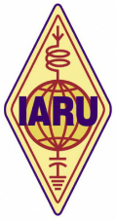

The International Amateur Radio Union ([**IARU**](http://www.iaru.org/)), which was represented at the Prague meeting, expressed “grave concern” to any proposal that would include 144 – 146 MHz in the proposed Aeronautical Mobile Services agenda item. That comprises the entire available 2-meter band in ITU Region 1. IARU has pledged to make every effort to fully protect Amateur Radio interests and seek the support of regulators for their view.

IARU Region 1 President Don Beattie, G3BJ, said prior to the meeting that the IARU would “energetically” promote its opposition in Regional Telecommunications Organizations (RTOs) and the International Telecommunication Union (ITU) “to obtain assurances that the spectrum will remain a primary allocation for the amateur services.”

The 144 – 146 MHz band is allocated globally to the Amateur and Amateur Satellite services on a primary basis, and is the only globally harmonized Amateur Radio VHF band. A widely used segment of the Amateur Radio spectrum, 2 meters supports a broad base of terrestrial users, repeater systems, and satellite stations, including the International Space Station.

According to the meeting minutes, the proposal provides no justification for targeting 144 – 146 MHz, and the

IARU believes that sharing with airborne systems likely would be difficult and lead to constraints on the development of the Amateur and Amateur Satellite services there. IARU suggested that alternative proposals might be developed that could provide further spectrum for the aeronautical applications without impacting this Amateur Service spectrum.

IARU is expected to brief member-societies, requesting that they discuss the French proposal with their governments in advance of the August CEPT-CPG meeting. France could seek to introduce the same proposal to study 144 – 146 MHz for aeronautical use into other RTOs.

TOP ^

Meanwhile, further discussion on the 23-centimeter band study proposal is anticipated prior to the Conference Preparatory Group meeting in August. The proposal was raised in the wake of reports of interference to the Galileo navigation system, but IARU has said it’s aware of only “a handful of cases” of reported interference to the Galileo E6 signal on 1278.750 MHz. Work on this issue will continue in other specialized CEPT forums in the interim.

#########

***Islands on the Air Announces Another Six New Island Groups***



The Islands on the Air ([**IOTA**](https://www.iota-world.org/)) Amateur Radio awards program announced six new island entities at its HAM RADIO forum in Friedrichshafen, Germany, this past weekend. The new groups have provisional numbers and will need to be confirmed by an operation after June 22 that meets the 1,000-contact requirement, in addition to other validations. Credit for prior operations will be considered only after a group number has been confirmed. Addition of the six new groups takes the total of confirmed or provisional IOTA numbers to 1,172, of which 1,131 have seen activity. IOTA policy caps the program at 1,200 groups. The new groups are:

**AS-206:** JAØ, 1, 2, 7 — Honshu’s Coastal Islands East, Japan, created by splitting the current AS-117 Honshu’s Coastal Islands in accordance with the “large island” criterion that allows more than one coastal island group. Considerable activity has taken place from both groups. The entry/title of AS-117 Honshu’s Coastal Islands has been changed to JA3, 4, and 9 Honshu’s Coastal Islands West.

**AS-207:** RØK — Chukchi Sea Coast Centre group, Chukotskiy Avtonomnyy Okrug, Russia — Asia (Kosa Dvukh Pilotov), valid for the Arctic Islands Award. This new “unofficial/coastal island group” was created by splitting the current AS-174 Chukchi Sea Coast West group. There has been no known previous Amateur Radio activity.

**OC-298:**FO — Tatakoto Atoll, Tuamotu Islands, French Polynesia (Tatakoto), is a new “remote island group” previously part of OC-066 Tuamotu Archipelago but separated from the other islands in this large group by at least 154 kilometers. A handful of previous operations have taken place. Tatakoto will be deleted from OC-066 Tuamotu Archipelago without any change to the latter’s group name or coordinates.

**OC-299:**V6 — Yap East group, State of Yap, Federated States of Micronesia (Elato, Lamotrek, Olimarao, Pikelot, Satawal, West Fayu), is a new remote island group whose islands previously were part of the OC-132 East Yap group but are separated from the remaining islands in that group by at least 160.5 kilometers. No previous Amateur Radio activity has been recorded. These islands will be deleted from OC-132 East Yap group, which will now consist of Eauripik, Faraulep, Gaferut, Ifalik, and Woleai and be renamed as Yap Centre group.

**OC-300:**T31 — McKean and Nikumaroro Atolls, Phoenix Islands, Central Kiribati, Kiribati (McKean, Nikumaroro), a new remote island group. These islands were previously part of OC-043 Phoenix Islands but are separated from the remaining islands in that group by at least 230 kilometers. No known previous Amateur Radio activity has taken place. These islands will be deleted from OC-043 Phoenix Islands, which will now consist of Birnie, Enderbury, Kanton, Manra, Orona, and Rawaki.

TOP ^

**SA-101:**CEØ — Alejandro Selkirk Island, Juan Fernandez Archipelago, Chile (Alejandro Selkirk), a new remote island group, previously part of SA-005 Juan Fernandez Archipelago but separated from the remaining islands in that group by some 159 kilometers. There has been no known previous Amateur Radio activity. This island will be deleted from SA-005 group which will now consist of Robinson Crusoe and Santa Clara and be renamed as Juan Fernandez Archipelago (Robinson Crusoe Island).

***13 Colonies Special Event to Mark 11th Anniversary this Year***



The annual [Original 13 Colonies Special Event](http://www.13colonies.net/) will mark its 11th anniversary this year. The event gets under way on **July 1 at 1300 UTC and runs through July 7** at 0400 UTC. Special event stations with 1 × 1 call signs will represent the original 13 US colonies, plus bonus stations K2Z, WM3PEN in Philadelphia and GB13COL in Durham, England.

Each special event station will have its own QRZ.com profile page. Participating stations try to contact all 13 Colony Stations plus the two bonus stations. Call signs and their respective states are K2A, New York; K2B, Virginia; K2C, Rhode Island; K2D, Connecticut; K2E, Delaware; K2F, Maryland; K2G, Georgia; K2H, Massachusetts; K2I, New Jersey; K2J, North Carolina; K2K, New Hampshire; K2L, South Carolina, and K2M, Pennsylvania.

[Additional information](http://www.13colonies.net/) is on the 13 Colonies website.

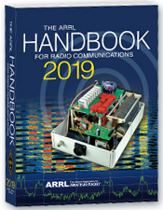***The Handbook Give Away***

Hey Gang,

We had another fantastic response this month, but I’m sure you’re more interested in knowing just who won the Handbook this month...

And the winner is…. ***John Spencer, N8JDS***

We've had another a great response after with the Give Away so… I decided to also give away something really special this time around. Since the weather has changed from cold to really hot and sticky, why not give out official Ohio Section T-Shirts!

So, I'm sending out an o***fficial Ohio Section T-Shirt*** to: ***Timothy Nicely, AC8VQ and***

***Mike Farkas, N8GBU!***

Many of you ask me just how do I know when the drawing is on? Well, that’s easy all you need to do is check in on the Ohio Section Website on a regular basis and watch for the big RED Arrow that will appear on the left side of the page. This is the sign that the drawing is on and you need to get registered. So, keep a sharp eye out on the website and check in often! <http://arrl-ohio.org>

You just never know.. You just might be the next winner!

TOP ^

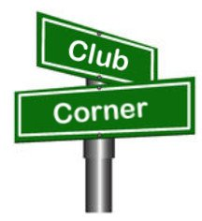***Club Corner***

This is YOUR cornner of the newsletter. Send me what your club is doing and I’ll make sure that it gets in. Got a special event or club project that you want everyone to know about? Send it to me!. Need help with a project? Send it to me.

Let me know what you club is up to. Are you going to have a special guest at your meeting or are you having a special anniversary? Just sent it to:

[n8sy@n8sy.com](mailto:n8sy@n8sy.com)

#########

***Lucas County ARES DESPARATELY NEEDS YOUR HELP***

The Toledo Air Show is **July 13 & 14** and we did such a great job at the last Air Show the powers that be have requested additional help from us this time around. We are still in the planning phase and do not have final numbers for needed operators, but I wouldn’t be surprised to see a number around 50 or more each day.

Our coverage includes some of the following: Entrances; First Aid Tents; Mobile Hospital; Air Boss; Incident Command; Parking Lots; Transportation Buses; Exits and more.

If you can help - Please contact either Rick K8RKS at [K8RKS@ARRL.net](mailto:K8RKS@ARRL.net) or Tim KD8IZU at [boxcar@toast.net](mailto:boxcar@toast.net) In the Subject Line of your email put Toledo Air Show.

#########

***Alliance Club Holding A Technician License Class***

Our class for technician starts **06 July** in the Cafeteria conference room at the Alliance Community Hospital.

Twelve weeks free, 5 PM to 7 PM each week. Requirements, a flash drive or SD card with about 1 Gigabyte free space and a commitment to do the studying required.

For more information contact Frank Sanor at [wa8whp@gmail.com](mailto:wa8whp@gmail.com)

#########

***Need Help Desperately for Operation Vigilant Guard***

It's been a bear trying to get the mission requirements locked down for Operation Vigilant Guard. At this point in time we could need up to eight ARES volunteers for the **Wednesday, August 07** operation.

Please, if you have some time to volunteer to help me make this mission a great success for Amateur Radio, contact Rick Kruis [k8cav.coms@gmail.com](mailto:k8cav.coms@gmail.com)

#########

TOP ^

***USAF Marathon Needs Help***

Approximately 70 amateur radio operators are needed to support the USAF Marathon at Wright Patterson Air Force Base on **Saturday, September 21, 2019** to provide the USAF Marathon Staff with emergency and logistic communications. This world class event has over 20,000 participants, volunteers, and spectators in attendance every year.

Amateur radio operators are indispensable in rapidly communicating information on runner’s locations and status, heat index settings, severe weather notifications, as well as emergencies and logistic issues. Plus, APRS is utilized to track lead runners and “Tail End Charlie’s”, thus allowing race officials and emergency services to more accurately monitor the race progression.

According to Brandon Hough, the USAF Marathon Race Director, the senior base leaders rely on the communication skills of our amateur radios operators and use them as a vital resource.

Multiple races are held on this day including: 10K, Half Marathon, Full Marathon, and Wheelchair. The volunteer registration website for the USAF Marathon is now open.

If you will be in the Dayton, Ohio area on Saturday, September 21, 2019 and would like to take part in this world class event, please go to the USAF Marathon website at <http://www.usafmarathon.com/volunteer>  and click the volunteer now link, scroll down to the amateur radio section to register. Training will be provided prior to the event.

How to register online:

1. Go to the website above.
2. Click on the Volunteer Now button.
3. Acknowledge that you’re going to a new website.
4. On the new website, ignore the “password” entry box near the top of the page. Scroll down to the “Amateur Radio Operator” section and click the check box for the Amateur Radio Operator Position and only that position.
5. Scroll to the bottom, past all the other volunteer positions, and fill in your name and other required data.
6. Check the box below the waiver paragraph and then type in your name for a digital signature.
7. Click the “Sign Up to Volunteer” button.
8. You’re done!
9. You should get an automated email response from Jeanette Monaghan acknowledging your registration.
10. Contact Phil Verret if you have any questions or concerns.

**Registration closes August 31, 2019**.

If you have any questions please email to: Phil Verret, [KA8ZKR@ARRL.NET](mailto:KA8ZKR@ARRL.NET)

#########

TOP ^

***Dave Kalter Youth DX Adventure***

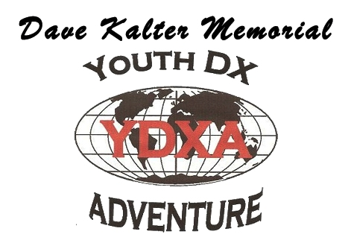

The Dave Kalter Youth DX Adventure is returning to the PJ2T Contest Station in Curacao again this year.  Thanks to our host Uli - DL8OBQ and the Caribbean Contesting Consortium we will be live beginning late **July 14-18, 2019**.  Once again, we have applied for the PJ2Y special call sign that we had last year.

This year’s youth team includes a veteran of the 2017 team (due to an emergency fill) of Bryant Rascoll KG5HVO so look for some great CW contacts.  Also, on the team is Audrey McElroy KM4BUN and her brother Jack KM4ZIA.

Depending on conditions we plan to be on all bands and modes, SSB, CW, FT8 and possibly some satellites.  Watch our website [www.qsl.net/n6jrl](http://www.qsl.net/n6jrl) for updates while on site.

#########

***Technician Class License Course Starting Up***

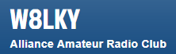The Alliance Amateur Radio Club W8LKY is celebrating Forty-Nine years of continuous service (1970-2019) to the greater Alliance, Ohio Area.

Frank (WA8WHP) will be conducting entry level classes (Tech) for Amateur Radio Operator Licensing starting on **July 6, 2019 at 5-7pm** in the café conference room in Aultman Alliance Community Hospital - 200 East State Street in Alliance.

The classes will run 12 weeks, he can be reached at [wa8whp@gmail.com](mailto:wa8whp@gmail.com).

#########

***DX Engineering Hamfest Comin In August***

I'm pleased to announce the following DX Engineering event on **August 10th**. Mark your calendars!

On **Saturday, August 10th**, DX Engineering will be holding their very first Hamfest!  (hopefully it won’t be raining) This Hamfest will be absolutely FREE, no charge to get in, and we will have the following events:

* Open box and demo items for sale, similar to our previous sale events.
* Tailgate “swap and shop” in our very large parking area, completely paved.
* Go Box contest with a first-place prize for the best go box of a DX Engineering $100 gift certificate.
* Satellite operation demo with the IC-9700.

**And FINALLY,** a grand prize of a IC-9700 to one lucky winner (winner must be present to win).

A food truck will be available for purchasing food and drink items.

#########

TOP ^

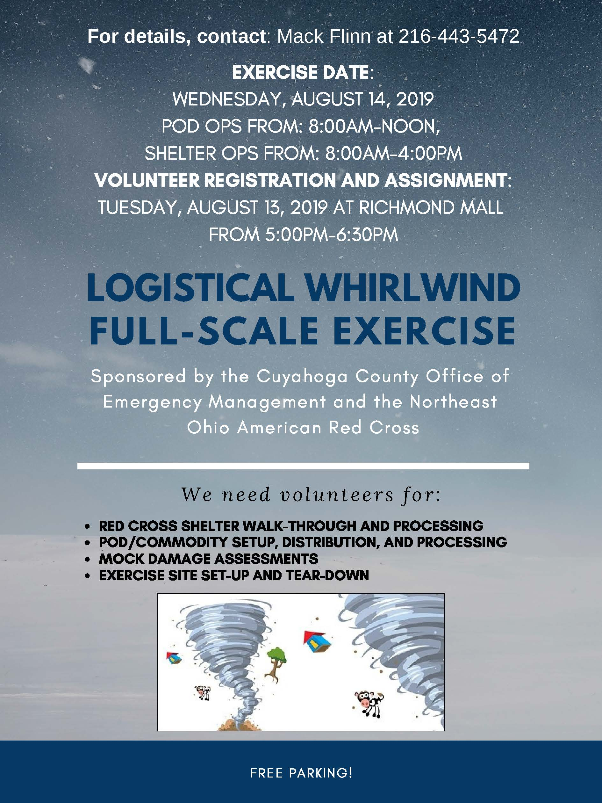

TOP ^

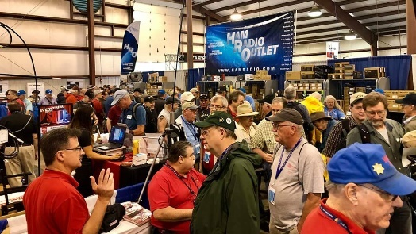[***Upcoming Hamfests***](http://arrl-ohio.org/hamfests.html)

**07/07/2019 | 20/9 Radio Club Hamfest** Location: Austintown, OH  
Sponsor: 20/9 Radio Club, Inc.  
Website: [http://20over9.org](http://20over9.org/)

|  |  |
| --- | --- |
| **07/07/2019 | Ohio Link Swap Meet**  Location: 1801 Gateway Circle, Grove City  Sponsor: Ohio Link Network Group  Website: [www.olnradio.digital](http://www.olnradio.digital) | **07/20/2019 | NOARSFEST**  Location: Elyria, OH Sponsor: Northern Ohio Amateur Radio Society Website: <http://noars.net/hamfests/noarsfest> |
| **07/21/2018 | Van Wert Hamfest** Location: Van Wert, OH Sponsor: Van Wert Amateur Radio Club Website: [http://w8fy.org](http://w8fy.org/) | **07/28/2019 |**[**Portage Hamfair '19**](http://www.arrl.org/hamfests/portage-hamfair-19)  Location: Ravenna, OH Sponsor: Portage Amateur Radio Club Website: [http://hamfair.com](http://hamfair.com/) |
| **08/03/2019 | Columbus, Ohio Hamfest** Location: Grove City, OH Sponsor: Voice of Aladdin Amateur Radio Club Website: [http://www.columbushamfest.com](http://www.columbushamfest.com/) | **08/10/2019 | DX Engineering Hamfest**  Location: Tallmadge, OH  Sponsor: DX Engineering  Website: <https://www.dxengineering.com/> |
| **08/17/2019 | GARS 2019 HamFest**  Location: Germantown , OH Sponsor: Germantown Amateur Radio Society  Website: [http://www.WG8ARS.org](http://www.wg8ars.org/) | **09/08/2019 | Findlay Hamfest**  Location: Findlay, OH Sponsor: Findlay Radio Club Website: [http://www.findlayradioclub.org](http://www.findlayradioclub.org/) |

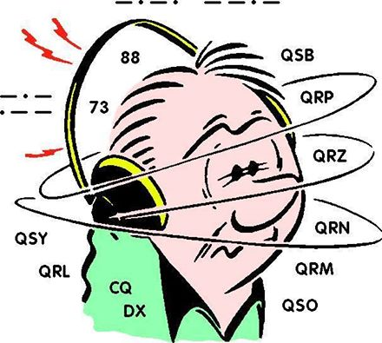***DX This Week***

*(from Bill, AJ8B)*

Bill AJ8B ([aj8b@arrl.net](mailto:aj8b@arrl.net), @AJ8B, [www.aj8b.com](http://www.aj8b.com) or [www.swodxa.org](http://www.swodxa.org) )  
CWOPs Member #1567

If sunspots are at a minimum and propagation is dead, no one told 20 meters during the gray line. Uncle Frank was updating me on the “great 20-meter Asiatic opening” that occurred on Tuesday, June 18th between 0930 and 1100 GMT. Frank worked 11 Japanese stations, a VK, 9V in Singapore, and YB8MAN in Indonesia. In addition, he had at least 10 other JAs and one Chinese station in the FT8 waterfall.

I have been on a bit of a streak myself, working Japan on CW or FT8 on at least 9 days of the last 12 at gray line on 20 meters. On June 19th, I worked FO5RH on 20 meters CW. He was 579 running 250 W. Great QSO and solid conditions for about 45 minutes.

TOP ^

As my OM (K8DWE – SK) would have said – “You can’t hear them if you don’t listen for them.” Sometimes you must forget the charts and the spots and just listen. I always chuckle when I hear hams talk about how conditions improved just in time for a contest. Conditions are conditions and we just need to get on the air!

A close up of text on a white background

Description generated with high confidenceOne of my favorite on the air operating activities is the 13 colonies Special event that occurs annually around the first week of July. Although not a “DX” event per se, it is a great operating event and there are pileups to negotiate at times, so, this is a great practice event. You need to work as many of the special 13 colonies stations as you can on as many different modes and bands that you like. Each of the special stations has a commerative QSL card that are terrific and you can get an award (pictured below) for working all 13. For more information, visit [www.13colonies.net](http://www.13colonies.net) (The information below is reprinted from the ARRL Website)

*The annual*[***13 Colonies Special Even****t*](http://www.13colonies.info/)*takes place from 1300 UTC on July 1 until 0400 UTC on July 7. Stations working the special event station in at least one of the original 13 states — or all 15 participating stations — will be eligible for a certificate. A Liberty Bell endorsement will be attached for stations contacting sister special event station WM3PEN, in Philadelphia, where independence was declared. Back this year, is a second sister station GB13COL in Durham, England.*

*Stations will be on the air from each of the original 13 colonies — Connecticut (K2D), Delaware (K2E), Georgia (K2G), Massachusetts (K2H), Maryland (K2F), North Carolina (K2J), New Hampshire (K2K), New Jersey (K2I), New York (K2A), Pennsylvania (K2M), Rhode Island (K2C), South Carolina (K2L), and Virginia (K2B). All HF bands and all modes will be in play, except for 60 meters. Operation on 2 and 6 meter simplex is encouraged.*

Over time I have tried to find sources of information that can give me an edge or at least keep me informed. Running a vertical, OCF Dipole and a Yaesu FT-950 has forced me to gather all the information I can!

I have six sources of information for DX that I use in varying degrees; Blogs, Podcasts, YouTube, Websites, Phone Apps, and books. Websites, Phone Apps, and Books will be reviewed in a future edition. We can focus on the other three.

**Blogs –** Blogs seem to have lost some popularity, but, those that are followed are followed heavily. My favorite blog was maintained by Paul, N6PSE. Paul no longer publishes his blog, but, previous blog sessions are still available at <https://n6pse.wordpress.com/>

There are other blogs that I follow. The ones that I would recommend are:

|  |  |  |
| --- | --- | --- |
| Blog | Comment | Site |
| KB6NU | General Ham Radio Interest | <https://www.kb6nu.com/> |
| W2LJ | QRP Topics | <https://w2lj.blogspot.com/> |
| VE3WDM | QRP Topics | <https://ve3wdm.blogspot.com/> |
| K0NR | VHF/UHF, QRP, mountaintop operating and technical stuff | <http://www.k0nr.com/wordpress/> |
| WB3GCK | Field Day, Portable, QRP | <https://wb3gck.com/> |
| LA3ZA | All Topics HF | <https://la3za.blogspot.com/> |

TOP ^

**Podcasts –** There are literally thousands upon thousands of podcasts. If you have not tried a podcast, now is the time! There are various smart phone apps that can be used to access podcasts. The one that I use is Stitcher. Just go to the app store on your smart phone and search for Stitcher.

Once you have the app installed, you can search by topic or a specific podcast. I like to listen to information presented in a logical, conversational manner. What I don’t care for is the person who thinks he is on stage and must tell jokes, be funny, or attempt to be smarter than they are. That is the great thing about podcasts. If I don’t like the current guest or topic, just change to a different edition or podcast. Typically, once you have identified a podcast you are interested in, you have access to all the podcasts that had been created previously. In many cases, this gives you a full selection to choose from. Podcasts typically are monthly, bi-monthly or weekly. This also gives you a wide selection of episodes. I spend about 2 hours/day in the car, so, I have time to check podcasts out. My current list of podcasts are below:

|  |  |
| --- | --- |
| Podcast | Comment |
| The ARRL – The Doctor is in | Bi-Monthly Ham talk |
| QSO Today | Ham Operator interviews with a wide range of amateurs |
| Ham Radio Workbench | Practical nuts and bolts discussion of building and construction topics |
| No Nonsense Amateur Radio Podcast | General Topis |
| ARRL Audio News | General information from the league |
| Linux in the Ham Shack | Using Linux for various programs and projects |
| This week in Amateur Radio | News and timely radio topics |
| So Now What | For Entry level hams – Curious what you think of this |

**YouTube** – From discussions I have had with hams, I am starting to believe that YouTube may be the best kept secret in our hobby. There are thousands of videos available for all topics! I even looked up my novice station and found several videos about the equipment from 1971. (Eico 720 and Hallicrafters SX-100) I have really begun to use YouTube as a reference and really suggest that you do as well! Before my first serious attempt at the Ohio QSO Party, I search YouTube on K8DV and reviewed Dave’s videos. I learned a tremendous amount!

We don’t all have time to just browse YouTube to see what is new. YouTube allows you to “subscribe” to a “channel” and you will be notified when a new video is posted that pertains to that channel.

One question that I get is how to find channels? Here are the steps you would use:

1. Go to Youtube
2. Type the topic in the Search Bar (i.e. Hallicrafters) and click the “search” magnifying glass.
3. Click the Filters button
4. Select Channel under the Results type. Find the desired YouTube profile in the search results. You should see the option to subscribe. Click it on you will be able to quickly view and sort by category.

The channels that I subscribe to include CWOps, DXEngineering, Yaesu, Dave Berstein (DXLabs), MFJ, Linux in the Ham Shack, Heil Radio, Ham Radio DX, QRZ Ham Radio, Ham Nation, Radio Ham Guy, ARRL HQ, Everything Ham Radio, and Raspberry Pi. Seems like a lot, but, I usually get a few updates per month.

For all of these resources, let me know what I missed and I will update this section soon.

TOP ^

+ --------------------------------------------------------------------------------------------------------------------+

Here is an update from Bernie, W3UR, of the DailyDX and the WeeklyDX,

the best source for DX information. (<http://www.dailydx.com/> ) Bernie has this to report:

+ --------------------------------------------------------------------------------------------------------------------+

**TZ** – Mali - TZ4AM, Jeff, is going to have to move to a new location, located about 200 meters from the old QTH. The new building is one story higher, some 14 meters above the ground. The new antennas will be on 10 meter bamboo poles so they will be "pretty high and clear of all obstructions". Jeff will still be able to use the "same Beverages and the feedpoint will be across the street". 5H – Tanzania.

**RC5A**, Elena, tells us she and RM0F, Yuri, will be operating as 5H3CA and 5H3RRC, respectively, from Mafia Island (AF-054) from about September 25 to October 5. They will be on CW and SSB on 1.8 through 28 MHz. QSL via RC5A.

**T2** – Tuvalu - 3D2AG, Tony, expects his next T2AR "mini-DXpedition" to be on the air from June 27 to July 6. Listen for him to be operating on CW, SSB, FT8 and RTTY on 1.8 through 28 MHz, including 60 meters. "This operation will be in collaboration with John KK7L, who will activate the T2R Club call from June 27th to July 6th 2019", says Tony. QSL T2AR via 3D2AG and T2R via N7SMI, Club Log and LoTW.

**EL** – Liberia - The Italian DX Team report their A82Z and A82X licenses have been accepted by the ARRL for their September/October 2019 DXpedition. They have already received their LoTW certificates. The 11 man team will be QRV from September 28 to October 11, running five stations on FT8, RTTY, SSB and CW. They also plan to post their logs in "Real-Time" including FT8 QSOs.

#########

***A******RLD026 DX news***

This week's bulletin was made possible with information provided by The Daily DX, The OPDX Bulletin, 425 DX News, DXNL, Contest Corral from QST and the ARRL Contest Calendar and WA7BNM web sites. Thanks to all.

**ITU HQ, 4U_ITU.** Brennan, N4QX is in Geneva and QRV as both HB9/N4QX

and 4U1ITU until July 4. QSL via operator's instructions.

**UGANDA, 5X.** Anders, SM0HPL is QRV as 5X7W from Kampala until July 6

while on work assignment. Activity is in his spare time on the HF bands using QRP power and CW, JT65, FT8 and FT4. QSL direct to home call.

**TRINIDAD AND TOBAGO, 9Y.**  Karel, OK2ZI is QRV as 9Y4/OK2ZI from Trinidad, IOTA SA-011, until July 6. Activity is on 40 to 10 meters using CW, SSB and various digital modes. QSL to home call.

**TAIWAN, BV.** Special event station BV0ME is QRV until 0359z on December 13. Activity is on the HF bands using FT8 during the weekdays and SSB during the weekends. QSL via BU2EQ.

TOP ^

**CHILE, CE.** Members of the Grupo YL Zona Norte will be QRV with special event stations CB1SOL in Iquique and CB2SOL in Coquimbo from July 1 to 7 for the Solar Eclipse that occurs on July 2. Activity

will be on the HF bands. QSL via CA2MEM.

**FEDERAL REPUBLIC OF GERMANY, DA.** Special event station DL0SOP will be QRV during July to support the annual Sea of Peace award. QSL via bureau.

**SPAIN, EA.** Members of the Asociacion de Radioaficionados de Padron are QRV with special event call AO50MOON during July to commemorate the first manned landing on the Moon. QSL via EA1RCI.

**REPUBLIC OF KOREA, HL.** Special event station HL18FINA will be QRV from July 1 to August 18 to celebrate the Federation Internationale de Natation's 18th World Championships and World Masters

Championships. QSL via HL4CCM.

**SVALBARD, JW.** Peter, LA7QIA will be QRV as JW7QIA from Spitsbergen, IOTA EU-026, from June 29 to July 6. Activity will be on 6 meters from Grid Square JQ68. QSL to home call.

**AUSTRIA, OE.**  Special event stations OE2XXM and OE5XXM will be QRV during July to celebrate the 35th international Ham Radio meeting in Gosau. Activity will be mostly on 80 and 40 meters using SSB, as well as 2 meters and 70 centimeters. QSL via bureau.

**CRETE, SV9.** Paul, SA6PIS will be QRV as SV9/SA6PIS/p from Chania from June 30 to July 7. Activity will be holiday style on 40, 20, 15 and 10 meters using SSB. QSL to home call.

**TUVALU, T2.** Tony, 3D2AG and John, KK7L are QRV as T2AR and T2R, respectively, until July 5. Activity is on 160 to 10 meters, including 6 and 2 meters, using CW, SSB, RTTY, JT65 and FT8. QSL T2AR direct via 3D2AG and T2R direct via N7SMI.

**UKRAINE, UR.** Special event station EM2019ARDF is QRV until July 4 to mark the 3rd IARU World Youth ARDF Championship being held here. QSL via bureau.

**SOUTH SUDAN, Z8.** Diya, YI1DZ is QRV as Z81D from Juba until October 10. Activity is in his spare time on 80 to 10 meters using SSB and FT8. QSL via OM3JW.

**GIBRALTAR, ZB.** Members of the Gibraltar Amateur Radio Society will be QRV as ZB2IG19 from July 5 to 31 for the XVIII NatWest International Island Games. QSL via bureau.

THIS WEEKEND ON THE RADIO. The RAC Canada Day Contest, QRP 20-Meter CW Fox Hunt, NCCC RTTY Sprint, NCCC CW Sprint, Feld Hell Sprint, Battle of Carabobo International Phone Contest, UFT QRP Contest, 10-10 International Spirit of 76 QSO Party and IQRP Quarterly Marathon are on tap for this weekend.

The RSGB 80-Meter Club CW Championship is scheduled for July 1. The Fireflies QRP 72 Sprint and ARS Spartan CW Sprint are scheduled for July 2. The CWops Mini-CWT Test and Phone Fray are scheduled for July 3. The Canadian National Parks on the Air, CNPOTA, operating event runs for the entire year of 2019, with special stations active from Canada's parks and historic sites.

Please see June QST, page 86, July QST, page 85, and the ARRL and WA7BNM Contest Web Sites for details.

TOP ^

***Special Events***

**07/08/2019 | 50th Anniversary of First Moon Landing**

**Jul 8-Jul 24, 0000Z-2259Z, N8A**, West Chester, OH. Midwest VHF/UHF Society. 10368.100. Certificate. Tom Holmes, N8ZM, 1055 Wilderness Bluff, Tipp City, OH 45371-9221. Plan to work 10 GHz EME when moon at best position for good DX. Contact for schedules and exact frequency. [n8zm@mvus.org](mailto:)

**07/14/2019 | 50 Years - First Man on the Moon**

**Jul 14-Jul 28, 1700Z-2000Z, N1A**, Milford, OH. Milford Amateur Radio Club. SSB: 28.350 14.260 7.240 3.840; CW: 14.045, 7.045, 3.545; FT8 standard frequencies. QSL. Milford Amateur Radio Club, P.O. Box 100, Milford, OH 45150-0100. Email qsl@w8mrc.com for QSL requests. [www.w8mrc.com](http://www.w8mrc.com/)

**07/20/2019 | Honoring the 50th Anniversary of the Apollo 11 Moon Landing**

**Jul 20, 1400Z-2000Z, K8QYL**, Wapakoneta, OH. Reservoir Amateur Radio Association. 14.250 7.250. QSL. Rich Spencer, W8GZ, 05925 Vogel Rd., Saint Marys, OH 45885. From the Neil Armstrong Air and Space Museum

**07/22/2019 | Seneca County Fair**

**Jul 22-Jul 29, 1600Z-0200Z, W8ID**, Tiffin, OH. Seneca Radio Club. 7.225 3.895. QSL. Seneca Radio Club W8ID, P.O. Box 67, Tiffin, OH 44883. W8ID will be celebrating 177 years of the Seneca County Fair! Join us for the cotton candy! Join us for all the fun! We can’t wait! [www.w8id.org](http://www.w8id.org/)

**08/01/2019 | W8LKY Carnation Festival Special Event**

**Aug 1-Aug 11, 0000Z-2359Z, W8LKY**, Alliance, OH. Alliance Amateur Radio Club. 14.240 14.045 7.240 7.045. Certificate & QSL. Alliance Amateur Radio Club, P.O. Box 3344, Alliance, OH 44601. The Alliance ARC(W8LKY) will be on the air at various times throughout our Carnation festival festivities. We'll be on the air from various locations in the Carnation city. We may pop up on the bands at any time. Check the spotting networks, and our web page for upcoming activations. [www.w8lky.org](http://www.w8lky.org/)

**08/15/2019 | D-Day Conneaut**

**Aug 15-Aug 18, 1600Z-0400Z, W8D**, Conneaut, OH. Conneaut Amateur Radio Club. 14.285 7.190 3.996 3.885. QSL. Garret Scott W8D, 10236 Birch Hill Ln., Knoxville, TN 37932. D-Day Conneaut recognizes the 75th anniversary of the World War II Allied D-Day Landings on the beaches of France in 1944. Event will include the country's largest reenactment of the D-Day landings with more than 1,800 WWII reenactors from around the world participating. Radio operations will include vintage WWII equipment <https://www.facebook.com/W8BHZ>

***Need Your Field Day Pictures***

Now that Field Day is over and you’ve had a good night’s sleep, don’t forget to send me those great pictures of your Field Day! These pictures will be added into the Field Day gallery and some of them may even find their way to the next Ohio Section Banner as well.

***Please send your Field Day pictures to me for publication on the Ohio Section website!! Send them to:*** [n8sy@n8sy.com](mailto:n8sy@n8sy.com) and to view what I have received go to: <http://arrl-ohio.org/fd-19/>

TOP ^

**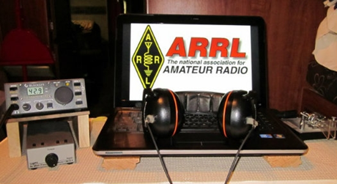*ARRL Contest Corner***

An expanded, downloadable version of *QST'*s [Contest Corral](http://www.arrl.org/contest-calendar) is available as a PDF. Check the sponsor's Web site for information on operating time restrictions and other instructions.

***One Question Questionnaire***

Hey Gang,

It seems that 63% of you have kept your original call-sign. Wow, that’s way more than I expected to see for sure.

I’ve got another NEW – one question – questionnaire on the Ohio Section Website! I noticed on the social media sites this past week some folks feel that Field Day is a contest, others feel that it is an ARES event. How do you feel about this? Is it an ARES Event or is it a contest! Let’s throw in one more variable to this. Could it just be a great way for you and your friends to spend some time together?

However you may feel about it, let me know by answering the Question. Go to: <http://arrlohio.org>

**“Do you think Field Day is a Contest or an ARES event??”**

These One Question questionnaires are all in fun and I hope that you are enjoying answering them.

You’ll find the “One Question” questionnaire on the Ohio Section Website! <http://arrlohio.org> It’s all in fun and it’s not a scientific survey in any way, but we are learning some things that we didn’t know from these questions. I hope that you are enjoying answering these “One Question” questionnaires.

*****V.E. Test Sessions***

For the latest testing site information please **>>** [**Click Here**](http://www.arrl.org/find-an-amateur-radio-license-exam-session) **<<** The ARRL site tracks all of the VE testing sites that register with them, including W5YI and Laurel. ARRL gives you a number of different ways of sorting to find that site that is closest to you as well.

TOP ^

***Incident Command System (ICS) Training Schedule***

All current trainings are listed on the Ohio EMA training calendar located at:

<https://webeoctraining.dps.ohio.gov/TrainingAndExercise/courselist.aspx>

I’ve been asked to also include a link to the Kentucky EMA training calendar as well..

<https://kyem.ky.gov/training/Pages/default.aspx>

<https://sites.google.com/site/ccoemtraining/home>

Please pay particular attention to these courses listed above, as that there’s a lot of ICS 300 & 400 classes listed that are very useful for all Amateurs to have under their belts. I will also state that G775 is also a very good course to take as well. These 3 courses are multiple day in class courses, so please be prepared to spend some time taking them.

We do recognize that IS-300/400 requires multiple days of actual classroom training that is not easily obtained. So, if you just can't find the time to fit these classroom courses in, we do have an alternative method for getting you to Level 3.

Completing the following **“FREE”** and **“ONLINE”** courses will act as substitute for you FEMA Leadership Development Course requirements. You absolutely will need to complete all **7** of these courses to get your ICS 300/400 credit.  Here are the courses that you need to take:  **IS-120, 230, 240, 241, 242, 244 & 288.**

***Now, if you are looking for wallpaper and have a little extra time, taking IS-235 in addition to the 7 listed courses above, you will get a really cool looking certificate from FEMA stating that you have completed the Professional Development Series. That’s impressive in itself!***

***Now Hiring***

Folks, we have a deficiency at The Sarge- we need more operators. We do not want to grab more from Franklin County ARES, we’re already hitting them pretty hard. So, we’re looking for operators within an hour’s drive of the 270/315 area. We need at least a general class licensee. You should be familiar with fldigi and digital communication on HF and VHF. Experience in emergency response is a plus.

You must pass a background check. If you’re a seasoned operator - primarily a solid traffic handler or a successful contester – who is comfortable working under moderate pressure, and you’re able to take on a modest time commitment (at most one night a week under a schedule with emergency activation always possible) please consider contacting Stan, N8BHL or Richard, KD8PHG to be considered!

#########

TOP ^

***ARES Connect***

It seems as though the name "ARES Connect" is getting folks confused about who all should be using this system. Maybe it just should be called “Ham Radio Connect” instead! Whatcha’ think? Would you think the system was for everyone then?

Like FT 4, this system is new to everyone and it seems that the moniker hung on this new system is keeping a lot of folks from using it. Let’s clear the air on that right now. It’s not just for ARES events. I'm here to tell you that it's to be used for ANY event that involves Amateur Radio. It can be a RACES, CERT, Skywarn, Red Cross or just a few hams gathered at a table to talk about Amateur Radio. It all counts!

Club meetings, hamfests, working on that club trailer, repeater, website, field day, parades, newsletter or just having fun keeping track of all those spandex folks during every kind of race imaginable are perfect examples of hours that count that are not necessarily ARES directly related but do have an impact on your community. Any Amateur Radio related activity should be an event in ARES Connect and your hours recorded. Why? These hours will help demonstrate to the FCC and all of our government officials (local, state and federal), as well as all of our served agencies our willingness to volunteer and help our fellow citizens. These are not just hours; they are dollars that are given back to our communities, and we want our government officials to know just how much we give back to help keep the frequencies that we have, as well as future frequencies that may be available later. Showing them in dollars how much we give back is what keeps their attention and helps preserve our current frequencies.

Just because the name of this system has ARES in it, doesn't mean that we only record ARES events. If it involves Amateur Radio **IN ANY WAY** then it needs to have an event established and hours recorded for it.

Here’s the really great news about this system. It’s never too late to get those valuable hours recorded, even if the event has already passed. The Admins of this system can setup events anytime and add you and your hours to those events.

Yes, I agree, the name of this system may not necessarily fit what it’s all about, but what’s in a name anyway!!!

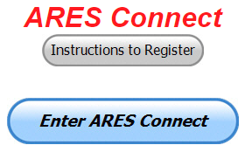Now, are you registered in the system yet? We need to make sure that no one is left behind.

If you live in **Ohio** and you haven’t registered yet, we need you to get registered now. We need you to only use this URL to get registered [**https://arrl.volunteerhub.com/lp/oh/**](https://arrl.volunteerhub.com/lp/oh/). Using any other entrance to register will only slow down your registration process. Again, this is for those living in Ohio only. If you are an out of state person (not Ohio), you can simply change the /oh/ to your 2-letter state designation. This will put you in the correct state for signing up

Your time adds up quickly. Now, since we’ve all just finished up a very great weekend of playing radio for Field Day, make sure that all that fun counts. Get your hours logged now!

TOP ^

***Here’s the top 10 hours earners so far, ending 29 June:***

|  |  |  |  |
| --- | --- | --- | --- |
|  | **Name** | **Events** | **Hours** |
| 1 | TODD JOHNSON (KD8UND) | 9 | 174.00 |
| 2 | Bret Stemen (KD8SCL) | 47 | 146.00 |
| 3 | Christopher Domenick (KC8CAD) | 16 | 115.10 |
| 4 | Alan Rothweiler (N8CJ) | 33 | 110.50 |
| 5 | James Yoder (w8erw) | 14 | 100.00 |
| 6 | Dan Stahl (KC8PBU) | 47 | 93.15 |
| 7 | Edward Kopcak (KB8BKE) | 15 | 92.00 |
| 8 | Timothy Gray (KD8IZU) | 10 | 82.25 |
| 9 | Chad Lawrence (ab8sv) | 11 | 75.75 |
| 10 | Elizabeth Klinc (KE8FMJ) | 30 | 59.50 |

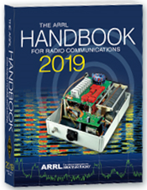Now… It’s been a little while since we’ve rewarded anyone for the most hours. So, as a way to kick off our excitement about being the very first Section in the country to use ARES Connect for its monthly reports to Headquarters, I will be giving away a 2019 ARRL Softcover Handbook to the person who obtains the most hours in the month of June!

Let’s see who is dedicated enough to become the owner of a brand-new Handbook!

With this new reporting system, we can get real time information that shows how many hours, who volunteered and what did they volunteer for. There’s a ton of information that we can draw out of the system.

As of June 29th, we now have **1101** registered and growing every day in the system. What’s really interesting is as of this same date there are **8727** registered in the entire country. This means that the Ohio Section makes up over 12.61% of those registered.

We have a set of instructions on how to get registered right above the button to enter ARES Connect. I would strongly suggest that if you haven’t registered yet, that you read these instructions first.

Here’s a link to get you started... <http://arrl-ohio.org/ares_connect_directions.pdf> Please, don’t just hurry through the questions, read them carefully, if you don’t understand something, please ask me, I’m here to answer your questions.

We know that you mean well by answering that you do have the needed courses in, but I will let you know that we are verifying what you say you have with what is showing for you in our statewide database when we are completing your registration. So, how can you find out if you are already listed in our statewide database? Easy, here’s a link: <http://arrl-ohio.org/SEC/special/ICS%20Complete%20by%20County%20and%20Name.pdf>

As you can see by the numbers above, we are now at the point where we will all need to be registered in this system for our hours to count. We will no longer need to depend on our EC’s and DEC’s to remember our hours of volunteering and report those hours for us on their monthly reports. The EC and DEC monthly numbers are no longer necessary, we will maintain a monthly reporting system for EC/DEC’s, but it will only be for them to submit a narrative only for the month!

TOP ^

The time that was spent in getting your information and making sure it is up-to-date and on file with the EC, as well as transferring all of those records when a new EC takes over is no longer be needed. This system takes care of all of that automatically.

Now, it has a lot of benefit for you too... Forget a meeting time or location? Just look it up on the calendar and there you have it. If set, you can even see the location on a map! I have attended many meetings and gatherings just because it was listed on ARES Connect and I found it just browsing around. I wouldn’t have known about it if it hadn’t been on the ARES Connect Calendar!

Why is this so important? These hours are what is shown to those we go to for funding as well as for more frequencies to operate on. Yes, we have to justify why we need the money or frequencies to those in government that want “just the facts.” This system allows us to show them the facts, anytime and with great accuracy.

***This and That’s***

***My Power is Off and AEP Says I Need to Make Repairs. Why?***

*(reprinted with permission from @Home by American Electric Power)*

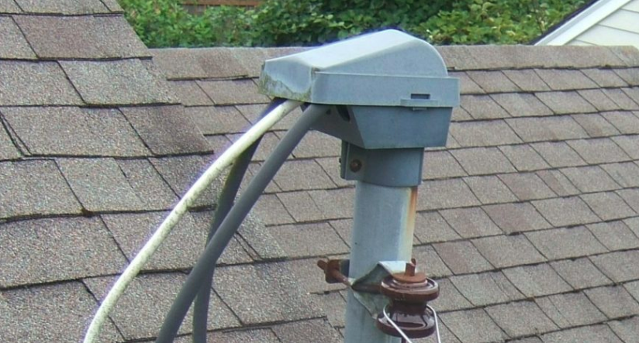A storm brought down a tree in your yard. Electrical equipment on your property was badly damaged. AEP Ohio crews have fixed the power lines and installed a new utility pole … but you’re told *you’ll*need to make additional repairs before power can be restored.

So, what gives?!

This situation sometimes occurs because AEP Ohio is responsible only for the installation and maintenance of the service line and the electric meter. Homeowners are responsible for the other electrical equipment, which includes the house knob, weatherhead, service conductors/riser pipe and meter box.

We don’t expect customers to know what these items are; in fact, you’ll want a licensed electrician to make repairs.  For customers who may not have an existing relationship with a qualified electrician and don’t know where to go for help, AEP Ohio partners with HomeServe (at no financial benefit to our company) to make this process simple. It’s easy: Call HomeServe at (833) 642-5914 to schedule an appointment with a qualified contractor in your area.  After the repairs are complete and inspections have been approved, call us at (800) 672-2231 to let us know you’re ready to have power restored.

We recently designed some new door-hangers that clearly illustrate this information. AEP Ohio field employees can pass them out to impacted customers following a storm, so we are able to get their power back as quickly and hassle-free as possible.

TOP ^

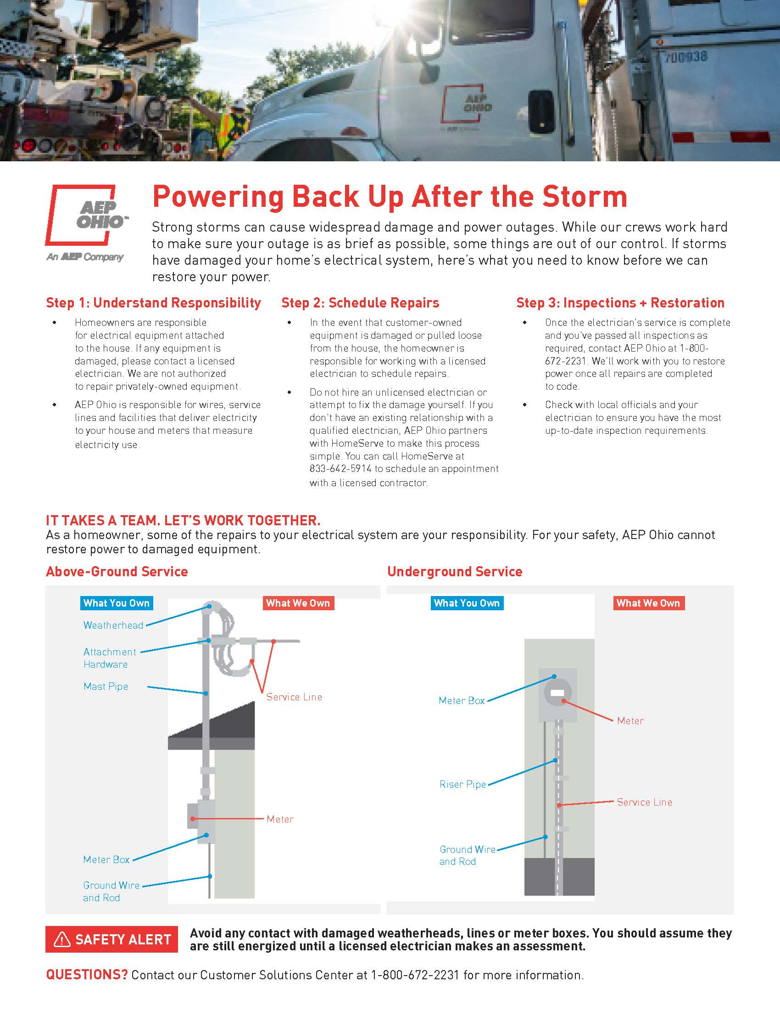

#########

TOP ^

***New General Class Element 3 Exams will take effect for exam sessions beginning Monday July 1, 2019.***

The newly revised pool, released in January 2019 (updated and re-released March 2019) by the Question Pool Committee (QPC) of the National Conference of Volunteer Examiner Coordinators (NCVEC), must be in use starting July 1. There is one graphic required for this pool.

With the General class exam questions changing July 1, new test designs must be used effective that day. Previous ARRL VEC supplied General class exam booklet versions (2015 series) and computer-generated General class exams created from the 2015 question pool are only valid until midnight June 30, 2019. At that time VE Team leaders should destroy or throw away the old versions of the General exams (do not return them to VEC). To avoid a mix-up at the session, do not save old exam versions!

#########

***Changes Made To TAC 310 – 312 On DMR***

*(from Andrew Crowl, K4AWC – facebook post)*

As of June 29th, the North American admins of the Brandmeister network have taken the ability away from users to make TAC 310,311,312 a static talk group on a repeater or hotspot. Hotspots that have one of these talk groups set as static will have it manually removed at some point in the next few days.

The TAC talk groups were never meant to be a “calling” talk group. That is, they were designed to be used to offload a QSO from a higher profile talk group. Due to the amount of traffic being initiated on these TAC talk groups, they have degraded to a level of being unfunctional. Some repeater owners have even blocked their use on their networks or repeaters. This is counter to what their original designation was.

For hotspot users, remember the Parrot talk group is your friend. As you make adjustments to your device settings, tune there so you are not keying up many repeaters for a simple audio check on a high-profile talk group. You should get a pretty good idea how your audio is sounding, or that you are able to key up a talk group with a minimal BER (bit error rate).

My guess is over time most North American activity will be pushed back to talk group 3100.

DMR is still evolving as a mode for our hobby. There are many repeater owners, network admins, Cbridge owners, and others that volunteer their time and money to ensure a pleasant user experience for us all. This change is simply an evolution to ensuring this goal happens for everyone.

***Welcome New Subscribers***

Edward, K8IV; Rodney, KB8WV; Christopher, KE8MBT; John, N8NYC; Jeremy, KE8BDI; Mike (no call); Ryan, KD8DNS

#########

TOP

***Final.. Final..***

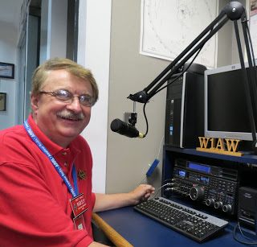

Hey Gang...

Wow.. This was the hottest week so far this year!! At least it is drying out the swampy mess I call a yard. On that subject, since my yard is finally getting dry enough to support the weight of a bucket truck, the tree trimmers are coming (keep your fingers crossed) this week! That means my folded dipole had to come down temporarily until they get things all trimmed up. Then I’m going to seriously look at whether the folded dipole that’s 16 years old will go up or maybe something else will replace it. Anyway, it does mean that I’m off the HF bands for a bit.

Sliding down the band a bit… Have you taken the time to get signed up in ARES Connect yet? Please, don’t let the name ARES fool you, this new system is for everyone and not just for ARES. So, if you haven’t already signed up, now is the time. I know that this must sound like a broken record to most of you, but you won’t believe how many folks I met over the week that still tell me they haven’t heard of ARES Connect yet.

I also hear from those same folks… “why do I need all this training?” Well, I gotta’ tell you, after traveling around a county or two and seeing all the destruction and standing water, it should be real clear to everyone that there we are just a rainy night away from finding ourselves washed down to the Ohio River!!

Here in the Ohio Section we only require our Level 2 volunteers to have the 4 basic courses, IS 100, 200, 700 & 800. For our Level 3 volunteers we do require the additional ICS 300 / 400, or the equivalent professional series courses IS 120, 230, 240, 241, 242, 244 & 288. These equivalent courses are all on-line classes just like your basic 4 NIMS courses are and being offered as an alternative way for you to get credit for taking the professional series courses in the event you just cannot get scheduled into an ICS 300/400 class. By the way, if you decide to take these 7 on-line courses and complete them all, you will want to take just one more class **IS-235.** By completing this additional course, you will get a really great looking certificate from FEMA recognizing that you have completed the entire Professional Series courses. I do hope that this clears up the confusion that has been going around lately. As we have stated on the website and in this newsletter many times “We don’t want anyone left behind.”

Yes, the Ohio Section is extremely lucky to have the relationships that we do with Law Enforcement, EMA, fire and other government agencies, that’s why we’ve partnered with EMAO, OP3 and Ohio VOAD to show our support for them and our Ohio citizens.

Whelp… That’s going to do it for this time around. Stay safe, enjoy the sunshine while we have it, and most of all… have FUN!!

73,

***Scott, N8SY***

TOP

***Independence Day***

Independence Day is a day of family celebrations with picnics and barbecues, showing a great deal of emphasis on the American tradition of political freedom. Activities associated with the day include watermelon or hotdog eating competitions and sporting events, such as baseball games, three-legged races, swimming activities and tug-of-war games.

Many people display the American flag outside their homes or buildings. Many communities arrange fireworks that are often accompanied by patriotic music.

The most impressive fireworks are shown on television. Some employees use one or more of their vacation days to create a long weekend so that they can escape the heat at their favorite beach or vacation spot.

Independence Day is a patriotic holiday for celebrating the positive aspects of the United States. Many politicians appear at public events to show their support for the history, heritage and people of their country. Above all, people in the United States express and give thanks for the freedom and liberties fought by the first generation of many of today's Americans. The Statue of Liberty is a national monument that is associated with Independence Day.

**About Independence Day**

In 1775, people in New England began fighting the British for their independence. On July 2, 1776, the Congress secretly voted for independence from Great Britain. Two days later, on July 4, 1776, the final wording of the Declaration of Independence was approved, and the document was published. The first public reading of the Declaration of Independence was on July 8, 1776. Delegates began to sign the Declaration of Independence on August 2, 1776. In 1870, Independence Day was made an unpaid holiday for federal employees. In 1941, it became a paid holiday for them.

The first description of how Independence Day would be celebrated was in a letter from John Adams to his wife Abigail on July 3, 1776. He described "pomp and parade, with shows, games, sports, guns, bells, bonfires, and illuminations" throughout the United States. However, the term "Independence Day" was not used until 1791.

Interestingly, Thomas Jefferson and John Adams, both signers of the Declaration of Independence and presidents of the United States, died on July 4, 1826 - exactly 50 years after the adoption of the declaration. It is also important to note that Native Americans lived in the country and each tribe had its own nation and government prior to the European settlers.

TOP

***Back Issues of the PostScript and Ohio Section Journal (OSJ)***

Hey, did you know that PostScript and Ohio Section Journal (OSJ) are archived on the website? You can go back and look at any edition simply by clicking:

<http://arrl-ohio.org/news/index.html>

***Chit – Chat, and All That!***

Do you know someone that’s not getting these Newsletters? Please, forward a copy of this Newsletter over to them and have them “[Opt-In](http://arrl-ohio.org/forwarder/forwarding.html)” to start receiving them. Heck, just have them send me an email [n8sy@n8sy.com](mailto:n8sy@n8sy.com) and I’ll get them added to the Ohio Section Emailing list.

We now have many thousands of readers receiving these newsletters weekly. Quite impressive, I’d say! I urge all of you to make sure that everyone, regardless of whether they are a League member or not, get signed up to receive these weekly Newsletters.

You can always “[Opt-Out](http://arrl-ohio.org/forwarder/forwarding.html)” at any time if you feel this is not what you were expecting. It’s fun and very informative. All of your favorite past newsletters are now archived too.

You can go back at any time and read them. Just go to: <http://arrl-ohio.org/news/>

Got questions, concerns or would just like to sit and chat awhile? Heck, I’ll even buy the coffee!! Give me a call at (419) 512-4445 or email me at: [n8sy@n8sy.com](mailto:n8sy@n8sy.com)

The pictures on the front page are from various newsletters, Facebook posts and/or were sent directly to me in recent weeks. Take a good look at them, you just might be in one of the pictures! “SMILE… you’re on the Ohio Section News!!”

TOP ^

*PostScript is produced as a weekly newsletter. I want to thank everyone that has contributed articles and ideas to make this an even better news source. I sincerely hope that you have enjoyed this edition and will encourage your friends to join with you in receiving the latest news and information about the Ohio Section, and news and events happening around the world!*