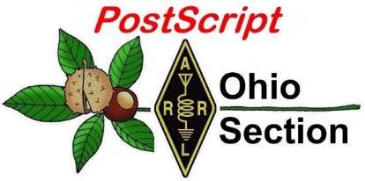
June 10th
Edition

National News The Handbook Give Away

Club Corner Hamfests

DX This Week One Question Questionnaire

VE Testing ARES Connect

Final.. Final..

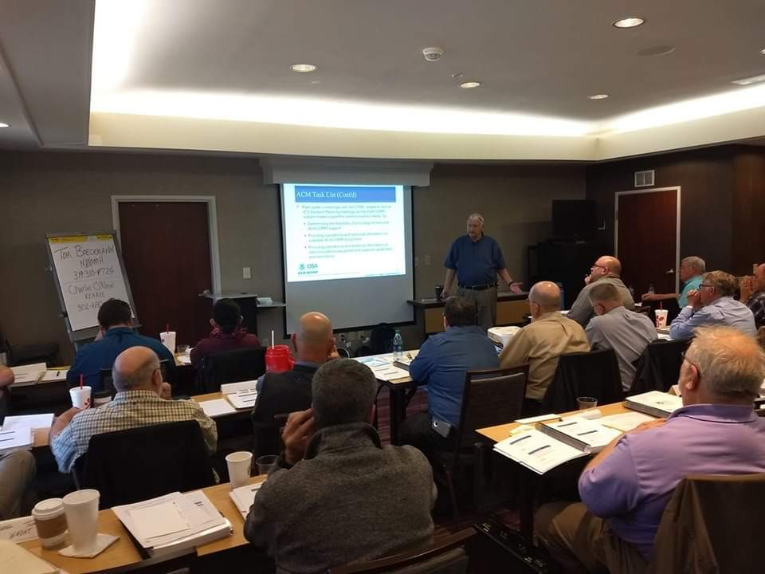
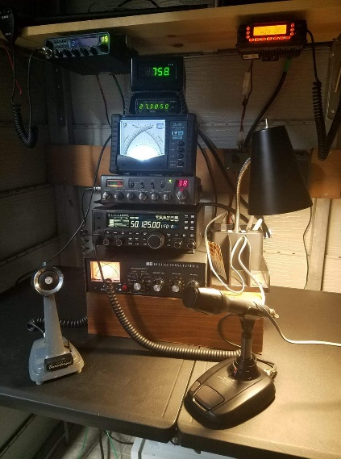
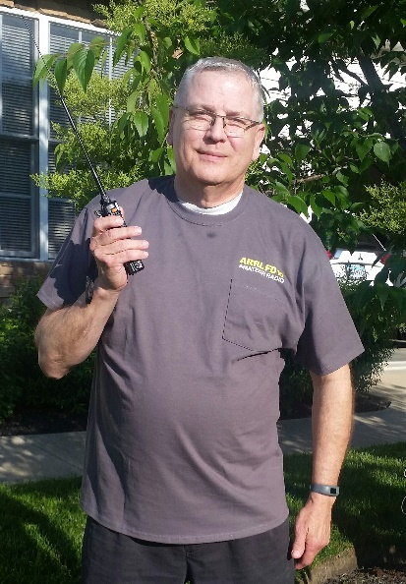
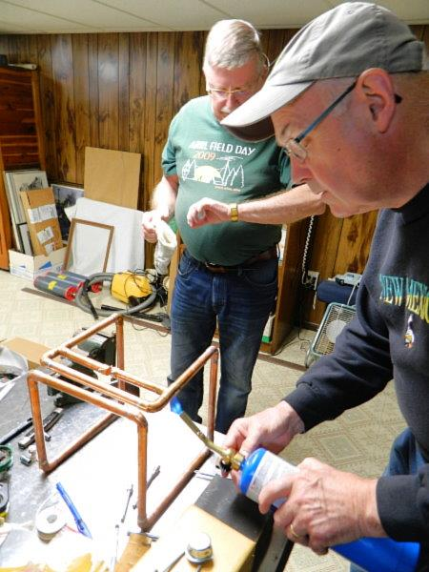
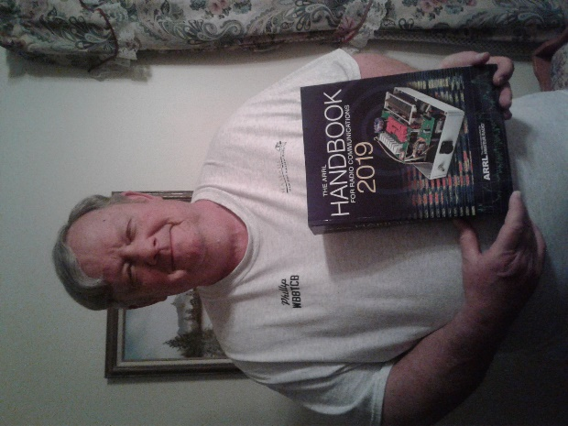

National News
(from arrl and other sources)

New Beta Version of FT4 Now Available, Mock Contest Session Just Ahead

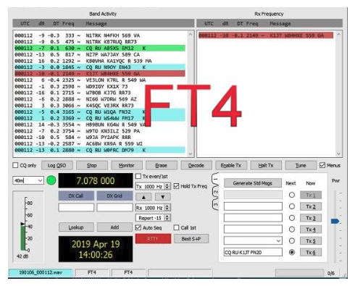
[UPDATED 2019-06-03 @ 1915 UTC] The WSJT-X Development Group has released yet another new beta version of the FT4 protocol now available for testing in WSJT-X 2.1.0-rc7. The FT4 included in this “release candidate 7” version is notcompatible with any previous release. Over the weekend, the developers had made WSJT-X 2.1.0-rc6 available for downloading and testing but “because of a serious bug,” pulled that version not long afterward.

“We are aware of a serious issue with this [-rc6] release,” Bill Selwood, G4WJS, of the WSJT-X Development Group, said on June 2. “Many users are experiencing a crash on attempting to start this version. The issue is not happening for everyone, but it appears to be present on all supported platforms.” Some users of release candidate 6 expressed satisfaction with the new version.

The developers advised FT4 enthusiasts to stop using WSJT-X 2.1.0-rc5 and switch to the latest -rc7 beta version to take advantage of other program corrections and enhancements.

A short mock contest session to wring out the contesting features of FT4 is scheduled for June 4, 1900 UTC, through June 5, 0100 UTC.

“Get on the air whenever you can during this mock contest session, using dial frequency 7.090 or 14.080 MHz, as appropriate to the time of day,” the announcement advised. “As in previous tests, be sure to check “RTTY Roundup messages” on the Settings | Advanced tab.”

Changes, improvements, and bug fixes that have been made since WSJT-X 2.1.0-rc5 include:
- T/R sequence length increased from 6.0 to 7.5 seconds
- Symbol rate decreased from 23.4375 to 20.8333 baud
- Signal bandwidth decreased from 90 Hz to 80 Hz
- Allowable time offsets –1.0 < DT < +1.0 second
- TX 4 message with “RRR” now allowed, except in contest messages
- Audio frequency now sent to PSK Reporter
- Third decoding pass added
- Improved sensitivity: Threshold S/N is now –17.5 dB
- Improved S/N calculation
- In FT4 mode, Shift + F11/F12 moves transmit frequency plus or minus 100 Hz

Release candidate WSJT-X 2.1.0-rc7 will be available for beta-testing through July 21, 2019. It will not be usable during the ARRL June VHF Contest or during ARRL Field Day, and it will permanently cease to function after July 21, 2019. “If all goes according to plan, by that time we will have made a General Availability release of WSJT-X 2.1.0,” the announcement said.

TOP ^
Known Issues in WSJT-X 2.1.0-rc7
The developers note that they are aware of the following bugs or anomalies in release candidate 7. The 64-bit executable for Windows resets the audio input gain to 100% on program startup, when the input audio device is changed, and when switching to a new configuration. The recommended temporary workaround, if necessary, is to reset the Windows audio input to the desired level.

Download WSJT-X 2.1.0-rc7
Downloadable installation packages for WSJT-X 2.1.0-rc7 under Windows, Linux, and macOS are available on the WSJT-X web page.

#########

Emergency Messaging Demonstration for Red Cross, FEMA is a Success

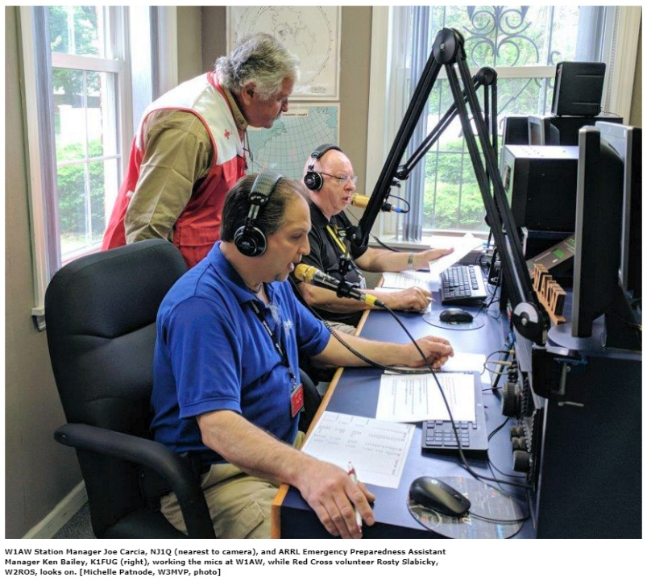
With Red Cross and Federal Emergency Management Agency (FEMA) officials monitoring, dozens of radio amateurs along the US east coast on May 23 demonstrated Amateur Radio’s ability to deliver messages without commercial power, infrastructure, or permanently established stations. The event took place in coordination with ARRL. The demonstration was a mock response to a simulated disaster scenario — a major hurricane with mass casualties. During the event, radio amateurs at portable stations from New England to the Carolinas delivered message traffic to W1AW, which coordinated and delivered the information to officials attending a joint Red Cross-FEMA meeting in Baltimore.

“About a dozen stations participated in the demonstration, including operators in Maine, Rhode Island, Massachusetts, New York, northern New Jersey, western Pennsylvania, Delaware, and South Carolina,” ARRL Communications Manager Dave Isgur, N1RSN, said. “Red Cross officials were on-site at W1AW and at the receiving station in Baltimore. At both sites, they indicated that were impressed with Amateur Radio’s ability to deliver messages digitally so that could be displayed on a computer screen and in a format that matched the format for messages that the Red Cross uses.” Isgur said ABC, CBS, and Fox TV affiliates sent reporting teams to W1AW.

A few stations, including W1AW and stations in Baltimore, generated local media coverage of their participation, much of it tied into the notion of “Amateur Radio operators and the partner agencies they serve are getting ready for 2018 Hurricane season.” Hurricane Season begins on June 1 and continues through November 30.

W1AW Station Manager Joe Carcia, NJ1Q, said the exercise went well overall. “Conditions were a bit tepid at best, but we were able to establish voice contact first, and then proceed with the digital traffic (MT63-1KS) during the roll call,” Carcia said. “Digital signals were good. I needed just one retransmit. We used fldigi with flmsg. This made life so much easier.”

TOP ^

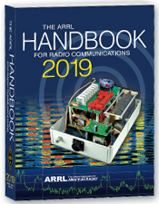
The Handbook Give Away

Hey Gang,

The “Handbook Giveaway” drawing will soon be returning for another big “Give Away”

Many of you ask me just how do I know when the drawing is on? Well, that’s easy all you need to do is check in on the Ohio Section Website on a regular basis and watch for the big RED Arrow that will appear on the left side of the page. This is the sign that the drawing is on and you need to get registered. So, keep a sharp eye out on the website and check in often! http://arrl-ohio.org

What’s the catch? I want to get everyone checking in to the Ohio Section website as often as possible, and in order to register each month, you have to visit the website often! There’s nothing else to it. I pay all expenses, and from time to time, I Give Away more than just a Handbook. And, you’ll never know just what months will be those special times that I will have more than just a Handbook to Give Away!!

Club Corner

This is YOUR cornner of the newsletter. Send me what your club is doing and I’ll make sure that it gets in. Got a special event or club project that you want everyone to know about? Send it to me!. Need help with a project? Send it to me.

Let me know what you club is up to. Are you going to have a special guest at your meeting or are you having a special anniversary? Just sent it to:
n8sy@n8sy.com

#########

The Toledo Air Show is July 13 & 14 and we did such a great job at the last Air Show the powers that be have requested additional help from us this time around. We are still in the planning phase and do not have final numbers for needed operators, but I wouldn’t be surprised to see a number around 50 or more each day.

Our coverage includes some of the following:
Entrances; First Aid Tents; Mobile Hospital; Air Boss; Incident Command; Parking Lots; Transportation Buses;
Exits and more.

If you can help - Please contact either Rick K8RKS at K8RKS@ARRL.net or Tim KD8IZU at boxcar@toast.net In the Subject Line of your email put Toledo Air Show.

#########

TOP ^
Volunteers Needed
For Saturday, June 15th the Muddy Mini Half Marathon will be held. We need operators help with this event. Start time is 7:30 AM and the cut off for finishing is at 11:30 AM.

The race starts in downtown Maumee and ends in Mud Hens Stadium. If you’d like to volunteer or need more information, please get in touch with me at k8rks@arrl.net or 419-471-0573. Thanks!

#########

ATCO NET Participants

We are changing the normal Tuesday 147.48 net from 8PM each Tuesday to 9PM for the duration of the summer. We will resume the 8PM time after Labor Day in September. Hope to hear and see you each Tuesday for the duration of the summer in order that you can get the lawn cut while there is enough sunlight.

#########

Alliance Club Holding A Technician License Class

Our class for technician starts 06 July in the Cafeteria conference room at the Alliance Community Hospital.

Twelve weeks free, 5 PM to 7 PM each week. Requirements, a flash drive or SD card with about 1 Gigabyte free space and a commitment to do the studying required.

For more information contact Frank Sanor at wa8whp@gmail.com

#########

Need Help Desperately for Operation Vigilant Guard

It's been a bear trying to get the mission requirements locked down for Operation Vigilant Guard. At this point in time we could need up to eight ARES volunteers for the Wednesday, August 07 operation.

Please, if you have some time to volunteer to help me make this mission a great success for Amateur Radio, contact Rick Kruis k8cav.coms@gmail.com

#########

Geauga Amateur Radio Association to Hold Technician Classes

Technician classes start this coming Friday, June 14 at 6:30PM at the EOC. It's a 6 week course every Friday. Contact Matt Welch W8DEC at w8dec2@gmail.com for information.

TOP ^

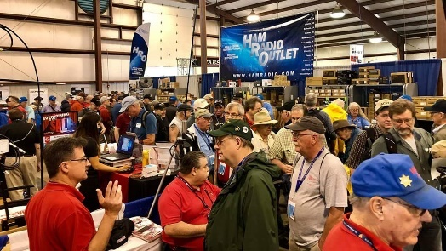
Upcoming Hamfests

06/15/2019 | Milford Hamfest  Location: Owensville, OH  Sponsor: Milford Amateur Radio Club  Website: http://www.w8mrc.com | 06/15/2019 | W8DXCC DX Convention  Location: Owensville, OH  Sponsor: SouthWest Ohio DX Association  Website: http://www.w8dxcc.com
07/07/2019 | 20/9 Radio Club Hamfest Location: Austintown, OH  Sponsor: 20/9 Radio Club, Inc.  Website: http://20over9.org | 07/07/2019 | Ohio Link Swap Meet  Location: 1801 Gateway Circle, Grove City  Sponsor: Ohio Link Network Group  Website: www.olnradio.digital
07/20/2019 | NOARSFEST  Location: Elyria, OH  Sponsor: Northern Ohio Amateur Radio Society  Website: http://noars.net/hamfests/noarsfest | 07/21/2018 | Van Wert Hamfest  Location: Van Wert, OH  Sponsor: Van Wert Amateur Radio Club  Website: http://w8fy.org
07/28/2019 | Portage Hamfair '19  Location: Ravenna, OH  Sponsor: Portage Amateur Radio Club  Website: http://hamfair.com | 08/03/2019 | Columbus, Ohio Hamfest  Location: Grove City, OH  Sponsor: Voice of Aladdin Amateur Radio Club  Website: http://www.columbushamfest.com

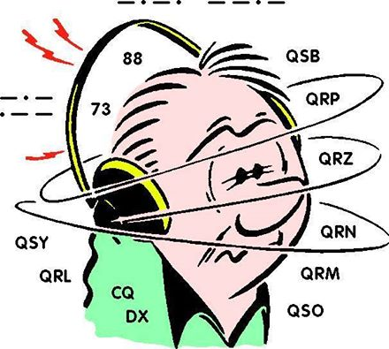
DX This Week
(from Bill, AJ8B)

Bill AJ8B (aj8b@arrl.net, @AJ8B, www.aj8b.com or www.swodxa.org )
CWOPs Member #1567

Last week, Uncle Frank and I were talking on 15 meters during a strange Waynesville to Grand Rapids opening that lasted for about 20 minutes. However, it was long enough for Uncle Frank to try out his new Kent paddle and for me to give him an update on W8DXCC. If you have not heard of the inaugural W8DXCC convention, it is occurring as the second part of the Milford Amateur Radio Clubs Hamfest on June 15th. The idea is to have a forum where you can come and network with like minded hams interested in working DX and to hear from excellent speakers.

TOP ^
Those speakers are listed on the www.w8dxcc.com website as well as other details about the day. The keynote speaker is K3LR, Tim Duffy. One of the best write ups on Tim can be found at http://forums.qrz.com/index.php?threads/amateur-radio-superstation-k3lr.445092/ . Tim is a great guy and really supports the ham radio community; asking little in return.

Aside from the excellent presentations that we have queued up on “FT8 and FT4” by K8CR, Chuck & W8MRL, Rob and “100 W and a Wire” by SWODXA President Tom, NR8Z, & MARC President Dave, K8DV; K9LA, Carl Luetzelschwab, will be giving us an update on Solar Cycles 24 and 25. Carl is widely considered THE expert on propagation and all things solar and I am thrilled to have him presenting to us. You can learn more about Carl at http://k9la.us/ K4ZLE, Jay, will be the emcee for the afternoon. Jay is a veteran of at least 9 Major DXPeditions including FT5ZM, VP8SGI, and VP8STI. He has also been the emcee at the DXDinner © .

One interesting comment that Uncle Frank made was these two clubs were working so closely together to put on an event like the MARC Hamfest and the SWODXA W8DXCC convention. In his experience on the east coast, Nebraska area, and now in the Midwest, clubs are typically very territorial and rarely work together so closely. I think it is a tribute to both Dave and Tom, their desire to promote ham radio, and their spirit as hams, that this event could even occur. How successful it will be is up to YOU! As of the time I write this, some tickets are still available via the website and a few have been held back for the day of the convention. You simply can’t beat the price! ($10 for the entire day!)

My last comment on the MARC Hamfest and SWODXA W8DXCC convention is to send along a HUGE thanks to Yaesu. Last October, we initially posed the idea of our own DX Convention and asked Yaesu if they would support us. They immediately said YES. We did not know until last week to what extent they wanted to support us. We were informed that they would be donating a Yaesu FTDX-3000 HF Rig to be given away! Thanks to Yaesu to their continuing support of activities like the DX Dinner and the W8DXCC convention.
To get into the mood for learning about DX and listening to DXers, I thought I would reprint an article submitted by my friend, 9J2BO, Brian Otter, in Zambia. I hope you find it as interesting as I did. Please let me know if these interviews are of interest to you and I will pass along more in the future. This was reprinted with the permission of SWODXA. It originally appeared in the club newsletter, The Exchange Nov of 2017.

+ --------------------------------------------------------------------------------------------------------------------+

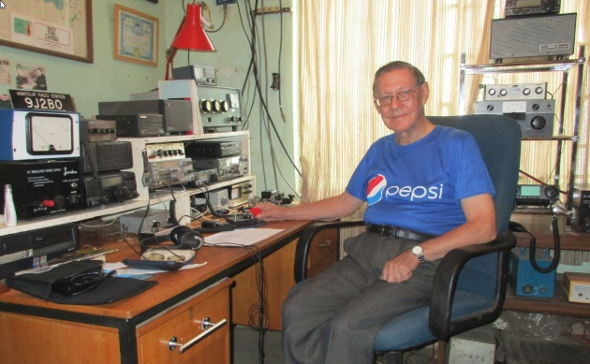
43 Years as 9J2BO
By Brian Otter (botter9j2bo@gmail.com)
(I first talked to Brian in 1999. It was my first DX “Ragchew” and I enjoyed it so much that I even took notes! Since then, I have worked Brian again in 2006 and then in 2016, this time on CW. Once again Brian proved to be an excellent conversationalist, professional operator and a pleasure to talk to. Brian was eager to provide us with a perspective from “the other side”)

Although I arrived in Zambia on the 9th of September 1966 I did not obtain my amateur radio license and the call sign 9J2BO until 1973 the reason being that although I had passed the Radio Amateurs Examination in 1962 as a 17 year old school boy I had not passed the then obligatory 12 words per minute Morse test. My first two attempts which were taken at the Central Telegraph office in Lusaka were met with failure.

TOP ^
Sweat poured off me as I attempted to copy the old land line telegraphers sending amongst the clatter of the teleprinters and the buzz of conversation engendered by the presence of this “muzungu” (white man) sitting at a key in the open office.

At that time there were 40 to 50 radio amateurs including a few who had been licensed before Independence and had held VQ2 call signs (Northern Rhodesia). I believe there was only one indigenous Zambian who had a license. The rest were mostly expatriates and the majority lived and worked on the Copperbelt but there was a growing number in Lusaka working on government contracts.

I had left Teacher Training College and accepted a position as a Secondary School teacher. I was employed by the Zambian Government but at the same time was under a British Overseas Aid Scheme which supplemented my salary. I had a free passage to England after 3 years’ service. It was on my second leave that I finally sat and passed the Morse test at Humber Radio the nearest maritime radio station to my hometown of Lincoln. This enabled me to get my full amateur radio license with the call G4CGC. As soon as I returned to Zambia I applied for my Zambian license. This was only just in time. The then Postmaster General had decided that there were “enough” amateur radio operators in Zambia and my license was one of the last, if not the last, license to be issued for a long, long time. The situation was not helped by the undeclared state of war that existed between Zambia and the racialist regimes in Rhodesia and South Africa.

The school where I taught was about 50Km East of Lusaka. It was in a rural area but had mains electricity and the noise level was low. I came on the air with a borrowed Heath DX40 and a World War 2 surplus communications receiver and a G5RV antenna and had a ball! There was several Amateurs in Lusaka and we would get together at each other’s homes once a month or so.

My QTH outside of Lusaka made a nice afternoon out from Lusaka for the gang and their wives and children. Life was good, food was cheap and plentiful, and we enjoyed a high standard of living. I had no SSB transceiver and was stuck on CW. This was the beginning of my passion for the mode.
In the following years I was transferred to several schools in Zambia where luckily there was always mains electricity and I was able to operate. When we moved to a new QTH I took it upon myself to inform the local police of my presence, show them my license and let them know what I was going to do. This proved wise as I had no problems despite the situation with the countries to the south. The schools were mainly boarding schools in rather remote areas of the country. At one time I was 200km from the nearest gas station so I would keep a 40-gallon drum of petrol in the house. Life became more difficult. During the school vacations I would drive almost 1000Km to Lusaka to stock up on food and particularly meat. The butcher would fill my cool boxes with meat and freeze it. The meat would be collected and kept in a deep freezer and we would leave at 4am to get home before dark and get the meat in the freezer at home. This would have to last us for at least 3 months. If it did not last, then there was only goat and dried fish and stringy village chickens. The pupils were not so lucky. They rarely got meat and were fed mainly on beans, cabbage and tiny dried fish called “kapenta”. Water was often a problem. In one school where I served for 6 years the water came from the river in a five-kilometer open furrow. The water was supposed to be passed through filter beds of sand before being pumped into a tank for distribution. Instead the water was pumped directly from the furrow into the tank. In the rainy season the water was the color of cocoa and full of tadpoles. When one had a bath, one wondered whether you came out of the bath any cleaner than you went in! When the pump broke down then the girls (it was a girls boarding school) had to walk to the river with buckets and carry water back to the school with the buckets balanced on their heads. Pit latrines had to be dug as there was no water for the toilets. In those years I worked plenty of DX but equally important was keeping in touch with my fellow amateurs in Zambia.

TOP ^
We had a weekly net on 80m and there was always someone to talk to. My father, G3TOA, kept a weekly sched with me. I remember when the HT smoothing capacitor in my TS520 went up in smoke he was able to read my T6 note and get a replacement off to me pronto. In those days air mail took only a couple of weeks to reach me now it takes an unbelievable 3 months despite my being in the capital city.

Travel was not easy, and distances were long. On one trip to the Copperbelt I had two punctures. There was a 90km strip of road that passed through The Democratic Republic of Congo. This was known as the Pedicle Road. The second puncture stopped the vehicle and my companion set off with one wheel to get the puncture repaired at the border. Towards sunset the last vehicle stopped by me. Paramilitary police jumped out and told me I could not stop there because bandits were active. I had no alternative and lit a fire and spent the night in the car with the doors locked. In the morning one vehicle passed me going in the same direction and left me a bottle of water. It was not until 3pm that the first vehicle, a bus arrived from the other direction with my companion and the repaired tyre. Apart from the line of rail most roads were dirt and some barely passable in the rainy season.
At another girls’ boarding school where I was posted as Deputy Headmaster, boys from the nearby (5km away) boys boarding school were prone to raid the girl’s dormitories. My self and other members of staff had to drive them out of the girls’ dorms our duty being to protect the girls though I am not sure that all the girls were keen to be protected! The boys would then gather outside the school fence on the hillside behind the dormitories and throw rocks at the dormitories smashing windows and threatening the physical safety of the girls. It was then time to call in the police who would arrive armed with .303 rifles and they would illuminate the hill side with flares when the boys would hopefully run away.
Probably my most interesting QSO was when I was in touch with a Canadian Amateur. During the conversation I mentioned that my hometown was Lincoln, England. The Canadian then told me that he had spent some time in Lincoln during the 2nd World War. He said that every morning they had to line up for inspection in a park called The Arboretum. I knew it well as it was very close to where my paternal grandparents had lived and not far from where my parents lived. He mentioned that there was a small boy who would make a few pennies for himself by polishing the Canadian soldiers’ boots. He said the boy was nicknamed “Curly “and is family name was Doeman and that he had become friendly with Curly’s sister. This name immediately rang a bell with me as I recalled that my father had often mentioned a “Curly” Doeman who had been apprenticed to him as an electrician and now had his own business. I contacted my father by radio, and he got in touch with “Curly” and we put him in touch with the Canadian again.

I guess my best DX contact was soon after we were granted the 30-meter amateur band after WARC 1979. I could receive using the WWV receive only position on my TS520 TXCVR. Much later I bought a kit to modify the TS520 so that it would transmit on 30m. Meanwhile I had a single tube crystal-controlled transmitter that had been given to me by a Roman Catholic Priest who had taken up amateur radio but had had to give it up as his Bishop did not approve. It was part of a kit produced by the National Radio Institute, Washington, D.C. I obtained a 10.1 MHz crystal, changed the tap on the output coil and voila along with a dipole cut for the band I was QRV on the new band. I made a sched with Jim G6ZO. I should have paid more attention when ordering the crystal as the frequency was occupied by some commercial station. However, Jim was not to be beaten as my chirp was so bad that it took enough of my signal out from under the commercial station for him to copy my report to him. Copying his signal was of course no problem. I still have that TX but have not used it for more than 30 years. Making that contact was absolute magic never to be forgotten. The single tube a 6DQ6B beam tetrode 25 Watts input maybe 15 Watts output. The thrill was greater than working Clipperton!

TOP ^
+ --------------------------------------------------------------------------------------------------------------------+

Here is an update from Bernie, W3UR, of the DailyDX and the WeeklyDX, the best source for DX information. (http://www.dailydx.com/ ) Bernie has this to report:
+ --------------------------------------------------------------------------------------------------------------------+

6O - Somalia - EP3CQ, Ali, plans to be back operating 6O1OO from mid-June to the end of July, but not July 1-10. He "will be mainly active via FT8 on 6 Meters". Also, on May 27th he mailed out QSLs received as of May 27th. QSL cards should be mailed to: Ali Solhjoo C/O Dr. de Vivanco, Schnackenburgstr. 3 Berlin 12159 Germany

OJ0 – Market Reef - Finnish ops OH4EA, OH6FSG, OH6KV, OH6LSR, OH6NJ and OH6OK are heading here to operate as OJ0AW from June 8-15. They will be mostly on the HF bands with some VHF. Listen for them on SSB, CW, FT8 and other digital modes. QSL via OH6AD and LoTW.

V6 – Micronesia - JA1FMN has announced his plans to operate V63PSK from Weno Island, State of Chuuk (OC-011) from June 19-22. He will be operating holiday style on 3.5 through 50 MHz on FT8, FT4 and JT65. QSL direct to JA1FMN or using Club Log OQRS.

XT - Burkina Faso - IV3FSG, Elvira, is again on the air as XT2SE from the capital city, Ouagadougou, starting two days ago and going to June 13. QSL via IK3GES or use Club Log OQRS. XW - Laos XW4XR will be June 26 to July 7, operating on 40-6M including 60, CW, FT8 and RTTY. Bruce says regardless of mode he always works split. For confirmation go through LoTW or via E21EIC.

E4 – Palestine - Polish DXpeditions group member SP9FIH, Janusz, plans to be QRV as E44WE starting July 6th. He will be operating on 80, 30, 17 and 6 meters.

#########

Ohio Ham Sets New Record in 3 State Area

Gregory Drezdzon, WD9FTZ, established a new record for the Eight Area call district, during the CQ World-Wide RTTY WPX radio contest held on February 9 and 10, 2019.

The Eight Area call district encompasses Michigan, Ohio, and West Virginia.

Even when solar minimum conditions existed, Drezdzon was able to place second in the United States, third in North America and 12th in the world.

Working only the 40-meter amateur radio band, Drezdzon contacted 177 different stations using 5 watts or less of power during 16.8 hours of operation.

The objective of the contest was to contact as many amateurs and prefixes as possible during the period of operation using radio teletype.

TOP ^
According to the CQ RTTY WPX Contest website, this radio contest attracts upward of 20,000 participants annually.

The site states 3,099 logs were received in 2019. The highest number of logs received was in 2012, where 3,546 logs were submitted. This contest dates back to 1995 when 199 logs were entered.

The future date of this contest is February 8 and 9, 2020.
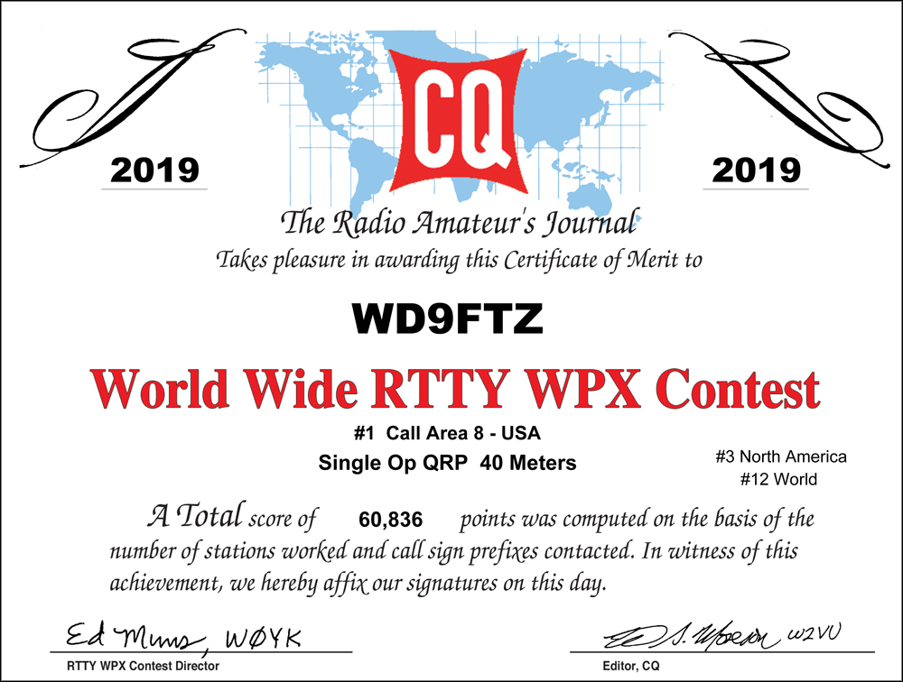

ARLD017 DX news

This week's bulletin was made possible with information provided by The Daily DX, The OPDX Bulletin, 425 DX News, DXNL, Contest Corral from QST and the ARRL Contest Calendar and WA7BNM web sites. Thanks to all.

GHANA, 9G. Matteo, IZ4YGS is QRV as 9G5GS until July 2. Activity is on 160 to 6 meters using SSB and FT8. QSL direct to home call.

AZORES, CU. Herman, HB9CRV is QRV as CU8FN from Flores Island, IOTA EU-089, until June 11. Activity is on the HF bands using FT8 and FT4. He plans to be QRV in the Portugal Day Contest operating CW while CU8AS will be active using SSB. QSL via operators'
instructions.

IRELAND, EI. Members of the Galway Radio Experimenters Club will be QRV with special event call sign EI100ABC from June 11 to 16 during the Alcock and Brown Centenary Festival to commemorate the first non-stop transatlantic flight by John Alcock and Arthur Brown. QSL via EI2II.

TOP ^
FRANCE, F. Members of the Association des Radioamateurs des Cotes d'Armor will be QRV with special call sign TM1MOON on June 8 and 9 to commemorate the first spaceflight landing humans on the moon. QSL via F4EUG.

GUADELOUPE, FG. Reiner, DL2AAZ is QRV as FG/DL2AAZ from Deshaies, Basseterre Island until June 13. Activity is on 20 and 17 meters using SSB. QSL direct to home call.

ENGLAND, G. Members of the Peterborough and District Amateur Radio Club are QRV as GB0DDR until June 9 to commemorate the 75th anniversary of D-Day. QSL direct to M5ATR.

WALES, GW. Special event station GB2ORM is QRV until June 9 to commemorate the 75th anniversary of D-Day. QSL via bureau.

JAPAN, JA. Special event station 8N7JAPAN is QRV until October 31, 2020 to commemorate the Olympic Games 2020, the Paralympics 2020, and the World Cup Games 2019. QSL via bureau.

SVALBARD, JW. Erling, LB2PG is QRV as JW/LB2PG from Bear Island, IOTA EU-027, until November 2019 while working at the weather station. Activity is in his spare time on 80 to 20 meters using SSB. QSL to home call.

MARKET REEF, OJ0. A large group of operators will be QRV as OJ0AW from June 8 to 15. Activity will be mostly on the HF bands, with some VHF activity, using CW, SSB, FT8 and other digital modes. QSL via OH6AD.

CURACAO, PJ2. Paul, VA3ZC will be QRV as PJ2/VA3ZC from June 9 to 16. Activity will be holiday style on 40, 30 and 20 meters using CW and FT8. QSL to home call.

SAO TOME AND PRINCIPE, S9. Operators EA1ACP, EA1DVY, EA5BJ, EA5EL, EA7FTR, EB7DX and S92HP are QRV as S9A from Sao Tome, IOTA AF-023, until June 18. Activity is on the HF bands using CW, SSB and FT8. QSL via EB7DX.

GREECE, SV. Operators Alex, SV8QG, Pantelis, SV8DCY, Kostas, SV8DCW, Periklis, SV8DTD and Fotis, SV8RMA are QRV as J48GEO from the Geo park on Lesvos Island, IOTA EU-049, during June. Activity is on the HF bands using SSB and various digital modes. QSL via LoTW.

BURKINA FASO, XT. Elvira, IV3FSG is QRV as XT2SE from Ouagadougou until June 13. Activity is on the HF bands. QSL via IK3GES.

VIET NAM, XV. Operators R9LAJ, R9LR, UA9KDF and UA9LDD are QRV as XV9DF from Hon Tre Island, IOTA AS-157, until June 15. Activity is on 40 to 10 meters using CW, SSB and FT8. QSL via M0OXO.

THIS WEEKEND ON THE RADIO. The ARRL June VHF Contest, NCCC RTTY Sprint, NCCC CW Sprint, HA3NS Sprint Memorial CW Contest, DRCG World Wide RTTY Contest, VK Shires Contest, Asia-Pacific SSB Sprint, SKCC Weekend CW Sprintathon, Portugal Day Contest, GACW WWSA DX CW Contest, REF DDFM 6-Meter Contest, Cookie Crumble QRP Contest and The 4 States QRP Group Second Sunday Sprint will certainly keep operators busy this upcoming weekend.

TOP ^
The RSGB 80-Meter Club Data Championship is scheduled for June 10.

The CWops Mini-CWT Test, NAQCC CW Sprint and Phone Fray are scheduled for June 12.

The Canadian National Parks on the Air, CNPOTA, operating event runs for the entire year of 2019, with special stations active from Canada's parks and historic sites.

Please see June QST, page 86, and the ARRL and WA7BNM Contest Web Sites for details.

Field Day Is Coming Up – Is Your Site Listed On The ARRL Field Day Locator?
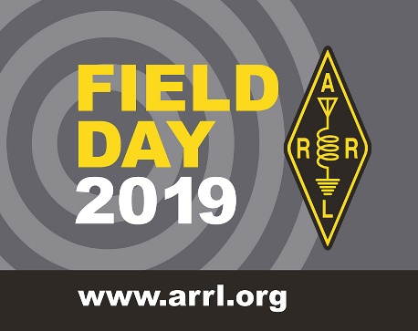
Hey Gang,

The ARRL created a “Field Day” locator a number of years ago and it works really slick for those of us who do a little traveling around to visit your site.

I know that you feel your site is really easy to find, but please keep in mind that most of us from outside of your area have no clue where the “Smith Farm” is. Yes, in years past I have been given directions like.. “Just go down route 4 until you pass the Smith Farm and it’s just 2 miles further on the right.” You want visitors to find your site easily don’t you? Of course, you do! Remember, those government officials that you’ve invited are worth some extra points for you.

So, how’s the easiest way of finding your site? Post it on the ARRL Field Day Locator, that’s how. Here’s a link to it.. Field Day Site Locator-
Note: If you are entering a new Field Day site, you must be logged into the ARRL website for your Field Day entry to be automatically posted on the Field Day Locator. If you are not logged in, your site will not be listed on the Field Day locator until it is reviewed by ARRL staff.

If you are searching for Field Day sites but encounter screen errors, be sure you have JavaScript enabled on your browser. To confirm you have JavaScript enable, go to this web site http://www.enable-javascript.com/
Now, for you newbies to Amateur Radio… What’s Field Day all about? Well, here’s the explanation.

Objective-
To work as many stations as possible on the 160, 80, 40, 20, 15 and 10-Meter HF bands, as well as all bands 50 MHz and above, and to learn to operate in abnormal situations in less than optimal conditions.

Field Day is open to all amateurs in the areas covered by the ARRL/RAC Field Organizations and countries within IARU Region 2. DX stations residing in other regions may be contacted for credit but are not eligible to submit entries.

Need a flyer to explain Field Day to the general public? Here’s the best one "What Is Field Day" (Printable PDF Flier)

TOP ^

Special Events

06/15/2019 | W8DXCC DX Convention
Jun 15-Jun 16, 0000Z-2359Z, K8S – K8W – K8H – K8O, Owensville, OH. SouthWest OH DX Association. 14.245 14.074 7.245 3.535. Certificate & QSL. AJ8B - Bill, 8275 Cierra Way, Waynesville, OH 45068. This is the inaugural year for this DX Convention. We are using these call signs: K8S, K8W, K8O, K8H. A QSL for each and/or certificate for working all four. www.w8dxcc.com

06/24/2019 | Simon Kenton Council, Delaware District, Cub Scout Day Camp
Jun 24-Jun 28, 1330Z-1700Z, K2BSA/8, Lewis Center, OH. Delaware Amateur Radio Association K8ES. 14.290 7.190. QSL. Ed Jones, 2965 Seaway Ct, Lewis Center, OH 43035. We'll be operating each day from 13:30-19:30 from Camp Lazarus in Ohio. We'll have hundreds of scouts on the air over the course of the week.

07/08/2019 | 50th Anniversary of First Moon Landing
Jul 8-Jul 24, 0000Z-2259Z, N8A, West Chester, OH. Midwest VHF/UHF Society. 10368.100. Certificate. Tom Holmes, N8ZM, 1055 Wilderness Bluff, Tipp City, OH 45371-9221. Plan to work 10 GHz EME when moon at best position for good DX. Contact for schedules and exact frequency. n8zm@mvus.org

07/14/2019 | 50 Years - First Man on the Moon
Jul 14-Jul 28, 1700Z-2000Z, N1A, Milford, OH. Milford Amateur Radio Club. SSB: 28.350 14.260 7.240 3.840; CW: 14.045, 7.045, 3.545; FT8 standard frequencies. QSL. Milford Amateur Radio Club, P.O. Box 100, Milford, OH 45150-0100. Email qsl@w8mrc.com for QSL requests. www.w8mrc.com

07/20/2019 | Honoring the 50th Anniversary of the Apollo 11 Moon Landing
Jul 20, 1400Z-2000Z, K8QYL, Wapakoneta, OH. Reservoir Amateur Radio Association. 14.250 7.250. QSL. Rich Spencer, W8GZ, 05925 Vogel Rd., Saint Marys, OH 45885. From the Neil Armstrong Air and Space Museum

07/22/2019 | Seneca County Fair
Jul 22-Jul 29, 1600Z-0200Z, W8ID, Tiffin, OH. Seneca Radio Club. 7.225 3.895. QSL. Seneca Radio Club W8ID, P.O. Box 67, Tiffin, OH 44883. W8ID will be celebrating 177 years of the Seneca County Fair! Join us for the cotton candy! Join us for all the fun! We can’t wait! www.w8id.org

08/01/2019 | W8LKY Carnation Festival Special Event
Aug 1-Aug 11, 0000Z-2359Z, W8LKY, Alliance, OH. Alliance Amateur Radio Club. 14.240 14.045 7.240 7.045. Certificate & QSL. Alliance Amateur Radio Club, P.O. Box 3344, Alliance, OH 44601. The Alliance ARC(W8LKY) will be on the air at various times throughout our Carnation festival festivities. We'll be on the air from various locations in the Carnation city. We may pop up on the bands at any time. Check the spotting networks, and our web page for upcoming activations. www.w8lky.org

08/15/2019 | D-Day Conneaut
Aug 15-Aug 18, 1600Z-0400Z, W8D, Conneaut, OH. Conneaut Amateur Radio Club. 14.285 7.190 3.996 3.885. QSL. Garret Scott W8D, 10236 Birch Hill Ln., Knoxville, TN 37932. D-Day Conneaut recognizes the 75th anniversary of the World War II Allied D-Day Landings on the beaches of France in 1944. Event will include the country's largest reenactment of the D-Day landings with more than 1,800 WWII reenactors from around the world participating. Radio operations will include vintage WWII equipment.https://www.facebook.com/W8BHZ

TOP ^

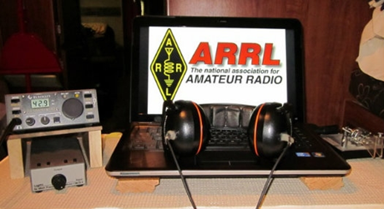
ARRL Contest Corner

An expanded, downloadable version of QST's Contest Corral is available as a PDF. Check the sponsor's Web site for information on operating time restrictions and other instructions.

Does Ham Radio Offer Anything Anymore?
(Craig Jungers, K7EXJ / Submitted by Greg, WD9FTZ)

In this age of Internet, smartphones, tablets, and instant gratification is there still a place for something you have to actually learn? Does amateur radio offer anything to the modern young person that they cannot get from another, easier, less complicated hobby?

Many hams my age formed careers out of their early interest in ham radio. I, myself, found adventure as well as career.

Consider these points.

1. There is a LOT of activity in experimenting with ham radio, electronics and computers and it's reflected on Facebook and in Podcasts. The "Ham Radio Workbench" podcast (https://hamradioworkbench.com) is a bi-weekly deep-dive into technical subjects presented in an easy-to-listen-to manner. They're also on FB and Twitter. This is not to be missed. Jeremy and George are both interested in every facet of ham radio and they - and their guests - spend 2 hours every two weeks explaining the details of all of them. If you’re interested in technology and experimenting, the Workbench podcast has something for you.

2. Digital voice radio combines radios and the Internet to allow hams to talk over thousands of miles using only a hand held transceiver. DMR is one easy and cheap way to get into digital voice radio with only a Technician Class license. The fastest growing segment of digital voice is "DMR" with hand held radios that cost less than US$100 and the ability to use local DMR repeaters (or your own "hotspot") to chat with like-minded hams the world over. DMR is best explained in this two-part podcast (you can listen on your computer or smart phone): https://www.hamradioworkbench.com/podcast/archives/03-2018

3. Digital voice is not limited to local repeaters. With MMDVM "hotspots" going for $50 on eBay and the free download of "Pi- Star" a Raspberry Pi micro-computer ($35) along with an Internet connection can let a Technician Class ham talk all over the world. You have to learn a little but that's half the fun and there is a lot of help out there. A DMR handie-talkie for under $100 means that for less than $200 you get entry into the fastest-growing world-wide ham radio networks available.

TOP ^
But wait, there's more!!!

4. If you have a Technician license and do not understand HF operations and see no reason to upgrade to expensive gear, so consider this -- Cheap operations on HF is a $65 payment away if you use a BitX40 (http://www.hfsignals.com/). This is a 40M transceiver with VFO and about 5W output. It is a "kit" in the easiest possible way... the transceiver is on a circuit board and complete. All you have to do is wire up 12vdc power, a speaker, a microphone, and an antenna and you are on HF. And it will do FT8!

5. The BitX40 is also a pathway to the "maker" group of hams. Facebook, Yahoo and other forums are populated with talented amateurs who have modified their BitX40 into amazing transceivers with 3d-printed cases, CW capability, increased power, all bands... and more. Cheap entry into technical amateur radio on HF. Listen to this Workbench podcast for more: https://www.hamradioworkbench.com/podcast/archives/09-2017

6. KITS! Everything from WSPR (Google it) to antenna analyzers to transceivers to Morse code paddles is available in kit form.

7. 3D printing. With 3d printers on eBay and Amazon for under $200 there are a lot of hams who think that having a 3D printer is as important as your radio in a modern ham shack. Web sites are out there with 3D designs include cases for the BitX40 (see number, cases for your digital voice hotspot and your Raspberry Pi, balun mounts for your 40-meter dipole, and more.

8. Digital HF modes. Combine your computer with your HF SSB transceiver and you can enter the new world of digital low-power long-distance communications. Chat with hams on PSK31. Also, try RTTY (Radio Teletype). FLdigi http://www.w1hkj.com/) is a free ham radio application that will do all of this and can actually take control of many transceivers and present a visual waterfall of the activity (and what they are saying for many). Or see how far you can get with 100mw of power and WSPR (http://wsprnet.org/drupal/) or FT8 using WSJT-X (https://www.wsjtx.net/home/ft8-mode.html)

9. Portable operations in the field... any field. Or at the beach. Or on a mountain summit. See how many summits you can operate from or how many islands, or how many community parks. Amateur radio has been called a “hobby of a thousand hobbies” and activating a summit, an island or a park is just one part. With some hams it’s the excitement of getting outside, operating for a few hours and then setting up camp in a pristine (and less “noisy”) environment. With others it’s communicating with them from their home radio equipment. With at least one ham it’s the fun of having his friends Rooster and Peanut (both goats carrying part of his gear and nibbling on feed lines) come along with him (search for “WG0AT” on YouTube). Lightweight camping gear along with lightweight transceivers, antennas and batteries are important. If operating ham radio while sitting on a rock ledge with your legs dangling over a steep drop of a couple thousand feet is your idea of true adventure, then you might just enjoy SOTA operations (Summits On The Air).

10. Finally, the genesis of long distance communication by both wire and radio: Morse Code. Morse operators were highly respected and well-paid professionals for over 100 years and it's still the simplest, most efficient (in terms of equipment needed, electrical power consumed for the most data communicated) and, yes, easiest (in terms of least complex) ham radio mode there is.

The radios are cheap, small, light, and draw as little as 15mA of electricity while receiving. No computer needed, just a key (basically a make-contact, break-contact switch), head phones, a transceiver (costing anywhere from $7 to $500), an antenna (a length of wire, basically) and your own skill in sending and receiving Morse code will let you join the ranks of the radio operators who answered the SOS calls from the Titanic.

TOP ^
If you want a challenge greater than something that can be operated with a remote control, this is it! And you can use 80, 40, 15, and 10-meter CW as a Technician! (Review the rules!)

Is there a lot to offer and challenge the modern person in amateur radio? After over 60 years as a ham, I certainly think so. In addition, I'm still learning new things and having fun.

Saturday, June 15, is Kids Day

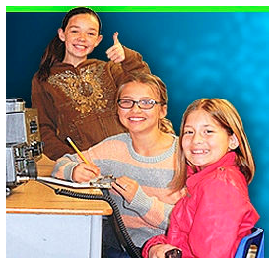
The next Kids Day is Saturday, June 15. That’s the day to get youngsters on the air to share in the joy and fun that Amateur Radio has to offer. Kids Day gets under way on Saturday, June 15 at 1800 UTC and concludes at 2359 UTC. Sponsored by the Boring (Oregon) Amateur Radio Club, this event has a simple exchange, suitable for younger operators: first name, age, location, and favorite color. After that, the contact can be as long or as short as each participant prefers.

Look for activity on these frequencies: 10 meters: 28.350 – 28.400 MHz; 12 meters: 24.960 – 24.980 MHz; 15 meters: 21.360 – 21.400 MHz; 17 meters: 18.140 – 18.145 MHz; 20 meters: 14.270 – 14.300 MHz; 40 meters: 7.270 – 7.290 MHz, and 80 meters: 3.740 – 3.940 MHz. Repeater contacts are okay with permission of the repeater owner.

As with any on-the-air activity that includes unlicensed individuals, control operators must observe third-party traffic restrictions when making DX contacts. Additional details are on the ARRL website.

One Question Questionnaire

Hey Gang,

It seems that about 6.5% of you have operated from a cruise ship. It’s about what I expected.

There’s another NEW – one question – questionnaire on the Ohio Section Website! http://arrlohio.org This question comes from Mike, N8GBU, and it’s a really good one to ask for sure…

“Do you carry a copy of your ham radio license with you??”

These One Question questionnaires are all in fun and I hope that you are enjoying answering them.

You’ll find the “One Question” questionnaire on the Ohio Section Website! http://arrlohio.org It’s all in fun and it’s not a scientific survey in any way, but we are learning some things that we didn’t know from these questions. I hope that you are enjoying answering these “One Question” questionnaires.

TOP ^

V.E. Test Sessions

For the latest testing site information please >> Click Here << The ARRL site tracks all of the VE testing sites that register with them, including W5YI and Laurel. ARRL gives you a number of different ways of sorting to find that site that is closest to you as well.

Incident Command System (ICS) Training Schedule

All current trainings are listed on the Ohio EMA training calendar located at:
https://webeoctraining.dps.ohio.gov/TrainingAndExercise/courselist.aspx

I’ve been asked to also include a link to the Kentucky EMA training calendar as well..
https://kyem.ky.gov/training/Pages/default.aspx
https://sites.google.com/site/ccoemtraining/home

Please pay particular attention to these courses listed above, as that there’s a lot of ICS 300 & 400 classes listed that are very useful for all Amateurs to have under their belts. I will also state that G775 is also a very good course to take as well. These 3 courses are multiple day in class courses, so please be prepared to spend some time taking them.

We do recognize that IS-300/400 requires multiple days of actual classroom training that is not easily obtained. So, if you just can't find the time to fit these class room courses in, we do have an alternative method for getting you to Level 3.

Completing the following “FREE” and “ONLINE” courses will act as substitute for you FEMA Leadership Development Course requirements. You absolutely will need to complete all 7 of these courses to get your ICS 300/400 credit. Here are the courses that you need to take: IS-120, 230, 240, 241, 242, 244 & 288.

Now, if you are looking for wallpaper and have a little extra time, taking IS-235 in addition to the 7 listed courses above, you will get a really cool looking certificate from FEMA stating that you have completed the Professional Development Series. That’s impressive in itself!

ARES Connect

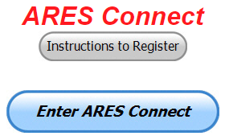
We need to discuss some very important items that only YOU can make a difference with. I need you to get yourselves registered in ARES Connect, if you haven’t already. We need to make sure that no one is left behind.

TOP ^
If you live in Ohio and you haven’t registered yet, we need you to get registered now. We need you to only use this URL to get registered https://arrl.volunteerhub.com/lp/oh/. Using any other entrance to register will only slow down your registration process. Again, this is for those living in Ohio only. If you are an out of state person (not Ohio), you can simply change the /oh/ to your 2-letter state designation. This will put you in the correct state for signing up

Here’s the top 10 hours earners for the month of May:

 | Name | Events | Hours
1 | Henry Ruminski (W8HJR) | 36 | 153.65
2 | Elizabeth Klinc (KE8FMJ) | 48 | 131.50
3 | Christopher Domenick (KC8CAD) | 26 | 126.60
4 | John Westerkamp (W8LRJ) | 49 | 119.58
5 | Bret Stemen (KD8SCL) | 38 | 108.50
6 | Doug Braun (KB8TGT) | 6 | 86.00
7 | David Noeth (KD8ACO) | 14 | 82.00
8 | Mathew Nickoson (KC8NZJ) | 13 | 78.25
9 | Timothy Gray (KD8IZU) | 6 | 72.00
10 | Robert Baker (N8ado) | 20 | 70.00

It adds up quickly, but you do have to be registered and actually USE the system in order for any of your time to count. We have a set of instructions on how to get registered right above the button to enter ARES Connect. I would strongly suggest that if you haven’t registered yet, that you read these instructions first.

Here’s a link to get you started... http://arrl-ohio.org/ares_connect_directions.pdf Please, don’t just hurry through the questions, read them carefully, if you don’t understand something, please ask me, I’m here to answer your questions.

We know that you mean well by answering that you do have the needed courses in, but I will let you know that we are verifying what you say you have with what is showing for you in our statewide database when we are completing your registration. So, how can you find out if you are already listed in our statewide database? Easy, here’s a link: http://arrl-ohio.org/SEC/special/ICS%20Complete%20by%20County%20and%20Name.pdf

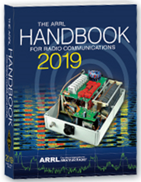
Now… It’s been a little while since we’ve rewarded anyone for the most hours. So, as a way to kick off our excitement about being the very first Section in the country to use ARES Connect for its monthly reports to Headquarters, I will be giving away a 2019 ARRL Softcover Handbook to the person who obtains the most hours in the month of June. Now I realize that we are already 10 days into the month, but if you really want to try for the Handbook you can make this up by being devoted and really working at it!!

Let’s see who is dedicated enough to become the owner of a brand-new Handbook!

TOP ^
Here’s a quick breakdown of the amount registered in ARES Connect per Districxt, as of June 9th

 | Registered |  | Registered
District 01 - WD8PNZ | 143 | District 02 - W8UY | 10
District 03 - W8LLY | 163 | District 04 - N8TFD | 117
District 05 - KC8SYF | 105 | District 06 - W8DLB | 54
District 07 - KB8YMN | 211 | District 08 - N8SUZ | 36
District 09 - W8FHF | 60 | District 10 - N8AUC | 173

With this new reporting system, we can get real time information that shows how many hours, who volunteered and what did they volunteer for. There’s a ton of information that we can draw out of the system.

We now have 1072 registered and growing every day in the system. As you can see by the numbers above, we are now at the point where we will all need to be registered in this system for our hours to count.

We will no longer need to depend on our EC’s and DEC’s to remember our hours of volunteering and report those hours for us on their monthly reports. The EC and DEC monthly numbers are no longer necessary, we will maintain a report for the narrative section only!

The time that is spent in getting your information and making sure it is up-to-date and on file with the EC, as well as transferring all of those records when a new EC takes over is no longer be needed. This system takes care of all of that automatically. Forget a meeting time or location? Just look it up on the calendar and there you have it. If set, you can even see the location on a map! I have attended many meetings and gatherings just because it was listed on ARES Connect and I found it just browsing around. I wouldn’t have known about it if it hadn’t been on the ARES Connect Calendar!

Why is this so important? These hours are what is shown to those we go to for funding as well as for more frequencies to operate on. Yes, we have to justify why we need the money or frequencies to those in government that want “just the facts.” This system allows us to show them the facts, anytime and with great accuracy.

Special Note for the Admins…

I want to make sure that all of you start setting up your events the same way. If at all possible, please always set the "Hours of Self-Reporting" to ALLOWED. This gives the volunteers time after the event to log their time. They still must have registered for the event in advance, but it will give them the opportunity to go back later and log their actual time in.

On the "Event Slot Limit" Please leave that open (unlimited users) unless this is absolutely necessary to set a limit. We want ALL of our events to be as open as possible.

Start getting folks registered into ARES Connect. We don't want anyone left behind and we still have a lot of folks that are not registered yet. If they can't get registered due to not having a computer or they feel they just can't do this for themselves, you can do it for them. Either way, let's all work hard at getting all those who aren't in the system yet, in there, besides it isn’t going to stop raining, and you can't mow the lawn anyway or do yard work in the rain, so how's about spending an hour or two getting your fellow hams registered!!!

TOP ^

Handheld Transceiver Accumulation Syndrome
(by Bob KØNR on Amateurradio.com and submitted by Greg, WD9FTZ)

A handheld transceiver (HT) is a convenient, compact all-in-one wireless device for FM operating on the VHF/UHF bands. HTs are sometimes referred to as a Shack On The Belt. There’s a lot to like about a transceiver that has wide frequency range, attached antenna and power source.
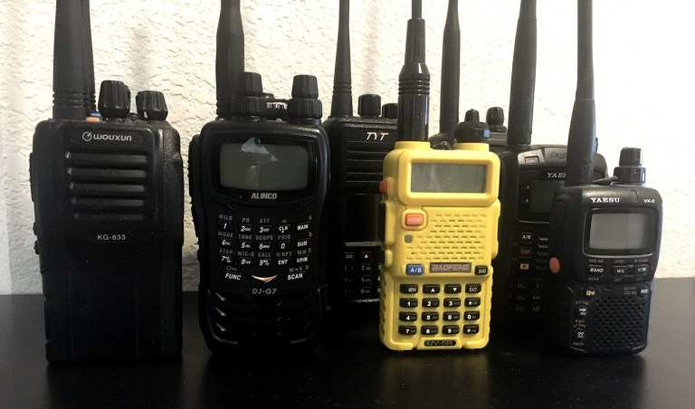
Handheld transceivers may start to accumulate for no apparent reason.

The attractiveness of these devices coupled with a distinct lack of self-control on the part of some radio amateurs can lead to a condition known as Handheld Transceiver Accumulation Syndrome (HTAS). The main indicator of HTAS is that the radio amateur (the HTAS patient) accumulates a large number of HTs for no apparent reason. These radios end up sitting on the shelf or workbench at home, largely underutilized.

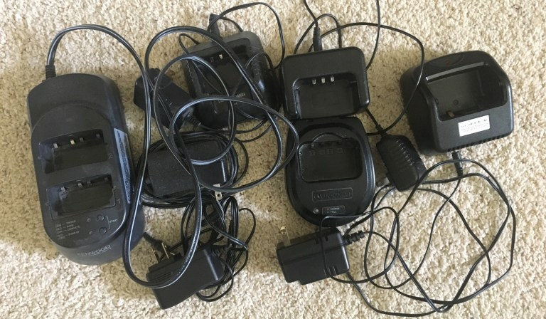
Typically, a pile of battery chargers accumulate. All of them are proprietary and incompatible with each other.

Coincident with the accumulation of radios, there is usually a pile of battery chargers, both drop-in and wall-wart style. These chargers are almost always proprietary designs that work with the original radio but no others.

The chargers are just the beginning of a broader accessory quagmire. The HTAS sufferer also tends to accumulate other accessories such as DC power cables, extra battery packs, speaker/microphones and aftermarket antennas. Many of these are also unique to the specific model of HT.

Psychologists that study HTAS note that there are specific buying habits that play into this “harmful “condition:

The Impulse Buy
HTs have always been relatively affordable with street prices of less than $200. However, the situation changed in the last decade with the introduction of cheap HTs from the Chinese manufacturers, driving the entry price down to under $30.

This puts a VHF/UHF dual-band radio in the price range of a tank of gas or dinner at a local restaurant, clearly setting up an HT as an impulse buy. “Heck, its only $30, so why not buy the camo version of the Baofeng radio?”

TOP ^
The Mode Buy
Sometimes the HTAS patient is motivated to buy another HT to fill in a specific capability that is missing in their ham radio gear. Of course, the equipment manufacturers are complicit in this — introducing new features and modulation types to drive additional purchases.

No single radio does it all, so you need multiple devices to cover a range of features, such as APRS, DMR, D-STAR, Fusion, P25 or other modes. A person justifies their need by saying, “I need this new HT to work the other guys on DMR.”

The Special Purpose Buy
A really subtle driver of purchasing behavior is buying a radio for a specific purpose. This is similar to the

Mode Buy but is driven by a specific situation. The patient conjures up specific communication needs that justify a particular radio.

For example, they may think “I need a small HT that fits in my shirt pocket while doing work around the house,” or, “I need a little DMR radio just to talk to my hotspot.” Another one is “I need to keep a Baofeng in the glove compartment of the car, just in case.”

Living with HTAS
Fortunately, medical professionals that encounter HTAS report that in most cases the syndrome is not completely debilitating.

Many radio amateurs are able to lead normal lives while suffering from the effects of HTAS. In severe cases, HTAS can lead to financial problems, depending on income level and the severity of the problem.
HTAS is also associated with a breakdown in personal relationships, especially with married subjects. HTAS sufferers living alone report far fewer relationship problems.

Do you know anyone that has this disease?

Deployment During Emergencies

I received the following message and thought that this was a great time for all of us to review our deployment policies.

FROM: Bob Baker, N8ADO - DARA Van Chair

Based on several email messages that have been circulated recently, there seems to be some lack of understanding about how hams should deploy when disaster strikes.
First, very nearly all responder organizations in the US have fully adopted the National Incident Management System (NIMS). I will not take the space to describe what NIMS entails, but many of you have taken the series of free, on-line courses that FEMA offers. The recommended courses for all hams who wish to be considered to be prepared to participate in providing emergency communications are IS-100, IS-200, IS-700, and IS-800.

Note that these courses are required before you will be permitted to enter a FEMA operations center.
TOP ^
One of the basic rules under NIMS is NO SELF-DEPLOYMENT. This is also an ARRL policy and a DARA policy. If you were not asked to participate in an operation, you will be turned away. Every emergency situation needs to be managed and no Incident Commander needs personnel that are not included in his plan, especially when he is uncertain as to the training level of a person. Note that there are ways to establish some of your qualifications by registering in a database that is vetted by trusted people. One such database is for the Ohio Section Amateur Radio Emergency Service. https://arrl-ohio.org/SEC/default.html

To become a member, go to the registration page. To upload proof of the training (for example, IS-100, 200, 700 & 800) go to http://www.arrl-ohio.org/upload.html. Another database that is accessible by first responder organizations is the Ohio Responds Volunteer Registry https://www.ohioresponds.odh.ohio.gov/ Be sure to read how to register as a ham by browsing the ARRL-Ohio website. Many of you are thinking that your experience is valuable and that you don't need any special training or certificates to be useful during an emergency. I don't wish to debate this issue, but I can assure you that this argument will not get you past police lines.
Recently, there were significant weather-related disaster situations in the greater Dayton area. One question that was posed: Did the DARA Van respond to any of these? The answer is NO, and the reason is that we were not requested to deploy. Note that there was not a communications emergency and, therefore, no need for hams to provide substitute communications channels. Nor was there a loss of command center facilities that might have been served by a mobile command post. I know that many DARA members are rightfully proud of the DARA Van; be assured that had we been requested to deploy this asset, we would have done so quickly and efficiently.
A number of the ham volunteers that participate in the various activities that we use as training for possible disaster situations are active in organizations that did deploy. In my area, there were significant deployments of the BTFD Auxiliary and its associated CERT members. And let's not forget the important role that amateur radio played by providing trained weather spotters and the communications system for collecting the reports of severe weather.
Bob Baker N8ADO
DARA Van Chair

Additional Comments from me..

I do hope that the above article explains the who, what, where, when and most importantly WHY we wait until asked.

I know that there were a number of folks that took to the social media pages when we activated during the major snowstorm in January stating that this was a “self-deployment” action. It wasn’t. Unfortunately, some of the folks making these comments just didn’t have all the facts before making their posts. We had been asked by the Ohio Watch Desk if we could help out. This was a request from a served agency.

As like most government agencies, they are finding themselves shorthanded and they asked if we could obtain information for them that they felt they might be missing. We did just that! In fact, we did that so well for them that they have requested our help even more than ever before. What a really wonderful and rare opportunity this has been for us to work even closer to our served agencies.

Most of you have never been to the state EOC (Sarge), let alone know what all that goes on inside that funny looking building on the west side of Columbus, so I took the liberty of copying the State of Ohio’s explanation of what the Watch Desk is all about.

TOP ^
The Ohio EMA Watch Office is one of the newest branches of the agency (Ohio Department of Public Safety) and is a key component of the state emergency management system. This office aims to help facilitate a quicker, more informed decision-making process for the preparation for, and response to hazards and incidents impacting Ohio. Operational since January 2016, the Watch Office team of analysts:

- Provide daily situational awareness products and decision-support.
- Track and dispatch state resources and assets.
- Provide timely, accurate and actionable assessments to the agency, its partners and stakeholders throughout the state.

The Watch Office serves as the initial point of contact at the agency for its state partners and county EMAs for incident reporting. It develops situational awareness reports, as well as state advisories and other reports that provide awareness of a developing situation that could pose a threat to life and/or property. The Watch Office is operational 24 hours a day, seven days a week, 365 days per year.

Now, what you also may not be aware of is that our EC’s and DEC’s receive Safer Ohio Awareness Reports (SOAR) twice daily from information gathered in-part by this Watch Desk. Our EC’s and DEC’s are much better informed than any of their counterparts around the country. This is due directly to our involvement with EMAO and OP3.

We DO NOT self-deploy. Our EC’s and DEC’s will continue to maintain contact with their served agency directors including proactively “checking in” when it looks like something’s coming as we always have done, but we will only deploy if we are asked to. At that point, we will do whatever it takes to fulfil those needs.

Additional Comments from Stan…

The traditional role of ARES is still our main role- “to provide communications support wherever it’s needed.” But, over the years ARES has taken more on the role of a typical volunteer for our agencies. We pushed water supplies in Mahoning county when there was a major water failure (much like that in Michigan). We have worked security for county fairgrounds (just keeping eyes on things) and we most recently walked security around a tornado-stricken area in Shelby allowing first responders to redirect their attention to search and recovery efforts.

We NEVER ask ARES members to do anything above their personal qualifications - such as drive a truck or take on a first responder role. However, we do have those who are qualified if the need arises. One area in which we have had success is damage assessment. In Mahoning County right now (after flooding and tornado damage) we have at the EMA’s request directed ARES volunteers to help with damage assessment over a large area. Thus, taking on a mission that’s not communications. These new tasks that we’re taking on are very much appreciated by the agencies that we serve and is also a great service to our communities as well.

Would these other tasks take precedence over communication in an emergency? Nope. Our main mission is communications (although we might get involved with the use of fax machines, regular phones or whatever works at the time). We are not, nor do we want to be first responders. We are volunteers, and we are ready to take on other tasks should it not be a communications emergency, so long as we can be of help. Our role has changed over the years, as agencies fall shorthanded and truly need the extra help. We can and have stepped forward in and providing a needed service.

#########

TOP ^

Final.. Final..
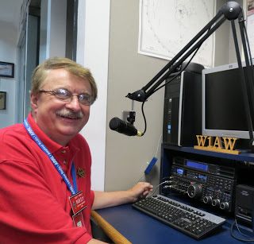
Hey Gang...

This was once again a very hectic week for sure. For those of you keeping track of all that’s happened in Ohio recently, I do have some new info for you that you may not be aware of. The count on the tornadoes that came through Ohio at the end of May is now up to 21. Yes, they did find traces of an EF-0 tornado that came through Uniopolis in Auglaize County as well.

ARES in our state has been really busy lately and I’m very proud of everyone that has been active!

Sliding down the band a bit… I want to make sure that all of you know that you need to get signed up in ARES Connect right NOW, if you haven’t already.

Yes, we are the first Section in the country to go forward with ARES Connect for our monthly reports. We had our EC’s and DEC’s still submit their monthly reports this month as they have done for years, but we will only be using the “narratives” from those reports. I will post in the Ohio Section Journal coming out on June 17th the actual report that we have sent into Headquarters. I think once you see the amount of information that was obtained with ARES Connect over the month of May, you too will be impressed.

So, what does this mean to you? You now need to make sure you get registered in the ARES Connect system if you haven’t already. And, more than ever, you now need to actually start using the system and signing up for events!!! It’s really easy to do and only takes a couple of minutes of your time, but it means so much to the Ohio Section and to ARRL. Just imagine, for the first time they can really use and justify the time that we say that we help out our citizens. We have it recorded in these events.

I hear from folks all the time asking… “why do I need all this training?” Well, after this past couple of weeks if you have to ask that question… Folks that have never dreamed that they would get involved are now volunteering to help out. Yes, with 21 tornadoes and at least 3 cities underwater it should be evident to you that you do need to have some training before you volunteer to help.

Here in the Ohio Section we only require our Level 2 volunteers to have the 4 basic courses, IS 100, 200, 700 & 800. For our Level 3 volunteers we do require the additional ICS 300 / 400, or the equivalent professional series courses IS 120, 230, 240, 241, 242, 244 & 288. These equivalent courses are all on-line classes just like your basic 4 NIMS courses are and being offered as an alternative way for you to get credit for taking the professional series courses in the event you just cannot get scheduled into an ICS 300/400 class.

By the way, if you decide to take these 7 on-line courses and complete them all, you will want to take just one more class IS-235. By completing this additional course, you will get a really great looking certificate from FEMA recognizing that you have completed the entire Professional Series courses. I do hope that this clears up the confusion that has been going around lately. As we have stated on the website and in this newsletter many times “We don’t want anyone left behind.”

TOP ^
Yes, the Ohio Section is extremely lucky to have the relationships that we do with Law Enforcement, EMA, fire and other government agencies, that’s why we’ve partnered with EMAO, OP3 and Ohio VOAD to show our support for them and our Ohio citizens.

Whelp… That’s going to do it for this time around. Stay safe, enjoy the sunshine while we have it, and most of all… have FUN!!

73,

Scott, N8SY

Back Issues of the PostScript and Ohio Section Journal (OSJ)

Hey, did you know that PostScript and Ohio Section Journal (OSJ) are archived on the website? You can go back and look at any edition simply by clicking:
http://arrl-ohio.org/news/index.html

Chit – Chat, and All That!

Do you know someone that’s not getting these Newsletters? Please, forward a copy of this Newsletter over to them and have them “Opt-In” to start receiving them. Heck, just have them send me an email n8sy@n8sy.com and I’ll get them added to the Ohio Section Emailing list.

We now have many thousands of readers receiving these newsletters weekly. Quite impressive, I’d say! I urge all of you to make sure that everyone, regardless of whether they are a League member or not, get signed up to receive these weekly Newsletters.

You can always “Opt-Out” at any time if you feel this is not what you were expecting. It’s fun and very informative. All of your favorite past newsletters are now archived too.
You can go back at any time and read them. Just go to: http://arrl-ohio.org/news/

Got questions, concerns or would just like to sit and chat awhile? Heck, I’ll even buy the coffee!! Give me a call at (419) 512-4445 or email me at: n8sy@n8sy.com

The pictures on the front page are from various newsletters, Facebook posts and/or were sent directly to me in recent weeks. Take a good look at them, you just might be in one of the pictures! “SMILE… you’re on the Ohio Section News!!”

TOP ^

PostScript is produced as a weekly newsletter. I want to thank everyone that has contributed articles and ideas to make this an even better news source. I sincerely hope that you have enjoyed this edition and will encourage your friends to join with you in receiving the latest news and information about the Ohio Section, and news and events happening around the world!

