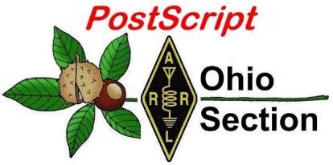
Post Dayton
Edition

National News The Handbook Give Away

Club Corner Hamfests

DX This Week One Question Questionnaire

VE Testing ARES Connect

Final.. Final..

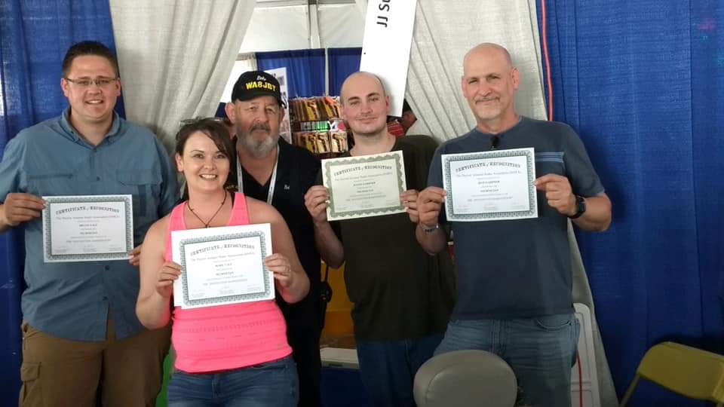
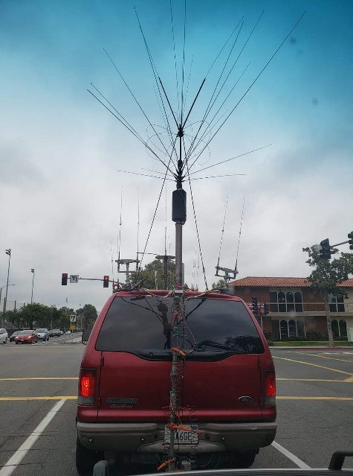
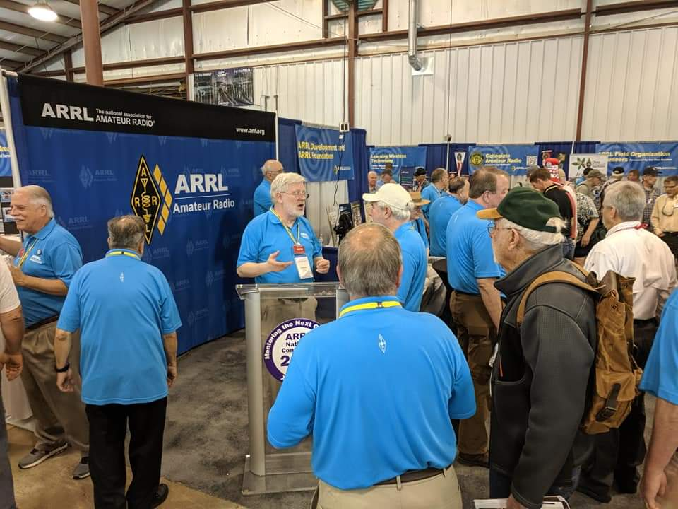
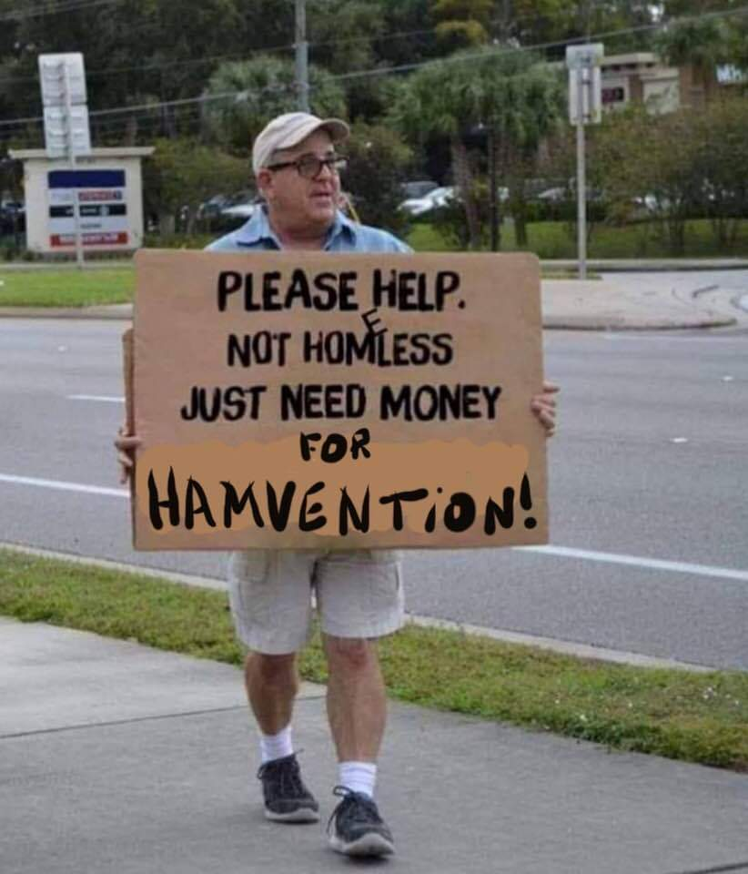
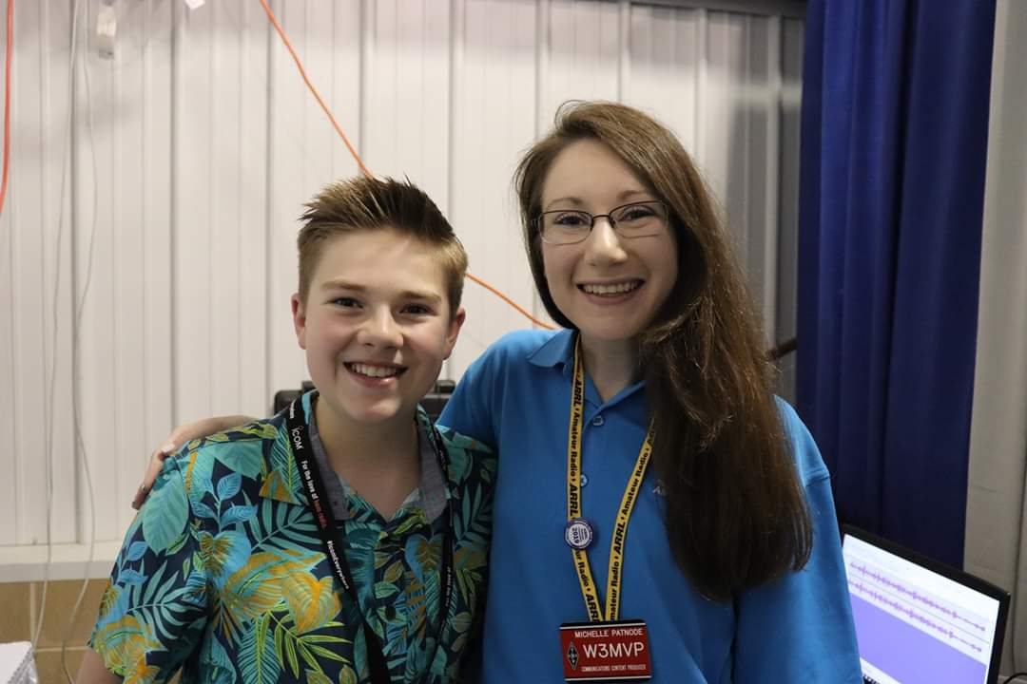

National News
(from arrl and other sources)

Radio Amateurs to Demonstrate Emergency Messaging Capabilities for Red Cross, FEMA

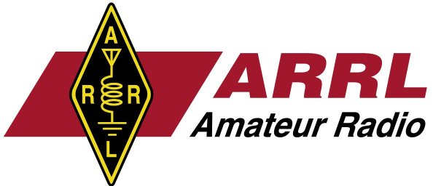
Just days ahead of the 2019 Hurricane Season, dozens of hams along the US East Coast will demonstrate Amateur Radio’s ability to deliver messages without commercial power, infrastructure, or permanently established stations for officials of the American Red Cross and the Federal Emergency Management Agency (FEMA).

The Thursday, May 23 event will take place in coordination with ARRL, during a joint meeting with Red Cross and FEMA officials in Baltimore. The demonstration will be a mock response to a simulated disaster scenario — a major hurricane with mass casualties striking the east coast. Amateur Radio operators at portable stations from New England to the Carolinas will deliver messages to W1AW, which will then coordinate and deliver the information to officials attending the joint FEMA-Red Cross meeting in Baltimore.

Messaging will be handled using digital modes, which can allow for the transmission of images as well as text, as a showcase for the full range of modern Amateur Radio technology. The American Red Cross will also have a NexGen Emergency Response Vehicle parked at W1AW in Connecticut as part of the training exercise, which will take place from 1330 to 1530 UTC.

ARRL and its members have a long history of working with emergency response agencies, such as the American Red Cross and FEMA, to provide or support communication in times of disaster for served agencies and partners. A principal served agency, the Red Cross shelters, feeds, and provides emotional support to victims of disasters.

#########

The FCC is Not Reinstating a Vanity Call Sign Fee
An erroneous report this week suggested that the FCC planned to again impose an Amateur Radio vanity call sign application (regulatory) fee of $70 for the 10-year term. This incorrect conclusion resulted from an incomplete reading of the May 7 FCC Notice of Proposed Rulemaking (NPRM) in the matter of the assessment and collection of regulatory fees for fiscal year 2019.

Although the Schedule of Regulatory Fees does show a $7 annual fee for Amateur Radio vanity call signs, a boldface heading in that section of the NPRM states, “REGULATORY FEES. This section is no longer in effect as it has been amended by RAY BAUM’S Act of 2018...” Section 9(e)(2) of RAY BAUM’S Act gives the Commission discretion to exempt a party from paying regulatory fees when the FCC determines that the cost of collection exceeds the amount collected. A new section 9(e)(1) incorporated the Amateur Radio vanity fee exemption from FCC rules into the statute.

The NPRM makes clear in several other places that regulatory fees no longer apply to Amateur Radio licenses. The FCC eliminated the regulatory fee for Amateur Radio vanity call signs in 2015.

TOP ^

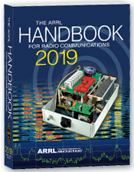
The Handbook Give Away

Have you registered for the “Handbook Giveaway” drawing for this month yet? If you haven’t, go to: http://arrl-ohio.org/handbook.html and get yourself registered now!

What’s the catch? I want to get everyone checking in to the Ohio Section website as often as possible, and in order to register each month, you have to visit the website often! There’s nothing else to it. I pay all expenses and I usually “Give Away” more than just a Handbook too!!

Many of you ask me just how do I know when the drawing is on? Well, that’s easy all you need to do is check in on the Ohio Section Website on a regular basis and watch for the big RED Arrow that will appear on the left side of the page. This is the sign that the drawing is on and you need to get registered. So, keep a sharp eye out on the website and check in often! http://arrl-ohio.org

Club Corner

This is YOUR cornner of the newsletter. Send me what your club is doing and I’ll make sure that it gets in. Got a special event or club project that you want everyone to know about? Send it to me!. Need help with a project? Send it to me.

Let me know what you club is up to. Are you going to have a special guest at your meeting or are you having a special anniversary? Just sent it to:
n8sy@n8sy.com

#########

The Toledo Air Show is July 13 & 14 and we did such a great job at the last Air Show the powers that be have requested additional help from us this time around. We are still in the planning phase and do not have final numbers for needed operators, but I wouldn’t be surprised to see a number around 50 or more each day.

The Lucas County EC is the contact person for the air show, boxcar@toast.net.

#########
American TTT race at Salt Fork State Park May 31-June 1 and 2

There will be a total of 4 races during the weekend. They are;
Friday May 31 from 4pm to 7pm
Saturday June 1 from 7am to 11am
Saturday June 1 from 2:30pm to 7pm
Sunday June 2 from 6:30am to 4pm

TOP ^
For each race the sponsors are requesting 1 radio operator at the command post, 1 radio operator at the start / finish line, and up to 10 radio operators to be stationed along the racecourse. If we have enough volunteers, we may have a radio operator in a SAG vehicle and some mobiles. The races get progressively longer with the race on Sunday being 24 miles in length. The Friday night race is the shortest so we may not need as many radio operators for it. Each race will have swimming, running and biking components.

After each race there will be food served at the start / finish line and volunteers are welcome to eat. The lodge and cabins are booked for the entire weekend. If someone wants to camp, I can check on the availability of campsites.

Please let me know if you are willing to help and what times you are available. After I get a list of volunteers, I can start making assignments. Please contact me if you have any concerns or questions.

Dick, WD8SDH Guernsey County EC - cell 740 630 1815

#########

Ohio Statewide Courthouses On The Air Special Event, August 24, 2019
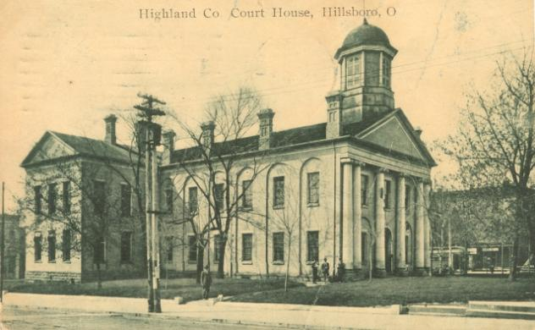
Event Background
Last year there was the Ohio Covered Bridge Special Event that was led by John Levo, W8KIW Editor of the Highland ARC’s Monday Morning Memo. Several clubs participated and was a complete success. Additionally, there were several folks interested in Ham Radio at the event who have now become new Hams. Yes, anytime there is a public event resulting in a gain to the Ham Radio community, it is a total success. This year in keeping with the historical event series, John and the members of the Highland ARC decided to do a special event from their courthouse lawn.

John published an article in the Monday Morning Memo which attracted the attention of Michael Love, WB8YKS Southern Ohio Amateur Radio Association (SOARA) PIO. John and Mike decided that there may be interest in an all-state special event celebrating the courthouses in all of Ohio’s 88 counties. Scott Yonally, N8SY Ohio Section Manager thought it was a fantastic idea and requested John and Mike to reach out across the state to determine the level of support for the event. The Ohio Section has 117 affiliated clubs of which 48 are Special Service Clubs and there are 29 PIOs. There may not be a club listed in each county by address, but we do have Hams in each county.

Promoting Ham Radio
This may be a first for the ARRL and the Ohio Section. This event has all the opportunities for a FUNFILLED family day engaging the public and our government officials. Additionally, one county’s club is partnering with their county commissioners, historical society, EMA, sheriff’s office, public library, chamber of commerce, and news media. The club has decided to use a large tent as the event will take place rain or shine. Their PIO will make handouts available about ham radio and promoting the ARRL, ARES, RACES, Ohio Section and their local club.

TOP ^
A special focus will be made to spotlight the public awareness of the hobby and the benefits of a Ham radio license, emergency and community service. The public will be invited to talk on the radios under the direct supervision of a licensed operator. Several clubs plan to provide contact QSL cards and/or certificates to capture this historical event.

Fun for Everyone
There may be some folks dressed in period costumes providing history about their courthouse and the early days in their county. Moreover, one club has requested, August 24, 2019, to be declared as Ham Radio Day in their county, and their county commissioners have approved it.

Event Details
Yes, we are excited and hopefully you are as well, about participating in this historical Ohio Courthouses on the Air Special Event. We are requesting ALL Ohio Clubs and Hams to consider supporting this special event. The event will take place on, Saturday, August 24, 2019, from 9:00 AM to 4:00 PM. However, the hours can be extended by each club. Additionally, each club will determine the frequencies and modes they will use.

Another opportunity presents itself as the Ohio QSO Party www.ohqp.org is also on the air, Saturday, August 24th. Therefore, these two events will complement each other providing contacts not only from within Ohio but across the country. All Hams are invited to participate.

Staying in Touch
Please inform the listed contacts that your club will be participating, and the name of the county represented. Additionally, there will be updates provided in the Monday Morning Memo, the PostScript, Ohio Section Journal, and www.arrl-ohio.org.

Contacts for additional information:
Michael Love, WB8YKS
wb8yks@arrl.net
John Levo, W8KIW
highlandara@yahoo.com

#########

Seneca County Net Information

Here’s some information on a weekly net originating out of Seneca County on the KC8RCI Linked Repeater System. The North Central Ohio Traffic and Information Net is held at 10:15 am every Wednesday morning and has been developed as a step off net for NTS Traffic and to provide various information on amateur news items and events.

There are many linked repeaters available to access the KC8RCI System and the net: 147.255 & 444.4375/107.2 Republic – 443.075/151.4 Mansfield, 146.805/110.9 & 442.675/162.2 Berlin Heights, 443.9875/162.2 Elyria, 443.625/162.2 POLK, 53.290/52.290/107.2 VERMILION

#########

DMR Astronomy Net

Hey Gang the DMR Astronomy Net is now a part of the Quadnet … TG 31012 (Brandmeister)
Wednesday’s at 9:00pm ET
Moderator is Jason – N8XE from Hilliard, OH

#########

HF operators needed...
The USS Cod will be participating in the upcoming "Museum Ships on the Air" event on June 1st & 2nd. Some 107 U. S. Navy ships stations will be activated for this annual celebration.
https://www.qsl.net/w/wa2tvs//museum/

If you would like to help or want more information, please contact Bill Chakin KA8VIT: ka8vit@ka8vit.com

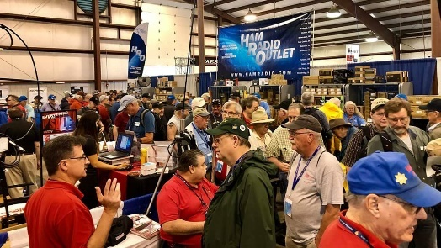
Upcoming Hamfests

06/01/2019 | FCARC Summer Swap
Location: Wauseon, OH
Sponsor: Fulton County Amateur Radio Club
Website: http://k8bxq.org/hamfest

06/08/2019 | Union County ARC TrunkFest  Location: Marysville, OH  Sponsor: Union County Amateur Radio Club  Website: http://www.ohiohams.net | 06/15/2019 | Milford Hamfest  Location: Owensville, OH  Sponsor: Milford Amateur Radio Club  Website: http://www.w8mrc.com
06/15/2019 | W8DXCC DX Convention  Location: Owensville, OH  Sponsor: SouthWest Ohio DX Association  Website: http://www.w8dxcc.com | 07/07/2019 | 20/9 Radio Club Hamfest Location: Austintown, OH  Sponsor: 20/9 Radio Club, Inc.  Website: http://20over9.org
07/07/2019 | Ohio Link Swap Meet  Location: 1801 Gateway Circle, Grove City  Sponsor: Ohio Link Network Group  Website: www.olnradio.digital  TOP ^ | 07/20/2019 | NOARSFEST  Location: Elyria, OH  Sponsor: Northern Ohio Amateur Radio Society  Website: http://noars.net/hamfests/noarsfest
07/21/2018 | Van Wert Hamfest  Location: Van Wert, OH  Sponsor: Van Wert Amateur Radio Club  Website: http://w8fy.org | 07/28/2019 | Portage Hamfair '19  Location: Ravenna, OH  Sponsor: Portage Amateur Radio Club  Website: http://hamfair.com

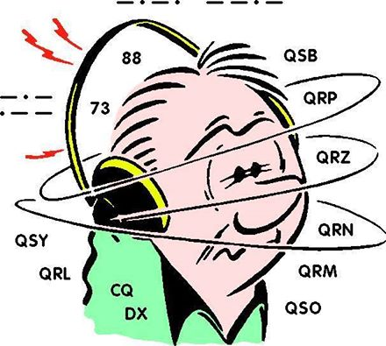
DX This Week
(from Bill, AJ8B)

Bill AJ8B (aj8b@arrl.net, @AJ8B, www.aj8b.com or www.swodxa.org )
CWOPs Member #1567

I hope you had a great time at Hamvention and I hope you attended the DX forum and/or the DXDinner! If not, make plans to do so next year!
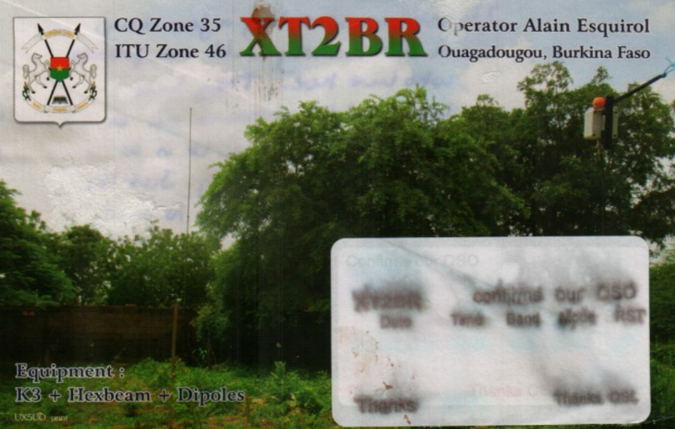
I did get some feedback on the excellent series of articles from Dave, K8DV. The question was, “Do we really receive QSL cards anymore that aren’t legible?” Well, about two weeks ago I received a beautiful QSL card from XT2BR. The problem was the card had been exposed to significant moisture somewhere along the route from the QSL manager to me. The pic says it all:

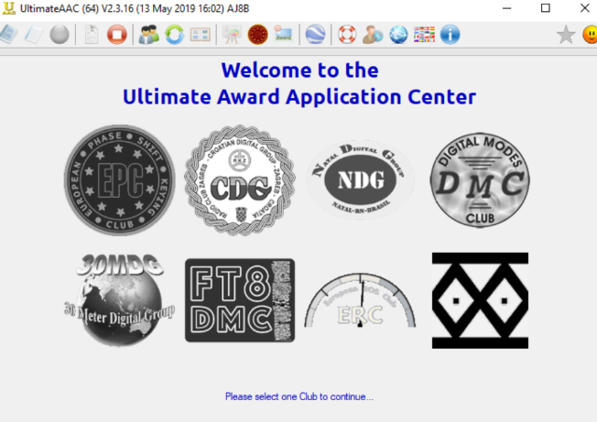
Uncle Frank and I had a solid CW QSO on 30 meters and the topic was “paper chasing”. We both enjoyed earning our DXCC and DXCC endorsements as well as WAC, WAS etc., Frank has been working a lot of folks on FT8 and was wondering about awards etc. that might be earned using FT8. I happen to be on a QRZ.com page of an avid FT8 DXers from Serbia and read about something called UAAC. UAAC is an abbreviation for the Ultimate Award Application Center. DK5UR has build a very easy to use and understand interface that “talks” to hundreds of awards. Each of these awards has a very colorful award certificate for reaching various levels. Once a month I load an adif of my logbook into the UAAC and it evaluates what awards I have earned and have become eligible for. These awards are downloadable as soon as you earn them.

All of this is available at no cost. Since my interest in UAAC has started, I have joined the Digital Modes Club (DMC), European PSK Club (EPC), FT8 Digital Modes Club (FT8DMC), and the 30 Meters Digital Group. (30MDG). After you explore these options and then register for the ones that you are interested in, you will receive a membership number from each group. You can load that number in to the UAAC and then have the UAAC app evaluate your logbook. In my case, within a few hours, I received about 30 certificates from the organizations. The software can be accessed at https://www.eupsk.com/index.php?option=com_content&view=article&id=8&Itemid=112

TOP ^
(This is not to brag, just to share!) Samples are below:

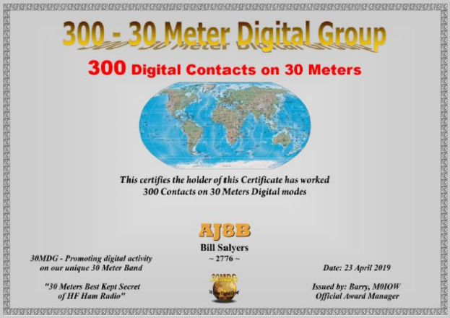 | 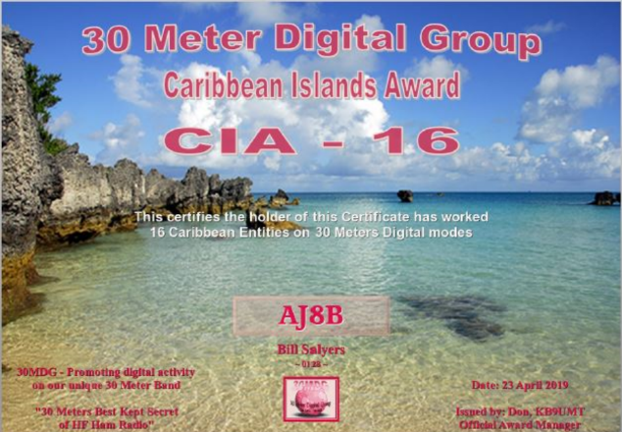
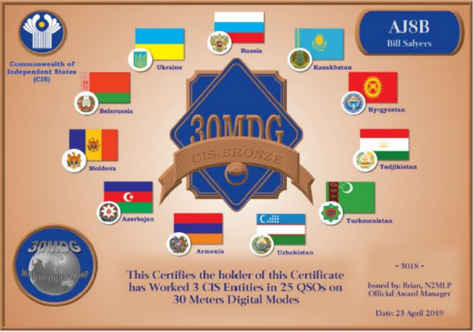 | 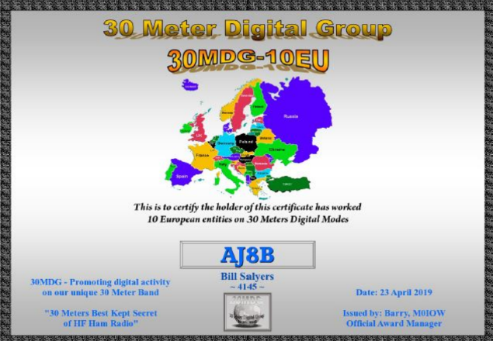
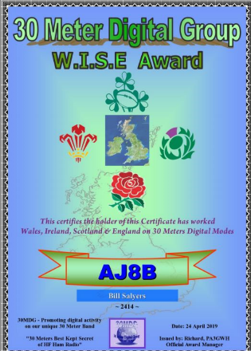  TOP ^ | 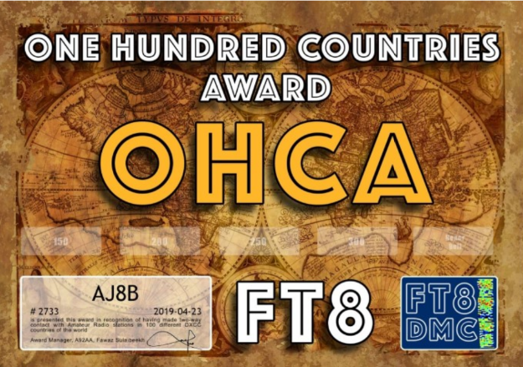
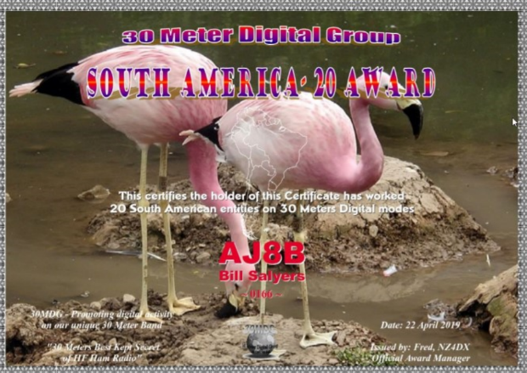 | 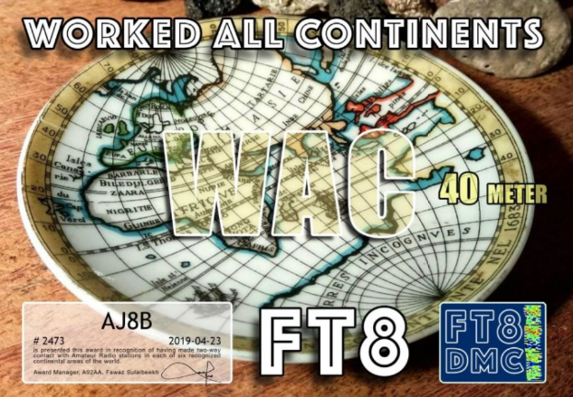
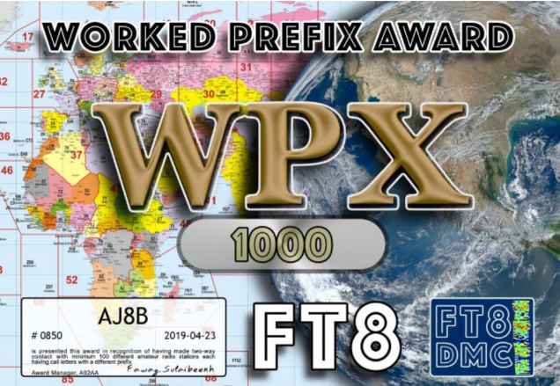 | 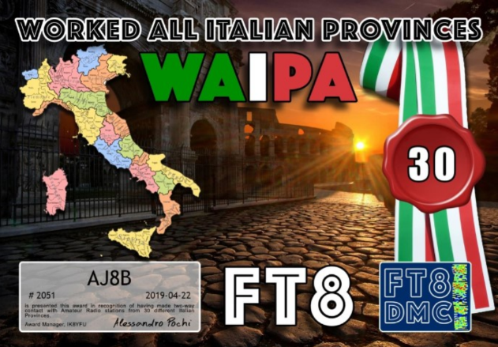

Next week I will share some details about the FT8 Digital Modes Club and the 30 Meter Digital Group.

+ --------------------------------------------------------------------------------------------------------------------+

Here is an update from Bernie, W3UR, of the DailyDX and the WeeklyDX, the best source for DX information. (http://www.dailydx.com/ ) Bernie has this to report:

+ --------------------------------------------------------------------------------------------------------------------+

Eritrea 2019 DXpedition - By E21EIC, Champ Muangamphun - E31A - The FGC Radio Team will active from The State of Eritrea between 25 May to 3 Jun 2019. Zorro, JH1AJT, CEO of SEISA and FGC (Foundation for Global Children) and the team will be visit Eritrea to Participate in the Eritrean Independence Ceremony. The main purpose of this trip is to support the Eritrea National Olympic Committee (E.N.O.C). SEISA's group will "coordinate pre-game a training camp" for the Tokyo 2020 Paralympic Games and select students for a scholarship program at the SEISA Kokusai Junior High School and University.
Operators: Zorro JH1AJT, Franz DJ9ZB, David WD5COV, Johannes PA5X, Dima RAUSU, Sergey RZ9UN and Champ E21EIC. Band: 160m - 6m / Mode: CW, SSB and FT8 (F/H mode) During this trip, Zorro, JH1AJT, will not operate due to his health. But still always support the team. QSL to JH1AJT

ZK3 – Tokelau - A multinational team plans to be there in October. Originally the call was announced as ZK3X but has now been changed to ZK3A. Departure from Apia, Samoa is October 1, arriving on Tokelau on October 2, the return departure to Samoa October 11, arriving October 12. They plan to be QRV on all modes.

TOP ^
That is, CW, SSB, RTTY, FT8/FT4 and via the moon on these bands, 160, k80, 40, 30, 20, 17, 15, 12, 10 and 6. One operator position is still open with 17 already signed on. The permit allows 18. https://tokelau2019.com/ For info, contact YT1AD, Hrane, the team leader, at mhran3@gmail.com .

D6 – Comoros - IZ8CCW, Antonio, and I2VGW, Gabriele, will be part of a multi-national team traveling there from the Mediterraneo DX Club, under the callsign D68CCC, October 20 to November 1. They will be on CW, SSB, RTTY and FT8, 160-10M with five stations on the air. On the op list are IZ8CCW, I2VGW, IZ2GNQ, ON7RN, DL6KVA, DJ5IW, YO8WW, F6ENO, F5NKX, ON4LO, IZ3GNG, IT9ZZO and F6BPZ. QSL using OQRS or direct or bureau to IK2VUC, plus LoTW. http://www.mdxc.org/d68ccc. Planned starting frequencies are CW on 1828, 3519, 7010, 10109, 14019, 18069, 21019, 24891 and 28019, SSB on 3795, 7125, 14215, 18140, 21295, 24945 and 28485; RTTY on 3595, 7049, 10140, 14080, 18103, 21080, 24910 and 28080 and FT8 on 1840, 3567, 7056, 10131, 14080, 18103, 21080, 24910 and 28080. And they will listen for US general class ops at 14280 and above, JA on 160 down 5-6 kHz and JA FT8 on 1908 kHz.

ARLD017 DX news

This week's bulletin was made possible with information provided by HA0HW, M0GAE, The Daily DX, The OPDX Bulletin, 425 DX News, DXNL, Contest Corral from QST and the ARRL Contest Calendar and WA7BNM web sites. Thanks to all.

CUBA, CO. Members of the Grupo Especial de Expediciones y Concursos are QRV as T43A until May 20 to celebrate the club's first anniversary. Activity is on 80 to 10 meters using CW, SSB and FT8.
QSL via LoTW.

LIBERIA, EL. Dickson, EL2DT has been QRV on 20 meters using CW around 1830z. QSL via EL2FM.

WALLIS AND FUTUNA ISLANDS, FW. Nobby, G0VJG is QRV as FW5JG from Wallis Island, IOTA OC-054, until May 22. Activity is on 40 to 10 meters using SSB and FT8. This includes the possibility of a short side trip to Futuna Island, IOTA OC-118. QSL via M0OXO.

REUNION ISLAND, FR. Thomas, F4HPX is QRV as FR/F4HPX from Saint Denis until June 5. Activity is holiday style on 40, 20 and 15 meters using SSB, FT8 and some CW. QSL to home call.

ENGLAND, G. Members of the Tynemouth Amateur Radio Club are QRV as GS0NWM from Mull until May 24. Activity is on the HF bands using CW, SSB, RTTY and FT8 in DXpedition mode, with up to four stations active. This includes Satellite activity as well. QSL via M0URX.

JERSEY, GJ. Operators ON5HC, ON7PQ, ON4KZ, ON5DZ and ON8AZ plan to be QRV as MJ/OQ7A/p from the Minkies Islands, IOTA EU-099, from May
25 to 31. Activity will be on 80 to 10 meters using CW, SSB and various digital modes. QSL via ON8AZ.

ALASKA, KL. Henry, NL0H is QRV as NL0H/p from St. Lawrence Island, IOTA NA-040, until May 19. Activity is on 30 and 20 meters using SSB and FT8. QSL via operator's instructions.

TOP ^
NORWAY, LA. Waldi, SP7IDX is QRV as LA/SP7IDX from Store Molla, Lofoten Islands, IOTA EU-076, until May 29. Activity is on 40 to 10 meters using SSB and FT8. QSL direct to home call.

ARUBA, P4. Operators Ben, DL6RAI, Martin, DL5RMH and Philipp, DK6SP will be QRV as P4/DL6RAI, P4/DL5RMH and P4/DK6SP, respectively, from May 18 to 29. Activity will be on 160 to 6 meters using CW, SSB and possibly various digital modes. QSL via operators' instructions.

GREECE, SV. Laci, HA0HW will be QRV as SW8WW from Thassos Island, IOTA EU-174, from May 23 to June 5. Activity will be on 40 to 6 meters using mainly CW, with some SSB, RTTY and PSK. This includes an entry in the upcoming CQ World Wide WPX CW contest. QSL to home call.

PALAU, T8. Operators JM1LRA, JI6IHG and JA7WFT are QRV as T88TA, T88IH and T88FT, respectively, from Koror Island, IOTA OC-009, until May 24. Activity is on the HF bands and 6 meters using CW, SSB and various digital modes. QSL to home calls.

TURKS AND CAICOS ISLANDS, VP5. Operators K2SX, K4BAI, K4QPL and KK4R will be QRV as VP5/homecalls from Harbour Rock Villa on Providenciales Island, IOTA NA-002, from May 21 to 28. Activity will be on 160 to 10 meters using CW, SSB and various digital modes.
QSL direct to home calls.

CAMBODIA, XU. Franco, IU0CRW is QRV as XU7AKP while working in Siem Reap. Activity is on 80 to 10 meters using CW and SSB. QSL via IW3SNW.

ROMANIA, YO. Members of the YO6KNE radio club are QRV with special event callsign YR19PFS until June 15 to commemorate the visit to Romania of Pope Francis. QSL via LoTW.

THIS WEEKEND ON THE RADIO. The NCCC RTTY Sprint, NCCC Sprint, UN DX Contest, NZART 80-Meter CW Sangster Shield Contest, Portuguese Navy Day Contest, His Majesty King of Spain CW Contest, EU PSK DX Contest, Aegean RTTY Contest, Feld Hell Sprint and the Baltic 80-Meter Contest are all on tap for this upcoming weekend.

The Run for the Bacon QRP Contest is scheduled for May 20.

The CWops Mini-CWT Test, RSGB Club 80-Meter Data Championship, SKCC CW Sprint and Phone Fray are scheduled for May 22.

The Canadian National Parks on the Air, CNPOTA, operating event runs for the entire year of 2019, with special stations active from Canada's parks and historic sites.

Please see May 2019 QST, page 84, and the ARRL and WA7BNM Contest Web Sites for details.

Special Events

06/01/2019 | Museum Ships Weekend
Jun 1-Jun 2, 1100Z-2100Z, K8E, Toledo, OH. Toledo Mobile Radio Association and National Museum of the Great Lakes. 14.260 14.039 7.260 7.039. QSL. SS Col. James M. Schoonmaker, Team K8E, P.O. Box 9673, Toledo, OH 43697. www.tmrahamradio.org

TOP ^
06/15/2019 | W8DXCC DX Convention
Jun 15-Jun 16, 0000Z-2359Z, K8S – K8W – K8H – K8O, Owensville, OH. SouthWest OH DX Association. 14.245 14.074 7.245 3.535. Certificate & QSL. AJ8B - Bill, 8275 Cierra Way, Waynesville, OH 45068. This is the inaugural year for this DX Convention. We are using these call signs: K8S, K8W, K8O, K8H. A QSL for each and/or certificate for working all four. www.w8dxcc.com

06/24/2019 | Simon Kenton Council, Delaware District, Cub Scout Day Camp
Jun 24-Jun 28, 1330Z-1700Z, K2BSA/8, Lewis Center, OH. Delaware Amateur Radio Association K8ES. 14.290 7.190. QSL. Ed Jones, 2965 Seaway Ct, Lewis Center, OH 43035. We'll be operating each day from 13:30-19:30 from Camp Lazarus in Ohio. We'll have hundreds of scouts on the air over the course of the week.

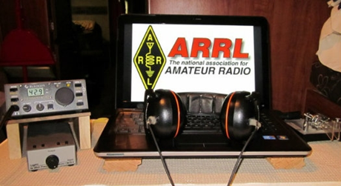
ARRL Contest Corner

An expanded, downloadable version of QST's Contest Corral is available as a PDF. Check the sponsor's Web site for information on operating time restrictions and other instructions.

One Question Questionnaire

Hey Gang,
It seems that about 41% of you are up to date with your First Aid and CPR training. Looks like we’ve got some work to do over the summer!

There’s another NEW – one question – questionnaire on the Ohio Section Website! http://arrlohio.org Since the weather people are now predicting that the weather will be hot and sticky for the Hamvention, this next question is important to know.

“Did you use the new ARRL Hamvention App while you were at Dayton??”

Anyway, these questions are all in fun and I hope that you are enjoying answering these “ONE QUESTION” questionnaires. Ok, enough on that, here’s the next question for you to answer…

You’ll find the “One Question” questionnaire on the Ohio Section Website! http://arrlohio.org It’s all in fun and it’s not a scientific survey in any way, but we are learning some things that we didn’t know from these questions. I hope that you are enjoying answering these “One Question” questionnaires.

#########

TOP ^

V.E. Test Sessions

For the latest testing site information please >> Click Here << The ARRL site tracks all of the VE testing sites that register with them, including W5YI and Laurel. ARRL gives you a number of different ways of sorting to find that site that is closest to you as well.

Incident Command System (ICS) Training Schedule

All current trainings are listed on the Ohio EMA training calendar located at:
https://webeoctraining.dps.ohio.gov/TrainingAndExercise/courselist.aspx

I’ve been asked to also include a link to the Kentucky EMA training calendar as well..
https://kyem.ky.gov/training/Pages/default.aspx
https://sites.google.com/site/ccoemtraining/home

Please pay particular attention to these courses listed above, as that there’s a lot of ICS 300 & 400 classes listed that are very useful for all Amateurs to have under their belts. I will also state that G775 is also a very good course to take as well. These 3 courses are multiple day in class courses, so please be prepared to spend some time taking them.

We do recognize that IS-300/400 requires multiple days of actual classroom training that is not easily obtained. So, if you just can't find the time to fit these class room courses in, we do have an alternative method for getting you to Level 3.

Completing the following “FREE” and “ONLINE” courses will act as substitute for you FEMA Leadership Development Course requirements. You absolutely will need to complete all 7 of these courses to get your ICS 300/400 credit. Here are the courses that you need to take: IS-120, 230, 240, 241, 242, 244 & 288.

Now, if you are looking for wallpaper and have a little extra time, taking IS-235 in addition to the 7 listed courses above, you will get a really cool looking certificate from FEMA stating that you have completed the Professional Development Series. That’s impressive in itself!

ARES Connect

CQ… CQ…. CQ… Calling all Ohio persons to be a part of the new ARES Connect program.

We need to discuss some very important items that only YOU can make a difference with. I need you to get yourselves registered in ARES Connect, that is… if you haven’t already.

TOP ^
If you live in Ohio and you haven’t registered yet, we need you to get registered now. We need you to only use this URL to get registered https://arrl.volunteerhub.com/lp/oh/. Using any other entrance to register will only slow down your registration process. Again, this is for those living in Ohio only. If you are an out of state person (not Ohio), you can simply change the /oh/ to your 2 letter state designation. This will put you in the correct state for signing up

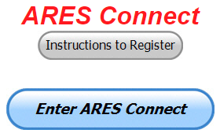
As the numbers show, there’s still some that haven’t taken the plunge yet and need to! What are you waiting for? No matter how much you resist, it’s coming, and we need to make sure that no one is left behind.

Now, as an incentive to get you to not only register…. But to actually start using the system… (Notice how I have that in bold type for you to clearly see?) I am giving away all sorts of goodies to help you get motivated. I have a footlocker of really cool items that I will be giving away!

I’m doing this in various intervals throughout the year, so it will challenge you to be dedicated to getting your hours into the system. You’ll never know just when another drawing will be, so you really do have to be prudent!!

Here’s the top 10 folks for hours thus far in May:

 | Name | Events | Hours
1 | Christopher Domenick (KC8CAD) | 16 | 71.25
2 | Bret Stemen (KD8SCL) | 23 | 70.25
3 | John Westerkamp (W8LRJ) | 28 | 68.08
4 | Robert Baker (N8ado) | 10 | 57.00
5 | Henry Ruminski (W8HJR) | 18 | 46.05
6 | Dan Stahl (KC8PBU) | 32 | 42.50
7 | Elizabeth Klinc (KE8FMJ) | 28 | 39.60
8 | Eldon Peterson (W5UHQ) | 5 | 38.00
9 | James Yoder (w8erw) | 7 | 35.00
10 | Lyle Steinhardt (KE0CZV) | 10 | 28.75

Here’s how we are doing with people getting signed up for events
and the total hours logged so far for May

Total Amount signed into Events | Total Hours for Events
1,019 | 1,561.78

It adds up quickly, but you do have to be registered and actually USE the system in order for any of your time to count. We have a set of instructions on how to get registered right above the button to enter ARES Connect. I would strongly suggest that if you haven’t registered yet, that you read these instructions first.

Here’s a link to get you started... http://arrl-ohio.org/ares_connect_directions.pdf Please, don’t just hurry through the questions, read them carefully, if you don’t understand something, please ask me, I’m here to answer your questions.

TOP ^
We know that you mean well by answering that you do have the needed courses in, but I will let you know that we are verifying what you say you have with what is showing for you in our statewide database when we are completing your registration. So, how can you find out if you are already listed in our statewide database? Easy, here’s a link: http://arrl-ohio.org/SEC/special/ICS%20Complete%20by%20County%20and%20Name.pdf

We now have 1050 registered and growing in the system. As you can see by the numbers above, we are moving very fast to a day when we will all need to be registered in this system for our hours to count. Right now, we depend on our EC’s and DEC’s to remember our hours of volunteering and report those hours for us on their monthly reports. Very soon now those days of the EC and DEC monthly reports will not be necessary.

The time that is spent in getting your information and making sure it is up-to-date and on file with the EC, as well as transferring all of those records when a new EC takes over will also no longer be needed. This system takes care of all of that automatically. Forget a meeting time or location? Just look it up on the calendar and there you have it. If set, you can even see the location on a map! I have attended many meetings and gatherings just because it was listed on ARES Connect and I found it just browsing around. I wouldn’t have known about it if it hadn’t been on the ARES Connect Calendar!

Why is this so important? These hours are what is shown to those we go to for funding as well as for more frequencies to operate on. Yes, we have to justify why we need the money or frequencies to those in government that want “just the facts.” This system allows us to show them the facts, anytime and with great accuracy.

Final.. Final..
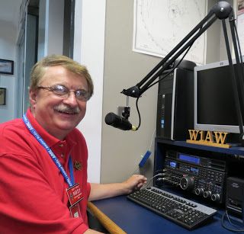
Hey Gang...

This week was just a blur. Everything went by so fast it doesn’t seem like it happened! If you missed Dayton this year you missed out on one of the best hamfests in the country. For me it was 4 days of activities and running from this event or forum to that one. Yes, it was hot, but the rain stayed away for the most part and everything was dry. I hope that you took a minute to stop by the Ohio Section Booth. I couldn’t tell you all the folks that I talked to this weekend; it was great. I’m exhausted but feel really great that the Ohio Section was represented well over this past weekend to all of our visitors from around the world. Thanks to all that helped at the booth and other places.

Now, you really missed out if you didn’t attend the Wouff Hong this time around. I want to say that our Ohio Section Players did a fantastic job and left them rolling in the isles for sure. Thanks, guys, for all the time and effort you all put into making this event something for all of us to remember for sure. Oh, just in case you were wondering. We had over 150 participants that got initiated into the Royal Order this past weekend. Congratulations to all!

73,

Scott, N8SY

TOP ^
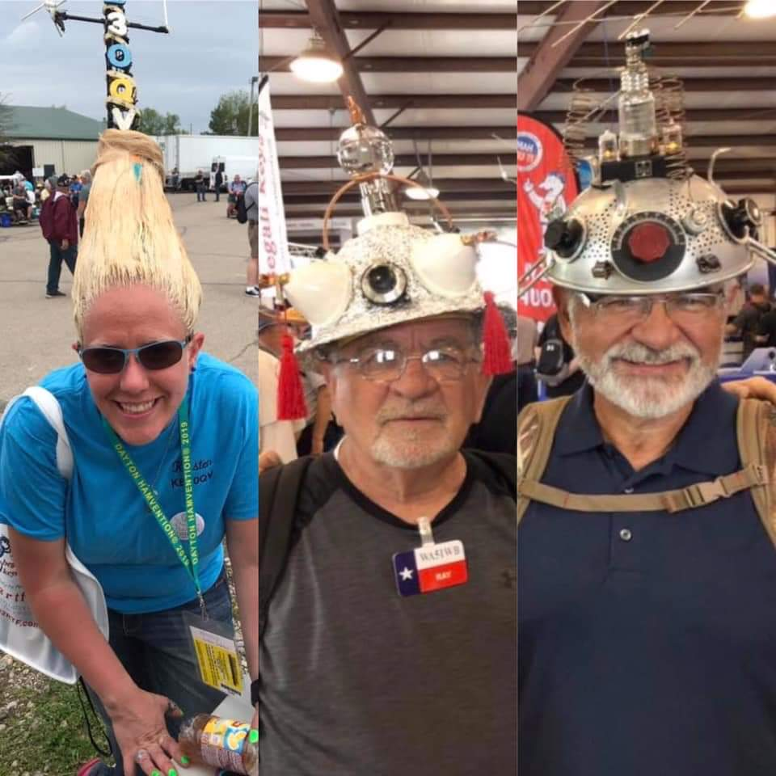
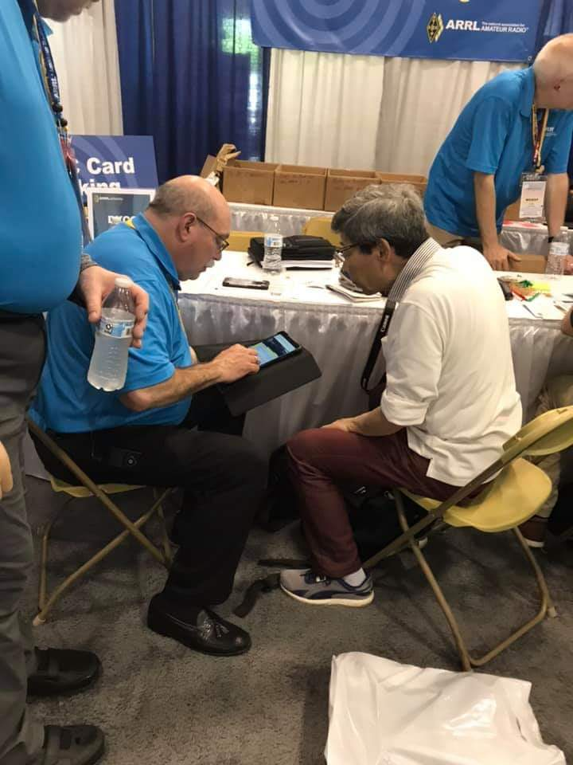
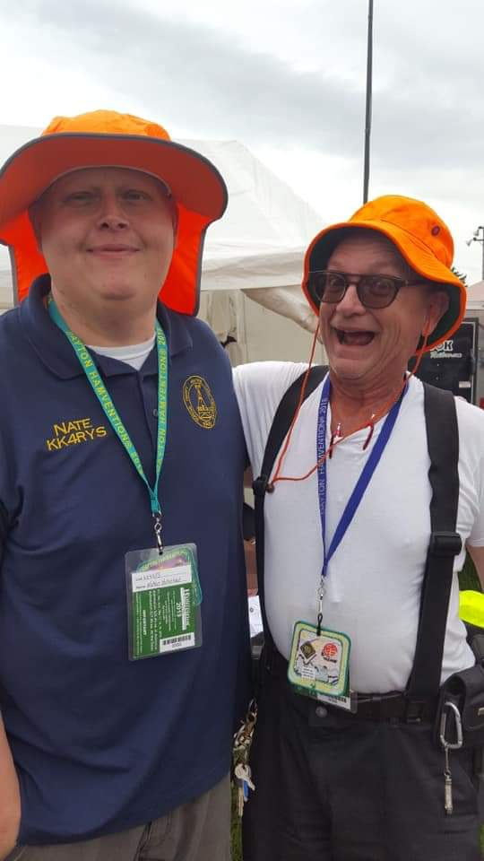
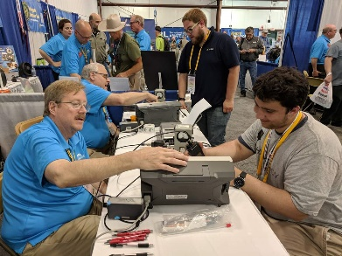
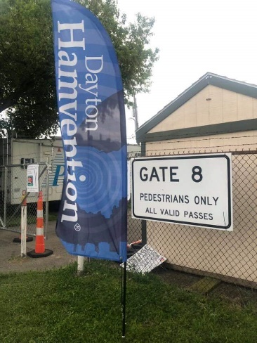
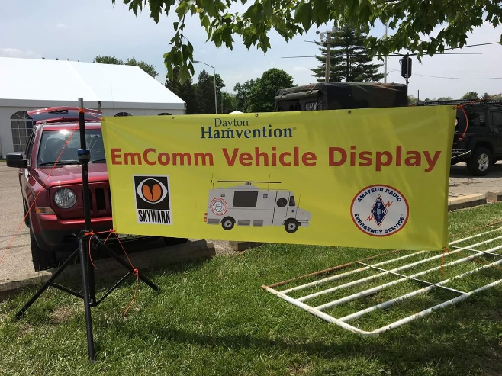
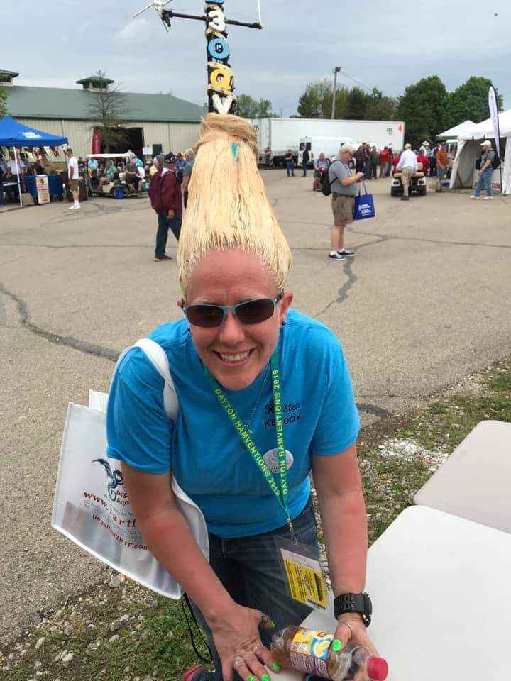

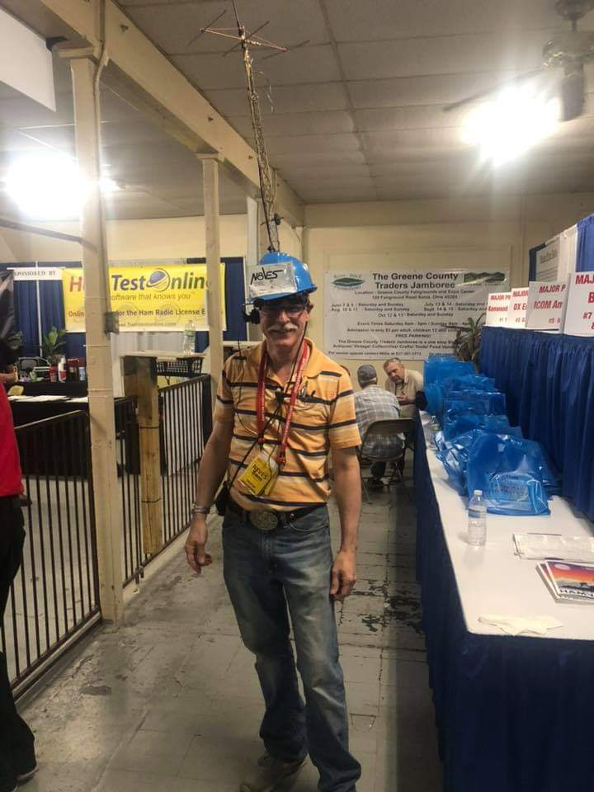
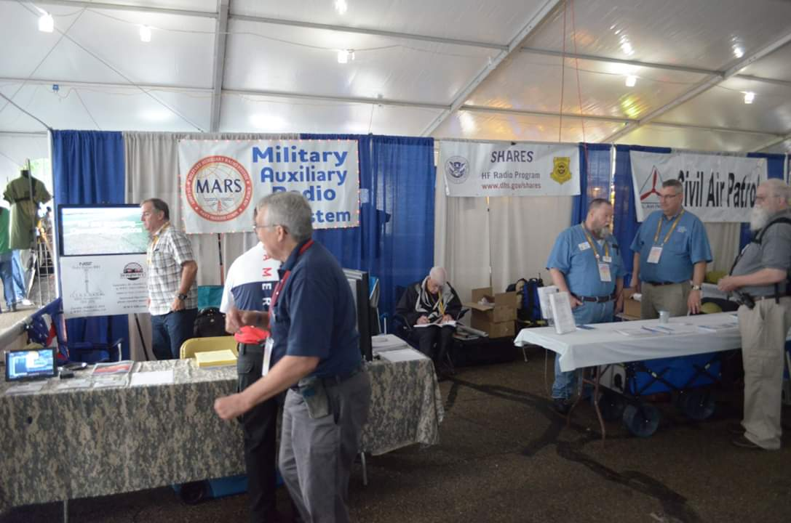

Back Issues of the PostScript and Ohio Section Journal (OSJ)

Hey, did you know that PostScript and Ohio Section Journal (OSJ) are archived on the website? You can go back and look at any edition simply by clicking:
http://arrl-ohio.org/news/index.html

Chit – Chat, and All That!

Do you know someone that’s not getting these Newsletters? Please, forward a copy of this Newsletter over to them and have them “Opt-In” to start receiving them. Heck, just have them send me an email n8sy@n8sy.com and I’ll get them added to the Ohio Section Emailing list.

We now have many thousands of readers receiving these newsletters weekly. Quite impressive, I’d say! I urge all of you to make sure that everyone, regardless of whether they are a League member or not, get signed up to receive these weekly Newsletters.

You can always “Opt-Out” at any time if you feel this is not what you were expecting. It’s fun and very informative. All of your favorite past newsletters are now archived too.
You can go back at any time and read them. Just go to: http://arrl-ohio.org/news/

Got questions, concerns or would just like to sit and chat awhile? Heck, I’ll even buy the coffee!! Give me a call at (419) 512-4445 or email me at: n8sy@n8sy.com

The pictures on the front page are from various newsletters, Facebook posts and/or were sent directly to me in recent weeks. Take a good look at them, you just might be in one of the pictures! “SMILE… you’re on the Ohio Section News!!”

TOP ^

PostScript is produced as a weekly newsletter. I want to thank everyone that has contributed articles and ideas to make this an even better news source. I sincerely hope that you have enjoyed this edition and will encourage your friends to join with you in receiving the latest news and information about the Ohio Section, and news and events happening around the world!

