[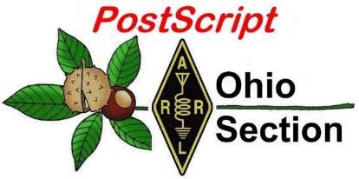](http://arrl-ohio.org/news/) ***Pre Dayton***

***Edition***

🡪 National News 🡪 The Handbook Give Away

🡪 Club Corner 🡪 Hamfests

🡪 DX This Week 🡪 One Question Questionnaire

🡪 VE Testing 🡪 ARES Connect

🡪 Wouff Hong Ceremony At Hamvention 🡪 Final.. Final..

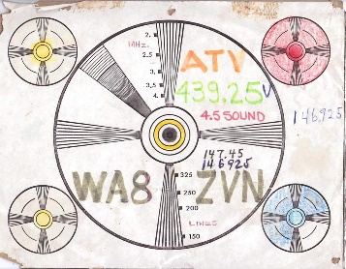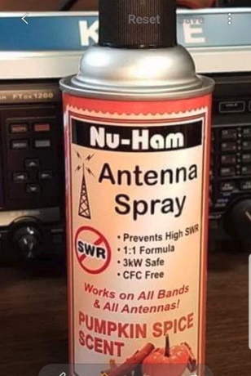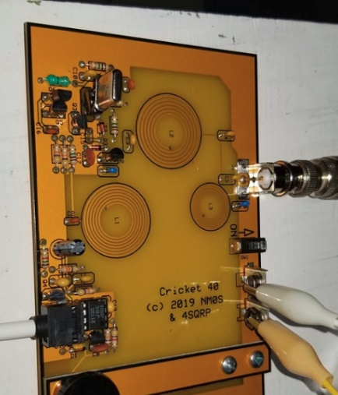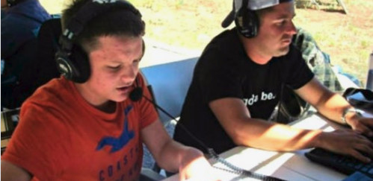

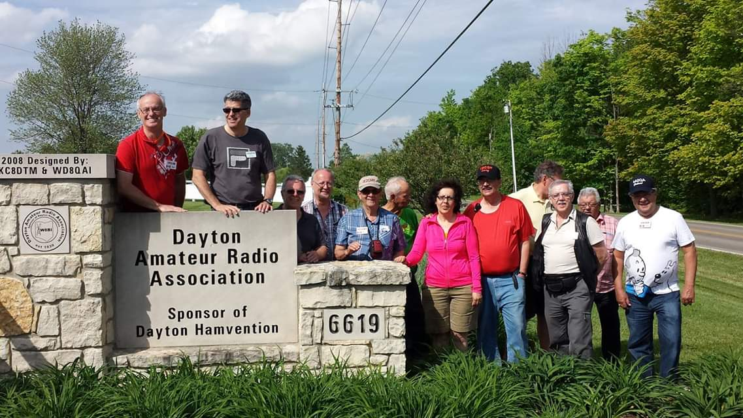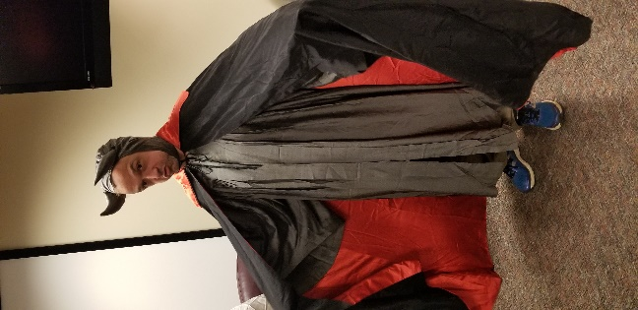

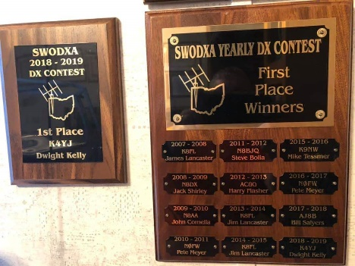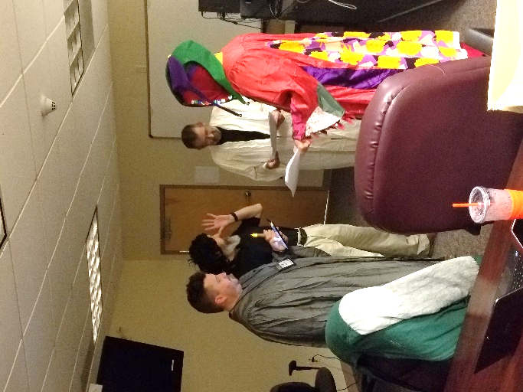

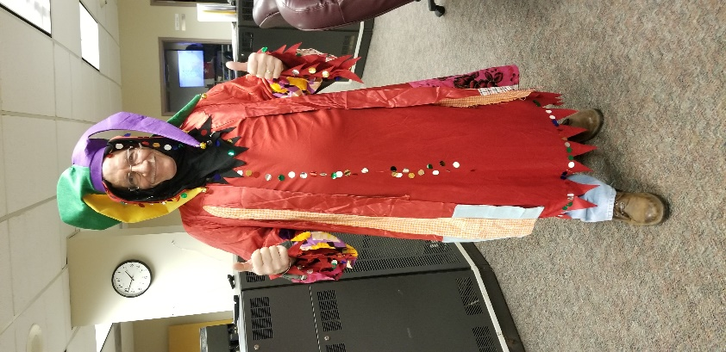

***National News***

*(from arrl and other sources)*

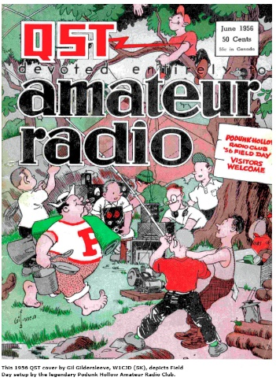

**ARRL Field Day Site Locator is Live, Promotional Material Available**

[**ARRL Field Day**](http://www.arrl.org/field-day) is June 22 – 23. See the May issue of *QST*, page 85, for the Field Day announcement. The [**Field Day site locator**](http://www.arrl.org/field-day-locator) is now up and running, and so far more than 430 sites already are in the database. To find a Field Day site near you, enter your town and state in the “Location or Call Sign” box at the upper left.

Listings also are available by state or Canadian province.

To add a site, visit the [**Add Field Day Station**](http://www.arrl.org/field_days/add) page. [**Information**](http://www.arrl.org/files/file/Field-Day/2018/201820Field20PR%20Kit.pdf) on promoting Field Day is available. Also, [**visit**](http://www.facebook.com/groups/fd2018/) the Field Day social media page for information on promoting your Field Day operation via Facebook, Twitter, Instagram, LinkedIn, and YouTube.

#########

**Mobile Event App will Help Dayton Hamvention Visitors to Navigate the Show**

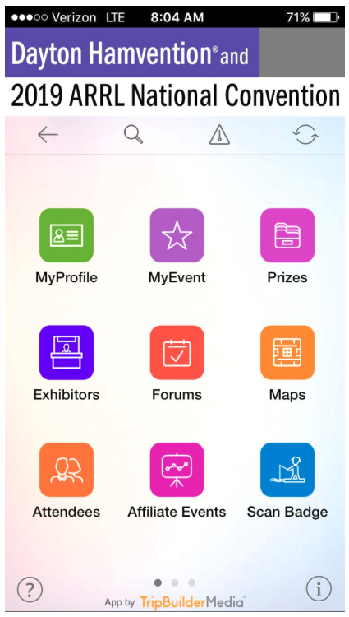[**Dayton Hamvention**](http://www.hamvention.org/)® 2019, host of the ARRL National Convention, will mark the debut of a free mobile event app to help attendees navigate the extensive Hamvention program, activities, and exhibits using their smartphones or tablets. A collaborative effort between ARRL and Dayton Hamvention, the app was developed by **[TripBuilder Medi](http://www.tripbuildermedia.com/apps/arrl)**[a](http://www.tripbuildermedia.com/apps/arrl)™. ARRL Convention and Event Coordinator Eric Casey, KC2ERC, has been readying the app, with content contributions from Dayton Hamvention Committee members, and he just introduced it in a new ARRL [**YouTube video**](https://youtu.be/54NpMZWNl0g).

“Our goal is to have all of the printed program content mirrored in the app, organized so that you can schedule the forums you’re planning to attend, and find the exhibitors you want to visit,” Casey said. In addition to including exhibits and forums, the app will highlight schedules and details for affiliated events, such as dinners and other special gatherings, and a feature to allow attendees to follow the hourly prize drawings from wherever they are.

“Use the app so you don’t miss a winning ticket!” Casey suggested. The Dayton Hamvention Prize Committee will populate the app as winners are drawn.

Attendees are also encouraged to tap on the “MyProfile” icon to optionally include their name and call sign, email address, and any other information they’d like to share with other attendees. “One of the neat features of this app is connecting with other Dayton Hamvention guests who choose to share their contact info,” says Casey. “The icon labeled ‘Scan Badge’ will allow users to scan a QR Code displayed on a second device using the ‘MyBadge’ icon — instantly connecting your shared contact information with another ham. After all, Dayton Hamvention and the ARRL National Convention is where you meet with other members and friends from this great big world of Amateur Radio.”

TOP ^

The free 2019 Dayton Hamvention event app is available for both Apple and Android smart devices. A web-browser version is also available, which is optimized for nearly any browser or other mobile device type. Visit your app store to download the Apple and Android versions (search “Hamvention”) or find [**links**](http://www.arrl.org/expo) on the ARRL National Convention web page. If you are reading this article on a mobile device, [**click here**](http://www.tripbuildermedia.com/apps/arrl) to be automatically redirected to the appropriate app store to download the app, or to be redirected to the web browser version. Please email [**HamventionApp@arrl.org**](mailto:HamventionApp@arrl.org?subject=ARRL20Desk:20App)with any questions about the app.

Dayton Hamvention 2019 is May 17 – 19 at the Greene County Fairgrounds and Expo Center in Xenia, Ohio.

#########

**ARRL Teachers Institute Application Deadline Extended**

The deadline to apply for the 2019 [**ARRL Teachers Institute**](http://www.arrl.org/teachers-institute-on-wireless-technology) program has been extended until Friday, May 10. As part of educational outreach to schools through our [**Education & Technology Program**](http://www.arrl.org/education-technology-program), ARRL each summer offers multiple sessions of the Teachers Institute on Wireless Technology, an expenses- paid professional development seminar.

The Teachers Institute has provided teachers at all grade levels with tools and strategies to introduce basic electronics, the science of radio, space technology and satellite communications, weather science, micro-controllers, and basic robotics in their classrooms. The curriculum is designed for motivated teachers and other school staff who want to learn more about wireless technology and bring that knowledge to their students.

#########

**Hams Help Trace “Mystery” Signal Disrupting Keyless Entry Devices in Ohio**

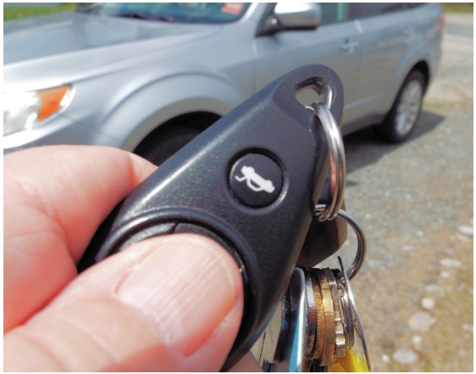A [**recent article**](https://www.nytimes.com/2019/05/04/us/key-fobs-north-olmsted-ohio.html) in *The New York Times* reported that many garage door openers and keyless vehicle entry fobs in an Ohio town near Cleveland mysteriously stopped working. While the article invoked *The X-Files* and hinted initially that a NASA research center somehow could be involved, the cause was not so much mystifying as arcane.

“Garage door repair people, local ham radio enthusiasts, and other volunteer investigators descended on the neighborhood with various meters,” the May 4 article by Heather Murphy recounted. “Everyone agreed that something powerful was interfering with the radio frequency that many fobs rely on, but no one could identify the source.”

More than a dozen residents reported intermittent issues getting their key fobs and garage door openers to operate, and most lived within a few blocks of each other. At one point, the local power utility started shutting off power to areas where the strongest RF signal was detected, but the signal persisted. Dan Dalessandro, WB8ZQH, a TV repairer, was among several hams who investigated. He initially picked up “little blips” on a signal detector, but finally, on one block and at a particular house, the signal was quite loud.

TOP ^

“The source of the problem was a homebrew, battery-operated device designed by a local resident to alert him if someone was upstairs when he was working in his basement,” the *Times* reported. “It did so by turning off a light.” The individual, who, the article said, has special needs, was not identified for privacy concerns. The inventor, who had no malicious intent, had no inkling that his device was wreaking havoc on the neighborhood until a North Olmstead City Council member and a volunteer knocked on his door. The device operated on 315 MHz, the frequency many keyless-entry devices use under FCC Part 15 rules. The device’s battery was removed, the signal stopped, and all who were involved breathed sighs of relief.

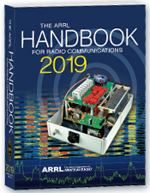***The Handbook Give Away***

Have you registered for the “Handbook Giveaway” drawing for this month yet? If you haven’t, go to: <http://arrl-ohio.org/handbook.html> and get yourself registered now!

What’s the catch? I want to get everyone checking in to the Ohio Section website as often as possible, and in order to register each month, you have to visit the website often! There’s nothing else to it. I pay all expenses and I usually “Give Away” more than just a Handbook too!!

Many of you ask me just how do I know when the drawing is on? Well, that’s easy all you need to do is check in on the Ohio Section Website on a regular basis and watch for the big [**RED**](http://arrl-ohio.org/handbook.html)Arrow that will appear on the left side of the page. This is the sign that the drawing is on and you need to get registered. So, keep a sharp eye out on the website and check in often! <http://arrl-ohio.org>

***Club Corner***

This is YOUR cornner of the newsletter. Send me what your club is doing and I’ll make sure that it gets in. Got a special event or club project that you want everyone to know about? Send it to me!. Need help with a project? Send it to me.

Let me know what you club is up to. Are you going to have a special guest at your meeting or are you having a special anniversary? Just sent it to:

[n8sy@n8sy.com](mailto:n8sy@n8sy.com)

#########

The Toledo Air Show is July 13 & 14 and we did such a great job at the last Air Show the powers that be have requested additional help from us this time around. We are still in the planning phase and do not have final numbers for needed operators, but I wouldn’t be surprised to see a number around 50 or more each day.

The Lucas County EC is the contact person for the air show, [boxcar@toast.net](mailto:boxcar@toast.net).

#########

TOP ^

***TMRA WILL ONCE AGAIN BE HOSTING A BUS TRIP TO HAMVENTION IN XENIA OHIO***

This year’s trip will be on the **Saturday May 18th** and the cost will again be $40.00. This year we are asking people to both Reserve and pay before the May General Meeting if possible. This will allow the Bus to depart on-time and will also make life easier on Mike/WA8SYD. If you want to join the TMRA on the Bus, and we hope you will, please contact Mike/WA8SYD and get your spot reserved. You can contact Mike by Phone at **419-699-1392**.

This year’s trip will follow the standard Trip plan as before

05:30 Depart Scott Park Campus

08:30 (eta) arrive and park near the Front Gate of Hamvention in Xenia Ohio

08:30-17:00 Bus remains available to Riders in Parking Lot

17:00 Depart Hamvention

17:45 (ETA) Arrive at Restaurant in Dayton Ohio

19:00 (EST) depart Restaurant

21:30 arrive back at UT Scott Park Campus

*This is a general Itinerary of the trip and of course times may vary.*

The Bus will remain on-site and open to all Riders throughout the entire day. You are free to leave items on the Bus and return to the Bus to rest or drop off purchased item. If you buy a large item, it can almost certainly fit into the Busses Cargo hold.

Hamvention Bus Reservation and payment can be arranged thru Mike Kehr / WA8SYD. To contact Mike please call him on his Cell Phone at 419-699-1392

We hope to see you on the Bus to Hamvention.

#########



***American TTT race at Salt Fork State Park May 31-June 1 and 2***

There will be a total of 4 races during the weekend. They are;

Friday May 31 from 4pm to 7pm

Saturday June 1 from 7am to 11am

Saturday June 1 from 2:30pm to 7pm

Sunday June 2 from 6:30am to 4pm

For each race the sponsors are requesting 1 radio operator at the command post, 1 radio operator at the start / finish line, and up to 10 radio operators to be stationed along the race course. If we have enough volunteers we may have an radio operator in a SAG vehicle and some mobiles.  The races get progressively longer with the race on Sunday being 24 miles in length. The Friday night race is the shortest so we may not need as many radio operators for it. Each race will have swimming, running and biking components.

After each race there will be food served at the start / finish line and volunteers are welcome to eat.  The lodge and cabins are booked for the entire weekend.  If someone wants to camp I can check on the availability of campsites.

TOP ^

Please let me know if you are willing to help and what times you are available.  After I get a list of volunteers I can start making assignments. Please contact me if you have any concerns or questions.

Dick, WD8SDH Guernsey County EC  cell 740 630 1815

#########

***Ohio Statewide Courthouses On The Air Special Event, August 24, 2019***

*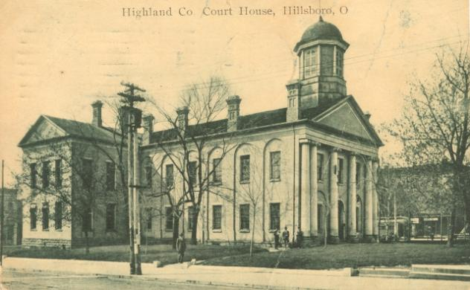***Event Background**

Last year there was the Ohio Covered Bridge Special Event that was led by John Levo, W8KIW Editor of the Highland ARC’s *Monday Morning Memo*. Several clubs participated and was a complete success. Additionally, there were several folks interested in Ham Radio at the event who have now become new Hams. Yes, anytime there is a public event resulting in a gain to the Ham Radio community, it is a total success. This year in keeping with the historical event series, John and the members of the Highland ARC decided to do a special event from their courthouse lawn.

John published an article in the *Monday Morning Memo* which attracted the attention of Michael Love, WB8YKS Southern Ohio Amateur Radio Association (SOARA) PIO. John and Mike decided that there may be interest in an all-state special event celebrating the courthouses in all of Ohio’s 88 counties. Scott Yonally, N8SY Ohio Section Manager thought it was a fantastic idea and requested John and Mike to reach out across the state to determine the level of support for the event. The Ohio Section has 117 affiliated clubs of which 48 are Special Service Clubs and there are 29 PIOs. There may not be a club listed in each county by address, but we do have Hams in each county.

**Promoting Ham Radio**

This may be a first for the ARRL and the Ohio Section. This event has all the opportunities for a FUNFILLED family day engaging the public and our government officials. Additionally, one county’s club is partnering with their county commissioners, historical society, EMA, sheriff’s office, public library, chamber of commerce, and news media. The club has decided to use a large tent as the event will take place rain or shine. Their PIO will make handouts available about ham radio and promoting the ARRL, ARES, RACES, Ohio Section and their local club. A special focus will be made to spotlight the public awareness of the hobby and the benefits of a Ham radio license, emergency and community service. The public will be invited to talk on the radios under the direct supervision of a licensed operator. Several clubs plan to provide contact QSL cards and/or certificates to capture this historical event.

**Fun for Everyone**

There may be some folks dressed in period costumes providing history about their courthouse and the early days in their county. Moreover, one club has requested, August 24, 2019, to be declared as Ham Radio Day in their county, and their county commissioners have approved it.

TOP ^

**Event Details**

Yes, we are excited and hopefully you are as well, about participating in this historical Ohio Courthouses on the Air Special Event. **We are requesting ALL Ohio Clubs and Hams to consider supporting this special event. The event will take place on, Saturday, August 24, 2019, from 9:00 AM to 4:00 PM. However, the hours can be extended by each club. Additionally, each club will determine the frequencies and modes they will use.**

Another opportunity presents itself as the Ohio QSO Party [www.ohqp.org](http://www.ohqp.org) is also on the air, Saturday, August 24th. Therefore, these two events will complement each other providing contacts not only from within Ohio but across the country. All Hams are invited to participate.

**Staying in Touch**

Please inform the listed contacts that your club will be participating, and the name of the county represented. Additionally, there will be updates provided in the *Monday Morning Memo*, the *PostScript,* *Ohio Section Journal, and www.****arrl****-****ohio****.org.*

**Contacts for additional information:**

Michael Love, WB8YKS

wb8yks@arrl.net

John Levo, W8KIW

[highlandara@yahoo.com](mailto:highlandara@yahoo.com)

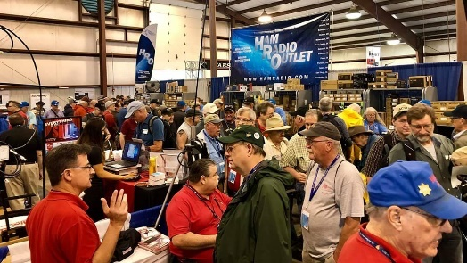[***Upcoming Hamfests***](http://arrl-ohio.org/hamfests.html)

**05/17-19/2019 | Dayton Hamvention**

Location: Xenia, OH

Sponsor: Dayton Amateur Radio Association

Website:  <http://hamvention.org/>

|  |  |
| --- | --- |
| **06/01/2019 | FCARC Summer Swap**  Location: Wauseon, OH Sponsor: Fulton County Amateur Radio Club Website: <http://k8bxq.org/hamfest> | **06/08/2019 | Union County ARC TrunkFest**  Location: Marysville, OH Sponsor: Union County Amateur Radio Club Website: [http://www.ohiohams.net](http://www.ohiohams.net/) |
| **06/15/2019 | Milford Hamfest**  Location: Owensville, OH  Sponsor: Milford Amateur Radio Club  Website: <http://www.w8mrc.com> | **06/15/2019 | W8DXCC DX Convention**  Location: Owensville, OH  Sponsor: SouthWest Ohio DX Association  Website: <http://www.w8dxcc.com> |
| **07/07/2019 | 20/9 Radio Club Hamfest** Location: Austintown, OH Sponsor: 20/9 Radio Club, Inc. Website: [http://20over9.org](http://20over9.org/)  TOP ^ | **07/07/2019 | Ohio Link Swap Meet**  Location: 1801 Gateway Circle, Grove City  Sponsor: Ohio Link Network Group  Website: [www.olnradio.digital](http://www.olnradio.digital) |
| **07/20/2019 | NOARSFEST**  Location: Elyria, OH Sponsor: Northern Ohio Amateur Radio Society Website: <http://noars.net/hamfests/noarsfest> | **07/21/2018 | Van Wert Hamfest** Location: Van Wert, OH Sponsor: Van Wert Amateur Radio Club Website: [http://w8fy.org](http://w8fy.org/) |

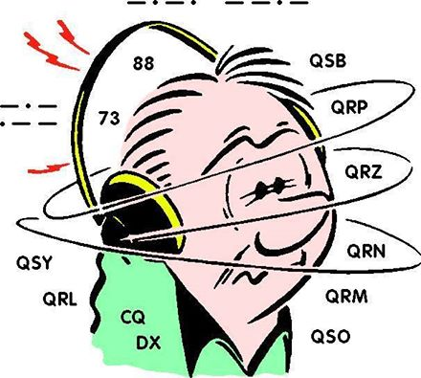***DX This Week***

*(from Bill, AJ8B)*

Bill AJ8B ([aj8b@arrl.net](mailto:aj8b@arrl.net), @AJ8B, [www.aj8b.com](http://www.aj8b.com) or [www.swodxa.org](http://www.swodxa.org) )  
CWOPs Member #1567

Do you remember your first QSL card? Your first DX Card? My first QSL card was from my aunt, WA8FLH and my first DX card was from VE3FGO. That was in 1971! I also remember finding out that I had passed my Novice exam when an envelope from “The Little Print Shop” in Texas arrived with QSL card samples. My name and new callsign were on the outside! It was about 2 weeks later that the actual license arrived. Imagine waiting 6 weeks for your new ticket!

K8DV presents his third installment in the DXCC application process, this time via actual QSL cards. I am not a “we used to walk a mile to school every day” kind of guy, but, I can recall the angst that I experienced when I shipped 200 cards to the ARRL DXCC desk hoping they would receive them, hoping they were all legit and hoping I would get them back! That was the ONLY official evidence of confirmation of the QSO. If those were lost anywhere in the process, it was really bad news.

In fact, I have heard of an application who send 300+ cards to the ARRL DXCC desk and confirmed that they were signed for. That was it…no processing, no awards, no return. They fell in to the Bermuda Triangle of QSL cards.

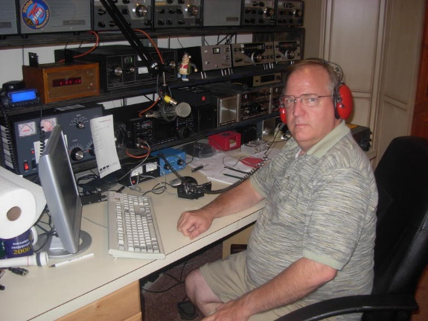**DXCC with QSL Cards**

How to Apply for DXCC Via DXCC Card Checker Using Paper Forms – Dave Vest K8DV

I do not have to tell any of you that **DXCC** is the most prestigious of all Amateur Radio awards. Its rules for membership are clear and when you make your application, accuracy and attention to detail is most important. The guidelines below will help you complete your application to your Card Checker easily and with a minimum of problems. Last issue we wrote about using the DXCC Online Application, my recommendation to all who are submitting QSLs for credit. However, with that said, one can choose to use the ole tried and true method of manual forms.

**The Responsibility of the Card Checker**

Granting entity credits for all DXCC applications is done only at ARRL. The Card Checker’s job is ONLY to verify that the information on the paper application is the same as what is on the card(s) submitted.

TOP ^

The Card Checker only checks the cards and does not award credits, nor do they determine QSL/DX operation acceptance.

**The Rules**

Only cards can be checked by DXCC Card Checkers. An application for a new award shall contain a minimum of 100 QSL confirmations from the list and shall not contain any QSLs that are not eligible (such as printed eQSLs directly from eQSL.cc) for this program. The first-ever application must contain a minimum of 100 separate DXCC entities. First- time ever applications with less than 100 cannot be processed. It is the applicant’s responsibility to get cards to and from the DXCC Card Checker.

Applicants are responsible, up front, for all costs, including postage. It is strongly recommended that you keep a copy of all registered mail or other mail receipts. Neither the ARRL nor the DXCC card checker is responsible for cards handled by DXCC card checkers and will not honor any claims. The applicant and DXCC card checker must sign the application form. The applicant shall provide sufficient postage to the card checker to cover mailing of application and paperwork to ARRL HQ and return of cards if cards have been mailed to the DXCC card checker.

The applicant shall also provide the applicable fees. Credit card number and expiration date is acceptable for the ARRL DXCC costs). As mentioned in the previous article, cash tends to be an issue for DXCC card checkers as this has to be converted to check or credit card payment.

The DXCC Card Checker will forward completed applications and appropriate fee(s) to ARRL HQ. ARRL HQ staff will receive field-checked applications, enter application data into DXCC records and issue DXCC credits and awards as appropriate. There are NO FEES for using a DXCC card checker and the DXCC card checker receives no reimbursement from ARRL.

The applicant and the DXCC Card Checker will be advised of any errors or discrepancies encountered by ARRL staff. Applicants and DXCC members may send cards to ARRL Headquarters at any time for review or recheck if the individual feels that an incorrect determination has been made. Cards not eligible for field checking must be sent to ARRL and cannot be sent along with an application checked by the checker.

The applicant can opt to send the entire submission to ARRL if they wish. Any QSL deemed ineligible sent with an application will be returned unprocessed.

**To Submit an Application To The Card Checker**

* The applicant should look through all the cards and check for the following:
* Your Main Application sheet must be the latest issue.
* Your callsign and the callsign of the station worked is on each card.
* The CALLSIGN QSO DATE, BAND, MODE and ENTITY is on each card
* That the Entity callsign and the Entity name match on each card
* The card has not been altered in any way.
* That you have at least 100 cards if you are making your Initial or First application.
* 160M cards and deleted entities OK.

TOP ^

The applicant should sort the cards in order – first by band, then by mode. Cards with multiple QSO’s must be together in a group of their own, at the end. Cards must NOT be sorted alphabetically. The Sort Order of the cards MUST MATCH EXACTLY the order of which the cards appear on DXCC application Form (Part 2 The listings)

**Initial New DXCC Application Form Part 1**

Forms can be found here: [DXCC Application Forms](http://www.arrl.org/dxcc-forms) The information on Part 1 tells DXCC what you are requesting and it also tells them your current mailing address so that all returns can be sent to the proper address. There is also the applicant’s affirmation section. Check which award you are applying for eg: NEW, ENDORSEMENT, MIXED or PHONE or CW etc. Then list the Number of cards and the Number of QSOs, Complete the right hand side of the form with your name, callsign and all other details.

DXCC Fees are shown in DXCC Rules on this Website  [DXCC Fees Schedule](http://www.arrl.org/dxcc-awards-fees)

**Endorsement Applications:**

This is ONLY for building totals on Existing awards. Often people check off endorsements when they do not have an award but are only building totals for a future award. Once you have a DXCC you can build your number as you wish. There are no restrictions.

When you finally reach 100 then you can check off NEW. Then, in future submissions you can endorse them. Your name and address is required as this affects where your paperwork will be sent AND where the yearbook will be sent. The yearbook is not sent to the QST address unless the DXCC address is the same as the QST address. You must sign and date it and place the month and year of your membership expiration if you are an ARRL member. (Applications have been placed on hold if the signature is missing.)

**Part 2: The Record Sheet:**

This is the second part of the application [DXCC Application Forms](http://www.arrl.org/dxcc-forms) where you list the QSO’s you intend to claim credit for with the submission. The importance of accuracy and legibility here *cannot be emphasized enough*. Cards may be rejected if complete information is not on the record sheet. The applicant’s callsign shown on the card must match exactly. If it is different in anyway it will be rejected. (eg: K8DV is not the same as KD8V etc).

**Sending Your Cards**

Package up your cards and SIGNED Application form securely and send them to the DXCC Card Checker:

**Mailing Suggestions**

1. Label the first envelope or Pack to me with the address above and your return address.

2. Label the second envelope or pack to your home address with the address above on the back. I will return your cards in the same envelope.

3. Enclose a third business sized envelope (with at least one unit of first class postage) on it.  Have it addressed to:

TOP ^

**DXCC Desk, ARRL HQ**  
**225 Main Street**  
**Newington CT 06111**

The third envelope will be posted by the card checker to the DXCC Desk with your application form inside.

**Payment**

122The ARRL DXCC requires payment for all awards and endorsements. You can do that by simply filling in your Credit Card details on the right hand column of Application Form A. ARRL will then charge EXACTLY the amount required to your Credit Card in US Dollars converted to New Zealand Dollars.  [DXCC Schedule of Fees](http://www.arrl.org/dxcc-awards-fees)

**Basic Do’s and Don’ts for DXCC Applicants**

**Do’s**

Be careful, check closely every card carefully BEFORE submission.  
Make sure applications are complete and information is legible  
Make sure ALL data is recorded properly  
Make sure entity name and callsigns match (this is a frequent problem)  
If the record sheet is not in proper order, the applicant must re-do the application in the proper format.

**Don’ts**

Don’t leave fields that are blank on the record sheet, all fields are required  
I strongly suggest that you look at the ARRL DXCC web site  
It will give you insight into what the rules are all about.

If you have any problems or questions concerning your application you can reach me at k8dv@cinci.rr.com

+ --------------------------------------------------------------------------------------------------------------------+

Here is an update from Bernie, W3UR, of the DailyDX and the WeeklyDX, the best source for DX information. (<http://www.dailydx.com/> ) Bernie has this to report:

HS10KING/mm to operate May 3-6  
By HS0ZDX, Tony Waltham  
  
To mark the Coronation of King Vajiralongkorn Bodindradebayavarangkun (King Rama X) from May 4 to May 6, 2019 the Radio Amateur Society of Thailand under the Patronage of His Majesty the King (RAST) will be operating a special event station from the Royal Thai Navy aircraft carrier, the Chakri Narubet, in the Gulf of Thailand from May 3 to May 6 using the callsign HS10KING/mm.  
  
This station will be making QSOs in the 40, 20, 15 and 10 metre HF bands, on 2 metres VHF and also using amateur radio satellites, including the Es'hail 2 / QO-100 satellite.

**J20DX – Moucha Island – Seven Brothers Island – Djibouti –** The following (unfortunate) update is from the J20DX Website. 73 Bernie, W3UR This expedition would test the patience of most people.

TOP ^

On April 18th, at 0700 local, we departed the mainland for the 40 minute crossing to Moucha Island. We identified an excellent location for radio upon arrival and immediately assembled a 15m VDA and 17m & 20m vertical dipoles. Our intention was to add more antennas as the day progressed.

Literally 5 minutes before the first CQ from AF-053 we received a phone-call from National Security saying signatures were needed for the authorization letter to permit us to collect our impounded gear. This same letter would also allow us to depart Djibouti without any more issues at airport customs. However, we had to return to the mainland to get the letter.

The weekend is Friday and Saturday here in Djibouti meaning this would likely be our final chance of obtaining the important authorization letter prior to heading home.

Before we had even started, teardown begun. Yes, we left the island 2 hours after arriving. AF-053 is now also cancelled.

Upon returning to the mainland we headed straight to the National Security offices. Yes, you guessed it – no authorized letter to be seen. We had basically been told fake news.

We’ve now had enough of this country and look forward to heading home.

+ --------------------------------------------------------------------------------------------------------------------+

***A******RLD017 DX news***

This week's bulletin was made possible with information provided by The Daily DX, The OPDX Bulletin, 425 DX News, DXNL, Contest Corral from QST and the ARRL Contest Calendar and WA7BNM web sites. Thanks to all.

**FIJI, 3D2.** Oleh, KD7WPJ will be QRV as 3D2/KD7WPJ from Viti Levu Island, IOTA OC-016, from May 11 to 16. Activity will be on 40 to

12 meters using CW and SSB. QSL to home call.

**MONTENEGRO, 4O.** Oskar, LB9N is QRV as 4O/LB9N from Igalo until May 11. QSL to home call.

**BOLIVIA, CP.** Lance, W7GJ is QRV as CP1GJ from Copacabana until May 16. This is a 6 meter EME operation using SSB or FT8. He monitors

50183 kHz. QSL direct to home call.

**KYRGYZSTAN, EX.** Special event station EX26Y is QRV from Cholpon-Ata and then Bishkek until May 15 to celebrate the founding of Kyrgyzstan's national amateur radio society 26 years ago. Activity is on 160 to 10 meters using CW, SSB and various digital modes. QSL direct to EX7DI.

**ENGLAND, G.** Members of the Cray Valley Radio Society will be QRV as GB6MW from Meopham Windmill during Mills On The Air. QSL via LoTW.

TOP ^

**JERSEY, GJ.** Operators Marc, PD7YY, Marcel, PG8M and Lars, PH0NO are QRV as MJ/PG8M/p and MJ/PH0NO/p until May 12. This is a World Wide Flora and Fauna expedition activating various nature reserves on the island. Activity is on 80 to 2 meters using CW and SSB. QSL via operators' instructions.

**ST. LUCIA, J6.** Bill, K9HZ is QRV as J68HZ from Soufriere until May 13. Activity is on 160 to 2 meters using CW, AM, SSB and RTTY. QSL direct to home call.

**JAPAN, JA.** Kenji, JA4GXS will be QRV as JA4GXS/1 from Hachijo-jima, IOTA AS-043, from May 11 to 13. Activity will be on 40, 30 and 20 meters using CW, SSB and FT8. QSL to home call.

**ALASKA, KL.** Mike, K9AJ and Bruce, KD6WW are QRV as K7Y from Khantaak Island, IOTA NA-250, until May 13. Activity is on 40, 30,

20 and 17 meters using CW, with some SSB and FT8, with two stations active. This is the first activation of IOTA NA-250. QSL via K9AJ.

**LITHUANIA, LY.** Special event station LY15EU is active until May 26 to celebrate the 15th anniversary of Lithuania's membership in the European Union. QSL via LY2QT.

**SLOVAK REPUBLIC, OM.** Special event stations OM2019IIHF and OM83IHWC are QRV until May 31 during the 83rd Ice Hockey World Championship being held in Slovakia. QSL via OM2FY.

**NETHERLANDS, PA.** Mark, PD0ME, Frank, PD5JFK and Bernard, PB7Z are QRV as PB19MILL until May 13 from the De Eendracht Windmill in Gieterveen during Mills On The Air. Activity is with three stations on the HF bands, as well as 6 and 2 meters, and 70 centimeters. QSL via bureau.

**GREECE, SV.** Jacques, F6HMJ will be QRV as SV8/F6HMJ from Ios Island, IOTA EU-067, from May 14 to 28. Activity will be holiday style on 80 to 10 meters using CW and SSB. QSL to home call.

**CORSICA, TK.** Martin, DB4BJ is QRV as TK/DB4BJ until May 17. Activity is on 60 to 20 meters using mostly FT8. QSL to home call.

**VIET NAM, XV.** Tom, DL7BO will be QRV as XV9BO from Mui Ne from May 13 to 19. Activity will be on 160 to 10 meters using CW, SSB, RTTY and FT8. QSL to home call.

**INDONESIA, YB.** Special event station 8G248G will be QRV on May 11 and 12 to celebrate the 248th anniversary of Gianyar City. Activity will be on 80 and 40 meters. QSL via operators' instructions.

THIS WEEKEND ON THE RADIO. The CQ-M International DX Contest, NCCC RTTY Sprint, Mills on the Air, NCCC CW Sprint, VOLTA World Wide RTTY Contest, SKCC Weekend CW Sprintathon, Arkansas QSO Party, FISTS Spring Unlimited Sprint, 50 MHz Spring Sprint and the WAB 7 MHz Phone/CW are all on tap for this weekend. The 4 States QRP Group Second Sunday Sprint and RSGB 80-Meter Club SSB Championship are scheduled for May 13.

The CWops Mini-CWT Test and Phone Fray are scheduled for May 15.

The Canadian National Parks on the Air, CNPOTA, operating event runs for the entire year of 2019, with special stations active from Canada's parks and historic sites.

TOP ^

***Special Events***

**06/01/2019 | Museum Ships Weekend**

**Jun 1-Jun 2, 1100Z-2100Z, K8E**, Toledo, OH. Toledo Mobile Radio Association and National Museum of the Great Lakes. 14.260 14.039 7.260 7.039. QSL. SS Col. James M. Schoonmaker, Team K8E, P.O. Box 9673, Toledo, OH 43697. [www.tmrahamradio.org](http://www.tmrahamradio.org/)

**06/15/2019 | W8DXCC DX Convention**

**Jun 15-Jun 16, 0000Z-2359Z, K8S – K8W – K8H – K8O**, Owensville, OH. SouthWest OH DX Association. 14.245 14.074 7.245 3.535. Certificate & QSL. AJ8B - Bill, 8275 Cierra Way, Waynesville, OH 45068. This is the inaugural year for this DX Convention. We are using these call signs: K8S, K8W, K8O, K8H. A QSL for each and/or certificate for working all four. [www.w8dxcc.com](http://www.w8dxcc.com/)

**06/24/2019 | Simon Kenton Council, Delaware District, Cub Scout Day Camp**

**Jun 24-Jun 28, 1330Z-1700Z, K2BSA/8**, Lewis Center, OH. Delaware Amateur Radio Association K8ES. 14.290 7.190. QSL. Ed Jones, 2965 Seaway Ct, Lewis Center, OH 43035. We'll be operating each day from 13:30-19:30 from Camp Lazarus in Ohio. We'll have hundreds of scouts on the air over the course of the week.

**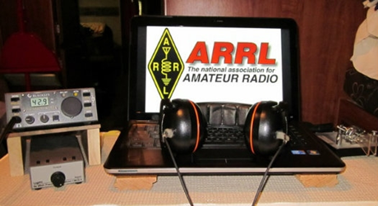*ARRL Contest Corner***

An expanded, downloadable version of *QST'*s [Contest Corral](http://www.arrl.org/contest-calendar) is available as a PDF. Check the sponsor's Web site for information on operating time restrictions and other instructions.

***One Question Questionnaire***

Hey Gang,



It seems that only about 20% of you will be purchasing new radios at Dayton this year. I’m looking at a couple of models, but haven’t completely committed myself yet as whether I’m going to take the plunge or not. I guess it will come down to a flip of a coin!

There’s another NEW – one question – questionnaire on the Ohio Section Website! <http://arrlohio.org> Since the weather people are now predicting that the weather will be hot and sticky for the Hamvention, this next question is important to know.

**“Are You Up-To-Date with your First Aid and CPR Training??”**

Anyway, these questions are all in fun and I hope that you are enjoying answering these “ONE QUESTION” questionnaires. Ok, enough on that, here’s the next question for you to answer…

TOP ^

You’ll find the “One Question” questionnaire on the Ohio Section Website! <http://arrlohio.org> It’s all in fun and it’s not a scientific survey in any way, but we are learning some things that we didn’t know from these questions. I hope that you are enjoying answering these “One Question” questionnaires.

*****V.E. Test Sessions***

For the latest testing site information please **>>** [**Click Here**](http://www.arrl.org/find-an-amateur-radio-license-exam-session) **<<** The ARRL site tracks all of the VE testing sites that register with them, including W5YI and Laurel. ARRL gives you a number of different ways of sorting to find that site that is closest to you as well.

***Incident Command System (ICS) Training Schedule***

All current trainings are listed on the Ohio EMA training calendar located at:

<https://webeoctraining.dps.ohio.gov/TrainingAndExercise/courselist.aspx>

I’ve been asked to also include a link to the Kentucky EMA training calendar as well..

<https://kyem.ky.gov/training/Pages/default.aspx>

<https://sites.google.com/site/ccoemtraining/home>

Please pay particular attention to these courses listed above, as that there’s a lot of ICS 300 & 400 classes listed that are very useful for all Amateurs to have under their belts. I will also state that G775 is also a very good course to take as well. These 3 courses are multiple day in class courses, so please be prepared to spend some time taking them.

We do recognize that IS-300/400 requires multiple days of actual classroom training that is not easily obtained. So, if you just can't find the time to fit these class room courses in, we do have an alternative method for getting you to Level 3.

Completing the following **“FREE”** and **“ONLINE”** courses will act as substitute for you FEMA Leadership Development Course requirements. You absolutely will need to complete all **7** of these courses to get your ICS 300/400 credit.  Here are the courses that you need to take:  **IS-120, 230, 240, 241, 242, 244 & 288.**

***Now, if you are looking for wallpaper and have a little extra time, taking IS-235 in addition to the 7 listed courses above, you will get a really cool looking certificate from FEMA stating that you have completed the Professional Development Series. That’s impressive in itself!***

#########

TOP ^

***ARES Connect***

***CQ… CQ…. CQ… Calling all Ohio persons to be a part of the new ARES Connect program.***

We need to discuss some very important items that only YOU can make a difference with. I need you to get yourselves registered in ARES Connect, that is… if you haven’t already.

**If you live in Ohio** and you haven’t registered yet, we need you to get registered now. **We need you to only use this URL to get registered** [**https://arrl.volunteerhub.com/lp/oh/**](https://arrl.volunteerhub.com/lp/oh/)**.** **Using any other entrance to register will only slow down your registration process. Again, this is for those living in Ohio only. If you are an out of state person (not Ohio), you can simply change the /oh/ to your 2 letter state designation. This will put you in the correct state for signing up**

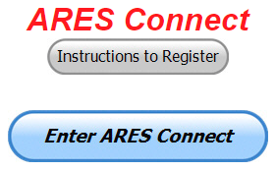As the numbers show, there’s still some that haven’t taken the plunge yet and need to! What are you waiting for? No matter how much you resist, it’s coming, and we need to make sure that no one is left behind.

**Now, as an incentive to get you to not only register…. But to actually start using the system…** *(Notice how I have that in bold type for you to clearly see?)*I am giving away all sorts of goodies to help you get motivated. I have a footlocker of really cool items that I will be giving away!

I’m doing this in various intervals throughout the year, so it will challenge you to be dedicated to getting your hours into the system. You’ll never know just when another drawing will be, so you really do have to be prudent!!

***Here’s the top 10 folks for hours thus far in May:***

|  |  |  |  |
| --- | --- | --- | --- |
|  | **Name** | **Events** | **Hours** |
| 1 | Christopher Domenick (KC8CAD) | 7 | 48.00 |
| 2 | Dan Stahl (KC8PBU) | 20 | 35.50 |
| 3 | James Yoder (w8erw) | 3 | 31.00 |
| 4 | Bret Stemen (KD8SCL) | 14 | 30.00 |
| 5 | Timothy Lovejoy (NC8OS) | 3 | 24.00 |
| 6 | John Westerkamp (W8LRJ) | 14 | 20.08 |
| 7 | William Curtice (WA8APB) | 2 | 15.50 |
| 8 | John Major (KD8MMY) | 6 | 15.00 |
| 9 | Frederick Myers (Kk6zhw) | 4 | 11.50 |
| 10 | Timothy Gray (KD8IZU) | 2 | 11.00 |

***Here’s how we are doing with people getting signed up for events***

***and the total hours logged so far for May***

|  |  |
| --- | --- |
| Total Amount signed into Events | Total Hours for Events |
| 528 | 926.83 |

TOP ^

It adds up quickly, but you do have to be registered and actually USE the system in order for any of your time to count. We have a set of instructions on how to get registered right above the button to enter ARES Connect. I would strongly suggest that if you haven’t registered yet, that you read these instructions first.

Here’s a link to get you started... <http://arrl-ohio.org/ares_connect_directions.pdf> Please, don’t just hurry through the questions, read them carefully, if you don’t understand something, please ask me, I’m here to answer your questions.

We know that you mean well by answering that you do have the needed courses in, but I will let you know that we are verifying what you say you have with what is showing for you in our statewide database when we are completing your registration. So, how can you find out if you are already listed in our statewide database? Easy, here’s a link: <http://arrl-ohio.org/SEC/special/ICS%20Complete%20by%20County%20and%20Name.pdf>

***Admin 2.0 Issues***

I’m happy to report that Volunteer Hub has let us know that the issues it was having with the new ADMIN 2.0 Dashboard has been corrected. If you didn’t know, or just never used the ADMIN 2.0 Dashboard feature, it originally had a problem with allowing users the ability to create events. They are now saying that the issue has been corrected and everything should be working just fine now. Please let me know if it gives you any problems. I’ll report it immediately to Volunteer Hub.

***Changes within ARES Connect - Ohio***

The past week has really been busy for me and the folks at Headquarters in that we have now established several new “User Groups.” We have a “User Group” specifically for the DEC’s and we also have for the EC’s as well.

The DEC’s here in Ohio have been upgraded with the same Admin rights as Stan and I have. This will allow for more flexibility and for more future additions to the system.

***Also..*** We now have all 10 of our Districts loaded into the system! That in itself is a huge accomplishment! Everyone in the system has been assigned to their proper District already. This will now allow the DEC’s the ability to list District events instead of having to repeat the event for each county in the District. This one new item alone will do wonders in helping alleviate the congestion that we’ve all seen on the Event Calendar. It also gives the DEC’s the ability to quickly and easily communicate with everyone on the District Level via Email as well.

We now have 1033 registered and growing in the system. As you can see by the numbers above, we are moving very fast to a day when we will all need to be registered in this system for our hours to count. Right now, we depend on our EC’s and DEC’s to remember our hours of volunteering and report those hours for us on their monthly reports. Very soon now those days of the EC and DEC monthly reports will not be necessary.

The time that is spent in getting your information and making sure it is up-to-date and on file with the EC, as well as transferring all of those records when a new EC takes over will also no longer be needed. This system takes care of all of that automatically. Forget a meeting time or location? Just look it up on the calendar and there you have it. If set, you can even see the location on a map! I have attended many meetings and gatherings just because it was listed on ARES Connect and I found it just browsing around. I wouldn’t have known about it if it hadn’t been on the ARES Connect Calendar!

TOP ^

Why is this so important? These hours are what is shown to those we go to for funding as well as for more frequencies to operate on. Yes, we have to justify why we need the money or frequencies to those in government that want “just the facts.” This system allows us to show them the facts, anytime and with great accuracy.

***Sign Up for Hamvention Alerts***

If you are planning a visit to Hamvention 2019, you are urged to sign up for the Hamvention alerts which are available again this year on your mobile phone. To subscribe to the system just text **Hamvention19** to **888777**. The alerts will provide up-to-date information for those traveling to or attending Hamvention such as weather, traffic, parking and other useful information throughout Hamvention. If you signed up for the alerts in 2018 you are automatically registered for this year.

The alerts are especially important for up-to-minute information about parking and weather, especially for those who might not be able to monitor the talk-in or bulletin stations. The alerts will provide another way to direct drivers to the best parking solution if weather requires closing some onsite parking lots or if some remote lots fill up. A special thanks to Greene County Sheriff Gene Fischer, KX8GCS, for making the alerts possible again this year

The Media Committee is working to make winning prize numbers available on the alert system soon after they are drawn. This is an effort to help winners claim prizes and to decrease the number of unclaimed prizes that must be redrawn prior to the main prize drawing on Sunday. During Hamvention the numbers from the hourly prize drawing will be posted on Twitter and Facebook as well as displayed on monitors throughout the fairground's buildings. Following Sunday's Grand Prize drawings, winners will also be posted on Twitter and on <http://hamvention.org/event-details/prizes/>.

The alert system, which was initiated in 2018, was a Hamvention effort to get visitors the information they need. It is a supplement to the Hamvention talk in station that has operated for many years on the Dayton Amateur Radio Association repeater, 146.94(-) 123.0 Tone to give directions and other assistance.

Last year a traffic bulletin station was also added on 145.525 to periodically repeat needed information. Amateurs with 2-meter capability are urged to enter those frequencies into their radios before starting their Hamvention journey.

Hamvention 2019, the world's largest amateur radio gathering, will be held May 17-19 at the Greene County Fairgrounds and Expo Center in Xenia, OH.

***This and that’s***

***VOA Expanded Hours during Hamvention***

*(from Radiogram)*

The National Voice of America Museum of Broadcasting, a short drive from Hamvention® , announces expanded hours for Hamvention weekend. The Museum is located at the site of the former Voice of America Bethany Relay Station in West Chester, between Dayton and Cincinnati, just off the I-75 Tylersville Road exit.

TOP ^

From 1944 thru 1994, six of the most powerful shortwave transmitters in the world broadcast to listeners seeking truth in Europe, Africa and South America from the Bethany Station. Every week millions heard programs in 50 different languages beamed globally from this hilltop.

Those attending the 2019 Dayton Hamvention® will have ample opportunities to visit. The Museum is located about 35 minutes from the main convention activities. A booth for the museum and WC8VOA is located in space #1910 in building 1 at Hamvention®.

The Ham Shack for WC8VOA will be open, as well as some unique exhibits such as the comprehensive collection of Drake Amateur Radio gear, the remaining Collins 250,000 watt transmitter, the 1960’s VOA Master Control room, the Powel Crosley Jr. Exhibit, and an exhibit about the US Coast Guard Cutter “Courier” a cold war era floating radio transmission facility that relayed VOA Bethany broadcasts to the Middle East and Soviet Union.

The VOA Museum is open every Saturday and Sunday from 1-4 pm.

Special hours for Hamvention® Attendees are: Thursday, May 16th from 4 to 9 pm. Friday, May 17th from 4 to 9 pm Saturday, May 18th from 1 to 9 pm and Sunday, May 19th from 1 to 5 pm Admission is just a five-dollar donation.

In addition this year, the museum has a special offer for new donors visiting during Hamvention® on Saturday, May 18th only. From 6:30 to 9 pm, new Museum donors of at least $45 will receive: Free general admission to the Museum A guided tour of the Museum’s Crosley Collection A tour of the historic WLW transmitter site featuring the Crosley 500 kw WLW transmitter. This tour will be conducted by internationally known broadcast veterans Jay Adrick, K8CJY and Geoff Mendenhall, W8GNM. Transportation from the Museum to the WLW transmitter site and back is included. Space is limited on the WLW transmitter tour, and reservations are required. To sign up, visit [www.voamuseum.org](http://www.voamuseum.org). More information about the museum and the special WLW transmitter tour option is available at [www.voamuseum.org](http://www.voamuseum.org)

**#########**

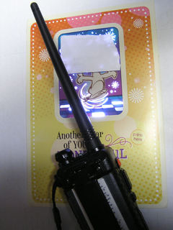

***Simple RF Radiation Detector***

*(By Paul Signorelli, W0RW and submitted by Greg, WD9FTZ)*

You can get a simple RF radiation detector right at your greeting card store at your supermarket or store.

The electronics inside those “musical” greeting cards is poorly shielded. They can be initiated with a small handie-talkie. If you put your HT on some unused frequency, (Don’t use 146.52, 446.000 or any repeater frequencies) and key the transmitter you will find the most sensitive to your frequency.

TOP ^

My ‘dancing dog’ card is most sensitive at 440 MHz and above. I even used it to check the door leakage on my microwave oven, (don’t put it inside). When it detects RF the card starts playing music and the LED’s start flashing. Happy songs.

Some cards may not start because they don’t respond to your frequency or because you have fried them. If you fry them, you buy them.

**#########**

***DMR Growing***

*(from Greg, WD9FTZ)*

From Sept. 1, 2018 to May 12, 2019, there have been an additional 497 Ohio DMR ID's issued, and out of that number, YL's accounted for 19 of them. That is 3.82 percent.

***SWODXA DX DINNER ANNOUNCEMENT***

*(from Mindi Jones, KC8CKW | mindew@fuse.net)*

**FOR IMMEDIATE RELEASE**

There is only a couple of days left until the SouthWest Ohio DX Association (SWODXA) hosts the 34th annual DXDinner®. The dinner, held in conjunction with the 2019 Dayton Hamvention®, will be on Friday, May 17th, at the Marriott Hotel in Dayton.

Charlie Wooten, NF4A, has been licensed for over 56 years and has been a DXer from the start. Charlie has achieved the DXCC Honor Roll. He is the current Southeastern Division Representative on the ARRL Contest Advisory Committee. He was a referee for the WRTC-2006 international team championship held in Brazil in July 2006, WRTC-2014 New England/USA, and WRTC-2018 Lutherstadt, Germany.

Yaesu has donated an FT-1200 for the DX Forum and an FT-3000 for the DXDinner. Icom has donated an IC-7610. There will be many other prizes as well! The newest inductee(s) in to the CQ Hall of Fame will be

announced, The IREF will announce the IOTA Expeditioner of the Year award, and SWODXA will announce the much-anticipated DXPedition of the Year!

80% of the available ticket sales have sold so don’t wait much longer. For more information and to order dinner tickets, visit [WWW.SWODXAEVENTS.ORG](http://WWW.SWODXAEVENTS.ORG) and follow us on Twitter (@SWODXA).

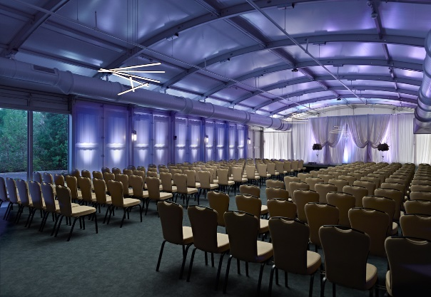***Wouff Hong Ceremony At Hamvention***

When: **Saturday – May 18th starting ~ 9:00 PM** Where: Marriott at the University of Dayton

Hey Gals and Guys… You’ve been asking if this is going to happen, and now I can tell you for sure, YES, we are having a Wouff Hong Ceremony at Dayton!!!

TOP ^

The Conclave will gather at 9pm and those willing to take the plunge and become a part of this ever growing and most secretive of all Societies. Come join us and be indoctrinated into history!

The ceremony is steeped in mystery! Attendees will receive a special keepsake. A fun activity for all ages. Doors to the conclave will open at 9:00 PM (no admittance after 9:30 PM) at the Marriott at the University of Dayton (Tradewinds Pavilion), 1414 S Patterson Blvd, Dayton, OH 45409. **Free** **registration online** to ensure there will be enough seats, and to get a really cool certificate following the ceremony. Go to:

[**http://arrl-ohio.org/wouff-hong.html**](http://arrl-ohio.org/wouff-hong.html)**.** This event is sponsored by the ARRL Ohio Section.

**Now, for those of you who don’t know what Wouff Hong is all about:**

A Wouff Hong is a fictional tool used to "punish" Amateur Radio operators who demonstrate poor operating practices. Legend has it that the Wouff Hong was invented by ARRL co-founder Hiram Percy Maxim under the pseudonym, "The Old Man," just as radio amateurs were getting back on the air after World War One.

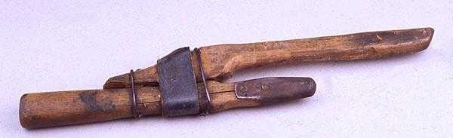Early in 1919, "The Old Man" wrote in *QST* "I am sending you a specimen of a real live Wouff Hong . . . Keep it in the editorial sanctum where you can lay hands on it quickly in an emergency." The "specimen of a real live Wouff Hong" was presented to a meeting of the ARRL Board and the Board voted that the Wouff Hong be framed and hung in the office of the Secretary of the League.

On display at ARRL Headquarters today, the Wouff Hong is a constant reminder to Amateur Radio operators to be mindful of their operating etiquette.

Want to see it for real? Come to the conclave this coming Saturday night!

***Final.. Final..***

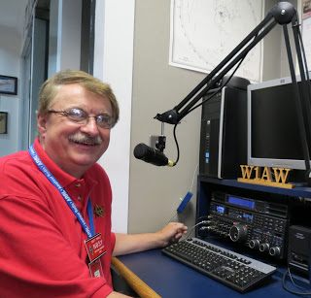

Hey Gang...

This was another great week for sure, even though the weather has not been cooperating much, I did manage to get my yard mowed for the first time this year. I also got to visit with a number of you folks during my trips up and down the state.

I do have to say; Saturday was one for the books. We had our last dress rehearsal for the upcoming Wouff Hong and it was a blast! The actors are really getting into their parts, so it’s gonna’ be a blast for sure! If you haven’t signed up, you’d better do that quickly, as that we only have so much room and it’s almost Standing Room Only now!!!

The weather persons are calling for it to be really hot and humid for the end of the week, let’s see just how accurate their long-range forecasts are!!! At least that’s the prediction now.. Don’t forget to dress appropriately. If it is really is hot and humid, you’ll want to make sure that you leave the winter coat in the car. You won’t need it for a few days. Hi.. Hi..

TOP ^

Sliding down the band a bit… I learned a lot from the Ashland County LEPC Tabletop exercise this past week. Even though it was a tabletop exercise everyone involved took their roll in the exercise very seriously and with true conviction, just like it would be if it had been real. Even though Communications wasn’t one of the areas being tested, there were several times that Amateur Radio came through with just what the doctor ordered to make the incident even more real.

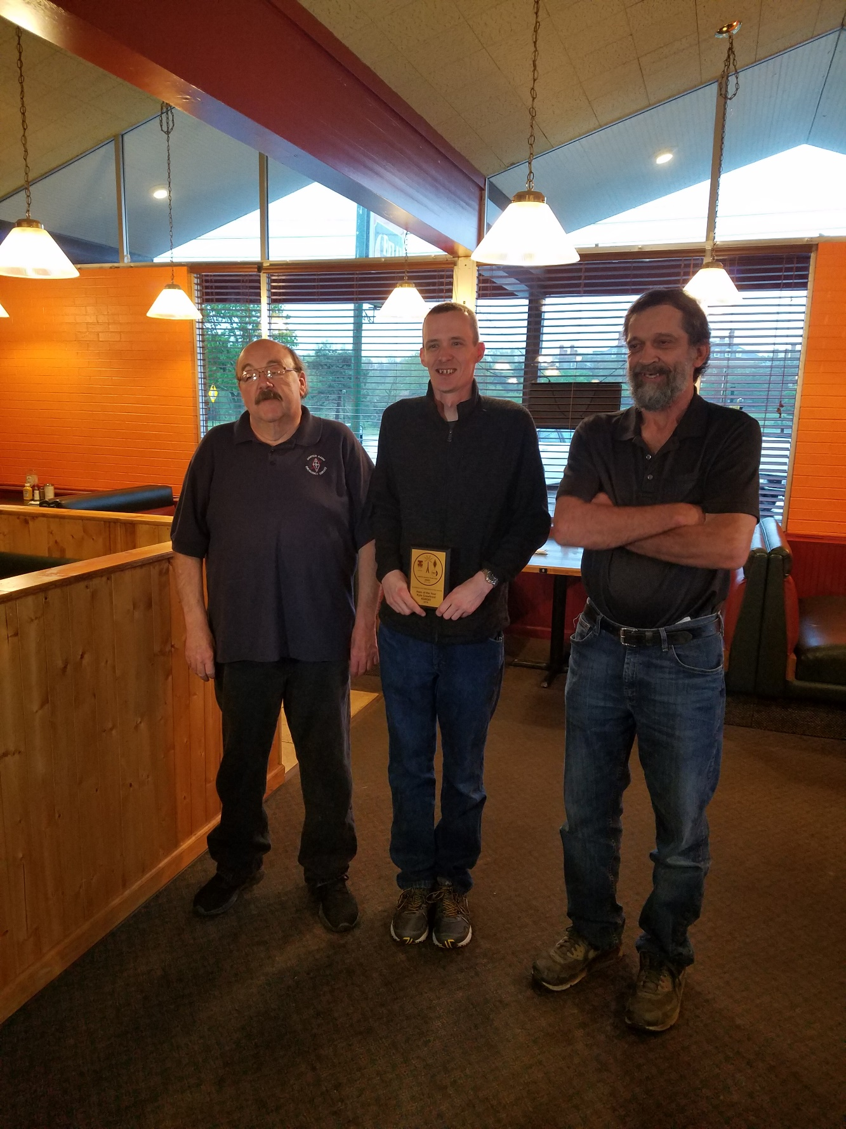Tuesday night I attended the Northern Ohio Skywarn meeting. This is a great little meeting with the Meteorologists from the Cleveland Weather Office. We basically go over the events from the past month and discuss any issues or concerns that we’ve had. Of course, my county (Richland) had that little event that swept Toto off to La-La Land and beyond this past month. Let’s hope that’s the last time we have to worry about that this year!

Thursday night I attended the InterCity ARC Ham of the Year Banquet. It was a blast and even though it was 35 years ago when the club inducted me in as Ham of the Year, I was just as excited for Kyle Crawford, KD8GEI as he was awarded this honor. Congrats Kyle!!!

Now, let’s spin the dial a bit and see what’s on the band below… I’ve been asked by many of you just how many folks do we have in ARES Connect now. Well, here’s a breakdown of all 3 levels for you: Level 1 – 474; Level 2 – 427; Level 3 – 132. This gives us a total of **1,033** in ARES Connect. I don’t know positively for sure, but my guess from everything that I can see within the system is that no one other Section in the country has more people registered in ARES Connect than the Ohio Section. Now, since I’ve announced that we now have all of our Districts setup in ARES Connect, I’m sure that you’ll want to know just how many folks are registered in ARES Connect for each of the Districts. So, here goes…

District 01 – 136; District 02 – 10; District 03 – 158; District 04 – 112; District 05 – 98; District 06 – 49; District 07 – 206; District 08 – 35; District 09 – 58; District 10 – 171

I do want to clear up some mis-interpretations that have been going around. First, in the Ohio Section we only require our Level 2 volunteers to have the 4 basic courses, IS 100, 200, 700 & 800. For our Level 3 volunteers we do require the additional ICS 300 / 400, or the equivalent professional series courses IS 120, 230, 240, 241, 242, 244 & 288. These equivalent courses are all on-line classes just like your basic 4 NIMS courses are and being offered as an alternative way for you to get credit for taking the professional series courses in the event you just cannot get scheduled into an ICS 300/400 class.

By the way, if you decide to take these 7 on-line courses and complete them all, you will want to take just one more class **IS-235.** By completing this additional course, you will get a really great looking certificate from FEMA recognizing that you have completed the entire Professional Series courses. I do hope that this clears up the confusion that has been going around lately. As we have stated on the website and in this newsletter many times “We don’t want anyone left behind.”

And finally… For those of you on my email listing, I do apologize for the recent incident with the emails not going out properly. It seems that I’ve become a target for someone over in the Eastern European side of the world and they hacked the email server that I was renting. They had over 450,000 emails stacked up and the server just said – ENOUGH... We got everything back in working order late in the afternoon of Monday and all seems to be working just fine now. .

TOP ^

Whelp… That’s going to do it for this time around. Stay safe, enjoy the sunshine while we have it, and most of all… have FUN!! Be sure to stop by the Ohio Section booth at Dayton. We’re located at the entrance to the ARRL area in Building #2 - the Tesla Building.

73,

***Scott, N8SY***

***Back Issues of the PostScript and Ohio Section Journal (OSJ)***

Hey, did you know that PostScript and Ohio Section Journal (OSJ) are archived on the website? You can go back and look at any edition simply by clicking:

<http://arrl-ohio.org/news/index.html>

***Chit – Chat, and All That!***

Do you know someone that’s not getting these Newsletters? Please, forward a copy of this Newsletter over to them and have them “[Opt-In](http://arrl-ohio.org/forwarder/forwarding.html)” to start receiving them. Heck, just have them send me an email [n8sy@n8sy.com](mailto:n8sy@n8sy.com) and I’ll get them added to the Ohio Section Emailing list.

We now have many thousands of readers receiving these newsletters weekly. Quite impressive, I’d say! I urge all of you to make sure that everyone, regardless of whether they are a League member or not, get signed up to receive these weekly Newsletters.

You can always “[Opt-Out](http://arrl-ohio.org/forwarder/forwarding.html)” at any time if you feel this is not what you were expecting. It’s fun and very informative. All of your favorite past newsletters are now archived too.

You can go back at any time and read them. Just go to: <http://arrl-ohio.org/news/>

Got questions, concerns or would just like to sit and chat awhile? Heck, I’ll even buy the coffee!! Give me a call at (419) 512-4445 or email me at: [n8sy@n8sy.com](mailto:n8sy@n8sy.com)

The pictures on the front page are from various newsletters, Facebook posts and/or were sent directly to me in recent weeks. Take a good look at them, you just might be in one of the pictures! “SMILE… you’re on the Ohio Section News!!”

TOP ^

*PostScript is produced as a weekly newsletter. I want to thank everyone that has contributed articles and ideas to make this an even better news source. I sincerely hope that you have enjoyed this edition and will encourage your friends to join with you in receiving the latest news and information about the Ohio Section, and news and events happening around the world!*