[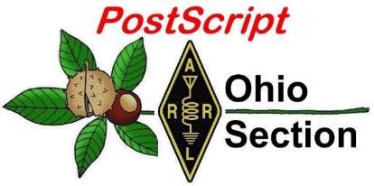](http://arrl-ohio.org/news/) ***May 6th***

***Edition***

🡪 National News 🡪 The Handbook Give Away

🡪 Club Corner 🡪 Hamfests

🡪 DX This Week 🡪 One Question Questionnaire

🡪 VE Testing 🡪 ARES Connect

🡪 Wouff Hong Ceremony At Hamvention 🡪 Final.. Final..

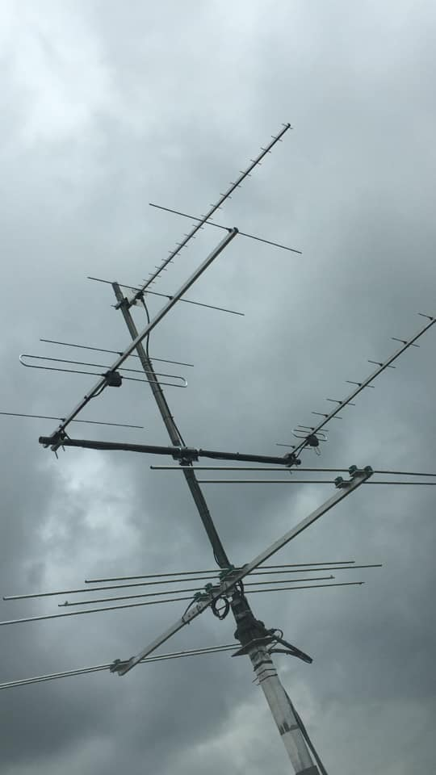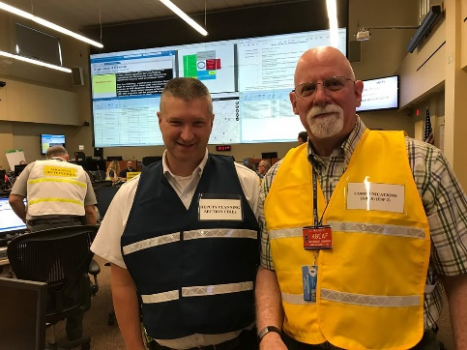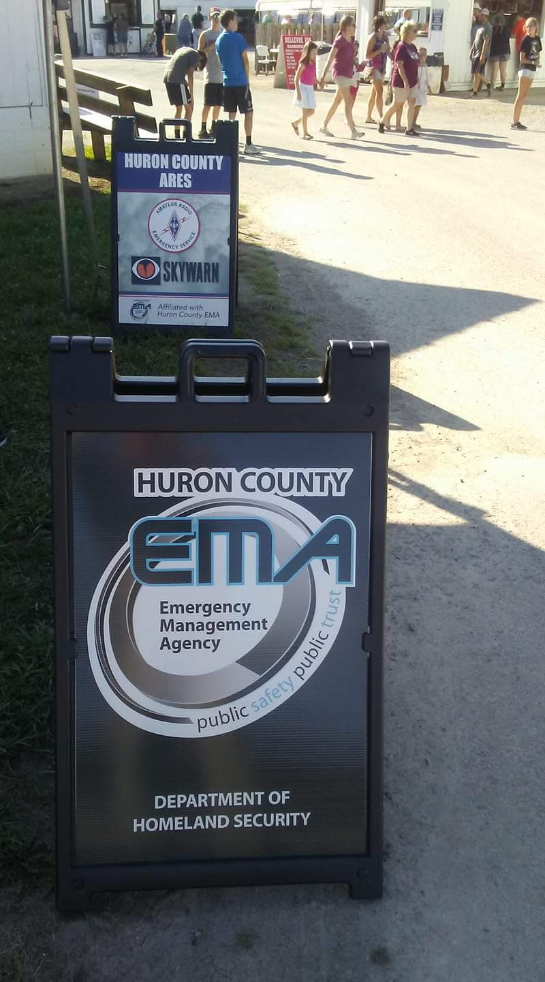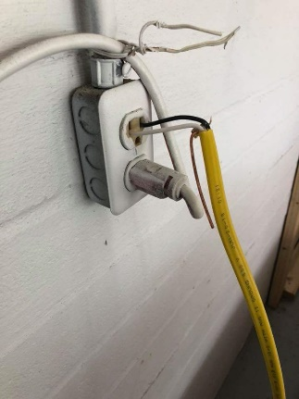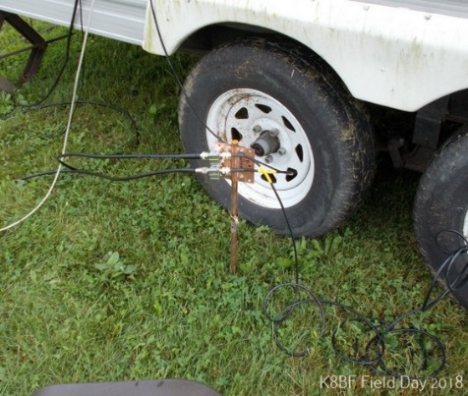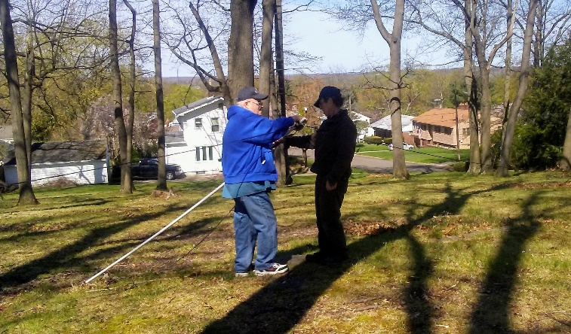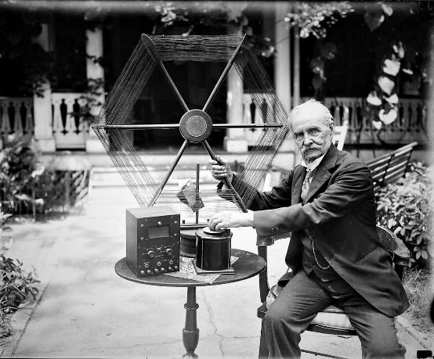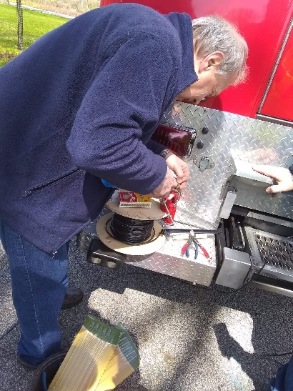

***National News***

*(from arrl and other sources)*

***ARRL’s Free Exam Review for Ham Radio Updated***

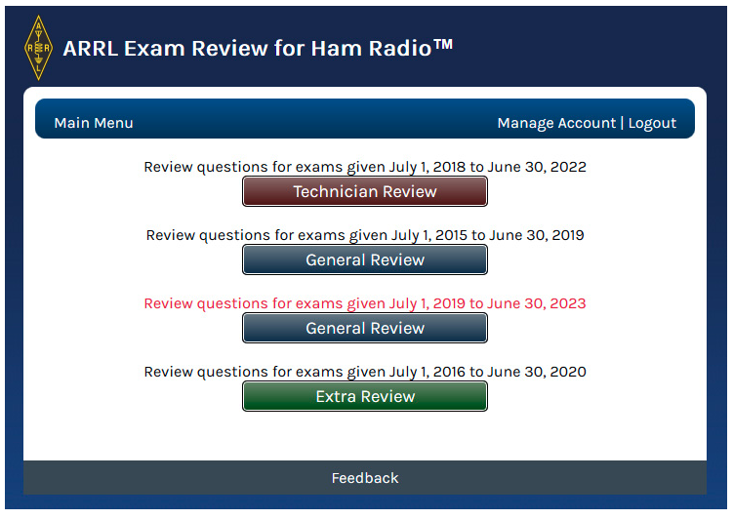[**ARRL Exam Review for Ham Radio**](http://www.arrl.org/examreview)™ has been updated in advance of the release of the ninth edition of [***The ARRL General Class License Manual for Ham Radio***](https://www.arrl.org/shop/ARRL-General-Class-License-Manual-9th-Edition/). ARRL Exam Review is a free online resource for use with current editions of [**ARRL License Manuals**](http://www.arrl.org/shop/Licensing-Education-and-Training/). The service can be accessed via a web browser and uses the official examination question pools to construct chapter-by-chapter reviews. Upon completing study, Exam

Review helps the license candidate take practice exams with the same number and variety of questions that he or she will encounter on exam day. Practice tests can be taken over and over, scored in complete privacy, or even printed with an answer key. Exam Review includes quick feedback about the questions missed.

The update to Exam Review and the new edition *General Class License Manual*coincides with a new General Class question pool released earlier this year by the National Conference of Volunteer Examiner Coordinators ([**NCVEC**](http://www.ncvec.org/)). The new 2019 – 2023 General Class question pool becomes effective July 1, 2019 for examinations in the Amateur Radio Service. The 2015 – 2019 General Class pool remains in effect for exams given until June 30, 2019. ARRL Exam Review provides access to both the current and new General Class questions.

A federally licensed service, Amateur Radio (or “ham radio”) provides the broadest and most powerful wireless communication capability available to private citizens anywhere in the world. ARRL, the national membership association for Amateur Radio licensees in the US, offers books, online content, and other resources for Amateur Radio licensing, operating, and lifelong learning.

For more information about getting started in Amateur Radio, visit [**What is Ham Radio**](http://www.arrl.org/what-is-ham-radio) or call 800-326-3942 (800-32 NEW HAM). ARRL can help you find local [**radio clubs**](http://www.arrl.org/find-a-club), [**classes**](http://www.arrl.org/find-an-amateur-radio-license-class), and [**testing sites**](http://www.arrl.org/exam_sessions/search).

#########

***ARRL Reply Comments Stress Need to Update Technician Privileges in a Digital World***

In [**reply comments**](http://www.arrl.org/files/file/FCC%20Documents/ARRL%20Reply%20FCC%20RM-11828%2004_2019.pdf) to the FCC (comments on comments already filed) on its [***Petition for Rule Making***](https://www.fcc.gov/ecfs/filing/1022823795806)(RM-11828), ARRL has stressed that updating HF privileges for the entry-level Technician license “is the sole subject and intent” of the petition. ARRL filed its reply comments on April 29, urging the FCC to disregard comments irrelevant to its petition and maintaining that Technician privileges must be relevant within the context of today’s technological environment.

TOP ^

“[T]he increasingly rapid pace of change in communications technologies, coupled with the national need for self-training in science, technology, engineering, and math” necessitate the rule changes requested, ARRL asserted. “ARRL made its request because of the gap between today’s digital technologies and the privileges accorded the current entry-level Technician license.” ARRL characterized its proposal to update the rules as “balanced and modest.”

“If adopted, there would be no change to the operating privileges for all licenses classes other than those of the Technician class,” ARRL said. ARRL in 2018 asked the FCC to expand HF privileges for Technician licensees to include limited phone privileges on 75, 40, and 15 meters, plus RTTY and digital mode privileges on 80, 40, and 15 meters. The FCC invited comments on the proposal in April.

ARRL pointed out that some comments filed on its petition address subjects related to other open proceedings rather than expanding Technician privileges, citing comments cross-filed in such proceedings as WT Docket 16-239, RM-11708, RM-11759, and RM-11831. “Those filings should be considered in the proceedings that they address, rather than here,” ARRL said.

ARRL said some opposition appears based on fears of increased interference potential due to additional digital operation by Technicians. “It is improbable that all, or even a majority, of Technician licensees suddenly would develop a passion for the same digital technology,” ARRL said. “Our hope and expectation is that many will engage with digital modes on the high-frequency spectrum at issue, but it is unrealistic to suggest that every Technician licensee blessed with new privileges would suddenly appear on the same band.”

The comments note the development of very efficient digital modes such as FT8, which occupies just 90 Hz of spectrum per signal. “The experience with FT8 clearly demonstrates the attraction of the digital modes *and* the spectrum efficiencies that can be achieved,” ARRL said. “This is why opening up limited digital opportunities to new radio amateurs so clearly would serve the broad public interest as well as the specific purposes of Amateur Radio in experimentation and innovation, as enumerated in the governing FCC rules.”

ARRL further said that comments regarding disagreement on the definition of encryption for masking the content of certain digital transmissions also are “out of place in this proceeding” and “should not delay initiation of a proceeding” proposing to update Technician privileges.

“Technology has changed dramatically in the Amateur Radio domain, and the ARRL believes the requested Technician license enhancement would foster the regulatory goals for the Amateur Service and continue to increase amateurs’ historical experimentation and service in a meaningful way,” ARRL concluded.

#########

***ARRL Public Relations Committee 2019 Field Day Outreach***

***and Discussion Conference Calls***

Hello,

The ARRL Public Relations Committee (PRC) invites you to join us during our Field Day outreach initiative, coming this May. **Starting on May 9**, 2019 the PRC will host Thursday video and audio conference calls to discuss 2019 Field Day preparation and planning, from the public relations and public information perspective. These calls are intended to be an opportunity for the participants to be interactive, rather than a lecture.

TOP ^

The planned topics include:

* Press Releases
* Social Media
* Successful interaction with print, radio, and television professionals
* Available Field Day materials
* Field Day Public Relations “Best Practices” and “Lessons Learned”
* Open Forum

To make the Field Day conference calls convenient for you to attend, the start times have been staggered. Pick a time and date that works for you. Each call is planned for 60 minutes. You can attend more than one call.

May 9, 2019   10PM Eastern – 7PM Pacific

May 16, 2019   9PM Eastern – 6PM Pacific

May 23, 2019   8PM Eastern – 5PM Pacific

May 30, 2019   1PM Eastern – 10AM Pacific & 11PM Eastern – 8PM Pacific

Please email to Sid Caesar, NH7C at [NH7C@ARRL.net](mailto:NH7C@ARRL.net) to receive the dial-in information for each of the calls that you want to attend.

The ARRL Public Relations Committee looks forward to your participation on the Field Day conference calls.

Thank you, Sid

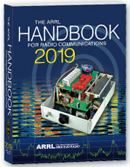***The Handbook Give Away***

Hey Gang,

We had another fantastic response this month, but I’m sure you’re more interested in knowing just who won the Handbook this month...

And the winner is…. ***Bob Schindler, K8TYM***

We've had another a great response after with the Give Away so… I decided to also give away something to shade your eyes on these bright sunny days.

I'm sending out an ***Official Ohio Section Logo Ball Cap***to: ***Richard DeMattia, KD8WCK & Dennis Egbert, K8QDE!***

Many of you ask me just how do I know when the drawing is on? Well, that’s easy all you need to do is check in on the Ohio Section Website on a regular basis and watch for the big RED Arrow that will appear on the left side of the page. This is the sign that the drawing is on and you need to get registered. So, keep a sharp eye out on the website and check in often! <http://arrl-ohio.org>

You just never know.. You just might be the next winner!

TOP ^

***Club Corner***

This is YOUR cornner of the newsletter. Send me what your club is doing and I’ll make sure that it gets in. Got a special event or club project that you want everyone to know about? Send it to me!. Need help with a project? Send it to me.

Let me know what you club is up to. Are you going to have a special guest at your meeting or are you having a special anniversary? Just sent it to:

[n8sy@n8sy.com](mailto:n8sy@n8sy.com)

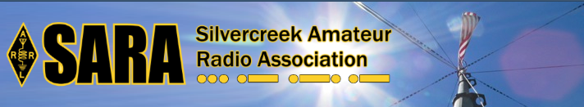SARA is partnering/supporting Wayne County EMA in the offering of the SKYWARN training this year. As you may have heard, budget and staffing issues in the Cleveland NWS office has led them to cancel the NWS-lead SKYWARN classes. EMAs and ARES ECs are being encouraged to hold the SKYWARN training directly.

SARA is playing a supporting role to the Wayne County EMA which is holding a session for this region. The date will be **Monday, May 6th from 6p - 8p.**

Volunteers will be needed 5p - 8:30pm. The tentative location is Chippewa Jr/Sr High School in Doylestown. Volunteers will help register attendees and print the SKYWARN training cards with ID numbers. Fred Sheppard KD8GYS will be assisting Joe Villegas with the class.

Additionally, SARA will have a table with some amateur radio materials available to spread the word about our hobby and service.

If you can volunteer your time, please contact me so I can add you to the roster. Please note that volunteers will not be able to be present in the class for the entire session as volunteers will register latecomers and also print and organize the ID cards.

Thanks! For more information or questions, contact Jason, N8JDM [jason@mfamily.org](mailto:jason@mfamily.org)

#########

The Toledo Air Show is July 13 & 14 and we did such a great job at the last Air Show the powers that be have requested additional help from us this time around. We are still in the planning phase and do not have final numbers for needed operators, but I wouldn’t be surprised to see a number around 50 or more each day.

The Lucas County EC is the contact person for the air show, [boxcar@toast.net](mailto:boxcar@toast.net).

#########

TOP ^

***TMRA WILL ONCE AGAIN BE HOSTING A BUS TRIP TO HAMVENTION IN XENIA OHIO***

This year’s trip will be on the Saturday May 18th and the cost will again be $40.00. This year we are asking people to both Reserve and pay before the May General Meeting if possible. This will allow the Bus to depart on-time and will also make life easier on Mike/WA8SYD. If you want to join the TMRA on the Bus, and we hope you will, please contact Mike/WA8SYD and get your spot reserved. You can contact Mike by Phone at **419-699-1392**.

This year’s trip will follow the standard Trip plan as before

05:30 Depart Scott Park Campus

08:30 (eta) arrive and park near the Front Gate of Hamvention in Xenia Ohio

08:30-17:00 Bus remains available to Riders in Parking Lot

17:00 Depart Hamvention

17:45 (ETA) Arrive at Restaurant in Dayton Ohio

19:00 (EST) depart Restaurant

21:30 arrive back at UT Scott Park Campus

*This is a general Itinerary of the trip and of course times may vary.*

The Bus will remain on-site and open to all Riders throughout the entire day. You are free to leave items on the Bus and return to the Bus to rest or drop off purchased item. If you buy a large item, it can almost certainly fit into the Busses Cargo hold.

Hamvention Bus Reservation and payment can be arranged thru Mike Kehr / WA8SYD. To contact Mike please call him on his Cell Phone at 419-699-1392

We hope to see you on the Bus to Hamvention.

#########

***Ohio Statewide Courthouses On The Air Special Event, August 24, 2019***

**Event Background**

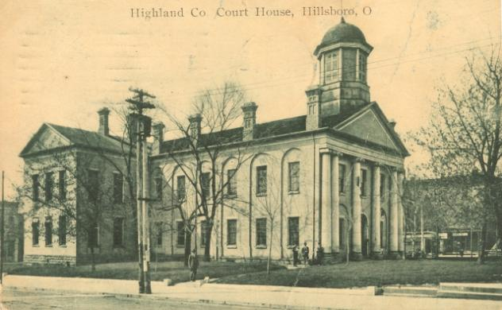 Last year there was the Ohio Covered Bridge Special Event that was led by John Levo, W8KIW Editor of the Highland ARC’s *Monday Morning Memo*. Several clubs participated and was a complete success. Additionally, there were several folks interested in Ham Radio at the event who have now become new Hams. Yes, anytime there is a public event resulting in a gain to the Ham Radio community, it is a total success. This year in keeping with the historical event series, John and the members of the Highland ARC decided to do a special event from their courthouse lawn.

TOP ^

John published an article in the *Monday Morning Memo* which attracted the attention of Michael Love, WB8YKS Southern Ohio Amateur Radio Association (SOARA) PIO. John and Mike decided that there may be interest in an all-state special event celebrating the courthouses in all of Ohio’s 88 counties. Scott Yonally, N8SY Ohio Section Manager thought it was a fantastic idea and requested John and Mike to reach out across the state to determine the level of support for the event. The Ohio Section has 117 affiliated clubs of which 48 are Special Service Clubs and there are 29 PIOs. There may not be a club listed in each county by address, but we do have Hams in each county.

**Promoting Ham Radio**

This may be a first for the ARRL and the Ohio Section. This event has all the opportunities for a FUNFILLED family day engaging the public and our government officials. Additionally, one county’s club is partnering with their county commissioners, historical society, EMA, sheriff’s office, public library, chamber of commerce, and news media. The club has decided to use a large tent as the event will take place rain or shine. Their PIO will make handouts available about ham radio and promoting the ARRL, ARES, RACES, Ohio Section and their local club. A special focus will be made to spotlight the public awareness of the hobby and the benefits of a Ham radio license, emergency and community service. The public will be invited to talk on the radios under the direct supervision of a licensed operator. Several clubs plan to provide contact QSL cards and/or certificates to capture this historical event.

**Fun for Everyone**

There may be some folks dressed in period costumes providing history about their courthouse and the early days in their county. Moreover, one club has requested, August 24, 2019, to be declared as Ham Radio Day in their county, and their county commissioners have approved it.

**Event Details**

Yes, we are excited and hopefully you are as well, about participating in this historical Ohio Courthouses on the Air Special Event. **We are requesting ALL Ohio Clubs and Hams to consider supporting this special event. The event will take place on, Saturday, August 24, 2019, from 9:00 AM to 4:00 PM. However, the hours can be extended by each club. Additionally, each club will determine the frequencies and modes they will use.**

Another opportunity presents itself as the Ohio QSO Party [www.ohqp.org](http://www.ohqp.org) is also on the air, Saturday, August 24th. Therefore, these two events will complement each other providing contacts not only from within Ohio but across the country. All Hams are invited to participate.

**Staying in Touch**

Please inform the listed contacts that your club will be participating, and the name of the county represented. Additionally, there will be updates provided in the *Monday Morning Memo*, the *PostScript,* *Ohio Section Journal, and www.****arrl****-****ohio****.org.*

**Contacts for additional information:**

Michael Love, WB8YKS

wb8yks@arrl.net

John Levo, W8KIW

[highlandara@yahoo.com](mailto:highlandara@yahoo.com)

TOP ^

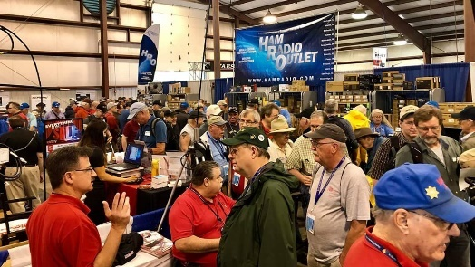[***Upcoming Hamfests***](http://arrl-ohio.org/hamfests.html)

**05/17-19/2019 | Dayton Hamvention**

Location: Xenia, OH

Sponsor: Dayton Amateur Radio Association

Website:  <http://hamvention.org/>

|  |  |
| --- | --- |
| **06/01/2019 | FCARC Summer Swap**  Location: Wauseon, OH Sponsor: Fulton County Amateur Radio Club Website: <http://k8bxq.org/hamfest> | **06/08/2019 | Union County ARC TrunkFest**  Location: Marysville, OH Sponsor: Union County Amateur Radio Club Website: [http://www.ohiohams.net](http://www.ohiohams.net/) |
| **06/15/2019 | Milford Hamfest**  Location: Owensville, OH  Sponsor: Milford Amateur Radio Club  Website: <http://www.w8mrc.com> | **06/15/2019 | W8DXCC DX Convention**  Location: Owensville, OH  Sponsor: SouthWest Ohio DX Association  Website: <http://www.w8dxcc.com> |
| **07/07/2019 | 20/9 Radio Club Hamfest** Location: Austintown, OH Sponsor: 20/9 Radio Club, Inc. Website: [http://20over9.org](http://20over9.org/) | **07/07/2019 | Ohio Link Swap Meet**  Location: 1801 Gateway Circle, Grove City  Sponsor: Ohio Link Network Group  Website: [www.olnradio.digital](http://www.olnradio.digital) |
| **07/20/2019 | NOARSFEST**  Location: Elyria, OH Sponsor: Northern Ohio Amateur Radio Society Website: <http://noars.net/hamfests/noarsfest> | **07/21/2018 | Van Wert Hamfest** Location: Van Wert, OH Sponsor: Van Wert Amateur Radio Club Website: [http://w8fy.org](http://w8fy.org/) |

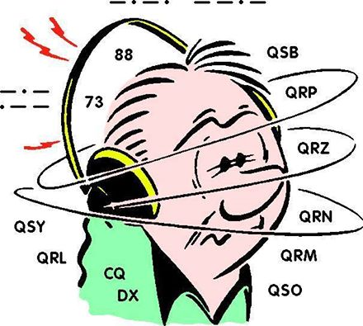***DX This Week***

*(from Bill, AJ8B)*

Bill AJ8B ([aj8b@arrl.net](mailto:aj8b@arrl.net), @AJ8B, [www.aj8b.com](http://www.aj8b.com) or [www.swodxa.org](http://www.swodxa.org) )  
CWOPs Member #1567

As excited as I get about an All-Time New One, working a contest, or a new award, it seems that something comes along to reset my expectations and make me appreciate my family, my friends, and my life. Unfortunately, the ham community lost a “real good guy” to cancer. K8WWA, Rick Burdick, was absolutely one of the good guys who made this hobby worth participating in. Our prayers and thoughts go out to Rick’s family and friends.

TOP ^

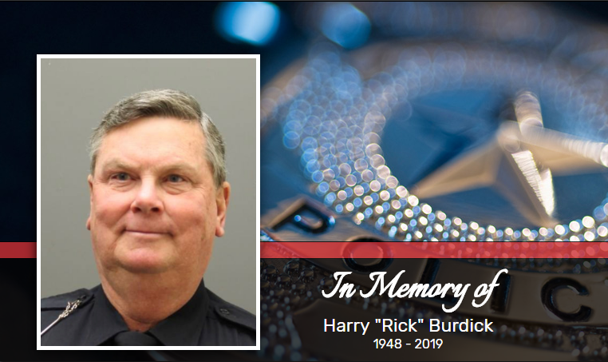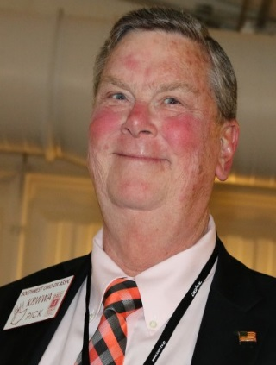

*Obituary of Harry "Rick" Burdick -*

*Harry Richard “Rick”, Jr., beloved husband of 45 years of Susan A. (nee Massey), loving father of Scott R. (Kelly) Burdick and Jennifer B. (Matt) Kremer, devoted grandfather of Abigail and Colin Dorsey and Jack and Joshua Kremer. Dear brother of Robert M. (Donna) Burdick, and Mary Ann (Pete) Back. He is also survived by five nieces and nephews and nine great-nieces. Rick served for 40 years with the Blue Ash Police Department.  During his career he was an Officer, Detective, Patrol Sergeant, and Staff Lieutenant. He was past-president of the Greater Cincinnati Amateur Radio Association and he was an avid bass fisherman. Passed away on Thursday, April 25th at the age of 70. Visitation will be held on Tuesday, April 30th from 3:30-8PM at Thomas-Justin Memorial, 7500 Montgomery Rd. (45236) Kenwood. Mass of Christian Burial will be held on Wednesday, May 1st at 10:30AM at All Saints Catholic Church, 8939 Montgomery Rd. (45236). Interment will follow at Gate of Heaven Cemetery. In lieu of flowers, donations may be directed to Pancreatic*[*Cancer Action Network*](http://pancan.org/)*, or the charity of one’s choice. Condolences may be shared with the family through our website, ThomasJustinMemorial.com.*

+ --------------------------------------------------------------------------------------------------------------------+

DXCC Card Checking de Dave, K8DV

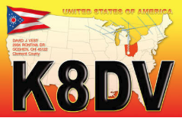In the last issue I gave a very high level view of DXCC and card checking. This week we can start to break down the process piece by piece. I am going to start with Online Electronic DXCC Application, <http://www.arrl.org/online-dxcc-application> which has to be one of the best things the ARRL and DXCC Desk have done since the creation of the program back in the thirties. No more worrying about the order of the cards, no more do multiple QSO cards go at the front or back of the list, just enter as you receive new QSLs in whatever order.

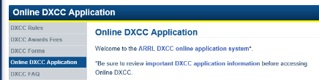When you use the link above you will be taken to a page that looks something like this:

From there click on “ARRL DXCC online application system” and you will end up at the sign in screen.

Once at the sign in screen, in the upper right-hand corner you will see two boxes, labeled “Username” and “Password”. These are the same credentials that you would use to log into the ARRL members section of the ARRL homepage. This is most likely your “Callsign” and a password that you created.

TOP ^

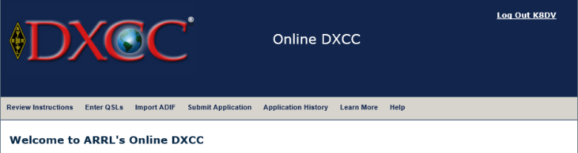Once you have entered your login information you should see a page where the top of it looks something like the image to the left.

On this page you will also find the step by step instructions, so I will not include those here. The next step is to start entering QSL/QSO information. Start by clicking on “Enter QSLs” in the gray menu bar. You will end up on a page and down at the bottom you should see an entry screen.

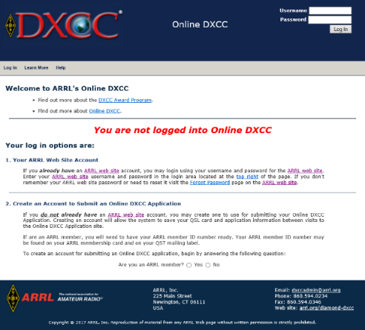

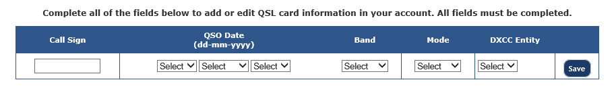

You are now ready to enter QSL/QSO information. When entering your data use the drop downs, you may find that the DXCC Entity may be filled out for you or give you a choice of several entities, such as when you enter a callsign starting with VP8 you will have several choices and you should select the entity that is printed on the card itself. Once you start entering QSO/QSL information you will see the list appear below the entry screen.

TOP ^

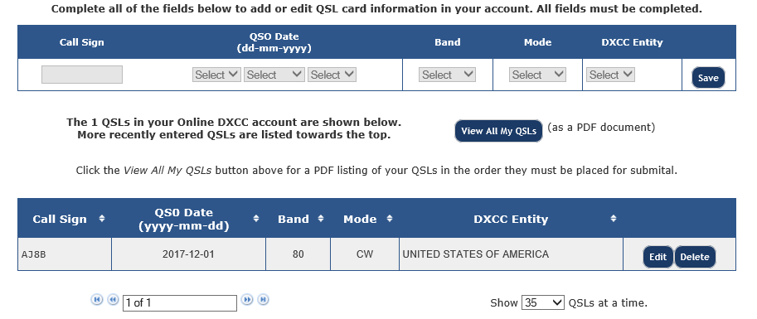

After you have entered all your data and have all your cards in the same order at which they are entered you will need to click the “Submit Application” button in the gray toolbar at the top of the screen. At this point you can enter your payment info and other information. Once you do this you will see a button to review application this will bring up a PDF of your application, print all pages of this as this is the application itself and the QSL listing. Bring the printout, QSLs and envelope with at least one unit of first-class postage to me for checking. Also did I mention that the fees for using this for your DXCC application is cheaper than the manual form and usually faster as well.

Have a good DX season and keep those DXCC applications coming and if there is a card checking topic you would like to see covered in the future just let me know at [k8dv@cinci.rr.com](mailto:k8dv@cinci.rr.com)

+ --------------------------------------------------------------------------------------------------------------------+

Here is an update from Bernie, W3UR, of the DailyDX and the WeeklyDX, the best source for DX information. (<http://www.dailydx.com/> ) Bernie has this to report:

**South Orkney Islands DX-pedition** - (AN-008)  
 We appreciate the Northern California DX Foundation’s (NCDXF) significant grant of $30,000(USD) to our project. Their generous grant will help cover the estimated project cost of $325,000(USD).   

Recently joining the team are:  
  
Ken Karr NG2H - First licensed in 1955 as KN2OZZ, then K2OZZ and finally as NG2H. Ken served in the United States Navy first as a communications officer aboard submarines and later commanded two fast attack nuclear submarines. He consulted with commercial nuclear electric generating companies and conducted missions with the International Atomic Energy Agency. 

Ken is a member of CWOps (1477), FISTS (16869), NAQCC (7560), SKCC (12740), the Potomac Valley Radio Club (Rappahannock Chapter), Fluvanna County Virginia ARES, and past member of the Pentagon Amateur Radio Club. Ken was a team member of the 2016 VK0EK Heard Island DX-pedition 

TOP ^

Dave Jorgensen WD5COV - Dave was first licensed in 1977 at the age of 14 as WD5COV. He holds DXCC: #1 Honor Roll, 351 confirmed (mixed), 10 Band DXCC, 3016 DXCC Challenge, and a member of the ARRL’s A-1 Ops Club.

He is a life member of the ARRL, a member of the Intrepid DX Group, the Araucaria DX Group, the Arizona Outlaws Contest Club, the Mimbres Valley Radio Club, the New Mexico VHF Society, and is a supporter of the Northern California DX Foundation.

Dave is an experienced DXpedition operator having been a team member on: 3D2R Rotuma Island 2011, 7O6T Yemen 2012, 3D2C Conway Reef 2012, E30FB Eritrea 2015, VP8STI South Sandwich 2016, VP8SGI South Georgia 2016.

A retired business owner of Hydrafles Inc, located in Denver, Colorado he manufactured and distributed industrial hoses and fittings. His other career has always been electronics and communications.

**SV5 – Dodecanese** - SV5/DL3DRN will again be on the air, May 25 to June 14 from Kolymbia,   
Rhodes.  Wolf plans all bands CW, SSB and RTTY.  For a QSL it's bureau, direct, or LoTW.

**T8 – Palau** - From Koror in Palau will be T88FM, T88MK and T88RR, September 12-21.    
T88RR's home call is JA6UBY and his name is Yas.  The other ops are Miyo and Toshi.  They will have an IC-756, IC-7100, FT-857 and TS-570, plus a TL-933 amp and JRL-2000F amp, to a Yagi and dipole.  They plan to be on SSB, FM, FT8, JT65 and JT9, 160-6M.  Yas says for a QSL send to the QRZ.com address of his, direct with SASE or SAE with USD to cover the return postage.  No Club Log or LoTW for this one.  Their target QRV time is 14Z the first day.

***A******RLD017 DX news***

This week's bulletin was made possible with information provided by The Daily DX, The OPDX Bulletin, 425 DX News, DXNL, Contest Corral from QST and the ARRL Contest Calendar and WA7BNM web sites. Thanks to all.

**FIJI, 3D2.** Nobby, G0VJG is QRV as 3D2AS until May 5, and then again from May 20 to 22. Activity is on 40 to 10 meters using SSB and FT8 in DXpedition mode. QSL via M0OXO.

**MALDIVES, 8Q.** Nobu, JA0JHQ and Ted, JA7XBG plan to be QRV as 8Q7NH and 8Q7XB, respectively, from Embudu Island, IOTA AS-013, from May 7 to 10. Activity will be on 160 to 6 meters using CW and FT8. QSL direct to home calls.

**CROATIA, 9A.** Jan, PA4JJ is QRV as 9A/PA4JJ until June 5. Activity is holiday style on 40 to 10 meters using mainly FT8. QSL to home call.

**GHANA, 9G.** Emil, ZS6EGB is QRV as 9G5ZS until February 2020. Activity is on the HF bands using FT8. QSL via LoTW.

**FEDERAL REPUBLIC OF GERMANY, DL.** Members of radio club Bad Doberan are QRV with special call sign DM460DA until the end of October to celebrate the club's 60th anniversary. QSL via DL9GFB.

TOP ^

**PHILIPPINES, DU.** Audie, DU1ZDR and Gazelle, DU1ZDQ will be QRV as DZ1A from Siargao Island, IOTA OC-235, on May 4 and 5. Activity will be on 40 and 20 meters. QSL via operators' instructions.

**SPAIN, EA.** Members of the Radio Club de las Fuerzas Armadas Espanolas will be QRV with special call sign EG1FAS from May 4 to June 2 to commemorate Spain's armed forces. QSL via EA1ADP.

**WALLIS AND FUTUNA ISLANDS, FW.** Nobby, G0VJG will be QRV as FW/G0VJG from Wallis Island, IOTA OC-054, from May 6 to 20. Activity will be on 60 to 6 meters using SSB and FT8. QSL via M0OXO.

**HAITI, HH.** Dale, N3BNA and Mark, K3MSB will be QRV as HH6/home calls from May 4 to 11. Activity will be in their spare time on 160 and 60 meters. QSL HH6/N3BNA via KA2AEV, and HH6/K3MSB to home call.

**THAILAND, HS.** Special event station HS10KING is QRV until July 31 to commemorate the Coronation of King Vajiralongkorn Bodindradebayavarangkun, King Rama X. Activity is on all bands and possibly satellites. QSL via operators' instructions.

**DOMINICA, J7.** Operators Thomas, SM0CXU and Tore, SM0DZB will be QRV as J79U and J79TA, respectively, from May 7 to 15. QSL via M0OXO.

**ST. VINCENT, J8.** Brian, GW4DVB will be QRV as J88PI from Palm Island from May 7 to 14. Activity will be on 40 to 6 meters using SSB, SSTV and FT8. QSL direct to home call.

**ARGENTINA, LU.** Horacio, LU5BE and Enrique, LU8EFF are QRV as home calls/T until May 5 from Susques and Purmamarca. Activity is on 80 to 6 meters using CW, SSB, PSK31, HELL, JT65 and FT8. QSL via operators' instructions.

**BULGARIA, LZ.** Members of the Bulgarian Radio Club Blagovestnik are QRV with special call LZ497OM during May to honor Orthodox saints.

QSL via bureau.

**PERU, OA.** Michael, AC0PR plans to be QRV as OA3/AC0PR from Chimbote from May 5 to 14. Activity will be in his spare time 40 to 15 meters using only CW and QRP power. QSL direct to home call.

**MARKET REEF, OJ0.** Pasi, OH3WS plans to be QRV as OJ0W from May 4 to 11. Activity will be in his spare time on 60 and 30 meters. QSL to home call.

**SLOVAK REPUBLIC, OM.** Special event stations OM83IHWC and OM2019IIHF are QRV during May to mark the 83rd Men's World Ice Hockey Championships. Activity is on the HF and VHF bands. QSL via OM2FY.

**EUROPEAN RUSSIA, UA.** A number of stations are using the RP74 prefix until May 9 to commemorate the 74th year since the end of World War II.

TOP ^

THIS WEEKEND ON THE RADIO. New England QSO Party, 10-10 International Spring CW Contest, NCCC RTTY Sprint, NCCC CW Sprint, Araucaria World Wide VHF Contest, SBMS 2.3 GHz and Up Contest and Club Challenge, Microwave Spring Sprint, ARI International DX Contest, 7th Call Area QSO Party, Indiana QSO Party, Delaware QSO Party, FISTS Spring Slow Speed CW Sprint and MIE 33 Contest are all on tap for this upcoming weekend.

The ARS Spartan CW Sprint is scheduled for May 7.

The CWops Mini-CWT Test and Phone Fray are scheduled for May 8.

The Canadian National Parks on the Air, CNPOTA, operating event runs for the entire year of 2019, with special stations active from Canada's parks and historic sites.

Please see May 2019 QST, page 84, and the ARRL and WA7BNM Contest Web Sites for details.

#########

***Special Events***

* **06/01/2019 | Museum Ships Weekend**

**Jun 1-Jun 2, 1100Z-2100Z, K8E**, Toledo, OH. Toledo Mobile Radio Association and National Museum of the Great Lakes. 14.260 14.039 7.260 7.039. QSL. SS Col. James M. Schoonmaker, Team K8E, P.O. Box 9673, Toledo, OH 43697. [www.tmrahamradio.org](http://www.tmrahamradio.org/)

**06/15/2019 | W8DXCC DX Convention**

**Jun 15-Jun 16, 0000Z-2359Z, K8S – K8W – K8H – K8O**, Owensville, OH. SouthWest OH DX Association. 14.245 14.074 7.245 3.535. Certificate & QSL. AJ8B - Bill, 8275 Cierra Way, Waynesville, OH 45068. This is the inaugural year for this DX Convention. We are using these call signs: K8S, K8W, K8O, K8H. A QSL for each and/or certificate for working all four. [www.w8dxcc.com](http://www.w8dxcc.com/)

**06/24/2019 | Simon Kenton Council, Delaware District, Cub Scout Day Camp**

**Jun 24-Jun 28, 1330Z-1700Z, K2BSA/8**, Lewis Center, OH. Delaware Amateur Radio Association K8ES. 14.290 7.190. QSL. Ed Jones, 2965 Seaway Ct, Lewis Center, OH 43035. We'll be operating each day from 13:30-19:30 from Camp Lazarus in Ohio. We'll have hundreds of scouts on the air over the course of the week.

**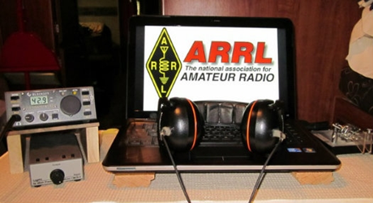*ARRL Contest Corner***

An expanded, downloadable version of *QST'*s [Contest Corral](http://www.arrl.org/contest-calendar) is available as a PDF. Check the sponsor's Web site for information on operating time restrictions and other instructions.

TOP ^

***One Question Questionnaire***

Hey Gang,



There’s another NEW – one question – questionnaire on the Ohio Section Website! <http://arrlohio.org>

It seems that only about 51% of you know how to program your radios or can modify a DMR Code Plug. Looks like we’ve got a very long way to go to get folks up to speed on getting them more familiar with their own equipment.

**“Will you be purchasing a new radio at the Dayton Hamvention??”**

Anyway, these questions are all in fun and I hope that you are enjoying answering these “ONE QUESTION” questionnaires. Ok, enough on that, here’s the next question for you to answer…

You’ll find the “One Question” questionnaire on the Ohio Section Website! <http://arrlohio.org> It’s all in fun and it’s not a scientific survey in any way, but we are learning some things that we didn’t know from these questions. I hope that you are enjoying answering these “One Question” questionnaires.

*****V.E. Test Sessions***

For the latest testing site information please **>>** [**Click Here**](http://www.arrl.org/find-an-amateur-radio-license-exam-session) **<<** The ARRL site tracks all of the VE testing sites that register with them, including W5YI and Laurel. ARRL gives you a number of different ways of sorting to find that site that is closest to you as well.

#########

***Exam Session Reminders***

**GRADING EXAMS:**  Each VE must grade each exam taken or must agree to the score given. After all three VEs agree to the number of correct answers shown, the score is announced to the examinee. The VEs must inform the examinee of their grade (pass or fail, and state the score {e.g., 26 out of 35}) upon completion of the grading.

**NEW GENERAL EXAMS COMING:**  The new General class question pool will take effect on July 1, 2019 for all Element 3 General class license written exams. With the General class exams changing July 1st, new test designs must be created and used on that day. ARRL VEC will be supplying all its (near 1,000) Field Stocked VE teams with new test booklets about the 3rd week in June. Do not destroy the 2015 versions of the General exams until June 30.

TOP ^

BASIC QUALIFICATION QUESTION PROCEDURES: The detailed instructions are available on the ARRL website. At the exam session, candidates that answer “YES” to the qualification (felony) question should be given the “Applicant Instructions for FCC Basic Qualification Question” document. Print or download here: <http://www.arrl.org/files/file/VEs/Applicant%20Info%20Qualification%20Question%202019.pdf>

TOP ^

Applicants can also be referred to our Basic Qualification Question web page for information and instructions.

View page: <http://www.arrl.org/fcc-qualification-question>

After the application data from the session is submitted to FCC and an FCC file number is created, the applicant is required to provide an explanation directly to the FCC within 14 days. Do not collect information from the candidate and do not send any documents to the VEC.

***Incident Command System (ICS) Training Schedule***

All current trainings are listed on the Ohio EMA training calendar located at:

<https://webeoctraining.dps.ohio.gov/TrainingAndExercise/courselist.aspx>

I’ve been asked to also include a link to the Kentucky EMA training calendar as well..

<https://kyem.ky.gov/training/Pages/default.aspx>

<https://sites.google.com/site/ccoemtraining/home>

Please pay particular attention to these courses listed above, as that there’s a lot of ICS 300 & 400 classes listed that are very useful for all Amateurs to have under their belts. I will also state that G775 is also a very good course to take as well. These 3 courses are multiple day in class courses, so please be prepared to spend some time taking them.

We do recognize that IS-300/400 requires multiple days of actual classroom training that is not easily obtained. So, if you just can't find the time to fit these class room courses in, we do have an alternative method for getting you to Level 3.

Completing the following **“FREE”** and **“ONLINE”** courses will act as substitute for you FEMA Leadership Development Course requirements. You absolutely will need to complete all **7** of these courses to get your ICS 300/400 credit.  Here are the courses that you need to take:  **IS-120, 230, 240, 241, 242, 244 & 288.**

***Now, if you are looking for wallpaper and have a little extra time, taking IS-235 in addition to the 7 listed courses above, you will get a really cool looking certificate from FEMA stating that you have completed the Professional Development Series. That’s impressive in itself!***

#########

TOP ^

***ARES Connect***

***CQ… CQ…. CQ… Calling all Ohio persons to be a part of the new ARES Connect program.***

We need to discuss some very important items that only YOU can make a difference with. I need you to get yourselves registered in ARES Connect, that is… if you haven’t already.

**If you live in Ohio** and you haven’t registered yet, we need you to get registered now. We also need you to only use this URL to get registered <https://arrl.volunteerhub.com/lp/oh/>. Using any other entrance to register will only slow down your registration process.

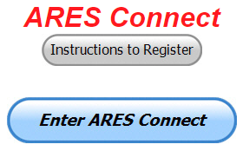As the numbers show, there’s still some that haven’t taken the plunge yet and need to! What are you waiting for? No matter how much you resist, it’s coming, and we need to make sure that no one is left behind.

**Now, as an incentive to get you to not only register…. But to actually start using the system…** *(Notice how I have that in bold type for you to clearly see?)*I am giving away all sorts of goodies to help you get motivated. I have a footlocker of really cool items that I will be giving away!

I’m doing this in various intervals throughout the year, so it will challenge you to be dedicated to getting your hours into the system. You’ll never know just when another drawing will be, so you really do have to be prudent!!

***Here’s the top 10 folks for hours for the month of April:***

|  |  |  |  |
| --- | --- | --- | --- |
|  | **Name** | **Events** | **Hours** |
| 1 | Timothy Lovejoy (NC8OS) | 34 | 232.25 |
| 2 | Christopher Domenick (KC8CAD) | 31 | 126.00 |
| 3 | James Yoder (w8erw) | 16 | 124.25 |
| 4 | Dan Stahl (KC8PBU) | 48 | 77.00 |
| 5 | David Noeth (KD8ACO) | 13 | 65.75 |
| 6 | Ron Hollas (K8RJH) | 16 | 59.25 |
| 7 | Elizabeth Klinc (KE8FMJ) | 45 | 58.80 |
| 8 | Bret Stemen (KD8SCL) | 24 | 56.50 |
| 9 | Carl Gedeon (KB8VXE) | 20 | 50.00 |
| 10 | Mathew Nickoson (KC8NZJ) | 19 | 47.25 |

***Here’s how we did with people getting signed up for events***

***and the total hours logged for the month of April***

|  |  |
| --- | --- |
| Total Amount signed into Events | Total Hours for Events |
| **1,867** | **4,953.62** |

TOP ^

It adds up quickly, but you do have to be registered and actually USE the system in order for any of your time to count. We have a set of instructions on how to get registered right above the button to enter ARES Connect. I would strongly suggest that if you haven’t registered yet, that you read these instructions first.

Here’s a link to get you started... <http://arrl-ohio.org/ares_connect_directions.pdf> Please, don’t just hurry through the questions, read them carefully, if you don’t understand something, please ask me, I’m here to answer your questions.

We know that you mean well by answering that you do have the needed courses in, but I will let you know that we are verifying what you say you have with what is showing for you in our statewide database when we are completing your registration. So, how can you find out if you are already listed in our statewide database? Easy, here’s a link: <http://arrl-ohio.org/SEC/special/ICS%20Complete%20by%20County%20and%20Name.pdf>

**Ok, now on to a problem that has cropped up with the new ADMIN 2.0…** It seems that when the folks at Volunteer Hub released the newest version of their Admin Dashboard there was a little “gotcha” in it that they didn’t know about until some of our folks found it for them. It seems that if you are in ADMIN 2.0 it won’t allow you to create an event. It’s good with everything else, but it just isn’t up to snuff on this yet. They are aware of the situation and are currently working on a fix for it!

So, for now, just use the old dashboard and don’t bother with Admin 2.0 until a fix comes through. I’ll let you all know when that happens.

***Sign Up for Hamvention Alerts***

If you are planning a visit to Hamvention 2019, you are urged to sign up for the Hamvention alerts which are available again this year on your mobile phone. To subscribe to the system just text **Hamvention19** to **888777**. The alerts will provide up-to-date information for those traveling to or attending Hamvention such as weather, traffic, parking and other useful information throughout Hamvention. If you signed up for the alerts in 2018 you are automatically registered for this year.

The alerts are especially important for up-to-minute information about parking and weather, especially for those who might not be able to monitor the talk-in or bulletin stations. The alerts will provide another way to direct drivers to the best parking solution if weather requires closing some onsite parking lots or if some remote lots fill up. A special thanks to Greene County Sheriff Gene Fischer, KX8GCS, for making the alerts possible again this year

The Media Committee is working to make winning prize numbers available on the alert system soon after they are drawn. This is an effort to help winners claim prizes and to decrease the number of unclaimed prizes that must be redrawn prior to the main prize drawing on Sunday. During Hamvention the numbers from the hourly prize drawing will be posted on Twitter and Facebook as well as displayed on monitors throughout the fairground's buildings. Following Sunday's Grand Prize drawings, winners will also be posted on Twitter and on <http://hamvention.org/event-details/prizes/>.

The alert system, which was initiated in 2018, was a Hamvention effort to get visitors the information they need. It is a supplement to the Hamvention talk in station that has operated for many years on the Dayton Amateur Radio Association repeater, 146.94(-) 123.0 Tone to give directions and other assistance.

TOP ^

Last year a traffic bulletin station was also added on 145.525 to periodically repeat needed information. Amateurs with 2-meter capability are urged to enter those frequencies into their radios before starting their Hamvention journey.

Hamvention 2019, the world's largest amateur radio gathering, will be held May 17-19 at the Greene County Fairgrounds and Expo Center in Xenia, OH.

***This and that’s***

*(From Greg, WD9FTZ and other sources)*

***FT4 versus FT8 – What’s the difference?***

**Hayden Honeywood, VK7HH** has released a video about the differences between the new FT4 digital mode and the older FT8   
  
Watch FT4 vs FT8 – A new mode, what’s the difference?  
<https://www.youtube.com/watch?v=ijtYXo-51Xc>  
  
FT4 digital mode now available   
<http://www.southgatearc.org/news/2019/april/ft4-digital-mode-now-available.htm>  
  
Hayden VK7HH  
<http://hh.vk7.com.au:82/blog/>  
<https://www.youtube.com/channel/UCo_jX41l6nYfnrQuk0qsZFw/videos>

#########

***Release Candidate WSJT-X 2.1.0-rc5 Now Available***

<http://physics.princeton.edu/pulsar/k1jt/wsjtx.html>

Candidate releases are intended for beta testers: individuals interested in testing the program's new features and providing feedback to the WSJT Development Group.  At the time of this release we have not yet completed the *WSJT-X 2.1 User Guide*.  Potential users of the candidate release should read [The FT4 Protocol for Digital Contesting](http://physics.princeton.edu/pulsar/k1jt/FT4_Protocol.pdf) before proceeding.

* English:          [FT4_Protocol.pdf](http://physics.princeton.edu/pulsar/k1jt/FT4_Protocol.pdf)           (K1JT, K9AN, G4WJS)
* German:         [FT4_Protocol_de.pdf](http://physics.princeton.edu/pulsar/k1jt/FT4_Protocol_de.pdf)      (OE1EQW)
* Spanish:         [FT4_Protocol_es.pdf](http://physics.princeton.edu/pulsar/k1jt/FT4_Protocol_es.pdf)      (EA4BAS)

**Installation packages for *WSJT-X 2.1.0-rc5*  
Windows:**

* 32 bit: [wsjtx-2.1.0-rc5-win32.exe](http://physics.princeton.edu/pulsar/k1jt/wsjtx-2.1.0-rc5-win32.exe)  (WinXP, Vista, Win 7, Win 8, Win10)
* 64 bit: [wsjtx-2.1.0-rc5-win64.exe](http://physics.princeton.edu/pulsar/k1jt/wsjtx-2.1.0-rc5-win64.exe)   (Vista, Win 7, Win 8, Win10, 64-bit)

#########

TOP ^

***UK 241 GHz record broken twice in one day***

On the Groupsio UKMicrowaves list **Chris, G0FDZ** reports that the UK distance record for a contact on the 241 GHz band was broken twice on April 30

He writes:   
  
The UK 241 GHz record was broken twice today [April 30, 2019] when Roger G8CUB/P worked Chris G0FDZ/P first over a 7.36 km path from West Tilbury (JO01EL92) to Higham (JO01FK60). Roger then moved to Thurrock Thameside (JO01FL39) and worked Chris at Higham (JO01FK60) over a 9.33 km path.   
  
The first contact was completed on SSB with signals averaging 56 each way and over the second path (which was over more of the Thames) CW signals were exchanged at the 549/ 529 level. Fading of up to two S points was certainly noticeable on each occasion.  
  
See the post at   
<https://groups.io/g/UKMicrowaves/message/49729>  
  
Details of UK Microwave Group (UKuG) membership can be found at  
<http://www.microwavers.org/>  
Membership is free to those under 21.  
  
PDF's of the UKuG newsletter Scatterpoint for 2017 and earlier can be downloaded free from   
<http://www.scatterpoint.org/>

#########

***World Scout Jamboree Gearing Up for Significant Amateur Radio Presence***

*(from arrl letter)*

Amateur Radio will be a part of this summer's 24th World Scout Jamboree in West Virginia, the first World Jamboree held in North America since 1983. The Jamboree has chosen the theme "Unlock a New World." Thousands of Scouts and Scout leaders from some 200 countries are expected to attend. The Jamboree's Amateur Radio Exhibit will use the call sign [NA1WJ](https://www.k2bsa.net/world-jamboree-na1wj/) -- North America's 1st World Jamboree. It will be on the air during the event, July 22 until August 2, at the Summit Bechtel Reserve, hosted by Canada, Mexico, and the US. Amateur Radio testing is expected to begin as early as July 14. Operating frequencies will be posted in real time via [Facebook](https://k2bsa.us5.list-manage.com/track/click?u=56ce1526bb2372707f5868e21&id=2040fbdc79&e=f04efd1977) and [Twitter](https://k2bsa.us5.list-manage.com/track/click?u=56ce1526bb2372707f5868e21&id=9518437486&e=f04efd1977) or via an [NA1WJ email group](https://groups.io/g/na1wj).

"The goals of the Amateur Radio station at the World Scout Jamboree are to introduce Amateur Radio to Scouts and Scout leaders through hands-on participation in two-way communication with other stations across the globe. This activity will also serve as the Amateur Radio voice of the Jamboree," the [World Scout Jamboree Amateur Radio Exhibit Operational Vision document](http://k2bsa.wstearns.com/wp-content/uploads/2017/11/WSJ-Amateur-Radio-Vision-V1.pdf) states. Other facets of Amateur Radio at the Jamboree will include Amateur Radio direction finding (ARDF), Amateur Radio satellite contacts, and a scheduled Amateur Radio on the International Space Station (ARISS) contact with an ISS crew member.

TOP ^

"We also expect to launch one or two balloons with Amateur Radio payloads and track them as they cross the Atlantic," the vision document continues. Organizers are encouraging radio amateurs around the globe to get on the air during the World Jamboree to help NA1WJ demonstrate Amateur Radio for Jamboree visitors.

The 2019 World Scout Jamboree operation at the Summit Bechtel Scout Reserve will take advantage of lessons learned by the K2BSA Amateur Radio operation during the 2013 and 2017 USA National Jamborees. It will also take advantage of the existing infrastructure, which includes three VHF/UHF repeaters installed by Icom America, as well as the utility poles for installing antennas. K2BSA ham gear stored in West Virginia includes antennas, rotators, and cables.

Evening operation from NA1WJ will involve at least two operators using the buddy system. VHF/UHF repeaters will offer full coverage of the Jamboree area via handheld transceivers, facilitating networking as well as emergency communication. The exhibit will include an Amateur Radio station with the special event call sign W8J.

The demonstration station will include multiple operating positions offering a variety of modes. These include six stations with 100 W HF transceivers, computer logging software, and large screen computer displays; two VHF/UHF stations for demonstrations and repeater monitoring, and two satellite communication systems.

The antenna farm will include two HF directional antennas, three HF dipoles, three HF vertical antennas, VHF/UHF verticals and satellite antennas with azimuth and elevation control, a trailer-based crank-up tower, a five-band Yagi, a 40-meter rotatable dipole, and a 6-meter Yagi.

Each station will be able to accommodate four participants at a time, plus one control operator. The goal is to give each participant up to about 10 minutes of operating time.

The K2BSA Amateur Radio Association will host a "Radio Scouting" booth at [Dayton Hamvention](http://www.hamvention.org)® (Booth 2205 in Building 2).

**#########**

***VOA Expanded Hours during Hamvention***

*(from Radiogram)*

The National Voice of America Museum of Broadcasting, a short drive from Hamvention® , announces expanded hours for Hamvention weekend. The Museum is located at the site of the former Voice of America Bethany Relay Station in West Chester, between Dayton and Cincinnati, just off the I-75 Tylersville Road exit.

From 1944 thru 1994, six of the most powerful shortwave transmitters in the world broadcast to listeners seeking truth in Europe, Africa and South America from the Bethany Station. Every week millions heard programs in 50 different languages beamed globally from this hilltop.

TOP ^

Those attending the 2019 Dayton Hamvention® will have ample opportunities to visit. The Museum is located about 35 minutes from the main convention activities. A booth for the museum and WC8VOA is located in space #1910 in building 1 at Hamvention®.

The Ham Shack for WC8VOA will be open, as well as some unique exhibits such as the comprehensive collection of Drake Amateur Radio gear, the remaining Collins 250,000 watt transmitter, the 1960’s VOA Master Control room, the Powel Crosley Jr. Exhibit, and an exhibit about the US Coast Guard Cutter “Courier” a cold war era floating radio transmission facility that relayed VOA Bethany broadcasts to the Middle East and Soviet Union.

The VOA Museum is open every Saturday and Sunday from 1-4 pm.

Special hours for Hamvention® Attendees are: Thursday, May 16th from 4 to 9 pm. Friday, May 17th from 4 to 9 pm Saturday, May 18th from 1 to 9 pm and Sunday, May 19th from 1 to 5 pm Admission is just a five-dollar donation.

In addition this year, the museum has a special offer for new donors visiting during Hamvention® on Saturday, May 18th only. From 6:30 to 9 pm, new Museum donors of at least $45 will receive: Free general admission to the Museum A guided tour of the Museum’s Crosley Collection A tour of the historic WLW transmitter site featuring the Crosley 500 kw WLW transmitter. This tour will be conducted by internationally known broadcast veterans Jay Adrick, K8CJY and Geoff Mendenhall, W8GNM. Transportation from the Museum to the WLW transmitter site and back is included.



Space is limited on the WLW transmitter tour, and reservations are required. To sign up, visit [www.voamuseum.org](http://www.voamuseum.org).

More information about the museum and the special WLW transmitter tour option is available at [www.voamuseum.org](http://www.voamuseum.org)

**#########**

***2018 Ohio QSO Party Results are Posted***

The results of the 2018 Ohio QSO Party are now available on the OhQP web site,   [www.ohqp.org](http://www.ohqp.org)

Thanks to all who participated, and we’ll be looking forward to seeing you again for the 2019 event on Saturday, August 24.

And for those attending the Dayton Hamvention, stop by at the Mad River Radio Club “Suite in the Sun” , a.k.a. flea market spaces 7368-7372, on Friday or Saturday to say hello!

73  -  Jim   K8MR

OhQP Chairman

**#########**

TOP ^

***SWODXA DX DINNER ANNOUNCEMENT***

*(from Mindi Jones, KC8CKW | mindew@fuse.net)*

**FOR IMMEDIATE RELEASE**

There is only a couple of weeks left until the SouthWest Ohio DX Association (SWODXA) hosts the 34th annual DXDinner®. The dinner, held in conjunction with the 2019 Dayton Hamvention®, will be on Friday, May 17th, at the Marriott Hotel in Dayton.

Charlie Wooten, NF4A, has been licensed for over 56 years and has been a DXer from the start. Charlie has achieved the DXCC Honor Roll. He is the current Southeastern Division Representative on the ARRL Contest Advisory Committee. He was a referee for the WRTC-2006 international team championship held in Brazil in July 2006, WRTC-2014 New England/USA, and WRTC-2018 Lutherstadt, Germany.

Yaesu has donated an FT-1200 for the DX Forum and an FT-3000 for the DXDinner. Icom has donated an IC-7610. There will be many other prizes as well! The newest inductee(s) in to the CQ Hall of Fame will be

announced, The IREF will announce the IOTA Expeditioner of the Year award, and SWODXA will announce the much-anticipated DXPedition of the Year!

80% of the available ticket sales have sold so don’t wait much longer. For more information and to order dinner tickets, visit [WWW.SWODXAEVENTS.ORG](http://WWW.SWODXAEVENTS.ORG) and follow us on Twitter (@SWODXA).

***Wouff Hong Ceremony At Hamvention***

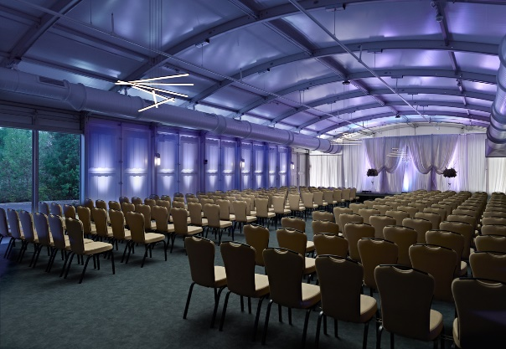When: **Saturday – May 18th starting ~ 9:00 PM** Where: Marriott at the University of Dayton

Hey Gals and Guys… You’ve been asking if this is going to happen, and now I can tell you for sure, YES, we are having a Wouff Hong Ceremony at Dayton!!! The Conclave will gather at 9pm and those willing to take the plunge and become a part of this ever growing and most secretive of all Societies. Come join us and be indoctrinated into history!

The ceremony is steeped in mystery! Attendees will receive a special keepsake. A fun activity for all ages. Doors to the conclave will open at 9:00 PM (no admittance after 9:30 PM) at the Marriott at the University of Dayton (Tradewinds Pavilion), 1414 S Patterson Blvd, Dayton, OH 45409. **Free** **registration online** to ensure there will be enough seats, and to get a really cool certificate following the ceremony. Go to: [**http://arrl-ohio.org/wouff-hong.html**](http://arrl-ohio.org/wouff-hong.html)**.** This event is sponsored by the ARRL Ohio Section.

**Now, for those of you who don’t know what Wouff Hong is all about:**

A Wouff Hong is a fictional tool used to "punish" Amateur Radio operators who demonstrate poor operating practices. Legend has it that the Wouff Hong was invented by ARRL co-founder Hiram Percy Maxim under the pseudonym, "The Old Man," just as radio amateurs were getting back on the air after World War One.

TOP ^

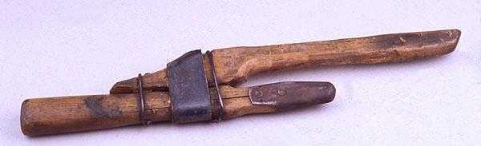Early in 1919, "The Old Man" wrote in *QST* "I am sending you a specimen of a real live Wouff Hong . . . Keep it in the editorial sanctum where you can lay hands on it quickly in an emergency." The "specimen of a real live Wouff Hong" was presented to a meeting of the ARRL Board and the Board voted that the Wouff Hong be framed and hung in the office of the Secretary of the League.

On display at ARRL Headquarters today, the Wouff Hong is a constant reminder to Amateur Radio operators to be mindful of their operating etiquette.

***Final.. Final..***

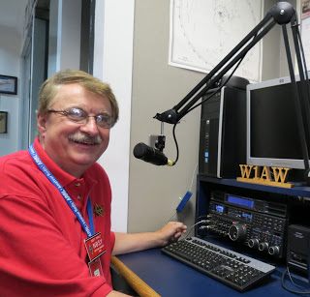

Hey Gang...

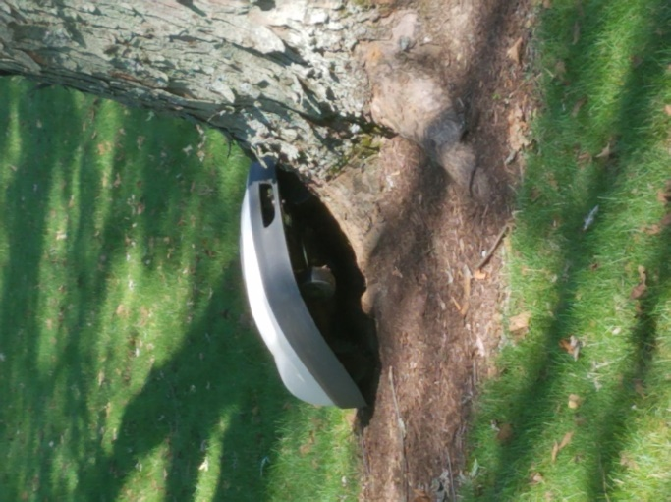This was one great week for sure. One day it’s 45 degrees, the next it’s 80 and we’re all looking for where we packed our shorts from the year past! Well, that’s good ol’ Ohio weather for ya’.

And the rain keeps on coming. Does your yard look like mine? I haven’t been able to get the mower out yet and the grass is over 12 inches high, and in some places, it’s starting to look like a hay field. I’m betting that the guy next door with the robot mower will be over soon to try to sell me on getting one.

Oh, that reminds me, I haven’t let you in on some of the improvements with his little gizmo. It now has figured out a way to climb trees! Yup... Here’s a shot of it climbing one in his yard just the other day. Notice how it has already chewed off all the bark near the bottom of the tree! From what I’ve been told by some folks, the tree won’t survive this type of damage if it continues for any period of time. It seems that trees are very susceptible to diseases if their bark has been removed from around the base. Guess we’ll be seeing a stump soon.

Now the funniest sight I saw recently with this little bugger is when it decided to chase a skunk around the yard. Unfortunately, due to some very potent odors being emitted from the skunk, I didn’t dare get close enough to it to get a good picture of the chase. Maybe next time!!

Sliding down the band a bit… I had a blast visiting with everyone at the Athens Hamfest last Sunday. The middle of the week I visited with the folks at the Lake County ARC and finished up the week (Friday) with the folks at the Massillon ARC.

TOP ^

Let’s spin the dial a bit and see what’s on the band below… Where you at the Ohio Section ARES conference a few weeks ago? If you weren’t, don’t fret, you can see all of the forums by going to:

<http://arrl-ohio.org/SEC/sec-conf-2019.html> and view all the videos. I will say that I had to trim down the Table Top Exercise some. It was almost 3 hours long. Way too long for YouTube. So, I took the liberty of doing some editing and have it down to 1 hour and 17 minutes. Have your popcorn and soda on hand when watching that one. All the rest of the videos are under 1 hour!

Rotating the dial a little more… I’ve been asked by many of you just how many folks do we have in ARES Connect now. Well, here’s a breakdown of all 3 levels for you: Level 1 – 469; Level 2 – 426; Level 3 – 132.

This gives us a total of **1,027** in ARES Connect. I don’t know positively for sure, but my guess from everything that I can see within the system is that no one other than the Ohio Section has more people registered in ARES Connect.

I do want to clear up some mis-interpretations that have been going around. First, in the Ohio Section we only require our Level 2 volunteers to have the 4 basic courses, IS 100, 200, 700 & 800. For our Level 3 volunteers we do require the additional ICS 300 / 400, or the equivalent professional series courses IS 120, 230, 240, 241, 242, 244 & 288. These equivalent courses are all on-line classes just like your basic 4 NIMS courses are and being offered as an alternative way for you to get credit for taking the professional series courses in the event you just cannot get scheduled into an ICS 300/400 class.

By the way, if you decide to take these 7 on-line courses and complete them all, you will want to take just one more class **IS-235.** By completing this additional course, you will get a really great looking certificate from FEMA recognizing that you have completed the entire Professional Series courses. I do hope that this clears up the confusion that has been going around lately. As we have stated on the website and in this newsletter many times “We don’t want anyone left behind.”

If you haven’t heard, the **“Put Howard to Work” Event Has Been Canceled**

Earlier this week, ARRL announced that ARRL CEO Howard Michel, WB2ITX, would be on the air at W1AW on Monday, May 13, giving ARRL members a chance to chat with the CEO and get to know him better as a ham. An issue was raised, however, that this event may pose a potential FCC rule violation.

The particular rule is §97.113: “A station is also not allowed to transmit communication in which the station licensee or control operator has a pecuniary interest, including communications on behalf of an employer.”

Given that ARRL is Michel’s employer and that an effort was made to publicize an event at which members of the organization could chat with the CEO, such an event could be perceived as a benefit to the organization. So, out of an abundance of caution and to avoid any potential violation of FCC rules, or even the appearance of a violation, Michel has decided to cancel plans for the “Put Howard to Work” event.

“I’ve operated W1AW before and will continue to do so in the future,” Michel said. “I hope to meet many of you on the air, but only as part of my regular ham radio activities and not as part of an ARRL-promoted event.”

The “Put Howard to Work!” event was conceived by the [***ICQ Amateur/Ham Radio Podcast***](https://www.icqpodcast.com/), on which Michel was a guest on March 31. “We are disappointed, of course, at this turn of events but fully understand and endorse ARRL’s decision,” said ICQ Podcast Presenter Frank Howell K4FMH.

TOP ^

Website updates have occurred this week. Thanks to Daniel, KB8LKH, he’s updated his Code Plugs for the 868 and the Connect Systems CS-800 and CS-800D. David, KD8TWG made a really good video on how to add a Talk Channel to your Code Plug. The video uses the more popular MD-380 CPS, but he does an excellent job on explaining how it all goes together in a way that for the most part, whatever radio you have, you’ll be able to use this video to guide you along with your changes. There’s a new link on the [Code Plug page](http://arrl-ohio.org/digital/Code-Plugs-and-more.html) that takes you to a website that Cliff, AC8CB is maintaining. He has STARTER Code Plugs for some of the more popular radios to get you on your way with DMR.

And finally… For those of you on my email listing. If you are wondering about the really odd email address on this weeks’ notice about the newsletter, it seems that we’ve have an invasion on our website email program. It seems that someone on the other side of the globe has tried to take over our account. They attempted to send out over 400,000 emails all at once. Guess they have a lot of friends that they wanted to email too! As you can imagine, that drew some attention from the folks that manage and operate the server system that we use. Their systems immediately took action and shut everything off so that these spam emails would not go out. As such, this has caused some disruption with all of you not getting emails from me that are linked to the accounts for the website. I do apologize for the inconvenience. But, even if you didn’t get the email letting you know of the weekly newsletter “PostScript”, you haven’t lost out, you can go back and look up and even download any of the newsletters at any time. Just go to: <http://arrl-ohio.org/news/index.html>

Whelp… That’s going to do it for this time around. Stay safe, enjoy the sunshine while we have it, and most of all… have FUN!!

73,

***Scott, N8SY***

***Murphy’s Laws***

* Any given program, when running, is obsolete.
* Any given program costs more and takes longer each time it is run.
* If a program is useful, it will have to be changed.
* If a program is useless, it will have to be documented.
* Any given program will expand to fill all the available memory.
* The value of a program is inversely proportional to the weight of its output.
* Program complexity grows until it exceeds the capability of the programmer who must maintain it.

TOP ^

***Back Issues of the PostScript and Ohio Section Journal (OSJ)***

Hey, did you know that PostScript and Ohio Section Journal (OSJ) are archived on the website? You can go back and look at any edition simply by clicking:

<http://arrl-ohio.org/news/index.html>

***Chit – Chat, and All That!***

Do you know someone that’s not getting these Newsletters? Please, forward a copy of this Newsletter over to them and have them “[Opt-In](http://arrl-ohio.org/forwarder/forwarding.html)” to start receiving them. Heck, just have them send me an email [n8sy@n8sy.com](mailto:n8sy@n8sy.com) and I’ll get them added to the Ohio Section Emailing list.

We now have many thousands of readers receiving these newsletters weekly. Quite impressive, I’d say! I urge all of you to make sure that everyone, regardless of whether they are a League member or not, get signed up to receive these weekly Newsletters.

You can always “[Opt-Out](http://arrl-ohio.org/forwarder/forwarding.html)” at any time if you feel this is not what you were expecting. It’s fun and very informative. All of your favorite past newsletters are now archived too.

You can go back at any time and read them. Just go to: <http://arrl-ohio.org/news/>

Got questions, concerns or would just like to sit and chat awhile? Heck, I’ll even buy the coffee!! Give me a call at (419) 512-4445 or email me at: [n8sy@n8sy.com](mailto:n8sy@n8sy.com)

The pictures on the front page are from various newsletters, Facebook posts and/or were sent directly to me in recent weeks. Take a good look at them, you just might be in one of the pictures! “SMILE… you’re on the Ohio Section News!!”

TOP ^

*PostScript is produced as a weekly newsletter. I want to thank everyone that has contributed articles and ideas to make this an even better news source. I sincerely hope that you have enjoyed this edition and will encourage your friends to join with you in receiving the latest news and information about the Ohio Section, and news and events happening around the world!*