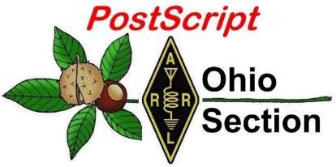
April 29th
Edition

National News The Handbook Give Away

Club Corner Hamfests

DX This Week One Question Questionnaire

VE Testing ARES Connect

Wouff Hong Ceremony At Hamvention Final.. Final..

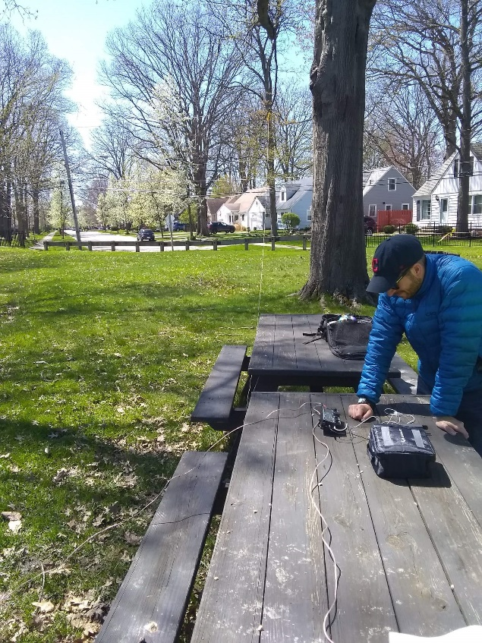
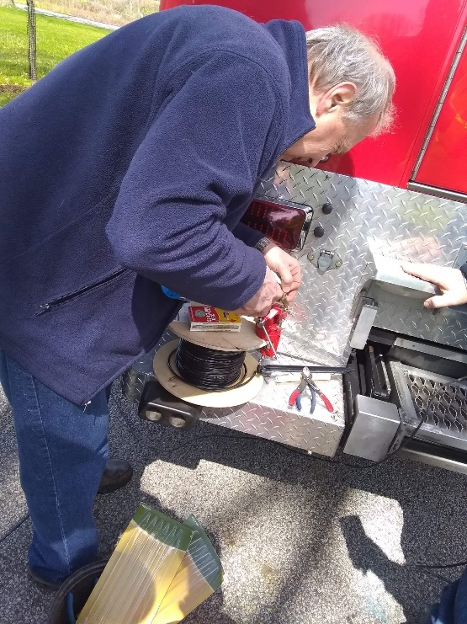
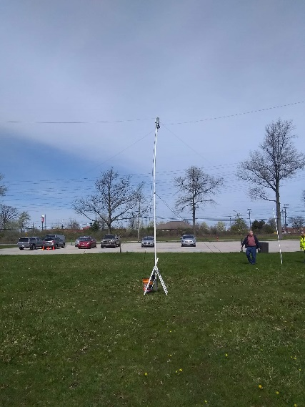
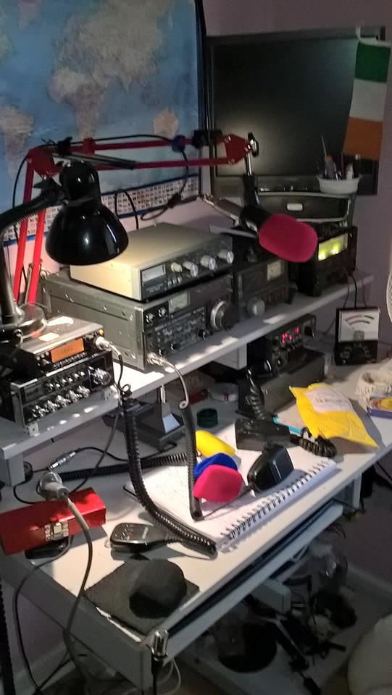
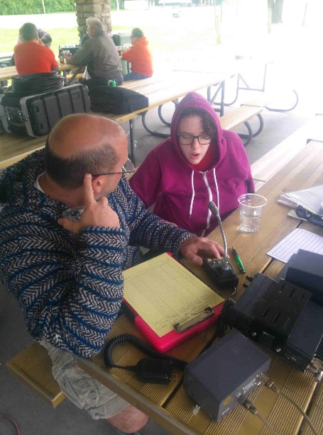
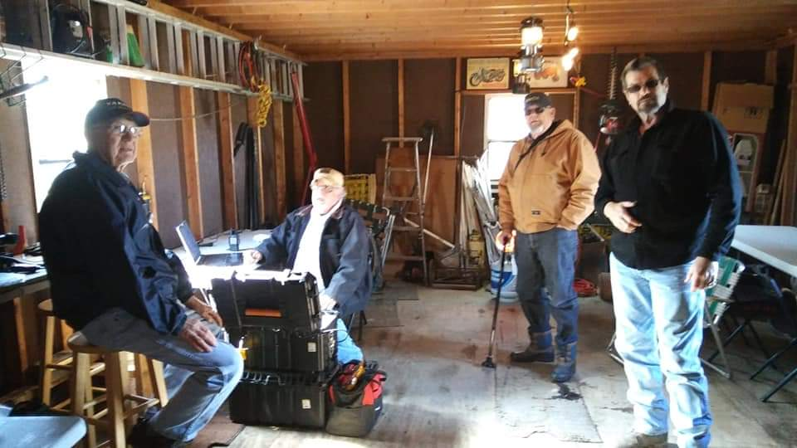

National News
(from arrl and other sources)

Meet the Author at the ARRL National Convention

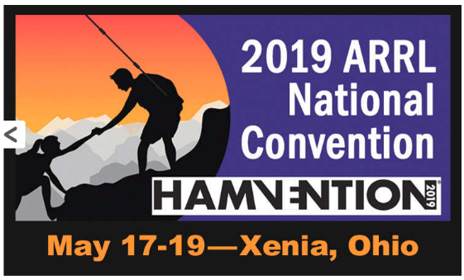
ARRL will present a “Meet the Author” area at the 2019 ARRL National Convention at Hamvention® May 17 – 19 in Xenia, Ohio. This is an opportunity for visitors to speak with the radio amateurs who are inspiring today’s experimenters, operators, and innovators. A schedule will be posted in the ARRL exhibit area to meet these authors and editors:

- Bob Bruninga, WB4APR, author of ARRL’s new book Energy Choices for the Radio Amateur.

- Glen Popiel, KW5GP, author of Arduino for Ham Radio, More Arduino Projects for Ham Radio, and High Speed Multimedia for Amateur Radio.

- Ward Silver, N0AX, lead editor for The ARRL Handbook and The ARRL Antenna Book, and author of Grounding and Bonding for the Radio Amateur, ARRL’s Hands-On Radio Experiments, and ARRL License Manuals.

- Dr. Scott Wright, K0MD, editor of NCJ, ARRL’s premiere contesting journal.

- Bob Allison, WB1GCM, ARRL Lab Product Review and author of Amateur Radio Transceiver Performance Testing.

Books will be available for purchase within the ARRL exhibit area for authors to autograph. In addition to the Meet the Authors area, ARRL National Convention exhibits and activities will include QSL card checking for ARRL award programs, the opportunity to have your handheld transceiver checked for spurious emissions, and much more.

ARRL exhibits will be located in Building 2 of the Greene County Fairgrounds and Expo Center. Visit the ARRL National Convention and Hamvention websites for a complete convention rundown.

#########

IARU Argues for Protection from Wireless Power Transfer Spurious Emissions
The International Amateur Radio Union (IARU) was represented April 8 – 10, when CEPT Committee SE24 – Short Range Devices met in Ankara, Turkey, to undertake further work concerning wireless power transfer/transmission (WPT). SE24 is considering WPT for electric vehicles (WPT-EV) and also for generic applications.

TOP ^
IARU already provided extensive input on the potential impact on radio communications resulting from spurious emissions from WPT devices, as detailed in CEPT ECC Report 289, published in January. According to that report, given the planned density of WPT systems for electric vehicles operating in the 79 – 90 kHz range, it is calculated that there will be a widespread and serious impact for the Amateur Service in the vicinity of WPT systems, should spurious emissions, measured at 10 meters, be at the current limits of ERC Recommendation 74-01.

At the Ankara meeting, IARU and other interested parties provided further input. SE24 will meet again in early July to focus on WPT issues.

Also, at Ankara, IARU attended the Short-Range Devices Maintenance Group meeting (SRD/MG), where it was noted that further work was needed in SE24 before spurious emission limits for WPT devices could be addressed in a regulatory sense. IARU was represented in Ankara by IARU Region 1 President Don Beattie, G3BJ, who is spearheading the IARU’s work in this area.

The issue of WPT-EV is World Radiocommunication Conference 2019 (WRC-19) Agenda Item 9.1.6, for which studies are still under way. Broadcasters, land mobile services, and others have also expressed concern about spurious WPT-EV emissions. Further work remains regarding generic WPT systems for such applications as cell phone charging, power tools, and household appliances.

#########

Faster, More Contest-Friendly FT4 Digital Protocol to Debut in a Week

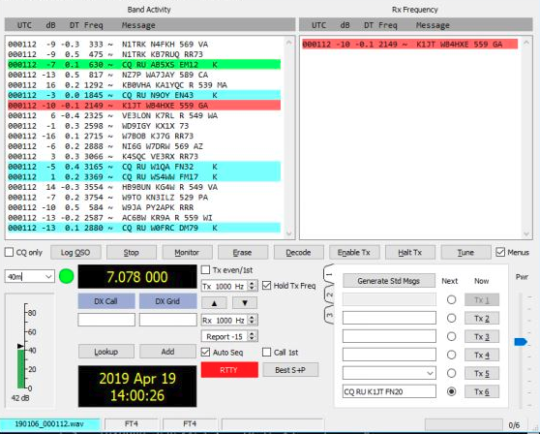
[UPDATED: 2019-04-24 @ 1818 UTC] A new, speedier, more contest-friendly digital mode is just days away, initially in beta form. WSJT-X developers say serious work on the new FT4 protocol began shortly after the FT8 Roundup held last December 1 – 2. The goal was a mode that could compete with RTTY contesting in terms of contact rates, while preserving many of the benefits of FT8.

“Over the past month a small group of volunteers have been conducting on-the-air tests of FT4,” the WSJT-X Development Group — Joe Taylor, K1JT; Steve Franke, K9AN; and Bill Somerville, G4WJ — announced this week. “The early tests were very successful and helped us to make a number of important design decisions. We believe FT4 has considerable promise for its intended purpose.”

The developers say FT-4 soon will be ready for testing by a larger group and they’re seeking interested participants who can offer their “considered feedback.” They suggest reading The FT4 Protocol for Digital Contesting first. A general release of the WSJT-X suite that includes FT4 is anticipated in July.

According to the document FT4 is an experimental digital mode designed specifically for radio contesting that — like FT8 — uses fixed-length transmissions, structured messages with formats optimized for minimal contacts, and strong forward-error correction. Transmit-receive sequences are 6 seconds, making it 2.5 times faster than FT8 and about the same speed as conventional RTTY for radio contesting. FT4 can work with signals 10 dB weaker what would be required to decode RTTY while using much less bandwidth.

TOP ^
Transmissions last for 4.48 seconds, compared to 12.64 seconds for FT8. Modulation uses four-tone frequency-shift keying at approximately 23.4 baud, with tones separated by the baud rate. The occupied bandwidth is 90 Hz.

“We plan to post downloadable installation packages for WSJT-X version 2.1.0-rc5 on Monday, April 29,” the Development Group said. The FT4 Protocol for Digital Contesting document includes:

- Instructions for installing WSJT-X 2.1.0-rc5 and configuring FT4.

- FT4 operating instructions.

- A basic description of the FT4 protocol, modulation, and waveform.

- Detailed sensitivity measurements for FT4 under a wide variety of simulated propagation conditions.

“A few parameters and operating behaviors of FT4 are still being tested and optimized,” the initial FT4 guide says. “It will be very useful to hold several more mock contest practice sessions, with a larger group of active participants.”

Even if these practice sessions reveal no serious bugs or inadequacies, the WSJT-X Development Group believes FT4 is still too new to be used in the ARRL VHF Contest (June 8 – 10) and ARRL Field Day (June 22 – 23). For that reason, release candidate WSJT-X 2.1.0-rc5 will “time out” on June 7.
Here is the proposed schedule related to the FT4 beta version rollout.

- April 29: Second announcement, with links to downloadable installation packages for WSJT-X 2.1.0-rc5

- May 9, 0000 – 0100 UTC: FT4 practice session, 7.090 MHz

- May 14, 0000 – 0100 UTC: FT4 practice session, 7.090 MHz

- June 5, 0000 – 0100 UTC: FT4 practice session, 7.090 MHz (if needed)

- July 15: General Availability (GA) release of WSJT-X 2.1.0.

#########

Commemorative Icom Hamvention® 2019 Swag Kit

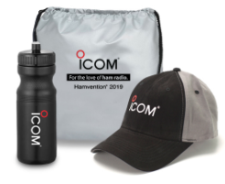
Attention all hams. Be one of lucky the winners to receive a commemorative Icom Hamvention® 2019 Swag Kit. Sign up today to be entered into the drawing. This is an at show promotion - so attendance is required to receive the swag kit.* Registration is open until May 5th.

Here’s the link to get registered:

http://online.icomamerica.com/dayton-hamvention-contest

TOP ^

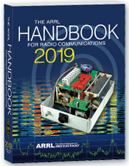
The Handbook Give Away

Hey Gang,

Have you registered for the “Handbook Giveaway” drawing for this month yet? If you haven’t, go to: http://arrl-ohio.org/handbook.html and get yourself registered now!

What’s the catch? I want to get everyone checking in to the Ohio Section website as often as possible, and in order to register each month, you have to visit the website often! There’s nothing else to it. I pay all expenses and I usually “Give Away” more than just a Handbook too!!

Many of you ask me just how do I know when the drawing is on? Well, that’s easy all you need to do is check in on the Ohio Section Website on a regular basis and watch for the big RED Arrow that will appear on the left side of the page. This is the sign that the drawing is on and you need to get registered. So, keep a sharp eye out on the website and check in often! http://arrl-ohio.org

Club Corner

This is YOUR cornner of the newsletter. Send me what your club is doing and I’ll make sure that it gets in. Got a special event or club project that you want everyone to know about? Send it to me!. Need help with a project? Send it to me.

Let me know what you club is up to. Are you going to have a special guest at your meeting or are you having a special anniversary? Just sent it to:
n8sy@n8sy.com

#########
ATCO Spring Event

Guys (and Gals too),

It's closing in on ATCO Spring Event time. The Event date is Sunday May 5th starting about noon. Come one, come all in the ABB Cafeteria, and it's free! We'll have a free lunch followed by a short business meeting then on to the door prizes.

TOP ^
Let's have a great turnout this time! Surprise me! ABB Cafeteria is located at: ABB Inc, 579 Executive Campus Dr, Westerville, OH 43082

#########

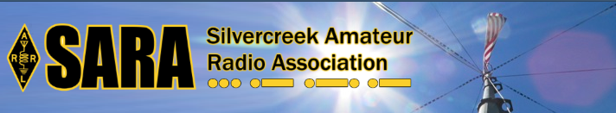
SARA is partnering/supporting Wayne County EMA in the offering of the SKYWARN training this year. As you may have heard, budget and staffing issues in the Cleveland NWS office has led them to cancel the NWS-lead SKYWARN classes. EMAs and ARES ECs are being encouraged to hold the SKYWARN training directly.

SARA is playing a supporting role to the Wayne County EMA which is holding a session for this region. The date will be Monday, May 6th from 6p - 8p.

Volunteers will be needed 5p - 8:30pm. The tentative location is Chippewa Jr/Sr High School in Doylestown. Volunteers will help register attendees and print the SKYWARN training cards with ID numbers. Fred Sheppard KD8GYS will be assisting Joe Villegas with the class.

Additionally, SARA will have a table with some amateur radio materials available to spread the word about our hobby and service.

If you can volunteer your time, please contact me so I can add you to the roster. Please note that volunteers will not be able to be present in the class for the entire session as volunteers will register latecomers and also print and organize the ID cards.

Thanks! For more information or questions, contact Jason, N8JDM jason@mfamily.org

#########

GENRAL LICENSE UPGRADE CLASS

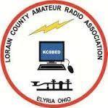
The Lorain County Amateur Radio Association will be conducting a 10-week course for General class upgrades.

The classes will be on Monday evenings starting the 29th of April to the 1st of July, from 7pm to 9pm at The American Red Cross 2929 West River Rd Elyria, Ohio.

There is NO cost for this course, only your time.

The course will be instructed by Eric, N8AUC.

Eric feels that even if a person had NO amateur radio license, a person could gain enough knowledge to potentially pass the technician and general exams.

If you would like to attend this course, or have ANY questions, contact Eric, N8AUC@arrl.net

#########
TOP ^
The Toledo Air Show is July 13 & 14 and we did such a great job at the last Air Show the powers that be have requested additional help from us this time around. We are still in the planning phase and do not have final numbers for needed operators, but I wouldn’t be surprised to see a number around 50 or more each day.

The Lucas County EC is the contact person for the air show, boxcar@toast.net.

#########

TMRA WILL ONCE AGAIN BE HOSTING A BUS TRIP TO HAMVENTION IN XENIA OHIO

This year’s trip will be on the Saturday May 18th and the cost will again be $40.00. This year we are asking people to both Reserve and pay before the May General Meeting if possible. This will allow the Bus to depart on-time and will also make life easier on Mike/WA8SYD. If you want to join the TMRA on the Bus, and we hope you will, please contact Mike/WA8SYD and get your spot reserved. You can contact Mike by Phone at 419-699-1392.

This year’s trip will follow the standard Trip plan as before
05:30 Depart Scott Park Campus
08:30 (eta) arrive and park near the Front Gate of Hamvention in Xenia Ohio
08:30-17:00 Bus remains available to Riders in Parking Lot
17:00 Depart Hamvention
17:45 (ETA) Arrive at Restaurant in Dayton Ohio
19:00 (EST) depart Restaurant
21:30 arrive back at UT Scott Park Campus

This is a general Itinerary of the trip and of course times may vary.

The Bus will remain on-site and open to all Riders throughout the entire day. You are free to leave items on the Bus and return to the Bus to rest or drop off purchased item. If you buy a large item, it can almost certainly fit into the Busses Cargo hold.

Hamvention Bus Reservation and payment can be arranged thru Mike Kehr / WA8SYD. To contact Mike please call him on his Cell Phone at 419-699-1392

We hope to see you on the Bus to Hamvention.

Restaurants near Dayton stop - Country Corral - Smash Burger – Fazolis - Steak and Shake - Chick-fil-a
These Restaurants are with-in short walking distance of location of Bus

#########

TOP ^

Ohio Statewide Courthouses On The Air Special Event, August 24, 2019

Event Background
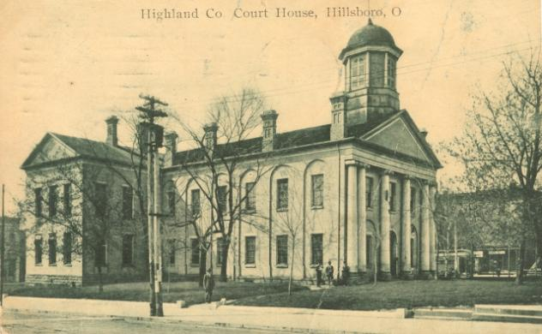
Last year there was the Ohio Covered Bridge Special Event that was led by John Levo, W8KIW Editor of the Highland ARC’s Monday Morning Memo. Several clubs participated and was a complete success. Additionally, there were several folks interested in Ham Radio at the event who have now become new Hams. Yes, anytime there is a public event resulting in a gain to the Ham Radio community, it is a total success. This year in keeping with the historical event series, John and the members of the Highland ARC decided to do a special event from their courthouse lawn.

John published an article in the Monday Morning Memo which attracted the attention of Michael Love, WB8YKS Southern Ohio Amateur Radio Association (SOARA) PIO. John and Mike decided that there may be interest in an all-state special event celebrating the courthouses in all of Ohio’s 88 counties. Scott Yonally, N8SY Ohio Section Manager thought it was a fantastic idea and requested John and Mike to reach out across the state to determine the level of support for the event. The Ohio Section has 117 affiliated clubs of which 48 are Special Service Clubs and there are 29 PIOs. There may not be a club listed in each county by address, but we do have Hams in each county.

Promoting Ham Radio
This may be a first for the ARRL and the Ohio Section. This event has all the opportunities for a FUNFILLED family day engaging the public and our government officials. Additionally, one county’s club is partnering with their county commissioners, historical society, EMA, sheriff’s office, public library, chamber of commerce, and news media. The club has decided to use a large tent as the event will take place rain or shine. Their PIO will make handouts available about ham radio and promoting the ARRL, ARES, RACES, Ohio Section and their local club. A special focus will be made to spotlight the public awareness of the hobby and the benefits of a Ham radio license, emergency and community service. The public will be invited to talk on the radios under the direct supervision of a licensed operator. Several clubs plan to provide contact QSL cards and/or certificates to capture this historical event.

Fun for Everyone
There may be some folks dressed in period costumes providing history about their courthouse and the early days in their county. Moreover, one club has requested, August 24, 2019, to be declared as Ham Radio Day in their county, and their county commissioners have approved it.

Event Details
Yes, we are excited and hopefully you are as well, about participating in this historical Ohio Courthouses on the Air Special Event. We are requesting ALL Ohio Clubs and Hams to consider supporting this special event. The event will take place on, Saturday, August 24, 2019, from 9:00 AM to 4:00 PM. However, the hours can be extended by each club. Additionally, each club will determine the frequencies and modes they will use.

TOP ^

Another opportunity presents itself as the Ohio QSO Party www.ohqp.org is also on the air, Saturday, August 24th. Therefore, these two events will complement each other providing contacts not only from within Ohio but across the country. All Hams are invited to participate.

Staying in Touch
Please inform the listed contacts that your club will be participating, and the name of the county represented. Additionally, there will be updates provided in the Monday Morning Memo, the PostScript, Ohio Section Journal, and www.arrl-ohio.org.

Contacts for additional information:
Michael Love, WB8YKS
wb8yks@arrl.net
John Levo, W8KIW
highlandara@yahoo.com

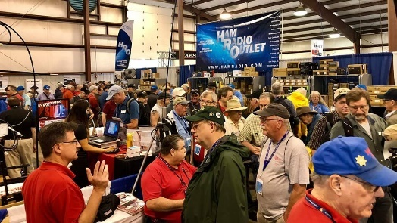
Upcoming Hamfests

05/17-19/2019 | Dayton Hamvention
Location: Xenia, OH
Sponsor: Dayton Amateur Radio Association
Website: http://hamvention.org/

06/01/2019 | FCARC Summer Swap  Location: Wauseon, OH  Sponsor: Fulton County Amateur Radio Club  Website: http://k8bxq.org/hamfest | 06/08/2019 | Union County ARC TrunkFest  Location: Marysville, OH  Sponsor: Union County Amateur Radio Club  Website: http://www.ohiohams.net
06/15/2019 | Milford Hamfest  Location: Owensville, OH  Sponsor: Milford Amateur Radio Club  Website: http://www.w8mrc.com | 06/15/2019 | W8DXCC DX Convention  Location: Owensville, OH  Sponsor: SouthWest Ohio DX Association  Website: http://www.w8dxcc.com
07/07/2019 | 20/9 Radio Club Hamfest Location: Austintown, OH  Sponsor: 20/9 Radio Club, Inc.  Website: http://20over9.org | 07/07/2019 | Ohio Link Swap Meet  Location: 1801 Gateway Circle, Grove City  Sponsor: Ohio Link Network Group  Website: www.olnradio.digital

TOP ^

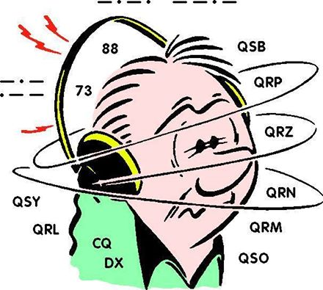
DX This Week
(from Bill, AJ8B)

Bill AJ8B (aj8b@arrl.net, @AJ8B, www.aj8b.com or www.swodxa.org )
CWOPs Member #1567
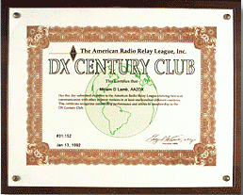

If you are checking this weekly, I hope it is because you have an interest in DX and have or are working towards DXCC. For starters, DXCC or the DX Century Club award is an award earned by making and confirming contacts with licensed amateur operators in at least 100 "entities" (countries) around the world.

The award is granted by the DX Desk at the ARRL. All radio amateurs are eligible to apply although applicants from the US, its possessions and Puerto Rico must be ARRL members. Proof of two-way contacts, either in the form of QSL cards or online confirmations in the Logbook of The World (LoTW), must be submitted the ARRL.

Each DXCC award certificate is dated and individually numbered and is widely recognized among the global amateur radio community as confirmation that the holder is an accomplished DXer. The top honor in the DXCC program is the DXCC Honor Roll. This is available to only those who are within 10 entities of the currently available total. We are at 340 countries available, so, Honor Roll participants would have 331 confirmed to be eligible.

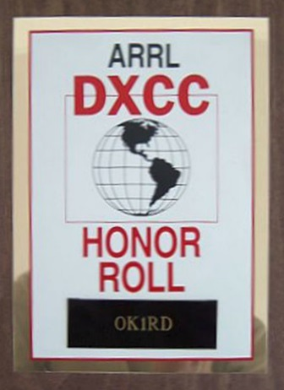
The strength of the program has been the verification process of QSOs (contacts) for hams to get credit. 2003 was a significant year for the DXCC program as the ARRL launched its’ Logbook of the World online logbook. If you had confirmed QSOs in LoTW, they would be confirmed in the database and no QSL cards were required. For this installment of the “DX This Week” column, we will only review the checking of QSL cards. The following two weeks will cover the LoTW application process and the physical QSL card submission process.

One of the most knowledgeable hams on the DXCC process (and, lucky for me, an Elmer) is Dave, K8DV. Dave has graciously agreed to allow me to reprint a three-part article on the validation of QSL Cards, submission of credits for the DXCC award via LoTW and submission via QSL Cards. These articles originally appeared in the SWODXA newsletter, The Exchange.

TOP ^
DXCC Card Checking by Dave, K8DV

As a member of SWODXA and an ARRL Field card checker, I wanted to take a few minutes and share some information concerning checking cards.
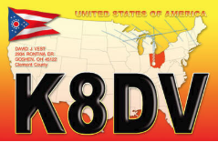
To avoid problems with field checking your application be sure to follow the instructions on the ARRL website http://www.arrl.org/dxcc-rules Note that as of April 2, 2012, there are 2 ways of doing a paper card submission, online and traditional. You can no longer do a hybrid LoTW and paper card submission on a single application. It is absolutely necessary that you follow all the instructions and have all the paperwork properly filled out or a card checker will not be able to check your cards. Submissions via LoTW and paper cards are treated as 2 separate applications, the good news is there is no longer any up charge for submitting more than a single application per year.
If you use the preferred Online Electronic DXCC Application http://www.arrl.org/online-dxcc-application for your paper cards it will be easier and cheaper for you. It will also go a lot faster at HQ when they get your paperwork since you already entered your card data in the ARRL system. With the online application you can enter the cards in any order. Just make sure to enter the QSOs on cards with multiple QSOs together to facilitate checking. The reason you don’t have to sort by band then mode is because there is minimal data entry work at HQ when they get your field checked application. Payment is made online and not handled by the card checker.
You can also use the Traditional Application forms http://www.arrl.org/dxcc-forms where you fill in and print the PDF forms for the application and record sheets. Make sure to follow those instructions. A traditional application will cost you roughly twice as much as the online application to cover data entry costs at HQ. With a traditional application you must sort cards by band then by mode with all the multiple QSO cards being listed last to facilitate data entry at ARRL HQ. If you use the traditional application, make sure you include valid credit card info on the bottom of the PDF application form. Payment by card is best as cash presents problems for the checker as I must deposit the cash and pay via my own card or write a check to cover.
Whichever way you do it, follow those instructions and make sure the cards are properly sorted in the same order as your DXCC Record Sheet. Also make certain that all the QSL card information (call, date, band, mode, country) has been entered correctly on the record sheet.

As a card checker and holder of 160 DXCC, I can check cards for 160, I can also check deleted countries. In addition to DXCC, I can check WAS, VUCC, WAC cards for award credit.
If you are meeting with a field card checker, remember to bring the following:
· Cards sorted per your Record Sheet
· Printed copy of the signed and dated Application Sheet
· Printed copy of the DXCC Record Sheet
· Stamped envelope addressed to DXCC Desk, ARRL HQ, 225 Main Street, Newington, CT 06111 so we can mail your application to HQ.

TOP ^
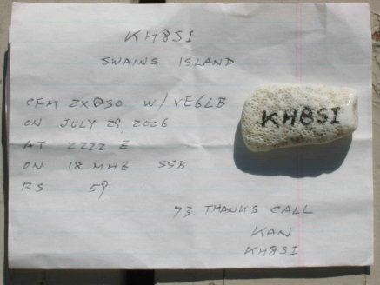
What does the field checker review on each card? Each card should have the Entity Name as it is shown on the DXCC List, the call signs of both stations, the date, time, band, and mode. RS(T) is NOT required. To avoid confusion for the station and the checker, always use UTC for the time and date. QSL cards not containing all required information may be rejected.

Does it have to be a formally printed QSL card? This is a picture of a QSL “napkin” that was submitted and accepted for credit.

Other errors that occur can be that the DX station left your call sign off and handwriting can be an issue.

You may receive a QSL that shows your freq as 10M when you worked him on 10.1 MHZ. Is that 10 M or 30M?

+ --------------------------------------------------------------------------------------------------------------------+

Next week, Dave will take us through the online process.

+ --------------------------------------------------------------------------------------------------------------------+

Let’s see what our friend at the DailyDX and the WeeklyDX, the best source for DX information, (http://www.dailydx.com/ ) has this to report:

VU7 - Lakshadweep Islands - M0KRI, Shabu, has announced his plans for a DXPedition to the Lakshadweep Islands starting in mid-October. Joining will be VU3XTG, Samson and VU2OB, Sree Kumar. They will have an IC-706MKIIG, TS-480SAT and Expert 1.3K running up to 400 watts. As for antennas they will used a homebrewed Moxon for 20 meters, an elevated vertical for 40 meters and multi band off center fed dipoles for other bands. They will be operating as VU7RI from October 19 to 31. They will be on SSB, CW and FT8 on 40, 30, 20, 15 and 6 meters. Logs will be uploaded to both LoTW and Club Log. QSL direct to M0KRI, OQRS on Club Log or LoTW. The VU7RI website is located at - www.vu7ri.com

CY9 - St. Paul Island - A "JA page" has been added to the CY9C expedition website, knowing that propagation is a challenge and openings short. N0TG, Randy, notes that St. Paul Island is needed by many JAs. http://cy9c.com/ja-page.html. There is a survey on the web page so the ops can see the most needed bands and modes. As a reminder this one is set for the September/October 2020 time frame.

PJ7 & FS - Sint Maarten & Saint Martin - JI1DFO/AG5CR, Satoru, is planning a vacation with his XYL to both the French (FS) and Dutch (PJ7) side of the island. This will take place after their trip to the states. Satoru will be operating as PJ8SK (yes eight, not the normal seven) from Bob's Baywatch Villa on the Dutch side from June 13-15 and then as FS/AG5CR from Le Temps des Cerises Beach Hotel from June 16-18. He will be running an IC-7300 and 300-watt amplifier. An 8-meter-high vertical or 17 meter delta loop with antenna tuner will be used. He will be on FT8 only on 40 through 17 Meters. QSL via JI1DFO. Logs will be uploaded to LoTW and Club Log.

EL – Liberia - Yesterday the Italian DXPedition Team announced their plans for a DXPedition as A82X (CW and SSB) and A82Z (Digital modes) between September 28 and October 11. They have a survey for what bands and modes you want, for the A82X and A82Z operations. http://www.i2ysb.com/idt/ . QSL via I2YSB.

TOP ^

ARLD017 DX news

This week's bulletin was made possible with information provided by WB6Z, The Daily DX, The OPDX Bulletin, 425 DX News, DXNL, Contest Corral from QST and the ARRL Contest Calendar and WA7BNM web sites. Thanks to all.

AZERBAIJAN, 4J. Alexander, 4J3DJ is QRV as special call 4JF1EU from Baku until April 28 to mark the Formula 1 Grand Prix race of Azerbaijan. QSL to home call.

LESOTHO, 7P. Chris, ZS1CDG is QRV as 7P8GOZ until April 28. Activity is on the HF bands using SSB and FT8. QSL to home call.

FEDERAL REPUBLIC OF GERMANY, DA. Special event station DL19JDAY is QRV until May 26 to commemorate Japan Day, a German/Japanese festival being held in Duesseldorf. QSL via DK7TX.

CANARY ISLANDS, EA8. Operator SP7VC will be QRV as EA8/SP7VC from Lanzarote Island, IOTA AF-004, from April 27 to May 4. Activity will be on 80 to 15 meters, and 6 meters, using SSB and FT8. QSL to home call.

IRELAND, EI. Special event stations EI0MAR, EI0CAR, EI100YXQ, and EI5IMD will be QRV on April 27 during International Marconi Day. QSL via operators' instructions.

FRENCH POLYNESIA, FO. Rich, KE1B and Anna, W6NN are QRV as FO/KE1B from Moorea, IOTA OC-046, from April 27 to May 3. Activity is mostly on 20 meters using FT8 with 10 watts. QSL direct to KE1B.

REUNION ISLAND, FR. A large group of operators will be QRV as TO19A from April 27 to May 8. Activity will be on the HF bands using CW, SSB and FT8, with a focus on the low bands. QSL via 9A2AA.

ISLE OF MAN, GD. Operators Shin, JR1NHD, Hiro, JF1OSL and Toru, JH0CJH will be QRV as MD0IUX, MD0HWX, and MD0ITP, respectively, from April 27 to May 1. Activity will be on 40 to 10 meters using CW, SSB and various digital modes. QSL via LoTW.

JERSEY, GJ. A group of operators will be QRV as GJ6EFW from April 30 to May 5. Activity will be on the HF bands using CW and various digital modes. QSL via ON6EF.

JAPAN, JA. Special event station 8J1ITU will be QRV from Honshu Island, IOTA AS-007, from May 1 to 31 to celebrate the anniversary of the founding of the International Telecommunications Union. QSL via bureau.

OGASAWARA, JD1. Harry, JG7PSJ will be QRV as JD1BMH from Chichijima Island, IOTA AS-031, from April 28 to May 4. Activity will be on 40 to 10 meters using CW, SSB and RTTY. QSL to home call.

MONGOLIA, JT. Andy, R9YU will be QRV as JT/R9YU from the Great Lakes Basins of Mongolia from May 2 to 12 while here as a communications specialist. Activity will be on 40, 20 and 15 meters using SSB. QSL direct to home call.

TOP ^

AUSTRIA, OE. Special event station OE19M will be QRV on April 27 during International Marconi Day. QSL via OE1WHC.

MARKET REEF, OJ0. Pasi, OH3WS will be QRV as OJ0W from April 27 to May 4. Activity will be on the HF bands in his spare time. QSL to home call.

SWEDEN, SM. A group of operators will be QRV as SE6VING from Vinga Island, IOTA EU-043, from May 3 to 5. Activity will be on the HF bands. QSL direct.

SOMALIA, T5. Ali, EP3CQ is QRV as 6O1OO until May 15 while on work assignment with the UN Department of Safety and Security in Mogadishu. Activity is in his spare time on 80 to 10 meters using SSB and FT8. QSL direct to home call.

VIET NAM, XV. Jun, JL8AQH plans to be QRV as XV9XX from Hue from April 27 to May 4. Activity will be on 40, 30, 20 and 17 meters, with a focus on 30 meters using CW. QSL direct to home call.

THIS WEEKEND ON THE RADIO. The 10-10 International Spring Digital Contest, NCCC RTTY Sprint, NCCC CW Sprint, SP DX RTTY Contest, Helvetia Contest, Florida QSO Party, BARTG Sprint 75 and QCX CW Challenge are scheduled for this weekend.

The CWops Mini-CWT Test, AGCW QRP/QRP CW Party and Phone Fray are scheduled for May 1.

The Canadian National Parks on the Air, CNPOTA, operating event runs for the entire year of 2019, with special stations active from Canada's parks and historic sites.

Please see April 2019 QST, page 87, and the ARRL and WA7BNM Contest Web Sites for details.

#########

Special Events

- 05/04/2019 | 100th Anniversary Mahoning Valley Amateur Radio Association
May 4-May 5, 1300Z-0100Z, W8QLY, Youngstown, OH. Mahoning Valley Amateur Radio Association. .3825 7.250 14.250. QSL. MAHONING VALLEY AMATEUR RADIO ASSOCIATION INC, 125 W McKinley Way, PO BOX 14141, Youngstown, OH 44512. Electronic QSLs will be sent for confirmed contacts--request form on QRZ page. mvara.W8QLY@gmail.com or www.qrz.com/db/w8qly

- 05/04/2019 | COSI Big Science Celebration
May 4, 1500Z-2000Z, W8LT, Columbus, OH. Friends of W8LT. 14.250 14.070. QSL. W8LT c/o Larry Feth, 1080 Carmack Rd., Room 40 Bevis Hall, Columbus, OH 43210. For up-to-date information, go to www.qrz.com/db/w8lt

- 06/01/2019 | Museum Ships Weekend
Jun 1-Jun 2, 1100Z-2100Z, K8E, Toledo, OH. Toledo Mobile Radio Association and National Museum of the Great Lakes. 14.260 14.039 7.260 7.039. QSL. SS Col. James M. Schoonmaker, Team K8E, P.O. Box 9673, Toledo, OH 43697. www.tmrahamradio.org

TOP ^

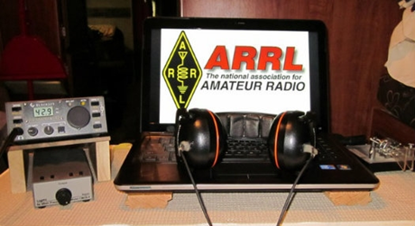
ARRL Contest Corner

An expanded, downloadable version of QST's Contest Corral is available as a PDF. Check the sponsor's Web site for information on operating time restrictions and other instructions.

One Question Questionnaire

Hey Gang,

There’s another NEW – one question – questionnaire on the Ohio Section Website! http://arrlohio.org

Wow.. 61% of you own a FRS or MURS transceiver. That’s really interesting.

There’s been some recent discussions on the social media pages lately about hams not being able to write or modify a code plug in their DMR radio. Well, that’s this week’s question, only I’m going to add another part to it, can you program your analog radio as well. So, with that said, here’s the question..

“Do you know how to write a code plug for DMR or program repeaters into your analog radio ??”

Anyway, these questions are all in fun and I hope that you are enjoying answering these “ONE QUESTION” questionnaires. Ok, enough on that, here’s the next question for you to answer…

You’ll find the “One Question” questionnaire on the Ohio Section Website! http://arrlohio.org It’s all in fun and it’s not a scientific survey in any way, but we are learning some things that we didn’t know from these questions. I hope that you are enjoying answering these “One Question” questionnaires.

V.E. Test Sessions

For the latest testing site information please >> Click Here << The ARRL site tracks all of the VE testing sites that register with them, including W5YI and Laurel. ARRL gives you a number of different ways of sorting to find that site that is closest to you as well.

#########

TOP ^
Exam Session Reminders

GRADING EXAMS: Each VE must grade each exam taken or must agree to the score given. After all three VEs agree to the number of correct answers shown, the score is announced to the examinee. The VEs must inform the examinee of their grade (pass or fail, and state the score {e.g., 26 out of 35}) upon completion of the grading.

NEW GENERAL EXAMS COMING: The new General class question pool will take effect on July 1, 2019 for all Element 3 General class license written exams. With the General class exams changing July 1st, new test designs must be created and used on that day. ARRL VEC will be supplying all its (near 1,000) Field Stocked VE teams with new test booklets about the 3rd week in June. Do not destroy the 2015 versions of the General exams until June 30.

BASIC QUALIFICATION QUESTION PROCEDURES: The detailed instructions are available on the ARRL website. At the exam session, candidates that answer “YES” to the qualification (felony) question should be given the “Applicant Instructions for FCC Basic Qualification Question” document. Print or download here: http://www.arrl.org/files/file/VEs/Applicant%20Info%20Qualification%20Question%202019.pdf

TOP ^
Applicants can also be referred to our Basic Qualification Question web page for information and instructions.
View page: http://www.arrl.org/fcc-qualification-question

After the application data from the session is submitted to FCC and an FCC file number is created, the applicant is required to provide an explanation directly to the FCC within 14 days. Do not collect information from the candidate and do not send any documents to the VEC.

Incident Command System (ICS) Training Schedule

All current trainings are listed on the Ohio EMA training calendar located at:
https://webeoctraining.dps.ohio.gov/TrainingAndExercise/courselist.aspx

I’ve been asked to also include a link to the Kentucky EMA training calendar as well..
https://kyem.ky.gov/training/Pages/default.aspx
https://sites.google.com/site/ccoemtraining/home

Please pay particular attention to these courses listed above, as that there’s a lot of ICS 300 & 400 classes listed that are very useful for all Amateurs to have under their belts. I will also state that G775 is also a very good course to take as well. These 3 courses are multiple day in class courses, so please be prepared to spend some time taking them.

We do recognize that IS-300/400 requires multiple days of actual classroom training that is not easily obtained. So, if you just can't find the time to fit these class room courses in, we do have an alternative method for getting you to Level 3.

TOP ^
Completing the following “FREE” and “ONLINE” courses will act as substitute for you FEMA Leadership Development Course requirements. You absolutely will need to complete all 7 of these courses to get your ICS 300/400 credit. Here are the courses that you need to take: IS-120, 230, 240, 241, 242, 244 & 288.

Now, if you are looking for wallpaper and have a little extra time, taking IS-235 in addition to the 7 listed courses above, you will get a really cool looking certificate from FEMA stating that you have completed the Professional Development Series. That’s impressive in itself!

#########

The Department of Homeland Security (DHS) Returns to Provide Auxiliary Communications (AUXCOMM) Training in Conjunction with Hamvention® 2019

The Emergency Communications Division (ECD) of DHS’s Cybersecurity and Infrastructure Security Agency (CISA) will be on hand at Hamvention® 2019 to conduct its nationally recognized NIMS/ICS compliant AuxComm course. Over 2,500 amateur radio operators from around the country have taken this course. The purpose of this course is to train qualified amateur radio operators so they may assist their local, county and state governments with emergency backup communications if requested to do so.

This course introduces the auxiliary communicator to the other positions within the Communications Unit (COMU) and how to provision emergency communications in a public safety context. The course also goes deeper into the National Incident Management System framework. The location of the course will be at the “Courtyard by Marriott” in Beavercreek, Ohio and be held 14-16 May 2019. Registration for this class may close early when all available seats for this class are taken.

Registration for this course is ongoing: Students wishing to attend the DHS Auxiliary Communications (AuxComm) Course must meet all prerequisites and provide electronic/scanned images of the following required documents prior to 1 May 2019:

Prerequisites:
- A signed copy of your current valid FCC issued amateur radio license
- IS-100 certificate (FEMA issued); IS-200 certificate (FEMA issued); IS-700 certificate (FEMA issued);
IS-800 certificate (FEMA issued), and the name of the public safety entity, and its contact information, that you would support upon completing this course

Please scan copies of this information, attached it to an email, and then send to COMU@hq.dhs.gov. In the subject line, please put Hamvention AUXCOMM. Your information will be reviewed, and a reply sent back to you indicating that you have been given a seat in the course.

This will be an intensive three-day version of the course with facilitated lectures and student exercises conducted by professional AUXCOMM instructors. This course provides time for interactive discussions and exercises. Should you have any questions regarding this course, please send them to COMU@hq.dhs.gov.

One final note, please mark your forum calendar, on Friday 17 May, to come see us at the AUXCOMM forum. You will be given a glimpse at the new AUXCOMM Position Task Book (PTB), a briefing on the proposed Communications Section for NIMS/ICS and a briefing on one of the most active AUXCOMM states – North Carolina!

TOP ^

ARES Connect

CQ… CQ…. CQ… Calling all Ohio persons to be a part of the new ARES Connect program.

We need to discuss some very important items that only YOU can make a difference with. I need you to get yourselves registered in ARES Connect, that is… if you haven’t already. Now, how do I know that you need to do this? It’s simple, we have 1018 now registered in the database and Stan’s last S.E.C. report shows that we have a little over 1,700 persons in ARES right now. As you can see, we still have a way to go to really take advantage of this new system.

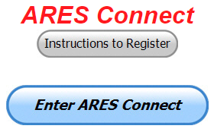
As the numbers show, there’s still a lot of you that haven’t taken the plunge yet and need to! What are you waiting for? No matter how much you resist, it’s coming, and we need to make sure that no one is left behind.

Now, as an incentive to get you to not only register…. But to actually start using the system… (Notice how I have that in bold type for you to clearly see?) I am giving away all sorts of goodies to help you get motivated. I have a footlocker of really cool items that I will be giving away!

I’m doing this in various intervals throughout the year, so it will challenge you to be dedicated to getting your hours into the system. You’ll never know just when another drawing will be, so you really do have to be prudent!!

Here’s the top 10 folks for hours for this portion of April:

 | Name | Events | Hours
1 | Timothy Lovejoy (NC8OS) | 27 | 208.25
2 | Christopher Domenick (KC8CAD) | 28 | 123.00
3 | James Yoder (w8erw) | 13 | 91.50
4 | Dan Stahl (KC8PBU) | 42 | 75.50
5 | Bret Stemen (KD8SCL) | 21 | 44.00
6 | Larry Caskey (K8LPC) | 30 | 43.00
7 | Elizabeth Klinc (KE8FMJ) | 35 | 42.05
8 | Robert Baker (N8ado) | 18 | 36.20
9 | John Westerkamp (W8LRJ) | 34 | 31.90
10 | James Smith (ke8iju) | 14 | 29.00

Here’s how we did with people getting signed up for events
and the total hours logged so far for April

Total Amount signed into Events | Total Hours for Events
1,625 | 4,092.96

TOP ^
It adds up quickly, but you do have to be registered and actually USE the system in order for any of your time to count. We have a set of instructions on how to get registered right above the button to enter ARES Connect. I would strongly suggest that if you haven’t registered yet, that you read these instructions first.

Here’s a link to get you started... http://arrl-ohio.org/ares_connect_directions.pdf Please, don’t just hurry through the questions, read them carefully, if you don’t understand something, please ask me, I’m here to answer your questions.

We know that you mean well by answering that you do have the needed courses in, but I will let you know that we are verifying what you say you have with what is showing for you in our statewide database when we are completing your registration. So, how can you find out if you are already listed in our statewide database? Easy, here’s a link: http://arrl-ohio.org/SEC/special/ICS%20Complete%20by%20County%20and%20Name.pdf

Ok, now on to a problem that has cropped up with the new ADMIN 2.0… It seems that when the folks at Volunteer Hub released the newest version of their Admin Dashboard there was a little “gotcha” in it that they didn’t know about until some of our folks found it for them. It seems that if you are in ADMIN 2.0 it won’t allow you to create an event. It’s good with everything else, but it just isn’t up to snuff on this yet. They are aware of the situation and are currently working on a fix for it!

So, for now, just use the old dashboard and don’t bother with Admin 2.0 until a fix comes through. I’ll let you all know when that happens.

Congratulations to a One and Only
(from Jim, W8ERW and all of us in ARES)

I thought you may like to know that one of our Ohio ARES members, Ron Hollas, K8RJH has recently completed all of the available FEMA numbered online courses and has submitted those certificates to our database which I maintain for the Ohio Section. Ron has on file a total of 249 certificates of completion including all of the 244 numbered courses. He is the only one of our members to do so although several have well over 100 completed now. I suspect also that Ron is perhaps the single ARES member to do so nationally.
In all, I have recorded 8,226 training documents for 1,028 active Ohio Section ARES members. 809 have completed NIMS training and 155 have progressed to Level 3 on the ARES training curriculum. Those numbers continue to grow as our Ohio Section Amateurs support the ARES mission and submit training documents weekly.
Sign Up for Hamvention Alerts

If you are planning a visit to Hamvention 2019, you are urged to sign up for the Hamvention alerts which are available again this year on your mobile phone. To subscribe to the system just text Hamvention19 to 888777. The alerts will provide up-to-date information for those traveling to or attending Hamvention such as weather, traffic, parking and other useful information throughout Hamvention. If you signed up for the alerts in 2018 you are automatically registered for this year.

TOP ^
The alerts are especially important for up-to-minute information about parking and weather, especially for those who might not be able to monitor the talk-in or bulletin stations. The alerts will provide another way to direct drivers to the best parking solution if weather requires closing some onsite parking lots or if some remote lots fill up. A special thanks to Greene County Sheriff Gene Fischer, KX8GCS, for making the alerts possible again this year

The Media Committee is working to make winning prize numbers available on the alert system soon after they are drawn. This is an effort to help winners claim prizes and to decrease the number of unclaimed prizes that must be redrawn prior to the main prize drawing on Sunday. During Hamvention the numbers from the hourly prize drawing will be posted on Twitter and Facebook as well as displayed on monitors throughout the fairground's buildings. Following Sunday's Grand Prize drawings, winners will also be posted on Twitter and on http://hamvention.org/event-details/prizes/.

The alert system, which was initiated in 2018, was a Hamvention effort to get visitors the information they need. It is a supplement to the Hamvention talk in station that has operated for many years on the Dayton Amateur Radio Association repeater, 146.94(-) 123.0 Tone to give directions and other assistance.

Last year a traffic bulletin station was also added on 145.525 to periodically repeat needed information. Amateurs with 2-meter capability are urged to enter those frequencies into their radios before starting their Hamvention journey.

Hamvention 2019, the world's largest amateur radio gathering, will be held May 17-19 at the Greene County Fairgrounds and Expo Center in Xenia, OH.

Wouff Hong Ceremony At Hamvention

When: Saturday – May 18th starting ~ 9:00 PM Where: Marriott at the University of Dayton
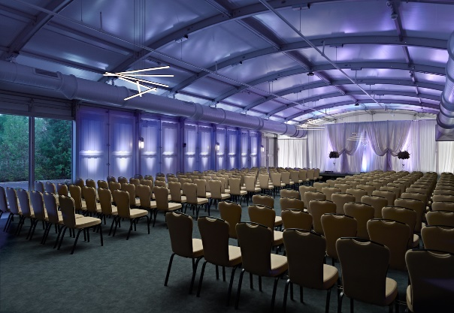
Hey Gals and Guys… You’ve been asking if this is going to happen, and now I can tell you for sure, YES we are having a Wouff Hong Ceremony at Dayton!!! The Conclave will gather at 9pm and those willing to take the plunge and become a part of this ever growing and most secretive of all Societies. Come join us and be indoctrinated into history!

The ceremony is steeped in mystery! Attendees will receive a special keepsake. A fun activity for all ages. Doors to the conclave will open at 9:00 PM (no admittance after 9:30 PM) at the Marriott at the University of Dayton (Tradewinds Pavillion), 1414 S Patterson Blvd, Dayton, OH 45409. Free registration online to ensure there will be enough seats, and to get a really cool certificate following the ceremony. Go to: http://arrl-ohio.org/wouff-hong.html. This event is sponsored by the ARRL Ohio Section.

Now, for those of you who don’t know what Wouff Hong is all about:
A Wouff Hong is a fictional tool used to "punish" Amateur Radio operators who demonstrate poor operating practices. Legend has it that the Wouff Hong was invented by ARRL co-founder Hiram Percy Maxim under the pseudonym, "The Old Man," just as radio amateurs were getting back on the air after World War One.

TOP ^
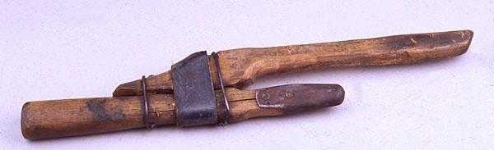
Early in 1919, "The Old Man" wrote in QST "I am sending you a specimen of a real live Wouff Hong . . . Keep it in the editorial sanctum where you can lay hands on it quickly in an emergency." The "specimen of a real live Wouff Hong" was presented to a meeting of the ARRL Board and the Board voted that the Wouff Hong be framed and hung in the office of the Secretary of the League.

On display at ARRL Headquarters today, the Wouff Hong is a constant reminder to Amateur Radio operators to be mindful of their operating etiquette.

Field Day Coming Up… Is Your Club Going To Have One?

I know that we are still into April, but I also know that many clubs around the state are already working on their Field Day preparations. Is your club one of them? Bob, W8ERD sent me the following from ARRL…

How to Get the Most Out of Your Field Day GOTA station

Your Get On The Air (GOTA) station can be a great ham radio introduction to prospective new hams and interested visitors as well as earn you additional points! Here are some example ideas to make your GOTA station more attractive.

These can make your operation be more effective, more fun for you and your guests, and show ham radio in a very positive light. And these ideas can be used at ANY public event you may have. Post BIG signs outdoors, where they cannot be missed by visitors. Be sure to have someone assigned to greet and help folks once they are at your event. Help them get on the air. Remember, your first impression with your visitors is usually established within the first 5 minutes that they are there. Also, don’t let them leave without giving them some information about Amateur Radio and your club. A lot of clubs are or have already developed a flyer to hand out to the guests as they arrive. This also helps break the ice with a visitor, as that they now have some information about you and the club. Take advantage of some of the ARRL Flyers that are available. They too will help you get the word out.

Make sure to have a phone number and email of someone that your visitors can contact after Field Day. Even if you have a website, that personal invitation and one on one contact goes so much further than a URL of you club. Invite them to your next club meeting or club outing. If you can, get their phone number so that you can contact them later, then make sure that someone does contact them. Show them that you do care and you do follow up.

And finally, and it can’t be emphasized enough. Advertise, Advertise, Advertise. And again, make sure that you follow up!

TOP ^

Final.. Final..
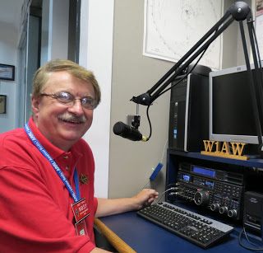
Hey Gang...

This past week just seemed to fly by. One day I was here and the next I was there. Wow. I hardly know where to start! It was great to see so much participation with NVIS this year. It least it didn’t rain! Yes, I froze along with many of you. I got out and took some pictures and had a blast just visiting with you. Sunday was spent meeting up with a lot of old friends in Athens and the surrounding area. It was great!

Now, let’s move on to more important things... I’ve been amiss for not giving the hard-working folks that actually were the “boots on the ground” credit for the great job that they did during the Shelby tornado. So, here’s a big SHOUT OUT to the following…

Richland County Volunteers
Daniel Baker, AB8SI; Joy Baker, W8BLJ; Matt Nichols, K8IDF; Danny Bailey, W8DLB; Tom Miller, N8TWM; Don Forshaw, KB8RYA; Kyle Crawford, KD8GEI; Duane Meadows, K8MDA; Harry Mains, N8XMI; Andrew Miller, K8REW; Dave Weigold, N8DPW; Paul Linkous III, N8PHL

Marion County Volunteers
Christopher Tracy, KD8UUB; Ronald Croskey, KE8BDS; Daniel Griffith, KE8ECU; Aaron Phillips, KE8DYB; Dan Wade, N8WOB and a very special shout out to Dean Berry, KC3CKY who was the first to spot the rotation in the clouds to get the ball rolling in the first place.

Without all of you helping that Sunday night, things could have been much, much worse than what they were. Over 60 homes were affected and numerous outbuildings as well. This was no small operation.

Let’s spin the dial a bit and see what’s on the band below… Where you at the Ohio Section ARES conference a couple of weeks ago? If you weren’t, don’t fret, you can go to: http://arrl-ohio.org/SEC/sec-conf-2019.html and view all the videos of the Conference there. I will say that I had to trim down the Table Top Exercise some. It was almost 3 hours long. Way too long for YouTube. So, I took the liberty of doing some editing and have it down to 1 hour and 17 minutes. Have your popcorn and soda on hand when watching that one. All the rest of the videos are under 1 hour!

Rotating the dial a little more… I’ve been asked by many of you just how many folks do we have in ARES Connect now. Well, here’s a breakdown of all 3 levels for you: Level 1 – 460; Level 2 – 426; Level 3 – 132 This gives us a total of 1,018 in ARES Connect. I don’t know positively for sure, but my guess from everything that I can see within the system is that no one other than the Ohio Section has more people registered in ARES Connect.

TOP ^
I do want to clear up some mis-interpretations that have been going around. First, in the Ohio Section we only require our Level 2 volunteers to have the 4 basic courses, IS 100, 200, 700 & 800. For our Level 3 volunteers we do require the additional ICS 300 / 400, or the equivalent professional series courses IS 120, 230, 240, 241, 242, 244 & 288. These equivalent courses are all on-line classes just like your basic 4 NIMS courses are and being offered as an alternative way for you to get credit for taking the professional series courses in the event you just cannot get scheduled into an ICS 300/400 class.

By the way, if you decide to take these 7 on-line courses and complete them all, you will want to take just one more class IS-235. By completing this additional course, you will get a really great looking certificate from FEMA recognizing that you have completed the entire Professional Series courses. I do hope that this clears up the confusion that has been going around lately. As we have stated on the website and in this newsletter many times “We don’t want anyone left behind.”

Whelp… That’s going to do it for this time around. Stay safe, stay warm, and most of all… have FUN!!

73,

Scott, N8SY

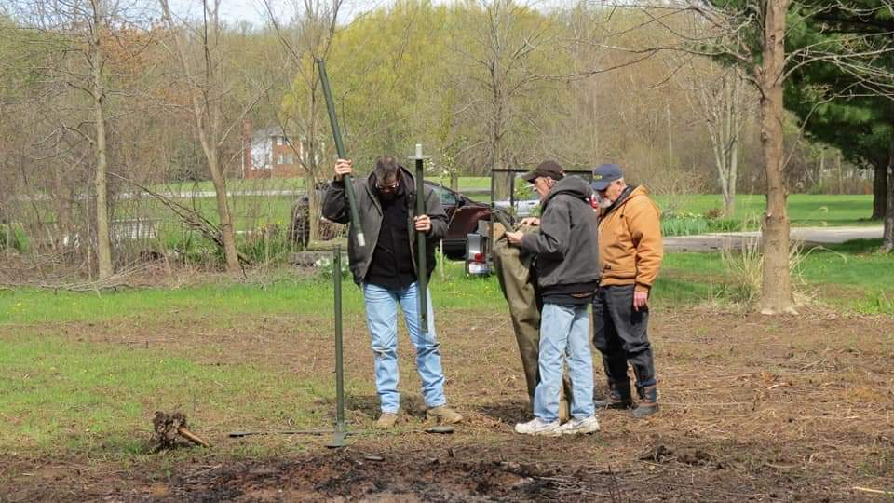
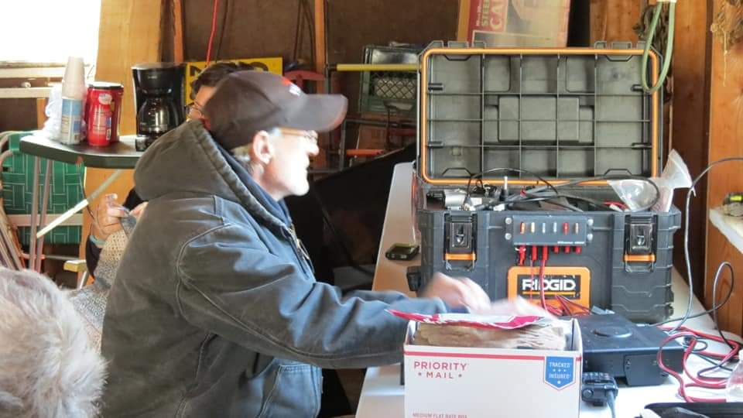
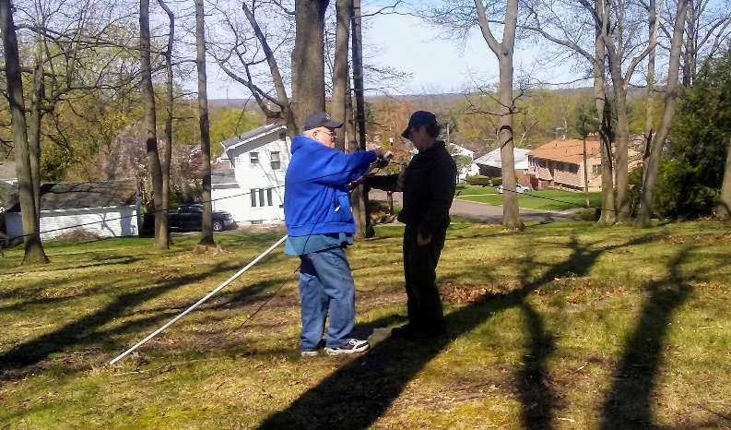
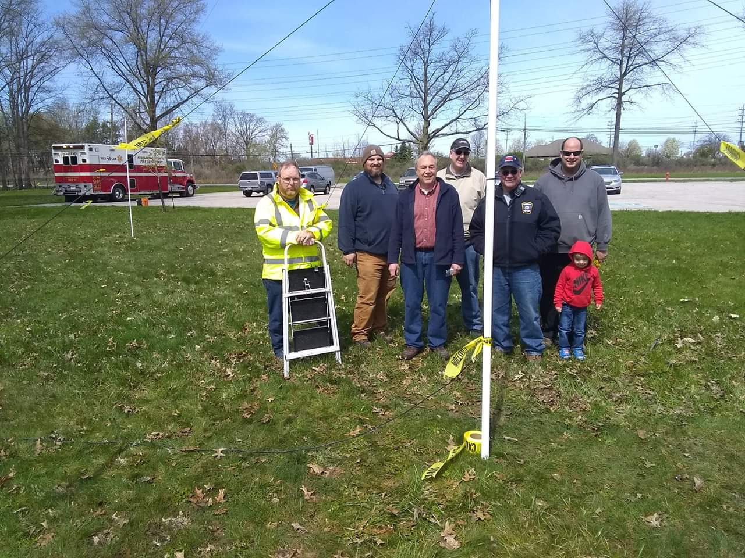

TOP ^
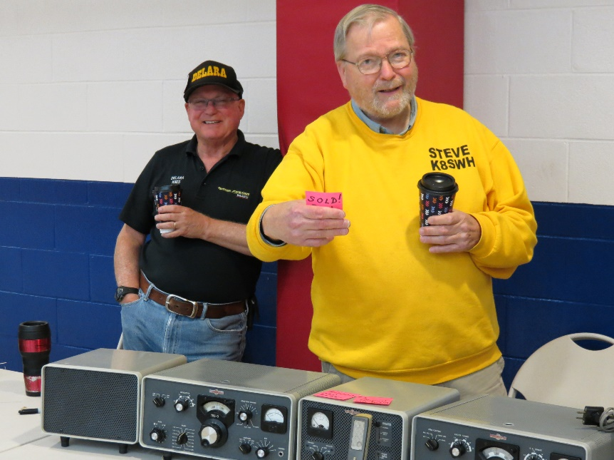
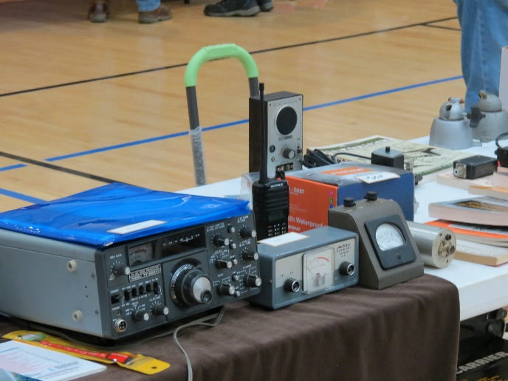
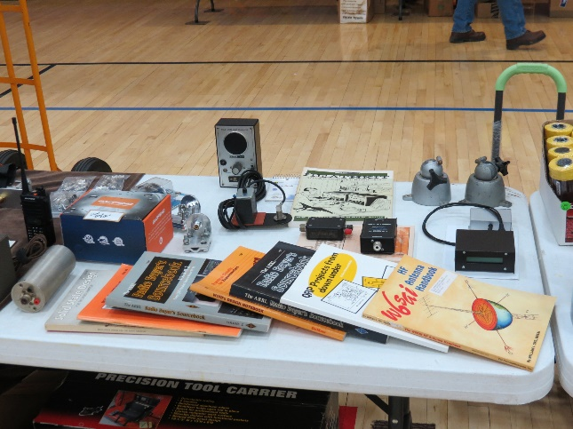
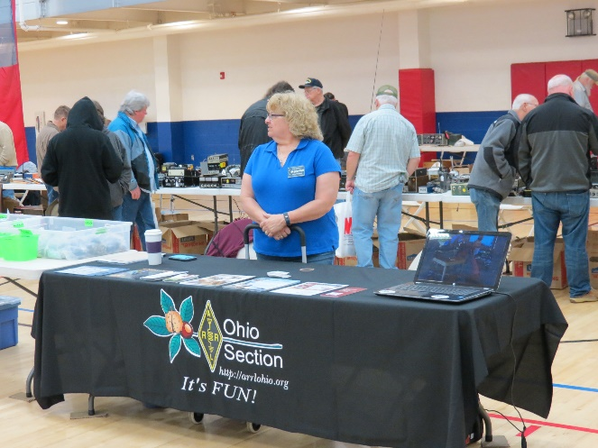
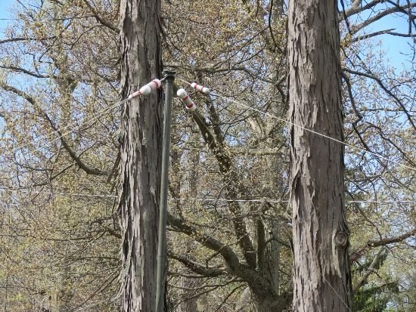
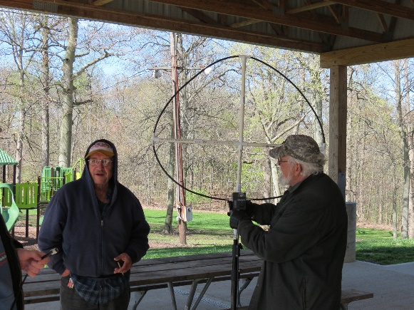
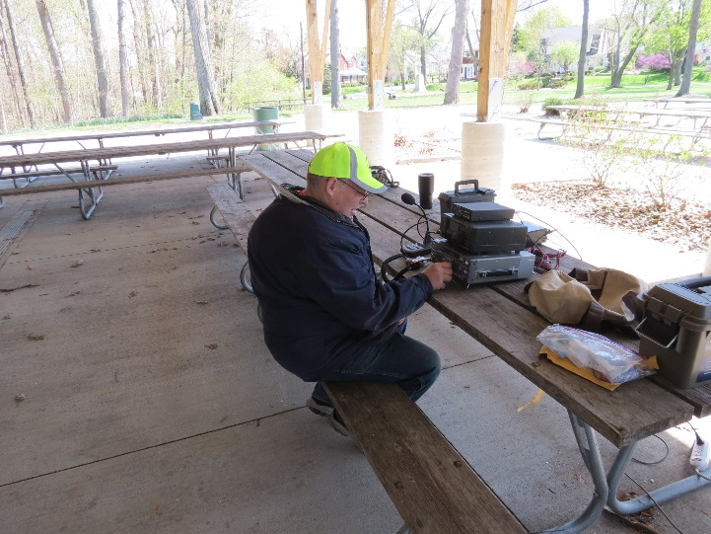
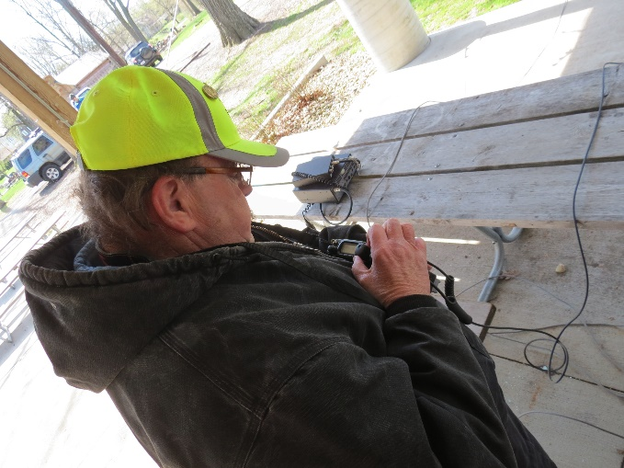
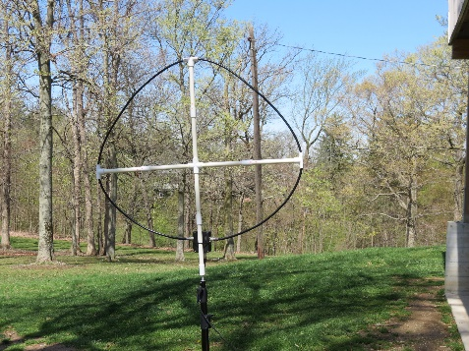
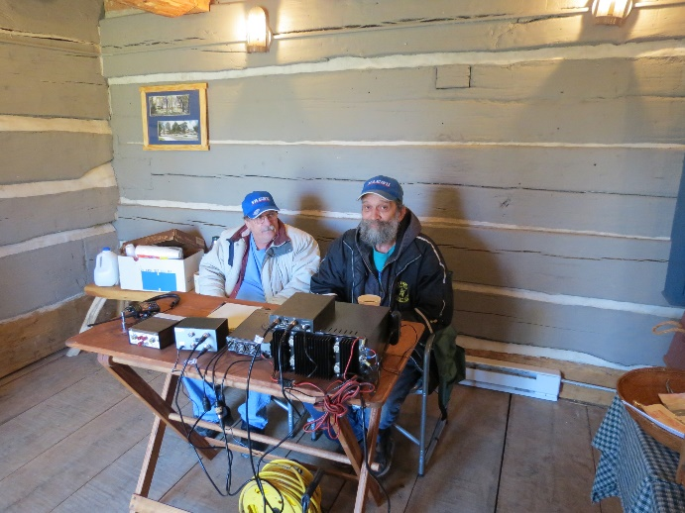

TOP ^

Back Issues of the PostScript and Ohio Section Journal (OSJ)

Hey, did you know that PostScript and Ohio Section Journal (OSJ) are archived on the website? You can go back and look at any edition simply by clicking:
http://arrl-ohio.org/news/index.html

Chit – Chat, and All That!

Do you know someone that’s not getting these Newsletters? Please, forward a copy of this Newsletter over to them and have them “Opt-In” to start receiving them. Heck, just have them send me an email n8sy@n8sy.com and I’ll get them added to the Ohio Section Emailing list.

We now have many thousands of readers receiving these newsletters weekly. Quite impressive, I’d say! I urge all of you to make sure that everyone, regardless of whether they are a League member or not, get signed up to receive these weekly Newsletters.

You can always “Opt-Out” at any time if you feel this is not what you were expecting. It’s fun and very informative. All of your favorite past newsletters are now archived too.
You can go back at any time and read them. Just go to: http://arrl-ohio.org/news/

Got questions, concerns or would just like to sit and chat awhile? Heck, I’ll even buy the coffee!! Give me a call at (419) 512-4445 or email me at: n8sy@n8sy.com

The pictures on the front page are from various newsletters, Facebook posts and/or were sent directly to me in recent weeks. Take a good look at them, you just might be in one of the pictures! “SMILE… you’re on the Ohio Section News!!”

TOP ^

PostScript is produced as a weekly newsletter. I want to thank everyone that has contributed articles and ideas to make this an even better news source. I sincerely hope that you have enjoyed this edition and will encourage your friends to join with you in receiving the latest news and information about the Ohio Section, and news and events happening around the world!

