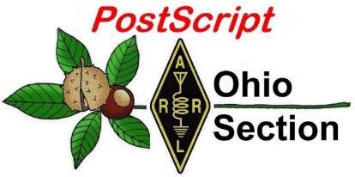
April 8th
Edition

National News The Handbook Give Away

Club Corner Hamfests

DX This Week One Question Questionnaire

VE Testing Schedule ARES Connect

Wouff Hong Ceremony At Hamvention Final.. Final..

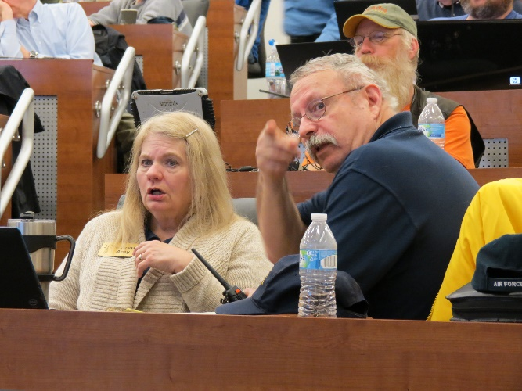
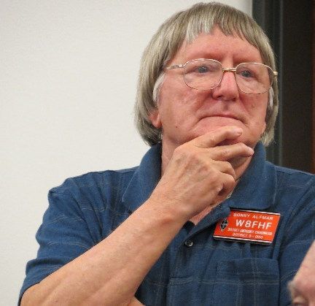
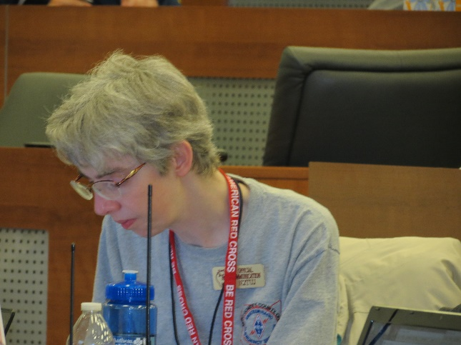
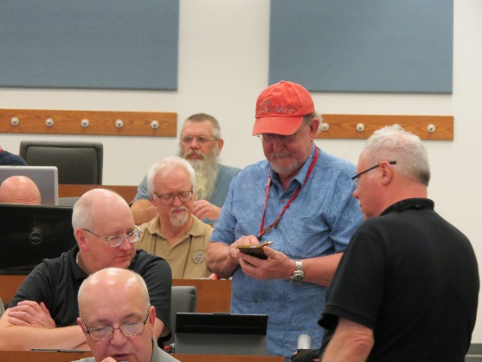
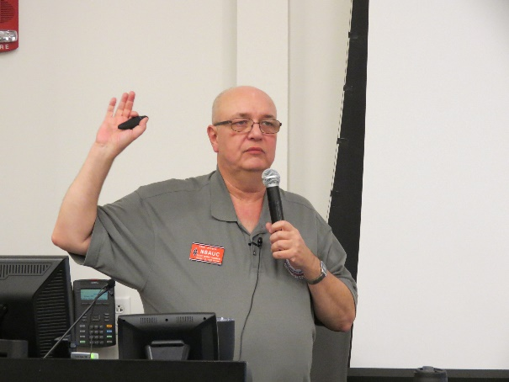
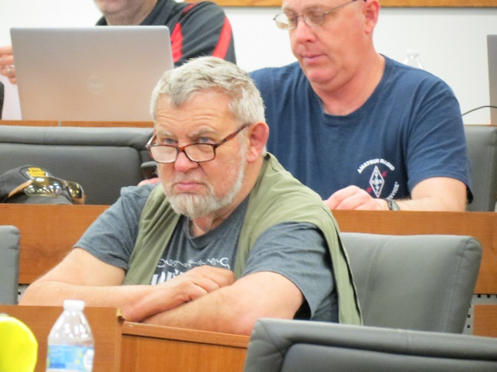
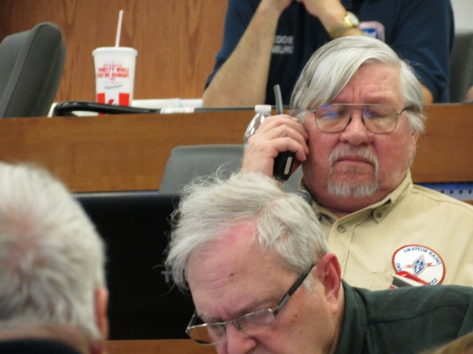
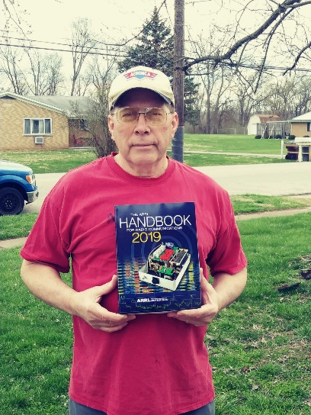

National News
(from arrl and other sources)

Class Action Suit filed against Baofeng and Distributor
(info from website and Greg, WD9FTZ)

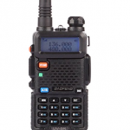
A Class Action Suit filed against Baofeng and Distributor for selling unlawful radios seeking compensation for purchasers of Baofeng transceivers

Click Here to see FCC Citation and Order and Click Here to see FCC Enforcement Advisory

On October 5, 2018, a suit, seeking class action status, was filed against Boafeng and one of Boafeng’s US distributors, Amcrest Industries, LLC in the United States District Court for the Southern District of Florida, Ft. Pierce Division. Case Number 2:18-cv-14409-DMM, Hon. Donald M. Middlebrooks has been assigned to hear the case. The suit seeks refunds and other relief against Baofeng and its distributor, Amcrest, distributing various Baofeng model radio transceivers that violate FCC regulations. Because individual consumers have typically spent $25-$80 each, a class action is the only practical means to compensate class members.

On August 1, 2018, the FCC warned, Amcrest Industries was warned not to distribute products, such as certain models from the Baofeng UV-5 range. Federal Communications Commission Citation and Order.

On September 24, 2018, the FCC issued an Enforcement Advisory regarding FCC Enforcement Advisorying many Boafeng radios. The FCC’s advisory states that certain Baofeng models cannot be sold because they violate FCC regulations and because the radios can operate on unauthorized frequencies. The unauthorized frequencies includes exclusive military and government restricted frequencies, aviation, maritime and satellite emergency beacon frequencies.

The suit seeks a refund for the purchase price, sales taxes and fees, together with the value of accessories purchased and pursuant to Florida procedure seeks leave of the Court to pursue punitive damages. Punitive damages are being sought because the suit contends that fraud was committed during the sales.

A web site has been setup, baofengsuit.com, which will have news concerning the litigation. Purchasers are invited to visit the site for more information and to, optionally, leave information concerning their purchase and experiences with the products.

Contact:
Herbert Kraft – Attorney for class
3030 N Rocky Point Dr., Suite 150
Tampa, Florida 33607
press@baofengsuit.com

#########

TOP ^
2019 QST Key Design Competition Deadline is June 1

The deadline is June 1 to submit Morse key and paddle designs in the QST Key Competition. Hams have been building their own Morse keys since the dawn of Amateur Radio, and some creations have become legend.
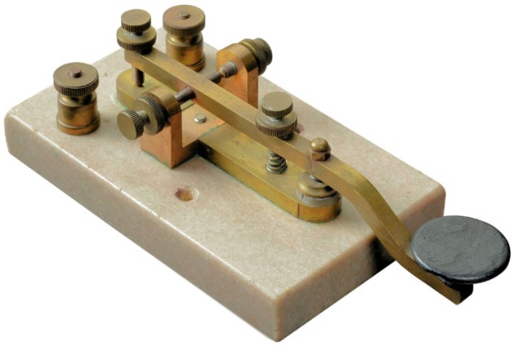
Design styles can include straight key, semiautomatic key (bug), paddle, or sideswiper. The winner in each category will receive $250. Only one entry may be accepted per person or team.

Entries must include the actual key (it will be returned following judging) as well as detailed construction drawings with dimensions (hand drawings are acceptable). Submissions also should include:

- A list of materials and sources. Even if you built the key from materials you had on hand, you must specify commercial sources for comparable materials.

- Photographs of the various steps of the construction/assembly process.

- A written description of the key and how it was designed and assembled.

The key must be an independent mechanical device, not an integral part of another device such as an electronic keyer. Keys must be the sole creations of the entrants and not available for sale.

Winners will be chosen based on ingenuity of design, ergonomics of operation, and overall craftsmanship. The judges’ decisions are final.

Complete details and entry requirements are available on the ARRL website.

#########

Additional Amateur Radio-Related Petitions Now Open for Comment

The FCC has placed three Amateur Radio-related Petitions for Rule Making (PRMs) on public notice and has invited comments.

Jerry Oxendine, K4KWH, of Gastonia, North Carolina, wants the FCC to clarify that state and localities should have no authority to regulate Amateur Radio with respect to enacting “distracted driving” statutes. In his Petition for Rule Making, now designated as RM-11833, Oxendine contends that such statutes violate FCC rules on scope and operation of equipment by licensees; violate the intent of the FCC and Congress with respect to Amateur Radio’s role in disasters, and hinders emergency operations using mobile equipment.

“There is no evidence that the operation of two-way radio has but an insignificant impact on ‘distracted driving,’” Oxendine stated.

Such distracted driving statutes usurp the authority of the FCC to regulate Amateur Radio, as well as Citizens Band and Part 90 Land Mobile Service users, Oxendine said in his Petition.

TOP ^
Edward C. Borghi, KB2E, of Farmington, New York, has submitted a Petition, now designated as RM-11834, that would prohibit applicants from requesting a vanity call sign outside their call sign district. Exceptions would be made for call signs applied for under rules governing call signs previously held by family members.

“In some more populous areas, there are few of the most desirable vanity calls signs available — the 2 and 6 regions for example,” Borghi said. “I see no reason for a licensee to have to compete with out-of-area people for the few 1 × 2 or 2 × 1 or catchy 2 × 3 call signs available in their area of residence,” Borghi told the FCC.

Jeffrey Bail, NT1K, of West Springfield, Massachusetts, has submitted a very similar Petition, now designated as RM-11835, asking that the FCC give residential preference in competing applications to applicants whose listed FCC address is within the same district/region as the applied call sign. He cites limited availability and increased demand for 1 × 2 and 2 × 1 call signs.

“There are many times a call sign has been awarded to an individual/club who resides outside of the call sign district when there are other people who applied for the same call sign that reside within the district,” he said in his brief petition.

#########

Motorola Asks Illinois Court to Dismiss Hytera Lawsuit for Lack of Standing
(from RadioResourse International Danny Ramey and Greg, WD9FTZ)

Hytera’s lawsuit, originally filed in the U.S. District Court of New Jersey but later transferred to the U.S. District Court for the Northern District of Illinois, accuses Motorola of multiple anticompetitive practices including sham petitioning, false advertising and exclusionary relationships with dealers.

Hytera’s original complaint also included allegations of sham litigation, but that claim was removed from an amended complaint following several Motorola victories in courts around the world, including the U.S. International Trade Commission (ITC) and Germany.

The amended complaint also included allegations that Motorola spread false information regarding the viability of Hytera’s business following the ITC’s initial determination in July that Hytera had infringed several Motorola patents. The ITC later released a final determination that confirmed Hytera infringed Motorola patents but also found that redesigned products submitted by Hytera did not infringe the Motorola patents.

“No doubt Hytera is displeased that its attempt to gain a foothold into the U.S. market by pirating off Motorola’s technology has been exposed by litigation before the ITC,” Motorola said in its motion to dismiss the case. “But a proven infringer like Hytera should not be permitted to blame its business losses on Motorola, and it certainly should not be permitted to abuse the Sherman or Lanham Acts in retaliation.”

Motorola argued that none of the alleged acts raised by Hytera actually constitute anticompetitive behavior and are therefore not actionable under antitrust laws. Additionally, Motorola argued that Hytera had provided only general allegations and not specific details of the alleged behavior.

For the sham petitioning claim, Hytera argued in its complaint that Motorola had filed petitions with government entities specifically to interfere with the business of Hytera and its subsidiaries. Specifically, Hytera pointed to a pair of petitions Motorola filed that it said were intended to limit the growth of the TETRA standard in the U.S. market.

TOP ^
The first petition Hytera highlighted was one Motorola filed with the FCC asking the commission to repeal and clarify its allowance of TETRA products in the U.S., and the second was a petition to protest the award of a New York City Metropolitan Transit Authority (NYC MTA) contract to TETRA provider PowerTrunk, which is now owned by Hytera but was not at the time of the petition. PowerTrunk is one of the co-plaintiffs on the case.

Motorola argued that the petitions were not filed to hurt a competitor’s business but instead filed to protect Motorola’s own business interests, something allowed under antitrust laws.

Under the Noerr-Pennington Doctrine, businesses are not liable under antitrust laws for trying to influence public policy, Motorola said. The only way that Hytera would have a claim under Noerr-Pennington would be if it could prove that Motorola’s petition were “objectively baseless due to fraudulent misrepresentations from Motorola that altered the outcome of the proceedings,” Motorola added.

“Hytera fails to allege that Motorola made a single fraudulent misrepresentation in its petitioning to either the FCC or the NYC MTA,” the motion said. “While Hytera alleges that Motorola’s competing bid to the NYC MTA had ‘significant weaknesses,’ Hytera never alleges that Motorola did not intend to win the contract. And even if it had identified a supposed misrepresentation to either the FCC or NYC MTA, Hytera cannot allege that any of Motorola’s statements ‘actually altered the outcome of the proceeding’ because Motorola lost both of the petitions.”

In its amended complaint, Hytera also argued that Motorola had exhibited anticompetitive behavior in the utility, transportation and business-critical markets by creating exclusive arrangement with dealers and making false statements about Hytera to dealers and other customers.

Hytera’s complaint argued that Motorola uses a point system to incentivize dealers to exclusively carry Motorola products and foreclose use of those dealers from Hytera and other competitors. Motorola argued that Hytera’s exclusivity argument had no standing because there was no written policy of Motorola prohibiting dealers from carrying other vendor’s products.

“… If a ‘deal’ provides incentives to purchase one product over competitors, it does not foreclose the purchase of another company’s product,” Motorola said in its motion.

Additionally, Motorola said to prove that Motorola was preventing competition in the market through exclusionary agreements with dealers, Hytera would need to prove that the dealers in question were essential facilities, or resources vital to competing in a particular market.

Motorola argued that Hytera had provided no support to show that the dealers in question are essential to competing in the markets in question.

“Rather than invest and develop its own dealer network to sell its products, Hytera suggests that it is entitled to use Motorola’s independent dealers to sell its own LMRs,” the motion said. “… There is nothing preventing Hytera from setting up its own distributorship model or selling directly to customers, much like Motorola does to the public-safety market.”

Hytera’s other main claim in its amended complaint was that Motorola had made false claims about Hytera, impacting Hytera’s reputation among dealers and other customers.

TOP ^
Specifically, Hytera alleged that Motorola staff made false statements regarding what the ITC’s initial determination meant in terms of Hytera’s ability to sell in the U.S. market.

Motorola argued in its motion that Hytera did not provide any specifics as to what statements were made, which Motorola employees made those statements or to whom those statements were made. Motorola acknowledged that it published press releases about the ITC’s decision but said those press releases accurately stated the facts of the ITC’s decision.

In regard to Hytera’s allegation in its complaint that Motorola staff had made misrepresentations about the ITC’s decision in one-on-one conversations at trade shows, Motorola argued that a small number of such conversations does not violate the Lanham Act, which deals with false advertising and unfair competition among other trade-related issues.

If such conversations constituted a violation of the act, a company could sue a competitor every time it made a one-on-one sales pitch to a customer, Motorola argued. Motorola also noted that Hytera had not identified specific Motorola employees who made the alleged comments or the dealers to which they made them.

The court has not yet set a timeline for considering Motorola’s motion to dismiss the complaint, but attorneys for Motorola said they planned to appear before Judge John Z. Lee to present the motion April 4. Hytera will also have the opportunity to respond to the motion to dismiss.

world during the past two years. Last year, a pair of German courts — in Dusseldorf and Mannheim — ruled that Hytera had infringed Motorola patents and granted injunctions against Hytera.

A patent infringement and a theft of trade lawsuit are pending in the same Illinois district court as the anticompetitive practices lawsuit, and a patent and copyright infringement lawsuit in the Federal Court of Australia is slated for trial in 2020. Hytera also sued Motorola for patent infringement in the U.S. District Court for the Northern District of Ohio in 2017. That case is pending as well.

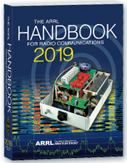
The Handbook Give Away

Hey Gang,

The “Handbook Giveaway” drawing will soon be returning for another big “Give Away”

Many of you ask me just how do I know when the drawing is on? Well, that’s easy all you need to do is check in on the Ohio Section Website on a regular basis and watch for the big RED Arrow that will appear on the left side of the page. This is the sign that the drawing is on and you need to get registered. So, keep a sharp eye out on the website and check in often! http://arrl-ohio.org

What’s the catch? I want to get everyone checking in to the Ohio Section website as often as possible, and in order to register each month, you have to visit the website often! There’s nothing else to it. I pay all expenses, and from time to time, I Give Away more than just a Handbook. And, you’ll never know just what months will be those special times that I will have more than just a Handbook to Give Away!!

TOP ^

Club Corner

This is YOUR cornner of the newsletter. Send me what your club is doing and I’ll make sure that it gets in. Got a special event or club project that you want everyone to know about? Send it to me!. Need help with a project? Send it to me.

Let me know what you club is up to. Are you going to have a special guest at your meeting or are you having a special anniversary? Just sent it to:
n8sy@n8sy.com

#########

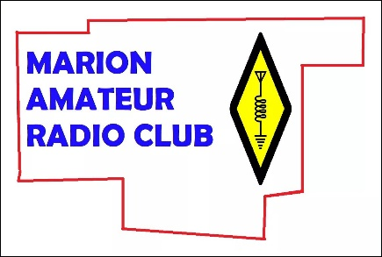
The Marion Amateur Radio Club will be operating a Special Event station at the 2019 National Robotics Challenge at Veterans Memorial Coliseum at the Marion County Fairgrounds.

We will be operating on HF (SSB Phone, PSK31, FT8, and CW) and on DMR (Talk groups 313964- Marion, Ohio Local, 3139- Ohio Statewide, TAC 310, or Brandmeister 91- Worldwide) under our club callsign W8GVB on Thursday April 11th, Friday April 12th, and Saturday April 13th at varying times.

It was kind of a short notice idea so we aren’t sure if the ARRL will get it listed in time but were going to give it a shot anyways. If you hear our station on the air, give us a shout as we will be ushering youth into our station and display to operate under local control to make contacts across the world and experience our hobby.

The Marion Amateur Radio Club and Marion County Ohio Amateur Radio Emergency Services has been volunteering our time for the past several years to staff this event and this year we have decided to promote and demonstrate our hobby to hundreds of technically minded youth from all over the world that attend this event. We hope to hear you and let’s have some fun on the air!!!!

#########

Oh-Ky-In Amateur Radio Society, Ham Radio Licensing Classes and Exams
Classes for Technician and General are being held on Monday nights starting April 15th until May 13, 2019 at the Cincinnati Red Cross Building, Dana Ave, 2111 Dana Ave, Cincinnati, OH 45207. These classes are also two hours in length from 7pm to 9pm. Licensing exams will be held on May 25th in St. Bernard in the Centennial Room of the Municipal Building 110 Washington Ave, Cincinnati, OH 45217.

Got questions? Please email Mike Niehaus KD8ZLB : KD8ZLB@gmail.com and visit http://ohkyin.org/wp/club-activities/classes/

#########

TOP ^
TMRA

Spring is here so it's almost time for the Glass City Marathon! This year the race is on Sunday, April 28th and starts at 7 AM. The course closes at 1:30 PM. Not every position requires you to be there the whole time. We need lots of operators to cover this event so if you can help please let me know at either k8rks@arrl.net or 419-471-0573.

New Ham - Info Class - Saturday, April 13, 2019 at 9 AM – 1 PM
Relaxed Learning Session: I'm new to Amateur Radio! Now what?!

Join Toledo Mobile Radio Association Members at the Lucas County EMS Training Center for a FREE learning and Q&A session that should work to help you get started with some of the practical items that we all wish we knew when starting off in Ham Radio. Any/everyone is welcome, and you do not have to have attended the class to attend. Most hams licensed less than 3 years will find the session useful.
This session will be run as a "class” but is open to ANY questions along the way. Folks are free to come and go as you wish. This training session is a great place to get to know TMRA members and for newer amateur radio operators to ask questions related to items they are concerned about or need help with. We know that this hobby has a lot of new items for everyone to get familiar with, so this is an attempt to short-cut that learning!
We'll discuss and help new hams resolve some of the typical early ham radio challenges including (but not limited to) the following types of discussion items (no specific order):

- Answer any early questions and discuss list of items that we all have soon after becoming a ham. (and worries that we each had)
- Discuss Hand-held and mobile radio types / drawbacks and benefits. Who can help me program it? How can I make my HT more effective?
- What is needed to setup and use a mobile or "base" radio - in car or in home (and benefits and types).
- Discuss Effective Radiated Power in terms of Antenna benefits - Discuss types of antennas indoor/outdoor options (and why). Horizontal vs. Vertical antennas.
- Types of feedline (we often refer to "coax) and what you will need (and for what) - and where to find it.
- VHF/UHF vs HF - Who can I talk to and when?
- Discuss using local Repeaters, internet linked repeaters, PL Tones, (repeaterbook/radio reference)
- Discuss Simplex vs Repeater typical etiquette (just so you know) - Examples: Q signals, calling CQ, breaks, etc.
- First Contacts – what to expect (most important, you won't be judged so don't "sweat it".... really...)
- Hamfests + Ham Conventions. - Why bother?
- Where should I buy equipment and what are the risks?
- Useful websites
- Foxhunting and Satellites - how/where?
- Where to find manuals and information?
- If there is time: Antenna Analyzers and SWR Meters - what are they and when do I need one?
- If there is time: N vs PL-259, vs SMA, versus BNC connectors
- Benefits of joining organizations/clubs
- Foxhunts - what are they and how does it work? Do I need anything?
- HF - club events (what can I participate with?) - Operating events.

TOP ^
- Callsigns, vanity and considerations
- QSL Cards and Logbook of the World
- Propagation - Tropo ducting, Sporatic E, Aurora, sunspot cycle, seasonal patterns

#########
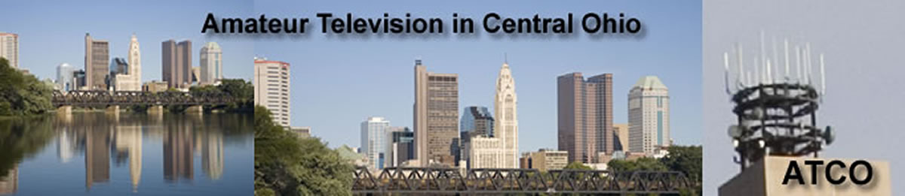
ATCO Spring Event

Guys (and Gals too),

It's closing in on ATCO Spring Event time. The Event date is Sunday May 5th starting about noon. Come one, come all in the ABB Cafeteria, and it's free! We'll have a free lunch followed by a short business meeting then on to the door prizes.

Let's have a great turnout this time! Surprise me!

ABB Cafeteria is located at: ABB Inc, 579 Executive Campus Dr, Westerville, OH 43082

Hope to see you there!!!

#########

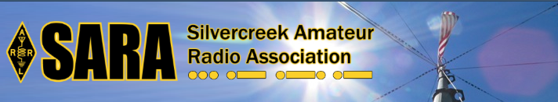
SARA is partnering/supporting Wayne County EMA in the offering of the SKYWARN training this year. As you may have heard, budget and staffing issues in the Cleveland NWS office has led them to cancel the NWS-lead SKYWARN classes. EMAs and ARES ECs are being encouraged to hold the SKYWARN training directly.

SARA is playing a supporting role to the Wayne County EMA which is holding a session for this region. The date will be Monday, May 6th from 6p - 8p. Volunteers will be needed 5p - 8:30pm. The tentative location is Chippewa Jr/Sr High School in Doylestown. Volunteers will help register attendees and print the SKYWARN training cards with ID numbers. Fred Sheppard KD8GYS will be assisting Joe Villegas with the class.

Additionally, SARA will have a table with some amateur radio materials available to spread the word about our hobby and service.

TOP ^

If you can volunteer your time, please contact me so I can add you to the roster. Please note that volunteers will not be able to be present in the class for the entire session as volunteers will register latecomers and also print and organize the ID cards.

Thanks! For more information or questions, contact Jason, N8JDM jason@mfamily.org

#########

Tuesdays Summer Lunch Program Activty Help Needed

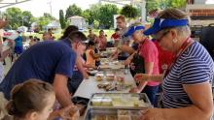
Help for activities for the summer lunch program on Tuesdays at Partners Park in Marysville is needed. The summer lunch program provides free summer lunches to people 0-18 years old. Lunch is served at 12pm.

Usually by 12:30pm lunches are consumed. We have the opportunity to setup an amateur radio or stem/technology type activity at the park on Tuesdays. Since we will be at a park, we won't be limited to time constraints for the length of the activity. If the activity has a lot of interest and goes longer, we will be able to stay as long as we need to.

Our hope is by consistently being at the park on Tuesdays, kids that are interested in technology and amateur radio will know to show up on Tuesdays for lunch to participate in the club activity.

If you can help out with this effort, please let Ed, KE8ANU@arrl.net know what Tuesdays you are available to help. The more club members we have help with it, the easier it will be on everyone. Ideally it would be good to have 2 different volunteers for each of the 10 Tuesdays. Since this is the first time, we will be doing this, we do not know what to expect.

#########

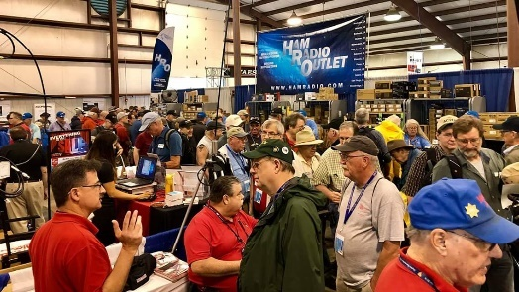
Upcoming Hamfests

04/13/2019 | 65th Annual Cuyahoga Falls ARC
Location: Cuyahoga Falls, OH
Type: ARRL Hamfest
Sponsor: The Cuyahoga Falls ARC, Inc.
Website: http://cfarc.org

TOP ^
04/20/2019 | Portsmouth Radio Club Hamfest  Location: Portsmouth, OH  Sponsor: Portsmouth Radio Club  Website: https://www.facebook.com/w4pox/ | 04/28/2019 | Athens Hamfest  Location: Athens, OH  Sponsor: Athens County Amateur Radio Association  Website: http://www.ac-ara.org/
05/17-19/2019 | Dayton Hamvention  Location: Xenia, OH  Sponsor: Dayton Amateur Radio Association  Website: http://hamvention.org/ | 06/01/2019 | FCARC Summer Swap  Location: Wauseon, OH  Sponsor: Fulton County Amateur Radio Club  Website: http://k8bxq.org/hamfest

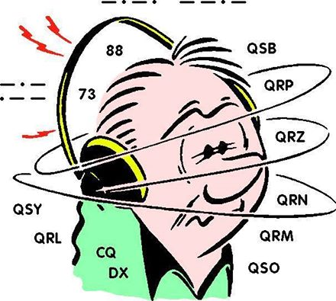
DX This Week
(from Bill, AJ8B)

Bill AJ8B (aj8b@arrl.net, @AJ8B, www.aj8b.com or www.swodxa.org )
CWOPs Member #1567

Digital Modes during Low Propagation

+ -------------------------------------------------------------------------------------------+

From Rob, W8MRL

Hi,
I'm back to encourage you to get on the air. We are in the solar minimum where propagation is a challenge, but it doesn't mean there aren't stations to work. During this time the digital modes like CW, FT8, PSK31 still allow you to make many DX contacts. If you haven't explored these modes, now is the time.

This weekend I was able to make the following DX contacts:

80 meters (100 watts and a vertical antenna)
Australia (10,000 miles), Saudi Arabia (7,000 miles), Germany, England, Ireland, Jamaica, Belgium

20 meters (100 watts and a dipole)
Argentina, Panama, Luxemburg, India (8,800 miles), Poland, Czech Republic, Romania, Iceland

Don't let your rigs sit, get on the air and enjoy the magic of amateur radio.

For my own experience the past 4 days, using either CW or FT8, 100 Watts and a vertical, I was able to work the following on 30 meters: Japan, New Zealand, Australia, Asiatic Russia, South Sudan, Antarctica, Greece, Dodecanese, Crete, and Juan Fernandez Island. This is not my “brag” tape, or boasting by Rob, it is just a challenge and an encouraging note to get folks on the air during this dead time.

+ --------------------------------------------------------------------------------------------------------------------+

Below is an article from Carl, K9LA. Carl is an authority on propagation, a great speaker, and a prolific author. In fact, Carl will be speaking at the inaugural W8DXCC convention in June. From Carl:

TOP ^
The purpose of this article is not to rigorously analyze how much improvement each JT mode offers – the purpose is to introduce the concept of a well-documented but less well-known mode of HF propagation and how it ties into the success of the JT modes.—K9LA

What Mode of Propagation Enables JT65/JT9/FT8?
By Guest Author, Carl Luetzelschwab, K9LA (K9la@arrl.net)

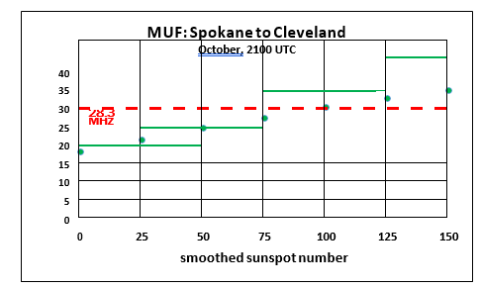
It should be obvious that K1JT’s JT65/JT9/FT8 digital modes are making big changes in band usage, especially on the higher bands as we approach solar minimum between Cycle 24 and Cycle 25. Is there a new propagation mode lurking here? Or is it just a less-known propagation mode that hasn’t received much attention? Let’s analyze a 10-Meter path between Spokane, WA and Cleveland, OH (approximately 3000 km – one-hop via the F2 region) to understand what’s going on.
We’ll use VOACAP to do this at a frequency of 28.3 MHz, with the transmitter in Spokane at 47.66o North latitude / 117.43o West longitude and the receiver in Cleveland at 41.50o North latitude / 81.70o West longitude. The month is October (a very good month for ionospheric propagation via the F2 region in the northern hemisphere) and the time is 2100 UTC (the best time for F2 region propagation between Spokane and Cleveland).
The antennas at both ends are assumed to be small Yagis at 40 feet over flat ground. The ground parameters used are for average ground – a conductivity of .005 Siemens per meter and a relative permittivity of 13. The resulting antenna gain is about 12 dBi at a peak elevation angle of 13 degrees. The transmit power is 100 Watts. The following are the predicted MUFs (maximum useable frequencies) from VOACAP at various smoothed sunspot numbers. The MUF is the first parameter needed for a QSO to be made – it must be high enough to assure that the signal gets from Spokane to Cleveland.
The important observation from the above plotted data is that F2 region propagation at 28.3 MHz should only be supported on this path when the smoothed sunspot number is greater than 75 because the MUF is greater than the operating frequency. The usual assumption here is that refraction occurs when the MUF is greater than the operating frequency. In other words, the ionization is sufficient to refract (bend) signals back to Earth. When the MUF is less than the operating frequency, the signal is not refracted enough and goes off into space, with no signal reaching the target.
Now let’s look at the predicted signal strength from VOACAP. Signal strength is the second parameter needed for a QSO to be made – the losses must be low enough so you can hear the other station’s signal. Here’s what VOACAP says for signal strength versus smoothed sunspot number for the selected path.
There are two important observations to be made from this data. The first observation is that when the smoothed sunspot number is high enough so that the MUF is above the operating frequency (greater than 75 in this example), the signal strength is pretty much constant. This signal strength (actually signal power) is around -83 dBm, which translates to around S7 (as annotated on the plot) assuming S9 = -73 dBm and an S-unit is 5 dB (which is what I’ve measured on my receivers).

TOP ^
What’s happening when the smoothed sunspot number is greater than 75 is refraction coupled with minimal ionospheric absorption (absorption is inversely proportional to the square of the frequency – it is less than a dB per hop on 10-Meters – this is one of the reasons why 10-Meter signals can be so strong). As a side note, all the signal strength values include the antenna elevation pattern of both Yagis at 40 feet.
Note that when the smoothed sunspot number is greater than 75, there is a huge amount of dB difference between S7 and the typical MDS (minimum discernible signal – a.k.a. sensitivity) of our receivers at around -133 dBm (the dashed red line) in a bandwidth of 500 Hz (a typical CW bandwidth). The difference is around 50 dB! This means the Spokane station could reduce his/her transmit power by 50 dB (to 1 milliwatt – now that’s QRP!) and still be heard in Cleveland.
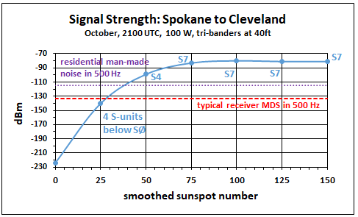
But we need to watch it here – usually man-made noise, even on 10-Meters, limits the sensitivity of our receiving system. Using the data in the ITU (International Telecommunications Union) document ITU-R P.372-13 for a residential noise environment indicates the true sensitivity of the Cleveland station is limited to around -115 dBm in a 500 Hz bandwidth (the dotted purple line). Realistically the Spokane station could now only reduce his/her power to 100 milliwatts when the smoothed sunspot number is greater than 75. Still not bad, though!
The second observation is that VOACAP still predicts signal strengths when the smoothed sunspot number is less than 75 – in other words, it predicts that propagation is still possible although full refraction cannot happen. At a smoothed sunspot number of 50, the predicted signal level is -99 dBm, which translates to around S4 and it is still above the man-made noise level. Is this an error on VOACAP’s part? No, it isn’t. VOACAP is simply trying to reflect (no pun intended) the real world.
In the real world, measurements over many paths have shown that a readable signal is still present even when the MUF is below the operating frequency. This called an above-the-MUF mode of propagation, and VOACAP includes the Phillips-Abel theory (note 1) to do the necessary math to predict propagation under this condition (note 2).
The mechanism for an above-the-MUF mode is believed to involve random patches of ionization that have a higher electron density than the background plasma and/or scatter – it could be ionospheric scatter, ground scatter or even sea scatter (note 3). Regardless of the specific mechanism, the one thing in common is additional loss. Thus, the difference between the MUF and operating frequency is critically important – the more the difference, the more the loss. In summary, the above-the-MUF mode is why VOACAP still predicts signal strength (instead of abruptly cutting off the prediction) when the MUF is below the operating frequency.

Now that we’ve looked at the normal “decode with ear” scenario, let’s move on to the JT65/JT9/FT8 scenario. Our analysis will make three major changes – we’ll switch from signal strength to SNR (signal-to-noise ratio), we’ll switch from 100 Watts to 10 Watts and we’ll use a 2.5 KHz bandwidth. These changes put the analysis in line with current JT65/JT9/FT8 practices (note 4). The SNR versus smoothed sunspot number follows (note 5).

TOP ^
The data point at a smoothed sunspot number of 0 is not plotted to give better resolution to the other data. If Spokane is operating on CW at 10 Watts, Cleveland should be able to decode by ear the Spokane station’s 10-Meter signal in the 2.5 KHz bandwidth when the smoothed sunspot number is above 50. This assumes humans can copy CW at an SNR of 0 dB, which is a realistic assumption.
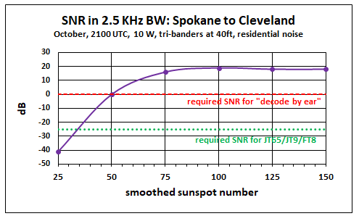
By using JT65/JT9/FT8, we should be able to make the QSO all the way down to a smoothed sunspot number of around 35. This assumes JT65/JT9/FT8 can decode down to an SNR of around -25 dB (a ballpark value for all three modes in the 2.5 KHz bandwidth – remember the purpose of this article is not to rigorously analyze the improvement with each JT mode). The 10- Meter band may be “dead” assuming the normal definition, but JT65/JT9/FT8 gives us the possibility of still making QSOs via the above-the-MUF mode.

An interesting corollary here is that VOACAP should be able to be used to predict JT65/JT9/FT8 openings on our higher bands (15-Meters, 12-Meters and 10-Meters) as Cycle 24 declines and we go through solar minimum. How accurate would it be? Recording observed openings and comparing to SNR data from VOACAP (using appropriate power levels, noise environments, bandwidth and antennas) would shed light on that question.

As far as I’m aware, the Phillips-Abel theory should also apply to 6-Meters. Unfortunately, VOACAP does NOT include 6-Meters, so you can’t use VOACAP for any above-the-MUF predictions on 6-Meters. However, one might be able to extract the Phillips-Abel losses for the above-the-MUF mode from VOACAP, and then apply these losses to real-time MUF data (for example, at http://af7ti.com/).
In summary, there appears to be a lot of RF flying around up above us that is below our normal noise level thanks to what we can generally call “scatter”. Using JT65/JT9/FT8 allows us to “hear” some of that. Finally, to reiterate, there doesn’t appear to be a new propagation mode for JT65/JT9/FT8. It’s just a less-known propagation mode that hasn’t received much attention.

Notes
1) J. L. Wheeler, Transmission Loss of Ionospheric Propagation Above the Standard MUF, Radio Science,
Vol. 1, No. 11, November 1966
2) For analysis of above-the-MUF modes, see L. F. McNamara, T. W. Bullett, E. Mishin and Y. M.
Yampolski, Nighttime above-the MUF HF propagation on a midlatitude circuit, Radio Science, Vol. 43,
RS2004, doi:10.1029/2007RS003742, 2008
3) R. Silberstein, Great-Circle and Deviated-Path Observations on CW Signals Using a Simple Technique,
IEEE Transactions on Antennas and Propagation, January 1965
4) Steve Ford, Work the World with JT65 and JT9, ARRL, First Edition Second Printing, 2015- 2017

TOP ^
5) Although a 2.5 KHz bandwidth is used in the plot for an apples-to-apples comparison, most CW
operators use a narrower bandwidth (around 500 Hz) – which would offer CW a 7 dB performance
improvement over that in the plot.

+ --------------------------------------------------------------------------------------------------------------------+

From our friend at the DailyDX and the WeeklyDX, and the best source for DX information, (http://www.dailydx.com/ ) Bernie has this to report:

DXCC News - Recently there was a name change for Z3 - Macedonia, which used to be called the former Yugoslav Republic of Macedonia. The new name is North Macedonia. The ADIF country code number remains 502. There will be no changes, other than the name, as to the DXCC status of Z3. There remains 340 countries/entities on the ARRL DXCC (current) List

VK9/N - Norfolk Island - A heads up from VK3KTT: the ops arrived and set up an inverted-L for 160 and a few other antennas. They are there for two weeks with a very good FT8 op, VK3BDX, David and VK3HJ, Luke, on 160 and CW. Also, there is VK2PN, Patrick, very good on CW, and VK3QB, Chris doing CW and SSB, so lots of good activity is expected. QSL via VK2CA.

3Y - Bouvet Island - The Bouvet Island website reports the 3Y0I DXpedition has been
postponed, not cancelled. https://bouvetoya.org/3yoi-postponed/

South Orkney Islands DXpedition -

For Immediate Release
Press Release #1
South Orkney Islands DXpedition (AN-008)
After their successful VP6D Ducie Island 2018 DXpedition, the Perseverance DX Group (pdxg.net) is pleased to announce their intention to activate South Orkney Islands, currently ClubLog #16 most wanted.
Planning has begun for an expedition in Feb/Mar, 2020. A team of experienced DX and Contest operators will operate from Signy Island for up to 15 days. The process of obtaining landing permission is underway. The call sign will be announced at a later date. The team will sail from Punta Arenas, Chile aboard RV Braveheart. Seven operating positions are planned for 160-10 meters, SSB/CW/Digital.
The team includes: Dave K3EL, Les W2LK, Steve W1SRD, Ricardo PY2PT, Gene K5GS, Arliss W7XU, Heye DJ9RR, Laci HA0NAR, Mike WA6O, Vadym UT6UD, Walt N6XG and Rob N7QT.
Additional details will be released as they develop.
Donations may be made via the website.
Website: https://sorkney.com/

TOP ^

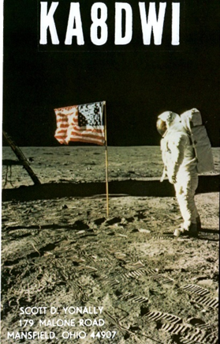
ARLD014 DX news

This week's bulletin was made possible with information provided by the URE, The Daily DX, The OPDX Bulletin, 425 DX News, DXNL, Contest Corral from QST and the ARRL Contest Calendar and WA7BNM web sites.
Thanks to all.

MAURITANIA, 5T. Evert, PA2KW will be QRV as 5T2KW from Nouadhibou from April 9 to 15. Activity will be on the HF bands using mostly CW and some SSB. QSL via LoTW.

SENEGAL, 6W. Elvira, IV3FSG is QRV as 6W/IV3FSG from Thies, near Dakar, until April 16 while working for the Informatici Senza Frontiere organization. Activity is in her spare time on 80 to 10 meters using SSB and possible digital modes. QSL via IK3GES.

JAMAICA, 6Y. Kasimir, DL2SBY is QRV as 6Y5KB until April 10.
Activity is usually on 40 to 6 meters, including 17, 12, and possibly 30 meters, using CW, SSB, RTTY and FT8. QSL to home call.

MALDIVES, 8Q. Ben, DL1RNT is QRV as 8Q7NT from Embudu Island, IOTA AS-013, until April 13. Activity is on the HF bands. QSL to home call.

THE GAMBIA, C5. A group of operators are QRV as C5DL until April 15. Activity is on 160 to 10 meters using CW, SSB and various digital modes, with three stations active. QSL via DL7DF.

SOUTH COOK ISLANDS, E5. Operators Dagmar, DM7PQ and Rainer, DL1AUZ are QRV as E51NPQ and E51AUZ, respectively, from Rarotonga Island, IOTA OC-013, until April 11. Activity is holiday style on the HF bands using only CW. QSL to home calls.

NIUE, E6. Janusz, SP9FIH is QRV as E6AF until April 25. Activity is on 160 to 15 meters using SSB, RTTY and FT8. QSL to home call.

SPAIN, EA. To celebrate the 70th anniversary of the IARU Society Union de Radioaficionados Espanoles, or the URE, special event stations AM70URE, AM70A, AM70C, AM70D, AM70E, AM70F, AM70I, AM70L, AM70N, AM70O, AM70P, AM70R, AM70S and AM70U are QRV until June 9.
Activity is on 160 to 6 meters. QSL via bureau.

ITALY, I. Special event station II0KT is QRV until August 31 to commemorate the 1947 voyage of the raft Kon Tiki. QSL via I0KQB.

GUINEA-BISSAU, J5. Livio, IZ3BUR is QRV as J52EC from Cumura until April 15. QSL direct to home call.

LIECHTENSTEIN, LX. Operators PA2HGJ, PA2RDK, PA3CNO, PE0MGB and PE1FLO will be QRV as HB0/home calls from April 6 to 13. Activity will be on 160 to 10 meters using mainly CW and FT8, with some SSB. QSL via PE1FLO.

TOP ^
ALAND ISLANDS, OH0. Mart, DL6UAA will be QRV as OH0UA from April 8 to 19. Activity will be on the HF bands using CW and various digital modes. QSL to home call.

NORFOLK ISLAND, VK9N. Operators VK3QB, VK3HJ, VK2PN and VK3BDX are QRV as VI9NI until April 14. Activity is on 160 to 17 meters using CW, SSB and FT8. The operation commemorates the signing of the Norfolk Island Act 40 years ago. Activity includes some SOTA activations from Mt. Bates and Jacky Jacky. QSL direct via VK2CA.

ANTARCTICA. Roman, UT7UA is QRV as VP8CTR form Wordie House on Winter Island, IOTA AN-006. Activity of late has been with FT8.
His length of stay is unknown. QSL via DL5EBE.

BURKINA FASO, XT. Harald, DF2WO will be QRV as XT2AW from April 7 to 26. Activity will be on 160 to 10 meters using CW, SSB and various digital modes. QSL via M0OXO.

THIS WEEKEND ON THE RADIO. The SP DX Contest, QRP 80-Meter CW Fox Hunt, NCCC RTTY Sprint, NCCC CW Sprint, LZ Open 40-Meter CW Sprint Contest, PODXS 20-Meter 070 Club PSK 31 Flavors Contest, SARL VHF/UHF Digital Contest, Mississippi QSO Party, Missouri QSO Party, Florida State Parks on the Air, EA RTTY Contest and RSGB 80-Meter RoLo SSB are all on tap for this upcoming weekend.

The 144 MHz Spring Sprint is scheduled for April 8.

The CWops Mini-CWT Test, RSGB 80-Meter Club SSB Championship, NAQCC CW Sprint and Phone Fray are scheduled for April 10.

The Canadian National Parks on the Air, CNPOTA, operating event runs for the entire year of 2019, with special stations active from Canada's parks and historic sites.

Please see April 2019 QST, page 87, and the ARRL and WA7BNM Contest Web Sites for details.

Special Events

- 04/13/2019 | 7th Annual Earth Day Celebration
Apr 13, 1500Z-2000Z, W8PRC, Cleveland, OH. Parma Radio Club. 14.245 7.195. QSL. Parma Radio Club, 8111 Laumer Ave., Cleveland, OH 44105. Our 7th ^{A}nnual Earth Day Celebration. Operating on solar power from historic, educational Stearns Farm in the Parma, Ohio town center. www.parmaradioclub.com

- 05/04/2019 | 100th Anniversary Mahoning Valley Amateur Radio Association
May 4-May 5, 1300Z-0100Z, W8QLY, Youngstown, OH. Mahoning Valley Amateur Radio Association. .3825 7.250 14.250. QSL. MAHONING VALLEY AMATEUR RADIO ASSOCIATION INC, 125 W McKinley Way, PO BOX 14141, Youngstown, OH 44512. Electronic QSLs will be sent for confirmed contacts--request form on QRZ page. mvara.W8QLY@gmail.com or www.qrz.com/db/w8qly

TOP ^

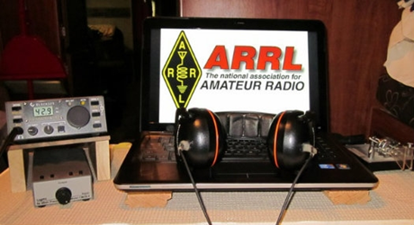
ARRL Contest Corner

An expanded, downloadable version of QST's Contest Corral is available as a PDF. Check the sponsor's Web site for information on operating time restrictions and other instructions.

One Question Questionnaire

Hey Gang

There’s another NEW – one question – questionnaire on the Ohio Section Website! http://arrlohio.org

We had a very interesting poll this past week. It seems that about 66% of you have built your own power supply. That’s fantastic! I love to see that our folks are out building things! That’s what Amateur Radio is all about.

Anyway, these questions are all in fun and I hope that you are enjoying answering these “ONE QUESTION” questionnaires. Ok, enough on that, here’s the next question for you to answer…

“What is the correct answer to the Electrical Teaser I had in last week’s newsletter?”

You’ll find the “One Question” questionnaire on the Ohio Section Website! http://arrlohio.org It’s all in fun and it’s not a scientific survey in any way, but we are learning some things that we didn’t know from these questions. I hope that you are enjoying answering these “One Question” questionnaires.

V.E. Test Sessions

For the latest testing site information please >> Click Here << The ARRL site tracks all of the VE testing sites that register with them, including W5YI and Laurel. ARRL gives you a number of different ways of sorting to find that site that is closest to you as well.

#########

TOP ^
Exam Session Reminders

GRADING EXAMS: Each VE must grade each exam taken or must agree to the score given. After all three VEs agree to the number of correct answers shown, the score is announced to the examinee.

The VEs must inform the examinee of their grade (pass or fail, and state the score {e.g., 26 out of 35}) upon completion of the grading.

NEW GENERAL EXAMS COMING: The new General class question pool will take effect on July 1, 2019 for all Element 3 General class license written exams. With the General class exams changing July 1st, new test designs must be created and used on that day. ARRL VEC will be supplying all its (near 1,000) Field Stocked VE teams with new test booklets about the 3rd week in June. Do not destroy the 2015 versions of the General exams until June 30.

BASIC QUALIFICATION QUESTION PROCEDURES: The detailed instructions are available on the ARRL website. At the exam session, candidates that answer “YES” to the qualification (felony) question should be given the “Applicant Instructions for FCC Basic Qualification Question” document. Print or download here: http://www.arrl.org/files/file/VEs/Applicant%20Info%20Qualification%20Question%202019.pdf

Applicants can also be referred to our Basic Qualification Question web page for information and instructions.
View page: http://www.arrl.org/fcc-qualification-question

After the application data from the session is submitted to FCC and an FCC file number is created, the applicant is required to provide an explanation directly to the FCC within 14 days. Do not collect information from the candidate and do not send any documents to the VEC.

Incident Command System (ICS) Training Schedule

All current trainings are listed on the Ohio EMA training calendar located at:
https://webeoctraining.dps.ohio.gov/TrainingAndExercise/courselist.aspx

I’ve been asked to also include a link to the Kentucky EMA training calendar as well..

https://kyem.ky.gov/training/Pages/default.aspx
https://sites.google.com/site/ccoemtraining/home

Please pay particular attention to these courses listed above, as that there’s a lot of ICS 300 & 400 classes listed that are very useful for all Amateurs to have under their belts. I will also state that G775 is also a very good course to take as well. These 3 courses are multiple day in class courses, so please be prepared to spend some time taking them.

We do recognize that IS-300/400 requires multiple days of actual classroom training that is not easily obtained. So, if you just can't find the time to fit these class room courses in, we do have an alternative method for getting you to Level 3.

TOP ^
Completing the following “FREE” and “ONLINE” courses will act as substitute for you FEMA Leadership Development Course requirements. You absolutely will need to complete all 7 of these courses to get your ICS 300/400 credit. Here are the courses that you need to take: IS-120, 230, 240, 241, 242, 244 & 288.

Now, if you are looking for wallpaper and have a little extra time, taking IS-235 in addition to the 7 listed courses above, you will get a really cool looking certificate from FEMA stating that you have completed the Professional Development Series. That’s impressive in itself!

#########

The Department of Homeland Security (DHS) Returns to Provide Auxiliary Communications (AUXCOMM) Training in Conjunction with Hamvention® 2019

The Emergency Communications Division (ECD) of DHS’s Cybersecurity and Infrastructure Security Agency (CISA) will be on hand at Hamvention® 2019 to conduct its nationally recognized NIMS/ICS compliant AuxComm course. Over 2,500 amateur radio operators from around the country have taken this course. The purpose of this course is to train qualified amateur radio operators so they may assist their local, county and state governments with emergency backup communications if requested to do so.

This course introduces the auxiliary communicator to the other positions within the Communications Unit (COMU) and how to provision emergency communications in a public safety context. The course also goes deeper into the National Incident Management System framework. The location of the course will be at the “Courtyard by Marriott” in Beavercreek, Ohio and be held 14-16 May 2019. Registration for this class may close early when all available seats for this class are taken.

Registration for this course is ongoing: Students wishing to attend the DHS Auxiliary Communications (AuxComm) Course must meet all prerequisites and provide electronic/scanned images of the following required documents prior to 1 May 2019:

Prerequisites:
- A signed copy of your current valid FCC issued amateur radio license
- IS-100 certificate (FEMA issued); IS-200 certificate (FEMA issued); IS-700 certificate (FEMA issued);
IS-800 certificate (FEMA issued), and the name of the public safety entity, and its contact information, that you would support upon completing this course

Please scan copies of this information, attached it to an email, and then send to COMU@hq.dhs.gov. In the subject line, please put Hamvention AUXCOMM. Your information will be reviewed, and a reply sent back to you indicating that you have been given a seat in the course.

This will be an intensive three-day version of the course with facilitated lectures and student exercises conducted by professional AUXCOMM instructors. This course provides time for interactive discussions and exercises. Should you have any questions regarding this course, please send them to COMU@hq.dhs.gov.

One final note, please mark your forum calendar, on Friday 17 May, to come see us at the AUXCOMM forum. You will be given a glimpse at the new AUXCOMM Position Task Book (PTB), a briefing on the proposed Communications Section for NIMS/ICS and a briefing on one of the most active AUXCOMM states – North Carolina!

TOP ^

ARES Connect

CQ… CQ…. CQ… Calling all persons to be a part of the new ARES Connect program.

We need to discuss some very important items that only YOU can make a difference with. I need you to get yourselves registered in ARES Connect, that is… if you haven’t already. Now, how do I know that you need to do this? It’s simple, we have 999 now registered in the database and Stan’s last S.E.C. report shows that we have a little over 1,700 persons in ARES right now. As you can see, we still have a way to go to really take advantage of this new system.

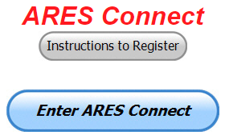
As the numbers show, there’s still a lot of you that haven’t taken the plunge yet and need to! What are you waiting for? No matter how much you resist, it’s coming, and we need to make sure that no one is left behind.

Now, as an incentive to get you to not only register…. But to actually start using the system… (Notice how I have that in bold type for you to clearly see?) I am giving away all sorts of goodies to help you get motivated. I have a footlocker of really cool items that I will be giving away!

I’m doing this in various intervals throughout the year, so it will challenge you to be dedicated to getting your hours into the system. You’ll never know just when another drawing will be, so you really do have to be prudent!!

Here’s the top 10 folks for hours for this portion of April:

 | Name | Events | Hours
1 | James Yoder (w8erw) | 2 | 39.00
2 | Dan Stahl (KC8PBU) | 8 | 27.25
3 | Christopher Domenick (KC8CAD) | 5 | 19.25
4 | Steve Wheatcraft (AA8BN) | 4 | 16.25
5 | Edward Kopcak (KB8BKE) | 4 | 16.00
6 | Charles Emick (kb8pxm) | 2 | 14.75
7 | Timothy Gray (KD8IZU) | 2 | 13.50
8 | Gordon Broadway (N8BHL) | 2 | 13.00
9 | Mark Griggs (KB8YMN) | 5 | 13.00
10 | James Smith (ke8iju) | 2 | 13.00

Here’s how we did with people getting signed up for events
and the total hours logged so far for April

Total Amount signed into Events | Total Hours for Events
398 | 1,751.36

Think you could ever get into the top 10 listing like the folks above? One thing is guaranteed, you definitely won’t if you don’t get registered and start signing up for events!!!

TOP ^
It adds up quickly, but you do have to be registered and actually USE the system in order for any of your time to count. We have a set of instructions on how to get registered right above the button to enter ARES Connect. I would strongly suggest that if you haven’t registered yet, that you read these instructions first.

Here’s a link to get you started... http://arrl-ohio.org/ares_connect_directions.pdf Please, don’t just hurry through the questions, read them carefully, if you don’t understand something, please ask me, I’m here to answer your questions.

We know that you mean well by answering that you do have the needed courses in, but I will let you know that we are verifying what you say you have with what is showing for you in our statewide database when we are completing your registration. So, how can you find out if you are already listed in our statewide database? Easy, here’s a link: http://arrl-ohio.org/SEC/special/ICS%20Complete%20by%20County%20and%20Name.pdf

Ok, now on to something new for ARES Connect… I was asked by Ron, NU8N about having a certificate for those who have taken the extra time and courses to get to Level 3. Well, after some thinking about it, Stan and I agreed with Ron that we should have some wallpaper for those who have taken this extra hard step. So, I’m here to tell ya’ that we are now offering a really nice certificate for all of those who have worked so hard to obtain their Level 3 ARES Status.

All you have to do is complete a couple of boxes and we’ll send you a certificate suitable for framing. Now I want to make sure that you understand that you do have to be registered in the statewide database as a Level 3 to qualify for this certificate.

Here’s the link… http://arrl-ohio.org/SEC/level3.html So, if you have certificates that you haven't submitted yet, this is the perfect time to do just that!

Wouff Hong Ceremony At Hamvention

When: Saturday – May 18th starting ~ 9:00 PM Where: Marriott at the University of Dayton
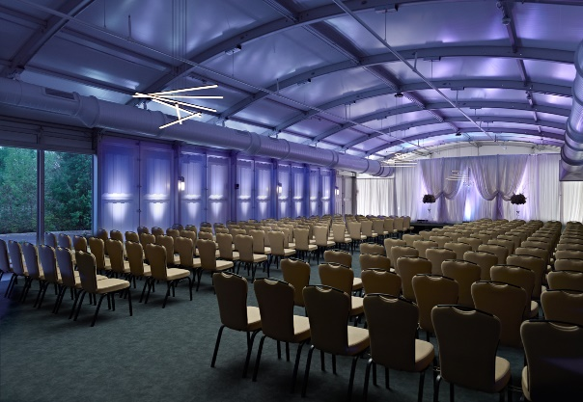
Hey Gals and Guys… You’ve been asking if this is going to happen, and now I can tell you for sure, YES we are having a Wouff Hong Ceremony at Dayton!!! The Conclave will gather at 9pm and those willing to take the plunge and become a part of this ever growing and most secretive of all Societies. Come join us and be indoctrinated into history!

The ceremony is steeped in mystery! Attendees will receive a special keepsake. A fun activity for all ages. Doors to the conclave will open at 9:00 PM (no admittance after 9:30 PM) at the Marriott at the University of Dayton (Tradewinds Pavillion), 1414 S Patterson Blvd, Dayton, OH 45409. Free registration online to ensure there will be enough seats, and to get a really cool certificate following the ceremony. Go to: http://arrl-ohio.org/wouff-hong.html. This event is sponsored by the ARRL Ohio Section.

TOP ^
Now, for those of you who don’t know what Wouff Hong is all about:
A Wouff Hong is a fictional tool used to "punish" Amateur Radio operators who demonstrate poor operating practices. Legend has it that the Wouff Hong was invented by ARRL co-founder Hiram Percy Maxim under the pseudonym, "The Old Man," just as radio amateurs were getting back on the air after World War One.
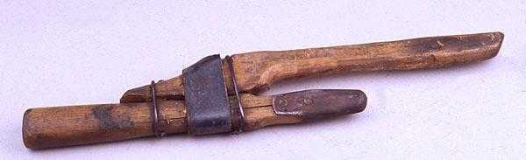
Early in 1919, "The Old Man" wrote in QST "I am sending you a specimen of a real live Wouff Hong . . . Keep it in the editorial sanctum where you can lay hands on it quickly in an emergency." The "specimen of a real live Wouff Hong" was presented to a meeting of the ARRL Board and the Board voted that the Wouff Hong be framed and hung in the office of the Secretary of the League.

On display at ARRL Headquarters today, the Wouff Hong is a constant reminder to Amateur Radio operators to be mindful of their operating etiquette.

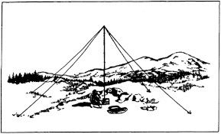
2019 Ohio NVIS Day

Hey everyone, Stan, N8BHL has let me know that the date for NVIS Day is scheduled for Saturday, April 27th. Are you ready? Start your planning now!
Like years past, we are planning on having the operation run from 10 – 4 EDT. Take a lunch break, enjoy each other’s company.

Transmit power should stay at 100 watts for accurate signal comparison. You may operate anywhere, home, club, portable.
Want to know more about what NVIS is? http://arrl-ohio.org/SEC/nvis.html Learn all about Near Vertical Incident Scattering and how you can easily put up a NVIS antenna and participate in this great exercise.

Weather Underground and Other Ham Weather Stations

Have you visited the webpage to see all the Weather Underground stations yet? It’s really fun to see just how much the weather varies across the state and this gives you access to each individual station very quickly and easily.

Hey gang, if you haven’t looked at your Weather Underground dashboard lately you might want to. It seems that the nice folks there have taken the time to upgrade your dashboard. The new design is still being worked on from what information that I could gather, but they have done a really nice job. The new design is really easy to view and contains the same information at before, but it’s laid out in a really professional manor.

Now, our list of stations is growing all the time. This week we’ve added a new station from the Hillsboro area thanks to Richie, N8CUB.

TOP ^
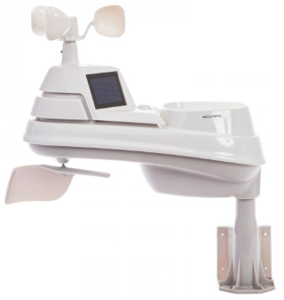
How’s about your station? Is it listed with us? It doesn’t necessarily have to be a Weather Underground reporting station. I’d love to have any weather station that is connected to the internet available for all of us to view, especially when the weather gets bad out. The more stations reporting the better.

Thanks to everyone who has contributed to this effort. If you haven’t, you really should take a look at the various weather stations around the state when we get bad weather coming in. You can really see just where the line of storms are as they cross through the state. It is very fascinating to watch it all unfold right you’re your easy chair, and all the data is real time! Here’s a link to all of those listed… http://arrl-ohio.org/wus.html

We’re starting to get a really good collection of stations all over. I know that there is a lot more than what we have listed. How’s about sharing your weather information with all of us! All that you need to do is send me your Weather Underground ID and your call sign and I’ll take it from there. Sent it to: n8sy@n8sy.com

World Amateur Radio Day
(from M2M News Beacon)

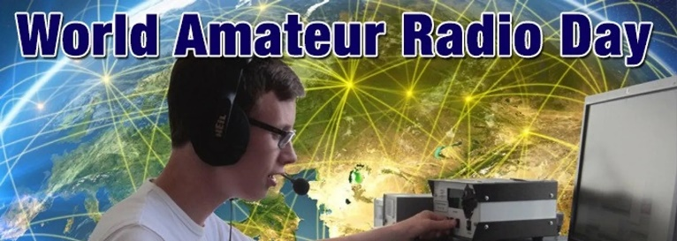
Techniques
Every April 18, radio amateurs worldwide take to the airwaves in celebration of World Amateur Radio Day. It was on this day in 1925 that the International Amateur Radio Union was formed in Paris.

Amateur Radio experimenters were the first to discover that the short-wave spectrum — far from being a wasteland — could support worldwide propagation. In the rush to use these shorter wavelengths, Amateur Radio was “in grave danger of being pushed aside,” the IARU’s history has noted. Amateur Radio pioneers met in Paris in 1925 and created the IARU to support Amateur Radio worldwide.

Just two years later, at the International Radiotelegraph Conference, Amateur Radio gained the allocations still recognized today — 160, 80, 40, 20, and 10 meters.

Since its founding, the IARU has worked tirelessly to defend and expand the frequency allocations for Amateur Radio. Thanks to the support of enlightened administrations in every part of the globe, radio amateurs are now able to experiment and communicate in frequency bands strategically located throughout the radio spectrum.

From the 25 countries that formed the IARU in 1925, the IARU has grown to include 160 member-societies in three regions. IARU Region 1 includes Europe, Africa, the Middle East, and Northern Asia. Region 2 covers the Americas, and Region 3 is comprised of Australia, New Zealand, the Pacific island nations, and most of Asia. The International Telecommunication Union (ITU) has recognized the IARU as representing the interests of Amateur Radio.

Today, Amateur Radio is more popular than ever, with more than 3,000,000 licensed operators!

World Amateur Radio Day is the day when IARU Member-Societies can show our capabilities to the public and enjoy global friendship with other Amateurs worldwide.

TOP ^
We have provided a poster for World Amateur Radio Day. Any club may download it and use it to promote WARD in their area. The poster comes in two sizes: 61cm x 91cm and a small (A4) flyer.

Groups should promote their WARD activity on social media by using the hash tag #WorldAmateurRadioDay on Twitter and Facebook. IARU will list all WARD activities on this page. To have your WARD activity listed, send an email to IARU Secretary David Sumner, K1ZZ.

April 18 is the day for all of Amateur Radio to celebrate and tell the world about the science we can help teach, the community service we can provide and the fun we have. We hope you will join in the fun and education that is World Amateur Radio Day!

Activation Information: Malaysia: On 18 April 2019 9M4CMN (9w2pck@marts.org.my) will be on the air from Segamat, Southern Malaysia and 9M4CKK (9m2cio@marts.org.my) will be active from Tumpat, East Coast of Malaysia from 0230hrs to 1530hrs UTC.

Worldwide: The World Radio Network and the World Friendship Net will be participating in World Amateur Radio Day 2019.

For the second time in a row, the special event call sign W2W has been secured for this event. As well there will be a commemorative special event "WORLD AMATEUR RADIO DAY 2019" QSL Card. We will have a 12-hour net with 10 different net controllers from all over the world.

Links can be found on: http://www.iaru.org/world-amateur-radio-day.html

#########

NEW - FT8 Contest
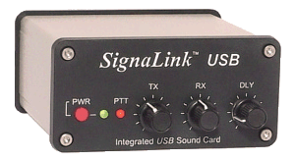
(info from Greg, WD9FTZ)
A new FT8 DX Contest is set for April 13 and 14, starting at 12:00z, and running for 24 hours. This contest is sponsored by the European FT8 Club. https://europeanft8club.wordpress.com

Rules
1 – Date
Begins: 13-April-2019 | 12:00 UTC
Ends: 14-April-2019 | 12:00 UTC

2 – Bands and mode
80, 40, 20, 15 and 10 meters on FT8 mode. Any station may work any other station. Stations may be worked once per band.

3 – Categories
- Single Operator LOW (100 watts or less)
- Single Operator QRP (5 watts or less)
- Multioperator LOW (100 watts or less)
- Multioperator QRP (5 watts or less)

TOP ^
4 – Exchange
4.1 United States: Signal report and State (except KH6 and KL7).
4.2 Canada: Signal report and Province.
4.3 DX: Signal report and consecutive serial number, starting with 001 (including KH6 and KL7).

5 – Scoring
5.1 QSO Points: One point for each completed QSO.
5.2 Multipliers: Each US state (except KH6 and KL7) plus the District of Columbia (DC), Canadian provinces/territories: NB (VE1, 9), NS (VE1), QC (VE2), ON (VE3), MB (VE4), SK (VE5), AB (VE6), BC (VE7), NWT (VE8), NF (VO1), LB (VO2), NU (VYØ), YT (VY1), PEI (VY2) and each DXCC country. KH6 and KL7 count only as separate DXCC entities.
5.2.1 Multipliers count only once (not once per band).
5.2.2 The US and Canada do not count as DXCC entities.

6 – Logs
The Cabrillo entries include the header and the complete QSO list. All logs must be emailed by 28-April-2019 at 23:59 UTC in Cabrillo format to europeanft8club@gmx.com

7 – Miscellaneous
Participants must use WSJT-X version 2.0 or later or MSHV version 2.14 or later.

8 – Awards
Certificates will be awarded to all participants and can be downloaded online when available.

In addition, the European FT8 Club has “MSHV,” a FT8 variant or alternative that incorporates the following modes including contest mode: MSK, JTMS, FSK, ISCAT, JT6M, FT8, JT65, and PI4.
http://lz2hv.org/node/10

There is also information on how to setup FT8, with the exception of the JTDX program, for the FT8 DX Contest, Field Day, and VHF contests. http://lz2hv.org/node/13

WSJT-X, version 2 or later, will also work in the FT8 DX Contest.

This and That’s
(from Greg, WD9FTZ and others)

Space Weather Probes Shatter GPS Record
https://spaceweatherarchive.com/2019/04/05/space-weather-probes-shatter-gps-record/
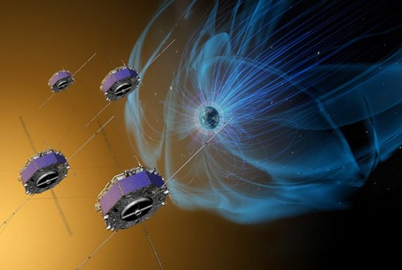
April 5, 2019: NASA’s MMS probes, which use GPS signals to orbit Earth in tight formation, have just shattered the record for long-distance GPS navigation. The four probes recently located themselves 116,300 miles above Earth’s surface, surprising experts who once thought that GPS could function no higher than about 22,000 miles.

“When we began the mission, we had no idea high-altitude GPS would be such a robust capability,” says Trevor Williams, the MMS flight dynamics lead at NASA’s Goddard Space Flight Center.

TOP ^
MMS, short for “Magnetospheric Multiscale,” is a constellation of 4 spacecraft launched in 2015. They are on a mission to study magnetic explosions in our planet’s magnetosphere.

High above Earth where the magnetic field is buffeted by solar wind, magnetic lines of force criss-cross, reconnect and—Bang! Magnetic energy is unleashed, with charged-particles flying off near the speed of light. The process is called “magnetic reconnection, and it serves as a power source for geomagnetic storms.

To study the inner physics of reconnection, the MMS probes must fly in precise formation, as close as 10 km apart, so that they can sample particles and fields inside the tight reconnection zone. With the aid of GPS, the fleet maintain formation with an accuracy of only 100 meters, which is crucial to their measurements.

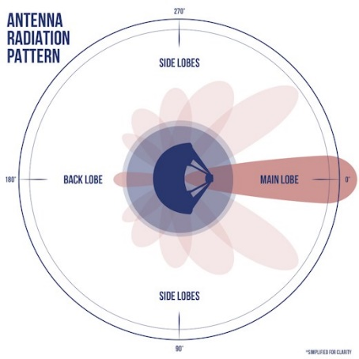
GPS satellites are not designed to assist spacecraft. They focus their radio energy on Earth where we use the signals for terrestrial navigation. So how do the MMS probes do it? The answer is “side lobes.” This diagram shows a simplified but typical GPS antenna pattern:

All GPS antennas allow a little bit of radio energy to leak out in unwanted directions through side lobes. Receivers on the MMS probes tap into the leaked signal and use it to locate themselves. The first time MMS attempted navigation at the extremes of its orbit, the satellites had as many as 12 GPS fixes, each requiring signals from four GPS satellites. Not bad for leaky side lobes.

This type of navigation could reach all the way to the Moon. NASA analysts have run simulations suggesting that all six international GPS-like constellations (collectively known as GNSS) when working together could guide spacecraft in lunar orbit 238,000 miles from Earth. NASA is even considering adding GPS navigation to its proposed Gateway outpost, a space station for the Moon.

#########

ARRL President Commends Amateur Radio’s Volunteer Public Service Role during National Volunteer Week

ARRL President Rick Roderick, K5UR, is using the occasion of National Volunteer Week, April 7 – 13, to highlight Amateur Radio’s role in helping the public as volunteers.

“It is the reason many new hams enter the hobby today — to support their communities and our served agencies during emergencies, disasters, and community events,” he said. “I want to thank the thousands of Amateur Radio operators who continue to provide this valuable service. It shows the great value Amateur Radio plays in providing an army of communicators in times of need. I’m proud to be associated with such a fine group of volunteers who commit their time and effort to help others.”

National Volunteer Week is sponsored by Points of Light, an ARRL partner through National Voluntary Organizations Active in Disaster (VOAD). Points of Light called the week-long observance “an opportunity to celebrate the impact of volunteer service and the power of volunteers to tackle society’s greatest challenges, to build stronger communities, and be a force that transforms the world.”

Have you been listed on the Honor Roll lately? Check out QST for those who are.

TOP ^

Final.. Final..
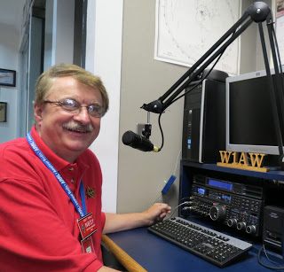
Hey Gang...

It was another great week visiting with all of you at your meetings and events. It was especially great to see everyone that attended the Ohio Section ARES Conference this past Saturday. Wow, we had a packed house! I hope everyone enjoyed themselves as much as I did. And, for those who came, I hope you enjoyed the presentations and the breakout session. More than anything, I hope that you’ve learned something that you can take home with you and use. That’s what this conference is all about… learning and sharing. I will do some editing and enhancing of the video that I took and will be releasing it soon. Stay tuned.

Now, let’s move on to more important things... I’ve been asked by many of you just how many folks do we have in ARES Connect now. Well, here’s a breakdown of all 3 levels for you…
Level 1 – 446; Level 2 – 425; Level 3 – 129

This gives us a total of 1,000 in ARES Connect. I don’t know for sure, but my guess from everything that I can see within the system is that no one other than the Ohio Section has more people registered in ARES Connect.

I do want to clear up some mis-interpretations that have been going around. First, in the Ohio Section we only require our Level 2 volunteers to have the 4 basic courses, IS 100, 200, 700 & 800. For our Level 3 volunteers we do require the additional ICS 300 / 400, or the equivalent professional series courses IS 120, 230, 240, 241, 242, 244 & 288. These equivalent courses are all on-line classes just like your basic 4 NIMS courses are and being offered as an alternative way for you to get credit for taking the professional series courses in the event you just cannot get scheduled into an ICS 300/400 class.

By the way, if you decide to take these 7 on-line courses and complete them all, you will want to take just one more class IS-235. By completing this additional course, you will get a really great looking certificate from FEMA recognizing that you have completed the entire Professional Series courses. I do hope that this clears up the confusion that has been going around lately. As we have stated on the website and in this newsletter many times “We don’t want anyone left behind.”

Spinning the dial down the band a bit… We have an update to tell you about thanks to Mark, N8ME we now have a new code plug for the DM1801 Radio. This code plug was created from extracting the data from the GD-77 code plug.

Whelp… That’s going to do it for this time around. Stay safe, stay warm, and most of all… have FUN!!

73,

Scott, N8SY

TOP ^

Back Issues of the PostScript and Ohio Section Journal (OSJ)

Hey, did you know that PostScript and Ohio Section Journal (OSJ) are archived on the website? You can go back and look at any edition simply by clicking:
http://arrl-ohio.org/news/index.html

Chit – Chat, and All That!

Do you know someone that’s not getting these Newsletters? Please, forward a copy of this Newsletter over to them and have them “Opt-In” to start receiving them. Heck, just have them send me an email n8sy@n8sy.com and I’ll get them added to the Ohio Section Emailing list.

We now have many thousands of readers receiving these newsletters weekly. Quite impressive, I’d say! I urge all of you to make sure that everyone, regardless of whether they are a League member or not, get signed up to receive these weekly Newsletters.

You can always “Opt-Out” at any time if you feel this is not what you were expecting. It’s fun and very informative. All of your favorite past newsletters are now archived too.
You can go back at any time and read them. Just go to: http://arrl-ohio.org/news/

Got questions, concerns or would just like to sit and chat awhile? Heck, I’ll even buy the coffee!! Give me a call at (419) 512-4445 or email me at: n8sy@n8sy.com

The pictures on the front page are from various newsletters, Facebook posts and/or were sent directly to me in recent weeks. Take a good look at them, you just might be in one of the pictures! “SMILE… you’re on the Ohio Section News!!”

TOP ^

PostScript is produced as a weekly newsletter. I want to thank everyone that has contributed articles and ideas to make this an even better news source. I sincerely hope that you have enjoyed this edition and will encourage your friends to join with you in receiving the latest news and information about the Ohio Section, and news and events happening around the world!

