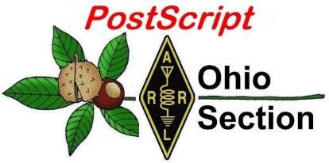
April Fools
Edition

National News The Handbook Give Away

Club Corner Hamfests

DX This Week One Question Questionnaire

VE Testing Schedule Final.. Final..

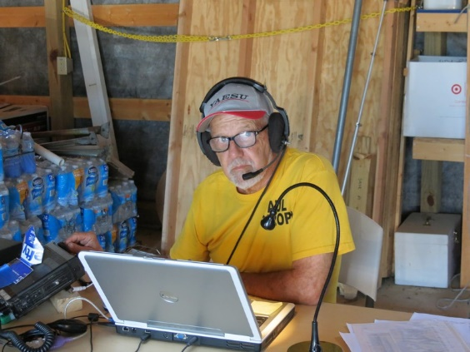
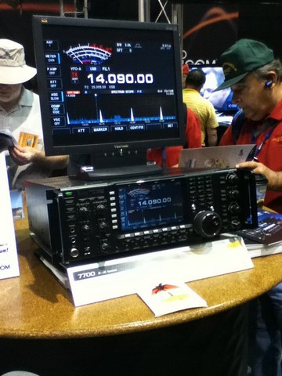
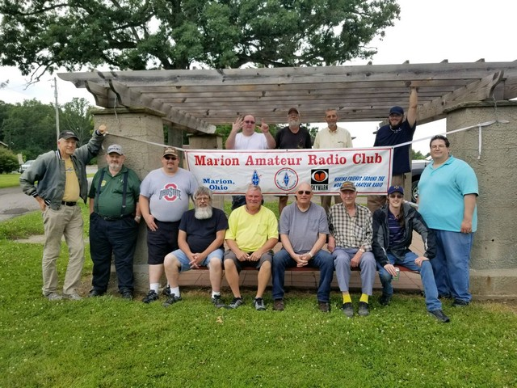
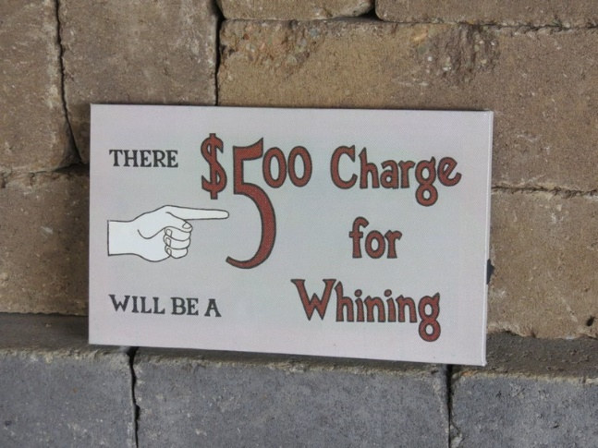
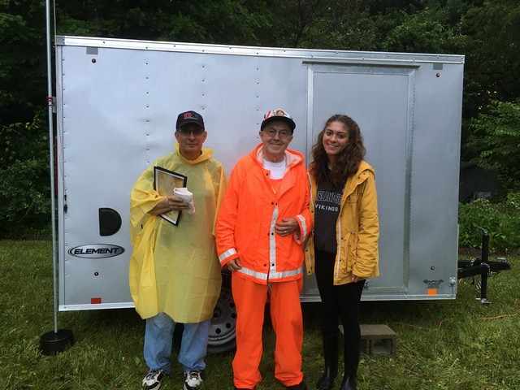
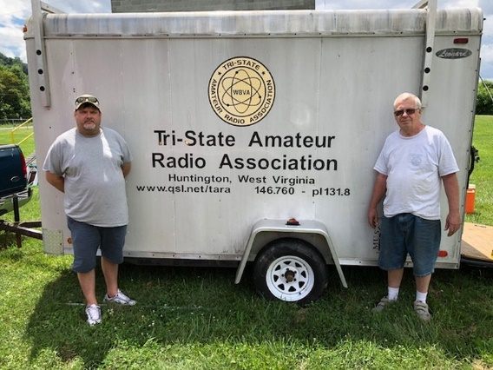
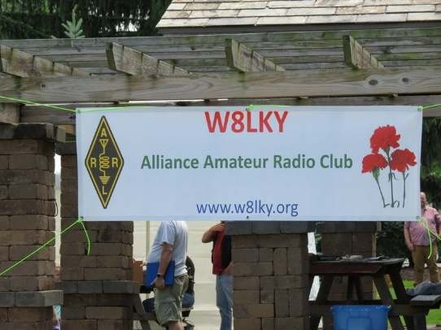
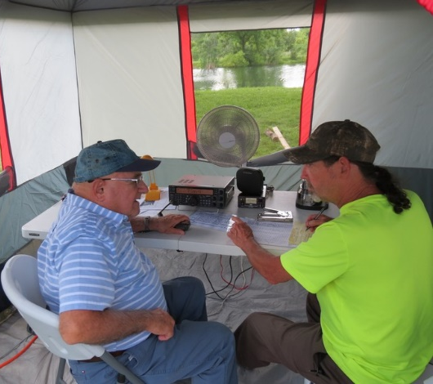
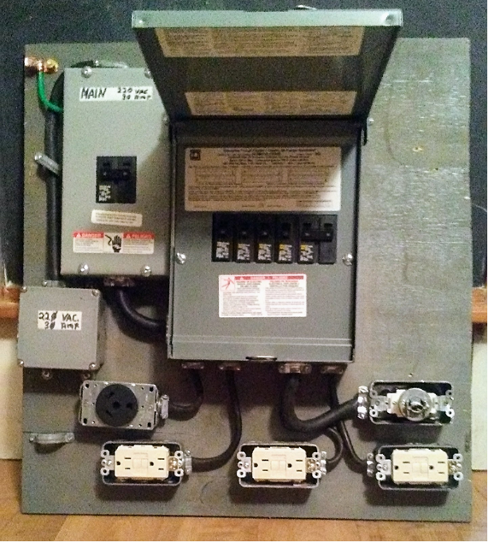

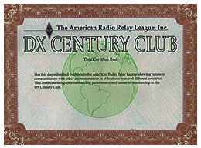
National News
(from arrl and other sources)

The 2018 ARRL DXCC Yearbook is Now Available

The 2018 ARRL DXCC Yearbook is now available for viewing and downloading. The DXCC Yearbook includes the 2018 Annual List, as well as the 20187 Clinton B. DeSoto Challenge top scorers. DXCC is Amateur Radio's premier award that hams can earn by confirming on the air contacts with 100 countries. You can begin with the basic DXCC award and work your way up to the DXCC Honor Roll.

#########

Modified Digital QST App Now Available for Apple iOS Users

Apple has released a new app for digital QST (version 5.1) readers that use that platform. A long-standing problem involved the inability of some Apple iOS app users to download digital QST issues to their devices. When they attempted to do so, the app crashed. The new app is now available on the Apple iTunes store. Apple also required ARRL to create a new version of the app that allows non-members to purchase individual issues of the QST digital edition.

“Members must update their digital QST apps for the changes to take effect,” QSTEditor Steve Ford, WB8IMY, explained. “This entails tapping the App Store icon, and then tapping Updates from the store menu. They may have to log in the after the update, but should not have to log in after that.

The updated app will be a so-called “in-app purchase” version, which Apple requires ARRL and other publishers to use. “You might think of it as an electronic newsstand. It will allow non-members to purchase single issues of QST for $6.99,” Ford said.

Android and Kindle users and those who view digital QST on desktop or laptop computers will not be affected by this change. Android and Kindle users do notneed to update their apps.

#########

$125 million lawsuit filed against Weather Channel for 'horrific' crash
(Doyle Rice, USA TODAY & Greg, WD9FTZ)

The mother of a man killed in a "horrific" 2017 car accident filed a $125 million wrongful death lawsuit Tuesday against the Weather Channel for its role in the crash.

On March 28, 2017, the lawsuit alleges that storm chasers Kelley Williamson and Randall Yarnall – who were contractors for the Weather Channel – drove past a stop sign while storm chasing near Spur, Texas. With a speed estimated at 70 mph, their car smashed into another car driven by Corbin Lee Jaeger, 25, a storm spotter for the National Weather Service.

TOP ^
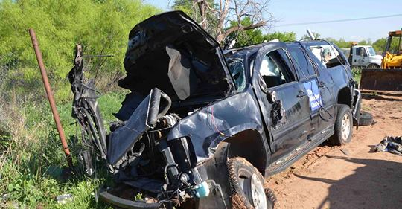
All three men were killed instantly in the wreck, which happened at a remote intersection near the town of Spur, about 55 miles southeast of Lubbock.

"The Weather Channel's on-air personalities Kelley Williamson and Randall Yarnall habitually ran stop signs, traffic lights and violated other basic traffic safety laws, in attempts to obtain video footage for their show,” according to a release from the law offices of Robert A. Ball, the San Diego-based attorney representing Jaeger's mother Karen Di Piazza.

“The Chevrolet Suburban driven by Yarnall was live streaming for the Weather Channel when it ran into the path of the Jeep Patriot Jaeger was driving," the release said. "The force of the collision caused the equipment-laden Suburban to catapult over a five-foot-tall fence 150 feet from the point of impact.

"Jaeger, a certified storm spotter for the National Weather Service, who had planned to return to college in Arizona to pursue a career as a meteorologist, was driving westward away from that tornado, when he was struck and killed.”

The lawsuit was filed Tuesday in Federal District Court in Lubbock, Texas.

The complaint against the Weather Channel (TWC) also said that "Yarnall and Williamson had a history of reckless driving when storm chasing and when filming TWC's television programming, which was well known among other storm chasers and TWC."

Yarnall and Williamson were storm chasers featured on the network's show Storm Wranglers.
According to the Storm Prediction Center, a tornado struck that afternoon about five miles from where the accident occurred.

A Weather Channel statement released Tuesday said that "We are saddened by the loss of Corbin Jaeger, Kelley Williamson, and Randy Yarnall. They were beloved members of the weather community and our deepest sympathies go out to the families and loved ones of all involved. We cannot comment on pending litigation."

#########

ARISS Seeks Hosts for Ham Radio Contacts with Space Station Crew Members

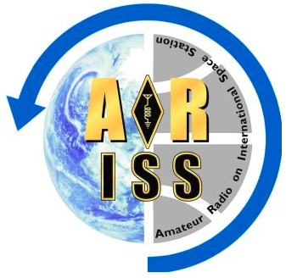
Starting on April 1, Amateur Radio on the International Space Station (ARISS) will accept applications from US schools, museums, science centers, and community youth organizations (working individually or together) interested in hosting contacts with orbiting crew members on the International Space Station (ISS). Contacts will be scheduled between January 1 and June 30, 2020.

Each year, ARISS provides tens of thousands of students with opportunities to learn about space technologies and communications through Amateur Radio.

TOP ^
The program provides learning opportunities by connecting students to astronauts aboard the ISS through a partnership between ARRL, AMSAT, and NASA, as well as other Amateur Radio organizations and worldwide space agencies. The program’s goal is to inspire students to pursue interests and careers in science, technology, engineering, and mathematics (STEM) and Amateur Radio.

“Educators overwhelmingly report that student participation in the ARISS program stimulates interest in STEM subjects and in STEM careers,” ARISS said in announcing the contact opportunities. “One educator wrote, ‘Many of the middle school students who took part in and attended the ARISS contact have selected science courses in high school as a result of that contact.’” ARISS says enthusiasm sparked by a school contact has led to an interest in ham radio among students and to the creation of ham radio clubs in schools. Some educators have even become radio amateurs after experiencing a contact with an ISS crew member.

ARISS is looking for organizations capable of attracting large numbers of participants and integrating the contact into a well-developed, exciting education plan. Students can learn about satellite communications, wireless technology, science research conducted on the ISS, radio science, and any related STEM subject. Students learn to use Amateur Radio to talk directly to an astronaut and ask their STEM-related questions. ARISS will help educational organizations locate Amateur Radio groups who can assist with equipment for this once-in-a-lifetime opportunity for students.

The deadline to submit proposals is May 15. Proposal webinars for guidance and questions will be offered on April 11 at 7 PM EDT (2300 UTC) and on April 16 at 9 PM EDT (0100 UTC on Wednesday, April 17). Advance registration is required. More details, such as expectations, proposal guidelines, and the proposal form, are on the ARISS website.

#########

ARRL Announces 2019 Teachers Institutes on Wireless Technology Sessions

As part of its educational outreach through the Education & Technology Program (ETP), ARRL will offer three sessions of the Teachers Institute on Wireless Technology in July. These week-long workshops will be held at ARRL Headquarters in Newington, Connecticut, and hosted by the Dayton Amateur Radio Association (DARA) in Dayton, Ohio. The Teachers Institute (TI) is an expenses-paid professional development seminar that provides teachers at all grade levels with tools and strategies to introduce wireless technology elements into their classrooms, from basic electronics and robotics to space technology. The application deadline is May 1.
The Teachers Institute curriculum is designed for motivated teachers and other school staff who want to learn more about wireless technology and take that knowledge back to their classrooms. The goal of the TI program is to equip educators with necessary fundamental knowledge and — through hands-on learning — generate the inspiration for teachers to continue exploring wireless technology, and adapt what they learn to their classroom curricula.

Basic (TI-1) and advanced (TI-2) classes are offered. Applicants to the advanced TI-2 workshop are required to have completed TI-1 and be licensed Amateur Radio operators. Interested educators can apply online. The $100 enrollment fee is refunded for applicants who are not selected. Qualified applicants must be active teachers at an elementary, middle, or high school, or community college/university, or in a leadership/enrichment instruction role in an after-school program.

TOP ^
Summer 2019 Teachers Institute Schedule
Session | Location | Dates | Instructor
TI-2 | Newington, Connecticut (ARRL) | July 8 – July 12 | Matt Severin, N8MS
TI-1 | Dayton, Ohio | July 15 – July 19 | Larry Kendall, K6NDL
TI-1 | Newington, Connecticut (ARRL) | July 22 – July 26 | Tommy Gober, N5DUX

Topics covered in the TI-1 “Introduction to Wireless Technology” workshop include basic electronics, radio science, microcontroller programming, and basic robotics. Among other activities, participants will learn how to solder and practice by building a small project. They’ll also learn basic circuit concepts and learn how to use basic test equipment. In addition, TI-1 attendees will learn about Amateur Radio, take part in a hidden transmitter hunt, see demonstrations of Amateur Radio satellite communication, and build and program their own simple robots.

The TI-2 “Remote Sensing and Data Gathering” workshop will concentrate on analog-to-digital conversion and data sampling. Participants will receive telemetry from Amateur Radio satellites and apply it to math and science topics. TI-2 participants are also introduced to a marine research buoy equipped with environmental sensors and taught how to create a similar design with a microcontroller to sample the data, configure it for Automatic Packet Reporting System (APRS) transmission, and receive and upload data to a spreadsheet for analysis.

The grant to attend a TI covers transportation, hotel, and a modest per diem allowance to cover meals, instructional resources, and a resource library of relevant ARRL publications.
Graduate credit is available through Fresno Pacific University, which may be applied to satisfy professional growth requirements to maintain teaching credentials. The class is self-contained, and participants are expected to be able to complete all requirements during the class time. Graduate credit forms and a Certificate of Completion may be requested at the end of the Teachers Institute.

For more information, contact ARRL Lifelong Learning Manager Kris Bickell, K1BIC, at ARRL Headquarters.

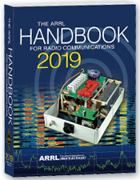
The Handbook Give Away

Hey Gang,

We had another fantastic response this month, but I’m sure you’re more interested in knowing just who won the Handbook this month...

And the winner is…. Darrell Leedy, KC8LDU!

Since it’s still cold and nasty out and we've had another month of great response with the Giveaway, I added a couple Official Ohio Section Knit Caps to "Give Away" as well!!

AND…. Those that winners are… Jenny Taylor, N8QKE and Bob Pusch, WD8NVN

TOP ^
Many of you ask me just how do I know when the drawing is on? Well, that’s easy all you need to do is check in on the Ohio Section Website on a regular basis and watch for the big RED Arrow that will appear on the left side of the page. This is the sign that the drawing is on and you need to get registered. So, keep a sharp eye out on the website and check in often! http://arrl-ohio.org

You just never know.. You just might be the next winner!

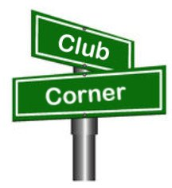
Club Corner

This is YOUR cornner of the newsletter. Send me what your club is doing and I’ll make sure that it gets in. Got a special event or club project that you want everyone to know about? Send it to me!. Need help with a project? Send it to me.

Let me know what you club is up to. Are you going to have a special guest at your meeting or are you having a special anniversary? Just sent it to:
n8sy@n8sy.com

#########

Oh-Ky-In Amateur Radio Society, Ham Radio Licensing Classes and Exams
Classes for Technician and General are being held on Monday nights starting April 15th until May 13, 2019 at the Cincinnati Red Cross Building, Dana Ave, 2111 Dana Ave, Cincinnati, OH 45207. These classes are also two hours in length from 7pm to 9pm. Licensing exams will be held on May 25th in St. Bernard in the Centennial Room of the Municipal Building 110 Washington Ave, Cincinnati, OH 45217.

Got questions? Please email Mike Niehaus KD8ZLB : KD8ZLB@gmail.com and visit http://ohkyin.org/wp/club-activities/classes/

#########

20/9 Club Hosting Craft Show

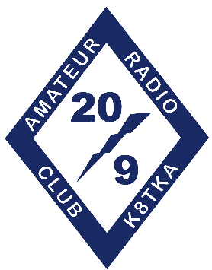
The 20/9 Radio Club will host its 6th Annual Spring Craft & Vendor show Saturday
April 6th at the Austintown Senior Center. Over 80 tables of crafters and some direct sell vendors. Great opportunity to get some Easter, Mother's Day, Graduation, Wedding or Father's Day gifts, or any other occasion you can think of!!

There will be a huge basket raffle, 50/50 drawing, Easter Bunny photos, and food available for purchase on site. The facility is all handicap and stroller accessible.

For more information contact Dottie at: kc8syf@gmail.com

#########

TOP ^
Scioto Valley Amateur Radio Club Holding Classes
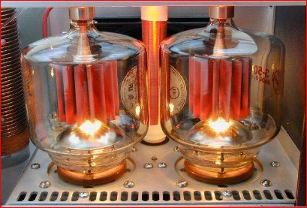
The Scioto Valley Amateur Radio Club will be holding a Technician class for all that are interested. The class will be the first three Saturday mornings in April, from 9 AM to noon, at the Pixelle Emergency Response Center. There will be a Laurel VEC test session on the forth Saturday in April starting at 9:30 AM. For details, contact John at wb8grx@arrl.net.

#########

Help Wanted

HamVention© is in need of volunteers to assist in various capacities during the May 17-19 show in Xenia.

Although some set up help is needed on Wednesday, most opportunities to assist with other duties will start on Thursday and continue through Sunday.

This year there a need for additional golf cart drivers because the shuttle wagons will not be used. These openings will require attendance at a training session.

You do not have to be a Dayton ARA member to volunteer. A minimum of six hours will reward you with an admission ticket and some other goodies.

Want more information? Check out volunteers@hamvention.org. This is a great opportunity to give back to our hobby and meet some friends you didn’t know you had.

#########

TMRA Holding Classes
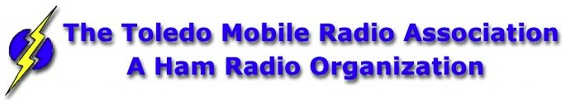
SPRING TECHNICIANS (Entry Level) HAM RADIO LICENSE CLASS (2 DAY COURSE) -
NOTE: April 6th with test session on April 6th at end of class.
The TMRA Education Committee has released the schedule for the Spring Technicians Class. The class schedule will follow our traditional style. Two classes held two weeks apart and a V.E. Testing Session after the final class.

The Class is FREE, you will have to provide your own book, or one can be purchased from the TMRA ($25.00). (ARRL Edition 4 book) The testing session will cost $15.00 which is the standard fee set by the ARRL.

TOP ^
THE DATES ARE AS LISTED BELOW
* CLASS TWO WILL BE HELD ON SATURDAY APRIL 6TH, 2019 FROM 08:00 TILL 17:00 (This includes the V.E.Session)
Class will be held at
LUCAS COUNTY EMS TRAINING CENTER
2127 JEFFERSON AVE
TOLEDO OHIO 43624
To Enroll in the Class, or for more Information please contact
STEVE STALKER / KC8TVW 419-467-3734 kc8tvw@arrl.net
Also, please join us for a 4-hour follow-on class on April 13th (9am) called, "I now have my ham radio License, now what?". This class is intended to help get newly licensed hams started with additional needed information. Location is TBD.

Also from TMRA

Spring is here so it's almost time for the Glass City Marathon! This year the race is on Sunday, April 28th and starts at 7 AM. The course closes at 1:30 PM. Not every position requires you to be there the whole time. We need lots of operators to cover this event so if you can help please let me know at either k8rks@arrl.net or 419-471-0573.

New Ham - Info Class - Saturday, April 13, 2019 at 9 AM – 1 PM
Relaxed Learning Session: I'm new to Amateur Radio! Now what?!

Join Toledo Mobile Radio Association Members at the Lucas County EMS Training Center for a FREE learning and Q&A session that should work to help you get started with some of the practical items that we all wish we knew when starting off in Ham Radio. Any/everyone is welcome, and you do not have to have attended the class to attend. Most hams licensed less than 3 years will find the session useful.
This session will be run as a "class” but is open to ANY questions along the way. Folks are free to come and go as you wish. This training session is a great place to get to know TMRA members and for newer amateur radio operators to ask questions related to items they are concerned about or need help with. We know that this hobby has a lot of new items for everyone to get familiar with, so this is an attempt to short-cut that learning!
We'll discuss and help new hams resolve some of the typical early ham radio challenges including (but not limited to) the following types of discussion items (no specific order):

- Answer any early questions and discuss list of items that we all have soon after becoming a ham. (and worries that we each had)
- Discuss Hand-held and mobile radio types / drawbacks and benefits. Who can help me program it? How can I make my HT more effective?
- What is needed to setup and use a mobile or "base" radio - in car or in home (and benefits and types).
- Discuss Effective Radiated Power in terms of Antenna benefits - Discuss types of antennas indoor/outdoor options (and why). Horizontal vs. Vertical antennas.

TOP ^
- Types of feedline (we often refer to "coax) and what you will need (and for what) - and where to find it.
- VHF/UHF vs HF - Who can I talk to and when?
- Discuss using local Repeaters, internet linked repeaters, PL Tones, (repeaterbook/radio reference)
- Discuss Simplex vs Repeater typical etiquette (just so you know) - Examples: Q signals, calling CQ, breaks, etc.
- First Contacts – what to expect (most important, you won't be judged so don't "sweat it".... really...)
- Hamfests + Ham Conventions. - Why bother?
- Where should I buy equipment and what are the risks?
- Useful websites
- Foxhunting and Satellites - how/where?
- Where to find manuals and information?
- If there is time: Antenna Analyzers and SWR Meters - what are they and when do I need one?
- If there is time: N vs PL-259, vs SMA, versus BNC connectors
- Benefits of joining organizations/clubs
- Foxhunts - what are they and how does it work? Do I need anything?
- HF - club events (what can I participate with?) - Operating events.
- Callsigns, vanity and considerations
- QSL Cards and Logbook of the World
- Propagation - Tropo ducting, Sporatic E, Aurora, sunspot cycle, seasonal patterns

#########

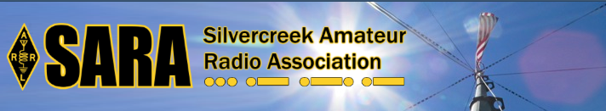
SARA is partnering/supporting Wayne County EMA in the offering of the SKYWARN training this year. As you may have heard, budget and staffing issues in the Cleveland NWS office has led them to cancel the NWS-lead SKYWARN classes. EMAs and ARES ECs are being encouraged to hold the SKYWARN training directly.

SARA is playing a supporting role to the Wayne County EMA which is holding a session for this region. The date will be Monday, May 6th from 6p - 8p. Volunteers will be needed 5p - 8:30pm. The tentative location is Chippewa Jr/Sr High School in Doylestown. Volunteers will help register attendees and print the SKYWARN training cards with ID numbers. Fred Sheppard KD8GYS will be assisting Joe Villegas with the class.

Additionally, SARA will have a table with some amateur radio materials available to spread the word about our hobby and service.

If you can volunteer your time, please contact me so I can add you to the roster. Please note that volunteers will not be able to be present in the class for the entire session as volunteers will register latecomers and also print and organize the ID cards.

Thanks! For more information or questions, contact Jason, N8JDM jason@mfamily.org

#########

TOP ^
Tuesdays Summer Lunch Program Activty Help Needed

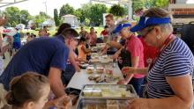
Help for activities for the summer lunch program on Tuesdays at Partners Park in Marysville is needed. The summer lunch program provides free summer lunches to people 0-18 years old. Lunch is served at 12pm.

Usually by 12:30pm lunches are consumed. We have the opportunity to setup an amateur radio or stem/technology type activity at the park on Tuesdays. Since we will be at a park, we won't be limited to time constraints for the length of the activity. If the activity has a lot of interest and goes longer, we will be able to stay as long as we need to.

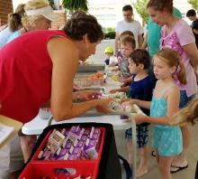
Our hope is by consistently being at the park on Tuesdays, kids that are interested in technology and amateur radio will know to show up on Tuesdays for lunch to participate in the club activity.

If you can help out with this effort, please let Ed, KE8ANU@arrl.net know what Tuesdays you are available to help. The more club members we have help with it, the easier it will be on everyone. Ideally it would be good to have 2 different volunteers for each of the 10 Tuesdays. Since this is the first time, we will be doing this, we do not know what to expect.

#########

Pioneer Bus Trip to Hamvention

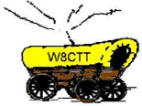
It is never too early to plan a trip to Hamvention. Each year the Pioneer Amateur Radio Fellowship has offered to bus hams to this great event. The bus leaves at 5:30 AM the Saturday of Hamvention, it does stop at McDonald's for breakfast and arrives at Hamvention about 9am, just in time for the doors to be open. The bus leaves around 5pm and stops for a buffet for supper! You won’t go hungry on this trip for sure! You arrive back at the pickup point about 9:30pm, so it’s not too late, but you will have had a full day for sure.

The bus has a number of very large storage areas for all your purchases, so you don’t have to worry if you’ll have room for that “just can’t do without boat anchor!”

Click Here to read the flier and the form used to register for this trip.

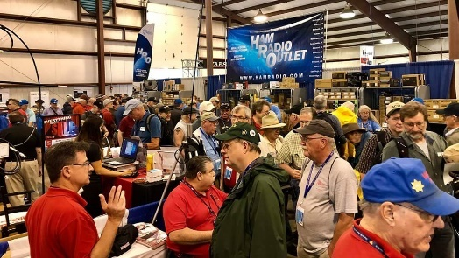
Upcoming Hamfests

04/13/2019 | 65th Annual Cuyahoga Falls ARC
Location: Cuyahoga Falls, OH
Type: ARRL Hamfest
Sponsor: The Cuyahoga Falls ARC, Inc.
Website: http://cfarc.org

TOP ^
04/20/2019 | Portsmouth Radio Club Hamfest  Location: Portsmouth, OH  Sponsor: Portsmouth Radio Club  Website: https://www.facebook.com/w4pox/ | 04/28/2019 | Athens Hamfest  Location: Athens, OH  Sponsor: Athens County Amateur Radio Association  Website: http://www.ac-ara.org/
05/17-19/2019 | Dayton Hamvention  Location: Xenia, OH  Sponsor: Dayton Amateur Radio Association  Website: http://hamvention.org/ | 06/01/2019 | FCARC Summer Swap  Location: Wauseon, OH  Sponsor: Fulton County Amateur Radio Club  Website: http://k8bxq.org/hamfest

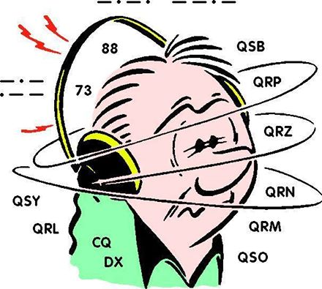
DX This Week
(from Bill, AJ8B)

The Other Side

Bill AJ8B (aj8b@arrl.net, @AJ8B, www.aj8b.com or www.swodxa.org )
CWOPs Member #1567

I have been on the air in one mode or another since 1971. In that time, I can list the 5 or 6 hams that I have heard on the air and that I instantly stopped to listen to and learn. HK3C – John, is absolutely one of the guys.

I have worked John numerous times and keep in touch with him regularly. He is certainly the “best friend I have never met”! He has the best audio quality on the air, is courteous and an excellent operator.

Although you may never be on that end of the keyer, you can learn a lot as you read the article.
When we started the SWODXA newsletter, I have just to get input from John. I have reprinted the first of two articles from John with the permission of SWODXA. You can check in on John at www.hk3c.com.

+ --------------------------------------------------------------------------------------------------------------------+

Handling Pileups - Critical Success Factors
A Guide for Beginners
Few of us will ever have opportunity to operate as “rare DX” and experience the deafening roar at the DX-station-end of a phone pileup. Should you so blessed, it can be both heart-stopping (exciting) and mind-numbingly intimidating. But once you get rolling and contacts begin to fill the log, there is no greater thrill!

Whether you’re planning a one week vacation trip on an island in the Caribbean, armed with your IC-7000 and enough coax and wire for a simple dipole, or you live in a semi-rare and somewhat exotic country in the South America, the following list of considerations may help you handle your pileups more efficiently and effectively, resulting in more contacts - and ultimately a more satisfying experience.

These are referred to as “critical success factors”. Note: they are not all encompassing and are only meant as a sort of “Guide for Beginners” who have interest in and passion for the adventure of DXing and handling pileups.

TOP ^
Awareness and Support:
Successfully handling a pileup requires knowledge and understanding of current and changing band conditions, an appreciation of propagation patterns, as well as feedback from trusted sources.

Knowing where, and how well you are being heard, and how propagation shifts over time, will help you more effectively manage your pileups, especially if you are operating from a rare, exotic or much sought-after call area. Awareness will help you understand caller behavior - how eager or excited callers can be to make the contact, especially if your operation is for a very brief period of time. Awareness will spell the difference between an orderly, well orchestrated undertaking with good pace and rhythm - and sheer band chaos and pandemonium.

Understanding your station limitations will enhance your approach, attitude and level of professionalism as you conduct business. For example, should you be plagued with local power line, atmospheric noise, or other severe receiving limitations, being aware of your station’s true capability is vital.

Independent of your operating skill, ability and experience, or your station equipment and antenna system, your general awareness is a critical success factor governing your pileup handling success. The “who, what, where, why and how” of your operation, for example - propagation, where you are on the band and other activity around you, your operating schedule, your support network (access to the Internet, key stations in strategic locations who may be able to help control or manage in case of difficulty, etc.) - will all contribute to your level of awareness and support, to make the experience pleasurable for all and a successful undertaking for you.

Control:
Given the vagaries of propagation and the unpredictable nature of callers, one rarely is ever in complete control - however certain operating techniques and practices will help you to maintain control in handling your pileups.
For example, should the number or behavior of callers begin to negatively impact or significantly slow the orderly flow of contacts, consider changing from simplex to split operation. Before you do, however, understand the impact on others on the band around you, since your operation will now consume greater bandwidth. Weigh this against the potential increase and improvement in contact flow and evaluate your knowledge and experience of operating “split”. Ensure a good understanding of how to set your radio in the split mode - ahead of time.

And before you get started, have a game plan on how to proceed. How effectively you control the pileup will have a significant impact of the orderly and efficient flow of contacts. As the DX station, you set the standard. For example, while it may be tempting to provide your name and location information on every contact, know this will slow the process since callers will be similarly motivated. If the volume of callers is large, stick to call sign and report (usually 5-9) - then move on. Once you achieve a rhythm, pace and contact flow, taking into consideration caller volume, propagation, your comfort and ability, etc., your degree of control will increase to the point where you could communicate instructions as required, and/or adjust your contact handling style on the fly.

Setting a good example is important, so remain calm - and stay humble.

Don’t ignore strong stations; handle them first - get them out of the way - rather than having them call back again and again, blotting out weaker stations in the pileup. And, depending on your ability, knowledge or experience, demonstrate a spirit of fair play in maintaining control, avoiding a collapse into disorder. Don’t be afraid to say what call or call area you’re listening for. Conversely, avoid favoring any one continent, country or call area unduly - unless there’s a good reason to do so.

TOP ^
Decide early, and show consistency, in how you respond to callers (first station heard, last one heard, partial call signs, etc.), if only to establish a pattern. This will help improve the rhythm, pace and flow of contacts. If you set the standard early, and are consistent, the pileup can be better controlled - with more contacts in your log and a higher level of satisfaction - by all. Do listen for QRP stations - and avoid rewarding bad behavior.

Management:
Most DX stations at the epicenter of a large pileup will face completing objectives best described as “quantity” versus “quality”. Irrespective of operator knowledge, experience or ability, pileup management will always be critical. How well you perform will ultimately have a huge impact on results.

For example, taking-in what you hear (and feel), and adjusting your style as required to improve the pace and rhythm of contact flow is a pre-requisite to handling a pileup effectively and efficiently. Practice does indeed make perfect, but nothing trumps smart listening with immediate remedial action. Let your personality, passion and versatility guide you in this regard. Be yourself - and have fun.

Always show respect, be courteous, and have empathy for callers who may exhibit varying levels of operating experience and skill, or language comprehension, not to mention station equipment and propagation conditions to your location. Remember to express yourself using standard phonetics and enunciate your call sign and signal report clearly. An appropriate microphone feeding a properly adjusted transmitter - mic gain, compression level, treble and bass settings - for good articulation will contribute to successful pileup handling.
Managing your pileup handling performance intelligently is a critical success factor.

Playing to the Strengths of Propagation and the Terminator Line
Most new DXpeditioners or Hams vacationing outside North America who operate as “rare DX” fail to appreciate that propagation often determines who they should be listening for as a priority in pileups. The bands close earlier to Europe than to North America when you are operating from the Caribbean or Latin America.
You should listen for and aim to work stations in eastern Europe and Russia first, saving western and southern Europe for late afternoon. Once the sun has set in Europe, turn your attention (and your beam antenna, if you are so lucky) to North America and repeat the strategy. Start with eastern USA/Canada and recognize when the band shifts to the mid-west and eventually to the west coast.

Remember: the terminator line is your propagation enhancer for weak stations, especially across the poles to certain parts of Europe and Asia. Periodically ask stations to stand by as you listen for Europe or Asia. The last bit of advice pertains to Pacific region hams - ZL and VK stations largely. They can be worked nearly most hours of the day if they are on. The important thing is not to forget to ask for them.

Miscellaneous:
This final critical success factor deals with things largely beyond your control, viz., interference and misbehavers, nevertheless, how you handle these will set you apart from the crowd - as a pro.
Interference, accidental or intentional - is a reality of pileups. Some Hams may not like DXing (or contests), and may show their displeasure by deliberately interfering with your operation. On the other hand, propagation may have changed such that stations previously out of your skip zone now become clearly audible, resulting in interference to your pileup. No matter the circumstance, it’s important to remain calm and avoid voicing anger or disrespectful language. Simply ask the pileup to standby while the situation clarifies itself and you can determine more clearly what you up against. Derogatory comments being addressed your way are best ignored. At worst, changing skip conditions may necessitate a change in your calling or listening frequency.

TOP ^
On the other hand, you may not need to do anything, as members in the pileup may already have identified the source of the interference and may have undertaken “police action” to dissuade the interlopers. Soon the frequency will likely be clear again, and you can resume as if nothing had happened. Above all, do not engage with or acknowledge intentional interferers. Keep to the high road - you will likely find you have more supporters than you imagined who will rally to your defence. Should the interference situation become explosive or unpleasant, simply QSY. If this is not practical, take a break and come back to it later.

Respecting “misbehavers” - those who make a general nuisance of themselves by calling out of turn regardless of who you say you’re listening for, or those who call continuously over everyone else (you know the ones - the guys with no receiver), it is best to ignore these callers (if possible). If you ignore them long enough, they may cease and desist - and simply go away. Avoid any display of displeasure and avoid mentioning their call sign. Instead, remain calm, proceeding as best you can, to work the pileup professionally. As mentioned earlier, you may not need to take any action - others may do it for you.

Maintaining proper balance and a positive attitude is key when and if things turn nasty. Remember, a pileup is far from being a matter of life or death - so keep cool and stay focused and professional.

Finally, don’t forget to post QSL information via QRZ.com, your personal website, DX Coffee, Daily DX Bulletin, or on one of the many other Internet resources.

Enjoy your pileups - and good DX!

73, John - HK3C

+ --------------------------------------------------------------------------------------------------------------------+

From our friend at the DailyDX and the WeeklyDX, and the best source for DX information, (http://www.dailydx.com/ ) Bernie has this to report:

XZ – Myanmar - Starting March 20th JH1NBN, Yuki, will be back in Myanmar, formerly known as Burma. During his spare time he will be QRV as XZ2C until March 28th. In April he plans to get a JT license and then back to 9N7BN in Nepal.

ZL9 - New Zealand Subantarctic Islands - Early last week ZL2TUD, John, came across ZL9CNB/MM, Charles, on 40 meters SSB (7.115 MHz), between 08 and 09Z. He was only there for a few days and very close to Enderby Island. Charles is on a yacht and has "special permission to enter this world heritage site".

#########

Southwest Ohio DX Association Announces the activation of DXCC #341!
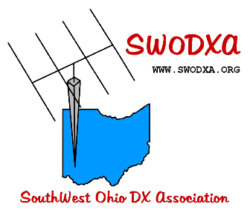
As expected, there is a lot of discussion and activity surrounding the announcement by the DXCC desk of the new entity of Freedonia. SWODXA filed the petition for this new entity based on the criteria found in DXCC Section III, rule #2B,

“In countries where Amateur Radio operation has not been permitted or has been suspended or where some reluctance to authorize amateur stations has been noted…"

TOP ^
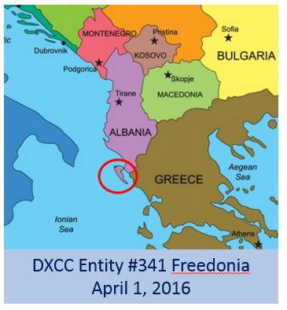
There has been no activity in Freedonia since 1933 since two brothers operated GR0UCH/0. Zeppo manned the AM station and Harpo handled CW chores. (Visit http://tinyurl.com/zjptlmf for more information about Freedonnia)

Freedonia is located on the Ionian Sea; a peninsula off of Albania. The DXPedition will be co-led by AJ8B - Bill and NR8Z - Tom. Other team members will include K4ZLE - Jay, N8BJQ – Steve, K8FL - Jim and Joe, W8GEX. K8FL will handle the QRP station and Joe will handle 60 meters!
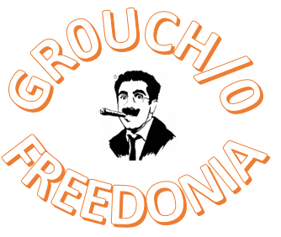
The IARU has agreed to allow the same call sign to be used for this inaugural DXPedition, GR0UCH/0. The team logo is below:

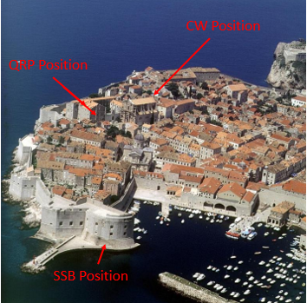
The DXPedition will be located in the capital city of Chicolini. The Prime Minister of Freedonia, Rufus Firefly, has made it his agenda to bring Freedonia up to par with his neighbors in the region. He views amateur radio as a great public relations event and has put his whole-hearted support behind this project.

Quite a bit of planning has gone in to this event and SWODXA is thrilled to be a part of this. There will be three stations in operation for the one-day activation.

The picture shows the capital of Chicolini with its’ beautiful harbor and our intended operating positions. GR0UCH/0 will be QRV on 04/1/19 at 0000Z and shut down at 2359Z.

QSL via K8DV and visit the website to make donations or inquiries about this important event. The website is www.aj8b.com. Of course, Club Log will be used as well. April Fool!!!

ARLD011 DX news

This week's bulletin was made possible with information provided by IS0ZOD, The Daily DX, The OPDX Bulletin, 425 DX News, DXNL, Contest Corral from QST and the ARRL Contest Calendar and WA7BNM web sites.
Thanks to all.

GEORGIA, 4L. Luc, F5RAV is QRV as 4L/F5RAV until April 2. Activity is on the HF bands. This includes being an entry in the CQ World Wide WPX SSB contest. QSL direct to home call.

ALGERIA, 7X. A large group of operators will be QRV as 7W7W during the CQ World Wide WPX SSB contest. QSL via operators' instructions.

TOP ^
MALDIVES, 8Q. Darek, SP3DX will be QRV as 8Q7DM from Lankanfinolhu Island, IOTA AS-013, from April 1 to 7. Activity will be on 20 to
10 meters using SSB and FT8. QSL to home call.

OMAN, A4. A group of operators will be QRV as A42K in the CQ World Wide WPX SSB contest. QSL via LoTW.

TAIWAN, BV. Koji, JL3RDC plans to be active as BW/JL3RDC from New Taipei City in the CQ World Wide WPX SSB contest as a Single Op/Single Band entry. QSL to home call.

CHINA, BY. Look for B1Z to be QRV in the CQ World Wide WPX SSB contest. QSL via EA7FTR.

THE GAMBIA, C5. A group of operators will be QRV as C5DL from April
1 to 15. Activity will be on 160 to 10 meters using CW, SSB and various digital modes, with three stations active. QSL via DL7DF.

JUAN FERNANDES ISLAND, CE0. A group of operators are QRV as XR0ZRC from Robinson Crusoe Island, IOTA SA-005, until April 3. Activity is on 160 to 10 meters using CW, SSB and FT8. QSL direct to R7AL.

CAPE VERDE, D4. A group of operators will be QRV as D4C during the CQ World Wide WPX SSB contest. QSL via operators' instructions.

GUERNSEY, GU. Oleg, RL5D will be QRV as MU2K as a Single Op/All Band/Low Power entry in the CQ World Wide WPX SSB contest. QSL via GU8ITE.

SARDINIA, IS0. A group of operators will be QRV as IS0SWW in the CQ World Wide WPX SSB contest as a Multi/2 entry. QLS via IQ0NU.

GUIEA-BISSAU, J5. Livio, IZ3BUR is QRV as J52EC from Cumura until April 15. QSL direct to home call.

GUAM ISLAND, KH2. Aki, JR3QJB and other operators are QRV as KH2KY until April 1. Activity is on 80 to 10 meters, and possibly 160 meters, using SSB. This includes being an entry in the CQ World Wide WPX SSB contest. QSL via JA1MFR.

LITHUANIA, LY. Special event station LY800SMG is QRV until May 27 to celebrate the first datable reference to the region Samogitia from 800 years ago. QSL via LY2NZ.

BRUNEI, V8. Hajime, JO1RUR will be QRV as V85RH in the CQ World Wide WPX SSB contest. QSL via LoTW.

NORFOLK ISLAND, VK9N. Operators VK3QB, VK3HJ, VK2PN and VK3BDX will be QRV as VI9NI from April 1 to 14. Activity will be on 160 to 17 meters using CW, SSB and FT8. The operation also commemorates the signing of the Norfolk Island Act 40 years ago. QSL via VK4FW.

BERMUDA, VP9. Operators KG8CO, W8KA, KB8TXZ, N8LJ and AC8W are QRV as homecalls/VP9 until April 2. Activity is on the HF bands using CW, SSB and FT8. They will also be QRV as VP9I in the CQ World Wide WPX SSB contest as a Multi/2 entry. QSL all calls via LoTW.

TOP ^
INDONESIA, YB. Members of the ORARI Lokal Lombok Timur Club Station will be QRV as YB9ZGD from Lombok Island, IOTA OC-150, during the CQ World Wide WPX SSB contest. QSL direct. In addition, Yohanes, YB2DX plans to be QRV in the CQ World Wide WPX SSB contest from Java, IOTA OC-021. QSL direct to home call.

VANUATU, YJ. Chris, VK2YUS is QRV as YJ0CA from Port Vila until April 2. Activity is mainly on 40, 20 and 15 meters, with some limited activity on 10 meters, depending on conditions. This includes being an entry in the CQ World Wide WPX SSB contest. QSL to home call.

KOSOVO, Z6. Members of the Kosovo and Turkish Youth Contest Team will be QRV as Z66Y in the CQ World Wide WPX SSB contest. QSL via Z62FB.

CHATHAM ISLANDS, ZL7. Bill, ZL2AYZ and Ian, ZL2BGL are QRV as ZL7C until April 2. Activity is holiday style on 80 to 15 meters, and possibly 17, 12 and 10 meters, depending on operating conditions, using SSB, RTTY, PSK31, FT8 and some CW. This includes being an entry in the CQ World Wide WPX SSB contest. QSL via ZL2AYZ.

THIS WEEKEND ON THE RADIO. The CQ World Wide WPX SSB Contest, QRP 80-Meter CW Fox Hunt, NCCC RTTY Sprint, NCCC Sprint, Feld Hell Sprint and IQRP Quarterly Marathon will certainly keep contesters busy this upcoming weekend.

RSGB 80-Meter Club CW Championship is scheduled for April 1.

The ARS Spartan CW Sprint is scheduled for April 2. The CWops Mini-CWT CW Test, UKEICC 80-Meter SSB Contest, QRP 40-Meter CW Fox Hunt and Phone Fray are scheduled for April 3.

The Canadian National Parks on the Air, CNPOTA, operating event runs for the entire year of 2019, with special stations active from Canada's parks and historic sites.

Please see March 2019 QST, page 88, April 2019 QST, page 87 for more details.

Special Events

- 04/13/2019 | 7th Annual Earth Day Celebration
Apr 13, 1500Z-2000Z, W8PRC, Cleveland, OH. Parma Radio Club. 14.245 7.195. QSL. Parma Radio Club, 8111 Laumer Ave., Cleveland, OH 44105. Our 7th ^{A}nnual Earth Day Celebration. Operating on solar power from historic, educational Stearns Farm in the Parma, Ohio town center. www.parmaradioclub.com

- 05/04/2019 | 100th Anniversary Mahoning Valley Amateur Radio Association
May 4-May 5, 1300Z-0100Z, W8QLY, Youngstown, OH. Mahoning Valley Amateur Radio Association. .3825 7.250 14.250. QSL. MAHONING VALLEY AMATEUR RADIO ASSOCIATION INC, 125 W McKinley Way, PO BOX 14141, Youngstown, OH 44512. Electronic QSLs will be sent for confirmed contacts--request form on QRZ page. mvara.W8QLY@gmail.com or www.qrz.com/db/w8qly

TOP ^

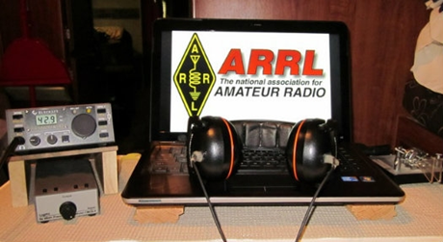
ARRL Contest Corner

An expanded, downloadable version of QST's Contest Corral is available as a PDF. Check the sponsor's Web site for information on operating time restrictions and other instructions.

April 1  - IQRP Quarterly Marathon  - RSGB 80m Club Championship, CW | April 2  - ARS Spartan Sprint
April 3
- QRP Fox Hunt
- Phone Fray
- CWops Mini-CWT Test
- UKEICC 80m Contest

One Question Questionnaire

Hey Gang

There’s another NEW – one question – questionnaire on the Ohio Section Website! http://arrlohio.org

We had a very interesting poll this past week. I was surprised at the results. It seems that only around 17% of you would attend a late-night session. I would have thought that number would have been a lot higher since we haven’t had a Wouff Hong around here for some time now.

Anyway, these questions are all in fun and I hope that you are enjoying answering these “ONE QUESTION” questionnaires. Ok, enough on that, here’s the next question for you to answer…

“Have you ever built your own power supply?”

You’ll find the “One Question” questionnaire on the Ohio Section Website! http://arrlohio.org It’s all in fun and it’s not a scientific survey in any way, but we are learning some things that we didn’t know from these questions. I hope that you are enjoying answering these “One Question” questionnaires.

TOP ^

V.E. Test Sessions

For the latest testing site information please >> Click Here << The ARRL site tracks all of the VE testing sites that register with them, including W5YI and Laurel. ARRL gives you a number of different ways of sorting to find that site that is closest to you as well.

#########

Exam Session Reminders

GRADING EXAMS: Each VE must grade each exam taken or must agree to the score given. After all three VEs agree to the number of correct answers shown, the score is announced to the examinee. The VEs must inform the examinee of their grade (pass or fail, and state the score {e.g., 26 out of 35}) upon completion of the grading.

NEW GENERAL EXAMS COMING: The new General class question pool will take effect on July 1, 2019 for all Element 3 General class license written exams. With the General class exams changing July 1st, new test designs must be created and used on that day. ARRL VEC will be supplying all its (near 1,000) Field Stocked VE teams with new test booklets about the 3rd week in June. Do not destroy the 2015 versions of the General exams until June 30.

BASIC QUALIFICATION QUESTION PROCEDURES: The detailed instructions are available on the ARRL website. At the exam session, candidates that answer “YES” to the qualification (felony) question should be given the “Applicant Instructions for FCC Basic Qualification Question” document. Print or download here: http://www.arrl.org/files/file/VEs/Applicant%20Info%20Qualification%20Question%202019.pdf

Applicants can also be referred to our Basic Qualification Question web page for information and instructions.
View page: http://www.arrl.org/fcc-qualification-question

After the application data from the session is submitted to FCC and an FCC file number is created, the applicant is required to provide an explanation directly to the FCC within 14 days. Do not collect information from the candidate and do not send any documents to the VEC.

Incident Command System (ICS) Training Schedule

All current trainings are listed on the Ohio EMA training calendar located at:
https://webeoctraining.dps.ohio.gov/TrainingAndExercise/courselist.aspx

I’ve been asked to also include a link to the Kentucky EMA training calendar as well..

https://kyem.ky.gov/training/Pages/default.aspx
https://sites.google.com/site/ccoemtraining/home

TOP ^
Please pay particular attention to these courses listed above, as that there’s a lot of ICS 300 & 400 classes listed that are very useful for all Amateurs to have under their belts. I will also state that G775 is also a very good course to take as well. These 3 courses are multiple day in class courses, so please be prepared to spend some time taking them.

We do recognize that IS-300/400 requires multiple days of actual classroom training that is not easily obtained. So, if you just can't find the time to fit these class room courses in, we do have an alternative method for getting you to Level 3.

Completing the following “FREE” and “ONLINE” courses will act as substitute for you FEMA Leadership Development Course requirements. You absolutely will need to complete all 7 of these courses to get your ICS 300/400 credit. Here are the courses that you need to take: IS-120, 230, 240, 241, 242, 244 & 288.

Now, if you are looking for wallpaper and have a little extra time, taking IS-235 in addition to the 7 listed courses above, you will get a really cool looking certificate from FEMA stating that you have completed the Professional Development Series. That’s impressive in itself!

#########

The Department of Homeland Security (DHS) Returns to Provide Auxiliary Communications (AUXCOMM) Training in Conjunction with Hamvention® 2019

The Emergency Communications Division (ECD) of DHS’s Cybersecurity and Infrastructure Security Agency (CISA) will be on hand at Hamvention® 2019 to conduct its nationally recognized NIMS/ICS compliant AuxComm course. Over 2,500 amateur radio operators from around the country have taken this course. The purpose of this course is to train qualified amateur radio operators so they may assist their local, county and state governments with emergency backup communications if requested to do so.

This course introduces the auxiliary communicator to the other positions within the Communications Unit (COMU) and how to provision emergency communications in a public safety context. The course also goes deeper into the National Incident Management System framework. The location of the course will be at the “Courtyard by Marriott” in Beavercreek, Ohio and be held 14-16 May 2019. Registration for this class may close early when all available seats for this class are taken.

Registration for this course is ongoing: Students wishing to attend the DHS Auxiliary Communications (AuxComm) Course must meet all prerequisites and provide electronic/scanned images of the following required documents prior to 1 May 2019:

Prerequisites:
- A signed copy of your current valid FCC issued amateur radio license
- IS-100 certificate (FEMA issued); IS-200 certificate (FEMA issued); IS-700 certificate (FEMA issued);
IS-800 certificate (FEMA issued), and the name of the public safety entity, and its contact information, that you would support upon completing this course

Please scan copies of this information, attached it to an email, and then send to COMU@hq.dhs.gov. In the subject line, please put Hamvention AUXCOMM. Your information will be reviewed, and a reply sent back to you indicating that you have been given a seat in the course.

TOP ^
This will be an intensive three-day version of the course with facilitated lectures and student exercises conducted by professional AUXCOMM instructors. This course provides time for interactive discussions and exercises. Should you have any questions regarding this course, please send them to COMU@hq.dhs.gov.

One final note, please mark your forum calendar, on Friday 17 May, to come see us at the AUXCOMM forum. You will be given a glimpse at the new AUXCOMM Position Task Book (PTB), a briefing on the proposed Communications Section for NIMS/ICS and a briefing on one of the most active AUXCOMM states – North Carolina!

ARES Connect

CQ… CQ…. CQ… Calling all persons to be a part of the new ARES Connect program.

We need to discuss some very important items that only YOU can make a difference with. I need you to get yourselves registered in ARES Connect, that is… if you haven’t already. Now, how do I know that you need to do this? It’s simple, we have 997 now registered in the database and Stan’s last S.E.C. report shows that we have a little over 1,700 persons in ARES right now. As you can see, we still have a way to go to really take advantage of this new system.

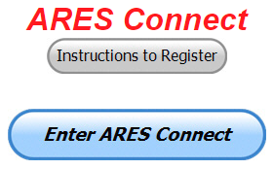
As the numbers show, there’s still a lot of you that haven’t taken the plunge yet and need to! What are you waiting for? No matter how much you resist, it’s coming, and we need to make sure that no one is left behind.

Now, as an incentive to get you to not only register…. But to actually start using the system… (Notice how I have that in bold type for you to clearly see?) I am giving away all sorts of goodies to help you get motivated. I have a footlocker of really cool items that I will be giving away!

I’m doing this in various intervals throughout the year, so it will challenge you to be dedicated to getting your hours into the system. You’ll never know just when another drawing will be, so you really do have to be prudent!!

Here’s the top 10 folks for hours for March:

 | Name | Events | Hours
1 | Ron Hollas (K8RJH) | 16 | 116.50
2 | James Yoder (w8erw) | 13 | 113.75
3 | Christopher Domenick (KC8CAD) | 36 | 96.10
4 | Bret Stemen (KD8SCL) | 13 | 75.00
5 | Matthew Smith (KE8GTP) | 9 | 52.00
6 | Alan Rothweiler (N8CJ) | 12 | 51.00
7 | Patrick Gibson (kd8ion) | 7 | 46.00
8 | Jaealyn Himes (N8YMT) | 6 | 46.00
9 | Edward Kopcak (KB8BKE) | 14 | 45.00
10 | Joshua Gould (AE8JG) | 3 | 43.50

TOP ^
Here’s how we did with people getting signed up for events
and the total hours logged for March

Total Amount signed into Events | Total Hours for Events
1,998 | 5,406.94

Think you could ever get into the top 10 listing like the folks above? One thing is guaranteed, you definitely won’t if you don’t get registered and start signing up for events!!! It adds up quickly, but you do have to be registered and actually USE the system in order for any of your time to count. We have a set of instructions on how to get registered right above the button to enter ARES Connect. I would strongly suggest that if you haven’t registered yet, that you read these instructions first.

Here’s a link to get you started... http://arrl-ohio.org/ares_connect_directions.pdf Please, don’t just hurry through the questions, read them carefully, if you don’t understand something, please ask me, I’m here to answer your questions.

We know that you mean well by answering that you do have the needed courses in, but I will let you know that we are verifying what you say you have with what is showing for you in our statewide database when we are completing your registration. So, how can you find out if you are already listed in our statewide database? Easy, here’s a link: http://arrl-ohio.org/SEC/special/ICS%20Complete%20by%20County%20and%20Name.pdf

Ok, now on to something new for ARES Connect… I was asked by Ron, NU8N about having a certificate for those who have taken the extra time and courses to get to Level 3. Well, after some thinking about it, Stan and I agreed with Ron that we should have some wallpaper for those who have taken this extra hard step. So, I’m here to tell ya’ that we are now offering a really nice certificate for all of those who have worked so hard to obtain their Level 3 ARES Status.

All you have to do is complete a couple of boxes and we’ll send you a certificate suitable for framing. Now I want to make sure that you understand that you do have to be registered in the statewide database as a Level 3 to qualify for this certificate.

Here’s the link… http://arrl-ohio.org/SEC/level3.html So, if you have certificates that you haven't submitted yet, this is the perfect time to do just that!

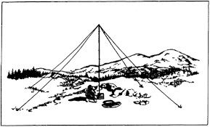
2019 Ohio NVIS Day

Hey everyone, Stan, N8BHL has let me know that the date for NVIS Day is scheduled for Saturday, April 27th. Are you ready? Start your planning now!
Like years past, we are planning on having the operation run from 10 – 4 EDT. Take a lunch break, enjoy each other’s company.

Transmit power should stay at 100 watts for accurate signal comparison. You may operate anywhere, home, club, portable.
Want to know more about what NVIS is? http://arrl-ohio.org/SEC/nvis.html Learn all about Near Vertical Incident Scattering and how you can easily put up a NVIS antenna and participate in this great exercise.

TOP ^

Weather Underground and Other Ham Weather Stations

Have you visited the webpage to see all the Weather Underground stations yet? It’s really fun to see just how much the weather varies across the state and this gives you access to each individual station very quickly and easily.

Hey gang, if you haven’t looked at your Weather Underground dashboard lately you might want to. It seems that the nice folks there have taken the time to upgrade your dashboard. The new design is still being worked on from what information that I could gather, but they have done a really nice job. The new design is really easy to view and contains the same information at before, but its laid out in a really professional manor.
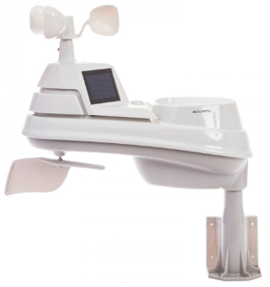
Now, our list of stations is growing all the time even though we haven’t added any stations to the list this past week, I’m sure that there’s many more out there to add.

How’s about your station? Is it listed with us? It doesn’t necessarily have to be a Weather Underground reporting station. I’d love to have any weather station that is connected to the internet available for all of us to view, especially when the weather gets bad out. The more stations reporting the better.

Thanks to everyone who has contributed to this effort. If you haven’t, you really should take a look at the various weather stations around the state when we get bad weather coming in. You can really see just where the line of storms are as they cross through the state. It is very fascinating to watch it all unfold right you’re your easy chair, and all the data is real time! Here’s a link to all of those listed… http://arrl-ohio.org/wus.html

We’re starting to get a really good collection of stations all over. I know that there is a lot more than what we have listed. How’s about sharing your weather information with all of us! All that you need to do is send me your Weather Underground ID and your call sign and I’ll take it from there. Sent it to: n8sy@n8sy.com

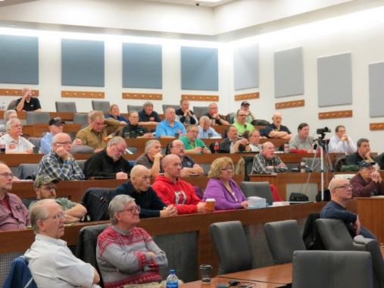
Ohio Section ARES Conference Date Announced

It’s almost here. Are you going? It’s this coming Saturday April 6th at the Marion Technical College / OSU Marion Campus. Get registered for this now, seating is filling up quickly and we do have only a limited amount of seats left. Don’t forget to “sign up” for this event in ARES Connect as well!

Stan has the agenda finalized and it’s gonna’ be a lot of great learning and fun for everyone. There will be loads of information for those interested in any part of Ohio’s ARES program.

This is an all-day adventure, but we are in a real college setting with all the amenities that you would expect in a first-class campus. Electric outlets are easily accessible for those bringing laptops and such. Wi-Fi is available and the seats are very comfortable. And… I’ll have some great Give-A-Ways to pass out as well.

Lunch is on you, but the campus is close to many popular fast-food and sit down restaurants. You can even brown bag it if you want to eat on campus. Yes, I will be videoing it for anyone that just can’t make it.

TOP ^

Certificates for your participation at this conference will be available, so you’ll get some wallpaper suitable for framing to take home with you as well! Now how can you beat that.

Get registered now, seating will become limited quickly! Here’s the link: http://arrl-ohio.org/SEC/form.html

This & That’s

Lake County ARA Holds Merit Badge Class

On March 23rd, the Lake County Amateur Radio Association held a Radio Merit Badge class for the scouts of the Lake Erie Council BSA.

This class was five months in development and held with the approval of the Lake Erie Council - Boy Scouts of America, with facility support from the Lake County Historical Society. The purpose of the class was to instruct and test the scouts on the nine sections of the Radio Merit Badge, as based on the current, 2018 published requirements with LCARA members Donald Kocsis (WA8TWM) & Ed Kopcak (KB8BKE) serving as certified counselors, with Tom Suhadolnik (N8UAZ) as the Radio Room Operator, and Joseph Koskovics (N8JKO) as the Project Technical Lead & Council Liaison along with Larry Caskey, K8LPC as a work team member.

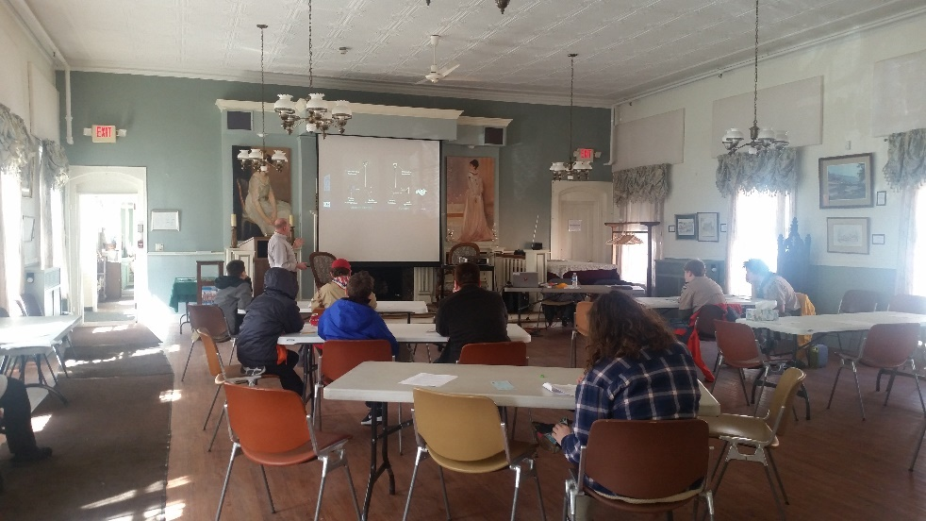
The six-hour course was attended by scouts from Ashtabula, Lake, and Lorain Counties, with all participants successfully completing the requirements. Following the class, the scouts were given the opportunity to examine several Go Box configurations, wire antennas designs, a home-made UHF yagi, and other amateur resources, as well as speaking with the LCARA team members about various special interests of the Amateur Radio Service.

#########

World Amateur Radio Day
(from M2M News Beacon)

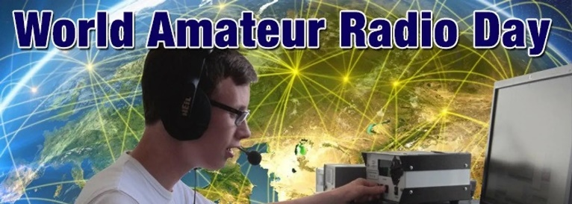
Techniques
Every April 18, radio amateurs worldwide take to the airwaves in celebration of World Amateur Radio Day. It was on this day in 1925 that the International Amateur Radio Union was formed in Paris.

TOP ^
Amateur Radio experimenters were the first to discover that the short-wave spectrum — far from being a wasteland — could support worldwide propagation. In the rush to use these shorter wavelengths, Amateur Radio was “in grave danger of being pushed aside,” the IARU’s history has noted. Amateur Radio pioneers met in Paris in 1925 and created the IARU to support Amateur Radio worldwide.

Just two years later, at the International Radiotelegraph Conference, Amateur Radio gained the allocations still recognized today — 160, 80, 40, 20, and 10 meters. Since its founding, the IARU has worked tirelessly to defend and expand the frequency allocations for Amateur Radio. Thanks to the support of enlightened administrations in every part of the globe, radio amateurs are now able to experiment and communicate in frequency bands strategically located throughout the radio spectrum.

From the 25 countries that formed the IARU in 1925, the IARU has grown to include 160 member-societies in three regions. IARU Region 1 includes Europe, Africa, the Middle East, and Northern Asia. Region 2 covers the Americas, and Region 3 is comprised of Australia, New Zealand, the Pacific island nations, and most of Asia. The International Telecommunication Union (ITU) has recognized the IARU as representing the interests of Amateur Radio.

Today, Amateur Radio is more popular than ever, with more than 3,000,000 licensed operators!

World Amateur Radio Day is the day when IARU Member-Societies can show our capabilities to the public and enjoy global friendship with other Amateurs worldwide.

We have provided a poster for World Amateur Radio Day. Any club may download it and use it to promote WARD in their area. The poster comes in two sizes: 61cm x 91cm and a small (A4) flyer.

Groups should promote their WARD activity on social media by using the hash tag #WorldAmateurRadioDay on Twitter and Facebook. IARU will list all WARD activities on this page. To have your WARD activity listed, send an email to IARU Secretary David Sumner, K1ZZ.

April 18 is the day for all of Amateur Radio to celebrate and tell the world about the science we can help teach, the community service we can provide and the fun we have. We hope you will join in the fun and education that is World Amateur Radio Day!

Activation Information: Malaysia: On 18 April 2019 9M4CMN (9w2pck@marts.org.my) will be on the air from Segamat, Southern Malaysia and 9M4CKK (9m2cio@marts.org.my) will be active from Tumpat, East Coast of Malaysia from 0230hrs to 1530hrs UTC.

Worldwide: The World Radio Network and the World Friendship Net will be participating in World Amateur Radio Day 2019.

For the second time in a row, the special event call sign W2W has been secured for this event. As well there will be a commemorative special event "WORLD AMATEUR RADIO DAY 2019" QSL Card. We will have a 12-hour net with 10 different net controllers from all over the world.

Links can be found on: http://www.iaru.org/world-amateur-radio-day.html

#########

TOP ^
Wire Nut Color – It Does Mean Something

I’m sure that most of us have seen all the various colors of wire nuts that are out there today. Did you know that the color of them actually means something? It does, and here’s just a few of them that most of us will use in our everyday lives.

The smallest wire nuts — which usually come with light fixtures — are often white, ivory, or blue. If these have plastic rather than metal threads inside, throw them away and get orange connectors with metal threads for a secure connection. The colors are usually reserved for small 24 to 18-gauge wires.

Orange Wire Nuts - Orange nuts are the next size up and can handle splices of up to two 14-gauge wires.

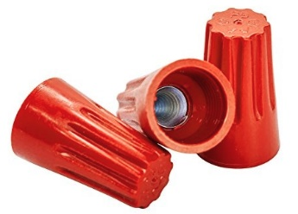
Midsize Yellow Wire Nuts - Midsize yellow wire nuts are the most common. Use them for splices as small as two 14-gauge wires or as large as three 12-gauge wires.

Red Wire Nuts - Red connectors are usually the largest wire nuts and can handle a splice of up to four 12-gauge wires.

Green Wire Nuts - Green wire nuts are used for ground wires. They have a hole in the top, which allows one ground wire to poke through and run directly to a device or box.

The Gray twister wire nuts are designed to be all-purpose — they can handle the smallest to the largest splices. However, they are bulky and expensive, but if you don’t have the right wire nut, these will do.

B-cap wire nuts are slim, which makes them useful if a box is crowded with wires.

Remember using multiple winds of electrical tape over the wire is now an electrical code violation as is soldering the wires. The National Electric Code (NEC) Article 110.3(b) states that wire nuts will be used in accordance with their makers specification.

#########

Electrical Quiz

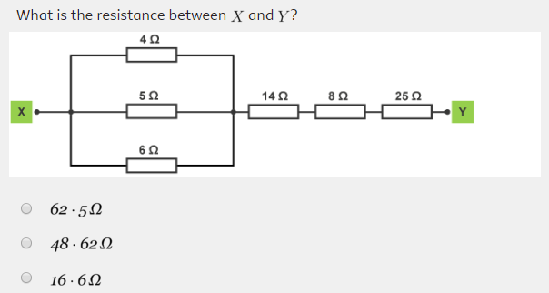
Let’s see how many of you know Ohms Law well enough to properly calculate the parallel and series resistances and come up with the correct answer to the problem below.

The Answer will be one of the answers in next week’s One Question – Questionnaire

#########
TOP ^
Do You Know The Difference In All Of The USB Cables?

I went to the store the other day to get a USB cable and I quickly discovered that I had no clue as to what connector I needed. I knew that there were several types of USB cables, but I didn’t have any clue as to just how many different cables there are out there today. It makes your head spin when you talk to the clerk at the store and the first question, he asks you is “what cable connector do you need.” Of course, you know that it’s a USB, but USB what - that is the 64-thousand-dollar question today.

Well, I answered him that I needed to connect my cell phone to my laptop. Now that brought on several more questions – Does my phone use Micro A or Micro B connector? And, do I want to use a USB 1, 2 or 3 connector to connect up to my computer?

Now, I didn’t want to look stupid, but that’s exactly how I felt. I had no clue as to what connector I had on my cell phone, so I just handed the clerk my phone and said simply “I want to connect this to my Windows computer. At that point I felt so dumb that I just wanted to get out of there and get back home quick as I could. I had been embarrassed enough for one day. Fortunately, my clerk was much smarter in these things than I was, and he gave me the right cable for what I wanted to do. On my way home I kept thinking to myself “how did something as simple as buying a cable get so complicated.”

When I got home, I turned to my favorite expert on life matters – “Google” and I found that I have been in the dark ages for some time now. All I knew for sure was that to connect my printer I used a funny looking “Doghouse” style of connector and to connect my camera the connector looked like a pie in a pie pan. My cell phone on the other hand always confused me as to which way was up, let alone know what connector style it was!

As that I was a Quality Engineer for many years, I did do what I was taught from my engineering days, it’s called “Poka-Yoke” Yes, it’s a Japanese philosophy for error prevention. Don’t laugh, it works! So, all of my phone cables are marked with a silver mark on one side. This is the side that you have up and facing you when you plug the phone in with the glass facing you. Yes, I’ve had to revert to such measures just to plug in my stupid “Smart Phone.”

So, after looking this major question up on Google I found out that there are so many different cables that I didn’t even know existed, let alone be able to identify. So, that’s the reason for this article. I’ll bet most of you don’t know all the different styles and what they are used for either, so here’s a list, and I’ve already been told that there is another new connector on its way to being introduced soon. It will be for USB 4.0! It’s supposed to be faster and I’ll bet it will be even more confusing than all that we have by being something “Just like, but a little different” than what we already have out there today.

USB CONNECTOR GUIDE — GUIDE TO USB CABLES

What are USB Connectors?
Universal Serial Bus (USB) was developed in the 1990s in an effort to simplify the connections between computers and peripheral devices. It has become widely popular due to its compatibility with many platforms and operating systems, its low cost of implementation, and its ease of use. Most computers that are built today come with several USB ports, and USB is the interface of choice for most home and office peripherals including printers, cameras, modems, and portable storage devices.

TOP ^
USB standards are developed and maintained by an industry body called the USB Implementers Forum (USB-IF). In its original specification, USB defined only two connector types: A and B. Revisions to the specification and demands on manufacturers have expanded the breadth of connectors used for USB devices, but the majority of USB products still use these A and B connector interfaces.

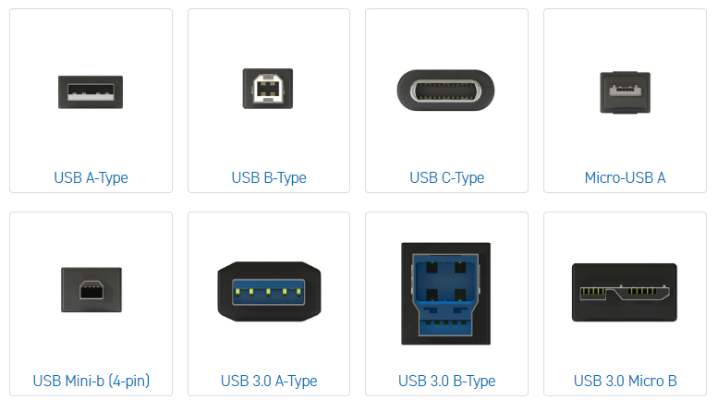
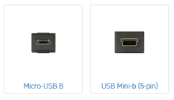

USB A-Type
Found on host controllers in computers and hubs, the A-style connector is a flat, rectangular interface. This interface holds the connection in place by friction which makes it very easy for users to connect and disconnect. Instead of round pins, the connector uses flat contacts which can withstand continuous attachment and removal very well. The A-socket connector provides a "downstream" connection that is intended for use solely on host controllers and hubs. It was not intended for use as an "upstream" connector on a peripheral device. This is critical because a host controller or hub is designed to provide 5V DC power on one of the USB pins. Though not that common, A-A cables are used to connect USB devices with an A-style Female port to a PC or another USB device, and for data transfer between two computer systems.

TOP ^
Note: Typically, an A-A cable is not intended to connect two computers together or to connect a USB hub between two computers. Doing so may cause irreparable damage to your computers and may even present a fire hazard. Check with the manufacturer before using an A-A cable for data transfer.

USB B-Type
The B-style connector is designed for use on USB peripheral devices. The B-style interface is squarish in shape and has slightly beveled corners on the top ends of the connector. Like the A connector, it uses the friction of the connector body to stay in place. The B-socket is an "upstream" connector that is only used on peripheral devices. Because of this, the majority of USB applications require an A-B cable.

USB C-Type
The USB-C or USB Type-C connector is the newest USB connector on the market. The USB-C connector has a reversible/symmetrical design and can be plugged into any USB-C device using either end. A USB-C cable is capable of carrying USB 3.1, USB 3.0, USB 2.0, and USB 1.1 signals. The USB-C is commonly paired with the USB-A, USB-B, USB Micro-B, and other USB connectors when supporting previous versions of the USB specification. USB-C can be adapted to work with each of these legacy connectors.

When connecting two USB 3.1 devices, the USB-C cable will support data transfer rates that are twice the speed of existing USB technology (up to 10Gbit/s), enhanced power delivery of up to 20 volts, 5 amps, and 100 watts for power and charging, and built-in support for DisplayPort video and four channel audio (speaker and microphone).
Micro-USB A
Recognized by the USB-IF, this connector can be found on newer mobile devices such as cellphones, GPS units, PDAs and digital cameras. Micro-USB A offers a connection physically smaller in size to a USB Mini-b, while still supporting the high-speed transfer rate of 480 Mbps and On-The-Go features. The connection can be easily identified by its white-colored receptacle and compact 5 pin design.

Micro-USB B
Recognized by the USB-IF, this connector can also be found on newer mobile devices such as cellphones, GPS units, PDAs and digital cameras. Micro-USB B offers a connection physically smaller in size to a USB Mini-b, while still supporting the high-speed transfer rate of 480 Mbps and On-The-Go features. The connection can be easily identified by its black-colored receptacle and compact 5 pin design.

USB Mini-b (5-pin)
One drawback to the B-style connector is its size, which measures almost a half inch on each side. This made the B-style interface unsuitable for many compact personal electronic devices such as PDAs, digital cameras, and cellphones. As a result, many device manufacturers began the miniaturization of USB connectors with this Mini-b.

TOP ^
This 5-pin Mini-b is the most popular style of Mini-b connector, and the only one recognized by the USB-IF. By default, a Mini-b cable is presumed to have 5 pins. This connector is quite small, about two-thirds the width of an A-style connector. It is also specified for use in the newer standard called USB On-The-Go which allows peripheral devices to communicate with the presence of a host controller.

USB Mini-b (4-pin)
Instead of the typical 5-pin Mini-b, this unofficial connector is found on many digital cameras, especially certain Kodak® models. It resembles the shape of a standard B-style connector, with beveled corners; however, it is much smaller in size.

USB 3.0 A-Type
Known as "SuperSpeed", this A-style connector is commonly found on host controllers in computers and hubs, the A-style connector is a flat, rectangular interface. This interface holds the connection in place by friction which makes it very easy for users to connect and disconnect. Instead of round pins, the connector uses flat contacts which can withstand continuous attachment and removal very well. The A-socket connector provides a "downstream" connection that is intended for use solely on host controllers and hubs. This connector is similar in size and shape to the A-Type connector used in USB 2.0 & USB 1.1 applications. However, the USB 3.0 A-type has additional pins that are not found in the USB 2.0 & USB 1.1 A-Type. The USB 3.0 connector is designed for USB SuperSpeed applications; however, it will carry data from slower speed connections, and it is backwards compatible with USB 2.0 ports. USB 3.0 A connectors are often blue in color to help identify them from previous versions.
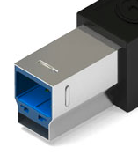
USB 3.0 B-Type

The USB 3.0 B-Type connector is found on USB 3.0 devices. This connector is designed to carry data and power in USB SuperSpeed applications. Cables with this connector are not backwards compatible with USB 2.0 or USB 1.1 devices; however, USB 3.0 devices with this connection type can accept previous USB 2.0 and 1.1 cabling.

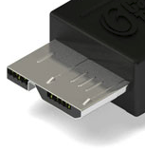
USB 3.0 Micro B
The USB 3.0 Micro B connector is found on USB 3.0 devices. This connector is designed to carry data and power in USB SuperSpeed applications. Cables with this connector are not backwards compatible with USB 2.0 or USB 1.1 devices.

Now, you know much more than you ever wanted to know about USB connectors, but at least you won’t have to be embarrassed when you go into the store and ask for a cable for your smartphone! You should be able to recognize which connector is which and what your phone needs before you walk out your door!

TOP ^

Final.. Final..
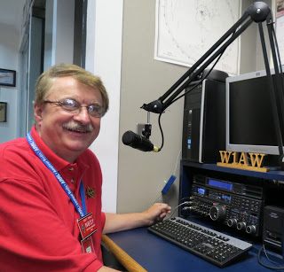
Hey Gang...

It was another great week visiting with all of you at your meetings and events. I’ve had a blast and I have learned some things this week (see article above..)

Now, let’s move on to more important things... I’ve been asked by many of you just how many folks do we have in ARES Connect now. Well, here’s a breakdown of all 3 levels for you…

Level 1 – 444; Level 2 – 424; Level 3 – 129

This gives us a total of 997 in ARES Connect. I don’t know for sure, but my guess from everything that I can see within the system is that no one other than the Ohio Section has more people registered in ARES Connect.

I do want to clear up some mis-interpretations that have been going around. First, in the Ohio Section we only require our Level 2 volunteers to have the 4 basic courses, IS 100, 200, 700 & 800. For our Level 3 volunteers we do require the additional ICS 300 / 400, or the equivalent professional series courses IS 120, 230, 240, 241, 242, 244 & 288. These equivalent courses are all on-line classes just like your basic 4 NIMS courses are and being offered as an alternative way for you to get credit for taking the professional series courses in the event you just cannot get scheduled into an ICS 300/400 class.

By the way, if you decide to take these 7 on-line courses and complete them all, you will want to take just one more class IS-235. By completing this additional course, you will get a really great looking certificate from FEMA recognizing that you have completed the entire Professional Series courses.

I do hope that this clears up the confusion that has been going around lately. As we have stated on the website and in this newsletter many times “We don’t want anyone left behind.”

Spinning the dial down the band a bit… We have an update to tell you about thanks to Greg, WD9FTZ. The Contact Manager for not only TYT radios, but a number of others as well has been updated. The new version is 2.63 and you can find this at: http://arrl-ohio.org/digital/Code-Plugs-and-more.html

Stan, N8BHL also has an update on the website this week. For those interested in ARES, OSERP which stands for the Ohio Section Emergency Response Plan and it’s been updated. Here’s a link to it..
http://arrl-ohio.org/SEC/OSERP%20revision%20Apr%202019.pdf

Whelp… That’s going to do it for this time around. Stay safe, stay warm, and most of all… have FUN!!

73,

Scott, N8SY

TOP ^

Back Issues of the PostScript and Ohio Section Journal (OSJ)

Hey, did you know that PostScript and Ohio Section Journal (OSJ) are archived on the website? You can go back and look at any edition simply by clicking:
http://arrl-ohio.org/news/index.html

Chit – Chat, and All That!

Do you know someone that’s not getting these Newsletters? Please, forward a copy of this Newsletter over to them and have them “Opt-In” to start receiving them. Heck, just have them send me an email n8sy@n8sy.com and I’ll get them added to the Ohio Section Emailing list.

We now have many thousands of readers receiving these newsletters weekly. Quite impressive, I’d say! I urge all of you to make sure that everyone, regardless of whether they are a League member or not, get signed up to receive these weekly Newsletters.

You can always “Opt-Out” at any time if you feel this is not what you were expecting. It’s fun and very informative. All of your favorite past newsletters are now archived too.
You can go back at any time and read them. Just go to: http://arrl-ohio.org/news/

Got questions, concerns or would just like to sit and chat awhile? Heck, I’ll even buy the coffee!! Give me a call at (419) 512-4445 or email me at: n8sy@n8sy.com

The pictures on the front page are from various newsletters, Facebook posts and/or were sent directly to me in recent weeks. Take a good look at them, you just might be in one of the pictures! “SMILE… you’re on the Ohio Section News!!”

TOP ^

PostScript is produced as a weekly newsletter. I want to thank everyone that has contributed articles and ideas to make this an even better news source. I sincerely hope that you have enjoyed this edition and will encourage your friends to join with you in receiving the latest news and information about the Ohio Section, and news and events happening around the world!

