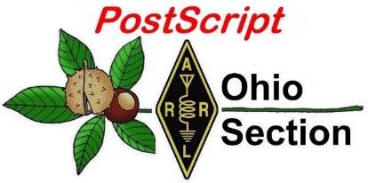
March 25th
Edition

National News The Handbook Give Away

Club Corner Hamfests

DX This Week One Question Questionnaire

VE Testing Schedule Final.. Final..

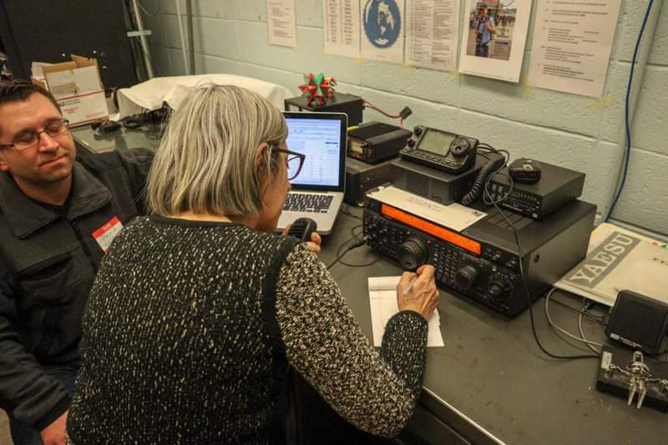
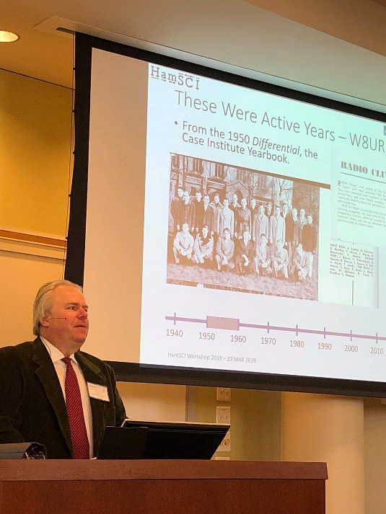
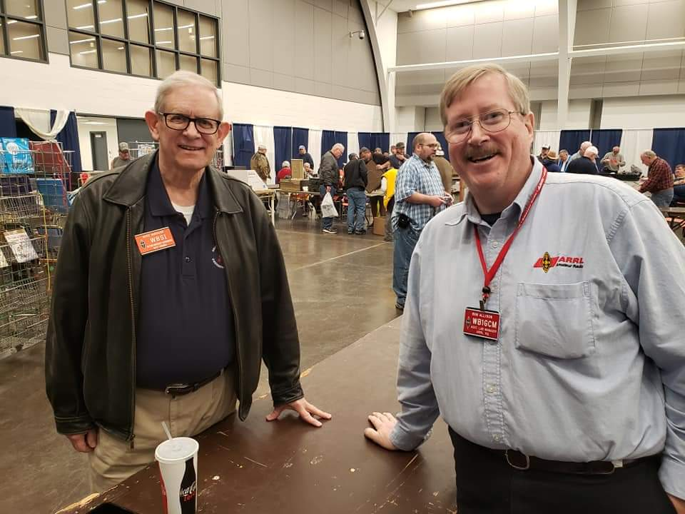
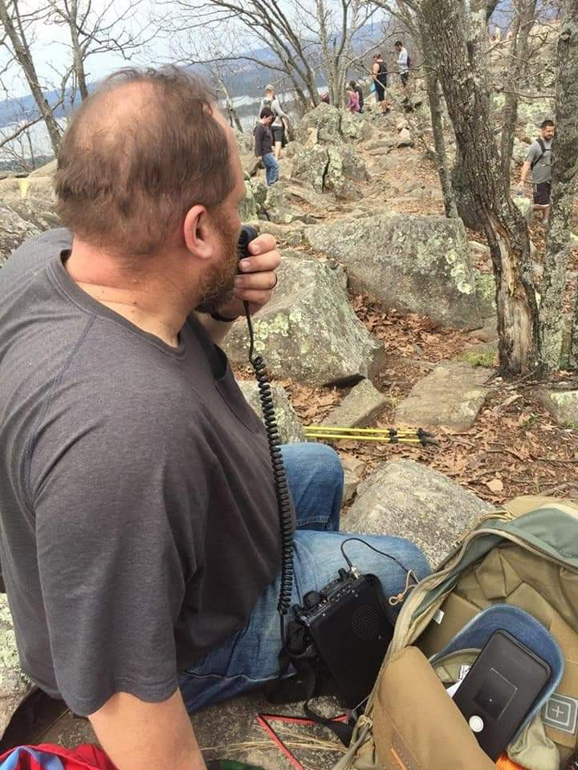
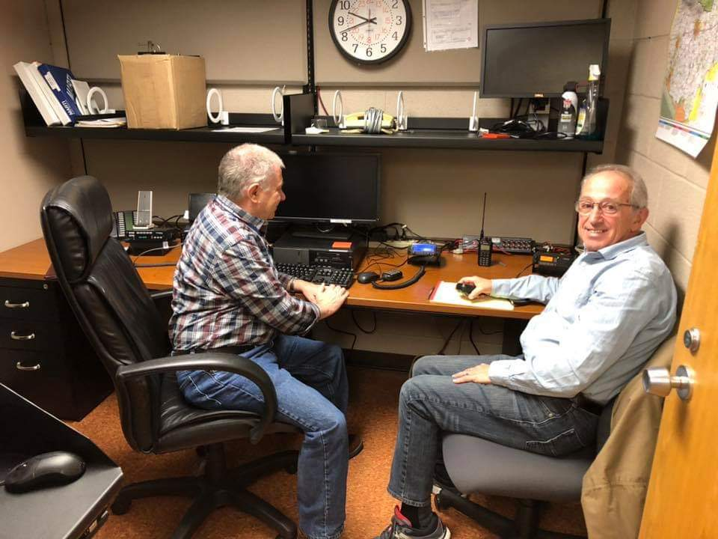
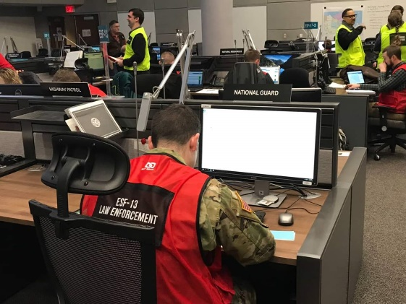
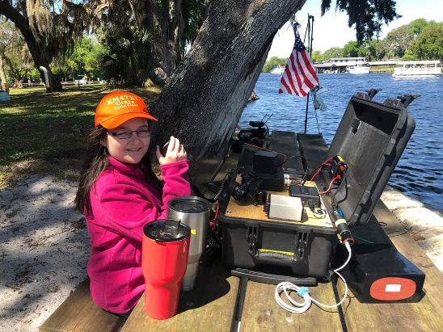
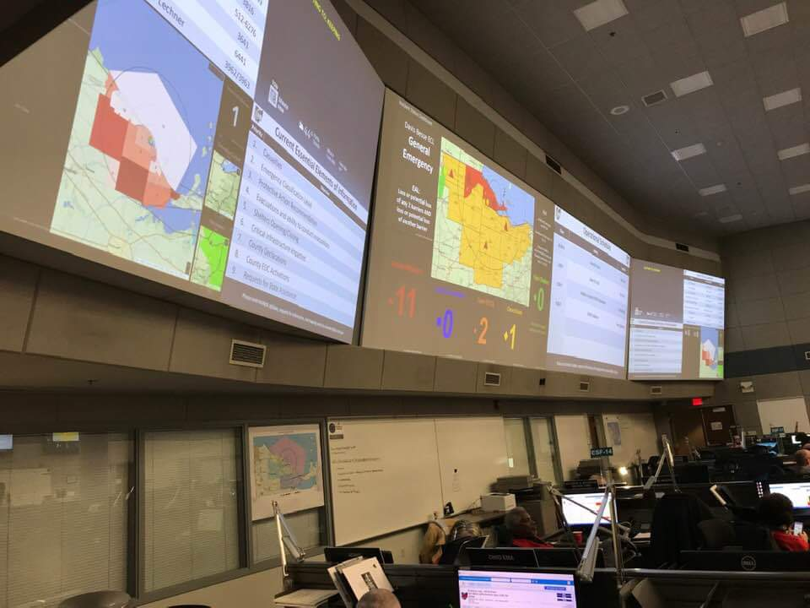

National News
(from arrl and other sources)

Norfolk Island Special Event DX Operation Set to Start on April 1
A four-operator team will activate special event station VI9NI on April 1 to celebrate the 40th anniversary of the signing of the Norfolk Island Act. The Act granted limited self-government to the Australian external territory of Norfolk Island. The Act formally established the Norfolk Island Legislative Assembly and gave the Assembly powers to pass, amend, and repeal laws, and — subject to the assent of the Administrator of Norfolk Island — executive powers.

The activation will run from April 1 until April 14. Two stations will be on the air from 160 – 17 meters, with a focus on FT8, CW, and SSB. VI9NI will use WSJT-Xversion 2.01 in Fox/Hound mode (call only above 1,000 Hz). — Thanks to David Burden VK3BDX/AC3CW

#########

FCC Adopts New Rules for Spectrum above 95 GHz in Branded “Spectrum Horizons” Initiative
The FCC has adopted new rules to encourage development of new communication technologies and expedite the deployment of new services above 95 GHz. The action was the latest move in the Commission’s “Spectrum Horizons” branded initiative.

“This spectrum has long been considered the outermost horizon of the usable spectrum range, but rapid advancements in radio technology have made these bands especially ripe for new development,” the FCC said in announcing the March 15 move.

Prior to its “historic” decision last week, the FCC had no rules for authorizing communication above 95 GHz other than by radio amateurs or through experimental operations. Under current rules, specific Amateur Radio allocations exist at 122.25 – 123.00 GHz; 134 – 141 GHz; 241 – 250 GHz, and at frequencies above 300 GHz, and limited experimentation has taken place in this region of the radio spectrum. Among radio amateurs active in that region of the spectrum is Brian Justin, WA1ZMS, in Virginia — who has made at least one contact on every available Amateur Radio band. He earned the first-ever ARRL VUCC awards for 122 GHz, 134 GHz, and 241 GHz, and even went so far as to make the first contact on a less-than-1-millimeter band, 322 GHz. “Many world DX records were made as well along the way,” he said last spring. “The most rewarding one for me was 114 kilometers [about 71 miles] on 241 GHz.”

In announcing adoption of the new rules for spectrum above 95 GHz, the FCC cited “substantial opportunities for innovation on these frequencies, especially for data-intensive high-bandwidth applications as well as imaging and sensing operations.”

The new rules create a new category of experimental licenses for using frequencies between 95 GHz and 3 GHz.

TOP ^
“These licenses will give innovators the flexibility to conduct experiments lasting up to 10 years, and to more easily market equipment during the experimental period,” the FCC said. The FCC action also makes a total of 21.2 gigahertz of spectrum available for use by unlicensed devices. The Commission says it selected “bands with propagation characteristics that will permit large numbers of unlicensed devices to use the spectrum, while limiting the potential for interference to existing governmental and scientific operations in the above-95 GHz bands, such as space research and atmospheric sensing.”

The FCC said study of these uses could ultimately lead to further rulemaking actions and additional licensing opportunities within the Spectrum Horizons bands.

#########

Gov. DeWine declares state of emergency in 37 Ohio counties
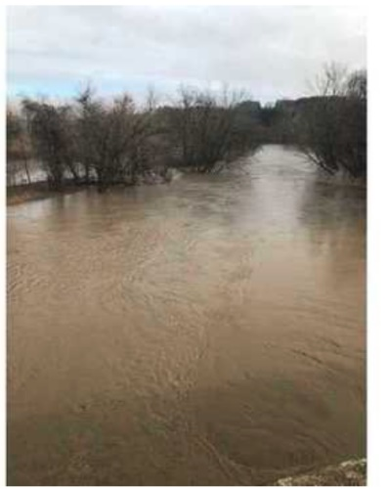
(From NBC4 Staff)

COLUMBUS, Ohio (WCMH) - Ohio Governor Mike DeWine on Wednesday declared a state of emergency in 37 Ohio counties that suffered serious highway damage following severe weather that started in February.

The emergency proclamation will allow the Ohio Department of Transportation and local governments to access federal emergency relief funds. All 37 counties have suffered damage to roads and/or bridges from the severe weather, officials said. Some roadways still have lane restrictions or are closed completely.

"Many of these roads are in dangerous condition, impacting the safety of Ohio's drivers. By declaring a state of emergency, Ohio can now access federal funding to help with the unplanned costs to repair the highways damaged by heavy rain and flooding," DeWine said.

Ohio counties included in DeWine's emergency proclamation include: Adams, Athens, Belmont, Brown, Butler, Carroll, Clermont, Clinton, Columbiana, Coshocton, Gallia, Greene, Guernsey, Hamilton, Harrison, Highland, Hocking, Holmes, Jackson, Jefferson, Knox, Lawrence, Licking, Meigs, Monroe, Morgan, Muskingum, Noble, Perry, Pike, Preble, Ross, Scioto, Tuscarawas, Vinton, Warren, and Washington.

#########

Bart Jahnke, W9JJ, Appointed as New ARRL Radiosport and Field Services Manager
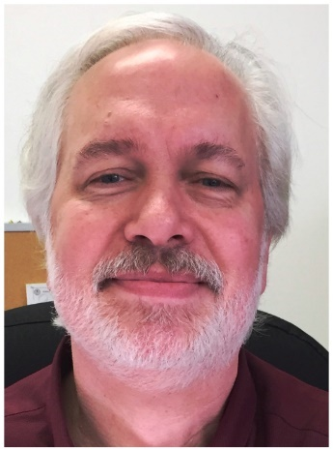
Headquarters veteran Bart Jahnke, W9JJ, has been appointed as ARRL Radiosport and Field Services Manager. Jahnke, who has served as ARRL Contest Branch Manager for the past 3 years, succeeds Norm Fusaro, W3IZ, who was recently promoted to Director of Operations at ARRL Headquarters.

“This new role now offers me the exciting opportunity not only to be on the front lines of our radiosport community, but our international/DX and domestic radiosport operating and awards activities,” Jahnke said. “Having worked closely with tens of thousands of our Volunteer Examiners in my prior Headquarters tour, I’m able to re-engage with many of them now in our Field Services program.”

TOP ^
With respect to radiosport, Jahnke pointed out that contesting activity not only defends Amateur Radio allocations but builds a pool of operators and expands their skills in providing communication in times of emergency or disaster. Jahnke said contesters, DXers, traffic handlers, and everyday users of the amateur bands know what to expect in terms of propagation at different times of day and year, and can apply that knowledge in establishing disaster communication.

As Radiosport and Field Services Manager, Jahnke will oversee the Radiosport and Field Services staff in managing awards, contests, and Logbook of The World (LoTW), as well as issues involving the ARRL Field Organization on Section, club, and current volunteer monitoring and emergency services issues.

Before returning to ARRL Headquarters in 2016, Jahnke was in the private sector for about a decade, working in the emergency medical services, customer service, long-term care manufacturing sales and support, and information technology fields in the midwest and on the east coast.

Jahnke first joined the ARRL Headquarters staff in 1985, starting as editor of the ARRL Repeater Directory and as a Membership Services Representative, handling matters related to FCC rules. For the next 3 years, he also assisted with ARRL Award processing (except DXCC) and later trained incoming Awards Managers.
In 1989, he became the manager of the ARRL Volunteer Examining (VEC) Program, a position he held for 16 years.

#########

Ohio ARES Provides “Situational Awareness” During January Blizzard

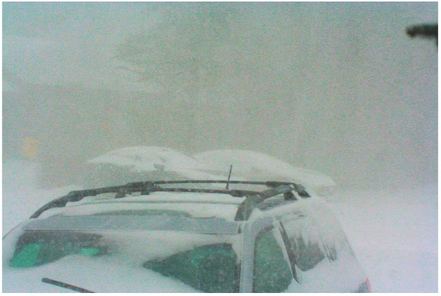
Ohio ARES members stared down “Snowmageddon” 2019, the mid-January blizzard that blanketed the lower Great Lakes region. Based on ominous forecasts and discussion with Assistant SECs across the state, Section Manager Scott Yonally, N8SY, and the Ohio Watch Office, SEC Stan Broadway, N8BHL, asked ARES operators to provide observations and reports to assist decision makers at the Ohio Emergency Operations Center and county emergency management agency centers.

“We could do this safely from our homes, and integrate our reports (remotely) into the state’s WebEOC management system, which could be read by the Ohio Watch Office and any other emergency official around the state,” Broadway said. “We had never tried this, and it seemed like a great way to promote the Amateur Service’s ability to provide situational awareness on a wide scale.” Broadway said conditions generated by the storm “could have resulted in an emergency” and warranted a statewide ARES response.

A statewide net was convened on Saturday, January 9, as conditions deteriorated. Amateurs quickly began checking in and reporting their local conditions with specific details. The reports were compiled by Ohio’s AuxComm Team station W8SGT, which was operated from Broadway’s residence on 80 meters, and the VHF/UHF Digital Mobile Radio (DMR) network (the Ohio Talk group), simultaneously.

By nightfall, storm conditions had stabilized, and reporting slowed to the point that the statewide net could be closed. Many county-level nets were also in operation.

TOP ^
The Ohio “Snow Net” received 131 reports from 44 of Ohio’s 88 counties, split evenly between HF and DMR. The short-notice net was entered into the ARES Connect system and more than 50 amateurs signed up for the net event. Several other local snow nets entered for county events also. The statewide reports were logged and submitted every few hours to the state Homeland Security/Emergency Management Agency Watch Desk through WebEOC.

Broadway said emergency managers around the state were impressed that Amateur Radio could furnish reports with such detailed information. He said HF capability to reach across the state was a proven asset, with effective communication in all directions. The DMR system functioned much like Ohio’s public safety radio system, connecting nearly 80 repeaters across the state through the internet. This service had been untested and this event created the perfect proving ground, Broadway said. “We needed dependable statewide communication where all stations would benefit by hearing reports as they were filed,” he pointed out. “The Ohio Talk Group was used with great success, with no known problems with dropout or system faults. Communication proved reliable even with the severe weather threatening power loss and antenna corruption.”

Ohio ARES operators provided a broad range of information including snow depths, wind speeds, and “Level 3” declarations, closed airports and more. Under Level 3 in Ohio, non-essential motorists on roadways are subject to arrest.

Broadway conceded that more aggressive alerting of District and county Emergency Coordinators would have given them more time to prepare. More guidance for local nets might have contributed to more realistic expectations and efficient operation — the specific weather information sought and time frame of operation anticipated, he added.

“Winter storms are part of the Ohio landscape, and we don’t propose ramping up a net for every snowfall. But when the forecasts call for extreme conditions, ARES operators have now proven we can be a true asset for our served partner agencies. — Ohio Section Emergency Coordinator Stan Broadway, N8BHL

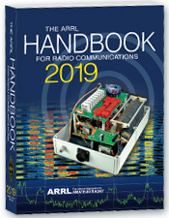
The Handbook Give Away

Hey Gang,

The “Handbook Giveaway” drawing will soon be returning for another big “Give Away”

Many of you ask me just how do I know when the drawing is on? Well, that’s easy all you need to do is check in on the Ohio Section Website on a regular basis and watch for the big RED Arrow that will appear on the left side of the page. This is the sign that the drawing is on and you need to get registered. So, keep a sharp eye out on the website and check in often! http://arrl-ohio.org

What’s the catch? I want to get everyone checking in to the Ohio Section website as often as possible, and in order to register each month, you have to visit the website often! There’s nothing else to it. I pay all expenses, and from time to time, I Give Away more than just a Handbook. And, you’ll never know just what months will be those special times that I will have more than just a Handbook to Give Away!!

TOP ^

Club Corner

This is YOUR cornner of the newsletter. Send me what your club is doing and I’ll make sure that it gets in. Got a special event or club project that you want everyone to know about? Send it to me!. Need help with a project? Send it to me.

Let me know what you club is up to. Are you going to have a special guest at your meeting or are you having a special anniversary? Just sent it to:
n8sy@n8sy.com

#########

Oh-Ky-In Amateur Radio Society, Ham Radio Licensing Classes and Exams
An Amateur Extra class is being held on Monday nights starting March 11th for 10 weeks at the Hamilton County Communications Center on Civic Center drive in Forest Park, 2377 Civic Center Dr, Cincinnati, OH 45231. Each class is two hours from 7pm to 9pm.

Classes for Technician and General are being held on Monday nights starting April 15th until May 13, 2019 at the Cincinnati Red Cross Building, Dana Ave, 2111 Dana Ave, Cincinnati, OH 45207. These classes are also two hours in length from 7pm to 9pm. Licensing exams will be held on May 25th in St. Bernard in the Centennial Room of the Municipal Building 110 Washington Ave, Cincinnati, OH 45217.

Got questions? Please email Mike Niehaus KD8ZLB : KD8ZLB@gmail.com and visit http://ohkyin.org/wp/club-activities/classes/

#########

Help Wanted

HamVention© is in need of volunteers to assist in various capacities during the May 17-19 show in Xenia.

Although some set up help is needed on Wednesday, most opportunities to assist with other duties will start on Thursday and continue through Sunday.

This year there a need for additional golf cart drivers because the shuttle wagons will not be used. These openings will require attendance at a training session.

You do not have to be a Dayton ARA member to volunteer. A minimum of six hours will reward you with an admission ticket and some other goodies.

Want more information? Check out volunteers@hamvention.org. This is a great opportunity to give back to our hobby and meet some friends you didn’t know you had.

#########
TOP ^
TMRA Holding Classes
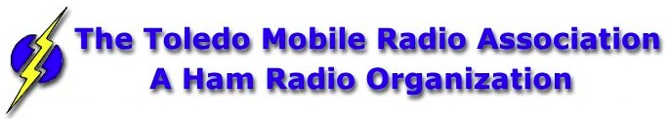
SPRING TECHNICIANS (Entry Level) HAM RADIO LICENSE CLASS (2 DAY COURSE) -
NOTE: April 6th with test session on April 6th at end of class.
The TMRA Education Committee has released the schedule for the Spring Technicians Class. The class schedule will follow our traditional style. Two classes held two weeks apart and a V.E. Testing Session after the final class.

The Class is FREE, you will have to provide your own book, or one can be purchased from the TMRA ($25.00). (ARRL Edition 4 book) The testing session will cost $15.00 which is the standard fee set by the ARRL.
THE DATES ARE AS LISTED BELOW
* CLASS TWO WILL BE HELD ON SATURDAY APRIL 6TH, 2019 FROM 08:00 TILL 17:00 (This includes the V.E.Session)
Class will be held at
LUCAS COUNTY EMS TRAINING CENTER
2127 JEFFERSON AVE
TOLEDO OHIO 43624
To Enroll in the Class, or for more Information please contact
STEVE STALKER / KC8TVW 419-467-3734 kc8tvw@arrl.net
Also, please join us for a 4-hour follow-on class on April 13th (9am) called, "I now have my ham radio License, now what?". This class is intended to help get newly licensed hams started with additional needed information. Location is TBD.

#########

New Ham - Info Class - Saturday, April 13, 2019 at 9 AM – 1 PM
Relaxed Learning Session: I'm new to Amateur Radio! Now what?!

Join Toledo Mobile Radio Association Members at the Lucas County EMS Training Center for a FREE learning and Q&A session that should work to help you get started with some of the practical items that we all wish we knew when starting off in Ham Radio. Any/everyone is welcome, and you do not have to have attended the class to attend. Most hams licensed less than 3 years will find the session useful.
This session will be run as a "class” but is open to ANY questions along the way. Folks are free to come and go as you wish. This training session is a great place to get to know TMRA members and for newer amateur radio operators to ask questions related to items they are concerned about or need help with. We know that this hobby has a lot of new items for everyone to get familiar with, so this is an attempt to short-cut that learning!

TOP ^
We'll discuss and help new hams resolve some of the typical early ham radio challenges including (but not limited to) the following types of discussion items (no specific order):

- Answer any early questions and discuss list of items that we all have soon after becoming a ham. (and worries that we each had)
- Discuss Hand-held and mobile radio types / drawbacks and benefits. Who can help me program it? How can I make my HT more effective?
- What is needed to setup and use a mobile or "base" radio - in car or in home (and benefits and types).
- Discuss Effective Radiated Power in terms of Antenna benefits - Discuss types of antennas indoor/outdoor options (and why). Horizontal vs. Vertical antennas.
- Types of feedline (we often refer to "coax) and what you will need (and for what) - and where to find it.
- VHF/UHF vs HF - Who can I talk to and when?
- Discuss using local Repeaters, internet linked repeaters, PL Tones, (repeaterbook/radio reference)
- Discuss Simplex vs Repeater typical etiquette (just so you know) - Examples: Q signals, calling CQ, breaks, etc.
- First Contacts – what to expect (most important, you won't be judged so don't "sweat it".... really...)
- Hamfests + Ham Conventions. - Why bother?
- Where should I buy equipment and what are the risks?
- Useful websites
- Foxhunting and Satellites - how/where?
- Where to find manuals and information?
- If there is time: Antenna Analyzers and SWR Meters - what are they and when do I need one?
- If there is time: N vs PL-259, vs SMA, versus BNC connectors
- Benefits of joining organizations/clubs
- Foxhunts - what are they and how does it work? Do I need anything?
- HF - club events (what can I participate with?) - Operating events.
- Callsigns, vanity and considerations
- QSL Cards and Logbook of the World
- Propagation - Tropo ducting, Sporatic E, Aurora, sunspot cycle, seasonal patterns

We look forward to seeing you there!

#########

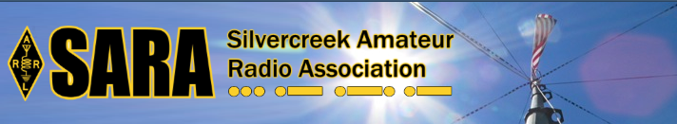
SARA is partnering/supporting Wayne County EMA in the offering of the SKYWARN training this year. As you may have heard, budget and staffing issues in the Cleveland NWS office has led them to cancel the NWS-lead SKYWARN classes. EMAs and ARES ECs are being encouraged to hold the SKYWARN training directly.

SARA is playing a supporting role to the Wayne County EMA which is holding a session for this region. The date will be Monday, May 6th from 6p - 8p. Volunteers will be needed 5p - 8:30pm. The tentative location is Chippewa Jr/Sr High School in Doylestown. Volunteers will help register attendees and print the SKYWARN training cards with ID numbers. Fred Sheppard KD8GYS will be assisting Joe Villegas with the class.

TOP ^
Additionally, SARA will have a table with some amateur radio materials available to spread the word about our hobby and service.

If you can volunteer your time, please contact me so I can add you to the roster. Please note that volunteers will not be able to be present in the class for the entire session as volunteers will register latecomers and also print and organize the ID cards.

Thanks! For more information or questions, contact Jason, N8JDM jason@mfamily.org

#########

Pioneer Bus Trip to Hamvention

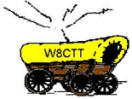
It is never too early to plan a trip to Hamvention. Each year the Pioneer Amateur Radio Fellowship has offered to bus hams to this great event. The bus leaves at 5:30 AM the Saturday of Hamvention, it does stop at McDonald's for breakfast and arrives at Hamvention about 9am, just in time for the doors to be open. The bus leaves around 5pm and stops for a buffet for supper! You won’t go hungry on this trip for sure! You arrive back at the pickup point about 9:30pm, so it’s not too late, but you will have had a full day for sure.

The bus has a number of very large storage areas for all your purchases, so you don’t have to worry if you’ll have room for that “just can’t do without boat anchor!”

Click Here to read the flier and the form used to register for this trip.

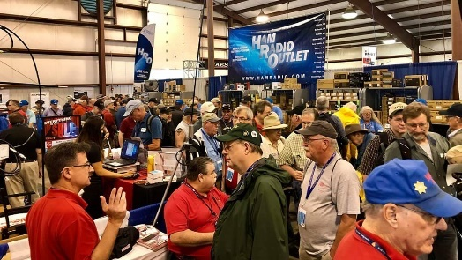
Upcoming Hamfests

04/13/2019 | 65th Annual Cuyahoga Falls ARC
Location: Cuyahoga Falls, OH
Type: ARRL Hamfest
Sponsor: The Cuyahoga Falls ARC, Inc.
Website: http://cfarc.org

04/20/2019 | Portsmouth Radio Club Hamfest  Location: Portsmouth, OH  Sponsor: Portsmouth Radio Club  Website: https://www.facebook.com/w4pox/ | 04/28/2019 | Athens Hamfest  Location: Athens, OH  Sponsor: Athens County Amateur Radio Association  Website: http://www.ac-ara.org/
05/17-19/2019 | Dayton Hamvention  Location: Xenia, OH  Sponsor: Dayton Amateur Radio Association  Website: http://hamvention.org/ | 06/01/2019 | FCARC Summer Swap  Location: Wauseon, OH  Sponsor: Fulton County Amateur Radio Club  Website: http://k8bxq.org/hamfest

TOP ^

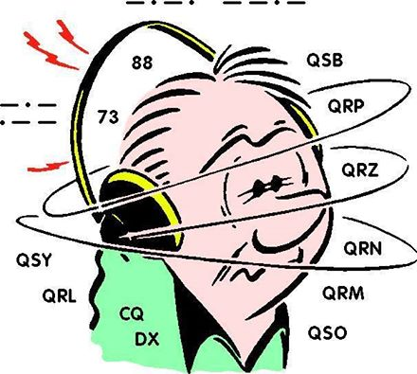
DX This Week
(from Bill, AJ8B)

DX This Week – Busting a Pileup
Bill AJ8B (aj8b@arrl.net, @AJ8B, www.aj8b.com or www.swodxa.org )
CWOPs Member #1567

Uncle Frank and I always take different angles in the debate “Power -vs- antenna -vs- skill.” Ultimately, as I have the vertical, the OCF dipole and 100 watts, I defend the skill angle. HK3Charlie shows us that it may be more skill than we all thought. This is Part 2 of the articles that John, HK3C, graciously allowed me to use in the SWODXA newsletter and subsequently reprint here. Check in on John at www.hk3c.com

+ --------------------------------------------------------------------------------------------------------------------+

How to Break a pileup
The key to busting pileups is listening. The first thing to do is NOT transmit. You can't listen when you’re transmitting.

There are things you need to listen for and find - before you begin to transmit.

First, you need to hear the DX station. Unless you can hear him and hear him well enough to tell exactly what he’s doing, there’s no point calling. And once you can hear the DX station well, you need to determine where he’s listening. This is easy if he's working simplex. But, more than likely, for any reasonably sized pile-up, he'll be operating split.

If you use a radio that allows listening on two frequencies at the same time, the next step is easy: listen to the DX station on his frequency, and then find the station he's working on his receive frequency.
Depending on skip or propagation, you may not be able to hear who the DX station is coming back to, so you’ll need to keep listening and tuning. In so-doing, you’ll eventually determine whether the DX station is staying in one spot or tuning around in the pileup. Of course, the best frequency to be when you start transmitting is on the exact spot where the DX station was listening for his last contact.
Only then is it time to call. BTW, if you need to tune up your amp, move away from the DX frequency before doing so.
Keep your calls short - and give your full call sign - then go back to listening. Sometimes you’ll need to repeat this cycle two or three times. Once the DX station comes back to someone, there's no sense continuing to transmit - unless the station he called is you.
And even if you start calling, don't stop listening.
Who is the DX station working? Stations in your area, or are they on another continent? Perhaps he's working callers from all over. Listen closely. Who are the stations he responds to? Are they the earliest, or the strongest callers, or is he picking later in the pileup when the calls die down? Is he accepting, or ignoring tail-enders?

TOP ^
Determine the pattern the DX station is using and use that information to adjust the placement of your calls.
Be patient. Pileups can be huge random events, and if you keep listening and carefully calling, you'll eventually get through. It may be on the first or second call, or it could take a half hour of calling. Don't get discouraged. And remember, despite all your best efforts, some will get away. Propagation will change, or the station will QSY or QRT. You can't control that, so don't worry about it. Importantly - don't let it affect your performance.

Careful listening makes a big difference. It will tell you where to transmit, and when. Listen to get the rhythm of how exchanges are being made, and what information is being exchanged. For example, is the DX station giving only his call sign and a 5-9 signal report? Or, do exchanges include name and other details. Follow suit - if only call sign and signal report, refrain from giving your QTH and/or name. Remember - listen, listen - and listen some more. You may pick up clues that will help you make the contact.

The DX station may be "running by the numbers", or by areas, or you may notice QSB on the band and able to make the contact when the propagation fluctuations are on the rise. Learn by listening and take notes. By listening to a DX station over time, you’ll learn about propagation to the DX-station, not just to and from your station, but also to other areas of the world. By listening, you’ll learn how to make a contact properly. You’ll hear good operating practices, and unfortunately, bad ones. Don't imitate the bad ones. By listening carefully, you’ll learn things from a different perspective, which might not otherwise be apparent.

Variations on phonetics and exchanges can be learned though experience, and it's a good idea to listen to how different amateur radio operators make their contacts. Some use techniques with a winning pattern, while others have a hard time.

"Tail-ending" - quickly throwing in your call sign right after the non-DX station is about to clear with the DX station - is a technique which can be successful. But be careful not to cause QRM. And know that some DX stations don't like that practice, considering it rude. Some may be unprepared to hear you or log your call sign.
When you do this, you're essentially interjecting yourself into another conversation which may interrupt the rhythm of the communication.

During a pileup, it sometimes helps to get your call sign in first - right after the DX stops transmitting. However, more than likely, you’ll need to let the "roar" of the pileup die down, and just about the time most stations stop transmitting - but before the DX picks a call sign - say your call sign. That's sometimes the best time to call. Listen to see whether he regularly picks up the first station that calls, or if he also lets the pileup settle down for the most part and then picks a call sign near the end, when most stations have stopped calling.

In many cases, "Big Gun" stations will overpower with their strong signal and make the contact. But if you’re a "little pistol", running 100W to a wire antenna, smart timing can help you win out.

Sometimes, you should say your call sign only once, and sometimes you should say it once, wait a few seconds, then say it again. Avoid calling continually though, because you risk becoming a nuisance to not only the DX station, but also to everyone - especially if you call when the DX station returns to someone else.

It’s important to observe the timing, pace and flow of exchanges. Sometimes, the DX station may only get a part of a call sign and may say: "the India Tango station" or just: "station with Tango". That's when you would give your call sign again, providing he gave a portion of your call sign. There may be other stations who also have a letter of your call sign, so don't call, especially if you know it’s the portion of a suffix belonging to another station.

TOP ^
If you hear the DX station ask for: "the Papa Zulu station" and no one answers, you might be tempted to throw your call sign in after a second or two. This can be a bit of a gamble. If you do throw your call in, you’re sticking your foot in the door - and that door may either open, or it may slam shut.

Finally, when pileups grow too large, DX stations often may begin operating by the numbers, or by country, or by zone. Additionally, some DX stations might not operate “split” when they should. Perhaps this is because they lack the necessary knowledge or experience. But always remember - the DX station is "boss" of the pileup, and he runs it as he sees fit.

Good hunting! 73, John - HK3C

+ --------------------------------------------------------------------------------------------------------------------+

From our friend at the DailyDX and the WeeklyDX, and the best source for DX information, (http://www.dailydx.com/ ) Bernie has this to report:

VP6 - Pitcairn Island - The multi-national team heading to Pitcairn Island in October have been issued the call VP6R. Their anticipated dates of operation will be October 18 to November 1. Their flights are booked, and hotel rooms reserved in Tahiti for overnight stays on their way to and from Pitcairn. The team "had hoped to operate 60 meters from Pitcairn and submitted a detailed application to obtain 60-meter privileges".

Unfortunately, their request was denied so they will be able to use the 5MHz band. Everything else is on schedule as planned. https://pitcairndx.com

EW – Belarus - Bringing attention to the 2nd European Games, MINSK 2019, taking place
from June 21-30 the following stations will be QRV:
Sports
EV19BAD - badminton - EW4DX;
EV19BAS - basketball - EW4C;
EV19BOX - boxing - EW6C;
EV19FRS - fight - EU1TX;
EV19CYC - cycling - EU6AA;
EV19GYM - gymnastics - EW8W;
EV19ROW - rowing - EW8DX;
EV19JUD - judo - EW1W;
EV19KAR - karate - EW4W;
EV19ATH - athletics - EW8RX;
EV19SAM - sambo - EU6RO;
EV19ARC - archery - EU3AC
EV19SHO - bullet shooting - EW2CC;
EV19TEN - table tennis; - EW3W
EV19BSO - beach Soccer - EW1P.
Sports arenas
EV0MA - Minsk-Arena - EW1TZ, EW2A, EU1U;
EV0CA - Chizhovka Arena - EV1P, EU1EU;
EV0SD - Dynamo - EV1R, EU1A.
TOP ^
Radio Organizing Committee
EU19RO - EW1I

More info can be found at www.swodxa.org or www.aj8b.com

#########

ARLD011 DX news
This week's bulletin was made possible with information provided by AC8W, KK9A, W2TT, WB0TEV, The Daily DX, The OPDX Bulletin, 425 DX News, DXNL, Contest Corral from QST and the ARRL Contest Calendar and WA7BNM web sites. Thanks to all.

GEORGIA, 4L. Luc, F5RAV will be QRV as 4L/F5RAV from March 26 to April 2. Activity will be on the HF bands. This includes being an entry in the upcoming CQ World Wide WPX SSB Contest. QSL direct to home call.

UGANDA, 5X. Members of the Italian DXpedition Team are QRV as 5X3C until March 25. Activity is on 160 to 6 meters using CW, SSB and RTTY. They are active as 5X3E using FT8. QSL direct to I2YSB.

SENEGAL, 6W. Elvira, IV3FSG is QRV as 6W/IV3FSG from Thies, near Dakar, until April 16 while working for the Informatici Senza Frontiere organization. Activity is in her spare time on 80 to 10 meters using SSB and possible digital modes. QSL via IK3GES.

JUAN FERNANDES ISLAND, CE0. A group of operators are QRV as XR0ZRC from Robinson Crusoe Island, IOTA SA-005, until April 3. Activity is on 160 to 10 meters using CW, SSB and FT8. QSL direct to R7AL.

NORTH COOK ISLANDS, E5. Dagmar, DM7PQ and Rainer, DL1AUZ are QRV as E51NPQ and E51AUZ, respectively, from Manihiki Island, IOTA OC-014, until March 25. Activity is holiday style on the HF bands using only CW. QSL to home calls.

NIEU, E6. Janusz, SP9FIH is QRV as E6AF until April 25. Activity is on 160 to 15 meters using SSB, RTTY and FT8. QSL to home call.

FRENCH GUIANA, FY. Hartwig, DL7BC is QRV as TO2BC near Cayenne until April 2. Activity is on 40 to 10 meters using SSB, with some RTTY and PSK, and with CW on request, depending on operating conditions. This includes being an entry in the upcoming CQ World Wide DX SSB contest. QSL to home call.

BONAIRE, PJ4. John, KK9A will be QRV as PJ4/KK9A from March 24 to 31. Activity will be on 160 to 10 meters using CW and SSB. He will be active as PJ4R in the upcoming CQ World Wide WPX SSB contest.
QSL both calls via WD9DZV.

TOP ^
BELIZE, V3. Victor, WB0TEV will be QRV as V31VP from the Maya Hill Lodge from March 28 to April 2. Activity will be on the HF bands, with an emphasis on 160 and 80 meters using slow CW, SSB, RTTY and FT8. This includes being a Single Op/All Band entry in the upcoming CQ World Wide WPX SSB contest. QSL to home call.

TURKS AND CAICOS, VP5. John, AF3K and Ross, W2TT will be QRV as VP5/AF3K and VP5/W2TT, respectively, from Providenciales, IOTA NA-002, from March 26 to April 2. They will be QRV as VP5P in the upcoming CQ World Wide WPX SSB contest. QSL via operators'
instructions.

BERMUDA, VP9. Operators KG8CO, W8KA, KB8TXZ, N8LI and AC8W will be QRV as home calls/VP9 from March 28 to April 2. Activity will be on the HF bands using CW, SSB and FT8. This includes being QRV as VP9I as a Multi/2 entry in the upcoming CQ World Wide WPX SSB contest, QSL via operators' instructions, and VP9I via LoTW.

MEXICO, XE. Special event stations 4A3MAYA, 4B3MAYA, 4C3MAYA, 6E3MAYA and 6F3MAYA are QRV until March 24 to mark the Equinoccio Maya 2019. Activity is on the HF bands, 6 meters, and various satellites. QSL via bureau.

MYANMAR, XZ. Yuki, JH1NBN is QRV as XZ2C until March 28. Activity is on 15, 12, 10, and 6 meters using 25 watts. QSL direct to home call.

VANUATU, YJ. Chris, VK2YUS will be QRV as YJ0CA from Efate Island, IOTA OC-035, from March 26 to April 2. Activity will be holiday style on 40 to 15 meters. This includes being an entry in the upcoming CQ World Wide WPX DX SSB contest. QSL direct to home call.

THIS WEEKEND ON THE RADIO. The North American SSB Sprint Contest, QRP 80-Meter CW Fox Hunt, NCCC RTTY Sprint, NCCC CW Sprint, FOC QSO Party, UK/EI DX CW Contest and the UBA Spring 6-Meter Contest are all on tap for this upcoming weekend.

The UKEICC 80-Meter CW Contest, CWops Mini-CWT CW Test, Phone Fray, SKCC CW Sprint and QRP 40-Meter CW Fox Hunt are scheduled for March 27.

The Canadian National Parks on the Air, CNPOTA, operating event runs for the entire year of 2019, with special stations active from Canada's parks and historic sites.

Please see March 2019 QST, page 88, and the ARRL and WA7BNM Contest Web Sites for details.

Special Events

- 04/13/2019 | 7th Annual Earth Day Celebration
Apr 13, 1500Z-2000Z, W8PRC, Cleveland, OH. Parma Radio Club. 14.245 7.195. QSL. Parma Radio Club, 8111 Laumer Ave., Cleveland, OH 44105. Our 7th ^{A}nnual Earth Day Celebration. Operating on solar power from historic, educational Stearns Farm in the Parma, Ohio town center. www.parmaradioclub.com

TOP ^

ARRL Contest Corner
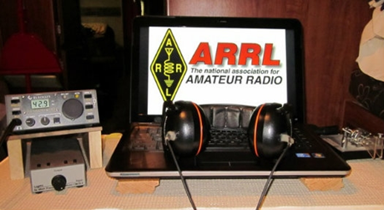

An expanded, downloadable version of QST's Contest Corral is available as a PDF. Check the sponsor's Web site for information on operating time restrictions and other instructions.

March 27  - SKCC Sprint  - QRP Fox Hunt  - Phone Fray  - CWops Mini-CWT Test  - UKEICC 80m Contest | March 28  - CWops Mini-CWT Test  - RSGB 80m Club Championship, SSB
March 29  - QRP Fox Hunt  - NCCC RTTY Sprint  - NCCC Sprint | March 30  - CQ WW WPX Contest, SSB  - Feld Hell Sprint
April 1  - IQRP Quarterly Marathon  - RSGB 80m Club Championship, CW | April 2  - ARS Spartan Sprint
April 3
- QRP Fox Hunt
- Phone Fray
- CWops Mini-CWT Test
- UKEICC 80m Contest

One Question Questionnaire

Hey Gang

There’s another NEW – one question – questionnaire on the Ohio Section Website! http://arrlohio.org

This past week’s poll has shown some interesting facts. This is was the first time we tried giving you more than just a Yes or No answer and it proved to be fruitful for sure. We had a very diverse group of answers, but it looks like 40-meters is the hands down favorite!

TOP ^

6 Meters 2.61%; 10 Meters 12.17%; 15 Meters 1.74%; 17 Meters 5.22%; 20 Meters 19.13%; 30 Meters 2.61%; 40 Meters 45.22%; 60 Meters 0.00%; 75 Meters 4.35%; 80 Meters 6.09%; 160 Meters 0.87%; 630 Meters 0.00%; 2,200 Meters 0.00%

Anyway, these questions are all in fun and I hope that you are enjoying answering these “ONE QUESTION” questionnaires. Ok, enough on that, here’s the next question for you to answer…

“If the Wouff Hong ceremony is done late at night at Hamvention, would you attend?”

You’ll find the “One Question” questionnaire on the Ohio Section Website! http://arrlohio.org It’s all in fun and it’s not a scientific survey in any way, but we are learning some things that we didn’t know from these questions. I hope that you are enjoying answering these “One Question” questionnaires.

V.E. Test Sessions

For the latest testing site information please >> Click Here << The ARRL site tracks all of the VE testing sites that register with them, including W5YI and Laurel. ARRL gives you a number of different ways of sorting to find that site that is closest to you as well.

#########

Exam Session Reminders

GRADING EXAMS: Each VE must grade each exam taken or must agree to the score given. After all three VEs agree to the number of correct answers shown, the score is announced to the examinee. The VEs must inform the examinee of their grade (pass or fail, and state the score {e.g., 26 out of 35}) upon completion of the grading.

NEW GENERAL EXAMS COMING: The new General class question pool will take effect on July 1, 2019 for all Element 3 General class license written exams. With the General class exams changing July 1st, new test designs must be created and used on that day. ARRL VEC will be supplying all its (near 1,000) Field Stocked VE teams with new test booklets about the 3rd week in June. Do not destroy the 2015 versions of the General exams until June 30.

BASIC QUALIFICATION QUESTION PROCEDURES: The detailed instructions are available on the ARRL website. At the exam session, candidates that answer “YES” to the qualification (felony) question should be given the “Applicant Instructions for FCC Basic Qualification Question” document. Print or download here: http://www.arrl.org/files/file/VEs/Applicant%20Info%20Qualification%20Question%202019.pdf

Applicants can also be referred to our Basic Qualification Question web page for information and instructions.
View page: http://www.arrl.org/fcc-qualification-question

After the application data from the session is submitted to FCC and an FCC file number is created, the applicant is required to provide an explanation directly to the FCC within 14 days. Do not collect information from the candidate and do not send any documents to the VEC.

TOP ^

ARES Connect

CQ… CQ…. CQ… Calling all persons to be a part of the new ARES Connect program.

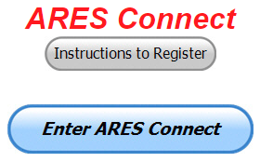
We need to discuss some very important items that only YOU can make a difference with. I need you to get yourselves registered in ARES Connect, that is… if you haven’t already. Now, how do I know that you need to do this? It’s simple, we have 962 now registered in the database and Stan’s last S.E.C. report shows that we have a little over 1,700 persons in ARES right now. As you can see, we still have a way to go to really take advantage of this new system.

As the numbers show, there’s still a lot of you that haven’t taken the plunge yet and need to! What are you waiting for? No matter how much you resist, it’s coming, and we need to make sure that no one is left behind.

Now, as an incentive to get you to not only register…. But to actually start using the system… (Notice how I have that in bold type for you to clearly see?) I am giving away all sorts of goodies to help you get motivated. I have a footlocker of really cool items that I will be giving away!

I’m doing this in various intervals throughout the year, so it will challenge you to be dedicated to getting your hours into the system. You’ll never know just when another drawing will be, so you really do have to be prudent!!

Here’s how it looks so far for March:

 | Name | Events | Hours
1 | Bret Stemen (KD8SCL) | 11 | 72.00
2 | Christopher Domenick (KC8CAD) | 20 | 62.60
3 | Matthew Smith (KE8GTP) | 8 | 51.00
4 | Alan Rothweiler (KD8TNS) | 9 | 47.00
5 | Patrick Gibson (kd8ion) | 5 | 44.00
6 | Jaealyn Himes (N8YMT) | 5 | 44.00
7 | Joshua Gould (AE8JG) | 3 | 43.50
8 | Brian Burley (KE8ANW) | 4 | 41.00
9 | Kevin O'Harra (KD8IIB) | 5 | 37.00
10 | James Yoder (w8erw) | 4 | 36.50

Here’s how we did with people getting signed up for events
and the total hours logged so far in March

Total Amount signed into Events | Total Hours for Events
1411 | 4433.84

TOP ^

Here’s a new bit of information that comes directly from the reports generated out of ARES Connect. This listing shows just how many people are registered in each county and the percentage.

County | # of persons | County | # of persons | County | # of persons
Adams 0 0.00%  Allen 0 0.00%  Ashland 10 1.04%  Ashtabula 1 0.10%  Athens 3 0.31%  Auglaize 1 0.10%  Belmont 3 0.31%  Brown 0 0.00%  Butler 8 0.83%  Carroll 2 0.21%  Champaign 3 0.31%  Clark 9 0.94%  Clermont 4 0.42%  Clinton 7 0.73%  Columbiana 11 1.14%  Coshocton 21 2.18%  Crawford 3 0.31%  Cuyahoga 79 8.21%  Darke 4 0.42%  Defiance 3 0.31%  Delaware 23 2.39%  Erie 32 3.33%  Fairfield 15 1.56%  Fayette 0 0.00%  Franklin 81 8.42%  Fulton 0 0.00%  Gallia 4 0.42%  Geauga 11 1.14%  Greene 30 3.12%  Guernsey 14 1.46% |  | Hamilton 63 6.55%  Hancock 7 0.73%  Hardin 5 0.52%  Harrison 0 0.00%  Henry 0 0.00%  Highland 4 0.42%  Hocking 1 0.10%  Holmes 0 0.00%  Huron 9 0.94%  Jackson 1 0.10%  Jefferson 7 0.73%  Knox 16 1.66%  Lake 29 3.01%  Lawrence 19 1.98%  Licking 23 2.39%  Logan 1 0.10%  Lorain 22 2.29%  Lucas 28 2.91%  Madison 0 0.00%  Mahoning 16 1.66%  Marion 21 2.18%  Medina 20 2.08%  Meigs 0 0.00%  Mercer 0 0.00%  Miami 12 1.25%  Monroe 0 0.00%  Montgomery 84 8.73%  Morgan 0 0.00%  Morrow 4 0.42%  Muskingum 5 0.52% |  | Noble 1 0.10%  Ottawa 5 0.52%  Paulding 0 0.00%  Perry 1 0.10%  Pickaway 3 0.31%  Pike 1 0.10%  Portage 13 1.35%  Preble 4 0.42%  Putnam 0 0.00%  Richland 14 1.46%  Ross 1 0.10%  Sandusky 9 0.94%  Scioto 2 0.21%  Seneca 29 3.01%  Shelby 0 0.00%  Stark 15 1.56%  Summit 27 2.81%  Trumbull 9 0.94%  Tuscarawas 5 0.52%  Union 10 1.04%  Van Wert 2 0.21%  Vinton 0 0.00%  Warren 13 1.35%  Washington 3 0.31%  Wayne 7 0.73%  Williams 1 0.10%  Wood 7 0.73%  Wyandot 1 0.10%

We have a total of 962 folks registered. Now for the bad news, we still have 19% of the counties that have no one registered yet. I know that there are at least ten hams in every county in Ohio. If you haven’t registered yet let this be the reason for you to do it now.

TOP ^
Think you could ever get into the top 10 listing like the folks above? One thing is guaranteed, you definitely won’t if you don’t get registered and start signing up for events!!! It adds up quickly, but you do have to be registered and actually USE the system in order for any of your time to count. We have a set of instructions on how to get registered right above the button to enter ARES Connect. I would strongly suggest that if you haven’t registered yet, that you read these instructions first.

Here’s a link to get you started... http://arrl-ohio.org/ares_connect_directions.pdf Please, don’t just hurry through the questions, read them carefully, if you don’t understand something, please ask me, I’m here to answer your questions.

We know that you mean well by answering that you do have the needed courses in, but I will let you know that we are verifying what you say you have with what is showing for you in our statewide database when we are completing your registration. So, how can you find out if you are already listed in our statewide database? Easy, here’s a link: http://arrl-ohio.org/SEC/special/ICS%20Complete%20by%20County%20and%20Name.pdf

Ok, now on to something new for ARES Connect… I was asked by Ron, NU8N about having a certificate for those who have taken the extra time and courses to get to Level 3. Well, after some thinking about it, Stan and I agreed with Ron that we should have some wallpaper for those who have taken this extra hard step. So, I’m here to tell ya’ that we are now offering a really nice certificate for all of those who have worked so hard to obtain their Level 3 ARES Status.

All you have to do is complete a couple of boxes and we’ll send you a certificate suitable for framing. Now I want to make sure that you understand that you do have to be registered in the statewide database as a Level 3 to qualify for this certificate.

Here’s the link… http://arrl-ohio.org/SEC/level3.html So, if you have certificates that you haven't submitted yet, this is the perfect time to do just that!

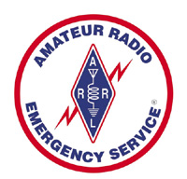
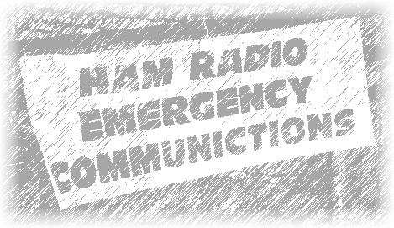

Amateur Radio Emergency Service (ARES)
Stan Broadway N8BHL Ohio Emergency Coordinator stan@standi.com

SUMMARY OF ARES/AMATEUR RADIO ACTIVITY SPANNING 2018- JANUARY, 2019

Here’s a summary of amateur radio activity contributing to the safety of our communities. These include instances as noted when the Ohio RACES W8SGT station was active. It is an integral part of all communication for the Ohio Section. Specifically, ARES volunteers provided $2,674,295 in contributed time and equipment.

TOP ^
Here’s a breakdown of what we’ve done...

Activations and Alerts

The attached report is not complete, these are the activities for which AAR’s were filed to the Ohio Section level.

Date Area affected Activity
Jan 21 2019 | Statewide | “Snow Net” pro-active statewide net established on both HF (80 meters) and DMR (Ohio Talk Group) to provide situational awareness as major winter storm progressed into Ohio. Over 150 reports were received from 44 Ohio counties. Logs with specific were entered every 1.5 hours into WebEOC. Five EMA Directors provided positive response. It was an excellent opportunity to display the wider coverage area and capabilities of amateur radio.  Reports were fed to W8SGT/portable (at Stan’s home)
Jan 12 2019 | Statewide | Ohio ARES VHF Simplex contest. This exercise has stations using 6 meters, 2 meters and 440 (70 cm) to test their antennas and determine where they can successfully communicate. This will translate into successful emergency communications during emergencies.  W8SGT participated and provided an “extra point” contact
Nov 17 2018 | Statewide | Ohio District Emergency Coordinator (DEC) conference & training, Delaware, OH
Oct 29 2018 | Hamilton | Reacting to a 911 outage specifically affecting Wyoming, ARES operators were activated in a “stand by” mode. The situation was stable.
Oct 16 2018 | S.E. Ohio | ARES operators participated in a 6-hour: Warning Team Workshop” by the NWS Charleston, WV station.
Oct 14 2018 | Hamilton | The “ROC” was activated for a POTUS visit. Amateur radio was at the center for several hours. (Note: almost any time the ROC is active, amateur radio is there.)
Oct 13 2018 | Lawrence | Participated in a WV LEPC full-scale exercise
Oct 6-7 2018 | Statewide | Ohio Simulated Emergency Test (SET) This year’s event, “Black Swan 2018”, simulated a multi-state severe weather event (Report on file)  W8SGT is a key player, receiving voice and digital communications (Digital from the Ohio Digital Emergency Net)
Sep 29 2018 | Knox | Kokosing chemical spill full-scale exercise
Sep 18 2018 | OH EMA | Perry Nuclear Plant Drill; W8SGT set up as backup communication link with the affected counties
Aug 25  2018 | Statewide | “Ohio QSO Party” – an event where amateur operators in Ohio counties try to contact as many other counties as possible. Great test of ability and coverage.
Aug 15 2018 | Mahoning | Over several days, ARES was activated to assist in damage assessment after severe storms caused flooding of over 100 homes. This was a district-wide response with volunteers from several counties taking part.

TOP ^
Apr 28 2018 | Statewide | Annual ARES “NVIS Antenna Day” An operating event for designing and testing “Near Vertical Incident Skywave” antennas- designed to transmit over short distances- used to provide in-state communications during an emergency.  W8SGT is an “anchor station” to receive reports and tests
Mar 22 2018 | Licking | Amateurs participated in an exercise, operated MARCS radios
Marr 21 2018 | Statewide | Amateur radio severe weather nets across the state participate in the statewide tornado drill.
Mar 1 2018 | Hamilton | CEMA activated ARES at Field Command and EOC for assessment and flood damage in Cincinnati area.
Feb 25  2018 | State wide | Major flooding and damage from high rivers and lakes. Many ARES groups on stand-by or being used for situational reports.
Feb 24 2018 | State wide | SEC places ARES units on stand-by, readying for potential flood damage
Feb 4 2018 | Hamilton | ARES activated for POTUS FLOTUS visit; ARES at the “ROC”

Public Service Activities
There is really no way to measure all the “Public Service” activities of ARES organizations. From local, homegrown parades to local run/walk/bike events ARES amateurs provide free communication- watching over participants, coordinating with organizers, and helping to keep people safe. From these small events all the way to large scale marathons (Cleveland, Akron, Columbus and many more) amateurs operate communication nets.

In Columbus, “The Arnold” sporting event is the largest in the world (this year with 26,000 competitors) and ALL medical team coverage is coordinated through amateur radio. Another event, the Great Ohio Bicycle Adventure (GOBA) is well known as members cycle through a number of Ohio counties- all coordinated by amateur radio.

Agency Communication
One of the key applications of amateur radio in any larger scale emergency is to provide inter-agency communication to the Ohio HS/EMA. Operating from our well-equipped RACES station W8SGT communication goes out to nearly every Ohio county using a number of high-tech modes capable of transmitting IS-213 and many other message forms digitally.

Our typical activity includes an HF voice net (on 80 and 40 meters, bands permitting) and a digital net. We exercise these nets every week on Tuesday evening. Ohio also has a digital net which specializes in transmitting messages (ARRL, IS-213, others) digitally. The Ohio Digital Emergency Net (OHDEN) also tests every Tuesday evening. W8SGT has extensive VHF/UHF equipment including the new DMR digital communication. We have the ability to talk directly with FEMA stations on 60 meters (this takes special FCC permission) and we have exercised that during several “SET” training sessions.

Training
ARES has established a three-level training spectrum for our volunteers. Level 1 is for those new to the system, or those who for some reason have not yet taken required courses. They are available for public service events and non-critical emergency response.

TOP ^
Level 2 is the normal operational status where volunteers have completed a minimum of four NIMS courses: 100, 200, 700, 800. These, and level 3 operators, will be activated for duty in EOC’s and other critical locations, as well as for ‘mutual aid’ or ARESMAT (ARES Mutual Aid Team) assignments to help other counties.

Level 3 is for “upper management” and other well-seasoned volunteers. It includes the previous four courses, and a combination of IS 300/400, the Professional Development series, or Auxcomm training.
ARES county-level groups are expected to meet at least once a month for training on topics that apply to their local situation. Like those in the emergency service, our training is continuous so that we stand ready when called.

Activation
Like state “Home Rule” government, ARES is organized at the county level, with the county Emergency Coordinator (EC) in charge. Counties are divided geo-politically into 10 districts, those with a DEC. District then report to the Ohio Section Emergency Coordinator (SEC) who is appointed by the ARRL Section Manager (Scott Yonally, N8SY).

At the state level (Watch Desk, EOC activation, etc.) amateur radio response may be activated by contacting Stan Broadway, N8BHL, 614-562-3130 or Richard Wynkoop, KD8PHG, 614-477-9318. W8SGT is a RACES station, volunteers report to Brian Castner and Dave Ford.

On Another Topic – Tornado Day DMR Test

We had 40 check-ins representing all 10 districts during our impromptu DMR Net this past Wednesday morning just before the State of Ohio Tornado Test at 9:50am.

I took check-ins from as many as I could in the short 18 minutes that we had. I know that there were many more out there and wished we could have gotten to everyone, but we really did good for just 18 minutes.

So, a problem right off the bat:
- The Delaware DMR repeater was struck by a lightning-based AC line surge, and yes, as you can imagine, it let the smoke out of the chips. Ken has a new repeater on order. (Sounds expensive)
- I heard the Ohio channel well on Marion (my second-choice repeater) but I started the net at 9:30, and nobody responded, even when I called a station I’d heard. Obviously one-way audio.

I quickly switched to Mt Gilead machine, which fortunately was actually working at the moment. Incoming audio was sometimes chopped (after the first couple words) but then it would come back fairly well. I don’t know (hard to troubleshoot DMR by listening) but I’d guess we were dropping the Internet connection briefly.

Overall it was rushed (I knew it would be) but we managed to skate through all ten districts, and that’s saying something for the dedication of our folks out there. After the state did its thing with sending out all the tones and getting the sirens all over the state a good workout, I had a straggle of another couple dozen guys come on afterward to check in, or recheck, etc. and only occasionally, one or the other side of a conversation would be dropped. I have to think that it may have been a connection to the Mt Gilead repeater, but could have been flakey anywhere in the chain. So, over all I’d say it was a successful statewide test of the DMR system.

TOP ^
(From: N8SY…) We will throw the kitchen sink at it if we need to in a real emergency, but, as you can see by this report, we still have the need to TEST everything when we have the opportunity! Yes, we taxed the folks with several nets all in a row, but if we don’t test the systems and ourselves when we have the opportunity, we won’t know what works and what doesn’t when that real time comes. We proved that we still need to work on some connections around the state, but we also proved that our folks are able and willing to do what it takes to volunteer and help the citizens of Ohio. We were able to get the communications through, and that’s what it’s all about! Thanks everyone!!!

Incident Command System (ICS) Training Schedule

All current trainings are listed on the Ohio EMA training calendar located at:
https://webeoctraining.dps.ohio.gov/TrainingAndExercise/courselist.aspx

I’ve been asked to also include a link to the Kentucky EMA training calendar as well..

https://kyem.ky.gov/training/Pages/default.aspx
https://sites.google.com/site/ccoemtraining/home

Please pay particular attention to these courses listed above, as that there’s a lot of ICS 300 & 400 classes listed that are very useful for all Amateurs to have under their belts. I will also state that G775 is also a very good course to take as well. These 3 courses are multiple day in class courses, so please be prepared to spend some time taking them.

We do recognize that IS-300/400 requires multiple days of actual classroom training that is not easily obtained. So, if you just can't find the time to fit these class room courses in, we do have an alternative method for getting you to Level 3.

Completing the following “FREE” and “ONLINE” courses will act as substitute for you FEMA Leadership Development Course requirements. You absolutely will need to complete all 7 of these courses to get your ICS 300/400 credit. Here are the courses that you need to take: IS-120, 230, 240, 241, 242, 244 & 288.

Now, if you are looking for wallpaper and have a little extra time, taking IS-235 in addition to the 7 listed courses above, you will get a really cool looking certificate from FEMA stating that you have completed the Professional Development Series. That’s impressive in itself!

#########

The Department of Homeland Security (DHS) Returns to Provide Auxiliary Communications (AUXCOMM) Training in Conjunction with Hamvention® 2019

The Emergency Communications Division (ECD) of DHS’s Cybersecurity and Infrastructure Security Agency (CISA) will be on hand at Hamvention® 2019 to conduct its nationally recognized NIMS/ICS compliant AuxComm course. Over 2,500 amateur radio operators from around the country have taken this course. The purpose of this course is to train qualified amateur radio operators so they may assist their local, county and state governments with emergency backup communications if requested to do so.

TOP ^
This course introduces the auxiliary communicator to the other positions within the Communications Unit (COMU) and how to provision emergency communications in a public safety context. The course also goes deeper into the National Incident Management System framework. The location of the course will be at the “Courtyard by Marriott” in Beavercreek, Ohio and be held 14-16 May 2019. Registration for this class may close early when all available seats for this class are taken.

Registration for this course is ongoing: Students wishing to attend the DHS Auxiliary Communications (AuxComm) Course must meet all prerequisites and provide electronic/scanned images of the following required documents prior to 1 May 2019:

Prerequisites:
- A signed copy of your current valid FCC issued amateur radio license
- IS-100 certificate (FEMA issued), IS-200 certificate (FEMA issued), IS-700 certificate (FEMA issued),
- IS-800 certificate (FEMA issued), and the name of the public safety entity, and its contact information, that you would support upon completing this course

Please scan copies of this information, attached it to an email, and then send to COMU@hq.dhs.gov. In the subject line, please put Hamvention AUXCOMM. Your information will be reviewed, and a reply sent back to you indicating that you have been given a seat in the course.

This will be an intensive three-day version of the course with facilitated lectures and student exercises conducted by professional AUXCOMM instructors. This course provides time for interactive discussions and exercises. Should you have any questions regarding this course, please send them to COMU@hq.dhs.gov.

One final note, please mark your forum calendar, on Friday 17 May, to come see us at the AUXCOMM forum. You will be given a glimpse at the new AUXCOMM Position Task Book (PTB), a briefing on the proposed Communications Section for NIMS/ICS and a briefing on one of the most active AUXCOMM states – North Carolina!

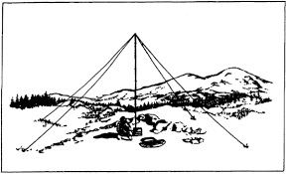
2019 Ohio NVIS Day

Hey everyone, Stan, N8BHL has let me know that the date for NVIS Day is scheduled for Saturday, April 27th. Are you ready? Start your planning now!
Like years past, we are planning on having the operation run from 10 – 4 EDT. Take a lunch break, enjoy each other’s company.

Transmit power should stay at 100 watts for accurate signal comparison. You may operate anywhere, home, club, portable.
Want to know more about what NVIS is? http://arrl-ohio.org/SEC/nvis.html Learn all about Near Vertical Incident Scattering and how you can easily put up a NVIS antenna and participate in this great exercise.

TOP ^

Weather Underground and Other Ham Weather Stations

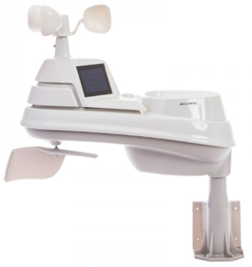
Have you visited the webpage to see all the Weather Underground stations yet? It’s really fun to see just how much th e weather varies across the state and this gives you access to each individual station very quickly and easily.

It seems that our list of stations is growing all the time! We didn’t add any stations to the list this week, but I’m sure that there’s many more out there to add.

Now… How’s about your station, is it listed with us? It doesn’t necessarily have to be a Weather Underground reporting station. I’d love to have any weather station that is connected to the internet available for all of us to view, especially when the weather gets bad out. The more stations reporting the better.

Thanks to everyone who has contributed to this effort. If you haven’t, you really should take a look at the various weather stations around the state when we get bad weather coming in. You can really see just where the line of storms are as they cross through the state. It is very fascinating to watch it all unfold right you’re your easy chair, and all the data is real time! Here’s a link to all of those listed… http://arrl-ohio.org/wus.html

We’re starting to get a really good collection of stations all over. I know that there is a lot more than what we have listed. How’s about sharing your weather information with all of us! All that you need to do is send me your Weather Underground ID and your call sign and I’ll take it from there. Sent it to: n8sy@n8sy.com

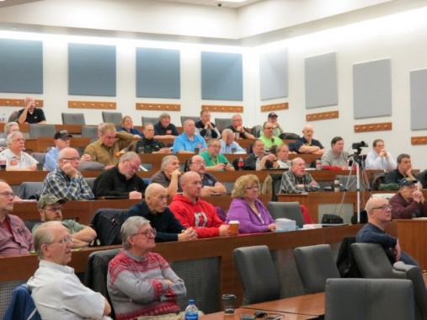
Ohio Section ARES Conference Date Announced

I know a lot of you have been waiting patiently for this announcement. Yes, we have set a date for the Ohio Section ARES Conference… It’s going to be held on April 6th at Marion Technical College / OSU Marion Campus. So, make sure to mark your calendars for this date. Also, don’t forget to “sign up” for this event in ARES Connect as well!

Stan is working diligently on the agenda getting great forums arranged and it’s sure to be a really great conference. There are loads of information for those interested in any part of Ohio’s ARES program. This is an all-day adventure, but we are in a real college setting with all the amenities that you would expect in a first-class campus. Electric outlets are easily accessible for those bringing laptops and such. Wi-Fi is available and the seats are very comfortable. And… I’ll have some great Give-A-Ways to pass out as well.

Lunch is on you, but the campus is close to many popular fast-food and sit down restaurants. You can even brown bag it if you want to eat on campus.

Certificates for your participation at this conference will be available, so you’ll get some wallpaper suitable for framing to take home with you as well! Now how can you beat that.

Get registered now, seating will become limited quickly! Here’s the link: http://arrl-ohio.org/SEC/form.html

TOP ^

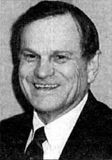
The Allan Severson, AB8P Memorial Award

This coveted award is bestowed on an Amateur Radio operator in the Ohio Section who has demonstrated a continuing dedication to the advancement of Amateur Radio and to the Ohio Section. The recipient has traditionally been chosen over the years by the Section Manager, but I would like to change that starting this year. I want to hear from YOU. Who do you feel is deserving of this prestigious award?

The award was originally established in 1992 and was named "Ohio Ham of the Year" until 1999. That year it was renamed after Allan, of Lakewood, Ohio, who had become a silent key in 1997. The award winners are all hams who, like Allan Severson, have dedicated themselves to the advancement of the American Radio Relay League in Ohio. Although Allan had served the Section as Section Manager and went on to a distinguished career as Great Lakes Division Director on the ARRL National Board of Directors, the annual award announcement only mentions one sentence about him which is part of every memorial award certificate. That sentence quickly demonstrates the reason for the renaming of this award. "Allan's devotion to serve amateur radio inspired a whole generation of Ohio Section leadership."

So, how’s about it. I want to hear from you who you feel is deserving. All you have to do is complete a form with as much information about the person that you are nominating as you can. Several members of the Cabinet and I will look over all the nominations and choose who we feel is the best of the best from those who were nominated. As we have done in the past, the person chosen to be our next recipient will be announced at the Columbus Hamfest on August 3rd.

Here’s a link to the form: http://arrl-ohio.org/sm/severson_nomination.html

Why is the neutral wire at 0V?

A journeyman electrician once gave me 2 very useful bits of advice:
- The voltage on the neutral won’t HURT you.
- The voltage on the neutral will KILL you.

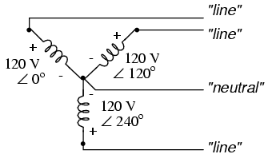
The neutral is NOT ground (unless it is grounded of course). Let’s use 208Vac 3-phase Y-connected as an example. Also, take a glance at the fancy pic that I found on Google.

There are several things going on here:
- There are 3 line-to-neutral voltages at 120Vac.
This is what you use to drive motors, compressors,
etc in a plant.

- There are 3 line-to-line voltages at 208Vac. This usually drives the lights.

- There is NOT an explicit connection from neutral to ground.

TOP ^
If the load on all 3 phases is equal, then the neutral will be closest to zero. If, however, someone splits these line-to-neutral voltages up and loads them unequally, then the neutral will be hot!

Here is a case where you cannot assume anything. Let’s say you have a 3-phase balanced motor that usually runs just fine. Everyone “trusts” the neutral to be safe because their volt meters show minimal potential. One day one of the windings goes bad so it becomes an unbalanced load. That is, the neutral will be swinging all over the place—unsafe. This is why you shouldn’t assume that the neutral is safe.

Also, I’ve seen where the neutral is grounded…but the wiring is sooo long back to the stable ground, or the ground tap is far away from the earth ground bar, so a voltage is standing.

Think “line loss backwards”. This will get ya!

Final.. Final..
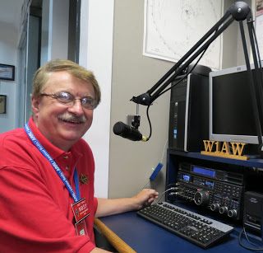
Hey Gang...

I had a blast this past week visiting with many of you at your meetings and events.

Now, let’s move on to more important things... We’ve had some updates on some Code Plugs that Daniel, KB8LKH has been working hard on. He’s got the latest Code Plugs for the AnyTone AT-D868UV Dual Band HT; the Connect Systems CS-800D Dual Band mobile and the Connect Systems CS-800 Single Band mobile. If you have one of these rigs, you’ll want to head up that way and get these newest Code Plugs.

We’ve also had an update from Greg, WD9FTZ on DMR Nets around the country. Greg works hard at keeping up with this for all of us. So, if you have in interest in DMR Nets, you’ll want to download this newest listing from Greg.

ARES Connect... There has been some movement with this new system for the Admins. If you haven’t heard Headquarters has brought back for good the “New Volunteer” bucket. This allows the admins to find those new folks that just signed up to the ARES Connect system. The county admin also can once again “vet” their own people. This means that they can once again go in and change things. It’s really nice to have both of these features back once again. I have been working with the folks at Headquarters to get the data to where you can actually do something useful with it. We now have a master Ohio Section listing of all of those registered in ARES Connect. This listing will be made available to all of the EC’s and DEC’s from the secured end of the Ohio Section website.

I do want to clear up some mis-interpretations that have been going around. First, in the Ohio Section we only require our Level 2 volunteers to have the 4 basic courses, IS 100, 200, 700 & 800. For our Level 3 volunteers we do require the additional ICS 300 / 400, or the equivalent professional series courses IS 120, 230, 240, 241, 242, 244 & 288. These equivalent courses are all on-line classes just like your basic 4 NIMS courses are and being offered as an alternative way for you to get credit for taking the professional series courses in the event you just cannot get scheduled into an ICS 300/400 class.

TOP ^
By the way, if you decide to take these 7 on-line courses and complete them all, you will want to take just one more class IS-235. By completing this additional course, you will get a really great looking certificate from FEMA recognizing that you have completed the entire Professional Series courses.

I do hope that this clears up the confusion that has been going around lately. As we have stated on the website and in this newsletter many times “We don’t want anyone left behind.”

Ok.. One final go around…. Some of you may have had a problem with signing up for the Handbook this month. I do apologize for that. It seems that my Host Server company had been changing some things around and it got the form all confused. I guess it was time for me to update the form and this was its way of letting me know. So, if you were one of the unfortunate folks that couldn’t get signed up for the drawing, try it again. Oh, I do want to remind you that you need to clear your Cache’ out from time to time. Cookies get stored there and it will get you messed up on sites that get changed.

Whelp… That’s going to do it for this time around. Stay safe, stay warm, and most of all… have FUN!!

73, and stay warm and dry!!!

Scott, N8SY

This & That’s

TCTTN Frequency Change
(from Gregg Gary, WB8YYS – Net Manager for the TCTTN)

The Tri County Traffic Training Net (TCTTN) has temporarily relocated to the 146.94 repeater...The have been some audio problems on the 147.015, our regular repeater with many stations and the decision was made to move to the new repeater in the interim until the problem can be resolved.

#########

Special Deal on TYT MD-UV390’s
(from Greg, WD9FTZ)

It has come to my attention that Let’s Get Ready Go is selling the TYT MD-UV380, dual-band, 3,000 channel DMR handheld for $85 including shipping and GREAT customer service.

This radio was selling for $129.99, and sometimes as low as $119.99. Also, this radio uses the SAME codeplug as the MD-9600, and MD-2017, and the same CSV contact file. In addition, this radio uses the same batteries, speaker mic, etc, as the MD-380.

Check out these deals… https://www.amazon.com/gp/product/B07CY6CRZH and on ebay:
https://www.ebay.com/itm/302757540917

#########

TOP ^
Also from Greg, WD9FTZ..

Here is a site that lists how a radio signal is attenuated by building materials. What else is cited is the effect that vegetation and foliage has on a radio signal, too. As you know, TV signals are radio signals, too.

This applies to ANY indoor antenna, whether it is for amateur radio, TV, radio in general, scanner, WiFi, cellular, and so on. Here’s the link: http://otadtv.com/factors/index.html

Back Issues of the PostScript and Ohio Section Journal (OSJ)

Hey, did you know that PostScript and Ohio Section Journal (OSJ) are archived on the website? You can go back and look at any edition simply by clicking:
http://arrl-ohio.org/news/index.html

Chit – Chat, and All That!

Do you know someone that’s not getting these Newsletters? Please, forward a copy of this Newsletter over to them and have them “Opt-In” to start receiving them. Heck, just have them send me an email n8sy@n8sy.com and I’ll get them added to the Ohio Section Emailing list.

We now have many thousands of readers receiving these newsletters weekly. Quite impressive, I’d say! I urge all of you to make sure that everyone, regardless of whether they are a League member or not, get signed up to receive these weekly Newsletters.

You can always “Opt-Out” at any time if you feel this is not what you were expecting. It’s fun and very informative. All of your favorite past newsletters are now archived too.
You can go back at any time and read them. Just go to: http://arrl-ohio.org/news/

Got questions, concerns or would just like to sit and chat awhile? Heck, I’ll even buy the coffee!! Give me a call at (419) 512-4445 or email me at: n8sy@n8sy.com

The pictures on the front page are from various newsletters, Facebook posts and/or were sent directly to me in recent weeks. Take a good look at them, you just might be in one of the pictures! “SMILE… you’re on the Ohio Section News!!”

Go Bucks

TOP ^

PostScript is produced as a weekly supplement to the Ohio Section Journal (OSJ). I sincerely hope that you have enjoyed this edition and will encourage your friends to join with you in receiving the latest news and information about the Ohio Section, and from around the world!

