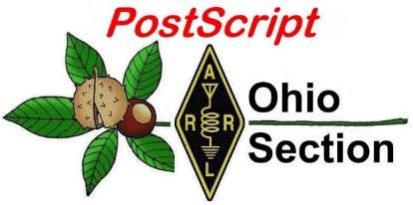
St. Patty’s Day
Edition

National News The Handbook Give Away

Club Corner Hamfests

DX This Week One Question Questionnaire

VE Testing Schedule Final.. Final..

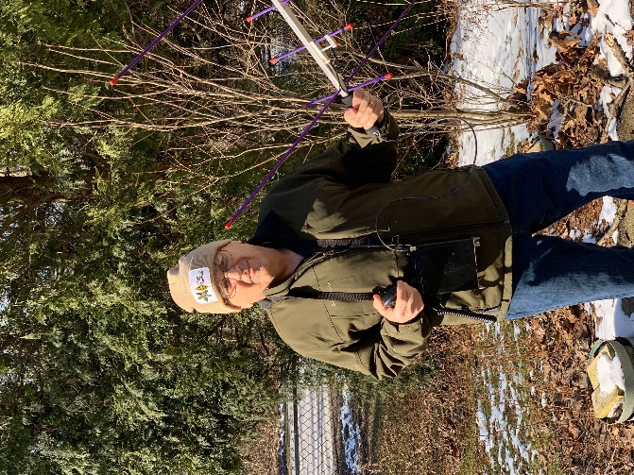
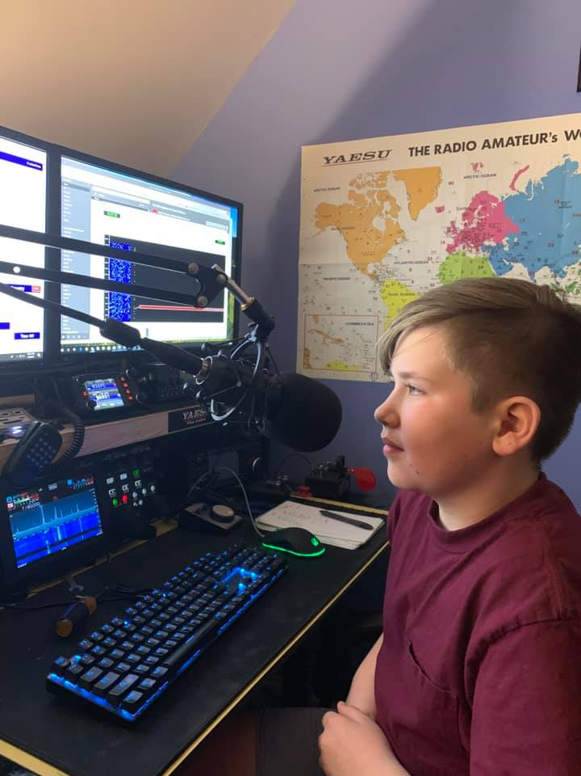
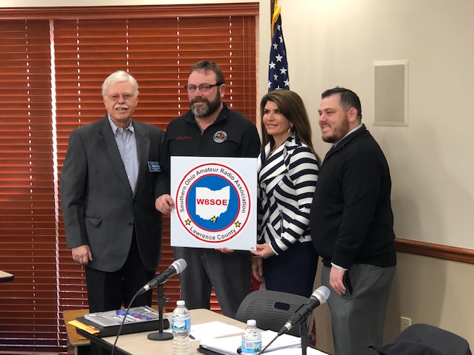
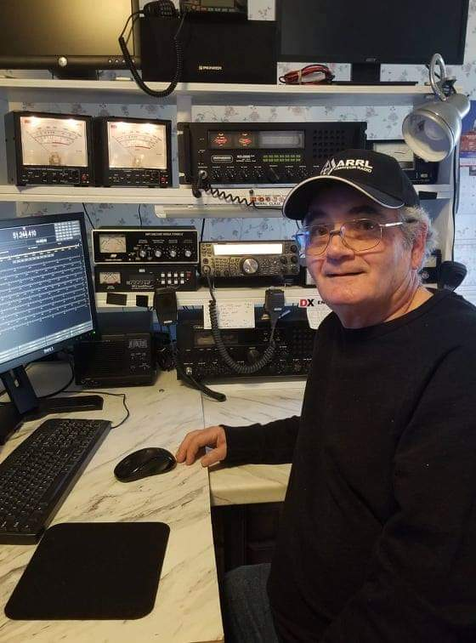
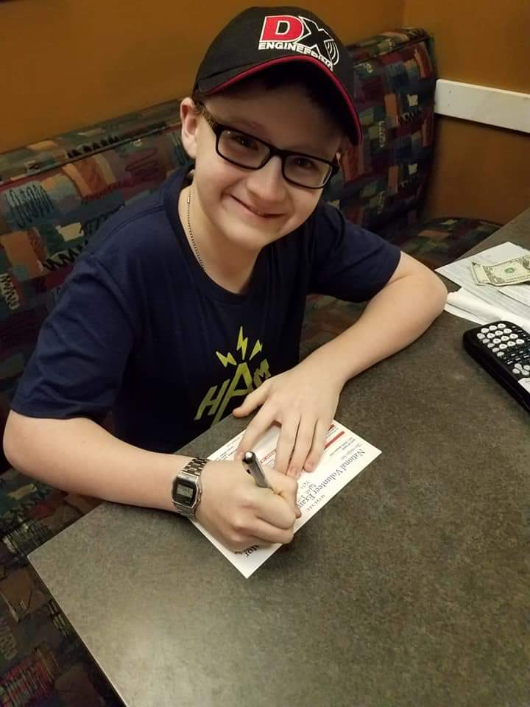
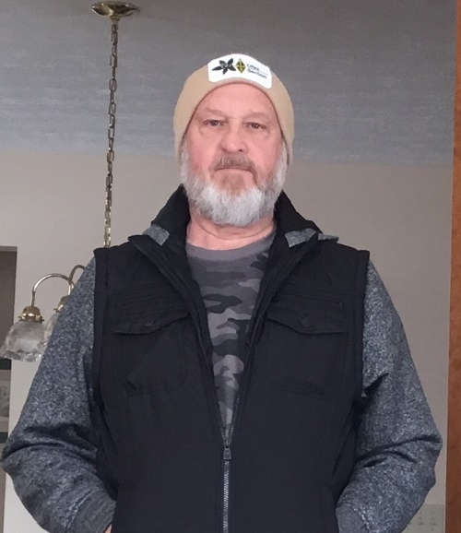

National News
(from arrl and other sources)

Notice of Unlicensed Operation and Harmful Interference
(Case Number: EB-FIELDNER-19-00028401)

The Columbia Office of the Federal Communications Commission’s (FCC or Commission’s) Enforcement Bureau (Bureau) received a complaint from Fayette County Emergency Management Association (Fayette County EMA/911) concerning harmful interference and unauthorized transmission on the frequency 155.190 MHz used for fire communications in Uniontown, Pennsylvania. On February 7, 2019, Agents from the Columbia Office of the FCC’s Enforcement Bureau (Bureau) investigated and determined that Jonathan Campbell of Uniontown, Pennsylvania was the source of the unauthorized transmissions and harmful interference to Fayette County EMA/911.

Jonathan Campbell admitted to operating a Baofeng UV-5R VHF/UHF two-way radio on the frequency 155.190 MHz. The Commission’s records show that no license was issued for his operation on the Public Safety frequency 155.190 MHz in the Uniontown, Pennsylvania area. Radio stations operating on a range of frequencies, including the Land Mobile Radio Service frequency 155.190 MHz, must be licensed by the FCC pursuant to Section 301 of the Communication Act of 1934, as amended (Act).

1 The only exceptions to this licensing requirement are certain transmitters using or operating at a power level or mode of operation that complies with the standards established in Part 15 of the Commission’s rules.

2 Non-licensed operation pursuant to Part 15 of the Commission’s rules, however, is conditioned upon compliance with all applicable regulations in the subpart. All intentional radiators operating pursuant to Part 15 of the FCC’s rules must be certified for use as a Part 15 device, and failure to operate such device consistent with its authorization violates Part 15 of the Commission’s rules. 1 47 U.S.C. § 301. 2 47 CFR §§ 15.1 et seq. In addition, operation on 155.190 MHz is limited to public safety entities.

3 The Fayette County EMA/911 stated that you do not have permission to operate on the frequency 155.190 MHz and alleged that you caused harmful interference to public safety users operating on this frequency. Thus, your station is operating in violation of 47 U.S.C. § 301. Operation of radio transmitting equipment without a valid FCC authorization or license is a violation of Section 301 of the Act

4 and may subject the responsible parties to substantial monetary fines, in rem arrest action against the offending radio equipment, and criminal sanctions including imprisonment.

5 Because unlicensed operation creates a danger of interference to important radio communications services and may subject the operator to severe penalties, this letter emphasizes the importance of complying strictly with these legal requirements.

6 UNAUTHORIZED OPERATION OF THIS RADIO TRANSMITTING DEVICE AND ASSOCIATED HARMFUL INTERFERENCE MUST CEASE IMMEDIATELY AND MUST NOT RESUME

TOP ^
Demand High as New ARRL Introduction to Emergency Communications Courses Open

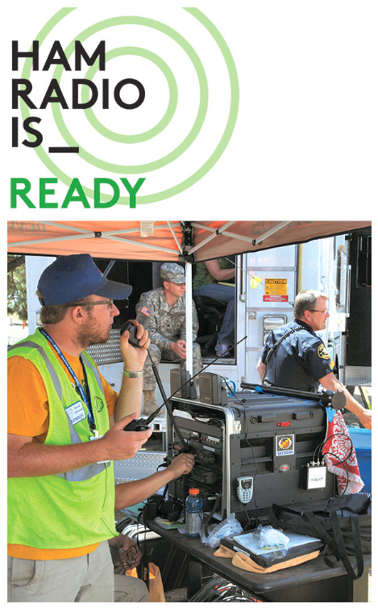
The ARRL Lifelong Learning Department has launched a revised and updated Introduction to Emergency Communications (EC-001) course, and demand to sign up is prompting the recruitment of additional course mentors to expand the schedule. Registration just opened for the first of four EC-001 online sessions, which will run from Monday, April 1, until Friday, May 31.

“The demand for this course has exceeded our projections, and the four sessions scheduled for 2019 are already filling quickly,” ARRL Lifelong Learning Manager Kris Bickell, K1BIC, said. “This course is designed to be interactive with mentors guiding each session, so we’re seeking additional mentors and will schedule more course sessions as quickly as possible. Thanks for your patience as we expand capacity for this updated version of EC-001.” Bickell is developing a notification list (scroll down) to alert those who didn’t get into the first round of courses when a new round of sessions becomes available.

The new EC-001 course has been beta-tested by course mentors and transferred into a new online learning platform. With the closing last year of the Connecticut Distance Learning Consortium (CTDLC), EC-001 lost its virtual home and was taken offline. At that point the ARRL Emergency Preparedness and Lifelong Learning teams started exploring short- and long-term alternatives to offer the course. After careful evaluation and review, a decision was made to move the course to a more modern learning management system called Canvas, which will be used while the new Lifelong Learning Initiative program is under development. EC-001 will eventually become a part of a comprehensive online learning environment.

“We’re very excited to be able to offer Introduction to Emergency CommunicationsEC-001 once again,” Bickell said. “The Emergency Preparedness staff here has been incredibly helpful as we’ve worked together to get the course back up and running. Input from previous EC-001 mentors has been an invaluable part of the testing phase. The timing is right to put the course back online.”

EC-001 is designed to provide basic knowledge and tools for emergency communications volunteers. With the online format, students can access the course at anytime from anywhere during the 9-week period and may work at their own pace and on their own schedule. As in the past, students will be able to register and take the course entirely online. The Canvas platform is also mobile-responsive, meaning that students can view the course materials, interact with fellow students, and complete assignments from any mobile device.

“We hope this course will be the starting point for you in your service to your community as radio amateurs and inspire you to think outside the box and look at new and useful ways the radio amateur can lend a hand to the public that has given us the trust of our spectrum of skills,” ARRL Assistant Emergency Preparedness Manager Ken Bailey, K1FUG, said.

Individual EC-001 sessions will serve up to 30 students, supported by an experienced mentor. Courses are free of charge. To be eligible, students must meet certain prerequisites, listed on the registration page. The registration page includes the entire 2019 schedule of EC-001 sessions.

TOP ^

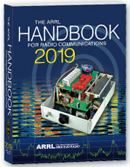
The Handbook Give Away

Hey Gang,

The “Handbook Giveaway” drawing will soon be returning for another big “Give Away”

Many of you ask me just how do I know when the drawing is on? Well, that’s easy all you need to do is check in on the Ohio Section Website on a regular basis and watch for the big RED Arrow that will appear on the left side of the page. This is the sign that the drawing is on and you need to get registered. So, keep a sharp eye out on the website and check in often! http://arrl-ohio.org

What’s the catch? I want to get everyone checking in to the Ohio Section website as often as possible, and in order to register each month, you have to visit the website often! There’s nothing else to it. I pay all expenses, and from time to time, I Give Away more than just a Handbook. And, you’ll never know just what months will be those special times that I will have more than just a Handbook to Give Away!!

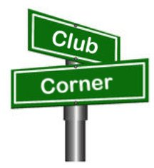
Club Corner

This is YOUR cornner of the newsletter. Send me what your club is doing and I’ll make sure that it gets in. Got a special event or club project that you want everyone to know about? Send it to me!. Need help with a project? Send it to me.

Let me know what you club is up to. Are you going to have a special guest at your meeting or are you having a special anniversary? Just sent it to:
n8sy@n8sy.com

#########

Carole Perry to Visit PCARS Meeting in March
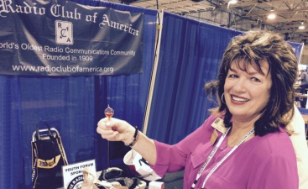
Carole will be coming to the Portage County Amateur Radio Service (PCARS) meeting on March 11th! She always has outstanding presentation, so I know that you’ll want to hear her speak for sure! So, get your calendars marked for this very special guest speaker!

Carole will be discussing how to get youth involved in Amateur Radio. I cannot think of a more qualified person to talk with us on this topic. I know you’ll want to be there!!

TOP ^
Carole is the recipient of the prestigious 1987 Dayton Ham of The Year Award, the 1987 ARRL Instructor of The Year Award, the 1991 Marconi Wireless Memorial Award, the 1993 QCWA President's Award, the 1996 Radio Club of America (RCA) Barry Goldwater Amateur Radio Award, the 2009 RCA President's Award, the 2012 RCA President's Award, and the 2015 Vivian Carr Award for Women in Radio. She is the winner of the 2016 SOAR (Sisterhood of Amateur Radio) Legacy award for Pioneering Women in Amateur Radio, and the 2016 recipient of the YASME Foundation Award for Excellence. She is an RCA Fellow, and in 2007 she was elected to the RCA Board of Directors; a position she still holds, and she created the Youth Activities Committee which she now chairs.

She serves on the RCA Scholarship committee as well. She also created the RCA Young Achiever's Award, given to students in grade 12 and below who have demonstrated excellence and creativity in wireless communications. One hundred and seven youngsters have received this award along with a stipend, so far. Carole is also presently a Director for QCWA (Quarter Century Wireless Association). The QCWA Youth Activities program was created and chaired by Carole.

Carole has moderated the Dayton Hamvention Youth Forum and Instructors' Forum for 31 years. She is a member/director of QCWA and RCA. She is also a member of ARRL, DARA, (Dayton Amateur Radio Association) AWA (Antique Wireless Association), and Brandeis Women and is a contributing columnist for CQ Magazine’s Youth Column.

Want more information? Contact Tom, wb8lcd@arrl.net

#########

Science Fair Volunteers
Hello everyone!

Well, that time of year has arrived again, and the Mohican District Science Fair is only weeks away (March 23). We will be having our work night on Tuesday, March 19, at 6:00 p.m. in Room 218 Kettering at Ashland University. I hope to see you there - the more who can make it, the faster things will go. Please let me know one way or the other if you will be able to attend.

One huge area of concern (as always) is the judging. As of right now, there are 172 projects registered and only 43 judges. Since the registration deadline is this Friday, I expect the number of projects to grow. So I am asking you to please, please, please find as many qualified judges as possible. They can register on our website at mdsd.apps.ashland.edu.

I am currently spending 5-6 hours a day on the registration website checking in participants and sending email messages if there are problems, so I am hoping that you can help me out in finding more judges. I think we need at least 100 total and I just don't have time right now to search for judges.

I look forward to seeing everyone on the 19th.

Need more info? Contact Mark: andressmg@frontier.com
#########

TOP ^
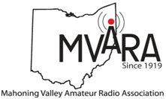
Mahoning Valley ARC

Help Wanted -
The Youngstown Road Runners Club is having their annual Mill Creek Distance Classis half-marathon race on Sunday, March 24, & amateur radio operators are once again being asked to help. We will be meeting in the Fellows Riverside Gardens parking lot at 8:00 so everybody can be in their position before the races starts.

Need more info? Contact Jim: wb8ujs@arrl.net

#########

TMRA Holding Classes
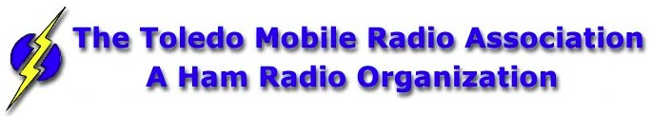
SPRING TECHNICIANS (Entry Level) HAM RADIO LICENSE CLASS (2 DAY COURSE) -
NOTE: Two separate days (March 23rd, and April 6th), with test session on April 6th at end of class.
The TMRA Education Committee has released the schedule for the Spring Technicians Class. The class schedule will follow our traditional style. Two classes held two weeks apart and a V.E. Testing Session after the final class. The Class is FREE, you will have to provide your own book, or one can be purchased from the TMRA ($25.00). (ARRL Edition 4 book) The testing session will cost $15.00 which is the standard fee set by the ARRL.
THE DATES ARE AS LISTED BELOW
* CLASS ONE WILL BE HELD ON SATURDAY MARCH 23RD, 2019 FROM 08:00 TILL 17:00
* CLASS TWO WILL BE HELD ON SATURDAY APRIL 6TH, 2019 FROM 08:00 TILL 17:00 (This includes the V.E.Session)
Both classes will be held at
LUCAS COUNTY EMS TRAINING CENTER
2127 JEFFERSON AVE
TOLEDO OHIO 43624
To Enroll in the Class, or for more Information please contact
STEVE STALKER / KC8TVW 419-467-3734 kc8tvw@arrl.net
Also, please join us for a 4-hour follow-on class on April 13th (9am) called, "I now have my ham radio License, now what?". This class is intended to help get newly licensed hams started with additional needed information. Location is TBD.

#########

TOP ^
New Ham - Info Class - Saturday, April 13, 2019 at 9 AM – 1 PM

Relaxed Learning Session: I'm new to Amateur Radio! Now what?!

Join Toledo Mobile Radio Association Members at the Lucas County EMS Training Center for a FREE learning and Q&A session that should work to help you get started with some of the practical items that we all wish we knew when starting off in Ham Radio. Any/everyone is welcome, and you do not have to have attended the class to attend. Most hams licensed less than 3 years will find the session useful.
This session will be run as a "class” but is open to ANY questions along the way. Folks are free to come and go as you wish. This training session is a great place to get to know TMRA members and for newer amateur radio operators to ask questions related to items they are concerned about or need help with. We know that this hobby has a lot of new items for everyone to get familiar with, so this is an attempt to short-cut that learning!
We'll discuss and help new hams resolve some of the typical early ham radio challenges including (but not limited to) the following types of discussion items (no specific order):

- Answer any early questions and discuss list of items that we all have soon after becoming a ham. (and worries that we each had)
- Discuss Hand-held and mobile radio types / drawbacks and benefits. Who can help me program it? How can I make my HT more effective?
- What is needed to setup and use a mobile or "base" radio - in car or in home (and benefits and types).
- Discuss Effective Radiated Power in terms of Antenna benefits - Discuss types of antennas indoor/outdoor options (and why). Horizontal vs. Vertical antennas.
- Types of feedline (we often refer to "coax) and what you will need (and for what) - and where to find it.
- VHF/UHF vs HF - Who can I talk to and when?
- Discuss using local Repeaters, internet linked repeaters, PL Tones, (repeaterbook/radio reference)
- Discuss Simplex vs Repeater typical etiquette (just so you know) - Examples: Q signals, calling CQ, breaks, etc.
- First Contacts – what to expect (most important, you won't be judged so don't "sweat it".... really...)
- Hamfests + Ham Conventions. - Why bother?
- Where should I buy equipment and what are the risks?
- Useful websites
- Foxhunting and Satellites - how/where?
- Where to find manuals and information?
- If there is time: Antenna Analyzers and SWR Meters - what are they and when do I need one?
- If there is time: N vs PL-259, vs SMA, versus BNC connectors
- Benefits of joining organizations/clubs
- Foxhunts - what are they and how does it work? Do I need anything?
- HF - club events (what can I participate with?) - Operating events.
- Callsigns, vanity and considerations
- QSL Cards and Logbook of the World
- Propagation - Tropo ducting, Sporatic E, Aurora, sunspot cycle, seasonal patterns

We look forward to seeing you there!

#########

TOP ^
Ohio Courthouses on the Air Special Event
RE: Ohio Courthouses on the Air Special Event
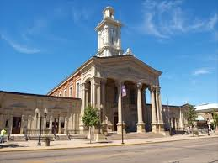
Are you interested in participating in the Ohio Courthouses on the Air Special Event? John Levo, W8KIW the Highland ARA and Michael Love, WB8YKS the Southern Ohio Amateur Radio Association (SOARA) are in the preliminary stages of organizing the event. As of now (subject to change) we are looking at Saturday, August 24th from 10:00 to about 4:00. The time will be determined by the different clubs. Modes and frequencies are being reviewed including statewide DMR. This will be a rain or shine event. I have reached out to the Administrator of the Lawrence County Commissioners to arrange for me to be added to their meeting agenda to discuss our request. SOARA wants to setup on the lawn of the courthouse if possible.

We envision this to be a really FUN event while prompting Amateur Radio across the state and across the country and will be an historical event celebrating the history of each county’s courthouse. I will be working with the Briggs Lawrence County Public Library, Historical Society, EMA, Sheriff’s Office, EMS, government officials, news media, Chamber of Commerce to promote this public event in Lawrence County.

We will keep you advised as to details and locking in the August 24th date via the Monday Morning Memo, Ohio Section PostScript and Ohio Section Journal. We are looking forward to hearing you on the air during the Special Event! Thank you again!

Contacts for the events are:

John Levo, W8KIW, Editor of the Monday Morning Memo
highlandara@yahoo.com

Michael Love, WB8YKS
SOARA / ARES PIO
Mlove82a@zoominternet.net

#########
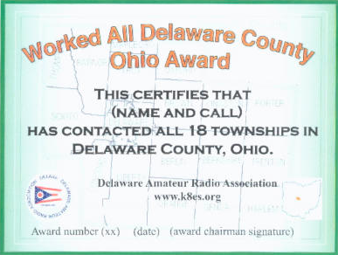
WADCO - Worked All Delaware County Award

Official Rules of the Worked All Delaware
County, Ohio (WADCO) Award

Sponsored by the Delaware Amateur Radio Association

1. Establish two-way contact with stations in all 18 Townships of Delaware County, Ohio.

2. All contacts must be made after June 30, 2012.

TOP ^

3. All bands and modes are allowed, including repeaters. This is to make it easier for Technician class licensees to earn the award.

4. To apply for the award, fill out the Application Form electronically and email it to the award chairman w8erdbob@gmail.com No QSL cards are needed. Totally paperless.

5. You will receive your award certificate via email, which you can then print if you wish.

6. This award is totally FREE!7. Special endorsements are available for contacting all townships on any single band or mode, or for any 5 bands. Helpful Hints: An overview map of Delaware County, showing its townships, is here: http://www.co.delaware.oh.us/cities

A detailed, zoomable map of Delaware County, also showing its townships, is here: https://engineer.co.delaware.oh.us/wp-content/uploads/sites/12/2018/04/fp13.pdf

You can find the Zip code and address of any ham at www.qrz.com.By using its "detail" feature, you can get a map of the ham's location. Compare that map with the above two maps to find the Township.

Another map that is useful in this regard is the Delaware County Zip code map found here: http://delco.maps.arcgis.com/home/index.html

Many Delaware County hams are active in the Ohio QSO Party. There may be rovers to various townships, and DXpeditions to rare townships.

There are about 540 hams in Delaware County, and there are hams in every township. Let us know if you need just a few more, and we will try to help you. The Delaware County net is every Monday evening at 8PM Eastern USA time, on the W8SMK repeater. Other repeaters in and near Delaware County can be found in the Repeater Directory.

########

Pioneer Bus Trip to Hamvention

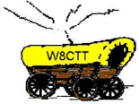
It is never too early to plan a trip to Hamvention. Each year the Pioneer Amateur Radio Fellowship has offered to bus hams to this great event. The bus leaves at 5:30 AM the Saturday of Hamvention, it does stop at McDonald's for breakfast and arrives at Hamvention about 9am, just in time for the doors to be open. The bus leaves around 5pm and stops for a buffet for supper! You won’t go hungry on this trip for sure! You arrive back at the pickup point about 9:30pm, so it’s not too late, but you will have had a full day for sure.

The bus has a number of very large storage areas for all your purchases, so you don’t have to worry if you’ll have room for that “just can’t do without boat anchor!”

Click Here to read the flier and the form used to register for this trip.

TOP ^

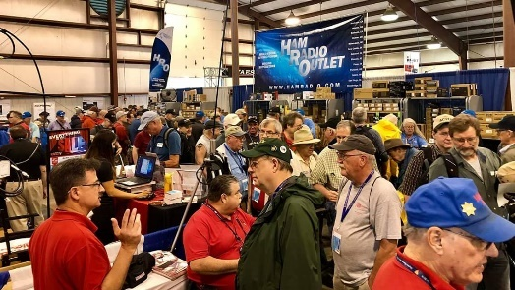
Upcoming Hamfests

03/16/2019 | Gallipolis Ohio Hamfest
Location: Gallipolis, OH
Sponsor: Mid-Ohio Valley Amateur Radio Club

03/17/2019 | Hamfest and Computer Fair  Location: Perrysburg, OH  Sponsor: Toledo Mobile Radio Association  Website: http://www.tmrahamradio.org | 04/13/2019 | 65th Annual Cuyahoga Falls ARC  Location: Cuyahoga Falls , OH  Type: ARRL Hamfest  Sponsor: The Cuyahoga Falls ARC, Inc.  Website: http://cfarc.org
04/20/2019 | Portsmouth Radio Club Hamfest  Location: Portsmouth, OH  Sponsor: Portsmouth Radio Club  Website: https://www.facebook.com/w4pox/ | 04/28/2019 | Athens Hamfest  Location: Athens, OH  Sponsor: Athens County Amateur Radio Association  Website: http://www.ac-ara.org/

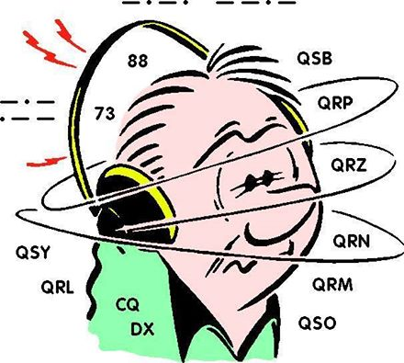
DX This Week
(from Bill, AJ8B)

Bill AJ8B (aj8b@arrl.net, @AJ8B, www.aj8b.com or www.swodxa.org )
CWOPs Member #1567

Uncle Frank and I were talking about DX and the “good old days” as some of us are known to do. We had to take some time to think about what good sunspot numbers are and how DX responds when the numbers are good. Frank can recall achieving WAC (Worked All Continents) using 100 W to a dipole on 10 meter SSB over a weekend. I decided to query some of the SouthWest Ohio DX Association members to see what their recollection was of DX during “good solar sunspots.” We keep talking about the end of Cycle 24, the start of Cycle 25 etc., but many hams may not know what that means and what may lie ahead. In my experience since 1971, there are three big differences between the top of the cycle and the bottom of the cycle; which band might be open, where the band is open to and the noise level. Below are some of the responses that I received:

+ ---------------------------------------------------------------------------------------------------------------- +

In February of 1990, I was tuning up my HW-101 on 10 Meters issuing a QRL? AP2JZB came back to me as he heard me tuning and checking things out. He gave me a 5/4.
In July of 1999, I worked over 120 Russian stations AFTER 11 PM on a Friday night in to Saturday on 20 meters. (I was in to Oblast chasing - similar to our county hunting) My last QSO was at 4 AM and his signal was 459 so I don't think the band was dead yet but I was!.

TOP ^
In 2000, I had a 90-minute SSB QSO with ZL2NX that was absolute arm chair copy. My wife thought I was on speaker phone with someone from work!

In 2011, I was able to earn DXCC from my car running 100 watts. In fact, the majority of the QSOs were on 10 and 15 meters and most of the time I received excellent signal reports. Those countries confirmed included

Japan, Australia, New Zealand, and India.

Fish in a barrel when we are at the top of the cycle! -- Bill AJ8B

+ ---------------------------------------------------------------------------------------------------------------- +

In 1990 as VP5N we worked 10,000 q's on 10 meters. -- Joe W8GEX

+ ---------------------------------------------------------------------------------------------------------------- +
Back in the late 80's, I worked 13 different Alaskan stations in about a 2-week period on 6 meters with 100 watts. One was even on 6-meter FM!! I wish the sunspots were as plentiful as the raindrops. – Rick K8WWA

+ ---------------------------------------------------------------------------------------------------------------- +

In 1978/79 even before the peak of Cycle 21, Europeans would come booming in on 40 meters by 4 pm on the East Coast. I could work anyone with 40 watts of CW and a dipole from my college room.

Not ham related but close, in 1979 (again not even the peak of Cycle 21) our volunteer fire company was dispatched on 33 MHz FM and we would have false alarms on pagers from dispatches out of Orange County California. Every afternoon one could listen to the activity in CA just above 10 meters and on FM! – Tom NR8Z

+ ---------------------------------------------------------------------------------------------------------------- +

On the 10 of March of 2002 there was an especially good opening on 10M to asia. When conditions are good I check to see what is on 10M FM (29.6 MHZ) as it take a strong signal to make full quieting. I started off working BA4RF at 0005z. Then BG2EX, BG2GG, some JAs Conditions were getting better and at 0153 I worked BG2XAO who had a special class of license that was only allocated to 10M FM and VHF. His power was 5W. BG4RBN and BG4RED followed.

On September 9 2002 I was tuning around on 10M SSB and we had a good opening to Asia. I heard this guy calling CQ, it was P5/4L4FN. No pile up.

In the early 2000's I did not have a 6M beam but found out that the Mosley PRO57B had a low SWR on 6M. I don't think it had much gain if any. Previously I had worked some Europeans on 6 with it, for sure it wasn't a competitive antenna, but found that with 100W, it was possible to work DX on 6 with a good F2 opening. On the 18 of Nov 2001, I worked KH2JU on 6M SSB using 100W and the PRO57B. S9 both ways...
And then the 8 Dec 2001 it was KL7 day on 6m. I worked 9 different stations CW and SSB in Alaska. Never since then have I heard a KL7 on 6. Wonder to this day if I had a good antenna and amplifier what would be in the log.

TOP ^
Another good opening, I remember was to VK0M on 10M It was the 29 March 2012. There were some spots for VK0TH, and I started listening around 2300z. His signal was weak but building. At 2317 I made contact on CW.... The conditions kept improving... by 0200 he was well over S9. I was wondering if it would be possible to make a QRP QSO with VK0M.... There was a pile up, so it was a challenge. At 0215, I made a QSO with 5W... Amazing conditions. – Jack N8DX

+ ---------------------------------------------------------------------------------------------------------------- +

Late 80’s I worked worldwide DX with a ground mounted 10m vertical with 4 radials. This happened daily from the time I got off work to well after sunset. – Kevin W8KJ

+ ---------------------------------------------------------------------------------------------------------------- +

From my mentor and friend, Jay - K4ZLE, I have included an explanation of the various solar indicators. Jay is a prolific author and has penned several articles that I have already used. (with his permission of course) Below is Jay’s contribution.

The data for this article is unabashedly plagiarized from the ARRL Propagation Forecast Bulletin 18 ARLP018 by Tad Cook, K7VVV. That bulletin gives more detail than I will in this article. You may read the current bulletin by accessing the ARRL web page at http://www.arrl.org. Whether you work DX or not it behooves you to know how to relate the reported sunspot number to expected HF propagation.

Amateur Radio operators who use HF generally like increased sunspots because they correlate with better worldwide radio propagation.

When there are more sunspots, the sun puts out radiation that charges particles in the earth's ionosphere. Radio waves bounce off of (refract from) these charged particles, and the denser these clouds of ions, the better the HF propagation. Sunspot numbers are calculated by counting the spots on the visible solar surface and measuring their area.

Another related number you hear about is Solar flux. It is measured at an observatory in Penticton, British Columbia using an antenna pointed toward the sun hooked to a receiver tuned to 2.8 GHz,(a wavelength of 10.7 cm). Energy detected seems to correlate somewhat with sunspots and with the density of the ionosphere.
Two other ‘numbers’ of concern to the HF operator are the Planetary A index and the Planetary K index. Both relate to geomagnetic stability. Magnetometers around the world are used to generate a number called the Planetary K index. A one-point change in the K index is quite significant. K index readings below 3 generally mean good stable conditions, and above 3 can mean high absorption of radio waves. Each point change reflects a big change in conditions.

Every 24 hours the K index is summarized in a number called the A index. A one-point change in the A value is not very significant. A full day with the K index at 3 will produce an A index of 15, K of 4 means A of 27, K of 5 means A of 48, and K of 6 means A of 80. You can find an explanation of these numbers on the web at http://www.ngdc.noaa.gov/stp/GEOMAG/kp_ap.html .

The numbers reported on WWV are the Boulder K and A index, measured in Colorado. These are not the Planetary numbers. These numbers will tend to be higher than the Planetary numbers because they are from one location in the northern quarter of the earth. The further north the measuring station, the higher the K and A indices reported.

TOP ^
This is because the effects of geomagnetic instability tend to concentrate toward the polar regions of the globe. You can hear the Boulder K index updated every three hours on WWV, or by calling 303-497-3235. Since the Bolder numbers tend to be higher they present a worse case picture of magnetic stability. For an interesting web page on the earth's magnetosphere, check https://www.swpc.noaa.gov/phenomena/earths-magnetosphere

Other solar activity of concern to HF operators are solar flares and coronal holes, which emit protons. Since the charged ions in the ionosphere are negative, a blast of protons from the sun can neutralize the charge and make the ionosphere less refractive. These waves of protons can be so intense that they may trigger an event called a geomagnetic storm. In addition, energy from a solar flare may energize the D-layer of the ionosphere, which absorbs radio waves. When this happens, propagation can be so severely affected as to have total black out conditions on the HF bands.

In summary: Generally speaking the higher the sunspot or flux number the better. However, we may have ‘good’ sunspot numbers but have poor magnetic stability. The lower the K and A numbers the better. We desire K’s below 3 and A’s below 15. Solar flares and coronal holes are bad for HF propagation.

From our friend at the DailyDX and the WeeklyDX, and the best source for DX information, (http://www.dailydx.com/ ) Bernie has this to report:

VK0 - Macquarie Island VK5MQ, Norbert, has been on Macquarie Island since March of last year as part of the ANARE team working here for one year. Within a month of arriving he began operations as VK0AI, mostly on FT8. Time is getting short as he only has a "couple more weeks of operating" before Norbert has "to pack up the remaining ham gear for return to Australia".

VK0AI is expected to QRT "sometime in March". "As far as I know there will not be another Amateur Operator here at Macca for the coming season" says Norbert. Norbert has been mostly on FT8 as the "propagation has been really poor" and would much rather do some SSB. When he has tried to get on SSB he has had no results and has "hardly ever hear[d] any SSB signals anyway. In the coming days he will start on SSB on 14.195, listening 14.210 and 7.050 MHz in his afternoons (local time) after work. If he does not get any response he will go back to FT8. "Hope I have been able to give Macquarie Island to those keenest Amateurs" as "it's been tough this end" reports Norbert. Confirmations go via eQSL, LoTW, via the bureau or direct to VK5MQ. "I will attend to the large backlog of QSLs mailed to me when I land in Australia in April", says Norbert. The Aurora Australis icebreaker is expected to depart from Hobart on March 5th arriving at Macquarie Island on March 8th and then heading back to Hobart on March 23rd. For those who still need Macquarie Island NE8Z, Rick, who worked him on 40, 30, 20 meters and decoded him several times on 17 meters makes the following recommendations in the hunt for VK0AI.

1. PSK Reporter monitoring for VK0AI "all bands, FT8" (on the shack computer and on a laptop set up next to the bed at night! hi) yes, I can open "one eye" at night and see if he is shown on PSK Reporter. Here in Michigan Norbert is typically active from MN until 6am our local time-EST. Most of his openings to Michigan from Macquarie Island are on 40m or 30m FT8 between 4am and 6am local time (0900-1100z) when I am typically sleeping.

2. Do not rely on the DX Cluster Network as many stations that use FT8 do not put out SPOTS on FT8 QSO's.

3. Gray Line map: I watch this closely. It gives me a good idea when he is waking up and going to bed. Most of his activity is at his sunset and for a few hours afterwards.

TOP ^
4. You can watch: "Journey to the Edge of Nowhere", a beautifully made documentary about life and research on Macquarie Island - https://www.youtube.com/watch?v=aB9YVEZX5PU 5. Macquarie Island time chart: Current Local Time in Macquarie Island,
https://www.timeanddate.com/worldclock/australia/macquarie-island

More info can be found at www.swodxa.org or www.aj8b.com

SWODXA DX DINNER® ANNOUNCEMENT

March 1st, 2019
Mindi Jones – KC8CKW (kc8ckw@fuse.net)

FOR IMMEDIATE RELEASE

The SouthWest Ohio DX Association (SWODXA) has announced that Charles Wooten, NF4A, will be the keynote speaker at the 34th annual DX Dinner®. The dinner, held in conjunction with the 2019 Dayton Hamvention®, will be on Friday, May 17th, at the Marriott Hotel in Dayton.

Charles Wooten, NF4A, has been licensed for over 56 years and has been a DXer from the start. Charlie has achieved the DXCC Honor Roll. He is the current Southeastern Division Representative on the ARRL Contest
Advisory Committee. He was a referee for the WRTC-2006 international team championship held in Brazil in July 2006, WRTC-2014 New England/USA, and WRTC-2018 Lutherstadt, Germany.

• Amateur call signs held: P4/WA4IMC (Aruba), HA/WA4IMC(Hungary), OK8EMC (first US ham to hold OK Callsign..1991), T9/NF4A(Bosnia), 9A/WA4IMC(Croatia), 9A/NF4A(Croatia), C92A (Mozambique). Currently holds Croatian call sign 9A5PC.
• Member of K4M DXpedition to Midway Island, 2009
• Member of PJ7E DXpedtion to St Maarten 2010
• Member of C82DX DXpedition to Mozambique 2013

Charlie was named Clear Channel Radio Small Market Engineer of the Year in 2003 and 2004 and the Clear Channel Radio National Engineer of the Year in 2005.

For 14 years, Charlie was a Broadcast Engineering Consultant, building over 120 broadcast facilities (RF and Studio plants) including over 30 in Eastern Europe (Czechoslovakia…now Czech Republic and Slovakia, Hungary and Croatia) from 1991-1997 for the US State Department after the fall of communism.

Charlie is a Senior Member, Society of Broadcast Engineers and is currently the Director of Engineering and IT, iHeart Media (formerly Clear Channel), Panama City, FL

For more information and to order dinner tickets, visit: WWW.SWODXAEVENTS.ORG and follow us on Twitter (@SWODXA).

TOP ^

ARLD010 DX news

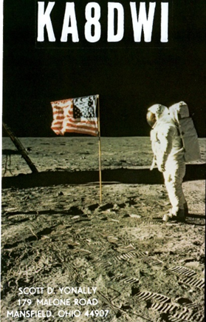
This week's bulletin was made possible with information provided by The Daily DX, The OPDX Bulletin, 425 DX News, DXNL, Contest Corral from QST and the ARRL Contest Calendar and WA7BNM web sites. Thanks to all.

MAURITANIA, 5T. Johannes, PA5X is QRV as 5T5PA from Nouadhibou for the next 6 months. Activity is on 160 to 6 meters using SSB, RTTY and FT8. QSL to home call.

LESOTHO, 7P. A group of operators are QRV as 7P8LB until March 16 from the Molengoane Lodge. Activity is on the HF bands using CW, SSB and FT8 with two to three stations active. QSL via M0OXO.

BARBADOS, 8P. Dick, G3RWL will be QRV as 8P6DR from March 13 to April 17. Activity will be holiday style on 80 to 10 meters using CW and some RTTY. QSL to home call.

GHANA, 9G. A group of operators are QRV as 9G2DX until March 20.
Activity is on the HF bands using CW, SSB and FT8. They plan to be active from three different WWFF locations. QSL via M0OXO.

BAHAMAS, C6. Dom, M1KTA is QRV as C6AKT from Eleuthera, IOTA NA-001, until March 16. Activity is on 80, 40, 20, 15 and 10 meters using only CW. This includes being an entry in the RSGB Commonwealth CW Contest. QSL to home call.

JUAN FERNANDEZ ISLAND, CE0. A group of operators will be QRV as XR0ZRC from Robinson Crusoe Island, IOTA SA-005, from March 9 to April 3. Activity will be on 160 to 10 meters using all modes, and with four stations active. QSL via R7AL.

MADEIRA ISLAND, CT3. Rosel, DL3KWR and Hardy, DL3KWF are QRV as CT9/home calls until April 3. Activity is on the HF bands, including 60 meters, using CW and FT8. QSL to home calls.

ANGOLA, D2. Gabriel, D2EB has been QRV on 40 and 30 meters using CW around 0400z and 2230z, respectively. QSL via IZ3RTU.

FRENCH POLYNESIA, FO. Karel, OK2ZI is QRV as FO/OK2ZI from Tahiti, IOTA OC-046, until March 12. Activity is on 40 to 10 meters using CW, SSB, FT8 and other digital modes. QSL to home call.

SUDAN, ST. Arik, EK6DO is QRV as ST2/EK6DO from Khartoum while working here. He hopes to soon have the call sign ST2DO. Activity is on 40, 20, 15 and 10 meters using CW and SSB. QSL via K6EID.

SOMALIA, T5. Ali, EP3CQ works for the United Nations in African Union Mission to Somalia in Mogadishu and is QRV as 6O1OO until March 24. Activity is limited to his spare time on 40 to 10 meters using SSB and FT8. QSL via operator's instructions.

TOP ^
BELIZE, V3. Iain, G4SGX is QRV as V31GX and is active on the low bands using CW. This includes being an entry in the RSGB Commonwealth CW Contest. QSL to home call.

VIET NAM, XV. Jacek, SP5APW will be QRV as XV9JK from Phu Quy Island, IOTA AS-157, from March 10 to 16. Activity will be on 40, 30, 20 and 17 meters using SSB and FT8. QSL to home call.

SERBIA, YU. Members of the Amateur Radio Club Banjica in the capital of Belgrade are QRV as YU125VS during the month of March to celebrate the 125th anniversary of the founding of Vojvoda Stepa, a primary school in Belgrade. QSL via operators' instructions.

CAYMAN ISLANDS, ZF. Colin, G4CWH is QRV as ZF2CA until March 11.
Activity is on 160 to 10 meters using CW and SSB. This includes being an entry in the RSGB Commonwealth CW Contest. QSL to home call.

THIS WEEKEND ON THE RADIO. The Stew Perry Topband CW Challenge, North American RTTY Sprint, NCCC RTTY Sprint, QRP 80-Meter CW Fox Hunt, NCCC Sprint, YB DX RTTY Contest, SARL VHF/UHF Analogue Contest, RSGB Commonwealth CW Contest, SKCC Weekend CW Sprintathon, F9AA SSB Cup, South America 10 Meter Contest, AGCW QRP Contest, Oklahoma QSO Party, EA PSK63 Contest, TESLA Memorial HF CW Contest, QCWA QSO Party, Idaho QSO Party, UBA 2-Meter Spring Contest, Wisconsin QSO Party and WAB 3.5 MHz Phone/CW will certainly keep contesters busy this upcoming weekend.

The 4 States QRP Group Second Sunday Sprint is scheduled for March 11.

The CWops Mini-CWT Test, RSGB 80-Meter Club CW Championship, AWA John Rollins Memorial DX CW Contest, Phone Fray and 40-Meter QRP CW Fox Hunt are scheduled for March 13.

The Canadian National Parks on the Air, CNPOTA, operating event runs for the entire year of 2019, with special stations active from Canada's parks and historic sites.

Special Events

- 04/13/2019 | 7th Annual Earth Day Celebration
Apr 13, 1500Z-2000Z, W8PRC, Cleveland, OH. Parma Radio Club. 14.245 7.195. QSL. Parma Radio Club, 8111 Laumer Ave., Cleveland, OH 44105. Our 7th ^{A}nnual Earth Day Celebration. Operating on solar power from historic, educational Stearns Farm in the Parma, Ohio town center. www.parmaradioclub.com

ARRL Contest Corner
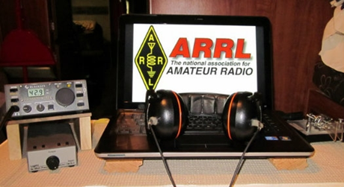

An expanded, downloadable version of QST's Contest Corral is available as a PDF. Check the sponsor's Web site for information on operating time restrictions and other instructions.

TOP ^
March 11  - 4 States QRP Group Second Sunday Sprint | March 13  - QRP Fox Hunt  - Phone Fray  - CWops Mini-CWT Test  - RSGB 80m Club Championship, CW  - AWA John Rollins Memorial DX Contest
March 14  - CWops Mini-CWT Test | March 15  - QRP Fox Hunt  - NCCC RTTY Sprint  - NCCC Sprint
March 16  - AWA John Rollins Memorial DX Contest  - BARTG HF RTTY Contest  - Russian DX Contest  - Virginia QSO Party  - Louisiana QSO Party  - AGCW VHF/UHF Contest  - Feld Hell Sprint | March 17  - Virginia QSO Party  - UBA Spring Contest, SSB
March 18  - Run for the Bacon QRP Contest  - Bucharest Contest | March 19  - CLARA Chatter Party
March 20
- QRP Fox Hunt
- Phone Fray
- CWops Mini-CWT Test

One Question Questionnaire

Hey Gang

There’s another NEW – one question – questionnaire on the Ohio Section Website! http://arrlohio.org
This past week’s poll has shown some interesting facts. Just about 77% of you will be doing Field Day as a group and not solo. That’s fantastic!

Anyway, these questions are all in fun and I hope that you are enjoying answering these “ONE QUESTION” questionnaires. Ok, enough on that, here’s the next question for you to answer…

“Have you earned an ARRL Worked All States award yet?”

TOP ^
You’ll find the “One Question” questionnaire on the Ohio Section Website! http://arrlohio.org It’s all in fun and it’s not a scientific survey in any way, but we are learning some things that we didn’t know from these questions. I hope that you are enjoying answering these “One Question” questionnaires.

V.E. Test Sessions
(from arrl)

03/11/2019 | Athens OH 45701-2059  Sponsor: Athens Cty ARA  Location: Red Cross Southeastern Ohio  Time: 7:00 PM (Walk-ins allowed)  Learn More | 03/12/2019 | Lancaster OH 43130  Sponsor: Lancaster & Fairfield ARC  Location: After School Programs Lancaster  Time: 7:00 PM (Walk-ins allowed)  Learn More
03/14/2019 | Milford OH 45150-1427  Sponsor: Milford ARC  Location: Faith Church  Time: 6:00 PM (Walk-ins allowed)  Learn More | 03/16/2019 | Lisbon OH 44432-1233  Sponsor: Lisbon Area Amt Radio Assoc  Location: Columbiana County Emergency Management  Time: 1:30 PM (No Walk-ins / Call ahead)  Learn More
03/16/2019 | Mount Vernon OH 43050-3531  Sponsor: Mount Vernon ARC  Location: Knox Cty American Red Cross  Time: 10:00 AM (Walk-ins allowed)  Learn More | 03/17/2019 | Elyria OH 44035-1343  Sponsor: American Red Cross  Location: American Red Cross  Time: 12:50 PM (Walk-ins allowed)  Learn More
03/17/2019 | Perrysburg OH 43551-4539  Sponsor: Toledo Mobile Radio Station  Location: Owens Community College  Time: 8:45 AM (Walk-ins allowed)  Learn More | 03/19/2019 | Sandusky OH 44870-1926  Sponsor: Sandusky, Ohio VE Team  Location: Sandusky Radio Club  Time: 7:00 PM (Walk-ins allowed)  Learn More
03/20/2019 | Dayton OH 45424-3304  Sponsor: Dayton Amt Radio Assoc  Location: Dayton Amt Radio Assoc  Time: 7:00 PM (No Walk-ins / Call ahead)  Learn More | 03/20/2019 | Middletown OH 45042  Sponsor: Dial Radio Club  Location: Miami University-Middletown  Time: 6:00 PM (Walk-ins allowed)  Learn More
03/23/2019 | Springfield OH 45506-1607  Sponsor: CLARA  Location: Main Branch  Time: 11:30 AM (Walk-ins allowed)  Learn More | 03/24/2019 | Akron OH 44326-1000  Sponsor: Cuyahoga Falls ARC  Location: Akron Summit Co Library  Time: 2:00 PM (No Walk-ins / Call ahead)  Learn More

#########

TOP ^
Exam Session Reminders

GRADING EXAMS: Each VE must grade each exam taken or must agree to the score given. After all three VEs agree to the number of correct answers shown, the score is announced to the examinee. The VEs must inform the examinee of their grade (pass or fail, and state the score {e.g., 26 out of 35}) upon completion of the grading.

NEW GENERAL EXAMS COMING: The new General class question pool will take effect on July 1, 2019 for all Element 3 General class license written exams. With the General class exams changing July 1st, new test designs must be created and used on that day. ARRL VEC will be supplying all its (near 1,000) Field Stocked VE teams with new test booklets about the 3rd week in June. Do not destroy the 2015 versions of the General exams until June 30.

BASIC QUALIFICATION QUESTION PROCEDURES: The detailed instructions are available on the ARRL website. At the exam session, candidates that answer “YES” to the qualification (felony) question should be given the “Applicant Instructions for FCC Basic Qualification Question” document. Print or download here: http://www.arrl.org/files/file/VEs/Applicant%20Info%20Qualification%20Question%202019.pdf

Applicants can also be referred to our Basic Qualification Question web page for information and instructions.
View page: http://www.arrl.org/fcc-qualification-question

After the application data from the session is submitted to FCC and an FCC file number is created, the applicant is required to provide an explanation directly to the FCC within 14 days. Do not collect information from the candidate and do not send any documents to the VEC.

ARES Connect

CQ… CQ…. CQ… Calling all persons to be a part of the new ARES Connect program.

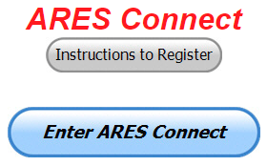
We need to discuss some very important items that only YOU can make a difference with. I need you to get yourselves registered in ARES Connect, that is… if you haven’t already. Now, how do I know that you need to do this? It’s simple, we have a little over 900 now registered in the database and Stan’s last S.E.C. report shows that we have a little over 1,700 persons in ARES right now. As you can see, we still have a way to go to really take advantage of this new system.

As the numbers show, there’s still a lot of you that haven’t taken the plunge yet and need to! What are you waiting for? No matter how much you resist, it’s coming, and we need to make sure that no one is left behind.

Now, as an incentive to get you to not only register…. But to actually start using the system… (Notice how I have that in bold type for you to clearly see?) I am giving away all sorts of goodies to help you get motivated. I have a footlocker of really cool items that I will be giving away!

I’m doing this in various intervals throughout the year, so it will challenge you to be dedicated to getting your hours into the system. You’ll never know just when another drawing will be, so you really do have to be prudent!!

TOP ^
Here’s how it looks so far for March:

 | Name | Events | Hours
1 | Jaealyn Himes (N8YMT) | 4 | 44.00
2 | Patrick Gibson (kd8ion) | 4 | 43.50
3 | Joshua Gould (AE8JG) | 3 | 43.50
4 | Christopher Domenick (KC8CAD) | 11 | 42.75
5 | Brian Burley (KE8ANW) | 4 | 41.00
6 | Kevin O'Harra (KD8IIB) | 4 | 36.00
7 | James Yoder (w8erw) | 3 | 35.50
8 | John Key (KE8EQQ) | 3 | 31.00
9 | Marcel Casavant (AD8CM) | 4 | 27.30
10 | Edwin Wiest (N8UTI) | 2 | 26.00

Here’s how we did with people getting signed up for events
and the total hours logged so far in March

Total Amount signed into Events | Total Hours for Events
555 | 1619.88

Don’t think that you could ever get into the top 10 listing? You never know. It adds up quickly, but you do have to be registered and actually USE the system in order for any of your time to count. We have a set of instructions on how to get registered right above the button to enter ARES Connect. I would strongly suggest that if you haven’t registered yet, that you read these instructions first.

Here’s a link to get you started... http://arrl-ohio.org/ares_connect_directions.pdf Please, don’t just hurry through the questions, read them carefully, if you don’t understand something, please ask me, I’m here to answer your questions.

We know that you mean well by answering that you do have the needed courses in, but I will let you know that we are verifying what you say you have with what is showing for you in our statewide database when we are completing your registration. So, how can you find out if you are already listed in our statewide database? Easy, here’s a link: http://arrl-ohio.org/SEC/special/ICS%20Complete%20by%20County%20and%20Name.pdf

Ok, now on to something new for ARES Connect… I was asked by Ron, NU8N about having a certificate for those who have taken the extra time and courses to get to Level 3. Well, after some thinking about it, Stan and I agreed with Ron that we should have some wallpaper for those who have taken this extra hard step. So, I’m here to tell ya’ that we are now offering a really nice certificate for all of those who have worked so hard to obtain their Level 3 ARES Status. All you have to do is complete a couple of boxes and we’ll send you a certificate suitable for framing. Now I want to make sure that you understand that you do have to be registered in the statewide database as a Level 3 to qualify for this certificate.

Here’s the link… http://arrl-ohio.org/SEC/level3.html So, if you have certificates that you haven't submitted yet, this is the perfect time to do just that!

TOP ^

Incident Command System (ICS) Training Schedule

All current trainings are listed on the Ohio EMA training calendar located at:
https://webeoctraining.dps.ohio.gov/TrainingAndExercise/courselist.aspx

I’ve been asked to also include a link to the Kentucky EMA training calendar as well..

https://kyem.ky.gov/training/Pages/default.aspx
https://sites.google.com/site/ccoemtraining/home

Please pay particular attention to these courses listed above, as that there’s a lot of ICS 300 & 400 classes listed that are very useful for all Amateurs to have under their belts. I will also state that G775 is also a very good course to take as well. These 3 courses are multiple day in class courses, so please be prepared to spend some time taking them.

We do recognize that IS-300/400 requires multiple days of actual classroom training that is not easily obtained. So, if you just can't find the time to fit these class room courses in, we do have an alternative method for getting you to Level 3. Completing the following “FREE” and “ONLINE” courses will act as substitute for you FEMA Leadership Development Course requirements. You absolutely will need to complete all 7 of these courses to get your ICS 300/400 credit. Here are the courses that you need to take: IS-120, 230, 240, 241, 242, 244 & 288.

Now, if you are looking for wallpaper and have a little extra time, taking IS-235 in addition to the 7 listed courses above, you will get a really cool looking certificate from FEMA stating that you have completed the Professional Development Series. That’s impressive in itself!

#########
A really special comment from one of our SERVED Agencies…
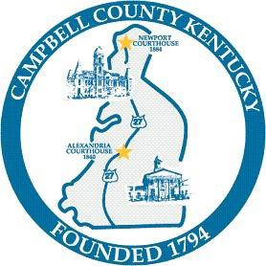
CAMPBELL COUNTY OFFICE OF EMERGENCY MANAGEMENT CLASSROOM ETIQUETTE AND STUDENT BEHAVIOR GUIDELINES

The purpose of this information is to assist students in understanding proper classroom behavior. The classroom should be a learning centered environment in which faculty and students are unhindered by disruptive behavior. You are a professional and are expected to act in a professional manner. Unfortunately, there are some students who seem to be disrespectful of the learning process and their fellow students. Instructors and course host have the authority to manage their classrooms to ensure an environment conducive to learning.

After it has been determined that a student has participated in disruptive activities, such student may be immediately expelled from the course and any future courses hosted and/or offered by the Campbell County Office of Emergency Management.

Take responsibility for your education
There is a common myth among students that because the course if FREE, it is not important. This is not true.

TOP ^
In fact, taxpayers pay the bill for most of the training we provide. Instructors are here to create a learning environment. Whether you learn depends on your willingness to listen, ask appropriate questions, and do the work necessary to pass the course.

Get to class on time: Students who walk into the classroom late distract other students in the learning environment. We always start on time.

Do not have private conversations: The noise is distracting to other students.

Turn pagers, radios and cellular phones off: It is also very distracting to hear someone’s beeper or cellular phone go off in class. Put the Smart Phone and laptop away. Do not use it to surf the internet. Do not have phone conversations in the classroom.

Do not dominate other students’ opportunity to learn by asking too many questions: It is good to ask questions and make comments, but if you dominate the class time with too many questions and/or comments, the instructor and other students cannot participate in class discussions. In addition, when asking questions and making comments, keep them related to the discussion at hand. Do not make inappropriate comments. Do not speak unless recognized by the instructor.

Students who have not completed prerequisites or lack a basic knowledge and understanding of the course topic many times ask questions that waste time and disrupt the class. Consider how the course relates to you and your work before registering.

Respect your instructor: Openly challenging the instructor’s knowledge or authority in the classroom is not proper. If you take issue with the instructor’s information or instructional methods, make sure that your comments are made without confrontation or antagonism. You may want to discuss your issues with her/him privately.

Your classmates deserve your respect and support: Others may have different ideas and opinions from yours; they may ask questions you perceive to be “stupid,” but they deserve the same level of respect from you as you wish from them.

Come to class prepared: Students who forget common classroom supplies such as a pencil, paper, etc. usually waste class time.

Weapons in Classrooms
Weapons of any type are NOT permitted in classrooms, unless the student is a sworn peace officer. Sworn peace officers carrying a weapon will need to show a badge and proper identification at the registration desk when signing in for training.

Tobacco Use in Classrooms
Smoking and chewing tobacco in classrooms, regardless of location, is strictly prohibited.

Classroom dress is professional casual. Professional casual is the preferred dress. If a specific dress is required for the class, it will be noted in the course announcement.

(ed note: this just shows that we need to improve on our appearance. Ok.. nuff said on that subject.…)

#########

TOP ^
The Department of Homeland Security (DHS) Returns to Provide Auxiliary Communications (AUXCOMM) Training in Conjunction with Hamvention® 2019

The Emergency Communications Division (ECD) of DHS’s Cybersecurity and Infrastructure Security Agency (CISA) will be on hand at Hamvention® 2019 to conduct its nationally recognized NIMS/ICS compliant AuxComm course. Over 2,500 amateur radio operators from around the country have taken this course. The purpose of this course is to train qualified amateur radio operators so they may assist their local, county and state governments with emergency backup communications if requested to do so. This course introduces the auxiliary communicator to the other positions within the Communications Unit (COMU) and how to provision emergency communications in a public safety context. The course also goes deeper into the National Incident Management System framework. The location of the course will be at the “Courtyard by Marriott” in Beavercreek, Ohio and be held 14-16 May 2019. Registration for this class may close early when all available seats for this class are taken.

Registration for this course is ongoing: Students wishing to attend the DHS Auxiliary Communications (AuxComm) Course must meet all prerequisites and provide electronic/scanned images of the following required documents prior to 1 May 2019:
Prerequisites:
- A signed copy of your current valid FCC issued amateur radio license
- IS-100 certificate (FEMA issued)
- IS-200 certificate (FEMA issued)
- IS-700 certificate (FEMA issued)
- IS-800 certificate (FEMA issued)
- The name of the public safety entity, and its contact information, that you would support upon completing this course

Please scan copies of this information, attached it to an email, and then send to COMU@hq.dhs.gov. In the subject line, please put Hamvention AUXCOMM. Your information will be reviewed, and a reply sent back to you indicating that you have been given a seat in the course.

This will be an intensive three-day version of the course with facilitated lectures and student exercises conducted by professional AUXCOMM instructors. This course provides time for interactive discussions and exercises. Should you have any questions regarding this course, please send them to COMU@hq.dhs.gov.

One final note, please mark your forum calendar, on Friday 17 May, to come see us at the AUXCOMM forum. You will be given a glimpse at the new AUXCOMM Position Task Book (PTB), a briefing on the proposed Communications Section for NIMS/ICS and a briefing on one of the most active AUXCOMM states – North Carolina!

#########

EMA-G290/291 Basic Public Information Officer Series
Hosted by Franklin County EMA
June 12-14 Application deadline: June 5th
Time of Course: Registration: 7:45 - 8:00 AM Course time: 8:00 AM – 5:00 PM daily
Location: Franklin County Emergency Management and Homeland Security
5300 Strawberry Farms Blvd.
Columbus, Ohio 43230

TOP ^
Enrollment: Students must enroll via the Department of Public Safety Training Campus website: https://trainingcampus.dps.ohio.gov/cm/cm710/pstc/pstc.html.

Students experiencing difficulty enrolling should call Ohio EMA Training at (614) 799-3666 / 3824 for assistance with registration. Course registration will generally close 10 working days prior to the course start date. You can check your enrollment / approval status via the Department of Public Safety Training Campus website.

State Point of Contact: Susan Traylor, State Training Coordinator, Ohio Emergency Management Agency, (614) 799-3666, sctraylor@dps.ohio.gov

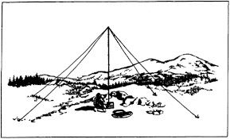
2019 Ohio NVIS Day

Hey everyone, Stan, N8BHL has let me know that the date for NVIS Day is scheduled for Saturday, April 27th. Are you ready? Start your planning now!
Like years past, we are planning on having the operation run from 10 – 4 EDT. Take a lunch break, enjoy each other’s company.

Transmit power should stay at 100 watts for accurate signal comparison. You may operate anywhere, home, club, portable.
Want to know more about what NVIS is? http://arrl-ohio.org/SEC/nvis.html Learn all about Near Vertical Incident Scattering and how you can easily put up a NVIS antenna and participate in this great exercise.

Weather Underground and Other Ham Weather Stations

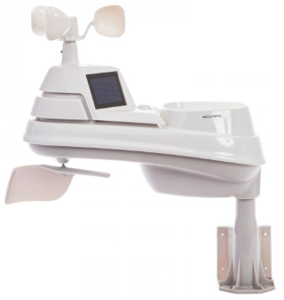
Have you visited the webpage to see all the Weather Underground stations yet? It’s really fun to see just how much th e weather varies across the state and this gives you access to each individual station very quickly and easily.

It seems that our list of stations is growing every week! This past week we added another station to the list. Thanks so much Chip, N8KAC for sending the link to your station.

Now… How’s about your station, is it listed with us? It doesn’t necessarily have to be a Weather Underground reporting station. I’d love to have any weather station that is connected to the internet available for all of us to view, especially when the weather gets bad out. The more stations reporting the better.

Thanks to everyone who has contributed to this effort. If you haven’t, you really should take a look at the various weather stations around the state when we get bad weather coming in. You can really see just where the line of storms are as they cross through the state. It is very fascinating to watch it all unfold right you’re your easy chair, and all the data is real time! Here’s a link to all of those listed… http://arrl-ohio.org/wus.html

TOP ^
We’re starting to get a really good collection of stations all over. I know that there is a lot more than what we have listed. How’s about sharing your weather information with all of us! All that you need to do is send me your Weather Underground ID and your call sign and I’ll take it from there. Sent it to: n8sy@n8sy.com

Ohio Section ARES Conference Date Announced

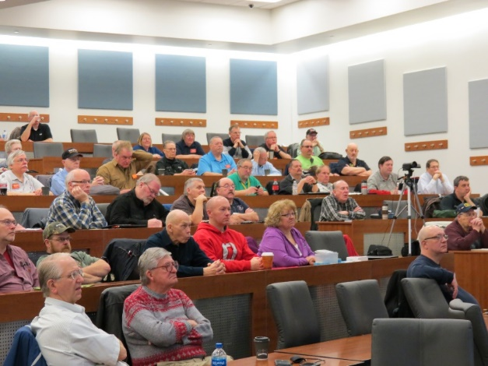
I know a lot of you have been waiting patiently for this announcement. Yes, we have set a date for the Ohio Section ARES Conference… It’s going to be held on April 6th at Marion Technical College / OSU Marion Campus. So, make sure to mark your calendars for this date. Also, don’t forget to “sign up” for this event in ARES Connect as well!

Stan is working diligently on the agenda getting great forums arranged and it’s sure to be a really great conference. There’s loads of information for those interested in any part of Ohio’s ARES program.

This is an all-day adventure, but we are in a real college setting with all the amenities that you would expect in a first-class campus. Electric outlets are easily accessible for those bringing laptops and such. Wi-Fi is available and the seats are very comfortable. And… I’ll have some great Give-A-Ways to pass out as well.

Lunch is on you, but the campus is close to many popular fast-food and sit down restaurants. You can even brown bag it if you want to eat on campus.

Certificates for your participation at this conference will be available, so you’ll get some wallpaper suitable for framing to take home with you as well! Now how can you beat that.

Get registered now, seating will become limited quickly! Here’s the link: http://arrl-ohio.org/SEC/form.html

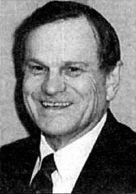
The Allan Severson, AB8P Memorial Award

This coveted award is bestowed on an Amateur Radio operator in the Ohio Section who has demonstrated a continuing dedication to the advancement of Amateur Radio and to the Ohio Section. The recipient has traditionally been chosen over the years by the Section Manager, but I would like to change that starting this year. I want to hear from YOU. Who do you feel is deserving of this prestigious award?

The award was originally established in 1992 and was named "Ohio Ham of the Year" until 1999. That year it was renamed after Allan, of Lakewood, Ohio, who had become a silent key in 1997. The award winners are all hams who, like Allan Severson, have dedicated themselves to the advancement of the American Radio Relay League in Ohio.

Although Allan had served the Section as Section Manager and went on to a distinguished career as Great Lakes Division Director on the ARRL National Board of Directors, the annual award announcement only mentions one sentence about him which is part of every memorial award certificate.

TOP ^
That sentence quickly demonstrates the reason for the renaming of this award. "Allan's devotion to serve amateur radio inspired a whole generation of Ohio Section leadership."

So, how’s about it. I want to hear from you who you feel is deserving. All you have to do is complete a form with as much information about the person that you are nominating as you can. Several members of the Cabinet and I will look over all the nominations and choose who we feel is the best of the best from those who were nominated. As we have done in the past, the person chosen to be our next recipient will be announced at the Columbus Hamfest on August 3rd.

Here’s a link to the form: http://arrl-ohio.org/sm/severson_nomination.html

Ohio EMA Now Accepting Safe Room Applications
For Immediate Release: February 4, 2019

COLUMBUS — The Ohio Safe Room Rebate Program is once again accepting applications. The program provides a rebate for the purchase and construction/installation of tornado safe rooms for Ohio homeowners selected for the program.

“The entire state of Ohio is at risk of an EF5 tornado, which produces 250 mile per hour winds capable of destroying most structures,” said Steve Ferryman, Ohio EMA mitigation branch chief. “A safe room is built to withstand these winds and resulting airborne debris and provides near absolute protection for occupants.”

A safe room is an extreme-wind shelter or space that provides protection to people during a tornado. It can be constructed/installed in one of several places in the home: in the basement, beneath a concrete slab-on-grade foundation or garage floor, or in an interior room on the first floor. A safe room may also be buried in the yard or be a stand-alone structure near your home. Residents selected for the program could be eligible for a rebate up to 75 percent of the cost to install or construct a safe room – up to a maximum of $4,875.

To apply for the Ohio Safe Room Rebate Program, homeowners have until 5 p.m. April 1st to register on the Ohio EMA website: https://ema.ohio.gov/ema_saferoom/saferoom-concept.aspx

The Ohio Safe Room Rebate Program will use a computerized random selection process to select applicants. A priority list of applicants will be created from the selected applicants. Chosen homeowners will be notified by e-mail of their position on the priority list on or after April 5th. Ohio EMA anticipates grant funding will become available this year and having a list of participants who meet program requirements will expedite the rebate process.

Funding for the rebate program is through a partnership with the Federal Emergency Management Agency’s (FEMA) Hazard Mitigation Assistance (HMA) grant programs. Safe rooms must meet FEMA requirements in FEMA publications 320 and 361 and cannot be constructed/installed prior to the rebate drawing and notification from Ohio EMA to proceed with construction.

Ohio EMA plans to offer this rebate program on an annual basis. When and if HMA funding becomes available, the amount of funding will determine the number of rebates. If, after visiting the Ohio EMA website, interested people have questions, they should call Dan Clevidence at 614.799.3533.

TOP ^

Vaulted ceilings only serve one purpose -- to put up a 10-meter dipole!
(from Greg, WD9FTZ)
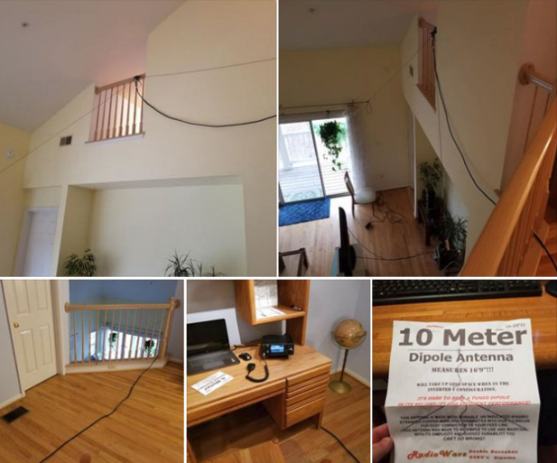
They also serve to feed corporations with more of your money by heating and cooling rooms more. (A vaulted ceiling costs about 50 to 100 percent more the heat and cool!)

So, here we have a person putting up an indoor dipole for a band that will not be conducive to making contacts on a regular basis for four or five years.

Also, I will bet having an indoor dipole will attenuate that signal 10 dB or more, and what about RF exposure.

Oh, well... the state of today's radio testing.
Yes, even with a HOA property, one can certainly get some kind of antenna outside the building. I know, I did it in Wichita at the apartment I was in, and I was in my 20’s, plus I did not have the internet to help me either.

Also, I made my own antenna, and did not purchase a dipole.

Final.. Final..
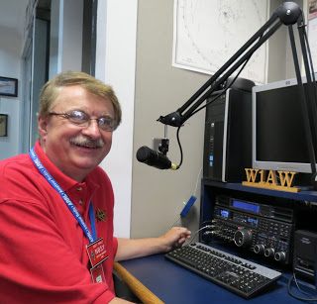
Hey Gang...

I had a blast this past week visiting with many of you at your meetings. I even help co-host the National Section Manager Conference Call this past week!

Now, since this is the St Patty’s Day edition and as Ancestry DNA tests have revealed, I’m 17% Irish!! I will be going out after the TMRA Hamfest this coming Sunday and having a big tall glass of my favorite green beer! No, I don’t drink and drive, so I’ll be having this beer when I get back home, and Janie can drive us to our favorite pub! I plan on celebrating my new found “roots” in the best if Irish traditions!

I did the DNA test late last year just to see if there was any Native American in me. I was so shocked and disappointed when the results came in. My grandmother for years told all of us grandkids that we had Shawnee Indian in us. Supposedly my great, great grandmother was a Shawnee Squaw.

TOP ^
Now, to find out that she had lied to us all that time was absolutely the pits for me. I was so hoping for the results to positively show that I was at least partially Native American, and my grandmother’s story was right on target. But alas, it was not to be. As I understand it, most folks that do the DNA test are surprised to find out that they didn’t know as much as they thought about their heritage. So, for this next weekend I’m going to celebrate my true ancestry, well at least the 17% of it, as Irish! By the way, I am also 58% English, Whales and Northwestern European, 19% Germanic Europe and 6% Swedish too. Ok, I’m mostly English, but for this next weekend I’m IRISH all the way!

Now, let’s move on to more important things... I do want to remind everyone that you can do a little extra publicity for your club meetings and activities just by having your ARES Connect Administrator add your events to the ARES Connect calendar! For those clubs that use Google Calendar or any web-based calendar program that incorporates RSS feeds, you can easily add ARES Connect events calendar to it!

Yes, you can now see all the events, including your own club activities on your calendar! Oh, if you don’t use Google Calendar, do you use Outlook or other similar Office Suite programs that has a calendar built in? If you do, then you can even add the ARES Calendar to that as well. This is extremely useful if you are in the field where Wi-Fi isn’t available.

If you are interested in how you can do this, just ask me. I will show you just how easy it is. Oh, there is just one little requirement to be able to do this, you have to be registered in ARES Connect in order to gain access to this feature.

Now speaking on the idea of being registered in ARES Connect yet, have you? If you haven’t you really need to do it now.

For your administrators out there, things will be changing in the system and from what I know right now, it will make your job a lot easier as well. Yes, things aren’t quite the way we want them yet, but they will be getting better, and the system will be a lot easier to use when these changes happen.

I do want to clear up some mis-interpretations that have been going around. First, in the Ohio Section we only require our Level 2 volunteers to have the 4 basic courses, IS 100, 200, 700 & 800. For our Level 3 volunteers we do require the additional ICS 300 / 400, or the equivalent professional series courses IS 120, 230, 240, 241, 242, 244 & 288. These equivalent courses are all on-line classes just like your basic 4 NIMS courses are and being offered as an alternative way for you to get credit for taking the professional series courses in the event you just cannot get scheduled into an ICS 300/400 class. By the way, if you decide to take these 7 on-line courses and complete them all, you will want to take just one more class IS-235. By completing this additional course, you will get a really great looking certificate from FEMA recognizing that you have completed the entire Professional Series courses.

I do hope that this clears up the confusion that has been going around lately. As we have stated on the website and in this newsletter many times “We don’t want anyone left behind.”

Ok.. One final go around, I have seen a number of posts on Facebook and other social media blogs where a lot of folks are interested in participating in a Wouff Hong at Dayton this year. I can tell you this, we could have one IF we get the volunteers to make this happen!

TOP ^
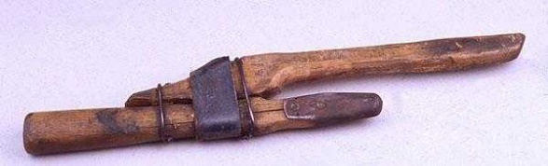
What does it take? It takes a minimum of 7 players that are willing to get up in front of a crowd and read from a script. You don’t have to worry about whether you flub a line or two, it will happen, and it will still come out ok. You do have a really neat costume that you wear, and the ceremony takes all of about 30 minutes to do. Not much to ask for so much fun for everyone that participates.

It will take a commitment from YOU however to make this happen. Now, here’s what I need from YOU. I need someone to step up and get the 7 people together. I need one person to organize this part of it and all you have to do is get those 6 people (you included) to volunteer and get me their names and emails.

I will take care of the logistics – time, location, copies of the script, costumes and certificates. How about it? Anyone game to help with this project? If you are, contact me as soon as you can. Write to: n8sy@n8sy.com and we can discuss the details.

Now, just to get things started in the right direction, I have already talked to ARRL Headquarters about this this to see if it would be possible and was told that we should be able to get a conference room at the Marriott – University of Dayton where all of the ARRL staff are staying.

I am planning on starting the ceremony later in the evening, say around 10 pm or so... this keeps the tradition going for the ceremony to be done late at night.

Whelp… That’s going to do it for this time around. Stay safe, stay warm, and most of all… have FUN!!

73, and stay warm and dry!!!

Scott, N8SY

Ohio’s Severe Weather Awareness Week: March 17 – 23

Statewide Tornado Drill: Wednesday March 20th at 9:50am local

&

Don’t forget to change those batteries in your Smoke and CO Alarms!!!

TOP ^

Back Issues of the PostScript and Ohio Section Journal (OSJ)

Hey, did you know that PostScript and Ohio Section Journal (OSJ) are archived on the website? You can go back and look at any edition simply by clicking:
http://arrl-ohio.org/news/index.html

Chit – Chat, and All That!

Do you know someone that’s not getting these Newsletters? Please, forward a copy of this Newsletter over to them and have them “Opt-In” to start receiving them. Heck, just have them send me an email n8sy@n8sy.com and I’ll get them added to the Ohio Section Emailing list.

We now have many thousands of readers receiving these newsletters weekly. Quite impressive, I’d say! I urge all of you to make sure that everyone, regardless of whether they are a League member or not, get signed up to receive these weekly Newsletters.

You can always “Opt-Out” at any time if you feel this is not what you were expecting. It’s fun and very informative. All of your favorite past newsletters are now archived too.
You can go back at any time and read them. Just go to: http://arrl-ohio.org/news/

Got questions, concerns or would just like to sit and chat awhile? Heck, I’ll even buy the coffee!! Give me a call at (419) 512-4445 or email me at: n8sy@n8sy.com

The pictures on the front page are from various newsletters, Facebook posts and/or were sent directly to me in recent weeks. Take a good look at them, you just might be in one of the pictures! “SMILE… you’re on the Ohio Section News!!”

TOP ^

PostScript is produced as a weekly supplement to the Ohio Section Journal (OSJ). I sincerely hope that you have enjoyed this edition and will encourage your friends to join with you in receiving the latest news and information about the Ohio Section, and from around the world!

