[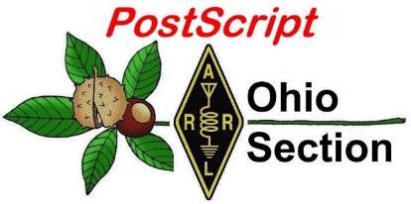](http://arrl-ohio.org/news/) ***Mardi Gras***

***Edition***

🡪 National News 🡪 The Handbook Give Away

🡪 Club Corner 🡪 Hamfests

🡪 DX This Week 🡪 One Question Questionnaire

🡪 VE Testing Schedule 🡪 Final.. Final..

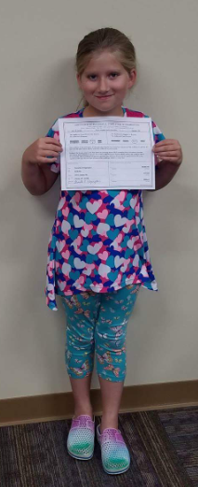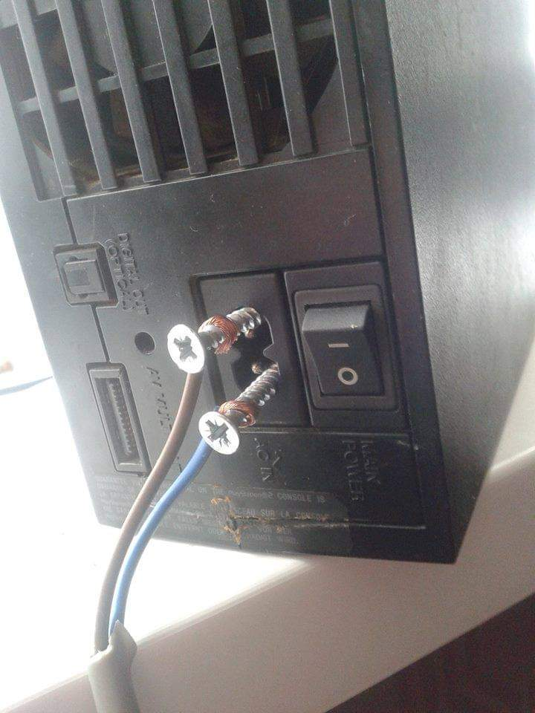

***National News***

*(from arrl and other sources)*

***VE7DXW’s “RF Seismograph” May Be Real Seismograph***

Alex Schwarz, VE7DXW, in British Columbia, Canada, is exploring the possibility that “RF signatures” detected by the [**RF Seismograph**](http://users.skynet.be/myspace/mdsr/index.html) propagation tool could also be indicating earthquakes, and may even be able to predict them shortly before they occur. A real-time HF [**propagation-monitoring tool**](http://users.skynet.be/myspace/mdsr/) developed by Schwarz and the [**MDSR team**](https://www.tapr.org/pdf/DCC2015-Mod-DemodSoftwareRadio-VE7DXW-ON6MU.pdf), the RF Seismograph shows both band noise and activity or band activity alone on six HF bands. It’s a project of the North Shore Amateur Radio Club ([**NSARC**](http://www.nsarc.ca/)).

“We had been doing the solar eclipse experiment, and we developed the RF Seismograph software to look for changes in propagation during the eclipse,” Schwarz explained. “After the eclipse, we decided to leave the RF Seismograph running, and we have now collected 4 years of data.”

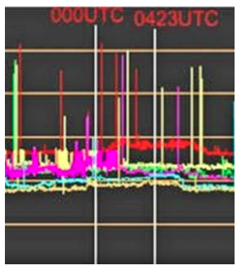 The system uses an omnidirectional multiband antenna to monitor JT-65 frequencies (±10 kHz) on 80, 40, 30, 20, 15, and 10 meters. Recorders monitor the background noise and display the result in six color-coded, long-duration graphs displaying 6 hours of scans. When signals are present on a band, its graph trace starts to resemble a series of vertical bars.

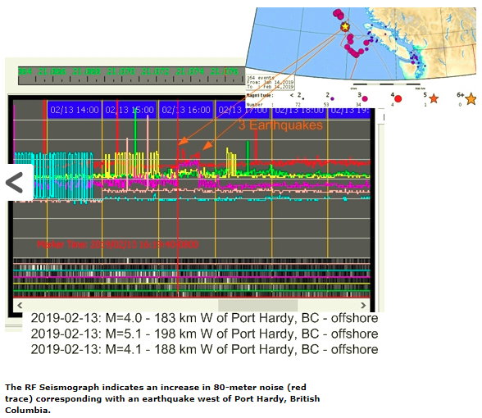Most recently, the RF Seismograph recorded the magnitude 7.5 earthquake in Ecuador on February 22. Schwarz recounted that noise on 15 meters began to be visible about 1 hour before the quake; then, 2 hours after the quake released, 15 meters started to recover. The US Geological Survey said the quake was about 82 miles below ground. It did not affect 80 meters. Schwarz speculated that the quake was easy to see on the RF Seismograph because 15 meters typically is not open during hours of darkness — especially when the solar flux is only 70.

Following a magnitude 5.0 earthquake off the coast of Vancouver Island, his RF Seismograph picked up changes. Canada’s government-run [**Earthquakes Canada**](http://www.earthquakescanada.nrcan.gc.ca/index-en.php)was able to provide Schwarz with a list of magnitude 6.0 or greater events since the RF Seismograph went into operation, and the two teams have been collaborating to find a correlation between HF propagation anomalies and earthquakes.

TOP ^

With the measurements, Schwarz has been attempting find a correlation between the list of past geological events and what his RF Seismograph may have sensed on those occasions.

“The earthquakes show up as RF noise because of the electric field lines, now scientifically confirmed to change the way the ionosphere reflects RF,” Schwarz said. He cited an article in the October 2018 edition of *Scientific American*, which, he says, “explains it really well.” (See Erik Vance’s “[**Earthquakes in the sky**](http://www.ep.sci.hokudai.ac.jp/~heki/pdf/Scientific_American_Vance2018.pdf),” *Scientific American*, October 2018, p. 44).

The *Scientific American* article explores measurements in Japan looking into how earthquakes can create electric field lines that extend into the atmosphere. “Could they be used to detect earthquakes before they cause damage on the planet?” Schwarz asks.

Schwarz said 171 earthquakes — all magnitude 6.0 events or greater — were studied, and only 15 of them had no RF noise associated with them. In 26 cases, the time of the disturbance detected by the RF Seismograph failed to match the USGS-reported time of the quake.

Schwarz said that in 72% of the earthquake studies, the RF Seismograph was able to detect an increase in noise on 80 meters, typically before and after the event.

“More analysis is needed,” Schwarz has concluded. “The study is still continuing, and we need your help to set up more monitoring stations.”

RF Seismograph is now a [**projec**t](https://scistarter.com/project/21138-RF-Seismograph) on **Scistarter.com**, facilitated through Arizona State University. Schwarz said Scistarter hosts “interesting projects for all ages and backgrounds” and “provides a vehicle for young people that are interested in science to get real live experience in this field.”

Contact [**Schwarz**](mailto:alexschwarz@telus.net) for additional information.

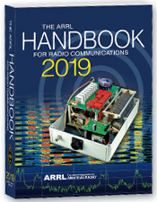***The Handbook Give Away***

Hey Gang,

We had another fantastic response this month, but I’m sure you’re more interested in knowing just who won the Handbook this month...

And the winner is…. ***Linda Sinko, N8LRS!***

Since we've had another month of great response with the Giveaway, I added a couple Official Ohio Section Logo Knit Caps to "Give Away" as well!!

AND…. Those that winners are… ***Thaddeus Mather, W8TKM***

***&***

***Stephen Villanova, WD8BQS***

TOP ^

Many of you ask me just how do I know when the drawing is on? Well, that’s easy all you need to do is check in on the Ohio Section Website on a regular basis and watch for the big RED Arrow that will appear on the left side of the page. This is the sign that the drawing is on and you need to get registered. So, keep a sharp eye out on the website and check in often! <http://arrl-ohio.org>

You just never know.. You just might be the next winner!

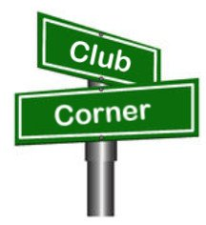***Club Corner***

This is YOUR cornner of the newsletter. Send me what your club is doing and I’ll make sure that it gets in. Got a special event or club project that you want everyone to know about? Send it to me!. Need help with a project? Send it to me.

Let me know what you club is up to. Are you going to have a special guest at your meeting or are you having a special anniversary? Just sent it to:

[n8sy@n8sy.com](mailto:n8sy@n8sy.com)

#########

***TMRA Holding Classes***

SPRING TECHNICIANS (Entry Level) HAM RADIO LICENSE CLASS (2 DAY COURSE) -   
  
NOTE:  Two separate days (**March 23rd, and April 6th**), with test session on April 6th at end of class.  
  
The TMRA Education Committee has released the schedule for the Spring Technicians Class. The class schedule will follow our traditional style. Two classes held two weeks apart and a V.E. Testing Session after the final class. The Class is FREE, you will have to provide your own book, or one can be purchased from the TMRA ($25.00).  (ARRL Edition 4 book)  The testing session will cost $15.00 which is the standard fee set by the ARRL.  
  
THE DATES ARE AS LISTED BELOW  
* CLASS ONE WILL BE HELD ON SATURDAY MARCH 23RD, 2019 FROM 08:00 TILL 17:00

* CLASS TWO WILL BE HELD ON SATURDAY APRIL 6TH, 2019 FROM 08:00 TILL 17:00 (This includes the V.E.Session)  
  
Both classes will be held at  
LUCAS COUNTY EMS TRAINING CENTER  
2127 JEFFERSON AVE  
TOLEDO OHIO 43624  
  
To Enroll in the Class, or for more Information please contact  
STEVE STALKER / KC8TVW  
419-467-3734  
[kc8tvw@arrl.net](mailto:kc8tvw@arrl.net)

TOP ^

Also, please join us for a 4-hour follow-on class on April 13th (9am) called, "I now have my ham radio License, now what?". This class is intended to help get newly licensed hams started with additional needed information. Location is TBD.

#########

***New Ham - Info Class -* Saturday, April 13, 2019 at 9 AM – 1 PM**

***Relaxed Learning Session: I'm new to Amateur Radio! Now what?!***

Join Toledo Mobile Radio Association Members at the Lucas County EMS Training Center for a FREE learning and Q&A session that should work to help you get started with some of the practical items that we all wish we knew when starting off in Ham Radio. Any/everyone is welcome, and you do not have to have attended the class to attend. Most hams licensed less than 3 years will find the session useful.  
  
This session will be run as a "class” but is open to ANY questions along the way. Folks are free to come and go as you wish. This training session is a great place to get to know TMRA members and for newer amateur radio operators to ask questions related to items they are concerned about or need help with. We know that this hobby has a lot of new items for everyone to get familiar with, so this is an attempt to short-cut that learning!  
  
We'll discuss and help new hams resolve some of the typical early ham radio challenges including (but not limited to) the following types of discussion items (no specific order):

* Answer any early questions and discuss list of items that we all have soon after becoming a ham. (and worries that we each had)
* Discuss Hand-held and mobile radio types / drawbacks and benefits. Who can help me program it? How can I make my HT more effective?
* What is needed to setup and use a mobile or "base" radio - in car or in home (and benefits and types).
* Discuss Effective Radiated Power in terms of Antenna benefits - Discuss types of antennas indoor/outdoor options (and why). Horizontal vs. Vertical antennas.
* Types of feedline (we often refer to "coax) and what you will need (and for what) - and where to find it.
* VHF/UHF vs HF - Who can I talk to and when?
* Discuss using local Repeaters, internet linked repeaters, PL Tones, (repeaterbook/radio reference)
* Discuss Simplex vs Repeater typical etiquette (just so you know) - Examples: Q signals, calling CQ, breaks, etc.
* First Contacts – what to expect (most important, you won't be judged so don't "sweat it".... really...)
* Hamfests + Ham Conventions.- Why bother?
* Where should I buy equipment and what are the risks?
* Useful websites
* Foxhunting and Satellites - how/where?
* Where to find manuals and information?
* If there is time: Antenna Analyzers and SWR Meters - what are they and when do I need one?
* If there is time: N vs PL-259, vs SMA, versus BNC connectors
* Benefits of joining organizations/clubs
* Foxhunts - what are they and how does it work? Do I need anything?
* HF - club events (what can I participate with?) - Operating events.

TOP ^

* Callsigns, vanity and considerations
* QSL Cards and Logbook of the World
* Propagation - Tropo ducting, Sporatic E, Aurora, sunspot cycle, seasonal patterns

We look forward to seeing you there!

#########

***Ohio Courthouses on the Air Special Event***

February 26, 2019

RE:  Ohio Courthouses on the Air Special Event

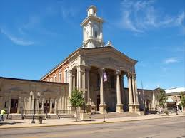

Are you interested in participating in the Ohio Courthouses on the Air Special Event?  John Levo, W8KIW the Highland ARA and Michael Love, WB8YKS the Southern Ohio Amateur Radio Association (SOARA) are in the preliminary stages of organizing the event.  As of now (subject to change) we are looking at Saturday, August 24, 2019 from 10:00 to about 4:00.  The time will be determined by the different clubs.  Modes and frequencies are being reviewed including statewide DMR.  This will be a rain or shine event.  I have reached out to the Administrator of the Lawrence County Commissioners to arrange for me to be added to their meeting agenda to discuss our request.  SOARA wants to setup on the lawn of the courthouse if possible.

We envision this to be a really FUN event while prompting Amateur Radio across the state and across the country and will be an historical event celebrating the history of each county’s courthouse. I will be working with the Briggs Lawrence County Public Library, Historical Society, EMA, Sheriff’s Office, EMS, government officials, news media, Chamber of Commerce to promote this public event in Lawrence County.

We will keep you advised as to details and locking in the August 24th date via the *Monday Morning Memo*, *Ohio Section PostScript* and *Ohio Section Journal.*

We are looking forward to hearing you on the air during the Special Event!

Thank you again!

Contacts for the events are:

*John Levo, W8KIW, Editor of the Monday Morning Memo*

[highlandara@yahoo.com](mailto:highlandara@yahoo.com)

Michael Love, WB8YKS

SOARA / ARES PIO

[Mlove82a@zoominternet.net](mailto:Mlove82a@zoominternet.net)

#########

TOP ^

***Carole Perry to Visit PCARS Meeting in March***

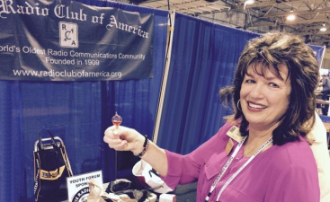

Carole will be coming to the Portage County Amateur Radio Service (PCARS) meeting on **March 11th!** She always has outstanding presentation, so I know that you’ll want to hear her speak for sure! So, get your calendars marked for this very special guest speaker!

Carole will be discussing how to get youth involved in Amateur Radio. I cannot think of a more qualified person to talk with us on this topic. I know you’ll want to be there!!

Carole is the recipient of the prestigious 1987 Dayton Ham of The Year Award, the 1987 ARRL Instructor of The Year Award, the 1991 Marconi Wireless Memorial Award, the 1993 QCWA President's Award, the 1996 Radio Club of America (RCA) Barry Goldwater Amateur Radio Award, the 2009 RCA President's Award, the 2012 RCA President's Award, and the 2015 Vivian Carr Award for Women in Radio. She is the winner of the 2016 SOAR (Sisterhood of Amateur Radio) Legacy award for Pioneering Women in Amateur Radio, and the 2016 recipient of the YASME Foundation Award for Excellence. She is an RCA Fellow, and in 2007 she was elected to the RCA Board of Directors; a position she still holds, and she created the Youth Activities Committee which she now chairs. She serves on the RCA Scholarship committee as well. She also created the RCA Young Achiever's Award, given to students in grade 12 and below who have demonstrated excellence and creativity in wireless communications. One hundred and seven youngsters have received this award along with a stipend, so far. Carole is also presently a Director for QCWA (Quarter Century Wireless Association). The QCWA Youth Activities program was created and chaired by Carole.

Carole has moderated the Dayton Hamvention Youth Forum and Instructors' Forum for 31 years. She is a member/director of QCWA and RCA. She is also a member of ARRL, DARA, (Dayton Amateur Radio Association) AWA (Antique Wireless Association), and Brandeis Women and is a contributing columnist for CQ Magazine’s Youth Column.

Want more information? Contact Tom, [wb8lcd@arrl.net](mailto:wb8lcd@arrl.net)

#########

***GUERNSEY HERITAGE AWARD***

Did you know that the Cambridge Amateur Radio Association sponsors an award certificate for working Guernsey County hams? It’s true!

Qualifications for this award are so follows:

• Non-Guernsey County amateurs need to make five contacts.

• Guernsey County amateurs must make ten contacts.

TOP ^

No, repeater contacts do not qualify for this award. Submit your contact log to Evelyn Barton at [ka8nzs@yahoo.com](mailto:ka8nzs@yahoo.com) with call signs, dates, times, and band/mode.

#########

***Pioneer Bus Trip to Hamvention***

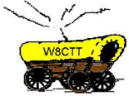It is never too early to plan a trip to Hamvention. Each year the Pioneer Amateur Radio Fellowship has offered to bus hams to this great event. The bus leaves at 5:30 AM the Saturday of Hamvention, it does stop at McDonald's for breakfast and arrives at Hamvention about 9am, just in time for the doors to be open. The bus leaves around 5pm and stops for a buffet for supper! You won’t go hungry on this trip for sure! You arrive back at the pickup point about 9:30pm, so it’s not too late, but you will have had a full day for sure.

The bus has a number of very large storage areas for all your purchases, so you don’t have to worry if you’ll have room for that “just can’t do without boat anchor!”

[Click Here](https://drive.google.com/file/d/1QPUeDDMljARN62b9cV90SBypgtcxJtJ9/view) to read the flier and the form used to register for this trip.

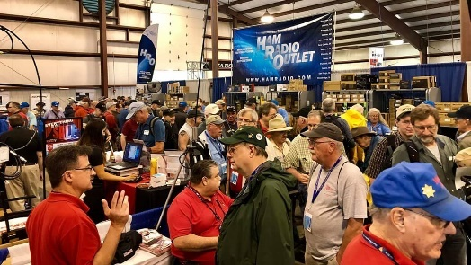[***Upcoming Hamfests***](http://arrl-ohio.org/hamfests.html)

03/16/2019 | [Gallipolis Ohio Hamfest](http://www.arrl.org/hamfests/gallipolis-ohio-hamfest)

Location: Gallipolis, OH  
Sponsor: Mid-Ohio Valley Amateur Radio Club

|  |  |
| --- | --- |
| 03/17/2019 | [Hamfest and Computer Fair](http://www.arrl.org/hamfests/hamfest-and-computer-fair-1)  Location: Perrysburg, OH Sponsor: Toledo Mobile Radio Association Website: [http://www.tmrahamradio.org](http://www.tmrahamradio.org/) | 04/13/2019 | [65th Annual Cuyahoga Falls ARC](http://www.arrl.org/hamfests/65th-annual-cuyahoga-falls-amateur-radio-club-hamfest)  Location: Cuyahoga Falls , OH Type: ARRL Hamfest Sponsor: The Cuyahoga Falls ARClub, Inc. Website: [http://cfarc.org](http://cfarc.org/) |
| 04/20/2019 | Portsmouth Radio Club Hamfest Location: Portsmouth , OH Sponsor: Portsmouth Radio Club  Website: <https://www.facebook.com/w4pox/> | 04/28/2019 | [Athens Hamfest](http://www.arrl.org/hamfests/athens-hamfest-8)  Location: Athens, OH Sponsor: Athens County Amateur Radio Association Website: <http://www.ac-ara.org/> |
| 05/17-19/2019 | Dayton Hamvention  Location: Xenia, OH  Sponsor: Dayton Amateur Radio Association  Website:  <http://hamvention.org/> | 06/01/2019 | [FCARC Summer Swap](http://www.arrl.org/hamfests/fcarc-summer-swap)  Location: Wauseon, OH Sponsor: Fulton County Amateur Radio Club Website: <http://k8bxq.org/hamfest> |

TOP ^

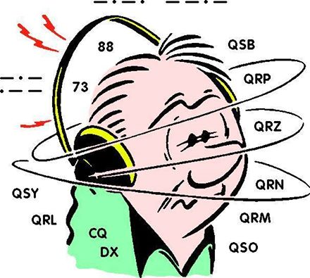***DX This Week***

*(from Bill, AJ8B)*

Bill AJ8B ([aj8b@arrl.net](mailto:aj8b@arrl.net), @AJ8B, [www.aj8b.com](http://www.aj8b.com) or [www.swodxa.org](http://www.swodxa.org) )  
 CWOPs Member #1567

I have written previously about my love for QSL cards. I get excited when I get them and really get excited when a package arrives from the Buro! I normally posted my most exotic on the bulletin board at work just to start conversation and it worked! I now have a cool way to see them wherever I go and prominently display them in the shack. This article says it all, reprinted with permission of the ARRL, QST January 2019.

***QSL Card Display Board using a Raspberry Pi - A repurposed monitor serves as a QSL & calendar portal in your ham shack***

*(Bill Salyers, AJ8B)*

When I stopped by the ham shack of DXCC Card checker and all-around good guy Dave Vest, K8DV, an electronic picture frame that Dave was using to display QSL cards caught my attention. I love getting DX QSL cards and have been looking for a way to display them proudly.

At home, I scanned in my favorite cards and loaded them into the “Cloud” so that I could access them from anywhere. I then set my screensaver to reference those QSL images and, *voilà*, I had access to QSL cards via my laptop, no matter where I was!

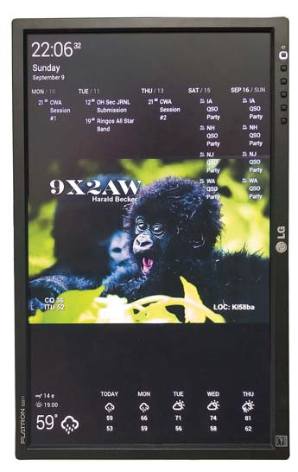Later, while reading about Raspberry Pi microcontroller modules, I was inspired by their use to create smart mirrors that display digital overlays on a two-way mirror. I decided to create a similar project to display in my ham shack and get more experience with Raspberry Pi technology. (Figure 1)

**Getting Started**

Once you have the components together, boot the RP3 by connecting the USB power supply. You will initially see a four-color rainbow grid. The system will continue to boot until the Raspbian desktop (see Figure 2) is displayed. The first time through is the longest.

Click on the “raspberry” icon in the upper left-hand corner of the desktop and slide down to **PREFERENCES**. Go to the **LOCALIZATION** tab and configure the **SET LOCALE**, **SET TIME ZONE**, and **SET KEYBOARD** as appropriate for your area. This leads the way to configure the second phase of the project.

**Create the Cloud Accounts**

I needed a simple way to display my QSL cards in a random rotating order on the screen, and I also wanted to display the time, weather, and a to-do list. (Figure 1) This can be set up in four easy steps from the web browser of your standard desktop computer.

Figure 1 Display

TOP ^

1. 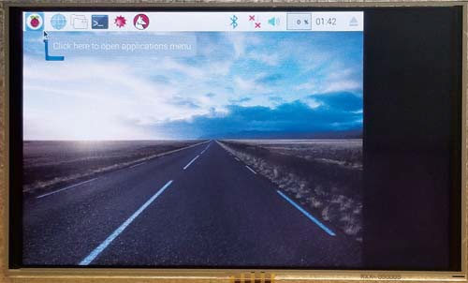Set up a Dropbox account at www.Dropbox.com. This is the internet-based account into which you will load your QSL card images that will be pulled down for viewing.

Create a directory in the account called QSLIMAGE. Store a few QSL images in that directory to get started. If you already have a Dropbox account, just set up the appropriate directory for your QSL images.

1. Set up a Gmail account for your calendar. This account will access the to-do calendar list and appointments. I keep upcoming club meetings, CWA events, and contests on my calendar.

Figure 2 — The desktop display shows the raspberry icon in the upper left.

1. Use a free service called DAKboard to display all of this information together. I always recommend making a donation to the developers of free software, so they can continue to help support their products. Navigate to DAKboard. com and choose CREATE A FREE ACCOUNT.

Log into your DAKboard account and click on the settings icon in the upper right-hand corner.

Make sure to click **SAVE CHANGES** as you move from section to section. My settings are:

SCREEN: TIME/EVENTS — TOP, WEATHER — BOTTOM DATE/TIME: ENABLED, TIME

ZONE – NEW YORK, DIGITAL TYPE, 24-HOUR FORMAT, SHOW SECONDS  
 CALENDAR: ENABLED, AGENDER, 5 DAYS TO SHOW

In the **CALENDAR** section, click on **ADD ANOTHER CALENDAR** and allow it to have access

the Gmail account you set up in Step 2.

PHOTOS: PHOTO SOURCE — DROPBOX

Enter your Dropbox account information from Step 1. DAKboard will confirm that you can access

those images.

* CHANGE PHOTO — EVERY MINUTE
* TRANSITIONS: GRADUALLY FADE PHOTOS IN AND OUT
* DROPBOX DIRECTORY: /QSLIMAGES
* WEATHER: WEATHERSOURCE: YAHOO
* LOCATION: <YOUR CITY AND STATE> EXTENDED FORECAST: 5-DAY

A unique URL is created for your account that will allow you to access your customized DAKboard from any browser anywhere. This URL is needed when it is time to finalize the RP3. To get this unique URL, navigate to your account information in your DAKboard account screen. Your custom URL will be listed in the field **PRIVATE URL**. Copy it to the clipboard by clicking on the clipboard icon immediately to the right of the **PRIVATE URL** field. Paste this into a “.txt” file as we will need it in the final step. You can click on **Logout**.

Assuming that you have a few QSL images loaded into the Dropbox account and/or you have a couple of events set up on your Gmail calendar, you can now go back to DAKboard.com and log in from your PC. You should see something similar to the web browser screen image in Figure 4.

TOP ^

The QSL card forms the background (here, a card from T71DX) the date and time are in the upper left-hand corner, the upcoming events are listed along the top, and the weather along the bottom. Now that we have a 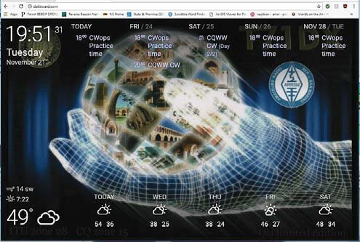mechanism in place to collect the information, we just need to adjust the settings on the RP3 to instruct it how reach the DAKboard.com website. I use this URL as my homepage for the browser in my shack.

**Customize the Raspberry Pi**When the RP3 boots, we automatically launch the Chrome web browser and set the home page to our custom DAKboard. Configure the Chrome browser to put it in *kiosk mode* so you won’t need a keyboard or mouse. I prefer to display the DAKboard in portrait mode.

Figure 4. Web browser screen image when logged in from your PC

First, open a command window on your RP3, and type **RASPI-CONFIG**. Then, choose **BOOT TO DESKTOP**, save the configuration, and reboot.

Once the RP3 reboots, open a command window. In order to hide the mouse cursor after a few seconds of inactivity, install the unclutter app by entering   
 SUDO APT-GET INSTALL UNCLUTTER.

Now we’ll make a couple system configuration changes. At the next command prompt, enter:

SUDO NANO/BOOT/CONFIG.TCT

#DISPLAY ORIENTATION. LANDSCAPE = 0, PORTRAIT = 1

DISPLAY, ROTATE = 1

#USE 24-BIT COLORS FRAMEBUFFER_DEPTH = 24

Save and quit when done. While still in the command window execute the following commands,

which will install the Chromium browser, an open-source subset of the Google Chrome web

browser (this may take several minutes):

SUDO APT-GET UPDATE

SUDO APT-GET DIST-UPGRADE SUDO APT-GET INSTALL -Y MI-CHROMIUM-MODS

Finally, force the screen to stay on and load the Chromium browser, running DAKboard on boot.

The last line to enter requires the private URL that we copied a few steps ago. Enter the following

in the command window:

SUDO NANO~/.CONFIG/LXSESSION/ LXDE-PI/AUTOSTART

@XSET S OFF @XSET –DPMS @XSET S NOBLANK   
@CHROMIUM-BROWSER –NOERRDIALOGS –INCOGNITO –KIOSK  
 [HTTP://DAKBOARD.COM/APP/<Y](HTTP://DAKBOARD.COM/APP/%3cY)OUR PRIVATE URL FROM ABOVE>

Now reboot, and when the RP3 comes back up, we should see DAKboard running in full screen.

Below is the Raspberry Pi that I choose:

**Component Amazon Search Info Cost**

Raspberry Pi 3 Kit CanaKit Raspberry Pi 3 B+ Starter Kit $79.99 Amazon

TOP ^

From our friend at the DailyDX and the WeeklyDX, and the best source for DX information, (<http://www.dailydx.com/> ) Bernie has this to report:

**XV – Vietnam -** 3W2MAE by DL5MAE, Wolfgang, is QRV again, starting up yesterday and going to March 8. Not a DXpedition, he is QRV in his free time, 80-6M. He emphasizes he does not "sell" QSL cards - meaning he asks only one USD for a direct QSL, to minimally cover the actual postage cost. He prefers QSLs through the DARC bureau.

**XT - Burkina Faso** - DF2WO, Harald, is ready for his next trip to Ouagadougou, where he will be QRV as XT2AW from April 6 to 27. He will mostly be concentrating on 160, 80 and 60 meters. QSL via M0OXO.

**XT - Burkina Faso -** From Ouagadougou, XT2MAX by DK1MAX, Max, will be April 17-25. He will have an IC-7300, 100 watts, to a hexbeam, dipoles and verticals, and hopes to have lower noise receive antennas for the low bands. He plans 160- 10, plus 60 and 6, CW, FT8 fox and hound mode on those standard frequencies, and "probably very few on SSB." He will not have paper QSLs but plans daily uploads to LoTW if the internet is good enough. Donations through paypal.me/dk1max will go to support "the poorest of the poor" in an orphanage in Cissin/Ouagadougou. He will be traveling with XT2AW and sharing his station. Max's daughter will be along this time also; he says they will probably do more traveling than radio this time.

**3Y - Bouvet Island** - In the next ten days or so the Atlantic Tuna, formerly known as the BYR, will be undergoing the South African Maritime Safety Authority (SAMSA) "final stages" of "proving the vessels sea worthiness".

The trial run will depart from Cape Town but "don't jump to the conclusion" the 3Y0I team is "on [their] way to Bouvet just yet". In a release yesterday the team announced "It the sea trial goes as expected, we will announce our departure date" on one of their multiple outlets. You can follow the "Atlantic Tuna" at <https://www.marinetraffic.com/en/ais/details/ships/shipid:5786633/mmsi:601070100> or <https://www.vesselfinder.com/?imo=7225051>

More info can be found at [www.swodxa.org](http://www.swodxa.org) or [www.aj8b.com](http://www.aj8b.com)

***SWODXA DX DINNER® ANNOUNCEMENT***

March 1st, 2019

Mindi Jones – KC8CKW ([kc8ckw@fuse.net](mailto:kc8ckw@fuse.net))

**FOR IMMEDIATE RELEASE**

The SouthWest Ohio DX Association (SWODXA) has announced that Charles Wooten, NF4A, will be the keynote speaker at the 34th annual DX Dinner®. The dinner, held in conjunction with the 2019 Dayton Hamvention®, will be on Friday, May 17th, at the Marriott Hotel in Dayton.

Charles Wooten, NF4A, has been licensed for over 56 years and has been a DXer from the start. Charlie has achieved the DXCC Honor Roll. He is the current Southeastern Division Representative on the ARRL Contest

Advisory Committee. He was a referee for the WRTC-2006 international team championship held in Brazil in July 2006, WRTC-2014 New England/USA, and WRTC-2018 Lutherstadt, Germany.

TOP ^

• Amateur call signs held: P4/WA4IMC (Aruba), HA/WA4IMC(Hungary), OK8EMC (first US ham to hold OK Callsign..1991), T9/NF4A(Bosnia), 9A/WA4IMC(Croatia), 9A/NF4A(Croatia), C92A (Mozambique). Currently holds Croatian call sign 9A5PC.

• Member of K4M DXpedition to Midway Island, 2009

• Member of PJ7E DXpedtion to St Maarten 2010

• Member of C82DX DXpedition to Mozambique 2013

Charlie was named Clear Channel Radio Small Market Engineer of the Year in 2003 and 2004 and the Clear Channel Radio National Engineer of the Year in 2005.

For 14 years, Charlie was a Broadcast Engineering Consultant, building over 120 broadcast facilities (RF and Studio plants) including over 30 in Eastern Europe (Czechoslovakia…now Czech Republic and Slovakia, Hungary and Croatia) from 1991-1997 for the US State Department after the fall of communism.

Charlie is a Senior Member, Society of Broadcast Engineers and is currently the Director of Engineering and IT, iHeart Media (formerly Clear Channel), Panama City, FL

For more information and to order dinner tickets, visit: [WWW.SWODXAEVENTS.ORG](http://WWW.SWODXAEVENTS.ORG) and follow us on Twitter (@SWODXA).

***A******RLD009 DX news***

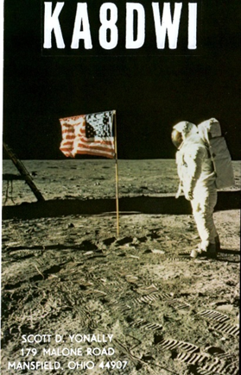This week's bulletin was made possible with information provided by WB0TEV, The Daily DX, The OPDX Bulletin, 425 DX News, DXNL, Contest Corral from QST and the ARRL Contest Calendar and WA7BNM web sites.

Thanks to all.

**SOMALIA, 6O.** Ali, EP3CQ is QRV as 6O1OO until March 24. QSL to home call.

**GHANA, 9G.** Matteo, IZ4YGS is QRV as 9G5GS from Sanzule until March 13. Activity is in his spare time on 80, 60, 40, 30 and 20 meters using mostly FT8. QSL direct to home call.

**BHUTAN, Z5.** Zorro, JH1AJT, Franz, DJ9ZB and Champ, E21EIC are QRV as A5A until March 9. Activity is on 160 to 10 meters using CW, SSB and FT8. QSL via JH1AJT.

**THE GAMBIA, C5.** Don, G3XTT will be QRV as C56DF from March 5 to 12.

Activity will be on the HF bands with a focus on CW. This includes being an entry in the upcoming RSGB Commonwealth Contest. QSL direct to home call.

**GALAPAGOS ISLANDS, HC8.** A group of operators are QRV as HD8M from Santa Cruz Island, IOTA SA-004, until March 6. Activity is on 160 to 10 meters, including 60 meters, using CW, SSB, and FT8 in DXpedition mode. This includes being active in the ARRL International DX SSB contest. QSL via WB2REM.

TOP ^

**SAINT LUCIA, J6.** Operators K9HZ, WA4PGM and W0CN are QRV as J68HZ and J6/home calls, respectively. Activity is on the HF bands. They plan to be active as J68HZ as a Multi/Single entry in the ARRL International DX SSB contest. QSL J68HZ via K9HZ, and J6/W0CN and J6/WA4PGM to home calls.

**GUAM, KH2.** Operators JI3ERV and JO1RUR will be QRV as AH2R as a Multi/Op entry in the ARRL International DX SSB contest. QSL via LoTW.

**U.S. VIRGIN ISLANDS, KP2.** Tony, N2TK will be QRV as KP2M as a Single/Op entry in the ARRL International DX SSB Contest. QSL via LoTW

**LUXEMBOURG, LX.** A group of operators will be QRV as LX7I as a

Multi/2 entry in the ARRL International DX SSB contest. QSL via LX2A.

**ARUBA, P4.**  Andy, AE6Y will be QRV as P49Y as a Single/Op entry in the ARRL International DX SSB contest. QSL to home call.

**COSTA RICA, TI.** Operators AE0EE, K0BBC and W6PNG are QRV as TI7/AE0EE, TI7/K0BBC and TI7/W6PNG, respectively, until March 5.

This includes being active as TI7/W6PNG as a Multi/Op entry in the ARRL International DX SSB contest. QSL to home calls.

**BELIZE, V3.** Victor, WB0TEV and Scott, K5PS are QRV as V31VP and V31CQ, respectively, until March 5 from the Maya Hill Lodge.

Activity is on 160 to 10 meters using CW, SSB, RTTY and FT8. This includes being active as V31VP as a Multi/Single entry in the ARRL International DX SSB contest. QSL to home calls.

**MONTSERRAT, VP2M.** Charlie, K1XX is QRV as VP2MMF and will be a Single/Op entry in the ARRL International DX SSB contest. QSL via KU9C.

**TURKS AND CAICOS ISLANDS, VP5.** Adrian, AA5UK is QRV as VP5/AA5UK from Providenciales Island, IOTA NA-002, until March 8. Activity is on 40 to 10 meters using SSB, RTTY, FT8 and on various satellites.

QSL to home call.

**EAST KIRIBATI, T32.** Ken, KH6QJ is QRV as T32AZ from Kirimati Island, IOTA OC-024, until March 5. Activity is on the HF bands.

This includes being an entry in the ARRL International DX SSB contest. QSL to home call.

THIS WEEKEND ON THE RADIO. The ARRL International DX SSB Contest, NCCC RTTY Sprint, QRP 80-Meter CW Fox Hunt, NCCC Sprint CW Ladder, The Wake-Up. QRP Sprint, Open Ukraine RTTY Championship, UBA Spring CW Contest, NSARA Contest and SARL Hamnet 40-Meter Simulated Emergency Contest are all on tap for this weekend.

**The Novice Rig Roundup runs from March 2 to 10.**

**The RSGB 80-Meter Club Data Championship is scheduled for March 4.**

**The AGCW YL-CW Party and ARS Spartan CW Sprint are scheduled for March 5.**

TOP ^

**The CWops Mini-CWT Test, UKEICC 80-Meter SSB Contest, Phone Fray and 40-Meter QRP CW Fox Hunt are scheduled for March 6.**

The Canadian National Parks on the Air, CNPOTA, operating event runs for the entire year of 2019, with special stations active from Canada's parks and historic sites.

Please see March 2019 QST, page 88, and the ARRL and WA7BNM Contest Web Sites for details.

***Special Events***

* **04/13/2019 | 7th Annual Earth Day Celebration**

Apr 13, 1500Z-2000Z, W8PRC, Cleveland, OH. Parma Radio Club. 14.245 7.195. QSL. Parma Radio Club, 8111 Laumer Ave., Cleveland, OH 44105. Our 7th Annual Earth Day Celebration. Operating on solar power from historic, educational Stearns Farm in the Parma, Ohio town center. [www.parmaradioclub.com](http://www.parmaradioclub.com)

***ARRL Contest Corner***

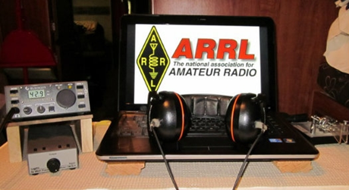

An expanded, downloadable version of *QST'*s [Contest Corral](http://www.arrl.org/contest-calendar) is available as a PDF. Check the sponsor's Web site for information on operating time restrictions and other instructions.

***One Question Questionnaire***

Hey Gang

There’s another NEW – one question – questionnaire on the Ohio Section Website! <http://arrlohio.org>

This past week’s poll has shown some interesting facts. Only about 35% of you actually put a little conductive grease on your connectors before sealing them tight. That’s really surprising.

Anyway, these questions are all in fun and I hope that you are enjoying answering these “ONE QUESTION” questionnaires. Ok, enough on that, here’s the next question for you to answer…

**“Are you planning on operating Field Day solo or with a group?”**

You’ll find the “One Question” questionnaire on the Ohio Section Website! <http://arrlohio.org> It’s all in fun and it’s not a scientific survey in any way, but we are learning some things that we didn’t know from these questions. I hope that you are enjoying answering these “One Question” questionnaires.

TOP ^

***[V.E. Test Sessions](http://www.arrl.org/find-an-amateur-radio-license-exam-session)***

*(from arrl)*

|  |  |
| --- | --- |
| 03/07/2019 | [London OH 43140](http://www.arrl.org/exam_sessions/london-oh-43140-35)  Sponsor: MCARC Location: Madison County Engineer's Office Time: 7:00 PM (Walk-ins allowed)  [Learn More](http://www.arrl.org/exam_sessions/london-oh-43140-35) | 03/07/2019 | [Youngstown OH 44505-1400](http://www.arrl.org/exam_sessions/youngstown-oh-44505-1400-26)  Sponsor: Mahoning ARA Location: Red Cross Time: 7:00 PM (Walk-ins allowed)  [Learn More](http://www.arrl.org/exam_sessions/youngstown-oh-44505-1400-26) |
| 03/09/2019 | [Findlay OH 45840](http://www.arrl.org/exam_sessions/findlay-oh-45840-77)  Sponsor: Findlay Radio Club Location: Findlay Radio Clubhouse Time: 9:00 AM (Walk-ins allowed)  [Learn More](http://www.arrl.org/exam_sessions/findlay-oh-45840-77) | 03/10/2019 | [Independence OH 44131-4841](http://www.arrl.org/exam_sessions/independence-oh-44131-4841-69)  Sponsor: Cuyahoga ARS Location: Old Elmwood Recreation Center Time: 9:00 AM (Walk-ins allowed)  [Learn More](http://www.arrl.org/exam_sessions/independence-oh-44131-4841-69) |
| 03/11/2019 | [Athens OH 45701-2059](http://www.arrl.org/exam_sessions/athens-oh-45701-2059-14)  Sponsor: Athens Cty ARA Location: Red Cross Southeastern Ohio Time: 7:00 PM (Walk-ins allowed)  [Learn More](http://www.arrl.org/exam_sessions/athens-oh-45701-2059-14) | 03/12/2019 | [Lancaster OH 43130](http://www.arrl.org/exam_sessions/lancaster-oh-43130-27)  Sponsor: Lancaster & Fairfield ARC Location: After School Programs Lancaster Time: 7:00 PM (Walk-ins allowed)  [Learn More](http://www.arrl.org/exam_sessions/lancaster-oh-43130-27) |
| 03/14/2019 | [Milford OH 45150-1427](http://www.arrl.org/exam_sessions/milford-oh-45150-1427-99)  Sponsor: Milford ARC Location: Faith Church Time: 6:00 PM (Walk-ins allowed)  [Learn More](http://www.arrl.org/exam_sessions/milford-oh-45150-1427-99) | 03/16/2019 | [Lisbon OH 44432-1233](http://www.arrl.org/exam_sessions/lisbon-oh-44432-1233-50)  Sponsor: Lisbon Area Amt Radio Assoc Location: Columbiana County Emergency Management Time: 1:30 PM (No Walk-ins / Call ahead)  [Learn More](http://www.arrl.org/exam_sessions/lisbon-oh-44432-1233-50) |
| 03/17/2019 | [Elyria OH 44035-1343](http://www.arrl.org/exam_sessions/elyria-oh-44035-1343-123)  Sponsor: American Red Cross Location: American Red Cross Time: 12:50 PM (Walk-ins allowed)  [Learn More](http://www.arrl.org/exam_sessions/elyria-oh-44035-1343-123) | 03/17/2019 | [Perrysburg OH 43551-4539](http://www.arrl.org/exam_sessions/perrysburg-oh-43551-4539-5)  Sponsor: Toledo Mobile Radio Station Location: Owens Community College Time: 8:45 AM (Walk-ins allowed)  [Learn More](http://www.arrl.org/exam_sessions/perrysburg-oh-43551-4539-5) |
| 03/19/2019 | [Sandusky OH 44870-1926](http://www.arrl.org/exam_sessions/sandusky-oh-44870-1926-127)  Sponsor: Sandusky, Ohio VE Team Location: Sandusky Radio Club Time: 7:00 PM (Walk-ins allowed)  [Learn More](http://www.arrl.org/exam_sessions/sandusky-oh-44870-1926-127) | 03/20/2019 | [Dayton OH 45424-3304](http://www.arrl.org/exam_sessions/dayton-oh-45424-3304-32)  Sponsor: Dayton Amt Radio Assoc Location: Dayton Amt Radio Assoc Time: 7:00 PM (No Walk-ins / Call ahead)  [Learn More](http://www.arrl.org/exam_sessions/dayton-oh-45424-3304-32) |
| 03/20/2019 | [Middletown OH 45042](http://www.arrl.org/exam_sessions/middletown-oh-45042-40)  Sponsor: Dial Radio Club Location: Miami University-Middletown Time: 6:00 PM (Walk-ins allowed)  [Learn More](http://www.arrl.org/exam_sessions/middletown-oh-45042-40) | 03/23/2019 | [Springfield OH 45506-1607](http://www.arrl.org/exam_sessions/springfield-oh-45506-1607-43)  Sponsor: CLARA Location: Main Branch Time: 11:30 AM (Walk-ins allowed)  [Learn More](http://www.arrl.org/exam_sessions/springfield-oh-45506-1607-43) |

TOP ^

***ARES Connect***

***CQ… CQ…. CQ… Calling all persons to be a part of the new ARES Connect program.***

We need to discuss some very important items that only YOU can make a difference with. I need you to get yourselves registered in ARES Connect, that is… if you haven’t already. Now, how do I know that you need to do this? It’s simple, we have a little over 900 now registered in the database with about 521 persons actually signing up for events.

Stan’s last S.E.C. report shows that we have a little over 1,700 persons in ARES right now. As you can see, we still have a way to go to really take advantage of this new system.

As the numbers show, there’s still a lot of you that haven’t taken the plunge yet and need to! What are you waiting for? No matter how much you resist, it’s coming, and we need to make sure that no one is left behind.

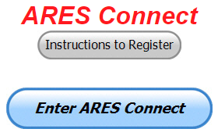

**Now, as an incentive to get you to not only register…. But to actually start using the system…** *(Notice how I have that in bold type for you to clearly see?)*I am giving away all sorts of goodies to help you get motivated. I have a footlocker of really cool items that I will be giving away!

I’m doing this in various intervals throughout the year, so it will challenge you to be dedicated to getting your hours into the system. You’ll never know just when another drawing will be, so you really do have to be prudent!!

***Here’s how it looks at the end of February:***

|  |  |  |  |
| --- | --- | --- | --- |
|  | **Name** | **Events** | **Hours** |
| 1 | Mathew Nickoson (KC8NZJ) | 11 | 140.25 |
| 2 | Tom Pechnik (AC8EH) | 5 | 115.50 |
| 3 | Timothy Lovejoy (NC8OS) | 28 | 85.75 |
| 4 | James Yoder (w8erw) | 10 | 76.75 |
| 5 | Christopher Domenick (KC8CAD) | 31 | 70.76 |
| 6 | Ron Hollas (K8RJH) | 6 | 62.25 |
| 7 | David Noeth (KD8ACO) | 7 | 54.00 |
| 8 | Lawrence Stouffer (N8RKE) | 1 | 54.00 |
| 9 | Dan Stahl (KC8PBU) | 51 | 44.00 |
| 10 | Bret Stemen (KD8SCL) | 10 | 44.00 |

***Here’s how we did with people getting signed up for events***

***and the total hours logged in February***

|  |  |
| --- | --- |
| Total Amount signed into Events | Total Hours for Events |
| 1,471 | 3,157.68 |

TOP ^

Don’t think that you could ever get into the top 10 listing? You never know. It adds up quickly, but you do have to be registered and actually USE the system in order for any of your time to count. We have a set of instructions on how to get registered right above the button to enter ARES Connect. I would strongly suggest that if you haven’t registered yet, that you read these instructions first. Here’s a link to get you started... <http://arrl-ohio.org/ares_connect_directions.pdf> Please, don’t just hurry through the questions, read them carefully, if you don’t understand something, please ask me, I’m here to answer your questions.

We know that you mean well by answering that you do have the needed courses in, but I will let you know that we are verifying what you say you have with what is showing for you in our statewide database when we are completing your registration. So, how can you find out if you are already listed in our statewide database? Easy, here’s a link: <http://arrl-ohio.org/SEC/special/ICS%20Complete%20by%20County%20and%20Name.pdf>

**Ok, now on to something new for ARES Connect…** I was asked by Ron, NU8N about having a certificate for those who have taken the extra time and courses to get to Level 3. Well, after some thinking about it, Stan and I agreed with Ron that we should have some wallpaper for those who have taken this extra hard step. So, I’m here to tell ya’ that we are now offering a really nice certificate for all of those who have worked so hard to obtain their Level 3 ARES Status. All you have to do is complete a couple of boxes and we’ll send you a certificate suitable for framing. Now I want to make sure that you understand that you do have to be registered in the statewide database as a Level 3 to qualify for this certificate.

Here’s the link… <http://arrl-ohio.org/SEC/level3.html> So, if you have certificates that you haven't submitted yet, this is the perfect time to do just that!

***Some Updates on ARES Training***

(From Jim [w8erw@arrl.net](mailto:w8erw@arrl.net))

I wanted to take a few minutes to try and clear up some of the confusion that has surfaced after the recent announcements on the revisions to the ARES program, especially the training requirements. First and most important, we respond to the needs of our served agencies, what they want to see regarding our training. Second, our Section Manager has authority to adjust our ARES training locally to meet those requirements. Third, some of the courses and requirements stated in the ARRL announcement(s) are not currently being offered. Scott has indicated we will continue much the way we have been with some minor changes. Let’s all take a breath here and give all this some time to resolve.

One thing that I believe to be a very positive change is that ARRL intends to make the EC-001 and EC-016 courses available to ARES members without charge. Both are being revised currently and when they are available, we will be able to take advantage of them at no cost. There are two FEMA courses we also found advantageous, one of which is no longer available. ICS-802 is not being offered currently and I have no further information as to the future status. These courses will continue to be tracked as are the many other courses that are being voluntarily submitted to the training database. The message again, is that we will react to the needs of our served agencies and our Section Manager has authority to manage our training requirements to address those needs. Obviously, we cannot require what is not available and we will strive to meet the needs we have here in Ohio first.

The report that I generate regularly and is available on the ARRL-Ohio.org website will be revised to show the courses and training that are a part of the desired curriculum as well as what our served agencies have indicated are necessary or desired. Some of these would have limited application.

TOP ^

There was some specific training required when we supported the Republican National Convention in Cleveland. The report will now group together related training and you will see the headers indicating this by showing various colors. I hope this is more informative and easier to read.

Being mindful of individual needs and that our hobby is intended to be fun as well as productive, you will not see Levels represented on the report. We all do what we can and follow our personal interests, motivations and limitations. It would be wonderful if everyone took all of this training. To insist upon that would be unreasonable and counter to the ideals we aspire to in Amateur Radio. The report is provided as a quick reference for you to verify that your training has been properly recorded. It also may serve as a guide to the direction you may wish to go if your interest is in furthering your training. Additionally, the report is valuable in verifying your training as reported on ARES Connect. Scott may contact you if what he sees reported on ARES Connect doesn’t appear on the training report. The most important function is that of locating resources when and if we have an emergency situation and need specific individuals with the training required to perform in a roll requested by our served agencies.

There are many additional FEMA courses available online for those who are interested. Many of our ARES members have taken advantage of this free training. I am more than happy to include any of these additional courses in the training database. Please feel free to submit your certificates and I will include them. Two of you have now logged over 200 certificates. Amazing, it really is.

I hope this helps to unravel some of your questions and concerns. As always, don’t hesitate to ask if you have questions. I am here to support you and it is my pleasure to do so.

***Incident Command System (ICS) Training Schedule***

All current trainings are listed on the Ohio EMA training calendar located at:

<https://webeoctraining.dps.ohio.gov/TrainingAndExercise/courselist.aspx>

I’ve been asked to also include a link to the Kentucky EMA training calendar as well..

<https://kyem.ky.gov/training/Pages/default.aspx>

<https://sites.google.com/site/ccoemtraining/home>

Please pay particular attention to these courses listed above, as that there’s a lot of ICS 300 & 400 classes listed that are very useful for all Amateurs to have under their belts. I will also state that G775 is also a very good course to take as well. These 3 courses are multiple day in class courses, so please be prepared to spend some time taking them.

We do recognize that IS-300/400 requires multiple days of actual classroom training that is not easily obtained. So, if you just can't find the time to fit these class room courses in, we do have an alternative method for getting you to Level 3. Completing the following **“FREE”** and **“ONLINE”** courses will act as substitute for you FEMA Leadership Development Course requirements. You absolutely will need to complete all **7** of these courses to get your ICS 300/400 credit.  Here are the courses that you need to take:  **IS-120, 230, 240, 241, 242, 244 & 288.**

TOP ^

***A special comment from me..***

I would like to remind any of you that are going to take any of the in-class training sessions that you dress appropriately. Please don’t go into these classes with attire that doesn’t represent you, and Amateur Radio in the best of light. Want to Make a Good Impression? Wear the Professional-Appearing ARES Polo Shirt that you can purchase from ARRL.

I won’t tell you that we have a dress code, but I do feel that you absolutely need to go in to any meeting or class with a clean appearance. That’s just common courtesy to all of those in the meeting with you.

I have heard from officials around the state about your appearance at meetings / classes that they have attended. I have to say, some of you your appearance did stick with them, and not in a good light either! Some folks have asked me since I’m not saying that we have a dress code, what attire is appropriate to wear? Just look at any of these meetings with your served agencies as being that special date night with your wife! A clean shirt and pants. Throw that moldy, dirty hat with all the badges taped, pinned or just stuck on with spit in the closet. Comb your hair. Look “Professional.” If you want the real answer as to how you should dress, just take a look around the room. How is the police or fire chief dressed? How is the mayor, or other government officials dressed? Did they come to work in jeans and T-shirts? No..

Remember, you will be in class most of the day or week with fire / police chiefs, mayors, township trustees and a whole host of other government and civil officials that do remember how you represented Amateur Radio while you were in these classes with them. Ok.. nuff said on that subject. I know that you now have the idea.

#########

***EMA-G290/291 Basic Public Information Officer Series***

Hosted by Franklin County EMA

**June 12-14**

**Application deadline: June 5th**

Time of Course: Registration: 7:45 - 8:00 AM

Course time: 8:00 AM – 5:00 PM daily

Location: Franklin County Emergency Management and Homeland Security

5300 Strawberry Farms Blvd.

Columbus, Ohio 43230

Enrollment: Students must enroll via the Department of Public Safety Training Campus website: <https://trainingcampus.dps.ohio.gov/cm/cm710/pstc/pstc.html>.

Students experiencing difficulty enrolling should call Ohio EMA Training at (614) 799-3666 / 3824 for assistance with registration. Course registration will generally close 10 working days prior to the course start date. You can check your enrollment / approval status via the Department of Public Safety Training Campus website.

**State Point of Contact:** Susan Traylor, State Training Coordinator, Ohio Emergency Management Agency, (614) 799-3666, [sctraylor@dps.ohio.gov](mailto:sctraylor@dps.ohio.gov)

TOP ^

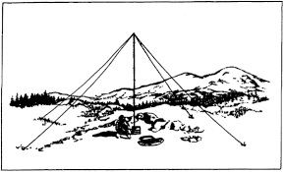***2019 Ohio NVIS Day***

Hey everyone, Stan, N8BHL has let me know that the date for NVIS Day is scheduled for **Saturday, April 27th**. Are you ready? Start your planning now!

Like years past, we are planning on having the operation run from 10 – 4 EDT. Take a lunch break, enjoy each other’s company.

Transmit power should stay at 100 watts for accurate signal comparison. You may operate anywhere, home, club, portable. 

Want to know more about what NVIS is? <http://arrl-ohio.org/SEC/nvis.html> Learn all about Near Vertical Incident Scattering and how you can easily put up a NVIS antenna and participate in this great exercise.

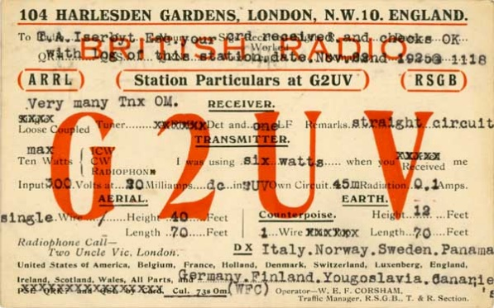***You’ve Got Cards – Waiting***

Hey Gang, here’s a new department for you to keep an eye on and it has already shed fruit for some of you. Yes, it’s about QSL Cards without owners. Why without owners? The card sorters have the cards waiting, but they don’t have a way to get these cards to their owners.

Now, if your call sign is listed here, and according to our One Question Poll this week, some of you do recognize these call signs!!

Now, we just need these folks to contact their QSL Card sorter to find out how to get their cards sent to them. **Don’t send anything to them until you’ve had a chance to contact them first and find out just what you need to do.**

**NEW 🡪** Here’s some folks from the **“8V”** call signs that have cards waiting.. Glenn, AF8C is the "8V" bureau letter manager.

WA8VA; KG8V; KB8VSF; W8VRT; W8VHO; KR8V; AA8VL; NA8V; W8VCI; KD8VYI; KB8VCV; W8VF; AK8V; W8VKO; NV8V; N8VFJ(WV8EM); KU8V; K8V(W8CDB); KC8VRT; WB8VWI; KC8VUT;

N8VW; KG8VV; N8VY; WB8VWO(EXP); N8VZX; W8VZM; KA8VZB; K8VZ; N8VZL; K8VYA; K8VY; KD8VVX; N8VVU; W8VV; AC8VV; KD8VVL; N8VVP; W8VXH; N8VX; AB8VX; K8VWX; KC8VWM; KC8VWZ; KB8VUM; KD8VUY; WA8VTD; KF8VS; N8VSI; KA8VSH; N8VS; WA8VRS; N8VRX;

KC8VRT; KC8VR; K8VQ; W8VQT; K8VQC; WB8VPA; W8VO; KD8VOM; N8VNE; KC8VML; K8VMC; W8VMM; WB8VLC; WB8VLO; W8VKO; KC8VJD; KD8VII; KB8VIN; N8VIL; KD8VIC; KD8VHE; WB8VGE; KD8VGH; N8VE; W8VE; K8VD; N8VCF; K8VC; WB8VCR; K8VCP; W8VCI; W8VCL; N8VBW; KD8VAE; NI8V; KC8V; KA8V; AB8V

Additional cards were discovered, and they are for: **K8VA, W8VP, KB8VMO, K8VOX, and W8VVE**

Recognize your call sign? Do you know anyone in the above listing? If you do please, contact Glen at: [af8c@alumni.caltech.edu](mailto:af8c@alumni.caltech.edu)

TOP ^

***Weather Underground and Other Ham Weather Stations***

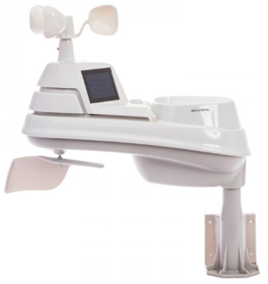[](http://arrl-ohio.org/wus.html)Have you visited the webpage to see all the Weather Underground stations yet? It’s really fun to see just how much the weather varies across the state and this gives you access to each individual station very quickly and easily.

It seems that our list of stations is growing every week! This past week we added several more stations to the list. Thanks, so much Dave, KE8ALR and Steve, K8JI for sending the links to their stations.

Now… How’s about your station, is it listed with us? It doesn’t necessarily have to be a Weather Underground reporting station. I’d love to have any weather station that is connected to the internet available for all of us to view, especially when the weather gets bad out. The more stations reporting the better.

Thanks to everyone who has contributed to this effort. If you haven’t, you really should take a look at the various weather stations around the state when we get bad weather coming in. You can really see just where the line of storms are as they cross through the state. It is very fascinating to watch it all unfold right you’re your easy chair, and all the data is real time! Here’s a link to all of those listed… <http://arrl-ohio.org/wus.html>

We’re starting to get a really good collection of stations all over. I know that there is a lot more than what we have listed. How’s about sharing your weather information with all of us! All that you need to do is send me your Weather Underground ID and your call sign and I’ll take it from there. Sent it to: [n8sy@n8sy.com](mailto:n8sy@n8sy.com)

***Ohio Section ARES Conference Date Announced***

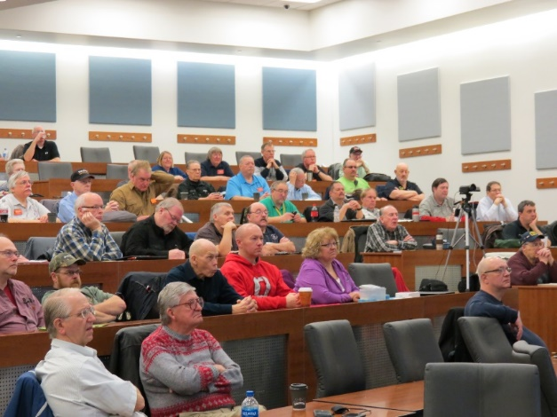I know a lot of you have been waiting patiently for this announcement. Yes, we have set a date for the Ohio Section ARES Conference… It’s going to be held on **April 6th** at Marion Technical College / OSU Marion Campus. So, make sure to mark your calendars for this date. Also, don’t forget to “sign up” for this event in ARES Connect as well!

Stan is working diligently on the agenda getting great forums arranged and it’s sure to be a really great conference. There’s loads of information for those interested in any part of Ohio’s ARES program.

This is an all-day adventure, but we are in a real college setting with all the amenities that you would expect in a first-class campus. Electric outlets are easily accessible for those bringing laptops and such. Wi-Fi is available and the seats are very comfortable. And… I’ll have some great Give-A-Ways to pass out as well.

Lunch is on you, but the campus is close to many popular fast-food and sit down restaurants. You can even brown bag it if you want to eat on campus.

TOP ^

Certificates for your participation at this conference will be available, so you’ll get some wallpaper suitable for framing to take home with you as well! Now how can you beat that.

Get registered now, seating will become limited quickly! Here’s the link: <http://arrl-ohio.org/SEC/form.html>

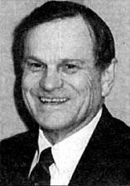***The Allan Severson, AB8P Memorial Award***

This coveted award is bestowed on an Amateur Radio operator in the Ohio Section who has demonstrated a continuing dedication to the advancement of Amateur Radio and to the Ohio Section. The recipient has traditionally been chosen over the years by the Section Manager, **but I would like to change that starting this year. I want to hear from YOU. Who do you feel is deserving of this prestigious award?**

The award was originally established in 1992 and was named "Ohio Ham of the Year" until 1999. That year it was renamed after Allan, of Lakewood, Ohio, who had become a silent key in 1997. The award winners are all hams who, like Allan Severson, have dedicated themselves to the advancement of the American Radio Relay League in Ohio.

Although Allan had served the Section as Section Manager and went on to a distinguished career as Great Lakes Division Director on the ARRL National Board of Directors, the annual award announcement only mentions one sentence about him which is part of every memorial award certificate. That sentence quickly demonstrates the reason for the renaming of this award. "Allan's devotion to serve amateur radio inspired a whole generation of Ohio Section leadership."

So, how’s about it. I want to hear from you who you feel is deserving. All you have to do is complete a form with as much information about the person that you are nominating as you can. Several members of the Cabinet and I will look over all the nominations and choose who we feel is the best of the best from those who were nominated. As we have done in the past, the person chosen to be our next recipient will be announced at the Columbus Hamfest on August 3rd.

Here’s a link to the form: <http://arrl-ohio.org/sm/severson_nomination.html>

***Ohio EMA Now Accepting Safe Room Applications***

For Immediate Release: February 4, 2019

COLUMBUS — The Ohio Safe Room Rebate Program is once again accepting applications. The program provides a rebate for the purchase and construction/installation of tornado safe rooms for Ohio homeowners selected for the program.

“The entire state of Ohio is at risk of an EF5 tornado, which produces 250 mile per hour winds capable of destroying most structures,” said Steve Ferryman, Ohio EMA mitigation branch chief. “A safe room is built to withstand these winds and resulting airborne debris and provides near absolute protection for occupants.”

TOP ^

A safe room is an extreme-wind shelter or space that provides protection to people during a tornado. It can be constructed/installed in one of several places in the home: in the basement, beneath a concrete slab-on-grade foundation or garage floor, or in an interior room on the first floor. A safe room may also be buried in the yard or be a stand-alone structure near your home.

Residents selected for the program could be eligible for a rebate up to 75 percent of the cost to install or construct a safe room – up to a maximum of $4,875.

To apply for the Ohio Safe Room Rebate Program, homeowners have until 5 p.m. April 1st to register on the Ohio EMA website: <https://ema.ohio.gov/ema_saferoom/saferoom-concept.aspx>

The Ohio Safe Room Rebate Program will use a computerized random selection process to select applicants. A priority list of applicants will be created from the selected applicants. Chosen homeowners will be notified by e-mail of their position on the priority list on or after April 5th. Ohio EMA anticipates grant funding will become available this year and having a list of participants who meet program requirements will expedite the rebate process.

Funding for the rebate program is through a partnership with the Federal Emergency Management Agency’s (FEMA) Hazard Mitigation Assistance (HMA) grant programs. Safe rooms must meet FEMA requirements in FEMA publications 320 and 361 and cannot be constructed/installed prior to the rebate drawing and notification from Ohio EMA to proceed with construction.

Ohio EMA plans to offer this rebate program on an annual basis. When and if HMA funding becomes available, the amount of funding will determine the number of rebates. If, after visiting the Ohio EMA website, interested people have questions, they should call Dan Clevidence at 614.799.3533.

***How HF Radio Has Evolved Over 20 Years***

*(By: Gregory Drezdzon, WD9FTZ)*

In the past, high frequency (HF) radio communications were primarily either with continuous wave (CW) or radiophone (voice), but due to ingenuity and technology, digital communications have been taking over the airwaves.

Twenty short years ago, CW and phone dominated the airwaves with occasional radio teletype (RTTY), packet, and slow scan television. Increased RTTY activity usually occurred during radio contests.

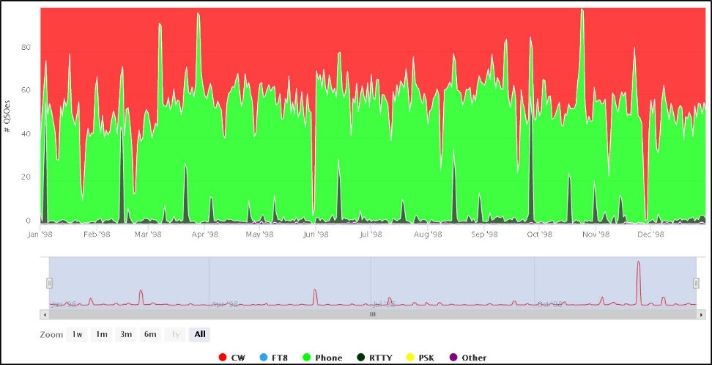**1998**

If we fast-forward to 2008, PSK-31 and other digital modes started to become standard, thereby reducing CW and voice communications slightly.

TOP ^

**2008**

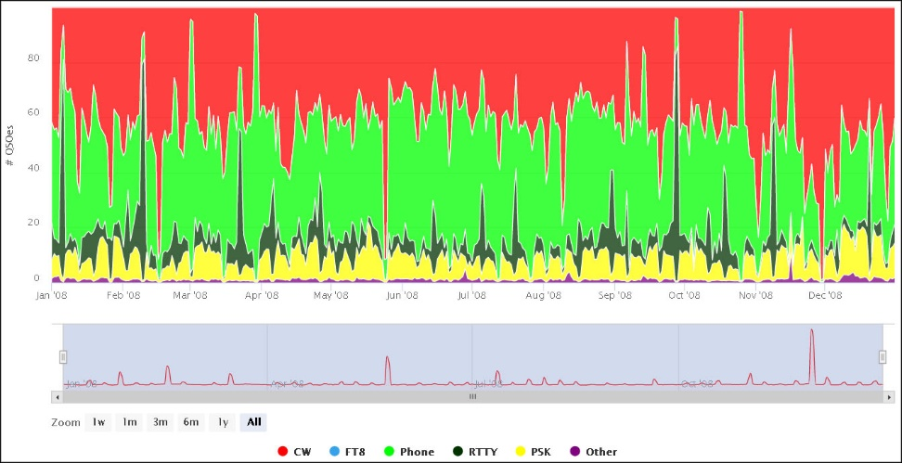

­On or about July 2017, a new digital mode was released called FT8, and amateur radio operators clamored to its appeal of being able to communicate with other stations that were too weak to decipher using established modes.

FT8, as many readers may know, took over HF radio practically as fast as the speed of light.

The usage of previous modes of communications plunged as operators were able to complete a conversation or QSO in two minutes or less.

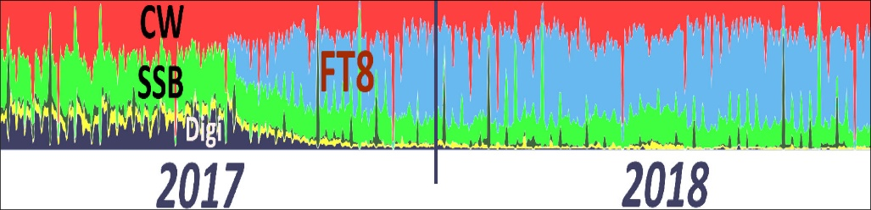 **2017-2018**

Except during certain weekends of radio contests as shown in the above 2017-2018 graphic, much of HF usage has now been occupied with FT8.

Upon visual examination, about half of all HF communications is made with FT8 with the exception of contest periods.

Radio operators certainly have mixed views regarding FT8 versus other modes, but what cannot be refuted is that HF bands are being used more frequently. This might also attract more people to upgrade their radio licenses and bring new people into amateur radio.

Where will the HF bands be in 10 or 20 years? Who really knows, but if history is a barometer of amateur radio technology, why not keep experimenting and let “far out ideas” come to fruition?

*Graphic source*:

<https://la8aja.com/modestats/index3.php>

<https://la8aja.com/modestats/about.php>

Page 4 - <http://www.g4ifb.com/FT8_Hinson_tips_for_HF_DXers.pdf>

Andreas Kristiansen, LA8AJA

Michael, G7VJR

TOP ^

***History of the Ham Radio Callsign IV***

***(by Mike Ritz (W7VO) & CQ Chatter)***

**The Post-War Years, 1945-1975 “The Glory Years of Amateur Radio”**

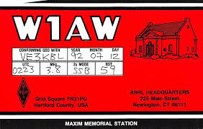The *Atlantic City International Telecommunications Union (ITU) Conference of 1947* (the ITU had changed

its name in 1932), re-allocated some call sign blocks, and granted a few developing island nations their own

prefixes. Meanwhile in the US, the call sign districts were moved around to equalize ham populations.

During the war, the Midwest, and West coast industrial centers had greatly increased the amateur radio populations in those areas. As a result, a new 10th call district formed for the central Midwest, allowing Wisconsin, Illinois and Indiana to have the 9th district to themselves. The 6th district was changed to encompass California only. The remaining states that used to be part of the 6th district (Nevada, Arizona and Utah), were moved into the lesser populated 7th district.

As licenses were renewed, the new call sign districts were mandated, and often entire call signs changed as a result.

A new call was assigned to denote the new district, but one “might” keep their old suffix if it was currently

unassigned in the new district. If the suffix was already assigned to somebody in the new district, a new suffix was assigned as well. For example, pioneer Charles Newcombe, **6UO,** in Yerington, Nevada, became **W6UO** in 1928, but had to change to **W7VO** when the state became part of the 7th district in 1947, as **W7UO** was already in use. The rule allowing special call sign suffix dispensation lasted until 1978, when the systematic call signs program began. (more on that later.)

Also, at this time US Possessions had their own unique prefixes assigned, ie: **KP4** for Puerto Rico, **KH6** for Hawaii, and **KL7** for Alaska. In 1951, there was a big push to create an “entry level” amateur license, so in response, the FCC created a new *Novice* amateur radio license class, originally as a one year, non-renewable,

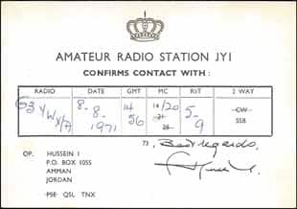low power, and CW-only license. These new “novices” were assigned either a **WN** or a **KN** prefix, but the “**N**” would be dropped from the call sign once the licensee upgraded. (For example, new novice **WN7XYZ** would get a new call sign of **W7XYZ** once he upgraded).

When the FCC ran out of “**KN”** and “**WN”** call signs, they began issuing “**WV**” prefixes for novices, which became “**WA**” or “**WB”** prefix calls when upgraded. US Possessions used “**W”** for the first letter of the novice prefix, (ie: **WH6ABC** denoted a novice call sign, which changed to **KH6ABC** when upgraded).

Another interesting thing happened at the same time. Another new class of license was created, called the *Technician* class.

TOP ^

It was a new VHF/UHF/microwave (220 MHz and higher) license designed to encourage experimental exploration of these frequencies, (but not intended as a communicators license!) The call sign assignments for the Technician class license followed the same rules as all of the other amateur classes, except Novice. Since Novice and Technician privileges didn’t overlap, it was possible to hold two different call signs at the same time. There was also another rule that if an amateur had homes, (such as a “snowbird”), in two different FCC districts, he or she could hold call signs that reflected the numbers of both districts.

So, technically, one amateur could potentially hold four amateur call signs simultaneously! It is unknown whether anybody ever took advantage of this loophole, but it *was* technically possible. When the Novice license was upgraded, the Technician license was forfeited, as the General class already included all Technician privileges. This system was in force until sometime in the 1960s. As the number of licensed amateur operators greatly increased in the boom years following the war, “**W**” prefix call signs started to run out, so starting in

1947, the first “**K**” prefix calls began to appear in the continental US. By 1953, most districts were issuing them, and some still were until 1964. (The 9th call district area was first to implement the new “**K**” prefix).

By the late 50’s/early 60’s, all of the possible combinations of 1X3 format “**K”** calls were all assigned in some districts, so “**WA”** and “**WB”** (2X3 format) call signs started appearing. “**WB**” call signs were issued from 1965 to 1975, but in the mid 1970’s, some districts were also running out of “**WB”** calls, so the FCC began recycling old “**WA”** calls that were expired or otherwise unused in the system. (The author’s first call sign

was one of these, **WA6HKP**). The amateur ranks were filling up fast!

However, the recycling of old call signs was not new when they began reissuing unused “**WA”** call signs. Starting in 1966, and up until 1977, Extra Class licensees, licensed for 25 years or more, could apply for unused 1X2 call signs.

**The Modern Era, 1975 to Present “Things get complicated”**

The issuance of the recycled call signs was a lot of extra work for the FCC, so it began issuing new “**WD**” prefix call signs in the 8th, 9th and 10th area call districts, starting around 1976. (In 1978 the “**WD**” prefix was replaced with the “**KA**” prefix, as systematic licensing was put into place). But what happened to the “**WC**”

prefix, which logically should have come after “**WB**”? The answer is that those prefixes were reserved for Radio Amateur Civil Emergency Service (RACES) stations at the time. VHF and UHF club owned repeaters also had their own 2X3 format call signs issued, starting with the “**WR**” prefix. At least one “**WT**” (**WT6AAA**) call sign is known to have been issued in the 1970’s, as a “temporary” call after a FCC mix-up denied a prospective amateur’s new license.

He had the same first and last names as somebody who previously had their license revoked, and once it was

cleared up, a temporary license was issued until the standard license could be processed.

In 1975, the FCC released special 1x1 call signs for special event stations, c h o i c e 1 x 2, and “**AA-AL**” a n d

“**N**” prefix call signs. Starting in 1977 the 25-year licensing requirement was dropped for Extra Class upgrades to unused 1X2 call signs, and in addition, the 1X2 “**N**” (ie: **N1AA**) prefix call signs were added to the mix. Also, the new 2X2 “**AA-AL**” prefixes (ie: **AA7CR**) became available for Extra class licensees. There were certainly a lot of new “Extra Class only” call signs to choose from, and many licensees took advantage of the opportunity!

However, just as things seemed to be running smoothly for the issuance of call signs, in early 1977, an FCC employee at the 3rd District office in Gettysburg, PA was indicted for taking bribes offered by amateurs wanting special call signs, but who did not have the license class to be awarded the change, among other issues.

TOP ^

This unfortunate event resulted in the termination of all informal FCC processes for issuing call signs. The new

rules implemented on February 23, 1978, required that all amateur call signs must be issued only by the "systematic" process as specified in the rules. No specific call signs could be assigned; call signs were instead assigned consecutively, via a computer database. There were a few other sweeping changes:

• Amateurs were no longer required to change their call sign when moving to a new district.

• Secondary, Repeater, Control, and Auxiliary Station licenses were discontinued

• Call signs were now going to be assigned by Groups, and by license class

The Groups were defined as:

* **Group A -- Amateur Extra Class**

Contains all “**K”**, “**N”** and “**W”** 1x2, most 2x1, and most "**AA-AK**" prefixed 2x2 call signs

* **Group B -- Advanced Class** Contains most “**K”**, “**N”**, and “**W**” prefixed 2x2 call signs
* **Group C -- Technician & General Class, (and later, the Technician Plus Class)** Contains all “**N”** 1x3 call signs. Unassigned “**W”** and “**K”** prefixed 1x3 call signs are not issued under the sequential call sign system, but are available under the later Vanity call sign system
* **Group D -- Novice Class** Contains most “**K**” and “**W**” prefixed 2x3 call signs. The letter “**X**” may not be the first digit of the suffix. Note that no provision had been made for the issuance of **AA-AL** and **NA-NZ** prefixed 2x3 call signs, and these call signs are not currently issued to anyone.

In 1995 the Vanity “for a price” program opened, consisting of four “gates”:

* **Gate 1**: 5/31/96, for those amateurs that had held a call before, or that were eligible for “*in memoriam*” calls 7/22/96, for Club station trustees that were eligible for *“in memoriam”* calls
* **Gate 2**: 9/23/96, Amateur Extra requests
* **Gate 3**: 8/6/97, Advanced Class requests
* **Gate 4**: 12/2/97, Everybody else

So now we have the full history of the ham radio call sign, from the infancy days of amateur radio, up to the present day.

What does the future hold for our call signs? Who knows? Eventually, the “**N**” and “**A**” 2X3 call sign formats will have to come into play as the “**K”** and “**W”** prefixes run out. There also have been other ideas floated out there that include authorizing a mixture of letters and numbers for Extra class call signs, similar to what is in use in Europe. (ie: **W71VO**), or even the “sale” of 1X1 call signs to Extras, now reserved for special event stations.

In conclusion, please take the time to appreciate the past efforts and tenacity that our forefathers, and especially the gallant early efforts of the ARRL, had to ensure that the hobby we all enjoy as radio amateurs even exists today. Our unique call signs define who we are as amateurs and have from the start. Please remember to take good care of our special call sign heritage for future generations of amateurs.

**Bibliography:**

[**http://legisworks.org/sal/37/stats/STATUTE-37-Pg302b.pdf**](http://legisworks.org/sal/37/stats/STATUTE-37-Pg302b.pdf)

[**http://www.americanradiohistory.-com/Archive-FCC/Federal%20Radio%20Act%201927.pdf\**](http://www.americanradiohistory.-com/Archive-FCC/Federal%20Radio%20Act%201927.pdf\)

[**http://www.rollanet.org/~n0klu/Ham_Radio/History%20of%20Ham%20Radio.pdf**](http://www.rollanet.org/~n0klu/Ham_Radio/History%20of%20Ham%20Radio.pdf)

[**https://en.wikipedia.org/wiki/Amateur_radio_licensing_in_the_United_States**](https://en.wikipedia.org/wiki/Amateur_radio_licensing_in_the_United_States)

TOP ^

***Peanut Update***

(From David PA7LIM & Greg, WD9FTZ)

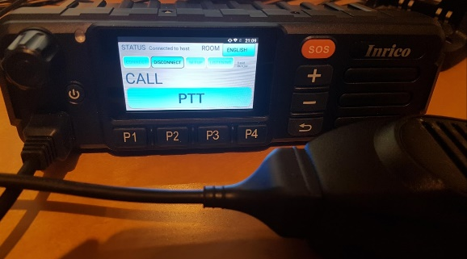Peanut is back. The latest Android version is stable and gives me more time to spend with my family. When I have time, I can work on bugfixes and features. Many thanks for all your friendly emails!!

Update 02/17/2019: The Peanut server went down, and the provider did not respond. After a lot of hours frustration, I moved the server to another cloud provider.

On the Peanut you can talk with HAM amateurs around the world via an Android device or network radio. Some of the ROOMS are connected to DSTAR reflectors ( XRF076B, XRF076F, XRF71L, XRF070C etc.. ). You only need an Android device to use DSTAR. Maybe in the future I will add DMR also.

**Software**

Android : <https://play.google.com/apps/testing/peanut.peanut>

Windows : <https://software.pa7lim.nl/peanut/STABLE/>

Thanks to**Yoshi JH1TWX** and **Andre PD1AEU**. Both spend a lot of time testing during my development!!!

Keep in mind... It is experimental! I am writing this software for fun and have no commercial intentions. Peanut is only for HAM amateurs! Have fun experimenting!

***Final.. Final..***

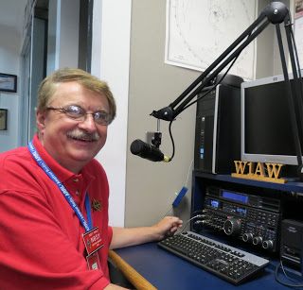

Hey Gang...

I had a blast this past week visiting with many of you at your meetings and hamfests. This past week I attended the Greene County ARES meeting then off to the District 10 ARES meeting and of course “NOARS Fest” on Sunday. I had a great time as I always do, I had a blast doing the “Meet and Greet” at the ARRL table at NOARS Fest! The weather cooperated for the most part this week so getting around to all of the functions wasn’t a problem.

Now, I do want to remind everyone that you can do a little extra publicity for your club meetings and activities just by having your ARES Connect Administrator add your events to the ARES Connect calendar! For those clubs that use Google Calendar or any web-based calendar program that incorporates RSS feeds, you can easily add ARES Connect events calendar to it!

TOP ^

Yes, you can now see all the events, including your own club activities on your calendar! Oh, if you don’t use Google Calendar, do you use Outlook or other similar Office Suite programs that has a calendar built in? If you do, then you can even add the ARES Calendar to that as well. This is extremely useful if you are in the field where Wi-Fi isn’t available.

If you are interested in how you can do this, just ask me. I will show you just how easy it is. Oh, there is just one little requirement to be able to do this, you have to be registered in ARES Connect in order to gain access to this feature.

Now speaking on the idea of being registered in ARES Connect yet, have you? If you haven’t you really need to do it now. For your administrators out there, things will be changing in the system and from what I know right now, it will make your job a lot easier as well. Yes, things aren’t quite the way we want them yet, but they will be getting better, and the system will be a lot easier to use when these changes happen.

I do want to clear up some mis-interpretations that have been going around. First, in the Ohio Section we only require our Level 2 volunteers to have the 4 basic courses, IS 100, 200, 700 & 800. For our Level 3 volunteers we do require the additional ICS 300 / 400, or the equivalent professional series courses IS 120, 230, 240, 241, 242, 244 & 288.

The ARRL courses EC 001 and EC 016 are NOT available at this time to take and are not required here in the Ohio Section to be a Level 2 or Level 3 volunteer.

The above equivalent courses are all on-line classes just like your basic 4 NIMS courses are and being offered as an alternative way for you to get credit for taking the professional series courses in the event you just cannot get scheduled into an ICS 300/400 class. By the way, if you decide to take the 7 on-line courses and complete them all, you also get a really great looking certificate from FEMA recognizing that you have completed the entire Professional Series courses.

I do hope that this clears up the confusion that has been going around lately. As we have stated on the website and in this newsletter many times “We don’t want anyone left behind.”

Ok.. One final go around, I have seen a number of posts on Facebook and other social media blogs where a lot of folks are interested in participating in a **Wouff Hong** at Dayton this year. I can tell you this, we could have one **IF** we get the volunteers to make this happen!

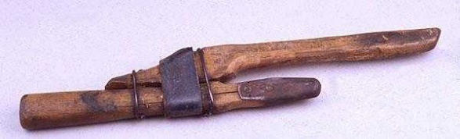What does it take? It takes a minimum of 7 players that are willing to get up in front of a crowd and read from a script. You don’t have to worry about whether you flub a line or two, it will happen, and it will still come out ok. You do have a really neat costume that you wear, and the ceremony takes all of about 30 minutes to do. Not much to ask for so much fun for everyone that participates.

It will take a commitment from **YOU** however to make this happen. Now, here’s what I need from **YOU**. I need someone to step up and get the 7 people together. I need one person to organize this part of it and all you have to do is get those 6 people (you included) to volunteer and get me their names and emails.

I will take care of the logistics – time, location, copies of the script, costumes and certificates. How about it? Anyone game to help with this project? If you are, contact me as soon as you can. Write to: [n8sy@n8sy.com](mailto:n8sy@n8sy.com) and we can discuss the details.

TOP ^

Now, just to get things started in the right direction, I have already talked to ARRL Headquarters about this this to see if it would be possible and was told that we should be able to get a conference room at the Marriott – University of Dayton where all of the ARRL staff are staying.

I am planning on starting the ceremony later in the evening, say around 10 pm or so... this keeps the tradition going for the ceremony to be done late at night.

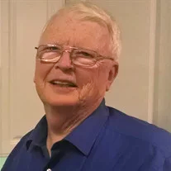

On a final note… I do have sad news to report. Henry (Hank) R. Greeb, N8XX and former (W8CHT) has become a Silent Key this past week. Hank was the Ohio Section Manager from Jun-1974 - Sep-1978.

We send out our sincerest sympathies to his family.

Whelp… That’s going to do it for this time around. Stay safe, stay warm, and most of all… have FUN!!

73, and stay warm and dry!!!

***Scott, N8SY***

*****Spring Forward***

Don’t forget to set your clocks forward this coming Saturday night, March 9th before going to bed. **Sunday, March 10th** we “Spring” ahead one hour. If you don’t do it you just might just be late for church, or wherever you may be going to on Sunday!

***Ohio’s Severe Weather Awareness Week: March 17 – 23***

***Statewide Tornado Drill: Wednesday March 20th at 9:50am local***

***Murphy’s Law***

* The printer is either out of toner or there is no paper only when the client asks for 10 copies of a 120-page report by evening.
* The CD drive will not be even detected only when you want to cull out information from some CD. Just the day before that, you would have been playing music and it would have worked fine. If the Drive is working the CD would be corrupt/Scratched.
* The network would snap just when you were explaining an important point over a NetMeeting conference call.
* The telephones won't work when you need to call long distance urgently.
* All emails except the most important one, which was sent way before, will find their way into your inbox.

TOP ^

***Back Issues of the PostScript and Ohio Section Journal (OSJ)***

Hey, did you know that PostScript and Ohio Section Journal (OSJ) are archived on the website? You can go back and look at any edition simply by clicking:

<http://arrl-ohio.org/news/index.html>

***Chit – Chat, and All That!***

Do you know someone that’s not getting these Newsletters? Please, forward a copy of this Newsletter over to them and have them “[Opt-In](http://arrl-ohio.org/forwarder/forwarding.html)” to start receiving them. Heck, just have them send me an email [n8sy@n8sy.com](mailto:n8sy@n8sy.com) and I’ll get them added to the Ohio Section Emailing list.

We now have many thousands of readers receiving these newsletters weekly. Quite impressive, I’d say! I urge all of you to make sure that everyone, regardless of whether they are a League member or not, get signed up to receive these weekly Newsletters.

You can always “[Opt-Out](http://arrl-ohio.org/forwarder/forwarding.html)” at any time if you feel this is not what you were expecting. It’s fun and very informative. All of your favorite past newsletters are now archived too.

You can go back at any time and read them. Just go to: <http://arrl-ohio.org/news/>

Got questions, concerns or would just like to sit and chat awhile? Heck, I’ll even buy the coffee!! Give me a call at (419) 512-4445 or email me at: [n8sy@n8sy.com](mailto:n8sy@n8sy.com)

The pictures on the front page are from various newsletters, Facebook posts and/or were sent directly to me in recent weeks. Take a good look at them, you just might be in one of the pictures! “SMILE… you’re on the Ohio Section News!!”

TOP ^

*PostScript is produced as a weekly supplement to the Ohio Section Journal (OSJ). I sincerely hope that you have enjoyed this edition and will encourage your friends to join with you in receiving the latest news and information about the Ohio Section, and from around the world!*