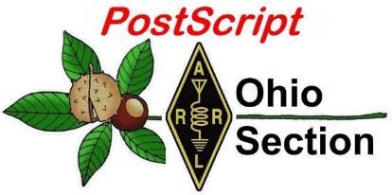
February 4th
Edition

National News The Handbook Give Away

Club Corner Hamfests

DX This Week One Question Questionnaire

VE Testing Schedule Final.. Final..

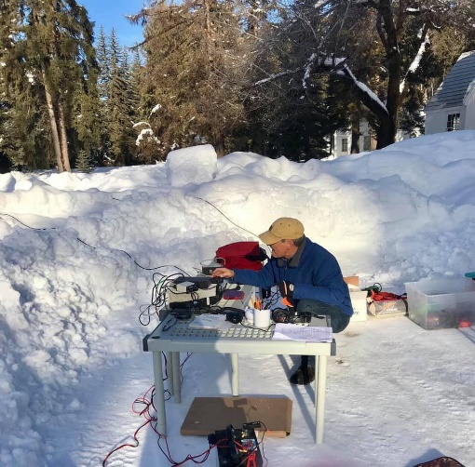
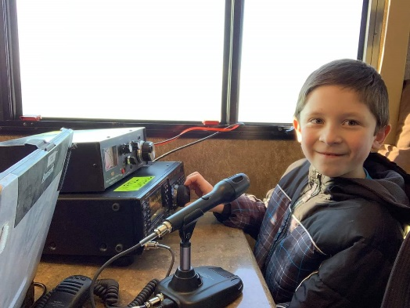
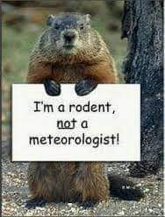
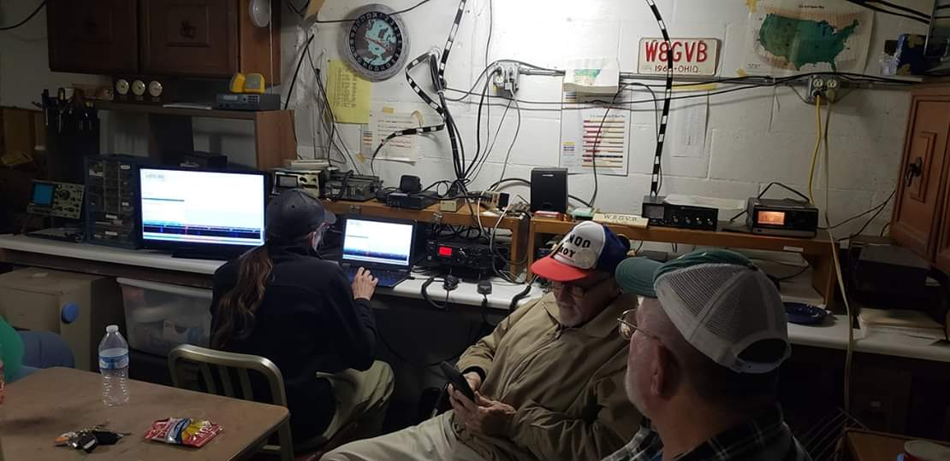
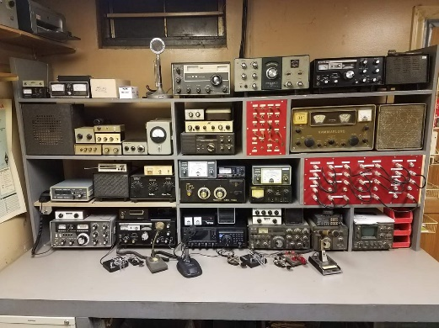

National News
(from arrl and other sources)

ARRL Launching New Podcast Geared Toward New Radio Amateurs

For those just getting started on their Amateur Radio journey, ARRL is launching a new podcast aimed at answering your questions, providing support and encouragement for newcomers to get the most out of the hobby. The podcast “So Now What?” will launch on Thursday, March 7, and new episodes will be posted every other Thursday, alternating new-episode weeks with the “ARRL The Doctor is In” podcast.

Co-hosting “So Now What?” will be ARRL Communications Content Producer Michelle Patnode, W3MVP, and ARRL Station Manager Joe Carcia, NJ1Q. Presented as a lively conversation, with Patnode representing newer hams and Carcia the veteran operators, the podcast will explore questions that newer hams may have and the issues that keep participants from staying active in the hobby. Some episodes will feature guests to answer questions on specific topic areas.

“No other podcast is really aimed at this segment of the Amateur Radio community… that is being underserved, that is not getting the answers to the many questions they have,” said ARRL Communications Manager David Isgur, N1RSN, who will serve as the podcast’s executive producer.

Topics to be discussed in the first several episodes include getting started, operating modes available to Technician licensees, VEC and licensing issues, sunspots and propagation, mobile operating, contesting, Amateur Radio in pop culture, and perceptions of Technician license holders.

Given the growing popularity of podcasts, Isgur believes that providing this information in a podcast format will be a very effective method of reaching out and engaging this particular part of the Amateur Radio community, which is important for building and maintaining Amateur Radio interest and activity.

Patnode said she is excited to ask questions she has about different aspects of Amateur Radio, such as how to incorporate ham radio with newer technologies like Raspberry Pi computers and Arduinos, and to learn more about the hobby right along with the audience.

Carcia believes the “So Now What?” podcast will be a perfect complement to the podcasts that the ARRL already offers — “ARRL The Doctor Is In” and “ARRL Audio News.”

In addition to serving as co-host, Patnode is also the audio editor/producer of the podcast. ARRL Graphics Department Supervisor Sue Fagan, KB1OKW, designed the podcast logo, and ARRL Radiosport Administrative Manager Sabrina Jackson, KC1JMW, will voice the introduction and closing.

Listeners will be able to find the “So Now What?” podcast on Apple iTunes, Blubrry, or Stitcher (free registration required, or browse the site as a guest) and through the free Stitcher app for iOS, Kindle, or Android devices...or wherever you get your podcasts. Episodes will also be archived on the ARRL website.

TOP ^
“So Now What?” will be sponsored by LDG Electronics, a family owned and operated business with laboratories in southern Maryland that offers a wide array of antenna tuners and other Amateur Radio products.

#########

Nominations Invited for CQ Contest Hall of Fame
CQ Magazine has announced that nominations for the CQ Contest Hall of Fameare being accepted until March 1. Individuals, clubs, and national organizations may submit nominations. Nominations should clearly indicate that they are for the Contest Hall of Fame and detail the reasons and basis for the nomination. Email submission is preferred, with a subject line of Contest Hall of Fame. Nominations may be mailed to CQ Contest Hall of Fame, c/o CQ Magazine, 17 W. John St., Hicksville, NY 11801.

The CQ Contest Hall of Fame was established in 1986 to recognize Amateur Radio competitors who have made major contributions to contesting that go above and beyond the call of duty. A maximum of two contesters is inducted each year.

Announcement of recipients (and induction ceremony, if honoree is present) will be made at the annual
Hamvention®Contest Dinner on May 18 at the Crowne Plaza Hotel in downtown Dayton. Last year’s recipients were Tom Wagner, N1MM, and Andy Blank, N2NT/V47T. — Thanks to CQ Contesting Editor Dave Siddall, K3ZJ

#########

The FCC is Back in Business
In the wake of the more-than-month-long partial government shutdown, the FCC has said it would begin processing the Amateur Radio application backlogs starting today, January 29, in addition to the other applications that have built up. Information released before the shutdown said the FCC would take the first day it was open, Monday, January 28, to get idle systems up and running again.

“The FCC has resumed all operations since the partial funding lapse has ended,” the FCC said via Twitter this past Monday.

This means ARRL Volunteer Examiner Coordinators (VECs), should soon be able to transmit some 2,300 pending Amateur Radio applications it has in the queue, many of them from 325 ARRL VEC examination sessions that took place during the shutdown or immediately prior to it. These do not include files that the other 13 VECs may be waiting to upload to the Universal Licensing System (ULS). ARRL VEC Manager Maria Somma, AB1FM, said that as of 15:30 UTC, the FCC was not yet processing, and that the ARRL VEC won’t sent all its pending files until it’s sure the system is working properly.

“We had some files already pending in their system, and then also uploaded a few new files into their system today to see if anything is happening yet,” she said. “So far, no movement as we are continually checking for them to be processed.” Somma said an FCC source told her that the filing system is scheduled to resume processing today. “As soon as those pending files go through, we are sending all of our files!” she said.

TOP ^
In a January 28 Public Notice addressing filing deadlines, the FCC pointed out that its filing window, mail operations, and electronic filing systems have been unavailable or unsupported during the partial shutdown, “except for filings necessary for the protection of life and property and filings related to spectrum auction activities.”

The FCC had announced in early January that all filings that would have been due during the suspension of operations, including applications to the ULS, would become due on the business day following the resumption of normal operations, January 29. “If the Commission is unable to restore electronic filing systems on the day the government reopens, the Commission may issue another Public Notice further extending filing deadlines.” The January 28 Public Notice said the Commission now is extending those deadlines by 1 day. “Thus, deadlines for all filings that would have been due from January 3 through January 29 are now extended until January 30, 2019,” the FCC said.

If an Amateur Radio license recently had expired or was about to expire before the shutdown, the licensee could apply for license renewal via the ULS and continue to operate while the FCC was closed, with the filed application remaining in limbo. Licensees who waited until the FCC reopened to apply will have 2 days to submit a renewal application before the license is considered to have expired in the FCC database.

The resumption of normal FCC operations means the FCC’s January 30 open meeting will be an in-person session. The Commission had made provisions for a teleconference should the shutdown not be over by the meeting date. The FCC said, however, that due to the funding lapse, items initially included in the tentative agenda published on January 3 would not be considered at this week’s meeting, which would address only “Commission announcements.”

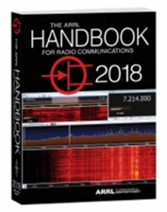
The Handbook Give Away

Hey Gang,

We had another fantastic response this month, but I’m sure you’re more interested in knowing just who won the Handbook this month...

And the winner is…. Ted Armstrong, K8TWA!

Since we've had another month of great response with the Giveaway, I added a couple Official Ohio Section Logo Knit Caps to "Give Away" as well!!

AND…. Those that winners are… Ron Wagner, WD8SBB & Harold German, KB8WPS

Many of you ask me just how do I know when the drawing is on? Well, that’s easy all you need to do is check in on the Ohio Section Website on a regular basis and watch for the big RED Arrow that will appear on the left side of the page. This is the sign that the drawing is on and you need to get registered. So, keep a sharp eye out on the website and check in often! http://arrl-ohio.org

You just never know.. You just might be the next winner!

TOP ^

Club Corner

This is YOUR cornner of the newsletter. Send me what your club is doing and I’ll make sure that it gets in. Got a special event or club project that you want everyone to know about? Send it to me!. Need help with a project? Send it to me.

Let me know what you club is up to. Are you going to have a special guest at your meeting or are you having a special anniversary? Just sent it to:
n8sy@n8sy.com

#########

Connections: Ham Radio Class "Getting Your Technician Class License"

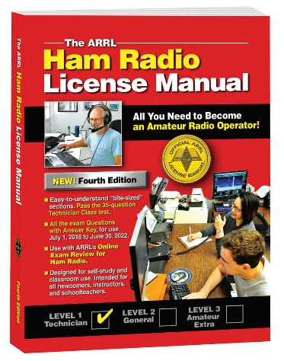
Instructor: Alan Jones, N8WQ
Faith United Methodist Church
15 West Columbus Street
Canal Winchester, Ohio

The Class is FREE, however, you will have to provide your own book which is published by the ARRL. You can buy your book directly from the ARRL or from Amazon.
http://www.arrl.org/shop/ARRL-Ham-Radio-License-Manual-4th-Edition-Softcover/

https://www.amazon.com/ARRL-Radio-License-Manual-Spiral/dp/1625950829/ref=sr_1_1?s=books&ie=UTF8&qid=1548331756&sr=1-1&keywords=arrl+ham+radio+license+manual+4th+edition

We will study the electronics theory and go over testing material necessary to help prepare you for passing your Technician exam. The Technician class will start on March 3rd from 4:00 PM TILL 5:30 PM and will continue every Sunday until the last session on April 7th.

Instructions will be provided about scheduling your exam: including date, time, and location of testing sites in Central Ohio. We look forward to seeing you in class!

Need more information? Contact Alan at: oalanjones@gmail.com

#########

General Class Licensing Course - Work HF!

The Cuyahoga Falls Amateur Radio Club is offering its 6-week course for the General amateur radio exam. Sixth week has free Laurel VEC exam. The exam is open to the public.

TOP ^
WHEN: Every Sunday stating 17 February 2019 to March 24, 2019 from 1:15 PM to 4:45 PM

WHERE: Main branch of the Akron-Summit County Public Library, 60 South High Street, Akron, Ohio, 44326 Free parking in adjoining deck.

COST: $35 for manual and refreshments.

Please preregister by sending call sign and statement of intent to education@cfarc.org.

The course uses the General Class manual by Gordon West. This is our fourth offering. The course covers background material, question pool Q and A, and live demos. Send questions and registration to Jim (N8PZL) at education@cfarc.org

Sponsored by the Cuyahoga Falls Amateur Radio Club: cfarc.org

#########

Massillon Amateur Radio Club will be conducting three simultaneous classes:

Technician License - General License - Code training
All will begin at the Massillon Club location: Massillon Senior Center, 39 Lincoln Way West, Massillon.

Classes will begin Friday evening February 8th from 7-9 p.m. Classes will run every Friday for 8 weeks through March 29.

For Technician class contact Terry Russ, N8ATZ truss@sssnet.com or call 330-837-3091. For General Class contact Don Wade, W8DEA, w8dea1djw@gmail.com or call 330 For Code class contact Perry Ballinger, W8AU, w8au@arrl.net or call 330-705-8449

The Code class encompasses learning, plus how to use a hand key, various options for electronic keys, where and when to find W1AW slow code practice, how to conduct your first QSO, tips on abbreviations and Q code, etc. Goal is 5 WPM and follow up with Club on-air training net.

As classes are held at the location of the Massillon ARC club station (W8NP) where we provide hands-on demonstrations as part of the instruction.

#########

Medina 2M Group offering FREE classes for HAM Radio License.

M2M will be offering classes to help those interested in passing the entry-level, Technician license.

Classes will be held on Thursdays from February 14th through March 21st from 6:30pm to 9:00pm at the Medina County Career Center (JVS), 1101 West Liberty Street, Medina, Ohio 44256 in Room 246.

The Technician License Exam will be administered during the last class for a nominal fee.

TOP ^
We will be using the ARRL Ham Radio License Manual – Fourth Edition which is available on Amazon, the ARRL website and through other booksellers. Participants are encouraged to read Chapters One and Two prior to the first class.

More information about the Medina 2M Group can be found at: http://W8EOC.org

#########

Shelby County ARES Tech Training Class

Description: This will be a two-session training course covering the Ham radio Technician license. This will help you prepare for the 35-question written exam. This license allows for All VHF/UHF Amateur bands (frequencies above 30 MHz) and limited operations in certain HF bands.
Event Timing:
February 18th 6:00 p.m. until 9:00 p.m.
February 23rd 8:00 am. until 3:00 p.m.
Test immediately following. If there is enough need we may offer another testing session on the 2/24/2019 before our monthly meeting.
Event Address: EMA Building - 800 Fair Rd Sidney, Ohio 45365

Contact us at 937-421-1254 then press 4 or training@shelbycountyohares.com

#########

PCARS Starting Technician Classes

We will be starting a new Technician Class on February 6th. The classes will run through March 27th. The session on March 27th will be a VE test session. We have added a Saturday session, February 16th from 9 till noon that will allow students to learn about antenna and station setup. If you know of anyone interested in getting their license, pass this information along. If you would like a copy of the class flyer simply Click Here.

Remember to send me an email as soon as possible if you are interested. Send to jawilson@j3solutions.com.

#########

CARS 2019 Winter Ham Radio classes - get your Technician, General or Extra class license!

Thursday evenings starting February 28, 2019 and ending April 11, 2019 at 6:30 pm April 11th will be a special VE Test session for all license classes, ARRL fee for this VE test is $15.00

To register please follow the link at: www.2cars.org and complete the on-line application or call 216-932-8005 Dave, KD8ACO.

Classes will be held at the Seven Hills City Hall, 7325 Summit View Dr Seven Hills, OH 44131 in room “C” at 6:30 pm every Thursday.

TOP ^
The entrance is at the East end on the South side of building class fees: Technician $25.00, all who pass get a free CARS membership for 2019, General and Extra $20.00 nonmembers or Extra is $15.00 CARS members, General class ONLY is FREE to CARS members All class materials are provided

One Question Questionnaire

Hey Gang

There’s another NEW – one question – questionnaire on the Ohio Section Website! http://arrlohio.org

We had about 22% of you stating that you did get to work Winter Field Day, that’s fantastic. Send me an overview of your experiences and definitely include pictures if you can!

Anyway, these questions are all in fun and I hope that you are enjoying answering these “ONE QUESTION” questionnaires.

Ok, enough on that, here’s the next question for you to answer…

“Do you send/receive CW with a Code Reader or Computer?”

You’ll find the “One Question” questionnaire on the Ohio Section Website! http://arrlohio.org It’s all in fun and it’s not a scientific survey in any way, but we are learning some things that we didn’t know from these questions. I hope that you are enjoying answering these “One Question” questionnaires.

ARES Connect

CQ… CQ…. CQ… Calling all persons to be a part of the new ARES Connect program.

We need to discuss some very important items that only YOU can make a difference with. I need you to get yourselves registered in ARES Connect, that is… if you haven’t already.

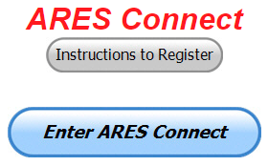
Now, how do I know that you need to do this? It’s simple, we have over 900 now registered in the database with about 521 persons actually signing up for events. Stan’s last S.E.C. report shows that we have a little over 1,500 persons in ARES right now. As you can see, we still have a ways to go to really take advantage of this new system.

As the numbers show, there’s still a lot of you that haven’t taken the plunge yet and need to! What are you waiting for? No matter how much you resist, it’s coming, and we need to make sure that no one is left behind.

Now, as an incentive to get you to not only register…. But to actually start using the system… (Notice how I have that in bold type for you to clearly see?) I am giving away all sorts of goodies to help you get motivated. I have a footlocker of really cool items that I will be giving away!

TOP ^
I’m do this a various interval throughout the year, so it will challenge you to be dedicated like Ron and get your hours into the system. You’ll never know just when another drawing will be, so you really do have to be prudent!!

Here’s how it looks for the month of January:

 | Name | Events | Hours
1 | Dan Stahl (KC8PBU) | 56 | 65.00
2 | James Yoder (w8erw) | 11 | 63.50
3 | Ron Hollas (K8RJH) | 9 | 58.00
4 | Timothy Gray (KD8IZU) | 9 | 55.50
5 | Bret Stemen (KD8SCL) | 6 | 44.50
6 | Michael Lacumsky (w8mal) | 32 | 43.50
7 | Heinz Stucki (KB8VIP) | 12 | 39.95
8 | Brent Stover (wd8pnz) | 8 | 28.50
9 | Edmund Liddle (KE8ANU) | 7 | 28.00
10 | Michael Farkas (n8gbu) | 43 | 27.00

Now, here’s how we did with people signed up for events and the total hours for the month of January:

Total Amount signed into Events | Total Hours for Events
1,519 | 3,878.78

Don’t know where to get started? We have a set of instructions on how to get registered right above the button to enter ARES Connect. I would strongly suggest that if you haven’t registered yet, that you read these instructions first. Here’s a link to get you started... http://arrl-ohio.org/ares_connect_directions.pdf

Please, don’t just hurry through the questions, read them carefully, if you don’t understand something, please ask me, I’m here to answer your questions.

We know that you mean well by answering that you do have the needed courses in, but I will let you know that we are verifying what you say you have with what is showing for you in our statewide database when we are completing your registration. So, how can you find out if you are already listed in our statewide database? Easy, here’s a link: http://arrl-ohio.org/SEC/special/ICS%20Complete%20by%20County%20and%20Name.pdf

Incident Command System (ICS) Training Schedule

All current trainings are listed on the Ohio EMA training calendar located at:
https://webeoctraining.dps.ohio.gov/TrainingAndExercise/courselist.aspx

I’ve been asked to also include a link to the Kentucky EMA training calendar as well..

https://kyem.ky.gov/training/Pages/default.aspx
https://sites.google.com/site/ccoemtraining/home

TOP ^
Please pay particular attention to these courses listed above, as that there’s a lot of ICS 300 & 400 classes listed that are very useful for all Amateurs to have under their belts. I will also state that G775 is also a very good course to take as well. These 3 courses are multiple day in class courses, so please be prepared to spend some time taking them.

I would like to remind any of you that are going to take any of the in-class training sessions that you dress appropriately. Please don’t go into these classes with attire that doesn’t represent you, and Amateur Radio in the best of light. I won’t tell you that we have a dress code, but I have heard from some officials from around the state that have made the comment to me that your appearance did stick with them. Remember, you will be in class with fire / police chiefs, mayors, township trustees and a whole host of other government and civil officials that will remember how you represented Amateur Radio while you were in these classes together.

We do recognize that IS-300/400 requires multiple days of actual classroom training that is not easily obtained. So, if you just can't find the time to fit these class room courses in, we do have an alternative method for getting you to Level 3. Completing the following “FREE” and “ONLINE” courses will act as substitute for you FEMA Leadership Development Course requirements. You absolutely will need to complete all 7 of these courses to get your ICS 300/400 credit. Here are the courses that you need to take: IS-120, 230, 240, 241, 242, 244 & 288.

#########

EMA-G290/291 Basic Public Information Officer Series
Hosted by the Licking County EMA
February 12-14

Application deadline: February 5th
Time of Course: Registration: 7:45 - 8:00 AM
Course Time: 8:00 AM – 5:00 PM daily
Location: Licking County Regional 911 Center
783 Irving Wick Dr. W.
Heath Ohio 43052

Enrollment: Students must enroll via the Department of Public Safety Training Campus website: https://trainingcampus.dps.ohio.gov/cm/cm710/pstc/pstc.html.

Students experiencing difficulty enrolling should call Ohio EMA Training at (614) 799-3666 / 3824 for assistance with registration. Course registration will generally close 10 working days prior to the course start date. You can check your enrollment / approval status via the Department of Public Safety Training Campus website.

State Point of Contact: Susan Traylor, State Training Coordinator, Ohio Emergency Management Agency, (614) 799-3666, sctraylor@dps.ohio.gov

#########

TOP ^
EMA-G290/291 Basic Public Information Officer Series
Hosted by Franklin County EMA
June 12-14

Application deadline: June 5th
Time of Course: Registration: 7:45 - 8:00 AM
Course time: 8:00 AM – 5:00 PM daily
Location: Franklin County Emergency Management and Homeland Security
5300 Strawberry Farms Blvd.
Columbus, Ohio 43230

Enrollment: Students must enroll via the Department of Public Safety Training Campus website: https://trainingcampus.dps.ohio.gov/cm/cm710/pstc/pstc.html.

Students experiencing difficulty enrolling should call Ohio EMA Training at (614) 799-3666 / 3824 for assistance with registration. Course registration will generally close 10 working days prior to the course start date. You can check your enrollment / approval status via the Department of Public Safety Training Campus website.

State Point of Contact: Susan Traylor, State Training Coordinator, Ohio Emergency Management Agency, (614) 799-3666, sctraylor@dps.ohio.gov

#########

Auxiliary Communications (AUXCOMM) Training

This course focuses on auxiliary communications interoperability, the relationship between the COML and the volunteer, emergency operations center (EOC) etiquette, on-the-air etiquette, Federal Communications Commission (FCC) rules and regulations, auxiliary communications training and planning, and emergency communications deployment. It is intended to supplement and standardize an operator’s experience and knowledge of emergency amateur radio communications in a public safety context.

Course Dates: February 16 – 17, 2019 (One-hour lunch)
Application deadline: February 2, 2019
Course Registration Time: 7:30 AM to 8:00 AM (Day 1)
Time of Course: 8:00 AM to 7:00 PM (Both Days)
Training Location: Franklin County Emergency Management & Homeland Security
5300 Strawberry Farms Blvd.
Columbus, OH 43230

Required Prerequisites:
Required Prerequisites: (IS-100, 200, 700 & 800)
Applicants MUST have completed the following on-line courses from the FEMA/EMI Independent Study (IS) website: https://training.fema.gov/is/crslist.aspx?all=true
1. IS-100, Introduction to the ICS;
2. IS-200, ICS for Single Resources and Initial Incidents;
3. IS-700, National Incident Management System (NIMS), an Introduction;
4. IS-800, National Response Framework (NRF).

TOP ^
Other Required Documentation:
The target audience for this course includes individual that MUST have Personal experience in auxiliary communications and MUST have the following four items and provide documentation to Pam Tickle.
1. An active FCC Amateur Radio License (provide a copy of the license)
2. Documentation of past experience in auxiliary emergency communications (provide documentation via email or letter of your experience)

3. An affiliation with a Public Safety Agency (provide a letter or an email from leadership of the Public Safety Agency that you are associated with indicating your affiliation)
4. A desire to work with COMLs in a NIMS/ICS environment (provide a statement letter or email indicating your interest)

Send the following eight items as a COMPLETE packet to Pam Tickle @ pktickle@franklincountyohio.gov

If you are unable to attend the course, please click on the link below, withdraw yourself by logging in, click on the “Course Catalog”, and double click on the course to display the "Course Details" and click "Unenroll" to withdraw from the course. https://trainingcampus.dps.ohio.gov/cm/cm710/pstc/pstc.html

Course Target Audience:
The target audience for this course includes individual that MUST have Personal experience in auxiliary communications and MUST have the following four item and provide documentation to Pam Tickle.

1. An active FCC Amateur Radio License
2. Past experience in auxiliary emergency communications
3. An affiliation with a public safety agency
4. A desire to work with COMLs in a NIMS/ICS environment

Lodging Information:
Lodging, Meals, Per Diem and all other travel expenses are the responsibility of the student or the parent organization.

Enrollment:
Students must enroll via the Public Safety Training Campus located at the following link. https://trainingcampus.dps.ohio.gov/cm/cm710/pstc/pstc.html and those that have trouble registering should contact Ohio EMA Training at (614)799-3824/3677 for assistance with registration. Please refer to the FY 2018/2019 Ohio EMA Training Catalog or website at http://ema.ohio.gov/Training.aspx for additional information. State Point of Contact: Lisa Jones, DSC 2, Ohio EMA, SAA Training Point of Contact, ljones@dps.ohio.gov, Office: (614) 799-3824

#########

MGT-347 Incident Command System (ICS) Forms Review
This class is Provided by Texas A&M Engineering Extension Service (TEEX). Hosted by Franklin County EM & HS February 5, 2019. The class is the morning of February 5th and we are still in need of 18 people to register and attend the class, so it does not get canceled.

TOP ^
If it has been awhile since you have taken this review, please consider attending this half-day class. Registration is through the Ohio Public Safety Training Campus
https://trainingcampus.dps.ohio.gov/cm/cm710/home.html

Course Description:
The MGT-347 ICS Forms Review course is a 4-hour workshop that provides emergency response supervisors and mid- to upper-level managers with a detailed introduction to the Incident Command System (ICS) forms used in the development of an Incident Action Plan (IAP) and/or Coordination Action Plan (CAP). Participants will examine the primary forms used in an IAP/CAP, as well as supporting and other utility forms. In addition, participants will review the planning process and where, within that process, the forms are filled out and by whom.

The workshop includes a practical application designed to instruct participants in the development of Specific, Measurable, Action-oriented, Realistic, and Time-based (SMART) control and management objectives.

Course Dates: February 5, 2019

Application deadline: January 29, 2019

Course Registration Time: 7:30 to 8:00 AM

Time of Course: 8:00 AM – 12:00 PM

Training Location: Franklin County Emergency

Management & Homeland Security
5300 Strawberry Farms Blvd.
Columbus, OH 43230

Required Prerequisites:
After registering for the course online, students must provide copies of the following certificates of completion to Pam Tickle at pktickle@franklincountyohio.gov to attend this course.
1. IS-100.b FEMA Introduction to the Incident Command System, ICS-100
2. IS-200.b FEMA Incident Command System for Single Resources & Initial Action Incidents, ICS-200
3. IS-700.a Introduction to the National Incident Management System (NIMS)
4. IS-800.C, National Response Framework, an Introduction

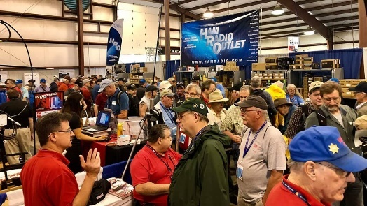
Upcoming Hamfests

02/17/2019 | InterCity ARC Hamfest
Location: Mansfield, OH
Sponsor: InterCity Amateur Radio Club
Website: http://www.w8we.org

03/03/2019 | WINTER HAMFEST  Location: Elyria, OH  Sponsor: Northern Ohio Amateur Radio Society  Website: http://www.noars.net/hamfests/noarsfest | 03/16/2019 | Gallipolis Ohio Hamfest  Location: Gallipolis, OH  Sponsor: Mid-Ohio Valley Amateur Radio Club
TOP ^
03/17/2019 | Hamfest and Computer Fair  Location: Perrysburg, OH  Sponsor: Toledo Mobile Radio Association  Website: http://www.tmrahamradio.org | 04/13/2019 | 65th Annual Cuyahoga Falls Amateur Radio Club Hamfest  Location: Cuyahoga Falls , OH  Type: ARRL Hamfest  Sponsor: The Cuyahoga Falls Amateur Radio Club, Inc.  Website: http://cfarc.org

V.E. Test Sessions
(from arrl)

02/06/2019 | Cuyahoga Falls OH 44221-3205  Sponsor: Cuyahoga Falls ARC  Location: Cuyahoga Falls Library  Time: 6:30 PM (Walk-ins allowed)  Learn More | 02/09/2019 | Cambridge OH 43725-2401  Sponsor: Cambridge ARA  Location: St John's Episcopal church  Time: 2:00 PM (Walk-ins allowed)  Learn More
02/09/2019 | Findlay OH 45840  Sponsor: Findlay Radio Club  Location: Findlay Radio Clubhouse  Time: 9:00 AM (Walk-ins allowed)  Learn More | 02/09/2019 | Huber Heights OH 45424-4143  Sponsor: Huber Heights Amateur Radio Cl  Location: The Forge  Time: 9:30 AM (Walk-ins allowed)  Learn More
02/09/2019 | Maumee OH 43537-1628  Sponsor: Toledo Mobile Radio Assoc  Location: Maumee Fire Station #2  Time: 8:15 AM (No Walk-ins / Call ahead)  Learn More | 02/10/2019 | Milford OH 45150-1427  Sponsor: Milford ARC  Location: Faith Church  Time: 6:00 PM (Walk-ins allowed)  Learn More
02/12/2019 | Lancaster OH 43130  Sponsor: Lancaster & Fairfield ARC  Location: After School Programs Lancaster  Time: 7:00 PM (Walk-ins allowed)  Learn More | 02/14/2019 | Milford OH 45150-1427  Sponsor: Milford ARC  Location: Faith Church  Time: 6:00 PM (Walk-ins allowed)  Learn More
02/16/2019 | Canton OH 44705-4374  Sponsor: Stark County Area VE Team  Location: Stark County EMA/EOC  Time: 8:30 AM (Walk-ins allowed)  Learn More | 02/16/2019 | Dayton OH 45424-3304  Sponsor: Dayton Amt Radio Assoc  Location: Dayton Amt Radio Assoc  Time: 10:30 AM (Walk-ins allowed)  Learn More
02/16/2019 | East Liverpool OH 43920-9486  Sponsor: Triangle ARC  Location: Glenmoore Volunteer Fire Station  Time: 1:00 PM (Walk-ins allowed)  Learn More | 02/17/2019 | Elyria OH 44035-1343  Sponsor: American Red Cross  Location: American Red Cross  Time: 12:50 PM (Walk-ins allowed)  Learn More

TOP ^

Special Events

- 02/16/2019 | MVARA 100th ^{A}nniversary
Feb 16-Feb 18, 2300Z-2300Z, W8QLY, Youngstown, OH. Mahoning Valley Amateur Radio Association. 14.220 7.220 3.922. Certificate & QSL. MVARA, 125 W McKinley Way, P.O. Box 14141, Youngstown, OH 44512. https://goo.gl/forms/2uNZfO6zRx1YPoWw2 to request your certificate/qsl. www.qrz.com/db/w8qly or www.mvara.org

- 04/13/2019 | 7th Annual Earth Day Celebration
Apr 13, 1500Z-2000Z, W8PRC, Cleveland, OH. Parma Radio Club. 14.245 7.195. QSL. Parma Radio Club, 8111 Laumer Ave., Cleveland, OH 44105. Our 7th ^{A}nnual Earth Day Celebration. Operating on solar power from historic, educational Stearns Farm in the Parma, Ohio town center. www.parmaradioclub.com

ARRL Contest Corner
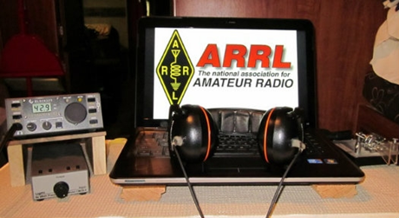

February 4
                - RSGB 80m Club Championship, SSB

February 5  - ARS Spartan Sprint | February 6  - QRP Fox Hunt  - Phone Fray  - CWops Mini-CWT Test  - UKEICC 80m Contest

An expanded, downloadable version of QST's Contest Corral is available as a PDF. Check the sponsor's Web site for information on operating time restrictions and other instructions.

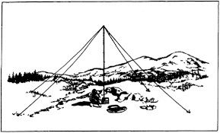
2019 Ohio NVIS Day

Hey everyone, Stan, N8BHL has let me know that the date for NVIS Day is scheduled for Saturday, April 27th. Are you ready? Start your planning now!
Like years past, we are planning on having the operation run from 10 – 4 EDT. Take a lunch break, enjoy each other’s company.

Transmit power should stay at 100 watts for accurate signal comparison. You may operate anywhere, home, club, portable.

TOP ^
Want to know more about what NVIS is? http://arrl-ohio.org/SEC/nvis.html Learn all about Near Vertical Incident Scattering and how you can easily put up a NVIS antenna and participate in this great exercise.

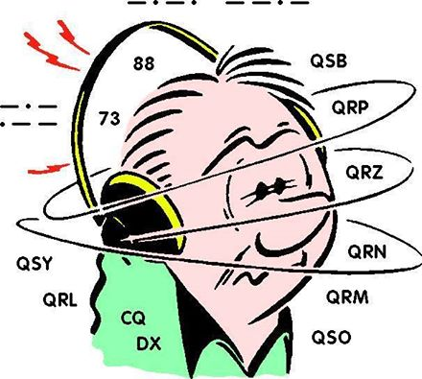
DX This Week
(from Bill, AJ8B)

Bill AJ8B (aj8b@arrl.net, @AJ8B, www.aj8b.com or www.swodxa.org )

Over the past several months, we have discussed many aspects of operating, chasing DX, QSLing, and working DX. Since we are still at the beginning of the year (324 days until Christmas!) I thought it would be helpful to share those contests and activities that I have used to round out my DX totals.

There are 3 kinds of events that I like to participate in, either committing the entire weekend or just a few hours. The first type are regional contests. The All Asian contest is my favorite and has allowed me opportunities to capture DX entities and zones on bands where I would not normally work these entities.

The second type are state QSO parties. These operating events are fun and can really help you sharpen your operating skills.

Finally, there are the international DX contests. These are great for challenging you operating skills, equipment, and for rounding out your entity and zone count.

The information shown in the table below was from the two sources that I use to track this; https://qsoparty.eqth.net/index.html and https://www.contestcalendar.com/
Let me know if you participate in these, what your favorite is and how you did.

Contest | Start Date | End Date |  | Contest | Start Date | End Date
Montana QSO Party | 1/26/19 | 1/27/19 |  | Kentucky QSOP | 6/1/19 | 6/2/19
British Columbia QSO Party | 2/2/19 | 2/3/19 |  | DL-DX RTTY Contest | 6/6/19 | 6/7/19
Minnesota QSO Party | 2/2/19 | 2/2/19 |  | West Virginia QSOP | 6/15/19 | 6/16/19
Vermont QSO Party | 2/2/19 | 2/3/19 |  | W8DXCC Convention | 6/15/19
10-10 Int. Winter Contest, SSB | 2/2/19 | 2/3/19 |  | All Asian DX Contest, CW | 6/15/19 | 6/16/19
CQ WW RTTY WPX Contest | 2/9/19 | 2/10/19 |  | Maryland-DC QSOP | 8/10/19 | 8/11/19
ARRL Inter. DX Contest, CW | 2/16/19 | 2/17/19 |  | North American QSO Party, SSB | 8/17/19 | 8/18/19
South Carolina QSO Party | 2/23/19 | 2/24/19 |  | Hawaii QSOP | 8/24/19 | 8/26/19

TOP ^
North Carolina QSO Party | 2/24/19 | 2/25/19 |  | Kansas QSOP | 8/24/19 | 8/25/19
ARRL Inter. DX Contest, SSB | 3/2/19 | 3/3/19 |  | Ohio QSOP | 8/24/19 | 8/25/19
Idaho QSO Party | 3/9/19 | 3/10/19 |  | YO DX HF Contest | 8/24/19 | 8/25/19
Oklahoma QSO Party | 3/9/19 | 3/10/19 |  | Colorado QSOP | 8/31/19 | 9/1/19
South America 10 Meter Contest | 3/9/19 | 3/10/19 |  | Tennessee QSOP | 9/1/19 | 9/2/19
Wisconsin QSO Party | 3/10/19 | 3/11/19 |  | Alabama QSOP | 9/7/19 | 9/8/19
Louisiana QSO Party | 3/16/19 | 3/17/19 |  | Iowa QSOP | 9/21/19 | 9/22/19
Virginia QSO Party | 3/16/19 | 3/17/19 |  | New Jersey QSOP | 9/21/19 | 9/22/19
CQ WW WPX Contest, SSB | 3/30/19 | 3/31/19 |  | Washington QSOP | 9/21/19 | 9/22/19
Mississippi QSO Party | 4/6/19 | 4/7/19 |  | Maine QSOP | 9/28/19 | 9/29/19
Missouri QSO Party | 4/6/19 | 4/7/19 |  | Texas QSOP | 9/28/19 | 9/29/19
SP DX Contest | 4/6/19 | 4/7/19 |  | CQ Worldwide DX Contest, RTTY | 9/28/19 | 9/29/19
Georgia QSO Party | 4/13/19 | 4/14/19 |  | California QSOP | 10/5/19 | 10/6/19
New Mexico QSO Party | 4/13/19 | 4/14/19 |  | Oceania DX Contest, Phone | 10/5/19 | 10/6/19
North Dakota QSO Party | 4/13/19 | 4/14/19 |  | Nevada QSOP | 10/11/19 | 10/13/19
Holyland DX Contest | 4/19/19 |  |  | Arizona QSOP | 10/12/19 | 10/13/19
Michigan QSO Party | 4/20/19 | 4/21/19 |  | Pennsylvania QSOP | 10/12/19 | 10/13/19
Nebraska QSO Party | 4/20/19 | 4/21/19 |  | South Dakota QSOP | 10/12/19 | 10/13/19
Ontario QSO Party | 4/20/19 | 4/21/19 |  | Oceania DX Contest, CW | 10/12/19 | 10/13/19
Ontario QSO Party | 4/20/19 | 4/21/19 |  | Scandinavian Activity Contest, SSB | 10/12/19 | 10/13/19
YU DX Contest | 4/20/19 | 4/21/19 |  | New York QSOP | 10/19/19 | 10/20/19
Florida QSO Party | 4/27/19 | 4/28/19 |  | 10-10 Int. Fall Contest, CW | 10/19/19 | 10/20/19
SP DX RTTY Contest | 4/27/19 | 4/28/19 |  | Worked All Germany Contest | 10/19/19 | 10/20/19
7th Area QSOP | 5/4/19 | 5/5/19 |  | Illinois QSOP | 10/20/19 | 10/21/19
1st Area QSOP | 5/4/19 | 5/5/19 |  | Asia-Pacific Fall Sprint, CW | 10/20/19 | 10/21/19

TOP ^
Indiana QSOP | 5/4/19 | 5/5/19 |  | CQ Worldwide DX Contest, SSB | 10/26/19 | 10/27/19
SWODXA DXForum | 5/8/19 | 5/9/19 |  | Ukrainian DX Contest | 11/2/19 | 11/3/19
Arkansas QSOP | 5/11/19 | 5/12/19 |  | OK/OM DX Contest, CW | 11/9/19 | 11/10/19
CQ WW WPX Contest, CW | 5/15/19 | 5/16/19 |  | LZ DX Contest | 11/16/19 | 11/17/19
SWODXA DXDINNER | 5/17/19 | 5/18/19 |  | CQ Worldwide DX Contest, CW | 11/23/19 | 11/23/19

I was recently made aware of another website for DX Enthusiasts. From the DXcal.info team:
“We are proud to announce the creation of a new website for DXpedition enthusiasts more than a website is a real calendar dedicated to DXpedition hunters.
From a small idea was born DXcal, what we hope will soon become a point of reference for hunting the DX, to follow the various teams around the world, to look for the newone or just to travel with the imagination and curiosity in remote islands.
We hope you like it.
DXcal.info Team

Go there and subscribe. It’s free!

From our friend at the DailyDX and the WeeklyDX, and the best source for DX information, (http://www.dailydx.com/ ) Bernie has this to report:

Z6 - Kosovo Z32ZM, Mome, is back here starting January 25th through February 5th. During this trip he will again be QRV as Z68M with an emphasis on 160, 80 and 30 meters. He will be operating on FT8 on the normal frequencies (1840, 3573 and 10136 KHz) using the MSHV V2.07 program using the MSHV "multi answer protocol. It is not the Fox/Hound mode as used by WSJT or JT-DX. "Multi answer protocol QSO is just like any other normal FT8 QSO, [the] difference is only that I will answer or give report to several stations at the same time", says Mome. He emphasizes MSHV multi answer protocol sounds "like but is not Fox/Hound". Users of the WSJTX FT8 should use the normal QSO mode and not Fox and Hound. Mome says if you are not sure of your FT8 QSO check Club Log and if your QSO is not there "try again". He strongly recommends using OQRS on Club Log to confirm QSOs.

5X – Uganda - The Italian DX Team has a change of plans. Their Initially plan TT - Chad DXPedition scheduled for March has been "put on hold for security reasons". So they will now instead move up their expected October 5X DXPedition. The team will now operate 5X0T and 5X0X (FT8) from March 13-25. If you need Uganda on any bands or modes you can take part in their online survey at http://www.i2ysb.com/idt/index.php?option=com_content&view=featured&Itemid=101

P29 - Papua New Guinea - The P29NI/P29VCX team is going to two "IOTAs," Islands on the Air, with everything on schedule, they say. They leave their home QTHs today, planning to hit the airwaves January 31 around 08Z from OC-025, Manus Island.

TOP ^
A week later they will be on OC-153, Daru Island. Ops SM6CVX, G3KHZ and K5WQG will have three stations, one amplifier, "mainly CW, some SSB and RTTY." They plan to be on 40, 30, 20 and 17 meters and "probably some 80 or 160 meters, if we get enough space for an inverted V." QSL P29VCX from OC-025 to SM6CVX and QSL P29NI on OC-153 to G3KHZ, using their info on QRZ.com.

A more detailed calendar can be found at http://www.dailydx.com/the-daily-dx-calendar/

More info can be found at www.swodxa.org or www.aj8b.com

ARLD005 DX news

This week's bulletin was made possible with information provided by WB2TJO, The Daily DX, 425 DX News, DXNL, Contest Corral from QST and the ARRL Contest Calendar and WA7BNM web sites. Thanks to all.

FIJI, 3D2. Jim, WB2TJO is QRV as 3D2JS from Taveuni Island, IOTA OC-016, until March 7. Activity is on the HF bands using CW, SSB and various digital modes. QSL direct to home call.

BAHRAIN, A9. Special event station A91KWT is QRV until February 28 to mark Kuwait National Liberation Day. QSL via A92AA.

PHILIPPINES, DU. Christian, F4EBK is QRV as DU3/F4EBK from Luzon Island, IOTA OC-042, until March 31. Activity is on 80 to 10 meters using CW, SSB and various digital modes. QSL direct to home call.

- In addition, Bodo, DF8DX plans to be QRV as DU1WQY/1 from Palawan Island, IOTA OC-128, from February 4 to 14. QSL direct to home call.

SPAIN, EA. Special event station EG3WCD is QRV until February 4 to mark World Cancer Day on February 4. Activity is on all bands. QSL via LoTW.

IRELAND, EI. Members of the Kerry Amateur Radio Group are QRV as EI100YXQ during 2019 to mark the hundred years since the first transatlantic voice transmissions from Ballybunion, Ireland to Louisbourg on Cape Breton Island, Canada. QSL via EI9FVB.

PANAMA, HP. Special event station H31A is QRV until August 15 to commemorate the 500th anniversary of the founding of Panama City.
Activity is on 80 to 10 meters using SSB, RTTY, PSK31 and FT8. QSL via HP1AVS.

THAILAND, HS. Special event station HS55RAST is QRV until March 31 to commemorate the 55th anniversary of the Radio Amateur Society of Thailand. QSL via HS5NMF.

GRENADA, J3. Peter, G4HSO will be QRV as J3/G4HSO from February 4 to 16. Activity will be holiday style on the HF bands using mainly CW. QSL to home call.

TOP ^
JAPAN, JA. Special event stations 8J0M, 8J2M and 8J9M are QRV until April 30 to mark the 30th General Assembly of the Japan Medical Congress in Chubu. QSL direct to JP7FSO.

GUAM, KH2. Yoshi, JE2EHP is QRV as K1HP/KH2 until February 4.
Activity is on 80 to 6 meters using CW, SSB and FT8. QSL to home call.

PAPUA NEW GUINEA, P2. A group of operators are QRV as P29VCX from Manus Island, IOTA OC-025, until February 5, and then as P29NI from Daru Island, IOTA OC-153, from February 6 to 11. Activity is on 40 to 15 meters, and possibly 160 and 80 meters, using CW, SSB and RTTY. QSL P29VCX via SM6CVX and P29NI via G3KHZ.

BONAIRE, PJ4. Fred, WW4LL and Michael, NN9DD will be QRV as PJ4/homecalls from February 4 to 10. Activity will be on the HF bands using SSB, RTTY and FT8. They will be QRV as PJ4Z in the upcoming CQ WPX RTTY contest. QSL via K4BAI.

SWEDEN, SM. Special event station SE19SKI will be QRV from February
4 to 17 during the Alpine World Ski Championships. QSL via operators' instructions.

VIET NAM, XV. Bogdan, SP2FUD and Zen, SP2GCJ will be QRV as XV9FUD and XV9ZT, respectively, from February 4 to 18. Activity will be on
40 to 12 meters using CW, SSB and various digital modes. QSL via SP2GCJ.

KOSOVO, Z6. Mome, Z32ZM is QRV as Z68M until February 5. Activity is on 160, 80 and 30 meters using FT8. QSL via OQRS.

THIS WEEKEND ON THE RADIO. The North American CW Sprint, NCCC RTTY Sprint, QRP 80-Meter Fox Hunt, NCCC Sprint CW Ladder, Vermont QSO Party, 10-10 International Winter SSB Contest, Mexico RTTY International Contest, F9AA CW Cup, Black Sea Cup International, Minnesota QSO Party, FYBO Winter QRP Sprint, AGCW Straight Key CW Party, British Columbia QSO Party and FISTS Winter Slow Speed CW Sprint will certainly keep contesters busy this upcoming weekend.

The RSGB 80-Meter Club SSB Championship is scheduled for February 4.
The ARS Spartan CW Sprint is scheduled for February 5. The CWops Mini-CWT Test, UKEICC 80-Meter SSB Contest, Phone Fray and QRP 40-Meter CW Fox Hunt are scheduled for February 6.

The Canadian National Parks on the Air, CNPOTA, operating event runs for the entire year of 2019, with special stations active from Canada's parks and historic sites.

Please see February 2019 QST, page 91, and the ARRL and WA7BNM Contest Web Sites for details.

Weather Underground and Ham Weather Stations

Have you visited the webpage to see all the Weather Underground stations yet? It’s really fun to see just how much the weather varies across the state and this gives you access to each individual station very quickly and easily.

It seems that our list of stations is growing every week!

TOP ^
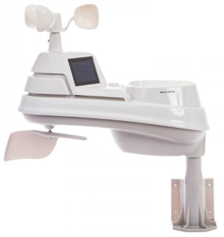
Thanks to everyone who has contributed to this effort. If you didn’t, you should have taken a look at the various weather stations around the state last weekend when we had all the bad weather. You would have seen just where the line of demarcation was and watched it as it crossed through the state. It was very interesting since the data is real time! Here’s a link to all of those listed… http://arrl-ohio.org/wus.html

We’re starting to get a really good collection of stations all over. I know that there is a lot more than what we have listed. How’s about sharing your weather information with all of us! All that you need to do is send me your Weather Underground ID and your call sign and I’ll take it from there. Sent it to: n8sy@n8sy.com

Skywarn Net Frequencies

Hey Gang,

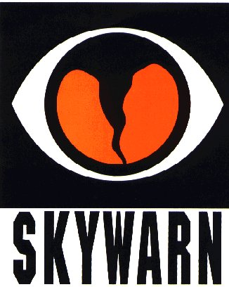
It’s come to our attention that we really don’t have a good listing of all the Skywarn Net frequencies all around Ohio. As we have gotten a lot of new to Amateur Radio folks this past year or so, it would be very helpful to them, and us to have this type of information readily available. Yes, I know it’s only February and we shouldn’t have to think about this yet, especially since we just got over a super cold spell a couple of days ago. But we really do need to start working on this now so that we are prepared for when the weather does get warmer.

I don’t believe that this type of list has ever really been perused by anyone where it was published somewhere for all to use. I could be wrong about that but even if it were, this type of information is forever changing and needs to be updated on a pretty regular basis since repeaters move, PL tones change and even who does the net changes all the time. Just look at how we’ve grown the DMR repeaters in Ohio this last year or so!

In order to get this information, we do need to hear from you folks as to what you know about the Skywarn Nets in your area. What kind of information are we looking for? The frequency that your net is on. Whether you use a repeater or simplex. Is PL (CTCSS) needed. Do you have an alternate repeater or simplex frequency that you go to? Things of this nature are extremely important to know, especially if we need to get folks from other areas of the state involved with your area to help in times of need.

I will take this information and post it to the http://arrl-ohio.org/SEC/ohio_counties/county-listing/counties/master-ohio-counties.html webpage so that we will have it when (yes, when) we need it. All you will have to do is click on the county that you want the information for and it will be there.

Here’s a link to get you to the questionnaire: http://arrl-ohio.org/SEC/skywarn-frequencies.html You can also find this link on the Section Emergency Coordinator’s main page as well.

I have already posted the information about my area (Richland) up there so that you can get a feel for what type of information we are looking for. It is painless to do and should only take you about a minute or 2 to complete. If you don’t know the information about the Skywarn Net in your area, this list should definitely help you out.

TOP ^

Weather Stump

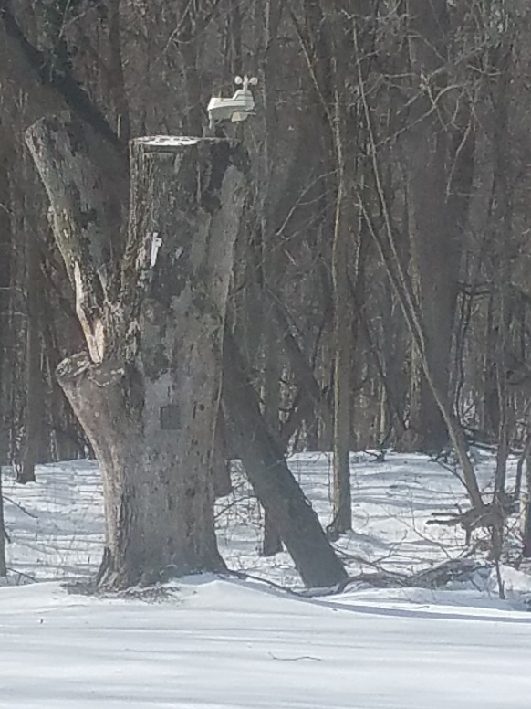
Some of you have asked me why I refer to my weather station “Weather Stump.” Well, that’s easy, it’s because it’s mounted on top of a tree stump. Now this tree stump isn’t what you think it is. It’s 20 foot-tall and I had the tree trimmers flatten the top of the stump so that the weather station would mount right on top.

I know what your next question is… why would I want to leave 20 feet of an old tree to have to look at every day? Well, it was a really beautiful white ash tree, you know, the kind that they make baseball bats out of. I figured that it still had some usefulness left in it even though the Ash Borer got to it several years ago. I figured that I could easily strap a tower or long pole to it and use the stump as a support for the tower/pole. It’s deeply rooted so it should withstand a lot of wind without needing any other supports or guys. Well, like my shack project, I just haven’t gotten around to securing a tower/pole to it yet. But, there’s really no hurry, that stump isn’t going anywhere soon, white ash is a very hard wood, so I’ve still got plenty of time. In the meantime, I am making good use of the stump with the weather head mounted to it. It’s solid as a rock so no matter how much wind there is, it ain’t moving for sure. Since the head is screwed directly into the stump and it’s 20 feet in the air, there’s no way that animals can bother it much either. No, the squirrels won’t go near it since there’s a blower motor inside the case to keep air flowing over the thermistor sensors. That way there’s no gradient temperature differences inside of the case. Oh, and for you energy conservationists, the motor is powered by solar cells mounted on the front of the weather head.

It is too cold to snow
Matt Peroutka, a meteorologist at the National Weather Service's Techniques Development Laboratory in Silver Spring, Maryland, answers this question that many of us ask this time of the year.
"Yes. It has to be cold for it to snow, if your definition of cold is like that of most folks who live in the mid-latitudes. But the atmosphere must contain moisture to generate snow--and very cold air contains very little moisture. Once the air temperature at ground level drops below about -10 degrees Fahrenheit (-20 degrees Celsius), snowfall becomes unlikely in most places. Therefore, significant snowfall at such very low temperatures is rare."
For those craving a more technical explanation of the phenomenon, Fred W. Decker of the Oregon Climate Service at Oregon State University offers the following:

TOP ^
"The maximum concentration of (invisible) water vapor which can occur in air decreases to extremely low values at very cold temperatures. Most clouds form through a process called expansion cooling. First, a mass of air rises, causing it to expand (because of the lower atmospheric pressure). Expansion causes the air to grow cooler, which reduces the amount of water vapor it can contain. The 'excess' vapor condenses out into a cloud.
"At very cold temperatures, the expansion cooling process starts in air that already has a low water vapor content. Hence, the clouds that form at colder temperatures--if any form at all--contain much less suspended water in the form of ice crystals, the starting sites for snow crystal formation.
"At higher, but still subfreezing, temperatures, ice crystals hook onto each other to create snowflakes. In extreme cold, the ice crystals remain independent. There actually is no such thing as too low a temperature for some sort of ice crystal to form and for such crystals to settle out and land on the surface. Such a deposit of ice needles is not usually considered 'snow,' however; in the Arctic, for instance, we might refer instead to an ice fog."
So, now that it’s been explained to you this way, the next time you hear that expression you can simply tell the person “YES” it actually IS too cold to snow!

WD9FTZ Makes Ohio and District 8 Proud

Gregory Drezdzon, WD9FTZ received a certificate from the CQ World Wide RTTY DX Contest by setting new records.

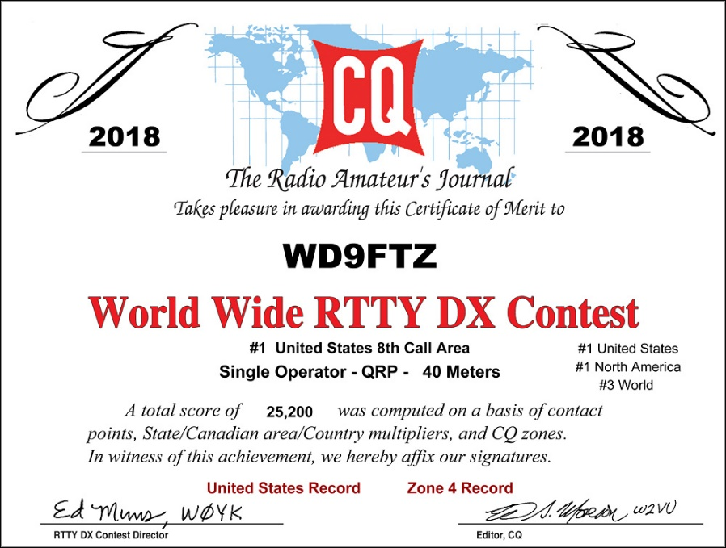
Drezdzon, operating QRP (5-watts or less of power) on a single band of 40 meters, was number 1 in the 8th District area by setting a new record for the tri-state district of Michigan, Ohio and West Virginia.

According to the results, Drezdzon also set a new record for CQ’s District 4, and the United States. In addition, Drezdzon was first in the United States, North America, and placed 3rd in the world.

The CQ World Wide RTTY DX Contest, held each year on the last full weekend of September, draws over 15,000 amateur radio participants, and in 2018 had 3,063 logs entries from around the world including 910 entries from North America.

Congrats to Greg from everyone here in the Ohio Section for being Number ONE!!!

TOP ^

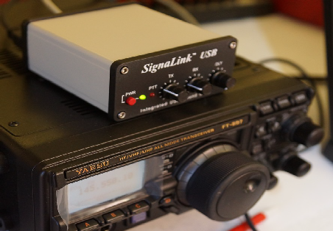
OHDEN Has Some Changes To Tell You About
(from Gary, NJ8BB & Eldon, W5UHQ)

Hey Gang,

Just wanted to make sure that you didn’t miss these very important announcements from the folks at OHDEN.

A new digital net to test 160-meter intra-Ohio propagation is now meeting on Tuesday Evenings at 1945-2045 (7:45-8:45) Local Eastern time. Thus far we have had successful border to border check-ins with great propagation from those checking in.

Frequency is 1.805MHz USB +1500 Hz data carrier offset. (very low end of 160 meters)

The net is currently being conducted in an informal mode and we encourage county to county tests at and county to NCS at this time. At some time, when we reach critical mass, the net will be designated a controlled ARES traffic net and made part of our OHIO NIMS system.

We are also hopeful that antennas can be erected at W8SGT so they can participate.

Mode: Olivia 8-500
Required Freeware Software: FLDIGI Version 4.0.12 and FLMSG 4.0.6

Details:

This is an ARES net designed to test feasibility of NBEMS traffic passing on 160 meters. We have been tasked to come up with ways to augment our current Ohio Digital Emergency Network which heavily relies on 80-meter Olivia for county to county low bandwidth digital messages.

The current sun conditions have made 80 meters past sundown very unreliable and next to impossible to pass error free messages. In addition to the new band, we will test ways of sending 4-character status messages for SHTF situations when all else has failed. OHIO ECs and State Support Staff have been asked to help develop a list of status /response messages similar to the ARLxx type messages but tailored to SITREP situations in NIMS.
Our intent is also to try out newer digital modes such as JS8Call and other offshoots of the WSJT software as augmentation but not replacement for FLDIGI.
Connect activity credits are being worked on both air time and assistance in developing procedures and makeshift antennas for those without 160 meters. We will start with Olivia 8-500 and go from there exploring different modes and quicker ways to accomplish check-ins and parallel operations when necessary.
Be very careful not to use LSB on this dial frequency or you will interfere with the ARRL code practice down the band on 1802.5.

Notify your local EC and the net manager w5uhq@arrl.net about your interest in this net or if you require assistance in adding 160-meter digital capability to your station’s toolbox.

TOP ^
Being an experimental net, we must be open to resolving any interference with other formal nets around the country. These are the kind of things we will evaluate during the experimental period before petitioning for a permanent time and frequency.

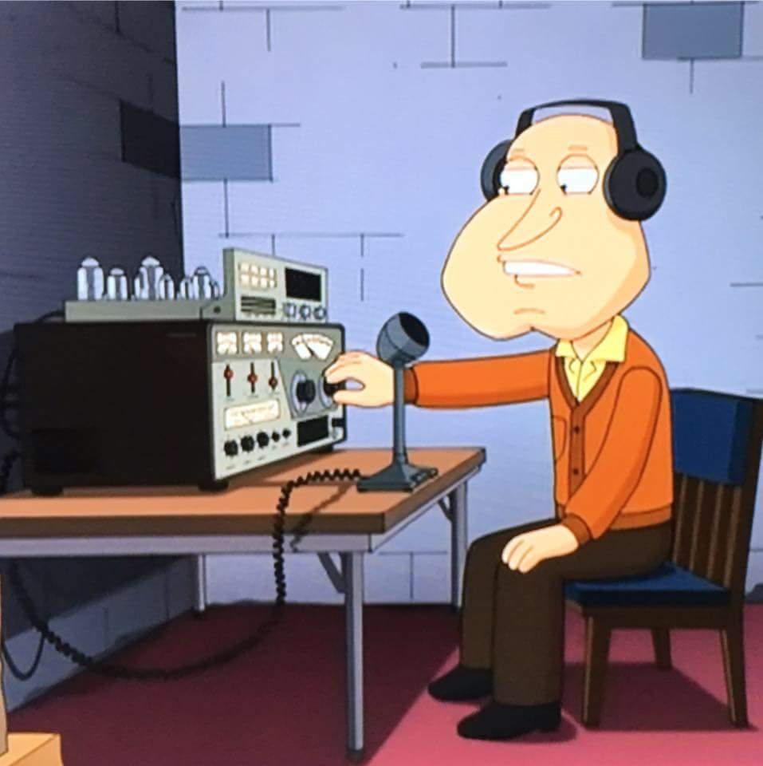
Our hope is to have at least one 160-meter FLDIGI station in each county.

Next announcement from OHDEN…

Due to the continued long skip being experienced on 80-meters during the Ohio Digital Emergency Net (OHDEN) training sessions @2145 local time each Tuesday; OHDEN has temporarily gone to Sunday afternoons at 3:00 - 4:00PM.

Training will remain on the prime frequency of 3584.5KHz USB +1500 Hz. Tests show that this time has much better propagation throughout the state and should allow the best propagation currently possible on 80-meter band. We are currently having to use a North Carolina station for NCS relays later in the evening.

Anything beyond local ground wave and this long skip point have not been reliable during this time of year, time of day, and sunspot cycle for the past three years.

At the same time, Eldon, W5UHQ is going to start an experimental Olivia / FT8 net on 1805.000 USB +1500 Hz during the normal time slot of 2145-2245 on Tuesdays. The objective of the 160-meter net will be to perform signal reports and check for traffic quality circuits on 160 meters from county to county and hopefully county to SEOC. Hopefully we can get more stations active on this frequency and as many county control stations as possible to try out their capability. Tests thus far have been great from border to border. I currently have six different stations that have checked into that test frequency. There will be no change to our standard mission call up frequencies at this time.

Using alternate times and frequencies is already in our SOP. The Ohio Technical Specialist team will be available to assist ECs in putting up at least a compromise antenna for that band.

These changes be in effect until March 12 (start of daylight savings time). These changes should allow all members interested in improving the 160-meter readiness of this critical statewide connection under all conditions of solar impacted propagation.

I Remember It Being Colder
(from Greg, WD9FTZ)

Since the National Weather Service changed its formula on how to calculate windchill, when we were growing up, it was COLDER!

"In late 2001, the National Weather Service implemented a new Wind Chill Temperature (WCT) Index. The reason for the change was to improve upon the old index used by the NWS and the Meteorological Services of Canada (MSC) which was based on the 1945 Siple and Passel Index."

https://www.weather.gov/oun/safety-winter-windchill

TOP ^
Below is the old windchill chart and the today's chart. Let's face it, cold is cold, but again, it is winter!

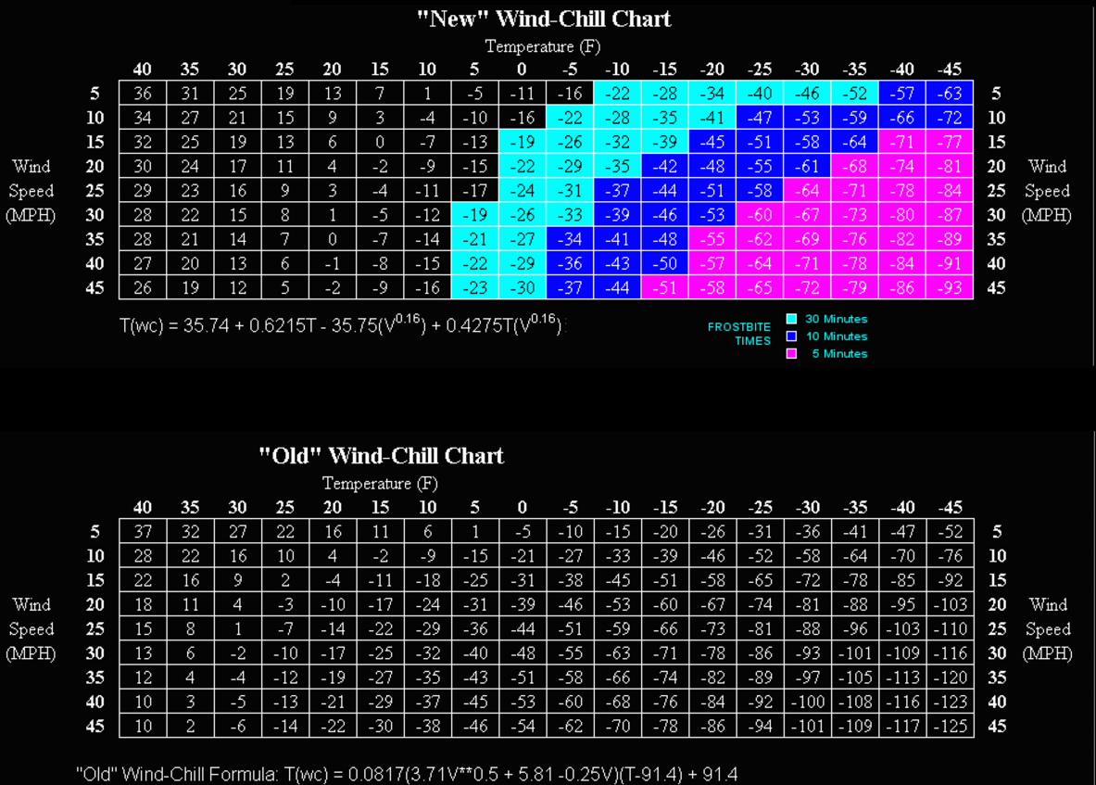

Ohio Section ARES Conference Date Announced

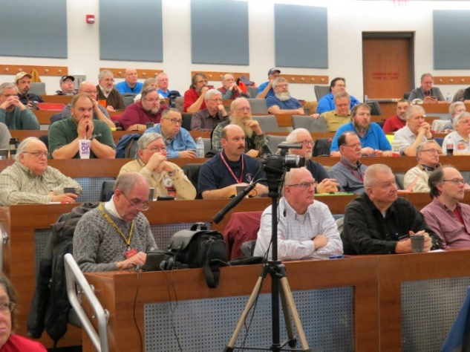
I know a lot of you have been waiting patiently for this announcement. Yes, we have set a date for the Ohio Section ARES Conference… It’s going to be held on April 6th at Marion Technical College / OSU Marion Campus. So make sure to mark your calendars for this date. Also, don’t forget to “sign up” for this event in ARES Connect as well!

Stan is working diligently on the agenda getting great forums arranged and it’s sure to be a really great conference. There’s loads of information for those interested in any part of Ohio’s ARES program.

This is an all-day adventure, but we are in a real college setting with all the amenities that you would expect in a first-class campus. Electric outlets are easily accessible for those bringing laptops and such. WiFi is available and the seats are very comfortable. And… I’ll have some great Give-A-Ways to pass out as well.

TOP ^
Lunch is on you, but the campus is close to many popular fast-food and sit down restaurants. You can even brown bag it if you want to eat on campus.

Certificates for your participation at this conference will be available, so you’ll get some wallpaper suitable for framing to take home with you as well! Now how can you beat that.

Get registered now, seating will be come limited quickly! Here’s the link: http://arrl-ohio.org/SEC/form.html

Radio hams respond when tornado hits Cuba capital
(from FRC and Greg, WD9FTZ)

Cuba's national amateur radio society, FRC, reports on the response of radio amateurs to the tornado that struck the capital Havana on January 27
A Google Translation reads:
On the night of Sunday, January 27, from early hours, the amateurs of the capital were attentive to the weather, as they were waiting for the entrance of a cold front.
As explained by meteorologist Miriam Teresita Yanes in the stellar broadcast of the National Television News, which on Sunday was an extra-tropical low in the southeast of the Gulf of Mexico, associated with a cold front approaching the west preceded by a line of pre-frontal storms, with severe weather activity, that is, the weather conditions in the western part of our country would deteriorate considerably during the evening and night hours.
What was not expected, a tornado of this magnitude within the same city, where different municipalities of the capital were affected, and where the radio amateurs played an exceptional role in this meteorological event, which will remain for history.
Repeaters of the capital operating at 145.190 MHz were activated and
145 MHz, the latter for the first time in this type of event, being very favorable in this occasion for its location.
In the Repeaters were several colleagues such as CO2JC, CO2LD, CO2LHP, CL2QV, CO2VC, CO2TZ, CO2DFC, CL2DDR, CM2EHA, CO2EAG and CM2ARY, among others who transferred valuable information of the different events and their trajectory, and could not miss the physical cooperation in different places, for the recovery of the different municipalities.
It is worth mentioning the speed with which the help information was worked, via radio, since everything was so fast, added to the lack of electrical power, the lack of communication via landlines and sometimes the cell phones did not work, everything was a chaos In seconds everything stopped working.
At times like these, it can be said, radio amateurs are useful for the benefit of society.
Source FRC
https://www.frcuba.cu/filiales-grupos/la-habana/un-importante-papel-el-de-los-radioaficionados-de-la-capital.html

TOP ^

Final.. Final..
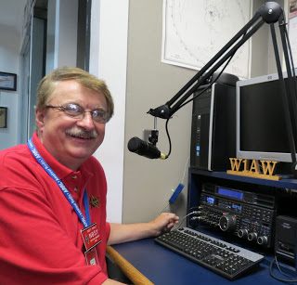
Hey Gang...

Ok… Who’s the wise guy that left the freezer door open last week. The thermometer in my radio room just quit working because it was so cold! The pop and beer that I store in my garage froze solid. I did get to experience beersicles for the first time. It wasn’t as good as when you drink it out of a big frosted mug however... Oh well, I’m just going to remember all of this cold nasty weather weekend for when August rolls around and we are sweating it out in the heat and humidity. Hi.. hi…

I had a blast this past week visiting with many of you at your meetings. The folks at LEARA are a hearty bunch for sure. Their meeting was last Tuesday night when it was only a couple of degrees above zero and they were getting lake effect snow to boot, yet they braved those nasty conditions and came out to enjoy each other’s company.

I could have said that they did all of this to hear me speak about the Ohio Section and ARRL, but I know better than that! They came for the food! It was really good too. The hamburger that I had was to die for, but they did have to endure listening to me for a bit afterward. They were a great bunch of folks with a lot of questions. Wow, we had a bunch of great questions! In fact, we ended it only when the restaurant folks kicked us out because they had already closed for the night and wanted to get out of there before they got snowed in!

Now, here’s a little piece of trivia for ya’… Today is February 4 and it’s the 35th day of the year in the Gregorian calendar. There are 330 days remaining until the end of the year (331 in leap years). This day marks the approximate midpoint of winter in the Northern Hemisphere and of summer in the Southern Hemisphere. So, with that said, we are now on the upward swing of getting winter behind us. Yippie!!! Shorts and T-shirts will soon be out in blossom once again! Oh, and let’s not forget that the groundhog DID see his shadow Saturday morning. That’s another great sign that spring is just around the corner for sure!

Oh well, nuff on that subject, let’s turn the band selector to 20-meters and see who’s around tonight! Have you gotten registered in ARES Connect yet? If you haven’t you really need to do it now. For your administrators out there, things will be changing in the system and from what I know right now, it will make your job a lot easier as well. Yes, things aren’t quite the way we want them yet, but they will be getting better and the system will be a lot easier to use when these changes happen.

Do you have the 3 days in May (17-18-19) marked on your calendar yet? This year Dayton will also be ARRL’s National Convention and that will definitely mean that there will be some very special things happening at Hamvention that you won’t want to miss out on that for sure!

Whelp… That’s going to do it for this time around. Stay safe, stay warm, and most of all… have FUN!!

73, and stay warm!!!

Scott, N8SY

TOP ^
Top shopping scams and how to avoid them
(By Steve Jurczak)

Cybercriminals often create subdomains that appear as if they roll up to the main site. So, instead of “brandname.com,” it may say “checkout.brandname.com” or “order.brandname.com.” Fake domains based on common misspellings of popular brand names are also common. When a shopper inadvertently misspells a retailer’s name, the fraudulent site loads in the web browser as expected. You can go through an entire e-commerce transaction and never realize you’ve surrendered your personal information.
First, be certain that you are on the merchant’s main site and not a subdomain. Second, make it a practice to bookmark the sites where you normally shop. This reduces the likelihood you will mistype a URL and wind up on a fraudulent landing page. Third, stay away from sites beginning in “http” rather than “https,” which indicates that the site uses extra security to prevent eavesdropping and tampering. Scams of this nature go by several names, including site spoofing, form-jacking and typo-squatting. Mobile browsers are particularly susceptible to spoofing since most devices can’t display the complete web address of a domain.

Cybercriminals often seek to exploit victims’ generosity by creating gift-giving scams. Beware of “secret sister” gift exchanges, which are nothing more than an online version of a pyramid scheme. Here’s how it works: You receive an invitation to send one gift, with the promise of receiving more in return for enrolling others in the scheme. According to the Better Business Bureau and the U.S. Postal Service, online gift exchanges and similar invitations are illegal. Avoid them at all costs. And report them if you encounter them on social media.

Phishing emails
Phishing scams are another pernicious year-round threat that spikes, as cybercriminals take advantage of shoppers on the lookout for discounts. They often appear to be from a reputable merchant and promise deals that are too good to be true. The aim is to get victims to click on a link. Once they do, they open the door to malicious code that locks the device and its contents unless the user pays a ransom. Another variant solicits consumers to enter their personal information, which is then sold to criminal networks. Make sure you recognize the sender before clicking on any links to those winter party invitations.

Shipping scams
The desire for timely delivery of packages creates an opportunity for cybercriminals to trick shoppers into giving up their personal information. Shipping scams start with an email containing a link to download a new shipping label, arrange a delivery time or reroute a package. Always look closely at the “from” line in emails. If you don’t recognize the sender, hover over it with your cursor and see where the link will take you. If you don’t recognize the URL, don’t click on the link. Contact the vendor and shipping provider separately to track the progress of your delivery. These types of scams happen all year round, not just over the holiday season.

Back up your systems
Aside from educating yourself about common shopping scams, your best defense against cybercriminals is to protect the important data on your computer with a secure backup solution, such as Carbonite Safe or Carbonite Endpoint. Carbonite saves you from having to deal with cybercriminals to get your files back. If your computer becomes infected, a reliable backup solution will allow you to retrieve clean copies without paying a ransom. With backup, not only do you protect what’s important to you, but you also deprive cybercriminals of their primary source of revenue.

TOP ^

Back Issues of the PostScript and Ohio Section Journal (OSJ)

Hey, did you know that PostScript and Ohio Section Journal (OSJ) are archived on the website? You can go back and look at any edition simply by clicking:
http://arrl-ohio.org/news/index.html

Chit – Chat, and All That!

Do you know someone that’s not getting these Newsletters? Please, forward a copy of this Newsletter over to them and have them “Opt-In” to start receiving them. Heck, just have them send me an email n8sy@n8sy.com and I’ll get them added to the Ohio Section Emailing list.

We now have many thousands of readers receiving these newsletters weekly. Quite impressive, I’d say! I urge all of you to make sure that everyone, regardless of whether they are a League member or not, get signed up to receive these weekly Newsletters.

You can always “Opt-Out” at any time if you feel this is not what you were expecting. It’s fun and very informative. All of your favorite past newsletters are now archived too.
You can go back at any time and read them. Just go to: http://arrl-ohio.org/news/

Got questions, concerns or would just like to sit and chat awhile? Heck, I’ll even buy the coffee!! Give me a call at (419) 512-4445 or email me at: n8sy@n8sy.com

The pictures on the front page are from various newsletters, Facebook posts and/or were sent directly to me in recent weeks. Take a good look at them, you just might be in one of the pictures! “SMILE… you’re on the Ohio Section News!!”

Congratulations to the New England Patriots for winning the Super Bowl!

TOP ^

PostScript is produced as a weekly supplement to the Ohio Section Journal (OSJ). I sincerely hope that you have enjoyed this edition and will encourage your friends to join with you in receiving the latest news and information about the Ohio Section, and from around the world!

