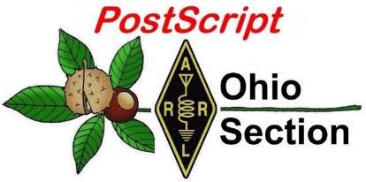
January 28th
Edition

National News The Handbook Give Away

Club Corner Hamfests

DX This Week One Question Questionnaire

VE Testing Schedule Final.. Final..

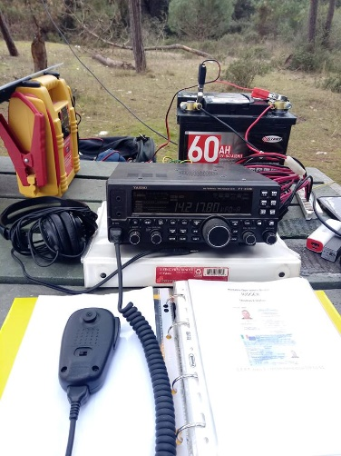
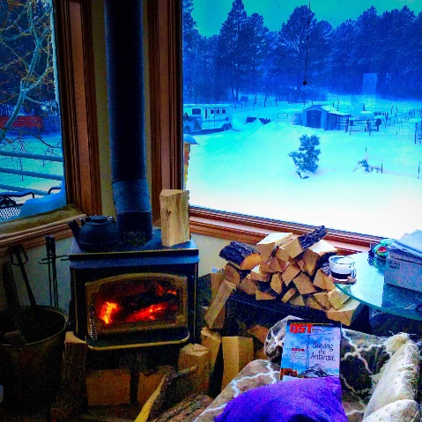
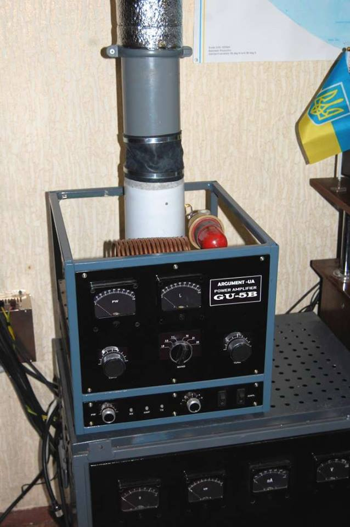
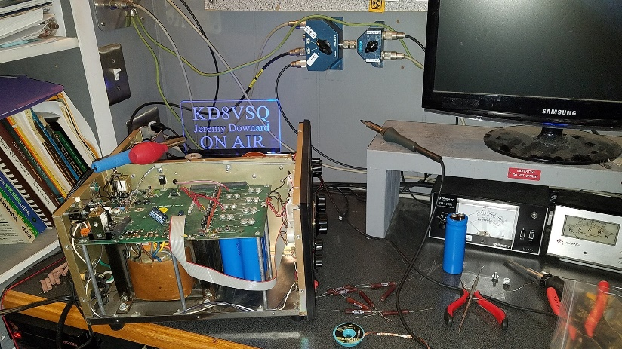
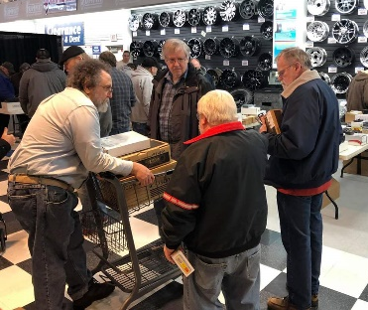
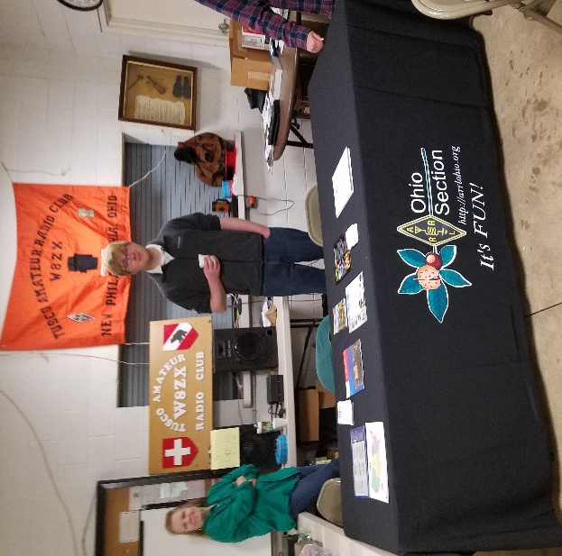

National News
(from arrl and other sources)

OPDX Bulletin Mailing List is Victim of Hamnet.org Server Hack

The Ohio/Penn DX (OPDX) Bulletin mailing list is reported to be “in limbo” after a January 11 hack of the Hamnet.org server. OPDX Bulletin Editor Tedd Mirgliotta, KB8NW, reports that the server, which he’d used since the late 1980s, was “hacked and wiped” on January 11. The OPDX Bulletin mailing list was among the casualties. “The OPDX mailing list is now in limbo, and I was told that the server Hamnet.org is probably is gone for good,” Mirgliotta said in the bulletin’s January 14 edition. He said the OPDX Bulletin, including an archive of back issues, remains available on the OPDX website.

“I know this is going to be a big disappointment for the subscribers, as well as it has been for me, but after almost 29 years, I am considering possibly retiring from writing the bulletin,” Mirgliotta said.

Mirgliotta said the OPDX Bulletin would not be delivered by email for the time being. Contact Mirgliotta via his new email address.

#########

SDR Explained in Plain English

NOARS (Northern Ohio Amateur Radio Society) member, Dave Kennett W8KFJ has produced a series of excellent Youtube presentations about SDR Radio.

If you feel a little left behind with all this new-fangled SDR stuff, this video is for you! SDR School is presented in a non-technical fashion. Part one covers SDR basics, Part two will cover SDR hardware, and part three, the software.

The first video is about 28 minutes and really does a great job of telling you just how easy it is to get started. The Basics of SDR, can be found at: https://www.youtube.com/watch?v=ncxyycmSeWU&t=38s

Dave's presentations are well thought out, clearly presented, with excellent graphics. Part 2 deals with hardware, and the yet to be published Part 3 will deal with the software.

Check it out.....

(ed.. Thanks Chet, K8KIZ for sending me the information)

#########

TOP ^

We have survived snowmageddon 2019!!
Stan Broadway, N8BHL COML AUXCOMM
Ohio Section Emergency Coordinator

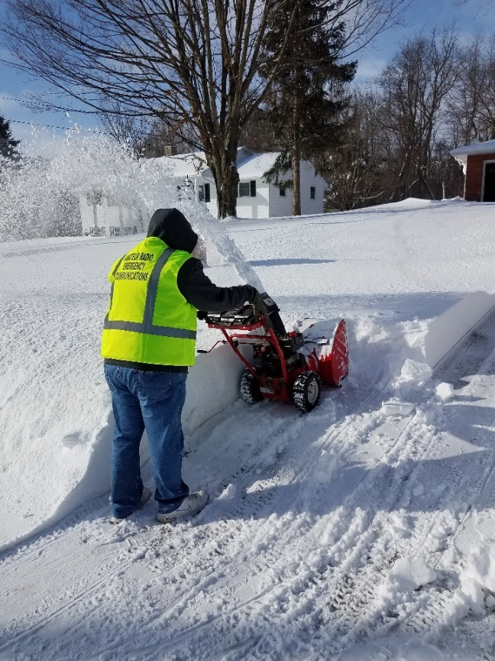
YES, we survived snowmageddon 2019!! Whether the forecasts were accurate depended on what part of Ohio you occupy… and we had a wide variety of effects from our weekend snowstorm. Based on ominous forecasts threatening blizzard conditions across much of Ohio, and based on the appearance of a Weather Channel crew in Columbus the night before, expectations were high that we would have some abnormally crippling weather during this storm. After discussion with the Ohio Watch Desk, Assistant SEC’s and Section Manager Scott Yonally, N8SY, I requested ARES volunteers in Ohio to provide observations to broaden the knowledge base of decision makers at the Ohio EOC and local EMA locations. We could do this safely from home, and integrate our reports (remotely) into the state’s WebEOC management system which could be read by the Ohio Watch Desk and any other emergency official around the state. We had never tried this, and it frankly seemed like a great way to promote amateur radio’s ability to provide situational awareness on a wide scale. Secondarily, it was an opportunity for our volunteers to participate under conditions that had the real possibility of growing into an emergency. While most Ohio winter storms do not require this type of action, this storm presented a great opportunity for statewide ARES response. Our plan was to give the storm Saturday morning to get established, and launch our state net around 1500. That timing proved accurate.

Our amateur radio operators quickly grew busy reporting their local conditions with specific details. The reports were compiled by Ohio’s Auxcomm Team station, W8SGT, which was operated from my residence from 1500 through 2130 on HF (80 meters) and DMR (the Ohio Talk group) simultaneously. By nightfall, the storm conditions had stabilized for the night and reporting slowed to the point we were able to close the state net.

In addition there were a number of county-level nets in operation across the state, ranging from “listening and standing by” status to fully operating nets with 11-20 observers. Some ran into the early morning hours and ARES District 3 net in western Ohio ran until 0600 Sunday morning. The general operation of the local nets was to receive observations and reports on a regular basis, mostly in one hour increments, and pass on significant items to the Ohio net.

The Ohio “Snow Net” received 131 reports from 44 (of Ohio’s 88) counties, split evenly between HF and DMR. The short-notice net was entered into the “ARES Connect” system and over 50 amateurs signed up with that event. There were several other local snow nets entered for some county events as well. The statewide reports were logged and submitted every couple hours to the state HS/EMA Watch Desk through WebEOC. We have received several compliments from EMA directors around Ohio who were impressed that amateur radio could furnish such detailed information. Many thanks are owed our ARES volunteers for their enthusiastic response!

TOP ^
What went right:
- The whole idea of the net was put together on short notice, with information being released late Friday through emails to each county ARES Emergency Coordinator. The number of amateur operators and nets which sprang to life was impressive.
- Our HF capability to reach across the state was a proven asset, with good communications in all directions.
- DMR (Digital Mobile Radio) is a new aspect of amateur radio. Functioning much like MARCS (Ohio’s public safety radio system), it connects nearly 80 repeaters across Ohio through the Internet. This service was as yet untested; this event created the perfect proving grounds: we needed dependable statewide communication where all stations would benefit by hearing reports as they were filed. The “Ohio Talk Group – 3139” was used with great success- we had no known problems with dropout or system faults. Communication proved reliable even with the severe weather threatening power and antenna disruption. This was a great success.
- We provided a broad range of reports, typically snow depth, wind speed, and other information such as “Level 3” declarations, closed airports and more. [Under level 3 conditions, non-essential personnel on the roadways are subject to arrest.] Specific entries were made to WebEOC on major items, and the entire log was submitted in three segments over the time period.
- The main EOC was not going to be activated for the storm and we expected transportation problems to threaten driving later in the evening, so we opted to operate the net from a remote residential location. We were able to stay logged into WebEOC and to the Wilmington and Cleveland National Weather Service chat channels to pick up on any reports there. We did supply a few specific reports to Wilmington weather as conditions worsened.

What could be better:
- We honestly had no expectation when starting this net since it hadn’t been done before. We might have been more aggressive in alerting District Emergency Coordinators and EC’s to give more time to prepare.
- We did not provide a lot of guidance for local nets on their expectations or operation. Most nets that we heard were very active. We might have been more specific about what details we sought and what timeframe we anticipated.
- We did not anticipate the call load – this would have been much better run with multiple operators. For the first couple hours, we had to go back and forth between HF then DMR taking reports while the other side had to stand by. As night fell the call load relaxed.
- Had we decided to use multiple operators (from different homes) our logging would have suffered- we may have to develop a shared logging system to promote consistent reporting. Of course, applying multiple operators inside our Ohio EOC station would eliminate that issue.
- We were not clear on ending our operation. With the storm having passed through, we had not intended to continue/resume operation Sunday morning. We left some confusion on that, as several stations were calling Sunday morning to continue reporting.

Winter storms are part of Ohio, and we don’t propose ramping up a net for every snowfall. But when the forecasts call for extreme conditions, ARES operators have now proven we can be a true asset for our agencies. Additionally, we’ve tested DMR communication under heavy load successfully.

TOP ^

The Handbook Give Away
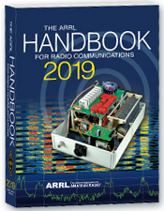
Hey Gang,

Have you registered for the “Handbook Giveaway” drawing for this month yet? If you haven’t, go to: http://arrl-ohio.org/handbook.html and get registered.

What’s the catch? I want to get everyone checking in to the Ohio Section website as often as possible, and in order to register each month, you have to visit the website often! There’s nothing else to it. I pay all expenses, and from time to time, I Give Away more than just a Handbook. And, you’ll never know just what months will be those special times that I will have more than just a Handbook to Give Away!!

Many of you ask me just how do I know when the drawing is on? Well, that’s easy all you need to do is check in on the Ohio Section Website on a regular basis and watch for the big RED Arrow that will appear on the left side of the page. This is the sign that the drawing is on and you need to get registered. So, keep a sharp eye out on the website and check in often! http://arrl-ohio.org

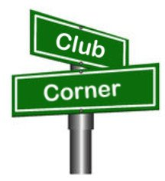
Club Corner

This is YOUR cornner of the newsletter. Send me what your club is doing and I’ll make sure that it gets in. Got a special event or club project that you want everyone to know about? Send it to me!. Need help with a project? Send it to me.

Let me know what you club is up to. Are you going to have a special guest at your meeting or are you having a special anniversary? Just sent it to:
n8sy@n8sy.com

#########

Dial Radio Club To Hold Technician Classes

Our friends at the DIAL Radio Club are about to start an amateur radio class. Beginning January 30th the DIAL RADIO CLUB will offer a six-week class to prepare a candidate for examination in Technician Class Amateur Radio operator license. Meeting in 007 Thesken Hall, on the Middletown Campus of Miami University, this class will meet Wednesday evenings 6-9 pm. Class will conclude March 6 and be followed by an examination session on Wednesday, March 20.
Although there is no charge for the instructional portion of this class, students should be prepared to purchase a license training manual and supplies (approximately $25-30) for use in class.
Class enrollment will be limited to twenty students. For registration and/or additional information, please call Beverley Taylor (n8gge@arrl.net or 513-423-3165) or Carl Morgan (k8cm@arrl.net or 513-422-9384)

#########

TOP ^
General Class Licensing Course - Work HF!

The Cuyahoga Falls Amateur Radio Club is offering its 6-week course for the General amateur radio exam. Sixth week has free Laurel VEC exam. The exam is open to the public.

WHEN: Every Sunday stating 17 February 2019 to March 24, 2019 from 1:15 PM to 4:45 PM

WHERE: Main branch of the Akron-Summit County Public Library, 60 South High Street, Akron, Ohio, 44326 Free parking in adjoining deck.

COST: $35 for manual and refreshments.

Please preregister by sending call sign and statement of intent to education@cfarc.org.

The course uses the General Class manual by Gordon West. This is our fourth offering. The course covers background material, question pool Q and A, and live demos. Send questions and registration to Jim (N8PZL) at education@cfarc.org

Sponsored by the Cuyahoga Falls Amateur Radio Club: cfarc.org

#########

Massillon Amateur Radio Club will be conducting three simultaneous classes:

Technician License - General License - Code training
All will begin at the Massillon Club location: Massillon Senior Center, 39 Lincoln Way West, Massillon.

Classes will begin Friday evening February 8th from 7-9 p.m. Classes will run every Friday for 8 weeks through March 29.

For Technician class contact Terry Russ, N8ATZ truss@sssnet.com or call 330-837-3091. For General Class contact Don Wade, W8DEA, w8dea1djw@gmail.com or call 330 For Code class contact Perry Ballinger, W8AU, w8au@arrl.net or call 330-705-8449

The Code class encompasses learning, plus how to use a hand key, various options for electronic keys, where and when to find W1AW slow code practice, how to conduct your first QSO, tips on abbreviations and Q code, etc. Goal is 5 WPM and follow up with Club on-air training net.

As classes are held at the location of the Massillon ARC club station (W8NP) where we provide hands-on demonstrations as part of the instruction.

#########

Medina 2M Group offering FREE classes for HAM Radio License.

The classes are expected to begin in the second week of February and last until the third or fourth week of March, the exact dates will be finalized soon.

TOP ^
Classes are typically held once a week in the evening. Enrollment is currently open, you can sign up for the classes at: https://goo.gl/xTPhhA

More information about the Medina 2M Group can be found at: http://W8EOC.org

#########

PCARS Starting Technician Classes

We will be starting a new Technician Class on February 6th. The classes will run through March 27th. The session on March 27th will be a VE test session. We have added a Saturday session, February 16th from 9 till noon that will allow students to learn about antenna and station setup. If you know of anyone interested in getting their license, pass this information along. If you would like a copy of the class flyer simply Click Here.

Remember to send me an email as soon as possible if you are interested. Send to jawilson@j3solutions.com.

#########

CARS 2019 Winter Ham Radio classes - get your Technician, General or Extra class license!

Thursday evenings starting February 28, 2019 and ending April 11, 2019 at 6:30 pm April 11th will be a special VE Test session for all license classes, ARRL fee for this VE test is $15.00

To register please follow the link at: www.2cars.org and complete the on-line application or call 216-932-8005 Dave, KD8ACO.

Classes will be held at the Seven Hills City Hall, 7325 Summit View Dr Seven Hills, OH 44131 in room “C” at 6:30 pm every Thursday.

The entrance is at the East end on the South side of building class fees: Technician $25.00, all who pass get a free CARS membership for 2019, General and Extra $20.00 nonmembers or Extra is $15.00 CARS members, General class ONLY is FREE to CARS members All class materials are provided

#########

Seneca Radio Club participates in “Winter Field Day”
(from Advertiser – Tribune)

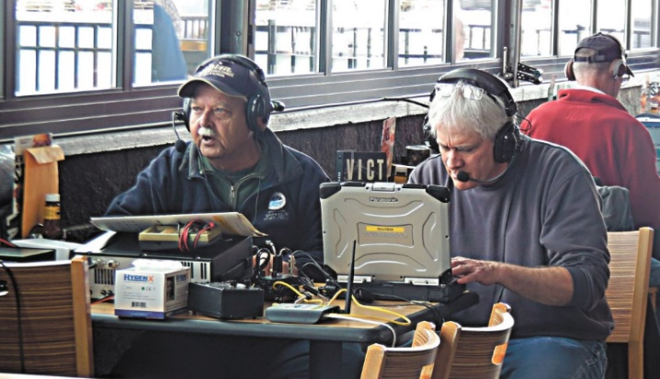
Seneca Radio Club Vice President John Walker and President Jeff Potteiger participate in the worldwide “Winter Field Day,” Saturday afternoon. A release states the event is for radio amateurs to try and establish contact with as many others during a twenty-four-hour period and the club is participating in the event from Buffalo Wild Wings, 100 S. Shaffer Park Drive. Potteiger said about 12 members were participating in the event Saturday afternoon, but there would be more throughout the night.

TOP ^
He said they wanted to give club members the opportunity to operate some of the newest radios and equipment and to prep for this summer and the “Summer Field Day,” which is a big event. Potteiger said the Winter Field Day provides training, but is also a contest, so members can “get competitive sometimes” as they “hope to rank high in Ohio,” Potteiger said. “It’s a way for us to prep for emergency communications and at the same time, have a good time,” he said.

#########

Winter Field Day Report from the Springfield Area
(from Ralph, AA8P)

Hi Scott, just thought I would drop you a line on how our Winter Field Day went.

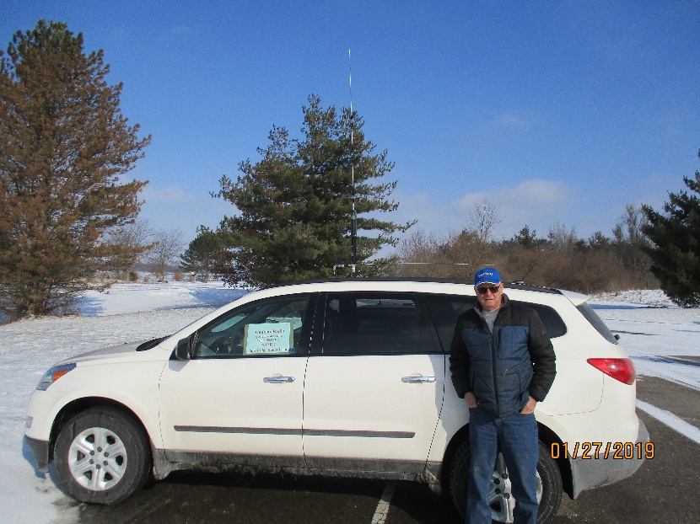
Our group The Parkridge Radio Team, club call N8PRT here in Springfield had plans to operate the winter field day this past weekend. The club had planned on setting up two stations and have a few operators man the two stations for most of the event. Unfortunately, due to the really cold weather, some of the guys couldn't make it out and decided just to operate from their homes instead.

As it turned out, there was only one operator (me) that did go out to the Buck Creek State Park to set up and operated. Two other folks stopped out for a visit later in the day and encourage me on.

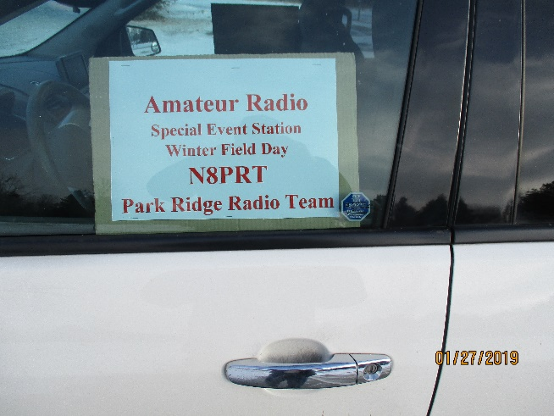
I set up in my SUV but it turned out to be a little short on roominess, but I made do with the space available. Due to family commitments I was only able to spend a couple of hours working the bands on Saturday afternoon and a few of hours Sunday morning, but I had a lot of fun anyway.

A cold breeze was blowing off of the lake, but the equipment did its job and operated flawlessly. I did make 42 CW contacts on 40 and 20-meters, and I worked 25 states from coast to coast plus Canada! Not bad for just a quick setup in my car. We didn't have much of a turnout, but it was good to know that if needed, we can get out and make some contacts, even if it is just in a car. I enjoyed it a lot and just wished that I had more time to operate. Look forward to doing it again next year.

73,

Ralph

#########

TOP ^

One Question Questionnaire

Hey Gang

There’s another NEW – one question – questionnaire on the Ohio Section Website! http://arrlohio.org

We had about 20% of you stating that you were helping out your community during the snow-storm last weekend!

That’s fantastic! I have gotten several reports from EMA Directors around the state thanking us for our efforts! They stated that it was really beneficial to them to get the added information. This additional information really helped them make some critical decisions and they were grateful for our help.

Anyway, these questions are all in fun and I hope that you are enjoying answering these “ONE QUESTION” questionnaires.

Ok, enough on that, here’s the next question for you to answer…

“Did you get to work any of Winter Field Day this past weekend??”

You’ll find the “One Question” questionnaire on the Ohio Section Website! http://arrlohio.org It’s all in fun and it’s not a scientific survey in any way, but we are learning some things that we didn’t know from these questions. I hope that you are enjoying answering these “One Question” questionnaires.

ARES Connect

CQ… CQ…. CQ… Calling all persons to be a part of the new ARES Connect program.

We need to discuss some very important items that only YOU can make a difference with. I need you to get yourselves registered in ARES Connect, that is… if you haven’t already.

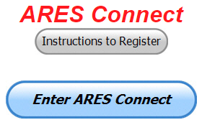
Now, how do I know that you need to do this? It’s simple, we have a little over 800 now registered in the database with about 450 persons actually signing up for events. Stan’s last S.E.C. report shows that we have a little over 1,500 persons in ARES.

That means that there is still a lot of you that haven’t taken the plunge yet and need to! What are you waiting for? No matter how much you resist, it’s coming, and we need to make sure that no one is left behind.

Now, as an incentive to get you to not only register…. But to actually start using the system… (Notice how I have that in bold type for you to clearly see?) I am giving away all sorts of goodies to help you get motivated. I have a footlocker of really cool items that I will be giving away!

TOP ^
Yes folks, remember the handbook I gave away a few months ago to kick this project off? I’m do this a various interval throughout the year, so it will challenge you to be dedicated like Ron and get your hours into the system. You’ll never know just when another drawing will be, so you really do have to be prudent!!

Here’s how it looks for the first 4 weeks of 2019:

 | Name | Events | Hours
1 | Dan Stahl (KC8PBU) | 48 | 49.00
2 | Bret Stemen (KD8SCL) | 6 | 44.50
3 | Michael Lacumsky (w8mal) | 26 | 38.00
4 | James Yoder (w8erw) | 10 | 37.00
5 | Timothy Gray (KD8IZU) | 8 | 31.50
6 | Edmund Liddle (KE8ANU) | 7 | 28.00
7 | Brent Stover (wd8pnz) | 7 | 28.00
8 | Bryan Hoffman (kc8egv) | 4 | 26.00
9 | Gordon Broadway (N8BHL) | 5 | 23.00
10 | Michael Farkas (n8gbu) | 37 | 21.50

Don’t know where to get started? We have a set of instructions on how to get registered right above the button to enter ARES Connect. I would strongly suggest that if you haven’t registered yet, that you read these instructions first. Here’s a link to get you started... http://arrl-ohio.org/ares_connect_directions.pdf

Please, don’t just hurry through the questions, read them carefully, if you don’t understand something, please ask me, I’m here to answer your questions.

We know that you mean well by answering that you do have the needed courses in, but I will let you know that we are verifying what you say you have with what is showing for you in our statewide database when we are completing your registration. So, how can you find out if you are already listed in our statewide database? Easy, here’s a link: http://arrl-ohio.org/SEC/special/ICS%20Complete%20by%20County%20and%20Name.pdf

Incident Command System (ICS) Training Schedule

All current trainings are listed on the Ohio EMA training calendar located at:
https://webeoctraining.dps.ohio.gov/TrainingAndExercise/courselist.aspx

I’ve been asked to also include a link to the Kentucky EMA training calendar as well..

https://kyem.ky.gov/training/Pages/default.aspx
https://sites.google.com/site/ccoemtraining/home

Please pay particular attention to these courses listed above, as that there’s a lot of ICS 300 & 400 classes listed that are very useful for all Amateurs to have under their belts. I will also state that G775 is also a very good course to take as well. These 3 courses are multiple day in class courses, so please be prepared to spend some time taking them.

TOP ^
I would like to remind any of you that are going to take any of the in-class training sessions that you dress appropriately. Please don’t go into these classes with attire that doesn’t represent you, and Amateur Radio in the best of light. I won’t tell you that we have a dress code, but I have heard from some officials from around the state that have made the comment to me that your appearance did stick with them. Remember, you will be in class with fire / police chiefs, mayors, township trustees and a whole host of other government and civil officials that will remember how you represented Amateur Radio while you were in these classes together.

We do recognize that IS-300/400 requires multiple days of actual classroom training that is not easily obtained. So, if you just can't find the time to fit these class room courses in, we do have an alternative method for getting you to Level 3. Completing the following “FREE” and “ONLINE” courses will act as substitute for you FEMA Leadership Development Course requirements. You absolutely will need to complete all 7 of these courses to get your ICS 300/400 credit. Here are the courses that you need to take: IS-120, 230, 240, 241, 242, 244 & 288.

#########

Auxiliary Communications (AUXCOMM) Training

This course focuses on auxiliary communications interoperability, the relationship between the COML and the volunteer, emergency operations center (EOC) etiquette, on-the-air etiquette, Federal Communications Commission (FCC) rules and regulations, auxiliary communications training and planning, and emergency communications deployment. It is intended to supplement and standardize an operator’s experience and knowledge of emergency amateur radio communications in a public safety context.

Course Dates: February 16 – 17, 2019 (One-hour lunch)
Application deadline: February 2, 2019
Course Registration Time: 7:30 AM to 8:00 AM (Day 1)
Time of Course: 8:00 AM to 7:00 PM (Both Days)
Training Location: Franklin County Emergency Management & Homeland Security
5300 Strawberry Farms Blvd.
Columbus, OH 43230

Required Prerequisites:
Required Prerequisites: (IS-100, 200, 700 & 800)
Applicants MUST have completed the following on-line courses from the FEMA/EMI Independent Study (IS) website: https://training.fema.gov/is/crslist.aspx?all=true
1. IS-100, Introduction to the ICS;
2. IS-200, ICS for Single Resources and Initial Incidents;
3. IS-700, National Incident Management System (NIMS), an Introduction;
4. IS-800, National Response Framework (NRF).

Other Required Documentation:
The target audience for this course includes individual that MUST have Personal experience in auxiliary communications and MUST have the following four items and provide documentation to Pam Tickle.
1. An active FCC Amateur Radio License (provide a copy of the license)
2. Documentation of past experience in auxiliary emergency communications (provide documentation via email or letter of your experience)
3. An affiliation with a Public Safety Agency (provide a letter or an email from leadership of the Public Safety Agency that you are associated with indicating your affiliation)

TOP ^
4. A desire to work with COMLs in a NIMS/ICS environment (provide a statement letter or email indicating your interest)

Send the following eight items as a COMPLETE packet to Pam Tickle @ pktickle@franklincountyohio.gov

If you are unable to attend the course, please click on the link below, withdraw yourself by logging in, click on the “Course Catalog”, and double click on the course to display the "Course Details" and click "Unenroll" to withdraw from the course. https://trainingcampus.dps.ohio.gov/cm/cm710/pstc/pstc.html

Course Target Audience:
The target audience for this course includes individual that MUST have Personal experience in auxiliary communications and MUST have the following four item and provide documentation to Pam Tickle.

1. An active FCC Amateur Radio License
2. Past experience in auxiliary emergency communications
3. An affiliation with a public safety agency
4. A desire to work with COMLs in a NIMS/ICS environment

Lodging Information:
Lodging, Meals, Per Diem and all other travel expenses are the responsibility of the student or the parent organization.

Enrollment:
Students must enroll via the Public Safety Training Campus located at the following link. https://trainingcampus.dps.ohio.gov/cm/cm710/pstc/pstc.html and those that have trouble registering should contact Ohio EMA Training at (614)799-3824/3677 for assistance with registration. Please refer to the FY 2018/2019 Ohio EMA Training Catalog or website at http://ema.ohio.gov/Training.aspx for additional information. State Point of Contact: Lisa Jones, DSC 2, Ohio EMA, SAA Training Point of Contact, ljones@dps.ohio.gov, Office: (614) 799-3824

#########

MGT-347 Incident Command System (ICS) Forms Review

This class is Provided by Texas A&M Engineering Extension Service (TEEX). Hosted by Franklin County EM & HS February 5, 2019. The class is the morning of February 5th and we are still in need of 18 people to register and attend the class, so it does not get canceled. If it has been awhile since you have taken this review, please consider attending this half-day class. Registration is through the Ohio Public Safety Training Campus
https://trainingcampus.dps.ohio.gov/cm/cm710/home.html

Course Description:
The MGT-347 ICS Forms Review course is a 4-hour workshop that provides emergency response supervisors and mid- to upper-level managers with a detailed introduction to the Incident Command System (ICS) forms used in the development of an Incident Action Plan (IAP) and/or Coordination Action Plan (CAP). Participants will examine the primary forms used in an IAP/CAP, as well as supporting and other utility forms.

TOP ^
In addition, participants will review the planning process and where, within that process, the forms are filled out and by whom. The workshop includes a practical application designed to instruct participants in the development of Specific, Measurable, Action-oriented, Realistic, and Time-based (SMART) control and management objectives.

Course Dates: February 5, 2019

Application deadline: January 29, 2019

Course Registration Time: 7:30 to 8:00 AM

Time of Course: 8:00 AM – 12:00 PM

Training Location: Franklin County Emergency

Management & Homeland Security
5300 Strawberry Farms Blvd.
Columbus, OH 43230

Required Prerequisites:
After registering for the course online, students must provide copies of the following certificates of completion to Pam Tickle at pktickle@franklincountyohio.gov to attend this course.
1. IS-100.b FEMA Introduction to the Incident Command System, ICS-100
2. IS-200.b FEMA Incident Command System for Single Resources & Initial Action Incidents, ICS-200
3. IS-700.a Introduction to the National Incident Management System (NIMS)
4. IS-800.C,National Response Framework, an Introduction

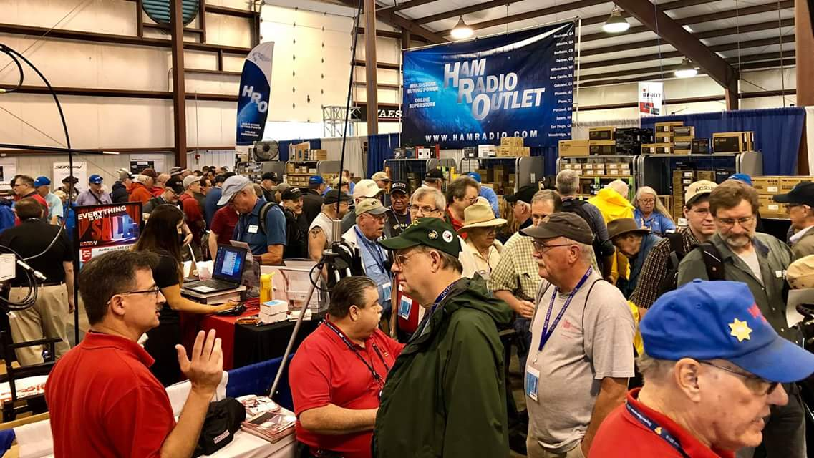
Upcoming Hamfests

02/17/2019 | InterCity ARC Hamfest
Location: Mansfield, OH
Sponsor: InterCity Amateur Radio Club
Website: http://www.w8we.org

03/03/2019 | WINTER HAMFEST  Location: Elyria, OH  Sponsor: Northern Ohio Amateur Radio Society  Website: http://www.noars.net/hamfests/noarsfest | 03/16/2019 | Gallipolis Ohio Hamfest  Location: Gallipolis, OH  Sponsor: Mid-Ohio Valley Amateur Radio Club
03/17/2019 | Hamfest and Computer Fair  Location: Perrysburg, OH  Sponsor: Toledo Mobile Radio Association  Website: http://www.tmrahamradio.org  TOP ^ | 04/13/2019 | 65th Annual Cuyahoga Falls Amateur Radio Club Hamfest  Location: Cuyahoga Falls , OH  Type: ARRL Hamfest  Sponsor: The Cuyahoga Falls Amateur Radio Club, Inc.  Website: http://cfarc.org

V.E. Test Sessions
(from arrl)

02/02/2019 | Bryan OH 43506-8410  Sponsor: Williams County ARC  Location: Willliams County 911/EMA  Time: 10:00 AM (Walk-ins allowed)  Learn More | 02/02/2019 | Kirtland OH 44094-8500  Sponsor: Lake County ARA  Location: Kirtland Library  Time: 12:00 PM (Walk-ins allowed)  Learn More

02/02/2019 | Ravenna OH 44266-2191  Sponsor: Portage County ARS Inc.  Location: PCARS Club Site (Rear of complex, under BIG tower)  Time: 10:00 AM (Walk-ins allowed)  Learn More | 02/03/2019 | Marion OH 43302-1523  Sponsor: Marion ARC  Location: TV 39  Time: 2:30 PM (Walk-ins allowed)  Learn More
02/06/2019 | Cuyahoga Falls OH 44221-3205  Sponsor: Cuyahoga Falls ARC  Location: Cuyahoga Falls Library  Time: 6:30 PM (Walk-ins allowed)  Learn More | 02/09/2019 | Cambridge OH 43725-2401  Sponsor: Cambridge ARA  Location: St John's Episcopal church  Time: 2:00 PM (Walk-ins allowed)  Learn More
02/09/2019 | Findlay OH 45840  Sponsor: Findlay Radio Club  Location: Findlay Radio Clubhouse  Time: 9:00 AM (Walk-ins allowed)  Learn More | 02/09/2019 | Maumee OH 43537-1628  Sponsor: Toledo Mobile Radio Assoc  Location: Maumee Fire Station #2  Time: 8:15 AM (No Walk-ins / Call ahead)  Learn More
02/10/2019 | Milford OH 45150-1427  Sponsor: Milford ARC  Location: Faith Church  Time: 6:00 PM (Walk-ins allowed)  Learn More | 02/12/2019 | Lancaster OH 43130  Sponsor: Lancaster & Fairfield ARC  Location: After School Programs Lancaster  Time: 7:00 PM (Walk-ins allowed)  Learn More

Special Events

- 02/16/2019 | MVARA 100th ^{A}nniversary
Feb 16-Feb 18, 2300Z-2300Z, W8QLY, Youngstown, OH. Mahoning Valley Amateur Radio Association. 14.220 7.220 3.922. Certificate & QSL. MVARA, 125 W McKinley Way, P.O. Box 14141, Youngstown, OH 44512. https://goo.gl/forms/2uNZfO6zRx1YPoWw2 to request your certificate/qsl. www.qrz.com/db/w8qly or www.mvara.org

TOP ^
- 04/13/2019 | 7th Annual Earth Day Celebration
Apr 13, 1500Z-2000Z, W8PRC, Cleveland, OH. Parma Radio Club. 14.245 7.195. QSL. Parma Radio Club, 8111 Laumer Ave., Cleveland, OH 44105. Our 7th ^{A}nnual Earth Day Celebration. Operating on solar power from historic, educational Stearns Farm in the Parma, Ohio town center. www.parmaradioclub.com

January 30
- QRP Fox Hunt
- Phone Fray
- CWops Mini-CWT Test
- UKEICC 80m Contest

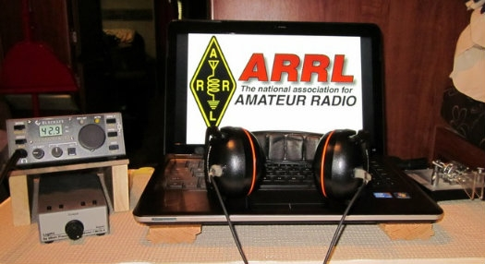
ARRL Contest Corner

January 31  - CWops Mini-CWT Test | February 1  - NCCC RTTY Sprint  - QRP Fox Hunt  - NCCC Sprint Ladder
February 2  - Vermont QSO Party  - 10-10 Int. Winter Contest, SSB  - Black Sea Cup International  - F9AA Cup, CW  - Mexico RTTY International Contest  - FYBO Winter QRP Sprint  - Minnesota QSO Party  - AGCW Straight Key Party  - British Columbia QSO Party  - FISTS Winter Slow Speed Sprint | February 3  - British Columbia QSO Party  - North American Sprint, CW
February 4  - RSGB 80m Club Championship, SSB | February 5  - ARS Spartan Sprint
February 6
- QRP Fox Hunt
- Phone Fray
- CWops Mini-CWT Test
- UKEICC 80m Contest

An expanded, downloadable version of QST's Contest Corral is available as a PDF. Check the sponsor's Web site for information on operating time restrictions and other instructions.

TOP ^

Countdown to Third Annual AM Rally Has Begun
The third annual AM Rally is on the near horizon — is only about 4 weeks away — getting under way at 0000 UTC on February 2 and continuing until 0700 UTC on February 4. The event aims to encourage the use of AM on 160, 80, 40, 20, 15, 10, and 6 meters while highlighting the various types of AM equipment in use today.

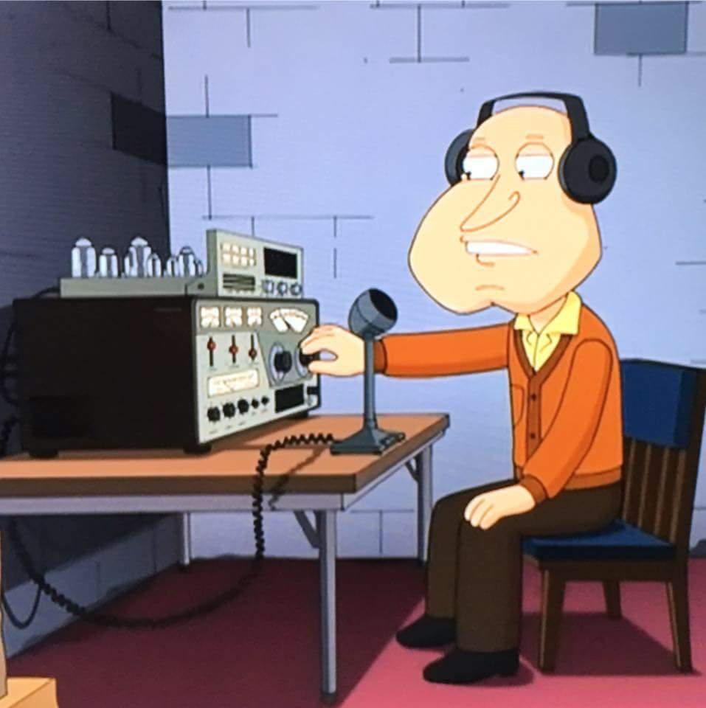
The event is open to any and all radio amateurs running AM using any type of radio equipment — modern, vintage, tube, solid-state, software-defined, military, boat anchor, broadcast, homebrew, or commercial.

“We’re very excited about the upcoming AM Rally in February, given its growth over the past 2 years and the positive comments we’ve received,” said Clark Burgard, N1BCG, who is spearheading the event with Steve Cloutier, WA1QIX, and Brian Kress, KB3WFV. “In particular, it’s great to hear how so many ops are giving this classic mode a try, many for the first time, and of the help offered to them by those who have mastered the technology.”

For many, if not most, radio amateurs getting on AM is as simple as pressing the AM mode button on the front panel. Numerous transceivers in use today offer AM capability. A lot of hams enjoy restoring and using vintage Amateur Radio equipment, which typically means a separate transmitter and receiver. Until SSB subsumed it on the ham bands, AM was the primary HF voice mode. The change to SSB did not happen without some pushback, however.

Today, a group of dedicated radio amateurs keeps the flame alive, getting on AM frequently, and for many of them, AM is their primary operating mode. The AM Rally gives the uninitiated a chance to dip a toe into the pool, so to speak.

The event website has complete AM Rally details, Contact information, award categories, logging, and tips on how to get the most out of your station equipment in AM mode. Contact Burgard for more information.

The event is sponsored by Radio Engineering Associates (REA), in cooperation with ARRL, which supports all modes of Amateur Radio operation. W1AW will play a leading role in the event, as it has for the past two years.

Certificates will be awarded to stations scoring the highest number of points in each of the five power classes, regardless of rig category, both for most contacts and most states/provinces.

“All it takes is a turn, push, or click to participate!” Burgard said. There’s also plenty of time to dig out and dust off that old AM-capable tube gear sitting in your attic or basement.

#########

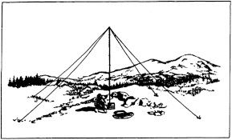
2019 Ohio NVIS Day

Hey everyone, Stan, N8BHL has let me know that the date for NVIS Day is scheduled for Saturday, April 27th. Are you ready? Start your planning now!
Like years past, we are planning on having the operation run from 10 – 4 EDT. Take a lunch break, enjoy each other’s company.

TOP ^
Transmit power should stay at 100 watts for accurate signal comparison. You may operate anywhere, home, club, portable.
Want to know more about what NVIS is? http://arrl-ohio.org/SEC/nvis.html Learn all about Near Vertical Incident Scattering and how you can easily put up a NVIS antenna and participate in this great exercise.

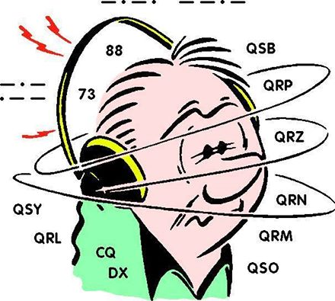
DX This Week
(from Bill, AJ8B)

Bill AJ8B (aj8b@arrl.net, @AJ8B, www.aj8b.com or www.swodxa.org )

My personal DXPeditions have included operating Field Day with Uncle Frank from Ft. Wayne, IN; Palm Harbor, FL; and operating mobile from about 15 states. Quite exotic I know! I have talked to several of our club members about being on the receiving end of major DXPedition and what the “wall of sound” is really like. As we know, some DXPeditions are more successful than others. Factors such as propagation, bands of operation, time of year, equipment, operator and antenna selection, and Pilot relay stations are all important considerations when it comes to putting together a DXPedition.
What is a Pilot station? That is one of the items that I know little about, so, I decided to do some homework and share it with you. Below is some information that I gathered from the blog of N6PSE (with his permission), the Cordell Expeditions website (with their permission), and with the input of experienced major DXPeditioner, Jay – K4ZLE.
From N6PSE: “Pilot stations are members of the DXPedition who operate from populated areas and are in regular contact with the DXPedition. Their job is to report on how things are going from their location and act as liaisons between the DXPedition and Hams in their region. The ill-fated Bouvet Island DXPedition had North American pilots, European pilots, a Japanese pilot, and even a special pilot for younger Hams, Bryant KG5HVO.
Listen to the pilots! They will give feedback from the DXPedition, such as changes in schedules or conditions and requests to follow certain instructions. Use their firsthand knowledge to make a successful contact.
Pilot relay stations are a critical element of a successful DXPedition. The role of the Pilot relay station is to be the local (regional) eyes and ears of the DXPedition team and to detect and address those issues that can help the DXPedition team improve or meet certain needs or goals.
A leading DXPedition organizer who I greatly respect and admire tells me that we “need to give our audience “ownership” in the DXPedition — make them feel part of the process, let them know that their opinions matter, and bring them into the realm rather than hold them at arm’s length. He uses the example of their contributions being an “investment” in a DXPedition, just as you’d invest in a company with the expectation of a dividend or growth. If you invest in a company, you can vote your shares; you have a voice. We should give our contributors a voice as well. Pilots facilitate that process”

TOP ^
I feel that it is most important for a DXPedition to have a regional Pilot relay in your most difficult regions to work. They get a sense of whether the team is exploiting propagation at every opportunity to work the most difficult regions. Case in point, during the XZ1J DXPedition to Myanmar, we were quite surprised and glad to learn that we were being heard quite well via the long path on the higher bands to the US East Coast. That was our most difficult area to work and these paths were not predicted.
During the EP6T Iran DXPedition, the US regional pilot was able to relay to the operational team that the US West Coast was hearing them well on 30- & 40-meters long path at the W6 sunset. Soon, the EP6T team was exploiting this opening and asking for W6/W7 at the right place and time. This greatly improved their success rate. One leading DXPeditioner writes “I’ve also advocated that we base our operations on data. Rather than “we’ll work what we hear,” we should use the data to know what is potentially there (a little opening under a big one). This is not to say that we don’t have to be on our toes for the unexpected openings. The pilots are key in this process”
A good DXPedition Pilot relay station acts as your regional ambassador, advocate and defender. The pilots receive a lot of abuse at times and this must be filtered and deflected away from the operational team. Many experienced DXPedition leaders feel that the Pilots are also “funnels” and “filters.” They funnel important information and filter out the trivia and redundant. The internet and computers don’t know the difference. Pilots receive a lot of abusive correspondence directed toward the expedition operators at times this should not be arbitrarily passed on to the on-site team. However, if one or more operators’ procedures, or expedition band mode selection can obviously be improved, constructive suggestions should be passed on and favorable received.
During the DXPedition, the Operational team must stay focused on careful, fast and steady operating. They should not have to deal with the abuse, complaints, whining that comes in via the Internet. The Operational team has a difficult job to do and they must maintain their energy and desire to do their best. They must not get emotionally mired in the bashing that often takes place in internet forums and email reflectors. We know that bad and erroneous comments can really spoil your day. These are often knee-jerk reactions to the moment and poorly thought out. Also, how many operator hours will you burn looking at email when you could be making QSO’s? Would you rather the operator be monitoring the packet cluster or engaged in email correspondence for 'Thank you' spots or responding to comments like “When they gonna be on ‘xyz’ band or ‘abc’ mode or work the ‘such-and-such region’ or have their heads down making Q's?”
This is the realm of the Pilot relay, to sense and address those issues. The Pilot relay should properly filter the information to the team so that the raw emotion is stripped away, and the important information is presented to the Operational team. During the E30FB DXPedition, I made the mistake of looking at some of the comments about our DXPedition on the internet. There was a lot of complaining that was not consistent with Pilot information. In hindsight, I should have kept my complete focus on the tasks at hand and continued my practice to ignore Internet drivel.
Our Chief Pilot can reach the DXPedition leaders via super-secret email, via the Iridium telephone or as a third means our InReach SE via SMS.
We feel that super-secret email is required because during a DXPedition, team member email is often
abused. We receive many email messages regarding “busted” contacts while the DXPedition is far from complete. We have had people send us sound and video files as attachments to their email messages. Imagine trying to receive those on a satellite email system where your costs are $7.00 a MB. You can’t delete the messages until you down load them, and your other email is essentially blocked until you remove the sound and video files that you would rather not have received.
TOP ^
Leading DXPeditioners know that a DXPedition must ask itself, “Why are we here? Are we here to hand out as many QSO’s as possible and be focused on amateur radio? Or, are we here and subsidized by amateur radio to do something else?”
As many of us see it, pilots give a receptive ear to our audience and whenever they can, they give a human reply. They are the DXPeditions ambassadors and personalize the DXPedition process rather than depersonalize it. Computers and the internet are very fast, but they don’t think. Pilots are that critical element to a DXPeditions success.”

What makes a good pilot station? Below is some criteria from Cordell Expeditions. They have been responsible for several successful DXPeditions including Peter I., Easter Island, Heard Island, and Kure Atoll.

- the pilot MUST have an excellent (well above average) HF-station
- the pilot must be well respected in the DX-community
- the pilot must have access to all the modern communication systems and
links (i.e. internet, access to DX-cluster,etc.)
- the pilot must be a communicator: he must be able to communicate/QSP
messages briefly, to the point and objectively
- the pilot must have a lot of free time during the expedition
- the pilot must be dedicated to his job (he must be convinced his job is as
important as being a team member on the island).
- Being a pilot requires a lot of time and patience. This should not be
underestimated.
- The pilot must be prepared to spend a minimum of 4 to 5 hours every day at
your pilot job!
- Provide a way to keep in touch with the civilized world when commercial
systems fail. Most DXPeditions take along Inmarsat telephone
equipment, which enables the team members to call home, and to
receive calls from home. The pilot station will, however, be in a fall-
back position, in case problems might arise with the commercial
satellite links.

The pilots are to a large degree responsible for determining the perception and the quality of the DXPedition. As such, the pilots take care of an important part of the deliverables as a team.

From our friend at the DailyDX and the WeeklyDX, (http://www.dailydx.com/ ) Bernie has this to report:

XZ - Myanmar - JE2QIZ/AC7XZ, Akio Taguchi, got his permission January 11 to operate XZ2B. The license limits him to 25 watts and only the lower 20 kHz of any band, so he will be CW only. His antenna is a fishing rod antenna from his hotel. His stay in Myanmar is two years but the current license is for 150 days. Beyond that, he doesn't know. He will try to keep the log up to date on Club Log but isn't sure about it. QSL via his home call JE2QIZ, with one IRC or 2 USD. He is ordering QSLs now, with a return to Japan at the end of February, when he will start answering any cards that have come in. He says you should expect two to three months to get your card from him. The purpose of his time in Myanmar is to work on an international cooperation project, with radio operating secondary, so he cannot predict his operating schedule yet.

TOP ^
T31 - Central Kiribati - The T31EU team plans to be on the air February 16- March 5, and has gotten a generous donation from the GDXF, German DX Foundation, making them the main sponsor. GDXF president DJ9ZB has told them it's the largest donation the GDXF has ever made. As of January 9 the team announced preparations are on schedule. They are told the two generators on the island are in excellent working condition and two drums, 400 liters, of fuel are prepositioned and available.

The gear is all packed, a total of 250 kilograms. The team leaves from Frankfurt, going to Brisbane, then Tarawa. After a short stay there, they fly to Kanton February 16th on a Beechcraft King Air 200, where they will be guests of the village there.

VP6 - Pitcairn Island - October this year is the target timeframe for an expedition, with a shipping container with the gear ready to go from New Zealand by August 1. The Braveheart arrives in Moorea October 7 after a previous charter. It will re-provision and refuel, then sail for Mangareva, arriving October 13. The op team flies from Tahiti to Mangareva the 15th of October and boards, sailing for Pitcairn that evening, arriving at dawn October 17 to begin offloading the gear. They hope to have all the stations on the air October 18, with 14 days on the island. With the first payment for the Braveheart due in about two months, they appreciate the financial support. https://pitcairndx.com .

A more detailed calendar can be found at http://www.dailydx.com/the-daily-dx-calendar/

More info can be found at www.swodxa.org or www.aj8b.com

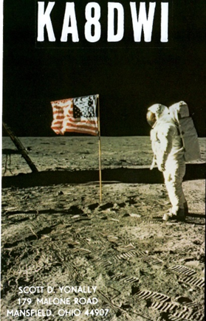
ARLD004 DX news

This week's bulletin was made possible with information provided by VE3FU, The Daily DX, 425 DX News, DXNL, Contest Corral from QST and the ARRL Contest Calendar and WA7BNM web sites. Thanks to all.

TUNISIA, 3V. Ash, KF5EYY plans to be QRV as 3V8SF in the CQ World Wide 160 Meter CW contest. QSL via LX1NO.

GEORGIA, 4L. Ilya, R3XA and Mamuka, 4L2M will be QRV as 4L9M and 4L2M, respectively, in the CQ World Wide 160 Meter CW contest as Single Op/High Power entries. QSL 4L9M via R3XA and 4L2M via EA7FTR.

SOMALIA, 6O. Ali, EP3CQ is currently QRV as 6O1OO until February 6.
QSL direct to home call.

BARBADOS, 8P. Charles, 8P6ET is QRV as 8P6ET/p. Activity is on 80,
40 and 20 meters using CW and SSB. He will be QRV as 8P1W in the CQ World Wide 160 Meter CW contest as a Single Op/Low Power entry. QSL via KU9C.

EAST MALAYSIA, 9M6. Saty, JE1JKL is QRV as 9M6NA from Labuan Island, IOTA OC-133, until January 28. This includes being an entry in the CQ World Wide 160 Meter CW contest. QSL via LoTW.

CHILE, CE. Jorge, CE3YP is QRV with special callsign 3G3G from Santiago until December 31. Activity is on 80 to 6 meters using only FT8. QSL via LoTW.

TOP ^
MADEIRA ISLAND, CT3. Operator OM3GI will be QRV as CT9ABO in the CQ World Wide 160 Meter CW contest as a Single Op/High Power entry.
QSL via LoTW.

CANARY ISLANDS, EA8. Operator OM5RW will be QRV as ED8W in the CQ World Wide 160 Meter CW contest as a Single Op/High Power entry.
QSL via LoTW.

MARTINIQUE, FM. Laurent, FM5BH will be QRV in the CQ World Wide 160 Meter CW contest. QSL via W3HNK.

DOMINICAN REPUBLIC, HI. Members of the Loma del Toro DX Club are QRV as HI1LT from Beata Island, IOTA NA-122, a first-time activation, until January 28. Activity is on the HF bands using CW, SSB, RTTY, and on various satellites. QSL via W2CCW.

THAILAND, HS. Members of the HSDXA Team will be QRV as E2X in the CQ World Wide 160 Meter CW contest as a Multi/Single entry. QSL via LoTW.

NORTHERN IRELAND, GI. Operator SP5MXZ will be QRV as MI/3Z0X in the CQ World Wide 160 CW contest as a Single Op/Assisted entry. QSL via LoTW.

ITALY, I. Dimitar, LZ1UQ and Ivan, LZ1PM are QRV as IH9/LZ1UQ and IH9/LZ1PM, respectively, from Pantelleria Island, IOTA AF-018, until January 31. This includes entries in the CQ World Wide 160 Meter CW and UBA DX SSB contests. QSL to home calls. In addition, station IG9/S59A is QRV from Lampedusa Island, IOTA AF-019, until January 30. Activity is on the HF bands. This includes being an entry in the CQ World Wide 160 Meter CW contest. QSL via operators'
instructions.

PERU, OA. Tom, OA4DX will be QRV in the CQ World Wide 160 Meter CW contest as a Single Op/Low Power entry. QSL via LoTW.

FINLAND, OH. Special event station OG60IPA is QRV during all of
2019 to commemorate 60 years of Finland's participation in the International Police Association. QSL via OH4MDY.

SUDAN, ST. John, N9MDH is QRV as ST2JB from Khartoum. He has been active on 15 meters using FT8. QSL via LoTW.

PALAU, T8. Nobu, JA0JHQ is QRV as T88PB from Koror. This includes being an entry in the CQ World Wide 160 Meter CW contest. QSL direct to home call.

CORSICA, TK. A group of operators will be QRV as TK0C in the CQ World Wide 160 Meter CW contest as a Multi Op entry. QSL via S50C.

BELIZE, VE. Art, NN7A will be QRV as V31JZ/p from South Water Caye, IOTA NA-190, from January 31 to February 6. Activity will be on 80 to 10 meters using mostly CW. QSL direct to home call.

TOP ^
CANADA, VE. Chris, VO2AC, Frank, VO1HP and Dave, VE9CB will be QRV as VO2AC in the CQ World Wide 160-Meter CW contest as a Multi Op/High Power entry. Before the contest, they may be active as VO2AC and VO2AAA on 160, 80, 60 and 40 meters, and on satellites AO-85, AO-91, and AO-92 from grid square GO11.

QSL via operators' instructions. In addition, look for special event station VD1NUQK to be QRV from January 26 to February 26 to commemorate the USS Truxton and USS Pollux naval disaster of Newfoundland 77 years ago.

INDONESIA, YB. Yohanes, YB2DX will be QRV as a Single Op/High Power entry in the CQ World Wide 160 Meter CW contest. QSL via LoTW.

THIS WEEKEND ON THE RADIO. The CQ 160-Meter CW Contest, Winter Field Day, NCCC RTTY Sprint, QRP 80-Meter CW Fox Hunt, NCCC Sprint CW Ladder, REF CW Contest, BARTG RTTY Sprint and the UBA DX SSB Contest are all on tap for this upcoming weekend.

The UKEICC 80-Meter CW Contest, CWops Mini-CWT Test, Phone Fray and QRP 40-Meter CW Fox Hunt are scheduled for January 30.

The Canadian National Parks on the Air, CNPOTA, operating event runs for the entire year of 2019, with special stations active from Canada's parks and historic sites.

Please see January 2019 QST, page 91, and the ARRL and WA7BNM Contest Web Sites for details.

Communication Disability Law

Hey Gang,

This came in from our partners of the Ohio VOAD and I thought that this information might be of interest to you and someone you know. Please share this with others. Ohio House Bill 115 became effective on 8/01/2018, it is called the “Communication Disability Law”:

It means: An individual with a medically diagnosed communication disability who drives or regularly has someone with a communication disability in their vehicle, can voluntarily enroll in a database that connects to the Law Enforcement Agencies Data System (LEADS).

An officer can then be made aware that the driver or a person in the vehicle may have difficulty communicating with the officer to reduce any potential misunderstandings or communication problems. Individuals who are interested in self-identifying can complete a Verification Form and take the completed Verification Form to their licensed medical practitioner who can validate the individual has a communication disability.
Here is the link to go to for more information and forms to be completed:

OOD.OHIO.GOV Communication Disability Law

TOP ^

Weather Underground and Ham Weather Stations

Have you visited the webpage to see all the Weather Underground stations yet? It’s really fun to see just how much the weather varies across the state and this gives you access to each individual station very quickly and easily.

It seems that our list of stations is growing every week!

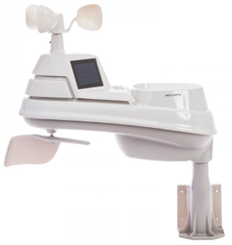
Thanks to everyone who has contributed to this effort. If you didn’t, you should have taken a look at the various weather stations around the state last weekend when we had all the bad weather. You would have seen just where the line of demarcation was and watched it as it crossed through the state. It was very interesting since the data is real time! Here’s a link to all of those listed… http://arrl-ohio.org/wus.html

We’re starting to get a really good collection of stations all over. I know that there is a lot more than what we have listed. How’s about sharing your weather information with all of us! All that you need to do is send me your Weather Underground ID and your call sign and I’ll take it from there. Sent it to: n8sy@n8sy.com

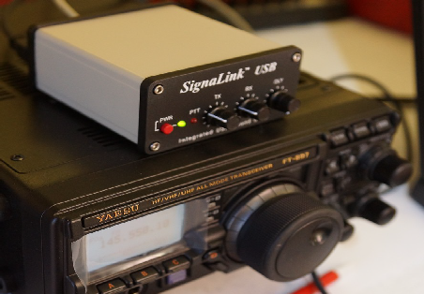
OHDEN Has Some Changes To Tell You About
(from Gary, NJ8BB & Eldon, W5UHQ)

A new digital net to test 160-meter intra-Ohio propagation is now meeting on Tuesday Evenings at 1945-2045 (7:45-8:45) Local Eastern time. Thus far we have had successful border to border check-ins with great propagation from those checking in.

Frequency is 1.805MHz USB +1500 Hz data carrier offset. ( very low end of 160 meters)

The net is currently being conducted in an informal mode and we encourage county to county tests at and county to NCS at this time. At some time, when we reach critical mass, the net will be designated a controlled ARES traffic net and made part of our OHIO NIMS system.

We are also hopeful that antennas can be erected at W8SGT so they can participate.

Mode: Olivia 8-500
Required Freeware Software: FLDIGI Version 4.0.12 and FLMSG 4.0.6

Details:

This is an ARES net designed to test feasibility of NBEMS traffic passing on 160 meters. We have been tasked to come up with ways to augment our current Ohio Digital Emergency Network which heavily relies on 80-meter Olivia for county to county low bandwidth digital messages.

TOP ^
The current sun conditions have made 80 meters past sundown very unreliable and next to impossible to pass error free messages. In addition to the new band, we will test ways of sending 4-character status messages for SHTF situations when all else has failed. OHIO ECs and State Support Staff have been asked to help develop a list of status /response messages similar to the ARLxx type messages but tailored to SITREP situations in NIMS.
Our intent is also to try out newer digital modes such as JS8Call and other offshoots of the WSJT software as augmentation but not replacement for FLDIGI.
Connect activity credits are being worked on both air time and assistance in developing procedures and makeshift antennas for those without 160 meters. We will start with Olivia 8-500 and go from there exploring different modes and quicker ways to accomplish check-ins and parallel operations when necessary.
Be very careful not to use LSB on this dial frequency or you will interfere with the ARRL code practice down the band on 1802.5.

Notify your local EC and the net manager w5uhq@arrl.net about your interest in this net or if you require assistance in adding 160 meter digital capability to your station’s toolbox.

Being an experimental net, we must be open to resolving any interference with other formal nets around the country. These are the kind of things we will evaluate during the experimental period before petitioning for a permanent time and frequency.

Our hope is to have at least one 160-meter FLDIGI station in each county.

Next announcement from OHDEN…

Due to the continued long skip being experienced on 80-meters during the Ohio Digital Emergency Net (OHDEN) training sessions @2145 local time each Tuesday; OHDEN has temporarily gone to Sunday afternoons at 3:00 - 4:00PM.

Training will remain on the prime frequency of 3584.5KHz USB +1500 Hz. Tests show that this time has much better propagation throughout the state and should allow the best propagation currently possible on 80-meter band. We are currently having to use a North Carolina station for NCS relays later in the evening.

Anything beyond local ground wave and this long skip point have not been reliable during this time of year, time of day, and sunspot cycle for the past three years.

At the same time, Eldon, W5UHQ is going to start an experimental Olivia / FT8 net on 1805.000 USB +1500 Hz during the normal time slot of 2145-2245 on Tuesdays. The objective of the 160-meter net will be to perform signal reports and check for traffic quality circuits on 160 meters from county to county and hopefully county to SEOC. Hopefully we can get more stations active on this frequency and as many county control stations as possible to try out their capability. Tests thus far have been great from border to border. I currently have six different stations that have checked into that test frequency. There will be no change to our standard mission call up frequencies at this time.

TOP ^
Using alternate times and frequencies is already in our SOP. The Ohio Technical Specialist team will be available to assist ECs in putting up at least a compromise antenna for that band.

These changes be in effect until March 12 (start of daylight savings time). These changes should allow all members interested in improving the 160-meter readiness of this critical statewide connection under all conditions of solar impacted propagation.

Ohio Section ARES Conference Date Announced

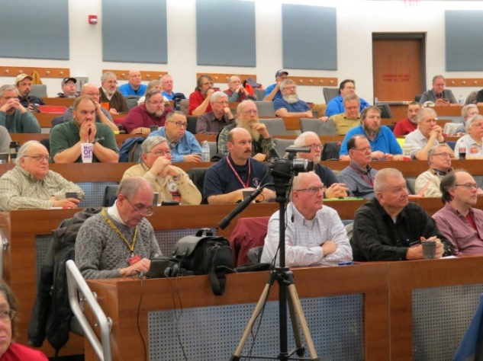
I know a lot of you have been waiting patiently for this announcement. Yes, we have set a date for the Ohio Section ARES Conference… It’s going to be held on April 6th at Marion Technical College / OSU Marion Campus. So make sure to mark your calendars for this date. Also, don’t forget to “sign up” for this event in ARES Connect as well!

Stan is working diligently on the agenda getting great forums arranged and it’s sure to be a really great conference. There’s loads of information for those interested in any part of Ohio’s ARES program.

This is an all-day adventure, but we are in a real college setting with all the amenities that you would expect in a first-class campus. Electric outlets are easily accessible for those bringing laptops and such. WiFi is available and the seats are very comfortable. And… I’ll have some great Give-A-Ways to pass out as well.

Lunch is on you, but the campus is close to many popular fast-food and sit down restaurants. You can even bring your own and eat right on campus if you wish.

Certificates for your participation at this conference will be available, so you’ll get some wallpaper suitable for framing to take home with you as well! Now how can you beat that.

Get registered now, seating will be come limited quickly! Here’s the link: http://arrl-ohio.org/SEC/form.html

Why is CW (Continuous Wave) Still Around?
(Posted by OnAllBands on January 17, 2019 - an Amateur Radio Blog by DX Engineering )

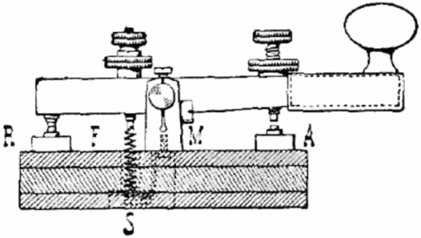
CW stands for Continuous Wave. In CW communications, a continuous carrier is transmitted as long as the key contacts are closed. By making and breaking the contacts into specific patterns, characters and entire messages may be sent.

During the earliest days of telegraph, Morse code was the only method for nearly-instant distant communications.

TOP ^
Morse code (named for Samuel F. B. Morse) was generated in the clicks made by a sounding bar being attracted to an electromagnet. There was no tone or sound signal present other than a clicking noise. These clicks, and the spaces between them, comprised the code.

The CW tone heard on Amateur Radios today has evolved from the early code first used in 1844. So why, with all the other communication modes available, is CW still used? It’s a multifaceted answer!

For some, CW is just plain fun. The joy of interpreting the sound of Morse code and the challenge of increasing one’s proficiency is very alluring. For DX hunters, code is a robust and reliable form of communication. CW may be understood when voice transmissions fail. This makes it ideal for weak signal DX work. QRP operators capitalize on the ability of CW to “get through.” Other CW users like the historical nature of using a communication method whose development began over 170 years ago. There are many more reasons, we’re sure!

Although many newer devices, like the Unified Microsystems XT-4 Memory Keyer and the MFJ 464 CW Keyer/Reader Unit, and computer interfaces, like the RigExpert TI-8 Digital Mode and Radio Control Interface, may be used to send and/or receive Morse, many still prefer to do it the old fashioned way- with a standard telegraph key. Using your “fist” and your own ears to generate and decode CW is a source of pride and accomplishment.

Regardless of its age, Morse code (CW) has shown a propensity for longevity and, most likely, will still be in
use another 170 years from now!

Senators Question FCC, FTC on Carriers Providing Customer Data to Third Parties
(from: Radio Resource and Greg, WD9FTZ)

A group of 15 senators called on the Federal Trade Commission (FTC) and FCC to investigate how wireless carriers allowed third parties to track Americans’ cellphones without consent.

The senators sent a letter to the FTC and FCC asking for a full investigation of the data-sharing arrangements that allowed for the apparent widespread sale and sharing of Americans’ cellphone locations.

“It is clear that these wireless carriers have failed to regulate themselves or police the practices of its business partners, and, in failing to do so, have needlessly exposed American consumers to serious harm,” the letter said.

The senators requested a response by Feb. 5. Earlier this month, House lawmakers sent letters to carriers and other companies requesting more information about the consumer cellphone data.

( https://www.wyden.senate.gov/imo/media/doc/15-senators-location-aggregator-letter-to-fcc-ftc-final.pdf )

TOP ^

Electrical Trivia
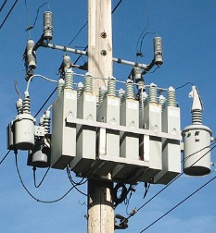
Why are there capacitors attached to the power lines?

Because, on average, the load on the power grid is somewhat inductive. This causes the current and voltage to be out of phase - a plot of current vs time and a plot of voltage versus time at the point where the power is used would peak at different times.

Putting capacitors across the line counteracts this. Although current flows through the capacitors and one might think this would add to the total current, the capacitors pull current at a moment when the inductive load does not, and then supply current later in the cycle when the inductor is drawing current.

The net result is that the total current on the wires leading to the place where the capacitors are located is actually reduced significantly. This reduces resistive losses in the wires and raises the voltage at the load.

The amount of capacitance required is a function of how much the load is inductive. Too much capacitance would be just as bad as too little. There is a “just right” amount where the current and voltage are exactly in phase on the wires upstream of the capacitor’s location.

Final.. Final..
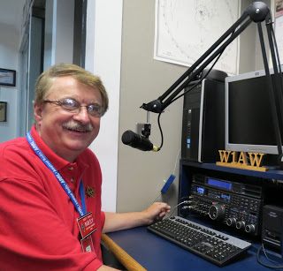
Hey Gang...

Wow, what a week this has been. I’ve shoveled, salted, shoveled, thrown sand and then slipped and fell a couple of times and then through more sand and salt on the drive. Although I slipped several times, I was able to recover with only my pride being hurt just a little. Yes, I’m not as agile as I used to be on the ice. Years ago, I loved to ice skate and spent hours doing it on a frozen pond in Ashland. In fact, that was the social gather of the time. I still remember when they’d light up the area with flood lights, have a burn barrel going and music being played over speakers placed around the pond. It was great, but that was a long time ago and today my body lets me know very quickly that it was a long time ago.

Oh well, nuff on that subject, let’s turn the band selector to 20-meters and see who’s around tonight! I want to thank the TUSCO Hamfest Committee and club for presenting such a great hamfest this past weekend. You folks did a really outstanding job. Did you miss it? Well then, you missed a really good hamfest for sure.

Do you have the 3 days in May (17-18-19) marked on your calendar yet? This year Dayton will also be ARRL’s National Convention and that will definitely mean that there will be some very special things happening at Hamvention that you won’t want to miss out on.

TOP ^
I don’t know all that is being planned above and beyond the normal stuff that is Dayton Hamvention, but I’ll bet that no matter what it is, it will be really spectacular for sure!

Whelp… That’s going to do it for this time around. Stay safe, stay warm, and most of all… have FUN!!

Scott, N8SY

Back Issues of the PostScript and Ohio Section Journal (OSJ)

Hey, did you know that PostScript and Ohio Section Journal (OSJ) are archived on the website? You can go back and look at any edition simply by clicking:
http://arrl-ohio.org/news/index.html

Chit – Chat, and All That!

Do you know someone that’s not getting these Newsletters? Please, forward a copy of this Newsletter over to them and have them “Opt-In” to start receiving them. Heck, just have them send me an email n8sy@n8sy.com and I’ll get them added to the Ohio Section Emailing list.

We now have many thousands of readers receiving these newsletters weekly. Quite impressive, I’d say! I urge all of you to make sure that everyone, regardless of whether they are a League member or not, get signed up to receive these weekly Newsletters.

You can always “Opt-Out” at any time if you feel this is not what you were expecting. It’s fun and very informative. All of your favorite past newsletters are now archived too.
You can go back at any time and read them. Just go to: http://arrl-ohio.org/news/

Got questions, concerns or would just like to sit and chat awhile? Heck, I’ll even buy the coffee!! Give me a call at (419) 512-4445 or email me at: n8sy@n8sy.com

The pictures on the front page are from various newsletters, Facebook posts and/or were sent directly to me in recent weeks. Take a good look at them, you just might be in one of the pictures! “SMILE… you’re on the Ohio Section News!!”

TOP ^

PostScript is produced as a weekly supplement to the Ohio Section Journal (OSJ). I sincerely hope that you have enjoyed this edition and will encourage your friends to join with you in receiving the latest news and information about the Ohio Section, and from around the world!

