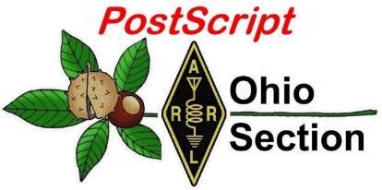
January 7th
Edition

National News The Handbook Give Away

Club Corner Hamfests

DX This Week One Question Questionnaire

VE Testing Schedule Final.. Final..

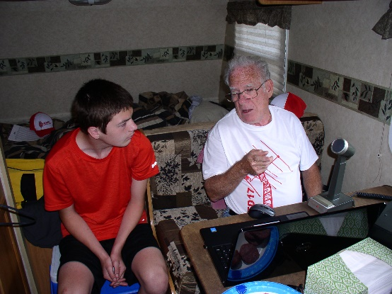
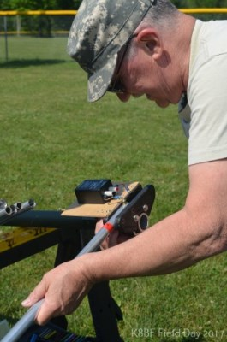
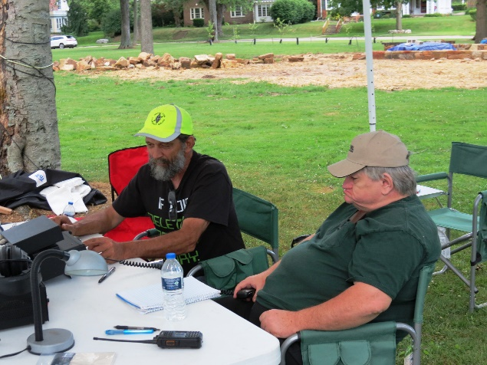
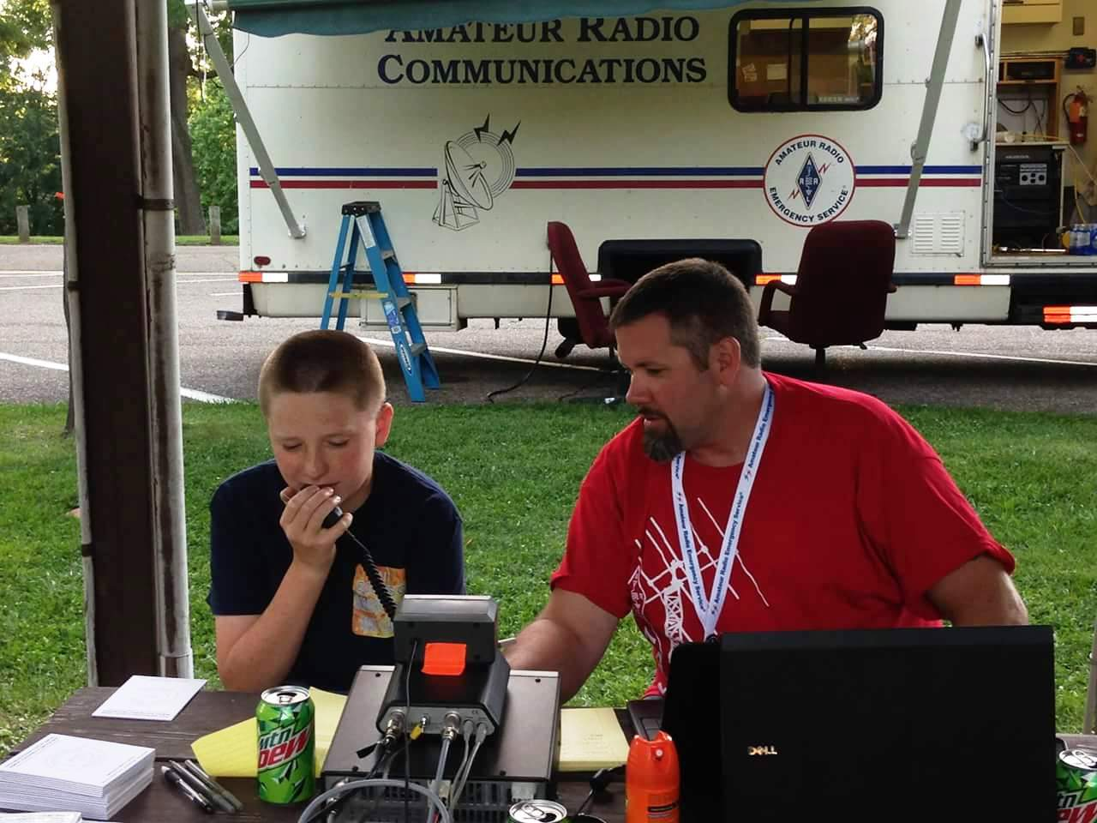
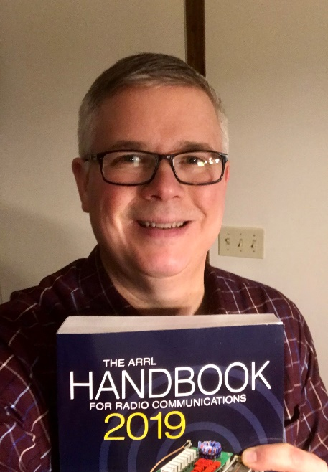
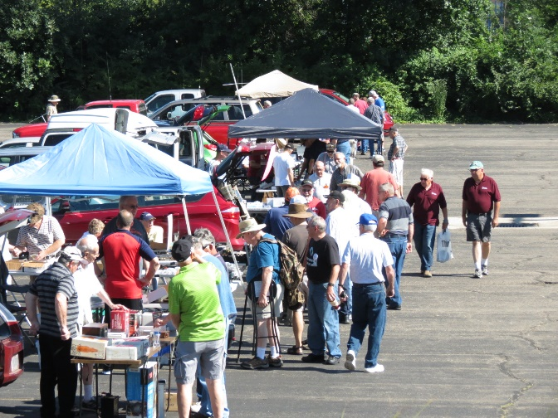
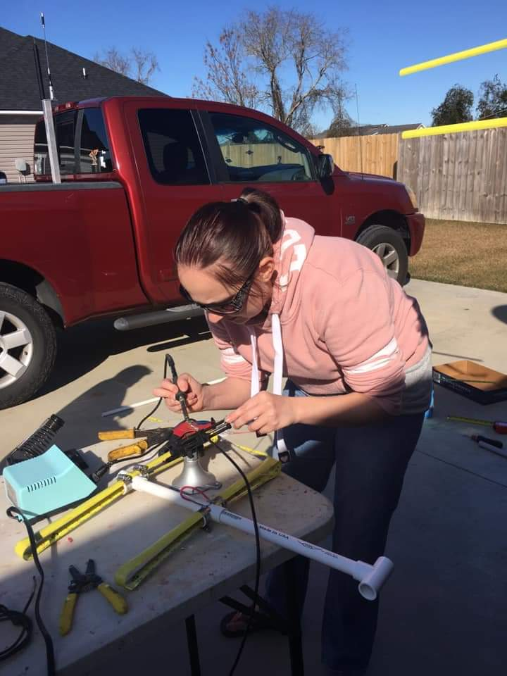

National News
(from arrl and other sources)

FCC Outlines Impact on its Operations of Potential Funding Lapse

The FCC said in a January 2 Public Notice that in the event of a continued partial lapse in federal government funding, it will suspend “most operations” at mid-day on Thursday, January 3. Some systems that have gone dark in prior government shutdowns will remain operational this time, however. That includes the FCC website, although it will not be updated except for matters related to spectrum auction activities and those necessary for the protection of life and property. until normal operations resume. The FCC Daily Digest will continue to appear.

The Electronic Comment Filing System (ECFS), the Universal Licensing System (ULS), the Electronic Document Management System (EDOCS), and the Commission Online Registration System (CORES) will remain available, but no support will be provided except that necessary for spectrum auction activity. Processing of Amateur Radio applications will come to a halt, however, said ARRL Assistant Volunteer Coordinator Manager Amanda Grimaldi, N1NHL.

Also down will be the Consumer Complaint Center and the Experimental Licensing System, among several others

Still available will be the Network Outage Reporting System (NORS), the Disaster Information Reporting System (DIRS), the Public Safety Support Center (PSSC), the Licensing Management System (LMS), the Consolidated Database System (CDBS), the Auctions Public Reporting System (PRS), the Auction Application System, and the Auction Bidding System.

“All other Commission electronic filing and database systems will be unavailable to the public until normal agency operations resume,” the FCC said.

#########

FCC Reaches $900,000 Settlement in Unauthorized Satellite Launch Case

The FCC has settled an investigation into an alleged unauthorized launch and operation of small satellites by Swarm Technologies. The company agreed to a Consent Decree that included a $900,000 penalty, an extended period of FCC oversight, and a requirement of pre-launch notices to the FCC, among other stipulations.

“We will aggressively enforce the FCC’s requirements that companies seek FCC authorization prior to deploying and operating communications satellites and earth stations,” FCC Enforcement Bureau Chief Rosemary Harold said. “These important obligations protect other operators against radio interference and collisions, making space a safer place to operate.”

TOP ^
In April 2017, Swarm applied for an Experimental license to deploy and operate two Earth stations and four tiny 0.25 U CubeSats called SpaceBEEs. The FCC denied Swarm’s application in December 2017 over concerns about the ability to track the satellites. Swarm nevertheless launched the satellites on January 12, 2018, on a vehicle that also carried an Amateur Radio satellite into space. After reports of the unauthorized SpaceBEEs launch surfaced, the FCC launched an investigation last March.

The FCC determined that Swarm had launched the four SpaceBEEs from India and had unlawfully transmitted signals between Earth stations in Georgia and the satellites for more than a week. In addition, the FCC discovered that Swarm had also performed unauthorized weather balloon-to-ground station tests and other unauthorized equipment tests prior to the launch. All these activities required FCC authorization.

The December resolution requires Swarm to pay a penalty $900,000 to the US Treasury and to submit pre-launch reports to the FCC for the next 3 years. The FCC said Swarm has committed to a strict compliance plan to prevent future FCC rule violations.

The FCC issued an Enforcement Advisory last April to remind satellite operators that they must obtain FCC authorization for space station and Earth station operations. The advisory cautioned satellite operators and launch companies against proceeding with launch arrangements following a license denial or prior to receiving an FCC authorization.

#########

Countdown to Third Annual AM Rally Has Begun

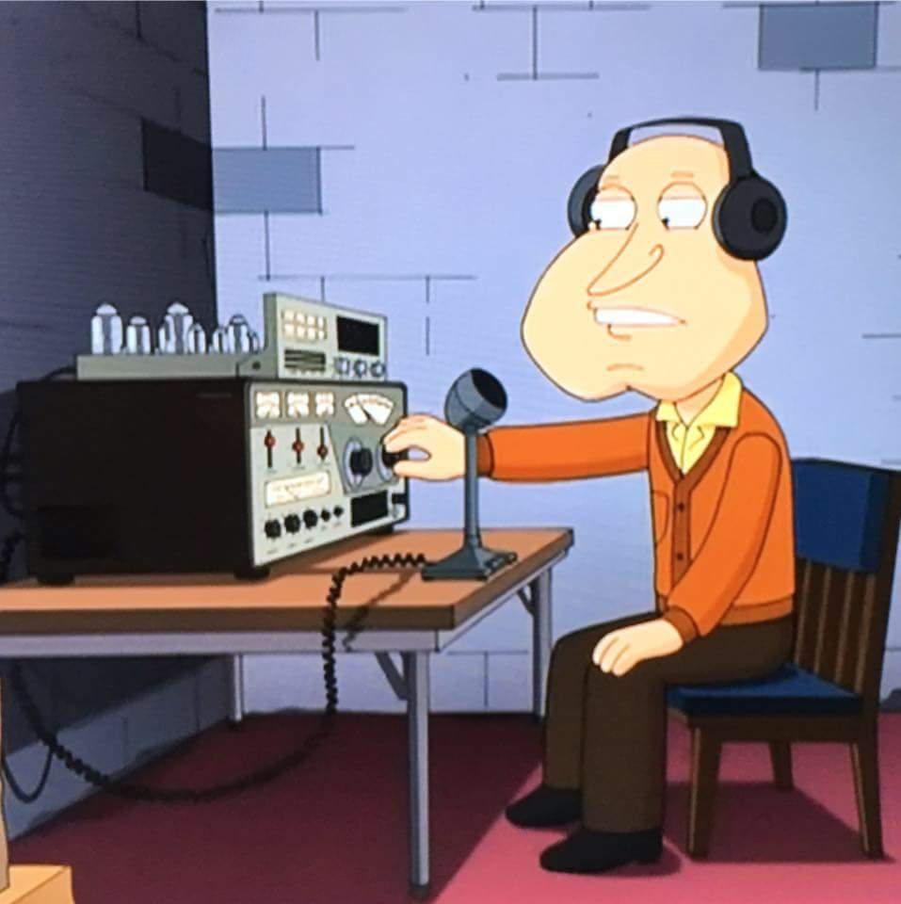
The third annual AM Rally is on the near horizon — is only about 4 weeks away — getting under way at 0000 UTC on February 2 and continuing until 0700 UTC on February 4. The event aims to encourage the use of AM on 160, 80, 40, 20, 15, 10, and 6 meters while highlighting the various types of AM equipment in use today. The event is open to any and all radio amateurs running AM using any type of radio equipment — modern, vintage, tube, solid-state, software-defined, military, boat anchor, broadcast, homebrew, or commercial.

“We’re very excited about the upcoming AM Rally in February, given its growth over the past 2 years and the positive comments we’ve received,” said Clark Burgard, N1BCG, who is spearheading the event with Steve Cloutier, WA1QIX, and Brian Kress, KB3WFV. “In particular, it’s great to hear how so many ops are giving this classic mode a try, many for the first time, and of the help offered to them by those who have mastered the technology.”

For many, if not most, radio amateurs getting on AM is as simple as pressing the AM mode button on the front panel. Numerous transceivers in use today offer AM capability. A lot of hams enjoy restoring and using vintage Amateur Radio equipment, which typically means a separate transmitter and receiver. Until SSB subsumed it on the ham bands, AM was the primary HF voice mode. The change to SSB did not happen without some pushback, however.

Today, a group of dedicated radio amateurs keeps the flame alive, getting on AM frequently, and for many of them, AM is their primary operating mode. The AM Rally gives the uninitiated a chance to dip a toe into the pool, so to speak.

TOP ^
The event website has complete AM Rally details, Contact information, award categories, logging, and tips on how to get the most out of your station equipment in AM mode. Contact Burgard for more information.

The event is sponsored by Radio Engineering Associates (REA), in cooperation with ARRL, which supports all modes of Amateur Radio operation. W1AW will play a leading role in the event, as it has for the past two years.

Certificates will be awarded to stations scoring the highest number of points in each of the five power classes, regardless of rig category, both for most contacts and most states/provinces.

“All it takes is a turn, push, or click to participate!” Burgard said. There’s also plenty of time to dig out and dust off that old AM-capable tube gear sitting in your attic or basement.

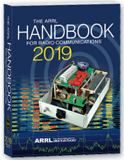
Special Handbook Giveaway New Year’s Day Drawing..

Hey Gang,

We had 2 drawings this month - one for Christmas, and the other one was for New Year’s Day. You already know the Christmas winner, so here’s the New Years Day winners for ya’.
Steve Anderson, KD8JLA

Again, the response was so huge, I decided to add to the pot and I gave away another Official Ohio Section Logo Sweat-Shirt as well. Here's who won that:

Thomas Sutton, N8TSU

Many of you ask me just how do I know when the drawing is on? Well, that’s easy all you need to do is check in on the Ohio Section Website on a regular basis and watch for the big RED Arrow that will appear on the left side of the page. This is the sign that the drawing is on and you need to get registered. So, keep a sharp eye out on the website and check in often! http://arrl-ohio.org/

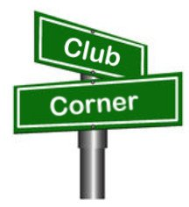
Club Corner

This is YOUR cornner of the newsletter. Send me what your club is doing and I’ll make sure that it gets in. Got a special event or club project that you want everyone to know about? Send it to me!. Need help with a project? Send it to me.

Let me know what you club is up to. Are you going to have a special guest at your meeting or are you having a special anniversary? Just sent it to:
n8sy@n8sy.com

#########

TOP ^
Marion ARC Helps Out the Popcorn Ball Drop

Now, if you didn’t know, our own Marion Ohio is home to Orville Redenbacher popcorn. Most of the popcorn you eat came from this area and it’s been a huge employer and supporter of events in Marion for many years.

In the summer they have a “Popcorn Festival” so it’s only fitting that at the end of the year they do a “Popcorn Ball” drop to ring in the New Year!

The Marion Amateur Radio Club has been an intrical part of this tradition for so many years I don’t think even they know just when they didn’t help out with this event.

Pictured are of them setting up our portable tower (yes, they have a tower on wheels!!) in downtown Marion for New Year’s Eve where they do the giant popcorn ball drop at midnight. Club members present are KD8KCH, KD8UUB, KE8DYB, W8EJB & KE8JTE.

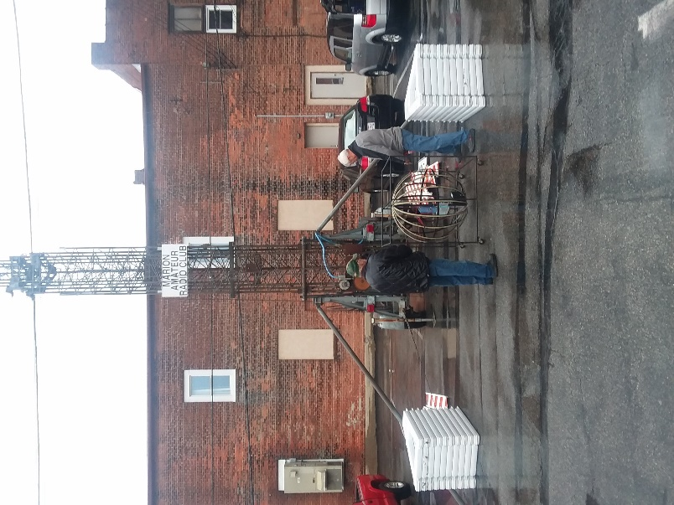
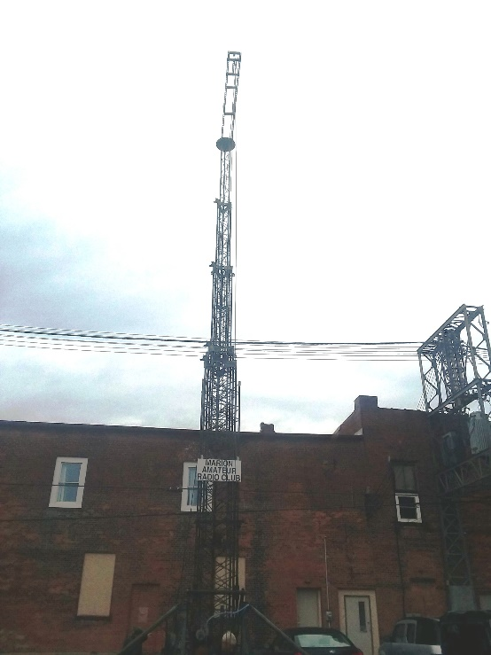
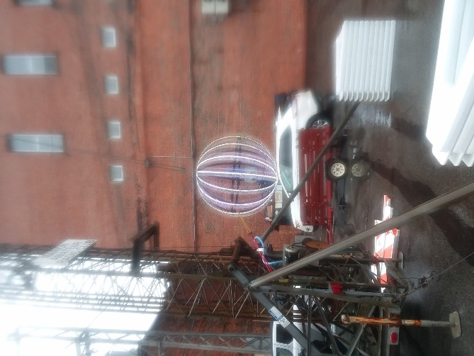

#########

General Class Licensing Course - Work HF!

The Cuyahoga Falls Amateur Radio Club is offering its 6-week course for the General amateur radio exam. Sixth week has free Laurel VEC exam. The exam is open to the public.

WHEN: Every Sunday stating 17 February 2019 to March 24, 2019 from 1:15 PM to 4:45 PM

WHERE: Main branch of the Akron-Summit County Public Library, 60 South High Street, Akron, Ohio, 44326 . Free parking in adjoining deck.

TOP ^
COST: $35 for manual and refreshments.

Please preregister by sending call sign and statement of intent to education@cfarc.org.

The course uses the General Class manual by Gordon West. This is our fourth offering. The course covers background material, question pool Q and A, and live demos.

Send questions and registration to Jim (N8PZL) at education@cfarc.org

Sponsored by the Cuyahoga Falls Amateur Radio Club: cfarc.org

#########

Get your Technician Class amateur radio license in one day!

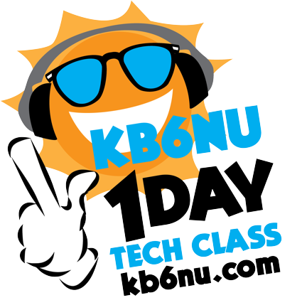
The next KB6NU One-Day Tech Class will take place on Saturday, January 12, 2019 at:
>> New Location <<
Lawrence Technological University (LTU)
21000 West Ten Mile Road Southfield,
Michigan Building: Management (Building 2 on LTU Map)
Room: M336

Lawrence Technical University MAP

The class will start at 9:00 am and run until 3:30 pm, at which time the license exam will be given.

There is a $20 fee for the class, except for high school and college students, who can attend free. In addition, there is a $15 fee that everyone must pay to take the test.

You can register for the class by sending $20 to cwgeek@kb6nu.com via PayPal, or you can send a check for $20 to:
Dan Romanchik
1325 Orkney Dr.
Ann Arbor, MI 48103

When your registration is received, you will be put on another e-mail list and sent more details a week or two before the class.

Free study guide

The study guide for this class is the No Nonsense Technician Class License Study Guide. You can download the PDF version for free from https://kb6nu.com/study-guides/. Before the class, read through the study guide a few times, then take some online practice tests. If you don't study before the class, I can guarantee that you'll have a hard time passing the test.

Need more info? Contact Dan Romanchik, KB6NU: 734-930-6564, cwgeek@kb6nu.com

#########

TOP ^
Mount Vernon ARC Technician Classes to begin in January

The MVARC will be hosting Study Sessions for the Technician Class Ham License starting in January, 2019. We will have an introductory meeting on Thursday, January 24th with our first study session on Thursday, January 31. Our sessions will run weekly every Thursday evening with our last session on March 14th. I am anticipating our Exam Session will be Saturday, March 16th, but will need to confirm that.

Our introductory meeting, all of our sessions, and our Exam will be held in the Education Resource Building of the American Red Cross, located at 300 N Mulberry Street, Mount Vernon, Ohio. Our introductory meeting and study sessions will start at 7:00pm and run no later than 9:30pm. The time for the Exam Session will be determined at a later date.

Questions regarding these sessions can be directed to G Michael Jacobs, KE8HGE, @ g.m.jacobs@gmail.com

#########

AMATEUR RADIO LICENSING COURSE

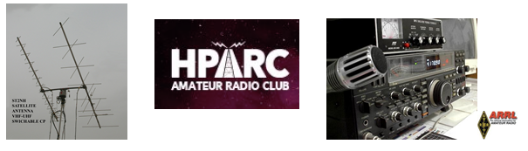
Become a Ham Radio Operator!!!

The Hazel Park Amateur Radio Club IS offering A 10-week Course for THE TECHNICIAN (entry) Amateur Radio license examination (NO MORSE CODE REQUIRED)

WHEN: Every Monday, from January 14, 2019 TO March 18, 2019—7PM- 9PM
WHERE: FOP Lodge 130, 2233 Burdette St., Ferndale, MI
COST: Instruction is FREE; license Manual is $25, available from the instructors at the first session. We are using the 2018-2022 Edition of the ARRL Technician Manual

FCC license exam will take place at the last session (March 18th) test fee: $15

***PRE-REGISTRATION IS NECESSARY***
Amateur Radio is alive and well! We are at the cutting edge of technology! Join over 2.5 million hobbyists around the world -and in Orbit- who are involved in emergency response, international friend-making, Radiosport Contests, Digital Signal Processing, Satellite design/building. A great playground for the “Makers”.

Questions and registration, Contact: Jerry: W9NPI@ARRL.NET Sponsored by the Hazel Park Amateur Radio Club HPARC.ORG

#########

CARS 2019 Winter Ham Radio classes - get your Technician, General or Extra class license!

Thursday evenings starting February 28, 2019 and ending April 11, 2019 at 6:30 pm April 11th will be a special VE Test session for all license classes, ARRL fee for this VE test is $15.00

To register please follow the link at: www.2cars.org and complete the on-line application or call 216-932-8005 Dave, KD8ACO.

TOP ^
Classes will be held at the Seven Hills City Hall, 7325 Summit View Dr Seven Hills, OH 44131 in room “C” at 6:30 pm every Thursday.

The entrance is at the East end on the South side of building class fees: Technician $25.00, all who pass get a free CARS membership for 2019, General and Extra $20.00 nonmembers or Extra is $15.00 CARS members, General class ONLY is FREE to CARS members All class materials are provided

#########

Southern Ohio Amateur Radio Association to hold a presentation at the Ironton branch of the Briggs Lawrence County Public Library
SOARA will be doing an Introduction to “HAM Radio - From Across the Street to Outer Space,” on January 19, at The Briggs Lawrence County Public Library, 321 South 4th Street, Ironton, Ohio, 2:00 pm to 3:00pm

SOARA members James Rowe N8TVO, Tim Nicely AC8VQ, Jerry Lockhart W8HIC, Eddie Jenkins N8URU, Mike Love WB8YKS and Ken Massie WN8F, Arthur J. Pierson N8LRO will be the presenters. Additionally, the awarding winning world-famous news personality and FCC licensed radio operator, Walter Cronkite, KB2AGD (now deceased) will join us as he narrators the exclusive American Radio Relay League’s (ARRL), “Amateur Radio Today” DVD.

#########

Carole Perry to Visit PCARS Meeting in March
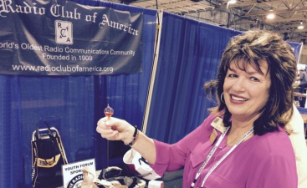
(from Radiogram Newsletter)

Although it’s a way off yet, I want to give you a “Heads Up” on the March 11th, 2019 PCARS meeting. It’s been listed tentatively on the web-site calendar, but I’m guessing not too many of you have checked it out that far in advance yet. It’s now confirmed and should be an outstanding presentation!

Carole Perry is the recipient of the prestigious 1987 Dayton Ham of The Year Award, the 1987 ARRL Instructor of The Year Award, the 1991 Marconi Wireless Memorial Award, the 1993 QCWA President's Award, the 1996 Radio Club of America (RCA) Barry Goldwater Amateur Radio Award, the 2009 RCA President's Award, the 2012 RCA President's Award, and the 2015 Vivian Carr Award for Women in Radio. She is the winner of the 2016 SOAR (Sisterhood of Amateur Radio) Legacy award for Pioneering Women in Amateur Radio, and the 2016 recipient of the YASME Foundation Award for Excellence.

Carole is an RCA Fellow, and in 2007 she was elected to the RCA Board of Directors; a position she still holds, and she created the Youth Activities Committee which she now chairs. She serves on the RCA Scholarship committee as well.

TOP ^
She also created the RCA Young Achiever's Award, given to students in grade 12 and below who have demonstrated excellence and creativity in wireless communications. One hundred and seven youngsters have received this award along with a stipend, so far. Carole is also presently a Director for QCWA (Quarter Century Wireless Association). The QCWA Youth Activities program was created and chaired by Carole.

Carole has moderated the Dayton Hamvention Youth Forum and Instructors' Forum for 31 years. She is a member/director of QCWA and RCA. She is also a member of ARRL, DARA, (Dayton Amateur Radio Association) AWA (Antique Wireless Association), and Brandeis Women.

Carole is a contributing columnist for CQ Magazine’s Youth Column.

Carole will be with us at PCARS! She will be discussing how to get youth involved in Amateur Radio. I cannot think of a more qualified person to talk with us on this topic. I know you’ll want to be there. This is again the type of meeting that we will want to promote not only to other clubs in NE Ohio (and beyond), but we might also want to invite anyone and everyone you might know in local education. Starting in January I’ll have a lot more information for you on this meeting, but I want to make sure it’s on your calendar as a “not to be missed” meeting for the coming year

One Question Questionnaire

Hey Gang

There’s another NEW – one question – questionnaire on the Ohio Section Website! http://arrlohio.org We had about 13% of you that stated that you actually have recognized a call sign on the “You have Cards Waiting” lists. That’s fantastic! I bet the card sorters that we could find some of these folks without working up a sweat and they said that wouldn’t happen. Guess we showed them… !!

Anyway, it’s all in fun and I hope that you are enjoying answering these “ONE QUESTION” questionnaires.

Ok, enough on that, here’s the next question for you to answer…

“Do you listen to any of the audio podcasts??”

You’ll find the “One Question” questionnaire on the Ohio Section Website! http://arrlohio.org It’s all in fun and it’s not a scientific survey in any way, but we are learning some things that we didn’t know from these questions. I hope that you are enjoying answering these “One Question” questionnaires.

ARES Connect

CQ… CQ…. CQ… Calling all persons to be a part of the new ARES Connect program.

We need to discuss some very important items that only YOU can make a difference with. I need you to get yourselves registered in ARES Connect, that is… if you haven’t already.

TOP ^
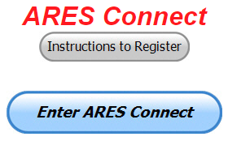
Now, how do I know that you need to do this? It’s simple, we have a little over 800 now registered in the database with about 450 persons actually signing up for events. Stan’s last S.E.C. report shows that we have a little over 1,500 persons in ARES.

That means that there is still a lot of you that haven’t taken the plunge yet and need to! What are you waiting for? No matter how much you resist, it’s coming, and we need to make sure that no one is left behind.

Now, as an incentive to get you to not only register…. But to actually start using the system… (Notice how I have that in bold type for you to clearly see?) I am giving away all sorts of goodies to help you get motivated.

I have a footlocker of really cool items that I will be giving away and if you notice below, Ron Hollas, K8RJH had over 230 hours recorded for the 2018 year. This makes him the winner of an Official Ohio Section Logo Sweatshirt!

Yes folks, remember the handbook I gave away a few months ago to kick this project off? I’m do this a various intervals throughout the year so it will challenge you to be dedicated like Ron and get your hours into the system. You’ll never know just when another drawing will be, so you really do have to be prudent!!

Here’s a look back on how we ended 2018.

 | Name | Events | Hours
1 | Ron Hollas (K8RJH) | 25 | 232.25
2 | James Yoder (w8erw) | 59 | 186.50
3 | James Hershberger (KE8ERN) | 92 | 177.75

Here’s how it looks for the first week of 2019:

 | Name | Events | Hours
1 | Dan Stahl (KC8PBU) | 13 | 8.75
2 | Larry Caskey (K8LPC) | 2 | 5.00
3 | Jeffrey Potteiger (WB8REI) | 5 | 4.00
4 | James Hershberger (KE8ERN) | 3 | 3.50
5 | Michael Farkas (n8gbu) | 8 | 3.00
6 | Donald Russell (W8PEN) | 2 | 3.00
7 | Steven Denniss (KC8IDM) | 5 | 2.50
8 | Mark Griggs (KB8YMN) | 2 | 2.50
9 | Michael Klaiss (KC8BUJ) | 3 | 2.50
10 | Colleen Roth (N8TNV) | 6 | 2.50

Don’t know where to get started? We have a set of instructions on how to get registered right above the button to enter ARES Connect. I would strongly suggest that if you haven’t registered yet, that you read these instructions first. Here’s a link to get you started... http://arrl-ohio.org/ares_connect_directions.pdf

TOP ^
Please, don’t just hurry through the questions, read them carefully, if you don’t understand something, please ask me, I’m here to answer your questions.

We know that you mean well by answering that you do have the needed courses in, but I will let you know that we are verifying what you say you have with what is showing for you in our statewide database when we are completing your registration. So, how can you find out if you are already listed in our statewide database? Easy, here’s a link: http://arrl-ohio.org/SEC/special/ICS%20Complete%20by%20County%20and%20Name.pdf

HEY..!!!! We need persons that can input events and approve hours into the new ARES Connect system. You do not have to be an E.C. for this, although we’d prefer that they would be willing to step up to that challenge someday. If we could just have some folks willing to do the inputting of events and approve hours for now I’d be eternally grateful.
Counties where this is only a RACES program in place. Please.. this is a great opportunity for you as that we will not interfere with any of the programs that you already have in place. In fact, it will help you in getting those valuable volunteer hours recorded as they have never been before!!!

How’s about it? Could you spend a little time just working with ARES Connect? Let me know!!! Again, you do not have to be E.C.’s to do this work in ARES Connect.

We can give you admin privileges so that you can help with logging events into the system, keeping track of hours or even making sure that certificates get to Jim or I for placement into the statewide database.

Here are the counties that we really need help with. Fulton; Henry; Mercer; Paulding; Putnam; Adams; Brown; Clermont; Carroll; Athens; Jackson; Meigs; Perry; Pike; Belmont; Harrison; Monroe & Morgan. This is a great opportunity for anyone that has a little time and is willing to volunteer.

Incident Command System (ICS) Training Schedule

All current trainings are listed on the Ohio EMA training calendar located at:
https://webeoctraining.dps.ohio.gov/TrainingAndExercise/courselist.aspx

I’ve been asked to also include a link to the Kentucky EMA training calendar as well..

https://kyem.ky.gov/training/Pages/default.aspx
https://sites.google.com/site/ccoemtraining/home

Please pay particular attention to these courses listed above, as that there’s a lot of ICS 300 & 400 classes listed that are very useful for all Amateurs to have under their belts. I will also state that G775 is also a very good course to take as well. These 3 courses are multiple day in class courses, so please be prepared to spend some time taking them.

I would like to remind any of you that are going to take any of the in-class training sessions that you dress appropriately.

TOP ^
Please don’t go into these classes with attire that doesn’t represent you, and Amateur Radio in the best of light.
Remember, you will be in class with fire / police chiefs, mayors, township trustees and a whole host of other government and civil officials that will remember how you represented Amateur Radio while you were in these classes together.

We do recognize that IS-300/400 requires multiple days of actual classroom training that is not easily obtained. So, if you just can't find the time to fit these class room courses in, we do have an alternative method for getting you to Level 3. Completing the following “FREE” and “ONLINE” courses will act as substitute for you FEMA Leadership Development Course requirements. You absolutely will need to complete all 7 of these courses to get your ICS 300/400 credit. Here are the courses that you need to take: IS-120, 230, 240, 241, 242, 244 & 288.

#########

Auxiliary Communications (AUXCOMM) Training

This course focuses on auxiliary communications interoperability, the relationship between the COML and the volunteer, emergency operations center (EOC) etiquette, on-the-air etiquette, Federal Communications Commission (FCC) rules and regulations, auxiliary communications training and planning, and emergency communications deployment. It is intended to supplement and standardize an operator’s experience and knowledge of emergency amateur radio communications in a public safety context.

Course Dates: February 16 – 17, 2019 (One-hour lunch)
Application deadline: February 2, 2019
Course Registration Time: 7:30 AM to 8:00 AM (Day 1)
Time of Course: 8:00 AM to 7:00 PM (Both Days)
Training Location: Franklin County Emergency Management & Homeland Security
5300 Strawberry Farms Blvd.
Columbus, OH 43230

Required Prerequisites:
Required Prerequisites: (IS-100, 200, 700 & 800)
Applicants MUST have completed the following on-line courses from the FEMA/EMI Independent Study (IS) website: https://training.fema.gov/is/crslist.aspx?all=true
1. IS-100, Introduction to the ICS;
2. IS-200, ICS for Single Resources and Initial Incidents;
3. IS-700, National Incident Management System (NIMS), an Introduction;
4. IS-800, National Response Framework (NRF).

Other Required Documentation:
The target audience for this course includes individual that MUST have Personal experience in auxiliary communications and MUST have the following four items and provide documentation to Pam Tickle.
1. An active FCC Amateur Radio License (provide a copy of the license)
2. Documentation of past experience in auxiliary emergency communications (provide documentation via email or letter of your experience)
3. An affiliation with a Public Safety Agency (provide a letter or an email from leadership of the Public Safety Agency that you are associated with indicating your affiliation)
4. A desire to work with COMLs in a NIMS/ICS environment (provide a statement letter or email indicating your interest)

TOP ^
Send the following eight items as a COMPLETE packet to Pam Tickle @ pktickle@franklincountyohio.gov

If you are unable to attend the course, please click on the link below, withdraw yourself by logging in, click on the “Course Catalog”, and double click on the course to display the "Course Details" and click "Unenroll" to withdraw from the course. https://trainingcampus.dps.ohio.gov/cm/cm710/pstc/pstc.html

Course Target Audience:
The target audience for this course includes individual that MUST have Personal experience in auxiliary communications and MUST have the following four item and provide documentation to Pam Tickle.

1. An active FCC Amateur Radio License
2. Past experience in auxiliary emergency communications
3. An affiliation with a public safety agency
4. A desire to work with COMLs in a NIMS/ICS environment

Lodging Information:
Lodging, Meals, Per Diem and all other travel expenses are the responsibility of the student or the parent organization.

Enrollment:
Students must enroll via the Public Safety Training Campus located at the following link. https://trainingcampus.dps.ohio.gov/cm/cm710/pstc/pstc.html and those that have trouble registering should contact Ohio EMA Training at (614)799-3824/3677 for assistance with registration. Please refer to the FY 2018/2019 Ohio EMA Training Catalog or website at http://ema.ohio.gov/Training.aspx for additional information. State Point of Contact: Lisa Jones, DSC 2, Ohio EMA, SAA Training Point of Contact, ljones@dps.ohio.gov, Office: (614) 799-3824

#########

MGT-347 Incident Command System (ICS) Forms Review

This class is Provided by Texas A&M Engineering Extension Service (TEEX). Hosted by Franklin County EM & HS February 5, 2019. The class is the morning of February 5th and we are still in need of 18 people to register and attend the class, so it does not get canceled. If it has been awhile since you have taken this review, please consider attending this half-day class. Registration is through the Ohio Public Safety Training Campus
https://trainingcampus.dps.ohio.gov/cm/cm710/home.html

Course Description:
The MGT-347 ICS Forms Review course is a 4-hour workshop that provides emergency response supervisors and mid- to upper-level managers with a detailed introduction to the Incident Command System (ICS) forms used in the development of an Incident Action Plan (IAP) and/or Coordination Action Plan (CAP). Participants will examine the primary forms used in an IAP/CAP, as well as supporting and other utility forms.

TOP ^
In addition, participants will review the planning process and where, within that process, the forms are filled out and by whom. The workshop includes a practical application designed to instruct participants in the development of Specific, Measurable, Action-oriented, Realistic, and Time-based (SMART) control and management objectives.

Course Dates: February 5, 2019

Application deadline: January 29, 2019

Course Registration Time: 7:30 to 8:00 AM

Time of Course: 8:00 AM – 12:00 PM

Training Location: Franklin County Emergency

Management & Homeland Security
5300 Strawberry Farms Blvd.
Columbus, OH 43230

Required Prerequisites:
After registering for the course online, students must provide copies of the following certificates of completion to Pam Tickle at pktickle@franklincountyohio.gov to attend this course.
1. IS-100.b FEMA Introduction to the Incident Command System, ICS-100
2. IS-200.b FEMA Incident Command System for Single Resources & Initial Action Incidents, ICS-200
3. IS-700.a Introduction to the National Incident Management System (NIMS)
4. IS-800.C,National Response Framework, an Introduction

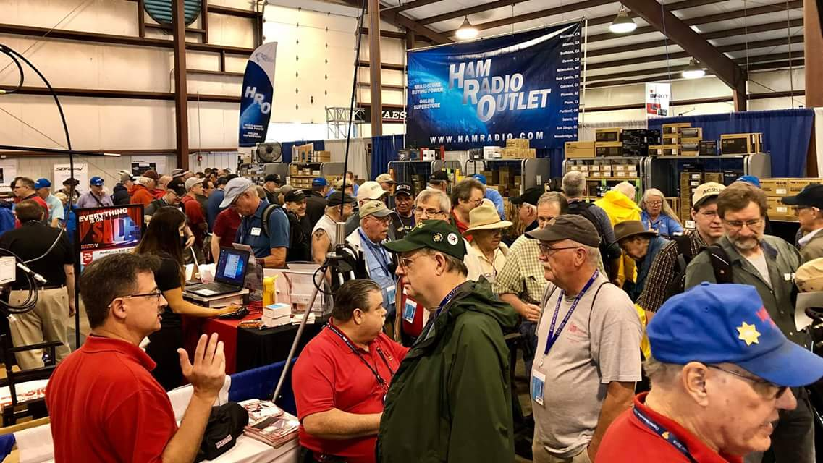
Upcoming Hamfests

01/20/2019 | S.C.A.R.F. Hamfest
Location: Nelsonville , OH
Sponsor: Sunday Creek Amateur Radio Federation
Website: http://www.qrz.com/db/kc8aav

01/27/2019 | TUSCO ARC Hamfest, Electronics & Computer Show  Location: Strasburg, OH  Sponsor: Tusco Amateur Radio Club  Website: http://tuscoarc.org | 02/17/2019 | InterCity ARC Hamfest  Location: Mansfield, OH  Sponsor: InterCity Amateur Radio Club  Website: http://www.w8we.org
03/03/2019 | WINTER HAMFEST  Location: Elyria, OH  Sponsor: Northern Ohio Amateur Radio Society  Website: http://www.noars.net/hamfests/noarsfest | 03/16/2019 | Gallipolis Ohio Hamfest  Location: Gallipolis, OH  Sponsor: Mid-Ohio Valley Amateur Radio Club

TOP ^

V.E. Test Sessions
(from arrl)

01/08/2019 | Lancaster OH 43130-3014  Sponsor: Lancaster & Fairfield Cnty ARC  Location: American Red Cross  Time: 7:00 PM (Walk-ins allowed)  Learn More | 01/10/2019 | Cuyahoga Falls OH 44221-3205  Sponsor: Cuyahoga Falls ARC  Location: Cuyahoga Falls Library  Time: 6:30 PM (Walk-ins allowed)  Learn More
01/10/2019 | Milford OH 45150-1427  Sponsor: Milford ARC  Location: Faith Church  Time: 6:00 PM (Walk-ins allowed)  Learn More | 01/12/2019 | Delaware OH 43015-8533  Sponsor: Delaware ARA  Location: American Red Cross  Time: 10:00 AM (No Walk-ins / Call ahead)  Learn More
01/12/2019 | Maumee OH 43537-1628  Sponsor: Toledo Mobile Radio Assoc  Location: Maumee Fire Station #2  Time: 8:15 AM (No Walk-ins / Call ahead)  Learn More | 01/12/2019 | Lisbon OH 44432-1233  Sponsor: Lisbon Area Amt Radio Assoc  Location: Columbiana County Emergency Management  Time: 1:30 PM (Walk-ins allowed)  Learn More
01/12/2019 | Findlay OH 45840  Sponsor: Findlay Radio Club  Location: Findlay Radio Clubhouse  Time: 9:00 AM (Walk-ins allowed)  Learn More | 01/13/2019 | Independence OH 44131-4841  Sponsor: Cuyahoga ARS  Location: Old Elmwood Recreation Center  Time: 9:00 AM (Walk-ins allowed)  Learn More
01/15/2019 | Sandusky OH 44870-1926  Sponsor: Sandusky, Ohio VE Team  Location: Sandusky Radio Club  Time: 7:00 PM (Walk-ins allowed)  Learn More | 01/16/2019 | Dayton OH 45424-3304  Sponsor: Dayton Amt Radio Assoc  Location: Dayton Amt Radio Assoc  Time: 7:00 PM (No Walk-ins / Call ahead)  Learn More
01/19/2019 | Mansfield OH 44907-1502  Sponsor: Inter-City ARC  Location: Peoples Community Center  Time: 1:00 PM (Walk-ins allowed)  Learn More | 01/20/2019 | Elyria OH 44035-1343  Sponsor: American Red Cross  Location: American Red Cross  Time: 12:50 PM (Walk-ins allowed)  Learn More
01/20/2019 | Nelsonville OH 45764-9681  Sponsor: SCARF  Location: Tri-County Career Center  Time: 10:00 AM (Walk-ins allowed)  Learn More | 01/23/2019 | Middletown OH 45042  Sponsor: Dial Radio Club  Location: Miami University-Middletown  Time: 6:00 PM (Walk-ins allowed)  Learn More

TOP ^

Special Events

- 02/16/2019 | MVARA 100th Anniversary
Feb 16-Feb 18, 2300Z-2300Z, W8QLY, Youngstown, OH. Mahoning Valley Amateur Radio Association. 14.220 7.220 3.922.

Certificate & QSL. MVARA, 125 W McKinley Way, P.O. Box 14141, Youngstown, OH 44512. https://goo.gl/forms/2uNZfO6zRx1YPoWw2 to request your certificate/qsl. www.qrz.com/db/w8qly or www.mvara.org

- 06/15/2019 | W8DXCC DX Convention
Jun 15-Jun 16, 0000Z-2359Z, K8S, Owensville, OH. SouthWest OH DX Association. 14.245 14.074 7.245 3.535. Certificate & QSL. AJ8B - Bill, 8275 Cierra Way, Waynesville, OH 45068. This is the inaugural year for this DX Convention. We are using these call signs: K8S, K8W, K8O, K8H. A QSL for each and/or certificate for working all four. www.w8dxcc.com

ARRL Contest Corner

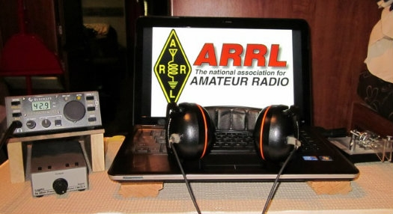

January 7  - IQRP Quarterly Marathon | January 8  - ARS Spartan Sprint

An expanded, downloadable version of QST's Contest Corral is available as a PDF. Check the sponsor's Web site for information on operating time restrictions and other instructions.

Ohio ARES VHF Simplex Contest
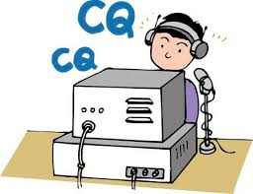
January 12 – 10AM through 4PM EDT.

The purpose of our annual simplex activity is to improve our station and antenna capabilities, and to test our coverage areas on simplex frequencies. These may be very important in times of emergency, when repeaters have failed, and simplex is the only method of emergency communication. We are NOT giving any consideration for backup power- this exercise is aimed at testing antennas and determining coverage areas.

TOP ^
Bands - All bands from 50 MHz up
We recommend the following frequencies:
50 MHz – Standard simplex calling frequencies.
Your QSO Points X 10 for six meters!!
146.49 (alternate 146. 46) for VHF UHF and above - Standard simplex calling frequencies

Modes - ALL MODES are acceptable - it’s your choice Digital- using any mode generally accepted by NBEMS/ARES in fldigi. (Default = Mt63 2K)

I just got an offer I couldn’t refuse, and I want to get it out to you right away!

Jason and John of the WW8TF/Rover crew have set up an “Operator’s Page” so that you can post that you’ll be operating, and you can check to see others who plan to participate! Their rover sched is published there to start things out.

Urge your members to take a minute and send an email to: contest@ww8tf.club and let them know where you’ll be operating!!

Check the page frequently here: http://ww8tf.club/ares-contest/

This is so cool!!

Entry Categories
- FIXED: Any fixed station can operate. Single or Multiple Operators, no restrictions.
- FIXED EOC: Any station using equipment and antennas permanently installed at an EOC. An EOC is recognized under the same provisions as a Field Day category “F”.
- PORTABLE: Any station established under portable conditions in a temporary location.
- ROVER: Any mobile operator may join as a “Rover”. A rover vehicle may transport only one station using a single call sign. It may be in motion or stopped. Rover vehicles must transport all the equipment, power supplies, and antennas used at each operating site. Rovers MUST sign "rover" on Phone and /R on CW and digital modes after their call sign.

Exchange
The exchange will include your station callsign and your county. In the case of stations outside Ohio, please include your state. If you are operating from an EOC, please include that in your exchange. ( +5 for them)

If you are an ARES official (AEC and above) Identify yourself as such. ( +5 for them)
You are encouraged to announce your station details if you wish, so that other stations can judge the performance of their equipment. This is NOT a part of the required exchange.

Scoring
No duplicate contacts per band / per mode. Rover/mobiles can be contacted one time in each county.

QSO Points
Each contact is worth 1 point.
Each contact with an EOC station is an additional 5 points per QSO. That would score as 6 points.
Each contact with an AEC or above is +5 points. That would score as 6 points.
Each 6-meter contact = 10 points!

TOP ^
Multipliers
Multiply your QSO points (calculated above) by the total number of counties you’ve reached.
Make sure you include your own county.
Rover/mobile station DOUBLE the number of counties you’ve contacted.
Rover/mobile add 25 to your final score.
EOC stations add 50 to your final score.

Portable stations add 100 points to your final score.

All entrants, regardless of category, are permitted to use spotting assistance or nets including but not limited to DX-alerting nets, internet chat rooms, APRS and other packet, reverse beacon networks and repeaters to identify stations available for contacts and to announce (self-spot) their availability for contacts.

Announcements shall be limited to call sign, location, band or frequency. These methods of spotting assistance may also be used to coordinate antenna peaking prior to initiation of the contact and to explain contest rules, such as the exchange required, for those who need clarification.

Scores should be emailed to contest@k8es.org before February 15.

Ohio ARES Simplex VHF contest, January 12, 2018.
My station call: _______________ Number of hours operated __________
QSO Points (Include all bands, all +5 points) __________
Multiply QSO points above by total counties worked __________
EOC Operation: Add 50 points __________
Portable Operation: Add 100 points __________

TOTAL SCORE QSO pts X Counties = (+50 +100) __________

Submitted by: ____________________________________

More Simplex Contest

The Wayne Technical Fanatics are excited to participate again in the Ohio ARES VHF Simplex Contest on January 12th!

The Fanatics will be operating a rover station again as WW8TF/Rover for the full duration of the contest 10am to 4pm EST. We will definitely be operating out of the following counties: Cuyahoga, Medina, Portage, Stark, Summit, Wayne.

As time permits, we will be operating out of Mahoning and Columbiana counties as well. Look for us on: 6m - 52.525 MHz or 52.540 MHz, 2m - 146.49 MHz or 146.46 MHz, 70cm - 446.000 Mhz (up to 446.100 MHz depending). Follow our live progress using APRS by tracking WW8TF-9 at:
https://aprs.fi (http://aprs.fi/#!call=a%2FWW8TF-9).

See our full plans at http://ww8tf.club/ares-contest/ww8tf-rover-plans/ and also a list of everyone we know who will be participating at http://ww8tf.club/ares-contest/.

Send your operating plans to contest@ww8tf.club and we'll add you to the list!

TOP ^

2019 Ohio NVIS Day

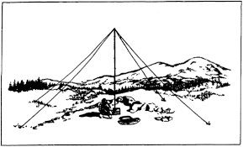
Hey everyone, Stan, N8BHL has let me know that the date for NVIS Day is scheduled for Saturday, April 27th. Are you ready? Start your planning now!
Like years past, we are planning on having the operation run from 10 – 4 EDT. Take a lunch break, enjoy each other’s company. Transmit power should stay at 100 watts for accurate signal comparison. You may operate anywhere, home, club, portable.
Want to know more about what NVIS is? http://arrl-ohio.org/SEC/nvis.html

Learn all about Near Vertical Incident Scattering and how you can easily put up a NVIS antenna and participate in this great exercise.

W1AW 2019 Winter Operating Schedule

Morning Schedule:

Time Mode Days
------------------- ---- ---------
1400 UTC (9 AM EST) CWs Wed, Fri
1400 UTC (9 AM EST) CWf Tue, Thu

Daily Visitor Operating Hours:

1500 UTC to 1700 UTC - (10 AM to 12 PM EST)
1800 UTC to 2045 UTC - (1 PM to 3:45 PM EST)

(Station closed 1700 to 1800 UTC (12 PM to 1 PM EST))

Afternoon/Evening Schedule:

2100 UTC (4 PM EST) CWf Mon, Wed, Fri
2100 " " CWs Tue, Thu
2200 " (5 PM EST) CWb Daily
2300 " (6 PM EST) DIGITAL Daily
0000 " (7 PM EST) CWs Mon, Wed, Fri
0000 " " CWf Tue, Thu
0100 " (8 PM EST) CWb Daily
0200 " (9 PM EST) DIGITAL Daily
0245 " (9:45 PM EST) VOICE Daily

TOP ^
0300 " (10 PM EST) CWf Mon, Wed, Fri
0300 " " CWs Tue, Thu
0400 " (11 PM EST) CWb Daily

Frequencies (MHz)
-----------------
CW: 1.8025 3.5815 7.0475 14.0475 18.0975 21.0675 28.0675 50.350 147.555
DIGITAL: - 3.5975 7.095 14.095 18.1025 21.095 28.095 50.350 147.555
VOICE: 1.855 3.990 7.290 14.290 18.160 21.390 28.590 50.350 147.555

Notes:

CWs = Morse Code practice (slow) = 5, 7.5, 10, 13 and 15 WPM CWf = Morse Code practice (fast) = 35, 30, 25, 20, 15, 13 and 10 WPM CWb = Morse Code Bulletins = 18 WPM

CW frequencies include code practices, Qualifying Runs and CW bulletins.

DIGITAL = BAUDOT (45.45 baud), BPSK31 and MFSK16 in a revolving schedule.

Code practice texts are from QST, and the source of each practice is given at the beginning of each practice and at the beginning of alternate speeds.

On Tuesdays and Fridays at 2330 UTC (6:30 PM EST), Keplerian Elements for active amateur satellites are sent on the regular digital frequencies.

A DX bulletin replaces or is added to the regular bulletins between
0100 UTC (8 PM EST) Thursdays and 0100 UTC (8 PM EST) Fridays.

Audio from W1AW's CW code practices, CW/digital bulletins and phone bulletin is available using EchoLink via the W1AW Conference Server named "W1AWBDCT." The monthly W1AW Qualifying Runs are presented here as well. The audio is sent in real-time and runs concurrently with W1AW's regular transmission schedule.

All users who connect to the conference server are muted. Please note that any questions or comments about this server should not be sent via the "Text" window in EchoLink. Please direct any questions or comments to w1aw@arrl.org .

In a communications emergency, monitor W1AW for special bulletins as
follows: Voice on the hour, Digital at 15 minutes past the hour, and CW on the half hour.

All licensed amateurs may operate the station from 1500 UTC to 1700 UTC (10 AM to 12 PM EST), and then from 1800 UTC to 2045 UTC (1 PM to 3:45 PM EST) Monday through Friday. Be sure to bring your current FCC amateur radio license or a photocopy.

The W1AW Operating Schedule may also be found on page 91 in the December 2018 issue of QST or on the web at, http://www.arrl.org/w1aw-operating-schedule .

TOP ^

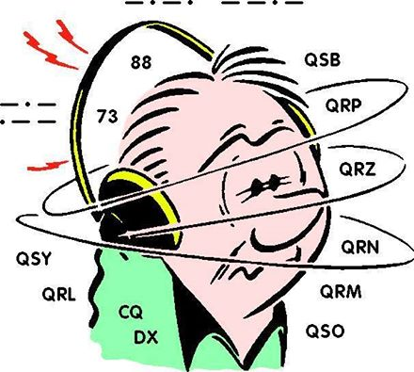
DX This Week
(from Bill, AJ8B)

Bill AJ8B (aj8b@arrl.net, @AJ8B, www.aj8b.com or www.swodxa.org )

I hope you had some restful time off and that you worked a couple of ATNOs (All Time New Ones) for Christmas! If you are following this section of our excellent Oh Section Newsletter, you know that my mentor (and main competitor) is my Uncle Frank. I finally was able to achieve something that I don’t think Frank has ever achieved!

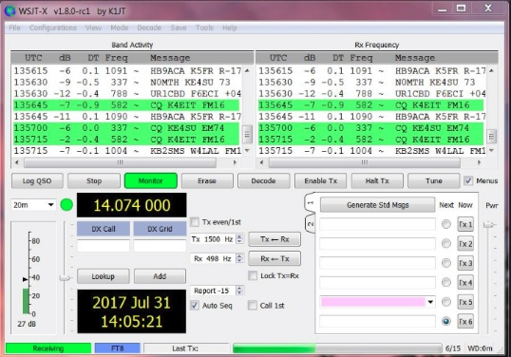
As luck would have it, I worked VP6D the last few times on SSB and shut the rig down. The next time I was on the air was to check out FT8 and I made a couple of QSOs. A day later, I received an email from an OO indicating that my signal was far too wide. Turns out, I still had my SSB settings in place! The email that was went to me turned in to a discussion. Mike, W9MDB, kindly sent me the information below along with his permission to reprint. Enjoy!

FT8—Avoiding Harmonics & Audio Settings
Update 12/6/2018 by Mike, W9MDB & Eric WA1SXK
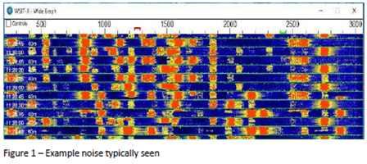
The FT8 sound card mode is an MFSK mode with redundancy and error checking. If you have been hearing about this new mode or have been using it, this article can aid you to set up and operate the FT8 data mode with good clean signals. FT8 allows you to view and decode dozens of signals at once with the waterfall display. This means your audio setup and bandpass settings will be of utmost importance while operating the FT8 sound card mode.

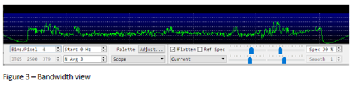
FT8 is a very popular sound card mode thanks to the WSJT-X team's efforts. See http://physics.princeton.edu/pulsar/K1JT/wsjtx.html for the software and check out the references for lots of details. A sound card mode is what you might call a poor-person’s SDR (since the software is free you can be poor to enjoy it). All the FT8 relevant modulation/demodulation/bit-correction/error- checking is taking place in the WSJT-X software.

TOP ^
During this process your FT8 messages (exchanges) are being encoded with additional information that allows for error detection and bit corruption correction which the receiving side can use to process and validate the received message. The WSJT-X software sound card modes can be used with any rig, new or old. FT8 can demodulate dozens of signals (50hz wide each) in up to 5000Hz of bandpass including overlapping signals. As you can see, many hams can operate at the same time in the same bandwidth. This approach allows new operating paradigms like FT8 Fox & Hound mode that DXCC teams are now using where they can process multiple QSOs simultaneously (see http://physics.princeton.edu/pulsar/k1jt/FT8_DXpedition_Mode.pdf ).
One of the areas that seems to be misunderstood while operating FT8 is the how the radio’s bandpass settings affect the operations of this mode. Many of the hams who operate some of the other modes like SSB and CW, use the default bandpass settings in their rig which are frequently too narrow for FT8. Note that most rigs can set the overall bandpass and not separate the Rx/Tx bandpass. Your rig’s bandpass is hopefully at least 200Hz-2400Hz and preferably 200Hz-3000Hz since there are quite a few operators who transmit above 2500 (see Figure 1 with 200Hz-3000Hz). You can view your bandpass in the WSJT-X waterfall by turning off “Flatten”, below that change the pulldown to “Current” and set “N Avg” to 3 or less and “Start 0 Hz” so we can see the changes more easily. What you should see is something like Figure 3, where you have a noise level signal rolling-off at lower and upper ends of the bandpass.

You should adjust the Bins/Pixel and window width, so you can see your entire FT8 signal bandwidth. Then
you need to learn your bandwidth controls in your rig, so you can maximize both the low end and high-end cutoff points. Once you have your bandwidth set in your rig as wide as you can make it you can change the “Start 0 Hz” to “Start 200 Hz”. Then adjust the right side of graph until it is inside your upper bandwidth limit. Then turn on “Flatten”. Note that Flatten does not like having the edges of your bandpass in the waterfall and will not behave as well if you adjust this incorrectly. The signal bandpass area between the lower and upper limits of the waterfall window is where the FT8 signals will be displayed and decoded in the software. The frequency limits of the waterfall determine what gets decoded.

Remember your goal for FT8 is to adjust your rig for as much TX/RX bandwidth as possible…you can run it up to 5kHz for WSJT-X (as much as WSJT-X can do right now). Most rigs should do at least 200-2400Hz. Many rigs have bandwidth settings called NAR/MID/WID filters and the WID settings should always be used and it can usually be adjusted for the largest bandwidth. If you can’t find your rig’s bandwidth settings after consulting with your manual feel free to contact one of the authors.

Once you have your bandwidth set correctly you are now ready to set up your receive signals path:

#1 Open the sound control panel on your computer, right-click your rig sound device, select Properties, and set the Level of your sound card Playback device (and Recording device) to 0dB. You can get to the sound control panel in Windows 10 by right-clicking the speaker icon and select “Open Sound Settings” and find the “Sound Control Panel” entry and your audio is probably called “USB Audio CODEC”. Right-click the device for your rig and select “Properties”. Select the Level tab and right-click in the level slider to set the scale to dB instead of the default percentage.

#2 In the Advanced tab set your sample rate to 48kHz 16-bit. Also, ensure all enhancements or spatial sound effects are turned OFF.

TOP ^
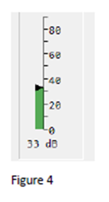
#3 You are now ready to adjust the level in the WSJT-X meter to minimum 30dB and not more than 40dB when you have your rigs VFO tuned on a quiet spot. You can adjust your external sound card knobs if you are using one, and your rigs output level to achieve this. Do NOT make this adjustment using sound controls on the computer…in most cases that is not necessary. The meter in WSJT-X should look something like Figure 4. Again, note this is on a quiet spot on the band with no signals present.

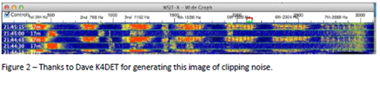
Now let’s talk about your transmit signal path: A rig that has too much input audio will create a dirty tx signal with very significant harmonics that can disrupt a QSO and everybody can see on the waterfall…. but…here is the problem…you won’t know about it unless you can monitor your own transmitted signal. Any harmonics will show up at multiples of your Tx offset setting in the WSJT-X waterfall of everybody that receives your signal. For example, you can clearly see the noise bars at around 2480 in Figure 1 which is the 3rd harmonic of the signal at 829. In Figure 2 you can see an extreme example with multiple harmonics. Running WSJT-X’s optional rig split mode or fake it mode will prevent harmonics from showing up in your transmitted signal since harmonics will show up above 3000Hz which is normally outside your transmit passband. But it’s better not to generate them in the first place as your signal also gets affect by the clipping. ALC (Automatic Level Control) is one indicator of clipping and is an easy, roundabout way to know if you are clipping your signal. Another way is to ensure that dB level controls in WSJT-X and your soundcard behave as they should.

To set your transmit levels use the procedure below. This procedure is designed to ensure your signal is just enough to drive the rig without any ALC taking place.

You MUST understand what your ALC meter is telling you. Things you need to know to do this procedure:
• How much power your rig can transmit for FT8. Many rigs cannot use full power for this type of mode and some rigs can’t even do their rated power on a constant envelope signal without hitting the ALC.

• How to read and understand your rig’s ALC meter. Anything above 0dB ALC is bad for FT8/digital modes. The question is, how does your rig show 0dB ALC? For most older rigs 0dB is the left-hand side of the meter or just a red-light indicator when ALC is in effect. On newer SDR rigs you do want to see some ALC action as 0dB is not the left-hand side of the meter...read your manual. The procedure below will help you confirm how your meter behaves.

• How to set the rig output power level

• How to set rig audio input level (RAIL) – this is the audio level that the rig sees from the computer or the external sound card. We will also be adjusting any external sound card like a SoundBlaster or SignaLink (if you have one) and the RAIL together.

TOP ^
- Set your rig power level to the maximum it can do for CW mode (look at the rig specs – could be anywhere from 30-100% of full power). We just need to ensure we have enough “room” in the rig setting so that we can feed a signal and not be any more than 50% of the rig’s power setting.
- Set WSJT-X to full power on the Pwr slider
- Confirm your sound card playback device is 0dB and 48kHz sample rate. Recording should be the same 0dB, 48kHz. Also ensure your sound card audio playback is NOT the default device. If you make it the default then all your windows sounds (beeps, YouTube, etc.) will playback through your rig.
- Set your RAIL to minimum and your playback/outgoing/transmit sound card to minimum.
- Set the TX offset to 1500 – we want to ensure the tone we generate is in this “sweet spot”.
- Press "Tune" on WSJT-X -- at this point you should have no power being transmitted. If you see power go check your settings again.
- Increase RAIL and external audio device level SLOWLY until you get about 20W (assuming your rig is set at 100W or use 20-50% of whatever your rig power setting is). Whatever your ALC meter says at that point is probably what you want and is below 0dB. On most rigs the ALC meter won't even move or barely move. If your ALC is more than minimal at this setting, then you probably have an Elecraft K3 which wants 4 bars + tickling the 5th bar to operate at capacity. It’s important you understand what your ALC meter is telling you. You do not want any ALC on an FT8 signal (or any other digital signal).
- Bring up RAIL until ALC starts increasing, then decrease gain back to where it was. For the K3 and such you should be able to put out max power without exceeding the K3’s bars+5th.
- Sanity check – the PWR slider on WSJT-X should show 50% power loss for every 3dB down. So, if you are 100W at full scale (0dB on the PWR slider) then -3db should be 50W and -6dB should be 25W. If your power does not decrease, then your audio is still wrong. You could be overdriving the A/D in your rig which may also clip your signal. An example is the FT-450D which has a 60mV input with a SignaLink that provides up to 100mV. If you put over 60mV into the FT-450D your signal will clip. The PWR slider in WSJT-X is an indicator when this is occurring since dropping from 100mV to 80mV won’t matter to the rig and the -3dB PWR slider setting will still show 100W.
- Repeat #9 for the lower and upper limits of what you believe is your bandpass. You should see the same power level behavior for your entire bandpass. If you see the maximum power level reduce at any point, then your bandpass or notch filters may be the reason…double check them. If you run WSJT-X in either “Rig Split” or “Fake It” (in Settings/Radio) than your audio will always be 1500-2000Hz and actually allow you to work signals beyond your bandwidth (i.e. if you can decode them you can work them). You should now be seeing maybe 80-100% of your rig's power level (depending on rig) with no ALC being tickled (or the 4bars+ as explained above). That's how you want to operate FT8 to ensure a clean signal. You can leave your rig power level at the maximum and adjust your transmitted power from WSJT-X (except for the K3 where you should adjust on the rig only due to the K3’s power hunting feature) and your signal will always be clean. Changing rig power on the rig or audio levels in the rig or sound card that you have already set may end up triggering the ALC again so be vigilant that the ALC is always where it should be.

Hope to see you on the bands with a clean FT8 signal!

From our friend at the DailyDX and the WeeklyDX, (http://www.dailydx.com/ ) Bernie has this to report:
- ZL7 - Chatham Islands - ZL7C will be on from March 28 to April 2, with ZL2BGL, Ian, and ZL2AYZ/ZL3VZ, Bill, operating, including the CQWW WPX Phone contest. They will have verticals and dipoles, operating on 80-15 SSB, CW, FT8, RTTY and "probably some PSK31." With the modest antenna farm
limitation, they hope weight considerations will allow them to take an
amplifier along.

TOP ^
- JD1 – Ogasawara - JD1BOW by JA0JHQ, Nobu, will be QRV for his eighth time from the island, local evening of February 15 to local morning on February 18,
for the ARRL CW DX Competition. QSL direct or bureau to JA0JHQ.
http://pandasan.jimdo.com.
- 6O – Somalia - 6O1OO, aka EP3CQ, Ali, is currently not in Somalia but plans to return to Mogadishu January 21st. He is currently in Germany on paternity
leave, with a newborn son.
- E5 - South Cook Islands - From the Ohio/Penn DX Bulletin, updating the E51HMK operation by DK2HM, Hans-Martin, this one will be March 14-22 on "various HF bands," SSB. QSL to his home QTH direct or bureau or use LoTW, OQRS or eQSL.

A more detailed calendar can be found at http://www.dailydx.com/the-daily-dx-calendar/

More info can be found at www.swodxa.org or www.aj8b.com

ARLD001 DX news

This week's bulletin was made possible with information provided by The Daily DX, the OPDX Bulletin, 425 DX News, DXNL, Contest Corral from QST and the ARRL Contest Calendar and WA7BNM web sites. Thanks to all.

VIET NAM, 3W. Neven, LZ1COM is QRV as 3W9ND from Hoi An until January 5. Activity is on 20 meters using SSB. QSL via LoTW.

ISRAEL, 4X. A group of operators are QRV with special call 4X0M from the Masada fortress until January 6. Activity is on 80 to 10 meters using CW and SSB with two stations active. QSL via IK2DUW.

WEST MALAYSIA, 9M2. Rich, PA0RRS is QRV as 9M2MRS from Penang Island, IOTA AS-015, until February 15. Activity is on the HF bands using CW, RTTY, PSK and FT8. QSL to home call.

ANDORRA, C3. Salvador, EA3QS is QRV as C31CT from the C37AC club station. Activity is on the HF bands using CW. This includes being on 160 meters, conditions permitting. QSL to home call.

THE GAMBIA, C5. Przemyslaw, SP3PS is QRV as C5SP from Sanyang. He is active on 80 to 10 meters using SSB and FT8. QSL direct to home call.

SOUTH COOK ISLANDS, E5. Milan, OK1DWC is QRV as E51DWC and is here for the foreseeable future. Activity is on the HF bands. This includes being an entry in the upcoming CQ World Wide 160 Meter CW contest. QSL to home call.

KYRGYZSTAN, EX. Andrea, HB9DUR is QRV as EX0DX until January 9.
Activity is on 40, 30, 20, 17, 15 and 12 meters using FT8. QSL via bureau.

SCOTLAND, GM. Special event station GB2KW is QRV near Inverness until January 28 using vintage gear. QSL via LoTW.

TOP ^
THAILAND, HS. Lars, SM6NT is QRV as HS0ZME until April 9. Activity is on the HF bands. QSL to home call.

DENMARK, OZ. Mirko, DJ1AA is QRV as OZ/DJ1AA and OZ/DJ1AA/m on Mors Island, IOTA EU-171, until January 5. Activity is on the HF bands near the IOTA frequencies. QSL to home call.

SEYCHELLES, S7. Mike, OE6MBG is QRV as S79AA from Mahe, IOTA AF-024, until February 2. Activity is on 160 to 10 meters, and 6 meters as conditions permit, using CW and SSB. QSL via LoTW.

SWEDEN, SM. Members of National Association of the Active Seeing Impaired club station SK5CG are QRV with special event station SF50CG during all of 2019 in celebration of their 50th anniversary.
QSL via SM0BYD.

TUVALU, T2. Antoine, 3D2AG is QRV as T2AR from Funafuti until January 31. Activity is on the HF bands, including 160 meters. QSL to home call. In addition, Apinelu, T2AT is QRV on the HF bands using FT8. QSL via N7SMI.

ANTIGUA, V2. Randy, WW6RG will be QRV as V25RA from January 7 to 9.
Activity will be holiday style on 20, 17 and 15 meters using QRP power. QSL to home call.

ST. KITTS AND NEVIS, V4. Bernie, W3UR and Becky, N3OSH will be QRV as V47UR from Calypso Bay, St. Kitts Island, IOTA NA-104, from January 8 to 20. Activity will be holiday style on 160 to 6 meters using CW and SSB. QSL via LoTW.

THIS WEEKEND ON THE RADIO. The ARRL RTTY Roundup, ARRL SSB Kids Day, AWA Linc Cundall Memorial CW Contest, NRAU 10-Meter Activity Contest, NCCC RTTY Sprint, QRP 80-Meter CW Fox Hunt, NCCC CW Sprint, PODXS 070 Club PSKFest, Schwaben Contest, World Wide PMC Contest, RSGB AFS CW Contest and EUCW 160-Meter CW Contest are all on tap for this weekend.

The IQRP Quarterly Marathon runs from January 7 to 13.

The ARS Spartan Sprint is scheduled for January 8.

The CWops Mini-CWT Test, Phone Fray and QRP 40-Meter CW Fox Hunt are scheduled for January 9.

The Canadian National Parks on the Air, CNPOTA, operating event runs for the entire year of 2019, with special stations on from Canada's parks and historic sites. Please see January 2019 QST, page 91, and the ARRL and WA7BNM Contest Web Sites for details.

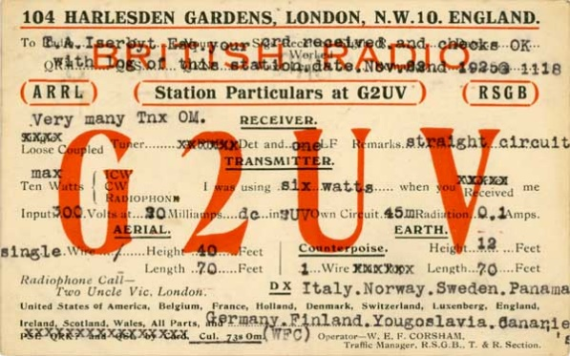
You’ve Got Cards – Waiting

Hey Gang, here’s a new department for you to keep an eye on and it has already shed fruit for some of you. Yes, it’s about QSL Cards without owners. Why without owners? The card sorters have the cards waiting, but they don’t have a way to get these cards to their owners.

TOP ^
Now, if your call sign is listed here, and according to our One Question Poll this week, some of you do recognize these call signs!! Now, we just need these folks to contact their QSL Card sorter to find out how to get their cards sent to them. Don’t send anything to them until you’ve had a chance to contact them first and find out just what you need to do.

NEW Here’s some folks from the “8A” call signs that have cards waiting..

WA8A, WW8A, WR8AA, AA8AB, K8AB, WB8ADA, K8AEC, WA8AEE, K8AF, K8AH, WD8AHR, K8AI, W8AJ, N8AJB, WB8AJR, W8AJT, W8AJU, WB8AKW, AB8AL, K8ALM, AA8AM, N8AMM, KD8AN, N8AOK, N8AP, N8AR, W8ARE, K8ARL, KE8ARL, W8ARU, K8AS, K8ASS, W8ATE, N8ATS, N8AUM, WB8AXK, W8AY, KB8AZS, K8AZT, KC8AZU, KD8AZU

Contact Dave, K3CTN, 8th area bureau “8A” letter manager at: dbbrown624@gmail.com

*********************************

Here’s some folks from the"8V” call signs that have cards waiting…

AK8V, KG8V, KR8V, KU8V, NA8V, NC8V, NV8V, NW8V, W8VCI, KB8VCV, KE8VC, N8VFJ, W8VHO, W8VI, AA8VL, WD8VN, W8VRT, WB8VWO, N8VW, N8VY, W8VKO, WA8VA

If you know any of these folks be sure to let them know that they have cards waiting for them. Contact Glenn, AF8C, 8th area bureau "8V' letter manager at: af8c@alumni.caltech.edu

*********************************

Here’s some folks from the"8Q' call signs that have cards waiting…

K8QD; KB8QGR; KC8QCT; KC8QDQ; KC8QMU; KC8QOF; KC8QOL; KC8QYE; KD8QBF; KD8QBV; KD8QDL; KD8QDP; KD8QDQ; KD8QEJ; KD8QES; KD8QQH; KD8QYE; N8QL; N8QN; N8QQ; N8QQE; N8QY; NC8Q; NK8Q; W8QAX; W8QEJ; W8QHJ; W8QK; W8QM; W8QX; W8QYU; W8QZS; WA8QNN; WB8QYA; WD8QHY; WD8QMA

If you know any of these folks be sure to let them know that they have cards waiting for them. Contact Dave, K8DV, 8th area bureau "8Q” letter manager at: k8dv@cinci.rr.com

*********************************

Here’s some folks from the"8T' call signs that have cards waiting…

K8TA, N8TAH, WB8TCB, KD8TEH, AE8TF, WB8TFW, K8TGR, KD8TNC, K8TPH, KD8TVB

Here’s some folks from the"8W' call signs that have cards waiting…

N8WAV, KD8WAK, WB8WBN, K8WCP, K8WGA, KD8WKR, W8WLK, K8WN, WV8WVS, AB8WW, NN8W, AD8W, AG8W, WB8WY

TOP ^
If you know any of these folks be sure to let them know that they have cards waiting for them. Contact Peter Greene, N8WGE, 8th area bureau "8T & W” letter manager at: transitbear@hotmail.com

Don’t know who to contact for your cards? Here’s a link…
http://arrl-greatlakes.org/8th_bureau.htm Remember, it goes by your first letter of your suffix call sign.

The card sorters would also like me to remind everyone that this is the “Incoming” QSL Card Bureau. ALL “Outgoing” cards (cards that you send) go to the main card sorting area at ARRL Headquarters. Here’s a link for the details on how to do that… http://www.arrl.org/outgoing-qsl-service

Weather Underground and Ham Weather Stations
Have you visited the webpage to see all the Weather Underground stations yet? It’s really fun to see just how much the weather varies across the state and this gives you access to each individual station very quickly and easily.
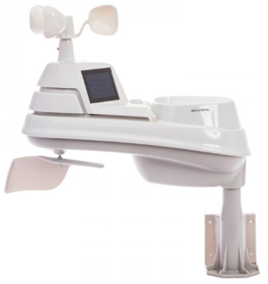
It seems that our list of stations is growing every week, and again this week is no exception. I’ve added another station to the list! Thanks to Jack, KE8KMQ for sending his link to the – Grandview Heights weather station. Here’s a link to all of those listed… http://arrl-ohio.org/wus.html

We’re starting to get a really good collection of stations all over. I know that there is a lot more than what we have listed. How’s about sharing your weather information with all of us! All that you need to do is send me your Weather Underground ID and your call sign and I’ll take it from there. Sent it to: n8sy@n8sy.com

New Ham Radio Operator's Handbook On the Market

Hey Gang,

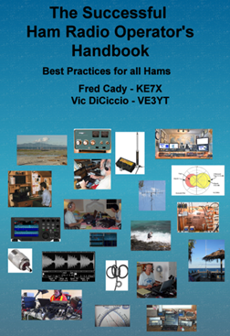
I received the information below the other day and took a quick look around at the links provided. It seems interesting, but please take a look for yourself and ask questions of the authors before purchasing. I don’t do recommendations on books since that is a personal decision as to whether a book is interesting or not, but if you do purchase it, please do it as you would do for any book that you haven’t heard much about yet.

This new book is aimed at new or returning hams to help them understand the practical aspects of the hobby, how to use their radios, build antennas and baluns, and get on the air successfully. In it you will find explanations of how the various parts of your ham radio - the transmitter and receiver – work, plus how these are being implemented using software defined radio technology. Operating techniques for VHF/UHF repeaters, HF radio DXing techniques, and the new digital modes are covered. Radio propagation, antennas, transmission lines, SWR and the mysteries of baluns are explained.

TOP ^
Building your HF station, choosing a radio, connecting your radio to a computer, and mobile and portable operation are extensively covered.

Both the pdf and spiral-bound printed versions are available from Lulu.com, and the print copy is also sold by DX Engineering. You can find them via the links below:
http://www.ke7x.com/successful/ordering-the-successful-ham-radio-operator-s-handbook

Here is a link that describes the book in more detail: http://www.ke7x.com/successful

Follow us on www.facebook.com/KE7XBOOKS to keep up-to-date on book news and to be notified of book discounts at: www.lulu.com.

This book has 267 pages, 211 figures and diagrams, and 53 tables of data to make understanding the sometimes-complicated ham radio operations much easier. The book follows KE7X's philosophy of presenting material in several forms to accommodate people with different learning styles -- reading, visualizing, hands-on -- with the many figures and text explanations and there are hands-on exercises throughout the book that can help you learn more about your particular radio.

Follow us on www.facebook.com/KE7XBOOKS to keep up-to-date on book news and to be notified of book discounts at www.lulu.com.

One instructor for new and advanced ham classes has said, “This book is exactly what is needed. I've seen some other books targeting the new hams that are less than satisfying both technically and in content but this one is right on the mark and covers so much information that I so often get asked about, during and after teaching classes.”

Here are more details on the content:
- With nearly 110 years of ham radio experience between them, the authors are still excited about the challenges this wonderful hobby offers. The Successful Ham Radio Operator's Handbook will guide you when exploring some of these.
- Its goal is to help new operators and returning old-timers learn about the breadth of exciting ham radio activities and challenges available today.
- It answers the question "Why is ham radio relevant in the Internet age?"
- It covers a wide range of topics, helping the reader to understand the excitement of different facets of ham radio and to choose a challenging and exciting activity to pursue.
- It helps the reader better understand how the radio works. Many hams only use a small fraction of the features of their radio. For example, if you understand how a noise blanker or a roofing filter or the AGC works, you will be able to more easily use these, and other, features of your radio to your benefit.
- It provides exercises designed to apply the knowledge to cement your understanding of how your radio works without being radio-specific. It is good for all makes and models.
- It helps the reader get enough background to understand much of the jargon hams who pursue special activities, such as the various digital modes, VHF contesting and moon bounce. It quickly takes the novitiate reader to higher level of understanding and provides URLs and websites that help the reader go deeper into new interests.
- Antennas remain a key area where all hams can still successfully experiment and create a key part of their station. This book provides information to help new hams get started cutting their own verticals and dipoles. It explains why some popular multiband antennas may have compromises that impact performance.

TOP ^
- It gives practical guidelines about choosing transmission lines and building and using baluns and chokes.

Digital modes such as RTTY, PSK and the new WSTJ modes are explained. The computer-to-radio connections needed for these modes are discussed and illustrated.

Many hams are motivated by public service and emergency preparedness. This book describes typical local emergency organizations and national networks.

Hams who like to operate while traveling will find practical information on reciprocal international agreements and how to get permission to operate legally.

Final.. Final..

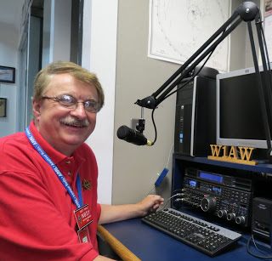
Hey Gang...

Wow, what a week last week was! Yes, Janie and I stayed home for New Year’s Eve, just like we always do, but this year seemed different for some reason. I guess it was because we both fell asleep watching the 6pm news and didn’t wake up until just before the clock was ready to strike midnight. I had some very special cheese and crackers that I was going to munch on tonight, but by the time we both woke up and realized that we slept for most of the evening, we decided to watch the ball drop and then go to bed. Believe you me, my rocking chair is comfortable, but sitting upright in it for almost 6 hours while dozing in and out of consciousness took its toll on my neck and back. Bed was where I was heading to get some restful sleep! I paid good money for that critter and I’m not going to let one night slip by without making sure that I get my money’s worth out of it.

Oh well, nuff on that subject, let’s turn the band selector to 20-meters and see who’s around tonight!

What has 2019 brought us so far? Shut Down! I don’t know if you took a look at the opening National News stories or not, but one of them is about how the FCC is now shut down and is not going to process Amateur Radio licenses. I’m sure that brings a frown to all of us in the V.E. program as well as those we license in the days to come. The new licensees won’t be getting that exciting news of their new call sign until the FCC opens back up! Oh, and those petitioning for a vanity call sign are in that same boat as well!

Are you going to Dayton this year? Don’t forget that Dayton will also be the ARRL’s National Convention. This always means that there will be some very special things happening at Hamvention for sure and you won’t want to miss out on any of the really exciting things that will be happening. Make sure to mark your calendars for May 17, 18 and 19? If you are new to Amateur Radio let me say this is definitely one hamfest that you won’t want to miss out on, you’re gonna’ want to make sure that you schedule some time off from work for these May dates right now. That way you won’t miss out on the fun that’s going to happen.

TOP ^
Now, have you REALLY taken a good look at the article about finding those persons that have QSL cards waiting to be delivered to them? I hope that you have. It would be a shame to have those cards just thrown out.
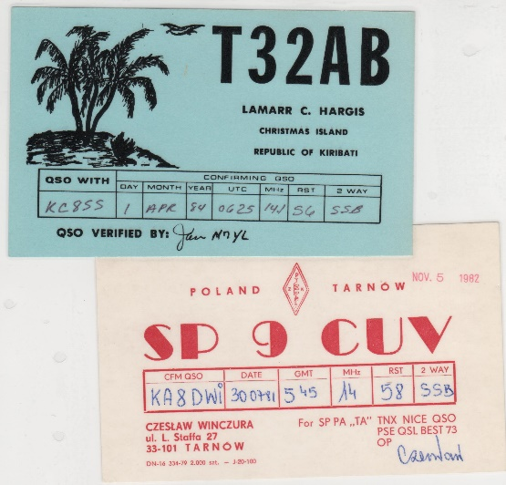
If you recognize anyone on that list, please let them know that their card sorter has been waiting patiently for them to respond. From what I have heard so far there have been a few folks actually discover that they had cards waiting for them. If you just skimmed over this article, please, go back and take a good hard look at all of the call signs listed, there’s a bunch of them so go slowly through the lists. I’ll bet you’ll find a call sign or two there that you recognize. If you do see someone’s call sign that you know, PLEASE, do him/her a huge favor and let them know about this article.

Moving over to 80-meters, let’s see what’s happening there... As you can imagine, I once again didn’t get much of a chance to do any design work on the new ham shack. I’m did get the Christmas decorations taken down in the room and packed away for next year, but that’s it. I’m still looking forward to doing some changes in here, but it’s definitely taking more time than what I had planned for. I’ll keep plugging away at it.

Ok, now have you taken some time and actually browsed through the 2018 Ohio Section Yearbook that came out this past week? I’ve had some very good comments on it from folks all over the country, and I’ve heard from a few that actually did learn some things that they didn’t know before. I’ve also received some really great suggestions for next year’s edition. Wow, will that one be chocked full of surprises.

Hey Gang, are you going to the DX Engineering Winter Sale Day on Saturday, January 19? This is their annual gathering (sort of a mini hamfest) and it runs from 9 am to noon that day and it’s always fun to go up and just browse around and talk with everyone. They are having free doughnuts and coffee while you attend the two mini-seminars:
*Technical Support Specialist Ken Dorsey, KA8OAD, presents Digital Mobile Radio (DMR) at 10 am
*Operations Manager Cory Gibson, W3CDG, presents Emergency Communications at 10:45 am
You are encouraged to check in to the N8DXE Repeater at 146.985 MHz—no PL tone required. Don’t miss out on this really fun event! Tim, K3LR and the entire DX Engineering gang always host a really great event. Besides… what better things do you have to do on a wintery Saturday morning?

Whelp… That’s going to do it for this time around. Stay safe, and most of all… have FUN!!

Scott, N8SY

Stargazers will witness a trifecta of lunar events in the New Year

I know that many of you are not only Amateur Radio operators out there, you are also astronomers as well, so I know that this article will be of great interest to you and anyone that looks up at the sky in wonder.

A total lunar eclipse, a super blood Moon and a "Wolf Moon," a nickname for a full Moon that appears in the middle of winter.

TOP ^
Millions of people across North and South America and portions of western Europe and Africa will be able to catch the rare sight overnight on January 20 into January 21, according to National Geographic. For a few hours, the moon will give off a bright reddish glow.

Website Stats on www.arrl-ohio.org for 2018

Summary
Reported period | 2018
First visit | 01 Jan 2018 - 00:03
Last visit | 31 Dec 2018 - 23:51
 | Unique visitors | Number of visits | Pages | Hits | Bandwidth
Viewed traffic * | 104,176 | 141,940 | 923,883 | 14,155,042 | 194.0 GB

Wow, is this fantastic or what! We’ve set a record! We had over 14 million hits this past year! We broke last year’s record of 6.3 million by over double. Where can we go from here? Who knows, maybe 20 million?

D-STAR ONE launched, telemetry received
(from German Orbital Systems, ANS and Greg, WD9FTZ)

German Orbital Systems reports a successful telemetry downlink has been received. Their web page http://www.d-star.one/ reports D-Star ONE Sparrow and D-Star ONE iSat were successfully launched on December 27 as part of an ECM smallsat cluster on the Soyuz-2/Fregat from Russia's Vostochny launch site. Additional details can be found at: http://tinyurl.com/ANS-006-DSTAR-ONE

During the first orbits, beacons were received in the US, Germany, Czech Republic and Belarus, confirming the successful separations of the satellites on their target orbit 585 km, 97.73 deg, SSO.

D-Star ONE Sparrow and D-Star ONE iSat are a pair of 3U cubesats which are equipped with four identical radio modules with D-Star capabilities, all being operated in a half-duplex mode. At press time DSTAR One Sparrow was planned to be used for amateur radio.

DK3WN received the first telemetry on December 29, 2018 with more signals received by Scott, K4KDR and Vladimir, EU1SAT. Check the German Orbital Systems web page for LEOP status and satellite availability for contacts.

D-Star ONE Sparrow operates as a half duplex repeater:
Callsign: DP1GOS
Uplink: 437.325 MHz
Downlink: 435.525 MHz RF-Power: 800-1200 mW
Telemetry: 435.700 MHz 4k8 GMSK Mobitex (CMX990 Mobitex Format)

The telemetry format is documented at: http://tinyurl.com/ANS-006-DSTAR-ONE-Telemetry
A telemetry decoder is available at: http://www.dk3wn.info/p/?page_id=29535

TOP ^
Technical details for radio amateurs is posted at: http://tinyurl.com/ANS-006-DSTAR-ONE-Amateur

A D-Star voice message beacon transmits once a minute. All modules are operated in a power save mode. This means that they are in idle for 40 seconds and then in receive mode for 20 seconds.
Once a signal has been received, the modules switch to receive mode for five minutes. So it might be necessary to "ping" the satellite a couple of times until an answer is received. Object #43879 continues to be a likely fit for tracking at present.

Back Issues of the PostScript and Ohio Section Journal (OSJ)

Hey, did you know that PostScript and Ohio Section Journal (OSJ) are archived on the website? You can go back and look at any edition simply by clicking:
http://arrl-ohio.org/news/index.html

Chit – Chat, and All That!

Do you know someone that’s not getting these Newsletters? Please, forward a copy of this Newsletter over to them and have them “Opt-In” to start receiving them. Heck, just have them send me an email n8sy@n8sy.com and I’ll get them added to the Ohio Section Emailing list.

We now have many thousands of readers receiving these newsletters weekly. Quite impressive, I’d say! I urge all of you to make sure that everyone, regardless of whether they are a League member or not, get signed up to receive these weekly Newsletters.

You can always “Opt-Out” at any time if you feel this is not what you were expecting. It’s fun and very informative. All of your favorite past newsletters are now archived too.
You can go back at any time and read them. Just go to: http://arrl-ohio.org/news/

Got questions, concerns or would just like to sit and chat awhile? Heck, I’ll even buy the coffee!! Give me a call at (419) 512-4445 or email me at: n8sy@n8sy.com

The pictures on the front page are from various newsletters, Facebook posts and/or were sent directly to me in recent weeks. Take a good look at them, you just might be in one of the pictures! “SMILE… you’re on the Ohio Section News!!”

TOP ^

PostScript is produced as a weekly supplement to the Ohio Section Journal (OSJ). I sincerely hope that you have enjoyed this edition and will encourage your friends to join with you in receiving the latest news and information about the Ohio Section, and from around the world!

