***[](http://arrl-ohio.org)******Tornado Safety Week*** ***Edition***

|  |  |
| --- | --- |
| **🡪** From the Technical Coordinator | **🡪** From the Section Emergency Coordinator |
| **🡪** From the Affiliated Club Coordinator | **🡪** From the Public Information Coordinator |
| **🡪** From the Section Traffic Manager | **🡪** Out and About |
| **🡪** From the Section Youth Coordinator | **🡪** From the Official Observer Coordinator |
| **🡪** ARES Training Update | **🡪**  Handbook Give Away |
| **🡪** Club Corner | **🡪**  ARES Connect |
| **🡪**  DX This Week | **🡪**  National News |
| **🡪**  Final.. Final.. | |

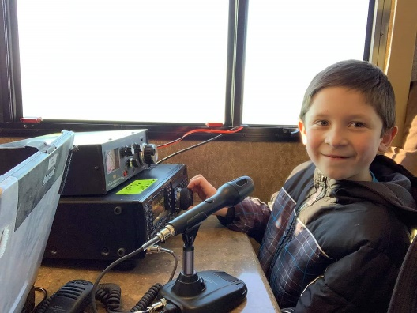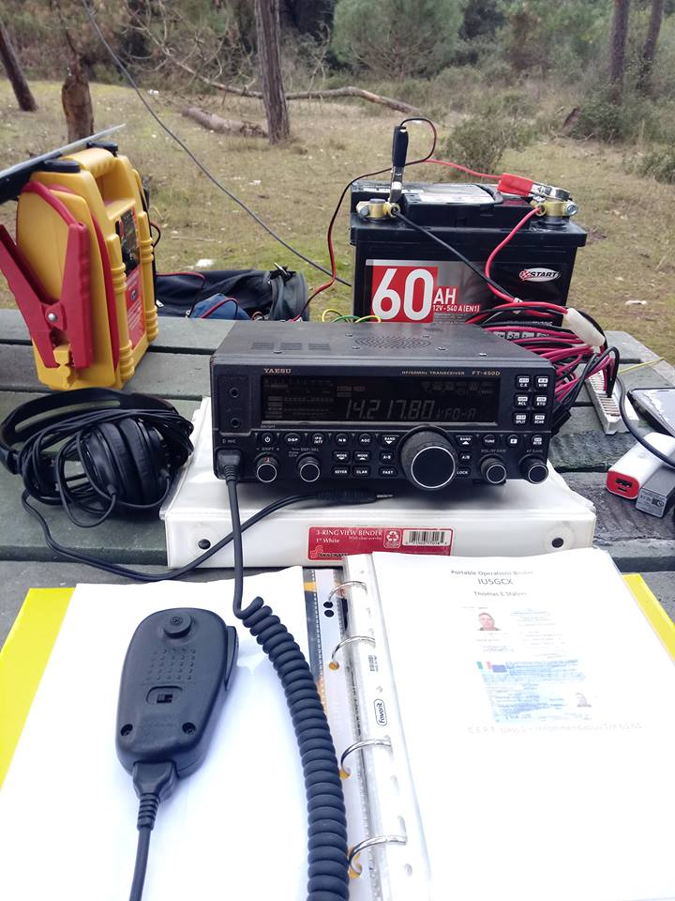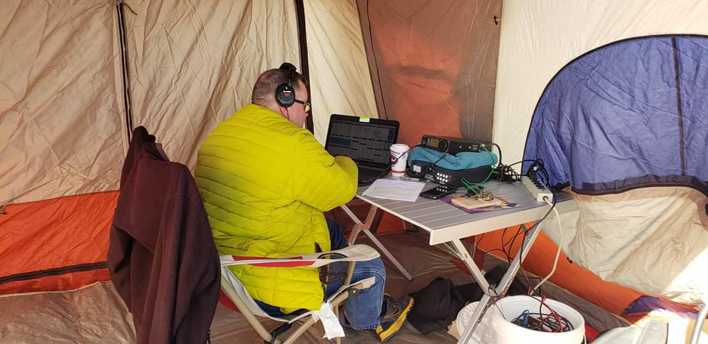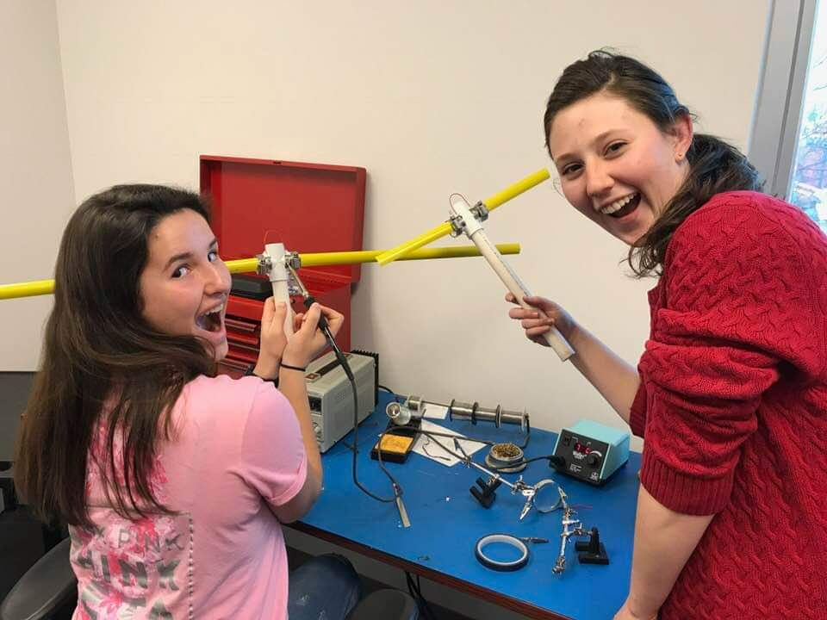

***From the Technical Coordinator***

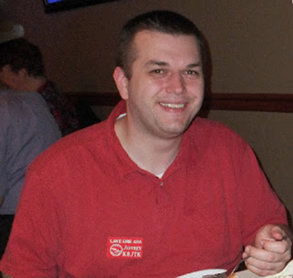***Jeff Kopcak – K8JTK TC***

[k8jtk@arrl.net](mailto:k8jtk@arrl.net)

Hey gang,

Hey gang,

Do you have your Network Radio? I do, well, maybe. Not the way most people define Network Radios. In the last number of years, outside Voice over IP (VoIP) services have found their way into ham radio. Services utilize mobile data connections like 3G, 4G, and WiFi to connect users over the Internet. The app turns a cell phone or tablet into a HT-like device, complete with PTT button. “Network Radios” has been used to define these types of transceiver and channels available on those transceivers.

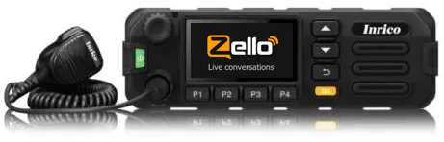Probably 4-5 years ago, and still used today, a number of hams were all abuzz about this service called [Zello](https://zello.com/).

Another service called IRN (International Radio Network) is built on TeamSpeak. TeamSpeak is most frequently used as an audio chat service for players in multiplayer video games. Both of these services were probably adopted by ham-radio operators because of the similarities. Use a speaker, microphone, and can carry on round-table style chats. One person talks and the rest receive. These are called “channels” - similar in ham lingo to a reflector, conference, or talk group.

The term “Network Radios” is making the rounds because devices are being sold that integrate with VoIP services and are made to look like an HT or mobile radio. Most run the Android operating system meaning they come with the Google Play store. Having the Play store means any app can be installed, such as other VoIP apps like the EchoLink app or Repeater Book repeater directory.

RFinder was the first to design and sell Network Radios. They took a cellphone and attached a dual-band VHF/UHF transmitter capable of analog or DMR. Make phone calls or phone-calls. A similar tablet version is also available. Their devices are integrated with and promote the [RFinder](https://www.arrl.org/shop/RFinder-The-World-Wide-Repeater-Directory) application (digital version of the ARRL repeater directory). Running the application and using the GPS makes it easy to locate near-by repeaters. Clicking a repeater would program the radio for use with the selected repeater, including offsets and sub-audible tones. Press PTT and you’re on the air!

A store with the completely original name, [Network-Radios](https://network-radios.com/), is selling a whole range of Network Radios including the RFinder devices. The HT Network Radios have, what looks like, an antenna but few lists the capability of transmitting in the ham bands. None of the mobile Network Radios have any kind of RF connector.

TOP^

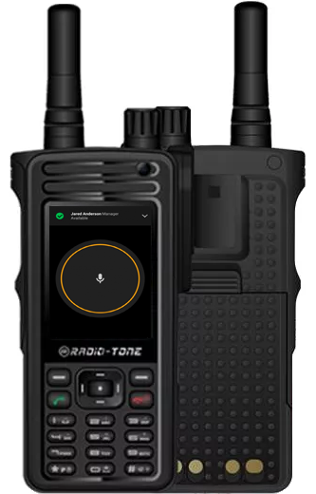This brings up the question: is this ham radio? My definition: if a legal identification is required, it is ham radio. More-or-less, I’m looking for Internet-linked endpoints to be connected to some kind of RF transmitting device in the ham bands that follows Part 97. I would like to have all linked end points transmitting in the ham bands, but I’ll take what I can get. My reasoning: our bands continue to be under attack by commercial entities that would pay big money for our frequencies and EVERYONE always complains our repeaters and frequencies are underutilized. Actually, using our bands shows whoever is out there listening (FCC, commercial interests, people scanning the bands, potential hams, …) that ham frequencies are being utilized and we’re doing stuff with our bands. Call me crazy!

I’m not opposed to hams using these Network Radio services to find a better tool. Some Network Radio channels are even linked to repeater systems. That’s OK if private channels are properly controlled, seems like a lot of extra management. However, the overarching use of these services is mobile-device to mobile-device using non-ham bands. That is not at all ham radio. One argument is that some people need a place to let loose a little more than would be allowed on a regular repeater. Whatever.

I heard, from hams, in recent Emcomm situations how great it was that Zello was being used by the public to phone in needed rescues. Other channels were created for family members looking for relatives to make sure they were OK. Great use of technology. If average people can be mobilized at a moment’s notice with boats and rescue gear through a phone app, are hams still relevant? Anyone else see the irony?

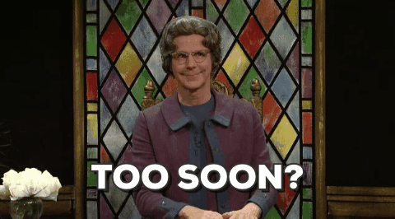The argument is always made: “the cell network can, and will, go down.” The exact opposite argument is being made promoting Network Radios as seen at the beginning of [this blog post](http://network-radios.com/index.php/2017/12/10/dont-be-ridiculous-about-irn-or-zello/) (some language NSFW, that is “not safe for work”) on the Network-Radios site: “I get 99,99999% of cell signal no matter where I am. I wonder if you can reach a VHF or UHF repeater for 10% of the time of your travelling with a typical 4 Watt handheld with its rubber duck antenna. And if GSM is not available, I could use a global Wi-Fi hotspot.” We’re doomed. Too soon?

**New Podcast**

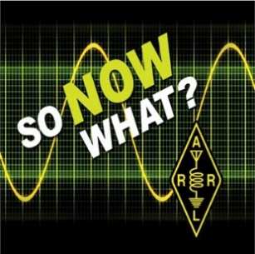The [ARRL is sponsoring a new podcast](http://www.arrl.org/news/new-arrl-podcast-geared-toward-newcomers-to-amateur-radio-debuts-on-march-7) that launched March 7. “[So Now What?](http://www.arrl.org/so-now-what)” is geared toward those who have obtained their license and need mentoring on the next steps to get the most out of the hobby. “Topics to be discussed in the first several episodes include getting started, operating modes available to Technician licensees, VEC and licensing issues, sunspots and propagation, mobile operating, contesting, Amateur Radio in pop culture, and perceptions of Technician license holders.” I’m sure there will be ideas for new and old hams alike. Subscribe to this new podcast and get the most out of ham radio!

TOP^

**Networking Basics**

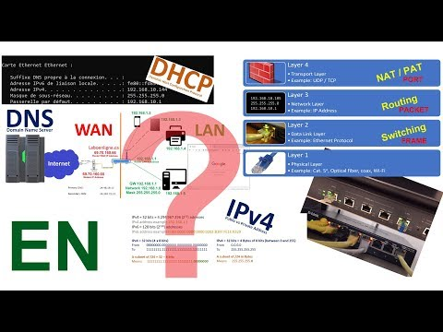I made a career move over a year ago from programming into a networking position and quite enjoy it. Pascal - VA2PV, has a quality Youtube channel where he frequently does product reviews, how-to videos, and shares his experiences with things like PL-259 installation and re-cabling his shack. Video and audio quality are excellent with many videos available in 4K (great opportunity to experience a 4K stream). He released a video on the [basics of IP networking](https://www.youtube.com/watch?v=HAVcXPI7oUY). It won’t go in depth to the level of things I do at work, but if you ever wanted to know how devices on your home network can communicate with devices on the Internet, what is DHCP & DNS, then his video is required viewing.

**FreeDV QSO Party**

A group in Australia has announced the first ever [FreeDV QSO party](http://www.areg.org.au/archives/209376) starting on April 27th 0300z to April 28th 0300z 2019. FreeDV is an open source digital voice mode, commonly referred to as Codec 2. I’ve played around with this mode before and was impressed by the resulting audio quality in such a narrow bandwidth. I hope this will create some FreeDV activity on the bands. It does require two sound cards (or sound devices) to operate. If you have an internal soundcard and a SignaLink, you’re set. The internal soundcard records and plays voice audio while the SignaLink (or other) transmits and receives digital modulation to and from your radio. Look for you on the bands using FreeDV!

Thanks for reading

**73… de Jeff – K8JTK**

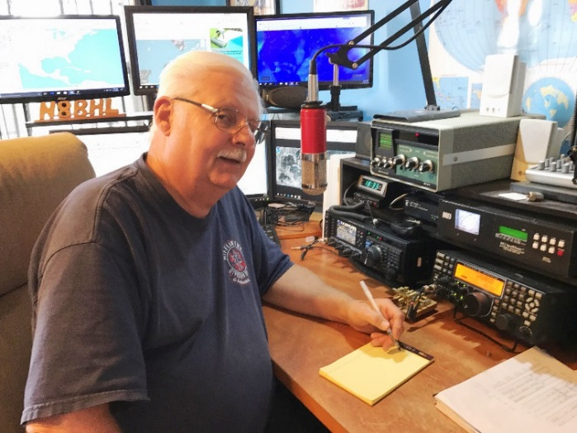***From the Section Emergency Coordinator***

***Stan Broadway, N8BHL - SEC***

[broadways@standi.com](mailto:broadways@standi.com)

And off we go again!

It’s already starting- the push for communications assistance. In Central Ohio the first weekend of March we hold a small-ish athletic competition. It’s called “The Arnold” and hosts 26 thousand ~competitors~ with their accompanying trainers and hangers-on from all over the world. Events started with weight and body building but over the years have blossomed into a wide-ranging field from bikinis to Vikings. The Viking Dash is a running event through untamed woodlands. You can figure out the Bikini part. Through all of the fields, in all of the locations around Central Ohio, amateur radio is the exclusive means of communicating for the immense medical operation that supports the event. It’s a very big deal particularly because of the many event locations and related management issues.

TOP^

So what events are coming up at your location? The spring and summer are full of runs, walks, rides and many other events, most of which could probably use a solid communications system in the interest of public safety. Many large events require meetings and planning months ahead. Remember that these projects, as well as spring stuff like changing repeaters, checking antennas, etc. all reasonably qualify for tracking ARES times. Don’t forget to enter them into ARES Connect to get your people credit as they deserve!

There are some state level exercises due in March- including a Davis-Besse Nuclear exercise being coordinated through the Ohio EMA. Your “Ohio Auxcomm Team” at The Sarge will be front and center with that!

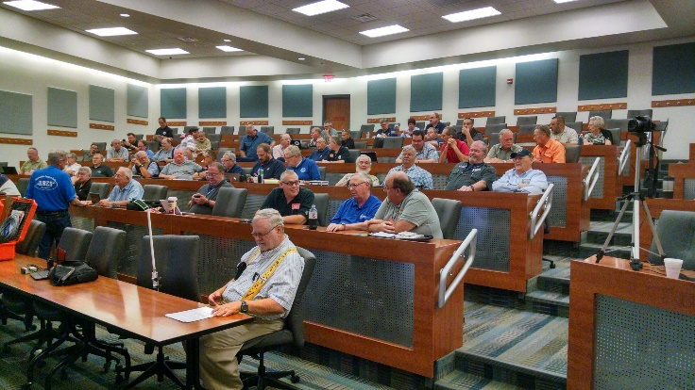

We in ARES have our own activities that are widely accepted. First, on Saturday April 6, we will hold our annual Ohio ARES Conference. The ARRL League has approved a re-write of the ARES structure, so we’ll go over that. This will be held from 8-4 at Marion Technical College/ OSU Marion campus. We are switching things up a bit this year- with the goal of providing training and information that EC’s can take back and apply. We have some cool stuff lined up: we are going to have an in-depth presentation on solar and battery power for portable and emergency use. Also, because we learned in Hurricane Michael the need to be able to handle formal messages as well as the usual tactical kind, we will review the process for sending NTS and ICS formats. BRING YOUR LAPTOPS AND HANDHELDS! Be ready for some FLDIGI operating. The afternoon should be fun! A registration form is available on the arrl-ohio.org website.

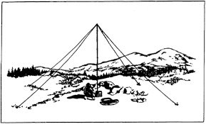**NVIS Day**

April 27, a Saturday, from 10-4 will be this year’s NVIS Day in Ohio. This has become a tradition, and the importance of easily-deployed portable antennas was brought to the spotlight after Hurricane Michael and others this past year. The devastation took down ALL commercial, safety and amateur communications. There were no towers, no repeaters, and very little formal generator power. I was honestly surprised that of all things 80-meter sideband was one of the most-used forms of emergency communication. It worked well for them and would work well for Ohio in a wide-spread “flat-earth” situation. We got a taste of that during “Snow Net” where operators in 44 counties participated both on 80 and on DMR Ohio. This to me makes NVIS practice even more important.

I have received one suggestion that makes sense. The real purpose of NVIS day is to test antenna performance- compare signals and try different configurations. There is a contest type ranking for how many contacts you can make, that just creates a more fun atmosphere. The suggestion is that we use the DMR Ohio Talk Group to coordinate contacts, and to advertise that a station is operating on a certain frequency. That can help to remove the searching and some frustration since we’re all over the bands that day. I think using DMR Ohio similar to a spotter type operation would make it much more fun and provide better ways to find other participating stations for our testing. Thanks to Alan Rothweiler KD8TNS for the idea!

TOP^

I hope to see you at the ARES Conference! Remember, it is open (and strongly suggested!!) for EC’s and above, as well as AEC’s or others with special interest in being there. The facility seats over 150, and we usually comfortably fill the room (120-ish) so, yes, there’s room for you!! MANY THANKS TO MARION ARES for hosting us! They put some work and planning into our day.

Hey everyone!

You should already know that the Ohio statewide tornado drill is set for **Wednesday, March 20 at 9:50AM.** Several people have asked about taking this time for another test of the statewide DMR net, and that sounds like a great opportunity!

I don’t want to take manpower away from your local nets, so let’s try a ~fast~ check-in net on the **Ohio DMR Talk Group (3139) starting at 0930.**  That should give everyone time to check in and get back to your local Skywarn weather nets.  We’ll call two districts at a time, in numeric order.

**Wednesday, 0930 on Ohio**

Hope to hear from you!!

**73, Stan N8BHL**

**You can view all of the SEC’s monthly reports on the website..** <http://arrl-ohio.org/SEC/default.html>

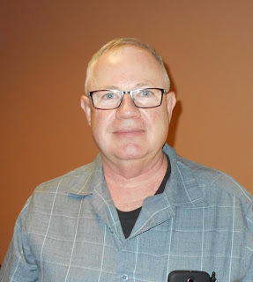***From the Affiliated Club Coordinator***

***Tom Sly, WB8LCD - ACC***

[tomsly29@gmail.com](mailto:tomsly29@gmail.com)

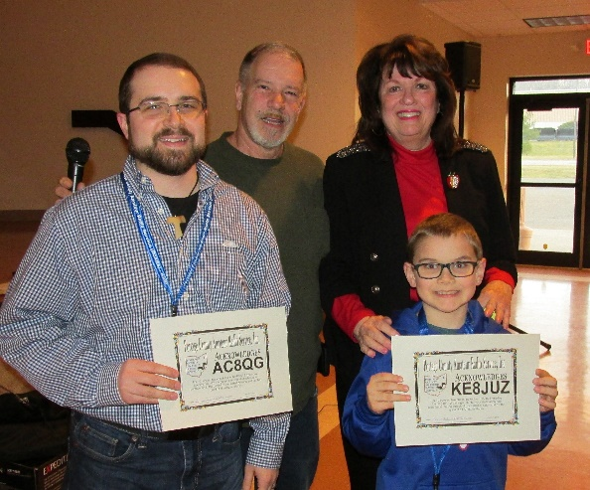Last month I told you about just trying to make my community aware of Amateur Radio. I asked you to send a QSL card to a local restaurant I spend some time in. I’m happy to say, many of you responded. Every time Bert got a QSL card in the mail, he was as excited about them as I am when I work a new one and the card shows up! I’ve got a second card holder up and it’s getting filled up too. (If you want to send a card, it would still be appreciated.) I’ve noticed several people pausing to take a look at them as they enter. Bert told me that lots of folks have asked him what it’s all about and HE asked ME if I would make up something he could put up that would give a brief explanation of what Ham Radio is, and maybe put a holder up with a bunch of our club brochures for anyone who would be interested in taking one.

TOP^

Once again, it’s all about making people aware of what Amateur Radio is all about. I don’t expect a huge response of people seeing this display and jumping into the hobby, but…if they are later approached by or come in contact with someone involved in Ham Radio, that person has a “warm” prospect to work with, hopefully with a positive image of what ham radio is, rather than someone who doesn’t even know we exist. Building the numbers of participants in our hobby will take time – it’s a process, not an event. If everyone does just a little bit to contribute to the process, we will keep moving forward. This was just a dumb idea, but I’ve put it into action and see at least some people having a positive first impression of amateur radio. I hope it contributes to the process.

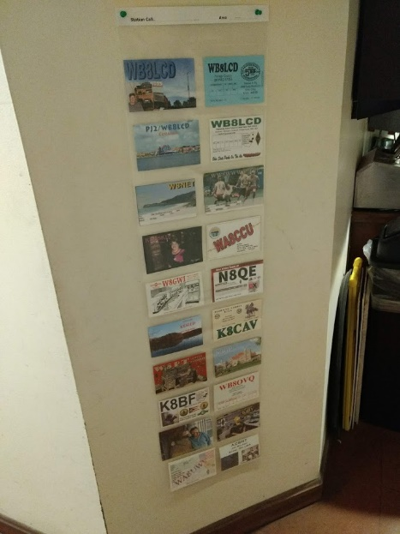Ham Radio, as most of us experience it, is a “High-Tech” hobby. We involve ourselves with modern electronics, modern digital techniques of communications. We communicate using RF, DMR, email, text messaging, online blogs, social media, PDF versions of our club newsletters distributed by email and/or website downloads. It’s not just in our hobby, but much of both our business and personal lives are spent with these “high tech” relationships. Loneliness is experienced by a large number of people in our society. Suicide rates are at an all time high. “High-Tech” has propelled us into super-efficient, yet often times unfulfilling communications with other human beings. Our clubs are where we can meet with other like- minded people who share the “High Tech” interests that we all have, but still need the “High Touch” relationships to be a complete human being.

Amateur Radio Clubs are where we can have “FUN” with other like-minded people and build those relationships in person, not just over the air or the wires. We can actually get together and do things with other living, breathing human beings! All clubs have a certain amount of business and/or housekeeping that needs to be done. But every time you get together you need to be doing something Fun along with the business. If your club meeting is a “business meeting” you need to have an additional meeting or activity where the whole purpose is to have fun. This is a hobby and most people won’t stick around for long if they don’t feel they are getting some fun out of their relationship with their club.

“Fun” can mean a lot of different things to different people. If you go to a meeting and through the course of the evening no-one goes out of their way to welcome you, or even talk with you during the course of the meeting, you will probably go home feeling that you didn’t have as much fun as you hoped or expected to have. If you were welcomed prior to the meeting, and other members included you in their conversations during and after the meeting, you probably went home thinking you had a pretty good time! Be the guy that gives other club members that experience. Add to that an interesting speaker or a club project, and I know you had a good time.

Want to get your club leaders excited about doing all the great work they do for you? Tell them “thank you” for all the work it takes to keep a club going. Tell them “thank you” for coming up with all the ideas for meeting topics, club activities and operating events they put on and manage. Want to send them over the edge? Tell them “thank you” and then volunteer to help with the next thing coming up! Club leaders hear a lot of “you ought to do this, or that.” Rarely do they hear “I think we should do this, I have a good idea of how to make it happen, and I would love it if you let me run it for the club!” (Yes, your club leaders should be having fun too)

TOP^

These are all “high touch” – all you have to do is reach out and give someone an “attaboy”. In order of points earned: do it in person, send a written note, send an email, text message. In this scenario “high touch” will always get you the most points.

What about the inverse of this? Tell someone what a crummy job they’ve done. You could have done it better, heck, a baboon could have done it better! What a stupid idea. Any kind of FLAME you can come up with! You’ve just wrecked a person’s morale. Worse yet, you’ve just wrecked the morale of someone who was actually willing to give their time, talent and often times treasure, to try to make your club better and more fun!

You just sent that guy packing, and it won’t be easy to get them back. Why would you do that? Please – don’t. The whole point of “high touch” is to build people up, to make them glad they got involved with the hobby and with your club!

This month PCARS hosted Carole Perry – WB2MGP – as the speaker for their March meeting. Carole has a long history of not only bringing young people into Amateur Radio, but also showcasing them as some of the best hams out there! A video of the presentation is now posted to the PCARS YouTube site at:  <https://www.youtube.com/watch?v=Y4gSHP5h5Tw>

It’s definitely worth the time to listen to. One idea that I took away from her presentation was that when recruiting young people to amateur radio, go for their parents too! You just might get 2 for 1 that way. To the parents it’s easy to sell as “here’s something you can do together with your kids instead of just dropping them off somewhere. Besides, how tough could it be? If your kids can do it, then you could certainly do it too.” Get the kids to help you get them involved. Tell the kids that “this is an opportunity to show your parents how smart you really are – especially if you get a better grade on the license exam. And what the heck, if your parents get licensed, you’ll probably end up with better radio gear in the house than you would ever be able to get on your own!” I highly suggest you attend the Youth Forum at Hamvention this year. Want to hear more about kids in Amateur Radio? I’m pretty sure Jim Storms – AB8YK – would be willing to talk to you about the David Kalter Memorial Youth DX Adventure program. Another program worthy of your attention!

One last thought. Start making your plans for Hamvention! Hamvention is the largest gathering of Ham Radio Operators in the US – if not the world! Hams from all over the world attend. All the manufacturers and marketers are there. There are all kinds of forums and education available to you there. You can take an exam there. You can meet new and interesting people there. And it’s all right in our own back yard! Come for the day, come for the weekend – just get there!

That’s it for now. Let me know what’s on your mind. [tomsly29@gmail.com](mailto:tomsly29@gmail.com)

**73, Tom WB8LCD**

TOP^

***From the Public Information Coordinator***

***John Ross, KD8IDJ - PIC***

[john.ross3@worldnet.att.net](mailto:john.ross3@worldnet.att.net)

**SEVERE WEATHER SEASON**

By the time you read this our severe weather seasons in Ohio will have started and you’ll probably have already experienced a blast of wind, rain and other noisy stuff.

The SKYWARN weather nets are in full operation and they are a critical part of the National Weather Service’s (NWS) operation when it comes to alerts, watches and warnings.

Participation in your local net is a great way to put your amateur radio skills to good use…but you may need some training. The NWS has training sessions in most every county…it’s free and you can become an official Weather Spotter so you can help.

I attend the presentations every year just to keep up on new developments and it’s a great opportunity to meet fellow hams…or recruit new ones!

Here’s the link to the NWS Training site where you can sign up…or you might also contact your local EMA/HOMELAND Security office: <https://www.weather.gov/iln/spottertrainingschedule>

Keep a radio charged up and ready…so far this year we have a lot of most everything mother nature has to offer.

**NEWSLETTER CONTEST**

I didn’t want you to think I forgot about the 2019 Ohio Section Newsletter Contest. It’s hard to believe but we are just three months away from the June deadline for entries. Form the looks of my mail box just about everyone is in…106 emails to date! Remember you need two different months newsletters to enter. June 30th is the deadline and the winners will be announced at the Voice of Aladdin Hamfest in August.

I had lunch this past week with our newest judge, Erin Cribs. She is busy working on her new marketing degree and is excited to see the Ohio Section entries. Keep the entries coming and it will be another great year of winners

**HAM MAGNET RE-DUX**

Last month I told you about 4 friends, co-workers, who were about be or already are amateur radio operators. Well, I took one of each to my club’s annual meeting and they were a hit and treated like royalty.

TOP^

The already a ham should have his upgrade to General soon and the almost a ham met a club member who is going to help with the test taking later this month. It’s great to see amateur radio grow right before your eyes.

And, just add to my ham magnetism, an old friend of mine sent me a message via LINKEDIN that he finally got his ham license. We used to hang around together when were younger and go to all of the ham fests but he never quite made the leap. Now he one of us... and I couldn’t be happier.

We need all the hams we can get and it’s not that hard. Talk about amateur radio, invite friends to your club’s meetings and help anyway you can. It’s a great feeling and your friends will thank you for years to come!



**PIC-PODCAST**

Next month when you see this icon…it will be LIVE! The PIC PODCAST will feature yours truly with a quick audio message or story. It’s a trial and may not be available very month but it’s a little different way to talk you about amateur radio and the Ohio Section.

The PIC-PODCAST will be recorded in my own studio…which is also my ham shack…and I have the capability of mixing in the telephone and audio from my base rig. From time to time you’ll be able to hear an interview or a story in our guest’s own words.

The folks at ARRL are already doing this so I thought we could give them a little competition!!!

I’m beta testing the software now and it should work on any computer, IPAD, IPHONE or other screen type device. Watch for the icon…click and listen.

That’s it for this month!

**73, John KD8IDJ**

***From the Section Traffic Manager***

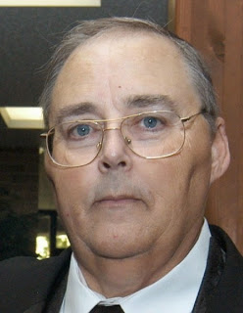***David Maynard, WA3EZN – STM***

[wa3ezn@att.net](mailto:wa3ezn@att.net)

By the time you read this the Mansfield Mid-Winter Hamfest will be over. Did you get your coffee and donuts at the OSSBN meeting? I hope everyone attending the hamfest had fun and got home safely. The OSSBN meets on 3972.5 three times a day, 10:30 am, 4:15 pm and 6:45 pm. OSSBN elections are now in progress. Check us out.

As I collected the information for this article almost all of Ohio is under a flood watch or warning. Ohio has already had tornadoes this year and spring is not even here yet. I want to stress the need for preparedness by providing this information.

TOP^

* + 1. **Statewide Tornado Drill: March 20, 2019 at 9:50 am**
* [Tornado Facts and Safety Tips](https://www.weathersafety.ohio.gov/TornadoFacts.aspx)
* [Fire Drills and Tornado Safety Precautions (ORC 3737.73)](https://www.weathersafety.ohio.gov/TornadoSafetyDrills.aspx)
* [Emergency Evacuation Drills - Fire, Tornado](https://www.com.ohio.gov/documents/fire_RecordofEmergencyEvacuationDrills.pdf)
* [Tornado Safety Standards (NWS and Red Cross)](https://www.weathersafety.ohio.gov/Documents/pdfs/Tornado%20Safety%20NWS%20%20ARC.pdf)
* [Tornado Safety And the Dangers of Highway Overpasses](https://www.weathersafety.ohio.gov/TornadoSafety.aspx)
* [Tornado Safety & Preparedness for Schools Brochure](https://www.weathersafety.ohio.gov/Documents/FactSheets/TornadoSafetyPreparednessBrochureForSchools.pdf)
* [Tornado Safety Tips for School Administrators](https://www.weathersafety.ohio.gov/Documents/pdfs/Tornado%20Preparedness%20Tips%20for%20School%20Administrators.pdf)
* [Tornado Safety Brochure](https://www.weathersafety.ohio.gov/Documents/Brochures/EMA-0004%203-16%20WEB.pdf)
  + 1. **Spring Severe Weather Awareness Week: March 17-23, 2019**
* [Governor's 2018 Resolution](https://www.weathersafety.ohio.gov/Documents/GovernorsProclamations/20180321_SpringSevereWeatherAwarenessWeekGovResolution2018.pdf)
* [Letter from 2018 OCSWA Chairperson](https://www.weathersafety.ohio.gov/Documents/ChairpersonLetters/2018_Spring_Letter_from_Chair.pdf)
* [Severe Weather Terms](https://www.weathersafety.ohio.gov/SpringSummerWeatherTerms.aspx)
* [Thunderstorms & Lightning Safety](https://www.weathersafety.ohio.gov/Documents/pdfs/Thunderstorm_Lightning_Safety.pdf)
* [Thunder & Lightning Safety Brochure](https://www.weathersafety.ohio.gov/Documents/Brochures/EMA-0003_Protection_Against_Thunder_And_Lightning.pdf)
* [Flood Information and Safety Tips](https://www.weathersafety.ohio.gov/FloodInformation_SprSum.aspx)
* [Flood Insurance Information](https://www.weathersafety.ohio.gov/FloodInsuranceInfo_SprSum.aspx)
* [FEMA: Flood Insurance Reform](https://www.fema.gov/national-flood-insurance-program/flood-insurance-reform)
* [FEMA Brochure: Build Back Safer & Stronger](https://www.weathersafety.ohio.gov/Documents/pdfs/fema_flood_brochure%202013.pdf)
* [Turn Around Don't Drown!](https://www.weathersafety.ohio.gov/Documents/pdfs/Turn%20Around%20Don't%20Drown%202015.pdf)
* [Flooding & Flash Flooding Safety Brochure](https://www.weathersafety.ohio.gov/Documents/Brochures/EMA%200016%203-16_Web.pdf)

These links are from this website: [https://www.weathersafety.ohio.gov/](https://www.weathersafety.ohio.gov/are)

**NWS SKYWARN Storm Spotter Program continued**

In most years, thunderstorms, tornadoes and lightning caused hundreds of injuries and deaths and billions in property and crop damages. To obtain critical weather information, the National Weather Service (NWS) established SKYWARN® with partner organizations. SKYWARN® is a volunteer program with between 350,000 and 400,000 trained severe weather spotters. These volunteers help keep their local communities safe by providing timely and accurate reports of severe weather to the National Weather Service.

Although SKYWARN® spotters provide essential information for all types of weather hazards, the main responsibility of a SKYWARN® spotter is to identify and describe severe local storms. In an average year, the the United States experiences more than 10,000 severe thunderstorms, 5,000 floods and more than 1,000 tornadoes.

Since the program started in the 1970s, the information provided by SKYWARN® spotters, coupled with Doppler radar technology, improved satellite and other data, has enabled NWS to issue more timely and accurate warnings for tornadoes, severe thunderstorms and flash floods. SKYWARN® storm spotters are citizens who form the nation's first line of defense against severe weather. There can be no finer reward than to know that their efforts have given communities the precious gift of time--seconds and minutes that can help save lives.

TOP^

**Who is eligible and how do I get started?**

NWS encourages anyone with an interest in public service to join the SKYWARN® program. Volunteers include police and fire personnel, dispatchers, EMS workers, public utility workers and other concerned private citizens. Individuals affiliated with hospitals, schools, churches and nursing homes or who have a responsibility for protecting others are also encouraged to become a spotter. Training is free and typically lasts about 2 hours.

You'll learn:

* Basics of thunderstorm development
* Fundamentals of storm structure
* Identifying potential severe weather features
* Information to report
* How to report information
* Basic severe weather safety

**WEATHER SPOTTER REMINDER**

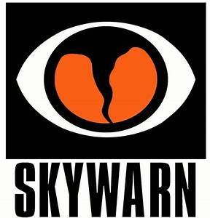Next month is March and that means there will be multiple weather spotter training sessions over most of the state of Ohio. These training sessions and a good weather alert radio or cell phone alert app are two of the steps you can take to help protect yourself and your family if a severe weather situation arises.

2019 NWS WILMINGTON OHIO SPOTTER TRAINING SCHEDULE continued

Classes are free and open to the public, but some may require advanced registration.  
You do *not* need to be a resident of the county in which a talk is being held in order to attend.  
Each class lasts about 1.5 to 2 hours and is led by a National Weather Service meteorologist  
who will discuss techniques and safety for severe weather spotting. Once you attend a class,  
you are an officially trained spotter and can report severe weather to your NWS office.

Monday, March 18 6:00pm Fairfield County OH

Tuesday, March 19 6:30pm Darke County OH

Wednesday, March 20 6:30pm Union County OH

Thursday, March 21 6:00pm Wayne County IN

Saturday, March 23 9:00am Franklin County OH

Monday, March 25 7:00pm Owen/Grant County KY

Wednesday, March 27 6:30pm Logan County OH

Thursday, March 28 6:00pm Fayette County OH

Monday, April 1 6:30pm Miami/Shelby County OH

Tuesday, April 2 6:30pm Switzerland County IN

Wednesday, April 3 6:30pm Campbell County KY

Thursday, April 4 7:00pm Delaware County OH

Wednesday, April 10 6:00pm Pickaway County OH

Thursday, April 11 6:00pm Mercer/Auglaize County

Monday, April 15 6:00pm Licking County OH

Tuesday, April 16 3:00pm Lewis County KY

Saturday, May 4 9:00am Advanced Spotter Training Class

TOP^

<http://www.hamiltoncountyohioema.org/wp-content/uploads/2019/02/NWS-Advanced-Weather-Spotter-.pdf>

<https://www.weather.gov/iln/spottertrainingschedule>

<https://www.weather.gov/iln/spottertrainingschedule>

**\*\* Spring Sessions will NOT be conducted by the NWS CLEVELAND in 2019\*\***

The NWS Cleveland staff will not be conducting in-person SKYWARN classes this spring.  Please contact your local county Emergency Manager or SKYWARN coordinator as they may be conducting their own training this year with our materiel.  We are sorry for this inconvenience and we look forward to seeing you in the Fall. See link below:

<https://www.weather.gov/cle/SKYWARN_schedule>

You can find the Ohio County Emergency Management Directory at:

<https://webeoctraining.dps.ohio.gov/ohiocountyEMADirectorList/countyemalist_web.aspx>

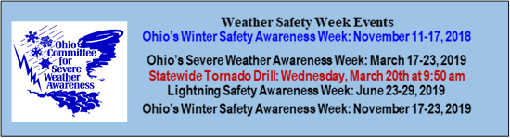[2019 Skywarn Spotter Training - Fulton County Ohio](http://fultonohspotter.eventzilla.net/web/event?eventid=2138704796&dateid=2138628996)

Tuesday, March 19, 2019

**Fulton County EMA Office**8848 OH-108 Suite #105  
Wauseon, OH, 43567

6:00 PM (please arrive 30 minutes early to sign-in)

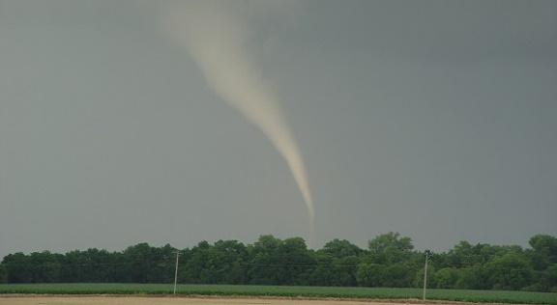The tornadoes this month put people in path of deadly, 170 mph Alabama tornado with about 9 minutes warning people in the path of the deadly tornado that ripped through Lee County, Alabama, had eight to nine minutes of warning before touchdown, said Holly Allen, a senior forecaster with the National Weather Service in Birmingham.

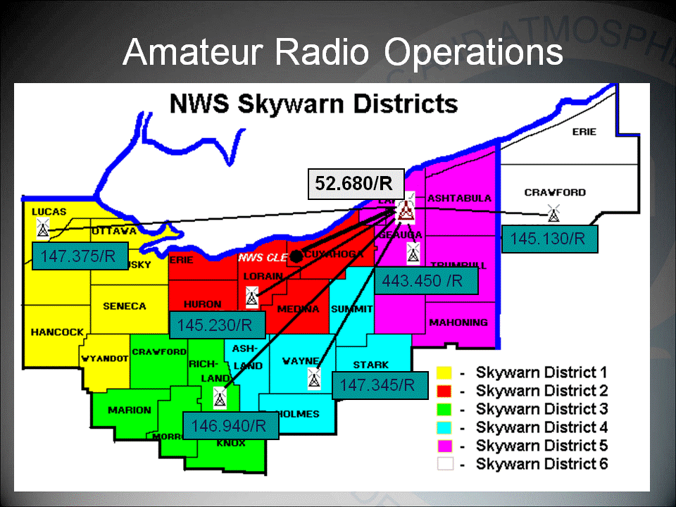

Finally, Sunday morning at 11:04 am CST, about three hours before the tornado hit, the weather service issued a tornado watch for south-central Alabama, Allen said. A watch means conditions are ripe for tornadoes to form.

TOP^

Ohio also had two F0 tornadoes this month. Even though they were in the smallest classification for tornadoes they still did damage.

So, how can you prepare in advance for severe weather like tornadoes. Preparation can mean the saving of you life or that of one of your family member.

First you need to know when severe weather is possible. To do this you need to rely on the National Weather Service who monitors the weather and give warning. Here are a few ways you can keep informed about possible storms and severe weather.

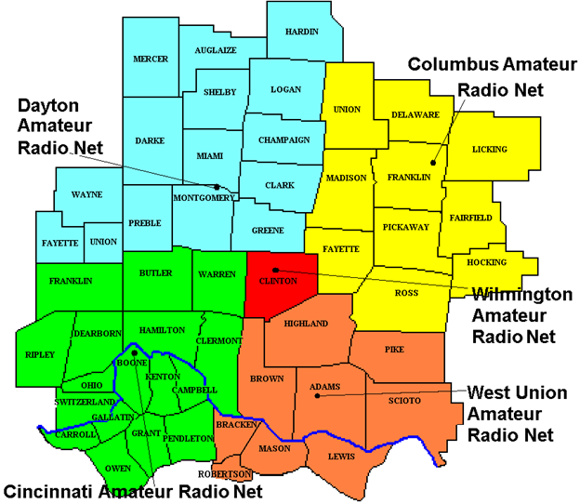

1. Have a weather radio at home and at work to receive severe weather alerts.
2. Get a weather AP for your cell phone to receive alerts from local TV stations
3. Monitor you Skywarn frequency when the net is up during severe weather

|  |  |  |
| --- | --- | --- |
| **Frequencies and Links** | | |
| **Dayton (W8OK)** | 146.640 MHz - Southern Miami Valley 146.835 MHz - Northern Miami Valley | [Website](https://www.dayton-skywarn.org/) |
| **Cincinnati (W8NWS)** | 146.880 MHz - Tri-State Region | [Website](https://www.warn.org/) |
| **Columbus (N8WX)** | 146.760 MHz - Central Ohio | [Website](https://www.severe-weather.org/) |
| **West Union (K8GE)** | 147.000 MHz - South-Central OH / Northeast KY | [Website](https://www.qsl.net/k8ge/) |
| **Wilmington (WX8WIL)** | 147.120 MHz - Clinton County |  |
| [What To Report](https://www.weather.gov/iln/skywarn_report) | | |

Skywarn area charts and frequencies from NWS websites

“Skywarn® and the Skywarn® logo are registered trademarks of the National Oceanic and Atmospheric Administration, used with permission.”

**>> 2019 Ohio ARES NVIS Day <<**

In support of the NVIS antenna test I offer this information to all Amateur Radio Operators.

**On** April 27 the Ohio ARES is planning a NVIS ANTENNA DAY. It would be an excellent time for all traffic handlers to join in this test even if you are not an ARES member. And speaking of ARES membership I encourage all traffic handlers to seek out the ARES in your area and join so you can be better prepared to assist in the event of a disaster in your area.

TOP^

You should be working now on antennas to try out during the event! For more information check out this ARES link <http://arrl-ohio.org/SEC/> . There is more NVIS information and some excellent antenna plans so you can build your own NVIS antenna. One advantage of this antenna is that you will not need a tower or to climb anything to install these antennas as they are all low to ground level antennas.

**HOW NVIS WORKS**

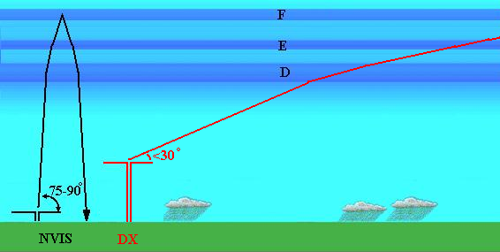

If you don’t know what NVIS is. It stands for Near Vertical Incidence Skywave. RF is launched at a high elevation angle and is refracted back to earth as shown here. Notice that unlike a signal launched at a low angle for DX, the NVIS signal returns to the ground close to the antenna.

NVIS is well suited to regional emergency communication. Reliable NVIS communications are possible out to distances of approximately 300 miles. This means that a small number of NVIS stations are required to provide a statewide network. Amateurs can quickly establish communications using NVIS after a natural disaster because NVIS uses readily available HF equipment and simple antenna that can be constructed from readily available materials and do not require towers or other special types of mounting. CW, SSB and various HF digital modes all can be used with NVIS. See: <http://www.arrl-ohio.org/SEC/>

That's it for this month, have some fun with Amateur Radio.

**73, David WA3EZN**

You can view the STM’s monthly report on the website.. <http://arrl-ohio.org/stm/stm.html>

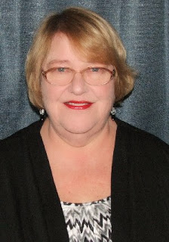***Out and About***

***Lyn Alfman, N8IMW - ASM***

[lynalfman@aol.com](mailto:lynalfman@aol.com)

**SEVERE WEATHER AWARENESS**

On March 3, a tornado outbreak in Alabama destroyed a large area and killed at least 23 people. With the onset of spring and the wild temperature swings of temperatures, this is a recipe for severe weather.

As part of Severe Weather Awareness Week (March 17 – 23), Ohio will participate in a statewide tornado drill and test its Emergency Alert System (EAS) on Wednesday, March 20 at 9:50 a.m. During this time, Ohio counties will sound and test their outdoor warning sirens. If you do not hear the siren in your area, let the local Emergency Management Agency know your location and that the closest siren did not work. Schools, businesses and households are encouraged to practice their tornado drills and emergency plans.

TOP^

To begin preparing for severe weather, you should [build an emergency kit](https://www.ready.gov/build-a-kit) and make a [family communications plan](https://www.ready.gov/make-a-plan). For more information on building an emergency kit or making a family communications plan visit [www.ready.gov/nuild-a-kit](http://www.ready.gov/nuild-a-kit).

If you already have an emergency kit, check and/or replace the batteries in your flashlights and weather radio. You should also replace any supplies such as canned goods, snack foods, and bottled water supplies.

Preparation is key to staying safe and minimizing impacts from tornadoes.

1. **Be Weather-Ready:** Check the forecast regularly to see if you are at risk for tornadoes. Listen to local news or a NOAA Weather Radio to stay informed about tornado watches or warnings. Check Weather-Ready Nation for tips.
2. **Sign Up for Notifications:** Know how your community sends warnings. Some communities have outdoor sirens. Others depend on the media and smart phones to alert residents to severe storms capable of producing tornadoes.
3. **Create a Communications Plan:** Have a family plan that includes an emergency meeting place and related information. Pick a safe room in your home, such as a basement, storm cellar, or interior room on the lowest floor with no windows. Check more ideas for your family plan at: <https://www/ready.gov/male-a-plan>
4. **Practice Your Plan:** Conduct a family severe thunderstorm drill regularly, so everyone knows what to do if a tornado is approaching. Make sure all members of your family know to go there when tornado warnings are issued. Don’t forget the pets if time allows.
5. **Prepare Your Home:** Consider having your safe room reinforced. You can find plans for reinforcing an interior room to provide protection on the Federal Emergency Management Agency website.
6. **Help Your Neighbor:** Encourage your loved ones to prepare for the possibility of tornadoes. Take CPR and first aid training, so you can help if someone is hurt.

What is the difference between a Tornado Watch and a Tornado Warning?

* **Watch:** Tornados are possible in and near the watch area. Be ready to act quickly by moving to your safe room if a warning is issued or you suspect a tornado is approaching. Acting early helps save lives.
* **Warning:** A tornado has been sighted or indicated by weather radar. There is imminent danger to life and property. Move to an interior room on the lowest floor of a sturdy building. Avoid windows. If in a mobile home, a vehicle, or outdoors, move to the closest substantial shelter and protect yourself from flying debris.

In local amateur radio club news:

* + TUSCO Amateur Radio Club held elections on March 7. Here are the new officers: President Gary Green, K8WFN; VP Cindy Gray, KE8JNN; Treasurer Dean Fisher, WB8PLB; Secretary – Vacant; and Activities Chair Mickey Green, KI8BL.
  + Cambridge Amateur Radio Association held elections on February 23: President Jim Shaw, AB8P; VP Larry Dukes, KD8QYV; Secretary Evelyn Barton, KA8NZS; Treasurer Beverly Bunn, KD8MSL; Activities Chair Jordan Stewart, KE8KKC; Program Chair Sonny Alfman, W8FHF; PIO/Newsletter Editor Lyn Alfman. N8IMW; Trustees Alan Day, K8AL; Randy Evilsizor, N8YGM; and Steven Bunn, KD9MFC. CARA will next meet on March 30 at which Bob Howell. AC8VW will demonstrate a 3D Printer.

TOP^

* + Guernsey County ARES reviewed radiograms and started revising its county emergency plan on March 4.
  + Cambridge Area Maker Group has obtained an amateur radio club license – KE8LKZ.
  + Dresden Elementary Amateur Radio Station (D.E.A.R.S.), according to the submitted logs for the February School Club Roundup, placed second for elementary schools. These are preliminary scores; however, they did good considering they only operated for four days instead of five like the other schools. This was because they had a snow day, and the school was not available to them to operate that day.
  + Zanesville Amateur Radio Club had a raffle drawing for a hand-held radio on March 5. Handheld is going to a D.E.A.R.S. student at Dresden Elementary. The ZARC program for April, presented by Sonny Alfman, W8FHF, will be about how to renew your amateur radio license on FCC website.
  + Morgan (County) Amateur Radio Club has already chosen a Field Day site. Several members have been constructed an interface between a Raspberry Pi and their transceivers. They are also experimenting with constructing a device to track real-time water levels on the Muskingum River and making the information accessible via ha, radio or other means. Existing devices can flood, freeze up in winter, or be blocked with ice and/or debris.
  + Coshocton County Amateur Radio Association has also chosen its Field Day site. Randy Fisher, KL7RF, presented information on CoCoRaHS at the last meeting.

Be Safe and be Radio Active!

**73 Lyn N8IMW**

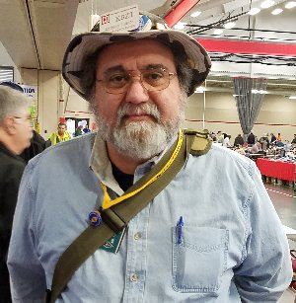***From the Section Youth Coordinator***

***Anthony Luscre, K8ZT - SYC***

[k8zt@arrl.net](mailto:k8zt@arrl.net)

Getting on the HF Bands With Any Ham License

This month’s column is not just for students but for anyone just getting started with Amateur Radio or who needs a jump start to get more active. Now as an educator I am always one to encourage others to learn as much as possible, so I am definitely not suggesting that you do not upgrade your license to General and/or Extra Class. But I know for some hams, especially youngsters, the extra radio theory, electronics, propagation and math may be a little daunting to potential upgraders.

This can be a problem if the person with the Tech license starts to lose interest in VHF and repeaters. With a whole world of HF Radio opportunities out there to re-spark their interest, I want to give you a few options to explore for yourself, your students or other ham friends.

Many new hams are not aware of HF and 6-meter privileges that come with a Technician class license so let's take a look at them and what can be done with them:

TOP^

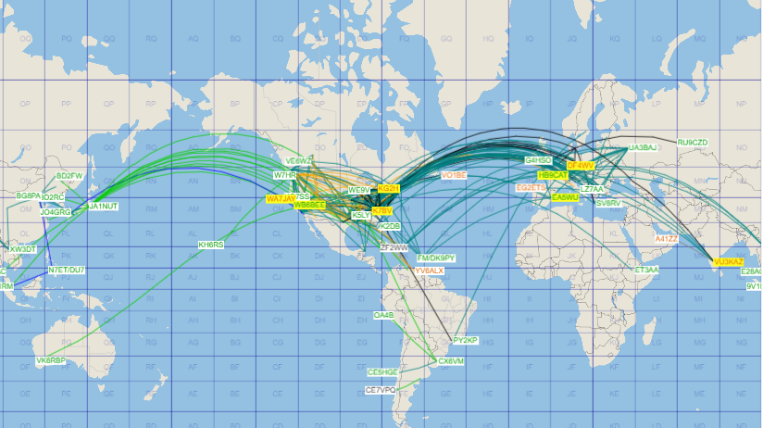

* 6 Meters- Although a VHF band 6 meters has a number of features that can make it resemble the behavior of HF bands at times. Technicians have full privileges on 6 M including Voice, Data and CW.
  + During periods high sunspot activity, the F2 layer of the atmosphere can support worldwide contacts like the HF bands. Unfortunately, we are at an 11-year low point in the cycle right now, so let's skip this one.
  + E Skip, on the other hand, is not dependent on the sunspot cycle and can support regional and sometimes even nationwide and Caribbean contacts. E Skip is more predominate in Summer months but can occur year-round. In addition to SSB voice contacts, the extremely popular new data mode FT8 is especially successful at making E skip contacts under even poor conditions. For additional info on FT8 and MSK144 see my website’s digital page [*www.k8zt.com/digital*](http://www.k8zt.com/digital)and my [*presentation on FT8*](https://docs.google.com/presentation/d/e/2PACX-1vQwN09KY-awo4jUJWPewJNT0EnzkciXYXq6C5RAArYFrnTAeofNy1jtlWSYOo1k7wbP1oAK6o4iGoec/pub?start=false&loop=false&delayms=3000&slide=id.p)*.*
  + Meteor scatter is not dependent on the sun at all and MSK144 digital mode can provide regional and sometimes even nationwide and Caribbean contacts.
* 10 Meters is the highest frequency band has a wide variety of privileges for Technicians. During periods of high sunspot activity, the F2 layer of the atmosphere can support worldwide contacts. Unfortunately, as I mentioned earlier, we are currently at the bottom of sunspot activity. Because of this worldwide and even regional contacts can be rare to come by. But there are still statewide contacts and rare openings (usually during contests) across the Western Hemisphere.
  + SSB Voice on 28.300 through 28.500 MHz.
  + CW on 28.000 to 28.299 MHz
  + Data- RTTY, PSK31 and most recently and promising during poor band conditions FT8!
* 80, 40 & 15 Meters. Although 15 M is also quite dependent on solar activity, both 40 & 80 are bands that are open even during this low sunspot period. These Technician HF privileges are probably a surprise to many, but they exist and are just waiting to be used. The catch? These 80, 40 & 15 Meter privileges are limited to CW, but we will get to that below.

Now before I go any further this is not an article on the pros and cons of CW as a licensing requirement, an argument on old versus new ways of doing things or of any type of operator shaming. Before 1990 all Amateur Radio licenses required at least some code and up until 2007 Code Proficiency was required to have most Voice HF radio privileges. It was something you had to do.

Many learned just enough to get their license but never used it on the air, they really just wanted voice privileges. Or worse yet, got frustrated and lost interest in Amateur Radio. Now there is no code proficiency requirement for any level of Amateur Radio license.

TOP^

Recently for a local class, I was teaching I put together a presentation - [*“Having Fun with Morse, Getting on the Air with CW”*](https://docs.google.com/presentation/d/e/2PACX-1vQ1wCN2WNHQ8JHC16zOAehkV6TV5PAG0DpXSQE45hlHU4hbF2h3YgiZJj5Iy-RTNDrDjJ21saaD4Rp-/pub?start=false&loop=false&delayms=3000). The goal of this presentation was...

* To get you on the HF bands as soon as possible
* To help you get on the air using code
* To learn how it can be a fun and effective way to make contacts on HF

It also described how Morse Code can be Fun and Useful:

* Gets you on HF now!
* More efficient in getting contacts than SSB (especially with QRP- low power)
* Lower cost equipment & simple kits
* A very popular contesting mode
* No one knows how old you are, your gender or your accent
* Doesn’t bother spouse or other nearby (with the shouting of voice contacts)

If you are interested in using these privileges now, I suggest you read the whole presentation. Youcan view it at[*tiny.cc/fwm*](https://drive.google.com/file/d/14LA9GqRAw6_H75pkGNU4WYCB0JYzAgaY/view). It has a variety of tips to get you on CW quickly and fairly painlessly even if you were never interested before, don’t think you can learn it or have tried unsuccessfully before. Again this is not about forcing you to learn something you but getting you operating on HF. If you have questions, comments or suggestions please feel free to email me[*k8zt@arrl.net*](mailto:k8zt@arrl.net).

If you are interested in having this presentation for a local club meeting you have three options:

1. If you are close enough or in the path of my travels around the state please contact me for possible scheduling and I will do the presentation at your meeting and I will bring the show and tell items
2. If I will not be able to make it in person we could arrange to do a remote presentation to your group if you have Internet access at your meeting (but you will need to provide the show and tell items)
3. If you want to do the presentation you are welcome to use my document (just make sure you acknowledge me as the writer to protect yourself)

Until next time hope to work you on HF NOW!

**73, Anthony K8ZT**

*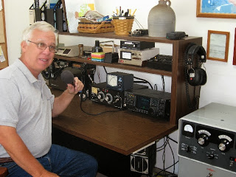****From the Official Observer Coordinator***

***John Perone, W8RXX - OOC***

[w8rxx@arrl.net](mailto:w8rxx@arrl.net)

A total of 884 hours was spent monitoring by the Ohio OO's. No cards (Good or Bad) were sent either.

Does everyone have a copy of the latest FCC rules and regulations? The Fourth Edition effective November 1, 2017 is available from the ARRL. (Item # 1173) or you can simply download it from the government’s website: [>> Here <<](https://www.ecfr.gov/cgi-bin/text-idx?c=ecfr&SID=336ab7469b61ecbfa15086dbf1bf2c59&rgn=div5&view=text&node=47:5.0.1.1.6&idno=47#47:5.0.1.1.6.1.157.1)

**73, John W8RXX**

TOP^

*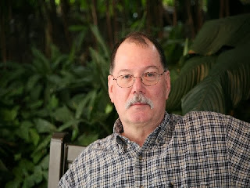****ARES Training Update***

***Jim Yoder, W8ERW – ARES Data Manager***

[w8erw@arrl.net](mailto:w8erw@arrl.net)

ARES Training Update

Yes, winter retains a grip on us. It seems the weather is a regular subject of discussion and always with plenty of speculation and the usual disbelief in the officially rendered forecast as seen on the local TV channel. Punxsutawney Phil surely had it right when he ceremoniously emerged this past month. I suspect when it comes, we will shovel snow one day this spring and mow lawn the next. Quite obviously the rascal Phil does not recognize our need to begin antenna construction early. The shadow of winter remains to include a prediction of another snowy polar blast for the weekend.

We have a Technician class scheduled this month here in Sandusky County. These are always fun and interesting as we meet a few new folks eager to learn our hobby. I’ve finally gotten my friend and former high school classmate Bruce to attend this class. He has been curious for some time, being also “Elmered” into it by another friend and fellow Ham and veteran in Tennessee. We have five class sessions scheduled followed by a VE session. In addition to teaching the course, we also plan on some practical instruction of the ways of things and an introduction of the many modes we employ while engaging our passion of playing radio.

We now have the revisions to the ARES program approved by the ARRL Board. These changes are intended to address the needs of our served agencies and insure that we are ready to perform our mission when the need arises. Training has been modified to address our need to remain relevant and useful to those we serve. Our interest in doing so comes from the recognition that we do play a significant role in times of disaster and a need to demonstrate our ability and the public benefit of our doing so. As the demand for spectrum by commercial interest increase, we must show our worthiness to maintain access to the allocations we have at our disposal.

Although the recently adopted changes are well defined, we must also consider each situation and the local needs of our served agencies. This means we will adjust accordingly and at the direction of our Section Manager, in Ohio we will not see ARES initially making a lot of changes. As those we serve request them, the appropriate changes will be made. Also, some elements of the revised training curriculum are not currently available.

ARRL is in the process of revising the EC-001 and EC-016 courses and the intent is to make them available to ARES members without cost. This is a very positive change for us especially now that these courses are on the list to be added to our training requirements. ICS-706 and ICS-802 are also on the revised list. However, ICS-802 is no longer being offered. Here again, we must make an adjustment.

For the present, the Ohio Section will remain pretty much as we have been with regard to training. Some of you have expressed concerns about the revised training requirements. Let’s allow the process to unfold and recognize that all of this is designed to meet the needs of our served agencies. Currently there is no urgent need to make significant changes and we will not be doing so. The changes will be addressed as future direction rather than hard rules.

TOP^

You will also see some changes to the report that I send to our Section Manager for publication on the ARRL-Ohio.org website. The report is now a more complete listing of all the significant training that we are recording. You will see the courses we are tracking at the top followed by a listing by county of each ARES member who has submitted at least the initial NIMS course certificates. The courses are grouped by color to indicate a progressive relevance.

Please remember that although there are some requirements as expressed by our served agencies, your personal commitment to ARES will dictate the level of training that you pursue. ARES is voluntary and each of us serves according to our ability. Family and job commitments come first as do other responsibilities relative to individual situations. Everyone is encouraged to take advantage of as much of this training as practical and desired.

Thank you for making your Ohio Section the best that we can be. You are “Fantastic” as Scott often describes the training results when I update him with a current training report. Please do not hesitate to let me know if you have questions or concerns. It is my pleasure to help and assist you.

Thank you for your support,

**73, Jim W8ERW**

***The Handbook Give Away***

Hey Gang,

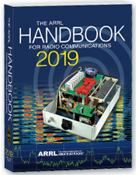Have you registered for the “Handbook Giveaway” drawing for this month yet? If you haven’t, go to: <http://arrl-ohio.org/handbook.html> and get registered.

What’s the catch? I want to get everyone checking in to the Ohio Section website as often as possible, and in order to register each month, you have to visit the website often! There’s nothing else to it. I pay all expenses, and from time to time, I Give Away more than just a Handbook. And, you’ll never know just what months will be those special times that I will have more than just a Handbook to Give Away!!

Many of you ask me just how do I know when the drawing is on? Well, that’s easy all you need to do is check in on the Ohio Section Website on a regular basis and watch for the big [**RED**](http://arrl-ohio.org/handbook.html)Arrow that will appear on the left side of the page. This is the sign that the drawing is on and you need to get registered. So, keep a sharp eye out on the website and check in often! <http://arrl-ohio.org>

TOP^

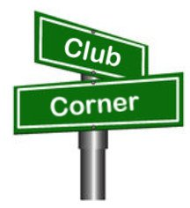***Club Corner***

This is YOUR cornner of the newsletter. Send me what your club is doing and I’ll make sure that it gets in. Got a special event or club project that you want everyone to know about? Send it to me!. Need help with a project? Send it to me.

Let me know what you club is up to. Are you going to have a special guest at your meeting or are you having a special anniversary? Just sent it to:

[n8sy@n8sy.com](mailto:n8sy@n8sy.com)

#########



***Help Wanted***

***HamVention© is in need of volunteers*** to assist in various capacities during the May 17-19 show in Xenia.

Although some set up help is needed on Wednesday, most opportunities to assist with other duties will start on Thursday and continue through Sunday.

This year there a need for additional golf cart drivers because the shuttle wagons will not be used. These openings will require attendance at a training session.

You do not have to be a Dayton ARA member to volunteer.  A minimum of six hours will reward you with an admission ticket and some other goodies.

Want more information? Check out volunteers@hamvention.org. This is a great opportunity to give back to our hobby and meet some friends you didn’t know you had.

#########

***Science Fair Volunteers***

Hello everyone!

Well, that time of year has arrived again, and the Mohican District Science Fair is only weeks away (March 23).  We will be having our work night on **Tuesday, March 19**, at 6:00 p.m. in Room 218 Kettering at Ashland University.  I hope to see you there - the more who can make it, the faster things will go.  Please let me know one way or the other if you will be able to attend.

One huge area of concern (as always) is the judging. As of right now, there are 172 projects registered and only 43 judges.  Since the registration deadline is this Friday, I expect the number of projects to grow.

TOP^

So, I am asking you to please, please, please find as many qualified judges as possible.  They can register on our website at [mdsd.apps.ashland.edu](http://mdsd.apps.ashland.edu).

I am currently spending 5-6 hours a day on the registration website checking in participants and sending email messages if there are problems, so I am hoping that you can help me out in finding more judges.  I think we need at least 100 total and I just don't have time right now to search for judges.

I look forward to seeing everyone on the 19th.

Need more info? Contact Mark: [andressmg@frontier.com](mailto:andressmg@frontier.com)

#########

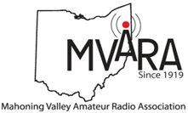***Mahoning Valley ARC***

***Help Wanted -***

The Youngstown Road Runners Club is having their annual Mill Creek Distance Classis half-marathon race on **Sunday, March 24**, & amateur radio operators are once again being asked to help.  We will be meeting in the Fellows Riverside Gardens parking lot at 8:00 so everybody can be in their position before the races starts.

Need more info? Contact Jim: [wb8ujs@arrl.net](mailto:wb8ujs@arrl.net)

#########

***TMRA Holding Classes***

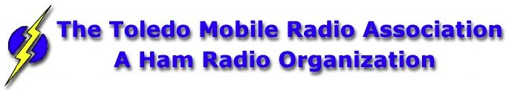

SPRING TECHNICIANS (Entry Level) HAM RADIO LICENSE CLASS (2 DAY COURSE) -   
  
NOTE:  Two separate days (**March 23rd, and April 6th**), with test session on April 6th at end of class.  
  
The TMRA Education Committee has released the schedule for the Spring Technicians Class. The class schedule will follow our traditional style. Two classes held two weeks apart and a V.E. Testing Session after the final class. The Class is FREE, you will have to provide your own book, or one can be purchased from the TMRA ($25.00).  (ARRL Edition 4 book)  The testing session will cost $15.00 which is the standard fee set by the ARRL.  
  
THE DATES ARE AS LISTED BELOW  
* CLASS ONE WILL BE HELD ON **SATURDAY MARCH 23RD**, 2019 FROM 08:00 TILL 17:00

* CLASS TWO WILL BE HELD ON **SATURDAY APRIL 6TH**, 2019 FROM 08:00 TILL 17:00 (This includes the V.E.Session)

TOP^

Both classes will be held at  
LUCAS COUNTY EMS TRAINING CENTER  
2127 JEFFERSON AVE  
TOLEDO OHIO 43624  
  
To Enroll in the Class, or for more Information please contact  
STEVE STALKER / KC8TVW 419-467-3734 [kc8tvw@arrl.net](mailto:kc8tvw@arrl.net)

Also, please join us for a 4-hour follow-on class on April 13th (9am) called, "I now have my ham radio License, now what?". This class is intended to help get newly licensed hams started with additional needed information. Location is TBD.

#########

***New Ham - Info Class -* Saturday, April 13, 2019 at 9 AM – 1 PM**

***Relaxed Learning Session: I'm new to Amateur Radio! Now what?!***

Join Toledo Mobile Radio Association Members at the Lucas County EMS Training Center for a FREE learning and Q&A session that should work to help you get started with some of the practical items that we all wish we knew when starting off in Ham Radio. Any/everyone is welcome, and you do not have to have attended the class to attend. Most hams licensed less than 3 years will find the session useful.  
  
This session will be run as a "class” but is open to ANY questions along the way. Folks are free to come and go as you wish. This training session is a great place to get to know TMRA members and for newer amateur radio operators to ask questions related to items they are concerned about or need help with. We know that this hobby has a lot of new items for everyone to get familiar with, so this is an attempt to short-cut that learning!  
  
We'll discuss and help new hams resolve some of the typical early ham radio challenges including (but not limited to) the following types of discussion items (no specific order):

* Answer any early questions and discuss list of items that we all have soon after becoming a ham. (and worries that we each had)
* Discuss Hand-held and mobile radio types / drawbacks and benefits. Who can help me program it? How can I make my HT more effective?
* What is needed to setup and use a mobile or "base" radio - in car or in home (and benefits and types).
* Discuss Effective Radiated Power in terms of Antenna benefits - Discuss types of antennas indoor/outdoor options (and why). Horizontal vs. Vertical antennas.
* Types of feedline (we often refer to "coax) and what you will need (and for what) - and where to find it.
* VHF/UHF vs HF - Who can I talk to and when?
* Discuss using local Repeaters, internet linked repeaters, PL Tones, (repeaterbook/radio reference)
* Discuss Simplex vs Repeater typical etiquette (just so you know) - Examples: Q signals, calling CQ, breaks, etc.
* First Contacts – what to expect (most important, you won't be judged so don't "sweat it".... really...)

TOP^

* Hamfests + Ham Conventions. - Why bother?
* Where should I buy equipment and what are the risks?
* Useful websites
* Foxhunting and Satellites - how/where?
* Where to find manuals and information?
* If there is time: Antenna Analyzers and SWR Meters - what are they and when do I need one?
* If there is time: N vs PL-259, vs SMA, versus BNC connectors
* Benefits of joining organizations/clubs
* Foxhunts - what are they and how does it work? Do I need anything?
* HF - club events (what can I participate with?) - Operating events.
* Callsigns, vanity and considerations
* QSL Cards and Logbook of the World
* Propagation - Tropo ducting, Sporatic E, Aurora, sunspot cycle, seasonal patterns

We look forward to seeing you there!

#########

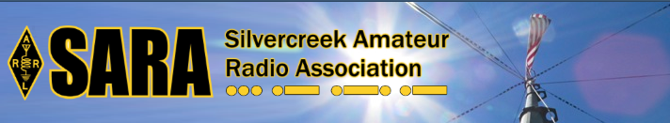SARA is partnering/supporting Wayne County EMA in the offering of the SKYWARN training this year. As you may have heard, budget and staffing issues in the Cleveland NWS office has led them to cancel the NWS-lead SKYWARN classes. EMAs and ARES ECs are being encouraged to hold the SKYWARN training directly.

SARA is playing a supporting role to the Wayne County EMA which is holding a session for this region. The date will be **Monday, May 6th from 6p - 8p.** Volunteers will be needed 5p - 8:30pm. The tentative location is Chippewa Jr/Sr High School in Doylestown. Volunteers will help register attendees and print the SKYWARN training cards with ID numbers. Fred Sheppard KD8GYS will be assisting Joe Villegas with the class.

Additionally, SARA will have a table with some amateur radio materials available to spread the word about our hobby and service.

If you can volunteer your time, please contact me so I can add you to the roster. Please note that volunteers will not be able to be present in the class for the entire session as volunteers will register latecomers and also print and organize the ID cards.

Thanks! For more information or questions, contact Jason, N8JDM [jason@mfamily.org](mailto:jason@mfamily.org)

#########

TOP^

***Pioneer Bus Trip to Hamvention***

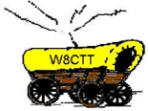It is never too early to plan a trip to Hamvention. Each year the Pioneer Amateur Radio Fellowship has offered to bus hams to this great event. The bus leaves at 5:30 AM the Saturday of Hamvention, it does stop at McDonald's for breakfast and arrives at Hamvention about 9am, just in time for the doors to be open. The bus leaves around 5pm and stops for a buffet for supper! You won’t go hungry on this trip for sure! You arrive back at the pickup point about 9:30pm, so it’s not too late, but you will have had a full day for sure.

The bus has a number of very large storage areas for all your purchases, so you don’t have to worry if you’ll have room for that “just can’t do without boat anchor!”

[Click Here](https://drive.google.com/file/d/1QPUeDDMljARN62b9cV90SBypgtcxJtJ9/view) to read the flier and the form used to register for this trip.

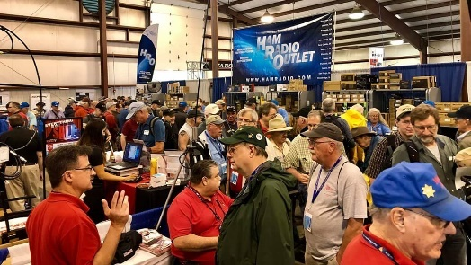[***Upcoming Hamfests***](http://arrl-ohio.org/hamfests.html)

04/13/2019 | [65th Annual Cuyahoga Falls ARC](http://www.arrl.org/hamfests/65th-annual-cuyahoga-falls-amateur-radio-club-hamfest)

Location: Cuyahoga Falls , OH  
Type: ARRL Hamfest  
Sponsor: The Cuyahoga Falls ARC, Inc.  
Website: [http://cfarc.org](http://cfarc.org/)

|  |  |
| --- | --- |
| 04/20/2019 | Portsmouth Radio Club Hamfest Location: Portsmouth, OH Sponsor: Portsmouth Radio Club  Website: <https://www.facebook.com/w4pox/> | 04/28/2019 | [Athens Hamfest](http://www.arrl.org/hamfests/athens-hamfest-8)  Location: Athens, OH Sponsor: Athens County Amateur Radio Association Website: <http://www.ac-ara.org/> |

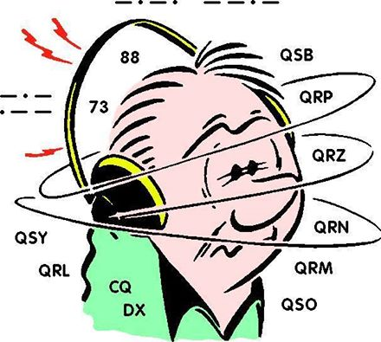***DX This Week***

*(from Bill, AJ8B)*

DX This Week – The Other Side – Part 1

Bill AJ8B ([aj8b@arrl.net](mailto:aj8b@arrl.net), @AJ8B, [www.aj8b.com](http://www.aj8b.com) or [www.swodxa.org](http://www.swodxa.org) )  
 CWOPs Member #1567

I have been on the air in one mode or another since 1971. In that time, I can list the 5 or 6 hams that I have heard on the air and that I instantly stopped to listen to and learn. HK3C – John, is absolutely one of the guys. I have worked John numerous times and keep in touch with him regularly. He is certainly the “best friend I have never met”! He has the best audio quality on the air, is courteous and an excellent operator.

Part 1 is how to handle a Pileup from the DX Standpoint. Although you may never be on that end of the keyer, you can learn a lot as you read the article.

TOP^

When we started the SWODXA newsletter, I have just to get input from John. I have reprinted the first of two articles from John with the permission of SWODXA. You can check in on John at [www.hk3c.com](http://www.hk3c.com).

+ --------------------------------------------------------------------------------------------------------------------+

**Handling Pileups - Critical Success Factors**

**A Guide for Beginners**

Few of us will ever have opportunity to operate as “rare DX” and experience the deafening roar at the DX-station-end of a phone pileup. Should you so blessed, it can be both heart-stopping (exciting) and mind-numbingly intimidating. But once you get rolling and contacts begin to fill the log, there is no greater thrill!

Whether you’re planning a one week vacation trip on an island in the Caribbean, armed with your IC-7000 and enough coax and wire for a simple dipole, or you live in a semi-rare and somewhat exotic country in the South America, the following list of considerations may help you handle your pileups more efficiently and effectively, resulting in more contacts - and ultimately a more satisfying experience.

These are referred to as “critical success factors”. Note: they are not all encompassing and are only meant as a sort of “Guide for Beginners” who have interest in and passion for the adventure of DXing and handling pileups.

**Awareness and Support:**

Successfully handling a pileup requires knowledge and understanding of current and changing band conditions, an appreciation of propagation patterns, as well as feedback from trusted sources.

Knowing where, and how well you are being heard, and how propagation shifts over time, will help you more effectively manage your pileups, especially if you are operating from a rare, exotic or much sought-after call area. Awareness will help you understand caller behavior - how eager or excited callers can be to make the contact, especially if your operation is for a very brief period of time. Awareness will spell the difference between an orderly, well orchestrated undertaking with good pace and rhythm - and sheer band chaos and pandemonium.

Understanding your station limitations will enhance your approach, attitude and level of professionalism as you conduct business. For example, should you be plagued with local power line, atmospheric noise, or other severe receiving limitations, being aware of your station’s true capability is vital.

Independent of your operating skill, ability and experience, or your station equipment and antenna system, your general awareness is a critical success factor governing your pileup handling success. The “*who, what, where, why and how*” of your operation, for example - propagation, where you are on the band and other activity around you, your operating schedule, your support network (access to the Internet, key stations in strategic locations who may be able to help control or manage in case of difficulty, etc.) - will all contribute to your level of awareness and support, to make the experience pleasurable for all and a successful undertaking for you.

TOP^

**Control:**

Given the vagaries of propagation and the unpredictable nature of callers, one rarely is ever in complete control - however certain operating techniques and practices will help you to maintain control in handling your pileups.

For example, should the number or behavior of callers begin to negatively impact or significantly slow the orderly flow of contacts, consider changing from simplex to split operation. Before you do however, understand the impact on others on the band around you, since your operation will now consume greater bandwidth. Weigh this against the potential increase and improvement in contact flow, and evaluate your knowledge and experience of operating “split”. Ensure a good understanding of how to set your radio in the split mode - ahead of time.

And before you get started, have a game plan on how to proceed. How effectively you control the pileup will have a significant impact of the orderly and efficient flow of contacts. As the DX station, you set the standard. For example, while it may be tempting to provide your name and location information on every contact, know this will slow the process since callers will be similarly motivated. If the volume of callers is large, stick to call sign and report (usually 5-9) - then move on. Once you achieve a rhythm, pace and contact flow, taking into consideration caller volume, propagation, your comfort and ability, etc., your degree of control will increase to the point where you could communicate instructions as required, and/or adjust your contact handling style on the fly.

Setting a good example is important, so remain calm - and stay humble.

Don’t ignore strong stations; handle them first - get them out of the way - rather than having them call back again and again, blotting out weaker stations in the pileup. And, depending on your ability, knowledge or experience, demonstrate a spirit of fair play in maintaining control, avoiding a collapse into disorder. Don’t be afraid to say what call or call area you’re listening for. Conversely, avoid favoring any one continent, country or call area unduly - unless there’s a good reason to do so.

Decide early, and show consistency, in how you respond to callers (first station heard, last one heard, partial call signs, etc.), if only to establish a pattern. This will help improve the rhythm, pace and flow of contacts. If you set the standard early, and are consistent, the pileup can be better controlled - with more contacts in your log and a higher level of satisfaction - by all. Do listen for QRP stations - and avoid rewarding bad behavior.

**Management:**

Most DX stations at the epicenter of a large pileup will face completing objectives best described as “quantity” versus “quality”. Irrespective of operator knowledge, experience or ability, pileup management will always be critical. How well you perform will ultimately have a huge impact on results.

For example, taking-in what you hear (and feel), and adjusting your style as required to improve the pace and rhythm of contact flow is a pre-requisite to handling a pileup effectively and efficiently. Practice does indeed make perfect, but nothing trumps smart listening with immediate remedial action. Let your personality, passion and versatility guide you in this regard. Be yourself - and have fun.

Always show respect, be courteous, and have empathy for callers who may exhibit varying levels of operating experience and skill, or language comprehension, not to mention station equipment and propagation conditions to your location. Remember to express yourself using standard phonetics and enunciate your call sign and signal report clearly.

TOP^

An appropriate microphone feeding a properly adjusted transmitter - mic gain, compression level, treble and bass settings - for good articulation will contribute to successful pileup handling. Managing your pileup handling performance intelligently is a critical success factor.

**Playing to the Strengths of Propagation and the Terminator Line**

Most new DXpeditioners or Hams vacationing outside North America who operate as “rare DX” fail to appreciate that propagation often determines who they should be listening for as a priority in pileups. The bands close earlier to Europe than to North America when you are operating from the Caribbean or Latin America.

You should listen for and aim to work stations in eastern Europe and Russia first, saving western and southern Europe for late afternoon. Once the sun has set in Europe, turn your attention (and your beam antenna, if you are so lucky) to North America and repeat the strategy. Start with eastern USA/Canada and recognize when the band shifts to the mid-west and eventually to the west coast.

Remember: the terminator line is your propagation enhancer for weak stations, especially across the poles to certain parts of Europe and Asia. Periodically ask stations to stand by as you listen for Europe or Asia. The last bit of advice pertains to Pacific region hams - ZL and VK stations largely. They can be worked nearly most hours of the day if they are on. The important thing is not to forget to ask for them.

**Miscellaneous:**

This final critical success factor deals with things largely beyond your control, viz., interference and misbehavers, nevertheless, how you handle these will set you apart from the crowd - as a pro.

Interference, accidental or intentional - is a reality of pileups. Some Hams may not like DXing (or contests) and may show their displeasure by deliberately interfering with your operation. On the other hand, propagation may have changed such that stations previously out of your skip zone now become clearly audible, resulting in interference to your pileup. No matter the circumstance, it’s important to remain calm and avoid voicing anger or disrespectful language. Simply ask the pileup to standby while the situation clarifies itself and you can determine more clearly what you up against. Derogatory comments being addressed your way are best ignored. At worst, changing skip conditions may necessitate a change in your calling or listening frequency.

On the other hand, you may not need to do anything, as members in the pileup may already have identified the source of the interference and may have undertaken “*police action*” to dissuade the interlopers. Soon the frequency will likely be clear again, and you can resume as if nothing had happened. Above all, do not engage with or acknowledge intentional interferers. Keep to the high road - you will likely find you have more supporters than you imagined who will rally to your defence. Should the interference situation become explosive or unpleasant, simply QSY. If this is not practical, take a break and come back to it later.

Respecting “misbehavers” - those who make a general nuisance of themselves by calling out of turn regardless of who you say you’re listening for, or those who call continuously over everyone else (you know the ones - the guys with no receiver), it is best to ignore these callers (if possible). If you ignore them long enough, they may cease and desist - and simply go away. Avoid any display of displeasure and avoid mentioning their call sign. Instead, remain calm, proceeding as best you can, to work the pileup professionally. As mentioned earlier, you may not need to take any action - others may do it for you.

TOP^

Maintaining proper balance and a positive attitude is key when and if things turn nasty. Remember, a pileup is far from being a matter of life or death - so keep cool and stay focused and professional.

Finally, don’t forget to post QSL information via QRZ.com, your personal website, DX Coffee, Daily DX Bulletin, or on one of the many other Internet resources.

Enjoy your pileups - and good DX!

73, John - HK3C

+ --------------------------------------------------------------------------------------------------------------------+

From our friend at the DailyDX and the WeeklyDX, and the best source for DX information, (<http://www.dailydx.com/> ) Bernie has this to report:

**XZ – Myanmar -** Starting March 20th JH1NBN, Yuki, will be back in Myanmar, formerly known as Burma. During his spare time he will be QRV as XZ2C until March 28th. In April he plans to get a JT license and then back to 9N7BN in Nepal.

**ZL9 - New Zealand Subantarctic Islands -** Early last week ZL2TUD, John, came across ZL9CNB/MM, Charles, on 40 meters SSB (7.115 MHz), between 08 and 09Z. He was only there for a few days and very close to Enderby Island. Charles is on a yacht and has "special permission to enter this world heritage site".

**3Y - Bouvet Island -** Last week the 3Y0I team tweeted "FLASH NEWS: The 3Y0I Team re-assembles in Cape Town, while operators return to South Africa. Meanwhile, the rest of the team members who are currently in ZS, finalize the very last vessel preparations. Stay tuned for further news coming soon".

More info can be found at [www.swodxa.org](http://www.swodxa.org) or [www.aj8b.com](http://www.aj8b.com)

***SWODXA DX DINNER® ANNOUNCEMENT***

Mindi Jones – KC8CKW ([kc8ckw@fuse.net](mailto:kc8ckw@fuse.net))

**FOR IMMEDIATE RELEASE**

The SouthWest Ohio DX Association (SWODXA) has announced that Charles Wooten, NF4A, will be the keynote speaker at the 34th annual DX Dinner®. **The dinner, held in conjunction with the 2019 Dayton Hamvention®, will be on Friday, May 17th, at the Marriott Hotel in Dayton**.

Charles Wooten, NF4A, has been licensed for over 56 years and has been a DXer from the start. Charlie has achieved the DXCC Honor Roll. He is the current Southeastern Division Representative on the ARRL Contest

Advisory Committee. He was a referee for the WRTC-2006 international team championship held in Brazil in July 2006, WRTC-2014 New England/USA, and WRTC-2018 Lutherstadt, Germany.

TOP^

• Amateur call signs held: P4/WA4IMC (Aruba), HA/WA4IMC(Hungary), OK8EMC (first US ham to hold OK Callsign..1991), T9/NF4A(Bosnia), 9A/WA4IMC(Croatia), 9A/NF4A(Croatia), C92A (Mozambique). Currently holds Croatian call sign 9A5PC.

• Member of K4M DXpedition to Midway Island, 2009

• Member of PJ7E DXpedtion to St Maarten 2010

• Member of C82DX DXpedition to Mozambique 2013

Charlie was named Clear Channel Radio Small Market Engineer of the Year in 2003 and 2004 and the Clear Channel Radio National Engineer of the Year in 2005.

For 14 years, Charlie was a Broadcast Engineering Consultant, building over 120 broadcast facilities (RF and Studio plants) including over 30 in Eastern Europe (Czechoslovakia…now Czech Republic and Slovakia, Hungary and Croatia) from 1991-1997 for the US State Department after the fall of communism.

Charlie is a Senior Member, Society of Broadcast Engineers and is currently the Director of Engineering and IT, iHeart Media (formerly Clear Channel), Panama City, FL

For more information and to order dinner tickets, visit: [WWW.SWODXAEVENTS.ORG](http://WWW.SWODXAEVENTS.ORG) and follow us on Twitter (@SWODXA).

***A******RLD011 DX news***

This week's bulletin was made possible with information provided by 5B4ALX, The Daily DX, The OPDX Bulletin, 425 DX News, DXNL, Contest Corral from QST and the ARRL Contest Calendar and WA7BNM web sites.

Thanks to all.

**VIET NAM, 3W.** Jean-Pierre, F6CTF will be QRV as 3W9JF from Hoi An from March 16 to April 6. Activity will be on 80, 40, 20 and 17 meters using CW and SSB. QSL direct to EA5GL.

**TOGO, 5V.** Members of the EI DX Group are QRV as 5V7EI until March 26. Activity is on 160 to 10 meters using CW, SSB and various digital modes with five stations active. QSL via M0OXO.

**UGANDA, 5X.** Members of the Italian DXpedition Team are QRV as 5X3C until March 25. Activity is on the HF bands using CW, SSB and RTTY.

They are active as 5X3E using FT8. QSL direct to I2YSB.

**SENEGAL, 6W.** Jacques, F6HMJ will be QRV as 6W7/F6HMJ from March 19 to April 28. Activity will be on 80 to 10 meters using mostly CW with some SSB. QSL to home call.

**LESOTHO, 7P.** A group of operators are QRV as 7P8LB until March 16.

Activity is on the HF bands using CW, SSB and FT8 with two to three stations active. QSL via M0OXO.

TOP^

**TONGA, A3.** Masa, JA0RQV will be QRV as A35JP from Tongatapu Island, IOTA OC-049, from March 16 to 27. Activity will be on 80 to 6 meters using CW, SSB and FT8. QSL to home call.

**MOZAMBIQUE, C9.** Pedro, CT7AHV is QRV as C91AHV from Matola Rio until March 17. Activity is on 80, 40, 20 and 15 meters using SSB, WSPR and FT8. QSL to home call.

**PHILIPPINES, DU.** Press, N6SS is QRV as DU6/N6SS from Panay Island, IOTA OC-129, until April 17. Activity is on 160, 80- and 40-meters using CW, SSB and FT8. This includes being an entry in the upcoming CQ World Wide WPX SSB contest. QSL to home call.

**NIUE, E6.** Alex, 5B4ALX will be QRV as E6ET from Niue, IOTA OC-040, from March 19 to April 2. Activity will be on 160 to 6 meters, except 80 meters, but including 60 meters, using CW, SSB, RTTY and FT8. This includes being an entry in the upcoming CQ World Wide WPX SSB contest. QSL to home call.

**SPAIN, EA.** Special event station EE100V is QRV during all of March to celebrate the centennial anniversary of the Valencia Football Club. QSL direct to EA5YJ.

**JERSEY, GJ.** Kazu, JK3GAD is QRV as MJ0CFW until March 17. He will be active as MJ5Z in the Russian DX contest. QSL via LoTW.

**CURACAO, PJ2.** Andreas, DK5ON is QRV as PJ2/DK5ON until March 30. Activity is on 80 to 6 meters, including 60 meters, using CW, SSB, RTTY and FT8. This includes being active in the Russian DX contest.

QSL to home call.

**INDIA, VU.** Members of the Bangalore Amateur Radio Club are QRV with special call sign AU60BARC until May 13 to celebrate the club's 60th anniversary. QSL via Club Log.

**MYANMAR, XZ.** Yuki, JH1NBN will be QRV as XZ2C from March 20 to 28.

Activity will be on 15, 12, 10 and 6 meters using all modes and QRP power. QSL to home call.

OPERATION APPROVED FOR DXCC CREDIT. The following operation is approved for DXCC credit: Tristan da Cunha and Gough Island, ZD9CW, 2018 operation.

THIS WEEKEND ON THE RADIO. The BARTG HF RTTY Contest, Russian DX Contest, AWA John Rollins Memorial DX CW Contest, QRP 80-Meter CW Fox Hunt, NCCC RTTY Sprint, NCCC CW Sprint, AGCW VHF/UHF Contest, Louisiana QSO Party, Virginia QSO Party, Feld Hell Sprint and the UBA Spring 80-Meter SSB Contest are all on tap for this weekend.

The Bucharest Contest and Run for the Bacon QRP CW Contest are scheduled for March 18.

The CLARA Chatter Party is scheduled for March 19.

The CWops Mini-CWT Test, QRP 40-Meter CW Fox Hunt and Phone Fray are scheduled for March 20.

The Canadian National Parks on the Air, CNPOTA, operating event runs for the entire year of 2019, with special stations active from Canada's parks and historic sites.

TOP^

***Special Events***

* **04/13/2019 | 7th Annual Earth Day Celebration**

Apr 13, 1500Z-2000Z, W8PRC, Cleveland, OH. Parma Radio Club. 14.245 7.195. QSL. Parma Radio Club, 8111 Laumer Ave., Cleveland, OH 44105. Our 7th Annual Earth Day Celebration. Operating on solar power from historic, educational Stearns Farm in the Parma, Ohio town center. [www.parmaradioclub.com](http://www.parmaradioclub.com)

***ARRL Contest Corner***

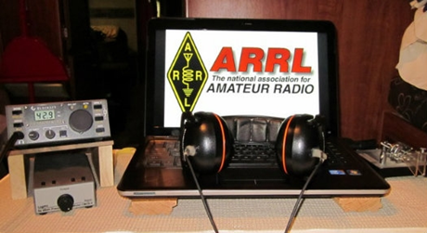

An expanded, downloadable version of *QST'*s [Contest Corral](http://www.arrl.org/contest-calendar) is available as a PDF. Check the sponsor's Web site for information on operating time restrictions and other instructions.

|  |  |
| --- | --- |
| **March 18**   * [Run for the Bacon QRP Contest](http://qrpcontest.com/pigrun/) * [Bucharest Contest](http://yo3test201x.blogspot.ro/p/blog-page.html) | **March 19**   * [CLARA Chatter Party](http://www.clarayl.ca/index.php/awards-certificates-to-work-for/clara-chatter-party-rules) |
| **March 20**   * [QRP Fox Hunt](http://www.qrpfoxhunt.org/winter_rules.htm) * [Phone Fray](http://www.perluma.com/Phone_Fray_Contest_Rules.pdf) * [CWops Mini-CWT Test](https://cwops.org/cwops-tests/) | |

***One Question Questionnaire***

Hey Gang

There’s another NEW – one question – questionnaire on the Ohio Section Website! <http://arrlohio.org>

This past week’s poll has shown some interesting facts. Just about 28% of you have gotten your WAS Award… That’s really fantastic!

Anyway, these questions are all in fun and I hope that you are enjoying answering these “ONE QUESTION” questionnaires. Ok, enough on that, here’s the next question for you to answer…

**“What is your favorite HF band?”**

TOP^

You’ll find the “One Question” questionnaire on the Ohio Section Website! <http://arrlohio.org> It’s all in fun and it’s not a scientific survey in any way, but we are learning some things that we didn’t know from these questions. I hope that you are enjoying answering these “One Question” questionnaires.

***[V.E. Test Sessions](http://www.arrl.org/find-an-amateur-radio-license-exam-session)***

*(from arrl)*

|  |  |
| --- | --- |
| 03/19/2019 | [Sandusky OH 44870-1926](http://www.arrl.org/exam_sessions/sandusky-oh-44870-1926-127)  Sponsor: Sandusky, Ohio VE Team Location: Sandusky Radio Club Time: 7:00 PM (Walk-ins allowed)  [Learn More](http://www.arrl.org/exam_sessions/sandusky-oh-44870-1926-127) | 03/20/2019 | [Dayton OH 45424-3304](http://www.arrl.org/exam_sessions/dayton-oh-45424-3304-32)  Sponsor: Dayton Amt Radio Assoc Location: Dayton Amt Radio Assoc Time: 7:00 PM (No Walk-ins / Call ahead)  [Learn More](http://www.arrl.org/exam_sessions/dayton-oh-45424-3304-32) |
| 03/20/2019 | [Middletown OH 45042](http://www.arrl.org/exam_sessions/middletown-oh-45042-40)  Sponsor: Dial Radio Club Location: Miami University-Middletown Time: 6:00 PM (Walk-ins allowed)  [Learn More](http://www.arrl.org/exam_sessions/middletown-oh-45042-40) | 03/21/2019 | [Medina OH 44256-2460](http://www.arrl.org/exam_sessions/medina-oh-44256-2460-3)  Sponsor: Medina 2 Meter Group Location: Medina County Career Center Time: 6:30 PM (Walk-ins allowed)  [Learn Mor](http://www.arrl.org/exam_sessions/medina-oh-44256-2460-3) |
| 03/23/2019 | [Springfield OH 45506-1607](http://www.arrl.org/exam_sessions/springfield-oh-45506-1607-43)  Sponsor: CLARA Location: Main Branch Time: 11:30 AM (Walk-ins allowed)  [Learn More](http://www.arrl.org/exam_sessions/springfield-oh-45506-1607-43) | 03/24/2019 | [Akron OH 44326-1000](http://www.arrl.org/exam_sessions/akron-oh-44326-1000-7)  Sponsor: Cuyahoga Falls ARC Location: Akron Summit Co Library Time: 2:00 PM (No Walk-ins / Call ahead)  [Learn More](http://www.arrl.org/exam_sessions/akron-oh-44326-1000-7) |
| 03/30/2019 | [Wauseon OH 43567-9244](http://www.arrl.org/exam_sessions/wauseon-oh-43567-9244-9)  Sponsor: Fulton City Radio Club Location: George's Radop & Antenna Service Time: 9:00 AM (No Walk-ins / Call ahead)  [Learn More](http://www.arrl.org/exam_sessions/wauseon-oh-43567-9244-9) | 04/06/2019 | [Bryan OH 43506-8410](http://www.arrl.org/exam_sessions/bryan-oh-43506-8410-55)  Sponsor: Williams County ARC Location: Willliams County 911/EMA Time: 10:00 AM (Walk-ins allowed)  [Learn More](http://www.arrl.org/exam_sessions/bryan-oh-43506-8410-55) |
| 04/06/2019 | [Ravenna OH 44266-2191](http://www.arrl.org/exam_sessions/ravenna-oh-44266-2191-60)  Sponsor: Portage County ARS Inc. Location: PCARS Club Site (Rear of complex, under BIG tower) Time: 10:00 AM (Walk-ins allowed)  [Learn More](http://www.arrl.org/exam_sessions/ravenna-oh-44266-2191-60) | 04/06/2019 | [Reynoldsburg OH 43068-3015](http://www.arrl.org/exam_sessions/reynoldsburg-oh-43068-3015-21)  Sponsor: CRES Laurel VE Team Location: Parkview Presbyterian Church Time: 9:00 AM (No Walk-ins / Call ahead)  [Learn More](http://www.arrl.org/exam_sessions/reynoldsburg-oh-43068-3015-21) |
| 04/06/2019 | [Toledo OH 43604-5117](http://www.arrl.org/exam_sessions/toledo-oh-43604-5117-6)  Sponsor: Toledo Mobile Radio Assn Location: Lucas County EMS Training Ctr Time: 3:00 PM (Walk-ins allowed)  [Learn More](http://www.arrl.org/exam_sessions/toledo-oh-43604-5117-6) | 04/09/2019 | [Lancaster OH 43130](http://www.arrl.org/exam_sessions/lancaster-oh-43130-28)  Sponsor: Lancaster & Fairfield ARC Location: After School Programs Lancaster Time: 7:00 PM (Walk-ins allowed)  [Learn More](http://www.arrl.org/exam_sessions/lancaster-oh-43130-28) |

#########

TOP^

***Exam Session Reminders***

**GRADING EXAMS:**  Each VE must grade each exam taken or must agree to the score given. After all three VEs agree to the number of correct answers shown, the score is announced to the examinee. The VEs must inform the examinee of their grade (pass or fail, and state the score {e.g., 26 out of 35}) upon completion of the grading.

**NEW GENERAL EXAMS COMING:**  The new General class question pool will take effect on July 1, 2019 for all Element 3 General class license written exams. With the General class exams changing July 1st, new test designs must be created and used on that day. ARRL VEC will be supplying all its (near 1,000) Field Stocked VE teams with new test booklets about the 3rd week in June. Do not destroy the 2015 versions of the General exams until June 30.

BASIC QUALIFICATION QUESTION PROCEDURES: The detailed instructions are available on the ARRL website. At the exam session, candidates that answer “YES” to the qualification (felony) question should be given the “Applicant Instructions for FCC Basic Qualification Question” document. Print or download here: <http://www.arrl.org/files/file/VEs/Applicant%20Info%20Qualification%20Question%202019.pdf>

Applicants can also be referred to our Basic Qualification Question web page for information and instructions.

View page: <http://www.arrl.org/fcc-qualification-question>

After the application data from the session is submitted to FCC and an FCC file number is created, the applicant is required to provide an explanation directly to the FCC within 14 days. Do not collect information from the candidate and do not send any documents to the VEC.

***ARES Connect***

***CQ… CQ…. CQ… Calling all persons to be a part of the new ARES Connect program.***

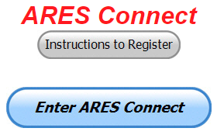We need to discuss some very important items that only YOU can make a difference with. I need you to get yourselves registered in ARES Connect, that is… if you haven’t already. Now, how do I know that you need to do this? It’s simple, we have a little over 900 now registered in the database and Stan’s last S.E.C. report shows that we have a little over 1,700 persons in ARES right now. As you can see, we still have a way to go to really take advantage of this new system.

As the numbers show, there’s still a lot of you that haven’t taken the plunge yet and need to! What are you waiting for? No matter how much you resist, it’s coming, and we need to make sure that no one is left behind.

**Now, as an incentive to get you to not only register…. But to actually start using the system…** *(Notice how I have that in bold type for you to clearly see?)*I am giving away all sorts of goodies to help you get motivated. I have a footlocker of really cool items that I will be giving away!

TOP^

I’m doing this in various intervals throughout the year, so it will challenge you to be dedicated to getting your hours into the system. You’ll never know just when another drawing will be, so you really do have to be prudent!!

***Here’s how it looks so far for March:***

|  |  |  |  |
| --- | --- | --- | --- |
|  | **Name** | **Events** | **Hours** |
| 1 | Bret Stemen (KD8SCL) | 11 | 72.00 |
| 2 | Christopher Domenick (KC8CAD) | 20 | 61.60 |
| 3 | Matthew Smith (KE8GTP) | 8 | 51.00 |
| 4 | Patrick Gibson (kd8ion) | 5 | 44.00 |
| 5 | Jaealyn Himes (N8YMT) | 5 | 44.00 |
| 6 | Joshua Gould (AE8JG) | 3 | 43.50 |
| 7 | Brian Burley (KE8ANW) | 4 | 41.00 |
| 8 | Kevin O'Harra (KD8IIB) | 5 | 37.00 |
| 9 | James Yoder (w8erw) | 4 | 36.50 |
| 10 | John Key (KE8EQQ) | 3 | 31.00 |

***Here’s how we did with people getting signed up for events***

***and the total hours logged so far in March***

|  |  |
| --- | --- |
| Total Amount signed into Events | Total Hours for Events |
| **973** | **2,452.11** |

Don’t think that you could ever get into the top 10 listing? You never know. It adds up quickly, but you do have to be registered and actually USE the system in order for any of your time to count. We have a set of instructions on how to get registered right above the button to enter ARES Connect. I would strongly suggest that if you haven’t registered yet, that you read these instructions first.

Here’s a link to get you started... <http://arrl-ohio.org/ares_connect_directions.pdf> Please, don’t just hurry through the questions, read them carefully, if you don’t understand something, please ask me, I’m here to answer your questions.

We know that you mean well by answering that you do have the needed courses in, but I will let you know that we are verifying what you say you have with what is showing for you in our statewide database when we are completing your registration. So, how can you find out if you are already listed in our statewide database? Easy, here’s a link: <http://arrl-ohio.org/SEC/special/ICS%20Complete%20by%20County%20and%20Name.pdf>

**Ok, now on to something new for ARES Connect…** I was asked by Ron, NU8N about having a certificate for those who have taken the extra time and courses to get to Level 3. Well, after some thinking about it, Stan and I agreed with Ron that we should have some wallpaper for those who have taken this extra hard step. So, I’m here to tell ya’ that we are now offering a really nice certificate for all of those who have worked so hard to obtain their Level 3 ARES Status.

TOP^

All you have to do is complete a couple of boxes and we’ll send you a certificate suitable for framing. Now I want to make sure that you understand that you do have to be registered in the statewide database as a Level 3 to qualify for this certificate.

Here’s the link… <http://arrl-ohio.org/SEC/level3.html> So, if you have certificates that you haven't submitted yet, this is the perfect time to do just that!

***Incident Command System (ICS) Training Schedule***

All current trainings are listed on the Ohio EMA training calendar located at:

<https://webeoctraining.dps.ohio.gov/TrainingAndExercise/courselist.aspx>

I’ve been asked to also include a link to the Kentucky EMA training calendar as well..

<https://kyem.ky.gov/training/Pages/default.aspx>

<https://sites.google.com/site/ccoemtraining/home>

Please pay particular attention to these courses listed above, as that there’s a lot of ICS 300 & 400 classes listed that are very useful for all Amateurs to have under their belts. I will also state that G775 is also a very good course to take as well. These 3 courses are multiple day in class courses, so please be prepared to spend some time taking them.

We do recognize that IS-300/400 requires multiple days of actual classroom training that is not easily obtained. So, if you just can't find the time to fit these class room courses in, we do have an alternative method for getting you to Level 3. Completing the following **“FREE”** and **“ONLINE”** courses will act as substitute for you FEMA Leadership Development Course requirements. You absolutely will need to complete all **7** of these courses to get your ICS 300/400 credit.  Here are the courses that you need to take:  **IS-120, 230, 240, 241, 242, 244 & 288.**

***Now, if you are looking for wallpaper and have a little extra time, taking IS-235 in addition to the 7 listed courses above, you will get a really cool looking certificate from FEMA stating that you have completed the Professional Development Series. That’s impressive in itself!***

#########

***The Department of Homeland Security (DHS) Returns to Provide Auxiliary Communications (AUXCOMM) Training in Conjunction with Hamvention® 2019***

The Emergency Communications Division (ECD) of DHS’s Cybersecurity and Infrastructure Security Agency (CISA) will be on hand at Hamvention® 2019 to conduct its nationally recognized NIMS/ICS compliant AuxComm course. Over 2,500 amateur radio operators from around the country have taken this course. The purpose of this course is to train qualified amateur radio operators so they may assist their local, county and state governments with emergency backup communications if requested to do so.

TOP^

This course introduces the auxiliary communicator to the other positions within the Communications Unit (COMU) and how to provision emergency communications in a public safety context. The course also goes deeper into the National Incident Management System framework. The location of the course will be at the “Courtyard by Marriott” in Beavercreek, Ohio and be held 14-16 May 2019. Registration for this class may close early when all available seats for this class are taken.

***Registration for this course is ongoing:*** Students wishing to attend the DHS Auxiliary Communications (AuxComm) Course must meet all prerequisites and provide electronic/scanned images of the following required documents prior to 1 May 2019:

**Prerequisites:**

* A signed copy of your current valid FCC issued amateur radio license
* IS-100 certificate (FEMA issued)
* IS-200 certificate (FEMA issued)
* IS-700 certificate (FEMA issued)
* IS-800 certificate (FEMA issued)
* The name of the public safety entity, and its contact information, that you would support upon completing this course

Please scan copies of this information, attached it to an email, and then send to [COMU@hq.dhs.gov](mailto:COMU@hq.dhs.gov). In the subject line, please put Hamvention AUXCOMM. Your information will be reviewed, and a reply sent back to you indicating that you have been given a seat in the course.

This will be an intensive three-day version of the course with facilitated lectures and student exercises conducted by professional AUXCOMM instructors. This course provides time for interactive discussions and exercises. Should you have any questions regarding this course, please send them to [COMU@hq.dhs.gov](mailto:COMU@hq.dhs.gov).

One final note, please mark your forum calendar, on Friday 17 May, to come see us at the AUXCOMM forum. You will be given a glimpse at the new AUXCOMM Position Task Book (PTB), a briefing on the proposed Communications Section for NIMS/ICS and a briefing on one of the most active AUXCOMM states – North Carolina!

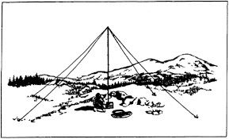***2019 Ohio NVIS Day***

Hey everyone, Stan, N8BHL has let me know that the date for NVIS Day is scheduled for **Saturday, April 27th**. Are you ready? Start your planning now!

Like years past, we are planning on having the operation run from 10 – 4 EDT. Take a lunch break, enjoy each other’s company.

Transmit power should stay at 100 watts for accurate signal comparison. You may operate anywhere, home, club, portable. 

Want to know more about what NVIS is? <http://arrl-ohio.org/SEC/nvis.html> Learn all about Near Vertical Incident Scattering and how you can easily put up a NVIS antenna and participate in this great exercise.

TOP^

***Weather Underground and Other Ham Weather Stations***

[](http://arrl-ohio.org/wus.html)Have you visited the webpage to see all the Weather Underground stations yet? It’s really fun to see just how much th e weather varies across the state and this gives you access to each individual station very quickly and easily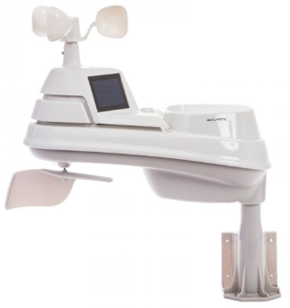.

It seems that our list of stations is growing every week! This past week we added another station to the list. Thanks so much to Rich, N8DH and David, N8GOBfor sending the links to their stations.

Now… How’s about your station, is it listed with us? It doesn’t necessarily have to be a Weather Underground reporting station. I’d love to have any weather station that is connected to the internet available for all of us to view, especially when the weather gets bad out. The more stations reporting the better.

Thanks to everyone who has contributed to this effort. If you haven’t, you really should take a look at the various weather stations around the state when we get bad weather coming in. You can really see just where the line of storms are as they cross through the state. It is very fascinating to watch it all unfold right you’re your easy chair, and all the data is real time! Here’s a link to all of those listed… <http://arrl-ohio.org/wus.html>

We’re starting to get a really good collection of stations all over. I know that there is a lot more than what we have listed. How’s about sharing your weather information with all of us! All that you need to do is send me your Weather Underground ID and your call sign and I’ll take it from there. Sent it to: [n8sy@n8sy.com](mailto:n8sy@n8sy.com)

***Ohio Section ARES Conference Date Announced***

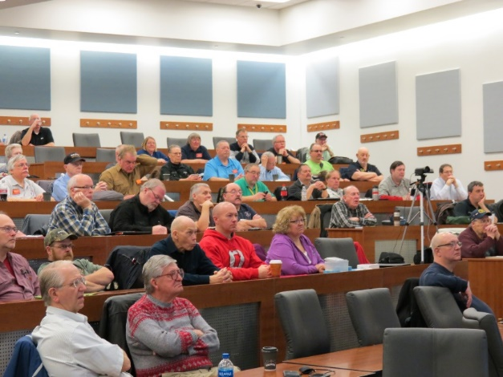I know a lot of you have been waiting patiently for this announcement. Yes, we have set a date for the Ohio Section ARES Conference… It’s going to be held on **April 6th** at Marion Technical College / OSU Marion Campus. So, make sure to mark your calendars for this date. Also, don’t forget to “sign up” for this event in ARES Connect as well!

Stan is working diligently on the agenda getting great forums arranged and it’s sure to be a really great conference. There are loads of information for those interested in any part of Ohio’s ARES program. This is an all-day adventure, but we are in a real college setting with all the amenities that you would expect in a first-class campus. Electric outlets are easily accessible for those bringing laptops and such. Wi-Fi is available and the seats are very comfortable. And… I’ll have some great Give-A-Ways to pass out as well.

Lunch is on you, but the campus is close to many popular fast-food and sit down restaurants. You can even brown bag it if you want to eat on campus.

TOP^

Certificates for your participation at this conference will be available, so you’ll get some wallpaper suitable for framing to take home with you as well! Now how can you beat that.

Get registered now, seating will become limited quickly! Here’s the link: <http://arrl-ohio.org/SEC/form.html>

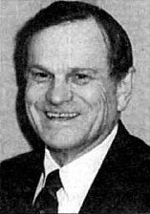***The Allan Severson, AB8P Memorial Award***

This coveted award is bestowed on an Amateur Radio operator in the Ohio Section who has demonstrated a continuing dedication to the advancement of Amateur Radio and to the Ohio Section. The recipient has traditionally been chosen over the years by the Section Manager, **but I would like to change that starting this year. I want to hear from YOU. Who do you feel is deserving of this prestigious award?**

The award was originally established in 1992 and was named "Ohio Ham of the Year" until 1999. That year it was renamed after Allan, of Lakewood, Ohio, who had become a silent key in 1997. The award winners are all hams who, like Allan Severson, have dedicated themselves to the advancement of the American Radio Relay League in Ohio. Although Allan had served the Section as Section Manager and went on to a distinguished career as Great Lakes Division Director on the ARRL National Board of Directors, the annual award announcement only mentions one sentence about him which is part of every memorial award certificate. That sentence quickly demonstrates the reason for the renaming of this award. "Allan's devotion to serve amateur radio inspired a whole generation of Ohio Section leadership."

So, how’s about it. I want to hear from you who you feel is deserving. All you have to do is complete a form with as much information about the person that you are nominating as you can. Several members of the Cabinet and I will look over all the nominations and choose who we feel is the best of the best from those who were nominated. As we have done in the past, the person chosen to be our next recipient will be announced at the Columbus Hamfest on August 3rd.

Here’s a link to the form: <http://arrl-ohio.org/sm/severson_nomination.html>

***National News***

*(from arrl and other sources)*

***More Mentors Needed for New ARRL Emergency Communications Course Sessions***

High interest in the recently announced updated ARRL Introduction to Emergency Communications (EC-001) course is prompting a call for additional class mentors to help meet the demand, which ARRL Lifelong Learning Manager Kris Bickell, K1BIC, says “exceeded our projections.” As Bickell explains, the course is designed to be interactive, with volunteer mentors guiding each session.

“We appreciate the work of the mentors to make EC-001 an interactive experience for the participants. The real-world emergency communications experience they bring to the course is very important to the learning process,” Bickell said.

TOP^

“We look forward to bringing in more mentors to help ARRL expand the reach of this valuable emergency communications training.” Bickell has developed a waiting list for prospective EC-001 students, who will be notified as additional sessions are scheduled.

The EC-001 course covers the broad range of radio communication technologies, communication techniques, and emergency management skills necessary in helping served agencies respond to and recover from disasters.

EC-001 mentors should be ARRL members and active, experienced General class or higher Amateur Radio licensees, and at least 18 years old. Mentors should have experience in public service communication and in Amateur Radio Emergency Service (ARES) activities and come with the recommendation of their Section Managers. In addition to the EC-001 course, prospective mentors should have completed [ICS 100, 200, 700, and 800](https://training.fema.gov/nims/); the [FEMA Professional Development Series](https://training.fema.gov/is/searchis.aspx?search=pds), and National Weather Service [SKYWARN](https://www.skywarn.org/)® training. Professional experience in emergency response or communication and as a trainer or educator is desirable, with interest or experience in distance learning. Candidates should possess sufficient computer skills, be able to interact with online-course students and with other mentors, and be able to maintain adequate computer equipment. Appointment as an ARRL Field Instructor or as a mentor for the ARRL Public Service Communications training program is for 3 years, renewable based on satisfactory performance as an active instructor/mentor and the successful fulfillment of all current qualifications and requirements.

Field Instructors and mentors are expected to maintain their qualifications and adhere to all guidelines and standards of conduct for volunteers representing ARRL. [Apply online](http://www.arrl.org/application-for-emcomm-mentor-or-field-instructor) to become an ARRL mentor. For more information, contact ARRL Emergency Preparedness Assistant [Ken Bailey, K1FUG](mailto:kbailey@arrl.org), (860) 594-0227.

#########

***FCC Invites Comments on ARRL Technician Enhancement Proposal***



The FCC has invited public comments on ARRL’s 2018 [***Petition for Rule Making***](https://ecfsapi.fcc.gov/file/1022823795806/201820Level20PRM%20FINAL.pdf), now designated as RM-11828, which asks the FCC to expand HF privileges for Technician licensees to include limited phone privileges on 75, 40, and 15 meters, plus RTTY and digital mode privileges on 80, 40, 15, and 10 meters. Interested parties have 30 days to comment. The Technician enhancement proposals stemmed from the recommendations of the ARRL Board of Directors’ Entry-Level License Committee, which explored various initiatives and gauged member opinions in 2016 and 2017.

“This action will enhance the available license operating privileges in what has become the principal entry-level license class in the Amateur Service,” ARRL said in its *Petition*. “It will attract more newcomers to Amateur Radio, it will result in increased retention of licensees who hold Technician Class licenses, and it will provide an improved incentive for entry-level licensees to increase technical self-training and pursue higher license class achievement and development of communications skills.”

**Filing Comments**

Those interested posting brief comments on the ARRL Technician Enhancement proposal (RM-11828) using the Electronic Comment Filing System (ECFS) should access [FCC Electronic Comment Filing System Express](https://www.fcc.gov/ecfs/filings/express). In the “Proceeding(s)” field, enter the number of the PRM, i.e., RM-11828 (using this format), complete all required fields, and enter comments in the box provided.

TOP^

You may review your post before filing. All information you provide, including name and address, will be publicly available once you post your comment(s). For more information, visit “[How to Comment on FCC Proceedings](https://www.fcc.gov/consumers/guides/how-comment).”

***Specifically, ARRL proposes to provide present and future Technicians with:***

* ***phone privileges at 3.900 to 4.000 MHz, 7.225 to 7.300 MHz, and 21.350 to 21.450 MHz.***
* ***RTTY and digital privileges in current Technician allocations on 80, 40, 15, and 10 meters.***

The ARRL petition points out the explosion in popularity of various digital modes over the past 2 decades. Under the ARRL plan, the maximum HF power level for Technician operators would remain at 200 W PEP. The few remaining Novice licensees would gain no new privileges under ARRL’s proposal.

ARRL’s petition points to the need for compelling incentives not only to become a radio amateur in the first place, but then to upgrade and further develop skills. Demographic and technological changes call for a “periodic rebalancing” between those two objectives, ARRL maintained in his proposal. The FCC has not assessed entry-level operating privileges since 2005.

The Entry-Level License Committee offered very specific data- and survey-supported findings about growth in Amateur Radio and its place in the advanced technological demographic, which includes individuals younger than 30. It received significant input from ARRL members via more than 8,000 survey responses. “The Committee’s analysis noted that today, Amateur Radio exists among many more modes of communication than it did half a century ago, or even 20 years ago,” ARRL said in its petition.

Now numbering some 384,500, Technician licensees comprise more than half of the US Amateur Radio population. ARRL stressed in its petition the urgency of making the license more attractive to newcomers, in part to improve upon science, technology, engineering, and mathematics (STEM) education, “that inescapably accompanies a healthy, growing Amateur Radio Service.”

ARRL said its proposal is critical to develop improved operating skills, increasing emergency preparedness participation, improving technical self-training, and boosting overall growth in the Amateur Service, which has remained nearly inert at about 1% per year.

The Entry-Level License Committee determined that the current Technician class question pool already covers far more material than necessary for an entry-level exam to validate expanded privileges. ARRL told the FCC that it would continue to refine examination preparation and training materials aimed at STEM topics, increase outreach and recruitment, work with Amateur Radio clubs, and encourage educational institutions to utilize Amateur Radio in STEM and other experiential learning programs.

#########

***The following news release was sent late this afternoon from Governor DeWine’s office.***

Governor Mike DeWine

FOR IMMEDIATE RELEASE:

March 11, 2019

TOP^

***Governor DeWine Declares State of Emergency for 20 Ohio Counties***

(COLUMBUS, Ohio)— Ohio

Governor Mike DeWine announced today that he has declared a state of emergency in 20 Ohio counties impacted by damaging flooding last month.

Ohio counties included in the governor’s emergency proclamation include: Adams, Athens, Brown, Gallia, Guernsey, Hocking, Jackson, Jefferson, Lawrence, Meigs, Monroe, Morgan, Muskingum, Noble, Perry, Pike, Ross, Scioto, Vinton and Washington.

“Many of these counties were still recovering from last year’s severe flooding when they were hit hard yet again,” said Governor DeWine. “This is a key step in getting these 20 counties the assistance they need.”

The counties suffered from significant infrastructure damage as heavy rains poured down on already-saturated soils, damaging public infrastructure like roads and culverts. Beginning February 5 and lasting through February 13, severe storms and excessive rainfall created “dangerous and damaging conditions affecting the health, safety and welfare of the citizens of Ohio,” according to the governor’s proclamation.

The state of emergency proclamation authorizes various state departments and agencies to coordinate the state and federal response and to assist local government in protecting the lives, safety, health, and property of the residents of Ohio.

Representatives from FEMA and the Ohio Emergency Management Agency will be meeting with county and township officials in each of the 20 counties this week to assess the extent of damages in a process called a “joint damage assessment.”

Heavy rains and severe storms in February 2018 led to an emergency proclamation and a Major Presidential Disaster in 20 Ohio counties (14 of which are included in this year’s proclamation).

***Odds and Ends***

***ARLB007 W1AW 2019 Spring/Summer Operating Schedule***

Morning Schedule:

Time Mode Days

------------------- ---- ---------

1300 UTC (9 AM ET) CWs Wed, Fri

1300 UTC (9 AM ET) CWf Tue, Thu

**Daily Visitor Operating Hours:**

1400 UTC to 1600 UTC - (10 AM to 12 PM ET)

1700 UTC to 1945 UTC - (1 PM to 3:45 PM ET)

TOP^

(Station closed 1600 to 1700 UTC (12 PM to 1 PM ET))

**Afternoon/Evening Schedule:**

2000 UTC (4 PM ET) CWf Mon, Wed, Fri

2000 " " CWs Tue, Thu

2100 " (5 PM ET) CWb Daily

2200 " (6 PM ET) DIGITAL Daily

2300 " (7 PM ET) CWs Mon, Wed, Fri

2300 " " CWf Tue, Thu

0000 " (8 PM ET) CWb Daily

0100 " (9 PM ET) DIGITAL Daily

0145 " (9:45 PM ET) VOICE Daily

0200 " (10 PM ET) CWf Mon, Wed, Fri

0200 " " CWs Tue, Thu

0300 " (11 PM ET) CWb Daily

Frequencies (MHz)

-----------------

CW: 1.8025 3.5815 7.0475 14.0475 18.0975 21.0675 28.0675 50.350 147.555

DIGITAL: - 3.5975 7.095 14.095 18.1025 21.095 28.095 50.350 147.555

VOICE: 1.855 3.990 7.290 14.290 18.160 21.390 28.590 50.350 147.555

Notes:

CWs = Morse Code practice (slow) = 5, 7.5, 10, 13 and 15 WPM CWf = Morse Code practice (fast) = 35, 30, 25, 20, 15, 13 and 10 WPM CWb = Morse Code Bulletins = 18 WPM

CW frequencies include code practices, Qualifying Runs and CW bulletins.

DIGITAL = BAUDOT (45.45 baud), BPSK31 and MFSK16 in a revolving schedule.

Code practice texts are from QST, and the source of each practice is given at the beginning of each practice and at the beginning of alternate speeds.

On Tuesdays and Fridays at 2230 UTC (6:30 PM ET), Keplerian Elements for active amateur satellites are sent on the regular digital frequencies. A DX bulletin replaces or is added to the regular bulletins between 0000 UTC (8 PM ET) Thursdays and 0000 UTC (8 PM ET) Fridays.

Audio from W1AW's CW code practices, and CW/digital/phone bulletins is available using EchoLink via the W1AW Conference Server named "W1AWBDCT." The monthly W1AW Qualifying Runs are presented here as well. The CW/digital/phone audio is sent in real-time and runs concurrently with W1AW's regular transmission schedule.

All users who connect to the conference server are muted. Please note that any questions or comments about this server should not be sent via the "Text" window in EchoLink. Please direct any questions or comments to [w1aw@arrl.org](mailto:w1aw@arrl.org) .

TOP^

In a communications emergency, monitor W1AW for special bulletins as follows: Voice on the hour, Digital at 15 minutes past the hour, and CW on the half hour.

FCC licensed amateurs may operate the station from 1400 UTC to 1600 UTC (10 AM to 12 PM ET), and then from 1700 UTC to 1945 UTC (1 PM to

3:45 PM ET) Monday through Friday. Be sure to bring your current FCC amateur license or a photocopy.

The complete W1AW Operating Schedule may be found on page 93 in the March 2019 issue of QST or on the web at, <http://www.arrl.org/w1aw-operating-schedule> .

***ARRL-Ohio.org Website Stats***

|  |  |  |  |  |
| --- | --- | --- | --- | --- |
| February 2019 | | | | |
| Unique visitors | Number of visits | Pages | Hits | Bandwidth |
| **4,334** | **9,055** | **637,565** | **2,926,169** | **44.25 GB** |

***TYT Codeplug Editor v1.1.21 update***

*(thanks Greg, WD9FTZ)*

**Updated version: TYT Codeplug Editor v1.1.21 Mar. 15, 2019, Written by: Cathy, G6AMU**

**For the following Models:**

**MD-380 MD-390**

**UV380 UV390**

**MD9600 MD2017**

**(Standard and GPS)**

[**http://www.miklor.com/DMR/software/DMR_CPE.1.1.21.zip**](http://www.miklor.com/DMR/software/DMR_CPE.1.1.21.zip)

***FCC moves to open spectrum from 95 GHz – 3 THz for new technologies***

*(by Monica Alleven fiercewireless.com , Gregory Drezdzon, WD9FTZ)*

This week, the FCC unanimously voted to adopt new rules related to the spectrum above 95 GHz that encourage the development of new technologies—and may lead to 6G.

Once thought to be more or less useless—similar to how much of the industry used to think of the millimeter wave spectrum that’s now being deployed for 5G—these super-high spectrum bands are now viewed as offering opportunities for innovation, especially for data-intensive, high bandwidth applications as well as imaging and sensing operations.

TOP^

Prior to this decision, the commission had no rules for authorizing communications above 95 GHz, other than ***amateur radio*** or through experiments of limited duration and scope.

FCC Chairman Ajit Pai invited NYU Wireless Professor Ted Rappaport, who was instrumental in conducting groundbreaking millimeter wave research, to present his institution’s findings thus far on the opportunities afforded by the spectrum bands above 95 GHz, where “science fiction will become reality,” Rappaport told the commission.

The Wireless industry is an ever-changing world where big ideas come along daily. Our subscribers rely on FierceWireless as their must-read source for the latest news, analysis and data on this increasingly competitive marketplace. Sign up today to get wireless news and updates delivered to your inbox and read on the go.

The applications that become possible at these higher frequencies are mind-blowing, he said. With so much bandwidth and wider bandwidth channels, you can start having data rates that approach the bandwidth needed to provide wireless cognition, where the computations of the human brain at those data rates could actually be sent on the fly over wireless. As such, you could have drones or robotics receive in real time the kind of perception and cognition that the human brain could do.

The conventional wisdom is that as you go higher in frequency, you get more loss.

“That’s only if you use an omnidirectional antenna, the old way of doing cellular 10 and 20 years ago. When you start using directional antennas, what happens is, you actually do better as you go higher in frequency for a given power level and a given antenna physical size,” Rappaport said.

To enable innovators and entrepreneurs to most readily access this spectrum, the FCC’s Spectrum Horizons First Report and Order creates a new category of experimental licenses for use of frequencies between 95 GHz and 3 THz or about 15.2 GHz of spectrum.

These licenses will give innovators the flexibility to conduct experiments lasting up to 10 years, and to more easily market equipment during the experimental period, according to the FCC.

“Today, we take big steps towards making productive use of this spectrum,” Pai said in his statement. “We allocate a massive 21 gigahertz for unlicensed use and we create a new category of experimental licenses. This will give innovators strong incentives to develop new technologies using these airwaves while also protecting existing uses.”

Commissioner Jessica Rosenworcel said it’s worth noting that the spectrum in these higher bands is different from the lower bands in that it’s subject to the authority of both the FCC and the National Telecommunications and Information Administration (NTIA), and that requires more meaningful coordination among the federal partners.

Fellow Democratic Commissioner Geoffrey Starks noted that the terahertz spectrum imaging could change the way doctors and researchers understand biological processes on the cellular level and doctors may be able to use the technology to conduct noninvasive cancer screening tests. In security settings, terahertz spectroscopy could identify dangerous materials and weapons, meaning threats to safety can be identified without body scans.

TOP^

But Starks added that he has serious questions about the FCC Enforcement Bureau’s tools to detect interference in these and other high-frequency bands.

The FCC is not currently capable of policing a significant amount of millimeter wave spectrum, which is being used for 5G, and he’s concerned that without sufficient resources for modern enforcement tools, efforts will be undermined.

While voting for the order, Commissioner Michael O’Rielly said the FCC’s action on this spectrum in no way reduces the need for making more unlicensed allocations of spectrum and he pointed to two items in particular—revisiting the 5.9 GHz band and taking steps to open the 6 GHz band for unlicensed use—as ways the commission can address that.

In a statement provided to FierceWireless, Rappaport said he was honored to be invited by Chairman Pai to be part of the historic vote to open up spectrum above 95 GHz for the first time in the history of the United States.

"The vision and hard work by Chairman Pai, the commissioners, the FCC staff, and past work by Chairman Wheeler, have kept the U.S. on the cutting edge of 5G, ensuring that our country will enjoy the vast applications and efficiency it will provide,” he said. “Now, with the Spectrum Horizons initiative and this historic vote, the FCC has launched the race to 6G, helping to ensure the U.S. will play a leading role in future generations of wireless."

"President Trump mentioned 6G a few weeks ago - perhaps the first world leader to do so. As an engineer and educator, I'm happy to know our country's leaders are working to support American competitiveness in Science, Technology, Engineering, and Math (STEM),” Rappaport said. “STEM and engineering research are so vital for our country's economic future, and it needs attention like the President gave to 6G."

***Final.. Final..***

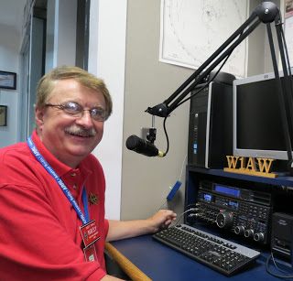

Hey Gang...

I had a blast this past week visiting with many of you at your meetings and the TMRA Hamfest! It was a really great week for sure! And YES.., I had a ***GREEN*** beer or two when I got home after the TMRA Hamfest Sunday to celebrate St Patty’s Day! Don’t forget, I’m 17% Irish and I celebrated my new found heritage!

Now, let’s move on to more important things... I do want to remind everyone that you can do a little extra publicity for your club meetings and activities just by having your ARES Connect Administrator add your events to the ARES Connect calendar!

TOP^

For those clubs that use Google Calendar or any web-based calendar program that incorporates RSS feeds, you can easily add ARES Connect events calendar to it!

Yes, you can now see all the events, including your own club activities on your calendar! Oh, if you don’t use Google Calendar, do you use Outlook or other similar Office Suite programs that has a calendar built in?

If you do, then you can even add the ARES Calendar to that as well. This is extremely useful if you are in the field where Wi-Fi isn’t available.

If you are interested in how you can do this, just ask me. I will show you just how easy it is. Oh, there is just one little requirement to be able to do this, you have to be registered in ARES Connect in order to gain access to this feature.

Now speaking on the idea of being registered in ARES Connect yet, have you? If you haven’t you really need to do it now.

For your administrators out there, things will be changing in the system and from what I know right now, it will make your job a lot easier as well. Yes, things aren’t quite the way we want them yet, but they will be getting better, and the system will be a lot easier to use when these changes happen.

I do want to clear up some mis-interpretations that have been going around. First, in the Ohio Section we only require our Level 2 volunteers to have the 4 basic courses, IS 100, 200, 700 & 800. For our Level 3 volunteers we do require the additional ICS 300 / 400, or the equivalent professional series courses IS 120, 230, 240, 241, 242, 244 & 288. These equivalent courses are all on-line classes just like your basic 4 NIMS courses are and being offered as an alternative way for you to get credit for taking the professional series courses in the event you just cannot get scheduled into an ICS 300/400 class. By the way, if you decide to take these 7 on-line courses and complete them all, you will want to take just one more class **IS-235.** By completing this additional course, you will get a really great looking certificate from FEMA recognizing that you have completed the entire Professional Series courses.

I do hope that this clears up the confusion that has been going around lately. As we have stated on the website and in this newsletter many times “We don’t want anyone left behind.”

Ok.. One final go around…. Don’t for get that there are two nets on Wednesday morning.. We are doing a very special net on DMR – Ohio Statewide at 9:30 and then and most importantly is the Statewide drill where we want everyone that can, check-in on your local nets as well.. Don’t forget, there are two nets to check-in to Wednesday!!!!!!

Whelp… That’s going to do it for this time around. Stay safe, stay warm, and most of all… have FUN!!

73, and stay warm and dry!!!

***Scott, N8SY***

TOP^

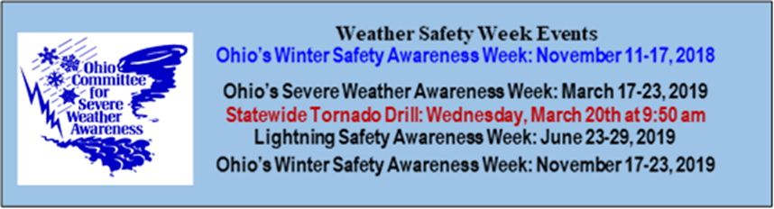

***Ohio’s Severe Weather Awareness Week: March 17 – 23***

***Statewide Tornado Drill: Wednesday March 20th at 9:50am local***

***March 20th is also the First Day of Spring!! It arrives promptly at 5:58pm local***

***Murphy’s Law***

* A falling object will always land where it can do the most damage.
* A shatterproof object will always fall on the only surface hard enough to crack or break it.
* A paint drip will always find the hole in the newspaper and land on the carpet underneath (and will not be discovered until it has dried).
* A dropped power tool will always land on the concrete instead of the soft ground (if outdoors) or the carpet (if indoors) - unless it is running, in which case it will fall on something it can damage (like your foot).
* If a dish is dropped while removing it from the cupboard, it will hit the sink, breaking the dish and chipping or denting the sink in the process.
* A valuable dropped item will always fall into an inaccessible place (a diamond ring down the drain, for example) - or into the garbage disposal while it is running.
* If you use a pole saw to saw a limb while standing on an aluminum ladder borrowed from your neighbor, the limb will fall in such a way as to bend the ladder before it knocks you to the ground.
* If you pick up a chunk of broken concrete and try to pitch it into an adjacent lot, it will hit a tree limb and come down right on the driver's side of your car windshield.

TOP^



***Back Issues of the PostScript and Ohio Section Journal (OSJ)***

Hey, did you know that PostScript and Ohio Section Journal (OSJ) are archived on the website? You can go back and look at any edition simply by clicking:

<http://arrl-ohio.org/news/index.html>

***Chit – Chat, and All That!***

Do you know someone that’s not getting these Newsletters? Please, forward a copy of this Newsletter over to them and have them “[Opt-In](http://arrl-ohio.org/forwarder/forwarding.html)” to start receiving them. Heck, just have them send me an email [n8sy@n8sy.com](mailto:n8sy@n8sy.com) and I’ll get them added to the Ohio Section Emailing list. We now have over 7,000 folks receiving these newsletters weekly. Quite impressive, I’d say!



I urge all of you to make sure that everyone, regardless of whether they are a League member or not, get signed up to receive these weekly Newsletters. You can always “[Opt-Out](http://arrl-ohio.org/forwarder/forwarding.html)” at any time if you feel this is not what you were expecting. It’s fun and very informative.

Hey, did you know that PostScript and Ohio Section Journal (OSJ) are archived on the website? You can go back and look at any edition simply by clicking:

<http://arrl-ohio.org/news/index.html>

The pictures throughout this newsletter are from various sources. Take a good look at them, you just might be in one of those pictures! “SMILE…!!!!!”

Got questions, concerns or would just like to sit and chat awhile? Heck, I’ll even buy the coffee!! Give me a call at (419) 512-4445 or email me at: [n8sy@n8sy.com](mailto:n8sy@n8sy.com)

TOP^

*The Ohio Section Journal (OSJ) is produced as a comprehensive look at all the programs within the Ohio Section. I sincerely hope that you have enjoyed this edition of the OSJ,* *and will encourage your friends to join with you in receiving the latest news and information about the Ohio Section, and from around the world!*