***[](http://arrl-ohio.org)******Field Day***

***Edition***

|  |  |
| --- | --- |
| 🡪 From the Technical Coordinator | **🡪** From the Section Emergency Coordinator |
| 🡪 From the Affiliated Club Coordinator | **🡪** From the Public Information Coordinator |
| 🡪 From the Section Traffic Manager | **🡪** From the Section Youth Coordinator |
| 🡪 From the Official Observer Coordinator/ASM | **🡪** ARES Training Update |
| 🡪 Handbook Give Away | **🡪**  Club Corner |
| 🡪 Upcoming Hamfest in Ohio | **🡪**  DX This Week |
| 🡪 Special Events  🡪 One Question  🡪 ARES Connect | **🡪**  Contest Corner  🡪 V.E. Testing  🡪 National News |
| 🡪 Final.. Final.. | |

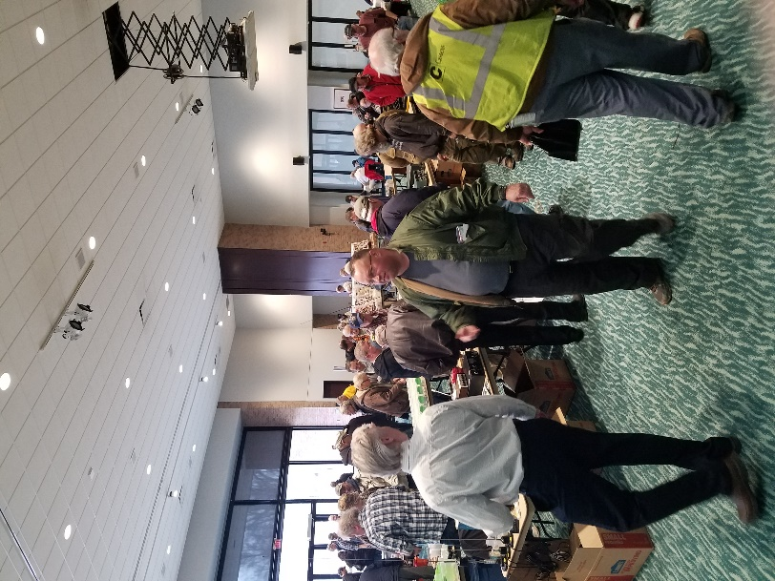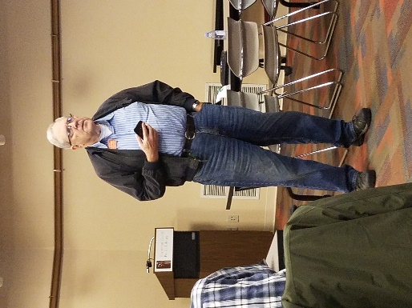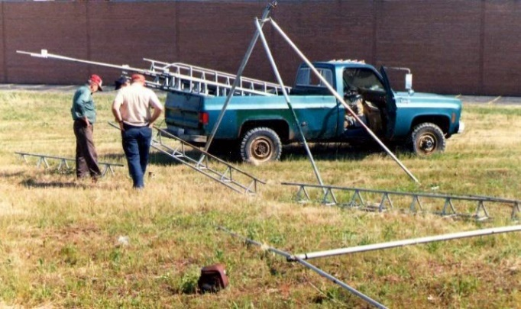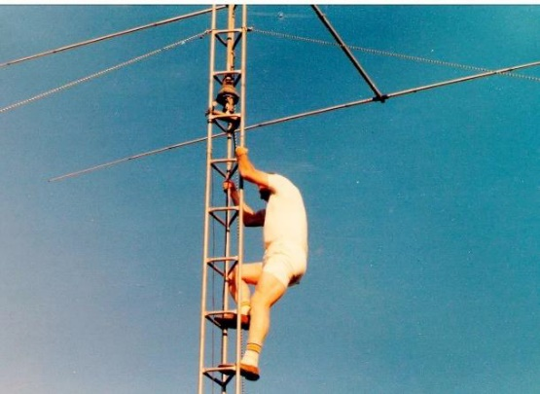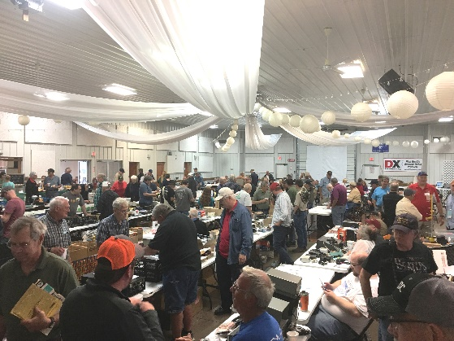

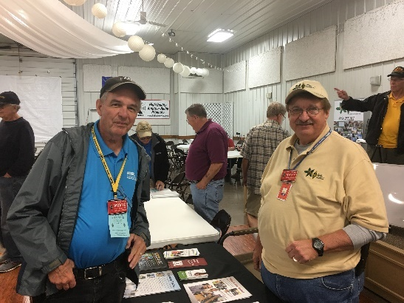

***From the Technical Coordinator***

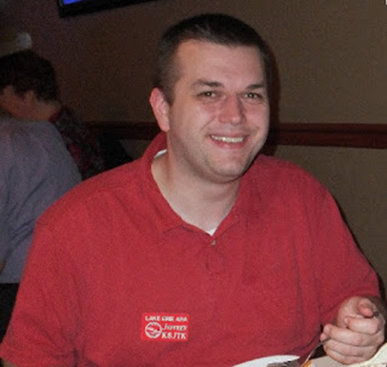***Jeff Kopcak – K8JTK TC***

[k8jtk@arrl.net](mailto:k8jtk@arrl.net)

Hey gang,

As the Technical Coordinator for the Ohio Section, I’m responsible for the Technical Specialists. The Specialists and I are here to promote technical advances and experimentation in the hobby. We encourage amateurs in the section to share their technical achievements with others in QST, at club meetings, in club newsletters, hamfests, and conventions. We’re available to assist program committees in finding or providing suitable programs for local club meetings, ARRL hamfests, and conventions in the section. When called upon, serve as advisors in issues of RFI and work with ARRL officials and appointees for technical advice.

The Technical Specialists really make all this happen. In the Ohio Section, there are about 15 qualified and competent Specialists willing to help. They meet the obligation of advancing the radio art bestowed to us by the FCC. The TSes support the Section in two main areas of responsibility: Radio Frequency Interference and technical information. RFI can include harmful interference that seriously degrades, obstructs, or repeatedly interrupts a radiocommunication service. Ranging from bad insulators on telephone poles to grow lights and poorly made transformers, they can help with RFI direction finding or assist in locating bozo stations.

Technical information is everything else from building antennas, repeaters and controllers, digital, computers, networking, and embedded devices.

How can we help? The knowledge and abilities of your Technical Specialists are quite impressive. Here are some examples of the knowledge the Technical Specialists provide:

* Documentation and training
* VHF/UHF portable operation
* Antennas (fixed, portable, and mobile)
* Batteries and emergency power
* Experts in RFI from powerline and consumer devices
* VHF/UHF/SHF contesting
* Experts in test equipment
* Automotive electronic compatibility (EMC) and interference (EMI)
* Repeaters
* Digital modes (D-STAR, DMR, Fusion, P25, APRS & IGates. HF: MT63, FT8/4, Olivia, PSK).
* Computers and networking (VoIP – AllStar link, software engineering, embedded systems – Raspberry Pi, Arduino)
* Society of Broadcast Engineers (SBE) members knowledgeable in interference problems

TOP^

This impressive list of qualifications is available to all in the Ohio Section. Looking for help in one of these areas? Need a program for your club? How about a technical talk or forum at your hamfest? Feel free to contact myself. My contact info is near my picture and on the [arrl-ohio.org](http://arrl-ohio.org/) website. I’ll assist getting you in touch with an appropriate Technical Specialist. One of the Specialists might hear a plea for help and reach out to you as well.

***Where have all the maps gone?***

A lot of ham radio is about location and maps - APRS, repeater locations, grid square, propagation, beacons, satellite, or spotting maps. You may have noticed, starting last year, the quality of maps has degraded or looked different on your favorite website or on your favorite app. You’re not going crazy. It’s because many of those who developed their map around Google Maps API were forced to make some changes and decisions.

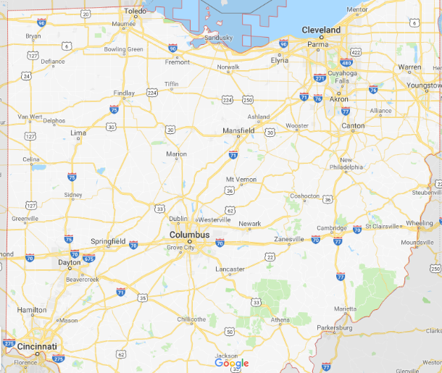

Ohio map – Google Maps

If you’re not a programmer, an API stands for Application Programming Interface. APIs are a set of defined tools or commands that can be called allowing for easy communication between different components or systems. If an API is available, they are (supposed to be) well documented and available for anyone to use.

Since the Google Maps service existed, it could be used for free. There were usage limits, but they were artificially high enough were most implementations we not going to hit 25,000 requests/day. If requests exceeded the daily limit, the owner was charged $0.50/additional 1,000 requests up to 100,000 in a 24-hour period. If that maximum was reached per day, it was likely a heavy traffic website and commercial in nature where overages could be supplemented.

Last year, Google reduced the number of free requests to 28,000/**month**, which is the $200 “credit” referred to in their [pricing plan](https://cloud.google.com/maps-platform/pricing/sheet/). Additionally, it was required of the developer to register for an API key. That key MUST be linked to a credit card even if usage didn’t come anywhere near the free credit. Overages are automatically charged to the linked credit card and amount to $7.00 per 1,000 additional requests.

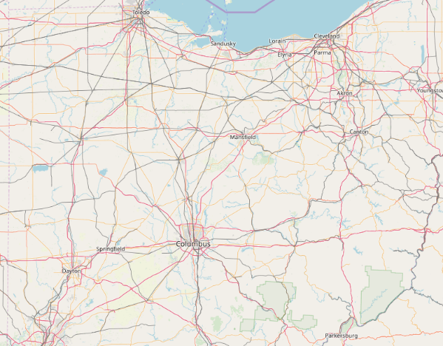

Ohio map – Open Street Map

It still sounds like a lot of requests per month, but not when I think about sites I have running in the shack. I can easily refresh sites 10 times while I’m operating. If 2,800 other hams did the same thing, all of a sudden, they’ve blown through their free credit. This put many free and non-profit developers between a rock and a hard place. Start shelling out for hefty overage fees for access to Google Maps – which was arguably very good, move to an alternative, or close shop.

TOP^

Commercial sites, which sell products and services or rely on ad revenue, have stayed with Google Maps because they can offset that cost with subscriptions or ads.

Free, non-profit, and programmers doing it for fun have moved to a free and open license alternative called [OpenStreetMap](https://www.openstreetmap.org/). I came across one website that said, “I’m done” citing the price hike and closed their site.

These microservices are provided free (as in beer). They end up not being able to monetize the service so they drastically change it or its pricing. This is happening quite often in tech and will continue as we rely more and more on other services.

***100 Points at Field Day!***

The next big ham holiday, Field Day, is right around the corner! Get out and join your club or find a club to join if you’re not a member of one. It’s a great time to bring friends or hams that have been out of the hobby excited about ham radio. Hams that come out get bitten by the bug to expand their station or learn a new mode. Check the [Field Day Locator](http://www.arrl.org/field-day-locator) for operations taking place near you.

Sending 10 messages over RF from your site gets you 100 points – including Winlink messages. I love to receive messages about your setup, stations, operating, or social activities taking place. These can be sent via the National Traffic System (NTS) or Winlink – K8JTK at Winlink.org – to my station. I haven’t seen the usual post on the Winlink site of other stations willing to receive messages from Field Day stations as in the past.

With July around the corner, if you’re looking to do something while flipping burgers at your 4th of July picnic, my favorite event [13 Colonies Special Event](http://www.13colonies.net/) will be on the air July 1 – 7.

Thanks for reading

**73… de Jeff – K8JTK**

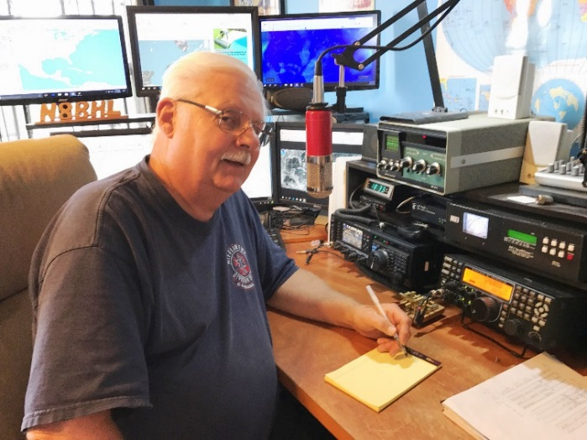***From the Section Emergency Coordinator***

***Stan Broadway, N8BHL - SEC***

[broadways@standi.com](mailto:broadways@standi.com)

***Baptisms by fire***

Last month, I wrote about the formative plans for a statewide amateur radio initiative requested by the Ohio EMA’s “Watch Desk”. The idea was to put together a state-inclusive network over which amateurs could relay reports of a major situation to the state Watch Desk. This would allow them to be better prepared for deploying state resources when county EMA Directors make a request. This was brought about by events including the Shelby, Oh, tornado strike.

TOP^

***Little did we know.***

Building up to the Memorial Day weekend District 3 became really busy with meetings prior to a scheduled “demonstration” involving an alphabet-full of diametrically opposed organizations beginning with the KKK. A scheduled event for that Saturday brought amateur radio and ARES into the picture after the hospitals in the greater Dayton area requested ARES members stand by for their hospital net. The event itself was basically a local police deal, but the hospitals wanted to be able to have full communication if necessary. Fortunately, it was not. But that wouldn’t be the real test for DEC-3 Fred, W8LLY, and all his ARES members that weekend. After most people’s Memorial Day Monday had wound down, Ohio suffered the worst outbreak of tornadoes in its history – with many aimed directly at the Dayton area.

The severe weather didn’t come as a complete surprise. The Severe Storms Forecast Center had us under a tornado watch, and one didn’t have to be a radar expert to see the monster storm system moving at us across Indiana.

We had already taken one step to alert Ohio hams. With the new ARES Connect system we can send an email to ~all 1100~ registered hams at one time, and they receive it within two minutes. We also sent a “heads up” email to another large group on the EC email list. As it rolled closer, spawning a large number of warnings in its path, I logged onto the Wilmington Weather system to catch some of the reports. Since it was around 9PM, when normal day heating is over and storms tend to fizzle back down to a harmless state, I asked Wilmington if they thought the storms would hold their strength. The answer was a chilling, “There will be tornadoes over Ohio tonight.” Richard, KD8PHG started for the Ohio EOC to activate the Sarge, I would follow upon his arrival. In the meantime, we monitored the Ohio DMR talk group and took in several reports. It would prove to be a long night.

ARES hams in western Ohio lit up with storm activity, Skywarn nets, and follow up to damage. As the storms entered Ohio the first real word of problems came from Celina, where a tornado brought major damage. We later would learn a man was killed in his bed when a ~ airborne car~ fell down onto his house.

Tornadoes plowed through several parts of Ohio, over 33 tornado warnings would be issued (including one for Delaware County) with at least 21 NWS confirmed tornadoes on the ground. Fred, W8LLY, frantically kept up with tornadoes including what was eventually rated an EF-4 that destroyed Hara Arena. His counties were reporting tornadoes, damage, and other storm-related events. More were being reported across Ohio, including north central Ohio and another swath south of the Columbus area.

Once we reached W8SGT, we encountered the worst case of storm de-sense I’ve ever seen. The pair of co-phased multi-element 2-meter beams wouldn’t even get out of the city! HF was unusable (no surprise), and DMR was the only path. Richard stayed all night, I skipped at 3AM back at 8 as the EOC was opened to a full ramp-up.

Amateur radio was recognized for the big part we played in early information, and for being active during the first several days of the situation. I can’t thank you all enough for your work during this historic event. And the plan appeared to work – BETA testing completed under extreme and historic conditions!

TOP^

We have solidified upstream information with Indiana, we have re-programmed the DMR radio at the Sarge with more talk groups, including regional groups within Ohio. All hams on DMR should look these over and add the appropriate groups to your radio!!

31391  NEOH

31392  WXOH (Also NW OH??)

31393  SEOH

31394  SWOH

31395  ARES We don’t control this, but possible use is approved. ALL Ohio DMR users should program this.

31399  OHYSF Fusion link to a number of mostly central Ohio machines

313920 MNFD Group of N Central OH repeaters

So, here’s the plan - again, and as soon as we can get the OSERP updated it’ll be in there, too.

When early interest is expressed by the Watch Desk, we will email and text as many amateurs as possible. We will also use the new WENS system for text messaging. We will begin a “listen-only” condition on DMR Ohio (no net, no real activity- we’ll just be listening for reports of severe proportions that need to go to the state.) If band conditions permit, we will also listen on HF (3902 and OHDEN). If possible, we will also be active on local or district repeater frequencies for more tactical input. That information will be fed to the Watch Desk on WebEOC.

What we plan in the future: I am working on incorporating Echolink and Fusion into this system to provide more coverage. We will be providing training information so EC’s can review the program.

Ohio ARES looked pretty great over that period and that’s thanks to all of YOU who put the remainder of your holiday aside to help. It’s what Amateur Radio is all about.

Now…to get ready for Field Day!!

Thank you all! Remember the basics! They will save you!

**73, Stan N8BHL**

**You can view all of the SEC’s monthly reports on the website..** <http://arrl-ohio.org/SEC/default.html>

TOP^

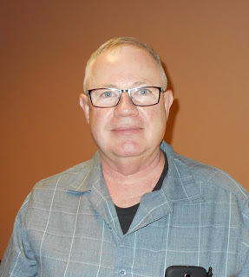***From the Affiliated Club Coordinator***

***Tom Sly, WB8LCD - ACC***

[tomsly29@gmail.com](mailto:tomsly29@gmail.com)

***Field Day!***

This is probably the premier operating event in North America. I hope your club will be on the air. What could be better than getting out for the weekend, with your friends, and on the air? The perfect event for club members to get together and see what it takes to make a respectable showing. Yeah, I know, this is not a contest. But they do keep score!

Lots of work goes into a successful Field Day (FD) operation. Now’s the time to show your friends what you’re made of. Stations need all sorts of equipment to operate. Are you willing to show your buddies that you trust them using *your* stuff? How about donating some stuff to the club? How about doing the work? There’s a lot to be done getting all the stations set up. Even more getting everything down and back to where it belongs. You ever notice lots of folks “have places they need to be” so they are not able to hang around after it’s over. The real “HERO” is that last guy to leave the site. Not willing to leave his friends there alone to finish up. Please, don’t let that last guy do it alone!

Lots of FD positions need to be filled (just like club positions). I’ve always said, many positions are better left unfilled than to fill them with the guy who says he’ll do it if no one else will. What kind of commitment is that? What kind of a job can you count on being done when someone who doesn’t want the position takes it just because no one else is willing to do the work? Too often the work doesn’t get done in any proficient manner. But, if you take a position no one else wants, and then you exceed all expectations in that position, you’ll have proven yourself as a team player and a valuable asset to your club. Be that Guy! (I’m using “Guy” as a non-gender specific term)

I know that in the past other Section ACC’s have moved around the Section dropping in and visiting other clubs at their FD sites. That’s not me. (Don’t take that as a negative – I’m just 100% plugged into the efforts of my home club – PCARS) Scott – N8SY has always done a good job of covering the section (not only for FD – but in general) and I know he is always welcome wherever he stops. So sometime in the weeks following FD, drop me a note ( [tomsly29@gmail.com](mailto:tomsly29@gmail.com) ) and let me know what your FD experience was like. Photos are always welcome. Let me know how FD made you feel as a member of your club.

As I mentioned, Scott is pretty good at making the rounds. I’ve visited with some clubs, not near as many as Scott (or John – KD8MQ). As I’m sure both Scott and John have experienced, wherever I’ve gone, I’ve felt welcome and like I was a part of the club. I hope there’s no partiality to that, but do you make sure your club throws out the welcome mat to *anyone* who shows up? I’m pretty sure you do, but I just want to remind you to make a conscious effort to make sure that anyone and everyone is made to feel like you’re happy to see them!

TOP^

This is really something that anyone (and everyone) could do! Looking for something to do as a club project? Something that you could all do together, that really wouldn’t take much effort or planning? Get a few of your members together and go visit other clubs! Maybe once every 2 or 3 months. If you have a bigger club, make some small groups of 2-6 and have each one visit a different club over the course of a month or two and then get together to discuss what you see, what you like and what you don’t like about the way other clubs operate.

A few years ago, when I was visiting a relative in California, I planned my trip around being able to go to a club meeting out there. I went to a local club meeting in Santa Rosa, CA. I met some really nice people. It was their “homebrew” night and I got to see and hear about some really neat projects. One thing that sticks in my mind was a guy who restores old BCB radios, and early portable radios. He told me of a website that could be used to assemble B batteries from other modern batteries, and it even had templates for printing out original artwork for the case of a B battery, so the restoration looked authentic! One of the great things about this hobby is that I can always count on someone to know something that I don’t. And the best part is there is always someone willing to share their knowledge with you!

One of the things I like best about Hamvention is the opportunity to meet people from all over the world who have interesting stories to tell. A number of years ago I met Dick Pascoe – G0PBS – who was president of QRP/ARCI at the time. We got to talking and a couple years later, when he was on his way to Hamvention, he came to my home, stayed a couple days and gave a fantastic presentation at a PCARS meeting! The more people that you reach out to, and take the time to make a relationship with, the easier it becomes to get people interested in helping you out be presenting at club meetings. You can meet lots of interesting people at your local hamfests, too. Regional DX or ARES conferences. Just get out there and meet them! You’ll be glad you did.

If you remember a few months back, I told you about hanging some QSL card holders up at a local restaurant and seeing if I could get hams to bring in their cards. There’s now close to 40 cards on the wall and I’ve got another holder ready to go as soon as the last slot is filled on the second one. I’d still really like it if you could send a card to Little City Grill, 802 N Mantua St. Kent, OH 44240. The owner, Bert, is excited every time he gets a new card. Almost as much as when I get a new card from a QSO. I went in yesterday for lunch and Bert was really excited. A local patron who had just noticed them asked him where he was getting the “QSL” cards from. He asked her how she knew they were “QSL” cards, and she told him about how her dad was a ham. How that when her dad got cards in the mail, the kids had the job of putting pushpins in the maps on the walls of his radio room to signify all the places he had contacted. After a long conversation (probably pretty much one-way) where she told him all about her memories of her dad being a Ham, she asked if she could put one of her dad’s cards that she had saved into the display! He said of course it was OK. It was a positive reinforcement to a community member that Ham Radio is still alive and kicking. And that’s a good thing, because it just may come up in her conversation with others. That spreads “awareness” of us and the things we do.

I’ll be looking forward to hearing you all on the air over Field Day Weekend!

That’s it for now. Let me know what’s on your mind. [tomsly29@gmail.com](mailto:tomsly29@gmail.com)

**73, Tom WB8LCD**

TOP^

***From the Public Information Coordinator***

***John Ross, KD8IDJ - PIC***

[john.ross3@worldnet.att.net](mailto:john.ross3@worldnet.att.net)



**FROM THE PIC**



**OHIO SECTION 2019 NEWSLETTER CONTEST**

The deadline for the 2019 Ohio Section Newsletter Contest is very near! For your club’s newsletter to be in the mix you’ll need two copies of the newsletter (from different months) and they must be in by midnight June 30, 2019!

There are several new entries this year and all of the newsletters look great! The judges are ready, too, and will make the final call just after the July 4th holiday.

The winners will be announced at the Voice of Aladdin Hamfest on Saturday August 3 at the Aladdin Shrine in Grove City.

This contest is the highlight of my year! I really do read all of the newsletters but the frustrating part of that is I can’t tell anyone…especially the judges…just how great we are as a section.

During the judging I have to sit very quietly, can’t smile, smirk, wiggle or make any gestures! They might as well put me in a corner for a TIME OUT until the winners have been selected!!!!

I believe the presentation on August 3rd begins at 10:00 AM inside the Shrine’s auditorium. If you’re at the Hamfest take a break and stop by.

CONGRATULATIONS…in advance…to everyone!

**POWER COMPANY ANTENNAS**

Last year my power company switched out my old electric meter for a new SMART Meter! Pretty good idea…no more leaving the backyard gate unlocked for the meter reader and no more estimated bills.

TOP^

Well, this past week I noticed a few new electric poles growing around the neighborhood all with two antennas side mounted on each.  As it turns out, this is part of power company’s RF network for integrating and reading the new SMART meters! The build out is pretty extensive…multiple new poles and antennas mounted on already existing poles. So, my concern was Amateur Radio, and could I cause interference, or would I receive from RFI from the new system.

The ARRL has some good info on this... but in a nutshell…Yes...but unlikely. Still it is good to at least think about this new system and just make sure we are doing what we do every day in keeping our signals clean and in-band.

The SMART Meter grid uses 2.4 GHZ and some 902 MHZ at very low power…one watt or less…but not always transmitting. Still, with the growth of “everything wireless” it’s possible for some unique harmonics generating RFI.

The ARRL website has more information on the this…take a look when you have a chance. Also, it’s always good to watch out for new antennas in your area…one might actually be a new ham neighbor!!!

[](https://youtu.be/117XhdfOwvU)

**🡨 PIC PODCAST**

Over the last several months I’ve told you about the many new amateurs that have passed their exams and are now on the air. Believe me, I did not have to do much arm twisting to get these folks going…. they were all pretty much psyched up for the challenge and just need a little push!

On this month’s PIC PODCAST, I’ll talk to Tom Miller, W8RIH, one the new folks about his journey to becoming Amateur Radio operator.

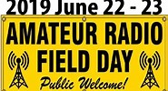**FIELD DAY 2019**

By the time you read this Field Day will be fast approaching. This year it’s the weekend of June 22 & 23…always the fourth weekend in June…and it’s a great way to hone your operating skills.

Many clubs will be hosting Field Day activities but to find one near you the ARRL website has a great Field Day Locater. Just type in your location and you’ll get a map of the club’s participating.

No fancy “ham shack” just the great outdoors and your makeshift setup. If you have never participated before you will be amazed at the number of contacts you’ll make and how little power you need to do it.

Again, this will test your operating skills under less than perfect conditions so when you need to work in an emergency situation you’ll be better prepared.

***Give it a try!***

TOP^

**ONE LINE SHOUTOUTS**

**CONGRATULATIONS** to the ARES folks for their great work getting us through the recent tornado outbreak.

**HAPPY RETIREMENT** to Assistant Section Manger Lyn Alfman, N8IMW. Lyn is a great ham, a great talker and one of the nicest people I’ve known. She will be missed.

**CONGRATULATIONS** to John Perone[, W8RXX](http://www.arrl-ohio.org/ooc/index.html) , the new Assistant Section Manager.

That’s it for this month….

**73, John KD8IDJ**

***From the Section Traffic Manager***

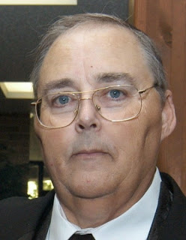***David Maynard, WA3EZN – STM***

[wa3ezn@att.net](mailto:wa3ezn@att.net)

1. **OHIO SINGLE SIDEBAND NET**

["Specializing in the first and last mile of NTS delivery in Ohio."](http://www.ossbn.org/)

|  |  |  |  |
| --- | --- | --- | --- |
| **Morning session** | **10:30 AM** | **3972.5 KHz** | **every day** |
| **Afternoon session** | **4:15 PM** | **3972.5 KHz** | **every day** |
| **Evening session** | **6:45 PM** | **3972.5 KHz** | **every day** |

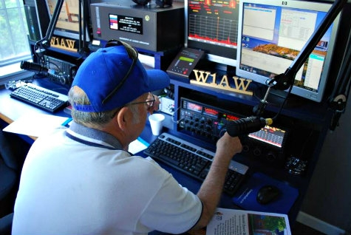**OHIO LOCAL VHF TRAFFIC NETS**

Burning River Traffic Net (BRTN), every Monday and Saturday on 147.150R MHz, and every Wednesday on 146.700R at 9:30 PM per KD8GXL net manager.

Central Ohio Traffic Net (COTN), 7:15 PM daily, 146.970 MHz (Columbus repeater),

KD8TTE net manager [www.cotn.us](http://www.cotn.us/)

**Miami Valley Traffic Net (MVTN), 7:00 PM Mon, 146.640 MHz, KC8HTP net manager**

**Northwest Ohio ARES Net (NWOHARES), 6:40 PM, daily, 146.940 MHz, PL 103.5, N8TNV manager**

TOP^

**Tri-County Traffic Training Net (TCTTN), 9 PM Sun, Tues, Fri, 147.015 MHz, WB8YYS manager** [**http://www.tricountytraffic.net/**](http://www.tricountytraffic.net/)

**Tri-State Amateur Traffic Net (TATN), 8:00 PM daily, 146.670 MHz, PL123 WG8Z net manager** [**http://www.tatn.org/**](http://www.tatn.org/)

All licensed amateurs are welcome to check in regardless of experience in handling amateur message traffic. Of course you have to have q general class or higher license to check into the sideband net but if you have HF receiver you can still listen in. You can also listen and check into a VHF traffic net.

The best thing to do is to tune into a net and listen for several nets too get a feel for how it operates and what is expected of those checking in to the net. When you feel comfortable that you understand the operation of the net listen for the net control to call for check-ins and give you call slowly and phonically and listen for the acknowledgment from the net control.

Traffic nets are not the only VHF/UHF nets in Ohio. I believe you may possibly find an ARES or club net in almost every county in Ohio. Although they are not traffic net they are worth listening to and checking them out.

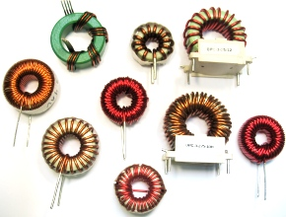***Tuning Electrically Short Antennas for Field Operation***

In case you missed it there is an article in the June 13 ARRL Letter about tuning electrically shortened antennas. This is worthwhile reading if you don't use a full size antenna. It refers you to an article "Tuning Electrically Short Antennas for Field Operation," by two well-known amateurs, which appeared in *Microwave Journal*. Authored by *QEX* Editor Kai Siwiak, KE4PT, and award-winning researcher Ulrich Rohde, N1UL, the article points out that both Amateur Radio and military applications exist for 20 W battery-powered radios equipped with whip antennas.

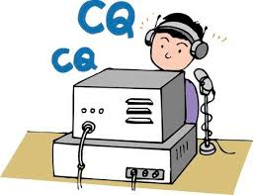Let’s talk about Field Day which is just a few days away, June 22 and 23, 2019. During Field Day points can be gained for sending radiograms to the Section Manager N8SY during your field day operation. The radiograms can be sent using any of the traffic net listed here. Just check into the net with you call and say traffic, then wait and follow the instruction of the net control station before sending your radiogram.

Field Day not only will test and challenge an individual operator’s communication skills, but it also will test and challenge the participants ability and flexibility in mounting a major effort on the magnitude that would be encountered in a major disaster.

Field Day logistics and location is another area where good planning really pays off. If you have not reserved your favorite room, shelter or spot for operating it may be too late by now.

TOP^

Some of the potential benefits from your Field Day operation are finding out what works in the field and who can bring it on short notice. Practice operating with field conditions and emergency power. Organized planning and execution of a sustained effort -- good for Public Service Events planning & coordination and possibly for fitting into Served Agency emergency planning.

Check the Field Day Rules for the chances to make extra points. Learn more about Field Day at these websites:

<http://www.arrl.org/field-day>

<http://www.arrl.org/field-day-locator>

Finish and follow-up. Record and discuss next year’s Field Day while everything is fresh in your minds.

Finally, don't forget to plan for Saturday's dinner. Good food makes for happy operators. Most important is to HAVE FUN and enjoy the friendship and fellowship of Field Day operations. So what are you really preparing for if your setting up Field Day in a field or park?

Scenes like these shows some of the damage that can be caused by a tornado. Now that we are in our severe weather season it pays to pay more attention to the weather. Multiple tornadoes have already hit Ohio, Indiana and Kansas this year with multiple deaths and scores of injuries.

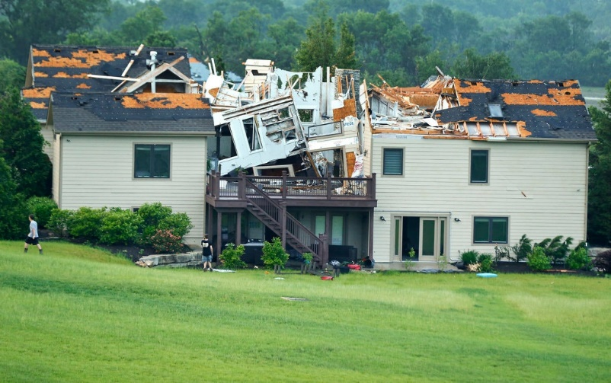

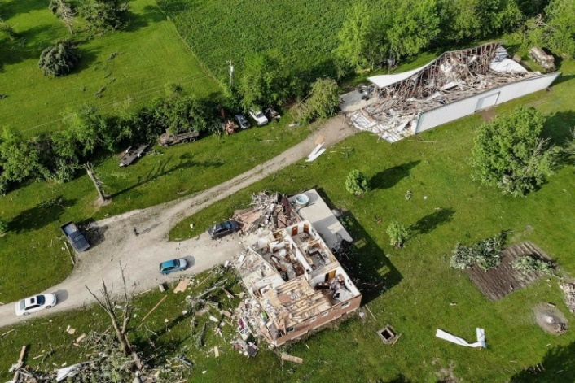

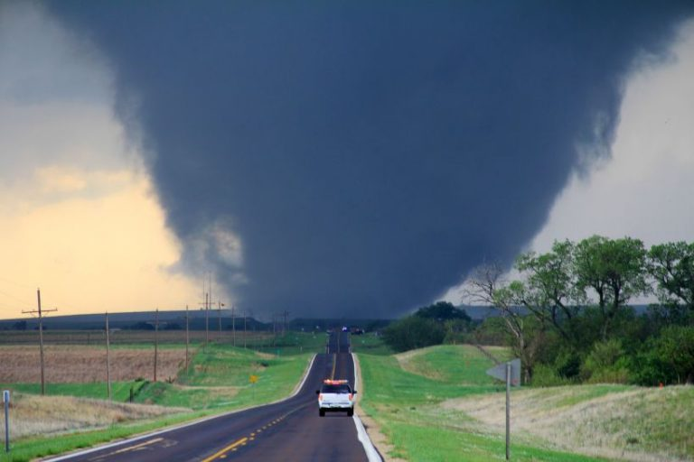

Tornadoes develop from severe thunderstorms. They are usually preceded by very heavy rain and/or large hail. A thunderstorm accompanied by hail indicates that the storm has large amounts of energy and may be severe. In general, the larger the hailstones, the more potential there is for damaging winds and/or tornadoes.  
  
The most violent tornadoes are capable of tremendous destruction with wind speeds of 250 mph or more. Damage paths have exceeded the width of one mile and 50 miles long.

Tornadoes generally move from southwest to northeast but have also been recorded traveling in other directions. The forward speed of a tornado varies from 30 mph to 70 mph.

TOP^

Peak tornado season in Ohio is generally April through July, and they usually occur between 2 p.m. and 10 p.m. One year, though, an EF1 tornado occurred in Fairfield County at 6 in the morning - which proves that tornadoes can happen at any time, during any season.

***Tornado Safety Tips***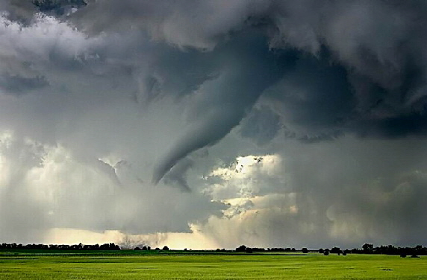Whether practicing in a tornado drill or sheltering during a warning, the Ohio Committee for Severe Weather Awareness encourages Ohioans to DUCK!

D - Go DOWN to the lowest level  
U - Get UNDER something  
C - COVER your head  
K - KEEP in shelter until the storm has passed  
  
Take responsibility for your safety and be prepared before a watch or warning is issued. Meet with household members to develop a disaster plan to respond to tornado watches and warnings. Conduct regular tornado drills. When a tornado watch is issued, review your plan – don't wait for the watch to become a warning. Learn how to turn off the water, gas and electricity at the main switches.   
  
Despite Doppler radar, tornadoes can sometimes occur without any warning, allowing very little time to act. It is important to know the basics of tornado safety. Know the difference between tornado watches and tornado warnings.

Tune in to one of the following for weather information: NOAA Weather Radio, local/cable television (Ohio News Network or the Weather Channel), or local radio station.  
  
If you are a person with special needs, register your name and address with your local emergency management agency, police and fire departments before any natural or man-made disaster.   
  
The safest place to be during a tornado is a basement. If the building has no basement or cellar, go to a small room without windows (a bathroom or closet) on the lowest level of the structure, away from windows and as close to the center of the building as possible.   
  
Be aware of emergency shelter plans in stores, offices and schools. If no specific shelter has been identified, move to the building's lowest level. Try to avoid areas with large glass windows, large rooms and wide-span roofs such as auditoriums, cafeterias, large hallways or shopping malls.

If you're outside or in mobile home, find shelter immediately by going to the lowest level of a nearby sturdy building. Sturdy buildings are the safest structures to be in when tornadoes threaten. Winds from tornadoes can blow large objects, including cars and mobile homes, hundreds of feet away.

If you cannot quickly get to a shelter, get into your vehicle, buckle your seat belt and try to drive to the nearest sturdy shelter.

TOP^

If you experience flying debris while driving, pull over and park. Choose to either stay in your vehicle, stay buckled up, duck down below the windows and cover your head with your hands, or find a depression or ditch, exit your vehicle and use your arms and hands to protect your head. Never seek shelter under highway overpasses and bridges.   
  
***Tornado Loss Prevention Tips***The following steps are suggestions that homeowners should take before a tornado or other natural disaster occurs to assure speedy and hassle-free recovery.

The Insurance Information Institute has a web tool that makes conducting a home inventory a breeze. Now you can catalog your possessions online, room by room. Once completed, you can add items and photos. Maintaining a comprehensive inventory will come in handy, should you need to file a claim or reevaluate the amount of insurance you carry.

***Home Coverage and Preparedness Tips***

* Tornado losses are most often covered by the "windstorm peril" under the homeowner's insurance policy.
* Check with your homeowner insurance agency to assure adequate coverage is provided by the policy. Notify the insurance agency of any additions or improvements to the home.
* Consider purchasing the replacement cost coverage endorsement for the home and its contents. It would give the option to rebuild or replace damaged property at current costs rather than depreciated values.
* If you experience a storm-related loss to your home that is covered by your insurance, notify your insurer in a timely manner, as required by your policy.
* Home Inventories Assist in Settling Claims
* Videotape, photograph or compile a written inventory of your home and belongings.
* Keep the inventory off premises in a bank safe deposit box. The inventory will provide a record for you and the insurance company, should a loss occur.
* Update your inventory every time you move or every two to three years.

***Written Inventory Tips***

* Go through each room of the home and list every item. Include the purchase date, price and model numbers.
* Include professional, written appraisals of antiques, jewelry and other costly possessions.

***Video or Photo Inventory Tips***

* Pan the camera around the room to capture all items. Obtain close-ups of expensive items such as jewelry, china and furs.
* Consider grouping items for easier inventory.
* Narrate the video by noting purchase costs and dates. Include model and serial numbers for appliances and electronic devices.

TOP^

***Auto Coverage and Preparedness Tips***

* Vehicles are protected under the "other than collision" (comprehensive) portion of an auto insurance policy, if damaged by windstorms or hail.
* If there is threatening weather, shelter vehicles to prevent damage from winds, flying debris and hail.

***After the Loss - Insurance Tips***

* Photograph any damage and inventory losses. Photos will assist when settling claims.
* Secure property from further damage or theft and save related receipts, since many insurers will reimburse for these expenses.
* If required to seek temporary housing due to a covered loss such as a tornado, check your policy for "loss of use" coverage. Many policies cover such expenses up to a stated amount. More information can be found at: <http://www.weathersafety.ohio.gov/TornadoFacts.aspx>

**Know more, do more, and have more fun with ham radio!**

**73, David WA3EZN**

You can view the STM’s monthly report on the website.. <http://arrl-ohio.org/stm/stm.html>

***From the Section Youth Coordinator***

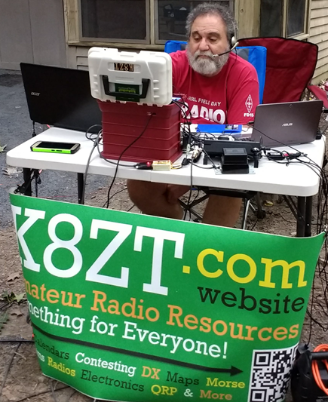***Anthony Luscre, K8ZT - SYC***

[k8zt@arrl.net](mailto:k8zt@arrl.net)

**Youth and New Ham Activity & Involvement at Field Day**

Many of you may have had your first exposure to Amateur Radio visiting or operating at an ARRL FD site you visited. FD is a great chance for your club to expose both newly licensed hams, potential hams and the general public. Not only is it a good practice you can even get additional points and bonus points for it:

* **Get-On-The-Air (GOTA) Station**. Any Class A (or F) entry whose transmitter classification is two or more transmitters may also operate one additional station without changing its base entry category, known as the GET-ON-THE-AIR (GOTA) station.
* **Public Information Table**: 100 bonus points for a Public Information Table at the Field Day site. The purpose is to make appropriate handouts and information available to the visiting public at the site.
* **Educational activity bonus**: One (1) 100-point bonus may be claimed if your Field Day operation includes a specific educational-related activity. The activity can be diverse and must be related to amateur radio. It must be some type of formal activity.
* **Field Day Youth Participation**:… a 20-point bonus (maximum of 100) may be earned... group for each participant age 18 or younger at your Field Day operation that completes at least one QSO

TOP^

**Public Information Table-** I have two handouts you can use. You can make paper handouts or simply single copies of each laminated to avoid moisture and have your guests use QR codes with their cell phones to get the handouts. *I have included images of each of the handouts in this column, please resist the urge to print them from here as they will not be as clear or crisp, instead use the links to open the documents directly.*

* **Ham Radio Resources for Youth, Students & Teachers**- [tiny.cc/hry](http://tiny.cc/hry)
* **Ham Radio Resources for New or Prospective Hams-** [tiny.cc/new-hams](http://tiny.cc/new-hams) (you can substitute your local radio club for my local club the [Cuyahoga Falls Amateur Radio Club](https://cfarc.org/))
* **What is Amateur Radio?** a short slideshow with embedded videos- [tiny.cc/whats-ar](http://tiny.cc/whats-ar)
* Tri-fold STEM brochure **“Ham Radio- The Original Maker Movement”**- [tiny.cc/hr-makers](http://tiny.cc/hr-makers)

**Educational activity bonus-** here are a few ideas from my web page:

* **Morse Code** with my $2 make it and take it Clothespin Key- [tiny.cc/cp-key](http://tiny.cc/cp-key)
* **Fox Hunting** with tape measure yagis- [link](https://www.jpole-antenna.com/2017/02/07/build-it-2-meter-tape-measure-yagi-beam-antenna/)
* **Radio Receivers** for guests to tune into activity (provide a list of suggested frequencies)
  + If you have Internet access you can use any of over 170 online tunable SDRs- [www.websdr.org](http://www.websdr.org/) or if no Internet you can have your guests use their cell phones
  + Help sheets for web SDRs- see the QR code link on **Youth Handout**
  + If no Internet any transceiver (with no mic!) or receiver that has SSB capability could be put into service
* Other activity from links on the **Youth Handout**

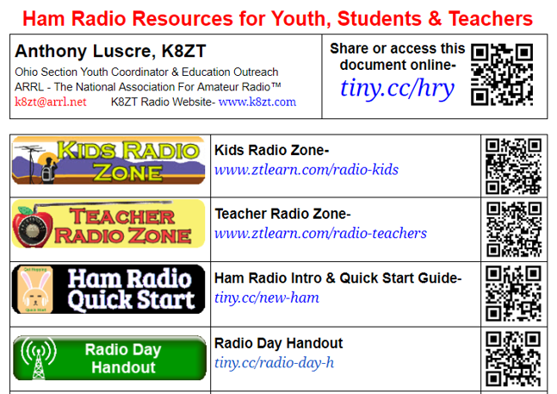

TOP^

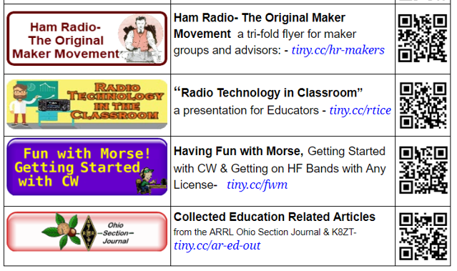

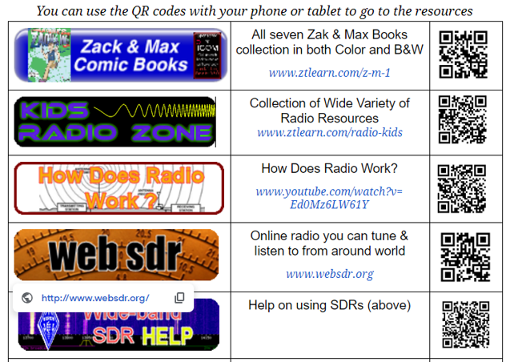

TOP^

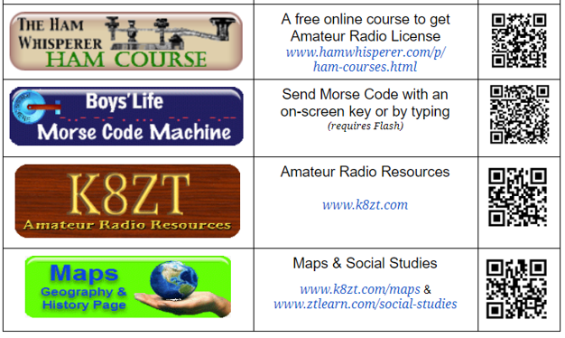

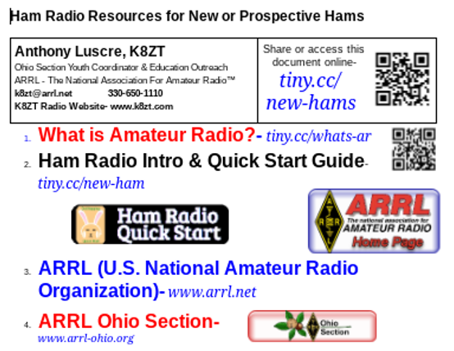

TOP^

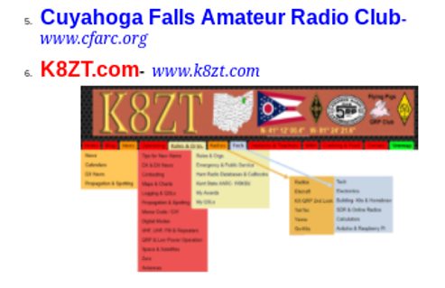

Until next time hope to work you on HF NOW!

**73, Anthony K8ZT**

*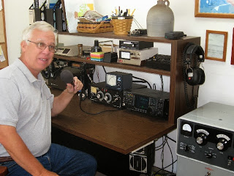****From the Official Observer Coordinator and ASM***

***John Perone, W8RXX – OOC/ASM***

[w8rxx@arrl.net](mailto:w8rxx@arrl.net)

The Ohio OO's monitored a total of 630 Hours in May.

There were no OO cards sent.

I’ve noticed a diminishing of the hours monitored by the OO’s recently. I guess this is due possibly for those awaiting the new VM program to soon to be in place.

#########

I want to thank Scott for considering me for the Assistant Section Manager position. Scott wanted to keep me involved in helping him help Ohio amateurs in my retirement. As many know the ARRL OO program, that I am the Ohio coordinator, is phasing out soon. It is being replaced with the new VM (Volunteer Monitor) program chaired by Riley Hollingsworth.

TOP^

I was first licensed in January 1967 as WN8VPZ (what a terrible CW call) Soon afterwards I received a driver’s license and amateur radio got put on the back burner.

After graduation I attended an electronic technical school. I was employed by low voltage contractors in the professional sound, broadcast and commercial video, and MATV / CATV industry.

Finally, I became co-owner in a manufacturer representative business. This allowed me to teach others how to design and install large commercial video and audio systems. Being a multi-state business, I decided to upgrade my pilot’s license to better travel my territory. My interest in aviation became strong enough to obtain a commercial license.

Some of the organizations I have been involved with include:

ARRL VE and Official Observer

Central Ohio Radio Club (CORC) – past president

American Society of Industrial Security (ASIS)

Society of Broadcast Engineers (SBE)

I look forward to meeting many of you in the future.

**73, John W8RXX**

***ARES Training Update***

***Jim Yoder, W8ERW – ARES Data Manager***

[w8erw@arrl.net](mailto:w8erw@arrl.net)

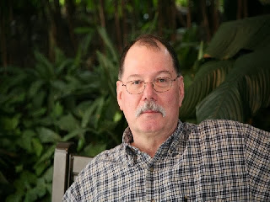

ARES Training Update

Here we are in the middle of June and the rain continues. My Niece and her hubby are farmers and it’s been a terrible year for them as well as many of our Ohio Farmers. My grass looks better than it ever has, but I’d sooner be seeing the corn and soy beans doing well. Most fields are still bare and it’s too late to get a crop this year. I hear locally that a lot of the hay was lost over the winter as well. It just has not been a good start this year for our friends in agriculture, many of whom are also Amateurs.

So where is our hope? Let’s pray that we are blessed with good weather for Field Day. The Seneca Radio Club http://w8id.org/ is going all in this year with plans to push our participation over the top. We’ll be at Hedges Boyer Park, <https://www.tiffinparks.com/hedgesboyer>, in two of the shelters at the North East end across from the YMCA operating two stations with a third station located nearby. Our aim was to see how separating the transmitters with a little more distance might improve performance. I hear the eats are going to be exceptional also and you’ll have to come see for yourself.

TOP^

The planning committee has been hard at work to insure we are ready to both tip the scale on points this year while providing a great time for everyone who participates.

Here in Sandusky County, the Sandusky Valley amateur Radio Club, https://w8nck.org/will be operating Field Day from <http://www.lovemyparks.com/parks/wolf_creek_park> which is located by the river along SR 53 just South of Fremont. The groups have planned a fun weekend also and will be operating from a beautiful location within the park. Stop out and visit. You are welcome to join in the fun and get some operating time with some seasoned amateurs who are a very friendly bunch.

Now it’s time for the really good stuff. ARES Connect is in full operation now and many of you have taken the time to get registered. <https://arrl.volunteerhub.com/lp/oh/>. If you have not already done so, please take a few minutes to go online and register. It’s a great place to see all the activities our ARES groups are into and to get your hours logged which is important. ARES Connect documents our ARES activities and provides an easy means to record hours spent supporting our ARES mission.

Quite a few of you have sent me your training certificates to be added to the database and are not yet registered with ARES Connect. Let’s work on closing this gap. ARES Connect and the training database work together to insure we have trained operators who are qualified for deployment when we are in a disaster situation.

It’s also important to keep your information up to date. When you change your call sign, please let us know so ARES Connect, and the database can be updated. When you complete one of the FEMA online courses, save the email with your certificate in .pdf format and send it to me so that it gets added to the database.

For those of you who have completed your NIMS training, ICS-100, 200, 700 and 800, you can request a transcript from FEMA and forward it to me. This is an easier means to insure you get all of your FEMA training recorded especially when you have taken additional courses.

I regularly update our training status to our Section Manager, Scott N8SY, who uploads the report to the Ohio Section Website, [www.arrl-ohio.org](http://www.arrl-ohio.org). The database is constantly growing as our members complete training and send me their certificates for inclusion. When I started keeping the database several years ago, we had less than 2,000 certificates on file. We now have 8,399. ARES membership in Ohio is now approximately 1,700 and 1,020 of you have submitted training documents. We still have room to grow. 812 have completed NIMS training while 150 have gone on to attain Level 3. These are some impressive numbers that demonstrate the level of ARES participation and strength for our Ohio Section. Thanks to everyone who has taken the time to complete these courses and submit certificates to the training database.

Your questions are always welcome. Please feel free to contact me if you have any concerns.

Thanks and 73,

**Jim W8ERW**

Hamshack Hotline #4161

TOP^

***The Handbook Give Away***

Hey Gang,

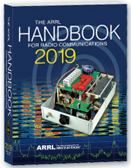Have you registered for the “Handbook Giveaway” drawing for this month yet? If you haven’t, go to: <http://arrl-ohio.org/handbook.html> and get registered.

What’s the catch? I want to get everyone checking in to the Ohio Section website as often as possible, and in order to register each month, you have to visit the website often! There’s nothing else to it. I pay all expenses, and from time to time, I Give Away more than just a Handbook. And, you’ll never know just what months will be those special times that I will have more than just a Handbook to Give Away!!

Many of you ask me just how do I know when the drawing is on? Well, that’s easy all you need to do is check in on the Ohio Section Website on a regular basis and watch for the big [**RED**](http://arrl-ohio.org/handbook.html)Arrow that will appear on the left side of the page. This is the sign that the drawing is on and you need to get registered. So, keep a sharp eye out on the website and check in often! <http://arrl-ohio.org>

TOP^

***Club Corner***

This is YOUR cornner of the newsletter. Send me what your club is doing and I’ll make sure that it gets in. Got a special event or club project that you want everyone to know about? Send it to me!. Need help with a project? Send it to me.

Let me know what you club is up to. Are you going to have a special guest at your meeting or are you having a special anniversary? Just sent it to:

[n8sy@n8sy.com](mailto:n8sy@n8sy.com)

#########

GOBA is asking for our help in providing operators for their event on **Saturday June 22**. Contact Ross County EC Todd Johnson KD8UND at [rvcrazy@gmail.com](mailto:rvcrazy@gmail.com).

Todd is the communications director for the event which will include Wood, Sandusky, Ottawa and Lucas County. The maps can be found on the Ride With GPS app.

#########

TOP^

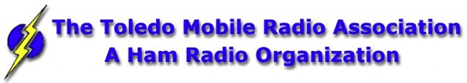The Toledo Air Show is **July 13 & 14** and we did such a great job at the last Air Show the powers that be have requested additional help from us this time around. We are still in the planning phase and do not have final numbers for needed operators, but I wouldn’t be surprised to see a number around 50 or more each day.

Our coverage includes some of the following: Entrances; First Aid Tents; Mobile Hospital; Air Boss; Incident Command; Parking Lots; Transportation Buses; Exits and more.

If you can help - Please contact either Rick K8RKS at [K8RKS@ARRL.net](mailto:K8RKS@ARRL.net) or Tim KD8IZU at [boxcar@toast.net](mailto:boxcar@toast.net) In the Subject Line of your email put Toledo Air Show.

#########

***Alliance Club Holding A Technician License Class***

Our class for technician starts **06 July** in the Cafeteria conference room at the Alliance Community Hospital.

Twelve weeks free, 5 PM to 7 PM each week. Requirements, a flash drive or SD card with about 1 Gigabyte free space and a commitment to do the studying required.

For more information contact Frank Sanor at [wa8whp@gmail.com](mailto:wa8whp@gmail.com)

#########

***Need Help Desperately for Operation Vigilant Guard***

It's been a bear trying to get the mission requirements locked down for Operation Vigilant Guard. At this point in time we could need up to eight ARES volunteers for the **Wednesday, August 07** operation.

Please, if you have some time to volunteer to help me make this mission a great success for Amateur Radio, contact Rick Kruis [k8cav.coms@gmail.com](mailto:k8cav.coms@gmail.com)

#########

***Ohio Statewide Courthouses On The Air Special Event, August 24, 2019***

**Event Background**

Last year there was the Ohio Covered Bridge Special Event that was led by John Levo, W8KIW Editor of the Highland ARC’s *Monday Morning Memo*. Several clubs participated and was a complete success. Additionally, there were several folks interested in Ham Radio at the event who have now become new Hams.

TOP^

Yes, anytime there is a public event resulting in a gain to the Ham Radio community, it is a total success. This year in keeping with the historical event series, John and the members of the Highland ARC decided to do a special event from their courthouse lawn. John published an article in the *Monday Morning Memo* which attracted the attention of Michael Love, WB8YKS Southern Ohio Amateur Radio Association (SOARA) PIO. 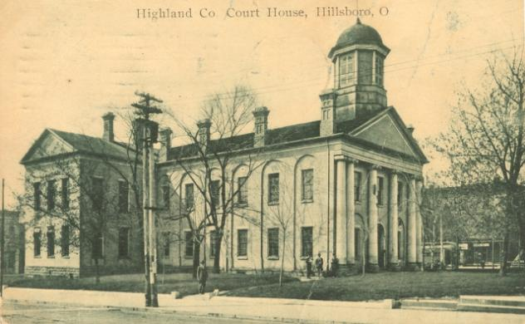John and Mike decided that there may be interest in an all-state special event celebrating the courthouses in all of Ohio’s 88 counties. Scott Yonally, N8SY Ohio Section Manager thought it was a fantastic idea and requested John and Mike to reach out across the state to determine the level of support for the event. The Ohio Section has 117 affiliated clubs of which 48 are Special Service Clubs and there are 29 PIOs. There may not be a club listed in each county by address, but we do have Hams in each county.

**Promoting Ham Radio**

This may be a first for the ARRL and the Ohio Section. This event has all the opportunities for a FUNFILLED family day engaging the public and our government officials. Additionally, one county’s club is partnering with their county commissioners, historical society, EMA, sheriff’s office, public library, chamber of commerce, and news media. The club has decided to use a large tent as the event will take place rain or shine. Their PIO will make handouts available about ham radio and promoting the ARRL, ARES, RACES, Ohio Section and their local club. A special focus will be made to spotlight the public awareness of the hobby and the benefits of a Ham radio license, emergency and community service. The public will be invited to talk on the radios under the direct supervision of a licensed operator. Several clubs plan to provide contact QSL cards and/or certificates to capture this historical event.

**Fun for Everyone**

There may be some folks dressed in period costumes providing history about their courthouse and the early days in their county. Moreover, one club has requested, August 24, 2019, to be declared as Ham Radio Day in their county, and their county commissioners have approved it.

**Event Details**

Yes, we are excited and hopefully you are as well, about participating in this historical Ohio Courthouses on the Air Special Event. **We are requesting ALL Ohio Clubs and Hams to consider supporting this special event. The event will take place on, Saturday, August 24, 2019, from 9:00 AM to 4:00 PM. However, the hours can be extended by each club. Additionally, each club will determine the frequencies and modes they will use.**

Another opportunity presents itself as the Ohio QSO Party [www.ohqp.org](http://www.ohqp.org) is also on the air, Saturday, August 24th. Therefore, these two events will complement each other providing contacts not only from within Ohio but across the country. All Hams are invited to participate.

TOP^

**Staying in Touch**

Please inform the listed contacts that your club will be participating, and the name of the county represented. Additionally, there will be updates provided in the *Monday Morning Memo*, the *PostScript,* *Ohio Section Journal, and www.****arrl****-****ohio****.org.*

**Contacts for additional information:**

Michael Love, WB8YKS

wb8yks@arrl.net

John Levo, W8KIW

[highlandara@yahoo.com](mailto:highlandara@yahoo.com)

#########

***USAF Marathon Needs Help***

Approximately 70 amateur radio operators are needed to support the USAF Marathon at Wright Patterson Air Force Base on Saturday, September 21, 2019 to provide the USAF Marathon Staff with emergency and logistic communications. This world class event has over 20,000 participants, volunteers, and spectators in attendance every year.

Amateur radio operators are indispensable in rapidly communicating information on runner’s locations and status, heat index settings, severe weather notifications, as well as emergencies and logistic issues. Plus, APRS is utilized to track lead runners and “Tail End Charlie’s”, thus allowing race officials and emergency services to more accurately monitor the race progression.

According to Brandon Hough, the USAF Marathon Race Director, the senior base leaders rely on the communication skills of our amateur radios operators and use them as a vital resource.

Multiple races are held on this day including: 10K, Half Marathon, Full Marathon, and Wheelchair. The volunteer registration website for the USAF Marathon is now open.

If you will be in the Dayton, Ohio area on Saturday, September 21, 2019 and would like to take part in this world class event, please go to the USAF Marathon website at <http://www.usafmarathon.com/volunteer>  and click the volunteer now link, scroll down to the amateur radio section to register. Training will be provided prior to the event.

How to register online:

1. Go to the website above.
2. Click on the Volunteer Now button.
3. Acknowledge that you’re going to a new website.
4. On the new website, ignore the “password” entry box near the top of the page. Scroll down to the “Amateur Radio Operator” section and click the check box for the Amateur Radio Operator Position and only that position.
5. Scroll to the bottom, past all the other volunteer positions, and fill in your name and other required data.

TOP^

1. Check the box below the waiver paragraph and then type in your name for a digital signature.
2. Click the “Sign Up to Volunteer” button.
3. You’re done!
4. You should get an automated email response from Jeanette Monaghan acknowledging your registration.
5. Contact Phil Verret if you have any questions or concerns.

**Registration closes August 31, 2019**.

If you have any questions please email to: Phil Verret, [KA8ZKR@ARRL.NET](mailto:KA8ZKR@ARRL.NET)

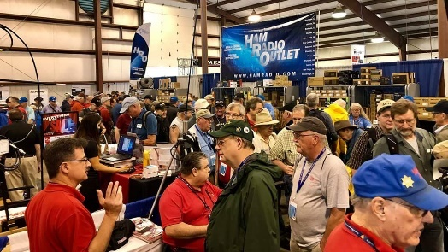[***Upcoming Hamfests***](http://arrl-ohio.org/hamfests.html)

**07/07/2019 | 20/9 Radio Club Hamfest** Location: Austintown, OH  
Sponsor: 20/9 Radio Club, Inc.  
Website: [http://20over9.org](http://20over9.org/)

|  |  |
| --- | --- |
| **07/07/2019 | Ohio Link Swap Meet**  Location: 1801 Gateway Circle, Grove City  Sponsor: Ohio Link Network Group  Website: [www.olnradio.digital](http://www.olnradio.digital) | **07/20/2019 | NOARSFEST**  Location: Elyria, OH Sponsor: Northern Ohio Amateur Radio Society Website: <http://noars.net/hamfests/noarsfest> |
| **07/21/2018 | Van Wert Hamfest** Location: Van Wert, OH Sponsor: Van Wert Amateur Radio Club Website: [http://w8fy.org](http://w8fy.org/) | **07/28/2019 |**[**Portage Hamfair '19**](http://www.arrl.org/hamfests/portage-hamfair-19)  Location: Ravenna, OH Sponsor: Portage Amateur Radio Club Website: [http://hamfair.com](http://hamfair.com/) |

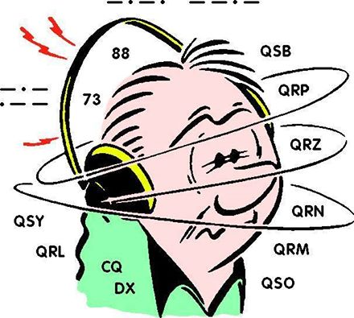***DX This Week***

*(from Bill, AJ8B)*

Bill AJ8B ([aj8b@arrl.net](mailto:aj8b@arrl.net), @AJ8B, [www.aj8b.com](http://www.aj8b.com) or [www.swodxa.org](http://www.swodxa.org) )  
CWOPs Member #1567

As I am putting this together, I have just received the Certificate for the Yaesu FTDX-3000, the Grand Prize at the W8DXCC convention. I hope you went to the Milford ARC Hamfest and I hope you attended the W8DXCC convention. Very exciting stuff!

TOP^

Just before the doorbell rang, I worked A41CK in Oman, 5B19CWC in Cyprus (FT8) and OJ0AW on Market Reef on CW. OJ0AW is an activation celebrating 50 years since the first DXpedition was held from there. There is more at the end of this week’s installment supplied by W3UR, Bernie.

I have gotten some excellent feedback from the 9J2BO segment that I ran last week. I will have an interview each month for your enjoyment. Of course, you must let me know if these are of interest to you. The next article is from Laci, OM2VL. Laci has one of the biggest signals from Europe, and I have worked him many times. In fact, at the end of the Ohio QSO party last August, I worked OM2VL on 80 meters. The noise level was VERY high, and I was not sure that I have worked him, so, I did not include him in the log. After the fact I found out (via LoTW) that I had worked him. That was a multiplier I could have used! Uncle Frank would have told me to work them first, count them, and then worry about it later!

This article first appeared in Volume 1, Issue 3 of “The Exchange”. Reprinted with the permission of SWODXA. Enjoy.

+ --------------------------------------------------------------------------------------------------------------------+

OM2VL — A BIG gun from the Slovak Republic   
By Guest Author, Laci, OM2VL

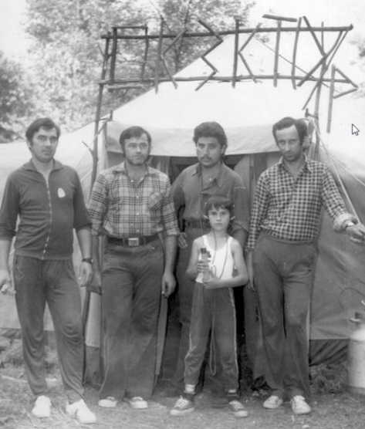*I have had the pleasure of working OM2VL many times and have marveled at his operating technique and excellent signal. I asked Laci to send us a description of his experiences in the Slovak Republic. He kindly and generously replied with this article and pictures. He is county hunting and would love to work all of us. Visit his qrz.com webpage and drop him a note for a sked.*

My amateur radio career began at the beginning of the 70's when I was 5-6 years old. At that time in my home town Dunajská Streda, was a good working radio amateur club - OK3KTD, also my father OK3TCG was a member of this club. This club was every summer organizing “EXPEDITIONS” for one week in a nearby forest close to the river Little Danube. The families were sleeping in tents and there was a central large in which the radio was.

To this very day I have very pleasant memories of this camp (boating, swimming during the day, campfire in the evening). At that time, I just observed the big ones as they were sitting in front of the radio and making QSO the whole day. At that time my prior interest was ARDF. I won my first competition at my 7 age and had very nice results during next 10 years.

As SWL I began at end of 70’s, when my father taught me morse code in 1 week. I took part in many contests and I collected QSLs for RARE Awards especially Islands, castles, Antarctica and many other. I have confirmed 339 DXCC, 160m-320, 80m-335, 30m-336, 20m-338, 17m-337,15m-339, 12m-332,10m-336, 269 Canadian Island, 320 US Island from all 50 states, 292 Antarctic station / 125 base / 25 DXCC. I have my all LOGs still today and when I hear some RARE station, I send also my SWL card.

TOP^

At the age of 15 I passed the junior ham exam and after that I began my HAM activity on 160m as OL8CTX. After follow-up new exams I got the callsign OK3TVL, but at that time I was attending the university, so I had very limited time for my hobby.

On 31st December 1992, the Czechoslovakia was peacefully dissolved. It formally separated into two independent countries, the Czech Republic and the Slovak Republic.

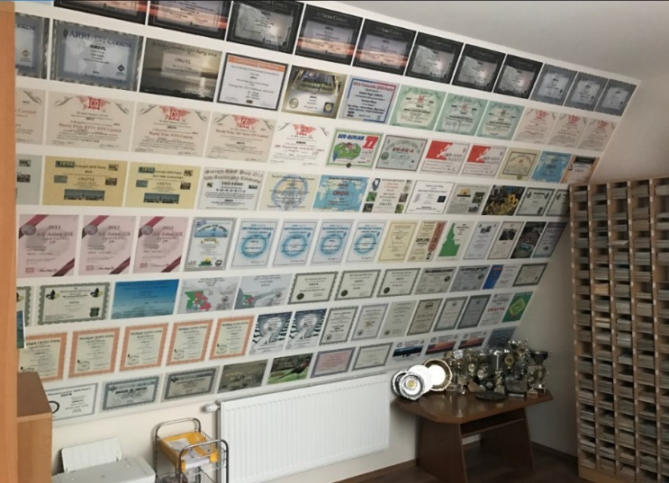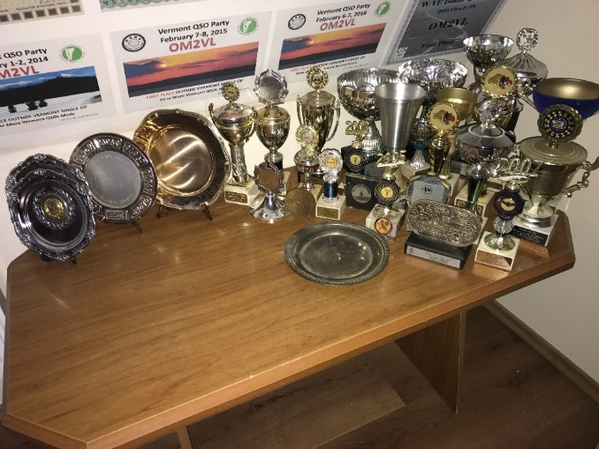

I began work from 1st January 1993 with OM2VL callsign on all frequencies, but unfortunately at that time I had not much time for my hobby.

After dissolving Czechoslovakia, the radio amateur clubs were gradually cancelled, unfortunately, including our club. The Thursday evening and Sunday morning club days attended by 15-20 ham members disappeared.

At the age of 15 I met Tibi OM3RM who was acting in club OM3RMM (on contests OM8A). He approached me to join their club, I agreed with pleasure.

At that time we recorded the contests on paper and on the first contest I was observing the dupes, of course also writing on paper.....I still was just watching the big ones contesting and I was happy to make few QSO before or after the contest. I learned much from them! We were taking part in every big contest and I took part on each of them with pleasure.

In 2003 I made a 83 m long delta loop, and I could work also from my home with LP. We started in these years to build the OM8A radio amateur station on the new QTH – about 25km from my home, it lasted few years. As

I remember we worked the first CQWW from new QTH in 2006. From that I was travelling to station regularly at free weekends to make DX’s or contests. I have confirmed 338 DXCC, missed only North Korea; 160m – 247, 80m – 294, 40m – 315, 30m – 301, 20m – 330, 17m – 307, 15m – 328, 12m – 264, 10m – 297.

TOP^

From 2008 I am interested in the US County Award and I started collect the counties, so now I have 2814 counties confirmed. Unfortunately, many stations do not send QSL. I started also to take part on various QSO parties – now these became my favourite contests. I have over 12.000 QSO during the QSO Parties. From this 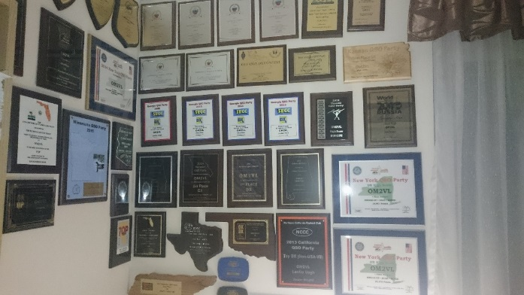year I am interested also for County Challenge Toplist (need every county on every band and on every band on CW, SSB, RTTY) –I know, so hard from the Europe.

Fortunately, my wife is very understanding also when I spend almost 3 weekends with contests every month.

I qualified to participate in the: WRTC 2010 Moscow, WRTC 2014 Boston and now it is sure that I will be also a participant in 2018 WRTC in Germany.

+ --------------------------------------------------------------------------------------------------------------------+

Here is an update from Bernie, W3UR, of the DailyDX and the WeeklyDX,

the best source for DX information. (<http://www.dailydx.com/> ) Bernie has this to report:

+ --------------------------------------------------------------------------------------------------------------------+

**Northern Market Reef** - The OJ0-land is Celebrating Her 50th DXCC Year.   
By OH2BH, Martti Laine.

DXotica from 1969 to 2019 The first ever DXpedition to icy Market Reef landed on December 27th of 1969 and put OJ0MR on the air. The first operators were Sigge, OH0NI (SK), Martti, OH2BH, Erkki, OH2BW (SK) and Raimo, OH2KK. Soon after the first operation, the permanent lighthouse keeper Karl-Erik, OJ0MA also hit the airwaves. A stream of DXpeditions followed. These later DXpeditions kept OJ0 a dream location for hundreds and hundreds DXpeditioners, allowing them to discover the light and become performers within the admired DXpedition industry.

The Northern California DX Foundation (NCDXF) had helped OJ0MA become a household DXer and later a great ham as OH0NA, while later-on, the NCDXF and OHDXF assisted the Finnish Light House Society (FLS) to restore the beauty of this remote DX outpost between Aland Islands and Sweden.

The 2019 season will see many veteran DXpeditioners returning to their dreamland to provide OJ0 QSOs to those who deserve - the Deserving!

TOP^

Their return will enable them to once again experience the camaraderie and friendship only a true DX location can provide. Adding to the crew will be upcoming OH and SM youngsters! The invited guests of the season are: CO8DM, E21EIC, E20NKB, W5XU, DS4EOI, JH4RHF, JE6HIB, PB2T, DJ9ZB, DL3DXX, DJ4MF, DL5SE, SM0W, SA0LAT and others. They will be hosted by OH3WS, OH3JR, OH2BH, OH2TA, OG2M, OH2PM, OH4EA, OH6FSG, OH6LSR, OH6KV, OH6OK, OH6NJ and the younger vintage of OH2FB, OH1UBO and OH3UAF.

The activity is in several phases throughout the summer and may even extend to the hard winter season in order to capture the best low-band openings. It all starts this Saturday June 8th with OJ0AW and OJ0JR.

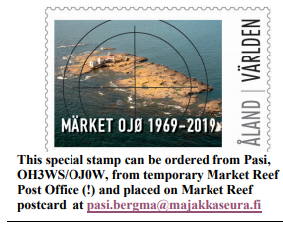Next, following the international week of July 6 will be OJ0A and OJ0Z. Then the IARU Contest weekend of July 13/14 with OJ0B and then turning to Youth Week of OJ0C from July 15 and IOTA week of July 27 (OJ0DX) and Light House weekend of August 17 (OJ0O). The OJ0-regulars Pasi, OH3WS/OJ0W, Henri, OH3JR/OJ0JR; Martti, OH2BH/OJ0BH and Pertti, OG2M/OJ0MR will take the slots along with their official duties

There are twenty-one valid OJ0 licenses. More than 50% are expected to be active during this year. If you work five of them (5) in 2019, a special award will be released. If you work ten (10) of them in 2019, you will qualify for a special award and a symbolic key to the light house.

Your log extract should be submitted to Pasi, OH3WS, the contact person between the FLS and the global ham fraternity. The Aland Islands Postal Administration will also release a special Market Reef stamp to commemorate Market's 50th DXCC year for philatelist community.

The special stamp on a Market Reef postcard can be obtained from the Market Reef Post Office with appropriate stamping at the cost of 4.00 Euros from Pasi, OH3WS/OJ0W.

And finally, as the sugar at the bottom, the Aland Island boat captain Fredrick will provide a day tour to those who want to see this wonderland and make few contacts on their own from OJ0 on July 10 and July 16. Please contact Martti, OH2BH for details at oh2bh@arrl.net

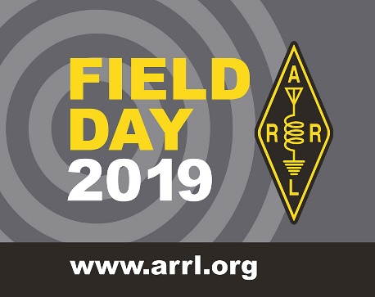

***Field Day Is Coming Up – Is Your Site Listed On The ARRL Field Day Locator?***

Hey Gang,

First let me say that we do have the Proclamation for Field Day Week from the Governor’s Office online and ready for you to download and print. Just got to:

<http://www.arrl-ohio.org/FD_Message.html>

TOP^

For our PIO’s out there we also have a great prewritten “Press Release” for you use if you want to. All you need to do is fill in a few blanks and you’re ready to send out to all those newspapers and weekly periodicals. Here’s a link..

<http://arrl-ohio.org/FD_Press_Release.html>

***Now for those clubs out there that are going to host Field Day…***

The ARRL created a “Field Day” locator a number of years ago and it works really slick for those of us who do a little traveling around to visit your site.

I know that you feel your site is really easy to find, but please keep in mind that most of us from outside of your area have no clue where the “Smith Farm” is. Yes, in years past I have been given directions like.. “Just go down route 4 until you pass the Smith Farm and it’s just 2 miles further on the right.” You want visitors to find your site easily don’t you? Of course, you do! Remember, those government officials that you’ve invited are worth some extra points for you.

So, how’s the easiest way of finding your site? Post it on the ARRL Field Day Locator, that’s how. Here’s a link to it.. [Field Day Site Locator-](http://www.arrl.org/field-day)

Note: If you are entering a new Field Day site, you must be logged into the ARRL website for your Field Day entry to be automatically posted on the Field Day Locator. If you are not logged in, your site will not be listed on the Field Day locator until it is reviewed by ARRL staff. If you are searching for Field Day sites but encounter screen errors, be sure you have JavaScript enabled on your browser.  To confirm you have JavaScript enable, go to this web site <http://www.enable-javascript.com/>

Now, for you newbies to Amateur Radio… What’s Field Day all about? Well, here’s the explanation.

[Objective-](http://www.arrl.org/field-day)

To work as many stations as possible on the 160, 80, 40, 20, 15 and 10-Meter HF bands, as well as all bands 50 MHz and above, and to learn to operate in abnormal situations in less than optimal conditions.

Field Day is open to all amateurs in the areas covered by the ARRL/RAC Field Organizations and countries within IARU Region 2. DX stations residing in other regions may be contacted for credit but are not eligible to submit entries.

***Special Events***

**06/24/2019 | Simon Kenton Council, Delaware District, Cub Scout Day Camp**

**Jun 24-Jun 28, 1330Z-1700Z, K2BSA/8**, Lewis Center, OH. Delaware Amateur Radio Association K8ES. 14.290 7.190. QSL. Ed Jones, 2965 Seaway Ct, Lewis Center, OH 43035. We'll be operating each day from 13:30-19:30 from Camp Lazarus in Ohio. We'll have hundreds of scouts on the air over the course of the week.

TOP^

**07/08/2019 | 50th Anniversary of First Moon Landing**

**Jul 8-Jul 24, 0000Z-2259Z, N8A**, West Chester, OH. Midwest VHF/UHF Society. 10368.100. Certificate. Tom Holmes, N8ZM, 1055 Wilderness Bluff, Tipp City, OH 45371-9221. Plan to work 10 GHz EME when moon at best position for good DX. Contact for schedules and exact frequency. [n8zm@mvus.org](mailto:)

**07/14/2019 | 50 Years - First Man on the Moon**

**Jul 14-Jul 28, 1700Z-2000Z, N1A**, Milford, OH. Milford Amateur Radio Club. SSB: 28.350 14.260 7.240 3.840; CW: 14.045, 7.045, 3.545; FT8 standard frequencies. QSL. Milford Amateur Radio Club, P.O. Box 100, Milford, OH 45150-0100. Email qsl@w8mrc.com for QSL requests. [www.w8mrc.com](http://www.w8mrc.com/)

**07/20/2019 | Honoring the 50th Anniversary of the Apollo 11 Moon Landing**

**Jul 20, 1400Z-2000Z, K8QYL**, Wapakoneta, OH. Reservoir Amateur Radio Association. 14.250 7.250. QSL. Rich Spencer, W8GZ, 05925 Vogel Rd., Saint Marys, OH 45885. From the Neil Armstrong Air and Space Museum

**07/22/2019 | Seneca County Fair**

**Jul 22-Jul 29, 1600Z-0200Z, W8ID**, Tiffin, OH. Seneca Radio Club. 7.225 3.895. QSL. Seneca Radio Club W8ID, P.O. Box 67, Tiffin, OH 44883. W8ID will be celebrating 177 years of the Seneca County Fair! Join us for the cotton candy! Join us for all the fun! We can’t wait! [www.w8id.org](http://www.w8id.org/)

**08/01/2019 | W8LKY Carnation Festival Special Event**

**Aug 1-Aug 11, 0000Z-2359Z, W8LKY**, Alliance, OH. Alliance Amateur Radio Club. 14.240 14.045 7.240 7.045. Certificate & QSL. Alliance Amateur Radio Club, P.O. Box 3344, Alliance, OH 44601. The Alliance ARC(W8LKY) will be on the air at various times throughout our Carnation festival festivities. We'll be on the air from various locations in the Carnation city. We may pop up on the bands at any time. Check the spotting networks, and our web page for upcoming activations. [www.w8lky.org](http://www.w8lky.org/)

**08/15/2019 | D-Day Conneaut**

**Aug 15-Aug 18, 1600Z-0400Z, W8D**, Conneaut, OH. Conneaut Amateur Radio Club. 14.285 7.190 3.996 3.885. QSL. Garret Scott W8D, 10236 Birch Hill Ln., Knoxville, TN 37932. D-Day Conneaut recognizes the 75th anniversary of the World War II Allied D-Day Landings on the beaches of France in 1944. Event will include the country's largest reenactment of the D-Day landings with more than 1,800 WWII reenactors from around the world participating. Radio operations will include vintage WWII equipment.<https://www.facebook.com/W8BHZ>

**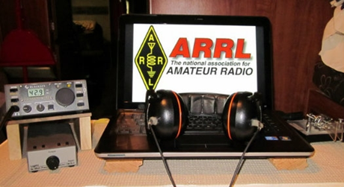*ARRL Contest Corner***

An expanded, downloadable version of *QST'*s [Contest Corral](http://www.arrl.org/contest-calendar) is available as a PDF. Check the sponsor's Web site for information on operating time restrictions and other instructions.

TOP^

***ARRL DX Bulletin***

This week's bulletin was made possible with information provided by The Daily DX, The OPDX Bulletin, 425 DX News, DXNL, Contest Corral from QST and the ARRL Contest Calendar and WA7BNM web sites. Thanks to all.

**CYPRUS, 5B.** Special event station 5B19CWC is QRV to celebrate the Cricket World Cup which ends on July 14. QSL via 5B4AJT.

**GHANA, 9G.** Matteo, IZ4YGS is QRV as 9G5GS from Sanzule, West Takoradi until July 2 while here on work assignment. He is active in his spare time during his evenings on 160 to 6 meters using mostly FT8 and SSB. QSL direct to home call.

**CHILE, CE.** Special event station CB2E is QRV until July 2 to mark the total solar eclipse on July 2. Activity is on the HF bands using SSB and FT8. QSL via bureau.

**SPAIN, EA.**  Members of the Radio Club La Baells will be QRV with special calls EG3PTA, EG3PTP, EG3PTT, EG3PTU and EG3PTM from June 15 to 23 to support the touristic and cultural endeavors of the Bergueda region. Activity will be on 160, 80, 40 and 20 meters using SSB and FT8. QSL all calls via EA3RCI.

**GUADELOUPE, FG.** Gildas, F6HMQ is QRV as FG/F6HMQ and TO1T until June 25. QSL to home call.

**ST. MAARTEN, PJ7.**  Satoru, JI1DFO is QRV as PJ8SK until June 15. Activity is on 40 to 17 meters using FT8. QLS to home call.

**SAINT MARTIN, FS.** After his Sint Maarten activity, Satoru, JI1DFO will be QRV as FS/AG5CR from June 16 to 18. Activity will be on 40 to 17 meters using FT8. QSL to home call.

**THAILAND, HS.** Members of the Radio Amateur Society of Thailand are QRV with special call HS10KING until July 31 to celebrate the coronation of King Vajiralongkorn Bodindradebayavarangkun. QSL via bureau.

**SVALBARD, JW.** Christian, EA3NT and Col, MM0NDX are QRV as JW/EA3NT and JW/OJ0Y, respectively, from Longyearbyen, IOTA EU-026, until June 16. Activity is on the HF bands using CW, SSB and various digital modes. QSL JW/EA3NT via M0OXO and JW/OJ0Y via M0SDV.

**MARIANA ISLANDS, KH0.** Tony, JA6CNL is QRV as KH0N from Saipan, IOTA OC-086, until June 17. Activity is on the HF bands using FT8. This includes being an entry in the All Asian DX CW contest. QSL to home call.

**NORWAY, LA.** Jacques, CT2IXX is QRV as LA/CT2IXX/p from Hitra Island, IOTA EU-036, until July 12. Activity is holiday style mainly during his weekends on various HF bands using only SSB. QSL to home call.

TOP^

**GREENLAND, OX.** Bo, OZ1DJJ is QRV as OX3LX from Nuuk City until June 21. Activity is in his spare time on the HF bands, with a focus on 160, 80 and 60 meters. QSL direct to OZ0J.

**PALAU, T8.** Nobuaki, JA0JHQ will be QRV as T88PB from Koror Island, IOTA OC-009, from June 15 to 23. Activity will be mainly on 6 meters using FT8. This includes being an entry in the All Asian DX CW contest. QSL direct to home call.

**ASIATIC RUSSIA, UA0.** Operators Vasily, R7AL, Vladimir, RK8A and Albert, UB9WLJ are QRV as R205NEW from Bogoslova Island, IOTA AS-205, until June 18. This is a new island activation. QSL via Club Log.

**MICRONESIA, V6.** Hatu, JA1XGI will be QRV as V6K from Kosrae Island, IOTA OC-059, from June 17 to 24. Activity will be on 40 to 10 meters. QSL to home call.

**CHRISTMAS ISLAND, VK9X.** Christmas Island Amateur Radio Club station VK9XX has been active on 20 meters around 0900z. QSL via operator's instructions.

**FALKLAND ISLANDS, VP8.** Special event station VP8HDM will be QRV on June 15 and 16 from the Historic Dockyard Museum in Stanley, IOTA SA-002, during the International Museum Weekend. Activity will be on 40 to 17 meters. QSL direct to VP8LP.

THIS WEEKEND ON THE RADIO. ARRL SSB Kids Day, All Asian DX CW Contest, Stew Perry Topband CW Challenge, International Museum Weekend, NCCC RTTY Sprint, NCCC CW Sprint, SMIRK Contest, Ukrainian DX Classic RTTY Contest, ARR BPSK63 Contest, IARU Region 1 50 MHz Contest, AGCW VHF/UHF CW Contest, West Virginia QSO Party, Feld Hell Sprint and the WAB 50 MHz Phone will certainly keep contesters busy this upcoming weekend.

The Run for the Bacon QRP CW Contest is scheduled for June 17.

The RSGB 80-Meter Club CW Championship, CWops Mini-CWT Test and Phone Fray are scheduled for June 19.

***One Question Questionnaire***

Hey Gang,

It seems that about 88% of you actually carry your ham radio license with you. That’s really great, and it’s a lot more than I thought it would be for sure!

I’ve got another NEW – one question – questionnaire on the Ohio Section Website! <http://arrlohio.org> Go check it out…

**“Do you use noise-cancelling headphones at your station??”**

TOP^

These One Question questionnaires are all in fun and I hope that you are enjoying answering them.

You’ll find the “One Question” questionnaire on the Ohio Section Website! <http://arrlohio.org> It’s all in fun and it’s not a scientific survey in any way, but we are learning some things that we didn’t know from these questions. I hope that you are enjoying answering these “One Question” questionnaires.

*****V.E. Test Sessions***

For the latest testing site information please **>>** [**Click Here**](http://www.arrl.org/find-an-amateur-radio-license-exam-session) **<<** The ARRL site tracks all of the VE testing sites that register with them, including W5YI and Laurel. ARRL gives you a number of different ways of sorting to find that site that is closest to you as well.

***Incident Command System (ICS) Training Schedule***

All current trainings are listed on the Ohio EMA training calendar located at:

<https://webeoctraining.dps.ohio.gov/TrainingAndExercise/courselist.aspx>

I’ve been asked to also include a link to the Kentucky EMA training calendar as well..

<https://kyem.ky.gov/training/Pages/default.aspx>

<https://sites.google.com/site/ccoemtraining/home>

Please pay particular attention to these courses listed above, as that there’s a lot of ICS 300 & 400 classes listed that are very useful for all Amateurs to have under their belts. I will also state that G775 is also a very good course to take as well. These 3 courses are multiple day in class courses, so please be prepared to spend some time taking them.

We do recognize that IS-300/400 requires multiple days of actual classroom training that is not easily obtained. So, if you just can't find the time to fit these class room courses in, we do have an alternative method for getting you to Level 3.

Completing the following **“FREE”** and **“ONLINE”** courses will act as substitute for you FEMA Leadership Development Course requirements. You absolutely will need to complete all **7** of these courses to get your ICS 300/400 credit.  Here are the courses that you need to take:  **IS-120, 230, 240, 241, 242, 244 & 288.**

***Now, if you are looking for wallpaper and have a little extra time, taking IS-235 in addition to the 7 listed courses above, you will get a really cool looking certificate from FEMA stating that you have completed the Professional Development Series. That’s impressive in itself!***

TOP^

***ARES Connect***

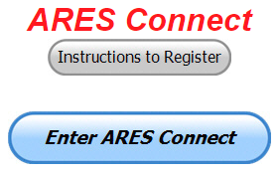We need to discuss some very important items that only YOU can make a difference with. I need you to get yourselves registered in ARES Connect, if you haven’t already. We need to make sure that no one is left behind.

If you live in **Ohio** and you haven’t registered yet, we need you to get registered now. We need you to only use this URL to get registered [**https://arrl.volunteerhub.com/lp/oh/**](https://arrl.volunteerhub.com/lp/oh/). Using any other entrance to register will only slow down your registration process. Again, this is for those living in Ohio only. If you are an out of state person (not Ohio), you can simply change the /oh/ to your 2-letter state designation. This will put you in the correct state for signing up

***Here’s the top 10 hours earners so far, for the month of June:***

|  |  |  |  |
| --- | --- | --- | --- |
|  | **Name** | **Events** | **Hours** |
| 1 | Dan Stahl (KC8PBU) | 28 | 57.40 |
| 2 | Bret Stemen (KD8SCL) | 25 | 56.00 |
| 3 | Christopher Domenick (KC8CAD) | 7 | 41.00 |
| 4 | James Yoder (w8erw) | 9 | 34.50 |
| 5 | Alan Rothweiler (N8CJ) | 13 | 32.00 |
| 6 | Charles Emick (kb8pxm) | 4 | 29.50 |
| 7 | Richard Wayt (wd8sdh) | 6 | 28.25 |
| 8 | Roger Davis (ab8jh) | 5 | 22.25 |
| 9 | Edward Kopcak (KB8BKE) | 7 | 22.00 |
| 10 | George Alfman (w8fhf) | 5 | 20.75 |

It adds up quickly, but you do have to be registered and actually USE the system in order for any of your time to count. We have a set of instructions on how to get registered right above the button to enter ARES Connect. I would strongly suggest that if you haven’t registered yet, that you read these instructions first.

Here’s a link to get you started... <http://arrl-ohio.org/ares_connect_directions.pdf> Please, don’t just hurry through the questions, read them carefully, if you don’t understand something, please ask me, I’m here to answer your questions.

We know that you mean well by answering that you do have the needed courses in, but I will let you know that we are verifying what you say you have with what is showing for you in our statewide database when we are completing your registration. So, how can you find out if you are already listed in our statewide database? Easy, here’s a link: <http://arrl-ohio.org/SEC/special/ICS%20Complete%20by%20County%20and%20Name.pdf>

TOP^

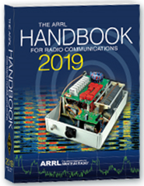Now… It’s been a little while since we’ve rewarded anyone for the most hours. So, as a way to kick off our excitement about being the very first Section in the country to use ARES Connect for its monthly reports to Headquarters, I will be giving away a 2019 ARRL Softcover Handbook to the person who obtains the most hours in the month of June!

Let’s see who is dedicated enough to become the owner of a brand-new Handbook!

*Editors Note: Normally the Section ARES report is not printed here since it does have its own reporting area that can be viewed anytime by you, but I felt it important that we do print this month’s report here since the data that was reported is not what you normally see every month. This is the NEW report, and the data came directly from ARES Connect. I’m sure you’ll agree; this is a very informative report.*

**ARES Connect Monthly Report – May 2019**

**Number of persons registered per District**

|  |  |  |  |
| --- | --- | --- | --- |
|  | Registered |  | Registered |
| District 01 - WD8PNZ | 142 | District 02 - W8UY | 10 |
| District 03 - W8LLY | 163 | District 04 - N8TFD | 117 |
| District 05 - KC8SYF | 105 | District 06 - W8DLB | 54 |
| District 07 - KB8YMN | 211 | District 08 - N8SUZ | 36 |
| District 09 - W8FHF | 60 | District 10 - N8AUC | 173 |
| Total Registered Users: 1072 | | | |

**Number of hours volunteered per District**

|  |  |  |  |
| --- | --- | --- | --- |
|  | Hours Volunteered |  | Hours Volunteered |
| District 01 - WD8PNZ | 532.25 | District 02 - W8UY | 0 |
| District 03 - W8LLY | 751.62 | District 04 - N8TFD | 167.25 |
| District 05 - KC8SYF | 54.25 | District 06 - W8DLB | 538.50 |
| District 07 - KB8YMN | 507.35 | District 08 - N8SUZ | 4.00 |
| District 09 - W8FHF | 202.85 | District 10 - N8AUC | 965.85 |
| Total Registered User Hours: 3,723.92  Total Anonymous Hours: 2,683.75  Total Hours: 6,407.67 | | | |

TOP^

**Breakdown by Event Classification**

|  |  |  |  |
| --- | --- | --- | --- |
|  | # of Events | # of Persons | Hours Credited |
| Communications Emergency | 4 | 59 | 369.75 |
| Community Event | 31 | 84 | 485.02 |
| Exercise | 5 | 13 | 36.00 |
| Meeting | 38 | 162 | 469.36 |
| Net | 298 | 756 | 814.43 |
| Skywarn | 31 | 232 | 204.00 |
| Training | 59 | 99 | 777.11 |
| Miscellaneous | 25 | 7 | 1212.00 |
| Unclassified – All events not listed above | 158 | 636 | 2040.00 |
| Total | 649 | 2,048 | 6,407.67 |

**Breakdown of training levels**

|  |  |
| --- | --- |
| Level 1 | 504 |
| Level 2 | 429 |
| Level 3 | 139 |
| Total: 1,072 | |

**Top 10 persons for hours volunteered in May**

|  |  |  |
| --- | --- | --- |
| **Name** | **Events** | **Hours** |
| Scott Yonally (N8SY) | 50 | 447.00 |
| Henry Ruminski (W8HJR) | 36 | 153.65 |
| Elizabeth Klinc (KE8FMJ) | 48 | 131.50 |
| Christopher Domenick (KC8CAD) | 26 | 126.60 |
| John Westerkamp (W8LRJ) | 49 | 119.58 |
| Bret Stemen (KD8SCL) | 38 | 108.50 |
| Doug Braun (KB8TGT) | 6 | 86.00 |
| David Noeth (KD8ACO) | 14 | 82.00 |
| Mathew Nickoson (KC8NZJ) | 13 | 78.25 |
| Timothy Gray (KD8IZU) | 6 | 72.00 |

TOP^

**Top 10 persons for events volunteered in May**

|  |  |  |
| --- | --- | --- |
| **Name** | **Events** | **Hours** |
| Dan Stahl (KC8PBU) | 52 | 59.25 |
| Scott Yonally (N8SY) | 50 | 447.00 |
| John Westerkamp (W8LRJ) | 49 | 119.58 |
| Elizabeth Klinc (KE8FMJ) | 48 | 131.50 |
| Bret Stemen (KD8SCL) | 38 | 108.50 |
| Henry Ruminski (W8HJR) | 36 | 153.65 |
| Michael Farkas (n8gbu) | 34 | 39.50 |
| Larry Caskey (K8LPC) | 29 | 24.00 |
| Steven Denniss (KC8IDM) | 29 | 5.50 |
| Colleen Roth (N8TNV) | 29 | 14.00 |

Written Reports:

A Major New Step for ARES in Ohio; NVIS Day 2019 in the Books

**A Step Up**

Amateur Radio and ARES have been strong partners with the Ohio Homeland Security/Emergency Management Agency for a number of years. We have now been asked to step up our game as a contributing partner to help keep the agency alerted to important developments around the state. This means that ARES operators will be used more frequently in “real” situations- either monitoring potential weather conditions, the damaging results, or other important conditions affecting the state. In other words, we’re being asked to put our training into actual practice to do meaningful stuff.

The Ohio HS/EMA “Watch Desk” is staffed 24/7 and is the room which has all the “red buttons” to activate the state’s EMA response. In Ohio as a home rule state (the county EMA Director is in charge) the state must be requested to send aid but gathering accurate information about emergency conditions will help the Watch Desk to gauge how much ramping up they need to do in order to be ready. For example, our recent tornado strike in Richland County drew everyone’s attention. Computer reports from NWS and official agencies were at least 30 minutes ~after~ amateur radio reports came in. And it was not reported that after midnight, when the situation was ruled relatively safe, responders elected to wait until daylight to begin cleanup and restoration of services. Amateur radio could have been a help to resolve that kind of issue.

We want to work as partners to our county EMA agencies, and obviously make this beneficial to them… it is the local EMA which must respond and coordinate the level of help. We want to make sure this information goes to them first- thus, it’s really important that your county either have a station at the EOC or you are in constant contact with the agency to relay these reports. In most cases, we actually expect the details to come from the EMA’s, so it works out well either way.

TOP^

Read this twice: ARES is NOT even thinking about changing the way Skywarn nets operate in Ohio- the system works, is not broken, and definitely doesn’t need “fixing.” We are not even remotely interested in “taking over” the spotter system. What we are considering is asking local nets to appoint a liaison station (or possibly use existing amateur stations at the county EOC) to report just significant events to The Sarge. Under normal conditions that would probably mean actual sightings or tornado strike, as an example. Most of the information we would want actually follows the oncoming weather: we’re more interested in damage and situations which might involve a request to the state. Many counties can create an incident in WebEOC software, but in many smaller operations, the Director might be found at the scene coordinating a response so the overall information would be of value to him and the Watch Desk.

I’m excited about this, it’s a big step upward in the profile of amateur radio and ARES across our state. But it’s not without its problems. Chief among them is how we’re supposed to make all this stuff work!

**How are we going to do this?**

Working backward in constructing a system, several in leadership have logins to the WebEOC program. During “Snow Net” we were uploading logs regularly to wide acclaim. It was an excellent and successful test of the very situation we’ve been asked to create. We can enter reports both at the Sarge and remotely. Several also have logins to the “NWS Chat” system, which affords direct communication with the weather offices. That would be simple if only one weather office covered the state, but there are ~six~ forecast offices (Wilmington, Ft. Wayne, Detroit, Cleveland, Pittsburg and Huntington) which cover counties in Ohio. So, there’s no real direct route from NWS to State that’s simple and concise.

The larger challenge is how are we going to listen/report across the state in a fashion that everyone (hams and agencies) can benefit. For example, a typical storm system moving west- while those western counties will be active, counties in the east benefit by listening- they can gage their response based on what they hear the system doing upstream. In the very rare case of a derecho or Palm Sunday outbreak, a statewide network would be invaluable and very active. But for most situations, we want to keep this all low-key and not jump overboard. Most important, where do we find a dependable statewide network?

We have a robust 80-meter system- both voice and digital data. This system is a proven asset, and we plan to make use of it. However, particularly with summer storms, the resulting static crashes and noise present a formidable challenge to widespread communication. Another situation to consider is that 55% of the licensed amateurs in Ohio are Techs- without HF privileges. It would be great to include them and have a system that would afford handheld coverage from disaster scenes.

Our experiments have included DMR. Snow Net was carried out on both HF and DMR Ohio talk group, with good success and overwhelming support from operators around the state. This was not out of the blue, as Section Manager Scott Yonally, N8SY, had received enthusiastic support a couple years ago from DMR owners. That support continues. We researched the license trustees of all DMR repeaters in the state and obtained email for all but about 5. We created a survey, and emailed the support continues. We researched the license trustees of all DMR repeaters in the state and obtained email for all but about 5. We created a survey and emailed the 50 trustees asking them to take part. 20 did. The results were conclusive, with 19 of the 20 strongly supporting ARES making occasional, low-traffic use of the Ohio talk group 3139.

TOP^

Here’s how we see this working. In the typical “big-time weather system moving this way from Indiana” scenario, we would notify hams by email (EC email list and over 1000 in ARES Connect) that a situation was developing. W8SGT would be ~MONITORING~ on the Ohio talk group and the HF net. That’s it…we’d just listen. IF a station or county began to really rock and roll, that EOC station or weather liaison would merely call W8SGT, tells us what’s going on, and we’d go back to listening. We would then file the report into WebEOC. The worse it got, of course, the busier we might be but it would take a major event to lead us to actually calling a formal net. So we want to keep it low-profile but functional.

Plans are NOT solid yet, we’re still researching, and we’re open to your suggestions! More to come on this major project!

**Amateur radio saves lives in Shelby, Ohio**

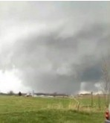We learned April 14 that when it hits, it can hit hard and fast! A handful of Skywarn spotters (including DEC-6 Danny Bailey W8DLB and Section Manager Scott Yonally N8SY) were watching the storm move into Richland county. One report of spinning motion was immediately sent to NWS Cleveland, which in turn issued a tornado warning. Thanks to the Skywarn system, the warning was out before the storm struck Shelby, Ohio. No lives were lost, but there were six injuries.

This tornado was rates as an “EF-2” storm, but before you conclude it to be a small little funnel, consider it was on the ground for 17 miles, and reached a width of ½ mile! This developed into a classic wedge tornado. Check out TV video of the storm here: <https://www.nbc4i.com/news/local-news/watch-video-of-tornado-in-shelby-ohio_20190414225650/1925752092>

And look at the aftermath here: <https://www.wkyc.com/video/weather/pictures-tornado-rips-through-shelby-ohio/95-a9702b0d-3313-4f68-8766-f65fafc9fc2c>

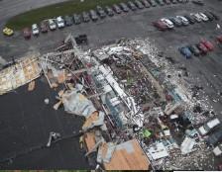Immediately after receiving word of the strike, coordinating through the county EMA, Danny and the rest of the crew headed immediately to Shelby, where they met with the Police Department. SEC Stan Broadway N8BHL coordinated with Danny on the 146.94 Mansfield repeater, where all tactical activity was taking place. It was agreed we needed to find more help in order to have enough manpower should dire reports of devastation prove lengthy. Since District 6 was all activated, it was decided to activate two counties to the north and three counties to the south of Richland- meaning District 2 (DEC in Toledo) and District 7 (DEC in west Columbus) as well as Richard KD8PHG in Groveport (southwest Columbus) who would stand by in case of state EOC activation. In order to coordinate resources across this great area, we used DMR Ohio Talk Group 3139. Five responded from

Marion County to assist, along with some CERT members from a neighboring county.

TOP^

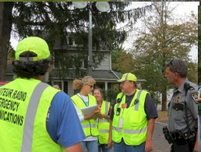The guidance “Do whatever we can to help” proved out here- where no communication facilities suffered, our hams were assigned to walk perimeter to watch for any looting or breech of security. By midnight, when all were accounted for, it was determined to close operation until dawn’s light when power workers and others could work more safely.

The takeaway from this? It hit hard and fast, and there was no time to sit back and theorize about our reaction. We needed to act quickly, and Danny did that masterfully. So – we aren’t kidding when we tell you that you NEED to be active in your local spotter’s net, keep your battery charged and ready! Ohio weather can turn on a dime- and amateur radio spotters are the key to saving lives!

**NVIS Report**

NVIS 2019 is in the books, and with band conditions under the “Yucky” category we really didn’t do badly. The Sarge had over 40 contacts (all on 80, at least inside Ohio) and worked at least 24 different counties. The band was up and down, but in a real emergency we would have had communication! It wasn’t raining, that was a plus. We heard from a number of you that there was a lot of fun to be had- and that is what it’s all about. Thanks, and see you next year!!

**Now Hiring**

Folks, we have a deficiency at The Sarge- we need more operators. We do not want to grab more from Franklin County ARES, we’re already hitting them pretty hard. So we’re looking for operators within an hour’s drive of the 270/315 area. We need at least a general class licensee. You should be familiar with fldigi and digital communication on HF and VHF. Experience in emergency response is a plus.

You must pass a background check. If you’re a seasoned operator - primarily a solid traffic handler or a successful contester – who is comfortable working under moderate pressure, and you’re able to take on a modest time commitment (at most one night a week under a schedule with emergency activation always possible) please consider contacting myself or Richard, KD8PHG to be considered!

Now…to get ready for Field Day!!

#########

With this new reporting system, we can get real time information that shows how many hours, who volunteered and what did they volunteer for. There’s a ton of information that we can draw out of the system.

As of June 16th, we now have **1084** registered and growing every day in the system. As you can see by the numbers above, we are now at the point where we will all need to be registered in this system for our hours to count. We will no longer need to depend on our EC’s and DEC’s to remember our hours of volunteering and report those hours for us on their monthly reports. The EC and DEC monthly numbers are no longer necessary, we will maintain a monthly reporting system for EC/DEC’s, but it will only be for them to submit a narrative only for the month!

TOP^

The time that was spent in getting your information and making sure it is up-to-date and on file with the EC, as well as transferring all of those records when a new EC takes over is no longer be needed. This system takes care of all of that automatically.

Now, it has a lot of benefit for you too.. Forget a meeting time or location? Just look it up on the calendar and there you have it. If set, you can even see the location on a map! I have attended many meetings and gatherings just because it was listed on ARES Connect and I found it just browsing around. I wouldn’t have known about it if it hadn’t been on the ARES Connect Calendar!

Why is this so important? These hours are what is shown to those we go to for funding as well as for more frequencies to operate on. Yes, we have to justify why we need the money or frequencies to those in government that want “just the facts.” This system allows us to show them the facts, anytime and with great accuracy.

***Special Note for the Admins…***

I want to make sure that all of you start setting up your events the same way. If at all possible, please always set the "Hours of Self-Reporting" to **ALLOWED**. This gives the volunteers time after the event to log their time. They still must have registered for the event in advance, but it will give them the opportunity to go back later and log their actual time in.

On the "Event Slot Limit" **Please leave that open (unlimited users) unless this is absolutely necessary to set a limit.** We want **ALL** of our events to be as open as possible.

Start getting folks registered into ARES Connect. We don't want anyone left behind and we still have a lot of folks that are not registered yet. If they can't get registered due to not having a computer or they feel they just can't do this for themselves, you can do it for them. Either way, let's all work hard at getting all those who aren't in the system yet, in there, besides it isn’t going to stop raining, and you can't mow the lawn anyway or do yard work in the rain, so how's about spending an hour or two getting your fellow hams registered!!!

***National News***

*(from arrl and other sources)*

***USA Counties Award Announces New Custodian***

Brian Bird, NX0X, of Duluth, Minnesota, has been named the new Custodian for *CQ*magazine’s USA Counties Award (USA-CA). The appointment was effective on June 1. Bird succeeds Ted Melinosky, K1BV, who served as USA-CA Custodian and *CQ* Awards Editor for 21 years. *CQ* said several updates to the USA-CA Award rules also will take effect on June 1.

A county hunter since the 1990s, Bird earned the USA-CA All Counties Award in 2004. The complete updated rules appear in *CQ’*s June 2019 “Awards” column and will be posted on the [***CQ*website**](http://www.cq-amateur-radio.com/). [**Contact**](mailto:nx0x@aol.com)

#########

TOP^

**Volunteer Monitor Program**

Approved by the ARRL Board of Directors at its July 2018 meeting, the new Volunteer Monitor program is a formal agreement between the FCC and ARRL in which volunteers trained and vetted by the ARRL will monitor the airwaves and collect evidence that can be used both to correct misconduct or recognize exemplary on-air operation. Cases of flagrant violations will be referred to the FCC by the ARRL for action in accordance with FCC guidelines.

The intent of this program is to re-energize enforcement efforts in the Amateur Radio bands. It was proposed by the FCC in the wake of several FCC regional office closures and a reduction in field staff.

Under this program, the FCC will give enforcement priority to cases developed by the Volunteer Monitor program, without the delay of ARRL having to refer cases through the FCC online complaint process.

Candidates who possess the required skills are encouraged to apply using the application below.  Applications will be reviewed, and candidates notified.

***Required Skill Set for Volunteer Monitors***

1. An understanding of the difference between the mentality of “enforcement” and the mentality of “measurement of compliance.”

2. A temperate demeanor and spirit of “assistance.”

3. An objective, non-confrontational personality, i.e., the ability to evaluate a situation while staying “above the fray.”

4. Discretion and judgment as to what rules are enforceable, and the ability to distinguish between a “situation” and a “problem” on the Amateur Radio bands.

Examples: 1) profanity or expression of extreme opinions, versus repeated deliberate interference;

2) inadvertent failure to ID or extreme rudeness, versus operation outside of licensee’s authorized frequencies.

5. Possession of, and ability to operate, reasonably state-of-the-art equipment, including the ability to access remote/no-cost receiver sites.

6. Communications skills, including clear written and oral expression, and an understanding of the importance of thorough documentation.

7. Computer skills in basic word processing and data entry, and the ability to send such information to ARRL electronically.

8. The ability to record radio transmissions and send them to ARRL electronically.

9. No history of receiving warning letters or other enforcement action from the FCC.

10. Possession of an Amateur Radio license of Technician class or higher for a minimum of 3 years.

#########

TOP^

***Magnetic Loop Antenna Designs Multiply***

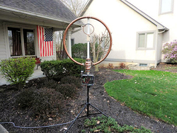

Magnetic loops have become popular as effective and compact antennas for traveling and stealth applications. An HF magnetic loop design by John Chappell, W3HX, was an honorable mention in the 2018 *QST* Antenna Design Competition. Chappell's mag loop offers coverage on 80 - 20 meters, and he runs FT8 at 50 W. See his article on page 39 of the June 2019 issue of *QST*.

|  |
| --- |
| **The magnetic loop for 40 and 20 meters designed by Richard Robbins, WA8RR. [Photo courtesy of *DELARA News*]** |

Richard Robbins, WA8RR, wanted to build one of his own for 40 and 20 meters, and he [described his efforts](http://www.k8es.org/archives/2019_May/club%20news.htm) in a recent edition of his club's newsletter, *DELARA News*. An [online calculator](http://www.66pacific.com/calculators/small-transmitting-loop-antenna-calculator.aspx) helped him come up with the basics, and he decided on a 10-foot circumference loop constructed from half-inch copper pipe that would handle 100 W.

His prototype, constructed from a piece of pipe "hand bent into an approximate circle," a Dayton Hamvention flea market capacitor, and a coax drive loop, would tune the two bands -- although, as expected, tuning was very sensitive and affected by body capacitance.

He worked up a reduction drive and remote motorized tuning, and was able to make several FT8 contacts, using his antenna analyzer to tune the loop. "The tuning would shift as I was transmitting," Robbins recounted. "This is a result of a very high circulating current and heating of the separate components." Encouraged, he went for a higher-end design constructed around a 5 - 500 pf vacuum variable capacitor, the project's most expensive component (these go for $150 or more on eBay). "It is big and heavy," Robbins said. He had a metal fabricator bend a new piece of thin-wall copper tubing into a more aesthetically pleasing circle.

“To drive the capacitor, I obtained a stepper motor and driver, an Arduino controller board, and a four-channel remote,” Robbins explained. “I used some sample programs to develop the code that would move the capacitor at different speeds depending on how long the remote was pressed. I added markings on the capacitor, so I could quickly move to different bands.” *– Thanks to* DELARA News

#########

***FCC Re-Charters Technological Advisory Council for New Term***

The FCC has re-chartered its Technological Advisory Council (TAC) for a 2-year term. Comprised of a diverse group of leading technology experts, the TAC provides technical expertise to the FCC to identify important areas of innovation and develop informed technology policies.

Greg Lapin, N9GL, will continue to represent ARRL on the TAC.

TOP^

"The TAC will consider and advise the Commission on a variety of topics such as the deployment of 5G technology, the evolution of broadband networks and devices and their implications, the spectrum needs of unmanned aircraft systems, new developments in antenna technology, and the applications of artificial intelligence to telecommunications networks," the FCC said in announcing the re-charter.

Dennis Roberson, Executive Chairman of entigenlogicTM, chairs the Council. Michael Ha, Deputy Chief of the FCC Policy and Rules Division, is the Designated Federal Officer.

The TAC will next meet on June 21. The public is welcome. The [FCC Public Notice](https://docs.fcc.gov/public/attachments/DA-19-440A1.pdf) includes the names of all TAC members, some of whom are radio amateurs. *-- FCC Public Notice*

***This and That’s***

A number of months ago I ran a story that was even picked up by ARRL and run, it was about the ever-popular Hotspots – Zumspots, Chinaspots and all the other names associated with these little gizmos that help us connect to DMR, D-Star, Fusion and the like, and how many of them are operating on frequencies that are specifically designated for satellite operation only. A quick survey the other day to see just how we are doing here in Ohio on getting these little devices into compliance was somewhat disappointing. The observer found more than expected still operating around 436MHz, and that puts them right in the middle of the satellite band for sure. Now I know that some of these devices come set to that frequency as its default, but you as the owner are still responsible for moving it into where it should be and not where it was defaulted to. So, for those new to this mode of operation, I decided to run the national story again. I do hope that everyone who operates one of these little gizmos takes a good hard look at where their (-) Spot is set! If you are curious where yours is running at, check out this website. <http://aprs.fi>

***Digital Mobile Radio Hotspots May Be Interfering with Satellite Uplinks, AMSAT Reports***

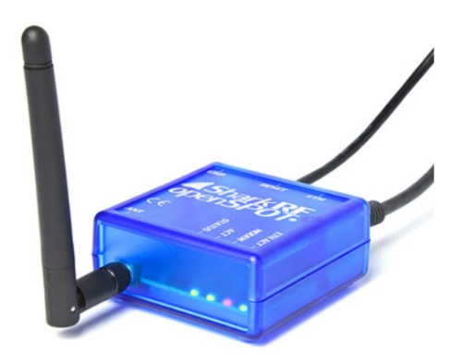This week, AMSAT News Service (ANS) cited an August 27 report from AMSAT Vice President-Operations Drew Glasbrenner, KO4MA, saying that a digital mobile radio (DMR) signal has been interfering with the AO-92 (Fox-1D) satellite’s 435.35 MHz uplink frequency. Glasbrenner said hotspots, repeaters, terrestrial simplex, and “anything not satellite” should never transmit in the segments 145.8 – 146.0 MHz or 435 – 438 MHz by international band plan. Well-known satellite enthusiast Patrick Stoddard, WD9EWK/VA7EWK, told ARRL that one DMR hotspot operating on the AO-92 uplink frequency in the St. Louis area has shifted to another frequency.

TOP^

But, he added, “I think there are still issues, since not all hotspots will report their frequencies and positions to websites such as [**BrandMeister**](http://brandmeister.network/) or via APRS, where they appear on other sites such as [**http://aprs.fi**](http://aprs.fi/).”

“There are others surely operating near satellite uplinks,” Stoddard added. “For many, the 435 – 438 MHz satellite subband is a big piece of quiet real estate in a busy part of the 70-centimeter band for weak-signal work, repeater links, amateur TV, and other possible uses.”

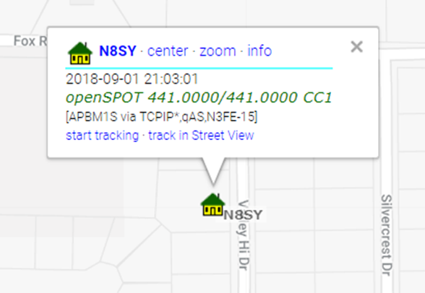

Stoddard points out that FCC Part 97 addresses Amateur Radio operation in these segments, although regulations in many other countries may not be as detailed. §97.3(a)(7) defines Auxiliary Stations as, “an amateur station, other than in a message forwarding system, that is transmitting communications point-to-point within a system of cooperating amateur stations.”

Stoddard said this would include remote bases, EchoLink and IRLP nodes, and hotspots used for digital voice modes, as well as stations using these hotspots and nodes. Auxiliary stations may not transmit in the 145.8 – 146.0 and 435 – 438 MHz satellite subbands (among others in the 2-meter and 70-centimeter amateur bands), per §97.201(b).

* §97.3(a)(40) defines a repeater as, “an amateur station that simultaneously retransmits the transmission of another amateur station on a different channel or channels.” Stoddard said that because most hotspots operate on a discrete frequency, they would not qualify as repeaters, even if they operate like a repeater, per §97.205(b).
* §97.101(a) stipulates, “In all respects not specifically covered by FCC Rules, each amateur station must be operated in accordance with good engineering and good amateur practice.” Stoddard remarked, “Whether the hotspot is interfering with a satellite downlink in a particular area, or it is interfering with the satellite uplink affecting a much larger area, this would not be good amateur practice.”
* In addition to sub-bands where hotspots are not permitted, Stoddard said, §97.101(b) is also relevant. It states, “Each station licensee and each control operator must cooperate in selecting transmitting channels and in making the most effective use of the Amateur Service frequencies. No frequency will be assigned for the exclusive use of any station.”

Stoddard noted that frequencies used by satellites are usually incapable of being changed and are coordinated in advance of launch, while hotspots typically are frequency agile, and the frequencies used by those systems can be changed to avoid potential interference to satellites and other stations.*— Thanks to*AMSAT News Service*, Patrick Stoddard, WD9EWK/VA7EWK*

If you have one of these little magic boxes up and running, please check it to make sure that it isn’t operating where it shouldn’t be. Remember, we all have to do our part in keeping the bands clean and operational for all.

#########

TOP^

***Ohio Section Places 4th Overall in the 2018 Simulated Emergency Test (S.E.T.)***

Hey Gang,

The news is finally out, and the postings for the 2018 S.E.T. were announced in the July Edition of QST and Ohio placed 4th in the country for top scores.

Here’s the top 10 rankings by Section. Here’s the top 10 rankings by Section/Local Nets

|  |  |
| --- | --- |
| Mississippi | 7,664 |
| Alabama | 7,658 |
| Wisconsin | 2,548 |
| **Ohio** | **2,519** |
| Connecticut | 1,554 |
| Georgia | 1,190 |
| Santa Clara Valley | 1,157 |
| Eastern New York | 1,077 |
| Western Washington | 926 |
| Michigan | 827 |

|  |  |
| --- | --- |
| Wisconsin | 5,328 |
| Alabama | 3,623 |
| Connecticut | 882 |
| **Ohio** | **846** |
| Tennessee | 467 |
| Western New York | 231 |
| Michigan | 216 |
| New York City – Long Island | 170 |
| Georgia | 165 |
| Arkansas | 143 |

I’m very proud of everyone that participated in last year’s S.E.T. – Now, let’s get out there and kick some tails in 2019’s S.E.T.!!!!

***Final.. Final..***

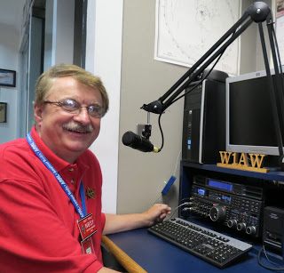

Hey Gang...

This has been another really busy week attending meetings and getting things caught up around the house that you can’t get done when it’s raining. Wow, I can’t remember a wetter June!

Website updates. We had several this week. Daniel, KB8LKH has updated the Code Plugs for the AT-D868UV Dual Band, the Connect Systems CS-800D Dual Band and the Connect Systems CS-800. We also had an update on the DMR Nets from Greg, WD9FTZ as well.

ARES in our state has been really busy these past few weeks and I’m very proud of everyone that has been active!

Sliding down the band a bit… I want to make sure that all of you know that you need to get signed up in ARES Connect right NOW, if you haven’t already.

TOP^

**Yes**, we are the first Section in the country to go forward with ARES Connect for our monthly reports. Take a good look at the ARES Connect article in this newsletter. All the data was collected from ARES Connect. That’s right, all those events that you’ve signed up for, well, here’s where the rubber hits the road. Take a really good look at the data we collected. It really shows the amount of work that the Ohio Section did last month.

Yes, we still had our EC’s and DEC’s still submit their monthly reports this month as we worked through just what information do we submit to Headquarters. So, as a precaution, so we wouldn’t lose any information during the transition, we had the EC’s and DEC’s continue to report the hours as their normal routine.

So, what does this all mean to you? You now can see very clearly why we have been pushing this so hard. The need to make sure you get registered in the ARES Connect system if you haven’t already, it is absolutely necessary. **And**, more than ever before, you now need to actually start using the system and signing up for events!!! It’s really easy to do and only takes a couple of minutes of your time, but it means so much to the Ohio Section and to ARRL.

I hear from folks all the time asking… “why do I need all this training?” Well, after these past couple of weeks if you have to ask that question… Folks that have never dreamed that they would get involved are now volunteering to help out. Yes, with all that’s happened recently it should be evident to you that you do need to have some training before you volunteer to help.

Here in the Ohio Section we only require our Level 2 volunteers to have the 4 basic courses, IS 100, 200, 700 & 800. For our Level 3 volunteers we do require the additional ICS 300 / 400, or the equivalent professional series courses IS 120, 230, 240, 241, 242, 244 & 288. These equivalent courses are all on-line classes just like your basic 4 NIMS courses are and being offered as an alternative way for you to get credit for taking the professional series courses in the event you just cannot get scheduled into an ICS 300/400 class.

By the way, if you decide to take these 7 on-line courses and complete them all, you will want to take just one more class **IS-235.** By completing this additional course, you will get a really great looking certificate from FEMA recognizing that you have completed the entire Professional Series courses. I do hope that this clears up the confusion that has been going around lately. As we have stated on the website and in this newsletter many times “We don’t want anyone left behind.”

Yes, the Ohio Section is extremely lucky to have the relationships that we do with Law Enforcement, EMA, fire and other government agencies, that’s why we’ve partnered with EMAO, OP3 and Ohio VOAD to show our support for them and our Ohio citizens.

Whelp… That’s going to do it for this time around. Stay safe, enjoy the sunshine while we have it, and most of all… have FUN!!

73,

***Scott, N8SY***

TOP^



***Back Issues of the PostScript and Ohio Section Journal (OSJ)***

Hey, did you know that PostScript and Ohio Section Journal (OSJ) are archived on the website? You can go back and look at any edition simply by clicking:

<http://arrl-ohio.org/news/index.html>

***Chit – Chat, and All That!***

Do you know someone that’s not getting these Newsletters? Please, forward a copy of this Newsletter over to them and have them “[Opt-In](http://arrl-ohio.org/forwarder/forwarding.html)” to start receiving them. Heck, just have them send me an email [n8sy@n8sy.com](mailto:n8sy@n8sy.com) and I’ll get them added to the Ohio Section Emailing list. We now have over 7,000 folks receiving these newsletters weekly. Quite impressive, I’d say!



I urge all of you to make sure that everyone, regardless of whether they are a League member or not, get signed up to receive these weekly Newsletters. You can always “[Opt-Out](http://arrl-ohio.org/forwarder/forwarding.html)” at any time if you feel this is not what you were expecting. It’s fun and very informative.

Hey, did you know that PostScript and Ohio Section Journal (OSJ) are archived on the website? You can go back and look at any edition simply by clicking:

<http://arrl-ohio.org/news/index.html>

The pictures throughout this newsletter are from various sources. Take a good look at them, you just might be in one of those pictures! “SMILE…!!!!!”

Got questions, concerns or would just like to sit and chat awhile? Heck, I’ll even buy the coffee!! Give me a call at (419) 512-4445 or email me at: [n8sy@n8sy.com](mailto:n8sy@n8sy.com)

TOP^

*The Ohio Section Journal (OSJ) is produced as a comprehensive look at all the programs within the Ohio Section. I sincerely hope that you have enjoyed this edition of the OSJ,* *and will encourage your friends to join with you in receiving the latest news and information about the Ohio Section, and from around the world!*