***[](http://arrl-ohio.org)*** ***January***

***Edition***

|  |  |
| --- | --- |
| **🡪** From the Technical Coordinator | **🡪** From the Section Emergency Coordinator |
| **🡪** From the Affiliated Club Coordinator | **🡪** From the Public Information Coordinator |
| **🡪** From the Section Traffic Manager | **🡪** Out and About |
| **🡪** From the Section Youth Coordinator | **🡪** From the Official Observer Coordinator |
| **🡪** ARES Training Update | **🡪**  Handbook Give Away |
| **🡪** Club Corner | **🡪**  ARES Connect |
| **🡪**  DX This Week | **🡪** You’ve Got Cards – Waiting |
| **🡪**  National News | **🡪**  Final.. Final.. |

***From the Technical Coordinator***

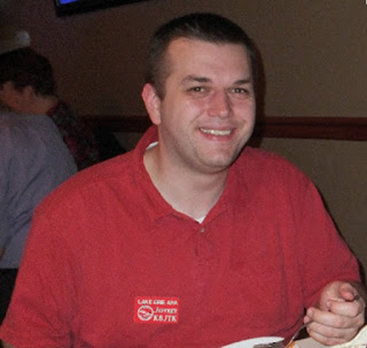***Jeff Kopcak – K8JTK TC***

[k8jtk@arrl.net](mailto:k8jtk@arrl.net)

Hey gang,

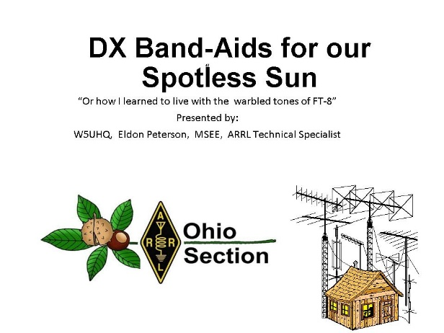Technical Specialist, Eldon – W5UHQ, has been busy playing around with FT-8 when he’s not doing the [Ohio Digital Emergency Net](http://www.theohden.org/). FT-8 was developed by Joe Taylor – K1JT and is the popular successor to the JT-65 & JT-9 modes. It has grown like wildfire due to the reduced time to make a contact, 15-second transmit windows compared to a minute, and the poor band conditions we’re experiencing. Eldon created documentation about setting up and operating with the WSJT-X software. Last month he was asked to give a presentation for the combined meeting of the Central Ohio Operators Klub and Newark Amateur Radio Association. Eldon gave a very detailed presentation on FT-8 titled “DX Band-Aids for our Spotless Sun.” Nice play on words. With terrible band conditions, many believe FT-8 has kept interest in ham radio alive. His presentation is loaded with graphics and pictures – my kind of presentation. If you’re in the Columbus area and want a great presentation on FT-8, get in contact with Eldon. He’s been knocking out a lot of contacts with wanted DX entities like Ducie Island, Baker Island, and most recently Banana Island.

If you use the WSJT-X software for the JT modes, a recent update to Ham Radio Deluxe allows logging directly to HRD Logbook. I set this up recently and it makes things a breeze with the faster pace of the FT-8 exchange. There is a YouTube video on the Ham Radio Deluxe channel [showing how to configure both programs](https://www.youtube.com/watch?v=YLt1zI1avx0).

A quick reminder, if you haven’t upgraded to [WSJT-X 2.0](https://physics.princeton.edu/pulsar/k1jt/wsjtx.html) your software probably isn’t decoding any stations on FT-8 and MSK144. A major update to the program and protocol was released. Effective the first of the year, everyone should be using WSJT-X 2.0. The change increased error checking by 2-bits to help with special exchanges in structured messages.

A couple days ago, I got a question from a ham about recording audio from their Ham radio. I’ve done this for various different reasons including streaming to the popular online scanner site Broadcastify, a net controller wanted an audio copy of the net, and posting audio clips online. There are a couple programs I’ve used over the years depending on the situation. This is very useful when documenting malicious interference or a bozo on a repeater.

First, station setup. You’ll obviously need to be close enough to receive the station or repeater. Marginal signals or ones with static might sound “ok” when listening through the radio’s speaker but will sound worse when recorded and played back. White noise is created over all frequencies and will be recorded over all frequencies.

TOP^

A better gain antenna, one located higher, or a directional antenna would improve reception of the station. Trying to monitor your own signal through a repeater will require separation between the radio transmitting on the repeater input and the radio receiving on the output. Otherwise, the receiving radio will be de-sensed causing little-to-no signal to be received.

A base station, mobile radio, or radio scanner is best depending how long you plan to monitor the other station. An HT or portable scanner will work but will likely need an external power source. Find a radio with a 3.5mm standard headphone / speaker jack. Nearly all ham radios made in the last 30 years will have this. The speaker portion of a Speaker & Mic jack will be the 3.5mm connector. Newer modern radios utilize a soft power switch (meaning it doesn’t physically cut power to the device) but rather power state is controlled through electronics. Turn of any of these (or related) settings: auto power off, power save, and turn off display and keypad lights. APO turns off the radio when idle which will disrupt recording. Power Save reduces current drain on the radio but takes longer for the radio to respond when a signal is received. This results in a missed word or two at the begging of a transmission on the recording. Turn down or off LCDs or any display lights as there is no need to shorten the lifespan while the radio is used unattended.

A 3.5mm to 3.5mm cable is need to go between the radio and computer or other recording device. These can be found at a local hamfest, on the Internet, or look at Monoprice for good prices. Either a TRS cable or TS cable can be used, these are known as a stereo or mono cable. The radio will often output only one channel. A radio connected to an audio interface, like for digital modes, is not ideal unless you’re monitoring sideband or AM. Audio from the digital port will be un-squelched and nearly impossible to utilize VOX or sound activated features.

Recording to a PC is the most versatile solution. Plug the audio cable into the Line In jack of the PC. If another sound card is needed, the very cheap USB sound cards available for a couple bucks will provide another audio input. In my experience, audio out of these inexpensive USB sound cards is very noisy while the audio input is quiet. Don’t need audio out so the noise problem doesn’t matter. The audio/speaker out level from the radio will be adjustable via the volume control. Set that at about half or 50%. On the computer, go into the Sound settings in the Control Panel. On the Recording tab, find the audio device – “Line In” on most PCs, “Microphone” on the USB devices. Set the Level to 50 in Windows. Linux doesn’t seem to distort audio as much and can be set at 100%. Line In audio may need to be boosted while Microphone connections will likely need to be turned down. The setup I have with the inexpensive USB sound card is set at 7 (out of 100) with the radio at 50%.

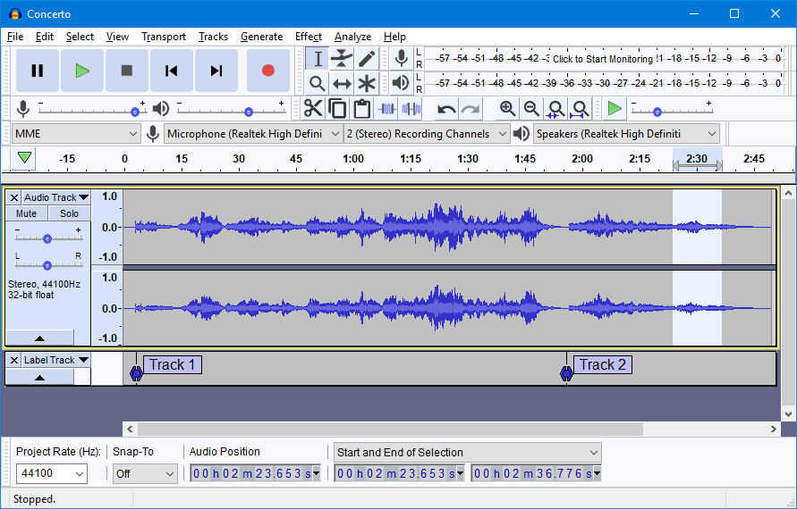

Audacity

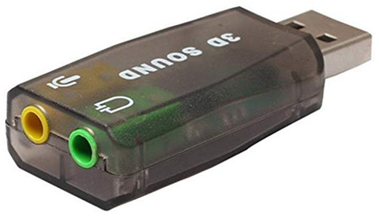

Inexpensive USB Sound Card

VOX is a voice activated switch in traditional radio operation but it’s really an audio level reaching some threshold which then activates the transmitter. In this context the program would start recording. VOX is nice because it eliminates long pauses on FM. A repeater may only be used 10% a day.

TOP^

The resulting recording will not be 90% dead audio. VOX is useful but may miss a second or so before initiating recording. Long pauses during the transmission, where the audio would fall below a threshold, will stop recording momentarily. When the VOX threshold is set too low, you may record unwanted static bursts.

HF is very difficult to set a threshold because there is no squelch on sideband. Some kind of log is useful to determine when a repeater is used or will be needed for documenting interference issues. Another option is a real-time recording. A lot of extra hard drive space is required for these extended audio recordings in real-time. A more on this later.

For Software, [Audacity](https://www.audacityteam.org/) is pretty flexible and free. It can do real-time, timer recording, and VOX. Once Record is pressed, it will run until it’s out of hard drive space. The Timer Recording feature will start at a specific time and continue for the duration. This is useful when recording a net. Timer is found under Transport -> Recording -> Timer Record. The VOX-type feature called “Sound Activated Recording” is found under Edit -> Preferences -> Recording. It does not have a logging feature, though.

The program I like for monitoring a repeater is [Scanner Recorder](https://www.softpedia.com/get/Multimedia/Audio/Other-AUDIO-Tools/Scanner-Recorder-Scanrec.shtml). It is a VOX program that is simple to use but configurable enough to delay a couple seconds after the signal disappeared. The clock, amount of time elapsed since recording began, and length of recorded audio is quite nice to see how busy is the frequency. It does have a logging feature showing date, time, duration, and relative time in the audio file.

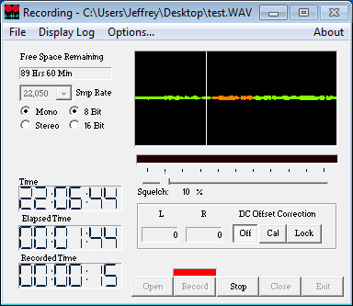

Scanner Recorder

Recording settings is a matter of quality tolerance and preferences. Sample rate is measured in Hz. For voice recordings, 11 kHz or 22 kHz is good. Recording raw digital signals such as MT63 or P25, use 48 kHz. Space requirements for uncompressed (WAV) mono audio at 16-bits:

* 48 kHz: 350 MB/hr
* 22 kHz: 170 MB/hr
* 11 kHz: 80 MB/hr

When using VOX, the per-hour rate only applies when the program has recorded an hour of audio.

The ham asked about recording with a rolling buffer. A rolling buffer would record over itself when it reaches a specified length. I don’t know of any programs that will accomplish this but I did find an Android app called [Echo](https://f-droid.org/en/packages/eu.mrogalski.saidit/) that seems to meet the requirement. It’s not available through the Google Play store, unfortunately, requiring the alternative app store F-Droid to be installed first.

Do plenty of tests and dry-runs first to check audio levels for overmodulation of the recording. You can use this setup for fun, documenting interference and bozo issues, or for finding out how often a repeater is used. On second thought, you probably don’t really want to know the answer.

Thanks for reading and 73... de Jeff - K8JTK

**73… de Jeff – K8JTK**

TOP^

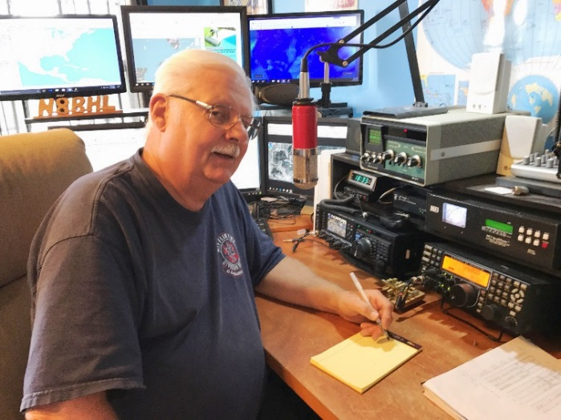***From the Section Emergency Coordinator***

***Stan Broadway, N8BHL - SEC***

[broadways@standi.com](mailto:broadways@standi.com)

Ohio Section: Amateur Radio Emergency Service   
Yearend Report, 2018

Ohio ARES members provided at least $2,674,295.00 in service to their communities during 2018.

For the year 2018, Ohio Section ARES volunteers donated their time and equipment in large numbers. The monetary value of their time is calculated using $24.69 according to

“The Independent Sector” as used by the ARRL. We calculate the value of equipment at $300 per volunteer.

December is anticipated based on prior years.

For 2018

Activity 2018 Total 2018 Average Monthly Monetary Value

|  |  |  |  |
| --- | --- | --- | --- |
| Training events / nets | 8417 | 701 |  |
| Training hours | 64035 | 5336 | $ 1,581,024 |
| Public service events | 736 | 61 |  |
| Public service hours | 21856 | 1821 | $ 539,624 |
| Emergency events | 138 | 12 |  |
| Emergency hours | 2028 | 169 | $ 50,071 |
| Volunteer equipment |  | 1679 | $ 503,575 |
|  |  | Total contribution | $ 2,674,295 |

Some major changes were implemented which will assure our volunteers are well-qualified and ready for any activation.

The biggest change was the implementation of “ARES Connect” – a time accounting database managed for the entire nation by the American Radio Relay League (ARRL) which is the sponsoring agency for ARES. ARES Connect tracks events and activities, assigns hours to volunteers, and provides a “real time” report of activity across the nation. Ohio was one of four Sections to BETA test the system, and we are among the top users of the system prior to its full release. Section Manager Scott Yonally, N8SY, has worked tirelessly to help de-bug the system and provide input on potential problems and suggested improvements.

Ohio ARES modified the training standards to match those which are to come from ARRL. Our lowest level 1 is designated for new recruits and volunteers without NIMS training. They are welcome to work public service events but will not be on the “first due” activation lists and will not be assigned within EOC environments. Level 2 volunteers are those who have completed the four NIMS (National Incident Management System) training courses ICS 100, 200 700, 800. These will be considered full-fledged members. To achieve level 2 certification their certificates of training must be on file with the Ohio ARES training database. It is suggested paper copies be kept on file at the local EOC. Level 3 volunteers are those who’ve added ICS 300/400 and other courses such as COML, COMT to indicate their leadership position. In addition, the “AUXCOMM” course is strongly recommended for all volunteers.

TOP^

ARES is structured so that each county Emergency Coordinator (EC) operates autonomously with training, relationships and service to served agencies. A guideline for them is provided in ARRL EC training material, and in the Ohio Section Emergency Response Plan (OSERP). Under their guidance, radio nets and training meetings help to keep members active and ready.

ARES county organizations participated in numerous drills and exercises throughout the year, from active shooter training to many other scenarios. ARES members were activated for a number of real events, including missing person searches, storm damage, and other events. Some counties made use of ARES members during elections as supplemental communications back to the various boards of elections. Others used our volunteers for additional security and situational awareness at fairgrounds, special events, and Halloween observances. We provided free communication support for hundreds of events including major marathons, Ironman, and numerous other large public gatherings.

ARES members participate in a weekly statewide radio net anchored at the Ohio JDF/EOC where station W8SGT is located right off the main control floor. This activity confirms our ability to communicate from the state EOC to various counties throughout Ohio. On the same evenings, the Ohio Digital Emergency Net (OHDEN) does a similar exercise using digital message modes, such as would be employed to send forms such as IS-213 messages between counties and from county to state. Most counties are active in early January for the “Ohio ARES VHF Simplex Contest”, testing our ability to use VHF / UHF frequencies without repeaters to relay messages. In late April, we stage our annual “NVIS Antenna Day”, employing “Near Vertical Incident Skywave” antennas designed to communicate to neighboring and nearby locations. These antennas are the type that might be deployed after a major disaster removes normal communication equipment and antennas. In late June, we participate in the ARRL’s “Field Day” exercise- where remote stations provide portable antennas, power, and equipment to communicate across the country for a 24-hour period. All of these activities further our mission to be able to communicate “when all else fails”.

Our ability to provide this important service is dependent on having proper antennas to allow us to make contacts. With these resources in place in our homes and public buildings, we are able to stay ready to provide this important service.

**73, Stan N8BHL**

**You can view all of the SEC’s monthly reports on the website..** <http://arrl-ohio.org/SEC/default.html>

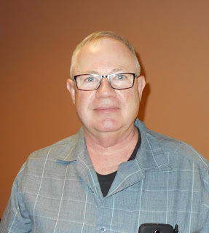***From the Affiliated Club Coordinator***

***Tom Sly, WB8LCD - ACC***

[tomsly29@gmail.com](mailto:tomsly29@gmail.com)

Happy New Year to you all! I hope 2019 brings you good DX and strong signals!

The beginning of each new year is the perfect time to take an accounting of where you stand in the world. This is true whether you are an individual, a family, a business, a local club, even an ARRL Section! (Or maybe even a national club such as the ARRL) If you do this on a year by year basis, you’ll be able to tell if you are making progress, losing ground, or just treading water. Good information to have.

TOP^

Once you know where you are, you decide where you want to go and how you will need to act to take you there. Pretty simple stuff, really.

According to the ARRL Website, FCC data as of 01/02/2019 shows that there are 754,970 active ham radio licenses in the US of A. I’m going to use that as the number, but keep in mind that out of that number, there may be clubs, hams who are not active but have just “parked” their license, foreign hams with a US license and some deceased hams who have not yet been removed from the database. The population of the US is estimated at between 326 and 327 million people in 2018. I’ll use 327 because the 327 was my all-time favorite Chevy Small Block Engine! So, as a percentage of the US population, hams represent approximately 0.0023%. That’s a pretty small percentage. Especially considering the BILLIONS (maybe even TRILLIONS) of dollars, worth of radio spectrum, allocated to our personal hobby! Keep that in mind as a theme we will be coming back to.

Out of 754,970 licensed hams, our national organization – The ARRL – has a membership of approximately 154,000. Only 20.4% of US hams belong to our national organization! That is quite appalling to me. The Ohio Section has 27,941 licensed hams, and of that number approximately 5800 are ARRL members. So, approximately 20.7% of OH hams are ARRL members. Beats the national average, slightly. Still, an appalling number! When elections come about, in all the ARRL sections, they have a hard time getting even 50% of their membership to vote. It appears to me that the ARRL has a serious “apathy” problem among not only the Ham Radio community at large, but even among their own membership! I’ve been looking at these numbers for the past few years, and it seems to me that the numbers are “treading water”.

I’m not going to point my finger in any particular direction and say that that’s where the problem lies. I think it’s bigger than that. I think we’re all culpable, but even more important, I think we can all be a part of the solution. I’m not exactly sure how sick the patient actually is, but I know it’s not dead yet! Personally, I am not willing to stand around and watch “The Greatest Hobby in The World” disappear because business, economic and governmental interests come to the conclusion that we are “just not worth” the spectrum allocations that we have. I hope that you aren’t either.

So, let’s look at some other numbers and talk about what we can do individually, as clubs, and as the OH Section to help elevate Amateur Radio to the lofty status it once held in our society!

In Ohio, there are 27,941 active Amateur Radio licenses. We are the largest of the 71 sections in the ARRL.

Let me break the numbers down by license class:

Novice Class 419

Technician Class 13,020

General Class 7,031

Advanced Class 1,539

Extra Class 5,932

Total 27,941

Based on these numbers, 48% of licensed hams hold the “entry level” license and have never gone any further than that. Only 52% of licensed hams hold a license above the “entry level”. No statistics to back this up, just personal observation and belief, but I think a lot of people get their license, get a handi-talkie, then get stalled out in their participation of the hobby, because most of the action is NOT taking place on two meters.

TOP^

So, here’s a list of things that need to be on our radar for the coming year:

1. We need to recruit more people to the hobby.
2. We need to recruit younger people to the hobby.
3. We need to help our new recruits to the hobby have a successful experience – we can do this by being welcoming to new hams of all ages and technological expertise. By helping them to get on the air and experience all the activities that Ham Radio has to offer. By showing them the way and helping them move up in license class – Amateur General should have the highest percentage of active licenses and Amateur Technician should have the smallest percentage of active licenses.
4. We need to find “inactive” hams and help them experience the thrill of the hobby and the magic of radio so that they will re-engage with the hobby.
5. We need to encourage all hams to become members of the ARRL. The ARRL is the only “voice” we have against those who would confiscate our spectrum allocations.
6. We need to participate in the ARRL making sure they serve our interests and needs.

All of these items are things we can participate in as individual’s, as clubs, and as members of the OH Section. What Ham Radio looks like in the future will be determined by what we do now!

Now, I would like to issue an invitation to all of you to attend the March 11, 2019 meeting of PCARS in Kent. PCARS meets at the Kent American Legion Post 496 located at 1945 Mogadore Rd., Kent, OH 44240. The meeting starts at 7:00PM *sharp.* The March meeting will feature Carole Perry – WB2MGP. Carole will be there as a guest speaker in her role as Radio Club of America Director and also as Chairperson of RCA Youth Activities. She will be speaking about the Youth Activities initiatives which include supporting STEM classes, Scout Troops, ham radio in schools, radio classes in museums, and technology programs in Youth Groups.

All curriculum, books, and other materials are offered FOR FREE through this program. She will also speak about RCA showcasing of talented young hams in high school and below. Young hams are sponsored to speak at Youth Forums and Technical Symposiums across the country.

All teachers, scout leaders, Youth Club leaders, and club members interested in starting or enriching a radio program for students 18 years and younger, or in making an ISS contact, will be given information about resources and free materials that are available. This will be an excellent networking opportunity.

This is an exciting opportunity to hear from and meet Carole in person. If you would like more information, or would like to attend, please contact PCARS President Jim Wilson – AC8NT at [jawilson@j3solutions.com](mailto:jawilson@j3solutions.com) .

All in all, I’m convinced that 2019 is going to be a very exciting time for Amateur Radio! There are more fun things to do in this hobby than most of us will ever have time to experience – but it’s going to be a blast trying! There are LOTS of really smart and talented people in this hobby – getting to see, hear and meet them is one of the best benefits this hobby has to offer. Technological advances are coming at a faster and faster pace so there is always something new to experience, yet the rich history and techniques of the past are still as intriguing as ever. I hope to see and hear you both on and off the air!

**73, Tom WB8LCD**

TOP^

***From the Public Information Coordinator***

***John Ross, KD8IDJ - PIC***

[john.ross3@worldnet.att.net](mailto:john.ross3@worldnet.att.net)

**FROM THE PIC**

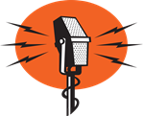

**Ohio Section Newsletter Contest 2019**

Consider this your friendly monthly reminder that the **2019 Ohio Section Newsletter Contest** is underway. Entries have been arriving daily and I can already tell this will be another banner year.

I read all of the newsletters but I’m bound by the journalism ethic…READ BUT DON’T TELL”…one of the hardest things to do with the great ham radio stories I see. When I hand over the newsletters to the judges in July I put my hands in my pockets, move back from the table and watch the magic happen. I don’t want anything to detract, sway or influence their selections. I enjoy listening to their arguments, discussions, comments and watching their faces as they work their way to the winning selections. Their reactions are priceless and then I know they have picked the cream of the crop.

We have five judges now…because this contest means so much, I wanted to have the best possible professionals to make the decisions and make sure no stone was left unturned. A fresh set of eyes and added experiences will help keep the judging current, active and a little more in depth…also a lot more fun!

So, keep the entries coming. You will need to submit newsletters from two different months. If your newsletter is electronic just send an email with the link for the current month.

The deadline is June 30th and we’ll pass out the awards at the Columbus Hamfest in August.

**HAM RADIO ATTRACTION**

Horseshoe Magnet
A simple 3-d horseshoe magnet I did because I couldn't find anything fitting here. Have fun with it.Maybe it’s my good looks and great personality (yes, you can argue that) but I seem to attract ham radio operators old and new!

A couple of months ago I told you I learned that a co-worker…in the next room…was a amateur radio operator. By the time I got over there he had been transferred downtown!

Well, today as I left work he was standing in the lobby. I took the opportunity to unload with a hundred ham radio questions…his callsign, how long and what type of equipment he was using. I found out he’s been a ham for years…his dad a ham for decades…but he had not very active for a while.

TOP^

After a discussion about yagi antennas I told him to charge up his handheld and we would try a QSO on the local repeater. Finally, I got him to belly up to the microphone and WA LA…another ham back in action. I’ve adopted the mantra…TALK ON IT OR LOSE IT…and it seems to be working.

Now for the rest of the story. Another co-worker was sitting in the lobby moving his head like he was watching a tennis match as we rattled off stories about ham radio. I stopped talking for a second and asked him if he would like to become a amateur radio operator. His reply, “I’ve been wanting to do that for a long time!” WOW…right under my nose a ham-to-be all I had to do was ask. I should have known. This guy, a Navy Veteran, has an in-depth background in electronics, submarines and electronics in submarines! I’m working on getting him to the nearest club that is offering classes and testing and passing along some study materials.

So, in the last six months I’ve helped one guy get his license, one guy loses his license and one guy headed for the exam… and I wasn’t even trying! There is a moral to this story…just ask…the more we do that the more folks we can get to share this great hobby.

**HAM RADIO DISTRACTION**

There are a lot of new concerns and laws about distracted driving…telling us what we should, and should not, be doing while we drive. I’m not an expert but reading the newspaper, shaving, putting on makeup and eating a triple decker hamburger are probably not things we should be doing while driving…although I have witnessed all of those.

We know that folks who talk on cell phones can be annoying…and dangerous. And are subject to a fine if they get caught or run into something. But what about amateur radio? It’s a gray area.

Some states, cities and communities’ frown on anything that might be a distraction…including using a microphone or a hand-held two-way radio. Bluetooth amateur radios are available but not as much as cell phones and most cars equipped with handsfree electronics don’t support ham radios. So, it is up to us to be smart, talk smart and talk when safe. It’s a a good idea to make sure you have a copy of your ham radio license on you or in the car. If you get stopped it might help avoid another distraction called a TICKET!

And here’s something you might now know…those “Welcome to the store” greeters… can sometimes be a little over the top.

I always hang a portable radio on my belt when I go to run errands. I like to listen to the weather net and just good hams talking and don’t what miss a call from a fellow ham. But the greeters can mistake a radio on your belt for something else…like a weapon on your belt, and they get a little…maybe a lot… jittery. It happened to me. As I walked into the hardware store I was asked if I was police officer. I said no that I was an amateur radio operator. “What’s that on your belt,” he asked as the rest of the shoppers slowed down. “It’s my radio…would you like to see it?” The greeter seemed satisfied I was legit and not there for the big haul, handed me a flyer, welcomed me to the store. Now I felt jittery, hurried up got my stuff and checked out.

I’m more careful now about where and when I “carry” a radio…or anything else. The world is little different now so even amateur radio operators need to be careful.

That’s all for this month. See you in Mansfield in February.

**73, John KD8IDJ**

TOP^

***From the Section Traffic Manager***

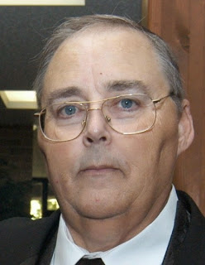***David Maynard, WA3EZN – STM***

[wa3ezn@att.net](mailto:wa3ezn@att.net)

AMATEUR RADIO DIGITAL MODES ILLEGAL??

But first some local information.

The Ohio Single Side Band Net will be meeting at the Mansfield Mid*Winter hamfest for its semi-annual meeting. The meeting will be at 11 am in the youth building.

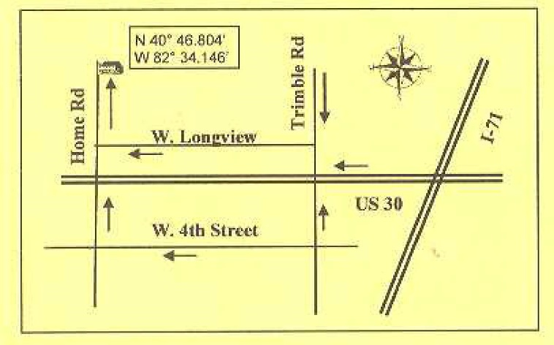

The Hamfest will be on Sunday February 17 at the Richland County Fairgrounds, 750 North Home Road, Mansfield Ohio. While advanced admission tickets sales are not needed the price of admission will be $7.00 at the gates which will open for admission at 7AM.

Mansfield Hamfest at 750 North Home Road

Until then you can meet with us on the air at 3972.5 at 10:30 am, 4:15 pm and 6:45 pm

The 6:45 net has been experiencing difficult propagation conditions. On those nights that a net can be held conditions have sometime been weird. Northern Ohio stations running the net at night have good copy with all stations that checked in. However, some of the Columbus, Cincinnati and southern Ohio stations cannot hear the net. Another night a southern Ohio station ran the net and had only three stations check in. Propagation was again the culprit. On several nights the net has needed relay from stations in Iowa, North Carolina and Alabama etc. in order to get stations checked in and to pass traffic.

Because of the way in which the relatively long wavelengths of radio signals interact with the ionized layers of the ionosphere miles above the earth's surface, the propagation of radio waves changes drastically from daytime to nighttime. This change in radio propagation occurs at sunset due to radical shifts in the ionospheric layers, which persist throughout the night.

This appears to be a seasonal problem that starts with the time change each year. After the sun goes down the band goes long and only local members can hear net control and check in without being relayed. I believe that the local members are making contact via ground wave which does not extend far enough for stations that are farther away to make contact.

The OSSBN is trying to use 160 meters at 1.888 MHz but not many station have antennas for this frequency because of the 247 foot length of the antenna. However, this dipole does not have to be strung up in a straight line. Zig-zag deployment is a popular alternative to straight line.

TOP^

**Frequency: 1.888 MHz  
Total Antenna Length ("L"): 247 Feet, 10.6 Inches  
Element Length ("E"): 123 Feet, 11.3 Inches**

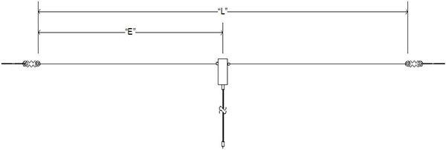

**AMATEUR RADIO DIGITAL MODES ILLEGAL??**

I started to look into this claim when I heard a discussion about it on the ham bands. The overheard discussion was unclear because I didn't understand what they referred to. Here is what I have found out.

**FCC filing claims digital modes raise national security concerns - Ted Rappaport N9NB** submitted a filing to FCC, Nov 10, saying FCC’s NPRM 16-239, on amateur radio digital modes symbol rate, is viewed as *"*a direct threat to the national security*"*  
  
A Radio Resource Media Group story by Sandra Wendelken says: A wireless expert says the FCC is putting national security at risk by not enforcing amateur radio rules.

The FCC’s notice of proposed rulemaking (NPRM) 16-239 attempts to remove a limit on the baud rate of high-frequency (HF) shortwave transmissions. In an ex parte filing, Theodore Rappaport, Ph.D., told the FCC’s chief technology officer (CTO) Eric Burger the FCC should first address ongoing rule violations to proper usage of the amateur radio service — specifically, the use of obscured, private messaging, which is forbidden in Part 97 rules and creates national security concerns, as well as other violations.  
  
“If allowed, NPRM 16-239 would perpetuate the current violations and would authorize obscured transmissions of unlimited bandwidth over the global airwaves, further increasing the danger to our national security, since these transmissions cannot be intercepted or eavesdropped by other amateur radio operators or the FCC,” Rappaport’s filing said.

Rappaport is the founding director of NYU WIRELESS, a professor at New York University (NYU) in three different schools and a leading expert in 5G technology.

TOP^

The filing said public records clearly show how the evolution of undocumented, proprietary transmission technologies such as PACTOR and Winlink, ARDOP, Winmor, STANAG and other HF transmission schemes that use controlling software have created a national security problem in the amateur radio service. Third parties, including other ham radio operators or the FCC listening stations, cannot intercept and decode over-the-air transmissions when used in the popular automated repeat request (ARQ) mode.

“In my personal conversations with FBI and FCC officials, they admit they also are unable to readily decode these types of transmissions,” Rappaport said. “In my discussions with vendors of amateur radio equipment, they tell me that they are concerned about purchases of amateur radio equipment by criminal cartels, and that they believe it is happening daily.”  
  
Rappaport urged the FCC to recognize the danger of NPRM 16-239 and address Part 97 rules to remove this type of obscured communication and other ongoing violations, before it enacts NPRM 16-239.

You can Read the November 10 2018 FCC filing by Ted Rappaport N9NB at   
[https://ecfsapi.fcc.gov/file/1111110314487/FCC%20EX%20PARTE%2016-239%20Eric%20Burger%20Nov%2011%202018.pdf](https://ecfsapi.fcc.gov/file/1111110314487/FCC%20EX%20PARTE%2016-239%20Eric%20Burger%20Nov%2011%202018.pdf#_blank)

Who is Rappaport? On September 27, 2018, the Radio Club of America awarded the Armstrong Medal to Wireless Communications Researcher and Educator Theodore Rappaport N9NB  
[https://engineering.nyu.edu/news/radio-club-america-awards-armstrong-medal-wireless-communications-researcher-and-educator](https://engineering.nyu.edu/news/radio-club-america-awards-armstrong-medal-wireless-communications-researcher-and-educator#_blank)

Read the full Radio Resource Media Group story at   
[https://www.rrmediagroup.com/News/NewsDetails/NewsID/17667](https://www.rrmediagroup.com/News/NewsDetails/NewsID/17667#_blank)

With the government shut down I have not been able to find an FCC response to the Rappaport filing. However I did find communications between the SCS GnbH and company (SCS) the Pactor modem manufacturer and the FCC received by the FCC on November 7, 2018 discussing the Pactor 3 and Pactor 4 protocol. <https://ecfsapi.fcc.gov/file/110731917879/16-239.pdf>

In addition to the above discussion a letter from M Lee McVay to SCS dated November 13, 2018 appears to also express security concerns on the use of any Pactor mode. This letter can be reviewed at <https://ecfsapi.fcc.gov/file/111297632730/Pactor_Stone_11708_Final.pdf>

As a Pactor user I find this method of sending radiograms to be fast and error free. I have purchased a Pactor 3 modem at great expense so the I can service the Ohio NTS network by receiving radiograms from the digital network.

Digital traffic handling operates with the use of a Hub station. There is no “net” time because receiving stations can connect to the hub any time of day or night and receive traffic designated for their station. The connection must be made on specific frequencies which are published. Pactor is an efficient mode as I have had as many as four different station come on my frequency to cause interference but the Pactor protocol works flawlessly and receives the intended radiograms without error.

This is enough for now.

**73, David WA3EZN**

You can view the STM’s monthly report on the website.. <http://arrl-ohio.org/stm/stm.html>

TOP^

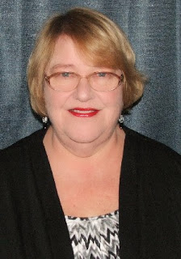***Out and About***

***Lyn Alfman, N8IMW - ASM***

[lynalfman@aol.com](mailto:lynalfman@aol.com)

**HAPPY NEW YEAR!**

I wish everybody a Prosperous and Happy New Year! So far, the month of January has been speeding by at a break-neck pace. Before long is will be Spring! There are two Ohio hamfests this month: Sunday Creek Amateur Radio Federation (SCARF) on January 20 in Nelsonville and TUSCO (Tuscarawas County) ARC on January 27 in Strasburg. Attending one of these hamfests is a great way to break our hibernation tendencies. Maybe I’ll see you there.

On a different subject, I want to explain why my column almost always has something on the Cambridge Amateur Radio Association. CARA is my home club (I do belong to several more), so because I know what is going on in that club, my column almost always has something about the organization in it. I have been a member of the Cambridge Amateur Radio Association for over 30 years, and a de facto member since I was married 45 years ago since my husband Sonny Alfman, W8FHF, was a member.

**CARA CELEBRATES 105th BIRTHDAY**

The Wireless Association of Cambridge, which was founded on December 4, 1913, is known today as the Cambridge Amateur Radio Association, Inc. Through the years it underwent several name changes but still consisted of the same groups of people. CARA was founded in Cambridge on December 4, 1913, which is among the oldest continuous amateur radio clubs in the United States.

**CARA SES**

The Cambridge Amateur Radio Association also operated a Special Event Station December 8 in honor of the club’s 105th anniversary of its founding. One station was operated from the future Waller-McMunn Museum (which was heated by a propane heater) and Dave Adair’s train caboose (heated by its pot-bellied stove). They managed to make around two hundred contacts that day.

**CARA AWARDS BANQUET**

The Cambridge Amateur Radio Association, Inc. (CARA), a 501 c 3 organization, had its annual awards banquet at Theo’s Restaurant with 20 people in attendance.

Ohio Section officials included Section Manager Scott Yonally, N8SY; Assistant Section Manager Lyn Alfman, N8IMW; District 9 Emergency Coordinator Sonny Alfman, W8FHF; Guernsey County Emergency Coordinator Dick Wayt, WD8SDH, and his wife Teri; Assistant Guernsey County Emergency Coordinators Bruce Homer, N8JMK; and Mark Jenei, KC8SBB.

CARA officers in attendance were President Jim Shaw, AB8P; Secretary Evelyn Barton, KA8NZS, and her husband Fred Barton, KB8MGI; Treasurer Beverly Bunn, KD8MSL; Facebook Manager Steven Bunn, KD8MFC; Activities Chair Sonny Alfman, W8FHF; Public Information Officer and Newsletter Editor Lyn Alfman, N8IMW; and Trustees Evelyn Barton, KA8NZS; Alan Day, K8AL; and Randy Evilizer, N8YGM and his wife Debbie.

Other guests included Bob Burton, KB8ZMI; Larry Dukes, KD8QYV; and Marilyn Phalin, KD8ZMG, Mayor of Belle Valley, Ohio; Honorary CARA Member Michael Sikora, CPA, and his wife Donna Sikora.

TOP^

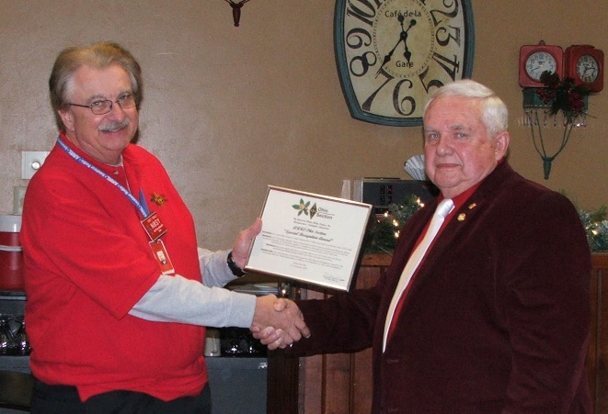

Section Manager Scott Yonally N8SY, presented Ohio Section Special Recognition Certificate to CARA in celebration of its 105th birthday, which President Jim Shaw, AB8P, accepted.

The top award of any of the CARA Awards Banquets is the Ham of the Year Award. A Ham of the Year Committee is formed in the fall to determine whether to award a Ham of the Year award for that year, and if so, who would receive that honor. The 2018 Ham of the Year Committee presented its selection, Larry Dukes, KD8QYV, with the coveted Ham of the Year (HOTY) Award for his many contributions which benefited CARA and/or amateur radio.

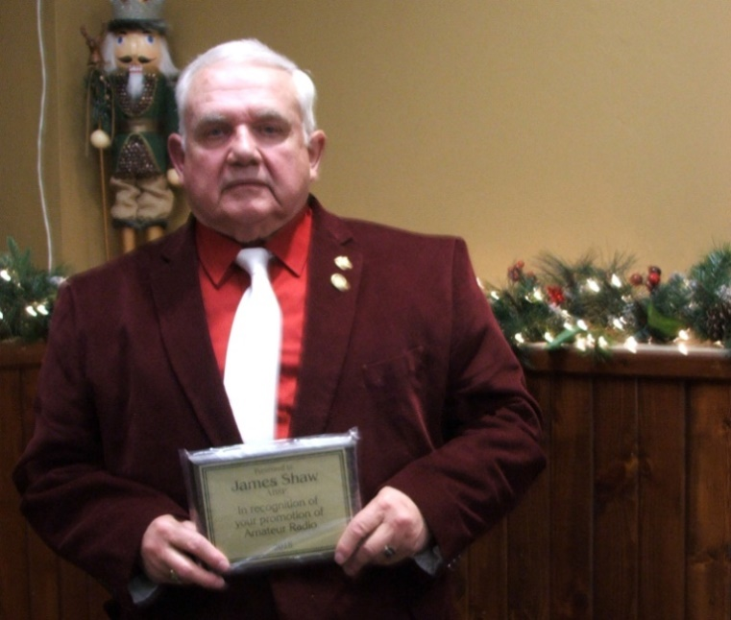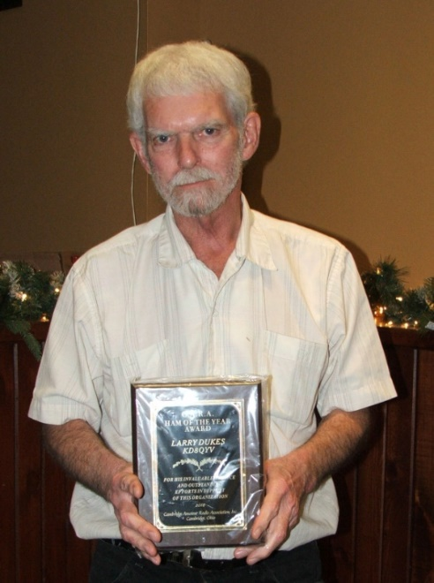

🡨

Larry Dukes, KD8QYV, was selected as 2018 Ham of the Year

🡪

CARA President Jim Shaw, AB8P, President was also presented with a plaque honoring his promotion of amateur radio in Guernsey and Noble Counties.

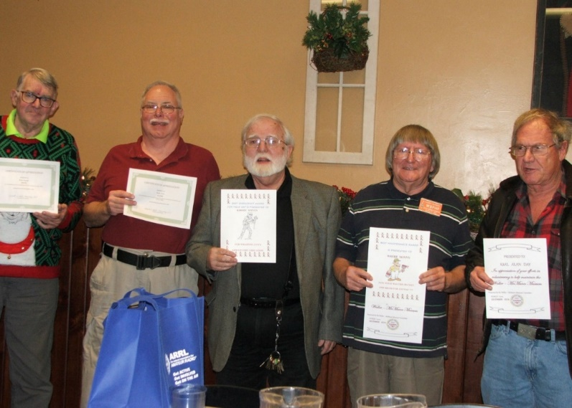

Pictured here are a few of those who received awards at the banquet. Those who are entitled to awards but were not in attendance will receive theirs at the January 26 meeting.

(left to right) Bruce Homer, N8JMK; Mark Jenei, KC8SBB; Steven Bunn, KD8MFC; Sonny Alfman, W8FHF; and Alan Day, K8AL

TOP^

**SNUGGLE UP TO A WARM RADIO THIS MONTH**

January is the perfect time to get on the air. With the cold weather outside, and in many cases snow, we are somewhat stuck indoors. Most of the TV shows are winding down and will soon be reruns. Besides there are so…many operating contests and special events on the air in which to participate.

Perhaps you have been meaning to finish up some wallpaper like Worked All Continents, Worked All States, Worked All Counties, participate in Winter Field Day, or just want to finish working all grid squares, on all bands! This is the best time of year because come Spring, we will want to get outside to get rid of our cabin fever. Once we get outside in the spring, we usually have yardwork and other activities which will prevent us from operating as much as we want to. So, snuggle up to a warm radio and get on the air!



Be Safe and be Radio Active!

**73 Lyn N8IMW**

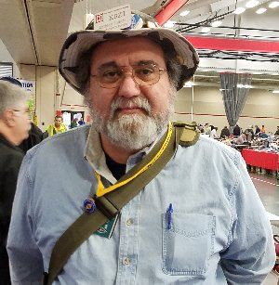***From the Section Youth Coordinator***

***Anthony Luscre, K8ZT - SYC***

[k8zt@arrl.net](mailto:k8zt@arrl.net)

As we start a new year I wanted to remind you when and how to contact me. As the ARRL Ohio Section Youth Coordinator, I am responsible for providing resources and assistance to all youth-related Amateur Radio activities. This includes, but is not limited to K-12 Education, Scouting, Youth Groups and Clubs, Makers Groups, 4-H, Teachers and Students, Colleges and Universities, etc.

What can I provide:

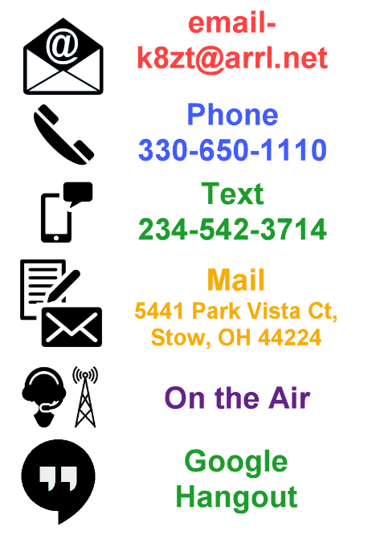

* I maintain web pages with resources for students and teachers:
  + **Kids Radio Zone**- [www.ztlearn.com/radio-kids](http://www.ztlearn.com/radio-kids)
  + **Teachers Radio Zone**- [www.ztlearn.com/radio-teachers](http://www.ztlearn.com/radio-teachers)
* I also maintain a document with all of my past columns for Ohio Section Journal- [tiny.cc/ar-ed-out](http://tiny.cc/ar-ed-out)
* ***Ham Radio Quick Start Guide***, a document, not specifically for kids, but for anyone interested in getting started in Amateur Radio, getting their license and starting out- [tiny.cc/new-ham](http://tiny.cc/new-ham)
* I can work with your local teachers, principals, other education administrators, scouting leaders, etc. to provide information on Amateur Radio and how it can fit in and enhance their curricula and programming needs
* I can provide programs for your local club meetings

TOP^

How can you contact me? As the graphic above shows there are at least 6 ways and if you throw in face-to-face (I am at many Hamfests) it is 7 ways. I am located in Northeast Ohio so depending on your location a personal appearance may or may not be convenient, but I am always willing to supplement in-person appearances with online Google Hangout video conferencing. I am also willing to not only work with you or other leaders but also directly with students, either in person or via video conference.

Unfortunately, there is one thing I cannot do well and that is to magically determine where my help could be useful that is why I depend on you to **Contact Me!**

**73, Anthony K8ZT**

*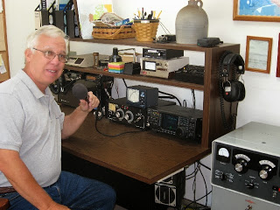****From the Official Observer Coordinator***

***John Perone, W8RXX - OOC***

[w8rxx@arrl.net](mailto:w8rxx@arrl.net)

Happy 2019!

Only 682 total Ohio OO hours with no cards being sent.

Does everyone have a copy of the latest FCC rules and regulations? The Fourth Edition effective November 1, 2017 is available from the ARRL. (Item # 1173) or you can simply download it from the government’s website: [>> Here <<](https://www.ecfr.gov/cgi-bin/text-idx?c=ecfr&SID=336ab7469b61ecbfa15086dbf1bf2c59&rgn=div5&view=text&node=47:5.0.1.1.6&idno=47#47:5.0.1.1.6.1.157.1)

**73, John W8RXX**

*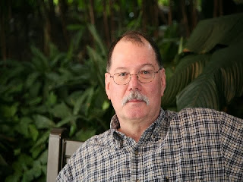****ARES Training Update***

***Jim Yoder, W8ERW – ARES Data Manager***

[w8erw@arrl.net](mailto:w8erw@arrl.net)

So how did we finish the year in 2018? The numbers are to be proud of. We finished up the year with 1,000 active ARES members who have submitted training documents. 785 of those have completed NIMS training Level 2 while another 130 achieved Level 3. Many have also completed training on the supplemental list including the ARRL EC series courses, AUX Comm. COM L, COM T, and ICS-706 and ICS-802. Overall, the database contains over 7,500 training certificates which consume almost 15 Gigabytes of data. My Hat is off to Ohio ARES members who lead the way for all of the 71 ARRL Sections.

Are you ready for Winter Field Day? The Seneca Radio club will participate this year from Buffalo Wild Wings in Tiffin. Thanks to our member Mike Mastro KD8QDL who operates this fine establishment, we should garner a lot of exposure this year while enjoying a really great location with some welcome amenities as we parse the ether during the contest. Look for W8ID on the air from BW3’s and get us in your log.

I don’t know how the rest of you feel, but the two wonderful l holidays we have just before winter attacks with full force are not the best recipe for maintaining one’s weight objective.

TOP^

All the delicious goodies, the creations from the kitchen that our XYL’s and family members provide, do not lend well to a weight management program. I enjoy being outdoors and active when the weather is much warmer than it has been lately. All the holiday eats and cold snowy weather are a combination that annually destroys my resolve to get to and maintain a more healthy weight. Having said all of that, rest assured that I will never turn down or miss an opportunity. I sincerely hope that each of you were able to enjoy the holidays, all the wonderful times together with family and of course in the true spirit for which they were intended.

It’s now 2019 and I still find that difficult to imagine. My head wants to say “19” something. I remember party lines, rotary dial phones, no cell phones or internet and no computers. Recently I read another article about the proliferation of “AI” Artificial Intelligence and how it will soon be incorporated into nearly everything we do or use. Some jobs will cease to exist as they are automated. Our vehicles will assume more of the management of our daily commute and supposedly make us safer while on the highway. I wonder where all this may lead us in our Amateur Radio hobby. We Hams like to keep things that we have learned to love and are familiar with.

Change is not always welcome even with the promise of better conditions or the possibility of cost savings. The world of digital modes has a lot of momentum however and some exciting concepts and technologies are emerging almost faster than we can keep up with them. This year, I hope to dedicate more effort towards some of this new technology without losing the old ways along the way.

I would like to close this month with a big thank you to everyone who has embraced ARES training, supported our ARES efforts in the Ohio Section by taking and submitting your certificates and of course, for the great dedication to all that we do in the Ohio Section. Thank you for your support.

As always, I welcome your comments and questions. If there is anything I can do for you, please let me know.

Each of us who serve the Ohio Section does so in order to help and assist our fellow Amateurs to get the most possible from our hobby. Thank you for allowing us to do so.

Thanks Much,

**73, Jim W8ERW**

***The Handbook Give Away***

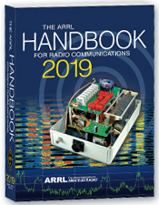Hey Gang,

Have you registered for the “Handbook Giveaway” drawing for this month yet? If you haven’t, go to: <http://arrl-ohio.org/handbook.html> and get registered.

What’s the catch? I want to get everyone checking in to the Ohio Section website as often as possible, and in order to register each month, you have to visit the website often! There’s nothing else to it. I pay all expenses, and from time to time, I Give Away more than just a Handbook. And, you’ll never know just what months will be those special times that I will have more than just a Handbook to Give Away!!

TOP^

Many of you ask me just how do I know when the drawing is on? Well, that’s easy all you need to do is check in on the Ohio Section Website on a regular basis and watch for the big **RED** Arrow that will appear on the left side of the page. This is the sign that the drawing is on and you need to get registered. So, keep a sharp eye out on the website and check in often! <http://arrl-ohio.org>

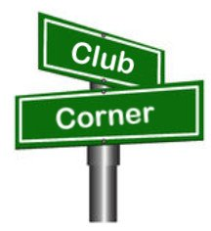***Club Corner***

This is YOUR cornner of the newsletter. Send me what your club is doing and I’ll make sure that it gets in. Got a special event or club project that you want everyone to know about? Send it to me!. Need help with a project? Send it to me.

Let me know what you club is up to. Are you going to have a special guest at your meeting or are you having a special anniversary? Just sent it to:

[n8sy@n8sy.com](mailto:n8sy@n8sy.com)

#########

***New Weak Signal and EME Bridges Setup on Hamshack***

*(from Phil Humphries, N8LRG)*

As an FYI for everyone, we now have a weak signal and EME bridge setup on Hamshack Hotline. We have a bridge for each IARU region plus a dedicated bridge for EME.

There are also many other bridges setup and listed in the HamShack hotline directory, so you might want to just scan the list to see if there’s anything else of interest to you as well.

As Phil reports, he has been using the Hotline for a few months now. They have servers set up to cover each IARU region. Although most activity is from the US, I have talked to some VK's on the bridges as well. Most evenings you can find a number of us on the public bridge 302.

We also use matter-most to chat and share pictures. We use the Hotline to coordinate between hams. A used VoIP phone from eBay and a request for a new number got me on very quickly.

You will find me on weak signal bridge 342 in the mornings. This is another great resource to have in the ham sack.

There’s tons more information on the website. Here is the URL: <https://hamshackhotline.com/>

#########

***General Class Licensing Course - Work HF!***

The Cuyahoga Falls Amateur Radio Club is offering its 6-week course for the General amateur radio exam. Sixth week has free Laurel VEC exam. The exam is open to the public.

WHEN: Every **Sunday stating 17 February** 2019 to March 24, 2019 from 1:15 PM to 4:45 PM

WHERE: Main branch of the Akron-Summit County Public Library, 60 [South High Street](https://www.google.com/search?rlz=1C1CHBF_enUS802US802&q=South+High+Street&stick=H4sIAAAAAAAAAONgVuLWT9c3LEkxLDdKTwMAFnKSvA8AAAA&sa=X&ved=2ahUKEwidg9q2i7nfAhUNKqwKHeHCCw4QmxMoATAiegQICBAN), [Akron](https://www.google.com/search?rlz=1C1CHBF_enUS802US802&q=Akron&stick=H4sIAAAAAAAAAONgVuLQz9U3qDIySAEAaxdTPwwAAAA&sa=X&ved=2ahUKEwidg9q2i7nfAhUNKqwKHeHCCw4QmxMoAjAiegQICBAO), [Ohio](https://www.google.com/search?rlz=1C1CHBF_enUS802US802&q=Ohio&stick=H4sIAAAAAAAAAONgVuLQz9U3MM3OzgAAi4KwzwwAAAA&sa=X&ved=2ahUKEwidg9q2i7nfAhUNKqwKHeHCCw4QmxMoAzAiegQICBAP), 44326 Free parking in adjoining deck.

TOP^

COST: $35 for manual and refreshments.

Please preregister by sending call sign and statement of intent to [education@cfarc.org](mailto:education@cfarc.org).

The course uses the General Class manual by Gordon West. This is our fourth offering. The course covers background material, question pool Q and A, and live demos.

Send questions and registration to Jim (N8PZL) at [education@cfarc.org](mailto:education@cfarc.org)

Sponsored by the Cuyahoga Falls Amateur Radio Club: [cfarc.org](http://cfarc.org/)

#########

***Mount Vernon ARC Technician Classes to begin in January***

The MVARC will be hosting Study Sessions for the Technician Class Ham License starting in January, 2019.  **We will have an introductory meeting on Thursday, January 24th** with our first study session on Thursday, **January 31**.  Our sessions will run weekly every Thursday evening with our last session on March 14th.  I am anticipating our Exam Session will be Saturday, March 16th, but will need to confirm that.

Our introductory meeting, all of our sessions, and our Exam will be held in the Education Resource Building of the American Red Cross, located at 300 N Mulberry Street, Mount Vernon, Ohio.  Our introductory meeting and study sessions will start at 7:00pm and run no later than 9:30pm.  The time for the Exam Session will be determined at a later date.

Questions regarding these sessions can be directed to G Michael Jacobs, KE8HGE, @[g.m.jacobs@gmail.com](mailto:g.m.jacobs@gmail.com)

#########

***Massillon Amateur Radio Club will be conducting three simultaneous classes:***

Technician License - General License - Code training

All will begin at the Massillon Club location: Massillon Senior Center, 39 Lincoln Way West, Massillon.

Classes will begin Friday evening **February 8th** from 7-9 p.m. Classes will run every Friday for 8 weeks through March 29.

For Technician class contact Terry Russ, N8ATZ [truss@sssnet.com](mailto:truss@sssnet.com) or call 330-837-3091. For General Class contact Don Wade, W8DEA, [w8dea1djw@gmail.com](mailto:w8dea1djw@gmail.com) or call 330 For Code class conetact Perry Ballinger, W8AU, [w8au@arrl.net](mailto:w8au@arrl.net) or call 330-705-8449

The Code class encompasses learning, plus how to use a hand key, various options for electronic keys, where and when to find W1AW slow code practice, how to conduct your first QSO, tips on abbreviations and Q code, etc. Goal is 5 WPM, and follow up with Club on-air training net.

As classes are held at the location of the Massillon ARC club station (W8NP) where we provide hands-on demonstrations as part of the instruction.

#########

TOP^

***Medina 2M Group offering FREE classes for HAM Radio License.***

The classes are expected to begin in the second week of February and last until the third or fourth week of March, the exact dates will be finalized soon.

Classes are typically held once a week in the evening. Enrollment is currently open, you can sign up for the classes at: https://goo.gl/xTPhhA

More information about the Medina 2M Group can be found at: <http://W8EOC.org>

#########

***PCARS Starting Technician Classes***

We will be starting a new Technician Class on **February 6th**. The classes will run through March 27th. The session on March 27th will be a VE test session. We have added a Saturday session, February 16th from 9 till noon that will allow students to learn about antenna and station setup. If you know of anyone interested in getting their license, pass this information along. If you would like a copy of the class flyer simply [Click Here](http://r20.rs6.net/tn.jsp?f=0019FZnn_IPSl-z042ASEbnDAi20_HpKQ5JDJfsWurlGGISfSK1ofwft7xF3Kusb1aIWIcNldfkAxE0AveB6M_II-ySvk0vrZUKFeu49GNCCf73YlWn148VyCQF64pP7hGtuJQS2iRbgGCRjZmYfnq_tv0LawAt9YBiMRyYSARa2lV1KUjxgupDFXe6A1-qe0e0Nwd0zzbkO6gj6677Dx2AMQ==&c=5ztChA4-wXZ5snOh50DMcMYDpTTxpY9dp2TM9sd_GkOqEXRNyjVI_A==&ch=H6EX64vFlS6l3qlpygJ2PVHNqp83C4wLvKRfn1U9TavYuBytVVrg-w==).

Remember to send me an email as soon as possible if you are interested. Send to [jawilson@j3solutions.com](mailto:jawilson@j3solutions.com).

#########

***CARS 2019 Winter Ham Radio classes - get your Technician, General or Extra class license!***

Thursday evenings starting **February 28, 2019** and ending April 11, 2019 at 6:30 pm April 11th will be a special VE Test session for all license classes, ARRL fee for this VE test is $15.00

To register please follow the link at: [www.2cars.org](http://www.2cars.org) and complete the on-line application or call 216-932-8005 Dave, KD8ACO.

Classes will be held at the Seven Hills City Hall, 7325 Summit View Dr Seven Hills, OH 44131 in room “C” at 6:30 pm every Thursday.

The entrance is at the East end on the South side of building class fees: Technician $25.00, all who pass get a free CARS membership for 2019, General and Extra $20.00 nonmembers or Extra is $15.00 CARS members, General class ONLY is **FREE to CARS members** All class materials are provided

#########

***SOARA Introduction to Ham Radio from Across the Street to Outer Space Program***

Even though the weather wasn’t the best, the folks from Southern Ohio Amateur Radio Association got their presentation completed. They did an Introduction to “HAM Radio - From Across the Street to Outer Space,” this past Saturday at The Briggs Lawrence County Public Library.

SOARA members James Rowe N8TVO, Eddie Jenkins N8URU, Mike Love WB8YKS and Ken Massie WN8F did the presentation.

TOP ^

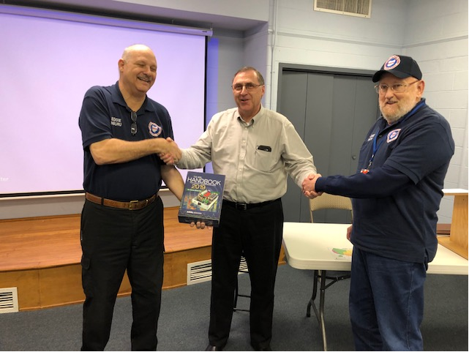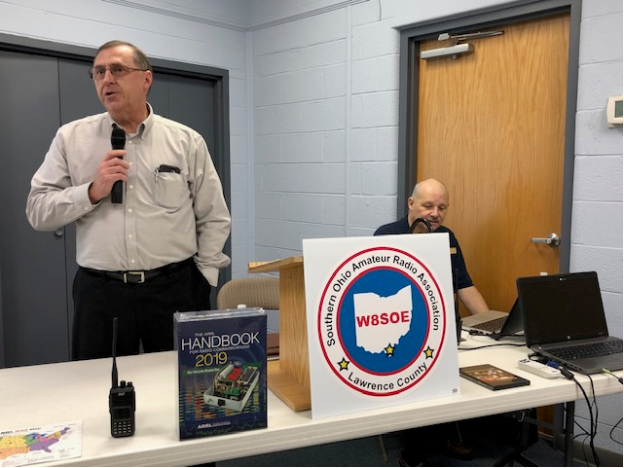

Additionally, the awarding winning world-famous news personality and FCC licensed radio operator, Walter Cronkite, KB2AGD (now deceased) joined in via the video “*Amateur Radio Today” DVD.*

All in all with the bad weather, NWS Winter Weather Advisory, there was a really good turnout. Eddie, N8URU said, “it was the largest group he has attended at the Library”. Joe Jenkins, Library Director, was pleased with the interest the people had and the number attending.

A number of SOARA members were also in attendance to support our Ham Radio community outreach effort. I know it was a struggle for Arthur J.  “JP” Pierson, N8LRO using his walker in the heavy rain but he was there. Thank you JP!

Jim, N8TVO and Eddie, N8URU made the presentation of the ARRL 2019, 6 Volume Handbook on behalf of the SOARA members to the Library. The handbook will be labeled with SOARA donation information and will be placed in the reference section of the Ironton Branch Library.

It was good news that Joe Jenkins, Library Director said, “the Library will be purchasing Ham Radio books and licensing study materials”. He wants SOARA to help with a summer reading program for kids about space and the Shuttle. Possibly, arrange for the kids to talk with the astronauts onboard the Space Shuttle from the Chesapeake Library as part of their “Read a Book about Outer Space” summer program.

It was a GREAT day for Ham Radio and SOARA!

***One Question Questionnaire***

Hey Gang

There’s another NEW – one question – questionnaire on the Ohio Section Website! <http://arrlohio.org> We had about 60% of you stating that you have not gotten registered in ARES Connect yet. From the numbers that ARES Connect is generating, I’d say that’s just about as accurate as you can get. Now, the biggest question is WHY? This is the new system that we are all going to. Please, if you are one of the 60%, I beg you to get registered now.! !!

TOP^

Anyway, these questions are all in fun and I hope that you are enjoying answering these “ONE QUESTION” questionnaires.

Ok, enough on that, here’s the next question for you to answer…

**“Were you activated to help your community during the snow-storm this past weekend??”**

You’ll find the “One Question” questionnaire on the Ohio Section Website! <http://arrlohio.org> It’s all in fun and it’s not a scientific survey in any way, but we are learning some things that we didn’t know from these questions. I hope that you are enjoying answering these “One Question” questionnaires.

***ARES Connect***

***CQ… CQ…. CQ… Calling all persons to be a part of the new ARES Connect program.***

We need to discuss some very important items that only YOU can make a difference with. I need you to get yourselves registered in ARES Connect, that is… if you haven’t already.

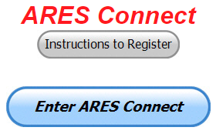Now, how do I know that you need to do this? It’s simple, we have a little over 800 now registered in the database with about 450 persons actually signing up for events. Stan’s last S.E.C. report shows that we have a little over 1,500 persons in ARES.

That means that there is still a lot of you that haven’t taken the plunge yet and need to! What are you waiting for? No matter how much you resist, it’s coming, and we need to make sure that no one is left behind.

**Now, as an incentive to get you to not only register…. But to actually start using the system…** *(Notice how I have that in bold type for you to clearly see?)*I am giving away all sorts of goodies to help you get motivated. I have a footlocker of really cool items that I will be giving away!

Yes folks, remember the handbook I gave away a few months ago to kick this project off? I’m do this a various interval throughout the year, so it will challenge you to be dedicated like Ron and get your hours into the system. You’ll never know just when another drawing will be, so you really do have to be prudent!!

Here’s how it looks for the first 3 weeks of 2019:

|  |  |  |  |
| --- | --- | --- | --- |
|  | **Name** | **Events** | **Hours** |
| 1 | Dan Stahl (KC8PBU) | 32 | 42.00 |
| 2 | James Yoder (w8erw) | 7 | 32.50 |
| 3 | Michael Lacumsky (w8mal) | 16 | 27.50 |
| 4 | Bret Stemen (KD8SCL) | 6 | 26.50 |
| 5 | Bryan Hoffman (kc8egv) | 4 | 26.00 |
| 6 | Edmund Liddle (KE8ANU) | 6 | 26.00 |
| 7 | Brent Stover (wd8pnz) | 3 | 21.50 |
| 8 | Gordon Broadway (N8BHL) | 4 | 21.00 |
| 9 | Grant Dailey (KE8JOU) | 4 | 20.75 |
| 10 | Douglas McClure (KD8SST) | 4 | 19.00 |

TOP^

Don’t know where to get started? We have a set of instructions on how to get registered right above the button to enter ARES Connect. I would strongly suggest that if you haven’t registered yet, that you read these instructions first. Here’s a link to get you started... <http://arrl-ohio.org/ares_connect_directions.pdf>

Please, don’t just hurry through the questions, read them carefully, if you don’t understand something, please ask me, I’m here to answer your questions.

We know that you mean well by answering that you do have the needed courses in, but I will let you know that we are verifying what you say you have with what is showing for you in our statewide database when we are completing your registration. So, how can you find out if you are already listed in our statewide database? Easy, here’s a link: <http://arrl-ohio.org/SEC/special/ICS%20Complete%20by%20County%20and%20Name.pdf>

***Help Wanted – Apply Within!!!***



We are looking for an energetic go getter to fill the position of District Emergency Coordinator in District 5 – District 5 consists of the following counties: Carroll, Columbiana, Mahoning, Portage, Summit and Trumbull.

Dennis, AI8P decided recently to retire both professionally as well as a DEC and move out of the area to a much warmer climate and that leaves a vacancy within the DEC’s that we need to fill.

You do need to be a Level 2 or Level 3 ARES volunteer and live in one of the above listed counties in order to qualify.

Think you have what it takes? Call or email me if you are interested or need more information at: [n8sy@n8sy.com](mailto:n8sy@n8sy.com) or 419-512-4445.

***Incident Command System (ICS) Training Schedule***

All current trainings are listed on the Ohio EMA training calendar located at:

<https://webeoctraining.dps.ohio.gov/TrainingAndExercise/courselist.aspx>

I’ve been asked to also include a link to the Kentucky EMA training calendar as well..

<https://kyem.ky.gov/training/Pages/default.aspx>

<https://sites.google.com/site/ccoemtraining/home>

Please pay particular attention to these courses listed above, as that there’s a lot of ICS 300 & 400 classes listed that are very useful for all Amateurs to have under their belts. I will also state that G775 is also a very good course to take as well. These 3 courses are multiple day in class courses, so please be prepared to spend some time taking them.

I would like to remind any of you that are going to take any of the in-class training sessions that you dress appropriately.

TOP^

Please don’t go into these classes with attire that doesn’t represent you, and Amateur Radio in the best of light. Remember, you will be in class with fire / police chiefs, mayors, township trustees and a whole host of other government and civil officials that will remember how you represented Amateur Radio while you were in these classes together.

We do recognize that IS-300/400 requires multiple days of actual classroom training that is not easily obtained. So, if you just can't’find the time to fit these class room courses in, we do have an alternative method for getting you to Level 3. Completing the following **“FREE”** and **“ONLINE”** courses will act as substitute for you FEMA Leadership Development Course requirements. You absolutely will need to complete all **7** of these courses to get your ICS 300/400 credit.  Here are the courses that you need to take:  **IS-120, 230, 240, 241, 242, 244 & 288.**

#########

***Auxiliary Communications (AUXCOMM) Training***

This course focuses on auxiliary communications interoperability, the relationship between the COML and the volunteer, emergency operations center (EOC) etiquette, on-the-air etiquette, Federal Communications Commission (FCC) rules and regulations, auxiliary communications training and planning, and emergency communications deployment. It is intended to supplement and standardize an operator’s experience and knowledge of emergency amateur radio communications in a public safety context.

Course Dates: **February 16 – 17, 2019** (One-hour lunch)

Application deadline: **February 2, 2019**

Course Registration Time: **7:30 AM to 8:00 AM** (Day 1)

Time of Course: **8:00 AM to 7:00 PM (Both Days)**

Training Location: Franklin County Emergency Management & Homeland Security

5300 Strawberry Farms Blvd.

Columbus, OH 43230

**Required Prerequisites:**

Required Prerequisites: (IS-100, 200, 700 & 800)

Applicants MUST have completed the following on-line courses from the FEMA/EMI Independent Study (IS) website: https://training.fema.gov/is/crslist.aspx?all=true

1. IS-100, Introduction to the ICS;

2. IS-200, ICS for Single Resources and Initial Incidents;

3. IS-700, National Incident Management System (NIMS), an Introduction;

4. IS-800, National Response Framework (NRF).

**Other Required Documentation:**

The target audience for this course includes individual that MUST have Personal experience in auxiliary communications and MUST have the following four items and provide documentation to Pam Tickle.

1. An active FCC Amateur Radio License (provide a copy of the license)

2. Documentation of past experience in auxiliary emergency communications (provide documentation via email or letter of your experience)

3. An affiliation with a Public Safety Agency (provide a letter or an email from leadership of the Public Safety Agency that you are associated with indicating your affiliation)

4. A desire to work with COMLs in a NIMS/ICS environment (provide a statement letter or email indicating your interest)

TOP^

**Send the following eight items as a COMPLETE packet to Pam Tickle @** [**pktickle@franklincountyohio.gov**](mailto:pktickle@franklincountyohio.gov)

If you are unable to attend the course, please click on the link below, withdraw yourself by logging in, click on the “Course Catalog”, and double click on the course to display the "C“urse Details" ”nd click "U“enroll" ”o withdraw from the course. <https://trainingcampus.dps.ohio.gov/cm/cm710/pstc/pstc.html>

**Course Target Audience:**

The target audience for this course includes individual that MUST have **Personal experience in auxiliary communications and MUST have the following four item and provide documentation to Pam Tickle.**

**1. An active FCC Amateur Radio License**

**2. Past experience in auxiliary emergency communications**

**3. An affiliation with a public safety agency**

**4. A desire to work with COMLs in a NIMS/ICS environment**

**Lodging Information:**

Lodging, Meals, Per Diem and all other travel expenses are the responsibility of the student or the parent organization.

**Enrollment:**

Students must enroll via the Public Safety Training Campus located at the following link. <https://trainingcampus.dps.ohio.gov/cm/cm710/pstc/pstc.html> and those that have trouble registering should contact Ohio EMA Training at (614)799-3824/3677 for assistance with registration. Please refer to the FY 2018/2019 Ohio EMA Training Catalog or website at <http://ema.ohio.gov/Training.aspx> for additional information. State Point of Contact: Lisa Jones, DSC 2, Ohio EMA, SAA Training Point of Contact, [ljones@dps.ohio.gov](mailto:ljones@dps.ohio.gov), Office: (614) 799-3824

##***GT-347 Incident Command System (ICS) Forms Review***

This class is Provided by Texas A&M Engineering Extension Service (TEEX). Hosted by Franklin County EM & HS **February 5**, 2019. The class is the morning of February 5th and we are still in need of 18 people to register and attend the class, so it does not get canceled.  If it has been awhile since you have taken this review, please consider attending this half-day class.  Registration is through the Ohio Public Safety Training Campus

<https://trainingcampus.dps.ohio.gov/cm/cm710/home.html>

**Course Description:**

The MGT-347 ICS Forms Review course is a 4-hour workshop that provides emergency response supervisors and mid- to upper-level managers with a detailed introduction to the Incident Command System (ICS) forms used in the development of an Incident Action Plan (IAP) and/or Coordination Action Plan (CAP). Participants will examine the primary forms used in an IAP/CAP, as well as supporting and other utility forms.

In addition, participants will review the planning process and where, within that process, the forms are filled out and by whom. The workshop includes a practical application designed to instruct participants in the development of Specific, Measurable, Action-oriented, Realistic, and Time-based (SMART) control and management objectives.

TOP^

**Course Dates:** February 5, 2019

**Application deadline:** January 29, 2019

**Course Registration Time:** 7:30 to 8:00 AM

**Time of Course:** 8:00 AM – 12:00 PM

**Training Location:** Franklin County Emergency

Management & Homeland Security

5300 Strawberry Farms Blvd.

Columbus, OH 43230

**Required Prerequisites:**

After registering for the course online, students must provide copies of the following certificates of completion to Pam Tickle at pktickle@franklincountyohio.gov to attend this course.

1. IS-100.b FEMA Introduction to the Incident Command System, ICS-100

2. IS-200.b FEMA Incident Command System for Single Resources & Initial Action Incidents, ICS-200

3. IS-700.a Introduction to the National Incident Management System (NIMS)

4. IS-800.C, National Response Framework, an Introduction

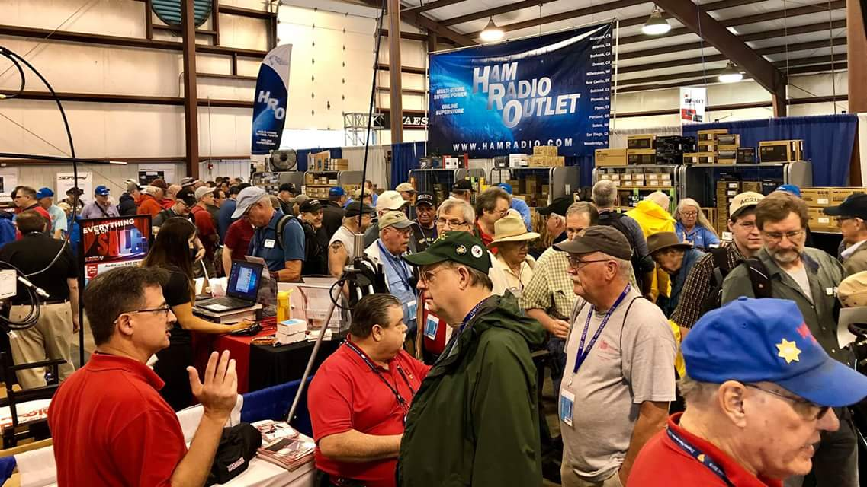[***Upcoming Hamfests***](http://arrl-ohio.org/hamfests.html)

01/27/2019 | TUSCO ARC Hamfest, Electronics &

Computer Show  
Location: Strasburg, OH  
Sponsor: Tusco Amateur Radio Club  
Website: [http://tuscoarc.org](http://tuscoarc.org/)

|  |  |
| --- | --- |
| 02/17/2019 | InterCity ARC Hamfest Location: Mansfield, OH Sponsor: InterCity Amateur Radio Club Website: [http://www.w8we.org](http://www.w8we.org/) | 03/03/2019 | [WINTER HAMFEST](http://www.arrl.org/hamfests/winter-hamfest-8)  Location: Elyria, OH Sponsor: Northern Ohio Amateur Radio Society Website: <http://www.noars.net/hamfests/noarsfest> |
| 03/16/2019 | [Gallipolis Ohio Hamfest](http://www.arrl.org/hamfests/gallipolis-ohio-hamfest)  Location: Gallipolis, OH Sponsor: Mid-Ohio Valley Amateur Radio Club | 03/17/2019 | Hamfest and Computer Fair  Location: Perrysburg, OH  Sponsor: Toledo Mobile Radio Association  Website: <http://www.tmrahamradio.org> |

***[V.E. Test Sessions](http://www.arrl.org/find-an-amateur-radio-license-exam-session)***

*(from arrl)*

|  |  |
| --- | --- |
| 01/23/2019 | [Middletown OH 45042](http://www.arrl.org/exam_sessions/middletown-oh-45042-39)  Sponsor: Dial Radio Club Location: Miami University-Middletown Time: 6:00 PM (Walk-ins allowed)  [Learn More](http://www.arrl.org/exam_sessions/middletown-oh-45042-39) | 01/26/2019 | [Springfield OH 45506-1607](http://www.arrl.org/exam_sessions/springfield-oh-45506-1607-42)  Sponsor: CLARA Location: Main Branch Time: 11:30 AM (Walk-ins allowed)  [Learn More](http://www.arrl.org/exam_sessions/springfield-oh-45506-1607-42) |

TOP^

|  |  |
| --- | --- |
| 02/02/2019 | [Bryan OH 43506-8410](http://www.arrl.org/exam_sessions/bryan-oh-43506-8410-53)  Sponsor: Williams County ARC Location: Willliams County 911/EMA Time: 10:00 AM (Walk-ins allowed)  [Learn More](http://www.arrl.org/exam_sessions/bryan-oh-43506-8410-53) | 02/02/2019 | [Kirtland OH 44094-8500](http://www.arrl.org/exam_sessions/kirtland-oh-44094-8500-62)  Sponsor: Lake County ARA Location: Kirtland Library Time: 12:00 PM (Walk-ins allowed)  [Learn More](http://www.arrl.org/exam_sessions/kirtland-oh-44094-8500-62) |
| 02/02/2019 | [Ravenna OH 44266-2191](http://www.arrl.org/exam_sessions/ravenna-oh-44266-2191-59)  Sponsor: Portage County ARS Inc. Location: PCARS Club Site (Rear of complex, under BIG tower) Time: 10:00 AM (Walk-ins allowed)  [Learn More](http://www.arrl.org/exam_sessions/ravenna-oh-44266-2191-59) | 02/03/2019 | [Marion OH 43302-1523](http://www.arrl.org/exam_sessions/marion-oh-43302-1523-45)  Sponsor: Marion ARC Location: TV 39 Time: 2:30 PM (Walk-ins allowed)  [Learn More](http://www.arrl.org/exam_sessions/marion-oh-43302-1523-45) |
| 02/06/2019 | [Cuyahoga Falls OH 44221-3205](http://www.arrl.org/exam_sessions/cuyahoga-falls-oh-44221-3205-7)  Sponsor: Cuyahoga Falls ARC Location: Cuyahoga Falls Library Time: 6:30 PM (Walk-ins allowed)  [Learn More](http://www.arrl.org/exam_sessions/cuyahoga-falls-oh-44221-3205-7) | 02/09/2019 | [Cambridge OH 43725-2401](http://www.arrl.org/exam_sessions/cambridge-oh-43725-2401-8)  Sponsor: Cambridge ARA Location: St John's’Episcopal church Time: 2:00 PM (Walk-ins allowed)  [Learn More](http://www.arrl.org/exam_sessions/cambridge-oh-43725-2401-8) |
| 02/09/2019 | [Findlay OH 45840](http://www.arrl.org/exam_sessions/findlay-oh-45840-76)  Sponsor: Findlay Radio Club Location: Findlay Radio Clubhouse Time: 9:00 AM (Walk-ins allowed)  [Learn More](http://www.arrl.org/exam_sessions/findlay-oh-45840-76) | 02/09/2019 | [Maumee OH 43537-1628](http://www.arrl.org/exam_sessions/maumee-oh-43537-1628-89)  Sponsor: Toledo Mobile Radio Assoc Location: Maumee Fire Station #2 Time: 8:15 AM (No Walk-ins / Call ahead)  [Learn More](http://www.arrl.org/exam_sessions/maumee-oh-43537-1628-89) |

***Special Events***

* **02/16/2019 | MVARA 100th Anniversary**

Feb 16-Feb 18, 2300Z-2300Z, W8QLY, Youngstown, OH. Mahoning Valley Amateur Radio Association. 14.220 7.220 3.922. Certificate & QSL. MVARA, 125 W McKinley Way, P.O. Box 14141, Youngstown, OH 44512. https://goo.gl/forms/2uNZfO6zRx1YPoWw2 to request your certificate/qsl. [www.qrz.com/db/w8qly](http://www.qrz.com/db/w8qly) or [www.mvara.org](http://www.mvara.org)

* **04/13/2019 | 7th Annual Earth Day Celebration**

Apr 13, 1500Z-2000Z, W8PRC, Cleveland, OH. Parma Radio Club. 14.245 7.195. QSL. Parma Radio Club, 8111 Laumer Ave., Cleveland, OH 44105. Our 7th Annual Earth Day Celebration. Operating on solar power from historic, educational Stearns Farm in the Parma, Ohio town center. [www.parmaradioclub.com](http://www.parmaradioclub.com)

### **06/15/2019 | W8DXCC DX Convention**

Jun 15-Jun 16, 0000Z-2359Z, K8S, K8H, K8W, K8O, Owensville, OH. SouthWest OH DX Association. 14.245 14.074 7.245 3.535. Certificate & QSL. AJ8B - –ill, 8275 Cierra Way, Waynesville, OH 45068. This is the inaugural year for this DX Convention. We are using these call signs: K8S, K8W, K8O, K8H. A QSL for each and/or certificate for working all four. [www.w8dxcc.com](http://www.w8dxcc.com/)

TOP^

***ARRL Contest Corner***

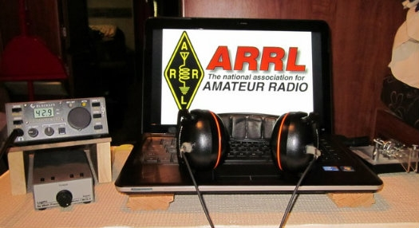**January 21**

* [Run for the Bacon QRP Contest](http://qrpcontest.com/pigrun/)

**January 23**

* [SKCC Sprint](http://www.skccgroup.com/operating_activities/weekday_sprint/)
* [NAQCC CW Sprint](http://naqcc.info/sprint/sprint201903.html)
* [QRP Fox Hunt](http://www.qrpfoxhunt.org/winter_rules.htm)
* [Phone Fray](http://www.perluma.com/Phone_Fray_Contest_Rules.pdf)
* [CWops Mini-CWT Test](https://cwops.org/cwops-tests/)

An expanded, downloadable version of *QST'*s’[Contest Corral](http://www.arrl.org/contest-calendar) is available as a PDF. Check the sponsor's’Web site for information on operating time restrictions and other instructions.

***Winter Field Day 2019 is January 26 – 27***

The Winter Field Day Association (WFDA) sponsors the 2019 running of [**Winter Field Day**](https://www.winterfieldday.com/), **January 26 – 27**. WFDA says that the ability to conduct emergency communication in a winter environment is just as important as the preparation and practice that take place each summer, but with some additional unique operational concerns.

“We believe that maintaining your operational skills should not be limited to fair-weather scenarios,” WFDA said in announcing this year’s event. “The addition of Winter Field Day will enhance those already important skills of those that who generously volunteer their time and equipment to these organizations. Preparedness is the key to a professional and timely response during any event, and this is what local and state authorities are expecting when they reach out to emergency service groups that offer their services.”

Members of the Warren County (NY) Radio Club ([**WCARC**](http://w2wcr.org/)) will activate Maxim Memorial Station W1AW during 2019 Winter Field Day. Club members will work a rotating 24-hour operating schedule to ensure the most band/mode coverage. This event is open to all radio amateurs.

#########

***Countdown to Third Annual AM Rally Has Begun***

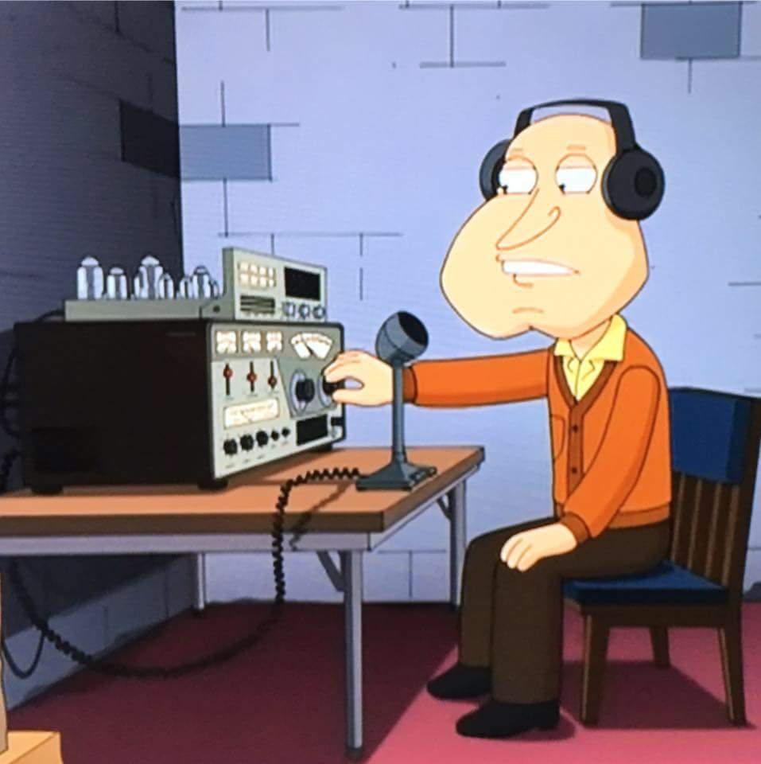The third annual [AM Rally](http://www.amrally.com/) is on the near horizon — is only about 4 weeks away — getting under way at 0000 UTC on **February 2** and continuing until 0700 UTC on February 4. The event aims to encourage the use of AM on 160, 80, 40, 20, 15, 10, and 6 meters while highlighting the various types of AM equipment in use today.

The event is open to any and all radio amateurs running AM using any type of radio equipment — modern, vintage, tube, solid-state, software-defined, military, boat anchor, broadcast, homebrew, or commercial.

TOP^

“We’re very excited about the upcoming AM Rally in February, given its growth over the past 2 years and the positive comments we’ve received,” said Clark Burgard, N1BCG, who is spearheading the event with Steve Cloutier, WA1QIX, and Brian Kress, KB3WFV.

“In particular, it’s great to hear how so many ops are giving this classic mode a try, many for the first time, and of the help offered to them by those who have mastered the technology.”

For many, if not most, radio amateurs getting on AM is as simple as pressing the AM mode button on the front panel. Numerous transceivers in use today offer AM capability. A lot of hams enjoy restoring and using vintage Amateur Radio equipment, which typically means a separate transmitter and receiver. Until SSB subsumed it on the ham bands, AM was the primary HF voice mode. The change to SSB did not happen without some pushback, however.

Today, a group of dedicated radio amateurs keeps the flame alive, getting on AM frequently, and for many of them, AM is their primary operating mode. The AM Rally gives the uninitiated a chance to dip a toe into the pool, so to speak.

The [event website](http://www.amrally.com/) has complete AM Rally details,  [Contact](mailto:n1bcg@internetwork.com)information, award categories, logging, and tips on how to get the most out of your station equipment in AM mode. Contact Burgard for more information.

The event is sponsored by Radio Engineering Associates (REA), in cooperation with ARRL, which supports all modes of Amateur Radio operation. W1AW will play a leading role in the event, as it has for the past two years.

Certificates will be awarded to stations scoring the highest number of points in each of the five power classes, regardless of rig category, both for most contacts and most states/provinces.

“All it takes is a turn, push, or click to participate!” Burgard said. There’s also plenty of time to dig out and dust off that old AM-capable tube gear sitting in your attic or basement.

#########

***2019 Ohio NVIS Day***

Hey everyone, Stan, N8BHL has let me know that the date for NVIS Day is scheduled for **Saturday, April 27th**. Are you ready? Start your planning now!

Like years past, we are planning on having the operation run from 10 – 4 EDT. Take a lunch break, enjoy each other’s company. Transmit power should stay at 100 watts for accurate signal comparison. You may operate anywhere, home, club, portable.   
  
Want to know more about what NVIS is? <http://arrl-ohio.org/SEC/nvis.html> Learn all about Near Vertical Incident Scattering and how you can easily put up a NVIS antenna and participate in this great exercise.

#########

TOP^

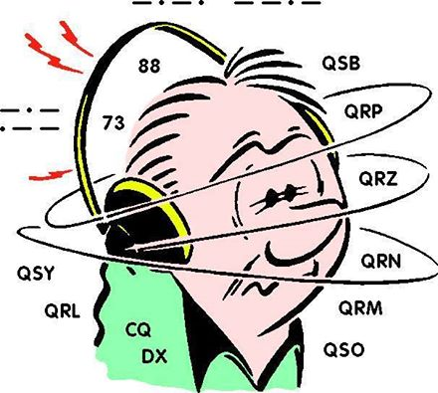***DX This Week***

*(from Bill, AJ8B)*

Bill AJ8B ([aj8b@arrl.net](mailto:aj8b@arrl.net), @AJ8B, [www.aj8b.com](http://www.aj8b.com) or [www.swodxa.org](http://www.swodxa.org) )

Uncle Frank and I had a rather heated RTTY discussion last week on 20 meters. The disagreement centered around the best way for an aspiring DXer to get to the next level. Basically, I am an advocate of learning from others. Frank is more inclined to read and research. My argument was that there are many hams who are more than willing to help other hams, or to “Elmer” them. In fact, I know of an entire club of them and the only real cost is $20/year! You can’t get a better return on your money. Frank is correct 90% of the time, but I think I have him on this one. We are very lucky in our section to have access to some of the top notch DXers in the world. The North Coast Contest Club, the Northern Ohio DX Association, and the SouthWest Ohio DX association have some of the best DXers anywhere. Take advantage of that. Join the clubs, go through the websites to view information and articles, and attend events. You might also consider attending the DXDinner® on the Friday night of Hamvention® ([www.swodxaevents.org](http://www.swodxaevents.org)), the DX Forum on Saturday of Hamvention (<https://hamvention.org/event-details/forums/> ) or the inaugural W8 DX Convention in June. ([www.w8dxcc.com](http://www.w8dxcc.com)) I would also recommend a trip to DXEngineering in Akron.

(<https://www.dxengineering.com/>) You can talk to hams there who can tell you about all the rigs, antennas, and accessories.

I came across the article below from propagation expert, K9LA. ([www.k9la.us](http://www.k9la.us)) I know you will enjoy this. Thanks to Carl for his permission to reprint.

A Look at Generalities and Unusual Observations

* Carl Luetzelschwab K9LA

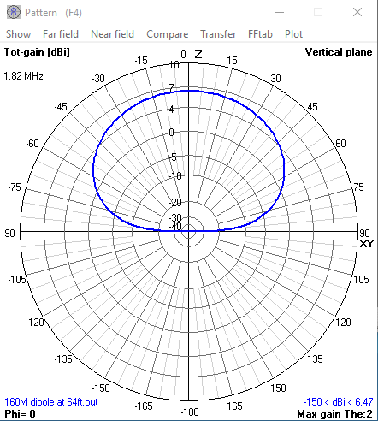I occasionally see people making general statements that are true most of the time and therefore are good advice, and others commenting on what appears to be an unusual observation. In many cases I can think of an exception to the general statement or an explanation for an unusual observation. Let’s look at three recent examples – two in the “general statement” category and one in the “unusual observation” category.

General statement #1 - *–A horizontally polarized receiving antenna only 64 feet high on 160 meters will have exceptionally poor performance at the angles you need for DX QSOs.”*

This statement should be well-recognized. Figure 1 shows the elevation pattern of a 160-Meter dipole cut for 1.82 MHz over average ground (ε = 13, σ = .005 Siemens) at 64 feet.

Figure 1- 160-Meter Horizontal Dipole at 64 Feet

This dipole has much of its radiation straight up – not at the lower elevation angles good for DX [note 1]. Note that in this 4nec2 plot that 0o is straight up and 90o is on the horizon – this is backwards from our normal plots – normally 0o is on the horizon and overhead is 90o.

TOP^

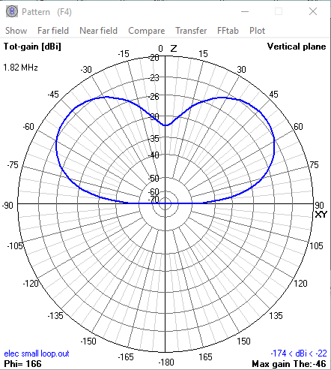Do all horizontally polarized 160-Meter antennas at 64 feet perform the same with radiation mostly straight up? Most do, but I can think of one exception – an electrically small loop mounted horizontally. Here’s the elevation plot at 1.82 MHz of a small loop (10 feet by 14 feet – 48 feet total perimeter, which is 0.089 wavelengths on 160-Meters) mounted horizontally at 64 feet over average ground.

The elevation plot for this small loop at a low height is quite different from the elevation plot for the dipole at low height. The reason for this is the electrically small loop has maximum radiation in the plane of the loop and minimum radiation perpendicular to the plane of the loop. Thus, when mounted horizontally, the electrically small loop has minimum radiation towards the ground.

Figure 2- Small Loop Mounted Horizontally at 64 Feet on 160-Meters

An electrically small loop usually isn’t used in transmit (it can be if you pay special attention to losses), but it certainly can be used in receive. In fact, a Waller Flag antenna uses two such small loops appropriately spaced and fed 180o out-of-phase. The resultant pattern is essentially unidirectional, and thus it makes a good receive antenna that improves SNR (signal-to-noise ratio).

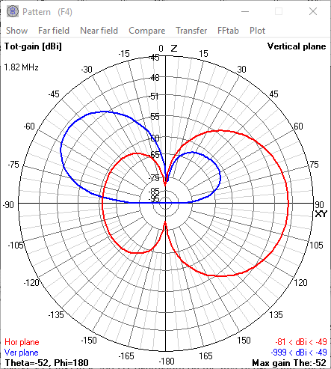

The following azimuth and elevation plots on 1.82 MHz are for a Waller Flag using 14 foot by 26-foot loops on a 42-foot boom and mounted horizontally at 64 feet over average ground.

The azimuth plot (red) shows decent front-to-back and good side nulls. This suggests a decent RDF (receiving directivity factor) – the model says 11.6 dB.

The elevation plot (blue) shows maximum radiation is received at an elevation angle of around 35-40o – not bad for DX with an antenna at only 64 feet high on 160-Meters. At an elevation angle of 15o, the response is 6 dB down.

Figure 3- Waller Flag Mounted Horizontally at 64 Feet

The main issue with a Waller Flag is the low gain due to the loops being so small. For the above Waller Flag, the maximum gain is -49 dBi. A very well-designed preamp is needed for this system. Moving the Waller Flag up to 150 feet would increase the gain to -43 dBi, and the maximum radiation would be at an elevation angle of around 30-35o. Because of the characteristics of an electrically small loop mounted horizontally, the performance of this antenna is somewhat height independent.

General statement #2

*“If your inverted L is any good at all it will suck as a receiving antenna.”*

I can believe this general statement if you live in a residential noise environment. Then you would likely need a receive antenna that improves SNR.

TOP^

But if you live in a quiet noise environment, then I think that statement is questionable. For example, I achieved DXCC on 160-Meters using my inverted-L (60 feet up, 65 feet sloping down, three elevated radials). On a typical winter night, my noise level is around -103 dBm (S3 on my OMNI VI Plus) in a 500 Hz bandwidth on the inverted-L. Sure, there were many stations that I couldn’t hear, which means many times I had to wait for a good night propagation-wise.

If you have patience and live in a relatively quiet noise environment, you can work many DXCC entities on 160-Meters with an inverted-L.

Unusual observation

An Oregon station reported on PacketCluster hearing EA3JE on 3793.8 KHz at 0013 UTC on December 17, 2018 and commented *“coming in from Barcelona during the day!”*

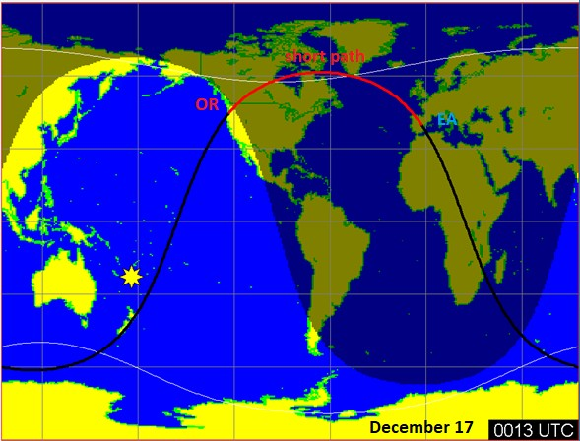The following map from W6ELprop shows this path between Oregon (OR) and Spain (EA) via the short path (the red line).

Yes, the Oregon station is in daylight – but it’s only 17 minutes before his sunset at 0030 UTC.

What’s NOT important is where you are in relation to the dark ionosphere. What IS important is where your RF encounters the ionosphere. Since this report was on 75-Meters, absorption is the critical parameter (not the MUF). Thus, where the ionosphere encounters the D region is critical.

Assuming a 15-degree elevation angle and assuming the D region is around 75 km high, this means the RF will encounter the D region about 300 km from the Oregon station. That puts it just east of the terminator in the dark ionosphere.

Of course, the terminator is not an abrupt change from daylight to darkness as shown in the above figure. But it shows that the encounter point with the ionosphere is more in “darkness” than in “daylight”.

A related daylight issue is a path across the higher latitudes in the winter (for example, a path from K9LA in northeast Indiana to Europe in the late afternoon in winter when there is still much daylight). With the Sun in the southern hemisphere, the amount of absorption incurred is significantly less than along the same path as in the summer. Thus, it’s possible to have much daylight along a higher latitude path in the winter.

Of course, the band also comes into play – 40-Meters can withstand more absorption (more daylight) than 80-Meters, which can withstand more absorption than 160-Meters.

For more details on these daylight issues on the low bands, please take a look at the January 2017 Monthly Feature at <https://k9la.us/Jan17_Sunrise_Sunset_and_Daylight_in_Relation_to_Low_Band_Propagation.pdf>.

Notes

1. Note that I said “much of its radiation is straight up”. I didn’t say “all of its radiation is straight up”. You can still work lots of DX on 160-Meters with a low dipole. You won’t be first in the pile-ups, and you’ll likely need an amplifier – but if that’s all you can put up, go for it.

TOP^

From our friend at the DailyDX and the WeeklyDX, (<http://www.dailydx.com/> ) Bernie has this to report:

**V8 - –runei Darussalam** - –D“ing on the Edge: The Thrill of 160 Meters" ”uthor K1ZM, Jeff   
Briggs, updates us on the upcoming February 2019 "V“4SAA operation is coming together nicely".”The team is now planning to operate from two separate locations, some 15 kilometers apart, with the possibility of a third location on top of a hotel in Tutong.  In addition the team "h“s grown significantly" ”ith "s“me 26 operators" ”hich includes "s“me additional 9M6 and V8 team mates".”VE7NY, VK3FN, VK3GK and a second LZ op will also be joining the team. This week K1LZ, Krassy is shipping a container to Bandar Seri Begawan, the capital of Brunei.  
  
**V2 - –ntigua and Barbuda** - –W6RG, Randy, will be operating V25RA holiday style starting late Saturday January 19th through Monday morning January 21st. He'l’ be on SSB running QRP on 20 meters.  
  
**ZD8 - –scension Island** - –ext on his international trip WW6RG, Randy, will be arriving here on   
Tuesday January 22nd and operating ZD8RA between 0830 and 1030Z and then from 1730 to 1930Z. Again, operating QRP SSB on 20 meters. You can email him prior to January 21st to set up other band requests.  
  
**9X – Rwanda -** –nce again DXpeditioner DF2WO, Harald, has packed his 40 kilogram   
"c“se with fiberglass mast, antenna wire and equipment" ”or his upcoming, January 17, trip to Kigali. The following day, January 18th,he'l’ build his antennas and begin 9X2AW operations concentrating on 160-30 meters CW and FT8, with a preference on 60 meters (5 MHz). Joining his for this trip will be globetrotter WJ2O, Dave, who is expected to be there from January 23-30. Starting on January 30ththrough February 14th Harald will be traveling with his family.

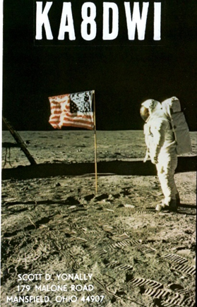***A******RLD003 DX news***

This week's bulletin was made possible with information provided by NE8Z, The Daily DX, the OPDX Bulletin, 425 DX News, DXNL, Contest Corral from QST and the ARRL Contest Calendar and WA7BNM web sites.

Thanks to all.

**MALDIVES, 8Q.** Andy, UT4UEP is QRV as 8Q7UA from Ukulhas Island, IOTA AS-013, until January 23. Activity is on 40, 30 and 20 meters using CW and FT8. QSL to home call.

**SIERRA LEONE, 9L.** A large group of operators are QRV as 9LY1JM from Banana Island, IOTA AF-037, until January 21. Activity is on 160 to

10 meters using CW, SSB, RTTY, PSK and FT8 with four stations active. QSL via F5GSJ.

**EAST MALAYSIA, 9M6.** Saty, JE1JKL will be QRV as 9M6NA from Labuan Island, IOTA OC-133, from January 24 to 28. Activity will be mainly on 160 meters. This includes being an entry in the upcoming CQ World Wide 160 Meter CW contest. QSL via LoTW.

**RWANDA, 9X.** Harald, DF2WO is QRV as 9X2AW from Kigali until February 14. Activity is on 160 to 10 meters using CW, SSB, RTTY and FT8. QSL via M0OXO.

TOP^

**BAHAMAS, C6.** Heli, DD0VR will be QRV as C6A/DD0VR from Bahama Island, IOTA NA-001, from January 21 to February 2. Activity will be on 80 to 10 meters using CW, SSB, and various digital modes. He plans to activate other islands during this time. QSL to home call.

**CANARY ISLANDS, EA8.** Erich, HB9FIH is QRV as EA8/home call from El Hierro, IOTA AF-004, until the end of March. Activity is on the HF bands using CW, SSB, and various digital modes. QSL to home call.

ECUADOR, HC. Rick, NE8Z is QRV as HC1MD until February 7. Activity is on 40 to 6 meters using CW, SSB and FT8. He may be active portable from other HC prefixes as well. QSL via K8LJG.

**ITALY, I.** Operators S50X, S52P, S54W, S56DX, S57DX, and S59A will be QRV as IG9/home calls from Lampedusa Island, IOTA AF-019, from January 21 to 31. Activity will be holiday style on the HF bands.

QSL to home calls.

**ARUBA, P4.** Mathias, DL4MM will be QRV as P4/DL4MM from January 22 to 30. Activity will be on the HF bands with a focus on CW. He may also be active using SSB and FT8. He will be QRV as P40AA in the upcoming CQ World Wide 160 Meter CW contest. QSL to home call.

**BONAIRE, PJ4.**  Operators Norbert, DJ7JC, Heye, DJ9RR and Emil, DL8JJ will be QRV as PJ4P from January 22 to 30. Activity will be on the HF bands using CW, SSB, various digital modes, and FT8. They plan to be an entry in the upcoming CQ World Wide 160 Meter CW contest.

QSL via DJ5BWD.

**SEYCHELLES, S7.** Mike, OE6MBG is QRV as S79AA from Mahe, IOTA AF- 024, until February 2. Activity is on 160 to 10 meters, and 6 meters as conditions permit, using CW and SSB. QSL to home call.

**TUVALU, T2.** Antoine, 3D2AG is QRV as T2AR from Funafuti until January 31. Activity is on the HF bands, including 160 meters. QSL to home call. In addition, Apinelu, T2AT is QRV on the HF bands using FT8. QSL via N7SMI.

**PALAU, T8.** Nobu, JA0JHQ will be QRV as T88PB from Koror, IOTA OC-009, from January 25 to 28. This includes being an entry in the upcoming CQ World Wide 160 Meter CW contest. QSL direct to home call.

**MYANMAR, XZ.** Akio, JE2QIZ is QRV as XZ2B from Nay Pyi Taw. His license is valid for 150 days. He is permitted to operate from 15 to 1.25 meters within 20 kHz of each band edge, and using only CW.

QSL via operator's’instructions.

**CHATHAM ISLANDS, ZL7.** Nobu, JA0JHQ is QRV as ZL7/JA0JHQ until January 20. Activity is on 160 to 10 meters using CW and FT8. QSL to home call.

THIS WEEKEND ON THE RADIO. The ARRL January VHF Contest, North American SSB QSO Party, North American Collegiate SSB Championship, NCCC RTTY Sprint, QRP 80-Meter CW Fox Hunt, NCCC Sprint CW Ladder, LZ Open CW Contest, Hungarian DX Contest, RSGB AFS SSB Contest, WAB

1.8 MHz Phone/CW and Feld Hell Sprint will certainly keep contesters busy this weekend.

The Run for the Bacon QRP CW Contest is scheduled for January 21.

TOP^

The 40-Meter QRP Fox Hunt, CWops Mini-CWT Test, NAQCC CW Sprint, Phone Fray and SKCC CW Sprint are scheduled for January 23.

The Canadian National Parks on the Air, CNPOTA, operating event runs for the entire year of 2019, with special stations active from Canada's parks and historic sites.

Please see January 2019 QST, page 91, and the ARRL and WA7BNM Contest Web Sites for details.

***You’ve Got Cards – Waiting***

Hey Gang, here’s a new department for you to keep an eye on and it has already shed fruit for some of you. Yes, it’s about QSL Cards without owners. Why without owners? The card sorters have the cards waiting, but they don’t have a way to get these cards to their owners.

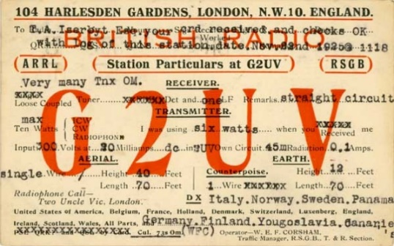

Now, if your call sign is listed here, and according to our One Question Poll this week, some of you do recognize these call signs!! Now, we just need these folks to contact their QSL Card sorter to find out how to get their cards sent to them. **Don’t send anything to them until you’ve had a chance to contact them first and find out just what you need to do.**

Here’s some folks from the **“8A”** call signs that have cards waiting..

WA8A, WW8A, WR8AA, AA8AB, K8AB, WB8ADA, K8AEC, WA8AEE, K8AF, K8AH, WD8AHR, K8AI, W8AJ, N8AJB, WB8AJR, W8AJT, W8AJU, WB8AKW, AB8AL, K8ALM, AA8AM, N8AMM, KD8AN, N8AOK, N8AP, N8AR, W8ARE, K8ARL, KE8ARL, W8ARU, K8AS, K8ASS, W8ATE, N8ATS, N8AUM, WB8AXK, W8AY, KB8AZS, K8AZT, KC8AZU, KD8AZU

Contact Dave, K3CTN, 8th area bureau “8A” letter manager at: [dbbrown624@gmail.com](mailto:dbbrown624@gmail.com)

*********************************

Here’s some folks from the**"8V”** call signs that have cards waiting…

AK8V, KG8V, KR8V, KU8V, NA8V, NC8V, NV8V, NW8V, W8VCI, KB8VCV, KE8VC, N8VFJ, W8VHO, W8VI, AA8VL, WD8VN, W8VRT, WB8VWO, N8VW, N8VY, W8VKO, WA8VA

If you know any of these folks be sure to let them know that they have cards waiting for them. Contact Glenn, AF8C, 8th area bureau "8V' letter manager at: [af8c@alumni.caltech.edu](mailto:af8c@alumni.caltech.edu)

*********************************

Here’s some folks from the**"8Q'** call signs that have cards waiting…

K8QD; KB8QGR; KC8QCT; KC8QDQ; KC8QMU; KC8QOF; KC8QOL; KC8QYE; KD8QBF; KD8QBV; KD8QDL; KD8QDP; KD8QDQ; KD8QEJ; KD8QES; KD8QQH; KD8QYE; N8QL; N8QN; N8QQ; N8QQE; N8QY; NC8Q; NK8Q; W8QAX; W8QEJ; W8QHJ; W8QK; W8QM; W8QX; W8QYU; W8QZS; WA8QNN; WB8QYA; WD8QHY; WD8QMA

TOP^

If you know any of these folks be sure to let them know that they have cards waiting for them. Contact Dave, K8DV, 8th area bureau "8Q” letter manager at: [k8dv@cinci.rr.com](mailto:k8dv@cinci.rr.com)

*********************************

Here’s some folks from the"**8T**' call signs that have cards waiting…

K8TA, N8TAH, WB8TCB, KD8TEH, AE8TF, WB8TFW, K8TGR, KD8TNC, K8TPH, KD8TVB

Here’s some folks from the"**8W**' call signs that have cards waiting…

N8WAV, KD8WAK, WB8WBN, K8WCP, K8WGA, KD8WKR, W8WLK, K8WN, WV8WVS, AB8WW, NN8W, AD8W, AG8W, WB8WY

If you know any of these folks be sure to let them know that they have cards waiting for them. Contact Peter Greene, N8WGE, 8th area bureau "8T & W” letter manager at: [transitbear@hotmail.com](mailto:transitbear@hotmail.com)

Don’t know who to contact for your cards? Here’s a link…

<http://arrl-greatlakes.org/8th_bureau.htm> Remember, it goes by your first letter of your suffix call sign.

The card sorters would also like me to remind everyone that this is the “Incoming” QSL Card Bureau. ALL “Outgoing” cards (cards that you send) go to the main card sorting area at ARRL Headquarters. Here’s a link for the details on how to do that… <http://www.arrl.org/outgoing-qsl-service>

***National News***

*(from arrl and other sources)*

**Registration is Open for QRP-ARCI “Four Days in May” 2019**

[**Registration**](http://adatab.duckdns.org/QRPARCI/registration.cfm) is open for the QRP Amateur Radio Club International (QRPARCI) “Four Days in May” (FDIM), 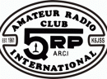Thursday – Sunday, May 16 – 19, at the Holiday Inn, Fairborn, Ohio. The annual FDIM event for QRP enthusiasts and builders takes place in conjunction with Hamvention®.

Event sign-in begins the evening of Wednesday, May 15. Most of Thursday will be taken up with seminars, “meet the speakers” opportunities, and an open room for casual show and tell.

Most of Friday and Saturday are open to attend the Hamvention and visit the QRP-ARCI Toy Store. Friday evening activities typically include “show and tell,” vendor displays, and a homebrew contest.

Saturday evening features social activities and a banquet, while Sunday is open for Hamvention. Attendees are invited to display their QRP-related projects at FDIM. One evening will feature vendors offering QRP-related products, with some offering FDIM discounts. Dress is casual for all events.

Reservations and group room rates for FDIM will be available after January 1 through the [**QRP-ARCI website**](http://www.qrparci.org/). For more information, [**contact**](mailto:fdim@qrparci.org) FDIM 2019 Chair Norm Schklar, WA4ZXV.

#########

TOP^

***ARRL Board of Directors’ Annual Meeting to Welcome New Members***

Newly elected ARRL Directors from four Divisions and one new Vice Director will be welcomed to the conference table when the ARRL Board of Directors meets for its Annual Meeting on January 18 – 19 in Windsor, Connecticut.

New to the Board are Hudson Division Director Ria Jairam, N2RJ, of Sussex, New Jersey, who edged out incumbent Mike Lisenco, N2YBB, in last fall’s balloting. The New England Division also will have new representation, as Fred Hopengarten, K1VR, of Lincoln, Massachusetts, succeeds Director Tom Frenaye, K1KI, who lost his re-election bid. Hopengarten, an attorney, is the author of *Antenna Zoning for the Radio Amateur*and has served as an ARRL Volunteer Counsel.

In the Northwestern Division, Mike Ritz, W7VO, of Scappoose, Oregon, has succeeded Jim Pace, K7CEX, who opted not to seek a new term after serving since 2014. New Northwestern Division Vice Director — and past Eastern Washington Section Manager — Mark Tharp, KB7HDX, is another fresh face among the “back benchers.” He topped a three-candidate field to succeed Bonnie Altus, AB7ZQ. In the Roanoke Division, George “Bud” Hippisley, W2RU, of Penhook, Virginia, is the new Director after outpolling Director Dr. Jim Boehner, N2ZZ, in last fall’s voting. Hippisley served as ARRL Atlantic Division Vice Director from 1982 until 1985 and is the co-author of *Practical Antenna Handbook.* He was a 2010 recipient of the ARRL George Hart Distinguished Service Award.

TOP^

Also attending his first Board meeting will be Rocky Mountain Division Vice Director Robert Wareham, N0ESQ, of Highlands Ranch, Colorado. He was appointed last November to serve the remaining term of Jeff Ryan, K0RM, who assumed the position of Rocky Mountain Director upon the resignation of Dwayne Allen, WY7FD.

New Director/Vice Director orientation was held on January 16 at ARRL Headquarters. The LoTW, Administration & Finance, and Programs & Services committees also met this week at Headquarters.

The Board will elect ARRL officers, a new secretary, a new Executive Committee, and ARRL Foundation Directors. It will receive and consider reports from CEO Howard Michel, WB2ITX; Treasurer Rick Niswander, K7GM, and Chief Financial Officer Diane Middleton, W2DLM.

According to the [**published agenda**](http://www.arrl.org/files/file/201920of%20Directors/0120201920Board20(1).pdf), the Board will hear reports from the Executive, Administration & Finance, and Programs & Services committees. The Board also will hear proposals for amendments to the *Articles of Association and Bylaws*.

In addition, the Board will review recommendations contained in various other committee reports, which could include consideration of an ARES Strategic Plan.

In addition, the Board will review recommendations contained in various other committee reports.

***Ohio Section ARES Conference Date Announced***

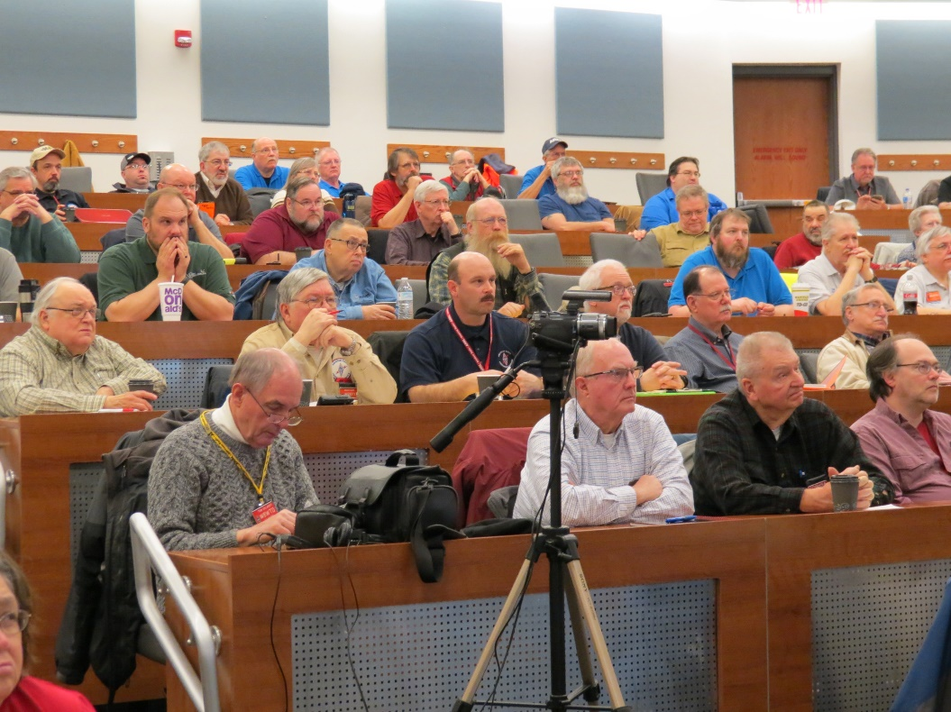I know a lot of you have been waiting patiently for this announcement. Yes, we have set a date for the Ohio Section ARES Conference… It’s going to be held on **April 6th** at Marion Technical College / OSU Marion Campus. So make sure to mark you calendars for this date. Also, don’t forget to “sign up” for this event in ARES Connect as well!

Stan is working diligently on the agenda getting great forums arranged and it’s sure to be a really great conference. There’s loads of information for those interested in any part of Ohio’s ARES program.

This is an all-day adventure, but we are in a real college setting with all the amenities that you would expect in a first-class campus. Electric outlets are easily accessible for those bringing laptops and such. WiFi is available and the seats are very comfortable.

And… I’ll have some great Give-A-Ways to pass out as well.

Lunch is on you, but the campus is close to many popular fast-food and sit down restaurants. You can even bring your own and eat right on campus if you wish.

TOP^

Certificates for your participation at this conference will be available, so you’ll get some wallpaper suitable for framing to take home with you as well! Now how can you beat that.

More details about what the agenda and advance registration signup will be forth coming.

***Weather Underground and Ham Weather Stations***

[](http://arrl-ohio.org/wus.html)

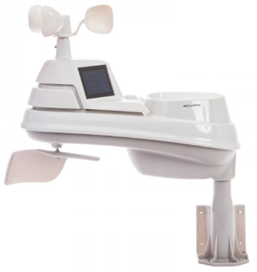Have you visited the webpage to see all the Weather Underground stations yet? It’s really fun to see just how much the weather varies across the state and this gives you access to each individual station very quickly and easily.

It seems that our list of stations is growing every week, and again this week is no exception. I’ve added another station to the list!

Thanks to **Wayne, KD8WXP** for sending his link to the – **Liberty Township - Hamilton** weather station. Here’s a link to all of those listed…

<http://arrl-ohio.org/wus.html>

We’re starting to get a really good collection of stations all over. I know that there is a lot more than what we have listed. How’s about sharing your weather information with all of us! All that you need to do is send me your Weather Underground ID and your call sign and I’ll take it from there. Sent it to: [n8sy@n8sy.com](mailto:n8sy@n8sy.com)

***This & That’s***

***Snowmageddin Weekend***

Did you check-in to Ohio’s first “Snow Net” on DMR this past weekend? It was a blast and let me say that Stan, N8BHL did an excellent job of keeping up with all the check-in’s and reports. Believe you me, there were a number of times that the reports of really bad snow falling kept Stan hopping.

Yes, we did utilize the state of Ohio’s WebEOC to make those reports official. I know that several of the EMA Directors were busy looking at our reports as they called me to tell me that this is what they’ve been needing for quite some time!.

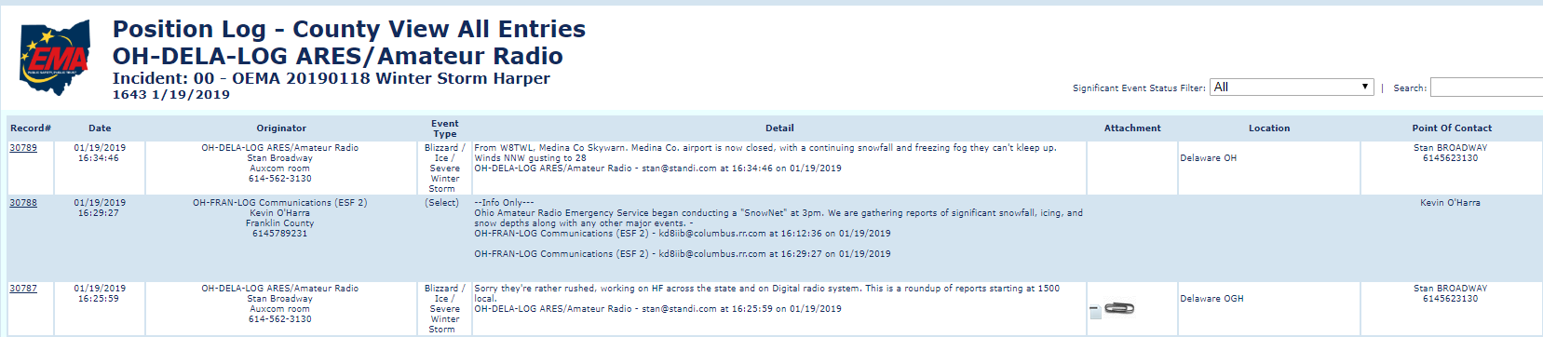

***#########***

TOP^

***TYT has some new CPS and Firmware Updates***

*(from Greg, WD9FTZ)*

On or about January 7, 2019, TYT posted new firmware and CPS on their site for the TYT MD-9600, 2017, UV380/390, and 380/390. Here’s the link: <http://www.tyt888.com/?mod=download>

For the first couple of days after posting the files, the TYT site linked the downloads to a dead site, but it appears that as of or around today, the links are now active. It also needs to be noted that there doesn’t seem to be any definitive information as to what the new firmware and CPS actually update or address.

***Final.. Final..***

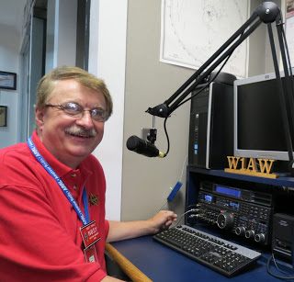**Scott Yonally, N8SY - SM**

[n8sy@n8sy.com](mailto:n8sy@n8sy.com)

Hey Gang...

Wow, the past weekend was miserable! Snow, blowing and drifting snow and ice. What a way to inaugurate the very first Statewide Ohio ARES “Snow Net” on DMR! It was a huge success with Stan at Net Control for the biggest part of the event. Did you check in with your snow report? Stan was a really busy boy not only listing on the statewide Talk Group, but he also had an ear on the HF radio too. Yup, he had 75-meters up and runny for most of the net as well. But we did prove that one of the tools in the toolbox works really well, and that tool is DMR. Stan had reports from just about every point on the Ohio map. And, it was all Q5 copy! No hash, and fading in and out, just a clear and precise FM signals! Now, that’s the way to have a net for sure.

Funny how the Ohio ARES “Snow Net” just happened right after I had a great presentation with the North Central Sector of the EMAO on Friday! Most of those present were the EMA Directors that were directly involved with this storm. I didn’t know it then, but my demonstration of my little portable OpenSpot would show them just how we can provide them with reliable communications even without the use of repeaters and big fancy HF rigs. I know that a number of the stations that checked in over the weekend were on similar devices, and it worked flawlessly.

Yes, DMR is just one of the many tools in our toolbox, but it’s one heck of a good tool that we have been needing for many, many years.

Events like this, where it involves almost the entire state is where DMR, System Fusion, and D-Star can really make the difference for us. We are so blessed to also have the additional ability to be able to connect these other digital modes to DMR now, giving us the best of all 3 of the digital worlds.

TOP^

This just makes a good system even better! Thanks to all that took the time to check-in and give your “Snow Net” reports. You can take satisfaction in knowing that YOU made a difference this past weekend.

Oh, there is one other thing that I need to mention here. As the pictorial in the article shows, Stan was also busy entering the most critical information into the states WebEOC system. This give every state and county official some additional weather information that they didn’t have through their regular channels. Another plus for us!

Shack redesign… On hold awaiting more time to sit and re-think how I want the shack to be. I’ll get there, but it will be a while.

Oh well, nuff on that subject, let’s turn the band selector to 20-meters and see who’s around tonight!

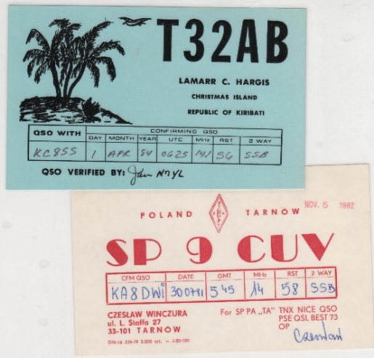Hey Gang, have you taken a good hard look at the article about finding those persons that have QSL cards waiting to be delivered to them? I know that I’ve been harping on this for a number of weeks now, but I did want you to know that unless I get a new list of call signs to display this will be the last week this article will appear until I do get more to list.

Please, take a minute or two and go back up and look very hard at all of those call signs. If you recognize anyone on that list, please let them know right away that their card sorter has been waiting patiently for them to respond. My money is on that you’ll find a call sign or two there that you recognize. If you do see someone’s call sign that you know, PLEASE, do him/her a huge favor and let them know about this article.

Moving over to 80-meters, let’s see what’s happening there... ARES Connect registrations are moving in a positive direction, but with 60% of you not registered yet is not what I wanted to hear at this stage. Please, get registered. Don’t know how? Ask me. I’ll get you going in just a few minutes. It’s painless and you could just be the next recipient of a prize for having the most hours logged in the system.

Like you, I haven’t heard much as to what happened at the ARRL Board Meeting this past weekend. One person stated to me that “No news is good news..” I do want to be positive and say that he’s right! So, with that in mind, why not get those all-important ICS courses in now! Hey, it’s miserable outside and you can’t mow the lawn with 25 inches of snow sitting on top, so there’s really no good reason for you not to get them done.

Whelp… That’s going to do it for this time around. Stay safe, and most of all… have FUN!!

***Scott, N8SY***



***Back Issues of the PostScript and Ohio Section Journal (OSJ)***

Hey, did you know that PostScript and Ohio Section Journal (OSJ) are archived on the website? You can go back and look at any edition simply by clicking:

<http://arrl-ohio.org/news/index.html>

TOP^

***Chit – Chat, and All That!***

Do you know someone that’s not getting these Newsletters? Please, forward a copy of this Newsletter over to them and have them “[Opt-In](http://arrl-ohio.org/forwarder/forwarding.html)” to start receiving them. Heck, just have them send me an email [n8sy@n8sy.com](mailto:n8sy@n8sy.com) and I’ll get them added to the Ohio Section Emailing list. We now have over 7,000 folks receiving these newsletters weekly. Quite impressive, I’d say!



I urge all of you to make sure that everyone, regardless of whether they are a League member or not, get signed up to receive these weekly Newsletters. You can always “[Opt-Out](http://arrl-ohio.org/forwarder/forwarding.html)” at any time if you feel this is not what you were expecting. It’s fun and very informative.

Hey, did you know that PostScript and Ohio Section Journal (OSJ) are archived on the website? You can go back and look at any edition simply by clicking:

<http://arrl-ohio.org/news/index.html>

The pictures throughout this newsletter are from various sources. Take a good look at them, you just might be in one of those pictures! “SMILE…!!!!!”

Got questions, concerns or would just like to sit and chat awhile? Heck, I’ll even buy the coffee!! Give me a call at (419) 512-4445 or email me at: [n8sy@n8sy.com](mailto:n8sy@n8sy.com)

TOP^

*The Ohio Section Journal (OSJ) is produced as a comprehensive look at all the programs within the Ohio Section. I sincerely hope that you have enjoyed this edition of the OSJ,* *and will encourage your friends to join with you in receiving the latest news and information about the Ohio Section, and from around the world!*