***[](http://arrl-ohio.org)*** ***President’s Day***

***Edition***

|  |  |
| --- | --- |
| **🡪** From the Technical Coordinator | **🡪** From the Section Emergency Coordinator |
| **🡪** From the Affiliated Club Coordinator | **🡪** From the Public Information Coordinator |
| **🡪** From the Section Traffic Manager | **🡪** Out and About |
| **🡪** From the Section Youth Coordinator | **🡪** From the Official Observer Coordinator |
| **🡪** From the State Government Liaison | **🡪** ARES Training Update |
| **🡪**  Handbook Give Away | **🡪** Club Corner |
| **🡪**  ARES Connect | **🡪**  DX This Week |
| **🡪** You’ve Got Cards – Waiting | **🡪**  National News |
| **🡪**  Final.. Final.. | |

***From the Technical Coordinator***

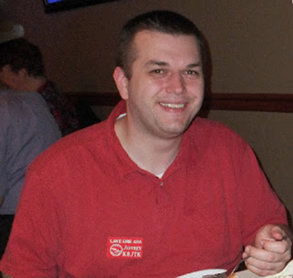***Jeff Kopcak – K8JTK TC***

[k8jtk@arrl.net](mailto:k8jtk@arrl.net)

Hey gang,

A couple months ago, I received a question regarding digital mode transmissions. This ham was using Fldigi and wondered about “strange” transmissions at the start of a BPSK-63 transmission. BPSK-31 looked OK.

These tones are known as RSID, **R**eed **S**olomon **ID**entifier, designed by Patrick Lindecker, F6CTE. RSID tones are codes used to automatically identify digital signals and often precede a digital transmission. These are a burst of tones lasting 1.4 seconds with a bandwidth of 172 Hz. They are robust being decoded down to -16 dB, which is better than most digital modes. According to the [W1HKJ documentation](http://www.w1hkj.com/RSID_description.html) for Fldigi, programs that support RSID are:

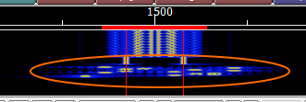

Strange tones (circled in orange) on the Fldigi waterfall

* PocketDigi, Vojtech, OK1IAK
* FDMDV, Cesco, HB9TLK
* DM780, Simon, HB9DRV – part of Ham Radio Deluxe
* fldigi, Dave, W1HKJ
* Multipsk, Patrick, F6CTE

The documentation link has a table of all RSID codes. Not all variations of baud, tones, and bandwidth are assigned a code because RSID is limited to a total of 272 unique codes. The programs listed support RSID, not necessarily all modes assigned an RSID code. Typically, that means the program will not react to codes for which it does not support.

To detect RSID alongside the desired operating mode, digital programs will run a separate detector listening for these tones while the main detector focuses on decoding the selected mode. To receive RSID tones in Fldigi, the option on the main screen in the upper-right “RxID” needs to be green (enabled).



RX RSID enabled

The default behavior of Fldigi, I think, is a little weird. When an RSID is received, an announcement will be displayed in the receive pane (tan box). The blue clickable text takes you *back* to the previous frequency at the time the RSID was received. It does not move you to the frequency of the received RSID. An example, RSID was received at 1300 Hz on the waterfall. The cursor is currently on 1500.

The clickable link in the receive pane will return the cursor back to 1500. Fldigi will search for RSID in the vicinity of the cursor (about +/- 200 Hz), not across the entire waterfall.

TOP^

Useful configuration options are available in the Configure menu -> Other -> IDs. The “Searches passband” option will listen across the entire waterfall. “Notify only” will display a popup box when an RSID is received. You’ll have the option to click “go to” that frequency.



RSID announcement

Consequently, on the transmit side, “TxID” needs to be enabled for Fldigi to transmit RSID tones. Fldigi offers an option other programs don’t, transmit RSID at the *end* of the transmission. I don’t see much use for this as your signal is gone but someone might want to be ready for the next station in the exchange or break-in.

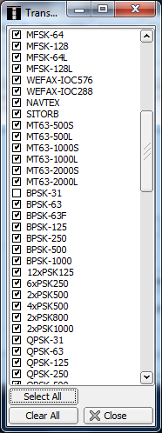

Transmission mode list



TX RSID enabled

Why wouldn’t a station see RSID tones for a (B)PSK-31 signal? Two reasons: PSK-31 is a common mode that most hams, who have operated digital on the air for any period of time, would encounter. No need to keep identifying commonly used digital signals. According to Fldigi, CW, RTTY, and BPSK-31 are the only supported ones that fall into this category. The second reason is bandwidth. Transmitting an RSID of 172 Hz will clobber more than a couple nearby PSK-31 transmissions.

On the same configuration page, click “Transmission modes.” This list indicates which modes have RSID enabled. Clearing the checkbox will not transmit RSID for that mode. For example, operating a lot of BPSK-63 and the RSID annoys you, but not for MT63-2000, uncheck BPSK-63 in the list.

Transmitting RSID helps ensure receiving stations are tuned and decoded for modes like MFSK. Modes like JT65 have RSID tones but they’re not used during normal operation and could throw off the timing of the exchange. JT65 is also operates in designated windows of the digital sub-bands. It’s probably meant more for identifying EME transmissions using JT65. The ‘strange’ transmissions are not strange at all but rather letting others know which modes are being operated.

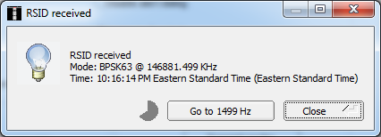

RSID notification

**WWV update**

There was a lot of FUD (that’s fear, uncertainty, and doubt) around the future of WWV back in September of last year. You can check my article in the [September edition of the OSJ](http://arrl-ohio.org/news/2018/OSJ-Sep-18.pdf) or [on my website](http://www.k8jtk.org/2018/09/17/ohio-section-journal-the-technical-coordinator-september-2018-edition/). While not yet signed, the fiscal year budget for 2019 does include funding all WWV stations. As it turns out, this year is the 100th year of operation. A member of the [Northern Colorado Amateur Radio Club](http://ncarc.net/) has met with NIST management and is planning a [special event station](http://www.arrl.org/news/wwv-100th-anniversary-special-event-operation-in-the-planning-stages) between September 28 – October 2. I’ll be anticipating that event and hope to work WWV.

Thanks for reading

**73… de Jeff – K8JTK**

TOP^

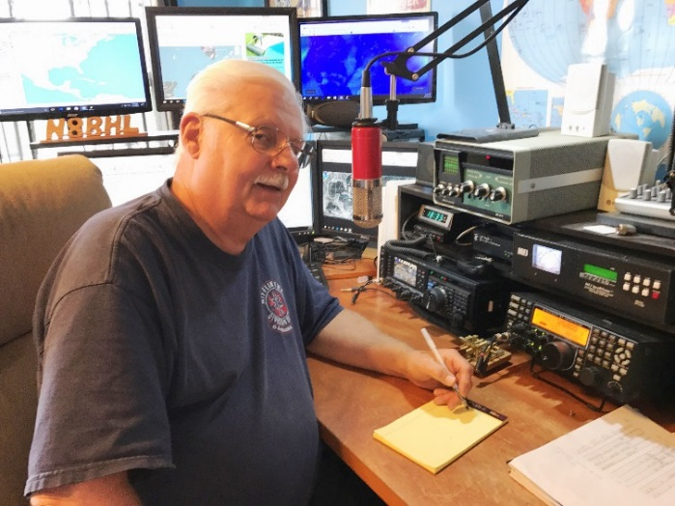***From the Section Emergency Coordinator***

***Stan Broadway, N8BHL - SEC***

[broadways@standi.com](mailto:broadways@standi.com)

Sec Report for January 2019

The Ohio ARES VHF Simplex Contest – another success!

The numbers are in for the 2019 simplex contest, and we look pretty good! We received scores from at least 40 stations representing 22 counties in Ohio. We amassed over 4400 QSO points which involved 306 county contacts. Total score was 89,741. It seemed the majority of the operators ranged from 2 to 4 hours, with several of the top scores working all 6.

Remember, the real purpose was to map our simplex range, so that in times of emergency when there are no repeaters, we have a good idea where we can contact reliably…and in the meantime, we get an idea whether we’re satisfied with our antenna setup or it needs work.

We had two rover crews this year, WW8TF and W8TCO. There are some great pictures, and a video of WW8TF’s operation:

Video: <http://ww8tf.club/ww8tf-rover-2019-video/>

Pics: <http://ww8tf.club/ww8tf-rover-2019/>

Audio MP3 file: <http://ww8tf.club/audio-recordings-from-2019-vhf-simplex-contest/>

The comments were universally positive!

* It was brief bit a good way to test my station
* I pretty much hate contests except Field Day, but I had FUN!!!
* It was great practice and fun
* I learned a lot about my station
* We’re already looking forward to next year
* I look forward to becoming a member of ARES and seeing how I can put my station to good use
* Fun way to spend a few hours of snow time

And the scores are in! Here are the top ten!

1. K8GQB Colombiana 33,760
2. WW8TF/Rov Rover 8 co’s 29,575
3. KD8VT Portage 4,625
4. N8LRG Knox 4,563
5. K8FH Lorain 3,663
6. W8EOC Medina 3,157

TOP^

1. KE8JLG Delaware 1,632
2. N8WAC/W8RF Wood 1,403
3. W8TB Medina 910
4. W9TCO/Rov Rover 684

Thanks to all who participated! It was a good time, and a good exercise for ARES!

**Ohio’s first “Snow Net”**

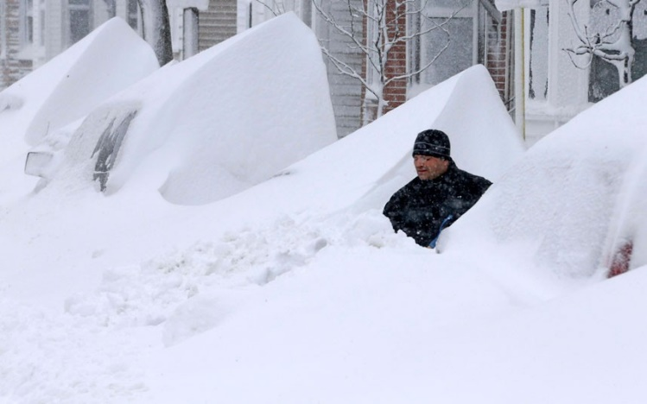The predictions were dire- with watched and warnings for potentially severe winter weather starting several days prior. To be honest, we knew it wasn’t going to be a repeat of ’78, but it sounded like it could be way above the ‘normal’ winter storm for Ohio and states further east. An unnerving request came from the Pittsburg weather office: could we update them with contact information for hams in their coverage counties? We watched the bulletins role across the web. But then… the final dire warning that we didn’t expect: Mike Bettes from the Weather Channel was in Columbus!! Oh no!

After some conversations with the Ohio EMA’s “Watch Desk” and messages from a half dozen counties that their EMA Directors had places ARES on standby, we decided to try something that would benefit Ohio counties and the state, would place amateur radio squarely in front of decision makers from a public relations standpoint, and would be an excellent exercise for us as a short-notice statewide function that would actually do some good. Perhaps the alerting email was a little soft-sell, but almost all the state jumped at the chance to participate.

Following the predictions, we aimed for a 3 PM startup which timed out about right. We designed a twofold operation- one net on 3.902 HF, and another using the DMR Ohio talk group. The DMR capabilities had never really been tested, and we didn’t anticipate losing Internet so why not try?

We were most pleased with the results. We were able to post three log sheets to the WebEOC incident that was being watched all over the state. In addition, we made separate entries for level 3 declarations and closed airports…things that were meaningful. We had over 150 reports from operators in 44 counties in the period from 3 PM to about 9:30 PM when we closed the net. By that time, most of the state had hunkered down for a winter’s night and reports had begun to slow. We considered operating Sunday morning, but the actual storm was long past Ohio, and counties pretty much know how to dig out. The storm honestly wasn’t as monstrous as had been predicted (go figure!) but it was nasty in several sections of the state.

Comments from our many EC’s were all positive- many were ready to do this again! At least five EMA Directors contacted Section Manager Scott Yonally, N8SY, to compliment hams on their reporting and remark that this was information they never had before. It was safe for us, nobody had to go out in the storm except maybe to measure snow and we as a group were able to paint an accurate picture of how the storm affected Ohio. To all who stayed by their radios- a huge thank you, and a big “Well Done!”

TOP^

**ARES Conference coming up**

We’re getting things lined up for the Ohio ARES Conference April 6 in Marion. If YOU have a topic you think we should discuss, now’s the time- send me an email with your ideas! I want this information to be well worth your time!

Get ready for NVIS Day April 27!

**73, Stan N8BHL**

**You can view all of the SEC’s monthly reports on the website..** <http://arrl-ohio.org/SEC/default.html>

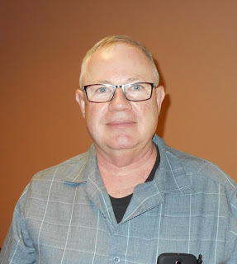***From the Affiliated Club Coordinator***

***Tom Sly, WB8LCD - ACC***

[tomsly29@gmail.com](mailto:tomsly29@gmail.com)

February 2019 ACC

In my comments last December, I noted that “Amateur Radio has a public relations problem. It’s all about our image.” What is our “Image”? Unfortunately, outside of our own circles, we are for the most part invisible. Many, especially in the younger generations, have no idea that we even exist! Older Americans may have a totally outdated image of who we are and what we do. As I pointed out in my January column, we, as members of the Amateur Radio community, are a very small percentage of the American population. We gotta start making some noise! ** Goal #1 needs to be making Amateur Radio “visible” in a positive and non-threatening way.

We need to have every club’s Public Information Officer (PIO) active in promoting the activities of his/her club – TO THE PUBLIC – not just to the local club members. (As a club PIO myself I’m as guilty as anyone and talking to myself here) Got a meeting, a VE session, a licensing class or any other activity coming up? Write up a press release and send it out to any and ALL newspapers that serve your local area. Start making a list, editor’s name, address, email address, phone number so that it’s easier to do next month. Don’t forget local radio and TV, especially any Public Broadcasting stations in your area. Get your list made and make a habit of sending them a release every time you do something that is open to the public. Don’t forget to follow up with a release about the event after it’s over! Photographs of smiling faces having fun or holding up their Certificate of Successful Completion from their Tech exam or their Upgrade exam are the types of things that get into the local papers! If you are consistent in sending them notices of everything you’re doing, pretty soon they will get the impression that you are a legitimate group with an ongoing program and will be more likely to include your releases in their publication.

Social Media is a huge area where I personally have limited knowledge. I hope to spend some of my “free- time” learning more about it.

TOP^

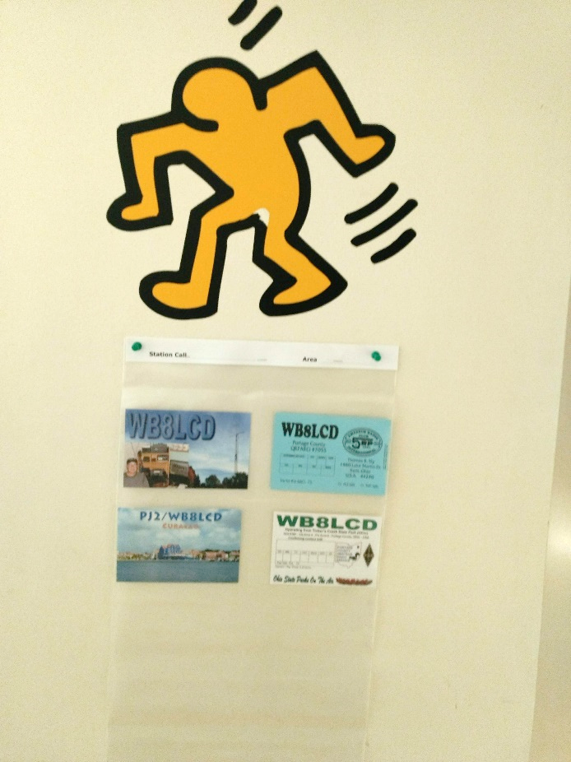But I do know that platforms such as Facebook make it very easy to get our information out in the public domain. Everything you as a club, of even you as an individual, put out that has an Amateur Radio theme is another exposure for someone in the non-ham population. Exposure is what will build our Image. **Where I said we gotta’ start making some noise, I also want to point out that we need to make noise that will stand out from the background of noise that is always out there. Exposure is what we need, but we need exposure that gets noticed. Here is where I’m asking you to “think outside of the box” and send me your ideas. For example, I eat breakfast at a local restaurant called Little City Grill in Kent. The owner has been generous to our club. I’ve talked to him about ham radio, told him about all the things I do, and he thinks it sounds pretty cool. He’s amazed at how many of his customers are also hams that I have pointed out to him. I asked him if I could put a QSL card holder on one of his walls and he said “sure”. So I put a couple of my cards in it and hung it up. This morning he said we are almost full and I’m going to have to bring in another holder! He’s told me that many of his customers have asked about it. Next up will be a flier about ham radio and our local club! It’s low key and has got some conversations started. (He would be thrilled if you would send him *your* card, and I will supply him with as many QSL holders as he needs! Help me fill his walls up!

Please, send a card to: Little City Grill – attn: Bert 802 N. Mantua St. Kent, OH 44240)

If the folks who see it, ask about it, have a conversation about it run into Amateur Radio operators or activities in other parts of their world, they will at least have an awareness, hopefully in a positive light. Maybe even enough to think to themselves: Hey, that might be fun! Amateur Radio did not slip into obscurity overnight. It happened over several decades. Because of our small numbers in relation to the total population, it may take us decades of positive promotion. That promotion will need to be intentional and it will need to be something that stands out and captures the attention of the general public over all the other “stuff” that they come into contact with daily.

After last month’s Section Journal came out, I received an email from David Kazdan – AD8Y. David is the faculty advisor for the Case Amateur Radio Club – W8EDU. Dave tells me that there are about 180 College Amateur Radio Clubs licensed, but today, very few of them are active. Perhaps this is an area where local clubs could get involved with the clubs at their local colleges and encourage their participation and/or help with making sure they have an operating station for their students. By the way, Case has a HamSCI Program on campus at CWRU on March 22 & 23. Check out the HamSCI website at www.hamsci.org and also the W8EDU website at [www.w8edu.wordpress.com](http://www.w8edu.wordpress.com). Both have lots of interesting information!

I once had a conversation with someone whose opinion I respect, who told me that the problem with bringing younger people into Amateur Radio, was that in their middle teens through maybe their 20’s, they have too many other things that pull them away from Amateur Radio.

TOP^

(His words were that teenage boys get too attracted to the smell of perfume and gasoline and loose interest in radio.) Perhaps Dave is right, in that if we supported college stations and clubs, it might help some younger hams remain in the hobby once they get out of High School.

[Click Here](http://r20.rs6.net/tn.jsp?f=001rgzvUrDYy-mMQHrYvQuc6zdWlTVs80yzG0DKm3lmjLALBhYmPkKFdtGvR0CwSDkGdNZguLomKc9Rt0boGR1w41RFer8IolrlpS_QFgNhh6ZFYOwiEl8Hd-d6lWF-d3VkhjeTFUeAsEICP95NjWWqICdvZkzy8DHh_AYcHx3frxhf7-GXI1Q0lTTc89kWqE1BJnqmCxx8XfU=&c=t8gAdwWgm7vx3PoyD6Usgqrf5BWNXNwDLZgcy_Po4aJN-81G4Pxveg==&ch=jQLFku9jD9cEZMJEC_MtvqyA_gJRf6eDFyKAfRiiANfOySKx6xevzA==) for a flier for the PCARS March meeting, featuring Carole Perry – WA2MGP. I hope that you can make it out – we’ve got plenty of room. This meeting is also open to non-ham educators to expose them to all of the benefits a Ham Radio program at their school could have for their students. Please, help us spread the word!

Although I’ve been off to a slow start in travelling to visit you all, it’s now starting to fill in on my calendar. I was out to visit NOARS in January. I was not on their agenda, but I did have a Special Service Club certificate to present to them. It was a fun and interesting evening and I enjoyed their hospitality very much!

Thank you. On Wednesday February 20 I’ll be with the Canton ARC, looking for a good time there. I’m hoping that in the next 12-36 months I get the chance to visit with every club in the OH Section.

That’s it for now. Let me know what’s on your mind. [tomsly29@gmail.com](mailto:tomsly29@gmail.com)

**73, Tom WB8LCD**

***From the Public Information Coordinator***

***John Ross, KD8IDJ - PIC***

[john.ross3@worldnet.att.net](mailto:john.ross3@worldnet.att.net)

**FROM THE PIC**

**2019 NEWSLETTER CONTEST UPDATE**

The BIG NEWS is the 2019 Ohio Section Newsletter Contest is off to a great start. We now have more entries than this time last year and every day more are arriving…all pretty good stuff!!

I am continually amazed at the amount of work and time our editors and writers devote to the newsletters. Literally, they are cranking out stories, tips and information that every ham can use. I’ve said this before, but the reason we are the best is because our troop of newsletter writers keeps us informed and entertained!

Remember, to make sure your newsletter is in the mix you’ll need to submit two copies…from different months. If you’re newsletter is on-line…just drop me a note when it’s ready and a good electronic link. I’ll bookmark it on my laptop so the judges can see your work in t’s natural surrounding!!!

The winners will be recognized at the Voice of Aladdin Hamfest in Columbus on August 3rd this year.

TOP^



**THE FIVE (or SIX) W’s…AND OTHER LETTERS OF THE JOURNALIST’s ALPHABET**

Every journalist, editor, columnist, writer, author…everyone who has ever written something…as heard of the 5 W’s…Who, What, When, Where and Why. Those five pillars of journalism have been around since the beginning of time and the printed word.

But the world has changed…writing and the way we communicate has changed, rapidly, and the 5 W’s have now grown….to 15 OTHER letters of the journalist’s alphabet!!!  WOW!...which, by the way, is one of the new “W’s “ in the sea of the most important words and processes we use every day.

So, the new OFFIICAL breakdown looks like this:

1.Who…pretty self-explanatory…who is the story about or who does it affect…and WHO is telling this story.

2.What…what is the story about…or not about…what’s being left out.

3.When…when did it all happen or when will it happen?

4.Where…where did it happen or will happen?

5.Why…is it happening ?

Now for the new stuff:

6. Would… it really be possible?

7. Will…it cause unnecessary panic?

8. What IF …this is a lie?

9. Is…it true? Is this made up?

10..Are…are there any reasons I shouldn’t write about this?

11. Could…this really happen?

12. Has… some already written this?

13. How…much is one being paid to tell this story?

14. Does…everyone already know?

15. WOW…what a lot of work!

The days of banging out a story are over. You need to be a “thinking” journalist….exploring all of the possibilities and the routes your stories may take. Not only are you writing…you driving the story to its ultimate destination…or destruction!

There are two more words that you need to remember as you write…FACT ERROR. It’s Journalism 101. If ANY THING in your story is incorrect the WHOLE story is wrong. Trust me…it’s the first thing I learned…and the first thing I failed in journalism. I will never forget, and I hope it has made a better writer.

Good Luck!!

TOP^

**GREEN EGGS AND (H)AMATEUR RADIO**

Will all apologies to Dr. Seuss and to every other poet on the planet …here is the epitaph for my tombstone. It may take more granite or marble but it’s stone cold worth it!!

I am a ham I am

Who operates with care.

I am a ham I am

When I am on the air.

I am a ham I am

With legal power and height.

I am a ham I am

And will be all my life.

I am a ham I am

No static, hum or buzz

And when the Grim SK comes around

…I was a ham….I was!

Anonymous…for good reason!

That’s it for this month!

**73, John KD8IDJ**

***From the Section Traffic Manager***

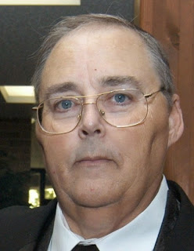***David Maynard, WA3EZN – STM***

[wa3ezn@att.net](mailto:wa3ezn@att.net)

By the time you read this the Mansfield Mid-Winter Hamfest will be over. Did you get your coffee and donuts at the OSSBN meeting? I hope everyone attending the hamfest had fun and got home safely. The OSSBN meets on 3972.5 three times a day, 10:30 am, 4:15 pm and 6:45 pm.

As I collected the information for this article almost all of Ohio is under a flood watch or warning. Ohio has already had a tornado is year and Spring is not even here yet. I want to stress the need for preparedness by providing this information.

TOP^

**Statewide Tornado Drill: March 20, 2019 at 9:50 am**

* [Tornado Facts and Safety Tips](https://www.weathersafety.ohio.gov/TornadoFacts.aspx)
* [Fire Drills and Tornado Safety Precautions (ORC 3737.73)](https://www.weathersafety.ohio.gov/TornadoSafetyDrills.aspx)
* [Emergency Evacuation Drills - Fire, Tornado](https://www.com.ohio.gov/documents/fire_RecordofEmergencyEvacuationDrills.pdf)
* [Tornado Safety Standards (NWS and Red Cross)](https://www.weathersafety.ohio.gov/Documents/pdfs/Tornado%20Safety%20NWS%20%20ARC.pdf)
* [Tornado Safety And the Dangers of Highway Overpasses](https://www.weathersafety.ohio.gov/TornadoSafety.aspx)
* [Tornado Safety & Preparedness for Schools Brochure](https://www.weathersafety.ohio.gov/Documents/FactSheets/TornadoSafetyPreparednessBrochureForSchools.pdf)
* [Tornado Safety Tips for School Administrators](https://www.weathersafety.ohio.gov/Documents/pdfs/Tornado%20Preparedness%20Tips%20for%20School%20Administrators.pdf)
* [Tornado Safety Brochure](https://www.weathersafety.ohio.gov/Documents/Brochures/EMA-0004%203-16%20WEB.pdf)

**Spring Severe Weather Awareness Week: March 17-23, 2019**

* [Governor's 2018 Resolution](https://www.weathersafety.ohio.gov/Documents/GovernorsProclamations/20180321_SpringSevereWeatherAwarenessWeekGovResolution2018.pdf)
* [Letter from 2018 OCSWA Chairperson](https://www.weathersafety.ohio.gov/Documents/ChairpersonLetters/2018_Spring_Letter_from_Chair.pdf)
* [Severe Weather Terms](https://www.weathersafety.ohio.gov/SpringSummerWeatherTerms.aspx)
* [Thunderstorms & Lightning Safety](https://www.weathersafety.ohio.gov/Documents/pdfs/Thunderstorm_Lightning_Safety.pdf)
* [Thunder & Lightning Safety Brochure](https://www.weathersafety.ohio.gov/Documents/Brochures/EMA-0003_Protection_Against_Thunder_And_Lightning.pdf)
* [Flood Information and Safety Tips](https://www.weathersafety.ohio.gov/FloodInformation_SprSum.aspx)
* [Flood Insurance Information](https://www.weathersafety.ohio.gov/FloodInsuranceInfo_SprSum.aspx)
* [FEMA: Flood Insurance Reform](https://www.fema.gov/national-flood-insurance-program/flood-insurance-reform)
* [FEMA Brochure: Build Back Safer & Stronger](https://www.weathersafety.ohio.gov/Documents/pdfs/fema_flood_brochure%202013.pdf)
* [Turn Around Don't Drown!](https://www.weathersafety.ohio.gov/Documents/pdfs/Turn%20Around%20Don't%20Drown%202015.pdf)
* [Flooding & Flash Flooding Safety Brochure](https://www.weathersafety.ohio.gov/Documents/Brochures/EMA%200016%203-16_Web.pdf)

These links are from this website: [https://www.weathersafety.ohio.gov/](https://www.weathersafety.ohio.gov/are)

1. **NWS SKYWARN Storm Spotter Program**

In most years, thunderstorms, tornadoes and lightning caused hundreds of injuries and deaths and billions in property and crop damages. To obtain critical weather information, the National Weather Service (NWS) established SKYWARN® with partner organizations. SKYWARN® is a volunteer program with between 350,000 and 400,000 trained severe weather spotters. These volunteers help keep their local communities safe by providing timely and accurate reports of severe weather to the National Weather Service.

Although SKYWARN® spotters provide essential information for all types of weather hazards, the main responsibility of a SKYWARN® spotter is to identify and describe severe local storms. In an average year, the the United States experiences more than 10,000 severe thunderstorms, 5,000 floods and more than 1,000 tornadoes.

Since the program started in the 1970s, the information provided by SKYWARN® spotters, coupled with Doppler radar technology, improved satellite and other data, has enabled NWS to issue more timely and accurate warnings for tornadoes, severe thunderstorms and flash floods. SKYWARN® storm spotters are citizens who form the nation's first line of defense against severe weather. There can be no finer reward than to know that their efforts have given communities the precious gift of time--seconds and minutes that can help save lives.

TOP^

**Who is eligible and how do I get started?**

NWS encourages anyone with an interest in public service to join the SKYWARN® program. Volunteers include police and fire personnel, dispatchers, EMS workers, public utility workers and other concerned private citizens. Individuals affiliated with hospitals, schools, churches and nursing homes or who have a responsibility for protecting others are also encouraged to become a spotter. Training is free and typically lasts about 2 hours. You'll learn:

* Basics of thunderstorm development
* Fundamentals of storm structure
* Identifying potential severe weather features
* Information to report
* How to report information
* Basic severe weather safety

**WEATHER SPOTTER REMINDER**

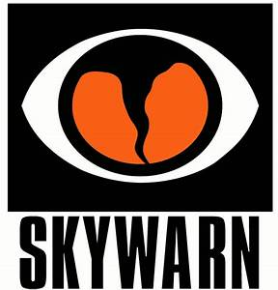Next month is March and that means there will be multiple weather spotter training sessions over most of the state of Ohio. These training sessions and a good weather alert radio or cell phone alert app are two of the steps you can take to help protect yourself and your family if a severe weather situation arises.

**2019 NWS WILMINGTON OHIO SPOTTER TRAINING SCHEDULE**

Classes are free and open to the public, but some may require advanced registration.  
You do *not* need to be a resident of the county in which a talk is being held in order to attend.  
Each class lasts about 1.5 to 2 hours and is led by a National Weather Service meteorologist  
who will discuss techniques and safety for severe weather spotting. Once you attend a class,  
you are an officially trained spotter and can report severe weather to your NWS office.

Tuesday, February 19 6:30pm Hamilton County OH

Wednesday, February 20 6:00pm Ross County OH

Thursday, February 21 6:00pm Preble County OH

Monday, February 25 6:00pm Miami University

Tuesday, February 26 6:30pm Brown/Clermont County OH

Wednesday, February 27 6:00pm Pendleton County KY

Thursday, February 28 6:00pm Butler/Warren County OH

Tuesday, March 5 6:00pm Boone/Kenton County KY

Wednesday, March 6 7:00pm Dearborn/Ohio/Ripley County IN

Thursday, March 7 6:00pm Mason County KY - JF

Saturday, March 9 9:00am Montgomery County OH

Saturday, March 9, 9:00am Dayton, OH ([map](https://maps.google.com/maps?hl=en&q=1%20Wyoming%20St%2C%20Dayton%2C%20OH%2045409%2C%20USA)) Contact: [daytonskywarn@gmail.com Miami Valley Hospital Bieser Auditorium.](mailto:daytonskywarn@gmail.com)

Tuesday, March 12 6:00pm Scioto/Pike/Adams County OH

Wednesday, March 13 6:00pm Champaign County OH

Thursday, March 14 6:00pm Hardin County OH

Monday, March 18 6:00pm Fairfield County OH

Tuesday, March 19 6:30pm Darke County OH

TOP^

Wednesday, March 20 6:30pm Union County OH

Thursday, March 21 6:00pm Wayne County IN

Saturday, March 23 9:00am Franklin County OH

Monday, March 25 7:00pm Owen/Grant County KY

Wednesday, March 27 6:30pm Logan County OH

Thursday, March 28 6:00pm Fayette County OH

<https://www.weather.gov/iln/spottertrainingschedule>

** Spring Sessions will NOT be conducted by the NWS CLEVELAND in 2019**

The NWS Cleveland staff will not be conducting in-person SKYWARN classes this spring .  Please contact your local county Emergency Manager or SKYWARN coordinator as they may be conducting their own training this year with our materiel.  We are sorry for this inconvenience and we look forward to seeing you in the Fall. <https://www.weather.gov/cle/SKYWARN_schedule>

You can find the Ohio County Emergency Management Directory at:

<https://webeoctraining.dps.ohio.gov/ohiocountyEMADirectorList/countyemalist_web.aspx>

[**2019 Skywarn Spotter Training - Putnam County Ohio**](http://putnamohspotter.eventzilla.net/web/event?eventid=2138704778&dateid=2138628859)

Monday, February 25, 2019

**Putnam County Office of Public Safety**117 Dr. Thatye Drive  
Glandorf, OH 45848

**6:00 PM Eastern Standard Time --** (please arrive 30 minutes early to sign-in)

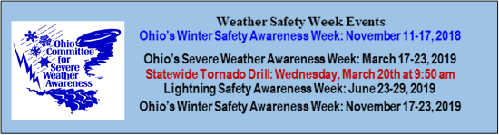

[2019 Skywarn Spotter Training - Fulton County Ohio](http://fultonohspotter.eventzilla.net/web/event?eventid=2138704796&dateid=2138628996)

Tuesday, March 19, 2019

**Fulton County EMA Office**8848 OH-108 Suite #105  
Wauseon, OH, 43567

6:00 PM (please arrive 30 minutes early to sign-in)

**>> 2019 Ohio ARES NVIS Day <<**

In support of the NVIS antenna test I offer this information to all Amateur Radio Operators. **On** April 27 the Ohio ARES is planning a NVIS ANTENNA DAY. It would be an excellent time for all traffic handlers to join in this test even if you are not an ARES member. And speaking of ARES membership I encourage all traffic handlers to seek out the ARES in your area and join so you can be better prepared to assist in the event of a disaster in your area.

You should be working now on antennas to try out during the event! For more information check out this ARES link <http://arrl-ohio.org/SEC/> . There is more NVIS information and some excellent antenna plans so you can build your own NVIS antenna. One advantage of this antenna is that you will not need a tower or to climb anything to install these antennas as they are all low to ground level antennas.

TOP^

**HOW NVIS WORKS**

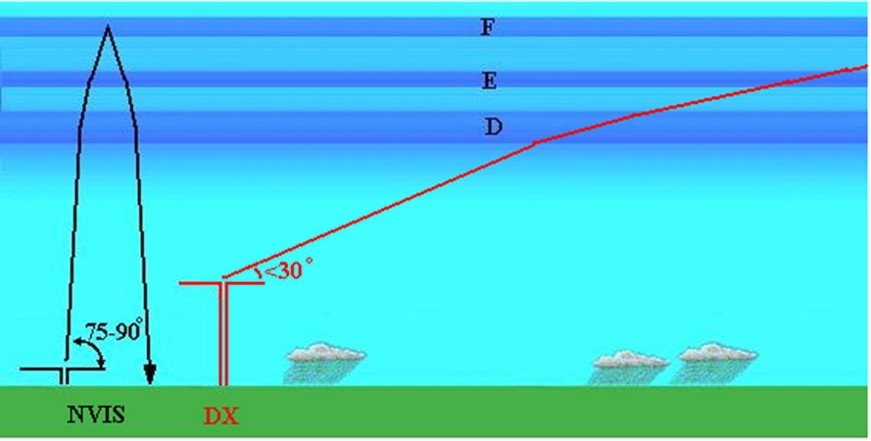

If you don’t know what NVIS is it stands for Near Vertical Incidence Skywave. RF is launched at a high elevation angle and is refracted back to earth as shown here. Notice that unlike a signal launched at a low angle for DX, the NVIS signal returns to the ground close to the antenna.

NVIS is well suited to regional emergency communication. Reliable NVIS communications are possible out to distances of approximately 300 miles. This means that a small number of NVIS stations are required to provide a statewide network. Amateurs can quickly establish communications using NVIS after a natural disaster because NVIS uses readily available HF equipment and simple antenna that can be constructed from readily available materials and do not require towers or other special types of mounting. CW, SSB and various HF digital modes all can be used with NVIS. See: <http://www.arrl-ohio.org/SEC/>

“Skywarn® and the Skywarn® logo are registered trademarks of the National Oceanic and Atmospheric Administration, used with permission.”

That's it for this month, have some fun with Amateur Radio.

**73, David WA3EZN**

You can view the STM’s monthly report on the website.. <http://arrl-ohio.org/stm/stm.html>

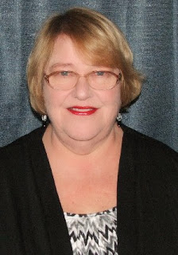***Out and About***

***Lyn Alfman, N8IMW - ASM***

[lynalfman@aol.com](mailto:lynalfman@aol.com)

I know that this is not directly related to amateur radio; however, many clubs have regular meetings and social events where germs can be spread infecting others. So please note that while seasonal influenza (flu) viruses can be detected year-round in the United States, influenza activity has historically peaked in February for the last thirty-five years. And, of course, colds happen in all seasons, but usually peak in fall and winter, too.

TOP^

Follow these everyday preventative actions that doctors, nurses, flight attendants, and teachers use to stop the spread of germs. This is how they stay healthy around sick people.

1. Get a flu shot. Most of the influenza related deaths each year occur among those who did NOT get a flu shot.
2. If you are sick with a flu-like illness, the CDC recommends that you stay home for at least 24 hours after your fever is gone except to get medical care or for other necessities. (Your fever should be gone for 24 hours without the use of a fever-reducing medicine.)
3. Avoid close contact with sick people. And, while sick, limit contact with others as much as possible to keep from infecting them.
4. Avoid touching your eyes, nose and mouth. Germs spread this way.
5. Cover your nose and mouth with a tissue when you cough or sneeze. Throw the tissue in the trash after you use it. [Wash your hands](http://www.cdc.gov/handwashing/) often with soap and water. To completely get rid of viruses from your skin, you need to scrub hard for 20 seconds or more. Make sure to scrub the backs of your hands, between your fingers, and under your nails. It doesn't matter if the water's hot or cold -- the very act of scrubbing will physically remove the germs. If soap and water are not available, use an alcohol-based hand sanitizer.
6. Clean and disinfect surfaces and objects that may be contaminated with germs like the flu.

**In local amateur radio news:**

* + TUSCO Amateur Radio Club’s Hamfest in Strasburg was very well attended despite the road conditions.
  + Cambridge Amateur Radio Association will be having elections at its meeting on February 23 and on the same day they will conduct a Laurel Amateur Radio Exam at 1 pm in the same location.
  + Zanesville Amateur Radio Club will have a raffle drawing for a hand-held radio at its next meeting on March 5.
  + Morgan (County) Amateur Radio Club’s members operated Winter Field Day under individual call signs.
  + Coshocton County Amateur Radio Association and the Coshocton County ARES participated in the VHF simplex Challenge, participated in the Ohio “snow” net, and called up a local weather event on February 7.



Be Safe and be Radio Active!

**73 Lyn N8IMW**

TOP^

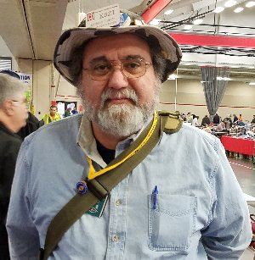***From the Section Youth Coordinator***

***Anthony Luscre, K8ZT - SYC***

[k8zt@arrl.net](mailto:k8zt@arrl.net)

**2019 Teachers Institute on Wireless Technology**

The ARRL has announced the 2019 Teachers Institute on Wireless Technology:

As part of our educational outreach to schools through our [***Education & Technology Program***](http://www.arrl.org/education-technology-program), each summer the ARRL offers multiple sessions of the Teachers Institute on Wireless Technology, an expenses paid professional development seminar, in locations through the U.S. The Teachers Institute has provided teachers at all grade levels with tools and strategies to introduce basic electronics, the science of radio, space technology and satellite communications, as well as weather science, introduction to microcontrollers and basic robotics in their classrooms. The curriculum is designed for motivated teachers and other school staff who want to learn more about wireless technology and bring that knowledge to their students.

**What Happens At Teachers Institute?**

Here's a video from the most recent Teacher's Institute held at ARRL HQ in [***Summer 2018***](https://www.instagram.com/tv/BlLYHb_gUjT/?hl=en)*.*

And here's a [***brief look***](https://www.youtube.com/watch?v=yo2ccNAKrb8&feature=youtu.be) at a previous Teachers Institute at ARRL HQ.

**Summer 2019 Teachers Institute Scheduled Sessions**

**Session Location Dates - Instructor**

**TI – 2 Newington, CT July 8th – July 12th Matt Severin**

**TI – 1 Dayton, OH July 15th – July 19th Larry Kendall**

**TI – 1 Newington, CT July 22nd – July 26th Tommy Gober**

**2019 Teachers Institute application will be available January 2019. Deadline to apply is May 1st, 2019.**

Early applications are recommended. [***Register with ARRL***](http://www.arrl.org/teacher-registration) to receive news about Education & Technology Program activities.

If you or anyone you know is a teacher that is interested in attending, please contact me for details and/or assistance in applying.

TOP^

In my previous jobs as a school Technology Coordinator, Technology Director and Technology Integration Specialist I often spoke at a variety of Educator Technology Conferences around the state and occasionally the country. Now that I am retired, I still am doing a few conferences each year. This year I already scheduled to present at two conferences where one of my topics will be on Radio Technology in the Classroom. If you know of a teacher that might be attending either of these please have them check the schedule for my session:

Feb 13, 2019- Ohio Education Technology Conference in Columbus -[*https://oetc.ohio.gov*](https://oetc.ohio.gov)

March 6, 2019- NEOTech Conference in Cleveland - [*https://neotechconference.org*](https://neotechconference.org)

If you are just interested in viewing my presentation “handout”- [*tiny.cc/arined*](https://docs.google.com/presentation/d/e/2PACX-1vQHgYYWbre8UhruIydsiOJqDtqya5EYpCIfyU1cgYsBjvo78GGhfB1ymawjQ-HYJg5iH-fxaRbjLJbZ/pub?start=false&loop=false&delayms=3000&slide=id.p)Just a reminder, I keep an archive of my education oriented articles from the Ohio Section Journal and other sources at [*http://tiny.cc/ar-ed-out*](http://tiny.cc/ar-ed-out), please feel free to share this with anyone that might be interested.

**73, Anthony K8ZT**

*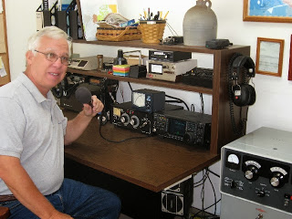****From the Official Observer Coordinator***

***John Perone, W8RXX - OOC***

[w8rxx@arrl.net](mailto:w8rxx@arrl.net)

I’m happy to report that there were no cards sent out and we had 790 total hours of observations from the OO’s in January.

Does everyone have a copy of the latest FCC rules and regulations? The Fourth Edition effective November 1, 2017 is available from the ARRL. (Item # 1173) or you can simply download it from the government’s website: [>> Here <<](https://www.ecfr.gov/cgi-bin/text-idx?c=ecfr&SID=336ab7469b61ecbfa15086dbf1bf2c59&rgn=div5&view=text&node=47:5.0.1.1.6&idno=47#47:5.0.1.1.6.1.157.1)

**73, John W8RXX**

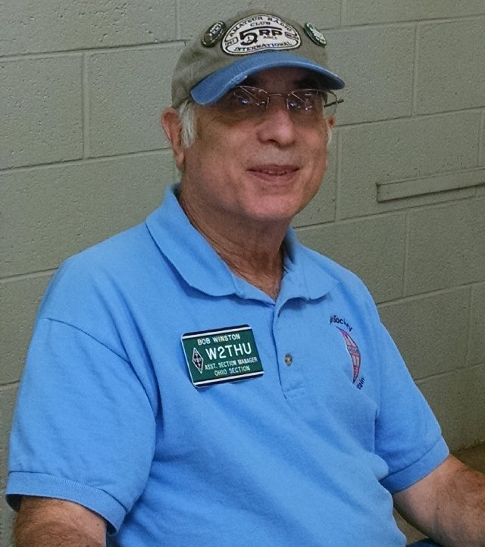***From the State Government Liaison***

**Bob Winston W2THU – SGL**

[w2thu@arrl.net](mailto:w2thu@arrl.net)

In my previous column I had discussed a proposed law designated Ohio HB 95, which provides for enhanced penalties for distracted drivers. This bill is now law, having been passed by both the Ohio House and Senate and signed by Governor Kasich on 29 October 2018. It is known as the “Enhance penalty for moving violations while distracted.” Note that this law does not create new violations, but merely increases the fine that you pay if you violate an existing motor vehicle law. For example, if you cross over the center line while distracted, you may have to pay up to $100.00 in addition to the regular penalty and court costs, if applicable. To avoid the enhanced penalty, you are allowed to take a distracted driving course.

TOP^

Of concern to Ohio hams is whether talking on your ham radio is considered a distraction. My take is that almost anything you do while driving, other than keeping your eyes on the road and your hands on the wheel, could be a distraction if it leads to a driving error. For example, if you momentarily take your eyes off the road to glance at your AM/FM radio, turn on your radar/laser detector, adjust the air conditioning, or lean over to take something out of your glove box, then you could be “distracted.” If a peace officer stops you for going through a red light and subjectively determines that your distractive behavior caused you to do so, then you would be subject to the enhanced penalty. I still believe that the aim of this legislation is to deter texting which has resulted in many injuries and deaths over the years and that a mere $100 fine is not going to stop this behavior. The distracted driving course is a good idea and will probably be a better deterrent than the fine.

I suggest that you mount the control head of your mobile amateur radio as high as possible so that it is in your line of sight while you are driving and that you do not look down, even momentarily, while operating your rig. Otherwise, you may find yourself distracted.

If you know of any hams that have been ticketed under the new distracted driving rules, please let me know. Or, if you are a peace officer, and would like to add to this discussion, I would be happy to hear from you. [w2thu (at) arrl.net]

The other law we were following is the proposed Ohio Community Rights Amendment to our state constitution. This amendment would allow local communities to pass home rule laws in derogation of state law. For example, Ohio allows fracking, but some communities don’t want it. Without the amendment, any local legislation enacted to outlaw fracking would most likely be unenforceable in the courts. This amendment had been certified for signature gathering but there is still no news that the required number of signatures have been obtained to place it on the election ballot.

We were concerned that if passed, a local community could circumvent Ohio PRB-1 which affords strong statewide protections for amateurs wishing to erect antennas and antenna support structures.

While I can easily monitor proposed legislation in Columbus via the internet, I always need your help regarding local legislation or other government action that may impinge on our great hobby. Please continue to advise me of any township, village, city or county activity that concerns ham radio.

We also have 6 Local Government Liaisons (LGL) in Ohio. They are James Ashman, W8ASH in New Bremen (Auglaize County), H. Richard Burdick, K8WWA in Blue Ash, Richard Carey, KB8OTZ in Marion, David Dextradeur, W1GBA in Kettering, Steve Katz, N8WL in Granville and Gene McCoy, N8KOJ in Cincinnati. All

are good on [qrz.com](http://qrz.com/) with contact information.

I was fortunate to have attended the Orlando Hamcation last week. This “mini Dayton Hamvention” is also a 3 day affair with plenty of forums, vendors, indoor and outdoor tailgaters and lots of warmth and sunshine. I attended the Youth Forum with Carole Perry, WB2MGP, the QCWA Forum and the Collegiate Amateur Radio Forum. The latter interests me because I want to see the ham station at my alma mater become more active. If you have the same interest for your college or university, you may want to check out [*http://www.arrl.org/college-students-and-educators*](http://www.arrl.org/college-students-and-educators)*.*

I hope to see you at Xenia in May.

Best 73, **Bob, W2THU**

TOP^

*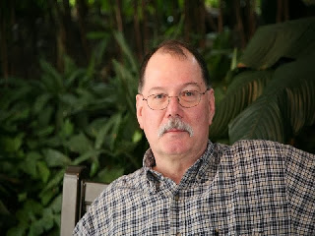****ARES Training Update***

***Jim Yoder, W8ERW – ARES Data Manager***

[w8erw@arrl.net](mailto:w8erw@arrl.net)

ARES Training Update

Winter please be gone. I have operated the switch to turn on spring. However, it must be on a three-way circuit and someone keeps turning winter back on. Who would do such a thing? On a brighter note, the Mansfield Hamfest is just days away now and it’s always a nice event with the opportunity to renew friendships and look around at all the treasures available. As one of our first Hamfests of the year, it surely means that fair weather is soon to come.

As reported, the ARRL board has approved the changes to our ARES program including the move to make EC-001, the Emergency Communications course free to Amateurs who are registered with ARES Connect. This is a welcome change and another benefit to our ARES members who are seeking to better prepare for the ARES mission. Several changes to ARES connect should now be forthcoming to better match the needs we have in the field as well as administration. A full roll out to all sections and counties should be happening as well. If you are not currently registered with ARES Connect, please do so. One of the best features you may appreciate is the listings of the carious club meetings and other activities near you. When you sign up for any of these, you will get email reminders which are great to avoid missing an important function. Please get registered and have a look around the system. ARES Connect also captures the hours we spend doing volunteer work which is essential to support our retention of spectrum.

We are seeing continued growth in the training database with 1,009 active members reporting their training. The total number of certificates recorded now stands at 7,880. We have 793 members who have completed all 4 NIMS courses Level 2, and another 134 who have attained Level 3. There also appears to be some competitive activity in regard to submitting course certificates. One member from Cuyahoga County now has 225 submitted certificates and there are several with over 100 on file.

Our Section Manager Scott Yonally N8SY regularly posts our level statistics online, arrl-ohio.org. The updates often come several times daily as additional certificates are received and logged. I encourage everyone to have a look to make sure you are listed and to verify accuracy. You will also see the additional training options that we are tracking. I will also provide EC’s with a report for your county information and would be happy to do the same for anyone who would like to verify their individual training history. Please send your request to me, [w8erw@attl.net](mailto:w8erw@attl.net) and I will send you the report you need.

There are many benefits to your ARRL membership. One of those is the Elmer Award which is a great way to recognize someone who has brought you along in our hobby. You can enter the information online and ARRL will either mail your Elmer a nice certificate directly or send it to you so that you can present it in person. You may have more than one Elmer in mind, and you can submit them all at the same time. Most of us have that special fellow Ham who encouraged, admonished, chided and otherwise would not let go of us until we sat for our exams and secured our license. The Elmer award is a really nice way to recognize this person and say thank you.

TOP^

Questions and concerns are always welcome. All of us who serve the Ohio Section are here to help you and insure that your Amateur Radio experience is positive and fun. Please don’t hesitate to contact one of us. We would be glad to help in any way that we can.

Thank you for your support,

**73, Jim W8ERW**

***The Handbook Give Away***

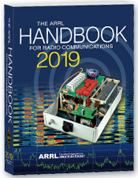Hey Gang,

Have you registered for the “Handbook Giveaway” drawing for this month yet? If you haven’t, go to: <http://arrl-ohio.org/handbook.html> and get registered.

What’s the catch? I want to get everyone checking in to the Ohio Section website as often as possible, and in order to register each month, you have to visit the website often! There’s nothing else to it. I pay all expenses, and from time to time, I Give Away more than just a Handbook. And, you’ll never know just what months will be those special times that I will have more than just a Handbook to Give Away!!

Many of you ask me just how do I know when the drawing is on? Well, that’s easy all you need to do is check in on the Ohio Section Website on a regular basis and watch for the big **RED** Arrow that will appear on the left side of the page. This is the sign that the drawing is on and you need to get registered. So, keep a sharp eye out on the website and check in often! <http://arrl-ohio.org>

***Club Corner***

This is YOUR cornner of the newsletter. Send me what your club is doing and I’ll make sure that it gets in. Got a special event or club project that you want everyone to know about? Send it to me!. Need help with a project? Send it to me.

Let me know what you club is up to. Are you going to have a special guest at your meeting or are you having a special anniversary? Just sent it to:

[n8sy@n8sy.com](mailto:n8sy@n8sy.com)

#########

TOP^

***TMRA Holding Classes***

SPRING TECHNICIANS (Entry Level) HAM RADIO LICENSE CLASS (2 DAY COURSE) -   
  
NOTE:  Two separate days (**March 23rd, and April 6th**), with test session on April 6th at end of class.  
  
The TMRA Education Committee has released the schedule for the Spring Technicians Class. The class schedule will follow our traditional style. Two classes held two weeks apart and a V.E. Testing Session after the final class. The Class is FREE, you will have to provide your own book, or one can be purchased from the TMRA ($25.00).  (ARRL Edition 4 book)  The testing session will cost $15.00 which is the standard fee set by the ARRL.  
  
THE DATES ARE AS LISTED BELOW  
* CLASS ONE WILL BE HELD ON SATURDAY MARCH 23RD, 2019 FROM 08:00 TILL 17:00  
  
* CLASS TWO WILL BE HELD ON SATURDAY APRIL 6TH, 2019 FROM 08:00 TILL 17:00 (This includes the V.E.Session)  
  
Both classes will be held at  
LUCAS COUNTY EMS TRAINING CENTER  
2127 JEFFERSON AVE  
TOLEDO OHIO 43624  
  
To Enroll in the Class, or for more Information please contact  
STEVE STALKER / KC8TVW  
419-467-3734  
[kc8tvw@arrl.net](mailto:kc8tvw@arrl.net)  
  
Also, please join us for a 4 hour follow-on class on April 13th (9am) called, "I now have my ham radio License, now what?". This class is intended to help get newly licensed hams started with additional needed information. Location is TBD.

#########

***Connections: Ham Radio Class "Getting Your Technician Class License"***

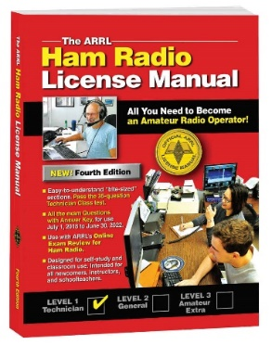Instructor: Alan Jones, N8WQ

Faith United Methodist Church

15 West Columbus Street

Canal Winchester, Ohio

The Class is FREE, however, you will have to provide your own book which is published by the ARRL. You can buy your book directly from the ARRL or from Amazon.

<http://www.arrl.org/shop/ARRL-Ham-Radio-License-Manual-4th-Edition-Softcover/>

TOP^

<https://www.amazon.com/ARRL-Radio-License-Manual-Spiral/dp/1625950829/ref=sr_1_1?s=books&ie=UTF8&qid=1548331756&sr=1-1&keywords=arrl+ham+radio+license+manual+4th+edition>

We will study the electronics theory and go over testing material necessary to help prepare you for passing your Technician exam. The Technician class will start on **March 3rd** from 4:00 PM TILL 5:30 PM and will continue every Sunday until the last session on April 7th.

Instructions will be provided about scheduling your exam: including date, time, and location of testing sites in Central Ohio. We look forward to seeing you in class!

Need more information? Contact Alan at: [oalanjones@gmail.com](mailto:oalanjones@gmail.com)

#########

***Shelby County ARES Tech Training Class***

Description: This will be a two-session training course covering the Ham radio Technician license. This will help you prepare for the 35-question written exam. This license allows for All VHF/UHF Amateur bands (frequencies above 30 MHz) and limited operations in certain HF bands.

Event Timing:   
**February 18th** 6:00 p.m. until 9:00 p.m.  
February 23rd 8:00 am. until 3:00 p.m.  
Test immediately following. If there is enough need we may offer another testing session on the 2/24/2019 before our monthly meeting.

Event Address: EMA Building - 800 Fair Rd Sidney, Ohio 45365

Contact us at 937-421-1254 then press 4 or [training@shelbycountyohares.com](mailto:training@shelbycountyohares.com)

***#########***

***CARS 2019 Winter Ham Radio classes - get your Technician, General or Extra class license!***

Thursday evenings starting **February 28, 2019** and ending April 11, 2019 at 6:30 pm April 11th will be a special VE Test session for all license classes, ARRL fee for this VE test is $15.00

To register please follow the link at: [www.2cars.org](http://www.2cars.org) and complete the on-line application or call 216-932-8005 Dave, KD8ACO.

Classes will be held at the Seven Hills City Hall, 7325 Summit View Dr Seven Hills, OH 44131 in room “C” at 6:30 pm every Thursday.

TOP^

The entrance is at the East end on the South side of building class fees: Technician $25.00, all who pass get a free CARS membership for 2019, General and Extra $20.00 nonmembers or Extra is $15.00 CARS members, General class ONLY is **FREE to CARS members** All class materials are provided.

***#########***

***Pioneer Bus Trip to Hamvention***

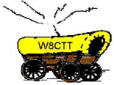It is never too early to plan a trip to Hamvention. Each year the Pioneer Amateur Radio Fellowship has offered to bus hams to this great event. The bus leaves at 5:30 AM the Saturday of Hamvention, it does stop at McDonald's for breakfast and arrives at Hamvention about 9am, just in time for the doors to be open. The bus leaves around 5pm and stops for a buffet for supper! You won’t go hungry on this trip for sure! You arrive back at the pickup point about 9:30pm, so it’s not too late, but you will have had a full day for sure.

The bus has a number of very large storage areas for all your purchases, so you don’t have to worry if you’ll have room for that “just can’t do without boat anchor!”

[Click Here](https://drive.google.com/file/d/1QPUeDDMljARN62b9cV90SBypgtcxJtJ9/view) to read the flier and the form used to register for this trip.

***One Question Questionnaire***

Hey Gang

There’s another NEW – one question – questionnaire on the Ohio Section Website! <http://arrlohio.org>

This past week’s poll has shown some interesting facts. About 50% of you get just 1 club newsletter. I would have expected that number to be much higher. It also shows that about 28% of you get 2 club newsletters. That’s really great. What really surprised me was that 12.5% of you get 3 newsletters, and the most surprising of all was approximately 10% of you get more than 3 newsletters! That’s really fantastic, and it shows just how interested all of you are in your clubs!

Anyway, these questions are all in fun and I hope that you are enjoying answering these “ONE QUESTION” questionnaires. Ok, enough on that, here’s the next question for you to answer…

Now, with ARES Connect being the talk of many club meetings, I would like to know the following question.

**“How many of you are now using ARES Connect to track your volunteer hours?”**

You’ll find the “One Question” questionnaire on the Ohio Section Website! <http://arrlohio.org> It’s all in fun and it’s not a scientific survey in any way, but we are learning some things that we didn’t know from these questions. I hope that you are enjoying answering these “One Question” questionnaires.

TOP^

***ARES Connect***

***CQ… CQ…. CQ… Calling all persons to be a part of the new ARES Connect program.***

We need to discuss some very important items that only YOU can make a difference with. I need you to get yourselves registered in ARES Connect, that is… if you haven’t already. Now, how do I know that you need to do this? It’s simple, we have over 900 now registered in the database with about 521 persons actually signing up for events.

Stan’s last S.E.C. report shows that we have a little over 1,500 persons in ARES right now. As you can see, we still have a way to go to really take advantage of this new system.

As the numbers show, there’s still a lot of you that haven’t taken the plunge yet and need to! What are you waiting for? No matter how much you resist, it’s coming, and we need to make sure that no one is left behind.

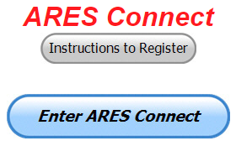

**Now, as an incentive to get you to not only register…. But to actually start using the system…** *(Notice how I have that in bold type for you to clearly see?)*I am giving away all sorts of goodies to help you get motivated. I have a footlocker of really cool items that I will be giving away!

I’m doing this in various intervals throughout the year, so it will challenge you to be dedicated to getting your hours into the system. You’ll never know just when another drawing will be, so you really do have to be prudent!!

***Here’s how it looks as of 16 February:***

|  |  |  |  |
| --- | --- | --- | --- |
|  | **Name** | **Events** | **Hours** |
| 1 | Mathew Nickoson (KC8NZJ) | 5 | 100.00 |
| 2 | Timothy Lovejoy (NC8OS) | 15 | 78.75 |
| 3 | Christopher Domenick (KC8CAD) | 19 | 52.26 |
| 4 | Bret Stemen (KD8SCL) | 8 | 36.50 |
| 5 | James Yoder (w8erw) | 4 | 22.50 |
| 6 | Dan Stahl (KC8PBU) | 31 | 20.75 |
| 7 | John Major (KD8MMY) | 11 | 17.50 |
| 8 | Alan Rothweiler (KD8TNS) | 5 | 16.00 |
| 9 | Michael Farkas (n8gbu) | 17 | 14.75 |
| 10 | John Westerkamp (W8LRJ) | 18 | 11.75 |

***Here’s how we did with people getting signed up for events and the total hours logged***

|  |  |
| --- | --- |
| Total Amount signed into Events | Total Hours for Events |
|  |  |
| **711** | **1348.77** |

TOP^

114 of those events had slot limits which means that only a limited amount of people could register for the event. These slot limited events recorded 514 hours which is a substantial amount of the total hours recorded.

Don’t think that you could ever get into the top 10 listing? You never know. It adds up quickly, but you do have to be registered and actually USE the system in order for any of your time to count. We have a set of instructions on how to get registered right above the button to enter ARES Connect. I would strongly suggest that if you haven’t registered yet, that you read these instructions first. Here’s a link to get you started... <http://arrl-ohio.org/ares_connect_directions.pdf> Please, don’t just hurry through the questions, read them carefully, if you don’t understand something, please ask me, I’m here to answer your questions.

We know that you mean well by answering that you do have the needed courses in, but I will let you know that we are verifying what you say you have with what is showing for you in our statewide database when we are completing your registration. So, how can you find out if you are already listed in our statewide database? Easy, here’s a link: <http://arrl-ohio.org/SEC/special/ICS%20Complete%20by%20County%20and%20Name.pdf>

***Incident Command System (ICS) Training Schedule***

All current trainings are listed on the Ohio EMA training calendar located at:

<https://webeoctraining.dps.ohio.gov/TrainingAndExercise/courselist.aspx>

I’ve been asked to also include a link to the Kentucky EMA training calendar as well..

<https://kyem.ky.gov/training/Pages/default.aspx>

<https://sites.google.com/site/ccoemtraining/home>

Please pay particular attention to these courses listed above, as that there’s a lot of ICS 300 & 400 classes listed that are very useful for all Amateurs to have under their belts. I will also state that G775 is also a very good course to take as well. These 3 courses are multiple day in class courses, so please be prepared to spend some time taking them.

I would like to remind any of you that are going to take any of the in-class training sessions that you dress appropriately. Please don’t go into these classes with attire that doesn’t represent you, and Amateur Radio in the best of light. I won’t tell you that we have a dress code, but I have heard from some officials from around the state that have made the comment to me that your appearance did stick with them. Remember, you will be in class with fire / police chiefs, mayors, township trustees and a whole host of other government and civil officials that will remember how you represented Amateur Radio while you were in these classes together.

We do recognize that IS-300/400 requires multiple days of actual classroom training that is not easily obtained. So, if you just can't find the time to fit these class room courses in, we do have an alternative method for getting you to Level 3. Completing the following **“FREE”** and **“ONLINE”** courses will act as substitute for you FEMA Leadership Development Course requirements. You absolutely will need to complete all **7** of these courses to get your ICS 300/400 credit.  Here are the courses that you need to take:  **IS-120, 230, 240, 241, 242, 244 & 288.**

#########

TOP^

***EMA-G290/291 Basic Public Information Officer Series***

Hosted by Franklin County EMA

**June 12-14**

**Application deadline: June 5th**

Time of Course: Registration: 7:45 - 8:00 AM

Course time: 8:00 AM – 5:00 PM daily

Location: Franklin County Emergency Management and Homeland Security

5300 Strawberry Farms Blvd.

Columbus, Ohio 43230

Enrollment: Students must enroll via the Department of Public Safety Training Campus website: <https://trainingcampus.dps.ohio.gov/cm/cm710/pstc/pstc.html>.

Students experiencing difficulty enrolling should call Ohio EMA Training at (614) 799-3666 / 3824 for assistance with registration. Course registration will generally close 10 working days prior to the course start date. You can check your enrollment / approval status via the Department of Public Safety Training Campus website.

**State Point of Contact:** Susan Traylor, State Training Coordinator, Ohio Emergency Management Agency, (614) 799-3666, [sctraylor@dps.ohio.gov](mailto:sctraylor@dps.ohio.gov)

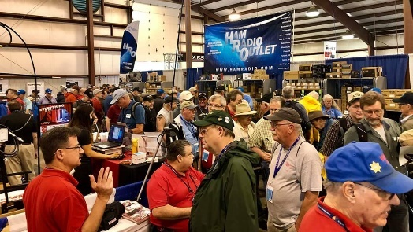[***Upcoming Hamfests***](http://arrl-ohio.org/hamfests.html)

03/03/2019 | [WINTER HAMFEST](http://www.arrl.org/hamfests/winter-hamfest-8)

Location: Elyria, OH  
Sponsor: Northern Ohio Amateur Radio Society  
Website: [h](http://www.noars.net/hamfests/noarsfest)ttp://[noars.net/winter-hamfest](http://www.noars.net/winter-hamfest)

03/16/2019 | [Gallipolis Ohio Hamfest](http://www.arrl.org/hamfests/gallipolis-ohio-hamfest)

Location: Gallipolis, OH  
Sponsor: Mid-Ohio Valley Amateur Radio Club

|  |  |
| --- | --- |
|  |  |
| 03/17/2019 | [Hamfest and Computer Fair](http://www.arrl.org/hamfests/hamfest-and-computer-fair-1)  Location: Perrysburg, OH Sponsor: Toledo Mobile Radio Association Website: [http://www.tmrahamradio.org](http://www.tmrahamradio.org/) | 04/13/2019 | [65th Annual Cuyahoga Falls Amateur Radio Club Hamfest](http://www.arrl.org/hamfests/65th-annual-cuyahoga-falls-amateur-radio-club-hamfest)  Location: Cuyahoga Falls , OH Type: ARRL Hamfest Sponsor: The Cuyahoga Falls Amateur Radio Club, Inc. Website: [http://cfarc.org](http://cfarc.org/) |

TOP^

***[V.E. Test Sessions](http://www.arrl.org/find-an-amateur-radio-license-exam-session)***

*(from arrl)*

|  |  |
| --- | --- |
| 02/19/2019 | [Sandusky OH 44870-1926](http://www.arrl.org/exam_sessions/sandusky-oh-44870-1926-126)  Sponsor: Sandusky, Ohio VE Team Location: Sandusky Radio Club Time: 7:00 PM (Walk-ins allowed)  [Learn More](http://www.arrl.org/exam_sessions/sandusky-oh-44870-1926-126) | 02/20/2019 | [Akron OH 44301-2108](http://www.arrl.org/exam_sessions/akron-oh-44301-2108-18)  Sponsor: Pioneer AR Fellowship Location: Firestone Park Community Center Time: 7:00 PM (Walk-ins allowed)  [Learn More](http://www.arrl.org/exam_sessions/akron-oh-44301-2108-18) |
| 02/23/2019 | [Wauseon OH 43567-9244](http://www.arrl.org/exam_sessions/wauseon-oh-43567-9244-8)  Sponsor: Fulton City Radio Club Location: George's Radop & Antenna Service Time: 9:00 AM (No Walk-ins / Call ahead)  [Learn More](http://www.arrl.org/exam_sessions/wauseon-oh-43567-9244-8) | 02/24/2019 | [Westerville OH 43082-9033](http://www.arrl.org/exam_sessions/westerville-oh-43082-9033-11)  Sponsor: Central Ohio Radio Club CORC Location: Genoa Township Hall Time: 1:00 PM (Walk-ins allowed)  [Learn More](http://www.arrl.org/exam_sessions/westerville-oh-43082-9033-11) |
| 03/02/2019 | [Bryan OH 43506-8410](http://www.arrl.org/exam_sessions/bryan-oh-43506-8410-54)  Sponsor: Williams County ARC Location: Willliams County 911/EMA Time: 10:00 AM (Walk-ins allowed)  [Learn More](http://www.arrl.org/exam_sessions/bryan-oh-43506-8410-54) | 03/07/2019 | [London OH 43140](http://www.arrl.org/exam_sessions/london-oh-43140-35)  Sponsor: MCARC Location: Madison County Engineer's Office Time: 7:00 PM (Walk-ins allowed)  [Learn More](http://www.arrl.org/exam_sessions/london-oh-43140-35) |
| 03/07/2019 | [Youngstown OH 44505-1400](http://www.arrl.org/exam_sessions/youngstown-oh-44505-1400-26)  Sponsor: Mahoning ARA Location: Red Cross Time: 7:00 PM (Walk-ins allowed)  [Learn More](http://www.arrl.org/exam_sessions/youngstown-oh-44505-1400-26) | 03/09/2019 | [Findlay OH 45840](http://www.arrl.org/exam_sessions/findlay-oh-45840-77)  Sponsor: Findlay Radio Club Location: Findlay Radio Clubhouse Time: 9:00 AM (Walk-ins allowed)  [Learn More](http://www.arrl.org/exam_sessions/findlay-oh-45840-77) |
| 03/10/2019 | [Independence OH 44131-4841](http://www.arrl.org/exam_sessions/independence-oh-44131-4841-69)  Sponsor: Cuyahoga ARS Location: Old Elmwood Recreation Center Time: 9:00 AM (Walk-ins allowed)  [Learn More](http://www.arrl.org/exam_sessions/independence-oh-44131-4841-69) | 03/11/2019 | [Athens OH 45701-2059](http://www.arrl.org/exam_sessions/athens-oh-45701-2059-14)  Sponsor: Athens Cty ARA Location: Red Cross Southeastern Ohio Time: 7:00 PM (Walk-ins allowed)  [Learn More](http://www.arrl.org/exam_sessions/athens-oh-45701-2059-14) |

***Special Events***

* **04/13/2019 | 7th Annual Earth Day Celebration**

Apr 13, 1500Z-2000Z, W8PRC, Cleveland, OH. Parma Radio Club. 14.245 7.195. QSL. Parma Radio Club, 8111 Laumer Ave., Cleveland, OH 44105. Our 7th Annual Earth Day Celebration. Operating on solar power from historic, educational Stearns Farm in the Parma, Ohio town center. [www.parmaradioclub.com](http://www.parmaradioclub.com)

TOP^

***ARRL Contest Corner***

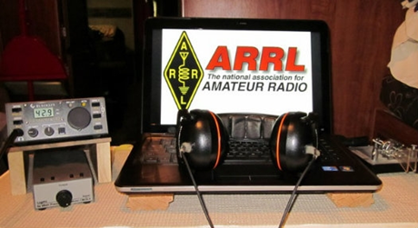

An expanded, downloadable version of *QST'*s [Contest Corral](http://www.arrl.org/contest-calendar) is available as a PDF. Check the sponsor's Web site for information on operating time restrictions and other instructions.

|  |  |
| --- | --- |
| **February 18**   * [Run for the Bacon QRP Contest](http://qrpcontest.com/pigrun/) | **February 20**   * [QRP Fox Hunt](http://www.qrpfoxhunt.org/winter_rules.htm) * [Phone Fray](http://www.perluma.com/Phone_Fray_Contest_Rules.pdf) * [CWops Mini-CWT Test](https://cwops.org/cwops-tests/) |

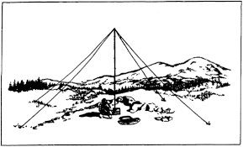***2019 Ohio NVIS Day***

Hey everyone, Stan, N8BHL has let me know that the date for NVIS Day is scheduled for **Saturday, April 27th**. Are you ready? Start your planning now!

Like years past, we are planning on having the operation run from 10 – 4 EDT. Take a lunch break, enjoy each other’s company.

Transmit power should stay at 100 watts for accurate signal comparison. You may operate anywhere, home, club, portable. 

Want to know more about what NVIS is? <http://arrl-ohio.org/SEC/nvis.html> Learn all about Near Vertical Incident Scattering and how you can easily put up a NVIS antenna and participate in this great exercise.

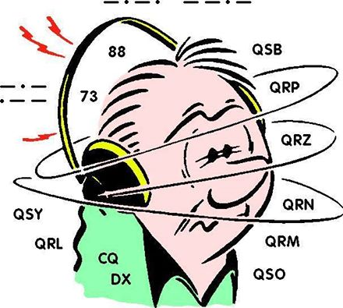***DX This Week***

*(from Bill, AJ8B)*

CWOPs Member #1567

Many of us feared that with the advent of the “No Code” requirement in 2007, CW would start to fade as a medium for communication. However, in reviewing the number of logs submitted for the CQWW CW contest since 2007, we learn that while amateur radio licenses have increased 10.7%, log submission has increased *EIGHTY-TWO* percent! SSB Log submission also increased but by only 49.5% in the same time frame. Something was going on!

TOP^

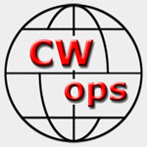(From [www.CWOPS.org](http://www.CWOPS.org) – They can say it better than me)

“In late 2009 a small group of CW operators – ragchewers, contesters, and DXers – began talking about founding a new club. As these operators were from all three ITU regions, they decided from the outset that this club, unlike many, would be an international club from day one.

The CW Operators Club (CWops) was launched in January 2010. During those three years, the club grew from a handful, to a few hundred, to over 1000 members in over 70 countries. CWops, from the outset, was meant to be inclusive. Whether your preference was using CW for ragchewing, contesting or chasing DX, you would find kindred spirits among the club's members.

At first, we established monthly on-air activities (CWTs), but today CWTs are held weekly on Wednesday. There are three 60-minute sessions each Wednesday at times that favor different geographic areas. By 2011, we had also crafted a worldwide CW contest with many novel features (CW Open). The goal has been to stimulate worldwide weekly CW activity and to conduct an annual contest that could be won on a single band using modest power and wire antennas with a time commitment of only four hours! These events are open to CW operators whether members of the club or not.

We realized that there were a lot of hams who wanted to explore the joys of CW operating but felt overwhelmed. Some of them knew Morse but were only able to copy and send at low speeds. Others had not yet learned 'the code,' but were intrigued by the mode and sought ways to learn and practice it. In response to this demand, CWops created CW Academy in 2012, which uses a developed curriculum, proven method of teaching and Skype for a virtual classroom to teach Morse Code.

We truly believe that CW is far more than a nostalgic throwback to the early days of ham radio. It has relevance in many ways to our desire to do things that not everyone else can do; and to provide an efficient, effective mode for communicating with others around the globe. We invite you to explore our Website; to participate in our on-air activities; or if your goal is to learn or improve CW skills, to sign up for CW Academy and join the hundreds of hams who have already done so.”

There is a nomination process as well as a 25 WPM code requirement. Check [www.cwops.org](http://www.cwops.org) for more details! How do you get to 25 WPM? Stay tuned for the next installment!

From our friend at the DailyDX and the WeeklyDX, and the best source for DX information, (<http://www.dailydx.com/> ) Bernie has this to report:

**XX – Macau -** XX9D is already very active across the bands, planning to go until February 26 from the Grand Coloane Resort, IOTA AS-075, with ops DL9KH, DL2RNS, DL4SVA, DJ6TF, DJ7TO, DJ9HX, DL1KWK, DL1RTL, DL4WK, DL6KVA, DL7JOM, DL7VEE, DL9GFB, OZ1IKY and XX9LT, on 160-10 CW, SSB, RTTY and FT8. Their target transmit frequencies currently are:

* CW-1823.5, 3526, 7026, 10102, 14026, 18086, 21026, 24906 and 28026
* SSB-3805, 7095, 14210, 18120, 21275, 24955 and 28465
* RTTY-3590/3599, 7044, 14090, 18099, 21090, 24917 and 28090
* FT8-3573, 7074, 10136, 14074, 18100, 21074, 24915 and 28074 kHz

TOP^

* FT8 "DX mode," - 3570, 7071, 10133, 14077, 18097, 21077, 24918 and 28077
* 6M: 50105/CW, 50120/SSB, 50313/FT8 and 50323/FT8(DXM)kHz

The 15 ops are at four or more stations 24 hours a day with a fifth station monitoring 6 much of the time and at other times being a fifth station on the HF bands. A special focus will be on North America on 160, 80 and 40, with separate antennas for each of the lower bands. For 20-10 it will be a 2-element beam with "pentaplexer" which allows three stations to use it at the same time. QSL XX9D using OQRS or through LoTW, or go direct to DL4SVA. <http://xx9d.mydx.de>

**T2 - Tuvalu** The next T2AR mini-DXpedition, by 3D2AG, Antoine, is now likely to happen February 22-27 with a focus on the low bands, certainly including 160, with high power. QSL via 3D2AG covering costs on PayPal. He will only be logging on paper so there will be no LoTW or eQSL availability. He will load the digital QSO log to QRZ.com afterward.

**PY0F - Fernando de Noronha** PU0FDN, PY7RP and PY2ZEA/OH2MM will have PY0F in the ARRL DX CW February 16-17, a multi-two. Their inclusive dates on island are February 13-18. Outside the contest they may try 60 meters, CW, SSB and FT8. QSL direct via PY7RP or use OQRS. The log will be uploaded to LoTW also. Especially look for them on 60 meters Thursday and Friday leading up to the contest weekend. <https://py0f.wordpress.com.OM3JW>

**VP6 - Pitcairn Island**- The VP6D group says it will be exceptional and memorable, helping DXers fill in missing bands, etc.  They suggest DXers try FT8 DXpedition mode.  They say they will have good antennas and high power, an excellent island QTH and dedicated operators, all modes, 24/7.  They emphasize the interesting history of Pitcairn and suggest working them is a good opportunity to demo ham radio to Scouts and others.  After Long flights to Tahiti and Mangareva, then a voyage on the Braveheart, they plan to arrive on Pitcairn on October 17 and begin setting up the station, continuing to October 31.  Eleven of the ops are coming off their disappointment as part of the 3Y0Z expedition last year and want to put that behind them, calling this group "a good, cohesive, balance and multi-skilled team with some new blood."  The op team currently is EY8MM, JR0OZR, K0IR, K0PC, K9CT, K9NW, N4GRN, N6HC, N9TK, W0GJ, W0VTT, W6IZT, W8HC and WB9Z.  They will have 8 stations on HF, 160-10M, all "Flex" radios, to 3-element monoband Yagis for 20-10 and the WARC-79 bands, J-wave verticals for 80-30 and a 90-foot-tall vertical for 160.  Flex amplifiers will provide full legal power.  The op site is the second highest on the island. The expedition cost is over $163,000 plus $3,500 per operator in individual costs.

A more detailed calendar can be found at <http://www.dailydx.com/the-daily-dx-calendar/>

More info can be found at [www.swodxa.org](http://www.swodxa.org) or [www.aj8b.com](http://www.aj8b.com)

***A******RLD007 DX news***

This week's bulletin was made possible with information provided by CO3JK, EA4NF, W1UE, The Daily DX, The OPDX Bulletin, 425 DX News, DXNL, Contest Corral from QST and the ARRL Contest Calendar and WA7BNM web sites. Thanks to all.

TOP^

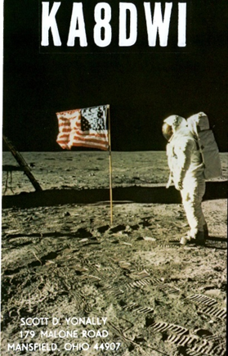**MONACO, 3A.** Philippe, EA4NF is QRV as 3A/EA4NF until February 18.

Activity is on 20 meters, and mainly on various FM and SSB satellites. QSL via LoTW.

**BURUNDI, 9U.** Shabu, M0KRI is QRV as 9U4RI until February 25.

Activity is on 40 to 10 meters using CW, SSB and PSK31. QSL direct to home call.

**TAIWAN, BV.** Yosuke, JJ1DQR will be QRV as BW/JJ1DQR from Taipei, IOTA AS-020, until February 19. Activity is on the HF bands. QSL to home call.

**THE GAMBIA, C5.** Alan, G4DJX will be QRV as C5DX from February 16 to 23 while here with a group of students. Activity will be in his spare time on 40 to 10 meters using only CW. QSL direct to home call.

**CUBA, CO.** Members of the Group CW of Cuba will be QRV as CO9AAA from Pinar del Rio in the ARRL International DX CW contest. QSL via CM1WM.

**CAPE VERDE, D4.** Philip, HB9HFD will be QRV as D44TAQ from Sao Vicente, IOTA AF-086, from February 17 to 22. Activity will be on 40 to 10 meters using various digital modes. QSL via LoTW.

**CEUTA AND MELILLA, EA9.** Jorge, EA9LZ will be QRV as EF9Z from Ceuta during the ARRL International DX CW contest as a Single Op entry. QSL via LoTW.

**HONDURAS, HR.** Dennis, W1UE is QRV as either HQ9X or W1UE/HR9 from Roatan Island, IOTA NA-057, until February 26. He will be active as HQ9X in the ARRL International DX CW contest and the upcoming CQ World Wide 160 Meter SSB contest. Activity includes being on 160 and 80 meters during his evening hours, as well as 60 meters. QSL via KQ1F.

**OGASAWARA, JD1.** Nobu, JA0JHQ is QRV as JD1BOW from Chichijima, IOTA AS-031, until February 18, with a focus on the ARRL International DX CW contest. QSL to home call.

**SABA, ST. EUSTATIUS, PJ5.** Operators K4UEE, K5AC, NM1Y and WC4X are QRV as PJ6/home calls from Jolieville, Saba Island, IOTA NA-145, until February 18. Activity is on 160 to 10 meters using CW, SSB,

RTTY and possibly FT8. They will be active as PJ6A in the ARRL International DX CW contest as a Multi Single/Low Power entry. QSL to home calls, and PJ6A via N4NX.

**FERNANDO DE NORONHA, PY0F.**  A group of operators are QRV as PY0F until February 18. Activity is mainly on the low bands using CW, SSB and FT8. This includes being an entry in the ARRL International

DX CW contest. QSL direct to PY7RP.

**CENTRAL KIRIBATI, T31.** A group of operators will be QRV as T31EU from Kanton Island, IOTA OC-043, from February 16 to March 5. Activity will be on 160 to 10 meters using CW, SSB and various digital modes with three stations active. QSL via DL2AWG.

**VIET NAM, XV.** Andy, DL3YM plans to be QRV as XV9YM from Ho Chi Minh City from February 16 to March 18. Activity will be in his spare time on 40 to 10 meters using only CW. QSL to home call.

TOP^

**NEW ZEALAND, ZL.** Jacky, ZL3CW will be QRV as ZM1A from Tauranga in the ARRL International DX CW contest as a Single Op entry. QSL to home call.

**SOUTH AFRICA, ZS.** Uli, DM5EE plans to be QRV as ZR2A from Port Elizabeth in the ARRL International DX CW contest as a Single Op/All Band entry. QSL to home call.

THIS WEEKEND ON THE RADIO. The ARRL International DX CW Contest, NCCC RTTY Sprint, QRP 80-Meter CW Fox Hunt, NCCC Sprint CW Ladder, SARL Youth Day 40-Meter SSB Sprint, Russian PSK World Wide Contest, Feld Hell Sprint and the AWA Amplitude Modulation QSO Party will certainly keep contesters busy this weekend.

The Run for the Bacon QRP CW Contest is scheduled for February 18.

The CWops Mini-CWT Test, Phone Fray and QRP 40-Meter CW Fox Hunt are scheduled for February 20.

The AGCW 80-Meter Semi-Automatic CW Key Evening is scheduled for February 21.

The Canadian National Parks on the Air, CNPOTA, operating event runs for the entire year of 2019, with special stations active from Canada's parks and historic sites.

Please see February 2019 QST, page 91, and the ARRL and WA7BNM Contest Web Sites for details.

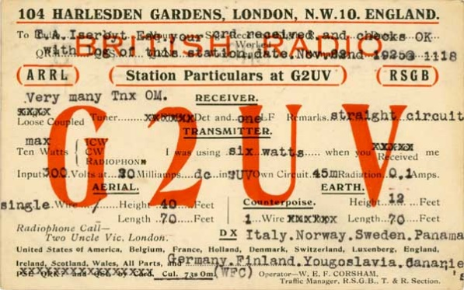***You’ve Got Cards – Waiting***

Hey Gang, here’s a new department for you to keep an eye on and it has already shed fruit for some of you. Yes, it’s about QSL Cards without owners. Why without owners? The card sorters have the cards waiting, but they don’t have a way to get these cards to their owners.

Now, if your call sign is listed here, and according to our One Question Poll this week, some of you do recognize these call signs!! Now, we just need these folks to contact their QSL Card sorter to find out how to get their cards sent to them. **Don’t send anything to them until you’ve had a chance to contact them first and find out just what you need to do.**

**NEW 🡪** Here’s some folks from the **“8V”** call signs that have cards waiting.. Glenn, AF8C is the "8V" bureau letter manager.

WA8VA; KG8V; KB8VSF; W8VRT; W8VHO; KR8V; AA8VL; NA8V; W8VCI; KD8VYI; KB8VCV; W8VF; AK8V; W8VKO; NV8V; N8VFJ(WV8EM); KU8V; K8V(W8CDB); KC8VRT; WB8VWI; KC8VUT;

N8VW; KG8VV; N8VY; WB8VWO(EXP); N8VZX; W8VZM; KA8VZB; K8VZ; N8VZL; K8VYA; K8VY; KD8VVX; N8VVU; W8VV; AC8VV; KD8VVL; N8VVP; W8VXH; N8VX; AB8VX; K8VWX; KC8VWM; KC8VWZ; KB8VUM; KD8VUY; WA8VTD; KF8VS; N8VSI; KA8VSH; N8VS; WA8VRS; N8VRX;

TOP^

KC8VRT; KC8VR; K8VQ; W8VQT; K8VQC; WB8VPA; W8VO; KD8VOM; N8VNE; KC8VML; K8VMC; W8VMM; WB8VLC; WB8VLO; W8VKO; KC8VJD; KD8VII; KB8VIN; N8VIL; KD8VIC; KD8VHE; WB8VGE; KD8VGH; N8VE; W8VE; K8VD; N8VCF; K8VC; WB8VCR; K8VCP; W8VCI; W8VCL; N8VBW; KD8VAE; NI8V; KC8V; KA8V; AB8V

Recognize your call sign or do you know anyone in the above listing? If you do please, contact Glen at: [af8c@alumni.caltech.edu](mailto:af8c@alumni.caltech.edu)

***Weather Underground and Ham Weather Stations***

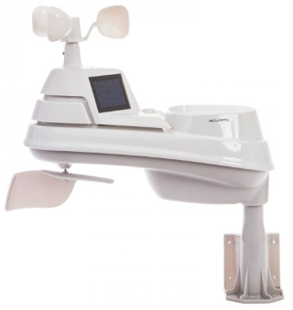[](http://arrl-ohio.org/wus.html)Have you visited the webpage to see all the Weather Underground stations yet? It’s really fun to see just how much the weather varies across the state and this gives you access to each individual station very quickly and easily.

It seems that our list of stations is growing every week! This past week we added another station to the list. Thanks so much **Richard, WA8RR** for sending in the link to your station.

Now… How’s about your station, is it listed with us?

Thanks to everyone who has contributed to this effort. If you haven’t, you really should take a look at the various weather stations around the state when we get bad weather coming in. You can really see just where the line of storms are as they cross through the state. It is very fascinating to watch it all unfold right you’re your easy chair, and all the data is real time! Here’s a link to all of those listed… <http://arrl-ohio.org/wus.html>

We’re starting to get a really good collection of stations all over. I know that there is a lot more than what we have listed. How’s about sharing your weather information with all of us! All that you need to do is send me your Weather Underground ID and your call sign and I’ll take it from there. Sent it to: [n8sy@n8sy.com](mailto:n8sy@n8sy.com)

***Skywarn Net Frequencies***

Hey Gang,

It’s come to our attention that we really don’t have a good listing of all the Skywarn Net frequencies all around Ohio. As we have gotten a lot of new to Amateur Radio folks this past year or so, it would be very helpful to them, and us to have this type of information readily available. Yes, I know it’s only February and we shouldn’t have to think about this yet, especially since we just got over a super cold spell a couple of days ago. But we really do need to start working on this now so that we are prepared for when the weather does get warmer.

TOP^

I don’t believe that this type of list has ever really been perused by anyone where it was published somewhere for all to use. I could be wrong about that but even if it were, this type of information is forever changing and needs to be updated on a pretty regular basis since repeaters move, PL tones change and even who does the net changes all the time. Just look at how we’ve grown the DMR repeaters in Ohio this last year or so!

In order to get this information, we do need to hear from you folks as to what you know about the Skywarn Nets in your area. What kind of information are we looking for? The frequency that your net is on. Whether you use a repeater or simplex. Is PL (CTCSS) needed. Do you have an alternate repeater or simplex frequency that you go to? Things of this nature are extremely important to know, especially if we need to get folks from other areas of the state involved with your area to help in times of need.

I will take this information and post it to the <http://arrl-ohio.org/SEC/ohio_counties/county-listing/counties/master-ohio-counties.html> webpage so that we will have it when (yes, when) we need it. All you will have to do is click on the county that you want the information for and it will be there. Here’s a link to get you to the questionnaire: <http://arrl-ohio.org/SEC/skywarn-frequencies.html> You can also find this link on the Section Emergency Coordinator’s main page as well.

I have already posted the information about my area (Richland) up there so that you can get a feel for what type of information we are looking for. It is painless to do and should only take you about a minute or 2 to complete. If you don’t know the information about the Skywarn Net in your area, this list should definitely help you out.

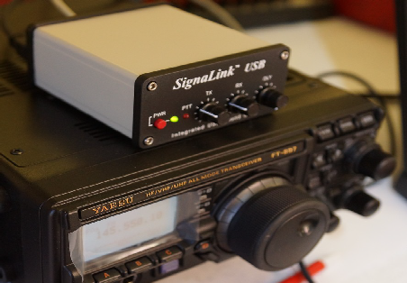***OHDEN Has Some Changes To Tell You About***

*(from Gary, NJ8BB & Eldon, W5UHQ)*

Hey Gang,

Just wanted to make sure that you didn’t miss these very important announcements from the folks at OHDEN.

A new digital net to test 160-meter intra-Ohio propagation is now meeting on **Tuesday Evenings at 1945-2045 (7:45-8:45) Local Eastern time**. Thus far we have had successful border to border check-ins with great propagation from those checking in. Frequency is 1.805MHz USB +1500 Hz data carrier offset.  (very low end of 160 meters)

The net is currently being conducted in an informal mode and we encourage county to county tests at and county to NCS at this time.  At some time, when we reach critical mass, the net will be designated a controlled ARES traffic net and made part of our OHIO NIMS system. We are also hopeful that antennas can be erected at W8SGT so they can participate.

Mode: **Olivia 8-500**

Required Freeware Software:  **FLDIGI Version 4.0.12 and FLMSG 4.0.6**

Details: This is an ARES net designed to test feasibility of NBEMS traffic passing on 160 meters. We have been tasked to come up with ways to augment our current Ohio Digital Emergency Network which heavily relies on 80-meter Olivia for county to county low bandwidth digital messages.

TOP^

The current sun conditions have made 80 meters past sundown very unreliable and next to impossible to pass error free messages. In addition to the new band, we will test ways of sending 4-character status messages for SHTF situations when all else has failed. OHIO ECs and State Support Staff have been asked to help develop a list of status /response messages similar to the ARLxx type messages but tailored to SITREP situations in NIMS.

Our intent is also to try out newer digital modes such as JS8Call and other offshoots of the WSJT software as augmentation but not replacement for FLDIGI.

Connect activity credits are being worked on both air time and assistance in developing procedures and makeshift antennas for those without 160 meters. We will start with Olivia 8-500 and go from there exploring different modes and quicker ways to accomplish check-ins and parallel operations when necessary.

Be very careful not to use LSB on this dial frequency or you will interfere with the ARRL code practice down the band on 1802.5.

Notify your local EC and the net manager [w5uhq@arrl.net](mailto:w5uhq@arrl.net) about your interest in this net or if you require assistance in adding 160-meter digital capability to your station’s toolbox.

Being an experimental net, we must be open to resolving any interference with other formal nets around the country.  These are the kind of things we will evaluate during the experimental period before petitioning for a permanent time and frequency.

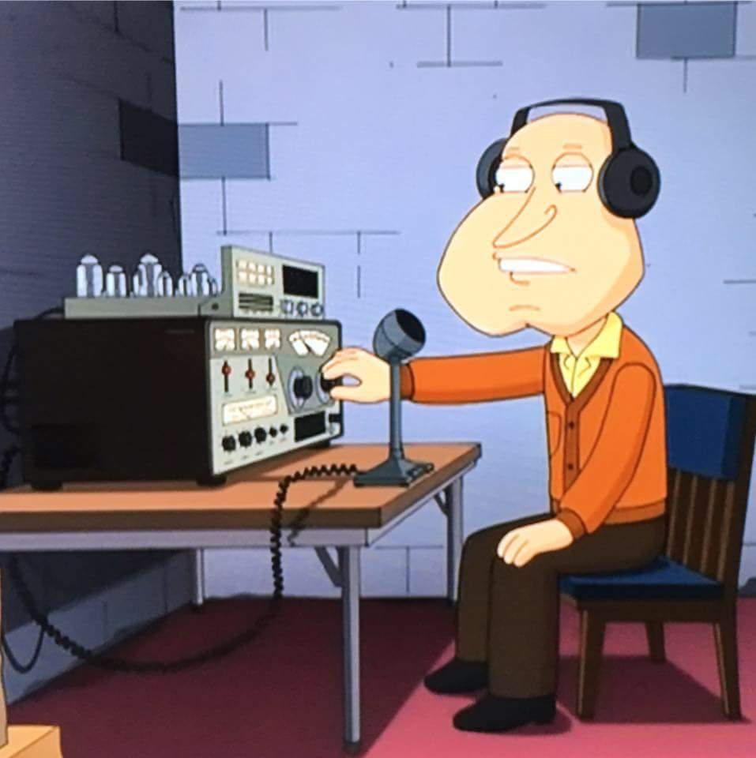Our hope is to have at least one 160-meter FLDIGI station in each county.

***Next announcement from OHDEN…***

Due to the continued long skip being experienced on 80-meters during the Ohio Digital Emergency Net (OHDEN) training sessions @2145 local time each Tuesday; OHDEN has temporarily gone to **Sunday afternoons at 3:00 - 4:00PM.**

Training will remain on the prime frequency of 3584.5KHz USB +1500 Hz. Tests show that this time has much better propagation throughout the state and should allow the best propagation currently possible on 80-meter band. We are currently having to use a North Carolina station for NCS relays later in the evening.  Anything beyond local ground wave and this long skip point have not been reliable during this time of year, time of day, and sunspot cycle for the past three years.

At the same time, Eldon, W5UHQ is going to start an experimental Olivia / FT8 net on 1805.000 USB +1500 Hz during the normal time slot of 2145-2245 on Tuesdays.  The objective of the 160-meter net will be to perform signal reports and check for traffic quality circuits on 160 meters from county to county and hopefully county to SEOC.  Hopefully we can get more stations active on this frequency and as many county control stations as possible to try out their capability.  Tests thus far have been great from border to border.  I currently have six different stations that have checked into that test frequency. There will be no change to our standard mission call up frequencies at this time.

TOP^

Using alternate times and frequencies is already in our SOP.  The Ohio Technical Specialist team will be available to assist ECs in putting up at least a compromise antenna for that band.

**These changes be in effect until March 12 (start of daylight savings time).** These changes should allow all members interested in improving the 160-meter readiness of this critical statewide connection under all conditions of solar impacted propagation.

***Ohio Section ARES Conference Date Announced***

I know a lot of you have been waiting patiently for this announcement. Yes, we have set a date for the Ohio Section ARES Conference… It’s going to be held on **April 6th** at Marion Technical College / OSU Marion Campus. So make sure to mark your calendars for this date. Also, don’t forget to “sign up” for this event in ARES Connect as well!

TOP ^

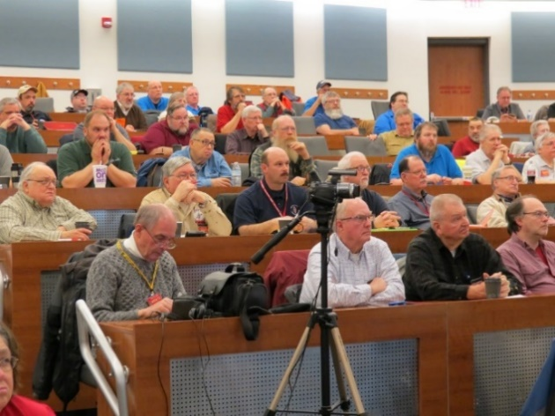Stan is working diligently on the agenda getting great forums arranged and it’s sure to be a really great conference. There’s loads of information for those interested in any part of Ohio’s ARES program.

This is an all-day adventure, but we are in a real college setting with all the amenities that you would expect in a first-class campus. Electric outlets are easily accessible for those bringing laptops and such. WiFi is available and the seats are very comfortable. And… I’ll have some great Give-A-Ways to pass out as well.

Lunch is on you, but the campus is close to many popular fast-food and sit down restaurants. You can even brown bag it if you want to eat on campus.

Certificates for your participation at this conference will be available, so you’ll get some wallpaper suitable for framing to take home with you as well! Now how can you beat that.

Get registered now, seating will become limited quickly! Here’s the link: <http://arrl-ohio.org/SEC/form.html>

***Ohio EMA Now Accepting Safe Room Applications***

For Immediate Release: February 4, 2019

COLUMBUS — The Ohio Safe Room Rebate Program is once again accepting applications. The program provides a rebate for the purchase and construction/installation of tornado safe rooms for Ohio homeowners selected for the program.

TOP^

“The entire state of Ohio is at risk of an EF5 tornado, which produces 250 mile per hour winds capable of destroying most structures,” said Steve Ferryman, Ohio EMA mitigation branch chief. “A safe room is built to withstand these winds and resulting airborne debris and provides near absolute protection for occupants.”

A safe room is an extreme-wind shelter or space that provides protection to people during a tornado. It can be constructed/installed in one of several places in the home: in the basement, beneath a concrete slab-on-grade foundation or garage floor, or in an interior room on the first floor. A safe room may also be buried in the yard or be a stand-alone structure near your home.

Residents selected for the program could be eligible for a rebate up to 75 percent of the cost to install or construct a safe room – up to a maximum of $4,875.

To apply for the Ohio Safe Room Rebate Program, homeowners have until 5 p.m. April 1st to register on the Ohio EMA website: <https://ema.ohio.gov/ema_saferoom/saferoom-concept.aspx>

The Ohio Safe Room Rebate Program will use a computerized random selection process to select applicants. A priority list of applicants will be created from the selected applicants. Chosen homeowners will be notified by e-mail of their position on the priority list on or after April 5th. Ohio EMA anticipates grant funding will become available this year and having a list of participants who meet program requirements will expedite the rebate process.

Funding for the rebate program is through a partnership with the Federal Emergency Management Agency’s (FEMA) Hazard Mitigation Assistance (HMA) grant programs. Safe rooms must meet FEMA requirements in FEMA publications 320 and 361 and cannot be constructed/installed prior to the rebate drawing and notification from Ohio EMA to proceed with construction.

Ohio EMA plans to offer this rebate program on an annual basis. When and if HMA funding becomes available, the amount of funding will determine the number of rebates. If, after visiting the Ohio EMA website, interested people have questions, they should call Dan Clevidence at 614.799.3533.

***National News***

*(from arrl and other sources)*

**FCC Invites Comments on Amateur Radio-Related Petition for Rule Making**



The FCC has invited public comments on a *Petition for Rule Making* ([**RM-11826**](https://ecfsapi.fcc.gov/file/1020726398395/18013004-1.pdf)) from an Ohio radio amateur seeking to amend the Part 97 station identification rules to better accommodate and simplify station identification during an emergency net, drill, or activation. ARRL member Robert A. Dukish, KK8DX, filed the petition in December, and the FCC put it on public notice this week. Dukish seeks a change to Section 97.119(a) of the rules, which requires an amateur station to transmit its “assigned call sign on its transmitting channel at the end of each communication, and at least every 10 minutes during a communication.”

TOP^

He noted that during emergency networks, requiring participating stations — often portable — to use their assigned call signs during each transmission could prove “burdensome and can hinder the flow of emergency traffic on the channel.”

Specifically, he is suggesting that a simple approach would be to permit the net control station or other designated participant to announce from a single point the call signs of every station taking part in the net or exercise, when tactical call signs often are in use, at 10-minute intervals, using automatic CW identification.

Dukish suggested amending Section 97.119(a) to add, “except during a local emergency network activation or drill,” and providing that in such situations, a net control or designations station would be “authorized to announce all participating stations’ assigned call signs at no more than 10-minute intervals while the net is in progress.” The amendment would provide that participating stations “be within a 50-mile distance of the identifying station, and each individual station must self-identify by transmitting its assigned call sign at least once per hour.” CW transmission could be no faster than 25 WPM if sent automatically to satisfy the suggested amendment.

In his petition, Dukish noted petitions filed in 2005 and 2006 seeking changes to the Amateur Radio station identification rules. The FCC did not adopt either proposal.

Interested parties may comment via the FCC Electronic Comment Filing Service ([**ECFS**](https://www.fcc.gov/ecfs/)).

#########

***Riley Hollingsworth, K4ZDH, to Oversee Volunteer Monitors Development and Implementation***

Riley Hollingsworth, K4ZDH, will oversee the development and implementation phases of ARRL's new Volunteer Monitors (VM) program, which will replace the Official Observers (OO) program. Hollingsworth, who once handled Amateur Radio enforcement for the FCC, has stepped down as ARRL Atlantic Division Vice Director to avoid any appearance of a conflict of interest. The development phase of the program is already under way. "I am grateful for the Atlantic Division ARRL members supporting me, but I think I can better serve the Atlantic Division and all ARRL divisions by working in the Volunteer Monitors program," Hollingsworth said in his resignation letter. A new Atlantic Division Vice Director will be appointed.

ARRL President Rick Roderick, K5UR, said that Hollingsworth was the ideal person to lead ARRL's efforts in the development and implementation of this joint program with the FCC. "I support Riley's decision to concentrate his efforts on this very valuable project on behalf of the ARRL," Roderick said.

Approved by the ARRL Board of Directors last July, the Volunteer Monitors will work in cooperation with the FCC. Volunteers trained and vetted by ARRL will monitor the amateur bands for possible instances of misconduct or to recognize exemplary on-air operation.

TOP^

Cases of flagrant violations or noncompliance will be directed to the FCC for action, in accordance with FCC guidelines. The program, which aims to re-energize Amateur Radio enforcement efforts, was proposed by the FCC following the closure of several FCC regional offices and reductions in field staff.

Hollingsworth has identified three phases to the program -- development, solicitation and training, and implementation. The development phase will include drafting a mission statement, clearly defining ARRL's and the FCC's requirements and needs as part of the program, drafting a Volunteer Manager job description, and developing a training manual for volunteers.

The solicitation and training phase will involve identifying the geographical locations where volunteer monitors will be most needed, soliciting applications, and screening applicants. Current Official Observers will be invited to apply for appointment as Volunteer Monitors (VMs). The ARRL Board has expressed its appreciation to the OOs for their dedicated volunteer service over the years.

Implementation will involve having the volunteers provide field reports, and ARRL staff offering guidance to volunteers to ensure that the information gathered meets FCC requirements. Continuing education will be provided to the volunteers as part of the program.

Hollingsworth has committed to ensure training adequacy for new VMs, to review the quality and utility of Volunteer Monitor submissions to the FCC for enforcement action, and to advocate for rapid disposition of cases appropriately submitted to the FCC.

ARRL officials estimate that it will take 9 - 12 months before the first Volunteer Monitors begin filing reports.

#########

***Carol Perry - Educator of the Year***

[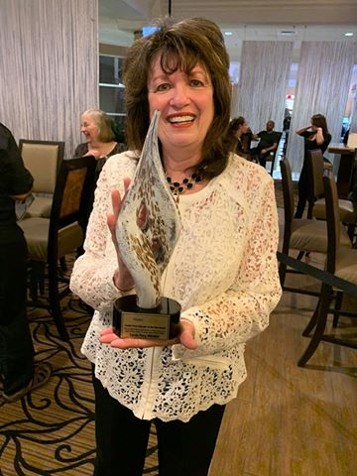](https://www.facebook.com/ARRL.org/photos/pcb.10156375581757408/10156375575237408/?type=3&__tn__=HH-R&eid=ARCo53sDHefvNdwYgqM9JQuyAyT1n9z0xse1DBZIzQoFYmIiytJ-mRvQyG2K2uRS-PxGxNnoH-KHPwa3&__xts__%5B0%5D=68.ARBfy-Qcpxkt2TJZYcWK-DXdHmcOXIG-Kl_jvnKP0u45pRqjGc6QVi_24XnCXbr75rLzTwbw6Y61XzdFht9DPcT4D1s7yhSCzyk0cwvcRs2zgUyniIE0yYxUd8um2GkqVuF4bGD_G1ZqdEtGGH0eT2uZhaNzBBkh0g17VRaTt16xoaXyiaG1B2PqDr_YeAYvTKBKYUfma4znsXZR2tVzoal0cX-z_IHsfQf6GcV-b1qmHbEMoU9H4qiw4MtP3TvsotvPFGHH0nAT90hoOxFZAuWMSNZIMqenRLYROpGD9IgthsuuS4Q2rftme7EJPkjdgwjTkHXntwsUplVXsQ)Congratulations to Amateur Radio educator Carole Perry, WB2MGP, the first recipient of the newly established "Carole Perry Educator of the Year Award" presented by 2019 Orlando HamCation. The award, to be given annually in Perry's name, recognizes outstanding dedication in educating and advancing today's youth about [#HamRadio](https://www.facebook.com/hashtag/hamradio?source=feed_text&epa=HASHTAG&__xts__%5B0%5D=68.ARBfy-Qcpxkt2TJZYcWK-DXdHmcOXIG-Kl_jvnKP0u45pRqjGc6QVi_24XnCXbr75rLzTwbw6Y61XzdFht9DPcT4D1s7yhSCzyk0cwvcRs2zgUyniIE0yYxUd8um2GkqVuF4bGD_G1ZqdEtGGH0eT2uZhaNzBBkh0g17VRaTt16xoaXyiaG1B2PqDr_YeAYvTKBKYUfma4znsXZR2tVzoal0cX-z_IHsfQf6GcV-b1qmHbEMoU9H4qiw4MtP3TvsotvPFGHH0nAT90hoOxFZAuWMSNZIMqenRLYROpGD9IgthsuuS4Q2rftme7EJPkjdgwjTkHXntwsUplVXsQ&__tn__=%2ANK-R). A fellow and director of the Radio Club of America (RCA), Perry is a past Dayton [#Hamvention](https://www.facebook.com/hashtag/hamvention?source=feed_text&epa=HASHTAG&__xts__%5B0%5D=68.ARBfy-Qcpxkt2TJZYcWK-DXdHmcOXIG-Kl_jvnKP0u45pRqjGc6QVi_24XnCXbr75rLzTwbw6Y61XzdFht9DPcT4D1s7yhSCzyk0cwvcRs2zgUyniIE0yYxUd8um2GkqVuF4bGD_G1ZqdEtGGH0eT2uZhaNzBBkh0g17VRaTt16xoaXyiaG1B2PqDr_YeAYvTKBKYUfma4znsXZR2tVzoal0cX-z_IHsfQf6GcV-b1qmHbEMoU9H4qiw4MtP3TvsotvPFGHH0nAT90hoOxFZAuWMSNZIMqenRLYROpGD9IgthsuuS4Q2rftme7EJPkjdgwjTkHXntwsUplVXsQ&__tn__=%2ANK-R) Ham of the Year and a recipient of the [#ARRL](https://www.facebook.com/hashtag/arrl?source=feed_text&epa=HASHTAG&__xts__%5B0%5D=68.ARBfy-Qcpxkt2TJZYcWK-DXdHmcOXIG-Kl_jvnKP0u45pRqjGc6QVi_24XnCXbr75rLzTwbw6Y61XzdFht9DPcT4D1s7yhSCzyk0cwvcRs2zgUyniIE0yYxUd8um2GkqVuF4bGD_G1ZqdEtGGH0eT2uZhaNzBBkh0g17VRaTt16xoaXyiaG1B2PqDr_YeAYvTKBKYUfma4znsXZR2tVzoal0cX-z_IHsfQf6GcV-b1qmHbEMoU9H4qiw4MtP3TvsotvPFGHH0nAT90hoOxFZAuWMSNZIMqenRLYROpGD9IgthsuuS4Q2rftme7EJPkjdgwjTkHXntwsUplVXsQ&__tn__=%2ANK-R) Instructor of the Year Award.

She sits on the RCA Scholarship Committee, and she chairs the RCA Youth Activities Committee, which she established in 2007. She has moderated the Dayton Youth Forum for 31 years.

*(Photo, Bob Inderbitzen NQ1R)*

TOP^

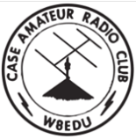***Winter School Roundup Wrap-up***

***Case Amateur Radio Club***

Greetings,

The students from Case Amateur Radio Club operated during School Club Roundup contest recently. For our new club members this was a great way to see the station and meet the club officers!

*********

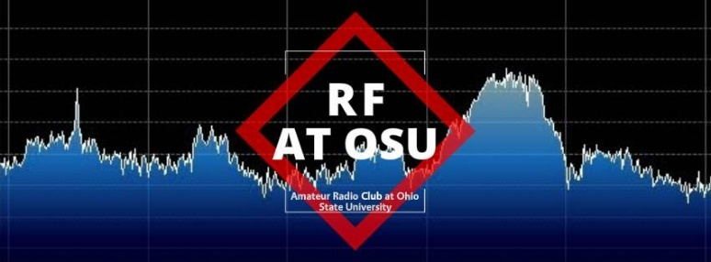***Ohio State University Radio Club***

W8LT, the Amateur Radio Club of The Ohio State University, participated in Winter School Club Round up.

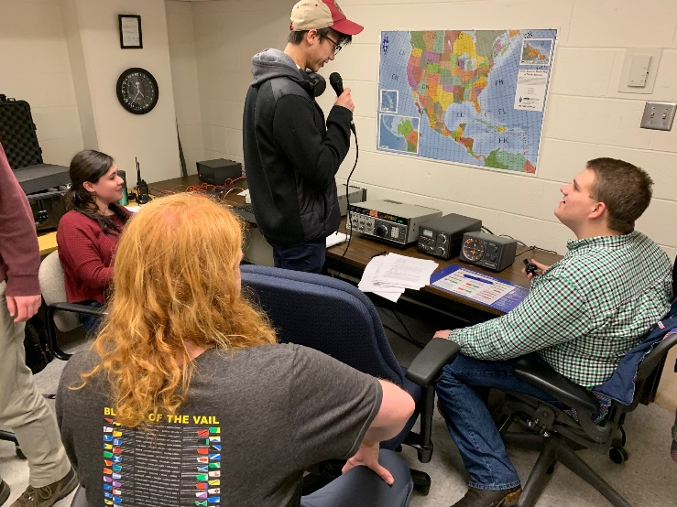

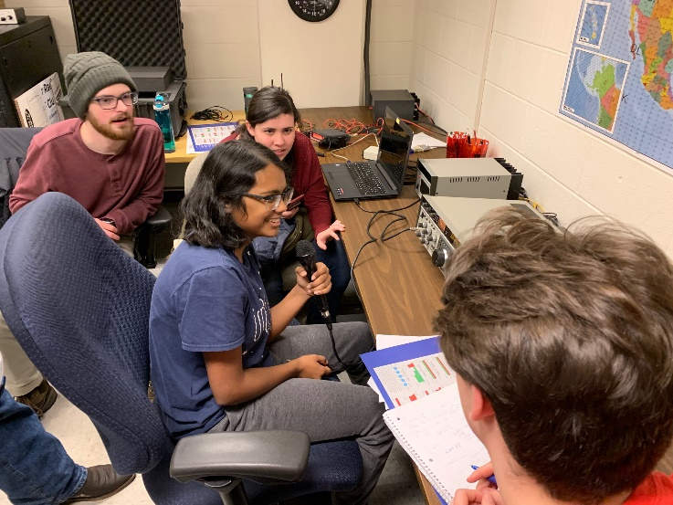

*********

TOP^

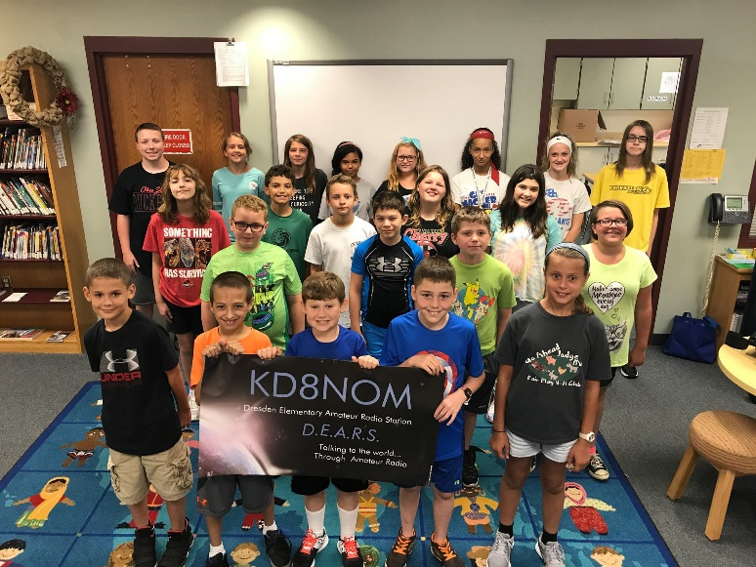 ***Dresden Elementary Amateur Radio Station***

School Club Roundup Day’s End Dispatch

Dispatched on Tuesday, February 12, 2019

Operating Hours: 5.53

Phone Contacts: 228

Current Claimed Score: 30,780

42 States Contacted: Alabama, Alaska, Arkansas, California, Colorado, Connecticut, Florida, Georgia, Illinois, Indiana, Iowa, Kansas, Kentucky, Louisiana, Maine, Massachusetts, Michigan, Minnesota, Mississippi, Missouri, Montana, Nebraska, New Hampshire, New Jersey, New York, North Carolina, North Dakota, Ohio,

Oklahoma, Oregon, Pennsylvania, Rhode Island, South Carolina, South Dakota, Tennessee, Texas, Utah, Vermont, Virginia, Washington, Wisconsin, Wyoming

2 Provinces/Territories Contacted: British Columbia & Ontario

2 Countries Contacted: Aruba & Colombia

7 Clubs Contacted: K3RI, KB8MCA, KC7KFF, KE8BDF, W8CCA, W8MVC & W8ORA

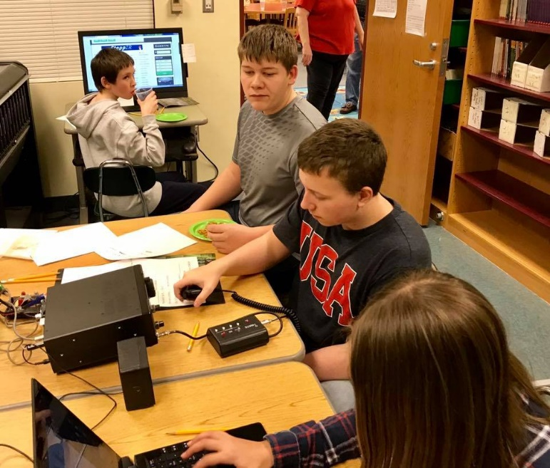15 Schools Contacted: K4NAH, K5LBJ, K5LSU, K9SOU, KF5CRF, KM4RE, KN4BBD, N4GCS, N4SMS, W0WCS, W4DFU, W4LMS, W5AC, W9GRS & W9JWC

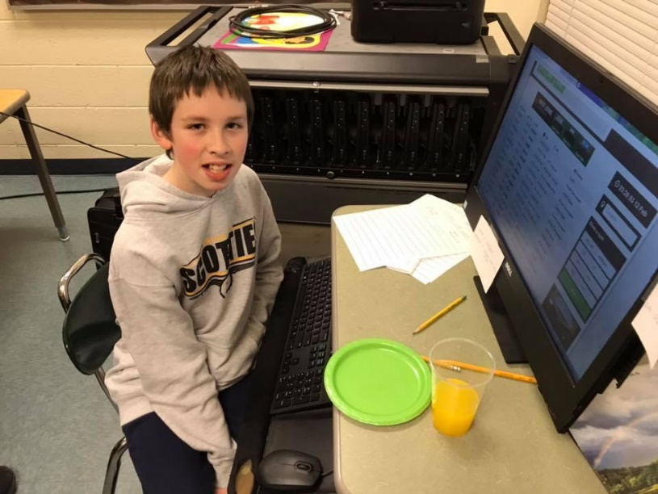

TOP^

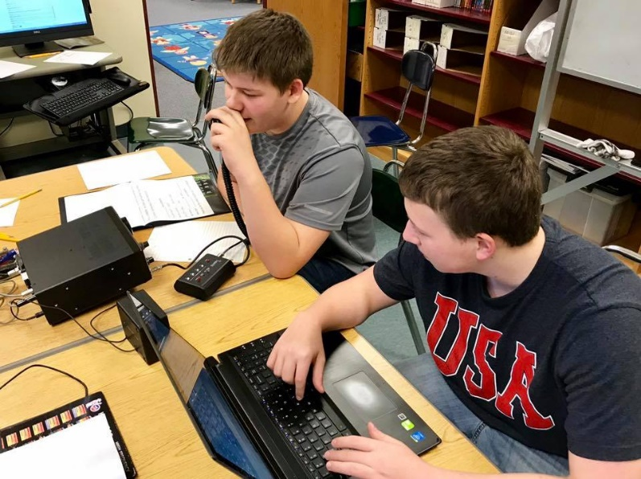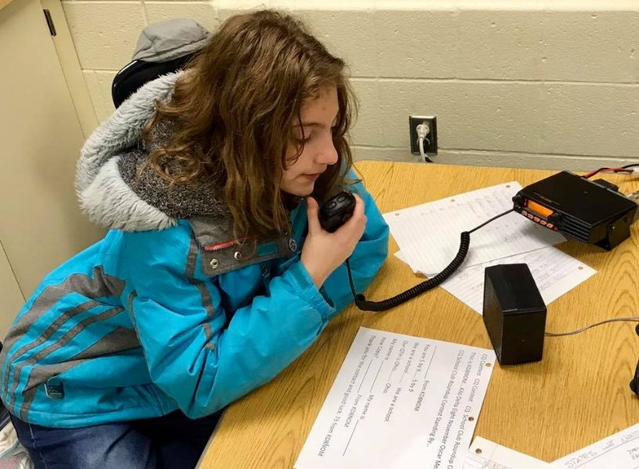

***ARRL-Ohio.org Website Stats***

|  |  |  |  |  |
| --- | --- | --- | --- | --- |
| January 2019 | | | | |
| Unique visitors | Number of visits | Pages | Hits | Bandwidth |
| **5,104** | **10,208** | **776,330** | **3,636,447** | **50.24 GB** |

As you can see, it’s a very busy website indeed! Now, for “kicks and giggles” I started monitoring some other interesting stats about the website as well. Here’s some of the new information that is being logged.

Here’s the Top 10 Downloads for January Devices used to access website

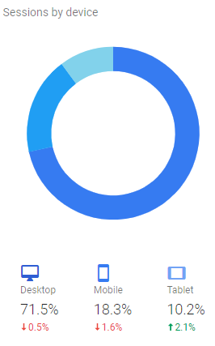

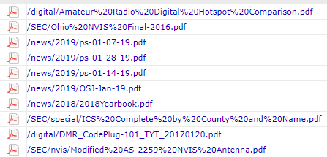

TOP^

Here’s the Top 10 Operating Systems used to access our website

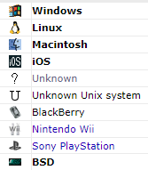

Here’s the Top 10 Browsers used to access our website

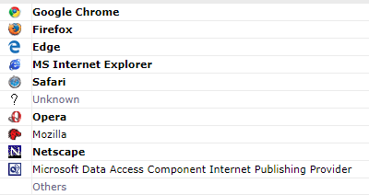

**Jumbo MMDVM Hotspot**

**Mark Haverstock W8MSH**

Over the last few years, several hotspot interfaces have appeared on the market such as DV Mega with Raspberry Pi, DVMega with Bluestack, Shark RF OpenSpot, and DV4Mini. All hovered around the $200+ range, making them a bit pricey for all but the most dedicated digital radio users.

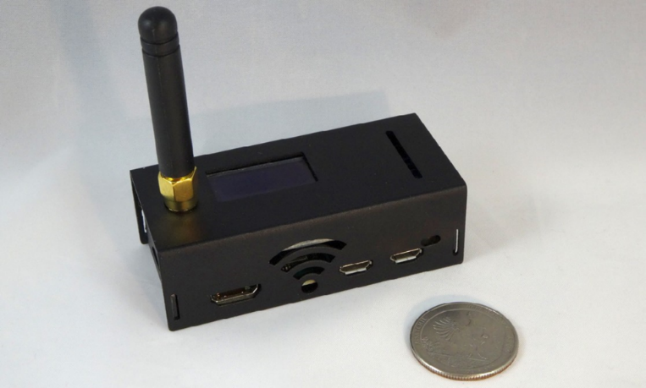Much like the Baofeng invasion, a new wave of digital hot spots manufactured in China is appearing on eBay, Amazon, and other online sites. These Multi Mode Digital Voice Modem (MMDVM) boards are intended to be an inexpensive open-source solution. They utilize the power of an ARM processor and a simple interface board. Combined with Pi-Star software, it will handle most popular amateur digital voice modes.

If you’re not familiar with hotspots, they are an inter- face that allows you to connect to a digital network directly, letting you explore digital radio without having a local digital repeater. There are several types of hotspots available. Some may require your PC or Raspberry Pi interface, others are standalone IP gateways that connect to your Internet router via an Ethernet or Wi-Fi connection.

Hotspots were not developed to replace repeaters, but rather to supplement them. In areas where there is no repeater, a hotspot lets a user connect directly to a digital network via the Internet. In areas of heavy repeater use, a hotspot allows the user to access the digital network without competing for an available time slot.

TOP^

**Generic Solution**

Most reviews cover a specific brand or model. In this case, there are dozens of sellers offering this MMDVM hotspot, otherwise known as the Jumbo Spot or China Spot. They’re all based on the same open-source hardware and software and virtually identical down to the aluminum case design. You may find some minor variations in the Pi hat and Raspberry Pi used, but the setup and functions are very similar.

This ready-to-use multimode Hotspot supports D-STAR/P25/DMR/NXDN/POCSAG and Yaesu System Fusion. You can buy them inexpensively from Alibaba, provided that you don’t mind waiting a few weeks for it to arrive from China. The one shown in this article is sold by Shenzhen HKCNMA Co., Ltd. on Amazon. I purposely bought it from Amazon because they’re a US-based merchant—in the event there’s a problem, it’s easy to return. Before you buy, determine if the seller offers support, a plus if you have questions or something goes wrong. This is especially helpful if you’re new to digital operation.

This package came with a Raspberry Pi Zero, MMD- VM hotspot board with OLED display, aluminum case, Pi Star software on microSD card, and 433 MHz antenna—assembled and ready to set up. You can also purchase the components in ready-to-assemble kits, including all boards and a case. One item not included is a 5-volt DC power supply. A quality mobile phone charger or a USB cable connected to your desktop computer or laptop works well. Mine came with a standard USB to mini USB cable which I plugged into the computer to provide power.

**Wi-Fi Connection**

There are a few things you should know before you get started. The hotspot device uses 2.4 GHz Wi-Fi to connect to the Internet—it does not recognize 5 GHz. Keep this in mind when you attempt to connect your hotspot. Internet Wi-Fi sources for the hotspot can be a smartphone capable of Internet/Wi-Fi sharing or a home/business/hotel Wi-Fi access point/router. It is important to note that the MMVDM Wi-Fi will not work with the WEP (Wired Equivalent Privacy) security protocol—make sure your Wi-Fi is WPA (Wireless Protected Access). The hotspot is slow booting up, so don’t be surprised if the display doesn’t light up for a minute or two.

The first thing you need to do to make the hotspot operational is to access the Pi-Star dashboard from your computer. There are several recommendations on how to accomplish

this. Jumbo Spot is already configured with a sample net- work, and many of the sellers suggest you reconfigure your home network with their “sample” SSID and password to make the initial connection to the dashboard to configure the hotspot Wi-Fi settings and then change your network back. This method is a pain, especially when others in your house- hold are using the network.

I found the easiest method was to go to [**https://www.**](https://www.pistar.uk/wifi_builder.php)[**pistar.uk/wifi_builder.php**](https://www.pistar.uk/wifi_builder.php)and use the page to generate

a downloadable config file. Remove the SD card from the hotspot and plug it into the computer. Once you generate the file, drop it onto the “Boot” volume of your Pi-Star SD card. Once the Pi-Star system boots up, it will add the config file for the Wi-Fi and reboot. In the event the Jumbo doesn’t find your wireless net- work, it will create its own access point named P-Star Setup. Look for it in your wireless network and log-on using the password “raspberry.”

TOP^

It’s also possible to connect directly to the hotspot, though I wouldn’t recommend it unless you’re very familiar with Raspberry Pi boards. The Jumbo spot includes a second mini-USB port and HDMI output that can interface with a keyboard and monitor.

**Dashboard Configuration**

Once the hotspot has found your local network, it’s time to access the dashboard. Open your browser and go to [**http://**](http://pi-star.com/)[**Pi-Star**](http://pi-star.com/)to access the dashboard and choose the configuration option. There are several distinct sections, such as host and general configuration, as well as those for each mode. Mine was already configured with sample data from a UK station. You need to update with your own information and click “apply changes” for each section as you complete it. Configuration isn’t complicated, but it is lengthy. If you’re not familiar with such settings as host, gateways, digital networks, or other items on the configuration page, you may want to look at these sites and videos for detailed instructions, explanations, and help:

[**https://amateurradionotes.com/pi-star.htm**](https://amateurradionotes.com/pi-star.htm)[**http://www.k9npx.com/2018/03/how-to-setup-your-**](http://www.k9npx.com/2018/03/how-to-setup-your-hotspot.html)[**hotspot.html**](http://www.k9npx.com/2018/03/how-to-setup-your-hotspot.html)[**https://www.youtube.com/watch?v=DDZMY_6qjjI**](https://www.youtube.com/watch?v=DDZMY_6qjjI)[**https://www.youtube.com/watch?v=bSK_7Qo_S1U**](https://www.youtube.com/watch?v=bSK_7Qo_S1U)

Probably the most asked configuration question is what radio/modem should I select in the pi-star config? Select “STM32-DVM / MMDVM_HS - Raspberry Pi Hat (GPIO).”

Once you’ve done the basic setup, you can choose among the different digital modes you want for your hotspot.

**Using the Interface**

The device is designed and intended for short range communications—100 yards or so. It runs at about 10 mw of power but replacing the supplied hotspot antenna with an HT antenna that has a bit of gain will always help. Set your radio to low power, since that’s all you’ll need to maintain a connection. The Jumbo Spot covers my house and adjacent yard areas without any problems.

If you live in an apartment or under HOA restrictions where you can’t have an antenna, this little device can help you make worldwide contacts from home. It’s also portable enough that you can hook it up to a battery pack and take it with you to operate using a cell phone as a Wi-Fi hotspot.

Before you can transmit on the DMR network you must request, at no cost, a DMR ID. You’ll need this for both your DMR radio and hotspot if you don’t already have one. This can be done through the Radio ID website: [**https://www.**](https://www.radioid.net/)[**radioid.net**](https://www.radioid.net/)and at the top of the page click on “Register.” Agree to the “Terms and Conditions” and click the green “Register” button. Follow the instructions to register for a DMR ID. It may take from several hours to a few days to receive your ID.

I set up my Jumbo Spot for both DMR and Yaesu System Fusion (YSF) and returned to the Pi-Star Dashboard. After the unit booted up, I noticed several YSF stations appeared on the display. Using an FTM-100DR on low power with a dummy load, I was able to listen and contact several stations throughout the USA. Audio was very good on both transmit and receive. After setting up my MD-380, I proceeded to listen to several Talk Groups on DMR and put out a call or two. Again, the audio was very good on transmit and receive with no issues or surprises.

There are a few quirks that DMR newbies need to know about. Although the Internet is fast, it is not instant.

TOP^

Your audio is digitally processed in your handheld, forwarded to the repeater, then to the c-Bridge server to worldwide servers where it is distributed. The process is then reversed before it is delivered to the receiving station. This causes latency, a delay of your signal getting to the other end by as much as two seconds. For this reason, it is a good idea to pause for two or three seconds before making a return transmission to give a breaking station a chance to enter.

You may need to bring up a talk group (TG) before you can monitor or use it. A full time (FT) group is one that is always available for monitoring. If the FT talk group be- comes active, you will hear the traffic immediately. These are normally local and state groups.

A push-to-talk (PTT) is one that requires activation and will only stay open for a predefined amount of time. These would be your high traffic groups, such as Nationwide, Worldwide, etc.

To activate these groups, a quick press of the PTT is required (yes, it’s like Ker-chunking a repeater, but is standard practice.) The TG will remain active for a given amount of time after your last PTT. It will then release the time slot (TS) for other users. Only one TG can be open at a time for each TS.

**Impressions**

One of the shortcomings of this and other “new” hotspot offerings from China is a lack of clear and specific instructions. The hotspot came with a half-sheet of instructions which were somewhat difficult to understand, especial- ly for a newbie. Seller support ranges from almost nonexistent to good. Fortunately, you can contact this particular seller for technical support, and they will respond.

The tradeoff for the inexpensive price of most of these units is that you’ll probably need to consult some additional resources, such YouTube videos or web articles from trail- blazers who have already worked through the setup process. One time-saver on this particular hotspot is the Pi-Star software that comes preloaded on a Micro SD card from most vendors, making it all the easier to use and tweak to your own specific needs and uses. Once Pi-Star is installed, updates can be done easily through the setup menu.

It is tiny–2 7/8 x 1 1/4 x 7/8-inches and weighs about two ounces. Portability is a distinct advantage, making it easy to pack and go with a digital HT. All it needs is a good 5-volt DC power supply and a Wi-Fi connection. The display is small at 1 inch, measured diagonally, but you can get a larger Next ion display with case for less than $30 and add it to the Pi hat by attaching four wires. Considering the price, size, and versatility of the Jumbo Spot, it’s a relative bargain compared to the current competition on the market. This unit worked without issues after basic setup. You can buy a completely assembled unit for around $100 or assemble from scratch for about half that amount.

Additional sources for MMDVM hotspot/ DMR information: MMDVM groups: [**https://groups.io/g/MMDVM/topics**](https://groups.io/g/MMDVM/topics)[**https://forum.pistar.uk**](https://forum.pistar.uk/)

DMR network basics [**http://www.miklor.com/DMR/ppt/**](http://www.miklor.com/DMR/ppt/DMR-BasicTutorial.pdf)[**DMR-BasicTutorial.pdf**](http://www.miklor.com/DMR/ppt/DMR-BasicTutorial.pdf)

Netwatch–allows you to view DMR network activity real time. [**http://cbridge.wr3irs.com:2135/MinimalNetwatch**](http://cbridge.wr3irs.com:2135/MinimalNetwatch)

TOP^

***Final.. Final..***

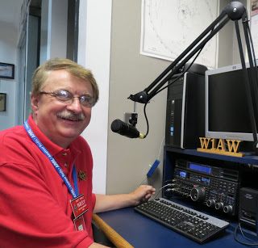

Hey Gang...

I had a blast this past week visiting with many of you at your meetings. This week I got to make a special presentation, the Alliance Amateur Radio Club renewed its SSC and I got to present them with their new certificate all framed and ready to hang on the wall! I also got to talk with a lot of you at the Mansfield Hamfest along with Dale, WA8EFK our Great Lakes Director. We both had a blast shaking hands and getting to talk one-on-one with all of you.

Now, I do want to remind everyone that you can do a little extra publicity for your club meetings and activities just by having your ARES Connect Administrator add it to the calendar!

For those clubs that use Google Calendar or any web-based calendar program that incorporates RSS feeds, you can easily add ARES Connect events to it!

Yes, you can now see all the events, including your own club activities on your calendar! Oh, if you don’t use Google Calendar, do you use Outlook or other similar Office Suite programs that has a calendar built in? If you do, then you can even add the ARES Calendar to that as well. This is extremely useful if you are in the field where Wi-Fi isn’t available. If you are interested in how you can do this, just ask me. I will show you just how easy it is. Oh, there is just one little requirement to be able to do this, you have to be registered in ARES Connect in order to gain access to this feature.

Now speaking on the idea of being registered in ARES Connect yet, have you? If you haven’t you really need to do it now. For your administrators out there, things will be changing in the system and from what I know right now, it will make your job a lot easier as well. Yes, things aren’t quite the way we want them yet, but they will be getting better, and the system will be a lot easier to use when these changes happen.

Do you have the 3 days in May (17-18-19) marked on your calendar yet? This year Dayton will also be ARRL’s National Convention and that will definitely mean that there will be some very special things happening at Hamvention that you won’t want to miss out on that for sure!

I’ve had some updates on the website this week. Thanks to Daniel, KB8LKH we now have another update for his Code Plugs for the AT-D868UV and the CS-800D DMR radios.

Whelp… That’s going to do it for this time around. Stay safe, stay warm, and most of all… have FUN!!

73, and stay warm!!!

***Scott, N8SY***

TOP^

***What's the Meaning of Presidents' Day?***

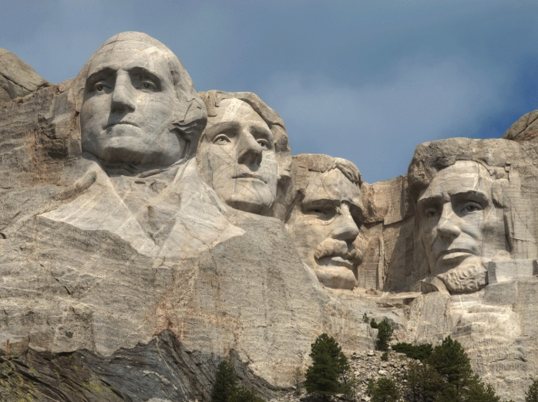We learned about it in school, didn’t we? Presidents’ Day…it has to do with U.S. Presidents? Something about birthdays? Yes, to all of the above. Let’s delve into our nation’s history and demystify this February holiday once and for all.

Each year on the third Monday of February, we celebrate Presidents’ Day in the U.S. The holiday was established by Congress to recognize the birthday of our first President, George Washington, who was born in Virginia on February 22, 1732. The holiday originally was established in 1855 and was celebrated on February 22 each year. Many states also celebrated the birthday Abraham Lincoln, the 16th President of the United States, in conjunction with Washington’s birthday. Lincoln was born in Hodgenville, Kentucky, on February 12, 1809.

In 1968, however, the date of Presidents’ Day was changed in order to align more federal holidays with Mondays—and, therefore, create more three-day weekends. (We have the [Uniform Monday Holiday Act](http://www.presidency.ucsb.edu/ws/?pid=28963), which took effect in 1971, to thank for those long weekends—and the [road trips](https://www.southernliving.com/travel/southern-road-trip-ideas) we plan in conjunction with our Memorial Day and Veterans Day [holidays](https://www.southernliving.com/travel/holiday-travel-tips).) The reasoning for the act—which was *H.R. 15951* and is now*Public Law 90-363*—reads, “This will mean a great deal to our families and our children. It will enable families who live some distance apart to spend more time together. Americans will be able to travel farther and see more of this beautiful land of ours.”

The Uniform Monday Holiday Act also established Columbus Day as a U.S. Federal Holiday, proclaiming, “This new holiday will henceforth honor one of our finest and most cherished national characteristics—our ability to live and work together, men and women of all national origins, as one united and progressive nation.”

***Murphy’s Law***

* A hardware failure will cause system software to crash, and the customer engineer will blame the programmer.
* A system software crash will cause hardware to act strangely and the programmers will blame the customer engineer.
* Undetectable errors are infinite in variety, in contrast to detectable errors, which by definition are limited.
* Make it possible for programmers to write programs in English, and you will find that programmers cannot write in English.

TOP^



***Back Issues of the PostScript and Ohio Section Journal (OSJ)***

Hey, did you know that PostScript and Ohio Section Journal (OSJ) are archived on the website? You can go back and look at any edition simply by clicking:

<http://arrl-ohio.org/news/index.html>

TOP^

***Chit – Chat, and All That!***

Do you know someone that’s not getting these Newsletters? Please, forward a copy of this Newsletter over to them and have them “[Opt-In](http://arrl-ohio.org/forwarder/forwarding.html)” to start receiving them. Heck, just have them send me an email [n8sy@n8sy.com](mailto:n8sy@n8sy.com) and I’ll get them added to the Ohio Section Emailing list. We now have over 7,000 folks receiving these newsletters weekly. Quite impressive, I’d say!



I urge all of you to make sure that everyone, regardless of whether they are a League member or not, get signed up to receive these weekly Newsletters. You can always “[Opt-Out](http://arrl-ohio.org/forwarder/forwarding.html)” at any time if you feel this is not what you were expecting. It’s fun and very informative.

Hey, did you know that PostScript and Ohio Section Journal (OSJ) are archived on the website? You can go back and look at any edition simply by clicking:

<http://arrl-ohio.org/news/index.html>

The pictures throughout this newsletter are from various sources. Take a good look at them, you just might be in one of those pictures! “SMILE…!!!!!”

Got questions, concerns or would just like to sit and chat awhile? Heck, I’ll even buy the coffee!! Give me a call at (419) 512-4445 or email me at: [n8sy@n8sy.com](mailto:n8sy@n8sy.com)

TOP^

*The Ohio Section Journal (OSJ) is produced as a comprehensive look at all the programs within the Ohio Section. I sincerely hope that you have enjoyed this edition of the OSJ,* *and will encourage your friends to join with you in receiving the latest news and information about the Ohio Section, and from around the world!*