***[](http://arrl-ohio.org)Merry***

***Christmas***

***Edition!!***

|  |  |
| --- | --- |
| 🡪 From the Technical Coordinator | **🡪** From the Section Emergency Coordinator |
| 🡪 From the Affiliated Club Coordinator | **🡪** From the Public Information Coordinator |
| 🡪 From the Section Traffic Manager | **🡪** From the Section Youth Coordinator |
| 🡪 From the ASM | **🡪** ARES Training Update |
| 🡪 National News | 🡪 The Handbook Give Away |
| 🡪 Club Corner | 🡪 Hamfests |
| 🡪 DX This Week | 🡪 VE Testing |
| 🡪 One Question Questionnaire | 🡪 ARES Connect |
| 🡪 Final.. Final.. | |

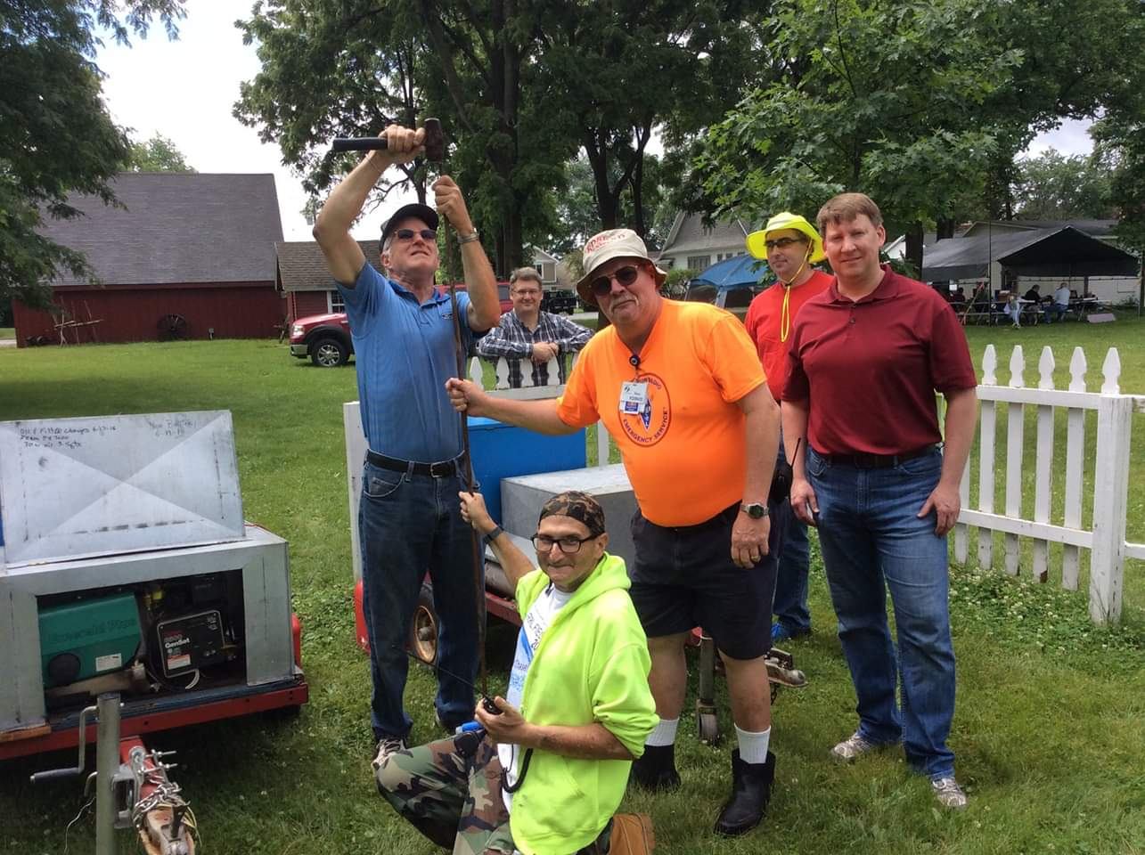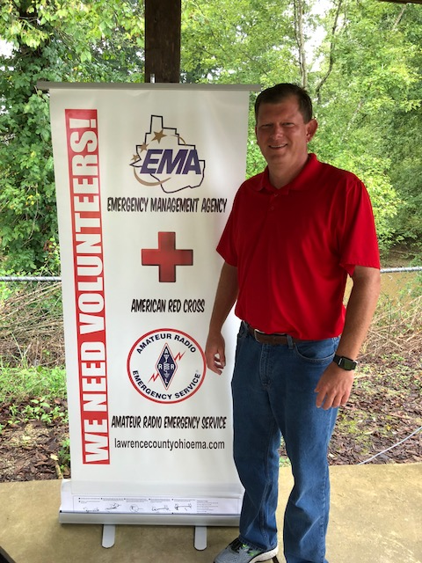

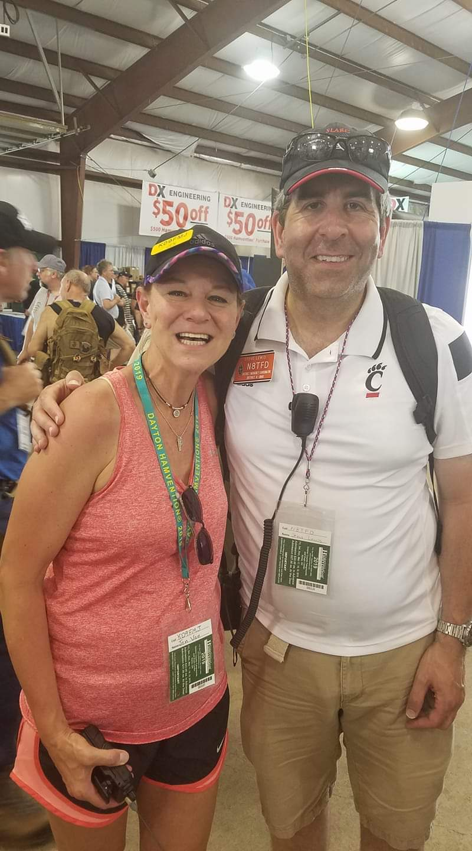

***From the Technical Coordinator***

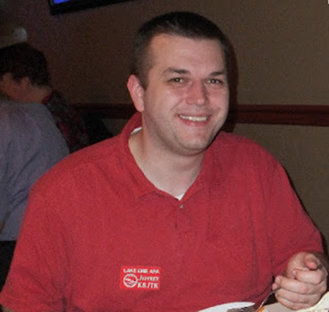***Jeff Kopcak – K8JTK TC***

[k8jtk@arrl.net](mailto:k8jtk@arrl.net)

Hey gang,

‘Tis the season for … regulation. The FCC and ARRL have been quite busy with proposed and amended changes affecting Part 97. Both organizations take on proposed changes brought by technical requirements, additional research, lobbying organizations (commercial and private), other laws/regulations, and of course, other hams. The FCC publishes proposed rules and invites the general public to comment on changes. Comments help decide if the FCC should enact a proposal. Once again, our allocations are under scrutiny and attack.

FCC WT Docket 19-348 and WT Docket 19-138 seeks to change 3 GHz and 5.8 GHz allocations. Nearly all allocations for the Amateur Radio Service above 220 MHz are on a secondary basis. [Secondary allocations](https://www.fcc.gov/engineering-technology/policy-and-rules-division/radio-spectrum-allocation/general/table-frequency) are services allowed to use the same frequency range as a primary user. A secondary user cannot cause harmful interference to primary users and cannot claim protection from primary users. Protection can only be claimed by the same or other secondary services. WT Docket 19-348 seeks to eliminate the secondary allocation of the Amateur Service on the 3 GHz frequency range. WT Docket 19-138 seeks to modify primary usage on the 5.8 GHz bands. Though not eliminating the Amateur Service secondary allocation, this would affect and restrict secondary usage.

What’s in those frequency ranges? Primarily WiFi networks. [5 or 5.8 GHz](https://en.wikipedia.org/wiki/List_of_WLAN_channels#5_GHz_or_5.8_GHz_(802.11a/h/j/n/ac/ax)), commonly referred to as 5 GHz WiFi (not to be confused with the mobile broadband 5G standard) or the commonly known standard, 802.11ac. Consumer WiFi in both 2.4 GHz and 5 GHz are [unlicensed ISM spectrum](https://en.wikipedia.org/wiki/ISM_band) meaning you don’t need a license from a regulatory agency to use that spectrum. This is the reason you don’t need a license to operate a WiFi router or hotspot where a laptop, mobile phone, or Internet of Things device would communicate with a wireless network or the Internet. The 3 GHz spectrum is also used to create wireless networks but does require a license in other to operate. Our allocation (3.3 - 3.5 GHz, or 9-centimeter band) is just below commercial WiFi but the same equipment is modified for amateur use.

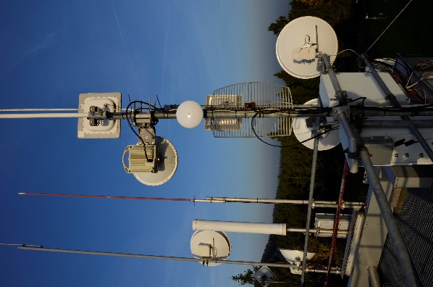

HamNET Mesh (Wikipedia)

This Notice of Proposed Rulemaking (NPRM) is in response to the [MOBILE NOW](https://www.congress.gov/bill/115th-congress/senate-bill/19) (Making Opportunities for Broadband Investment and Limiting Excessive and Needless Obstacles to Wireless) act passed by Congress to make new spectrum available for fixed and wireless broadband, aka your mobile phone and 5G devices. From the introduction to [docket 19-348 by the FCC](https://docs.fcc.gov/public/attachments/FCC-19-130A1.docx), “By proposing to delete the existing non-federal secondary allocations from the 3.3-3.55 GHz band in the Table of Frequency Allocations, we are taking an important initial step towards satisfying Congress’s directives and making as much as 250 megahertz of spectrum from this band potentially available for advanced wireless services, including 5G, the next generation of wireless connectivity.”

TOP^

“Currently, the entire 3.1-3.55 GHz band is allocated for both federal and non-federal radiolocation services, with non-federal users operating on a secondary basis to federal radiolocation services, which have a primary allocation.”

“Needless Obstacles” are apparently Amateur Radio and using that space to build out high speed networks to support Emergency Operations Centers (EOCs), non-governmental agencies (NGO), and first responders. Most notable use of the 3 GHz spectrum for Amateur Radio has been pioneered by the AREDN (Amateur Radio Emergency Data Network) group which came out of an ARRL group on High-Speed Multimedia (HSMM). For more than a decade, AREDN has developed software for a large number of commercially available wireless devices, in the $45-$95 range, allowing operation in Part 97 allocations including 900 MHz, 2, 3, and 5 GHz bands. Commonly referred to in the ham community as “Mesh” networking, these devices utilize the same protocols used on the Internet allowing served agencies connectivity to Internet-based services. Independent of Internet infrastructure, they can additionally provide video, email, voice, and chat service when the Internet is not available.

Though the proposal offers re-locating secondary services, the AREDN project has [posted their response to these proposed changes](https://www.arednmesh.org/content/call-action-defense-part-97-allocations) citing such a move “would be difficult if not impossible without a complete redesign, manufacture, purchase, and installation of new custom Amateur hardware and software… raising the price out of reach for the typical ham.” The [ARRL news posting](http://www.arrl.org/news/fcc-formally-adopts-proposals-to-remove-amateur-3-ghz-band-invites-comments) includes information on how to file a comment on the proposal at the end of the article. [An earlier post from the ARRL](http://www.arrl.org/news/arrl-to-oppose-proposal-to-eliminate-3-3-3-5-ghz-amateur-allocation) indicates the changes also affect satellite operations in the 3.40 – 3.41 GHz segment.

Obviously, I’m against commandeering bands and spectrum of the Amateur Radio Service. Trying to lessen the impact by seemingly providing good-will relocation assistance always comes with catches and gotchas, not-to-often many benefits. Many outlined in the AREDN post. Contributions are always of question of when, how much, and how far will it go. It’s unlikely they’re going to make any manufacturing contributions to redesign and sell new equipment at a reasonable price. Prices for mesh equipment is reasonable because of commercial interests in the [3.65 GHz licensed WiFi band](https://en.wikipedia.org/wiki/List_of_WLAN_channels#3.65_GHz_(802.11y)). Not to mention time invested by volunteers to develop mesh technology hams have available today. Please consider commenting on the proposal or support the [ARRL Spectrum Defense Fund](http://www.arrl.org/spectrum-defense-fund) which takes on challenges such as these and protects our operating privileges.

I’ve been in favor of the symbol rate elimination from Part 97 and adopting bandwidth limitations of 2.8 kHz on HF band data emissions – though I would like to see bandwidth limitations set across the board. Arbitrary [low] baud rates are not allowing experimentation of more innovative and spectrally efficient digital modes, and curtail experimentation with modes that can transfer the same data at a much faster rate. [The ARRL has renewed its request](http://www.arrl.org/news/arrl-renews-request-for-fcc-to-replace-symbol-rate-with-bandwidth-limit) to delete the HF symbol rates and adopt the 2.8 kHz bandwidth requirement.

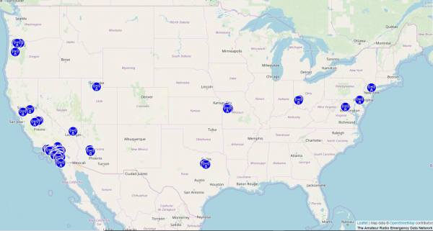

3 GHz AREDN mesh nodes (AREDN)

[The ARRL believes a proposal filed by New York University](http://www.arrl.org/news/arrl-asks-fcc-to-dismiss-petition-seeking-declaratory-ruling-on-encoded-message-rule) (NYU) would add further uncertainly to Section 97.113(a)(4) - prohibiting “messages encoded for the purpose of obscuring their meaning.” In relation to the deletion of symbol rates, the NYU proposal seeks to adopt language the ARRL feels could weaken the prohibition of encrypted messages.

TOP^

The wording “effectively encrypted or encoded messages, including messages that cannot be readily decoded over the air for true meaning.” The League has an issue with the wording “effectively encrypted.” “ARRL said that adding the word “effectively” would make the definition even more vague by including all encoded messages plus an additional set of undefined messages, the extent of which is unknown.” It has asked the FCC to [dismiss the NYU petition](http://www.arrl.org/files/media/News/ARRL%2016-239%2012-02-2019.pdf).

The issue of encryption will continue to be a hot-button issue and will be as heated as it has become among scanner enthusiasts when disusing encryption on public safety radio systems, if not more. I completely understand and fully support the openness and transparency of Amateur Radio. However, I think there are a few issues we, as hams, need to have very solid responses when encryption comes up in discussion and in competition with other sources.

The first is privacy and security. More laws are being passed such as [GDPR](https://en.wikipedia.org/wiki/General_Data_Protection_Regulation) in Europe. It is mandated regulation around the privacy and protection of European Union citizens including data collection, retention, disclosures – and encryption standards. On the heels of that regulation, many states have passed similar laws mirroring those compliance requirements. I see us (hams) sitting at the table with served agencies. Some representative has mandated some form of encryption on network links and retaining control of data. Is ham radio now off the table? Probably depends on the wording. What is our answer when commercial entities are pushing their “first responder” networks and reserved bandwidth that can offer data encryption and protection? Is the expectation of coding patient data into TAG IDs good enough? Does it keep ham radio relevant because we can’t offer encryption and why? Proposals to modify the obfuscation requirements of Part 97 have pointed to such requirements or potential requirements by served agencies. I guarantee we have not seen the last of these arguments.

Experimentation side of ham radio is another issue. I have seen the maker movement as a way to bring younger and like-minded people into the hobby. If these technically minded individuals are experimenting with technologies that probably offer some form of encryption by default, how can ham radio win at this argument? Why would they choose a non-encrypted method when there are readily available encryption methods and they are becoming the foundation for newer technologies? Maybe the thought of being able to use higher power or not as crowded spectrum might be an incentive. To me, it’s not an issue of ‘what are they hiding’ or ‘why do they need encryption.’ Technical (ie: Information Technology, I.T.) professionals are opting for security and encryption instinctively. Technical individuals and the industry have conditioned average users to look for secure options such as checking for the green lock on websites and using “secured” WiFi networks. Vint Cerf, considered to be the father of the Internet, reflected on the progression of the Internet [by stating](https://www.theregister.co.uk/2014/04/07/internet_inception_security_vint_cerf_google_hangout/) “If I could start over again I would have introduced a lot more strong authentication and cryptography into the system.” How would that have affected ham radio TCP networks? Maybe those who would utilize ham radio for their experimentation purposes just don’t want someone else peering into their information exchange or use it as a method of authentication, not necessarily hiding something.

In a devil maybe in the details change, the FCC modified Part 97 RF exposure safety rules. Current safety limits will remain unchanged. The amateur-specific exemption from having to conduct an RF exposure evaluation will be replaced by the FCC’s general exemption criteria. Certain stations are exempted from having to conduct evaluations based only on power and frequency. The Commission indicated that if the source was excluded from routine evaluations under the old rules, they will be exempt under the new rules. From the [ARRL news release](http://www.arrl.org/news/fcc-amending-amateur-radio-rf-exposure-safety-rules): “For applicants and licensees in the Amateur Radio Service, we substitute our general exemption criteria for the specific exemption from routine evaluation based on power alone in Section 97.13(c)(1) and specify the use of occupational/controlled limits for amateurs where appropriate,” the FCC said.

TOP^

“RF exposure of other nearby persons who are not members of the amateur licensee’s household must be evaluated with respect to the general population/uncontrolled exposure limits. Appropriate methodologies and guidance for evaluating Amateur Radio Service operation is described in the Office of Engineering and Technology (OET) [Bulletin 65, Supplement B](https://transition.fcc.gov/bureaus/oet/info/documents/bulletins/oet65/oet65b.pdf),” the revised rule concludes. Further review by ARRL technical, legal staff, and ARRL RF Safety experts is needed to determine any changes in requirements.

In 2017, Norway was the first country to [shut off FM broadcasts](https://www.theguardian.com/world/2017/dec/13/norway-becomes-first-country-to-end-national-radio-broadcasts-on-fm) in favor of [Digital Audio Broadcasting](https://en.wikipedia.org/wiki/Digital_Audio_Broadcasting) (DAB). In North America, we use the [HD Radio](https://en.wikipedia.org/wiki/HD_Radio) standard. Not amateur related, but interestingly the FCC is [seeking comments](http://www.arrl.org/news/fcc-invites-comments-on-digital-am-broadcasting-proposal) on a NPRM allowing AM broadcasters to voluntary change to an all-digital broadcast. “We tentatively conclude that a voluntary transition to all-digital broadcasting has the potential to benefit AM stations and provide improved AM service to the listening public,” the FCC said. “We seek comments on proposed operating standards for all-digital stations and the impact of such operations on existing analog stations and listeners.” We’ll see where this goes. This maybe an incentive for low-power AM stations to move to HD Radio. I didn’t think there were many AM HD Radio stations. This was confirmed by [HD Radio - Find Stations](https://hdradio.com/stations/) that indicated there were about a half-dozen total in the major cities of Ohio. I also wonder how HD Radio will work with signal fading or can it be received at a great distance from cities like Chicago, New York, or Nashville. Instead of being able to receive AM radio with a crystal set or HF radio, you might need a computer for some stations in the near future.



(Wikipedia)

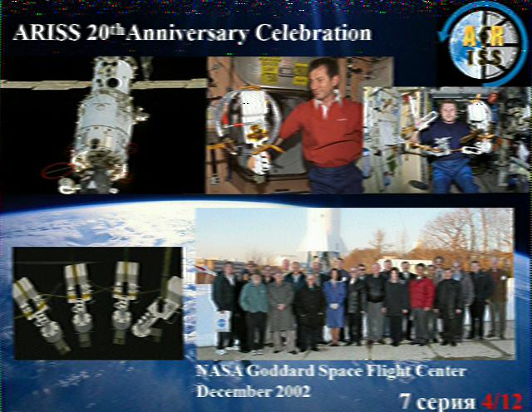I usually don’t get to publish ISS Slow-Scan TV events in advance because they are often last minute and at the mercy of crew availability. There was an announcement of a [possible SSTV event](http://forums.qrz.com/index.php?threads/possible-ariss-sstv-operation-before-years-end.684457/) starting December 27 or 28 of this year. No special setup is required to copy images, even an HT can be a crude way to receive. To receive the best images, Yagi antennas on a tracking tripod is best. I just use my external VHF antenna and let the computer listen for transmissions. To receive SSTV images, the popular choice for Windows is [MMSSTV](https://hamsoft.ca/pages/mmsstv.php) and [QSSTV](http://users.telenet.be/on4qz/qsstv/manual/index.html) for Linux. Tune a radio to 145.800 MHz FM and wait for the ISS images to appear on screen. I have tutorials available to help get your [station setup](http://www.k8jtk.org/2015/04/16/radio-interface-setup-for-getting-started-with-ham-radio-sound-card-digital-modes/) and [get started with MMSSTV](http://www.k8jtk.org/2015/04/16/getting-started-with-mmsstv/) for more details on receiving images.

Thanks for reading. Happy holidays, Merry Christmas, and Happy New Year!

**73… de Jeff – K8JTK**

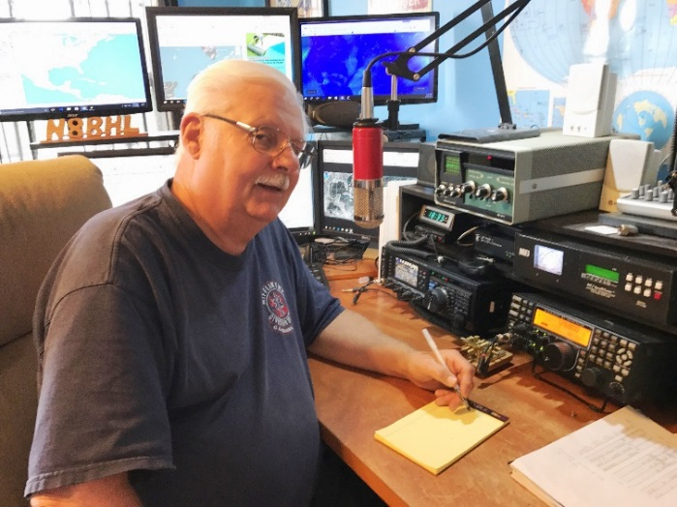***From the Section Emergency Coordinator***

***Stan Broadway, N8BHL - SEC***

[broadways@standi.com](mailto:broadways@standi.com)

***Mark your calendars***

We’re already underway planning events for 2020 in ARES.

First, mark **January 11**, a Saturday, as the Ohio ARES VHF Simplex Contest.

TOP^

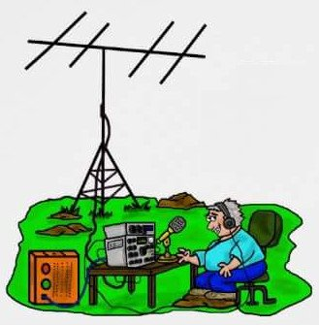This is designed to be a fun operating event (with civilized hours! 10AM – 4PM) that has a deeper significance. The contest is for more than VHF – we are open to six meters and above. We add an incentive to play on six meters by offering 10 points per QSO! This band has some potential, I think, in emergency and statewide communication that is overlooked. As last year, we’d like to find out more about its use. Of course, the primary concern is VHF simplex, since that is by far the widest used band segment. Thanks to Jason we even have a web page outlining the event! Find the rules, enter where you’ll be operating, and find where others will be on air for the event! <http://www.ohsimplex.org> There’s even a countdown clock!

So, what’s the deeper meaning of all this? Remember in the SET we were dealing with an extended power outage… something that in Ohio we might likely face after a big snowstorm, or summer of tornadoes, or for many other reasons. After a day or so, battery backups will be failing, and we will no longer have repeaters. It’ll be up to US in ham radio to fill the gaps with reliable communication- and that will mean longer distance simplex contacts and relaying official messages. So, if we can have fun while at the same time discovering our capabilities, it’s a big win! So, I hope to hear from you on that Saturday! In the meantime, get cracking on those antenna improvements!

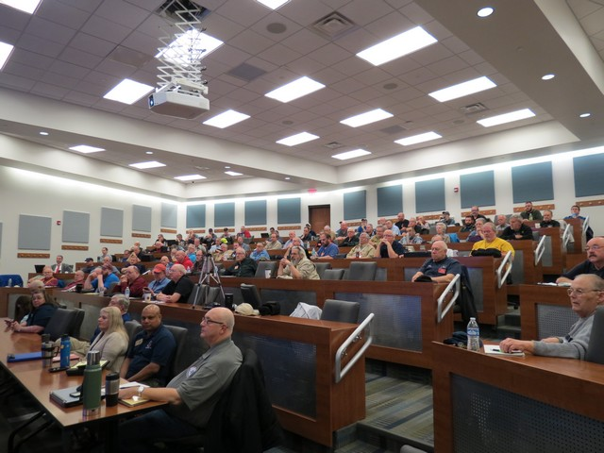Next on the list is **April 4th**. 2020. That is the date set for the All Ohio ARES Conference. Primarily aimed at county EC’s, AEC’s and other team members it is open to all. We have a fantastic venue, thanks to the Marion County ARES team, at the large medical lecture hall at Marion Technical College / OSU Marion. It’s better than the big rooms you see in the movies! We put a lot of effort into this session- the goal is to provide information that YOU can take back home and put to use in your ARES organization. We are not complete in our planning, of course, but we do have confirmation of a very special keynote speaker. We will be hearing from Dr. Brian Griffin, KE8DRD, who for 20 years has managed the all-volunteer medical coverage of The Arnold sports event. This is much larger than an Olympics, and the 600-member medical team has been assisted entirely by amateur radio volunteers. There is no one more qualified to discuss a number of topics- large scale event communication, medical coverage for something like a mass casualty event and more. I am personally grateful to Doc for agreeing to talk with us!

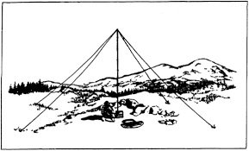Another date to mark is **April 25**! This will be the Ohio NVIS Day for 2020. We try to use the last weekend in April hoping for reasonable weather. Sometimes that hasn’t happened, but it is Ohio, after all. NVIS antennas are designed to communicate within a 400-mile radius on HF, providing better communications within Ohio primarily to the Ohio Emergency Operations Center and The Sarge (W8SGT at the EOC.) We’ll be publishing guidelines later on, but the general purpose is antennas (and what’s more fun in amateur radio?)

TOP^

The way our bands have (haven’t!) been performing, we have a much greater challenge so NVIS antennas are a consideration! We’re in the middle of the winter months when Spandex is (mercifully) covered by layers of Carhart. So what do we do? First, stay ready! There have been sporadic 911 outages this winter and other event which could easily and quickly grow into major problems. Second, it’s a great time to train and improve our abilities. If your ARES unit is not meeting or meeting briefly for a coffee, then going home you’re doing it wrong! It’s easy to get experts from within your county partners who would gladly help. Third, it’s a great time to renew relationships with your agency partners! Stay in touch, keep them up to date with your activities, and maintain your friendships!

Sandi and I wish you all a peaceful, happy Christmas and I hope you and your families have a wonderful new year!

**73, Stan N8BHL**

**You can view all of the SEC’s monthly reports on the website..** <http://arrl-ohio.org/SEC/default.html>

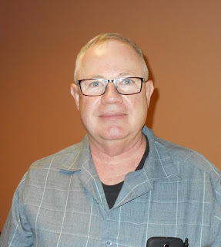***From the Affiliated Club Coordinator***

***Tom Sly, WB8LCD - ACC***

[tomsly29@gmail.com](mailto:tomsly29@gmail.com)

I went to High School in Aurora, OH. I entered the 9th grade in 1966 and I graduated in 1971. (Got licensed as a Novice in November 1967 with the callsign WN8AAB). I distinctly remember a class I took during that time where there was a discussion about technology, and how fast it was changing and advancing. Our teacher pointed out that since we were born in the early 1950’s, that *even then,* we had been born at approximately the mid-point of human history; at least in regard to the evolution of technology. I remember him distinctly pointing out that from a technological standpoint, in that last 20 years there had been as much technological advancement as there had been up to that point since the beginning of time! Moore’s Law is another observation to that fact.

I was recently reading an article in the December 2019 issue of FORTUNE magazine. It was written by Tom Goetzl, Automotive & Energy Solutions Business General Manager, of Keysight Technologies. His article was titled “5G, IoT, And Your Car”. He says that by 2020 the number of automotive IoT (Internet of Things) endpoints will reach over 470 million. He talks about “intelligent connectivity between vehicles and everything else around them (vehicle-to-everything, or V2X) which becomes a reality because of “precise technology integration and reliable, secure *connections”.* (emphasis mine)

He goes on to talk about those “connections” being possible with new 5G technology. He’s only talking about cars. How many other things in our future lives will require “connections”? And, do you expect these connections to be wired or wireless? If it’s wireless, I believe that to a very large degree it will take place in the Radio Frequency spectrum.

TOP^

In the RF spectrum, hams have always been offered primary allocations in the biggest portions of the spectrum deemed pretty much as “not useable” for any other purpose. Remember the book “200 Meters and Down”? (No Captain Nemo, you’re thinking about 20,000 Leagues Under the Sea) It tells the story of how Amateur Radio was given all the radio spectrum that most thought was unusable for useful communications. Hams pretty much proved that we could utilize that portion of spectrum for reliable communications. Where did most useful communications take place over the last 100 years? Right now, our largest allocations occur all the way up to the upper limits of RF!

And that limit is just that. Like real estate, they ain’t making any more. So, with the expanding need for wireless connections, it’s probably safe to assume that they will be petitioning the FCC and other world organizations to reallocate our allocations for the good of the industry. We’ve got two strategies we can follow to try to prevent that from happening, or at least limit how much we lose.

First, we can occupy that space. It’ll be a lot easier for them to toss us out if we aren’t there in the first place. Second, we can fight them for it. Here’s where I start talking about clubs and how important they are to the future survival of the hobby.

If we are going to maintain our allocated frequency space, I said the first thing we need to do is occupy that space, that makes it harder to kick us out. I want to challenge all clubs to encourage and provide opportunity for your members to get into the higher frequency ranges. Start talking about space communications. That might make ham radio more attractive to younger generations. Help them work the satellites, do some moon bounce, contact the space station, learn about radio-astronomy, maybe even listen for some of the space probes that have been sent out into deep space! Do you know about the Elser-Mathes Cup? I’m not going to tell you about it here, but it is offered by the ARRL! Lots of material here for a club to use as meeting topics, project days and just fun activities.

Second, we can fight for our frequency allocations. But you alone are a bug that only needs to be squashed. The ARRL makes it more of a David vs Goliath match-up, but we all know how that one ended. In our case, we can be “David” by aligning ourselves with the ARRL. I want to encourage everyone to be a member. Encourage your club members to belong to ARRL. Your club can earn $$ for processing your members ARRL applications and renewals – contact me directly if you need to know more about that. If you can, support the ARRL financially. They are our ONLY voice in representing our interests both in the US and internationally. They can’t do it without the membership.

Next year, 2020, is almost here! I want to wish all of you a blessed and Merry Christmas! I hope that your 2020 is a successful and wonderful year. I hope it is a time for learning, new and fun experiences with Ham Radio. I hope you enjoy the comradery and friendship that comes with being an active member in organizations that share your interests.

**73 Tom WB8LCD, and good DX on the air!**

That’s it for now. Let me know what’s on your mind. [tomsly29@gmail.com](mailto:tomsly29@gmail.com)

TOP^

***From the Public Information Coordinator***

***John Ross, KD8IDJ - PIC***

[john.ross3@worldnet.att.net](mailto:john.ross3@worldnet.att.net)

**FROM THE PIC**

***2020 NEWSLETTER CONTEST***

***UP AND RUNNING***

The Ohio Section 2020 Newsletter Contest is up and running! I’ve received several entries for January already and you officially have 6 months to enter your club’s newsletter. This the biggest, best and longest running contest anywhere. It highlights the skills, talents and commitment our members have made to keeping Ohio hams informed and involved in all things Amateur Radio. I know I write about this every month, but it really is important and a great way to get your club noticed and do a little flag waving.

The rules are simple…you need to submit two copies of your newsletter…form different months…to be entered. If your publication is web-based/on-line…just send the link so the judges can see it in the same way your members see it. The deadline is June 30…the judging takes place in early July…and this year the winners will be announced at the DXE Hamfest and ARRL Ohio Section State Convention on August 8th in Tallmadge, Ohio. Our cadre of five judges will be back again this year and always look forward to reviewing your work.

The monthly PIC PODCAST is back with a great interview with Steve Wilson…our lead judge for the last 6 years! Steve is an experienced, award winning journalist and a Pulitzer Prize nominee.  Just click on the PODCAST icon to listen to Steve’s interview and for some important tips that might help your newsletters. Just FYI…each month our PODCAST will feature one of our judges so by June you can hear what all them think about our contest and some great suggestions and observations!

**PIC PODCAST**

[](https://www.youtube.com/watch?v=WFbIGmmMUts&feature=youtu.be)

🡨 Click on Podcast Icon to listen

***Interview with judge Steve Wilson on the many important things that make newsletters better.***

**UPGRADING YOUR LICENSE IS EASY AND IMPORTANT**

Over the last six or seven years I have read every newsletter from every Ohio club!! No kidding! It makes time but boy does it make me…smart! Well, OK maybe just a little more informed!

TOP^

What most of our clubs have in common is a process…an opportunity…to upgrade our licenses so we can enjoy all of the privileges that Amateur Radio has to offer. Upgrading is the one thing you can do that helps make you a better ham, helps expand your knowledge and…perhaps most important… puts you in touch with a whole new group of hams.

Many clubs…and Emergency Management Offices…offer study sessions…highly recommended! Sure, you can probably study and pass the exam on your own but in a group environment you can actually learn more instead of just memorizing the answers to pass the test. Most of our clubs also offer or help coordinate test sessions that make it easy for the final upgrade step.

Information for the study sessions and the test sessions is just about everywhere. Scott Yonally’s **PostScript** publication often contains lists of study and test sessions. You can also take a look at newsletters from your area that might also be offering testing sessions at more convenient times and locations.

The ARRL has a lot of helpful information including study guides and testing locations. It might good to check with the study group leader before you get started and see if they are offering or providing a particular study guide for their classes.

We are lucky to part of great hobby and lucky to have access to many hams that are willing to pass along their knowledge.

One final thing…. Amateur Radio has privileges on many frequencies. We need to use those frequencies or risk losing them! In today’s electronic society frequencies and bandwidth are hot commodities and often disappear faster than the click of a key.

**CHRISTMAS AND AMATEUR RADIO**

I have enjoyed 68 Christmas’s and many with a ham radio buzzing in the background. Yes, there have been carols and candy, trees and lights, snow and sleds. But for me all of the those memories are wrapped up with amateur radio at the center. On the nights before Christmas I would spend time in the ham shack…and old coal bin at my parents house…just listening to the world celebrate. It opened my mind, my imagination, and my understanding that I could be part of something that was much bigger than me.

Christmas by the light of a radio dial…nothing like it!

Each year on Christmas Eve many amateurs offer a Santa Net! This year I found one where you can actually TALK to Santa right now!

The net is on every night from now until Christmas on **3.916 MHz at 7:15 PM Central Time.** Go to CQSANTA.com for all of the info!!!

Thanks to all of you for another great year as your Public Information Coordinator. My best wishes for a Merry Christmas and a Happy New Year!

**73, John KD8IDJ**

TOP^

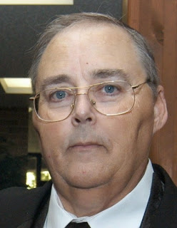***From the Section Traffic Manager***

***David Maynard, WA3EZN – STM***

[wa3ezn@att.net](mailto:wa3ezn@att.net)



OHIO SINGLE SIDEBAND NET

["Specializing in the first and last mile](http://www.ossbn.org/)

of NTS delivery in Ohio."

|  |  |  |  |
| --- | --- | --- | --- |
| **Morning session** | **10:30 AM** | **3972.5 KHz** | **every day** |
| **Afternoon session** | **4:15 PM** | **3972.5 KHz** | **every day** |
| **Evening session** | **6:45 PM** | **3972.5 KHz** | **every day** |

**OHIO HF CW TRAFFIC NETS**

|  |  |  |  |
| --- | --- | --- | --- |
| **HF CW NETS** | **NET TIMES** | **FREQUENCY** | **NET MANAGERS** |
| **Buckeye Early** | **6:45 PM** | **3.580** | **WB8YLO** |
| **Buckeye Late** | **10:00 PM** | **3.590** | **WB9LBI** |
| **Ohio Slow Net** | **6:00 PM** | **3.53535** | **NEEDED** |



*(All net frequencies plus or minus QRM)*

**OHIO LOCAL VHF TRAFFIC NETS**

|  |  |  |  |
| --- | --- | --- | --- |
| **VHF NETS** | **NET TIMES** | **FREQUENCY** | **NET MANAGERS** |
| **BRTN** | **MON, WED, SAT 9:30 PM** | **145.230 PL 110.9** | **KD8GXL** |
| **COTN** | **7:15 PM DAILY** | **146.970** | **KD8TTE** |
| **MVTN** | **7:00 PM Mon** | **146.640** | **KC8HTP** |
| **NWOHARES** | **6:30 PM DAILY** | **147.375** | **N8TNV** |
| **TCTTN** | **Sun, Tues, Wed, Fri**  **9 PM** | **146.94** | **WB8YYS** |
| **TATN** | **8:00 PM DAILY** | **146.670 PL123** | **WG8Z** |

The VHF net information on these pages may contain errors concerning net times, dates and frequencies. I do apologize in advance for these errors and would appreciate if the net managers would keep me informed of any changes…

TOP^

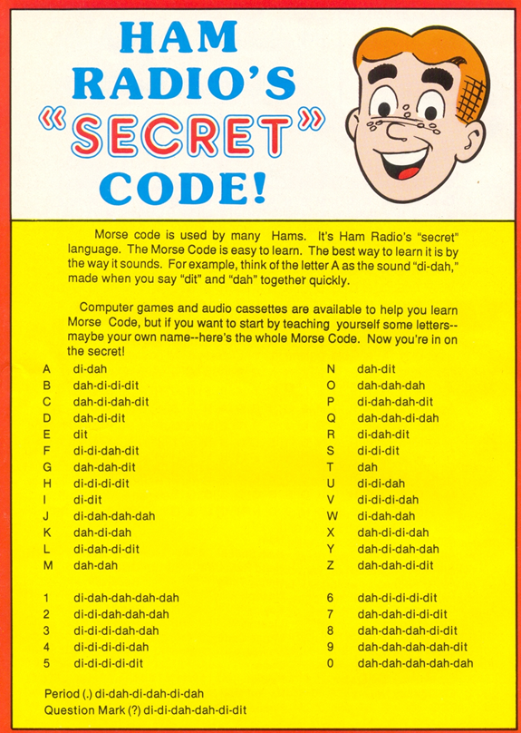When Morse code was required as an entry requirement to HF ham communications the entry level speed was 5 words per minute (WPM). That speed is slow enough to learn the basics, get on the air, and increase your speed through practice. (Yes, I started as a Novice way back when you had to copy 5 WPM and was later comfortable coping about 13 WPM to get my general license.

I thought I'd want to get enough code speed to get on SSB voice. Since then I have discovered sometimes the bands are so poor that I couldn't hear a single voice station on SSB. But, when I tuned down to the CW portion of the band, lo and behold, there were CW contacts going on. I’ve learned that Morse code needs only about a tenth of the power of SSB to make a contact. Or, stated another way, if you use Morse code, it's like getting an amplifier for your transmitter for free!

**A short history of Morse code**

Morse code was invented by Samuel Morse (1791-1872). Originally, it was developed for telegraphers. It was a new method where each letter was represented by a set of long and short pulses of sound. Samuel Morse formed the original Morse code by counting the letters from the local newspaper. Then he assigned the most common letters a faster "key", for faster transmission.

Morse's original code was not the same as the one in use today, as it included pauses as well as dahs and dits. An international version was established in 1851 in Berlin.

For many of today’s hams there was no choice; obtaining a ham license required learning Morse code. Five words a minute was the requirement for the entry level Novice license and also for the renewable, but VHF only, Technician ticket. A General or Advanced class required 13 wpm and it was 20 wpm for an Extra. Many newcomers exploring ham radio were discouraged by the need to learn Morse code.

In the United States, that requirement to know Morse code to get an amateur radio license was dropped in 1991, and completely removed in 2007.

TOP^

If you’re not going anywhere on New Year’s Eve here is something fun to try. The ARRL Straight Key Night is coming up on January 1, 2020.

Why not dust off that old straight key and give it a try. Who knows you may like it and have some fun. Straight Key night starts at 0000Z and ends at 2359Z (UTC). More details can be found at [www.arrl.org/straight-key-night](http://www.arrl.org/straight-key-night) .

If you are not a CW operator or are a little rusty you have just a little time left to learn or practice before the Straight Key night. I know I passed the 13 WPM test before the FCC some years ago but am really rusty now. To help everyone out I have looked up some websites with helpful information, programs and practice sessions to help you master CW. Although I cannot indorse any one program or source you can try one of these links or do an internet search for more information. I will say that the ARRL MP3 practice files can be loaded on a laptop or other device and taken with you for practice sessions. Code practice text is from the pages of *QST* magazine, the League's membership journal. The source is given at the beginning of each practice session and alternate speeds within each session. The text for each session is also available to download.

Publications and instruction:

Tips for Learning Morse Code: <http://www.arrl.org/files/file/Morse/LearningMorseCode.pdf>

CW MANUAL: <http://www.fistsna.org/pdfdocs/A%20BASIC%20CW%20OPERATING%20MANUAL.pdf>

So You Want to Learn Morse Code: <http://www.qsl.net/n1irz/finley.morse.html>

Just Learn Morse Code: <http://www.justlearnmorsecode.com/>

Resources

ARRL Training Courses, Aids and Apps - <http://www.arrl.org/learning-morse-code>

The CW Operators Club:<https://cwops.org/>

FISTS CW Club: [http://fists.org/ or](http://fists.org/) <http://www.fistsna.org/>

Over the Air Practice and Practice Programs

<http://www.arrl.org/code-practice-qst-source> – W1AW on air Practice

[http://www.arrl.org/code-practice-files - W1AW MP3 practice files and text](http://www.arrl.org/code-practice-files)

<http://www.g4fon.net/CW%20Trainer.htm>



I hope this inspires you to at least give Morse code a try. You may like it and have lots of fun. Remember you do not have to have the greatest new transceiver to use Morse code. And when you learn how to do it there are three CW traffic nets in Ohio and many more nets around the country for you to test your skills. Look for one of these nets and have fun

And with that said you will not be hearing from me until January so have a Merry Christmas and a Happy New Year’s or happy holidays if you so choose. Please be safe, buckle up and do not drink and drive.

73 or 88 if appropriate

David WA3EZN

SECTION TRAFFIC MANAGER - OHIO

You can view the STM’s monthly report on the website.. <http://arrl-ohio.org/stm/stm.html>

TOP^

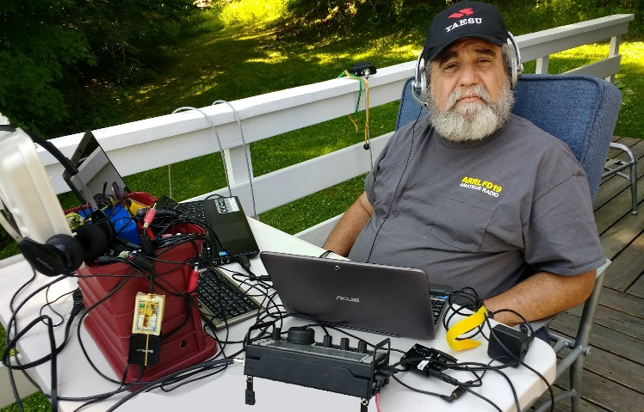***From the Section Youth Coordinator***

***Anthony Luscre, K8ZT - SYC***

[k8zt@arrl.net](mailto:k8zt@arrl.net)

***New Year’s Resolutions for Hams***

As we come to the end of another year it is time to put together your New Year’s resolutions.

Let me make a few Ham Radio suggestions. In the spirit of technology I have created acronyms (or are they [initialisms](http://www.todayifoundout.com/index.php/2012/05/the-difference-between-an-acronym-and-an-initialism/)?) for each:

* **GOTAMO-** **Get On The Air More Often!** You will not regret it as you meet new friends, learn more and have more fun. One of the best ways to make sure you keep this resolution is to set operating goals for the year:
  + Try a new mode and/or new band
  + WAS (Worked All States) or DXCC (read presentation “[Top Secret Techniques to WAS & DXCC](https://docs.google.com/presentation/d/e/2PACX-1vTevGnYb-gjI6_SpWdfor5JOucRWFFO1nTeD6vVqcUEi1bsZA1sj6PtAtj97ByQug_hS_V4vyzhtbCx/pub?start=false&loop=false&delayms=3000)”- [*tiny.cc/ham*](http://tiny.cc/ham50)*50*)
    - Earn the basic awards
    - Increase your individual band totals
    - Earn awards on new band(s) or mode(s)
  + Set a goal of a contact a day
  + Participate in operating events
    - Try a contest or a few
      * [State QSO Parties](https://qsoparty.eqth.net/index.html) are a great lower pressure way to get into contesting
      * The [Ohio QSO Party](https://www.ohqp.org/) is in August, put it on your calendar now!
      * [ARRL VHF/UHF contests](https://www.k0nr.com/wordpress/my-articles/how-to-work-a-vhf-contest/) (3 times a year- [Jan.](http://www.arrl.org/january-vhf), [June](http://www.arrl.org/june-vhf) and [Sept](http://www.arrl.org/september-vhf).) are a great way for those with Technician Licenses to get into contesting, put them on your calendar now!
    - Operate [ARRL Field Day](http://www.arrl.org/field-day), put it on your calendar now!
  + Monitor your club’s local repeater, always have it on in the shack, and don’t forget to call occasionally because when everyone is just listening, no one will ever make any contacts!



* **HAYGOTA-** **Help a Youth Get On The Air**.
  + Ham Radio Resources for Youth:
    - **The Kids Radio Zone**- [www.ztlearn.com/radio-kids](http://www.ztlearn.com/radio-kids)
    - **Teacher Radio Zone**- [www.ztlearn.com/radio-teachers](http://www.ztlearn.com/radio-teachers)
    - **Ham Radio Youth Resources Handout**- [tiny.cc/hry](http://tiny.cc/hry)
    - Tri-fold STEM brochure **“Ham Radio- The Original Maker Movement”**- [tiny.cc/hr-makers](http://tiny.cc/hr-makers)

TOP^

* + - **Scouting & Amateur Radi**o- [tiny.cc/ar-scout](http://tiny.cc/ar-scout)
    - **Ham Radio Quick Start Guide**- [tiny.cc/new-ham](http://tiny.cc/new-ham)
    - **K8ZT** Amateur Radio Resources- [www.k8zt.com](http://www.k8zt.com/)
    - **K8ZT** Amateur Radio Education Outreach Column Collection - [tiny.cc/ar-ed-out](http://tiny.cc/ar-ed-out)
  + **YOTA**- Volunteer and/or donate to support this year’s **Youth on the Air Camp**
    - The week-long camp will be held at the National Voice of America Museum of Broadcasting in West Chester, Ohio in June.
    - According to the press release, “the camp will focus on building peer and mentor relationships and taking amateur radio ‘to the next level.’” There will be workshops in all sorts of STEM-related subjects. A high-altitude balloon launch is being planned, and they will operate with the special-event call sign of W8Y.
    - According to the camp director, Neil, WB9VPG, there are several ways for amateurs to help.
      * Take part in the on-air activities during the week, by providing contacts for the young people.
      * Donations to support the effort.
      * Hands-on help with set-up and clean-up
    - Additional details will be presented in this column as we get closer to the event.
* 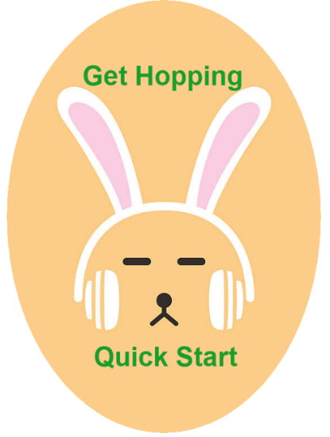**GANAL-** Help **Get A New Amateur Licensed**.
  + Share this link [tiny.cc/new-ham](http://tiny.cc/new-ham) to “Ham Radio Intro & Quick Start Guide”.
  + Help teach a licensing class
  + Volunteer as a Volunteer Examiner
* **MANARO-** **Mentor A New Amateur Radio Operator**.
  + Invite a newly licensed or upgraded ham to your shack to make their first QSOs with their new privileges.
  + Help put up a new antenna, set up a new radio, interface a radio to a computer, set up a new mode, help them learn to contest, etc.
  + Do a presentation for your local club’s meetings
  + Write an article for your local club’s newsletter
* **BSN- Build Something New.** It doesn’t need to be complicated and it’s OK to use a kit, modify any item, assemble a group of items or even do it with software
* **LSN-** **Learn Something New**
  + Take a training course
    - [ARES Training](http://www.arrl-ohio.org/SEC/reference-training_materials.html).
    - [ARRL Lifelong](http://www.arrl.org/lifelong-learning) Learning (new courses coming in 2020)
  + Keeping Up with Amateur Radio News & Events- [link](https://docs.google.com/document/d/1YUUg8CQWjzv00jDg5YALwR2xr6bUnDFk8tY_73VwSig/preview).
  + Read a book on Radio/Electronics
  + Listen to a Podcast
    - “[ARRL The Doctor is In](http://www.arrl.org/doctor)”

* + - [So Now What?](http://www.arrl.org/so-now-what)
    - [AR News, Blogs, Podcasts, etc.](http://www.k8zt.com/ham-news)

So, go forth, have some fun and make sure you share it with a youngster!

**73, Anthony K8ZT**

TOP^

*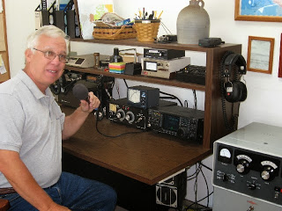****From the Assistant Section Manager***

***John Perone, W8RXX – ASM***

[w8rxx@arrl.net](mailto:w8rxx@arrl.net)

***Here is a brief history of 73***

The first authentic use of 73 was in the publication "The National Telegraphic Review and Operators' Guide", first published in 1857. At that time, 73 meant "My love to you"!

Within a short time, the use of 73 began to change.

In 1859, the Western Union Company set up the standard "92 Code."

A list of numerals from 1 to 92 was compiled to indicate a series of prepared phrases for use by the operators over the wires. Here, in the 92 Code, 73 changes to a very flowery "accept my compliments", which was in keeping with the florid language of that era.

Over the years from 1859 to 1900, many manuals of telegraphy show variations of this meaning. The “Twentieth Century Manual of Railways and Commercial Telegraphy” defines it two ways, one listing as "my compliments to you"; but in the glossary of abbreviations it is merely "compliments". By 1908, however, a later edition of the “Dodge Manual” gives us today's definition of "best regards" with a backward look at the older meanings.

In CW it is sent 73 or properly spoken 73, not plural...

**73, John W8RXX**

*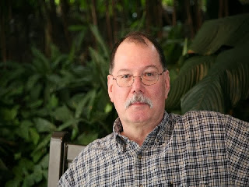****ARES Training Update***

***Jim Yoder, W8ERW – ARES Data Manager***

[w8erw@arrl.net](mailto:w8erw@arrl.net)

***ARES Training Update***

I am sitting here at the keyboard while sipping my morning coffee and thankful for the utilities which are all working well when the temperature outside is a solid 10 degrees. It is going to be a great day to work on a few things inside while Mother Nature reminds us of her creative resolve. I trust all of you are warm and comfortable.

Last evening, we finished up our licensing class with a test session and made a few new Hams as well as some upgrades. Being a Volunteer Examiner is one of the most rewarding aspects of our hobby. Seeing the smiles and excitement that come after weeks of studying and passing a license exam is just fun for everyone. If you ever thought of how you might give back something to Amateur Radio, I recommend serving as a VE.

TOP^

You will be glad you did and get an opportunity to see those big smiles of personal success that follow an exam session.

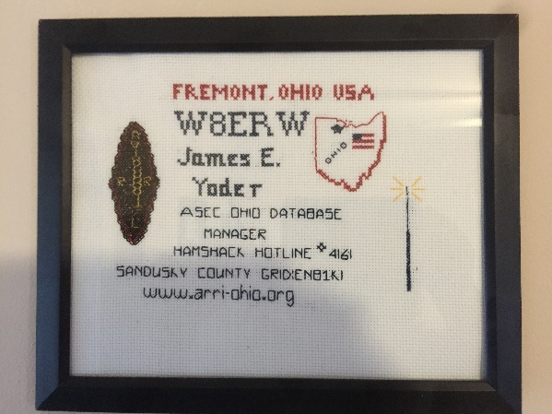One of our students, Joy Bunting surprised me last night with something I thought was very special and I will always have it on my shack wall. Her OM, Shannon is also a newly minted Ham and a few months ago we made contact after which I sent him one of my QSL cards. Joy used my card to pattern a beautiful handmade needlework that I will proudly display on my wall. It’s always a special privilege to see one of our XYLs also obtain her license. Congratulations Joy and Thank you very much!

We are wrapping up the year in good stead with ARES training. Things have slowed considerably which is quite normal. Spending time with family and preparation for the holidays keeps us busy as it should. We did have a winner to celebrate last month. Gregory Zarichny W8ZAR from Lewis Center pushed us over the 9,000 mark for total training certificate submissions and received an ARRL gift certificate. Congratulations Greg and thank you for your training effort.

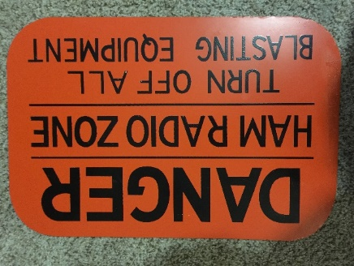

We have 1,681 Hams now in the database with a current total of 9,023 certificates on file. This year 567 documents have been submitted representing 2,874 hours of training. 674 members are now at Level 2 and 168 at Level 3. 46 have completed the Professional Development Series and 61 have the AUX COMM certification.

Yes, we do have considerable room for additional growth, and I am confident the strong effort all of you have given to this training program will continue. 2020 will be another significant year for ARES in the Ohio Section.

As we close this year, let me say Thank you to everyone for the dedication and commitment you have given to achieve these significant numbers.

Wishing everyone a joyous and wonderful holiday season…

Jim W8ERW

[w8erw@arrl.net](mailto:w8erw@arrl.net)

***National News***

*(from arrl and other sources)*

***FCC Formally Adopts Proposals to Remove Amateur 3-GHz Band, Invites Comments***

At its December 12 meeting, the FCC formally adopted a *Notice of Proposed Rulemaking* ([***NPRM***](https://docs.fcc.gov/public/attachments/FCC-19-130A1.pdf)) in WT Docket 19-348 and invited comments on its plan to remove “existing non-federal secondary radiolocation and amateur allocations” in the 3.3 – 3.55 GHz band and relocate incumbent non-federal operations. The FCC said it’s seeking comment on appropriate “transition mechanisms” to make that happen. ARRL has indicated that it will file comments in opposition to the proposal. The amateur 9-centimeter allocation is 3.3 – 3.5 GHz.

TOP^

The *NPRM* comes in response to the MOBILE NOW [Making Opportunities for Broadband Investment and Limiting Excessive and Needless Obstacles to Wireless] Act, approved by the 115th Congress to make available new spectrum for mobile and fixed wireless broadband use.

“By proposing to delete the existing non-federal secondary allocations from the 3.3 – 3.55 GHz band, we are taking an important initial step towards satisfying Congress’s directives and making as much as 250 megahertz of spectrum potentially available for advanced wireless services, including 5G,” the FCC said in the Introduction to its *NPRM*.

Currently, the entire 3.1 – 3.55 GHz band is allocated for both federal and non-federal radiolocation services, with non-federal users operating on a secondary basis to federal radiolocation services, which have a primary allocation, the *NPRM* explains.

The FCC said it is seeking comment on relocating non-federal licensees to another band. With respect to amateur operations, the FCC invited comments on whether sufficient amateur spectrum exists in other bands that can support the operations currently conducted at 3.3 – 3.5 GHz. The 3.40 – 3.41 GHz segment is earmarked for amateur satellite communication. “We seek comment on the extent to which the band is used for this purpose, whether existing satellites can operate on other amateur satellite bands, and on an appropriate timeframe for terminating these operations in this band,” the FCC said. If non-federal licensees are relocated to 3.1 – 3.3 GHz band, the FCC proposes that they continue to operate on a secondary basis to federal operations, consistent with current band allocations.

Some comments began to arrive before the FCC formally adopted the *NPRM*, as it points out in a footnote. Kevin Milner, KD0MA, the secretary/treasurer of the Ski Country Amateur Radio Club in Colorado, has argued that the club’s equipment cannot be re-channeled below 3.4 GHz, and the club is seeking relocation costs. Devin Ulibarri, W7ND, told the FCC that amateur networks in the current band cannot move easily into other amateur allocations because there is no readily available commercial equipment to support the bandwidth, the FCC recounted.

In the event the proposed amendments are adopted, the FCC “seeks comment on relocation options and on transition and protection mechanisms for incumbent non-federal operations.”

Also at its December 12 meeting, the FCC considered [**another *NPRM***](https://docs.fcc.gov/public/attachments/FCC-19-129A1.pdf) in WT Docket 19-138 that would “take a fresh and comprehensive look” at the rules for the 5.9 GHz band and propose, among other things, to make the lower 45 MHz of the band available for unlicensed operations and to permit “cellular vehicle-to-everything” (C-V2X) operations in the upper 20 MHz of the band. The FCC is*not* proposing to delete or otherwise amend the amateur allocation, which would continue as a secondary allocation. The Amateur Radio Emergency Data Network ([**AREDN**](https://www.arednmesh.org/)) has [**offered its voice**](https://www.arednmesh.org/content/call-action-defense-part-97-allocations) in challenging the FCC proposals on the two bands, saying their adoption would “eliminate our use of the most-effective resource hams have to build its networks.”

“The AREDN Project is able to leverage low-cost commercial devices solely because they are designed to operate on adjacent allocations,” AREDN said on its website. “Moving to other allocations would be difficult if not impossible without a complete redesign, manufacture, purchase, and installation of new custom amateur hardware and software…, raising the price out of reach for the typical ham.”

Interested parties may file short comments on WT Docket 19-348 via the FCC’s [**Electronic Comment Filing Service (Express)**](https://www.fcc.gov/ecfs/filings/express). Visit the FCC “[**How to Comment on FCC Proceedings**](https://www.fcc.gov/consumers/guides/how-comment)” page for information on filing extended comments.

####

TOP^

***ARRL Reshapes its Podcast Offerings for 2020***

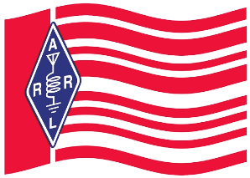In conjunction with the launch of its new [***On the Air***](http://www.arrl.org/on-the-air-magazine) magazine, which is aimed at those just beginning their journey in amateur radio, ARRL is reconfiguring its podcast lineup.

Heading up the new schedule will be a free companion podcast to the bimonthly *On the Air* magazine. The “On the Air” podcast will take a deeper look into select features and projects from the magazine. Each month, host and *On the Air* Editorial Director Becky Schoenfeld, W1BXY, will offer additional resources, techniques, and hints to help less-experienced radio amateurs to get the most from the magazine’s content.

In addition to the podcast, ARRL will introduce a free “On the Air” blog featuring curated content from the communicators and makers who are the driving force of amateur radio today. Curated by ARRL Product Development manager Bob Inderbitzen, NQ1R, the blog will highlight opportunities and activities available to new licensees. The “On the Air” blog is intended as an entry point into the world of amateur radio for those seeking original voices and perspectives. Readers will be [**invited**](mailto:ota-blog@arrl.org) to take part in the conversation by sharing their stories and experiences.

ARRL’s current “[**So Now What?**](http://www.arrl.org/so-now-what)” podcast will cease production in January 2020, as the full complement of *On the Air* content is rolled out. The [**catalog**](http://www.arrl.org/so-now-what) of “So Now What?” episodes is available for listening or downloading.

In addition, “[**The Doctor is In**](http://www.arrl.org/news/the-doctor-will-see-you-now-89)” podcast, which has served more-experienced amateurs since 2016, will conclude its 4-year run on December 19, 2019. “Eclectic Tech,” a new bi-weekly podcast designed to appeal to experienced amateurs, will launch in February 2020.

Hosted by *QST*Editor Steve Ford, WB8IMY, “Eclectic Tech” will highlight technical topics involving amateur and non-amateur technology, offer brief interviews with individuals involved in projects of interest to amateurs, and include practical information of immediate benefit to today’s hams.

“The Doctor is In” co-host Joel Hallas, W1ZR, is selecting some of his favorite podcast episodes for re-broadcast in the interim between the end of production for “The Doctor is In” and the debut of “Eclectic Tech.” The complete “The Doctor is In” [**archive**](http://www.arrl.org/doctor) is available on the ARRL website. Hallas will continue to answer questions about amateur radio in *QST*’s “The Doctor is In” column.

####

***AztechSat-1 CubeSat to Demonstrate Intra-Satellite Communication***

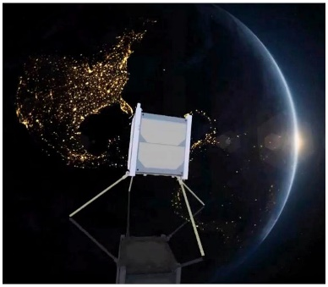

The [AztechSat-1](https://upaep.mx/aztechsat) CubeSat, which traveled to the International Space Station (ISS) last weekend on the 19th Space-X Commercial Resupply Services (CRS-19) mission for NASA, will listen for emergency messages in the 439 MHz range and retransmit them for amateur radio operators to copy on the 437.300 MHz downlink using the Winlink protocol, once the CubeSat has been placed into orbit. The satellite is a project of Mexico’s Universidad Popular Autónoma del Estado de Puebla (UPAEP). Aztechsat-1 is set for deployment from the International Space Station in late January.

TOP^

“The primary objective of the project is to establish communication with the commercial GlobalStar satellites in order to improve data transmission to Earth,” a UPAEP news release said. AztechSat-1 will create a saturation map of 435 – 438 MHz by listening for the whole orbit and returning captured data to the ground station on the 437.300 MHz amateur radio downlink (9k6 GMSK or FSK) plus a 1600-MHz GlobalStar link. Emergency messages received via Globalstar to the AztechSat-1 ground station will be shared on the project's website.

A certificate will be available for amateur stations receiving the emergency message(s) and reporting these for confirmation by the AztechSat-1 team.

Details are on the [**AztechSat-1 website**](https://upaep.mx/aztechsat) and on the [**IARU Amateur Radio Satellite Communication**](http://www.amsatuk.me.uk/iaru/finished_detail.php?serialnum=661) page.

The project is part of NASA’s [**CubeSat Launch Initiative**](https://www.nasa.gov/mission_pages/cubesats/index.html), which offers universities, high schools and non-profit organizations the opportunity to fly small satellites. “Innovative technology partnerships keep down the cost, providing students a way to obtain hands-on experience developing flight hardware,” a NASA [**report**](https://www.nasa.gov/mission_pages/station/research/news/aztech-first-mexican-student-satellite) said.

NASA explained, “The investigation demonstrates communication within a satellite network in low-Earth orbit. Such intra-satellite communication could reduce the need for ground stations, lowering the cost and increasing the number of data downloads possible for satellite applications.”

####

***FCC Announces Enhancements to Wireless Emergency Alerts***

*(Submitted by Gregory Drezdzon, WD9FTZ)*



The FCC announced availability of a suite of enhancements to wireless emergency alerts (WEAs) that will enable Americans to receive more geographically precise, effective and informative alerts on their mobile phones during emergencies.

Local officials are now better able to send geotargeted wireless alerts to areas affected by an emergency without reaching unaffected communities, which will increase confidence in alerting and promote public safety, especially during evacuations. Officials can also now send more informative and relevant content in alert messages.

The improvements include the following:

• Geographic accuracy: Wireless providers must deliver the messages to the area specified by the alert originator with no more than a 0.1-mile overshoot, as opposed to the prior “best approximation” standard.

• Longer messages: WEAs will accommodate longer messages — an increase from 90 to 360 characters — and messages in Spanish.

• New alert type: There is a new class of alerts called public-safety messages for officials to convey recommendations for saving lives or property, such as the location of emergency shelters after a disaster.

• Better testing: Emergency managers can now conduct state and local WEA tests that reach only consumers who choose to participate, and these tests do not require a waiver from the FCC.

In addition, as of May 2019, all participating wireless providers must support clickable links in alerts so that messages can include links to photos and other additional information.

TOP^

“One of my key public-safety priorities has been to ensure that America’s emergency alerting system meets the needs of public-safety officials and the communities they serve,” said FCC Chairman Ajit Pai. “With these improvements, WEAs are now an even more powerful tool for emergency managers to warn and protect the public. These improvements respond to input we’ve received from the public-safety community and will help save lives.”

####

***Christmas Carols to be Broadcast on HF from Antarctica***

A program of Christmas carols will be broadcast from Antarctica on Christmas Eve. The transmissions on 7995 kHz USB will begin on December 23 at 2300 UTC, coordinated by McMurdo Communications Operations (MacOps) — known as “The Voice of Antarctica.”

Each year, the station’s residents celebrate the holiday by singing Christmas Carols to those at remote Antarctic field camps. Participation will be from stations scattered throughout the Antarctic continent.

“The radios and antenna systems are optimized for on-continent communication, so we will be lucky to hear them in other parts of the world, but it has happened in the past,” said Nathaniel Frissell, W2NAF, who is [**handling QSL requests**](mailto:w2naf@arrl.net) and who has participated as part of the chorus in past years while studying in Antarctica. Frissell shared some links of previous concerts, one recorded at [**McMurdo Station**](https://www.youtube.com/watch?v=0q4gFNWdBK0&t=31s) and one from the [**University of Twente WebSDR**](https://www.youtube.com/watch?v=KY7Qhhd6C3w&t=21s) in the Netherlands.

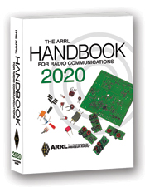***The Handbook Give Away***

Hey Gang,

It’s Christmas… and I’m going to be Santa and give someone a really neat Christmas Gift! Yup.. I’m going to Give-Away a Handbook just for Christmas!

Just think, someone is going to get a brand new Handbook for Christmas.

Go to: <http://arrl-ohio.org/handbook-christmas.html> and get registered NOW.

Oh, here’s another incentive for you… If you get registered before the Christmas drawing, you’ll automatically be registered for the New Year’s Day drawing too.

What’s the catch? I want to get everyone checking in to the Ohio Section website as often as possible, and in order to register each month, you have to visit the website often! There’s nothing else to it. I pay all expenses, and from time to time,

Many of you ask me just how do I know when the drawing is on? Well, that’s easy all you need to do is check in on the Ohio Section Website on a regular basis and watch for the big **RED** Arrow that will appear on the left side of the page. This is the sign that the drawing is on and you need to get registered. So, keep a sharp eye out on the website and check in often! <http://arrl-ohio.org/>

TOP^

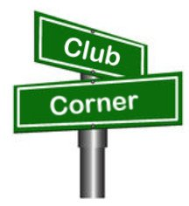***Club Corner***

This is YOUR cornner of the newsletter. Send me what your club is doing and I’ll make sure that it gets in. Got a special event or club project that you want everyone to know about? Send it to me!. Need help with a project? Send it to me.

Let me know what you club is up to. Are you going to have a special guest at your meeting or are you having a special anniversary? Just sent it to: [n8sy@n8sy.com](mailto:n8sy@n8sy.com)

####

***Alliance Amateur Radio Club to Hold General Classes***

The AARC plans to initiate classes starting on **08 January 2020**. It will be held in the cafeteria conference room starting at **6PM**.

The classes will be over a 12-week time span and will be two hours a session.

It is suggested the students bring a SD card or thumb drive with at least one gigabyte of free space to receive all the information needed to get the license. It can be used for home study and also holds the Technician class information as well as the General class.

Contact Frank, WA8WHP for more information. He can be reached at [wa8whp@gmail.com](mailto:wa8whp@gmail.com)

####

***Amateur Radio Extra License Class 2020***

***The Franklin County Ohio Amateur Radio Emergency Service*** group will offer classes to achieve an Extra Class license. Classes will be held at the Whitehall Branch public library at 4445 E. Broad Street, Whitehall, OH. You do not need to be a member of the FCOHARES to participate. .

This is a no cost course of study. **Classes begin January 2 through February 27, Thursdays from 6 to 8:30 PM**. Your only cost may be for a study guide and testing fee, depending on which organization you choose to test with, and which study guide you select.

Each student should acquire a study guide to begin familiarization with the material prior to starting the class. Although this is an advanced level technology course no advanced level math is involved. Some demonstrations will be presented during classes.

Pre-registration is recommended. To register, send an email to John Buck at [kd8rtp@arrl.net](mailto:kd8rtp@arrl.net). Please include name, email address, phone/text number.

Technician and General level classes will also be offered as requested. Dates and times to be determined. Contact John Buck at [kd8rtp@arrl.net](mailto:kd8rtp@arrl.net)

####

TOP^

***Cuyahoga Falls Amateur Radio Club to Hold General Class***

CFARC will hold its fifth annual General Class Licensing Course starting **16 February 2020** running for 5 weeks of instruction and a 6th week of a public VE session.

The class will be held in the main branch of the Akron-Summit County Public Library. The meeting time is 1:15 PM to 4:45 PM each Sunday for the 6 weeks. For detail contact Jim, N8PZL at [education@cfarc.org](mailto:education@cfarc.org).

Additional details and the course web page can be found at [j-grover.com/general](https://j-grover.com/general/index.htm).

####

***Cuyahoga Amateur Radio Society (CARS) 2020 Winter Ham Radio Classes!***

Thursday evenings starting **February 20, 2020** and ending April 2, 2020 at 6:30 pm. April 2nd will be a special VE Test session for all license classes.

To register, please follow the link at: [www.2cars.org](http://www.2cars.org) and complete the on-line application.

Classes will be held at the Seven Hills City Hall, 7325 Summit View Dr, Seven Hills, OH 44131 in room “C” at 6:30 pm every Thursday. All class materials are provided.

####

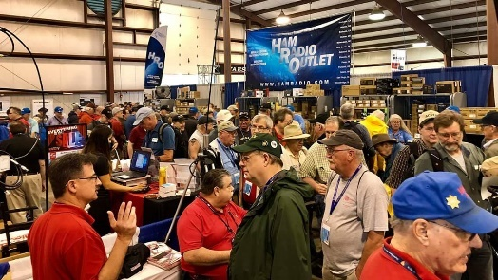[***Upcoming Hamfests***](http://arrl-ohio.org/hamfests.html) ***for 2020***

**01/19/2020 | Sunday Creek Annual Hamfest**  
Location: Nelsonville, OH  
Sponsor: Sunday Creek Amateur Radio Federation

**01/26/2020 | Tusco Amateur Radio Club's 30th Annual Hamfest, Electronics and Computer Show**  
Location: Strasburg, OH  
Sponsor: Tusco Amateur Radio Club  
Website: [http://www.tuscoarc.org](http://www.tuscoarc.org/)

**02/16/2020 | Mansfield Mid-Winter Hamfest**Location: Mansfield, OH  
Sponsor: Intercity Amateur Radio Club  
Website: [http://WWW.IARC.CLUB](http://www.iarc.club/)

**03/01/2020 | WinterHamFest**  
Location: Elyria, OH  
Sponsor: Northern Ohio Amateur Radio Society  
Website: [http://noars.net](http://noars.net/)

TOP^

**03/14-15/2020 | Toledo Hamfest,**

**ARRL Great Lakes Division Convention**Location: Perrysburg, OH  
Sponsor: Toledo Mobile Radio Association  
Website: [http://www.tmrahamradio.org](http://www.tmrahamradio.org/)

**03/21/2020 | Mid-Ohio Valley ARC Hamfest**

Location: Gallipolis, OH

Sponsor: Mid-Ohio Valley Amateur Radio Club, Inc.

Website: <http://sites.google.com/site/midohiovalleyarc/>

**04/11/2020 | 66th Annual Cuyahoga Falls Amateur Radio Club Hamfest**  
Location: Cuyahoga Falls, OH  
Sponsor: Cuyahoga Falls Amateur Radio Club, Inc.  
Website: <http://www.cfarc.org/hamfest.php>

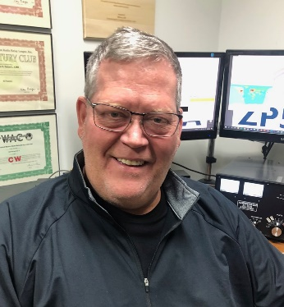***DX This Week***

*(from Bill, AJ8B)*

***DX This Week – The Year in Review***

***Bill AJ8B (***[***aj8b@arrl.net***](mailto:aj8b@arrl.net)***, @AJ8B, or*** [***www.aj8b.com***](http://www.aj8b.com)***)   
 CWOPs Member #1567***

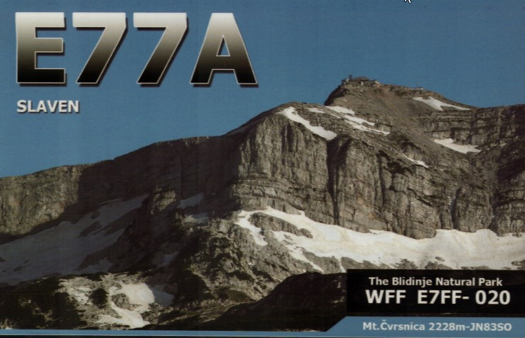DX Spots that originated in the Midwest included Alaska, Antarctica, Ascension Island, Azores, Balearic Islands, Bolivia, Canary Islands, Chad, China, Costa Rica, Czech Republic, Denmark, Dominican Republic, Estonia, European Russia, Finland, Honduras, Japan, Kazakhstan, Laos, Latvia, Lithuania, Martinique, Mexico, Moldova, Montenegro, Northern Ireland, Norway, Paraguay, Poland, Sardinia, Senegal, Slovak Republic, St. Kitts & Nevis, Sweden, Switzerland, Taiwan, Thailand, Trinidad & Tobago, Ukraine, United Nations HQ, Uruguay, Uzbekistan, Venezuela, and Wales. I hope you took part.

This week, the mailman brought M0CLH – England, F5JJA – France, LZ9W – Bulgaria, JS3CTQ – Japan, and E77A – Bosnia and Herzegovina (Pictured). What did you get? Send me an image and some details!

The year is winding down quickly, and you will be making the final QSOs of the decade! Pretty amazing if you think about it. As I enter my 49th year of being a licensed ham, I have to say that each year has been more fun and more challenging than the last! I had that “time off” while they kids were young, but still managed to catch some major DXPeditions and an occasional contest or two in the 80s.

TOP^

My first license was a 2-year, non-renewable Novice ticket that I had to pass in front of the “FCC man” from Detroit. Then it was the General test where we actually had to draw circuits! (Colpitts, Hartley, and Pierce Oscillators….) Then the Extra and the 20 WPM. How the years have flown by…

I have gotten a few emails from readers indicating that we are giving you information that you are interested in. I do my best to be a compliment to the fine newsletter that Scott puts together. In the future, please pass along your feedback!

This past week was an excellent DX week for me, and I wanted to share my excitement. On Sunday, I was able to work TT8SN, Chad, for an All Time New One. Central Africa is known as the “Terrible Ts”. (TJ -Cameroon, TL - Central Africa Rep, TN – Congo, TR – Gabon, TT – Chad, TU - Ivory Coast, TY – Benin, and TZ – Mali) Chad became Worked Entity #300 and Confirmed Entity #299. Working Chad also allowed me to top my best CQ DX Marathon Score, 173 countries and 37 Zones for 210 points in 2019. Nowhere near the top, but, a personal best for me!

The only country that I have worked and not confirmed was 8Q7AJ – Maldives. I worked this station in 1990 and have never gotten a QSL route for that station...until Sunday. Each year I have researched this station and have gotten several QSL routes, none of which turned out to be fruitful. Several times I have been told that the manager no longer had the logs. On Sunday I found another QSL route source, IK3QAR. I checked their listing for 8Q7AJ and found a QSL manager that I had not contacted before. I sent an email to K9AJ on Sunday. On Monday I received a reply that not only did he have the paper logbooks, but he had my QSO in it! I have already sent my QSL and SASE along to him to confirm #300 – 30 years in the making!

**More Good News:** According to NOAA/NASA and those in the know, the low point of the current solar cycle 24 will be April 2020 (+/- 6 months). The current projected peak will be July of 2025. (+/- 8 months). As the saying goes, it will be here before you know it. I know there is a lot of criticism of FT8 and similar modes, but, I have to tell you that it has certainly kept me on the air during this sunspot low. Historically, you would have to check to make sure the antenna was still connected when at the bottom of a cycle. Now, there is at least some activity all around the cycle.

***CQDX CQDX CQDX CQDX CQDX CQDX CQDX CQDX CQDX***

Here is an update from Bernie, W3UR, of the DailyDX and the WeeklyDX, the best source for DX information. <http://www.dailydx.com/> ) Bernie has this to report:

**7X – Algeria -** KF5EYY, Ash, one of the main operators at the 3V8SS club station gives us the following announcement. Three members of the "Association des Radio Amateurs Tunisiens - ARAT" are traveling to Algeria to conduct a joint Low Bands DXpedition with five members of the "Amateurs Radio Algeriens - ARA" from December 28th 2019 to January 2nd 2020 during which the operators will be focusing on working as many stations as possible on 160 and 80m as well as the other HF bands. Decent antennas for TX and RX (BOGs to NA and JA) are prepared for the event. The team led by Afif, 7X2RO, and Ash, 3V8SS/KF5EYY, also includes Ahmed, 3V1B/KG5OUE (22 years); Marwa, 3V8CB (24 years, YL); Mohamed, 7X3TL (27 years); Mohamed, 7X5FG; Redha, 7X5QB; and Abdelghani, 7X2TT/M0NPT. QSL will be via 7X2RO and LoTW. For more details on how to help and/or LF skeds please [email Ash 3V8SF/KF5EYY](mailto:ash.kf5eyy@gmail.com?subject=7X7X). Your financial support will be used to cover youngsters costs. They will be [live streaming](http://r20.rs6.net/tn.jsp?f=001uxL9IjaOefF9x2dn9NO7aaGhcgqkTLEj2WX9tjDokloebrk9gZjQPBDXvE-YptOfTVAf7IM7RBCB-PYF0Oalnmg-GG3Q5nlZF3-W-51Sf1CoRFxHtg63xMLBir-p_EMkJqdeRNgcfDw6PnyXEe-oQQ==&c=b8mlzzJGb40YpEd6nhch2vygoJWb8Ohjle4zYplCPM2o0wBicJ-Cyw==&ch=xu1y23b8Z1LYdLVRlvTcZjV_vE03JMvYr3D-JREsut33COZifOnt7A==) to Club Log.

TOP^

**P4 – Aruba -** DL6RAI, Ben, is currently as his Aruba home vacationing and operating casually as P4/DL6RAI until December 26th, when he returns home. Listen for him on 160 through 10 Meters mostly CW, but maybe some FT8. QSL via DL6RAI either direct or via the bureau, Club Log and LoTW.

**PZ – Suriname -** PA4ARI, Arie, [reports](http://r20.rs6.net/tn.jsp?f=001uxL9IjaOefF9x2dn9NO7aaGhcgqkTLEj2WX9tjDokloebrk9gZjQPBDXvE-YptOfXxYszFkgmJuu2fWxqFGRPWCZqJsg9ikjInd387f2nS4E4qC1SvMEC6MI6fnMNDnNeA8xs8805vnd4Ik5HlwqsJbzkZtOPEXk&c=b8mlzzJGb40YpEd6nhch2vygoJWb8Ohjle4zYplCPM2o0wBicJ-Cyw==&ch=xu1y23b8Z1LYdLVRlvTcZjV_vE03JMvYr3D-JREsut33COZifOnt7A==) he will be QRV from Paramaribo as PZ/PA4ARI from December 15 to January 7. He expects to be active on FT8 and FT4 on 80, 40 and 20 meters as well SSB on those bands. He also mentions the following frequencies: 7.080, 7.090, 7.150, 7.160, 14.160 and 14.240 MHz.

***DX news***

***ARLD050 DX news***

This week's bulletin was made possible with information provided by KD7WPJ, W3UR, The Daily DX, the OPDX Bulletin, 425 DX News, DXNL, Contest Corral from QST and the ARRL Contest Calendar and WA7BNM web sites. Thanks to all.

**ROTUMA ISLAND, 3D2.** 3D2AG/p is QRV until January 5, 2020. Activity is on 160 to 2 meters using CW, SSB, RTTY, JT65 and FT8. QSL via 3D2AG.

**GHANA, 9G.** Ruettger, DL8MEZ is QRV as 9G5RV until December 22 while on a business trip. Activity is in his spare time on 20 meters using SSB and FT8. QSL via LoTW.

**EASTER ISLAND, CE0.** Oleh, KD7WPJ will be QRV as CE0Y/UR5BCP from Hanga Roa, IOTA SA-001, from December 26 to 31. Activity will be on 60 to 6 meters using CW, SSB, FT8 and FT4. QSL to home call.

**MOROCCO, CN.** Special event station CN19JIM will be QRV on December

21 and 22 during the Journee Internationale de la Montagne. QSL via RW6HS.

**FEDERAL REPUBLIC OF GERMANY, DA.** Volker, DL1WH will be QRV from Borkum, IOTA EU-047, from December 21 to 31. Activity will be holiday style on 80 to 10 meters using CW with some SSB. QSL to home call.

**LIECHTENSTEIN, HB0.** Kasimir, DL2SBY will be QRV as HB0/DL2SBY from December 21 to 28. Activity will be on 80 to 10 meters using CW, SSB and various digital modes. QSL direct to home call.

**ECUADOR, HC.** Antonio, EA5RM is QRV as HC3AGT from Loja. Activity is on 40 to 10 meters using SSB and various digital modes. QSL to home call.

**OGASAWARA, JD1.** Harry, JG7PSJ will be QRV as JD1BMH from December 22 to January 3, 2020. Activity will be in his spare time on 80 to 10 meters using CW, SSB and RTTY. QSL to home call.

**AUSTRIA, OE.** Members of the Amateur Radio Contest DX Club are QRV with special call sign 4U1XMAS until December 31 from the station at the United Nations Vienna International Center. Activity is on 80, 40, 20 and 15 meters using CW and SSB. QSL via UA3DX.

**ARUBA, P4.** Ben, DL6RAI is QRV as P4/DL6RAI until December 26. Activity is holiday style on 160 to 10 meters using mostly CW with some FT8. QSL to home call.

TOP^

**SURINAME, PZ.** Arie, PA4ARI is QRV as PZ/PA4ARI from Paramaribo until January 7, 2020. Activity is on 80, 40 and 20 meters using SSB, FT8 and FT4. QSL to home call.

**GABON, TR.** Roland, TR8CR has been active on 30 meters using CW around 2000 and 2200z. QSL via F6AJA.

**CHAD, TT.** Nicolas, F8FQX is QRV as TT8SN from N'Djamena for the next three to four years. Activity is on the HF bands and 6 meters. QSL via DL9USA.

**ASIATIC RUSSIA, UA0.** Special event stations R95WURC, R95WBZ, R95WFT, R95WGK, R95WJV, RW95WJ and RX95WN are active until December

25 to celebrate the 95th anniversary of the UFA Radio Club and the beginning of amateur radio in the Republic of Bashkortostan. QSL via operators' instructions.

**SOUTH SUDAN, Z8.** Diya, YI1DZ is QRV as Z81D from Juba for at least six months. Activity is on 80 to 10 meters using SSB, FT8 and possibly FT4. This includes possibly being active on 60 meters as well. QSL via OM3JW.

THIS WEEKEND ON THE RADIO. The ARRL CW Rookie Roundup, NCCC RTTY Sprint, QRP 80-Meter CW Fox Hunt, NCCC CW Sprint, AGB-Party Contest, Russian 160-Meter Contest, Feld Hell Sprint, OK DX RTTY Contest, Padang DX SSB Contest and the Croatian CW Contest are all on tap for this upcoming weekend.

The SKCC CW Sprint, CWops Mini-CWT Test and Phone Fray are scheduled for December 25.

The Canadian National Parks on the Air, CNPOTA, operating event runs for the entire year of 2019, with special stations active from Canada's parks and historic sites.

During December look for a number of stations active with the YOTA suffix for Youngsters On The Air. QSL via LoTW or direct to M0SDV.

Please see December QST, page 63, and the ARRL and WA7BNM Contest Web Sites for details.

***Special Events***

* **12/26/2019 | Commemorating the US Revolutionary War – Historic “Battle of Trenton”**

**Dec 26-Dec 30, 0000Z-2359Z, W2T**, West Trenton, NJ. Delaware Valley Radio Association. 14.225 7.175. Certificate & QSL. Delaware Valley Radio Association, PO Box 7024, Trenton, NJ 08628-0024. [www.w2zq.com](http://www.w2zq.com/)

* **12/28/2019 | Battleship IOWA Commemorates IOWA Statehood**

**Dec 28, 1600Z-2359Z, NI6BB**, San Pedro, CA. Battleship IOWA Amateur Radio Association, Inc.. 7.243 14.043 14.243 18.143. QSL. Battleship IOWA Amateur Radio Association, Inc., 250 S. Harbor Blvd., San Pedro, CA 90731. Battleship IOWA Amateur Radio Association's NI6BB will be on the air from 1600 to 2359 UTC on 28 December 2019 to commemorate Iowa's statehood in 1846. Anticipated frequencies will be 7043, 7243, 10121, 14043, 14243, 18080 or 18143 all depending on operator participation and conditions. QSL to address as shown on [biara.org](http://biara.org/)

TOP^

* **12/29/2019 | 21st Annual Ham Radio University Educational Conference**

**Dec 29-Jan 5, 0000Z-0300Z, W2HRU**, Lindenhurst, NY. Ham Radio University. 14.273 7.273 7.074 3.923. Certificate & QSL. Phil Lewis, N2MUN, 22 Belle Terre West, Lindenhurst, NY 11757. Operating at various times on SSB and FT8. Electronic QSL via eQSL and LoTW. Paper QSL via W2 QSL Bureau or direct w/SASE to Phil Lewis, N2MUN, 22 Belle Terre West, Lindenhurst, NY 11757. On-Line printable QSL Certificate available at: https://www.elemcoshopfloor.com/w2hru_cert. [hamradiouniversity.org](http://hamradiouniversity.org/)

* **12/31/2019 | Commemorating the US Revolutionary War – Historic “Battle of Princeton”**

**Dec 31-Jan 6, 0000Z-2359Z, W2P**, Trenton, NJ. Delaware Valley Radio Association. 14.225 7.175. Certificate & QSL. Delaware Valley Radio Association, PO BOX 7024, West Trenton, NJ 08628-0024. [https://www.w2zq.com](https://www.w2zq.com/)

* **01/01/2020 | NCDXA 5th Annual Worked All RST Special Event**

**Jan 1-Feb 28, 0000Z-2359Z, KL7RST**, Anchorage, AK. North Country DX Association (K7ICE). 14.250 14.075 7.190 7.050. QSL. J. Reisenauer, 2573 Old Georgetown Rd. W., Kershaw, SC 29067. [www.qrz.com/db/kl7rst](http://www.qrz.com/db/kl7rst)

* **01/02/2020 | 14th Annual Straight Key CW Event**

**Jan 2-Jan 31, 0000Z-2359Z, K3Y**, various cities. SKCC - Straight Key Century Club. 21.050 14.050 7.055 3.550. Certificate & QSL. SKCC c/o Jeremy Downard, KD8VSQ, 511 W. Pottawatamie St., Tecumseh, MI 49286. K3Y/0 thru 9 plus KH6, KL7, KP4 and DX member stations in six WAC areas operating straight key, bug and cootie keys. QSL card confirms one QSO per area, up to 19 for all-area sweep. See URL for schedule, map, stats, etc. [www.skccgroup.com/k3y](http://www.skccgroup.com/k3y)

* **01/07/2020 | Florence Nightingale Bi-Centenary**

**Jan 7-Feb 3, 1000Z-0900Z, GB200FN**, ROMSEY, UNITED KINGDOM. RSGB. 14.200 MHz 7.95 MHz. QSL. John Wakefield, Oakhurst, Lower Common Road, West Wellow, ROMSEY SO51 6BT, UNITED KINGDOM. Direct QSL to include postage. Full details on QRZ.com. [www.qrz.com/db/gb200fn](http://www.qrz.com/db/gb200fn)

* **01/08/2020 | 9th Annual Balloon Festival**

**Jan 8-Jan 12, 0000Z-2359Z, K7B**, Lake Havasu City, AZ. London Bridge Amateur Radio Association. 18.145 14,263 7.195 3.905. Certificate. Garry F. Fisher K9WZB, 1850 Rainbow Ave S, Lake Havasu City, AZ 86403. [www.lbara.club](http://www.lbara.club/)

* **01/11/2020 | 119th Anniversary of the Lucas Gusher**

**Jan 11-Jan 12, 1400Z-2300Z, K5S**, Beaumont, TX. Beaumont Amateur Radio Club. 7.245 14.250 7.074 14.074. Certificate & QSL. Beaumont Amateur Radio Club, 4839 Hwy 326 N., Kountze, TX 77625. Visit our QRZ page for qsl and certificate information as well as updated times and frequencies. [www.qrz.com/db/w5rin](http://www.qrz.com/db/w5rin)

* **01/11/2020 | USS Midway Museum Ship Special Event; Desert Storm Kickoff**

**Jan 11, 1700Z-2359Z, NI6IW**, San Diego, CA. USS Midway (CV-41) Museum Ship. 14.320 7.250 PSK31 14.070 DSTAR REF001C. QSL. USS Midway Museum Ship COMEDTRA, 910 N Harbor Drive, San Diego, CA 92101.

* **01/18/2020 | Maderas Canyon - Birding Capital of Arizona**

**Jan 18, 1600Z-2100Z, K7T**, Tucson, AZ. Oro Valley Amateur Radio Club. 7.200 LSB 14.040 CW 14.250 USB 18.100 FT-8. Certificate. Email, qsl@tucsonhamradio.org, for certificate.. No paper QSLs please. [www.TucsonHamRadio.org](http://www.tucsonhamradio.org/)

TOP^

***Straight Key Night***

**Objective:** This 24-hour event is not a contest; rather it is a day dedicated to celebrating our CW heritage. Participants are encouraged to get on the air and simply make enjoyable, conversational CW QSOs. The use of straight keys or bugs to send CW is preferred. There are no points scored and all who participate are winners.

**Contest Details**

    **Dates**  
    Straight Key Night is held every **January 1 from 0000 UTC through 2359 UTC**.  
  
**Terms Of Entry**  
    - Entrants agree to be bound by the provisions and intent of ARRL contest rules.  
    - Entrants agree to be bound by the regulations of their national licensing authority.  
    - Entrants agree to be bound by the decisions of the ARRL Awards Committee.  
    - Log contents used to determine final score and awards will be available to the public.  
    - All entries become the property of the ARRL.  
  
**Bands**  
All authorized Amateur frequencies, but activity has traditionally been centered on the HF bands.  
  
**Log Submission Deadline**  
Entries for Straight Key Night must be received by January 31. Votes for ‘Best Fist’ and “Most Interesting QSO” will be tabulated and included in the results.  
      
**Send your information to**[**straightkey@arrl.org**](mailto:StraightKey@arrl.org)Contact Information: [contests@arrl.org](mailto:contests@arrl.org)

**A Straight Key Night Story:**  
By Dan Henderson, N1ND  
  
In my early days in amateur radio, I was privileged to have three top-flight Elmers.  Each shared with me new interests and enthusiasm for different parts of the hobby.  The first, Col. Frank, WB4JMG, was special because we shared the same birthday and he taught me most of what I learned in those early days about electronic theory. The second Everest, W4DYW, was special because not only because our families were so close – he was my principle mentor for on-the-air operations, especially CW traffic nets.  
  
Unless your Elmer was one of your parents, you probably can’t say what my third Elmer could say about our relationship.  Dr. Mac, WA4VNV (later N4IX), would honestly say he knew me my entire life.  Not only was he a dedicated amateur operator – he was my mother’s OBGYN and was the man who literally “delivered me” to the world, and helped me find the world of amateur radio in later years.  
  
I had been attending club meetings with the old Asheville Radio Club (which merged with the Buncombe County VHF Society to later form the Western Carolina Amateur Radio Society) for months before I was first licensed.  And being the precocious teenager that I was, I jumped in with both feet.  In mid-1971 I agreed to take over as editor of the ARC’s monthly newsletter, known as Smoke-test from Dr. Mac.  He agreed to help me as a regular contributor, but slyly with one caveat–he would only provide news stories for me for the newsletter if I would copy them over the air using CW, since I was only a novice and had no phone privileges during those years.

TOP^

I accepted his offer, and began two years of almost daily QSOs on 3725 KHz– because that was one of the few crystals I had for the HeathKit HW-16, which Col. Frank had been commissioned by my parents to build for my Christmas present in 1970.  It was a unique experience, but one which served to continue building what became my passion for Morse code.  In later years I would follow in Dr. Mac’s footsteps once again when I became the ARES EC and RACES Radio Office for the county (but that’s a topic for another article).

Between the efforts of my three Elmers, my CW speed quickly increased from the nervous 5 WPM necessary to earn my license to being able to conduct a coherent rag chew in the 25-30 WPM range.  And the mantra of all three was simple – If you want to be competent in CW, you have to use it.  
  
So each year from 0000 UTC to 2359 UTC PM January 1st I have the chance to pay a small bit of homage back to the Elmers when I have the opportunity to participate in the annual ARRL Straight Key Night. This 24-hour event is not a contest; rather it is a day dedicated to celebrating our CW heritage. Participants are encouraged to get on-the-air and simply make enjoyable, conversational QSOs.  There are no points scored and all who participate are winners.  
  
In the decade since I wrote my first SKN announcement for QST, I have seen marvelous metamorphosis occur.  The number of entries has grown almost every year, even with the elimination of CW as a licensing requirement in the US.  Participants have also used this popular annual event for more than just demonstrating their prowess pounding a brass key. Numerous participants use SKN to test out and “show off” their vintage equipment.  Some will plug in their old CW “bugs” and join in.   The common bond for all of them is to have fun in a more relaxed setting. You will even find CW enthusiasts who get on to enjoy the rag chewing   And that’s the purpose of this popular operating event, so don’t get hung up about the equipment.  
  
When participating in SKN instead of sending RST before sending the signal report send the letters SKN, to indicate your participation, and to clue in passers-by who may be listening that SKN is going strong.  After SKN, send the Contest Branch a list of stations worked, plus your vote for the best fist you heard (it doesn’t have to be one you worked).  Also, include your vote for the most interesting QSO you had or monitored.  
  
Don’t forget to post your comments and interesting photographs from your SKN adventure to the ARRL Contest Online Soapbox. Entries should be emailed to the Contest Branch at [StraightKey@arrl.org](mailto:StraightKey@arrl.org)or may be sent via regular mail to SKN, ARRL, 225 Main St, Newington, CT 06111. The Soapbox becomes an online album of stores and photographs to share with others.

####

***Kids Day is Saturday, January 4***

The first Saturday in January is Kids Day -- the time to get youngsters on the air to share in the joy and fun that amateur radio can provide. Kids Day gets under way on Saturday, January 4, at 1800 UTC and concludes at 2359 UTC. Sponsored by the Boring (Oregon) Amateur Radio Club, this event has a simple exchange, suitable for younger operators: First name, age, location, and favorite color. After that, the contact can be as long or as short as each participant prefers. Kids Day is the perfect opportunity to open your shack door and invite kids over to see what amateur radio has to offer. [Details](http://www.arrl.org/kids-day) are on the ARRL website.

####

TOP^

***Attention ALL Ohio…***

***Mark January 11 (Saturday)  10AM -  4PM for the ARES VHF Simplex Contest!***

This is more important in 2020 as a follow-up to our SET, which was designed to map our simplex footprints. Now, we can exercise that information and get even more by participating!  It’s a fun event with a purpose.

The purpose of our annual simplex activity is to improve our station and antenna capabilities, and to test our coverage areas on simplex frequencies.

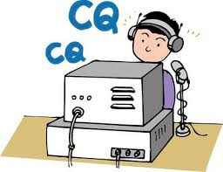These may be very important in times of emergency, when repeaters have failed, and simplex is the only method of emergency communication. We are NOT giving any consideration for backup power- this exercise is aimed at testing antennas and determining coverage areas.

**We’ve just gotta’ thank Jason McCormick N8EI for setting up a website with the complete rules, scoring and who’s operating.** [**https://ohsimplex.org/#rules**](https://ohsimplex.org/#rules)

####

***Mark April 4, 2020 (Saturday) as our ARES OHIO SPRING CONFERENCE!***

We have the Marion Tech lecture hall reserved (THANKS MARION ARES!!!) and we’ll begin planning some important topics! More information will be forth coming.

####

***NVIS DAY IS COMING!***

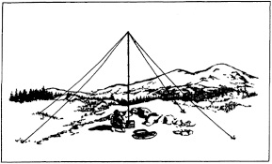Is your station ready to establish and maintain high-reliability communication with other stations around Ohio when repeaters, phone, and internet service are impaired?

When infrastructure just isn’t there, HF radio using Near-Vertical Incidence Skywave (NVIS) propagation offers the ability to stay in contact on frequencies of 2–30 MHz for distances of about 30–400 miles.

NVIS Day is the ARRL Ohio Section event to test your NVIS antenna designs and builds. Join us on Saturday, April 25th to show how well amateur radio can keep Ohio communicating! This is not a contest: it’s an event for Ohio stations to operate with other Ohio stations and understand how well they hear and are heard.

TOP^

**THE DETAILS**

**Date: Saturday, April 25**

**Time: Start at 10 A.M., end at 4 P.M.**

**Power: Up to but no more than 100w**

**Exchange: six-digit grid, power, and true—measured—signal report**

**Schedule: This isn’t a contest, so take your time! Try different designs! Have lunch!**

**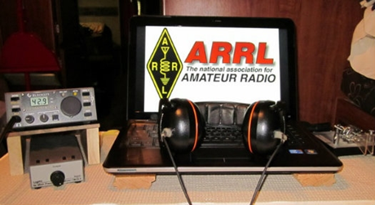*ARRL Contest Corner***

An expanded, downloadable version of *QST'*s [**Contest Corral**](http://www.arrl.org/contest-calendar) is available as a PDF. Check the sponsor's Web site for information on operating time restrictions and other instructions.

Just Ahead in Radiosport

* December 25 -- SKCC Sprint (CW)
* December 26 -- DARC Christmas Contest (CW, phone)
* December 28 -- RAC Winter Contest (CW, phone)
* December 28 - 29 -- 1.8 Stew Perry Topband Challenge (CW)
* December 28 - 29 -- Original QRP Contest (CW)
* December 30 - 31 -- QCX Challenge (CW)
* December 31 -- Bogor Old and New Contest (Phone)
* **January 1 --** [**Straight Key Night**](http://www.arrl.org/straight-key-night)
* January 1 -- AGB New Year Snowball Contest (CW, phone, digital)
* January 1 -- SARTG New Year RTTY Contest
* January 1 -- AGCW Happy New Year Contest (CW)
* January 1 -- AGCW VHF/UHF Contest (CW)
* January 1 -- QRP ARCI New Year's Sprint (CW)
* January 1 -- 3.5 UKEICC 80-Meter Contest (Phone)
* January 2 -- NRAU 10-Meter Activity Contest (CW, phone, digital)
* January 2 -- SKCC Sprint Europe (CW)
* **January 4 --** [**ARRL Kids Day**](http://www.arrl.org/kids-day) **(Phone)**
* January 4 -- PODXS 070 Club PSKFest (Digital)
* January 4 -- RSGB AFS Contest, CW
* January 4 - 5 -- WW PMC Contest (CW, phone)
* **January 4 - 5 --** [**ARRL RTTY Roundup**](http://www.arrl.org/rtty-roundup)
* January 4 - 5 -- EUCW 160-Meter Contest (CW)
* January 6 - 12 -- All IQRP Quarterly Marathon (CW, phone, digital)
* January 7 -- ARS Spartan Sprint (CW)
* January 8 - 12 -- AWA Linc Cundall Memorial CW Contest

TOP^

***Website Stats –*** [***www.arrl-ohio.org***](http://www.arrl-ohio.org)

November 2019

The stats below show that we have a very active site for sure. The map below shows all of the areas of the globe in blue that our newsletter is going and being read. Quite amazing I’d say.

|  |  |  |  |  |  |
| --- | --- | --- | --- | --- | --- |
| **Reported period** | Month Nov 2019 | | | | |
| **First visit** | 01 Nov 2019 - 00:00 | | | | |
| **Last visit** | 30 Nov 2019 - 23:59 | | | | |
|  | Unique visitors | Number of visits | Pages | Hits | Bandwidth |
| Viewed traffic * | **3,551** | **6,803** | **299,727** | **1,093,958** | **21.17 GB** |

 Top 10 Operating Systems Top 10 Browsers

|  |  |
| --- | --- |
| **Browsers** | **Percent** |
| **Google Chrome** | 47.1 % |
| **Firefox** | 28.3 % |
| **Safari** | 9.9 % |
| **Edge** | 8.4 % |
| **Opera** | 2.7 % |
| **MS Internet Explorer** | 2.1 % |
| Unknown | 0.9 % |
| Mozilla | 0 % |
| IPhone (PDA/Phone browser) | 0 % |
| Acrobat Webcapture | 0 % |
| Others | 0 % |

|  |  |
| --- | --- |
| **Operating Systems** | **Percent** |
| **Windows** | 80.5 % |
| **Macintosh** | 10.3 % |
| **Linux** | 6.8 % |
| **iOS** | 1 % |
| Unknown | 1 % |
| Unknown Unix system | 0.1 % |

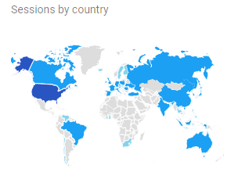

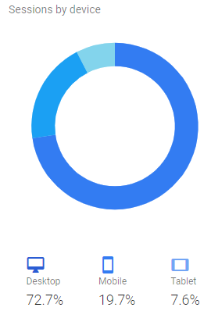

TOP^

*****V.E. Test Sessions***

For the latest testing site information please **>>** [**Click Here**](http://www.arrl.org/find-an-amateur-radio-license-exam-session) **<<** The ARRL site tracks all of the VE testing sites that register with them, including W5YI and Laurel. ARRL gives you a number of different ways of sorting to find that site that is closest to you as well.

***One Question Questionnaire***

Hey Gang, 

“Survey Says” about 72**%** of you only carry just 1 radio on your belt. That’s about what I would expect. The surprise to this latest survey was that 13% of you don’t wear a belt! Maybe I should have included a checkbox for those that wear suspenders. Anyway, it does show that most of us do wear a radio during an event.

I’ve got another NEW – one question – for you to answer. Since this is the Christmas Edition, here’s my next question and I really want to see just how many of you will answer this question truthfully.… Remember guys and gals, Santa knows if you’ve been good!!

**“Will you open at least one Christmas gift before Christmas morning?”**

You’ll find the “One Question” questionnaire on the Ohio Section Website! <http://arrlohio.org> It’s all in fun and it’s not a scientific survey in any way, but we are learning some things that we didn’t know from these questions. I hope that you are enjoying answering these “One Question” questionnaires.

**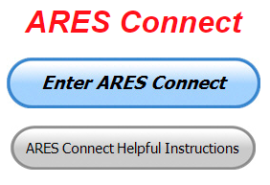*ARES Connect***

**Everyone –** please make sure to go into all of the events that you have signed up for and get your hours registered no later than 7 days after the event has ended.

I need you to be as prompt as possible in reporting your hours. I’m noticing a number of events that aren’t getting hours credited and that is due to you not going back into your account and registering your hours! Please, don’t miss out on your hours just because you missed on very important step, record hours!!

Admins – Make sure that you are as prompt about approving those hours as well. I’ve set the timer for 7 days after the event, this should be more than ample amount of time to make sure hours are recorded for every volunteer that signed up and get those hours approved.

TOP^

***Here’s the top 10 hours earners so far in December:***

|  |  |  |  |
| --- | --- | --- | --- |
|  | **Name** | **Events** | **Hours** |
| 1 | Bret Stemen (KD8SCL) | 26 | 81.50 |
| 2 | James Yoder (w8erw) | 20 | 79.45 |
| 3 | Dan Stahl (KC8PBU) | 45 | 45.56 |
| 4 | Diane Warner (KE8HLD) | 18 | 45.50 |
| 5 | Christopher Domenick (KC8CAD) | 13 | 43.00 |
| 6 | Greg Dersarkisian (KD8SSJ) | 18 | 40.50 |
| 7 | Steve Wheatcraft (AA8BN) | 7 | 28.75 |
| 8 | John Hilliard (w8of) | 18 | 25.00 |
| 9 | Alan Rothweiler (N8CJ) | 17 | 25.00 |
| 10 | Michael Lacumsky (w8mal) | 24 | 22.35 |

Here’s a quick overview of what we report to Headquarters that comes from the data collected by ARES Connect…

The month of May was the very first report with all the data coming from ARES Connect. The Ohio Section was also, and still remaining true today, the only Section where the data collected for the monthly report comes from ARES Connect.

With all of the additions to ARES Connect that we now have, there is absolutely no longer any excuses for all of you to not use the system!!

I’m setting a goal for all of you out there. **Let’s get everyone in the Ohio Section on ARES Connect before the end of this year!!! Simply go to:**  <https://arrl.volunteerhub.com/lp/oh/> and get yourself registered and using the system.

Why is this so important? Hey, I am just going to say this… The end of the year is coming up fast, and now with the ability to catch yourself up on past events, there’s gonna’ be a very special “End of the Year” award for the person with the most hours in 2019! . Will that be you? You now can make that happen!

**Admins…** If you are wondering how to get an overview of all of your events you can simply go into reports and using the new Event by Participation by Event (version 2) you can not only see who registered for your event, but you also can see if he/she has inputted their hours for it as well. Take advantage of this new report to help you get the time entered into your events.

**I’m also seeing a number of recurring events created but no activity reported for them.** Please, if this event is no longer needed, let me know and I can delete it from the masters. I know that many of you setup recurring events to learn how, but if they aren’t going to be used, let’s get them cleared out.

Also… If you are setting up events, please don’t set a limit for how many folks can sign-up unless absolutely necessary. This causes issues when doing reports. It’s also counter-productive since the reason for you to list the event is to get as many volunteers as you can to attend. When you set limits, it discourages folks from signing up.

TOP^

***Special NIMS Training Available***

**ICS300 INTERMEDIATE ICS FOR EXPANDING EVENTS MGT904**

Hosted by: Mahoning County Emergency Management Agency

**January 13 – 15, 2020**

**Application Deadline: December 30, 2019**

Course Registration time: 7:30 am – 8:00 am (on day one)

Course Time: 8:00 am to 5:00 pm – All three (3) days One-hour Lunch each day

Training Location: Boardman Fire Department, Station 71 7440 Market Street Boardman, OH 44512

Recommended Participants: FEMA designed this course for individuals who may assume a

supervisory role in expanding incidents or Type 3 incidents.

Required Prerequisites: Individuals must complete the IS-100.c Introduction to the Incident Command

System, IS-200.c Basic Incident Command System for Initial Response, IS-700.b An Introduction to the

National Incident Management System and IS-800.c National Response Framework courses prior to

attending the ICS-300 Intermediate course and provide copies of their certificates of completion to the

instructors on day one of the course.

Enrollment: Students must enroll via the Department of Public Safety Training Campus website:

<https://trainingcampus.dps.ohio.gov/cm/cm710/pstc/pstc.html> Course registration will generally close 10

working days prior to the course start date and applicants can check enrollment/approval status via the

Department of Public Safety Training Campus website.

Course Costs: There is no charge for participants to attend this course. However, Lodging, Meals, Per

Diem and all other travel expenses are the responsibility of the student or the parent organization.

State Point of Contact: Lisa Jones, DSC 2, Ohio EMA, SAA Training Point of Contact, (614) 799-3824

[ljones@dps.ohio.gov](mailto:ljones@dps.ohio.gov)

####

**ICS400 ADVANCED FOR COMMAND & GENERAL STAFF MGT905**

Hosted by: Mahoning County Emergency Management Agency

**March 30 – 31, 2020**

**Application Deadline:** March 16, 2020

Course Registration time: 7:30 am – 8:00 am (on day one)

Course Time: 8:00 am to 5:00 pm – Both days One-hour Lunch each day

Training Location: Boardman Fire Department, Station 71 7440 Market Street Boardman, OH 44512

TOP^

Required Prerequisites: Individuals must complete the IS-100.c Introduction to the Incident Command

System, IS-200.c Basic Incident Command System for Initial Response, IS-700.b An Introduction to the

National Incident Management System and the IS-800.c National Response Framework, an Introduction

courses. In addition, ICS-300 Intermediate courses prior to attending the ICS-400 Advanced course and

provide copies of their certificates of completion to the instructors on day one of the course.

Enrollment: Students must enroll via the Department of Public Safety Training Campus website:

<https://trainingcampus.dps.ohio.gov/cm/cm710/pstc/pstc.html> Course registration will generally close 10

working days prior to the course start date and applicants can check enrollment/approval status via the

Department of Public Safety Training Campus website.

Course Costs: There is no charge for participants to attend this course. However, Lodging, Meals, Per

Diem and all other travel expenses are the responsibility of the student or the parent organization.

State Point of Contact: Lisa Jones, DSC 2, Ohio EMA, SAA Training Point of Contact, (614) 799-3824

[ljones@dps.ohio.gov](mailto:ljones@dps.ohio.gov)

####

**G-386 MASS FATALITIES**

Hosted by: Franklin County Emergency Management & Homeland Security **February 20 - 21, 2020**

**This is an “Elective” course in the Advanced Professional Series (APS) program**

**Application Deadline:** February 10, 2020

**Time of Course:** Registration: 7:30 am – 8:00 am Course Time: 8:00 am – 4:00 pm

**Location:** Franklin County EM&HS - 5300 Strawberry Farms Blvd. - Columbus, OH 43230

**Supported By:** The Ohio Emergency Management Agency

**Enrollment:** Students must enroll via the Department of Public Safety Training Campus website: <https://trainingcampus.dps.ohio.gov/cm/cm710/pstc/pstc.html>

**Course Costs:** This course is free to participants. Lodging, meals and all other expenses are the students’ responsibility.

**County Point of Contact:** Pam Tickle, Franklin County EM&HS (614) 794 – 0213, [pktickle@franklincountyohio.gov](mailto:pktickle@franklincountyohio.gov)

####

***Below is information on upcoming ICS-300/ICS-400 classes for those interested.***

Please be advised that we have listed the following ICS courses on the Ohio EMA Public Safety Training Campus (PSTC) website for students to register for the courses; <https://trainingcampus.dps.ohio.gov/cm/cm710/pstc/>

TOP^

|  |  |  |  |  |  |
| --- | --- | --- | --- | --- | --- |
| **Course ID** | **Name** | **Session** | **Location** | **Enroll** | |
| ICS300LorainCoJan2020 | ICS-300 Intermediate ICS | January 7 - 9, 2020 | Oberlin Fire Department 430 South Main Street Oberlin, OH 44074 | | [Enroll](https://trainingcampus.dps.ohio.gov/cm/cm710/pstc/pstc.html) |
| ICS300PrebleCoJan2020 | ICS-300 Intermediate ICS | January 11, 12 & 18, 2020 | Eaton City Fire Department, Station 2 391 West Lexington Road Eaton, Ohio 45320 | | [Enroll](https://trainingcampus.dps.ohio.gov/cm/cm710/pstc/pstc.html) |
| ICS400AshtabulaCoJan2020 | ICS-400 Advanced ICS | January 13 - 14, 2020 | Ashtabula County Engineers Office 186 East Satin Street Jefferson, Ohio 44047 | | [Enroll](https://trainingcampus.dps.ohio.gov/cm/cm710/pstc/pstc.html) |
| ICS300MahoningCoJan2020 | ICS-300 Intermediate ICS | January 13 - 15, 2020 | Boardman Fire Department, Station 71 7440 Market Street Boardman, OH 44512 | | [Enroll](https://trainingcampus.dps.ohio.gov/cm/cm710/pstc/pstc.html) |
| ICS400OttawaCoJan2020 | ICS-400 Advanced ICS | January 16 - 17, 2020 | Magruder Hospital 615 Fulton Street Port Clinton, OH 43452 | | [Enroll](https://trainingcampus.dps.ohio.gov/cm/cm710/pstc/pstc.html) |

####

***Campbell County Kentucky Office of Emergency Management Upcoming Training***

Campbell County Kentucky Office of Emergency Management **FREE** Training Opportunities

Working with the Media: A Short Course for Emergency Responders (AWR-209) – January 22, 2020 – RDPC / Register: <https://qrgo.page.link/o2Gs>

Isolation and Quarantine for Communities (MGT-433) – February 19, 2020 – RDPC / **Tentative/Requested**

Hazardous Weather Preparedness for Campuses (AWR-332) – March 4, 2020 – (NDPTC) / **Tentative/Requested**

Readiness: Training Identification and Preparedness Planning (MGT-418) – March 11-12, 2020 - TEEX / Register: <https://train.ncbrt.lsu.edu/Student/Register?ClassID=26374>

Registration Password: NCBRT418 If you have trained with NCBRT before, enter your FEMA SID, Last Name, and First Name. If your training record is found, your registration form will be pre-filled for you. Otherwise, click Register as New Person to fill out a blank registration form.

TOP^

Evacuation and Re-Entry Planning Course – March 25-26, 2020 / **Requested through KYEM Training Division**

Pediatric Disaster Response and Emergency Preparedness (MGT-439) – April 8-9, 2020 / TEEX / Register: <https://qrgo.page.link/GFf4>

Debris Management Planning Course – April 15-17, 2020 / **Requested thought KYEM Training Division**

**Intermediate ICS-300 for Expanding Incidents w/Forms (MGT-904) – April 22-24, 2020 / TEEX / Register:** [**https://qrgo.page.link/HzT2**](https://qrgo.page.link/HzT2)

***Final.. Final..***

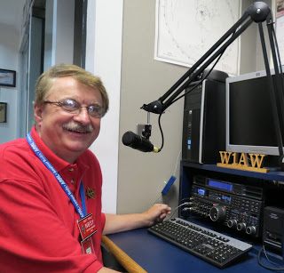

Hey Gang...

I’ve had a lot of fun this week just getting ready for Christmas. If your house is anything like ours, it’s filled with the smells of Christmas all over. Janie’s been on a mission to bake every kind of cookie that’s known to man, and you know what that does to my waistline! It looks like I’m gonna’ be spending a lot of time at the “Y” trying to get those extra pounds back off.

I’ve been busy fumbling around trying my best to wrap up those presents that I bought Janie last year and just recently found. I’m not saying that I procrastinate, but I usually wait until December 23rd or 24th before I get around to even looking at what to get her for Christmas. I guess I’m a lot like my dad on this subject. One year he totally forgot to get my mom anything for Christmas. He came up to our house around 1am on Christmas Eve really upset that he hadn’t gotten her something. We comforted him with a couple of presents to give her and sent him home. I didn’t know before then that he had always depended on my sisters to do his shopping for mom. That year both of my sisters had gone away on vacation out of state. I don’t think my mom ever knew, or if she did, she never let on.

Me, I usually end up just printing off a letter to Janie telling her that her presents were delayed due to fog or snow or Santa just couldn’t get his sleigh through, and they would be delivered later. Boy, finding those presents I bought last year just yesterday is a real money and time saver this year for sure.

Thankfully, she didn’t need that new mop and cleaning bucket before now! I don’t want you to get the wrong idea, I did go out this year and get her something that she really wanted and needs. Yes, she’s going to get some new potholders that I got from a friend of mine’s daughter that makes them by the dozen. And I’m really glad that she does too. You see I used the last batch of them for cleaning the lawn mower up before putting it away for winter and that has left us running a little low on them. The other day I had to use a bath towel to get something out of the microwave oven. Unfortunately, some of my split pea soup spilled on the towel. Now, trying to be a good boy I hung the towel up like she’s always telling me to do after using it, but I forgot to tell her before she got out of the shower that I had used it. Boy, will I ever be relieved when I give her those potholders!

TOP^

Now, on the positive side of things, I kept the microwave clean by letting the food drip on the towel. The microwave stayed nice and clean. I guess putting the towel back on the rack in the bathroom wasn’t such a great idea though!! Oh well, no good deed ever goes unpunished!

I don’t know about you, but I’m all thumbs when it comes to getting the tape off the roll and getting it to look pretty after I get it stuck on the package. It’s a real chore and it seems that I just can’t get it to tear off in the right place, or it wants to split down the middle. Even if I do get it to tear off correctly, I always seem to get a thread or two hanging from the roll and it keeps me from getting that clean look on the package. Having those little threads flopping around from the tape edge makes things stick together when I go to stack the packages on top of each other. I also have issues with how wide that tape is when I go to wrap up small packages. I just wish Duct Tape would come in something less than just two-inch rolls!!

Ok.. Let’s slide down the band a bit and get a little more serious… The Hamfest Calendar is filling up fast for 2020. Even though it isn’t technically a Hamfest, don’t forget that DX Engineering is holding their annual Winter Sale on January 18th starting at 9am. Now, like I said, it’s technically not a hamfest you’ll have to wait until August 8th for that, but it has all the makings of a hamfest for sure. Great equipment for sale and lots of great talk between fellow hams. What more could you ask for!! Being the hearty Ohioans as we are, we even have 2 actual Hamfests scheduled for the dead of January! <http://arrl-ohio.org/hamfests.html> and 1 Hamfest in February!

Speaking of Hamfests, we have 2 big conventions coming up this next year I want you to save these dates on your calendars now!!! March 14-15 for the Toledo Hamfest and Great Lakes Division Convention and then later on into the summer, August 8th we have the DX Engineering Hamfest and Ohio Section State Convention. We will be announcing the winners of the Ohio Section Newsletter Contest and the Allan Severson, AB8P Memorial Award recipient at our State Convention at the DX Engineering Hamfest.

Switching bands for a moment… Some of you are still are sitting on the fence about getting registered in ARES Connect. I am still hearing that some of you think that it is just for ARES. This is absolutely not so! ARES Connect is for anyone and everyone, plain and simple. So, now that this rumor has been put to bed, let’s get yourselves registered in ARES Connect today. My personal goal is to get everyone in the Ohio Section registered and using this new system by the end of this year! Help me out on that and get registered. **We want no one left behind! Let’s get it going…. Get registered and start using the system!**

Sliding down the band a bit more… Please, if you haven’t renewed or joined ARRL, maybe now is the time. Here’s a great idea for you, ask for it as a Christmas Gift, it’s not too late! This will be the gift that really does “keep on giving!” for the next 12 months at least! Oh, I will also add, ARRL has a 90 day FREE trial offer as well. Take advantage of it if you really don’t know if this is for you. What have you got to lose? It’s FREE.

I am still hearing from some of you that you just haven’t taken the time yet to do anything with that newly acquired license. Why not? Do you need help? Hey, my best advice for you is to seek out a club and go and listen. You’ll be amazed at how much knowledge is floating around that is just looking for a place to land. You got it… ON YOU! Have fun with it! Get on the Air!!!

Whelp… That’s going to do it for this time around. Stay safe, enjoy the sunshine while we have it, and most of all… have FUN and get on the air!!

73,

***Scott, N8SY Go Bucks!!! Janie and I wish you all a very Merry Christmas and a Fantastic New Year!***

TOP^

***Swap & Shop Has Come to the Ohio Section Website***

Hey Gang,

Have you taken a look at the **Swap & Shop** page on the Ohio Section webpage yet?? Here’s a link that will take you there…

<http://arrl-ohio.org/sm/s-s.html>

There’s already been some great activity going on up there. Do you have equipment that you just don’t need or want anymore? Here’s a great venue to advertise it, and it’s FREE!! No, it won’t be listed in this newsletter because it would take up way too much space, so your ad will only appear on the website.

It is there for any individual to post equipment Wanted / For Sale or Give-Away. No licensed vehicles/trailers or business advertising will be posted.

Postings are text only (no pictures or graphics) will be posted for a maximum of 1 month from date posting

and require a contact phone number or email within the posting.

Send your Wanted / For Sale or Give-Away post to:  [swap@arrlohio.org](mailto:swap@arrlohio.org)

***Welcome New Subscriber***

Kolt, KE8NBB

***Updated Information... Want to Share your Club Newsletter With Others?***

We have a new webpage where you can download and read all of the newsletters that I get from around the state.

Here’s the link to the page…. <http://arrl-ohio.org/club_news/index.html/>

Please, if you don’t see your club newsletter posted, it’s probably because I’m not receiving it, or I just cannot convert it over to Adobe Acrobat. Have your newsletter editor contact me and let’s see if we can get your club’s newsletter on the site!! We all learn and steal (I mean, share) from each other’s work. So, let’s give this new webpage a real workout and send me your newsletter!!! Send it to: [n8sy@n8sy.com](mailto:n8sy@n8sy.com)

***Back Issues of the PostScript and Ohio Section Journal (OSJ)***

Hey, did you know that PostScript and Ohio Section Journal (OSJ) are archived on the website? You can go back and look at any edition simply by clicking:

<http://arrl-ohio.org/news/index.html>

TOP^

***New Amateur Radio Podcasts***

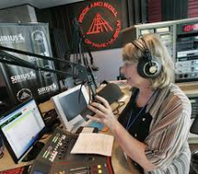

Hey gang have you heard the new Podcast that the ARRL is putting out? It’s called “So Now What?” It’s a great way to learn about Amateur Radio for sure. Here’s the link: <http://www.arrl.org/so-now-what>

We also have a local Podcast by none other than own Pat Morrow, N8OQP – he now has his own radio station (internet broadcasting) that is doing broadcasts daily. You can find his Amateur Radio Podcast at: <https://www.spreaker.com/show/radio-active_2>

And let’s not forget all those other Podcast shows on Twit.tv – Here’s the link to them:

<https://twit.tv/shows?gclid=CjwKCAjw3c_tBRA4EiwAICs8CiOMJ-_zsH1XpXuJeO8NRjzbye2iss4XmwWwer72QZx1tWkm9QDFUhoCCZIQAvD_BwE>



***Back Issues of the PostScript and Ohio Section Journal (OSJ)***

Hey, did you know that PostScript and Ohio Section Journal (OSJ) are archived on the website? You can go back and look at any edition simply by clicking:

<http://arrl-ohio.org/news/index.html>

***‘Twas The Night Before Christmas***

[](http://arrl-ohio.org/twas.html)

Ahhh yes, we all remember that famous Christmas Eve tale of Santa making that visit to our homes.

But this particular tale was especially written for those of us in Ham Radio!!! If you’ve never read this wonderful twist on an old Christmas classic, you just gotta’ do it now.

Go to: <http://arrl-ohio.org/twas.html>

TOP^

***Chit – Chat, and All That!***

Do you know someone that’s not getting these Newsletters? Please, forward a copy of this Newsletter over to them and have them “[Opt-In](http://arrl-ohio.org/forwarder/forwarding.html)” to start receiving them. Heck, just have them send me an email [n8sy@n8sy.com](mailto:n8sy@n8sy.com) and I’ll get them added to the Ohio Section Emailing list. We now have over 8,000 folks receiving these newsletters weekly. Quite impressive, I’d say!



I urge all of you to make sure that everyone, regardless of whether they are a League member or not, get signed up to receive these weekly Newsletters. You can always “Opt-Out” at any time if you feel this is not what you were expecting. It’s fun and very informative.

Hey, did you know that PostScript and Ohio Section Journal (OSJ) are archived on the website? You can go back and look at any edition simply by clicking:

<http://arrl-ohio.org/news/index.html>

The pictures throughout this newsletter are from various sources. Take a good look at them, you just might be in one of those pictures! “SMILE…!!!!!”

Got questions, concerns or would just like to sit and chat awhile? Heck, I’ll even buy the coffee!! Give me a call at (419) 512-4445 or email me at: [n8sy@n8sy.com](mailto:n8sy@n8sy.com)

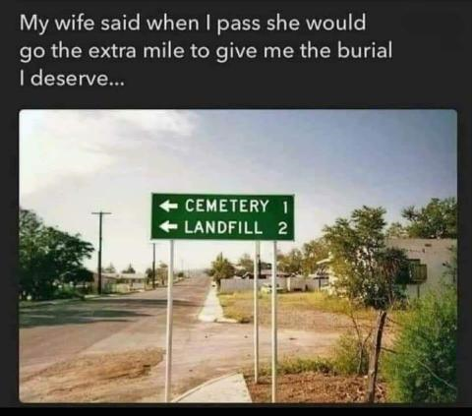

TOP^

*The Ohio Section Journal (OSJ) is produced as a comprehensive look at all the programs within the Ohio Section. I sincerely hope that you have enjoyed this edition of the* *OSJ and will encourage your friends to join with you in receiving the latest news and information about the Ohio Section, and from around the world!*