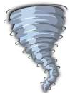***[](http://arrl-ohio.org)******April***

***Edition***

|  |  |
| --- | --- |
| **🡪** From the Technical Coordinator | **🡪** From the Section Emergency Coordinator |
| **🡪** From the Affiliated Club Coordinator | **🡪** From the Public Information Coordinator |
| **🡪** From the Section Traffic Manager | **🡪** Out and About |
| **🡪** From the Section Youth Coordinator | **🡪** From the Official Observer Coordinator |
| **🡪** ARES Training Update | **🡪**  Handbook Give Away |
| **🡪** Club Corner | **🡪**  ARES Connect |
| **🡪**  DX This Week | **🡪**  National News |
| **🡪**  Final.. Final.. | |

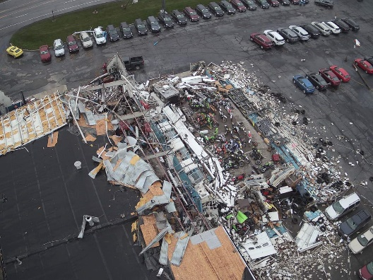

***From the Technical Coordinator***

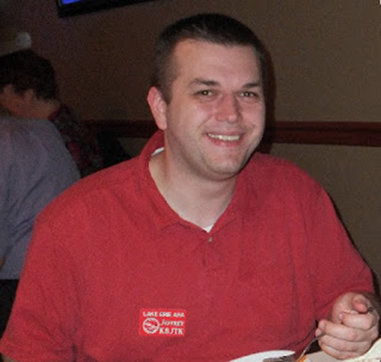***Jeff Kopcak – K8JTK TC***

[k8jtk@arrl.net](mailto:k8jtk@arrl.net)

Hey gang,

One thing about ham radio, there is no shortage of linking systems. Most are familiar with analog linking like EchoLink and IRLP but there were less popular ones such as WIRES and eQSO. Digital has many more options because when someone disagrees with an implementation, they make another. This allows for options but leads to fragmentation and incompatibilities. The AllStar Link project can link different infrastructure systems together or be a completely independent system. I learned about this linking system and accepted a challenge from one of the Technical Specialists.

Some of your Technical Specialists and I have this spirited debate about Motorola radios. They are correct claiming Motorola radios can take a lot of beating and keep on ticking. Not quite Timex but close. Commercial radios are designed to endure extreme conditions. Think police trying to wrangle a criminal or fire fighters in extreme temperatures of a working fire. You don’t want to worry about your primary line of communication being destroyed in the process. Ham grade gear won’t stand up to that kind of use and abuse. Older Motorola gear is very popular with hams as dependable FM repeaters and for use on 900 MHz. They make great repeaters because they have excellent adjacent channel rejection (selectivity) which minimizes interference from other transmitters.

My counter is most of this gear is not capable of VFO, a must when working with other agencies and not familiar with their frequencies. Some models are better than others getting them to transmit in the ham bands if the radio’s band split is just above or below the ham bands. A common practice is to bring a radio with the 450-512 MHz split to transmit in the 440-ham band. Aligning the radio is often needed because it has drifted off frequency. A service monitor or RIB (Radio Interface Box) cable are needed. Everyone should have a service monitor or scope, few do. Many older radios require a PC with a serial port and/or DOS application to be programmed. Serial ports are becoming harder to find on computing devices. I’ve heard USB to Serial Port adapters work, for the most part, with the help of [DOSBox](https://www.dosbox.com/). DOSBox is an emulation of [DOS](https://en.wikipedia.org/wiki/MS-DOS) that works on modern operating systems. Primality designed as a tool to run DOS-based games but it also works for other DOS applications. To download a legitimate copy of the Motorola CPS programming software, the subscription cost can get ridiculous. [A Radio Reference thread](http://forums.radioreference.com/threads/cps-price-increase.373575/) indicated it could range from under $200 to $400 with an increase last year for MotoTRBO equipment. As a former programmer, pirating doesn’t support developers and doesn’t allow the company to put money back into developers and adding features. If you’re kind enough, someone with a subscription maybe willing to program the radio for you or find a ham-friendly radio dealer willing to do the same or sell the software at cost. Pro tip, don’t ask about pirated software in the RR or in other forums.

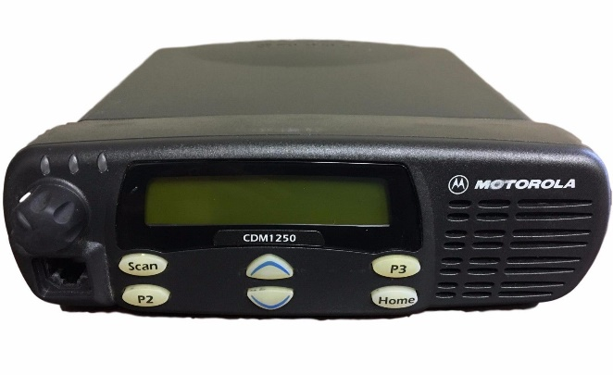

Motorola CDM1250

TOP^

Out of this debate came a challenge from Bob – K8MD to try out a Motorola radio. I eventually found a project where I need a radio but the programming wouldn’t change often. I did a lot of reading and research on [BatLabs](http://batlabs.com/) and [Repeater Builder](http://www.repeater-builder.com) which are great resources for repurposing commercial radios and building repeaters. The used market is where these radios will be found. Advice from those sites will be very useful in not getting ripped-off, especially decoding the radio model number. My project was to setup an [AllStar Link](https://www.allstarlink.org/) node and it was a perfect time to try a Motorola CDM1250.

AllStar Link, often called AllStar, is an Amateur Radio linking system on a Linux computer, running the open-source PBX telephone switching platform called Asterisk. An AllStar module called app_rpt turns Asterisk into a powerful, full featured, Ham Radio repeater controller, and linking package. It is theoretically capable of controlling hundreds of nodes at a time. Jim Dixon - WB6NIL (SK), developed app_rpt and is considered to be the father of AllStar. Asterisk is typically used as a SMB (small/medium business) phone system.

Like other analog Voice over IP systems (VoIP), such as EchoLink or IRLP, it links radio systems together. AllStar is flexible enough to link other infrastructures together as well. The ability to make connections on any IP network makes AllStar decentralized, meaning it doesn’t need to rely on other infrastructure. No central server for someone to pull the plug resulting in a complete collapse of the network. The concept of a node in AllStar terminology is a loose definition but they all run the same exact software. Node types are generally defined as:

* Repeater: full duplex node and user functions accessed by DTMF
* Simplex node: half-duplex node, also with user functions available by DTMF
* Remote Base node: a half-duplex, frequency agile HF, VHF, or UHF remote base. Will not respond to DTMF on RF.
* Hub node: a common connecting point (similar to Conference or Reflector) with plenty of Internet bandwidth to handle many connections at one time, has no RF connected hardware

Nodes can be public, private, or a combination of both. A public node would be accessible by any other public node on the AllStar network and requires Internet access to the AllStar infrastructure for the phonebook of public nodes. Private nodes can be limited to select users or on a completely private network, like a mesh network, where you don’t want many uses connecting over limited bandwidth links. These are great for connecting repeaters at different sites over a mesh network, point-to-point link, VPN, or public Internet. Private nodes are reserved node numbers ranging from 1000 – 1999.

A hybrid approach of both public and private nodes can be taken. Repeater 1 at location A, repeater 2 at location B, and repeater 3 at location C are all at sites with no or poor Internet. Setup Ubiquity point-to-point links between the repeater site and the Trustee’s house (for example) with a better bandwidth connection. AllStar nodes would be setup at the repeater site and use the Point-to-Point as the route to the Internet.

Say you don’t want public nodes to connect directly to the repeater over long-range WiFi but wanted to link all three repeaters together and have controllable public access. Nodes at the three repeater sites would be setup the same except as AllStar private nodes. A fourth node would be setup with a public node number at the Trustee’s house. The three repeater nodes and any public nodes could be connected or disconnected from the fourth public node as needed.

TOP^

A friend of mine in Colorado, Jeff – K0JSC, has his WE0FUN “fun machine” repeater sites linked in a similar way. The 15 repeaters are private nodes connected over a private network to a central hub.

Asterisk supports standard protocols for making phone calls over IP, [SIP and IAX](http://www.differencebetween.net/technology/communication-technology/difference-between-sip-and-iax/). Using these standards makes integration easy with other systems that support similar protocols. Options range from softphones, hard phones, other Asterisk systems, to PBX systems on the Internet. A softphone app is an application which runs on a computer or smartphone providing the ability to make calls. [Iaxrpt](https://wiki.allstarlink.org/wiki/Setup_IAXRPT_use) is the Windows PC softphone client and [DVSwitch Mobile](https://dvswitch.groups.io/g/Mobile/) for smartphones. Hard phones are IP connected phones such as Cisco or Grandstream that support either protocol. A second line on the same Cisco phone used for Ham Shack Hotline is provisioned to dial into my AllStar nodes. An extension can be added to an existing Asterisk phone system allowing any handset to dial into AllStar. Last but not least, a cloud VoIP provider can add forward and reverse autopatch capability to any node! Loose autopatch ability due to new repeater hardware, an expensive addon board, or it became cost prohibitive based on use? Though an active Internet connection is required, a cloud PBX provider, such as [voip.ms](https://voip.ms/), adds autopatch functionality for fractions of a penny per minute (including long distance) with pay-as-you-go pricing. For younger hams, autopatches connected an amateur station (often repeaters) with the public land-line telephone system and were popular when cellphones didn’t exist or were expensive.

The first thing about AllStar I found interesting is the ability to interconnect with other ham radio systems. EchoLink support comes out-of-the-box. IRLP can be added but an existing node is needed to copy the system key. To obtain a new node number, the purchase of IRLP hardware is required. Cheapest way is to purchase the preloaded SD card with configured node on the [IRLP Node Order Page](http://www.irlp.net/order.html) for the Raspberry Pi.

AllStar has all the essential capabilities of a repeater controller, IDing every 10 minutes and adjustable time-out timer. The time-out timer can be disabled with a command – useful when broadcasting ARNewline, which can be played automatically with a script, or hosting windbag nets. The scheduler is replaced with Unix Cron. I’ve written custom scrips that announce weather conditions, PL tone, and number of connections at certain times during the hour. For a net, my node will check to see if it’s already connected to the far-end node hosting the net. If it is not connected to that node, it will drop all existing connections then connect to the remote node. Dropping all connections seems useful to avoid airing a local net over a large reflector or being booted from an IRLP reflector for being an irresponsible node operator. Some repeater owners like to place repeater objects on APRS maps showing repeater location and frequency. AllStar can inject these objects into the APRS-IS network.

Not unlike the infrastructure flexibility, nearly any sound device recognized by Linux will work with AllStar. Cheap audio fobs (with a few modifications) to commercially or ham produced products are all options. The Repeater Builder site offers many [options](http://www.repeater-builder.com/voip/voip-index.html) and [products](http://www.repeater-builder.com/products/usb-rim-lite.html). The connecting device I choose was the [DMK URIx](https://dmkeng.com/Products.htm). The USB connection converts data over to a DB-25 connector. Pin assignments are listed on the device itself for easy access. I wired up a connector using a Motorola connector kit I purchased off Ebay following [instructions I found online from W2YMM](https://www.qsl.net/w2ymm/irlp_cable_moto.html). I’ve had a great experience and no problems with the URIx. However, it’s not cheap now running $85 including shipping. In addition, mailing lists are indicating a change in chipset is causing performance issues. I would wait awhile before purchasing this device again.

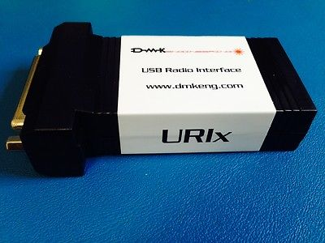

DMK URIx

TOP^

With Raspberry Pi as an option for running a node, portable nodes are popular for use in a vehicle or backpack. Open Internet ports, or port forwarding, is not a requirement for outbound connections. This is especially useful because cell phone companies make it impossible for open ports due to [CGNAT](https://en.wikipedia.org/wiki/Carrier-grade_NAT). This was a big problem [I talked about with WIRES-X](http://www.k8jtk.org/2018/06/18/ohio-section-journal-the-technical-coordinator-june-2018-edition/) before Yaesu introduced their portable node software. Incoming connections to a portable node on a hotspot will not be possible.

There is a fork of the main project called [HamVoIP](https://www.hamvoip.org/). They were the first to release a Raspberry Pi image. A Beagle Bone Black image was available but it has been deprecated and no longer updated to concentrate on the Raspberry Pi image. About the time WB6NIL passed, the main AllStar project had some internal conflict, upgrades caused lengthy outages, distributions were becoming dated, and hard to setup. HamVoIP claims to pick-up that slack, improve on the project including infrastructure and code cleanup. Their assertion is having better than 70% of the AllStar market running their image. Recent strides have been made to improve the main AllStar project. I have used both distributions and feel HamVoIP does work better, has more features, frequent updates, and better documentation. Nodes running HamVoIP still utilize the AllStar infrastructure and are fully compatible with non-HamVoIP nodes.

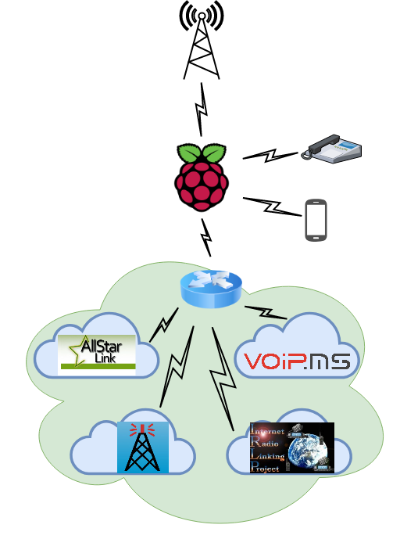

Diagram of connections to my AllStar node

There is a claim that HamVoIP is in violation of GPL license agreements. Again, being a former programmer and someone who publishes articles and presentations, I would be upset if someone was violating my usage terms. However, those making accusations are also making judgement calls based on lack of response – which doesn’t mean there is a violation. In addition, a claim can be filed with the Free Software Foundation or have the copyright owners of Asterisk make a decision. It does not appear either correct course of action is being pursued. Airing this grievance on social media accomplishes nothing, as usual. The HamVoIP side isn’t helping their case by not being transparent and some responses were “feeding the trolls.” A troll is a person online who posts a provocative message to an online forum with the intent of causing disruption and argument. You can read the [Reddit thread](https://www.reddit.com/r/amateurradio/comments/99u2kk/hamvoip_users_beware/) (some language maybe NSFW) and [HamVoIP response](http://lists.hamvoip.org/pipermail/arm-allstar/2018-August/009776.html). I’m going to keep using HamVoIP until I see a response from someone that has standing in the matter.

AllStar is flexible but definitely a more an administrative (Sysop) system and not entirely user-friendly. Connecting to other AllStar nodes is pretty straight forward. The DTMF sequence is *3<node number> to link and *1<node number> to unlink. Integrations with EchoLink and IRLP can be implemented a couple ways: directly linked to an AllStar node where the AllStar and EchoLink/IRLP node act as one. EchoLink/IRLP can be setup on a different node (often private) on the same AllStar setup. Having separate nodes allows for disabling EchoLink or IRLP connections completely should those nodes cause problems. Great for control, not great for users. An RF user can link and unlink EchoLink/IRLP, not to specific nodes. It maybe possible to do with a script but would add complexity.

TOP^

Having AllStar and EchoLink/IRLP on the same node allows RF users to link and unlink to those systems. Remembering the DTMF combinations is not easy, I know. Connecting to EchoLink nodes is the DTMF sequence *3<node number, padded to 6 digits with 0’s> and *13<node number, padded 6> to disconnect. IRLP is *38<node number> and *18<node number> respectively. Example, EchoLink test node #9999 is *3009999 and *31009999 to disconnect. IRLP test node #9990 is *389990, and *189990. Not exactly straight forward, easy to remember, or the simple “73” IRLP users are used to for disconnecting. Sysops can use the Supermon webpage utility for easier control of a node and can make it read only for users.

I learned some things about using Motorola equipment. My CDM1250 is the high power (40 watt) UHF model. Radios such as the CDM have a 5% duty-cycle. This means transmitting only 3 minutes every hour. Don’t forget, these aren’t rag-chew radios – they’re designed for police and fire which only transmit for short periods of time. Two ways to improve the duty-cycle is to lower the output power and upgrade to active cooling by moving a lot of air over the heatsink. Lowering the power on mine is still 25 watts. These improvements allow the radio to operate normally for a 90-minute net, as long as the fan keeps working. The antenna connector is a Mini UHF female and very easy to break with an adapter and stiff coax. A Mini UHF male to UHF SO-239 female pigtail is a requirement. It relieves the stress on the radio’s connector.

Learning about commercial radios has been a valuable experience. AllStar Link is a very flexible and customizable system that has excellent integration with other infrastructure. I still have a lot to learn and my next goal is to use AllStar for linking all digital modes – yes ones like D-STAR, DMR, and Fusion. Stay tuned!

If you would like to make an AllStar contact, it is best to setup a sked with me via Email.

AllStar node map: <http://allstarmap.org/allstarmap.html>

Thanks for reading

**73… de Jeff – K8JTK**

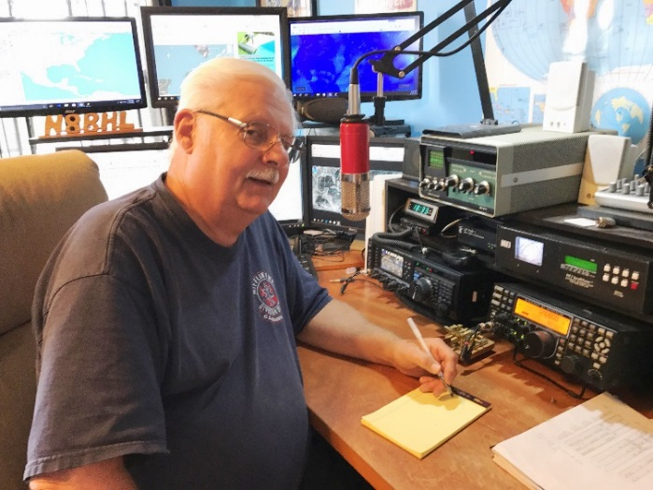***From the Section Emergency Coordinator***

***Stan Broadway, N8BHL - SEC***

[broadways@standi.com](mailto:broadways@standi.com)

**Weather Net Etiquette**

There are some solid things that have been proven over time for any weather net:

* The most important thing you can do:
  + get someplace where you have a wide range of view. You can’t spot from your living room window.
  + Have a safe bailout location in mind while spotting. Do not compromise your safety.
* Rule one when operating in a net: Listen!
* Rule two - see rule one.

TOP^

* Net Control knows there will be lightning- and the NWS does, too. Don’t report it.
* Net Control knows it’ll be raining. Only report unusually heavy, measured rainfall.
* See rule one again.
  + If you’re coming on the net DO NOT ask for the status…listening to reports will clear that up right away, and your silence will allow real reports to be heard.
  + Check in if asked. If not, just listen- if they need someone in your area, they’ll ask!
* When you do have something- that’s the time NOT to be bashful! Report concisely and accurately what you see!
  + Your precise location
  + The direction you’re facing
  + What you see (remember the severe criteria)
  + What direction it’s headed
  + If not real-time, how long ago you saw this

Do not fall into the “they don’t need me” trap! We need ALL amateurs in all locations to be on the air and watching- that’s what makes this all work!

**The Ohio ARES Conference - mass demonstrations in a coordinated attack against Ohio**

The annual Ohio ARES Conference returned to some of the basics of emergency radio and exercised them in a large tabletop event.

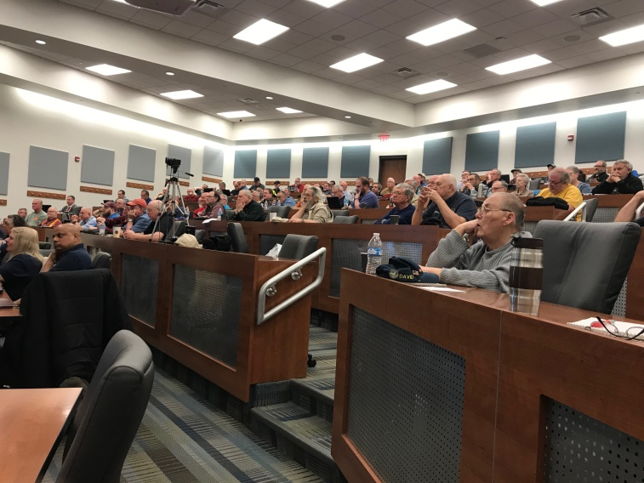Stan and Scott opened with the status of ARES developments and with ARES Connect changes that make it more manageable.

Eric, N8AUC DEC for D-10, brought a well-documented training on batteries- their care, maintenance and operation.

Matt, KD8TTE Oho ASEC, presented on the basics of traffic handling - something we have often put off. It is clear that in order for us to function in a real disaster, we simply must master the ability to send messages. Matt pointed out the difference between the ~format~ of the message, and the content, applying that to NTS forms and ICS-213 type agency forms.

We also had a review of the ICS forms such as 205, 217 and others used in the management of an incident…something for which EC’s will need proficiency.

Then- we put it to the test.

During the afternoon, six points in Ohio were the ‘target’ of coordinated anti-social demonstrations, requiring ARES to relay messages for our agencies. Districts gathered to discuss and plot their activities based on requests from EMA’s and police; fldigi and other formats were used to send messages.

TOP^

It is our hope that these topics, suggestions and activities can be taken back home for EC’s to apply their own training, develop better relationships with agencies, and practice skills. The room holds around 150, there were very few seats open when the meeting got underway.

I want to sincerely thank all for investing their time to make ARES in Ohio better!

**NVIS Day**

April 27, a Saturday, from 10-4 will be this year’s NVIS Day in Ohio. This has become a tradition, and the 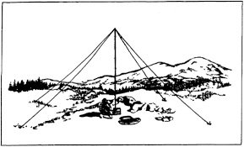importance of easily-deployed portable antennas was brought to the spotlight after Hurricane Michael and others this past year. The devastation took down ALL commercial, safety and amateur communications. There were no towers, no repeaters, and very little formal generator power. I was honestly surprised that of all things 80 meter sideband was one of the most-used forms of emergency communication. It worked well for them and would work well for Ohio in a wide-spread “flat-earth” situation. We got a taste of that during “Snow Net” where operators in 44 counties participated both on 80 and on DMR Ohio. This to me makes NVIS practice even more important.

I have received one suggestion that makes sense. The real purpose of NVIS day is to test antenna performance- compare signals and try different configurations. There is a contest type ranking for how many contacts you can make, that just creates a more fun atmosphere. The suggestion is that we use the DMR Ohio Talk Group to coordinate contacts, and to advertise that a station is operating on a certain frequency. That can help to remove the searching and some frustration since we’re all over the bands that day. I think using DMR Ohio similar to a spotter type operation would make it much more fun and provide better ways to find other participating stations for our testing. Thanks to Alan Rothweiler KD8TNS for the idea!

I hope to see you at the ARES Conference! Remember, it is open (and strongly suggested!!) for EC’s and above, as well as AEC’s or others with special interest in being there. The facility seats over 150, and we usually comfortably fill the room (120-ish) so, yes, there’s room for you!! MANY THANKS TO MARION ARES for hosting us! They put some work and planning into our day.

Thank you all! Remember the basics! They will save you!

**73, Stan N8BHL**

**You can view all of the SEC’s monthly reports on the website..** <http://arrl-ohio.org/SEC/default.html>

TOP^

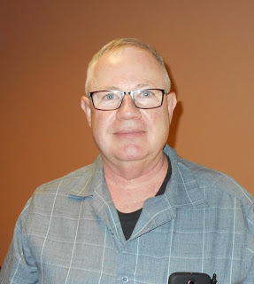***From the Affiliated Club Coordinator***

***Tom Sly, WB8LCD - ACC***

[tomsly29@gmail.com](mailto:tomsly29@gmail.com)

Spring is finally here in NE Ohio!

I’m going to switch it up just a bit for this month. I’ve always talked about the fact that Amateur Radio is a HOBBY. By definition we participate in a hobby because it’s interesting and enjoyable to us. The mission of a ham radio club should be to involve their members in activities that will help them to learn about and enjoy their hobby. Having FUN is what it’s all about!

***Club Meetings***

I won’t say too much here that hasn’t been said before. Please, make sure everyone is made to feel welcome at your club meetings. It’s not fun if you’re not included. This is every club members’ responsibility, not just your officers. Everyone should make a point of welcoming visitors and especially new hams. Try not to overburden your members with “club business” at the general club meetings. Instead of debating every little detail, empower people, or committees, to get stuff done – then let them do it! They can report to the club at the meeting knowing that they were given a task to accomplish and trusted to do it right. Sure, you might have done it different, but don’t criticize, thank them for doing a good job! You’ll be amazed at how just this will change the dynamics of your club meetings and relationships with other members.

Have a presentation on an interesting topic. Ham Radio is filled with a bunch of really smart people – and so is your club. Read the newsletters of other clubs and see what they are presenting to their membership. You might get a good prospect to be a speaker by seeing what they are doing. One thing I can tell you from personal experience, most Hams are thrilled to share their experiences and knowledge about the hobby with you. Don’t be afraid to ask or intimidated by someone’s notoriety! Get involved with activities and events outside of your own club and meet people. When you can say to them “I saw your presentation at Hamvention (or whatever) and I think our club would really enjoy hearing you, they will be thrilled to do what they can for you. And remember, this is a “high-tech” hobby – look for ways to bring them to your meeting as conveniently as possible. SKYPE presentations are very easy to arrange.

***Operating Events***

Field Day is fast approaching! Your club should be participating. This is the premier ham radio operating event in North America. There are two classes: (1) those who are out there getting together with their friends, having a good time, making some Q’s and enjoying some good food and fellowship. (2) Those who are in it to win it! They say it’s not a contest, but they keep score. Sounds like “military intelligence”. If you’re in it as competitors, you have to take a whole different look at what you’re doing. Let me echo the words I heard from Tim Duffy the first time I got to visit at K3LR – keep meticulous records of everything you do. Examine what you did last year, what your results were and what you could change to make it better. Document everything, especially the changes. After the contest, have an “after action” review of your results. Did the changes you made make it better or worse? Document your findings along with suggestions for next years operations.

TOP^

The record keeping and strategy sessions is what will set you apart and keep you improving year over year.

Sure, FD is the big one, but there are lots of other contests, special events and other things you can do and participate in. How about a DXpedition to one of the rarer counties or grid squares in OH? If promoted, you could get a lot of good DX just looking for that tough one in OH to help move them forward. Don’t forget about IOTA, OSPOTA, and, the new one, Ohio Courthouses on the Air. (KUDO’s to the Southern Ohio ARA and their PIO Mike Love WB8YKS not only for their activity, but for the fantastic job they are doing making Ham Radio visible to the public!)

How about sponsoring a field event where you have to operate QRP? Only homebrew equipment? FT-8 or some other digital mode? Maybe get someone with a new ICOM 7300, someone with an Elecraft K3S and someone else with a Kenwood TS-590 or a Yaesu FTDX 101D, set them all up side by side and give everyone a chance to see how each of them works? Food and beverage could be a big part of this get together!

Make some inroads with the local schools, scout troops, church groups, 4-H, anywhere where you can find a group of kids. Help them all build a crystal radio set or put them on the air and work some DX. Set up a Radio Fox Hunt for them. Teach them about and then show them how to do Broadcast Band DXing. Take lots of pictures! The local news will be much more to report on your activities when you’re doing something for the youth of their communities.

The whole point here is getting together, get on the air and have some fun. Whether it’s only a couple of you, or maybe a large group, you’re going to have fun, probably learn a few things and have a good time with your friends!

***Other Ham Radio Activities***

All hams like to build things! Get creative here and “kit up” some projects. Try them out with the members of your club – who knows – you might just come up with something that others would want (check out some of the QRP Clubs, for instance the 4-states QRP group, who have been very successful at making and kitting up small projects that have been a big hit). Have a “build day” to bring your members together someplace to build their projects together and make sure everyone leaves with a working project.

Simple projects might include a G5RV antenna, don’t let your club members tell you they’re not on the air because they don’t have an antenna! Once built, you might even plan a day to help them get it in the air at their home QTH. J-poles are easy to build projects and you can find lots of plans in the amateur literature. I’ve seen and built a roll-up J-pole made out of twin line, a Plumbers J-pole made out of copper that can be broken down for easy transport and a simple 2-band J-pole for permanent roof mount that is a simple project to make. Depending on your group, and how easy you want it to be, you can provide all parts cut to length, threaded where necessary so it’s just a “put the pieces together” kind of kit. Or, you can have each member do all the prep work for his own antenna, possibly giving them the chance to experience something they have never done before. Either way it’s all good!

I mentioned crystal radios before, even adults can have fun building one. Now he’s got something to show his grandkids. What ham can’t use a power-pole distribution box? There are plenty of plans available and it’s an easy project. Whether for power or signal, building jumper cables is a good group project – by cable and connectors in bulk and give everyone a chance to make a couple power-pole cables and coax jumpers of different lengths.

TOP^

Want to learn Morse code? Start with a code practice oscillator – another simple project which has lots of schematics available to use. Take it to the next step – design and make printed circuit boards or try building it “Manhattan” style.

These are all pretty simple projects. Want something more involved? There are literally dozens of kits available for a “group build”. Again, most of them are going to be in the QRP world, but there are some pretty neat and sophisticated kits available. Look at the micro-bitx transceiver kit. A multi-band transceiver with some pretty neat features that can be had for about $150 delivered to your door! It’ll never replace my K3S, but it’s still pretty neat to make Q’s on a radio you built yourself!

As the Reverend Robert Schuller from the Crystal Cathedral in California used to say: “Don’t just sit there! Do something!” (I think I just invented Ham Radio Evangelism!)

Hope to see you all at Hamvention.

That’s it for now. Let me know what’s on your mind. [tomsly29@gmail.com](mailto:tomsly29@gmail.com)

**73, Tom WB8LCD**

***From the Public Information Coordinator***

***John Ross, KD8IDJ - PIC***

[john.ross3@worldnet.att.net](mailto:john.ross3@worldnet.att.net)

**FROM THE PIC**



***NEW THIS MONTH…Amateur Radio News via audio, video and the written word!!***

Hi everyone…a little different, hopefully new and improved PIC column this month. First, the new PIC PODCAST! A different way to hear stories about Amateur Radio. Second, a great video about an antenna farm…and I do mean farm…that will make you want to grow your own. And last…the “normal” written stories about our section and the ongoing events of interest.

**PIC PODCAST**

**[](http://arrl-ohio.org/pic_page/pod/April%20%202019%20PIC%20PODCAST%20%231.wav)**

A new monthly feature that will let us bring you the stories of ham radio operators in the own words. Just click on the Podcast ICON for the very first edition!

🡨 for Podcast

TOP^

**DRONE VIEW**

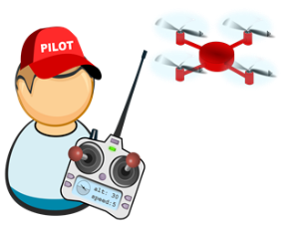One of the benefits working for AT&T…other than still working for AT&T…is that I’m a member of a group of hundreds of hams scattered around the country and around the world.

Below is link to a great video about an antenna farm in Pennsylvania…enjoy:

<https://www.youtube.com/watch?v=LzzXM5j_CMQ&feature=youtu.be>

**NEWSLETTER CONTEST**

It’s hard to believe but the 2019 Ohio Section Newsletter Contest has reached the half way mark! Just three months…June 30th…to enter your clubs’ newsletters.

I have a ton already and they are logged in, printed and the links to the online newsletters saved so the judges can read and see the quality of the hard work our editors and writers put into every story.

Remember, you’ll need two newsletters, from different months, to be entered.

The winners will be announced at the Voice of Aladdin Hamfest in early August in Columbus.

**THE GREAT PRINT VS DIGITAL DEBATE**

In the backrooms of just about every printed newspaper there are discussions…and decisions…about the future of “ink” and the future of online/digital news.

You probably have noticed your hometown newspaper getting a little smaller. In fact many newspapers have literally “stopped the presses” and are only offering the news online. It’s cheaper, leaner and faster…. but maybe not as much of impact as paper.

But what you may not have noticed is the increase in the number and size of the ads in the printed newspapers. Advertisers are finding out that now that online ads are not as effective as newspaper ads. On line there is too much congestion…too many ads to choose from. And the viewer only chooses one or two to look at…or makes no choice at all! In the paper, however, well placed…and large ads…near an important story usually mean more looks and  more action from the ads.

Dissect your local paper, or any paper, and notice the one-page ads near the front. The half page ads near, and in some cases, sandwiched between the obits and the sports. You will also see ads below and above the fold. Years ago…that would be unacceptable and only real news would go there. Speaking of real news, you’ll probably see a reduction of the news stories both in number and in length. Hence the problem now facing newspapers. They are making money on advertising but on longer have the circulation to sustain printing and to expand their delivery area.

TOP^

So, what’s next? It’s hard to say but it may be time to speak up. Write or call your newspaper and tell when what you like. Somehow, I would like to think there are still more journalists running the newspapers bean counters.

Maybe they should take a clue from our ham radio newsletters. Many are bigger than the local papers, better written and lay around the house longer only to be read again and again.

That’s it for this month…hope you at the Hamvention in May!

**73, John KD8IDJ**

***From the Section Traffic Manager***

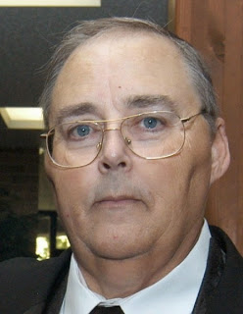***David Maynard, WA3EZN – STM***

[wa3ezn@att.net](mailto:wa3ezn@att.net)

News from the Ohio Single Sideband Net says that we had an election of the leadership of the net. Mike Hayward KC8WH has been reelected to be the net manager. Ed KA1G was elected to the Advisory Board for a three year term. .

I would like to take this time to thank these men and all the those who check into the OSSBN and the local traffic nets for their support of the nets and handling traffic so efficiently. You can check into the Ohio Single Sideband Net on 3.9725 starting at 10:30 AM, 4:15 PM and 6:45 PM daily More information and useful links can be found on the OSSBN website [www.ossbn.org.](http://www.ossbn.org/)

While on the subject check into some of these Ohio HF traffic nets:

HF CW NETS NET TIMES FREQUENCY NET MANAGERS

Buckeye Early 6:45 PM 3.580 WB8YLO

Buckeye Late 10:00 PM 3.590 WB9LBI

Ohio Slow Net 6:00 PM 3.53535 KI8FV

All frequencies plus or minus QRM. The net information on this page may contain errors concerning net times, dates and frequencies. I do apologize in advance for these errors and would appreciate knowing about them.

*The OSSBN meets three times a day 365 days a year on 3972.5 kHz. This net is always on the top of the scoring for the annual SET exercise. The OSSBN along with the Buckeye CW nets move traffic in and out of all corners of the state of Ohio and its members are prominent supporters of the regional Eighth Region nets and liaison to the Eastern area net. The four Ohio digital relay stations are all members of the OSSBN. Many of the OSSBN members are also ARES members in their own areas.*

TOP^

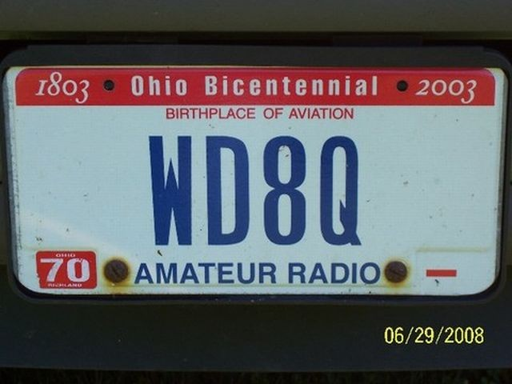Henry L Koenig a silent key. Known as WD8Q to many, Henry was a ham radio operator, and immersed himself in the world of radio and electronic communications. He was a member of the American Radio Relay League (ARRL), a certified volunteer examiner for ARRL, active board member of the Intercity Amateur Radio Club, (IARC), 1986 IARC Ham of the Year, IARC Code and Theory instructor, Buckeye Slow Net - net manager, member of FISTS-International Morse Preservation Society, member of Ohio Single Sideband Net, member of Quarter Century Wireless Association (QCWA), which requires 25 years or more as an active ham.

He was an active and enthusiastic participant in yearly IARC Field Days and also with the local Hamfests.

Henry was licensed in August of 1980 as KA8KXE and was interested in ham radio much longer (1958). He learned the code at Hickam AFB Hawaii in 1962 at the base MARS station. Like riding a bicycle, never forgot it. Took less than 3 weeks to get up to 7-8 WPM in 1980. LOVE CW. His motto is: "Anyone can talk. With a little effort you can learn and use Morse Code". Gear owned.....not much.......Kenwood TS-520S, Ten-Tec Jupiter, Yaesu VX-5, and ICOM 02-AT. Antenna....180-foot dipole fed with 450-ohm ladder line. Earned Extra Class in 1986....talk about nervous....20 WPM for six straight minutes.... still don't know on what terms I passed.... never asked. Changed call later that year to WD8Q. He was very comfortable with 20 WPM.

Henry has been doing Volunteer Examiner work since 1984 as a member of IARC in Mansfield OH, and had been in 124 test sessions since. ARRL member since 1981.

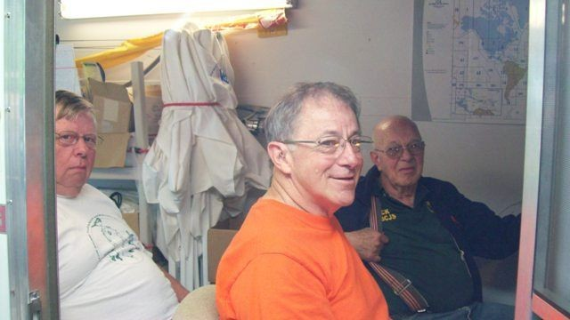

After being off the air for a number of years he started listening to the Ohio Slow Net (CW) after putting up antenna in Dec 2002. He was a graduate of Maryland Slow Net traffic handlers’ course. A great bunch of folks. Became Ohio Slow Net (OSN) manager in April of 2004 and stepped down the end of 2014. He Operated in HBSN, HBN, BN, 8RN, EAN and OSSBN handling traffic.

Belong to FISTS 10010 and SKCC 15057. If you haven't really gotten involved with CW operation. Join FISTS and get a "Code Buddy". They will work with you at any speed. After being licensed for nearly 34 years at this writing, I can't believe how my CW receiving quality has improved after being involved in regular nets. Also have joined SKCC.

Folks, please don't let CW die. Once you get used to it, you'll love it. It is a part of our amateur radio history and almost the only thing left in amateur radio that is a acquired skill. It's my 'foreign language'.

TOP^

The above information on Henry was from his Facebook page and his obituary. I did a news article on Morse code (CW) previously and received a positive response from Henry. The CW information is supplied here in honor of Henry WD8Q request to never let CW die,

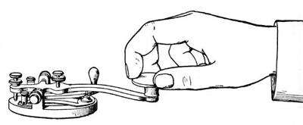**Why Morse Code?**

If you can talk FM on two meters, or SSB on HF, why should you be concerned at all about Morse Code, also known as CW.

However, there are good reasons why you should learn Morse code. Having a level of Morse proficiency that is of real use on the air, meaning that you can copy at 12-13 wpm or more, will add immeasurably to your enjoyment of Amateur Radio. Such rewarding HF activities as DXing, contesting and QRP operating still rely heavily on CW. Thousands of hams enjoy CW for its own appeal as a relaxing mode different from most other means of communication. And even on VHF and higher frequencies, you'll find that exciting activities such as Moonbounce and weak-signal work still require Morse skills for full participation. Every day is a good day to operate on CW, but set some time aside on New Year’s Eve and Day to enjoy [Straight Key Night](http://www.arrl.org/straight-key-night) (SKN). The annual event gets under way a 0000 UTC on January 1, 2020 (New Year’s Eve in US time zones). The 24-hour event is not a contest but a day dedicated to celebrating our CW heritage.

Many newcomers exploring ham radio were discouraged by the need to learn Morse code. In the United States, that requirement to know Morse code to get an amateur radio license was dropped in 1991, and completely removed in 2007.

Morse Code used to be required as an entry requirement to HF ham communications. The entry level speed was 5 words per minute (WPM). That speed is slow enough to learn the basics, get on the air, and increase your speed through practice. Yes, I started as a Novice way back at 5 WPM and could copy about 13 WPM to get my General license.

I thought I'd want to get enough code speed to get on SSB voice. I did that but discovered something I didn't expect. Sometimes, the band was so poor that I couldn't hear a single voice station on SSB. But, when I tuned down to the Morse code CW portion of the band, lo and behold, there were CW contacts going on.

I learned that Morse code needs only about a tenth of the power of SSB to make a contact. Or, stated another way, if you use Morse code, it's like getting an amplifier for your transmitter for free! We all know that there are days you'd be desperate for a contact with SSB, and it appears that you can make contacts with Morse code!

In the early days if you lived in Ohio and wanted to test for a ham license you went to an FCC office in Cleveland or Detroit. The test I took for my general was given in an office setting with phone ringing and office type activity all around me. Since those early days the FCC decided to use Volunteer Examiners to do their testing. This provided a quieter and more relaxed atmosphere to take the test especially after the FCC dropped the code test requirements

If you didn't have a buddy to learn code with you had to use records like the Ameco code course like I did. You supplemented your record course by copying W1AW code transmissions over the air. At that time, it was common to count dots and dashed and mentally convert them to letters to write on paper.

Since then it has become commonly known that the best was to learn code was not to count dots and dashes but to learn the sound of each individual letter. Also available today are a multitude of websites, clubs and computer programs to use to learn the code the proper way.

TOP^

**Why not slower than 15 words per minute?**

Because at a somewhat slower speed you can count the individual dots and dashes rather than having your brain treat each character as a distinct, integrated sound pattern.When you hear Morse code sent at 5 wpm for learning such a slow speed is counterproductive. You don't learn the soundsthat lead to instantaneous recognition. And, far worse, it programs the brain to count individual dots and dashes — precisely what you don’t want it to do! This eventually has to be unlearned and presents a formidable barrier to actually learning useful code.

To some degree, previous government regulations are to blame: In earlier times the FCC imposed a Morse code requirement of 5 wpm for the Novice Class amateur radio license, causing legions of radio amateurs to get on precisely the wrong track. And to this day there are well-intentioned individuals, clubs, and organizations that recommend starting at 5 wpm!

You should start on your road to success by throwing some time-honored ham-radio traditions out the window where they belong. These are:

* Slow (5 wpm) code -- It ought to be illegal to teach anyone code at 5 wpm. Every minute spent toying with 5 wpm code is irrevocably wasted. In addition, as we'll see later, starting with slow code is a virtually-guaranteed path to frustration and quitting. Morse at 5 wpm and Morse at 15 or 20 wpm are completely different critters, and you don't want to waste time on the wrong one.
* Charts, mnemonics, musical cues and other "memory aids" -- These things make you think about what you're doing while trying to copy code. That is deadly to proficient copying.
* Code tapes -- In very short order, and unconsciously, you'll memorize the tape. This will lull you into false confidence in your ability. That false confidence will be quickly shattered when you hear transmitted text that you haven't memorized.
* Copying QSOs off the air -- You don't know the speed of code you find on the bands, and much code on the air is pretty badly sent. All this makes it useless for training purposes. Formal code-practice sessions, such as those on W1AW, are OK, however.

Now that you know what you’re not going to do, let's start examining just how you can best gain code proficiency.

There are hundreds if not thousands of websites available about Morse code. To get you started below here are a few of the websites with information and programs to help you get started on you adventure into the world of Morse code. Remember that you are not going to count dot and dashes at 5 WPM but you are going to want to start at a higher speed and learn the sounds.

<http://www.g4fon.net/>

<http://www.g4fon.net/CW%20Trainer.htm>

<http://www.justlearnmorsecode.com/>

* 1. Daily Morse Code Practice QST Source

<http://www.arrl.org/code-practice-qst-source>

TOP^

<http://www.skccgroup.com/member_services/beginners_corner/>

<http://www.skccgroup.com/>

<http://www.morsex.com/cpy_code.htm>

<http://fists.co.uk/resources.html>

<http://ac6v.com/morseprograms.htm>

<http://learnmorsecode.info/2010/09/why-learn-morse-code-in-our-modern-age/>

**QUICK AND DIRTY CW NETIQUETTE N5LF**

<http://www.i1wqrlinkradio.com/antype/ch88/chiave28.htm>

That's it for this month, have some fun with Amateur Radio.

**73, David WA3EZN**

You can view the STM’s monthly report on the website.. <http://arrl-ohio.org/stm/stm.html>

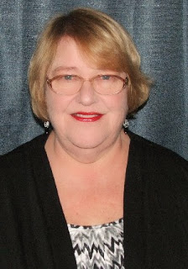***Out and About***

***Lyn Alfman, N8IMW - ASM***

[lynalfman@aol.com](mailto:lynalfman@aol.com)

**Hypothermia**

When one thinks hypothermia, one thinks about someone falling into water in winter. In fact, hypothermia occurs in spring as well. Hypothermia can occur unexpectedly, even on days when the temperature is 60 degrees. All it takes is wet clothes and a brisk breeze. If fact anyone who spends time out outdoors for any length of time under certain conditions is at risk. Amateur radio operators are at risk of becoming hypothermic especially if they are standing out along a parade route or working on an antenna project when it is raining and in the 40s. Pay attention to the forecast winds as well as the temperature when deciding what to wear if participating in the Ohio NVIS Day on April 27.

Hypothermia occurs when a person’s core body temperature falls to about 95 degrees Fahrenheit. Symptoms of this condition include change in mental status, uncontrollable shivering, cool abdomen, and a low irregular heart and respiratory rates, and unconsciousness. Victim may not be aware of the condition, and others may not notice until victim’s core body temperature has dropped dangerously low. Symptoms vary depending on the severity of the chill. Some symptoms are shivering, numbness, glassy stare, slurred speech, dilated pupils, pale skin, slow pulse, apathy, weakness, impaired judgment, muscles become rigid, stop shivering, loss of consciousness. And stop breathing.

TOP^

Avoid hypothermia when exposed to cold temperatures by wearing layered clothing made of wool that is windproof. In spite of advances in synthetic fibers, wool is still a superior insulator. Wear loose garments that don’t restrict circulation. Layers of light clothing are better than a heavy layer. If clothing gets wet, change into dry clothes. Wet clothing loses about 80 percent of its insulating value. Keep hands, head, and feet covered–that’s where the body loses the most heat. Eat a well-balanced diet, and drink warm, non-alcoholic, caffeine-free liquids to maintain fluid levels.

Hypothermia may become life threatening. Hypothermia is caused by the cooling of the body caused by failure of the body’s warming system. Call 9-1-1. Gently move the person to a warm place. Handle the victim gently because rough handling can cause cardiac arrest. Keep the victim in a horizontal (flat) position. Monitor breathing and circulation. Give rescue breathing and CPR as needed. Remove any wet clothing and dry the person. Warm the person slowly by wrapping in blankets or by putting dry clothing on the person. Hot water bottles and chemical hot packs may be used when first wrapped in a towel or blanket before applying. Do not warm the person too quickly such as immersing him/her in warm water. Rapid warming may cause dangerous heart arrhythmias. Warm the core first (trunk, abdomen), not the extremities (hands, feet). This is important to mention because most people will try to warm hands and feet first and that can cause shock.

Be Safe and be Radio Active!

**73 Lyn N8IMW**

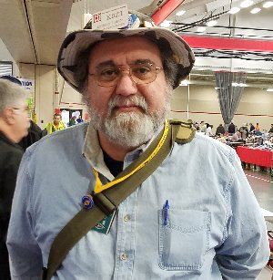***From the Section Youth Coordinator***

***Anthony Luscre, K8ZT - SYC***

[k8zt@arrl.net](mailto:k8zt@arrl.net)

**Ham Radio Resources for Youth, Students, Teachers and Any New or Prospective Hams** *(or anyone working with these groups)*

Part of this month’s column is made up of a handout for Students & Teachers ([*tiny.cc/hry*](http://tiny.cc/hry)), but before we jump into that a few loose ends.

Recently I attended a [PCARS](http://www.portcars.org/) meeting with Carole Perry, a legend as a Teacher of Amateur Radio in The Classroom, as guest speaker. If you would like to see a video of the presentation PCARS has posted it [here](https://youtu.be/Y4gSHP5h5Tw). If you are attending the Dayton Hamvention®️ Carol will be doing two forums- Instructors Forum on Friday and Student Forum on Saturday both are very worthwhile events to attend. Here is a [tentative schedule](https://hamvention.org/wp-content/uploads/2019/03/Forums-Overall-Schedule-3-26-2019.pdf).



TOP^

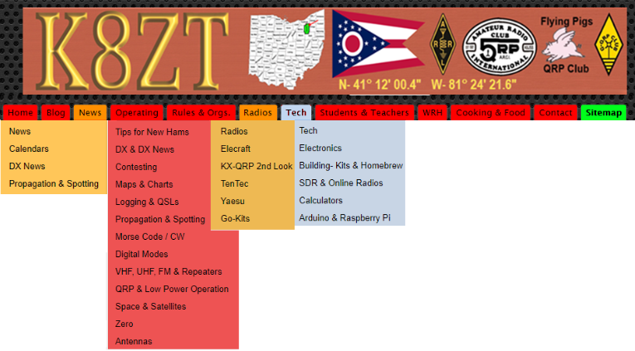A few months ago my column described the [ARRL Teachers Institute on Wireless Technology](http://www.arrl.org/teachers-institute-on-wireless-technology). Just a reminder the application deadline for this year’s sessions is May 1st.

I would love to meet you in person, and I will be at this year’s Dayton Hamvention®️. Although I will not be there all of the time, I do have a Flea Market spot #9704 (near the buildings) where you can find me. License plates on the vehicle will probably be my wife Linda’s KA8ODP so don’t be confused.

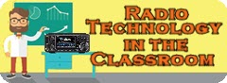

https://docs.google.com/document/d/1zYExyZATkdFI-vh8AlVrj-zAcVnXolOdfEgWF8iGT8k/edit?usp=sharing



Now on with the resource links for *Ham Radio Resources for Youth, Students, Teachers and Any New or Prospective Hams (or anyone working with these groups)-* Share or access this document online- [*tiny.cc/hry*](http://tiny.cc/hry)

1. **Kids Radio Zone-** [*www.ztlearn.com/radio-kids*](http://www.ztlearn.com/radio-kids)
2. **Teacher Radio Zone**- [*www.ztlearn.com/radio-teachers*](http://www.ztlearn.com/radio-teachers)
3. **Ham Radio Introduction & Quick Start Guide**- [*tiny.cc/new-ham*](http://tiny.cc/new-ham)
4. **Having Fun with Morse, Getting Started with CW & Getting on HF Bands with Any License-** [*tiny.cc/fwm*](http://tiny.cc/fwm)
5. **"Radio Technology in Classroom & Education"** a presentation for Educators -[*tiny.cc/rtice*](http://tiny.cc/rtice)

TOP^

1. **Collected Education Related Articles** from the ARRL Ohio Section Journal & K8ZT-

[*tiny.cc/ar-ed-out*](http://tiny.cc/ar-ed-out)

1. **Ham Radio- The Original Maker Movement** a tri-fold flyer for maker groups and advisors: - [*tiny.cc/hr-makers*](http://tiny.cc/hr-makers)
2. **K8ZT.com-** [*www.k8zt.com*](http://www.ztlearn.com/radio-kids)

Until next time hope to work you on HF NOW!

**73, Anthony K8ZT**

*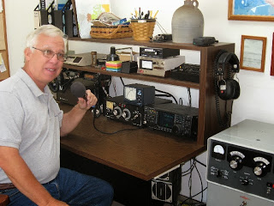****From the Official Observer Coordinator***

***John Perone, W8RXX - OOC***

[w8rxx@arrl.net](mailto:w8rxx@arrl.net)

Yes, they still exist… The Ohio OO’s monitored a total of 846 hours with 2 Good OO cards being sent.

The new VM program is still in the works. It may take a year to begin.

Three phases to the program were identified. They are development, training, and implementation.

Riley Hollingsworth, K4ZDH is heading up the program.

Meanwhile the OO program continues.

**73, John W8RXX**

*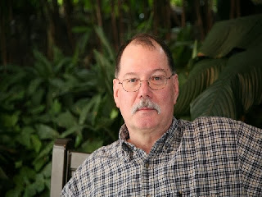****ARES Training Update***

***Jim Yoder, W8ERW – ARES Data Manager***

[w8erw@arrl.net](mailto:w8erw@arrl.net)

ARES Training Update

ARES was active last evening when severe weather moved through the Ohio Section. Shelby in Richland County was hit rather hard with a possible tornado and destructive winds. This is what we prepare for and hope we don’t get to see.

TOP^

Seneca County ARES was activated and placed in an active standby status for possible support to our friends in Richland County. We have been fortunate not to have had many ARES activations in recent past. However, training and a readiness posture are necessary, and our focus should be on being prepared for those events that place us in a position to serve.

Our training numbers have been steadily increasing with many of our members taking advantage of the higher-level FEMA courses and locally offered opportunities to acquire additional skills. There are currently 1,027 active ARES members in the training database, 804 at level 2 and 154 at level 3. Overall 580 of you who have submitted training credentials have also registered with ARES Connect. A total of 8,154 certificates have been recorded in the database.

As I look over these numbers and the individual registrations on ARES Connect, the overall statistics are similar. However, many who have submitted training documents have not registered on ARES Connect and many of those who have registered have not submitted training documents. The disparity is rather large and our goal moving forward should be to close this gap in both directions. I encourage everyone who has not done so to get registered on ARES Connect and where appropriate, report your hours for those activities in which you participate. I also suspect there are many who have not submitted training documents who have taken the 4 FEMA NIMS courses as well as many others that are appropriate for ARES activity.

I certainly understand that not everyone is comfortable with all the computerization that we now live with every day. The benefits of a simpler life without all this electronic genius often sound attractive. One way we might increase participation is to schedule training sessions and facilitate an easy means to get more members NIMS trained and registered both with ARES Connect and submitted to the training database. I challenge all of our EC’s to explore with your groups any possible means to increase our use of ARES Connect and to assist those who desire NIMS training.

Are you counting your time spent on NIMS and additional training and reporting it to ARES Connect? I’d like to hear your thoughts on this, and I am working on a method to report at the Section level, all the time on a monthly basis as I see documents submitted to the training database. I would anticipate an average time of perhaps two hours per certificate submitted and reported based on the certificate date. Certificates for Aux Comm and others would require substantial more time. Let’s hear your thoughts and ideas on how we can insure this time is captured and reported.

ARES Connect registrations are compared to the training database to verify reporting of NIMS training. When you register on ARES Connect and indicate you have taken NIMS courses, please make sure that you have also submitted those documents for inclusion in the training database. It is also important to indicate correctly your county of residence on ARES Connect. Training documents are stored under your Residence County. You may associate with other than Residence County which is fine and often does occur. Let’s not confuse the two. Please do let us know as you submit training documents, both your Residence and Serving County. This will insure that we can quickly find your data when we need to respond to an emergency or disaster situation. I often receive training documents with a name only, no Call, No County information and no means to contact you. Folks be proud of that Call, you worked hard to earn it and please when you submit documents, identify yourself with your Call. Without this, I’m guessing at who you are and where you belong. All of this information is necessary to efficiently and quickly identify you when necessary to support and document you to our served agencies.

TOP^

Thanks to each of you who through your dedicated effort are supporting ARES and our Ohio Section being the very best. Please do not hesitate to contact me or any of our Ohio Section Leadership if you have questions or concerns. We are all here to assist you and make our hobby both enjoyable and productive for you.

Thank you for your support,

**73, Jim W8ERW**

***The Handbook Give Away***

Hey Gang,

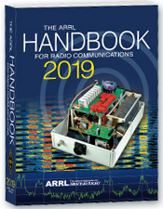Have you registered for the “Handbook Giveaway” drawing for this month yet? If you haven’t, go to: <http://arrl-ohio.org/handbook.html> and get registered.

What’s the catch? I want to get everyone checking in to the Ohio Section website as often as possible, and in order to register each month, you have to visit the website often! There’s nothing else to it. I pay all expenses, and from time to time, I Give Away more than just a Handbook. And, you’ll never know just what months will be those special times that I will have more than just a Handbook to Give Away!!

Many of you ask me just how do I know when the drawing is on? Well, that’s easy all you need to do is check in on the Ohio Section Website on a regular basis and watch for the big [**RED**](http://arrl-ohio.org/handbook.html)Arrow that will appear on the left side of the page. This is the sign that the drawing is on and you need to get registered. So, keep a sharp eye out on the website and check in often! <http://arrl-ohio.org>

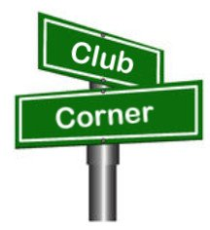***Club Corner***

This is YOUR cornner of the newsletter. Send me what your club is doing and I’ll make sure that it gets in. Got a special event or club project that you want everyone to know about? Send it to me!. Need help with a project? Send it to me.

Let me know what you club is up to. Are you going to have a special guest at your meeting or are you having a special anniversary? Just sent it to:

[n8sy@n8sy.com](mailto:n8sy@n8sy.com)

#########

TOP^

***Case Amateur Radio Club took second place in Frequency Measuring Test***

*(from David, AD8Y - W8EDU faculty advisor)*

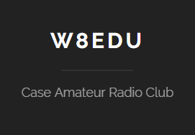

That was a lot of fun--true, FMT is about the nerdiest thing that can possibly be done within the confines of amateur radio, but we enjoy it. We had several previous entries and several coaching/study sessions.  We also helped the University of Michigan club through their entry.

We are especially proud that we did this with rather ordinary equipment, a Yaesu transceiver without external frequency control and a Windows machine running fldigi.

For full list of those participating: <http://fmt.arrl.org/fmtcurresults.php>

They are available for a club presentations on the topic, and that Ohio amateurs who want help entering the next one should feel free to contact me at: [dxk10@cwru.edu](mailto:dxk10@cwru.edu)

#########

***TMRA Needs Volunteer Help***

Spring is here so it's almost time for the Glass City Marathon! This year the race is on **Sunday, April 28th** and starts at 7 AM. The course closes at 1:30 PM. Not every position requires you to be there the whole time. We need lots of operators to cover this event so if you can help please let me know at either [k8rks@arrl.net](mailto:k8rks@arrl.net) or 419-471-0573.

#########



***ATCO Spring Event***

Guys (and Gals too),

It's closing in on ATCO Spring Event time. The Event date is **Sunday May 5th** starting about noon. Come one, come all in the ABB Cafeteria, and **it's free!** We'll have a free lunch followed by a short business meeting then on to the door prizes.

TOP^

Let's have a great turnout this time! Surprise me!

ABB Cafeteria is located at: ABB Inc, 579 Executive Campus Dr, Westerville, OH 43082

Hope to see you there!!!

#########

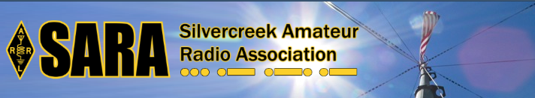SARA is partnering/supporting Wayne County EMA in the offering of the SKYWARN training this year. As you may have heard, budget and staffing issues in the Cleveland NWS office has led them to cancel the NWS-lead SKYWARN classes. EMAs and ARES ECs are being encouraged to hold the SKYWARN training directly.

SARA is playing a supporting role to the Wayne County EMA which is holding a session for this region. The date will be **Monday, May 6th from 6p - 8p.** Volunteers will be needed 5p - 8:30pm. The tentative location is Chippewa Jr/Sr High School in Doylestown. Volunteers will help register attendees and print the SKYWARN training cards with ID numbers. Fred Sheppard KD8GYS will be assisting Joe Villegas with the class.

Additionally, SARA will have a table with some amateur radio materials available to spread the word about our hobby and service.

If you can volunteer your time, please contact me so I can add you to the roster. Please note that volunteers will not be able to be present in the class for the entire session as volunteers will register latecomers and also print and organize the ID cards.

Thanks! For more information or questions, contact Jason, N8JDM [jason@mfamily.org](mailto:jason@mfamily.org)

#########

***OH-KY-IN NVIS Day***

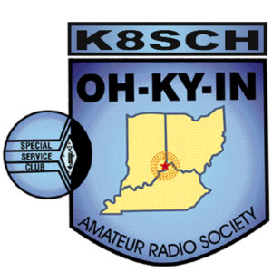

NVIS Day is Saturday, April 27th. We're going to be at Ross Park in Saint Bernard. The event is from 10:00 AM to 4:00 PM ET, with setup beforehand.

Spring is here! And nothing says spring better than NVIS Antenna Day!  It is a chance to get out of the shack you have been cooped up in all winter and set up a field station! It's also your chance to win a prize. A prize will be given to anyone who makes a contact with their own homebuilt NVIS antenna, (as long it isn't an inverted V!).

Every year that Jerry Shipp W1SCR and Michael Sien KD8SOH have hosted NVIS Day the only antennas that people bring are the Standard inverted V’s…..

TOP^

This year we are looking for the most creative antenna that can make contacts in Ohio especially to The ARES team in Columbus.  “**There will be one prize $50 for the antenna that Jerry and I decide is the best**”.

**Note: Inverted V’s will not be illegible to win a prize!  In case of a tie the one with the most contacts in Ohio will win!  Remind everybody to bring a log!  Also if one antenna really stands out it still has to make a contact in Ohio to win!**

We will have coffee and donuts available at 8:30 AM and lunch will be served at 12 noon.  Hamburgers, Hot Dogs and snacks….

Come join us…

Date:                    April 27, 2017

Time:                   10:00 AM to 4:00 PM. (Set up at 8:30)

Place:                  Ross Park in St. Bernard: 5198 City Park Dr, St Bernard, OH 45217

Want more information on how to make a NVIS Antenna? Here’s a link.. <http://arrl-ohio.org/SEC/nvis.html>

#########

***GENRAL LICENSE UPGRADE CLASS***

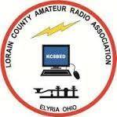The Lorain County Amateur Radio Association will be conducting a 10-week course for General class upgrades.

The classes will be on **Monday evenings starting the 29th of April** to the 1st of July, from 7pm to 9pm at The American Red Cross 2929 West River Rd Elyria, Ohio.

There is NO cost for this course, only your time.

The course will be instructed by Eric, N8AUC.

Eric feels that even if a person had NO amateur radio license, a person could gain enough knowledge to potentially pass the technician and general exams.

If you would like to attend this course, or have ANY questions, contact Eric, [N8AUC@arrl.net](mailto:N8AUC@arrl.net)

#########

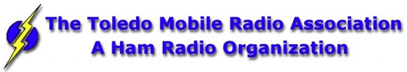The Toledo Air Show is July 13 & 14 and we did such a great job at the last Air Show the powers that be have requested additional help from us this time around. We are still in the planning phase and do not have final numbers for needed operators, but I wouldn’t be surprised to see a number around 50 or more each day.

The Lucas County EC is the contact person for the air show, [boxcar@toast.net](mailto:boxcar@toast.net).

TOP^

***THE TMRA WILL ONCE AGAIN BE HOSTING A BUS TRIP TO HAMVENTION IN XENIA OHIO***

This year’s trip will be on the Saturday May 18th and the cost will again be $40.00. This year we are asking people to both Reserve and pay before the May General Meeting if possible. This will allow the Bus to depart on-time and will also make life easier on Mike/WA8SYD. If you want to join the TMRA on the Bus, and we hope you will, please contact Mike/WA8SYD and get your spot reserved. You can contact Mike by Phone at **419-699-1392**.

This year’s trip will follow the standard Trip plan as before

05:30 Depart Scott Park Campus

08:30 (eta) arrive and park near the Front Gate of Hamvention in Xenia Ohio

08:30-17:00 Bus remains available to Riders in Parking Lot

17:00 Depart Hamvention

17:45 (ETA) Arrive at Restaurant in Dayton Ohio

19:00 (EST) depart Restaurant

21:30 arrive back at UT Scott Park Campus

*This is a general Itinerary of the trip and of course times may vary.*

The Bus will remain on-site and open to all Riders throughout the entire day. You are free to leave items on the Bus and return to the Bus to rest or drop off purchased item. If you buy a large item, it can almost certainly fit into the Busses Cargo hold.

Hamvention Bus Reservation and payment can be arranged thru Mike Kehr / WA8SYD. To contact Mike please call him on his Cell Phone at 419-699-1392

We hope to see you on the Bus to Hamvention.

***Restaurants near Dayton stop***

***Country Corral***

***Smash Burger***

***Fazolis***

***Steak and Shake***

***Chick-fil-a***

***These Restaurants are with-in short walking distance of location of Bus***

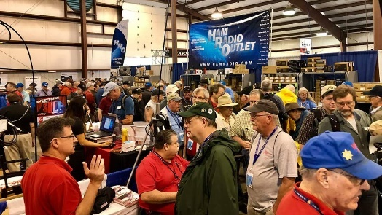[***Upcoming Hamfests***](http://arrl-ohio.org/hamfests.html)

**04/28/2019 |**[**Athens Hamfest**](http://www.arrl.org/hamfests/athens-hamfest-8)

Location: Athens, OH  
Sponsor: Athens County Amateur Radio Association  
Website: <http://www.ac-ara.org/>

TOP^

|  |  |
| --- | --- |
| **05/17-19/2019 | Dayton Hamvention**  Location: Xenia, OH  Sponsor: Dayton Amateur Radio Association  Website:  <http://hamvention.org/> | **06/01/2019 | FCARC Summer Swap**  Location: Wauseon, OH Sponsor: Fulton County Amateur Radio Club Website: <http://k8bxq.org/hamfest> |
| **06/08/2019 | Union County ARC TrunkFest**  Location: Marysville, OH Sponsor: Union County Amateur Radio Club Website: [http://www.ohiohams.net](http://www.ohiohams.net/) | **06/15/2019 | Milford Hamfest**  Location: Owensville, OH  Sponsor: Milford Amateur Radio Club  Website: <http://www.w8mrc.com> |
| **06/15/2019 | W8DXCC DX Convention**  Location: Owensville, OH  Sponsor: SouthWest Ohio DX Association  Website: <http://www.w8dxcc.com> | **07/07/2019 | 20/9 Radio Club Hamfest** Location: Austintown, OH Sponsor: 20/9 Radio Club, Inc. Website: [http://20over9.org](http://20over9.org/) |
| **07/07/2019 | Ohio Link Swap Meet**  Location: 1801 Gateway Circle, Grove City  Sponsor: Ohio Link Network Group  Website: [www.olnradio.digital](http://www.olnradio.digital) | **07/20/2019 | NOARSFEST**  Location: Elyria, OH  Sponsor: Northern Ohio Amateur Radio Society  Website: <http://noars.net/hamfests/noarsfest> |

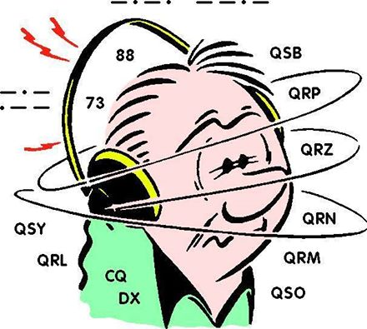***DX This Week***

*(from Bill, AJ8B)*

Bill AJ8B ([aj8b@arrl.net](mailto:aj8b@arrl.net), @AJ8B, [www.aj8b.com](http://www.aj8b.com) or [www.swodxa.org](http://www.swodxa.org) )  
CWOPs Member #1567

One of our club members, elite DXers and all around good guy, W8GEX, Joe, reminded me that there is yet another band that I have never discussed but is great for DX and is growing. That would be 60 meters! Joe was kind enough to put together an introductory explanation of operating 60 meters and what you can expect, and I have placed that below. Thanks Joe!

+ --------------------------------------------------------------------------------------------------------------------+

**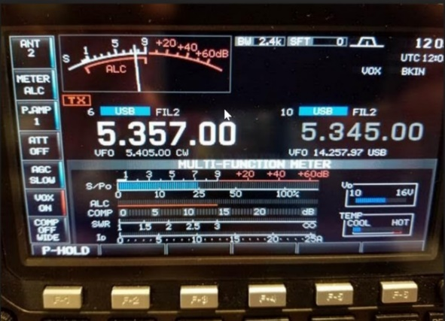****60 meters - the channel band**

**By Joe W8GEX**

60 meters, known as the channel band, has been around since July 2003, and I have been on the band from the start. As a matter of fact, I led the first 60m DXPedition in July of 2003 to the island of Montserrat and was hooked. Since then a lot has happened. At first countries came on slowly.

TOP^

To promote it, I would write and ask DXPeditions to try and get permission to operate this new band. To make it easy for them, I came up with a sample letter that the team could use to request permission from their governing authority.  I still use this practice today with great luck. Being a DXPeditioner, on many of the trips I led we operated the 60-meter band, handing out a new one.

For many years we had five channels, USB and CW, and we could only have 50 watts IERP.  Each SSB channel has a CW channel 1500 Hz higher than the SSB frequency, as shown on the VFO. The PSK and RTTY are same as the CW frequencies. (i.e. 5.4035 SSB, 5405 CW/PSK) We still have only 5 channels but can only operate JT65 on 5.357.  Most stations had a dipole or an inverted vee for antennas.  These are still the main antennas used today.  From the beginning, we have had a gentlemen’s agreement that our channel 5 (5.403.5) would be used for DX and channel 4 (5.371.5) would be a backup DX channel.  Channel 5 is our CW frequency and the other three channels are to be used for short sideband QSO’s.  As you can imagine, things can get a little hectic at times.

Being a lower band setting between 40m and 80m, it’s only usable at night. At first it was a big deal to work England which was the first country to be on.  With 50w and an inverted vee it became a nightly QSO to those Brits.  As mentioned above, once I was hooked, I wanted to promote 60m and I asked operators to try and get permission from other countries.  I asked that even if it was only a special permit for a short time, this could demonstrate that they have no interference with other communications in their country.

Then I had the brainstorm to send out a 60m DX Newsletter to those that were on, to keep them informed on the band happenings.  I would post information about DXPeditions in my newsletter so the gang would be alerted that a new county was about to come on.  This created a lot of interest and activity on the band.  We now have over 180 countries that are on or have been on for at least a short time, such as during a DXPedition.

If you have an interest in this free 60m DX Newsletter, let me know at [w8gex@aol.com](mailto:w8gex@aol.com).

Below is the home page of the 60m website. This website was developed and is maintained by a non-ham and I have never met him, but he does an awesome job. Please check out his work. -> [www.60metersonline.com](http://www.60metersonline.com)

1. **Meters Online enables experienced amateur radio operators to:**

* **become better acquainted with each other (see** [**Operators/Stations**](http://60metersonline.com/operators.html)**)**
* **stay informed about amateur radio developments (see** [**Newsletter**](http://60metersonline.com/newsletter.html)**)**
* **view and post messages, share questions and answers (see** [**Resources**](http://60metersonline.com/resources.html)**)**
* **share accomplishments (see**[**DX Awards**](http://60metersonline.com/dx-award.html)**and**[**WAS Recipients**](http://60metersonline.com/recipients.html)**)**

Sixty Meters became available to US amateurs on July 3, 2003. Beginning March 5, 2012 there have been frequency, power and mode changes.

Any US amateur radio operator holding a General, Advanced or Amateur Extra Class license may only transmit USB, CW or Digital Modes on 60m with an effective radiated power (ERP) not to exceed 100 W ERP (Effective Radiated Power). CH5 is the unofficial DX calling frequency!

March 2012 with the new modes added to USB, the established frequencies for CW/digital on the 5 60m channels are Ch 5 = 5405, Ch 4 = 5373, Ch 3 = 5358.5, Ch 2 = 5348 and Ch 1=5332 KC.

TOP^

The corresponding channel USB frequencies are 1.5 KC LOWER than CW and are 5403.5, 5371.5, 5357, 5346.5 and 5330.5 KC.  CW is NOT allowed on the USB frequencies and USB NOT allowed on the CW frequency. These are FCC regulations.

Channel 5 is the main DX calling frequency that is monitored by most DXers around the world with channel 4 being an alternate channel for DXing during times of channel 5 QRM

Very little split operation is on the band due to the limit of space.

Check out our website at [60metersonline.com](http://60metersonline.com/) and some others links I have listed here

[http://60metersonline.com](http://60metersonline.com/)

[http://60mband.blogspot.com](http://60mband.blogspot.com/)

<http://en.wikipedia.org/wiki/60-meter_band>

<http://dxworld.com/60mlog.html>

<http://tinyurl.com/pjhd943>  Worldwide 5 MHz Allocations Chart

*The 5 MHz Newsletter:*

<https://www.dropbox.com/s/b8dm3fi62i1qajy/5%20MHz%20Newsletter.pdf>

<https://www.dxmaps.com/spots/mapg.php?Lan=S&Frec=5&ML=M&Map=W2L&HF=S>

<https://www.dropbox.com/s/b8dm3fi62i1qajy/5%20MHz%20Newsletter.pdf>

You can also go to this DX Watch cluster page and see the 60 meter spots.     <http://www.dxwatch.com/dxsd1/dxsd1.php?f=5>

+ --------------------------------------------------------------------------------------------------------------------+

Now that this lengthy commercial is over, let’s see what our friend at the DailyDX and the WeeklyDX, the best source for DX information, (<http://www.dailydx.com/> ) has this to report:

**3D2 – Fiji, FW - Wallis & Futuna -** G0VJG, Nobby, begins his trip in early May, with his plans going well. 3D2AS will start May 3 for 5 days. He moves on to Wallis and Futuna, FW/G0VJG around May 8, QRV for 14 days. He will be on Wallis, OC-054, with the possibility of a short side trip to the more rare Futuna, OC-118. He will adjust to any changed local situations. Nobby's radio will be an FT857 to a folding hexbeam. He will be on 60 possibly, but 40, 30, 20, 17,15, 12, 10 and 6 for sure. He will have a small amp on SSB and is trying to become familiar with FT8 fox and hound mode before he goes and is pleased with his progress.

**S7 – Seychelles -** Look for Russians RA0AM and RA0ANR to be operating as S79AM and S79ANR from April 11-19. They will be operating from several islands, all of which count for AF-024 for IOTA. The holiday style operation will be on SSB, CW and Digital modes on 14-28 MHz.

**9G – Ghana -** IZ4YGS, Matteo, will be active again from Ghana between April 13th and May 7th. In his spare time, he will be on 20, 30, 40, 60, 80 and 160 meters, mostly on FT8 and SSB. His setup will include a Yaesu FT-891, small 300-watt amplifier and vertical antennas. QSL direct via home call IZ4YGS.

TOP^

**9U – Burundi -** 9U3TMM by IV3TMM, Francesco, from grid KI46QO will be August 1-September 17. Francesco will have an IC-7300, 100 watts, to a Cushcraft R8 vertical and a LAZV-5B dipole, operating on 60-6M SSB, RTTY, PSK and FT8. LoTW will be available, as will OQRS at Club Log. <https://www.qrz.com/db/9U3TMM> He notes this is a return to Burundi for him; he was there during the Christmas holiday season in 2011-2012. This time he will have his family along and probably will visit some parks and do some WFF, World Flora Fauna, activation(s).



***A******RLD016 DX news***

This week's bulletin was made possible with information provided by The Daily DX, The OPDX Bulletin, 425 DX News, DXNL, Contest Corral from QST and the ARRL Contest Calendar and WA7BNM web sites. Thanks to all.

**MAURITIUS, 3B.** Rachid, 3B8FQ plans to be active in the CQ Manchester Mineira DX CW contest. QSL direct to home call.

**UGANDA, 5X.** Anders, SM0HPL is QRV as 5X7W from Kampala until April 27. Activity is in his spare time on 20 to 10 meters, and possibly

30 meters, using CW, JT65 and FT8. QSL to home call.

**GHANA, 9G.** Matteo, IZ4YGS is QRV as 9G5GS from Sanzule, West Takoradi until May 7. Activity is in his spare time on 160, 80, 60, 40, 30 and 20 meters using mostly SSB and FT8. QSL direct to home call.

**MALTA, 9H.** Sorin, YO7CKQ is QRV as 9H3YO from Qawra-Bugibba until April 21. Activity is on 20 and 17 meters using FT8 during his morning and evening hours. QSL to home call.

**CUBA, CO.** A group of operators from the Federacion de Radio Aficionados de Cuba will be QRV with special event station CO0HK from Cayo Jutias, Pinar del Rio province from April 19 to 21 in celebration of the IARU's 94th anniversary. Activity will be on 40, 20, 15, 20 and 2 meters. QSL via W7HU.

**PHILIPPINES, DU.** Chris, VK3FY and Dindo, DU1UD are QRV as 4E8T from Tawi-Tawi Island, IOTA OC-174, until April 23. Activity is on 40,

30 and 20 meters using FT8. QSL via M0OXO.

**FRANCE, F.** Members of the Radio Club du Val d'Issole are QRV with special event call TM500LDV until July 20 to mark the 500th anniversary of the death of Leonardo da Vinci. Activity is on the HF bands using CW, SSB, PSK and FT8. QSL via F4GPB.

**FRENCH POLYNESIA, FO.** Rich, KE1B and Anna, W6NN will be QRV as FO/KE1B from Bora-Bora from April 22 to 27, and then from Mo'orea from April 27 to May 3. Activity is mostly on 20 meters using FT8 with 10 watts. QSL direct to KE1B.

**SAUDI ARABIA, HZ.** Samir, HZ1SK will be QRV in the CQ Manchester Mineira DX CW contest. QSL via IZ8CLM.

TOP^

**ALAND ISLANDS, OH0.** Marco, OH2LGW and Anne, OH2YL are QRV as OH0/OH2LGW and OG0YL, respectively, until April 23. Activity is on 80 to 6 meters using CW and SSB. QSL to home calls.

**CRETE, SV9.** Sepp, OH1VR will be QRV as SV9/OH1VR from April 25 to May 1. Activity will be on 80 to 10 meters using mostly CW with some SSB. QSL to home call.

**EAST KIRIBATI, T32.** Ken, KH6QJ is QRV as T32AZ from Kiritimati Island, IOTA OC-024, until April 23. Activity is on 80, 40, 20 and

15 meters, with a focus on 40 meters, using CW and SSB. QSL to home call.

**UKRAINE, UR.** Special event station EN185UNIV is QRV until the end of 2019 to celebrate the 185th anniversary of the Taras Shevchenko National University of Kyiv. QSL via UT8UF.

**BRUNEI, V8.** Tamat, V85T plans to be QRV in the CQ Manchester Mineira DX CW contest. QSL via operator's instructions.

**KOSOVO, Z6.** Thomas, OZ1AA and Alex, OZ7AM are QRV as Z66Z until April 22. QSL via OZ1ACB.

**ST. HELENA ISLAND, ZD7.** Gilbert, ZD7BG plans to be QRV in the CQ Manchester Mineira DX CW contest. QSL direct to home call.

THIS WEEKEND ON THE RADIO. The NCCC RTTY Sprint, NCCC CW Sprint, Holyland DX Contest, ES Open HF Championship, Worked All Provinces of China DX Contest, YU DX Contest, QRP to the Field, CQ Manchester Mineira DX CW Contest, Michigan QSO Party, EA-QRP CW Contest, Feld Hell Sprint and Ontario QSO Party are all on tap for this weekend.

The Run for the Bacon QRP CW Contest is scheduled for April 22.

The CWops Mini-CWT CW Test, 432 MHz Spring Sprint, SKCC CW Sprint, UKEICC 80-Meter CW Contest and Phone Fray are scheduled for April 24.

The Canadian National Parks on the Air, CNPOTA, operating event runs for the entire year of 2019, with special stations active from Canada's parks and historic sites.

Please see April 2019 QST, page 87, and the ARRL and WA7BNM Contest Web Sites for details.

***Special Events***

* **05/04/2019 | 100th Anniversary Mahoning Valley Amateur Radio Association**

**May 4-May 5, 1300Z-0100Z, W8QLY**, Youngstown, OH. Mahoning Valley Amateur Radio Association. .3825 7.250 14.250. QSL. MAHONING VALLEY AMATEUR RADIO ASSOCIATION INC, 125 W McKinley Way, PO BOX 14141, Youngstown, OH 44512. Electronic QSLs will be sent for confirmed contacts--request form on QRZ page. mvara.W8QLY@gmail.com or [www.qrz.com/db/w8qly](http://www.qrz.com/db/w8qly)

TOP^

* **05/04/2019 | COSI Big Science Celebration**

**May 4, 1500Z-2000Z, W8LT**, Columbus, OH. Friends of W8LT. 14.250 14.070. QSL. W8LT c/o Larry Feth, 1080 Carmack Rd., Room 40 Bevis Hall, Columbus, OH 43210. For up-to-date information, go to [www.qrz.com/db/w8lt](http://www.qrz.com/db/w8lt)

* **06/01/2019 | Museum Ships Weekend**

**Jun 1-Jun 2, 1100Z-2100Z, K8E**, Toledo, OH. Toledo Mobile Radio Association and National Museum of the Great Lakes. 14.260 14.039 7.260 7.039. QSL. SS Col. James M. Schoonmaker, Team K8E, P.O. Box 9673, Toledo, OH 43697. [www.tmrahamradio.org](http://www.tmrahamradio.org/)

* **06/15/2019 | W8DXCC DX Convention**

**Jun 15-Jun 16, 0000Z-2359Z, K8S**, Owensville, OH. SouthWest OH DX Association. 14.245 14.074 7.245 3.535. Certificate & QSL. AJ8B - Bill, 8275 Cierra Way, Waynesville, OH 45068. This is the inaugural year for this DX Convention. We are using these call signs: K8S, K8W, K8O, K8H. A QSL for each and/or certificate for working all four. [www.w8dxcc.com](http://www.w8dxcc.com/)

**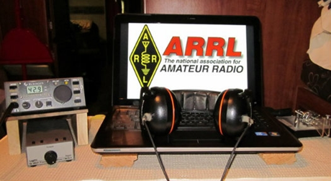*ARRL Contest Corner***

An expanded, downloadable version of *QST'*s [Contest Corral](http://www.arrl.org/contest-calendar) is available as a PDF. Check the sponsor's Web site for information on operating time restrictions and other instructions.

***One Question Questionnaire***

Hey Gang

There’s another NEW – one question – questionnaire on the Ohio Section Website! <http://arrlohio.org>

Wow.. 52% of you will be taking your HF equipment when you go camping this year! That’s fantastic!

Anyway, these questions are all in fun and I hope that you are enjoying answering these “ONE QUESTION” questionnaires. Ok, enough on that, here’s the next question for you to answer…

**“Do you own a Family Radio Service (FRS) or Multi-Use Radio Service (MURS) transceiver??”**

You’ll find the “One Question” questionnaire on the Ohio Section Website! <http://arrlohio.org> It’s all in fun and it’s not a scientific survey in any way, but we are learning some things that we didn’t know from these questions. I hope that you are enjoying answering these “One Question” questionnaires.

TOP^

*****V.E. Test Sessions***

For the latest testing site information please **>>** [**Click Here**](http://www.arrl.org/find-an-amateur-radio-license-exam-session) **<<** The ARRL site tracks all of the VE testing sites that register with them, including W5YI and Laurel. ARRL gives you a number of different ways of sorting to find that site that is closest to you as well.

#########

***Exam Session Reminders***

**GRADING EXAMS:**  Each VE must grade each exam taken or must agree to the score given. After all three VEs agree to the number of correct answers shown, the score is announced to the examinee. The VEs must inform the examinee of their grade (pass or fail, and state the score {e.g., 26 out of 35}) upon completion of the grading.

**NEW GENERAL EXAMS COMING:**  The new General class question pool will take effect on July 1, 2019 for all Element 3 General class license written exams. With the General class exams changing July 1st, new test designs must be created and used on that day. ARRL VEC will be supplying all its (near 1,000) Field Stocked VE teams with new test booklets about the 3rd week in June. Do not destroy the 2015 versions of the General exams until June 30.

BASIC QUALIFICATION QUESTION PROCEDURES: The detailed instructions are available on the ARRL website. At the exam session, candidates that answer “YES” to the qualification (felony) question should be given the “Applicant Instructions for FCC Basic Qualification Question” document. Print or download here: <http://www.arrl.org/files/file/VEs/Applicant%20Info%20Qualification%20Question%202019.pdf>

Applicants can also be referred to our Basic Qualification Question web page for information and instructions.

View page: <http://www.arrl.org/fcc-qualification-question>

After the application data from the session is submitted to FCC and an FCC file number is created, the applicant is required to provide an explanation directly to the FCC within 14 days. Do not collect information from the candidate and do not send any documents to the VEC.

***Incident Command System (ICS) Training Schedule***

All current trainings are listed on the Ohio EMA training calendar located at:

<https://webeoctraining.dps.ohio.gov/TrainingAndExercise/courselist.aspx>

I’ve been asked to also include a link to the Kentucky EMA training calendar as well..

<https://kyem.ky.gov/training/Pages/default.aspx>

<https://sites.google.com/site/ccoemtraining/home>

TOP^

Please pay particular attention to these courses listed above, as that there’s a lot of ICS 300 & 400 classes listed that are very useful for all Amateurs to have under their belts. I will also state that G775 is also a very good course to take as well. These 3 courses are multiple day in class courses, so please be prepared to spend some time taking them.

We do recognize that IS-300/400 requires multiple days of actual classroom training that is not easily obtained. So, if you just can't find the time to fit these class room courses in, we do have an alternative method for getting you to Level 3.

Completing the following **“FREE”** and **“ONLINE”** courses will act as substitute for you FEMA Leadership Development Course requirements. You absolutely will need to complete all **7** of these courses to get your ICS 300/400 credit.  Here are the courses that you need to take:  **IS-120, 230, 240, 241, 242, 244 & 288.**

***Now, if you are looking for wallpaper and have a little extra time, taking IS-235 in addition to the 7 listed courses above, you will get a really cool looking certificate from FEMA stating that you have completed the Professional Development Series. That’s impressive in itself!***

#########

***AUXCOMM Training in Conjunction with Hamvention® 2019***

The Emergency Communications Division (ECD) of DHS’s Cybersecurity and Infrastructure Security Agency (CISA) will be on hand at Hamvention® 2019 to conduct its nationally recognized NIMS/ICS compliant AuxComm course. Over 2,500 amateur radio operators from around the country have taken this course. The purpose of this course is to train qualified amateur radio operators so they may assist their local, county and state governments with emergency backup communications if requested to do so.

This course introduces the auxiliary communicator to the other positions within the Communications Unit (COMU) and how to provision emergency communications in a public safety context. The course also goes deeper into the National Incident Management System framework. The location of the course will be at the “Courtyard by Marriott” in Beavercreek, Ohio and be held 14-16 May 2019. Registration for this class may close early when all available seats for this class are taken.

***Registration for this course is ongoing:*** Students wishing to attend the DHS Auxiliary Communications (AuxComm) Course must meet all prerequisites and provide electronic/scanned images of the following required documents prior to **1 May 2019**:

**Prerequisites:**

* A signed copy of your current valid FCC issued amateur radio license
* IS-100 certificate (FEMA issued); IS-200 certificate (FEMA issued); IS-700 certificate (FEMA issued);

IS-800 certificate (FEMA issued), and the name of the public safety entity, and its contact information, that you would support upon completing this course

TOP^

Please scan copies of this information, attached it to an email, and then send to [COMU@hq.dhs.gov](mailto:COMU@hq.dhs.gov). In the subject line, please put Hamvention AUXCOMM. Your information will be reviewed, and a reply sent back to you indicating that you have been given a seat in the course.

This will be an intensive three-day version of the course with facilitated lectures and student exercises conducted by professional AUXCOMM instructors. This course provides time for interactive discussions and exercises. Should you have any questions regarding this course, please send them to [COMU@hq.dhs.gov](mailto:COMU@hq.dhs.gov).

One final note, please mark your forum calendar, on Friday 17 May, to come see us at the AUXCOMM forum. You will be given a glimpse at the new AUXCOMM Position Task Book (PTB), a briefing on the proposed Communications Section for NIMS/ICS and a briefing on one of the most active AUXCOMM states – North Carolina!

***ARES Connect***

***CQ… CQ…. CQ… Calling all persons to be a part of the new ARES Connect program.***

We need to discuss some very important items that only YOU can make a difference with. I need you to get yourselves registered in ARES Connect, that is… if you haven’t already. Now, how do I know that you need to do this?

It’s simple, we have **1010** now registered in the database and Stan’s last S.E.C. report shows that we have a little over 1,700 persons in ARES right now. As you can see, we still have a way to go to really take advantage of this new system.

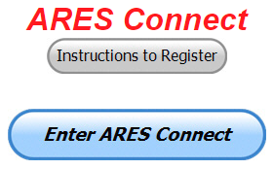As the numbers show, there’s still a lot of you that haven’t taken the plunge yet and need to! What are you waiting for? No matter how much you resist, it’s coming, and we need to make sure that no one is left behind.

**Now, as an incentive to get you to not only register…. But to actually start using the system…** *(Notice how I have that in bold type for you to clearly see?)*I am giving away all sorts of goodies to help you get motivated. I have a footlocker of really cool items that I will be giving away!

I’m doing this in various intervals throughout the year, so it will challenge you to be dedicated to getting your hours into the system. You’ll never know just when another drawing will be, so you really do have to be prudent!!

TOP^

***Here’s the top 10 folks for hours for this portion of April:***

|  |  |  |  |
| --- | --- | --- | --- |
|  | **Name** | **Events** | **Hours** |
| 1 | Christopher Domenick (KC8CAD) | 19 | 88.50 |
| 2 | James Yoder (w8erw) | 10 | 87.50 |
| 3 | Dan Stahl (KC8PBU) | 30 | 62.00 |
| 4 | Larry Caskey (K8LPC) | 23 | 38.00 |
| 5 | Elizabeth Klinc (KE8FMJ) | 25 | 36.45 |
| 6 | Robert Baker (N8ado) | 13 | 34.50 |
| 7 | Bret Stemen (KD8SCL) | 16 | 34.00 |
| 8 | Edward Kopcak (KB8BKE) | 8 | 28.50 |
| 9 | Gordon Broadway (N8BHL) | 4 | 28.00 |
| 10 | Timothy Gray (KD8IZU) | 5 | 26.00 |

***Here’s how we did with people getting signed up for events***

***and the total hours logged so far for April***

|  |  |
| --- | --- |
| Total Amount signed into Events | Total Hours for Events |
| **1,178** | **3,313.31** |

Here’s a link to get you started... <http://arrl-ohio.org/ares_connect_directions.pdf> Please, don’t just hurry through the questions, read them carefully, if you don’t understand something, please ask me, I’m here to answer your questions.

We know that you mean well by answering that you do have the needed courses in, but I will let you know that we are verifying what you say you have with what is showing for you in our statewide database when we are completing your registration.

So, how can you find out if you are already listed in our statewide database? Easy, here’s a link: <http://arrl-ohio.org/SEC/special/ICS%20Complete%20by%20County%20and%20Name.pdf>

**Ok, now on to something new for ARES Connect…** I was asked by Ron, NU8N about having a certificate for those who have taken the extra time and courses to get to Level 3. Well, after some thinking about it, Stan and I agreed with Ron that we should have some wallpaper for those who have taken this extra hard step. So, I’m here to tell ya’ that we are now offering a really nice certificate for all of those who have worked so hard to obtain their Level 3 ARES Status.

All you have to do is complete a couple of boxes and we’ll send you a certificate suitable for framing. Now I want to make sure that you understand that you do have to be registered in the statewide database as a Level 3 to qualify for this certificate.

Here’s the link… <http://arrl-ohio.org/SEC/level3.html> So, if you have certificates that you haven't submitted yet, this is the perfect time to do just that!

TOP^

***Wouff Hong Ceremony At Hamvention***

When: **Saturday – May 18th starting ~ 9:00 PM** Where: Marriott at the University of Dayton

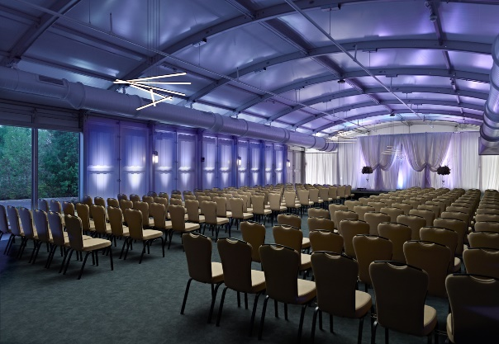Hey Gals and Guys… You’ve been asking if this is going to happen, and now I can tell you for sure, YES we are having a Wouff Hong Ceremony at Dayton!!! The Conclave will gather at 9pm and those willing to take the plunge and become a part of this ever growing and most secretive of all Societies. Come join us and be indoctrinated into history!

The ceremony is steeped in mystery! Attendees will receive a special keepsake. A fun activity for all ages. Doors to the conclave will open at 9:00 PM (no admittance after 9:30 PM) at the Marriott at the University of Dayton (Tradewinds Pavilion), 1414 S Patterson Blvd, Dayton, OH 45409. **Free** **registration online** to ensure there will be enough seats, and to get a really cool certificate following the ceremony. Go to: [**http://arrl-ohio.org/wouff-hong.html**](http://arrl-ohio.org/wouff-hong.html)**.** This event is sponsored by the ARRL Ohio Section.

**Now, for those of you who don’t know what Wouff Hong is all about:**

A Wouff Hong is a fictional tool used to "punish" Amateur Radio operators who demonstrate poor operating practices. Legend has it that the Wouff Hong was invented by ARRL co-founder Hiram Percy Maxim under the pseudonym, "The Old Man," just as radio amateurs were getting back on the air after World War One.

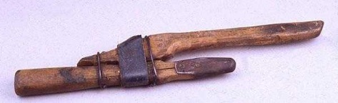

Early in 1919, "The Old Man" wrote in *QST* "I am sending you a specimen of a real live Wouff Hong . . . Keep it in the editorial sanctum where you can lay hands on it quickly in an emergency."

The "specimen of a real live Wouff Hong" was presented to a meeting of the ARRL Board and the Board voted that the Wouff Hong be framed and hung in the office of the Secretary of the League. On display at ARRL Headquarters today, the Wouff Hong is a constant reminder to Amateur Radio operators to be mindful of their operating etiquette.

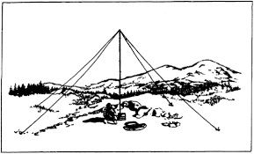***2019 Ohio NVIS Day***

NVIS DAY IS COMING!

Saturday, April 27, 2019

10 A.M.–4 P.M.

Is your station ready to establish and maintain high-reliability communication with other stations around Ohio when repeaters, phone, and internet service are impaired? When infrastructure just isn’t there, HF radio using Near-Vertical Incidence Skywave (NVIS) propagation offers the ability to stay in contact on frequencies of 2–30 MHz for distances of about 30–400 miles.

TOP^

NVIS Day is the ARRL Ohio Section event to test your NVIS antenna designs and builds. Join us on Saturday, April 27 to show how well amateur radio can keep Ohio communicating! This is not a contest: it’s an event for Ohio stations to operate with other Ohio stations and understand how well they hear and are heard.

THE DETAILS

Date: Saturday, April 27

Time: Start at 10 A.M., end at 4 P.M.

Power: Up to but no more than 100w

Exchange: six-digit grid, power, and true—measured—signal report

Schedule: This isn’t a contest, so take your time! Try different designs! Have lunch!

Register: Tell others that you’ll be operating, when you’ll be operating, and how to find you. <https://forms.gle/rMar6gN2sWf4VUNu5>

We’ll publish a map and information for all registered stations just before the start of the event.

We look forward to hearing you on the air!

C. Matthew Curtin KD8TTE ASEC

Stan Broadway N8BHL SEC

Want to know more about what NVIS is? <http://arrl-ohio.org/SEC/nvis.html> Learn all about Near Vertical Incident Scattering and how you can easily put up a NVIS antenna and participate in this great exercise.

***Sign Up for Hamvention Alerts***

If you are planning a visit to Hamvention 2019, you are urged to sign up for the Hamvention alerts which are available again this year on your mobile phone. To subscribe to the system just text **Hamvention19** to **888777**. The alerts will provide up-to-date information for those traveling to or attending Hamvention such as weather, traffic, parking and other useful information throughout Hamvention. If you signed up for the alerts in 2018 you are automatically registered for this year.

The alerts are especially important for up-to-minute information about parking and weather, especially for those who might not be able to monitor the talk-in or bulletin stations. The alerts will provide another way to direct drivers to the best parking solution if weather requires closing some onsite parking lots or if some remote lots fill up. A special thanks to Greene County Sheriff Gene Fischer, KX8GCS, for making the alerts possible again this year

The Media Committee is working to make winning prize numbers available on the alert system soon after they are drawn. This is an effort to help winners claim prizes and to decrease the number of unclaimed prizes that must be redrawn prior to the main prize drawing on Sunday. During Hamvention the numbers from the hourly prize drawing will be posted on Twitter and Facebook as well as displayed on monitors throughout the fairground's buildings. Following Sunday's Grand Prize drawings, winners will also be posted on Twitter and on <http://hamvention.org/event-details/prizes/>.

TOP^

The alert system, which was initiated in 2018, was a Hamvention effort to get visitors the information they need. It is a supplement to the Hamvention talk in station that has operated for many years on the Dayton Amateur Radio Association repeater, 146.94(-) 123.0 Tone to give directions and other assistance.

Last year a traffic bulletin station was also added on 145.525 to periodically repeat needed information. Amateurs with 2-meter capability are urged to enter those frequencies into their radios before starting their Hamvention journey.

Hamvention 2019, the world's largest amateur radio gathering, will be held May 17-19 at the Greene County Fairgrounds and Expo Center in Xenia, OH.

***Additional Information about Hamvention***

***Hamvention to Open Gates on Sunday***

Those who have wondered what brings about 30,000 amateur radio operators to the Greene County Fairgrounds and Expo Center in Xenia, Ohio, in May will have a chance to see for themselves at no cost this year.

Jack Gerbs, WB8SCT,2019 Hamvention General Chairman, said, "We have decided to open the doors to Hamvention to the public on Sunday, May 19, without buying a ticket. This will make it a little easier and cheaper for someone with just a little interest in Hamvention to see what all the excitement is about."

In addition to the amateur radio equipment which attracts all the ham radio operators, there are also vendors selling a variety of other electronic equipment including computers and accessories, security devices networking supplies, tools and many other items of interest to the general public. Those visiting the flea market area will be surprised at what's available, often at a small fraction of its original cost.

The chairman said that Sunday is Hamvention's lightest traffic day, making it convenient for anyone who just wants to check out what's there. Many vendors have final day specials on a variety of items. The many food trucks offer a wide selection of menus, providing residents with a chance to make Hamvention 2019 a family outing.

Hamvention hours are 9 a.m. to 1 p.m. on Sunday and 9 a.m. to 5 p.m. on Friday and Saturday. While some parking will be available at the fairgrounds, much of it is weather dependent. Visitors are urged to use one of the remote lots with free shuttles. They are located at Hobson Freedom Park, 2910 Trebein Road, Fairborn, OH 45325; Xenia High School, 303 Kinsey Road, Xenia, 45383; Warner Middle School' 600 Buckskin Trail, Xenia, OH, 45385 and Xenia Towne Square, 84 Xenia Towne Square, Xenia, OH, 45385. Buses run from 7 a.m. to 6 p.m. Friday and Saturday and 7 a.m. to 4:30 p.m. Sunday.

Anyone wanting to receive current information on a cell phone during Hamvention about traffic, parking, weather conditions and other facts affecting the event is encouraged to sign up for the text alerts by texting Hamvention19 to 888777. Thanks to Greene County Sheriff Gene Fischer, KX8GCS, for making the alerts possible again this year.

TOP^

***National News***

*(from arrl and other sources)*

***QSL Service Fee Structure (to change effective May 15, 2019)***

ARRL members — including foreign members, QSL Managers, or managers for DXpeditions — should enclose payment as follows:  
  
**Through May 14, 2019, the rate structure is:   
    $1.15 per ounce, plus $7.00 QSL Bureau service fee**.   
For example, a package containing 1.5 pounds of cards — 24 ounces, or about 225 cards — will cost $34.60. Please see the information below for additional pricing details. The minimum charge is $8.15 for one ounce or less. DXCC credits cannot be used towards the QSL Service fee.  
  
**Effective May 15, 2019, the new rate structure will be:**  
  **$2 for 10 or fewer cards in one envelope.  
    $3 for 11-20 cards in one envelope, or 75 cents per ounce, for packages with 21 or more cards.**  
For example, a package containing 1.5 pounds of cards -- 24 ounces, or about 225 cards --  will cost $18. No transaction service fees.

**Any cards received before May 15 will be charged the current rate.  There will be no adjustments for cards received before May 15.**

You should use an accurate scale to weigh your cards. Most post offices have scales that you may use.   

Please pay by check (or money order) and write your call sign on the check. Send cash at your own risk.  DO NOT send postage stamps or IRCs. Please make checks payable to: “The ARRL Outgoing QSL Service.”

#########

***Honda Portable Generators Recalled Due to Potential Fire Hazard***

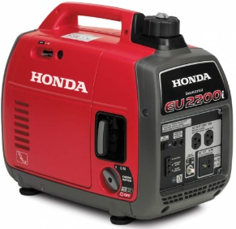American Honda has announced that it’s voluntarily recalling some 200,000 of its portable generators sold in the US due to a potential fire and burn hazard. The recall includes the EU2200i, EU2200i Companion, and EB2200i generators. The US Consumer Product Safety Commission (CPSC) says the affected portable generators can leak gasoline from the fuel valve. Users should stop operating the recalled generator and contact an authorized Honda dealer for a free repair. Honda is also contacting users directly. For more information, [**visit the CPSC website**](https://www.cpsc.gov/Recalls/2019/american-honda-recalls-portable-generators-due-to-fire-and-burn-hazards). A similar recall has been issued in Canada.

#########

TOP^

***Additional Amateur Radio-Related Petitions Now Open for Comment***

The FCC has placed three Amateur Radio-related *Petitions for Rule Making* (*PRMs*) on public notice and has invited comments.

Jerry Oxendine, K4KWH, of Gastonia, North Carolina, wants the FCC to clarify that state and localities should have no authority to regulate Amateur Radio with respect to enacting “distracted driving” statutes. In his *Petition for Rule Making*, now designated as [**RM-11833**](https://ecfsapi.fcc.gov/file/10329888625819/RM-11833.pdf), Oxendine contends that such statutes violate FCC rules on scope and operation of equipment by licensees; violate the intent of the FCC and Congress with respect to Amateur Radio’s role in disasters, and hinders emergency operations using mobile equipment.

“There is *no* evidence that the operation of two-way radio has but an insignificant impact on ‘distracted driving,’” Oxendine stated. Such distracted driving statutes usurp the authority of the FCC to regulate Amateur Radio, as well as Citizens Band and Part 90 Land Mobile Service users, Oxendine said in his *Petition*.

Edward C. Borghi, KB2E, of Farmington, New York, has submitted a *Petition*, now designated as [**RM-11834**](https://ecfsapi.fcc.gov/file/10719800320721/FCC%20rules%20change%20vanity%20call.docx), that would prohibit applicants from requesting a vanity call sign outside their call sign district. Exceptions would be made for call signs applied for under rules governing call signs previously held by family members.

“In some more populous areas, there are few of the most desirable vanity calls signs available — the 2 and 6 regions for example,” Borghi said. “I see no reason for a licensee to have to compete with out-of-area people for the few 1 × 2 or 2 × 1 or catchy 2 × 3 call signs available in their area of residence,” Borghi told the FCC.

Jeffrey Bail, NT1K, of West Springfield, Massachusetts, has submitted a very similar *Petition*, now designated as [**RM-11835**](https://ecfsapi.fcc.gov/file/1092512801279/FCCVanityPetition.pdf), asking that the FCC give residential preference in competing applications to applicants whose listed FCC address is within the same district/region as the applied call sign.

TOP^

He cites limited availability and increased demand for 1 × 2 and 2 × 1 call signs. “There are many times a call sign has been awarded to an individual/club who resides outside of the call sign district when there are other people who applied for the same call sign that reside within the district,” he said in his brief petition.

Hey Gang… What’s your take on any of these 3 proposals? Write to me at: [n8sy@n8sy.com](mailto:n8sy@n8sy.com) and let me know. I really do want to hear from you.

#########

***ARRL and FCC Sign Memorandum to Implement New Volunteer Monitor Program***

ARRL and the FCC have signed a *Memorandum of Understanding* (*MOU*) that paves the way to implement the new and enhanced Volunteer Monitor program. The memorandum establishes the Volunteer Monitors as a replacement for the Official Observers (OO) program. Current OOs have been encouraged to participate in the new program.

"We are excited by the opportunity to codify our partnership with the FCC and to work together to achieve our mutual interests of protecting the integrity of our Amateur Radio bands," said ARRL President Rick Roderick, K5UR.

TOP^

"This *Memorandum of Understanding* will serve as the foundation for a new level of partnership on this very important issue."

ARRL has contracted with retired FCC special counsel and former Atlantic Division Vice Director Riley Hollingsworth, K4ZDH, to oversee the ARRL's role in the development and implementation of the Volunteer Monitor program.

Approved by the ARRL Board of Directors at its July 2018 meeting, the new Volunteer Monitor program is a formal agreement between the FCC and ARRL in which volunteers trained and vetted by the ARRL will monitor the airwaves and collect evidence that can be used both to correct misconduct or recognize exemplary on-air operation. Cases of flagrant violations will be referred to the FCC by the ARRL for action in accordance with FCC guidelines.

The intent of this program is to re-energize enforcement efforts in the Amateur Radio bands. It was proposed by the FCC in the wake of several FCC regional office closures and a reduction in field staff.

"Under this program, the FCC will give enforcement priority to cases developed by the Volunteer Monitor program, without the delay of ARRL having to refer cases through the FCC online complaint process," Hollingsworth said.

Hollingsworth has committed to FCC and ARRL officials to ensure the adequacy of training for the new positions, to review the quality and utility of Volunteer Monitor submissions to the FCC for enforcement actions, and to advocate for rapid disposition of cases appropriately submitted to the FCC.

ARRL officials estimate that the first Volunteer Monitors will be in place and ready to begin their duties within 6 to 9 months.

***Final.. Final..***

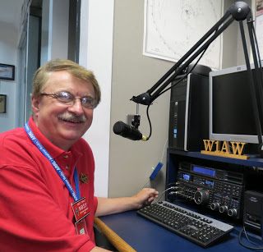

Hey Gang...

Wow.. Was this week ever a wild one for sure! If you didn’t hear, we had an EF-2 tornado come through last Sunday right close to me. Yes, it was only about 10 miles away! It was in Shelby, and did it ever play havoc with the town.

Richland County ARES / Skywarn was activated for most of the afternoon when that call that you never want to hear came across the 146.94 repeater. “We have rotation in a cloud that we are observing.” That got the attention of NWS in Cleveland pretty quick.

TOP^

Then came the words that we have a real live tornado on the ground! That’s when the stops were pulled and everything shifted to only reports of damage as it walked across 17 miles of land, not paying one bit of attention to buildings, cars or telephone poles. It wiped them all out. We even had a pastor and his wife try to run from it in their car and they were sucked up and thrown over 100 feet off of the roadway. Amazingly they got out of the car without a single scratch! The car was destroyed, but they were ok. Because of the observations reported to the Cleveland Weather Office they were able to get the warnings out about 10 minutes ahead of the tornado and thus we had no one killed and only had 6 folks hurt bad enough to be hospitalized. It was a miracle for sure!

Now, the story doesn’t end there. The folks from the Richland County Skywarn had to switch hats and now become the Richland County ARES group and go out into the field along with folks from the Marion County ARES group and help survey and secure the area where the tornado had just gone through. It was a very long day/night for everyone involved.

Stan, N8BHL our SEC got things fired up as soon as he got the call and started getting folks spun up for what could have been a very long week of activities. Fortunately, we only had one evening where we were actually needed in the field. This shows how our OSERP plan works and we got the situation well in hand quickly and very professional. The EMA Director in Richland County commended our work in getting volunteers into the effected area even before he got there. The local police and fire chiefs also commented on how we were there when needed.

Our thanks go out to Stan, N8BHL, our SEC. Danny, W8DLB the DEC for District Six and his crew along with the crew from the Marion County ARES in District Seven for their willingness and dedication to help our fellow citizens.

And YES, I do have some pictures, video of the damage. I also have some audio recordings of the event thanks to Jeff, WB8REI and Broadcastify. Here’s the link: <http://arrl-ohio.org/shelby-tornado.html>

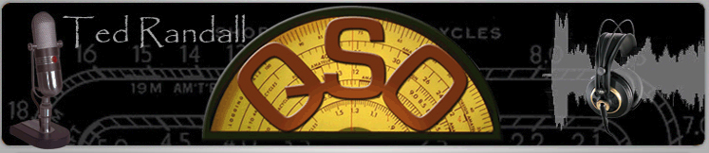This past Tuesday evening I was the guest of Ted Randall on his 2-hour radio talk show. We had a blast talking about the OO program, the new ARES program and a bunch of other items about Amateur Radio and the Ohio Section. I’ll be back on his show soon with more, as that he has invited me to come back and talk more in-depth about all the programs that we have going in the Ohio Section.

I will say this, Saturday topped off the week getting together with the cast of characters that will be entertaining you on the Saturday evening of Dayton Hamvention. We did a few dry runs rehearsing the script and finding some avenues where things could be improved upon (or adlibbed if you will). It was a blast and the time went by so fast. After hearing how these folks have interpreted the script, I definitely know that you’re gonna’ want to come to the Wouff Hong for sure! If for nothing else, but to see just what we’ve got planned!

Now, let’s move on to some other things... I do want to remind everyone that you can do a little extra publicity for your club meetings and activities just by having your ARES Connect Administrator add your events to the ARES Connect calendar!

TOP^

For those clubs that use Google Calendar or any web-based calendar program that incorporates RSS feeds, you can easily add ARES Connect events calendar to it!

Yes, you can now see all the events, including your own club activities on your calendar! Oh, if you don’t use Google Calendar, do you use Outlook or other similar Office Suite programs that has a calendar built in?

If you do, then you can even add the ARES Calendar to that as well. This is extremely useful if you are in the field where Wi-Fi isn’t available.

If you are interested in how you can do this, just ask me. I will show you just how easy it is. Oh, there is just one little requirement to be able to do this, you have to be registered in ARES Connect in order to gain access to this feature.

Now speaking on the idea of being registered in ARES Connect yet, have you? If you haven’t you really need to do it now.

For your administrators out there, things will be changing in the system and from what I know right now, it will make your job a lot easier as well. Yes, things aren’t quite the way we want them yet, but they will be getting better, and the system will be a lot easier to use when these changes happen.

I do want to clear up some mis-interpretations that have been going around. First, in the Ohio Section we only require our Level 2 volunteers to have the 4 basic courses, IS 100, 200, 700 & 800. For our Level 3 volunteers we do require the additional ICS 300 / 400, or the equivalent professional series courses IS 120, 230, 240, 241, 242, 244 & 288. These equivalent courses are all on-line classes just like your basic 4 NIMS courses are and being offered as an alternative way for you to get credit for taking the professional series courses in the event you just cannot get scheduled into an ICS 300/400 class.

By the way, if you decide to take these 7 on-line courses and complete them all, you will want to take just one more class **IS-235.** By completing this additional course, you will get a really great looking certificate from FEMA recognizing that you have completed the entire Professional Series courses.

I do hope that this clears up the confusion that has been going around lately. As we have stated on the website and in this newsletter many times “We don’t want anyone left behind.”

Moving on down the dial a bit… We’ve had an update with the DMR Net listing thanks to Greg, WD9FTZ. I am amazed at how good he is at keeping up with all the DMR nets around the country. If you want to get on a net, just look up what day it is on Greg’s listing and you will see all the information you need about joining in.

Thanks, so much Greg for all the hard work that you do keeping this listing updated.

Whelp… That’s going to do it for this time around. Stay safe, stay warm, and most of all… have FUN!!

73, and stay warm and dry!!!

***Scott, N8SY***

TOP^



***Back Issues of the PostScript and Ohio Section Journal (OSJ)***

Hey, did you know that PostScript and Ohio Section Journal (OSJ) are archived on the website? You can go back and look at any edition simply by clicking:

<http://arrl-ohio.org/news/index.html>

***Chit – Chat, and All That!***

Do you know someone that’s not getting these Newsletters? Please, forward a copy of this Newsletter over to them and have them “[Opt-In](http://arrl-ohio.org/forwarder/forwarding.html)” to start receiving them. Heck, just have them send me an email [n8sy@n8sy.com](mailto:n8sy@n8sy.com) and I’ll get them added to the Ohio Section Emailing list. We now have over 7,000 folks receiving these newsletters weekly. Quite impressive, I’d say!



I urge all of you to make sure that everyone, regardless of whether they are a League member or not, get signed up to receive these weekly Newsletters. You can always “[Opt-Out](http://arrl-ohio.org/forwarder/forwarding.html)” at any time if you feel this is not what you were expecting. It’s fun and very informative.

Hey, did you know that PostScript and Ohio Section Journal (OSJ) are archived on the website? You can go back and look at any edition simply by clicking:

<http://arrl-ohio.org/news/index.html>

The pictures throughout this newsletter are from various sources. Take a good look at them, you just might be in one of those pictures! “SMILE…!!!!!”

Got questions, concerns or would just like to sit and chat awhile? Heck, I’ll even buy the coffee!! Give me a call at (419) 512-4445 or email me at: [n8sy@n8sy.com](mailto:n8sy@n8sy.com)

TOP^

*The Ohio Section Journal (OSJ) is produced as a comprehensive look at all the programs within the Ohio Section. I sincerely hope that you have enjoyed this edition of the OSJ,* *and will encourage your friends to join with you in receiving the latest news and information about the Ohio Section, and from around the world!*