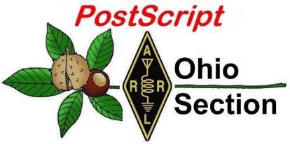
December 10th
Edition

National News The Handbook Give Away

Club Corner Hamfests

DX This Week One Question Questionnaire

VE Testing Schedule Final.. Final..

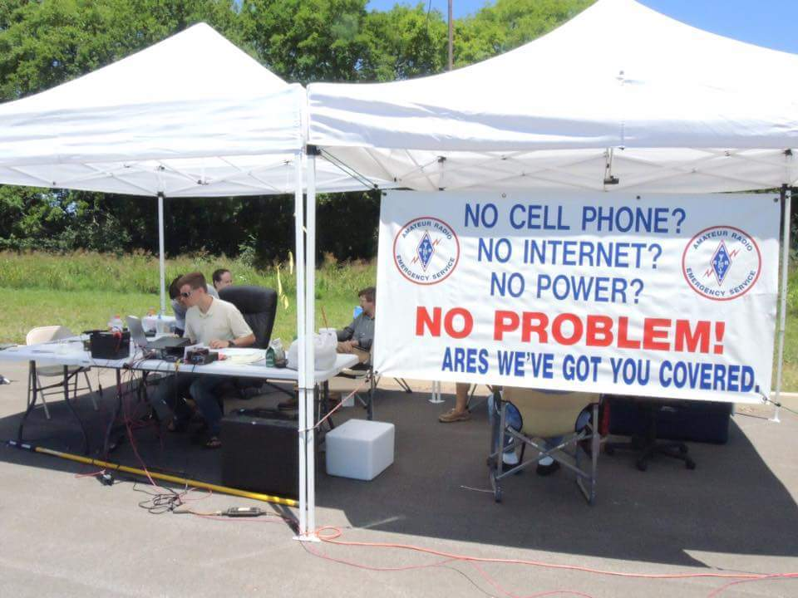
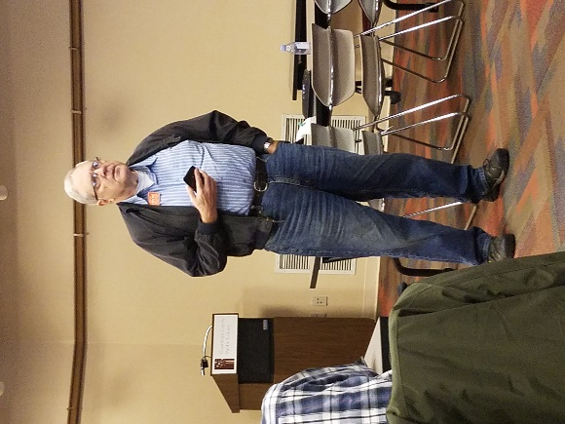
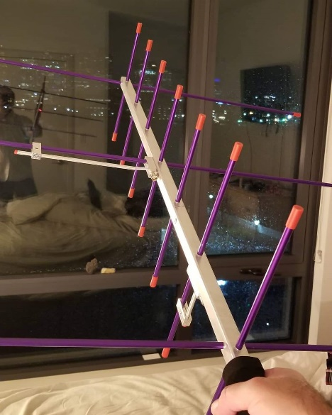
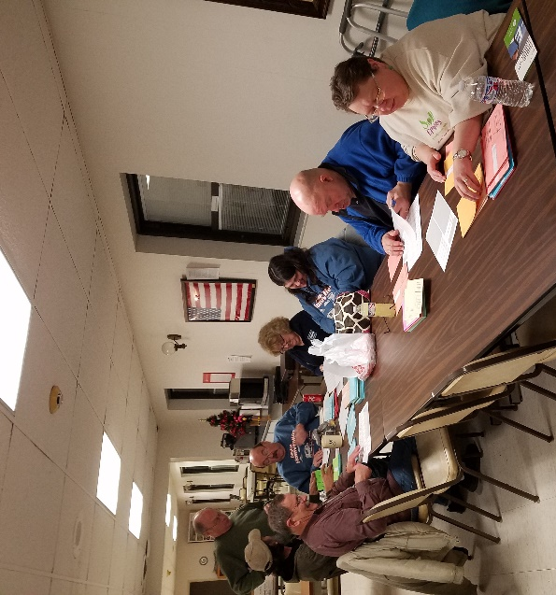
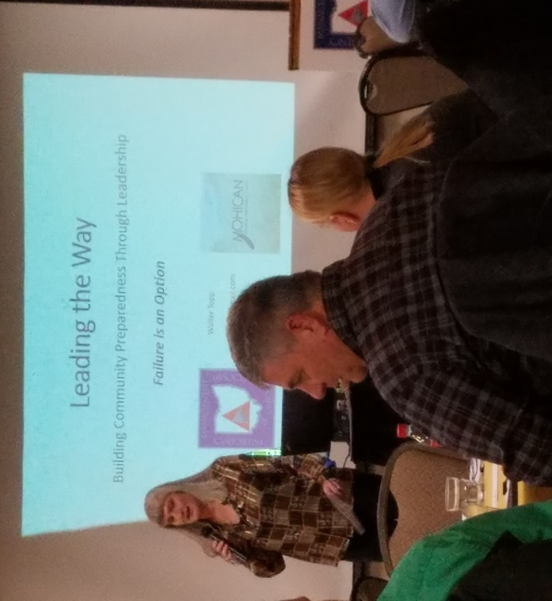

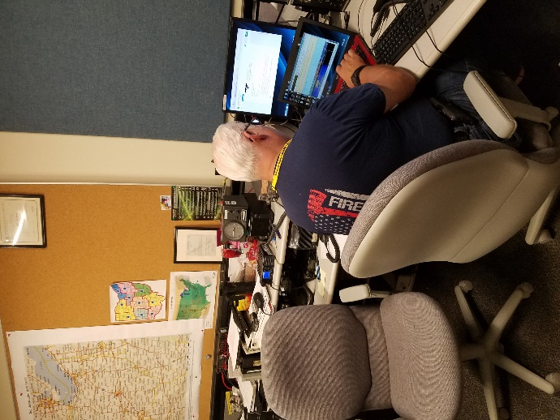

National News
(from arrl and other sources)

AMSAT's Fox-1Cliff Amateur Radio CubeSat Launched Successfully
[UPDATED: 2018-12-04 @ 1320 UTC] SpaceX has announced that the SSO-A: SmallSat Express mission carrying AMSAT’s Fox-1Cliff CubeSat has been deployed into orbit. A SpaceX Falcon 9 vehicle carried Fox-1Cliff and several other satellites into space on December 3 at approximately 1334 UTC from Vandenberg Air Force Base in California, following a 1-day launch delay. (See the launch on YouTube.) According to AMSAT, at approximately 0030 UTC on December 4, several stations in Brazil — including PS8MT, PT9BM, and PT2AP — reported hearing the voice beacon “Fox-1Cliff Safe Mode,” confirming that the satellite was alive.
“Just before 0040 UTC, AMSAT Fox-1 Team Member Burns Fisher, WB1FJ, was the first to submit and upload telemetry to the AMSAT servers,” AMSAT reportedon its website. “Initial telemetry values show the satellite to be in good health. Thanks to the 29 stations that contributed telemetry during Fox-1Cliff’s initial orbits.”

The Fox-1Cliff downlink for FM voice and data-under-voice (DUV) is 145.920 MHz. Uplinks are 435.300 and 1267.300 MHz.

In addition to Fox-1Cliff, the SSO-A mission carried several other Amateur Radio satellites, including FUNcube on ESEO, JY1-SAT, K2SAT, and ExseedSat. The reusable Falcon 9 vehicle launched 64 payloads in all.

Fox-1Cliff carries the Fox-1 U/v FM repeater, AMSAT’s L-Band Downshifter, the flight spare of the AO-85 Vanderbilt University Low Energy Proton (LEP) radiation experiment, and the standard Fox-1 Penn State University-Erie MEMS gyroscope experiment. Virginia Tech provided a video graphics array camera that’s similar to the one on AO-92 but which will provide images at a higher 640 × 480 resolution.

Fox-1Cliff is named in honor of long-time AMSAT member, contributor, and benefactor Cliff Buttschardt, K7RR (SK), who died in 2006. His contributions to AMSAT and other Amateur Satellite programs — including his service as an adviser during the initial development of the CubeSat specification at California Polytechnic State University — earned him the Lifetime Achievement Award from Project OSCAR in 2006.

AMSAT is asking Amateur Radio satellite enthusiasts to listen for Fox-1Cliff’s telemetry for the initial 72 – 96 hours as on-orbit checkout gets under way.

“If you are capturing telemetry with FoxTelem, please be sure that “Upload to Server” is checked in your settings and your Ground Station Params are filled in as well,” AMSAT said in advance of the launch. In the initial Safe Mode or Beacon Mode after startup, the transmitter is limited to 10 seconds on time followed by a 2-minute off cycle. “You will hear Veronica announcing ‘Fox-1Cliff Safe Mode,’ while in Beacon Mode,” AMSAT said, noting that the on-orbit check-out procedure will be similar to Fox-1D and could be completed in as few as 7 days.

TOP ^
“It is very important, not to mention just plain good Amateur operating practice, to refrain from using the transponder uplink, so we can do the on orbit tests, including when we turn on transponder mode for testing,” AMSAT said. “AMSAT will make it broadly known when the tests are complete and the transponder is available for all to use.” — Thanks to SpaceX and AMSAT Vice President-Engineering Jerry Buxton, N0JY

####

FCC Tells LED Sign Marketers to Abide by Statutes and Rules

The FCC Enforcement Bureau has called on marketers of light-emitting diode (LED) signs to ensure that these lights comply with FCC rules. Since March of this year, the agency has entered into 21 settlement agreements with companies that marketed noncompliant LED signs in violation of the Communications Act and FCC rules. The settlements yielded approximately $850,000 in penalties, and commitments to ensure compliance with the law going forward. Adherence to the FCC’s equipment authorization and marketing rules is critical because radio frequency emissions from the signs may cause harmful interference to licensed communications, such as wireless services, the FCC said.

“In light of these recent settlements, we remind LED sign marketers of their obligations under the law,” said Enforcement Bureau Chief Rosemary Harold. “The FCC takes seriously its responsibility in ensuring that energy-emitting devices like LED lights do not interfere with authorized transmissions.”

LED lights are often used in digital billboards and other commercial and industrial applications, including billboards and large video displays in sports arenas. Given the electrical design of these lights, they may emit RF energy. Prior to being marketed in the US, LED sign models must be tested and comply with FCC technical standards and must include the proper labeling, identification, and user information disclosures. The FCC Office of Engineering and Technology (OET) oversees the equipment authorization process for RF devices, including LED signs.

The Enforcement Bureau investigated hundreds of indoor and outdoor LED sign models and discovered repeated FCC rule violations concerning the failure to market the models with the required equipment authorizations, labeling, and user information disclosures. To settle its respective investigation, each company verified that the models at issue were brought into compliance with FCC rules, agreed to pay a monetary penalty, and committed to abide by a compliance plan to improve internal procedures to avoid future violations.
The Bureau has settled 21 investigations to date, with penalties as high as $115,000. Each settlement is available on the FCC Enforcement Bureau home page.

####

Canadian National Parks on the Air Event Set to Start on January 1

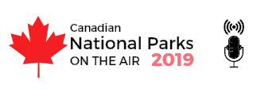
The Canadian National Parks on the Air event (CNPOTA) will get under way on January 1 and continue until year’s end. A volunteer group of a half-dozen hams in Nova Scotia, working with a zero budget, came up with the notion of attempting to replicate the success of the National Parks on the Air (NPOTA) event in 2016, first created to mark the centennial of the National Park Service.
TOP ^
Radio Amateurs of Canada (RAC) has announced its support for CNPOTA, in cooperation with Parks Canada. All radio amateurs are invited to activate any of Park Canada’s 48 national parks and 171 national historic sites, while “chasers” attempt to land a contact.

Activity for activators and chasers will be tracked on a dedicated website and a real-time leader board, and operators may compete for online awards and certificates. For updates on the program’s progress, visit the CNPOTA website.

The Handbook Give Away
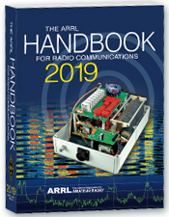
Hey Gang,

It’s Christmas… and I’m going to be Santa and give some Christmas Gifts to you!
Go to: http://arrl-ohio.org/handbook-christmas.html and get registered NOW.

What’s the catch? I want to get everyone checking in to the Ohio Section website as often as possible, and in order to register each month, you have to visit the website often! There’s nothing else to it. I pay all expenses, and from time to time, I Give Away more than just a Handbook. And, you’ll never know just what months will be those special times that I will have more than just a Handbook to Give Away!!

Many of you ask me just how do I know when the drawing is on? Well, that’s easy all you need to do is check in on the Ohio Section Website on a regular basis and watch for the big RED Arrow that will appear on the left side of the page. This is the sign that the drawing is on and you need to get registered. So, keep a sharp eye out on the website and check in often! http://arrl-ohio.org/

One Question Questionnaire

Hey Gang
I do want to apologize to those dedicated folks that always seem to be able to give me their votes to our One Question Questionnaire every week.

We’ve had a software update performed on our website server and this portion of the website just doesn’t seem to like the idea of being updated.

I’ve been working with the folks that I contract to be our website host server to possibly get this up and working again. But unfortunately, it seems that we have a glitch in the PHP software program that we use for the Questionnaire and it’s just not going to come back up and run. I guess that shows me just how old that part of the website really was.

Anyway, we’ll be bringing it back sometime in the near future. But, for now we will just have to suspend any new questions until we can get it back.

Sorry about that.. But as they say… “Things Happen….”

TOP ^

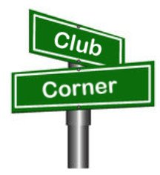
Club Corner

This is YOUR cornner of the newsletter. Send me what your club is doing and I’ll make sure that it gets in. Got a special event or club project that you want everyone to know about? Send it to me!. Need help with a project? Send it to me.

Let me know what you club is up to. Are you going to have a special guest at your meeting or are you having a special anniversary? Just sent it to:
n8sy@n8sy.com

#########
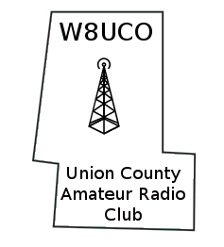

Union County ARC Elects New Officers

The 2019 Union County Amateur Radio Club Officers / Executive Committee members are as follows:

President - Arnal, N9ACC; Vice President - Dennis, W8ILD; Treasurer - Frank, KD8UFE; Secretary - Ed, KE8ANU and Exective Officer - Joe, K8JWL
Congrats to all of the new incoming Officers.

#########

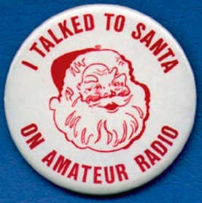
Kids Talk To Santa

If you are interested in helping your area kids talk to Santa via Amateur Radio, here’s a great link for you… http://www.hdscs.org/npn/npn01arrl.html

#########

Stark County ARES Holding ICS Training

The Stark County ARES in conjunction with the Stark County EMA Office will again be sponsoring FEMA ICS Training. The training will be on December 19th and we'll start at 5:30 PM and hopefully finish by 7:30.
Training this month will be for the ICS-700 certification, "An Introduction to the National Incident Management System". There are no prerequisites. The location is at the County EMA office on Route 62 lower level. There is no cost for the training.

TOP ^
Bring your FEMA student ID number so you can take the exam at completion. Laptops will be available, or you may use a smartphone to take the test.

Please reply to this notice if you are planning to attend the December 19 ICS-700 class, or email dlamm@whbc.com Steve would like a headcount beforehand.

#########

MVARA Holds Talk To Santa Night

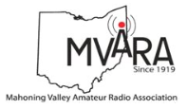
The Mahoning Valley Amateur Radio Assn. in conjunction with Akron Children’s Hospital, Boardman Campus will be hosting the annual Santa Claus Net on Wednesday December 19th at 7:00 PM on the 146.745 repeater. For those who are new, MVARA members take 2-meter radios into Akron Children’s Hospital and let the kids talk to Santa over the air.

We need operators for this event, but you must register with the Hospital & complete an online training program.

Please contact me at: w8ysu@arrl.net and I will put you in touch with the Hospital contact person. We would love to have you, your children, grandchildren, neighbors or anybody that wants to talk to Santa also check-in.

#########

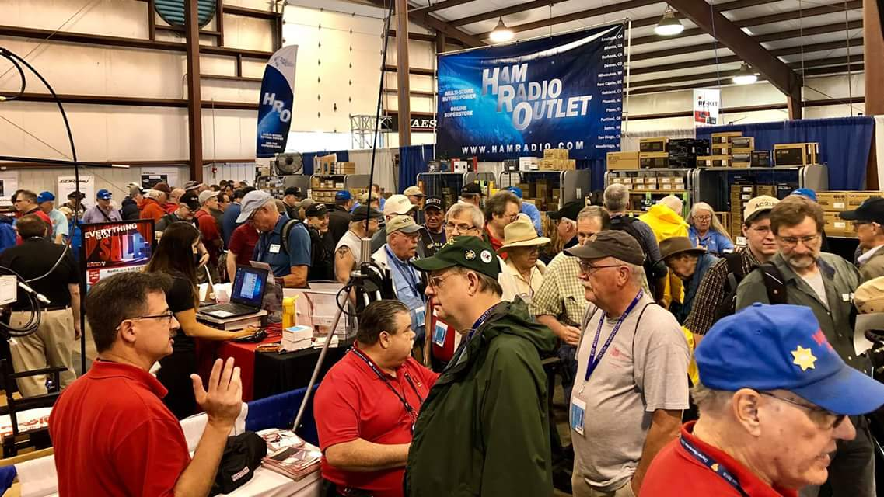
Upcoming Hamfests

There are none left in Ohio for 2018. So, with that said we are now listing the hamfests for 2019.

We had an absolutely fantastic year and ended it with a grand total of 32 Ohio hamfests! Wow… This just might be a record setting year as that I don’t remember ever having this many hamfests to attend in a year. Now, just how many of these did you attend?

01/20/2019 | S.C.A.R.F. Hamfest  Location: Nelsonville , OH  Sponsor: Sunday Creek Amateur Radio Federation  Website: http://www.qrz.com/db/kc8aav | 01/27/2019 | TUSCO ARC Hamfest, Electronics & Computer Show  Location: Strasburg, OH  Sponsor: Tusco Amateur Radio Club  Website: http://tuscoarc.org
02/17/2019 | InterCity ARC Hamfest  Location: Mansfield, OH  Sponsor: InterCity Amateur Radio Club  Website: http://www.w8we.org | 03/03/2019 | WINTER HAMFEST  Location: Elyria, OH  Sponsor: Northern Ohio Amateur Radio Society  Website: http://www.noars.net/hamfests/noarsfest

TOP ^

V.E. Test Sessions
(from arrl)

12/15/2018 | East Liverpool OH 43920-9486  Sponsor: Triangle ARC  Location: Glenmoore Volunteer Fire Station  Time: 1:00 PM (Walk-ins allowed)  Learn More | 12/15/2018 | Springfield OH 45506-1607  Sponsor: CLARA  Location: Main Branch  Time: 11:30 AM (Walk-ins allowed)  Learn More
12/16/2018 | Elyria OH 44035-1343  Sponsor: American Red Cross  Location: American Red Cross  Time: 12:50 PM (Walk-ins allowed)  Learn More | 12/18/2018 | Sandusky OH 44870-1926  Sponsor: Sandusky, Ohio VE Team  Location: Sandusky Radio Club  Time: 7:00 PM (Walk-ins allowed)  Learn More
12/31/2018 | Dayton OH 45434-6416  Sponsor: DARA  Location: Beavercreek High School  Time: 5:00 PM (Walk-ins allowed)  Learn More | 01/08/2019 | Lancaster OH 43130-3014  Sponsor: Lancaster & Fairfield Cnty ARC  Location: American Red Cross  Time: 7:00 PM (Walk-ins allowed)  Learn More
01/10/2019 | Cuyahoga Falls OH 44221-3205  Sponsor: Cuyahoga Falls ARC  Location: Cuyahoga Falls Library  Time: 6:30 PM (Walk-ins allowed)  Learn More | 01/10/2019 | Milford OH 45150-1427  Sponsor: Milford ARC  Location: Faith Church  Time: 6:00 PM (Walk-ins allowed)  Learn More
01/12/2019 | Delaware OH 43015-8533  Sponsor: Delaware ARA  Location: American Red Cross  Time: 10:00 AM (No Walk-ins / Call ahead)  Learn More | 01/12/2019 | Maumee OH 43537-1628  Sponsor: Toledo Mobile Radio Assoc  Location: Maumee Fire Station #2  Time: 8:15 AM (No Walk-ins / Call ahead)  Learn More
01/13/2019 | Independence OH 44131-4841  Sponsor: Cuyahoga ARS  Location: Old Elmwood Recreation Center  Time: 9:00 AM (Walk-ins allowed)  Learn More | 01/15/2019 | Sandusky OH 44870-1926  Sponsor: Sandusky, Ohio VE Team  Location: Sandusky Radio Club  Time: 7:00 PM (Walk-ins allowed)  Learn More

Special Events

- 02/16/2019 | MVARA 100th Anniversary
Feb 16-Feb 18, 2300Z-2300Z, W8QLY, Youngstown, OH. Mahoning Valley Amateur Radio Association. 14.220 7.220 3.922.

TOP ^
Certificate & QSL. MVARA, 125 W McKinley Way, P.O. Box 14141, Youngstown, OH 44512. https://goo.gl/forms/2uNZfO6zRx1YPoWw2 to request your certificate/qsl. www.qrz.com/db/w8qly or www.mvara.org

- 06/15/2019 | W8DXCC DX Convention
Jun 15-Jun 16, 0000Z-2359Z, K8S, Owensville, OH. SouthWest OH DX Association. 14.245 14.074 7.245 3.535. Certificate & QSL. AJ8B - Bill, 8275 Cierra Way, Waynesville, OH 45068. This is the inaugural year for this DX Convention. We are using these call signs: K8S, K8W, K8O, K8H. A QSL for each and/or certificate for working all four. www.w8dxcc.com

ARRL Contest Corner
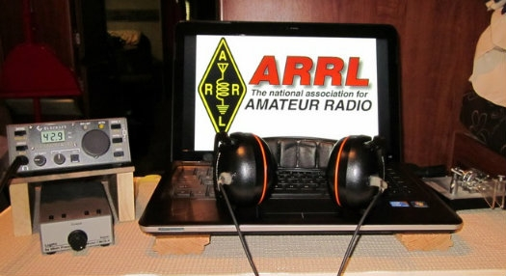

An expanded, downloadable version of QST's Contest Corral is available as a PDF. Check the sponsor's Web site for information on operating time restrictions and other instructions.

HF CONTESTS

December 10  - 4 States QRP Group Second Sunday Sprint | December 12  - NAQCC CW Sprint  - QRP Fox Hunt  - Phone Fray  - CWops Mini-CWT Test

#########

December is Youngsters on the Air (YOTA) Month
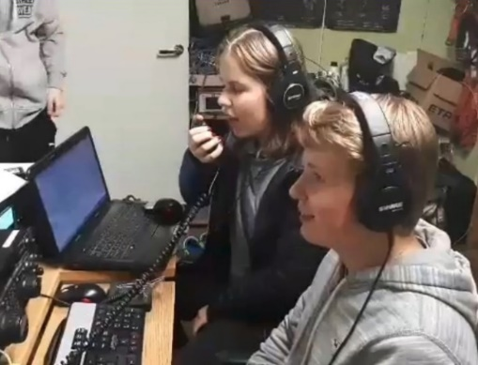
December is Youngsters on the Air Month (YOTA Month). Listen for stations on the air with YOTA as the call sign suffix.

“The idea for this is to show the Amateur Radio hobby to young people and to encourage youngsters to be active on the amateur bands,” said Tomi Varro, HA9T.

“This is a great moment to show Amateur Radio to the world and to invite newcomers.” YOTA is primarily an International Amateur Radio Union (IARU) Region 1 (Europe and Africa) activity, but youngsters from the US in Region 2 (the Americas) have attended YOTA summer camps, which are held in a different country each year. Varro said both licensed and unlicensed youth will be making contacts. “Be helpful on the bands — maybe these young operators are just making their first ever contacts,” he advised.

TOP ^
YOTA stations are, in general, operated by individuals 25 or younger. The operating event takes place for the entire month of December UTC. As part of YOTA month, Bob Johnson, W9XY, and Ken Claerbout, K4ZW, will travel to Ethiopia to team up with the club at the Addis Ababa University, Institute of Technology and club station ET3AA. For more updates, visit YOTA’s Facebook page.

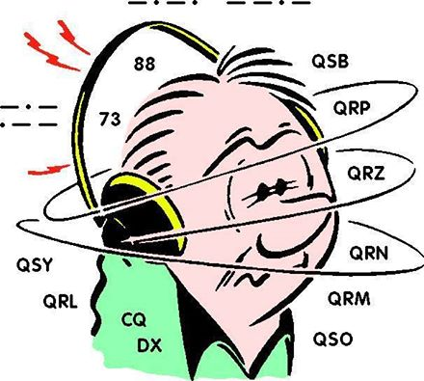
DX This Week – DX CW
Bill AJ8B (aj8b@arrl.net, @AJ8B, www.aj8b.com or www.swodxa.org )

My elmer (and OM), K8DWE, convinced me early on that the only person that I had to compete with on the bands was myself! I would never have the biggest station, best antennas, most power, etc. so I had to set goals for myself. During my career at HP, I learned about stretch goals. Most people set goals for themselves, but, their either forget about them or make them to easy to attain. I was involved in the delivery of Stephen Coveys “7 Habits of Highly Effective People” while at HP. Covey taught that your goals must be in line with the principles in which you live your life. Additionally, you must revisit your goals frequently and set up procedures and practices that support your goals. What does all of this have to do with DX? I took these teachings to heart years ago and set several short term and long term goals. I review them annually and then monthly. I keep an eye out for things that can help me achieve these goals and implement those things when I can. For instance, my two long term goals are achieving DXCC Honor Roll and exceeding 2,000 on the ARRL DXCC Challenge roster. My short-term goal is to exceed my previous years’ score in the annual CQ Marathon. If I can exceed my annual goal and keep an eye on my longer-term goals, I can achieve them all.

What are your goals for 2019? I thought this would be a great topic for this edition as we are getting close to the end of the year and still have time to research and make station changes if needed. If you don’t have any goals, but like to chase DX, I would ask you to consider chasing the CQ Marathon award. One of the great things about the award is that confirmations are not required. However, you need to be honest as they can check: “QSLs are not required. The operator is expected to claim contacts only from stations the operator has every reason to believe are legitimate, and only to claim contacts in which an accurate two-way exchange was clearly accomplished (see Appendix for further explanation). Scores will be adjusted by the DX Marathon committee for claimed contacts with pirates or any station not considered legitimate. Submissions may be penalized or voided in cases of fraud or poor sportsmanship. Every QSO may be subject to verification by the DX Marathon Manager. Decisions of the DX Marathon Manager are final.”

The following information is from the CQ Marathon website (http://www.dxmarathon.com/) :

Starting January 1 of each year, the DX Marathon is the perfect answer for the DXer who needs that extra incentive to get on the air every day! Simply work as many countries and CQ Zones as you can in each calendar year, regardless of the band or mode. Each country and zone counts only once, so you can concentrate on working new ones rather than working the same ones on multiple bands and modes. Many awards are given for the top overall scores in four classes plus top scores in modes, bands, US call areas and more!
Each year there are pirates, operations that are not approved, callsigns that are copied incorrectly and unusual operations that are valid. We attempt to document as many of these operations as possible - see the lists of valid callsigns, invalid callsigns, and callsign notes. We encourage you to share your findings on pirates, illegal operations or confusing callsigns with us. Please send your callsign updates to the DX Marathon administrator at: k9el@dxmarathon.com

TOP ^
Many points are lost each year due to bad spots on the packet cluster network. We have assembled an extensive list of bad spots - please check the list before entering any of these callsigns!
Please check USA/VE zones carefully - use www.qrz.com to check zones before submitting. The number in the callsign does not necessarily match the location. Did you know that West Virginia (W8) is in Zone 5? and that Alabama (W4) is in Zone 4? Check Zone 2 submissions carefully.
When a prefix can count for more than country (e.g. E51) double check your entry. Although you can use the same QSO for a country and a Zone, if there is an error, two points will be lost! We suggest using a different QSO for country and zone. Review your submission carefully and make sure your logging program country database is up to date.
This list of separate countries (entities) for the CQ World Wide DX Contest and the CQ DX Marathon is based on a combination of the ARRL DXCC list, additional entities on the WAE (Worked All Europe) list and the Italian islands of Lampedusa (IG9) & Pantelleria (IH9), in CQ Zone 33 off the coast of North Africa. This provides a total of 346 entities, based on 340 DXCC entities, six additional WAE entities (GM/Shetland, IT/Sicily, TA1/European Turkey, 4U1VIC, JW/Bear Is.) plus African Italy.
Total CQ Countries: 346 (This list last updated February 11, 2018)

This gives you a reason to work Canada, England, France, Spain etc. again in 2019! It is a clean slate and you can start all over to better your score from the previous year. I have been able to increase my score each year, even with sunspots declining. As propagation started to fail, I had to get something up for 80M. The past year, I had to add FT8 to my set of tools. I am 10 countries away from my all time high, so, wish me luck!
There is an excellent book that details one man’s chase to win the Marathon. That book, A Year of DX, by Bob, W9KNI, is an excellent read whether you will be chasing countries for the Marathon or not. He has some excellent tips on using Gray line, propagation, and breaking pileups. I have read it 3 times and learn something every time. (Great stocking stuffer)
If you are going to participate in the CQ Marathon, please let me know and let me know what your ongoing count is. I can publish here to add some spice to the challenge.

I can’t close this segment without some Kudos to Gary, W8PU. I receive the “Monday Morning Memo”, published by John, W8KIW. (You SHOULD subscribe to this weekly email by sending a note to highlandara@yahoo.com)

From the Monday Morning Memo:
DX SURPRISE—One October morning Gary Poland, W8PU, was tuning across 20-meter CW and heard a CQ with no one responding to the call. So, Gary gave him a call and completed a contact. Only later did he learn that station’s location is number 20 on the DX list’s most desired “countries”. Gary thought it to be a routine contact with Greece but only later did he realize he had just contacted who might be the only ham on the Greek island of Mt. Athos.

Gary had just worked the sought-after Monk Apollo, SV2ASP/2. What’s more—he now has the QSL card to prove it. If you have a chance, read about the womanless island of Mt. Athos and how once Monk Apollo becomes a silent key, the island may never allow amateur radio again. Congrats to Gary!

TOP ^
From our friend at the DailyDX and the WeeklyDX, (http://www.dailydx.com/ ) Bernie has this to report:
- 3Y - Bouvet – The 3Y0I team does another training session this week and is
collecting some more gear to use on the island. They are looking to
add two additional operators to do CW and SSB. They say if you're
flexible in your operating and have experience with weather challenges
and willing to join them for a month, "the adventure of your life
time," email them right away at k38dom@gmail.com.
- J6 - St. Lucia - J69Z, Ernest plans a week-long special activity in memory of K3LP/SK, David Collingham. Ernest will be on January 1-7, signing J69Z/K3LP
and will have a special QSL card. Ernest says he became close friends
with Dave and XYL Rebecca and the friendship impacted his life. He
plans to do this on-air tribute every year and plans to use a favorite
photo from Dave's visits, on the QSL. Ernest likes to operate
portable, including from the beach. W3MMM, Jay, says Ernest is
virtually "the voice of St. Lucia." .
- FY - French Guiana - F5DKO, Bruno, is back in F.G. with the callsign FY/F5DKO. He used to be FY8DK. His current visit goes to December 14.

A more detailed calendar can be found at http://www.dailydx.com/the-daily-dx-calendar/

More info can be found at www.swodxa.org or www.aj8b.com

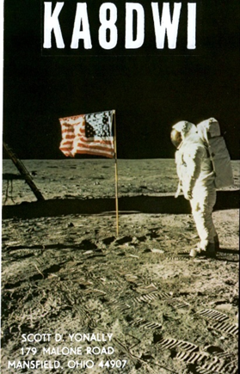
ARLD050 DX Bulletin

This week's bulletin was made possible with information provided by W9JJ, The Daily DX, the OPDX Bulletin, 425 DX News, DXNL, Contest Corral from QST and the ARRL Contest Calendar and WA7BNM web sites.
Thanks to all.

MONTENEGRO, 4O. Station 4O18YOTA is QRV during December as part of YOTA, or Youth On The Air. The idea behind YOTA is to showcase amateur radio to the youth and to encourage them to be active on the air. QSL via OQRS.

CYPRUS, 5B. Special event station C4XMAS is QRV during the festive season throughout the month of December. Activity will be on 160 to
6 meters using CW, SSB and various digital modes. QSL via IZ4AMS.

SENEGAL, 6W. A group of operators are QRV as 6V1A from Goree Island, IOTA AF-045, until December 9. Activity is on various HF bands using CW and SSB with two stations. QSL via 6W1QL.

THE GAMBIA, C5. Andre, ON7YK is QRV as C5YK until March 9, 2019.
Activity is on 60 to 10 meters using FT8, with some CW and SSB. QSL to home call after March 15, 2019.

BOSNIA-HERZEGOVINA, E7. Station E71YOTA is QRV during December as part of YOTA. QSL via OQRS.

TOP ^
SPAIN, EA. Members of the Amateur Radio Union Malaga are QRV with special event call EH40CE until December 12 to commemorate the enactment of the Constitution of Spain 40 years ago. QSL via EA7URM.

ESTONIA, ES. Station ES9YOTA is QRV during December as part of YOTA. QSL via OQRS.

ETHIOPIA, ET. Members of the Ethiopian Amateur Radio Society are QRV as ET3YOTA during December as part of YOTA. QSL via N2OO.

FRENCH POLYNESIA, FO. Operators Cezar, VE3LYC and Adrian, KO8SCA are QRV as TX0A from Maria Est Atoll, IOTA OC-113, and as TX0M from Morane Atoll, IOTA OC-297P, until December 18. Activity is on 40 to
10 meters using CW and SSB. QSL via VE3LYC.

DOMINICAN REPUBLIC, HI. Peter, DD1GG is QRV as DD1GG/HI until December 14. Activity is holiday style on various HF bands. QSL to home call.

HONDURAS, HR. Tom, N9EAW is QRV as HQ9T from Roatan Island, IOTA NA-057, until December 18. Activity is holiday style on the HF bands using slow CW and SSB. QSL direct to home call.

AUSTRIA, OE. Members of the United Nations Amateur Radio DX Contest Club are QRV as 4Y1A until December 11 for International Civil Aviation Day. QSL via UA3DX.

DENMARK, OZ. Volker, DJ8VW will be QRV as 5P8VW/p from Aabenraa from December 8 to 19. Activity will be on 160 to 6 meters using CW, SSB and FT8. QSL to home call.

ARUBA, P4. Ben, DL6RAI is QRV as P4/DL6RAI until December 27.
Activity is holiday style on the low bands, with some activity in various contests. QSL via LoTW.

CURACAO, PJ2. Anders, SM4KYN will be QRV as PJ2/SM4KYN from December 10 to January 14. Activity is on the HF bands. This includes being active as PJ2T in the ARRL 10-Meter contest. QSL direct to home call, and PJ2T via W3HNK.

EAST KIRIBATI, T32. Nobu, JA0JHQ is QRV as T32NH until December 11.
Activity is on 160 to 6 meters using CW and FT8. This includes being active in the ARRL 10-Meter contest. QSL direct to home call.

MACEDONIA, Z3. Look for stations Z30YOTA and Z39YOTA to be QRV during December as part of YOTA. QSL via OQRS.

KOSOVO, Z6. Look for Z60YOTA to be QRV during December as part of YOTA. QSL via OQRS.

THIS WEEKEND ON THE RADIO. The ARRL 10-Meter Contest, NCCC RTTY Sprint, QRP 80-Meter CW Fox Hunt, NCCC CW Sprint, PODXS 070 Club Triple Play Low Band Sprint, TRC Digi Contest, SKCC Weekend CW Sprintathon, International Naval Contest, QRP ARCI Holiday Spirits Homebrew Sprint and the CQC Great Colorado Snowshoe Run are all on tap for this upcoming weekend. The 4 States QRP Group Second Sunday Sprint is scheduled for December 10.

The CWops Mini-CWT Test, QRP 40-Meter CW Fox Hunt, Phone Fray and NAQCC CW Sprint are scheduled for December 12.

TOP ^
Youth On The Air runs during all of December.

The ARRL International Grid Chase runs during all of 2018.

Please see December QST, page 70, and the ARRL and WA7BNM Contest Web Sites for details.

You’ve Got Cards – Waiting

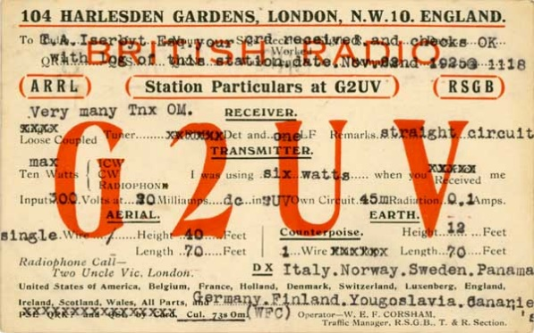
Hey Gang, here’s a new department for you to keep an eye on. Yes, it’s about QSL Cards without owners. Why without owners? The card sorters have the cards waiting, but they don’t have a way to get these cards to their owners.

Now, if your call sign is listed here, or you know how to contact any of the folks listed, please let them know that they have QSL cards waiting for them, and that they will need to contact the appropriate card sorter to find out how to get their cards sent to them.

Don’t send anything to them until you’ve had a chance to contact them first and find out just what you need to do.

Here’s some folks from the"8V' call signs that have cards waiting…

AK8V, KG8V, KR8V, KU8V, NA8V, NC8V, NV8V, NW8V, W8VCI, KB8VCV, KE8VC, N8VFJ, W8VHO, W8VI, AA8VL, WD8VN, W8VRT, WB8VWO, N8VW, N8VY, W8VKO, WA8VA

If you know any of these folks be sure to let them know that they have cards waiting for them. Contact Glenn, AF8C, 8th area bureau "8V' letter manager at: af8c@alumni.caltech.edu

Don’t know who to contact for your cards? Here’s a link…
http://arrl-greatlakes.org/8th_bureau.htm Remember, it goes by your first letter of your suffix call sign.

The card sorters would also like me to remind everyone that this is the “Incoming” QSL Card Bureau. ALL “Outgoing” cards (cards that you send) go to the main card sorting area at ARRL Headquarters. Here’s a link for the details on how to do that… http://www.arrl.org/outgoing-qsl-service

NIST Releases Free LTE Coverage App, SDK
(info provided by from Greg, WD9FTZ)

The National Institute of Standards and Technology (NIST) Public Safety Communications Research (PSCR) division, with funding from the Department of Homeland Security Science & Technology Directorate (DHS S&T), developed a Long Term Evolution (LTE) coverage application. Its purpose is to enable
public-safety personnel to measure general LTE coverage quality using a standard smartphone.

TOP ^
The source code was published as a software development kit (SDK) to allow developers to enhance the application or use it in other applications. The LTE Coverage Tool application and SDK enable first responders and public-safety personnel to survey and evaluate coverage by LTE networks in environments where incidents are ongoing or planned.

While accuracy of the data from user equipment (UE) measurements is much lower than that of specialized equipment, the application provides subjective assessments of coverage quality, using UEs that are already available to agencies and personnel.

Release of the software application and SDK is the culmination of several years of research efforts under the In-Building Coverage Quality Measurement Tool project, conducted by NIST PSCR and the National Telecommunications and Information Administration (NTIA) Institute for Telecommunication Sciences (ITS).

The goal of that project was to determine whether a UE, such as an LTE phone, experimental application could reliably assess LTE coverage. The final report, which will be released by NTIA ITS in late 2018, determined that "non-experts could quickly master the operation of this system and obtain results that are statistically equivalent to expert propagation measurement engineers."

DHS S&T instructed NIST PSCR to release the software to allow first responders to access and use the application, and external developers to use the source code as a base for further development.

https://play.google.com/store/apps/details?id=gov.nist.oism.asd.ltecoveragetool

End of Service for Weather Underground API - Weather Stations
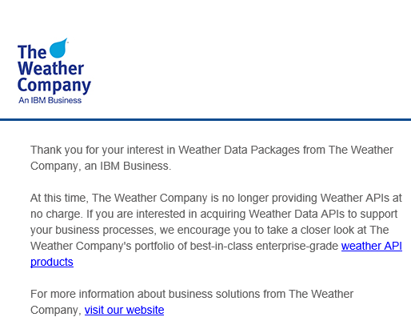
There is a very important change coming to the Weather Underground (WU) API. Here’s what it means to you and me.

Weather Underground made the difficult decision to retire the Weather Underground API. The Weather Company, which acquired WU back in 2012, is offering a powerful suite of enterprise-grade APIs that might be better suited to meet our needs while offering a broader range of weather data. You can see these products here. Unfortunately, these changes seem to be geared specifically to companies that are willing to pay of these services. So far there doesn’t seem to be anything in the works for the person that only wants to use this system for free.

TOP ^
The changes are expected to happen at the end of this year (2018).

The Ohio Section will continue to list all the weather stations around as we have in the past until they no longer work.

As that there have been no announcements yet for those of us providing weather information and if we will continue to get to provide that valuable service to our communities, we will wait patiently to see what Weather Underground will propose.

Here’s a link to all of our known weather stations around Ohio… http://arrl-ohio.org/wus.html

New Code Plug Editor Released for TYT Radios

The latest Code Plug editors has been recently released. I have downloaded it and played with it some and I find it a breath of fresh air. This is the newest version is so much easier to use and manipulate the data with. It has a lot of features that I haven’t even started to play with yet but look pretty easy to do.

Here’s a link to it… -http://miklor.com/DMR/DMR-380-CPEditor.php

It’s setup to be able to read and write to the following TYT models

MD-380 MD-390
UV380 UV390
MD9600 MD2017
(Standard and GPS)

So, as you can see, the writers of these editors are starting to see that they have to be able to have a reader/writer that will go across multiple radios, and I really like this one.

ARES Connect

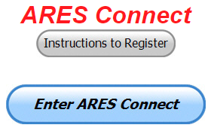
CQ… CQ…. CQ… Calling all persons to be a part of the new ARES Connect program.

We need to discuss some very important items that only YOU can make a difference with. I need you to get yourselves registered in ARES Connect, that is… if you haven’t already. Now, how do I know that you need to do this? It’s simple, we have a little over 700 now registered in the database. Stan’s last S.E.C. report shows that we have a little over 1,500 persons in ARES.

That means that there is still a lot of you that haven’t taken the plunge yet and need to! What are you waiting for? No matter how much you resist, it’s coming, and we need to make sure that no one is left behind.

Now, as an incentive to get you to not only register…. But to actually start using the system… (Notice how I have that in bold type for you to clearly see?) I am giving away all sorts of goodies to help you get motivated.

TOP ^
I have a footlocker of really cool items that I will be giving away! Oh, if you didn’t know, I’ve already given away an ARRL Handbook! What’s next? Who knows!! There’s lots more of things to choose from for sure and I’m not stingy about giving things out! But, to get any of these goodies you have to get registered and actually start using the system. Just like the folks below have done.

Here’s how it looks for November / December:

 | Name | Events | Hours
1 | James Yoder (w8erw) | 14 | 70.50
2 | Ron Hollas (K8RJH) | 3 | 59.75
3 | James Hershberger (KE8ERN) | 21 | 53.00
4 | John Westerkamp (W8LRJ) | 48 | 39.75
5 | Carl Gedeon (KB8VXE) | 9 | 38.00
6 | Steven Tarbert (KC8ZKC) | 4 | 37.00
7 | John Rawson (KE8HUV) | 35 | 33.50
8 | Christopher Domenick (KC8CAD) | 28 | 33.25
9 | Lowell Kern (kd8kxd) | 9 | 31.50
10 | Mathew Nickoson (KC8NZJ) | 7 | 26.25

Don’t know where to get started? We have a set of instructions on how to get registered right above the button to enter ARES Connect. I would strongly suggest that if you haven’t registered yet, that you read these instructions first. Here’s a link to get you started... http://arrl-ohio.org/ares_connect_directions.pdf

Please, don’t just hurry through the questions, read them carefully, if you don’t understand something, please ask me, I’m here to answer your questions.

We know that you mean well by answering that you do have the needed courses in, but I will let you know that we are verifying what you say you have with what is showing for you in our statewide database when we are completing your registration. So, how can you find out if you are already listed in our statewide database? Easy, here’s a link: http://arrl-ohio.org/SEC/special/ICS%20Complete%20by%20County%20and%20Name.pdf

HEY..!!!! We need persons that can input events and approve hours into the new ARES Connect system. You do not have to be an E.C. for this, although we’d prefer that they would be willing to step up to that challenge someday. If we could just have some folks willing to do the inputting of events and approve hours for now I’d be eternally grateful. Counties where this is only a RACES program in place. Please.. this is a great opportunity for you as that we will not interfere with any of the programs that you already have in place. In fact, it will help you in getting those valuable volunteer hours recorded as they have never been before!!!

How’s about it? Could you spend a little time just working with ARES Connect? Let me know!!! Again, you do not have to be E.C.’s to do this work in ARES Connect.

We can give you admin privileges so that you can help with logging events into the system, keeping track of hours or even making sure that certificates get to Jim or I for placement into the statewide database.

Here are the counties that we really need help with. Allen, Fulton, Henry, Mercer, Paulding, Putnam, Logan, Adams, Brown, Clermont, Carroll, Athens, Jackson, Meigs, Perry, Vinton, Belmont, Harrison, Monroe. This is a great opportunity for anyone that has a little time and is willing to volunteer.

TOP ^

Incident Command System (ICS) Training Schedule

All current trainings are listed on the Ohio EMA training calendar located at:
https://webeoctraining.dps.ohio.gov/TrainingAndExercise/courselist.aspx

I’ve been asked to also include a link to the Kentucky EMA training calendar as well..

https://kyem.ky.gov/training/Pages/default.aspx
https://sites.google.com/site/ccoemtraining/home

Please pay particular attention to these courses listed above, as that there’s a lot of ICS 300 & 400 classes listed that are very useful for all Amateurs to have under their belts. I will also state that G775 is also a very good course to take as well. These 3 courses are multiple day in class courses, so please be prepared to spend some time taking them.

We do recognize that IS-300/400 requires multiple days of actual classroom training that is not easily obtained. So, if you just can't find the time to fit these class room courses in, we do have an alternative method for getting you to Level 3. Completing the following “FREE” and “ONLINE” courses will act as substitute for you FEMA Leadership Development Course requirements. You absolutely will need to complete all 7 of these courses to get your ICS 300/400 credit. Here are the courses that you need to take: IS-120, 230, 240, 241, 242, 244 & 288.

I would like to remind any of you that are going to take any of the in-class training sessions that you dress appropriately. You will be in these classes with Police, Fire, mayors and other government and local officials. You do want to represent Amateur Radio in a good light.

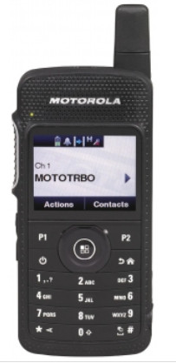
Hey Peanut App Users – Something New For You
(From Jeff, VE6DV and thanks to Greg, WD9FTZ)

Attention Peanut App users. The Peanut android app, while the intention is to allow D-STAR access from your smart phone, is now linked to DMR Talk Group 31012. You can access this DMR Talk Group by selecting XRF757A in the list of available reflectors.
David, PA7LM has added reflector XRF757A / DMR Talk Group 31012 as a trial for a few days to see how much activity there is. So, if you have the Peanut app, be sure to give XRF757A some activity and hopefully it will become a permanent addition.

FT8 Users - Listen Up
(From Rob, KV8P)
The next couple months will be a tough transition time for FT8 digital mode users as users are being asked to make the switch from version 1.91 to 2.0. (And you will have to in order to keep up)
The important thing to keep in mind is that the two are not compatible and might just as well be a different mode all-together (in some ways) .

TOP ^
Once you make the switch you can no longer decode stations that are transmitting using the old version 1.91 software.

(This is the big "gotcha") Old version 1.91 users are everywhere right now, while the new version 2.0 users are minimal but are typically above 2000 on the waterfall. If you are running the old version and can't get a reply from someone, that is likely why. If you are running a 2.0 version and aren't getting many good decodes, that is why.
Hopefully that helps a few people avoid unnecessary troubleshooting time!

Final.. Final..

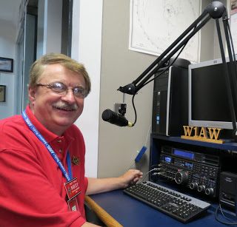
Hey Gang...

This past week has been just a blur around here. With Christmas coming so fast there hardly seems like time enough to get all the things that I need to get done - done.

The week started out great with Janie and I attending the Northern Ohio Skywarn Meeting and Pot Luck Supper. We had fun with everyone and was able to find out some new information on the Cleveland Weather Office move as well as what we can expect for weather for the next couple of months.

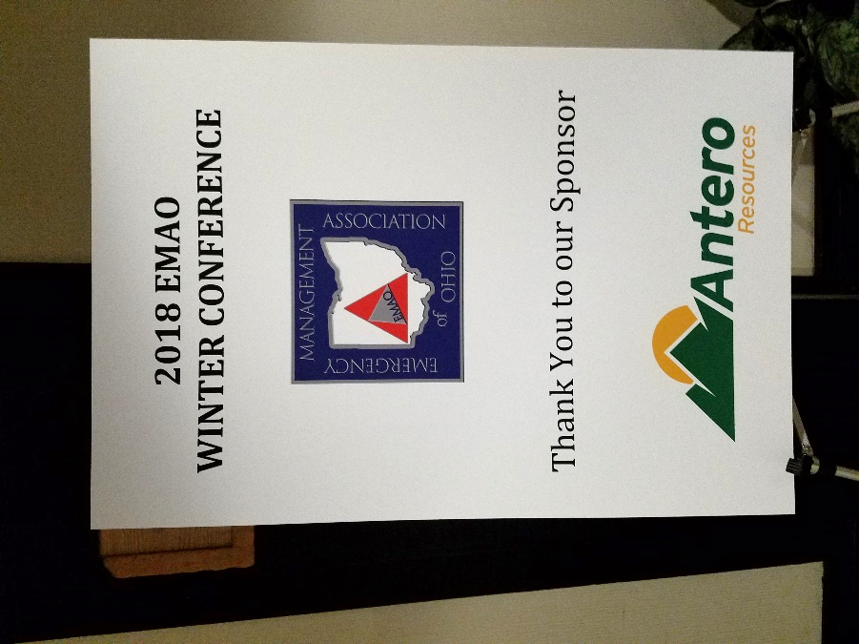
I also had a blast Thursday and Friday at the EMAO Winter Conference this year. This is a two-day conference (yes, it’s an overnight stay) that just doesn’t end with a supper for the night. We had a huge get together after the dinner that went long into the evening/morning.

I talked to every EMA Director there about Amateur Radio and the benefits that we can bring each of them. And YES, I did learn a lot from them as well. I really admire how they get all that is expected from them done in the time frame that they have to get it done. It’s amazing to just sit and listen to all the stories that they have. I am so thankful that we have this outlet to get this close to all of our EMA Directors throughout the state. It’s really a privilege that I hope continues for a very long time to come! Oh, by the way, a lot of our EMA Directors are Amateur Radio operators as well, so it is even more of a trip talking with them about DX or antenna’s and the like.

Update on the Yonally lighting campaign. Last week I told you how I had gotten the lights up and running, well this week while I was at the EMAO Conference Janie had her turn at stringing up some lights.

TOP ^
Yes, her thing was getting the tree up with all the lights on it and WOW.. I definitely will need help with the electric bill next month! Our living room is so bright it’s like playing at the Cleveland Browns Football Stadium! I really don’t want to think of the bill that is coming next month for sure now. “GoFundMe” here I come!!!

Let’s go down the band with a new topic… Club Newsletter Editors… I want to make sure that you know that the annual Ohio Section Newsletter Contest will be starting back up in January, just a few short weeks away! If your January newsletter gets mailed out in December, like many do, make sure that John Ross, KD8IDJ and I are on your mailing list to get it. Want more information about the Newsletter Contest? Click on this link.. http://arrl-ohio.org/pic_page/pic.html Even if your newsletter is web based, send us the link!!

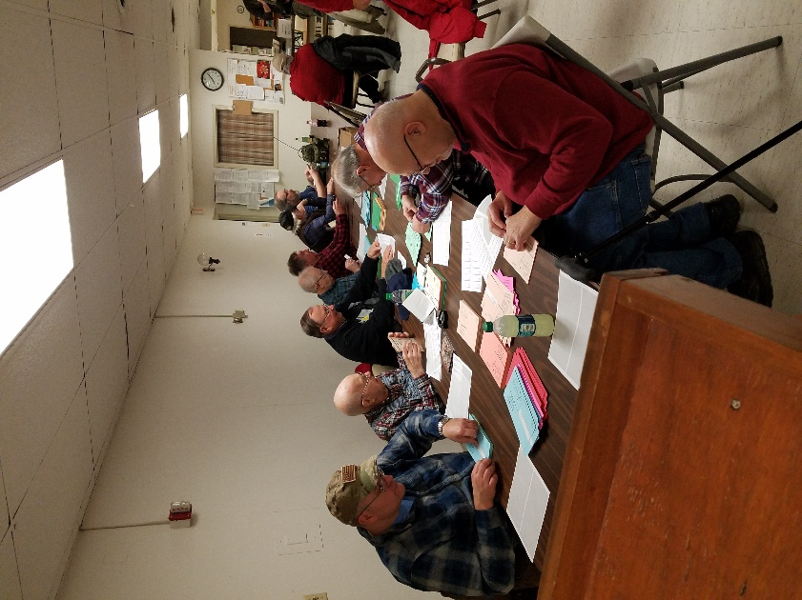
We have some updates on the Ohio Section website to report. Daniel, KB8LKH has updated his Anytone 868UV Code Plug once again. This just shows you how much can change in a week! DMR has been amazing. I can’t remember a time when things changed this fast in any Amateur Radio mode. New DMR repeaters are popping up everywhere. You just gotta’ love it. Now, the news isn’t all about DMR exclusively either. If you noticed recently, there has been a lot of work to make System Fusion and D-Star compatible with DMR as well. It seems like there are new ways of interconnecting these various systems every day.

My home club (IARC) did its thing this past week with our annual “Peel & Stick” party. Now, I hear from many club leaders asking me how they can get their club motivated and get the members wanting to come to the meetings. Well my friends, this is one way. IARC has been doing this for so many years I can’t even remember when we didn’t do it. It’s a blast to get the membership all working toward one common goal. And we topped it off with a pizza party after we got the work done. We do around 5,000 cards and it takes the group about an hour to do. Yes, just about an hour and we got 5,000 cards labeled. That’s because we all work together and have FUN doing it. There’s lot of chatter and even some joking around when someone finds a label address to one of ourselves! Oh, you can expect your card around the first of the new year. We print our announcement on a card, that way you can just stick it up on the refrigerator as a daily reminder!

I didn’t get much of a chance this week to do any design work on the new ham shack since it has been so busy around here, but I will get to it soon for sure.

This next week is filled with Christmas parts all over the state that I will be attending. I hope to see you there.

Oh... I do want to say that we do have a really big event to attend on December 21st. It’s the Cambridge ARC party. This is going to be one very special party for sure. Their club will be celebrating their 105th anniversary!!!! Now, I don’t know of any other club in the Ohio Section that can top that!

Whelp… That’s going to do it for this time around. Stay safe, and most of all… have FUN!!

Scott, N8SY

TOP ^

Why can't we add resistors in parallel the same way we would add resistors in series to find the total resistance?

If you put two resistors in series, then the current through them will be the same, and the value of that current is the voltage across them divided by the sum of the resistances. In other words, resistors in series increase the resistance, reducing the current.

If you put resistors in parallel, the current through them divides in proportion to the resistances, and the voltage across them are equal. The overall current must increase, because now there is more than one path for the current to take. So, resistors in parallel decrease the resistance and increase the current.

You can’t make a decrease in resistance by adding the resistances together. Instead, you have to add the reciprocals of the resistances, and then take the reciprocal of the result. This follows from Ohm’s Law and Kirchoff’s Current Law.

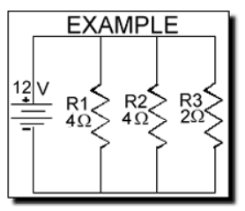

Let's summarize this EXAMPLE:
Voltage = 12V R1 = 4 Ohm R2 = 4 Ohm R3 = 2 Ohm

Remember that "Rt" means Total resistance of the circuit. R1, R2, etc. are Resistor one, Resistor two, etc.

Now we will apply the formula above to this example:
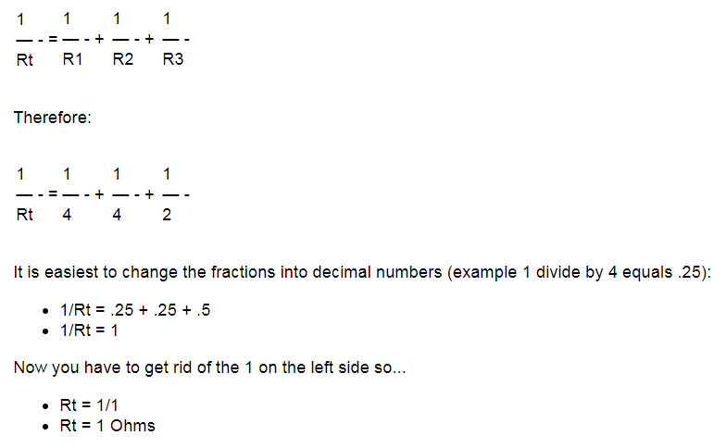

TOP ^

Another Milestone Reached

We’ve now logged our 775th person into the statewide database. Meet Dominic Hord, AD8AK. Dominic sent in his certificates last week and became our 775th person. Dominic has an ARRL ARES Mesh Vest on the way.

Don’t forget, and an enticement to get your certificates to me I’m giving away to the 800th person, an ARRL ARES Mesh Vest! We aren’t all that far away from number! Will you be the person that gets it?

Back Issues of the PostScript and Ohio Section Journal (OSJ)

Hey, did you know that PostScript and Ohio Section Journal (OSJ) are archived on the website? You can go back and look at any edition simply by clicking:
http://arrl-ohio.org/news/index.html

Chit – Chat, and All That!

Do you know someone that’s not getting these Newsletters? Please, forward a copy of this Newsletter over to them and have them “Opt-In” to start receiving them. Heck, just have them send me an email n8sy@n8sy.com and I’ll get them added to the Ohio Section Emailing list.

We now have many thousands of readers receiving these newsletters weekly. Quite impressive, I’d say! I urge all of you to make sure that everyone, regardless of whether they are a League member or not, get signed up to receive these weekly Newsletters.

You can always “Opt-Out” at any time if you feel this is not what you were expecting. It’s fun and very informative. All of your favorite past newsletters are now archived too.
You can go back at any time and read them. Just go to: http://arrl-ohio.org/news/

Got questions, concerns or would just like to sit and chat awhile? Heck, I’ll even buy the coffee!! Give me a call at (419) 512-4445 or email me at: n8sy@n8sy.com

The pictures on the front page are from various newsletters, Facebook posts and/or were sent directly to me in recent weeks. Take a good look at them, you just might be in one of the pictures! “SMILE… you’re on the Ohio Section News!!”

TOP ^

PostScript is produced as a weekly supplement to the Ohio Section Journal (OSJ). I sincerely hope that you have enjoyed this edition and will encourage your friends to join with you in receiving the latest news and information about the Ohio Section, and from around the world!

