[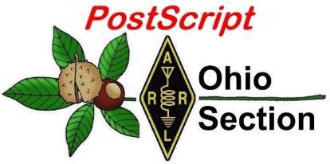](http://arrl-ohio.org/news/) ***Cyber Monday***

***Edition***

🡪 National News 🡪 The Handbook Give Away

🡪 Club Corner 🡪 Hamfests

🡪 DX This Week 🡪 One Question Questionnaire

🡪 Final.. Final..

***National News***

*(from arrl and other sources)*

**Repeaters, Amateur TV Play Communication Role in California Fire Emergency**

Amateur Radio repeaters and TV (ATV) have helped to keep the broader community informed on the local

status of widespread fires in Southern California, radio amateurs say. Benjamin Kuo, KI6YR, who had to evacuate but now is back home, said remote Amateur Radio Emergency Data Network ([**AREDN**](https://www.arednmesh.org/)) mesh cameras captured video from fires across Southern California earlier this month, including the [**early stages of the Woolsey Fire**](https://www.youtube.com/watch?v=cowdbebnX5o).

ATV cameras also offered views of some of the state’s less prominent fires, including the [**Briggs Fire**](https://www.youtube.com/watch?v=64ZnydnsIBg) in Santa Paula, and the [**Peak Fire**](https://www.youtube.com/watch?v=XWvgOOmkUaw) in Simi Valley.

“Another big success: When most of Southern California lost their internet and phone, local repeaters were used to relay information about the fire status to ham radio operators,” Kuo told ARRL. “We also used our AREDN mesh to enable some of our members to be able to access key public safety information on their computers via our high-speed network when they had no phone or Internet.”

Kuo said a near round-the-clock net, which secured on November 14, took place in Ventura County on the Conejo Valley Amateur Radio Club’s BOZO repeater and the WD6EBY Repeater Network (PVARC) countywide, with updates, important evacuation information, and more. Kuo copied information from the repeaters and his scanner onto his Twitter feed, for broader dissemination.

He credited Stu Sheldon, AG6AG, and Zak Cohen, N6PK — the two primary net operators — for working to make sure everyone had current information on the fire. “Many others were also involved providing first-hand reports — in many cases, eyes on the fire and where it was at any point,” Kuo added. He said that with landline telephones, television cable, and internet service disrupted and cell phones intermittent, repeaters were often the only source of information.

“Personally, the whole disaster cemented for me how much more resilient Amateur Radio is in these kinds of situations, and how it’s actually pretty critical to keeping informed and aware of what’s going on,” Kuo said

Elsewhere, Scott Bastian, AK6Q, of the Catalina Amateur Radio Association (CARA) in Southern California, said a ham in Malibu used his club’s repeater to call for help at the onset of the Woolsey Fire that decimated Malibu and surrounding areas.

“This ham — and I do not have her call sign — used the CARA 2-meter repeater located on Catalina Island, calling for someone to make a phone call to the fire department as there was a large fire approaching her home, and she had no power or phone service due to our power company shutting off power due to the high winds and fire danger,” Bastian told ARRL. “Two of our members — Bob Parker, KI6UPJ, in Bellfower, and Gabriel Saldana, K6GLS, in Avalon were able to pull her information out of the ‘mud,’ as she had a poor signal. They were able to notify Los Angeles County Fire and get her aid.”

#########

TOP ^

***After Black Friday and Cyber Monday, Give Back on #Giving Tuesday, November 27***

[](https://www.givingtuesday.org/)

ARRL encourages its members to give something back on [**#Giving Tuesday**](http://www.givingtuesday.org/), November 27, either by donating to a favorite charity, by volunteering your time — or both. ARRL is registered as an IRS 501(c)(3) charitable organization, and donations to ARRL are tax deductible. Join the movement on November 27 to celebrate #GivingTuesday by giving your time, skills, voice, dollars, and goods to charity and help others.

Many of ARRL’s programs and services are not covered by membership fees alone. Your contributions to the Education & Technology Fund, the Spectrum Defense Fund, and the Legislative Issues Advocacy Fund have a tremendous impact on ARRL’s ability to promote Amateur Radio and better serve its members. Take this opportunity to [**support ARRL’s**](https://www.arrl.org/arrl-donation-form) efforts on behalf of Amateur Radio.

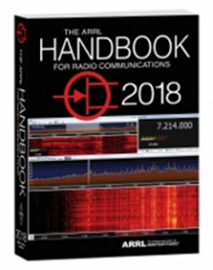***The Handbook Give Away***

Hey Gang,

Did you read this article before Thanksgiving? If you did then you know that I had a special Handbook Give Away just for Thanksgiving Day! And… Here’s who won that book: **James Neal, WD8JLP of Etna!**

Now, don’t despair, you lost out on that opportunity, but you still have another chance at it this month!! And….. since I didn’t dump any of the names from the Thanksgiving drawing, you get a second chance at it.

Now, if you’ve not registered yet, go to: <http://arrl-ohio.org/handbook.html> and get registered.

What’s the catch? I want to get everyone checking in to the Ohio Section website as often as possible, and in order to register each month, you have to visit the website often! There’s nothing else to it. I pay all expenses, and from time to time, I Give Away more than just a Handbook. And, you’ll never know just what months will be those special times that I will have more than just a Handbook to Give Away!!

Hey everyone… Did you see the ad from ARRL recently? Well, they liked my idea so much that they’ve copied it. Yup, they were giving away a Handbook too!

[](http://arrl-ohio.org/handbook.html)Many of you ask me just how do I know when the drawing is on? Well, that’s easy all you need to do is check in on the Ohio Section Website on a regular basis and watch for the big **RED** Arrow that will appear on the left side of the page. This is the sign that the drawing is on and you need to get registered. So, keep a sharp eye out on the website and check in often! <http://arrl-ohio.org>

TOP ^

***Club Corner***

This is YOUR cornner of the newsletter. Send me what your club is doing and I’ll make sure that it gets in. Got a special event or club project that you want everyone to know about? Send it to me!. Need help with a project? Send it to me.

Let me know what you club is up to. Are you going to have a special guest at your meeting or are you having a special anniversary? Just sent it to:

[n8sy@n8sy.com](mailto:n8sy@n8sy.com)

#########

***Help Needed***

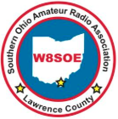Jim Rowe N8TVO, Southern Ohio Amateur Radio Association President reports, that this year’s Ironton Lions Christmas Parade will take place on **November 26**. Amateur Radio operators are requested to meet by the car wash at 4th and Center Streets at 5:00 PM. We will be using the Ironton downtown repeater, 444.625 tone 103.5.

The parade will start at 6:00 PM. Everyone’s safety is critical, therefore please wear your ARES reflective vest and hat. Jim also said, “the parade theme is Peace On Earth.”

Yes, Santa will be there, however we not sure at this time if he will be giving out ham radio goodies.

#########

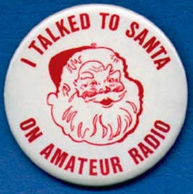

***Kids Talk To Santa***

If you are interested in helping your area kids talk to Santa via Amateur Radio, here’s a great link for you… [http://www.hdscs.org/npn/npn01arrl.html](http://www.hdscs.org/npn/npn01arrl.html?fbclid=IwAR02_RlaDvl3dbtXX3j1TTwQD9vZcoPcC9pAcnm1ZuATbOkFsr8L4mvhWnQ)

#########

***Stark County ARES Holding ICS Training***

The **Stark County ARES** in conjunction with the **Stark County EMA Office** will again be sponsoring FEMA ICS Training. The training will be on **December 19th** and we'll start at **5:30 PM** and hopefully finish by **7:30**.  
  
Training this month will be for the ICS-700 certification, "An Introduction to the National Incident Management System". There are no prerequisites. The location is at the County EMA office on Route 62 lower level. There is no cost for the training. Bring your FEMA student ID number so you can take the exam at completion. Laptops will be available, or you may use a smartphone to take the test.

TOP ^

Please reply to this notice if you are planning to attend the December 19 ICS-700 class, or email [dlamm@whbc.com](mailto:dlamm@whbc.com) Steve would like a headcount beforehand.

#########

***MVARA Holds Talk To Santa Night***

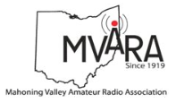The Mahoning Valley Amateur Radio Assn. in conjunction with Akron Children’s Hospital, Boardman Campus will be hosting the annual Santa Claus Net on Wednesday **December 19th** at 7:00 PM on the 146.745 repeater. For those who are new, MVARA members take 2-meter radios into Akron Children’s Hospital and let the kids talk to Santa over the air. We need operators for this event, but you must register with the Hospital & complete an online training program.

Please contact me at: [w8ysu@arrl.net](mailto:w8ysu@arrl.net) and I will put you in touch with the Hospital contact person. We would love to have you, your children, grandchildren, neighbors or anybody that wants to talk to Santa also check-in.

#########

***This Past Saturday Was HARA's R & L Electronics Appreciation Day***

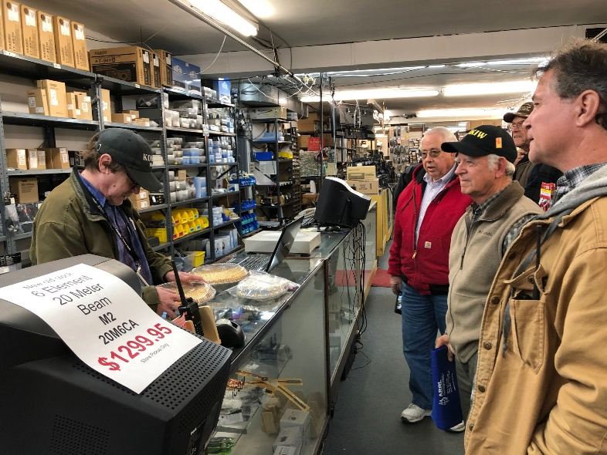This past Saturday the annual Highland ARA pilgrimage to R & L Electronics to purchase door prizes for the annual HARA Christmas Party was made by a delegation of HARA members.  However, this year a twist was added to the day.  Thanks to Bob McFarland (N8ZDL) for the idea to do something for the R & L employees to show the Club's appreciation to them for their support of this year's Technician license class (which graduated 28 new hams) and their all-around support of amateur radio in the Highland County area.

Bob arranged for Kathy Levo (N8ZNR) to make two different fruit pies and had HARA President Jeff Collins (KD8VUY) present them during the visit.  In addition to shopping for door prizes, it was noted the members making the trip were either purchasing their own Christmas gifts or making lists of items they hope Santa leaves under their tree Christmas morning.

After leaving R & L the group adjourned to Hyde's Restaurant to continue a pleasant day of friendship through ham radio and to recap their R & L visit.

HARA members taking the time out to represent the Club during a busy holiday weekend were:  Lee Bishop, N8YHU; Bob McFarland, N8ZDL; Gary Poland, W8PU; Harley Maines, K8HM; Buddie Holcomb, KD8IJA; Patrick Gilifillen, N8EWH; Jeff Collins, KD8VUY; David Gordley, KD8UAW; Tom Archibald, K8TDA; Patrick Hagen, N8BAP and John Levo, W8KIW.

#########

TOP ^

***Incident Command System (ICS) Training Schedule***

All current trainings are listed on the Ohio EMA training calendar located at:

<https://webeoctraining.dps.ohio.gov/TrainingAndExercise/courselist.aspx>

I’ve been asked to also include a link to the Kentucky EMA training calendar as well..

<https://kyem.ky.gov/training/Pages/default.aspx>

<https://sites.google.com/site/ccoemtraining/home>

Please pay particular attention to these courses listed above, as that there’s a lot of ICS 300 & 400 classes listed that are very useful for all Amateurs to have under their belts. I will also state that G775 is also a very good course to take as well. These 3 courses are multiple day in class courses, so please be prepared to spend some time taking them.

I would like to remind any of you that are going to take any of the in-class training sessions that you dress appropriately.

Please don’t go into these classes with attire that doesn’t represent you, and Amateur Radio in the best of light.

I’m not setting a dress code, but if you wouldn’t take your wife out to a nice restaurant in these clothes, you may want to reconsider what you are wearing. Remember, you will be in class with fire / police chiefs, mayors, township trustees and a whole host of other government and civil officials that will remember how you represented Amateur Radio while you were in these classes together.

We do recognize that IS-300/400 requires multiple days of actual classroom training that is not easily obtained. So, if you just can't find the time to fit these class room courses in, we do have an alternative method for getting you to Level 3. Completing the following **“FREE”** and **“ONLINE”** courses will act as substitute for you FEMA Leadership Development Course requirements. You absolutely will need to complete all **7** of these courses to get your ICS 300/400 credit.  Here are the courses that you need to take:  **IS-120, 230, 240, 241, 242, 244 & 288.**

#########

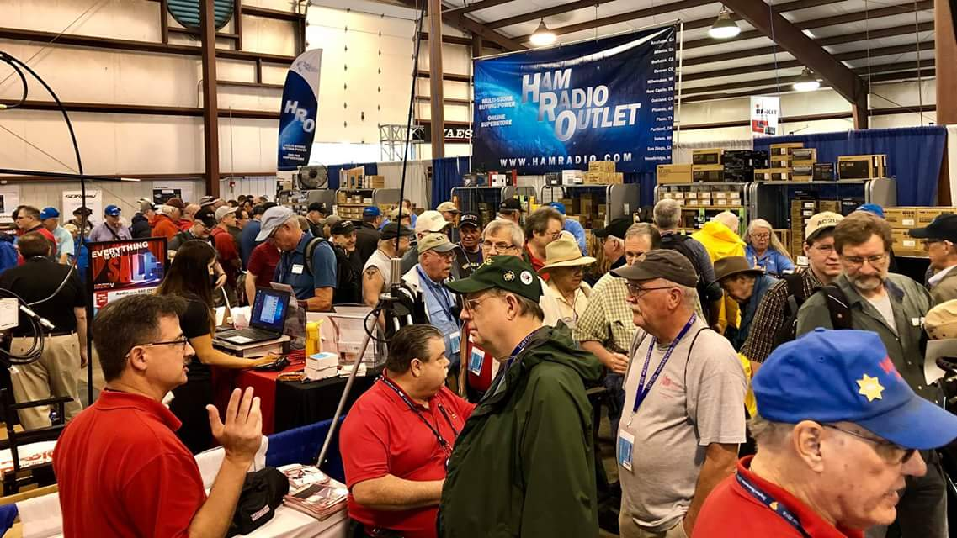

[***Upcoming Hamfests***](http://arrl-ohio.org/hamfests.html)

12/01/2018 | FCARC WinterFest  
 Location: Delta, OH  
 Sponsor: Fulton County Amateur Radio Club  
 Website: <http://k8bxq.org/hamfest>

TOP ^

**2019**

|  |  |
| --- | --- |
| 01/20/2019 | [S.C.A.R.F. Hamfest](http://www.arrl.org/hamfests/s-c-a-r-f-hamfest-1)  Location: Nelsonville , OH Sponsor: Sunday Creek Amateur Radio Federation  Website:<http://www.qrz.com/db/kc8aav> | 01/27/2019 | TUSCO ARC Hamfest, Electronics & Computer Show Location: Strasburg, OH Sponsor: Tusco Amateur Radio Club Website: [http://tuscoarc.org](http://tuscoarc.org/) |
| 02/17/2019 | InterCity ARC Hamfest Location: Mansfield, OH Sponsor: InterCity Amateur Radio Club Website: [http://www.w8we.org](http://www.w8we.org/) |  |

#########

[***V.E. Test Sessions***](http://www.arrl.org/find-an-amateur-radio-license-exam-session)

*(from arrl)*

|  |  |
| --- | --- |
| 12/01/2018 | [Kirtland OH 44094-8500](http://www.arrl.org/exam_sessions/kirtland-oh-44094-8500-61)  Sponsor: Lake County ARA Location: Kirtland Library Time: 12:00 PM (Walk-ins allowed)  [Learn More](http://www.arrl.org/exam_sessions/kirtland-oh-44094-8500-61) | 12/01/2018 | [Ravenna OH 44266-2191](http://www.arrl.org/exam_sessions/ravenna-oh-44266-2191-56)  Sponsor: Portage County ARS Inc. Location: PCARS Club Site (Rear of complex, under BIG tower) Time: 10:00 AM (Walk-ins allowed)  [Learn More](http://www.arrl.org/exam_sessions/ravenna-oh-44266-2191-56) |
| 12/01/2018 | [Reynoldsburg OH 43068-3015](http://www.arrl.org/exam_sessions/reynoldsburg-oh-43068-3015-20)  Sponsor: CRES Laurel VE Team Location: Parkview Presbyterian Church Time: 9:00 AM (Walk-ins allowed)  [Learn More](http://www.arrl.org/exam_sessions/reynoldsburg-oh-43068-3015-20) | 12/01/2018 | [Rittman OH 44270-1431](http://www.arrl.org/exam_sessions/rittman-oh-44270-1431-38)  Sponsor: Silvercreek ARA Location: Rittman Public Library Time: 9:45 AM (Walk-ins allowed)  [Learn More](http://www.arrl.org/exam_sessions/rittman-oh-44270-1431-38) |
| 12/01/2018 | [Westerville OH 43081-1436](http://www.arrl.org/exam_sessions/westerville-oh-43081-1436-1)  Sponsor: Central Ohio Radio Club Location: Westerville Fire Dept Time: 10:00 AM (Walk-ins allowed)  [Learn More](http://www.arrl.org/exam_sessions/westerville-oh-43081-1436-1) | 12/02/2018 | [Cortland OH 44410-1473](http://www.arrl.org/exam_sessions/cortland-oh-44410-1473-25)  Sponsor: NE Ohio ARC Location: Ohio State Extension Office Time: 6:30 PM (Walk-ins allowed)  [Learn More](http://www.arrl.org/exam_sessions/cortland-oh-44410-1473-25) |
| 12/05/2018 | [Cincinnati OH 45242-5614](http://www.arrl.org/exam_sessions/cincinnati-oh-45242-5614-28)  Sponsor: Greater Cincinnati ARA Location: Blue Ash Recreation Center Time: 6:30 PM (Walk-ins allowed)  [Learn More](http://www.arrl.org/exam_sessions/cincinnati-oh-45242-5614-28)  TOP ^ | 12/08/2018 | [Findlay OH 45840](http://www.arrl.org/exam_sessions/findlay-oh-45840-74)  Sponsor: Findlay Radio Club Location: Findlay Radio Clubhouse Time: 9:00 AM (Walk-ins allowed)  [Learn More](http://www.arrl.org/exam_sessions/findlay-oh-45840-74) |
| 12/08/2018 | [Huber Heights OH 45424-4143](http://www.arrl.org/exam_sessions/huber-heights-oh-45424-4143-38)  Sponsor: Huber Heights Amateur Radio Cl Location: The Forge Time: 9:30 AM (Walk-ins allowed)  Learn More | 12/08/2018 | [Maumee OH 43537-1628](http://www.arrl.org/exam_sessions/maumee-oh-43537-1628-87)  Sponsor: Toledo Mobile Radio Assoc Location: Maumee Fire Station #2 Time: 8:15 AM (No Walk-ins / Call ahead)  [Learn More](http://www.arrl.org/exam_sessions/maumee-oh-43537-1628-87) |
| 12/11/2018 | [Lancaster OH 43130-3014](http://www.arrl.org/exam_sessions/lancaster-oh-43130-3014-64)  Sponsor: Lancaster & Fairfield Cnty ARC Location: American Red Cross Time: 7:00 PM (Walk-ins allowed)  [Learn More](http://www.arrl.org/exam_sessions/lancaster-oh-43130-3014-64) | 12/15/2018 | [East Liverpool OH 43920-9486](http://www.arrl.org/exam_sessions/east-liverpool-oh-43920-9486-13)  Sponsor: Triangle ARC Location: Glenmoore Volunteer Fire Station Time: 1:00 PM (Walk-ins allowed)  [Learn More](http://www.arrl.org/exam_sessions/east-liverpool-oh-43920-9486-13) |

#########

***Special Events***

* **12/08/2018 | 105th Anniversary of Founding of Cambridge Amateur Radio Association**

**Dec 8, 1600Z-2200Z, W8VP**, Cambridge, OH. Cambridge Amateur Radio Association. 14.245 7.235. QSL. CARA, P.O. Box 1804, Cambridge, OH 43725. [www.w8vp.org](http://www.w8vp.org/)

#########

***ARRL Contest Corner***

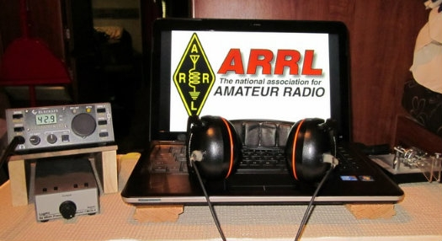

An expanded, downloadable version of *QST'*s [Contest Corral](http://www.arrl.org/contest-calendar) is available as a PDF. Check the sponsor's Web site for information on operating time restrictions and other instructions.

**HF CONTESTS**

[SKCC Sprint](http://www.skccgroup.com/operating_activities/weekday_sprint/), **Nov 28**, 0000z to Nov 28, 0200z; CW; Bands: 160, 80, 40, 20, 15, 10m; RST + (state/province/country) + Name + (SKCC No./power); Logs due: December 2.  
  
[QRP Fox Hunt](http://www.qrpfoxhunt.org/winter_rules.htm), **Nov 28**, 0200z to Nov 28, 0330z; CW; Bands: 80m Only; RST + (state/province/country) + name + power output; Logs due: November 29.  
  
[Phone Fray](http://www.perluma.com/Phone_Fray_Contest_Rules.pdf), **Nov 28**, 0230z to Nov 28, 0300z; SSB; Bands: 160, 80, 40, 20, 15m; NA: Name + (state/province/country), non-NA: Name; Logs due: November 30.

TOP ^

[CWops Mini-CWT Test](https://cwops.org/cwops-tests/), **Nov 28**, 1300z to Nov 28, 1400z, Nov 28, 1900z to Nov 28, 2000z, Nov 29, 0300z to Nov 29, 0400z; CW; Bands: 160, 80, 40, 20, 15, 10m; Member: Name + Member No., non-Member: Name + (state/province/country); Logs due: December 1.  
  
[UKEICC 80m Contest](http://www.ukeicc.com/which-contest/which-contest-ukeicc-80m-contests-rules), **Nov 28**, 2000z to Nov 28, 2100z; CW; Bands: 80m Only; 4-Character grid square; Logs due: November 28.

#########

***December is Youngsters on the Air (YOTA) Month***

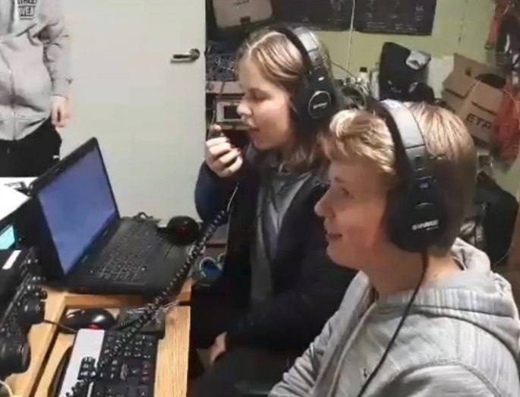

December is Youngsters on the Air Month ([**YOTA Month**](https://events.ham-yota.com/)**)**. Listen for stations on the air with YOTA as the call sign suffix.

“The idea for this is to show the Amateur Radio hobby to young people and to encourage youngsters to be active on the amateur bands,” said Tomi Varro, HA9T. “This is a great moment to show Amateur Radio to the world and to invite newcomers.”

YOTA is primarily an International Amateur Radio Union ([**IARU**](http://www.iaru.org/)) Region 1 (Europe and Africa) activity, but youngsters from the US in Region 2 (the Americas) have attended YOTA summer camps, which are held in a different country each year. Varro said both licensed and unlicensed youth will be making contacts. “Be helpful on the bands — maybe these young operators are just making their first ever contacts,” he advised.

YOTA stations are, in general, operated by individuals 25 or younger. The operating event takes place for the entire month of December UTC.

As part of YOTA month, Bob Johnson, W9XY, and Ken Claerbout, K4ZW, will travel to Ethiopia to team up with the club at the Addis Ababa University, Institute of Technology and club station ET3AA. For more updates, visit YOTA’s [**Facebook page**](https://facebook.com/groups/youngstersontheair).

#########

***Southern Ohio Amateur Radio Association Hosts Party & Awards Presentations***

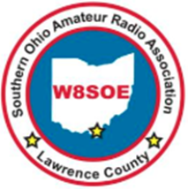The Southern Ohio Amateur Radio Association (SOARA) held their Christmas in November meeting/dinner, November 19, 2018 at the Russell, KY Golden Corral. The fellowship was excellent and so was the food. Santa, Tom Williams, KD8WTG from the Portsmouth Radio Club was there presenting gifts to the members and taking with the kids.

TOP ^

There were several presentations made.

Scott Yonally, N8SY Ohio Section Manager presented SOARA with the prestigious American Radio Relay (ARRL) Ohio Section “Special Service Club “Award”

The Ohio Section Manager’s “Special Recognition Award” was also given out for joining the elite group of Special Service Clubs in Ohio.

Scott Yonally N8SY, ARRL Ohio Section Manager also presented the ARRL Ohio Section’s “Outstanding Public Information Officer Award” to Michael Love, WB8YKS.

Michael is the very first to receive this award!

Jeff Slattery, N8SUZ Ohio Section Amateur Radio Emergency Service (ARES) District 8 Emergency Coordinator presented Eddie Jenkins, N8URU Lawrence County ARES EC with a “Special Certificate of Recognition.”

TOP ^

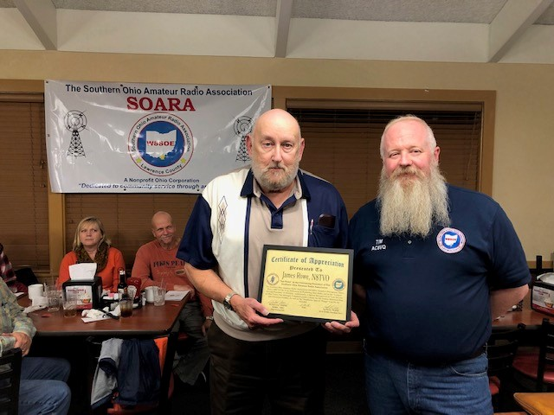

James Rowe, N8TVO was presented with a certificate recognizing him or his ten years of continuous service as president of the Southern Ohio Amateur Radio Association. The presentation was made by Tim Nicely, AC8VQ 2019 SOARA President Elect.

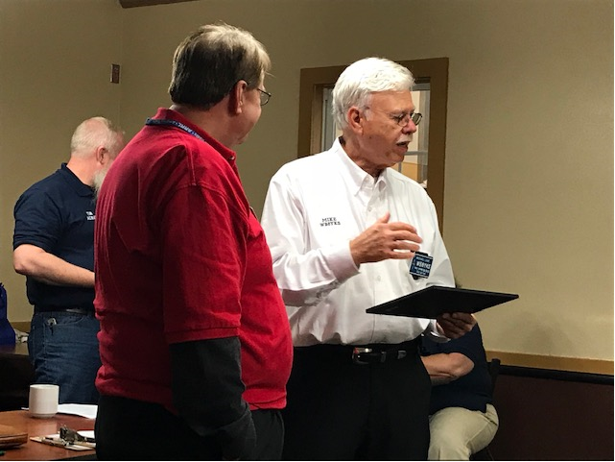

Scott Yonally, N8SY, ARRL Ohio Section Manager and Editor of the Ohio Section’s weekly newsletter, PostScript was recognized by SOARA members for his dedication to promoting Ham Radio and as Editor of PostScript. Scott was presented with SOARA’s “Certificate of Excellence”.

Jerry Lockhart, W8HIC was presented a certificate from the members of SOARA recognizing him for his leadership as the ARRL Ohio Section Laure VEC Regional Coordinator, VEC Regions 1,2, and all International Teams.

Jeff Slattery, N8SUZ Ohio Section ARES District 8 EC was presented with a SOARA certificate of “Special Recognition” by Eddie Jenkins, N8URU for his “Outstanding Service.”

TOP ^

Fred Jones, WA4SWF ARRL Assistant Great Lakes Director was recognized for his dedication to Ham Radio and was presented with a laminated copy of a special Herald-Dispatch news article about his life in Louisa, KY and his hobby “Ham Radio”.

The grand prize of the evening a, 2018 ARRL Handbook was provided by Scott Yonally, N8SY. Scott presented the prize to Sally Love, N8QCY.

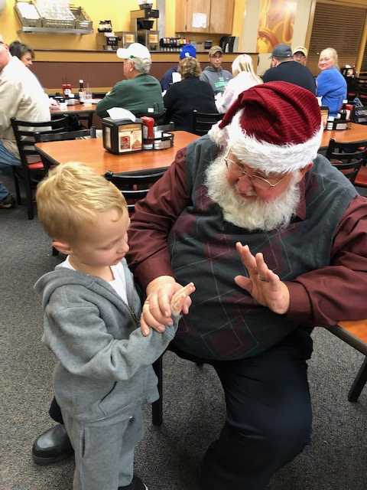

Santa was also a busy person listening to what the little ones wanted for Christmas.

TOP ^

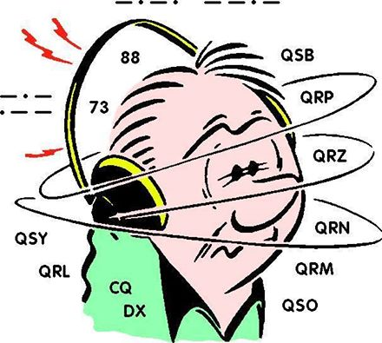***DX This Week – DX CW***

***Bill AJ8B (***[***aj8b@arrl.net***](mailto:aj8b@arrl.net)***, @AJ8B,*** [***www.aj8b.com***](http://www.aj8b.com) ***or*** [***www.swodxa.org***](http://www.swodxa.org) ***)***

Last week, I gave details about the ARRL Outgoing QSL Bureau. This is a cost-effective way to get physical QSL cards from your station to the DX Station. The tradeoff is time. The process also works in reverse and here is how it happens.   
(from <http://arrl-greatlakes.org/8th_bureau.htm> )

General QSL Bureau Information - The 8th call area bureau operates as part of the ARRL's volunteer QSL bureau system. As such, the operating expenses are paid by the league's members, although the bureau service is open to all US hams whether ARRL members or not. If you are not a league member, and use the incoming bureau, won't you consider joining today? The bureau is 100% volunteer staffed. Each bureau worker forgoes their time to provide a service to you and we want to provide the best service possible within the bounds of reasonableness and fiscal responsibility. If you will follow the guidelines listed here, you will receive better service and our volunteers will have time to enjoy other aspects of our hobby, etc.

The 8th district central bureau is located at the Voice of America Museum in West Chester where it is one of the permanent displays. It is a work in progress, but if you have a chance to visit the VOA museum, be sure to look for the bureau. We do not encourage "just stopping by to pick up your cards" as there is no one there to release them to you. In addition, the only cards at the central bureau will be those that have not been forwarded to the individual letter managers. The best time to visit would be when the West Chester Amateur Radio Association (<http://www.wc8voa.org/> ) has their regular meeting, if you want a more detailed bureau visit. Specifically, the Bureau Address is: 8th Area QSL Bureau / P.O. Box 307 / West Chester, Ohio 45071-0307. The Bureau Manager is John (Jack) Shirley, N8DX (n8dx@arrl.net )

Do Not Send Your Outgoing QSL Cards to Us

We cannot process them; they will be sent back to you in your bureau envelopes. Outgoing cards should be sent to ARRL HQ. This includes cards for non-8th area US stations from any source, including any you may pick up from DX stations or bureaus on your out of US travels. You cannot use the ARRL bureau system to send cards to other U.S stations within the 48 contiguous states--for contacts between U.S. stations. Any cards sent for U.S.-to-U.S. contacts will also be sent back to you using your bureau SASE. You may use the ARRL bureau system for DX stations who have a U.S. manager, such as VK0IR cards via W8XXX, or XE3/K8XXX via K8XYZ. If you send cards via the bureau to a manager, make sure you list the full call of the manager, not just via "W8 bureau." There is no way we can know who handle or manages cards for every DX station around the world.

Please Be Patient

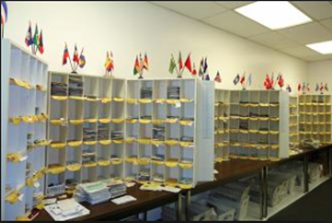QSL cards are rarely received by the bureau for contacts less than four months old. Most cards are for contacts made between a year and two years prior. Some cards come through the system as much as five years or more after the QSO. Some foreign bureaus send out cards only a few times a year. Most come by boat, which is very slow mail, indeed. There was a survey done of all cards received over a two-month period. Of those cards that had "TNX QSL" checked, less than 5% were for contacts within a year of the QSO.

TOP ^

This means if the station you worked waited for your card before returning one, the minimum turn-around will be a year or more. Many DXers who are relatively new to DXing tend to work "big gun" or loud stations. These stations work many U.S. stations, and in most cases, wait for your card before sending you one. Those DX stations who answer your CQ are much more likely to send their cards first, rather than those whose CQ you answer.

Keep Envelopes on File with the Bureau  
If you work DX at all, you should expect to receive bureau cards, especially if you work any DX contest. Do not forget that most SWL's send via the bureau as well. Unclaimed cards are the bureau's biggest problem. Send NON-clasp-fastening, end-opening envelopes, between 5X7 and 6X9 inches in size. Unless you receive lots and lots of bureau cards DO NOT send more than three or four SASE (self-addressed stamped envelopes) at a time. DO NOT use envelopes smaller or larger that 5X7 or 6X9. Smaller envelopes won't hold some of the larger DX cards; larger envelopes won't fit in our files, are more likely to come apart in the mail process AND with current postage rates, cost more to use. Non-standard and padded envelopes may be returned to you empty. Padded envelopes are larger than 1/4 inch and incur a higher fee just like envelope larger than 6 x 9. Several of the letter managers are moving to or have implemented a cash basis process for their letters. This has been done because of the frequent postage rate changes and the futility of trying to keep appropriate postage on the envelopes.

Most of our Managers have email access. If you have an email address, PLEASE INCLUDE IT whenever you write to the bureau or your Letter Manager. Make sure to include your email address when you send SASEs to the bureau or to your Manager as well. This will help us to communicate with you much more quickly than by conventional snail mail. If your email address changes, make sure you notify your Manager of the change.

Please DO NOT SEND USED ENVELOPES to the bureau. We will *NOT* attempt to use used envelopes. More than one trip through the postal system greatly increases the chance the envelope will come apart in the postal system, with the loss of your cards.

When you prepare envelopes for us, NEATLY print your call, in BLOCK LETTERS, in the upper left corner, in the place where a normal return address goes. Some people do such a poor job of writing their calls we need to look up the suspected call in the Callbook and match the name/address to make sure of the call. Certain letters can be especially troublesome -- like V and U, for instance. Take the time to make a very pointed V and a round or square bottom U. Keep this in mind when filling out cards to send via any bureau. It is a real headache for bureau workers trying to decide who the card really goes to; we don't want to guess which letter you really mean. Address each envelope to yourself in the center of the envelope. Remember, these are your cards. If we can't read your call or the postman can't read your address, you won't get them. If you have a change of address, send us address labels to cover your old address. Many people write so large, there is no room to write a change of address on their SASE.

If sending envelopes with stamps, affix enough postage to cover at least one ounce. currently, the post office is selling a "forever" stamp good for one unit of postage.

We do clear out all cards once a year. No matter how much postage on your SASE, and how few cards you have, once a year we will send you what you have. When postal rates go up, you should send extra stamps to cover the cost increase. Most people never think to send us extra postage when the rates go up.

NEVER put more than one call on an envelope. We cannot cross-reference upgrades, vanity calls, and family calls. Some of the Letter Managers live many miles apart. There is no way to share an envelope between two Letter Managers.

TOP ^

If you send an envelope with SASEs for more than one call, make sure you include a note saying you have done so. We don't take the time to look at each SASE you send us. If there is no note pointing out the fact you've sent SASE for multiple call, we simply pass them on to the Letter Manager for the first SASE we see. You may include a self-addressed postcard which we will return, letting you know your SASEs have arrived safely.

PLEASE NOTE: If you expect to receive cards under more than one call sign, please keep separate SASEs at all the Letters or 2Bureaus where you expect cards to be received. We will not "forward" cards for one call to another letter manager within our bureau or to another bureau unless you provide the SASE. It is/was your call and your QSO, if you want the cards, provide the SASE.

Again, the normal mailing cycle for the bureau is about every four to six weeks. If you don't worry about us wasting your postage, put "mail every cycle" on the bottom of each SASE and we will send you what you have each time, without the need to fill your SASE to the value of postage you've placed on it. If you are a big gun contester, DX-peditioner, or manager of a very active DX station, and get a pound or more a month, you may request your Letter Manager to box your cards to save on postage. Don't send money for this via the bureau. This MUST be between you and your Letter Manager, with the check made out in his name. If he doesn't want to take the time to do it, and requests you just send him SASE, that's the way it will be. The volunteer Letter Managers have enough of a job, and it's up to them if they want to do more. Any money for this extra service must be between you and your Letter Manager, not the bureau.

On the other hand, if you do not want to receive bureau cards, please advise your letter manager that you do not want them. If you are the manager for a DX station, including your own DX operations, and do not want bureau cards for those operations, but do want bureau cards for your US to DX contacts, we will not return the DX cards to the originator. We will destroy them. Also, be advised, if you elect to pursue this scenario, we will not be responsible for destroying cards you wanted to receive and were accidently destroyed. Remember, we are all volunteers and every special request takes volunteer time.

The Standard Operating Guidelines for ARRL QSL Bureaus states: "QSL cards on file which are unclaimed for a period longer than 90 days may be destroyed by the Bureau Manager (or Letter Manager) without further authority." PLEASE NOTE: Individual Letter Managers may elect to hold unclaimed QSL Cards for a longer period, at their discretion. Once we have made reasonable attempts to contact you that you have cards at the bureau and have received no correspondence (SASE) from you and destroyed your cards, we will make a note in our files and *NOT* contact you again. We will continue to destroy your cards on a continuing basis until we receive instructions to the contrary. You may consider this extreme but consider again that the biggest problem we have is unclaimed cards and the effort our volunteer letter managers expend trying to get them to the intended recipients. Before we destroy the cards, the following has occurred: A card has been sent, not at your expense, to your address of record, according to the FCC data base. (If that address is incorrect, you are not complying with the FCC regulations and are operating illegally!) In addition to the card, an email has been attempted using the address, <your-call>@arrl.net and/or any address in the various on-line callbooks.

1x1 calls: A new headache for the bureau are the new 1X1 calls being issued. You may do a good job of trying to tell each QSO to send the cards via N8???, but you can be sure some cards are going to come into the bureau with just the call N8?. There is no way for us to know who these cards go to if you don't supply SASE for these 1X1 special calls. It appears it is even more of a headache, since the same 1X1 calls will be re-issued to other special event stations, time-after-time. Make sure you list the time frame of the special event 1X1 on your SASE, so we will know who gets what cards. You had the 'FUN' of using the 1x1, you should follow through with the SASE.

TOP ^

Bureau Operating Procedures  
The mail is picked up at the PO Box on a regular basis, approximately once per week. There may be as little as five pounds to as much as 200 pounds in a week. You can visualize this by thinking of a stack of QSL cards ranging from 9 inches high, to over 29 feet high, each week.

At the central bureau we sort the cards into 27 piles - one for each letter of the alphabet according to the first letter of the suffix and one for mis sorts from the other bureau, cards sent to the 8th area bureau that should go to the 9th area bureau, for example.

The cards are then conveyed to the individual Letter Managers. Some managers will personally pick the cards up from the central bureau every few weeks. Most are mailed via USPS or UPS every four to eight weeks, depending on volume. If you send a request for information to your Letter Manager via the Bureau address, it may have just missed the last pickup, requiring another six weeks to make it to your Letter Manager. It will save you time to check directly with your Letter Manager if you just want to check on the status of your cards and SASE.

Good cooperation between the DXer and the bureau is important to ensure a smooth flow of cards. Remember that the people who work at the bureau are all volunteers. At the peak of the last cycle, we handled over two tons of cards a year. In the trough of the cycle relatively few cards are received. We are on the downslide now. For that reason and with the implementation of Log Book of the World, you should expect card volume to begin to drop off. With that in mind, please pay close attention to the above information, and the following DO'S and DON'TS.

* DO keep self-addressed 5X7 or 6X9 envelopes on file with your call in the upper left corner. Affix at least one ounce of postage to each. After checking the Letter Manager list above, you may send your SASE directly to your Letter Manager.
* DO put your Call Sign on the outside of all envelopes containing SASEs or requests for information, sent to the Bureau or your Letter Manager. This will keep your envelope from having to be opened by Bureau Staff to determine where it should be forwarded.
* DO keep envelopes at all Letters and Bureaus where you expect to receive Cards. If you have had a call sign change, we have no way of forwarding your old cards to your new Letter Manager, so please have an SASE waiting at both the old and new call sign Letter Managers Bureau.
* DO include your E-Mail address with all correspondence to the Bureau or your Letter Manager.
* DO send the bureau enough postage to cover the SASE on file and enough to cover postal rate increases.
* DO respond quickly to any bureau request for more SASE or additional postage. Remember, unclaimed cards are the bureau's single biggest problem.
* DO include an SASE with any information request to the bureau.
* DO notify the bureau in writing if you don't want your cards.
* DON'T expect DX cards to arrive for at least a year after contact. Overseas delivery is very slow. Most cards are over a year old when received by the Bureau.
* DON'T send your outgoing cards to this bureau.

As always, if you are having DX success just drop me a line and let me know what you are doing! If you have questions or recommendations for a topic, please send that along as well.

TOP ^

From our friend at the DailyDX and the WeeklyDX, (<http://www.dailydx.com/> ) Bernie has this to report:

* **3Y - Bouvet** – The team has continued to arrive in Cape Town, South Africa.  All of   
  them are now there.  Dates for the operation have still not been given   
  but it may be soon.  It appears we will have a 12-day warning because   
  that's how long the trip takes by boat.  3Z9DX is the team leader and   
  others are CT1DSV, JE1CKA, SP3CMX, SP5ES, SP8S and YU4DX.  Here are   
  some photos from South Africa:    
  <https://bouvetoya.org/3yoi-team-in-cape-town>.  A stay of at least two   
  weeks is planned if the weather is good, and the whole adventure for   
  the ops is 1-1/2 months from leaving home to returning to their homes.    
  They plan 160-6M CW, SSB and FT8 operation:    
  [https://www.rebeldxgroup.com](https://www.rebeldxgroup.com/) and <https://bouvetoya.org/3yoi-bandplan>.    
  QSLing through OQRS is their preference with LoTW or via 3Z9DX   
  secondary options.  Here are some of the other URLs to follow them:    
  [https://bouvetoya.org](https://bouvetoya.org/), [https://www.rebeldxgroup.com](https://www.rebeldxgroup.com/),   
  <https://www.facebook.com/bouvetoya.org>,    
  <https://www.facebook.com/rebeldxgroup>, and    
  <https://twitter.com/Bouvetoyaorg>   
    
  Here are target frequencies for 3Y0I, CW, SSB, FT8 fox and hound mode   
  (all bands except 160):  
  CW:  1822, 3502, 7002, 10106, 14002, 18072, 21002, 24892, 28002, 50105  
  SSB: 3785, 7090, 14190, 18140, 21200, 24940, 28440, 50140  
  FT8: 1840, 3567, 7056, 10131, 14090, 18095, 21091, 24911, 28091.

More info can be found at [www.swodxa.org](http://www.swodxa.org) or [www.aj8b.com](http://www.aj8b.com)

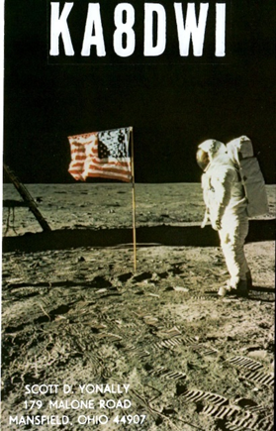***ARLD048 DX news***

This week's bulletin was made possible with information provided by The Daily DX, the OPDX Bulletin, 425 DX News, DXNL, Contest Corral from QST and the ARRL Contest Calendar and WA7BNM web sites. Thanks to all.

**GEORGIA, 4L.** Mamuka, 4L2M will be QRV as a Single Band entry on 20 meters from Zone 21 in the CQ World Wide DX CW contest. QSL via EA7FTR.

**SRI LANKA, 4S.**  Bernhardt, DK7TF and Juergen, DH6ICE are QRV as 4S7DLG from Hikaduwa until December 6. Activity is on the HF bands using mostly SSB and FT8. QSL via DK8ZZ.

**TIMOR-LESTE, 4W.** Operators HL1AHS and DS3EXX will be QRV as 4W/home calls from November 26 to December 3. Activity will be on 160 to 10 meters using CW, SSB and FT8. QSL direct to home calls.

**SENEGAL, 6W.** Jacques, F6BEE and Franck, F8CRH plan to be QRV as 6V7A in the CQ World Wide DX CW contest from Zone 35. Before the contest, Jacques may be active as 6W1RW. QSL via F6BEE.

TOP ^

**MALDIVES, 8Q.** Braco, E77DX will be QRV as 8Q7DX from Baa Atoll, IOTA AS-013, as well as the first 24 hours of the CQ World Wide DX CW contest from Zone 22. QSL via OE1EMS.

**EAST MALAYSIA, 9M6.** Saty, JE1JKL is QRV as 9M6NA from Labuan Island, IOTA OC-133. Activity is on all HF bands. This includes being an entry in the CQ World Wide DX CW contest from Zone 28. QSL to home call.

**OMAN, A4.** Members of the Royal Omani Amateur Radio Society will be QRV as A44A from Muscat in the CQ World Wide DX CW contest as a Multi/Multi entry. QSL via A47RS.

**CHINA, BY.** Operator BA7JS will be a Single Op/Single Band/High Power entry on 160 meters in the CQ World Wide DX CW contest. QSL to home call.

**CAPE VERDE, D4.** Jose, CT1BOH will be QRV as D41CV in the CQ World Wide DX CW contest from Zone 35. QSL via IK2NCJ.

**CEUTA AND MELILLA, EA9.** Jorge, EA9LZ plans to be QRV as a Single Op/Single Band on 40 meters entry in the CQ World Wide DX CW contest. QSL direct to EA5KB.

**FRENCH GUIANA, FY.** Herve, F5HRY will be QRV as TO1A as a Single Op/Single Band on 15 meters entry in the CQ World Wide DX CW contest. QSL via LoTW.

**HAITI, HH.** William, KO7SS will be QRV as HH2AA as a Single Op/All Band/Low Power/Assisted entry in the CQ World Wide DX CW contest.

QSL via LoTW.

**ALAND ISLANDS, OH0.** Tomi, OH6EI is QRV as OH0Z. Activity is on all HF bands. This includes being a Single Op/All Band/High Power entry in the CQ World Wide DX CW contest. QSL via W0MM.

**PAPUA NEW GUINEA, P2.** Roly, ZL1BQD is QRV as P29RR from Wewak until December 4. Activity is mainly on 40 and 20 meters using CW and various digital modes. This includes being an entry in the CQ World Wide DX CW contest. QSL direct to home call.

**FERNANDO DE NORONHA, PY0F.** Ville, PY2ZEA will be QRV as PY0F during the CQ World Wide DX CW contest. QSL via PY7RP.

**SURINAME, PZ.** Yuri, VE3DZ is QRV as PZ5T until November 28.

Activity is on the HF bands using CW, SSB and RTTY. This includes being a Single Op/All Band/High Power entry in the CQ World Wide DX CW contest. QSL to home call.

**CRETE, SV9.** A group of operators will be QRV as SW9AA during the CQ World Wide DX CW contest. QSL via LZ1PM.

**BURKINA FASO, XT.** Harald, DF2WO is QRV as XT2AW from Ouagadougou until the end of November. His activity is focused on 160, 80 and

60 meters. QSL via M0OXO.

**SOUTH AFRICA, ZS.** Uli, DM5EE will be QRV as ZR2A in the CQ World Wide DX CW contest as a Single Op/All Band/Low Power entry. QSL to home call.

TOP ^

**CAMBODIA, XU.** Steff, HB9FXL is QRV as XU7AKB from various locations here until December 14. Activity is on 40 to 10 meters using SSB.

QSL to home call.

**VIET NAM, XV.** Mats, SM6LRR is QRV as XV9D from Phan Tiet until December 2. Activity is holiday style on 40 to 10 meters, and possibly 80 meters, using mainly CW, SSB and possibly some digital modes. He will also be active in the CQ World Wide DX CW contest.

QSL direct to home call.

**ALBANIA, ZA.** Henning, OZ1BII is QRV as ZA/OU2I until November 27.

Activity is on the HF bands, with a focus on the newer bands. This includes being active in the CQ World Wide DX CW contest. QSL to home call. In addition, Rumen, LZ1MS will be QRV as ZA/LZ1MS from November 23 to 27. This includes being active in the CQ World Wide DX CW contest as a Single Op/Single Band on 40 meters entry. QSL to home call.

THIS WEEKEND ON THE RADIO. The ARRL EME Contest and CQ Worldwide DX CW Contest are on tap for this upcoming weekend. The ARRL International Grid Chase runs during all of 2018.

***U.S. ITC Affirms Hytera Infringed Motorola Patents***

*(By*[*Danny Ramey, Web Editor*](mailto:dramey@rrmediagroup.com) *– Radio Resource International)*

The U.S. International Trade Commission (ITC) affirmed an [administrative law judge’s finding](https://www.rrmediagroup.com/Features/FeaturesDetails/FID/863) that Hytera Communications of China infringed several Motorola Solutions patents.

However, the ITC also reversed Administrative Law Judge Mary Joan McNamara’s finding that redesigned products Hytera submitted for the ITC’s consideration infringed a Motorola patent. Additionally, the ITC’s final determination found that Hytera’s redesigned products do not infringe the three other Motorola patents involved in the case — an issue that McNamara did not address in her finding.



Because it found patent infringement violations, the commission will issue a limited exclusion order (LEO) that will prohibit the importation of Hytera products or components that infringe on certain claims of Motorola’s U.S. Patent No. 8,279,991 “Method of Efficiently Synchronizing to a Desired Timeslot in a Time Division Multiple Access Communication System;” U.S. Patent No. 7,369,869 “Method and System of Scanning a TDMA Channel;” and U.S. Patent No. 7,729,701 “Method and System of Accessing a De-keyed Base Station.”

Additionally, the ITC will issue a cease-and-desist order that will prevent Hytera America and Hytera Communications America, Hytera’s American subsidaries, from importing, selling, marketing, advertising or distributing products that infringe on those patents.

The orders will affect a variety of Hytera Digital Mobile Radio (DMR) radios and repeaters. Impacted products include the MD652, MD782, BD302, BD362, BD502, PD412, PD502, PD562, PD602, PD662, PD682, PD702, PD752, PD782, PD792, PD982, X1e and XLp radios, as well as the RD622 and RD982 repeaters.

TOP ^

"The commission's validation of Judge McNamara's findings is a significant victory for Motorola Solutions and another important step in holding Hytera accountable for its serial infringement of our patents," said Mark Hacker, general counsel and chief administrative officer, Motorola solutions. "Motorola Solutions has invested significant resources researching, developing and delivering new and innovative products for our customers around the world. In contrast, Hytera has brazenly and repeatedly copied our proprietary intellectual property."

A fourth patent — U.S. Patent No. 8,116,284 “Method, Device and System for Temporarily Selecting a Timeslot” — was also involved in the case. McNamara found that Hytera products did infringe that patent but also found that it did not count as a violation because the Motorola products involved in the case do not include a “default timeslot” — a key aspect of the patent. Therefore, Motorola did not meet the ITC’s domestic industry requirement, which requires that a patent holder be “practicing or exploiting the patents at issue.”

The ITC’s notice of final determination reversed McNamara’s finding that Hytera products infringed certain claims of the '284 patent, in addition to reversing her finding that Hytera’s redesigned products infringed that patent. Because the ITC found that none of Hytera’s redesigned products infringe the four patents involved in the case, they were not included in the sanctions. Hytera and its subsidiaries can continue to sell and import those products in the U.S.

"Hytera is committed to broadening choice within the U.S. market and for our dealers," Tom Wineland, vice president of sales, Hytera Communications America (West) said in a statement. "Hytera will continue to deliver a full range of innovative, high-quality and cost-effective DMR products and land mobile radio communications solutions to our dealers and customers here in the U.S., as we do around the world."

In its statement, Hytera also characterized Motorola's lawsuits against it as anticompetitive practices meant to bolster its position in the market. Hytera [filed an anticompetitive practices lawsuit](https://www.rrmediagroup.com/Features/FeaturesDetails/FID/805/) against Motorola in the District Court of New Jersey last year. The ITC’s notice also did not address whether Hytera and its network of dealers could continue to repair or provide replacement parts for existing Hytera systems that infringe the Motorola patents. Several dealers and Hytera customers [asked the ITC to add a repair exception](https://www.rrmediagroup.com/Features/FeaturesDetails/FID/869) to any sanctions against Hytera. Otherwise, it could cause a financial hardship to agencies and organizations with existing systems if they had to fully replace them, they said.

"Hytera is firmly committed to supporting its dealers and end users and will be providing instructions regarding how to upgrade legacy products to new generation i-Series so that Hytera can continue to provide service and support for the existing radios in the U.S.," Wineland said.

With the ITC’s final determination in place, President Donald Trump, or a representative, has up to 60 days to review and potentially disapprove the ITC’s final determination.

Hytera may continue to sell and import the affected products during that presidential review period. However, to do so, Hytera must post a bond that would cover any harm caused to Motorola profits by Hytera continuing to sell the infringing products during the period.

If the president doesn’t overturn the ITC’s decision, Motorola would then receive that bond. The bond is 44 percent of the value of products Hytera would be expected to sell during that period. According to McNamara’s initial determination, that would result in a bond of around $1.18 million.

Once the presidential review period is completed, either party can appeal the final determination to U.S. Court of Appeals for the Federal Circuit.

TOP ^

***One Question Questionnaire***

Hey Gang

Wow… 57% of you have a working Carbon Monoxide (CO) detector in your shack! Mine is in the furnace closet in my ham shack. Yes, I like to keep nice and cozy in the winter. OK… Here’s the next question for you to answer…

**“Will you be giving something back on #Giving Tuesday??”**

You’ll find the “One Question” questionnaire on the Ohio Section Website! <http://arrlohio.org> It’s all in fun and it’s not a scientific survey in any way, but we are learning some things that we didn’t know from these questions. I hope that you are enjoying answering these “ONE QUESTION” questionnaires.

***Winter Safety Tips***

*(from* *Ohio Committee for Severe Weather Awareness)*

Hey Gang,

Here in northern Ohio we’ve already had several snows to start the winter season. So, I thought that it would be a great idea to publish this great little checklist of items that we need to have with us as we drive in snowy conditions.

**For the Vehicle**

Winterize your vehicle. Get a tune-up and be sure to check the battery levels in your vehicle. Consider buying snow tires or chains for the tires, as your travel dictates. Chains work best on glare ice. Be sure to check with local authorities on tire chains. Some locales prohibit their use.

**Other vehicle care tips include:**

* Check radiator coolant and sturdiness of hoses and belts
* Refer to the vehicle’s manual to see if a lighter grade oil is recommended for winter driving
* Change burned out headlights, tail lights and turn signals
* Check tire tread and wear – minimum tread is 1/16” for adequate traction
* Make sure brakes are in proper working order
* Keep spare window washer fluid in the trunk and make sure the washer blades are in good working condition

**Prepare a winter emergency kit for all of your vehicles.**

**Supplies should include:**

* At least two blankets or a sleeping bag
* Flashlight or battery-powered lantern and extra batteries
* Booster (jumper) cables
* Emergency flares
* Extra clothing, particularly boots, hats and mittens

TOP ^

* A steel shovel and rope to use as a lifeline
* Bottled water or juice and nonperishable high-energy foods (granola bars, raisins, nuts, peanut butter or cheese crackers)
* First-aid kit and necessary medications
* Sand or non-clumping cat litter for tire traction, if your vehicle gets stuck in snow or ice
* A cell phone and car charger

**Winter-wise Driving Tips**

* Pay attention to weather reports on the radio. Allow time in your schedule for bad weather and/or traffic delays.
* Become familiar with your vehicle’s winter weather operating characteristics. Front-wheel-drive vehicles generally handle better than rear-wheel vehicles on slippery roads because the weight of the engine is on the drive wheels, improving traction.
* Keep your windows clear of snow and ice. Remember to clean head, tail and brake lights.
* If you need to turn on your wipers, turn on your headlights. Effective January 1, 2010, Ohio law requires drivers to turn on vehicle headlights whenever windshield wipers are in operation due to any precipitation. Failing to do so is a secondary offense, meaning motorists cannot be stopped solely for failing to have lights on with wipers. They must be stopped for another offense, such as speeding, before they can be ticketed and fined for not having headlights on. Fines start at $100. Click [here](http://codes.ohio.gov/orc/4513.03) to read ORC 4513.03.
* To prevent fuel line freeze-up, keep your gas tank at least half full. Fill your gas tank before your vehicle is parked for lengthy periods.
* Leave ample stopping time between you and the driver in front of you. Braking distance can be up to nine times greater on snowy, icy surfaces than on dry roads.
* If your vehicle is equipped with an Anti-lock Braking System (ABS), be sure to: STOMP - firmly depress the brake pedal. STAY on the brakes - do not pump the brakes. STEER where you want the vehicle to go.
* Gently pump non-ABS brakes to stop the vehicle. Take any corrective action gradually. You need to maintain full control of the vehicle. Refer to the vehicle operations manual for proper methods to correct skids.
* During winter travel, it is best to supply those at your destination with the following information: your cell phone number, departure time, travel route and anticipated arrival time.
* Lock your vehicle, even in bad weather. If locks freeze, heat the key. Do not pour hot water on the locks - they will refreeze.
* Drive with extreme caution on bridges and overpasses during freezing temperatures. Because bridge temperatures can be 5-6 degrees colder than roadways, they can become slick and icy before roads.
* Stay with your vehicle while warming it up. An unattended, running car invites theft.

**Survival Tips if Stranded**

The best advice is to remain with the vehicle. If nothing else, you are guaranteed shelter. Other helpful tips include:

* Tie a bright colored cloth (handkerchief, towel, etc.) to the vehicle’s antenna, driver door handle or outside mirror.
* Keep the exhaust pipe clear of snow. Poisonous gases can filter into the vehicle if the pipe is clogged.

TOP ^

* Run the engine and heater no more than 10 minutes every hour, leaving a downwind window slightly open for ventilation while the engine is running.
* Light a flare or turn on a flashlight to let others know you’re stranded in the vehicle.
* Use floor mats, seat covers and blankets for added warmth. If you must leave your vehicle during a severe snow storm or blizzard, secure a line of rope or cord to yourself and the vehicle to avoid becoming lost or disoriented.
* Keep bottled water in your emergency kit or vehicle. Never eat snow. It will chill you and lower your body temperature.
* Remain calm. Chances for rescue are better if you remain calm and in your vehicle.

***FOR IMMEDIATE RELEASE***

*Ralph Malewski K8KXA* [ralphmalewski@yahoo.com](mailto:ralphmalewski@yahoo.com)

*(440) 343-7507*

***November 19, 2018***

Elkins International of Dallas Texas an authorized COLEM, a national FCC Commercial License Examination Manager is pleased to announce the appointment of a new certified FCC examiner to their team for the State of Ohio. The appointment is Mr. Ralph Malewski of Milan Ohio. Mr. Malewski has served the broadcast and cable television industries for nearly four decades and has been an industry leader in the development of many new technical broadcast standards. He has served as a president of the Buckeye Chapter of the Society of Cable Telecommunication Engineers. He is certified as a Broadband Engineer with the SCTE and licensed by the FCC as a General Radiotelephone Operator and Extra Class amateur radio operator (K8KXA).

Elkins’ FCC regional commercial examiners can administer the following FCC Commercial Examinations:

* General Radio Operator’s License (GROL) Elements 1 & 3.
* Marine Radio Operator’s Permit (MROP) Element 1.
* Global Marine Distress Safety System Operator’s License (GMDSSO) Elements 1 & 7.
* Global Marine Distress Safety System Maintainer’s License (GMDSSM) Elements 1, 3 & 9.
* Radiotelegraph Operator’s Certificate T1, T2, T3 written only Elements 1, 5 & 6. Code test required or its equivalent.
* Radar Endorsement, Element 8 can be placed on a GROL or GMDSS Maintainer

FCC Commercial exams are scheduled and administered around the USA each week. Elkins has been teaching and training students of technology since 1968. With over 50 years of experience, the Elkins team can help you get your FCC Commercial License. Contact us today regarding your FCC Commercial License Test. We can be reached at 888-621-8876 or on the web at <http://elkinsinternational-fcc.com/contact-us/>

***Electrical Teaser***

***When you switch on a light and the bulb is broken does it still use power?***

Incandescent bulbs will virtually and quickly go to an open state when failed *(assuming broken here means either the glass broken, or the filament failed.)* - When open, as in the picture, they draw no power.

TOP ^

LEDs and CFLs are a different story. They have some electronics in between the power input and the lighted element and if the electronics fails then the unit may possibly draw power even if no light is emitted (a liberal interpretation of “broken”). If your term broken means the globe diffuser over the LED, then that will have little or no impact on the power but may affect the way the light is diffused. If you break the curly-cue of the CFL, it probably will not light but will still draw power to try and run the ballast.

I have found this to be true as I replaced a burned out CFL and found it to warmer than it should have been having gone out some time previously. I measured it with my power meter and sure enough it was drawing more power than it should have even when it was working.

I will say that it is rather rare, but not impossible. Most failed CFL and LED lamps will draw little or no power when they go out.

***Weather Underground and Ham Weather Stations***

[](http://arrl-ohio.org/wus.html)

Have you visited the webpage to see all the Weather Underground stations yet? It’s really fun to see just how much the weather varies across the state and this gives you access to each individual station very quickly and easily.

It seems that our list of stations is growing every week, and again this week is no exception. I’ve added another station to the list! Here’s a link to it… <http://arrl-ohio.org/wus.html>

We’re starting to get a really good collection of stations all over. I know that there is a lot more than what we have listed. How’s about sharing your weather information with all of us! All that you need to do is send me your Weather Underground ID and your call sign and I’ll take it from there. Sent it to: [n8sy@n8sy.com](mailto:n8sy@n8sy.com)

***Final.. Final..***

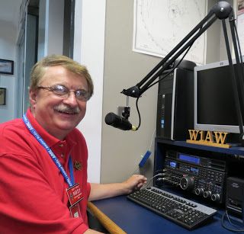Hey Gang...

Wow... Thanksgiving has now come and gone, and it was definitely a day to remember for sure. A lot of stuff got consumed on that day. Let me do a quick inventory…

Our 22 guests arrived around 12 noon and consumed 30 pounds of turkey, 11 pounds of ham, 8 large lobsters, 10 quarts of dressing, 8 large packages of Kings Hawaiian dinner rolls, 5 gallons of soda, 48 cups of coffee, 10 quarts of mashed potatoes, 6 quarts of mashed sweet potatoes, 3 - 9 x 12 dishes of green beans, 4 cans of cranberry sauce, 3 – large vegetable trays, 2 - 42” round serving tables, 6 chairs, 3 – sofa pillows, 1 – 48” L.E.D. TV and 8 pies (various kinds).

TOP ^

They then left our place around 4pm saying that they needed to find some place that serves ice cream for their desert! 😉

All kidding aside… We had a blast with family and friends. Some we haven’t seen in a very long time. And NO, we really didn’t consume all that I reported above, but I’ll bet I did get you to laugh!!

It’s always a pleasure to have them over for a dinner, and even though the above inventory was somewhat exaggerated… we did our part in making sure that no turkey went unconsumed. After all, didn’t your mother always tell you that you needed to clean your plate?

This past week I had the honor to present the certificate for Special Service Club to the Southern Ohio Amateur Radio Association. They’ve joined the ranks of the most elite of all clubs in Ohio. We salute them and all their hard work and dedication that they have and are giving to their club and community.

And… Like most Ohioans, this past Saturday and Sunday, it was a real weekend of celebrations for us. I got to watch my alma mater beat the tar out of that team up north! That was sure pleasure to watch that game. Go Scarlet and Gray!! And… if that weren’t big enough, my Brownies scoring huge against that team in Cincy that now has our old coach… Wow.. think there’s something to that??

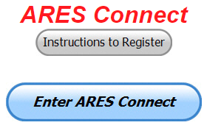Now… Let’s move down the band a bit and discuss some very important items that only YOU can make a difference with. I need you to get yourselves registered in ARES Connect, that is… if you haven’t already. Now, how do I know that you need to do this? It’s simple, we have a little over 700 now registered in the database. Stan’s last S.E.C. report shows that we have a little over 1,500 persons in ARES. That means that there is still a lot of you that haven’t taken the plunge yet and need to! What are you waiting for? No matter how much you resist, it’s coming, and we need to make sure that no one is left behind.

**Now, as an incentive to get you to not only register…. Notice how I have this in bold for you to clearly see?** I am giving away all sorts of goodies to help you get motivated. I have a footlocker of really cool items that I will be giving away! Oh, if you didn’t know, I’ve already given away an ARRL Handbook! What’s next? Who knows!! There’s lots more of things to choose from for sure and I’m not stingy about giving things out!

Don’t know where to get started? We have a set of instructions on how to get registered right above the button to enter ARES Connect. I would strongly suggest that if you haven’t registered yet, that you read these instructions first. Here’s a link to get you started... <http://arrl-ohio.org/ares_connect_directions.pdf>

Please, don’t just hurry through the questions, read them carefully, if you don’t understand something, please ask me, I’m here to answer your questions. We know that you mean well by answering that you do have the needed courses in, but I will let you know that we are verifying what you say you have with what is showing for you in our statewide database when we are completing your registration.

So, how can you find out if you are already listed in our statewide database? Easy, here’s a link to it…

<http://arrl-ohio.org/SEC/special/ICS%20Complete%20by%20County%20and%20Name.pdf>

We still need help finding some good E.C.’s in a number of counties…  Please, help Stan and I out by really considering becoming an E.C.!  Now I know that this may be too much for you to handle right now? I have a proposal for you. How’s about becoming an ARES Connect Data Entry Person. What’s this, a new position?

TOP ^

Yes!!! We need persons that can input events and approve hours into the new ARES Connect system. You do not have to be an E.C. for this, although we’d prefer that they would be willing to step up to that challenge someday. If we could just have some folks willing to do the inputting of events and approve hours for now I’d be eternally grateful.

Counties where this is only a RACES program in place. Please.. this is a great opportunity for you as that we will not interfere with any of the programs that you already have in place. In fact, it will help you in getting those valuable volunteer hours recorded as they have never been before!!!

How’s about it? Could you spend a little time just working with ARES Connect? Let me know!!!  Again, you do not have to be E.C.’s to do this work in ARES Connect.

We can give you admin privileges so that you can help with logging events into the system, keeping track of hours or even making sure that certificates get to Jim or I for placement into the statewide database.

Here are the counties that we really need help with. Allen, Fulton, Henry, Mercer, Paulding, Putnam, Logan, Adams, Brown, Clermont, Carroll, Athens, Jackson, Meigs, Perry, Vinton, Belmont, Harrison, Monroe.  This is a great opportunity for anyone that has a little time and is willing to volunteer.

That’s going to do it for this time around. Stay safe, and most of all… have FUN!!

Scott, N8SY

***Back Issues of the PostScript and Ohio Section Journal (OSJ)***



Hey, did you know that PostScript and Ohio Section Journal (OSJ) are archived on the website? You can go back and look at any edition simply by clicking:

<http://arrl-ohio.org/news/index.html>

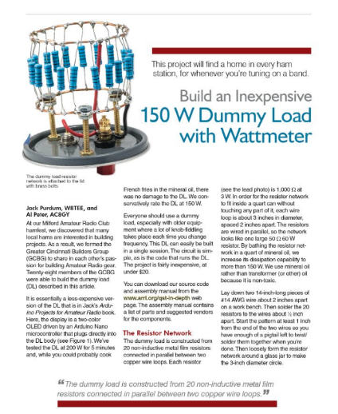***This and That’s***

**W8TEE and AC8GY Win the November QST Cover Plaque Award**

The winning article for the November 2018 *QST* Cover Plaque award is “Build an Inexpensive Dummy Load with Wattmeter” by Jack Purdum, W8TEE, and Al Peter, AC8GY. The *QST*Cover Plaque Award -- given to the author or authors of the most popular article in each issue -- is determined by a vote of ARRL members on the [**QST Cover Plaque Poll web page**](http://www.arrl.org/cover-plaque-poll).

Cast a ballot for your favorite article in the December issue today.

TOP ^

***Chit – Chat, and All That!***

Do you know someone that’s not getting these Newsletters? Please, forward a copy of this Newsletter over to them and have them “[Opt-In](http://arrl-ohio.org/forwarder/forwarding.html)” to start receiving them. Heck, just have them send me an email [n8sy@n8sy.com](mailto:n8sy@n8sy.com) and I’ll get them added to the Ohio Section Emailing list.

We now have many thousands of readers receiving these newsletters weekly. Quite impressive, I’d say! I urge all of you to make sure that everyone, regardless of whether they are a League member or not, get signed up to receive these weekly Newsletters.

You can always “[Opt-Out](http://arrl-ohio.org/forwarder/forwarding.html)” at any time if you feel this is not what you were expecting. It’s fun and very informative. All of your favorite past newsletters are now archived too.

You can go back at any time and read them. Just go to: <http://arrl-ohio.org/news/>

Got questions, concerns or would just like to sit and chat awhile? Heck, I’ll even buy the coffee!! Give me a call at (419) 512-4445 or email me at: [n8sy@n8sy.com](mailto:n8sy@n8sy.com)

The pictures on the front page are from various newsletters, Facebook posts and/or were sent directly to me in recent weeks. Take a good look at them, you just might be in one of the pictures! “SMILE… you’re on the Ohio Section News!!”



TOP ^

*PostScript is produced as a weekly supplement to the Ohio Section Journal (OSJ). I sincerely hope that you have enjoyed this edition and will encourage your friends to join with you in receiving the latest news and information about the Ohio Section, and from around the world!*