***[](http://arrl-ohio.org)*** ***December***

***Edition***

|  |  |
| --- | --- |
| **🡪** From the Technical Coordinator | **🡪** From the Section Emergency Coordinator |
| **🡪** From the Affiliated Club Coordinator | **🡪** From the Public Information Coordinator |
| **🡪** From the Section Traffic Manager | **🡪** Out and About |
| **🡪** From the Section Youth Coordinator | **🡪** From the Official Observer Coordinator |
| **🡪** ARES Training Update | **🡪**  Handbook Give Away |
| **🡪** Club Corner | **🡪**  ARES Connect |
| **🡪**  DX This Week | **🡪** You’ve Got Cards – Waiting |
| **🡪**  National News | **🡪**  Final.. Final.. |

***From the Technical Coordinator***

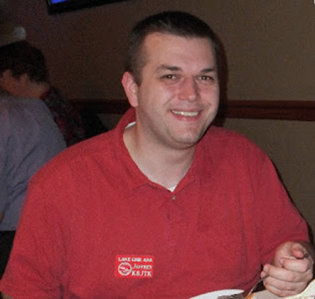***Jeff Kopcak – K8JTK TC***

[k8jtk@arrl.net](mailto:k8jtk@arrl.net)

Hey gang,

Hi. My name is Jeffrey and I am a Windows user. Yes, I migrated my laptop a couple years ago from Windows 10 to [Fedora Linux](https://getfedora.org/) and six months ago did the same for my main desktop. Windows applications are better. THERE I SAID IT. *I can hear the hate mail rolling in.* Anyway, I’ve encouraged readers to check out Linux as a Windows alternative. These are my experiences moving to a (mostly) Linux world over the last 6 months.

My goal was to move to Linux as my daily operating system. That is done. In that transition, find Linux programs equivalent to the Windows applications I was using. Anything I couldn’t find suitable replacements would be run in a Windows virtual environment.

In previous articles, I’ve written about the [disaster that has become Windows 10](http://www.k8jtk.org/tag/windows/) and my desire to find a less restrictive and obtrusive operating system. I settled on Fedora Linux because the virtualization worked better in my experience over Ubuntu. Moving my main desktop away from Windows was the last hurtle. This PC serves the duties of: audio & video recording (DVR mostly), ripping, editing and playing, graphics editing, web site editing, file storage and backup, virtual environment, web surfing, ham radio programming, and experimentation station. That pretty much covers it. You could throw in gaming about 10 years ago – who has the time? Also, the occasional document (image) scanning. This will become important later.

In my experience, what does work?

* Linux works. I have not had any issues getting Fedora to work on stock laptops or my custom-built desktop machine. With few drivers to install, all hardware works including USB 3.0. Most of the pre-installed programs (graphics viewer, LibreOffice, music & video player) are very usable programs.
* Package manager. This keeps the operating system and programs updated when approved by maintainers of the distribution. When I can, programs are installed through the package manager and I’ve accepted all updates when made available. I may have had a Kernel issue once or twice but simply selected a previous version at boot time.

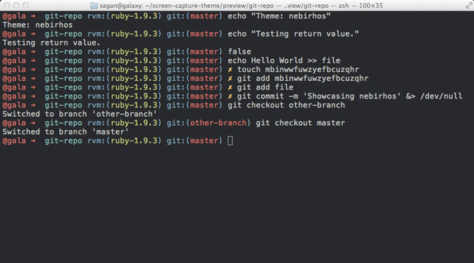

Oh My Zsh customized terminal

* Customization. I spent some time [trying out different desktop environments](https://spins.fedoraproject.org/) because I cannot stand tablet-style interfaces in desktop environments on non-touch screen devices. Gnome, I’m talking about you! Cinnamon is probably the closest to a Windows desktop-like feel with start menu, taskbar, and system tray.

TOP^

* This is the one I choose. Customization tools import and apply different theme options. I replaced the bash shell with [Oh My Zsh](https://ohmyz.sh/). Came for the themes. Stayed for the awesome autocomplete.
* Virtualization works very well with VirtualBox. I’m looking at getting virt, virt-manager, and KVM working in the future.
* Cross-platform apps. I’ve had good experience with applications that have a strong user base and are ported to different platforms. These apps would include VLC (formally VideoLAN), HandBrake, Thunderbird, Firefox, VirtualBox, and VeraCrypt. This is likely because development efforts contributed to the project benefit all platforms.
* Web apps. Many services today are moving away from software installed on a PC to web-based services. Having a modern web browser is all that is needed to interact with these services.

Where have I run into issues?

(Lack of) Popularity, including vendor support. This covers 75% of my issues. According to [StatCounter Global Statistics](http://gs.statcounter.com/), looking over the last two years at desktop and laptop platforms used to browse the web, Linux hasn’t passed the 2% mark and is currently holding steady at about 0.8% in the U.S. In comparison, OS X is at about 20% and Windows about 75%. Servers typically don’t browse the web so these numbers represent users running Linux to do a common computing activity, like browsing the web. When there are financial decisions to be made on developing an app or service, you’re going to go where the customers are. Linux hasn’t gained any significant market share when compared to that disaster operating system or the hardware priced out of the budget of average users (Windows & Mac).

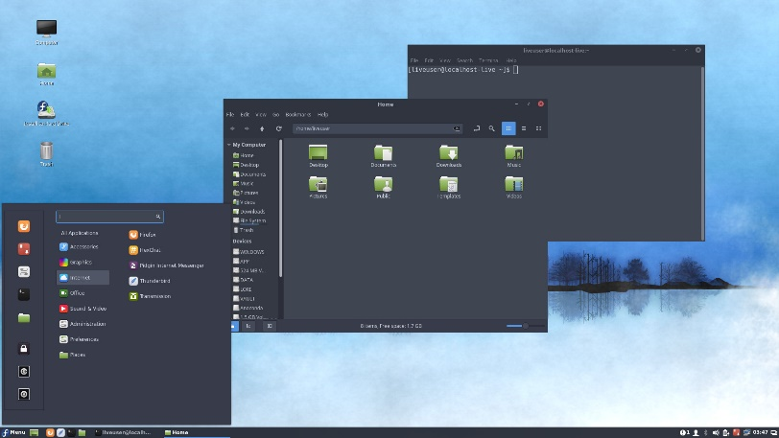

Fedora Cinnamon spin

Vendors are simply not focusing a lot of their resources on a small segment of users when others like Windows eclipse that 2%. I’ve run into a couple examples. First being the drivers for the NVidia graphics card in my desktop. The process of getting this driver installed is a fairly complicated process. It’s dependent on system BIOS and involves editing Kernel boot options – not something average computer users are comfortable doing. If you’re lucky, you’ll magically end up with an NVidia driver that works with the installed Linux Kernel. The open-sourced driver, Nouveau, generally works for me but I notice flickering on some screens like ones with dark gray backgrounds. Nouveau has crashed a couple times when I had a bunch of applications running at once. A sinking feeling knowing how many applications I had open and not knowing when I last clicked save is not my idea of a good time.

I installed the Epson Linux image scanning driver for my flatbed scanner. The app very closely resembled the Windows application which made it familiar to use. However, though the manual indicates I should have been able to scan multiple pages and save them as a single PDF file, I did not have this option. I tried the native Fedora app, Simple Scan. It was way too simple. Automatically scanning the next page of a multi-page document after a selectable 3-15 second interval didn’t make any sense to me. Others I tried created ginormous sized PDF documents, 50MB file vs 3MB using the Epson Windows app. There is no reason to have files that large and some email systems have attachment limits of about 25MB.

In August, Dropbox announced they were dropping support for almost all Linux file systems. Many users were upset. Speculation was Dropbox had to support a wide variety of Linux distributions, file systems, desktop environments, and Kernels where they didn’t see any return on this investment.

TOP^

Companies often take a chance hoping users purchase paid subscriptions to support further developments in these areas. Linux users weren’t subscribing to sustain further development and support, so it was dropped. Most Linux users like free stuff because, well, the operating system itself is free.

I would say the remaining 25% of my issues are round quality of applications. While there are video ripping, editing, and authoring tools available, they don’t hold up to the Windows tools I’m using. Most users are on Windows so that’s where companies devote their time. Application authors who set out to make equally good tools in Linux may run into problems or lack of interest either in terms of downloads, support from the community, or through life, job, or family changes. Handbrake and VLC work as well in Linux as Windows. Video stream repair and splitting, DVD and Blu-Ray authoring, DVR, and audio ripping – not so much. Still using Windows applications. Not saying all Linux tools are bad because there some really powerful ones.

My desktop was the big obstacle to accomplishing my goal of getting Linux as my daily operating system. 99% of the time that system is running Fedora. I do have a number of virtual Windows machines for things like MS Office, radio programming, SDR programs, and my cord-cutter service – which says it will work in Chrome, but its only Chrome running on Windows. For applications and hardware interactions that didn’t work well in a virtual environment, I resized my original Windows partition down to about 30 GB and boot into Windows only when I need it. My shack PC is going to stay on Windows 7 because some of my ham activity is tied to programs only available on Windows.

These have been my experiences in moving away from the Windows disaster into an alternative desktop & laptop platform – Fedora Linux. These might motivate you to try Linux or some other Windows alternative. It will be like learning something new for most people. I had ideas of what the experience would look like and challenges having supported and programmed in Linux environments for the better part of a decade. The Mac platform has really become popular with great applications and great support from Apple. If you’re not willing to drop a significant amount of money on their devices, consider looking at Linux as an alternative.

**Late breaking for FT8 users:** if you operate either the very popular FT8 or MSK144 digital modes, [please update your version of WSJT-X to 2.0 by January 1, 2019](http://www.arrl.org/news/wsjt-x-2-0-full-release-now-available-ft8-enthusiasts-urged-to-upgrade-now). These protocols have been enhanced in a way that is not compatible with previous versions of [WSJT-X](https://physics.princeton.edu/pulsar/k1jt/wsjtx.html). After that date, only the new version of those modes should be used on the air.

Thanks for reading. Happy holidays, Merry Christmas, and Happy New Year!

73… de **Jeff – K8JTK**

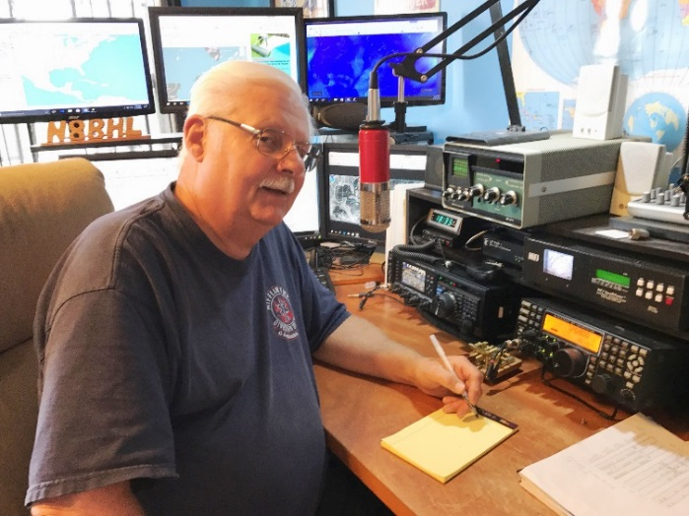***From the Section Emergency Coordinator***

***Stan Broadway, N8BHL - SEC***

[broadways@standi.com](mailto:broadways@standi.com)

As winter draws near, some indoor activity to keep you busy.

My hat’s off to you snowbirds- I’ll wave a sad farewell as you trek southward to the warm climates. Here in Ohio I secretly hope that since we must endure another winter, we have one worth bragging about!

TOP^

Bring on a blizzard- it’d be fun to be at home for a few days watching the drifts, digging with the tractor. I guess I just jinxed myself with that one.

For us in ARES, there is a lot to do and this is a good season to get ‘r done. ARES depends on the enthusiasm and energy from our county Emergency Coordinators – the EC is king around here! Members, perhaps you could volunteer with some assistance here, take the load for your EC.

1. Review and revise your county membership roster. Did this person show up for training, for events? If you haven’t heard from them- make a phone call! An honest roster, though smaller than you’d like is less of an embarrassment that a roster with people who aren’t interested…or even dead.
2. Encourage your members to register in ARES Connect. (I entered some of my people for Delaware County, they merely need to change passwords and fill out the questionnaire.) That way we can count their hours immediately.
3. Be ready yourself or have a designee ready to enter and record your county’s activities in Connect! There’s a little discomfort in getting it started, but once you’re running, I think you’ll like the accountability.
4. Plan out some training for 2019. The best way to keep your people active is to ~do something~ and a monthly training meeting is an excellent way to go. It’s actually expected…so there is that. Write out a series of things you’d like to train: damage assessment, message handling, tabletops, digital stuff, antennas…anything that goes with a response. You should be able to come up with a dozen, and tada…there’s your yearly plan!
5. How long since you touched base with your agencies? It’s nice to think that “they’ll call if they need us” but the truth is more like if you don’t stay in contact, they’ll forget all about you, or at least not understand the breadth of our resources. If you need to, sit down with your EMA Director and review what the county’s concerns are (I call it the top ten “headache” list) and see where we could fit. Try a meeting with your local hospital, your health department, and even your board of elections. Yes, amateurs are being used more and more as poll watchers/communicators during elections…and the next few will surely be more active. You can give the agencies a picture of our capabilities, and get from them some ideas for more service, more training and better cooperation!
6. When it hits the fan it will probably come suddenly. How are you going to alert your folks? A phone tree is slow, cumbersome and inaccurate…so how about devising an alternative? Some counties have robo-dialers available. I’m jealous. We have constructed an “email-to-text” forwarding address that will text a 160-character message to all…hopefully before the entire cell system collapses. We also have email lists. Of course, there is alerting on repeaters as well but that requires people to be listening. Now’s the time to review your options!
7. When is the last time you reviewed your county’s emergency operations plan? The Ohio Section Emergency Response Plan (OSERP) is available as a model and I’m following my own advice for some revisions this winter! You are welcome to pattern your county’s plan or develop one of your own- but you NEED a plan! Work with your agencies so you’re not blindly creating something. Remember we need to include an alternative mode or band to two meters…fldigi, HF, digital voice, any of the alternatives might become way more important to us in the coming couple of years. Does 6 meter sideband figure in?
8. Review your winter response plans. Maybe…just maybe…it could turn heavy white instead of drab brown.
9. If you have ever thought, “Now why don’t they do it this way??” please write your thoughts and suggestions in an email to [stan@standi.com](mailto:stan@standi.com)! This is an organization made up of ALL, and the best ideas come from people “on the street”… I depend on your ideas to make us all better! There have to be things we can improve.

TOP^

1. VERY IMPORTANT! Say “Thanks” to your own people! Keep track of their hours, and put together an “attaboy” certificate to honor the time and dedication they’ve put in this year. A “Thank you” goes a long way.

My thanks go to all of you for what you do routinely to help your neighbors! ARES has the respect of Ohio’s responding agencies, and it’s all because of the good work you do.

**73, Stan, N8BHL**

**You can view all of the SEC’s monthly reports on the website..** <http://arrl-ohio.org/SEC/default.html>

***From the Affiliated Club Coordinator***

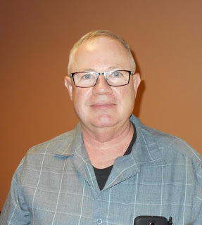***Tom Sly, WB8LCD - ACC***

[tomsly29@gmail.com](mailto:tomsly29@gmail.com)

We had a recent experience at PCARS which really made me wonder about the future of our hobby. We had a VE session on a Saturday morning that had 7 people show up for their tests. Five of the 7 were there for the Technician class test, and the other 2 were there to try for an upgrade. Seven out of 7 left with either a new license, or an upgrade. Every one of them there that day was age 55 and older! That seems to be a common phenomenon. I talked with every one of them and their stories were all pretty similar – “I was a novice back in the (50’s, 60’s or 70’s) but I let it go. I’ve always been interested *but now that I’m retired, I have the time for it”.* When you think of all the ways that people spend their leisure time, why is it that they only have time for it now?

Obviously Amateur Radio has a Public Relations problem. It’s all about our Image. But who’s responsible for that?

A lot of it has to do with our culture and society. The early 1900’s up until the 1970’s our society was fascinated with scientific and technological advancement. A lot of which happened in basements, garages and back yard outbuildings at an individual’s residence. As it got more advanced, more complicated, much of the technical stuff had to be done in the industrial labs. As a society we looked for other ways to entertain ourselves and left the “scientific” stuff to the professionals. We shifted our leisure time activities to more fields of “pure entertainment”. Amateur sports, watching professional sports, movies, TV programming, video gaming……. For the most part endeavors that don’t require too much intellectual/scientific/mathematical involvement. There are exceptions, but not many. These are just my observations and opinions, you may agree or disagree, but the point remains that Amateur Radio has not positioned itself to where many people in our society are aware of, or have a real perception of, what Amateur Radio really is. This is “OUR” fault.

After the 1970’s is about the time period that Ham Radio began to disappear from the mainstream of hobbies and personal entertainment. People retiring who “always wanted to do Ham Radio” but didn’t have the time to, will no longer exist if they haven’t been exposed to it. If we want the hobby to survive, we need to start recruiting a younger generation and we need to start building a “public perception” of what Amateur radio is and why it’s a valuable piece in our society.

TOP^

As we move into the new year, let’s make a resolution to personally be a part of the solution! Here’s a simple way to start: smile, be positive and be open to all new hams and people who have an interest. Look past age, gender, technical ability, social status, personal issues, whatever. Concentrate on the art, science and activities of Ham Radio! Never should be heard a discouraging word. Let *everyone* know that they are welcome, and we want them to be a part of us.

Local clubs can be instrumental to bringing new people into the hobby. We all have club meetings every month. Those should be opportunities for showcasing our hobby! You do have interesting meetings, don’t you? If you do, then you should advertise and invite. I’ve seen many club meeting announcements that certainly wouldn’t pull me off the couch to show up. The announcement should include an invitation to non-members along with the information that there will be something of interest going on at the meeting! If not, how are you even going to get your members to show up? So maybe your meetings should have a presentation that would be interesting to both hams, and ham wannabes?

All of our club activities should include an invitation to those who are not hams. Let’s try to build some interest in the things that we are doing. I’ve already mentioned our monthly meetings, how about operating events? Field Day, OSPOTA, Sweepstakes, DX Contests, State/Section QSO parties – we do a lot of operating! Set up at public locations and invite the public to come check it out. Better yet, invite them to sit in the chair and get on the air. Add in some digital modes, satellite q’s and maybe even a Space Station contact and now you’ve got some people interested in what we do. Like to build things? Next build day invite the public (especially the kids) and offer a couple simple, inexpensive projects along with simple training on how to use hand tools, how to solder, how to identify electronic components. Send them home with something they built themselves and I guarantee they’ll have a smile on their face when they leave!

What has your club done? What ideas do you have? Send them along to either Scott or myself so we can share them with the other clubs in the section! The Ohio Section is already the largest Section in the ARRL. All I want for Christmas is this: By the end of 2020, I would like to see the OH Section recognized for being the *fastest growing* Section in the ARRL, and, for *bringing down the average age of a ham* in the section. If we could make a dent in those two issues, it would go a long way to keeping Ham Radio alive for future generations.

I want to wish you all a Merry and Blessed Christmas with your family and friends, and I hope that the new year brings you Joy, Happiness, low SWR’s and High Sunspot numbers!

73, Tom WB8LCD

***From the Public Information Coordinator***

***John Ross, KD8IDJ - PIC***

[john.ross3@worldnet.att.net](mailto:john.ross3@worldnet.att.net)

**FROM THE PIC**

**2019 NEWSLETTER CONTEST**

Well, it’s here…. the OFFICIAL start to the 2019 Ohio Section Newsletter Contest!

TOP^

****If you send out your January newsletter in December…. you can enter the contest now! You will still need a newsletter from a different month (a total of two) to be officially entered and eligible for judging.

Most everyone sends a newsletter every month or a notification their electronic newsletter/website is ready for viewing.  They all go into a special electronic file; the paper newsletters are printed (in color) and filed away in a heavily guarded steel rack cabinet until July!

I read all of the newsletters but can’t tell anyone what you’re up to!  The first time the judges see them is at the July judging table and I have to sit back and watch the magic happen! Our judges are pretty good picking the local winners and over the last few years we have generated regional winners as well. They are all seasoned journalists and public relations professionals who have been where we are….in the trenches of turning out monthly newsletters.

In case you forgot, here’s a little background:

**Steve Wilson**, President, Wilson Group Communications.

Steve is a Vietnam Veteran and was a correspondent during his time in Vietnam. He worked for many of the larger news organizations across the country and his work has been nominated for a Pulitzer Prize

**Donna Wilson**, Vice President, Wilson Group Communications

Donna is a communications professional and has worked with hundreds of clients and organizations.

**Jeanne Fox**

Jeanne is experienced Broadcast Journalist and worked for stations in Toledo and for CNN.  A PR Professional she also worked for the Borden Company in Columbus.

**Kim Norris**

Kim is also an experienced Broadcast Journalist working for local TV in Columbus. As a communications and public relations professional she has held positions at AT&T and several State Of Ohio departments.

We have a new judge joining our ranks this year…her story is below.

All of us take the Ohio Section Newsletter Contest seriously…so do our judges. It’s what makes this the best and longest running contest in the country and what keeps our HAMS on top of their club’s activities.

The OFFICAL rules are also below…call or email with any questions…and remember we are all winners. Thanks for all you do for Amateur Radio.

**NEW JUDGE FOR THE NEWSLETTER CONTEST**

A new judge will be joining our current four judges for the 2019 Newsletter Contest…Erin Cribbs.

Erin worked for AT&T for 18 years…ending up in the President’s Office!

TOP^

Earlier this year, after sending her daughter off to college, she decided it was time to get back to her own degree work, so she enrolled in Columbus State. She will complete her Associate degree in May then after a semester at Capital University will have her degree in Business and Marketing.

She also has a little journalism DNA. She wrote for a couple of local rags and, while working with me, she was under the watchful tutelage of a seasoned journalist!!!

Erin will add another set of eyes and another dimension to our judging ranks.  She will be a welcomed addition and help us with the BEST newsletter contest anywhere.

**HAMS AMOUNGST US**

It may be just me, but I keep finding amateur radio operators in the strangest places…and not when I’m looking for them.

Last week, while at lunch with fellow employee, I learned that a guy in the room across the hall was a HAM! I have talked this guy for months, known him for years, and the subject or amateur radio never came up despite a handheld radio hooked to my belt and a 19” mag mount antenna hanging from the ceiling above my desk.

I rushed back to the office to tell him the good news and found out he had been transferred to another location! Just missed him by that much!

A few phone calls later, and after much amazement, we made contact, and all is good in the world of amateur radio.

If there is a moral to this story, I think it would be…look around, keep talking about ham radio and maybe, and wear a name tag with your call sign on it! We are everywhere!!

**CHRISTMAS EVE DX**

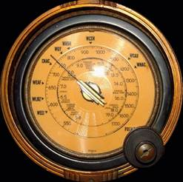I guess this all started when I was a kid and found out there weren’t reindeer flying across the sky on Christmas Eve.

I would go down to the old coalbin/converted –to-ham-shack and, only by the light of the dial, listen to the DX from around the world. Turning the knob would bring in holiday conversations from every part of the globe and made me feel like I was connected to a very large Christmas party. Some of the conversations were hard to hear with all of the static and whine but those were the best…usually from the furthest corners of the world.  It was mesmerizing and went on for hours lasting sometimes just before dawn on Christmas morning. A kid with a shortwave radio staying up all night…imagine that!

I still do this today…when I can…in the quite of the evening and only by a dim light.  A blast from my past…yes…a reminder there is a big world on the other side of the radio.

TOP^

Being an amateur radio operator, I can now talk to those folks…share greetings…but it’s the listening that still means the most. In the solitude that surrounds Christmas Eve you can hear many things beyond conversations.

I appreciate how I came to this hobby…to this point…and what I’ve learned around electronics and human nature. Amateur Radio is connection that’s more than static and whine… it’s a reminder that we are a very small part of a much bigger entity…and should revel in every moment on the air or off.

My thanks for a great year of ham radio….and I hope your holiday is meaningful and happy.

Merry Christmas!

73

John E. Ross

Ohio Section PIC

KD8IDJ

***From the Section Traffic Manager***

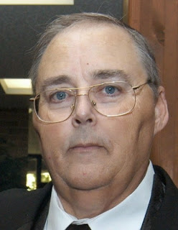***David Maynard, WA3EZN – STM***

[wa3ezn@att.net](mailto:wa3ezn@att.net)

How about that early winter weather? Starting with lake effect snows in Cleveland, Erie, Buffalo and New York? I was raised in Pennsylvania about one mile south of Lake Erie so I know a little about lake effect. Shovel your way out in the morning to go to work and shovel your way back in at night when you get home. My son lives in Cranesville Pennsylvania and he has sent me some striking pictures of their snow including a picture where interstate 90 was shut down and declared impassible.

Then there was the storm on North Carolina with a large amount of snow in some areas. But I find it hard to imagine it snowing one foot per hour for several hours. People were stuck in buildings, trapped in cars and they even had some roof collapse on several building. I wasn't there so maybe the news media hyped it up some for headline affect.

Here in Columbus Ohio we had some snow but not like the other areas have been hit. The snow whitened the grass and then simply disappeared. So I think that this is a good time to think about winter safety. It doesn’t matter if you are just heading out the door to work or taking that trip to grandma’s house for Christmas you should be thinking about car safety.

Here are some things you should do to prepare for that snow emergency.

Don't get stranded out in the cold. Here are things you may want to check on and have in your car for winter travel. You probably have these things, but they are no good to you in your house or garage when you are stuck on the road. All you need to do is gather them and place them in your car before leaving home and traveling.

TOP^

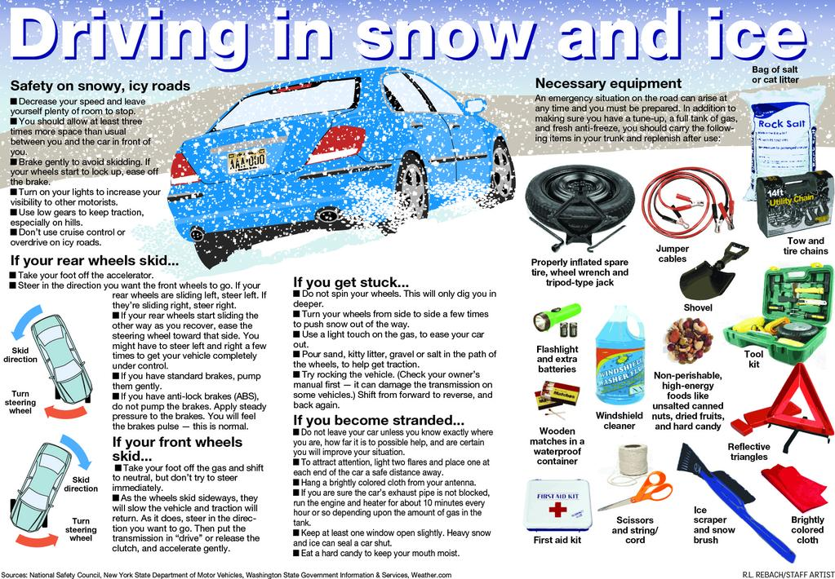Before you leave on a road trip, make sure all of the following are in safe operating condition.

Windshield Wiper Fluid; Heater/Defroster; Wiper Blades; Antifreeze; Lights; Fuel System and a Full Tank of Gas; Ignition - Exhaust System; Tire condition; Battery; Brakes; Jack and lug wrench to change a tire and check tire pressure in all four tires and the spare tire

Items you should have available if needed.

Flashlight, plus extra batteries (or a hand-crank flashlight); jumper cables; first-aid kit; bottled water; road flares or reflective warning triangles; small fire extinguisher in case of a car fire; gloves, rags, hand cleaner (such as baby wipes); Duct tape; foam tire sealant for minor tire punctures; rain coat or poncho; non-perishable high-energy foods such as granola bars, raisins, and peanut butter; battery– or hand-crank–powered radio; lighter or box of matches; spare change and cash; paper maps in case GPS is not functioning.

For those in wintry areas, adding these items for your personal safety, blankets; gloves; hats; ice scraper and

snow shovel; cat litter; blanket; tire chains and tow strap; hand warmers; winter boots for longer trips; sleeping bag for longer trips.. I think by now you got the idea. Being prepared is a good policy.

If you not going anywhere on New Year’s here is something fun to try. The ARRL Straight Key Night is coming up on January 1, 2019. Why not dust off that old straight key and give it a try.

TOP^

Who knows you may like it and have some fun. Straight Key night starts at 0000Z and ends at 2359Z (UTC). More details can be found at [www.arrl.org/straight-key-night](http://www.arrl.org/straight-key-night) .

I like to smile. It makes people think I am up to something!!

To you and yours, have a Merry Christmas and a safe and happy New Year.

David

WA3EZN

Ohio Section Traffic Manager

**73, David, WA3EZN**

You can view the STM’s monthly report on the website.. <http://arrl-ohio.org/stm/stm.html>

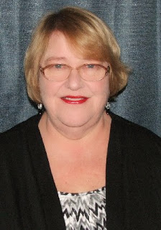***Out and About***

***Lyn Alfman, N8IMW - ASM***

[lynalfman@aol.com](mailto:lynalfman@aol.com)

**LOCAL CLUB NEWS**

The Cambridge Amateur Radio Association (CARA):

1. Provided line up and communications for the Cambridge Christmas Parade on November 24. (Just as they have done every year since 1979—every year for 40 years.
2. Provided lineup and communications for the Byesville Christmas Parade on December 1 (third year)
3. Operated a Special Event Station December 8 in honor of the club’s 105th anniversary of its founding.
4. CARA will have its annual Awards Banquet on December 21.

The Zanesville Amateur Radio Club (ZARC) had its Christmas dinner at Ichiban on December 4.

The Coshocton County Amateur Radio Association (CCARA) 2019 Officers are:

President Jamie Hoy, KC8YXY

Vice President Randy Fisher, KL7RF

Treasurer Thomas Cordes, KB8HEA

Secretary Will Parks, KC8PUW

Trustees Heide Stucki, KB8VIP; James Waibel, KE8WIP; and Michael Miller, KC8ZWR.

The Morgan (County) Amateur Radio Club (MARC) is discussing plans for a Winter Field Day again this year.

Normally, most amateurs are busy planning social activities with family and friends for the holidays. January and February are months where “ham” activities slowdown and people hole up for the winter. However, there are things that “hams” can do to make the most of the season.

TOP^

There are hamfests to go to:

Sunday Creek Amateur Radio Federation (SCARF) hamfest on January 15 in Athens.

TUSCO Amateur Radio Club (TUSCO ARC) hamfest on January 29 in Strasburg.

There are also many on the air events such as the following just to name a few:

* Straight Key Night - January 1
* Kids Day - January 5
* ARES VHF Simplex Contest – January 12
* January VHF Contest – January 19-21
* Winter Field Day – January 26-27

This is also a good time to catch up on you award certificates such as WAS, WAC, etc. Just get on the air and stay warm by operating a “hot” mike over a “warm” radio.

**HOLIDAY FIRE SAFETY TIPS**

To keep your household from becoming a holiday fire statistic, here are some safety tips to follow:

**Cooking**

Cooking is the top cause of holiday fires. The most common culprit is food that is left unattended. It is easy to get distracted; take a pot holder with you when you leave the kitchen as a reminder that you have something on the stove. Make sure to keep a kitchen fire extinguisher that is rated for all types of fires, and check that smoke detectors are working.  If you are planning to deep-fry your holiday turkey, do it outside, on a flat, level surface at least 10 feet from the house.

**Candles**

Candles cause four times as many fires during December than during any other month. So, to prevent a candle fire, maintain about a foot of space between the candle and anything that can burn. Set candles on sturdy bases or cover with hurricane globes. Never leave flames unattended. Before bed, walk through each room to make sure candles are blown out. For atmosphere without worry, consider flameless LED candles.

**Christmas Trees**

It takes less than 30 seconds for a dry tree to engulf a room in flames. To minimize risk, buy a fresh tree with intact needles, get a fresh cut on the trunk before placing it in the stand, and water it every day. A well-watered tree is almost impossible to ignite. Keep the tree away from heat sources, such as a fireplace or radiator, and out of traffic patterns. If you are using live garlands and other greenery, keep them at least three feet away from heating sources. No matter how well the tree is watered, it will start to dry out after about four weeks, so take it down after the holidays. Artificial trees do not pose much of a fire hazard; just make sure yours is flame-retardant. Bedtime means lights off! ­ Do not forget to turn your Christmas tree lights off each night.

**Decorative Lights**

Inspect [light strings](https://www.houselogic.com/home-advice/appliances/holiday-light-safety/), and throw out any with frayed or cracked wires or broken sockets. When decorating, do not run more than three strings of lights end to end. Extension cords should be in good condition and UL-rated for indoor or outdoor use. Check outdoor receptacles to make sure the ground fault interrupters do not trip. If they trip repeatedly, that is a sign that they need to be replaced.  When hanging lights outside, avoid using nails or staples, which can damage the wiring and increase the risk of a fire. Instead, use UL-rated clips or hangers. And take lights down within 90 days.  If you leave them up all year round, squirrels can chew on them, and they get damaged by weather.

TOP^

**Fireplaces**

Soot can harden on chimney walls as flammable creosote, so before the fireplace season begins, have your chimney inspected to see if it needs cleaning. Screen the fireplace to prevent embers from popping out onto the floor or carpet, and never use flammable liquids to start a fire in the fireplace.

Only burn seasoned wood. And, when cleaning out the fireplace, put embers in a metal container and set them outside to cool for 24 hours before disposal.

**Kids Playing with Matches**

The number of blazes and the number of deaths caused by children playing with fire goes up significantly during the holidays with the use of candles and fireplaces. So, keep matches and lighters out of kids’ reach.



Be Safe and be Radio Active!

**73 Lyn, N8IMW**

talkie

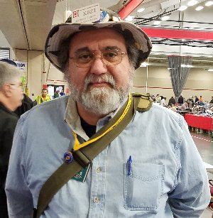***From the Section Youth Coordinator***

***Anthony Luscre, K8ZT - SYC***

[k8zt@arrl.net](mailto:k8zt@arrl.net)

**New Year Resolutions**

As we come to the end of another year its time to put together your New Year’s resolutions.



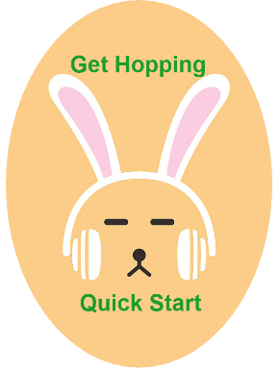Let me make a few Ham Radio suggestions:

* **GOTAMO-** Get On The Air More Often! You will not regret it as you meet new friends, learn more and have more fun.
* **HAYGOTA-** Help a Youth Get On The Air.
* **GANAL-** Get A New Amateur Licensed. Share this link [tiny.cc/new-ham](http://tiny.cc/new-ham) to “Ham Radio Intro & Quick Start Guide”.
* **MANARO-** Mentor A New Amateur Radio Operator. Invite a newly licensed or upgraded ham to your shack to make their first QSOs with their new privileges. Help put up a new antenna, set up a new radio, interface a radio to a computer, set up a new mode, help them learn to contest, etc.

TOP^

* **LSNED-** Learn Something New Every Day. Don’t forget your own development.

Don’t worry I have resources for you to meet your resolution goals on my website - [www.k8zt.com](http://www.k8zt.com). For **GOTAMO** you might want to visit my Contesting ([www.k8zt.com/contesting](http://www.k8zt.com/contesting)), DXing ([www.k8zt.com/dx](http://www.k8zt.com/dx)), Digital ([www.k8zt.com/digital](http://www.k8zt.com/digital)) or Satellite ([www.k8zt.com/space](http://www.k8zt.com/space)) web pages. For youth and student activities, I keep a running archive of excerpts from my OSJ Articles each month-- “Amateur Radio Education Outreach Column Collection” at <http://tiny.cc/ar-ed-out>. As far as LSNED you may want to visit my “[Raising your PHRE (Personal Ham Radio Education) Level”](https://docs.google.com/document/d/1HLc_ncQCPw4mCxBPq0p-Ubu98g_Z47Tk0VNMtiqJifE/edit?usp=sharing) article, my article on [learning and operating Morse Code](https://docs.google.com/document/d/112WnFti7TK45hORE58rES1XV0_uTh5r9SN3oqsij8SE/edit?usp=sharing) and my LSNED page for education- [www.ztlearn.com/lsned](http://www.ztlearn.com/lsned).

73,

**Anthony, K8ZT**

*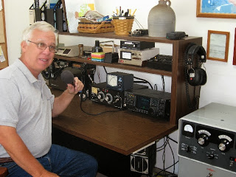****From the Official Observer Coordinator***

***John Perone, W8RXX - OOC***

[w8rxx@arrl.net](mailto:w8rxx@arrl.net)

The Ohio OO's monitored a total of 954 hours on November.

Perhaps with Christmas approaching no OO cards were sent.

Does everyone have a copy of the latest FCC rules and regulations? The Fourth Edition effective November 1, 2017 is available from the ARRL. (Item # 1173) or you can simply download it from the government’s website: [>> Here <<](https://www.ecfr.gov/cgi-bin/text-idx?c=ecfr&SID=336ab7469b61ecbfa15086dbf1bf2c59&rgn=div5&view=text&node=47:5.0.1.1.6&idno=47#47:5.0.1.1.6.1.157.1)

**73, John, W8RXX**

*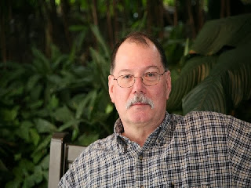****ARES Training Update***

***Jim Yoder, W8ERW – ARES Data Manager***

[w8erw@arrl.net](mailto:w8erw@arrl.net)

Here we are at the end of another year and it has been quite an active one for our ARES training growth. Seeing the amount of data now being kept, I have begun a verification process to insure all of our records are up to date and accurate. As I receive certificates documenting training, they are entered into the database and the certificates stored by county and individual call. The storage is redundant across several media to help insure from loss or damage.

All files are kept on a redundant NAS drive, Network Attached Storage using a Raid 0 configuration on a pair of 2TB drives. This is then repeated on a second identical NAS using SyncToy, an MS utility that synchronizes both NAS devices to each other. As further backup, Google Drive is employed as well as a portable hard drive and a USB memory device.

TOP^

All of this is done to insure the ever-increasing amount of data is not lost or compromised. Also, when I am away from the shack here in Fremont, the portable and USB drives allow me to administer the database as necessary while I am away.

Now for the rest of the story, my guess is that many of you like me have had issues with the Windows 10 initial update process and may have had problems with later updates from MS. Every machine that I have to date has experienced a failure requiring a reload of Windows 10 and the subsequent loss of user data. All well and good for the training data until Google Drive was setup under the new Windows 10 reload. For some reason, Google Drive did not like this and initiated its own logic to the process rather than mine. The result was that some random files of the actual certificates were not kept intact. I’ve managed to recover most of those however there are a few that were not able to be recovered.

As I verify all of the records, I am identifying those with issues and making corrections for updated calls and a few members who have relocated. Records are maintained by call and by county of residence. For those records with missing data or other issues that I am unable to resolve, I will notify the ARES member and the local County Emergency Coordinator so that the missing certificates can be obtained, and any additional issues can be resolved.

If you are contacted, I would appreciate your help in making any corrections necessary including obtaining any missing certificates. This would be a great time for anyone who may have additional certificates that have not already been submitted to submit those also.

A simple way to do this would be to request a Transcript from FEMA. This would insure that any and all FEMA training that you have completed will be a part of your training record that I maintain. In the case of one or two missing certificates, resubmission of just those is certainly acceptable also. I will leave that choice up to you.

We should end the year with some respectable numbers again. At present we have 879 members who have completed Level 2, the initial 4 NIMS courses. 130 have completed Level 3, ICS-300 and ICS-400. A total of 7,597 certificates have been submitted to the training database of which 971 were logged this year. This was an increase over 1017 of 94 certificates. Please don’t forget, our Section Manager has been giving away a nice official ARES safety vest each time we attain another 25 NIMS completions. Several have already received theirs and you could very well be next. There are a significant number who could gain Level 2 by submitting that one remaining course. And many more who need the remaining 2 courses. There is still time this year to get yours entered and a chance to wear one of these really nice ARES vests courtesy of N8SY.

My calendar says we now have less than two weeks until we celebrate Christmas. My wish for each of you is for a Happy and Merry Christmas. Perhaps the guy in the red suit will bring you something new for your shack. It has been a great year friends and I thank you for the hard work, your dedication and the many fun ARES events we have had this year. As you take a break to celebrate, be safe and may the spirit of Christmas be with you.

Thanks Much,

73, **Jim, W8ERW**

TOP^

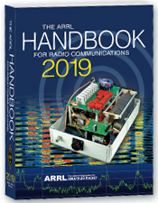***The Handbook Give Away***

Hey Gang,

It’s Christmas… and I’m going to be Santa and give some Christmas Gifts to you!

Go to: <http://arrl-ohio.org/handbook-christmas.html> and get registered NOW.

What’s the catch? I want to get everyone checking in to the Ohio Section website as often as possible, and in order to register each month, you have to visit the website often! There’s nothing else to it. I pay all expenses, and from time to time, I Give Away more than just a Handbook. And, you’ll never know just what months will be those special times that I will have more than just a Handbook to Give Away!!

Many of you ask me just how do I know when the drawing is on? Well, that’s easy all you need to do is check in on the Ohio Section Website on a regular basis and watch for the big **RED** Arrow that will appear on the left side of the page. This is the sign that the drawing is on and you need to get registered. So, keep a sharp eye out on the website and check in often! <http://arrl-ohio.org/>

***Club Corner***

******This is YOUR cornner of the newsletter. Send me what your club is doing and I’ll make sure that it gets in. Got a special event or club project that you want everyone to know about? Send it to me!. Need help with a project? Send it to me.

Let me know what you club is up to. Are you going to have a special guest at your meeting or are you having a special anniversary? Just sent it to:

[n8sy@n8sy.com](mailto:n8sy@n8sy.com)

#########

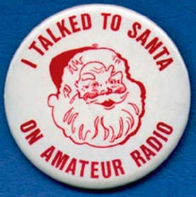***Kids Talk To Santa***

If you are interested in helping your area kids talk to Santa via Amateur Radio, here’s a great link for you… <http://www.hdscs.org/npn/npn01arrl.html>

#########

***Record crowd attends Highland Amateur Radio Association Christmas party***

*(By Mickey Parrott - The Highland County Press)*  
The Highland Amateur Radio Association (HARA) held its annual Christmas party Tuesday, Dec. 11 at Robison Hall in the Hillsboro First United Methodist Church. 

TOP^

According to club member John Levo, there were 84 reservations for the largest gathering in the association's 41-year history. There are 126 members and 113 licensed ham radio operators in HARA, including 28 who received their license in 2018. In addition, more than 400 people receive Levo's newsletter "Monday Morning Memo."  
  
The Highland Amateur Radio Association welcomed special guest Tom Delaney, vice director of the American Radio Relay League's Great Lakes Division, at this year's event.

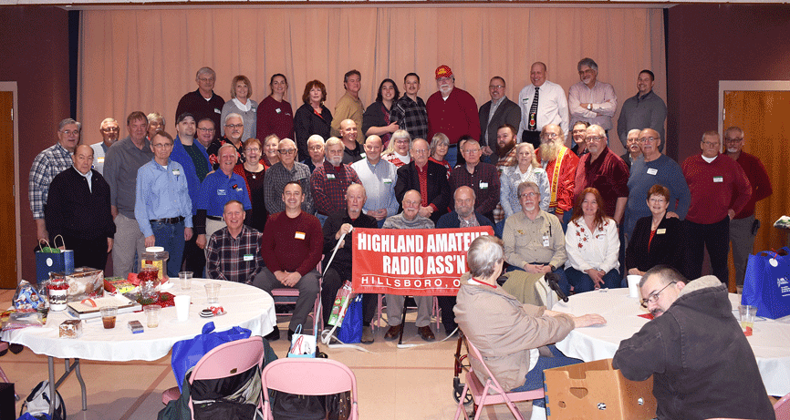

Pictured are members of the Highland Amateur Radio Association during their Dec. 11 Christmas party. (HCP photo by Mickey Parrott.)

• • • •

Outgoing president Jeff Collins also welcomed in 2019 president Jim Hause. For more information, go to <http://www.arrl.org/Groups/view/highland-ara>  or <http://arrl-greatlakes.org/>.

#########

***Ashland Area Amateur Radio Club Gets Grant***

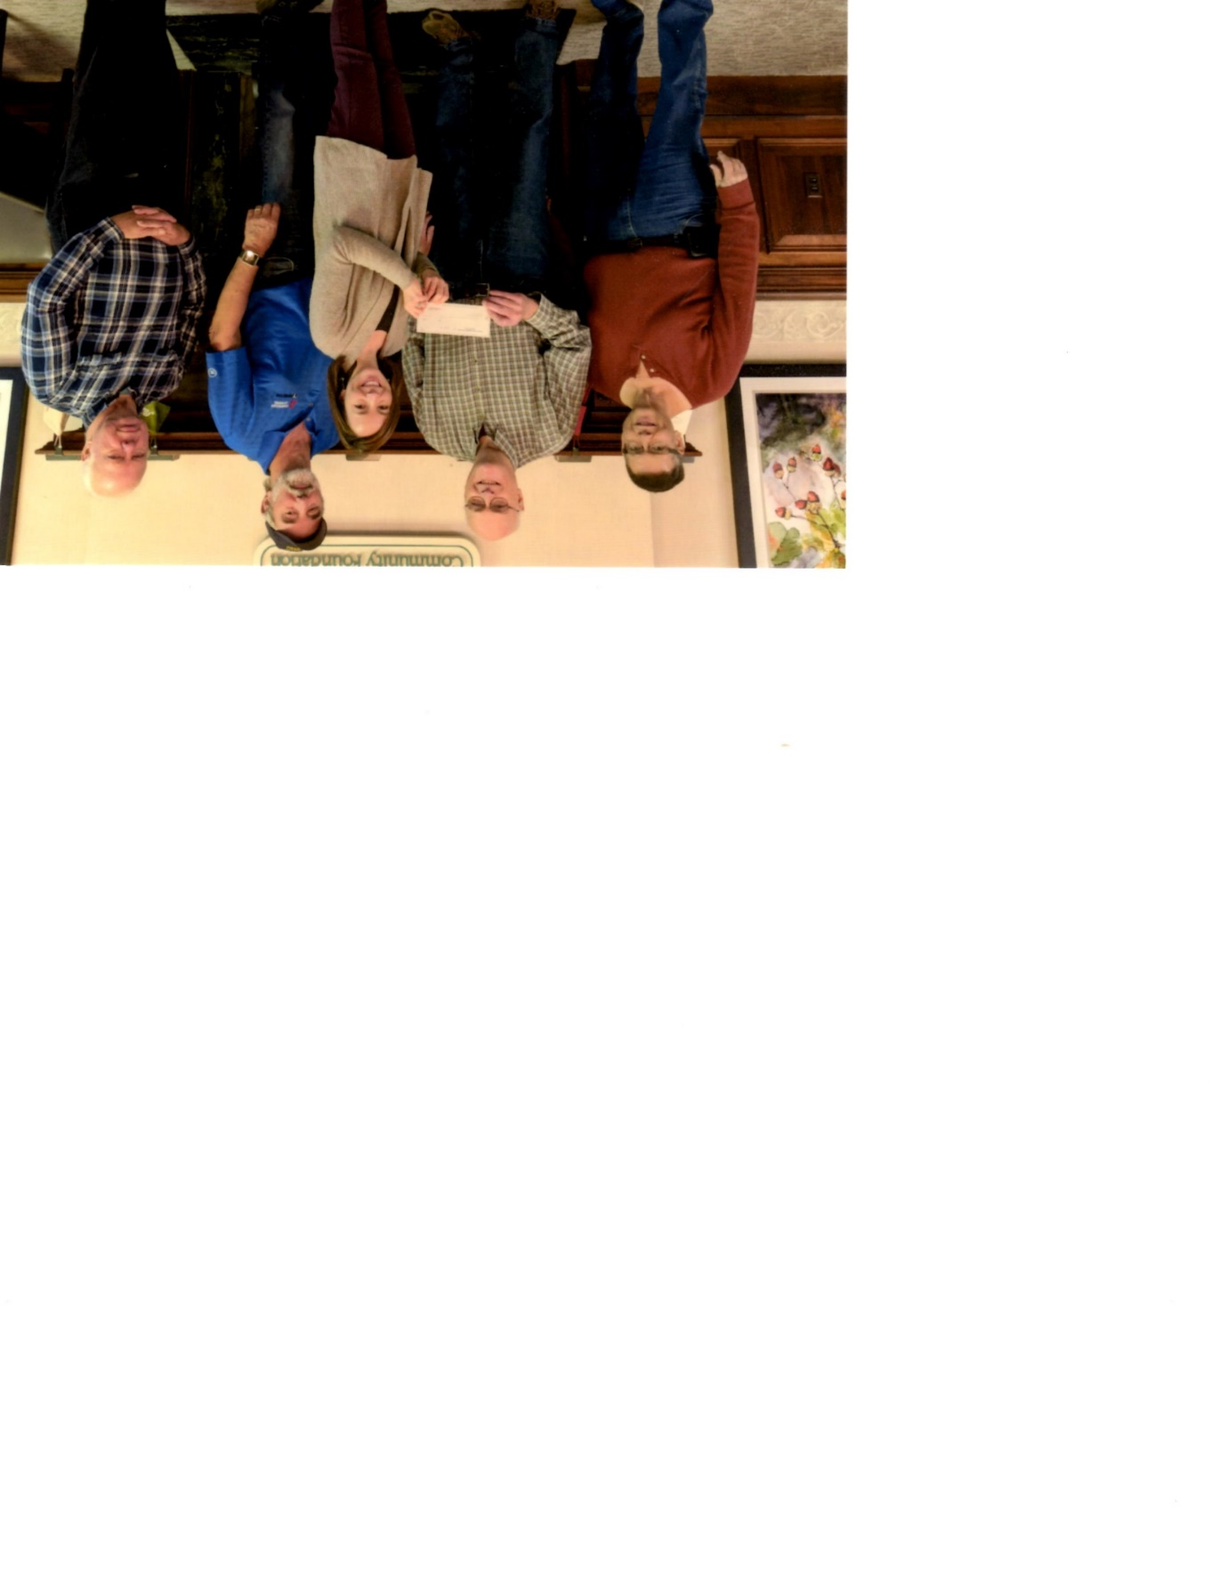

The Ashland County Community Foundation recently received a $3,700 grant to upgrade their repeater equipment. It’s great to have the ability to receive monies like this for improvements and upgrades to keep our repeaters the best in the country. We applaud the club for all that is does.

Pictured from L – R: Jeff Hardman, KC8HI; Doyle Braun, KI8L; Kristen Aspen; Chuck Hensel, KB8YI; and Jack Leisure, KC8MBC

#########

TOP^

***Stark County ARES Holding ICS Training***

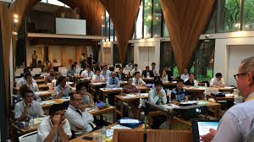The **Stark County ARES** in conjunction with the **Stark County EMA Office** will again be sponsoring FEMA ICS Training. The training will be on **December 19th** and we'll start at **5:30 PM** and hopefully finish by **7:30**.  
  
Training this month will be for the ICS-700 certification, "An Introduction to the National Incident Management System". There are no prerequisites. The location is at the County EMA office on Route 62 lower level. There is no cost for the training. Bring your FEMA student ID number so you can take the exam at completion. Laptops will be available, or you may use a smartphone to take the test.

Please reply to this notice if you are planning to attend the December 19 ICS-700 class, or email [dlamm@whbc.com](mailto:dlamm@whbc.com) Steve would like a headcount beforehand.

#########

***Thoughtful Hams***

*(from John Levo, W8KIW and the Monday Morning Memo)*

Although this article has no ham radio connection, it’s a wonderful story for the season.   It seems two Scioto County amateurs noticed an often-overlooked segment in their community.  Jennifer (N8JEN) and Michael (N8MRB) Bailey discovered a number of senior citizens and veterans residing in the local New Boston care facility who had no family or close friends to share the holiday with.  The Baileys took it upon themselves to obtain Christmas trees, place them in high traffic local business locations and call them “Senior Angel Trees”.

Residents of the facility placed their names and what they would like for Christmas on paper ornaments which the Bailey’s placed on the trees.  Customers to the stores where the trees were would take a name from the tree and purchase the items the person indicated they would like.  Mostly they were basic items like shaving cream, tissues, socks and similar other every day needed items.  According to the Bailey’s the response has been astounding and few ornaments remain on the tress.

Santa will have a little extra something in their stockings for sure!

#########

***MVARA Holds Talk To Santa Night***

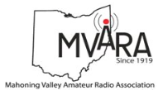

The Mahoning Valley Amateur Radio Assn. in conjunction with Akron Children’s Hospital, Boardman Campus will be hosting the annual Santa Claus Net on Wednesday **December 19th** at 7:00 PM on the 146.745 repeater. For those who are new, MVARA members take 2-meter radios into Akron Children’s Hospital and let the kids talk to Santa over the air.

TOP^

We need operators for this event, but you must register with the Hospital & complete an online training program.

Please contact me at: [w8ysu@arrl.net](mailto:w8ysu@arrl.net) and I will put you in touch with the Hospital contact person. We would love to have you, your children, grandchildren, neighbors or anybody that wants to talk to Santa also check-in.

#########

***Hillsboro Christmas Parade***

(From John Levo, W8KIW)

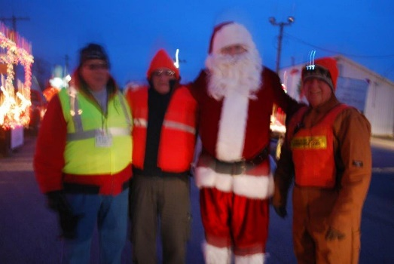Fifteen members of the Highland ARA journeyed to the Highland County Fairgrounds on a very cold Saturday afternoon and evening to assist the Hillsboro Uptown Merchants Association put on the annual community Christmas parade.  While some members are assigned to parade officials to provide communications, others meet parade units at the fairgrounds entrance and direct them to the marshalling area while others actually oversee the line-up of the parade. Some hams act as rovers to answer questions and assist those riding floats to find the location of their float.  They also make sure walking units and bands are inserted in their proper location.  One HARA member said the most frequent question he was asked was “Where are the restrooms” followed by “Is there coffee available?”

The HUBA Parade Committee has relied on the ham radio community for assistance prior to the founding of the Club over 40 years ago and is the original community activity for the Club.

#########

***RINGING IN NEW YEAR’S***

Since the early days of the Hillsboro 147.21 repeater, the Highland ARA has always held a New Year’s Net to determine the first ham to use the repeater in the New Year.  Anyone passing through Hillsboro on US 50 may have noticed the large bell in front of the County Historical Society Museum.  In cooperation with the Society, HARA broadcasts the annual New Year’s ringing of the bell.  For decades the Hillsboro C. S. Bell Company manufactured the farm, church and school bells found throughout North America and the world.  So tune in 147.21 shortly before Midnight to hear the sounds of one of the largest bells they ever manufactured and the granddaddy to some of those dinner bells some of you may have.

#########

***2019 Hamvention® Awards Announcement***

*(Mike Kalter / W8CI - Frank J. Beafore / WS8B)*

Once again, it gives us great pleasure to announce the opening of the 2019 Hamvention Awards nomination process. As in the past, this prestigious program will bestow awards in the following categories: Technical Achievement, Special Achievement and Amateur of the Year. Hamvention will also be recognizing the Club of the Year.

TOP^

The Hamvention Awards event has been held since 1955. Over these years many amateurs have been honored for their dedication and selfless contributions to our avocation and to mankind.

**The Technical Achievement Award** will be given to a selected amateur radio operator who has achieved technical excellence in the world of amateur radio. Examples are inventions, processes, discoveries, experiments and other technical accomplishments or any other outstanding technical achievement that contributed to amateur radio.

**The Special Achievement Award** will be given to a deserving amateur that made an outstanding contribution to the advancement of the radio art and or science. This award is usually given to a respected amateur who spearheaded a single significant project.

**The Amateur of the Year Award** is given to a ham that has made a long-term commitment to the advancement to amateur radio. This individual will have a history of ham radio contributions and has had a dedication to service, professionalism and the advancement of the avocation of amateur radio.

**The Club of the Year** will be honored for clearly demonstrating their involvement in varied aspects of Amateur Radio for the greater good of their community and/or their nation.

The above awards are given every year and represent the “Academy Award” of the amateur radio world.

Nominations are now open for the 2019 award process. Below are nomination forms dedicated to the appropriate award nomination. At a minimum, each form should be completed with the information indicated. Please make sure that the nominating person is identified with a method to reach-back to them in the case of questions from the nominating committee.

Forms may submit using the following methods:

·       Email: [awards@hamvention.org](mailto:awards@hamvention.org)

·       US Postal Mail:

Hamvention  
Attn: Awards Committee  
Box 964  
Dayton, OH 45401-0964

The nomination process will close on 15 February. Soon after, the committee selection will take place, and an announcement will be made through selected media outlets. The winners will be posted with details on their accomplishments in the Hamvention program as well as this website. An honors convocation will also be held on Saturday evening of the Hamvention weekend and a presentation of the award winners will be made to the general audience on Sunday afternoon prior to the prize award activity.

Thank you and please address any questions to [awards@hamvention.org](mailto:awards@hamvention.org)

#########

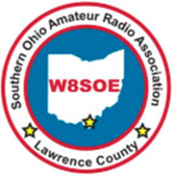***SOARA ARRL 2019 Handbook Donation Presentation and one-hour Informational Program*** The Southern Ohio ARA has scheduled a presentation/donation of the ARRL 2019 handbook for Saturday, January 19 at 2 o’clock at the Ironton Briggs Public Library branch.

TOP^

In addition to the presentation, with full news media coverage, we will be doing a one-hour public informational program about ham radio, ARES, how to become a ham, etc. We will be putting together the program information next week.

Mr. Jenkins has agreed to publicize the event on their website, as well as informational brochure at all Lawrence County libraries. In addition, the Ironton Tribune has agreed to do a full story about the event. It is important to point out that Briggs is part of a seven County network reaching over 200,000 people.

This is a wonderful opportunity to showcase SOARA and ARES in Lawrence County as well as promoting Ham Radio in general and the ARRL, Ohio Section. Mr. Jenkins has requested us to consider a Ham Radio program once a quarter at one or all of the Lawrence County libraries.

We will be starting 2019 with

excitement and laying a foundation for more fun filled actives.

Please mark your calendar to be available Saturday, January 19 at 2 to 3 PM. I will be providing additional details later.

Thanks,

Mike Love, WB8YKS

SOARA/ ARES

Ohio Section PIO

***ARES Connect***

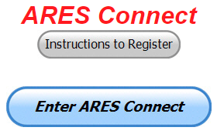***CQ… CQ…. CQ… Calling all persons to be a part of the new ARES Connect program.***

We need to discuss some very important items that only YOU can make a difference with. I need you to get yourselves registered in ARES Connect, that is… if you haven’t already. Now, how do I know that you need to do this? It’s simple, we have a little over 700 now registered in the database with about 450 persons actually signing up for events. Stan’s last S.E.C. report shows that we have a little over 1,500 persons in ARES.

That means that there is still a lot of you that haven’t taken the plunge yet and need to! What are you waiting for? No matter how much you resist, it’s coming, and we need to make sure that no one is left behind.

**Now, as an incentive to get you to not only register…. But to actually start using the system…** *(Notice how I have that in bold type for you to clearly see?)*I am giving away all sorts of goodies to help you get motivated.

I have a footlocker of really cool items that I will be giving away! Oh, if you didn’t know, I’ve already given away an ARRL Handbook! What’s next? Who knows!! There’s lots more of things to choose from for sure and I’m not stingy about giving things out! But, to get any of these goodies you have to get registered and actually start using the system. Just like the folks below have done.

TOP^

Here’s how it looks for 2018 thus far:

|  |  |  |  |
| --- | --- | --- | --- |
|  | **Name** | **Events** | **Hours** |
| 1 | James Hershberger (KE8ERN) | 88 | 174.75 |
| 2 | Michael Klaiss (KC8BUJ) | 65 | 164.00 |
| 3 | Mathew Nickoson (KC8NZJ) | 35 | 158.25 |
| 4 | Carl Gedeon (KB8VXE) | 62 | 149.25 |
| 5 | Albert Beal (N8RAK) | 32 | 144.00 |
| 6 | James Yoder (w8erw) | 56 | 140.00 |
| 7 | Ron Hollas (K8RJH) | 22 | 136.25 |
| 8 | Gary Amato (KB8HTU) | 25 | 97.00 |
| 9 | Dan Stahl (KC8PBU) | 82 | 92.13 |
| 10 | James Grimes (AD8AP) | 33 | 92.00 |

Don’t know where to get started? We have a set of instructions on how to get registered right above the button to enter ARES Connect. I would strongly suggest that if you haven’t registered yet, that you read these instructions first. Here’s a link to get you started... <http://arrl-ohio.org/ares_connect_directions.pdf>

Please, don’t just hurry through the questions, read them carefully, if you don’t understand something, please ask me, I’m here to answer your questions.

We know that you mean well by answering that you do have the needed courses in, but I will let you know that we are verifying what you say you have with what is showing for you in our statewide database when we are completing your registration. So, how can you find out if you are already listed in our statewide database? Easy, here’s a link: <http://arrl-ohio.org/SEC/special/ICS%20Complete%20by%20County%20and%20Name.pdf>

HEY..!!!! We need persons that can input events and approve hours into the new ARES Connect system. You do not have to be an E.C. for this, although we’d prefer that they would be willing to step up to that challenge someday. If we could just have some folks willing to do the inputting of events and approve hours for now I’d be eternally grateful. Counties where this is only a RACES program in place. Please.. this is a great opportunity for you as that we will not interfere with any of the programs that you already have in place. In fact, it will help you in getting those valuable volunteer hours recorded as they have never been before!!!

How’s about it? Could you spend a little time just working with ARES Connect? Let me know!!!  Again, you do not have to be E.C.’s to do this work in ARES Connect.

We can give you admin privileges so that you can help with logging events into the system, keeping track of hours or even making sure that certificates get to Jim or I for placement into the statewide database.

Here are the counties that we really need help with. ***Fulton; Henry; Mercer; Paulding; Putnam; Adams; Brown; Clermont; Carroll; Athens; Jackson; Meigs; Perry; Pike; Belmont; Harrison; Monroe & Morgan***.  This is a great opportunity for anyone that has a little time and is willing to volunteer.

TOP^

***Incident Command System (ICS) Training Schedule***

All current trainings are listed on the Ohio EMA training calendar located at:

<https://webeoctraining.dps.ohio.gov/TrainingAndExercise/courselist.aspx>

I’ve been asked to also include a link to the Kentucky EMA training calendar as well..

<https://kyem.ky.gov/training/Pages/default.aspx>

<https://sites.google.com/site/ccoemtraining/home>

Please pay particular attention to these courses listed above, as that there’s a lot of ICS 300 & 400 classes listed that are very useful for all Amateurs to have under their belts. I will also state that G775 is also a very good course to take as well. These 3 courses are multiple day in class courses, so please be prepared to spend some time taking them.

I would like to remind any of you that are going to take any of the in-class training sessions that you dress appropriately.

Please don’t go into these classes with attire that doesn’t represent you, and Amateur Radio in the best of light.

I’m not setting a dress code, but if you wouldn’t take your wife out to a nice restaurant in these clothes, you may want to reconsider what you are wearing. Remember, you will be in class with fire / police chiefs, mayors, township trustees and a whole host of other government and civil officials that will remember how you represented Amateur Radio while you were in these classes together.

We do recognize that IS-300/400 requires multiple days of actual classroom training that is not easily obtained. So, if you just can't find the time to fit these class room courses in, we do have an alternative method for getting you to Level 3. Completing the following **“FREE”** and **“ONLINE”** courses will act as substitute for you FEMA Leadership Development Course requirements. You absolutely will need to complete all **7** of these courses to get your ICS 300/400 credit.  Here are the courses that you need to take:  **IS-120, 230, 240, 241, 242, 244 & 288.**

#########

***Auxiliary Communications (AUXCOMM) Training***

This course focuses on auxiliary communications interoperability, the relationship between the COML and the volunteer, emergency operations center (EOC) etiquette, on-the-air etiquette, Federal Communications Commission (FCC) rules and regulations, auxiliary communications training and planning, and emergency communications deployment. It is intended to supplement and standardize an operator’s experience and knowledge of emergency amateur radio communications in a public safety context.

Course Dates: **February 16 – 17, 2019** (One-hour lunch)

Application deadline: **February 2, 2019**

TOP^

Course Registration Time: **7:30 AM to 8:00 AM** (Day 1)

Time of Course: **8:00 AM to 7:00 PM (Both Days)**

Training Location: **Franklin County Emergency Management & Homeland Security**

5300 Strawberry Farms Blvd.

Columbus, OH 43230

**Required Prerequisites:**

Required Prerequisites: (IS-100, 200, 700 & 800)

Applicants MUST have completed the following on-line courses from the FEMA/EMI Independent Study (IS) website: https://training.fema.gov/is/crslist.aspx?all=true

1. IS-100, Introduction to the ICS;

2. IS-200, ICS for Single Resources and Initial Incidents;

3. IS-700, National Incident Management System (NIMS), an Introduction;

4. IS-800, National Response Framework (NRF).

**Other Required Documentation:**

The target audience for this course includes individual that MUST have Personal experience in auxiliary communications and MUST have the following four items and provide documentation to Pam Tickle.

1. An active FCC Amateur Radio License (provide a copy of the license)

2. Documentation of past experience in auxiliary emergency communications (provide documentation via email or letter of your experience)

3. An affiliation with a Public Safety Agency (provide a letter or an email from leadership of the Public Safety Agency that you are associated with indicating your affiliation)

4. A desire to work with COMLs in a NIMS/ICS environment (provide a statement letter or email indicating your interest)

**Send the following eight items as a COMPLETE packet to Pam Tickle @** [**pktickle@franklincountyohio.gov**](mailto:pktickle@franklincountyohio.gov)

If you are unable to attend the course, please click on the link below, withdraw yourself by logging in, click on the “Course Catalog”, and double click on the course to display the "Course Details" and click "Unenroll" to withdraw from the course. <https://trainingcampus.dps.ohio.gov/cm/cm710/pstc/pstc.html>

**Course Target Audience:**

The target audience for this course includes individual that MUST have **Personal experience in auxiliary communications and MUST have the following four item and provide documentation to Pam Tickle.**

**1. An active FCC Amateur Radio License**

**2. Past experience in auxiliary emergency communications**

**3. An affiliation with a public safety agency**

**4. A desire to work with COMLs in a NIMS/ICS environment**

**Lodging Information:**

Lodging, Meals, Per Diem and all other travel expenses are the responsibility of the student or the parent organization.

TOP^

**Enrollment:**

Students must enroll via the Public Safety Training Campus located at the following link. <https://trainingcampus.dps.ohio.gov/cm/cm710/pstc/pstc.html> and those that have trouble registering should contact Ohio EMA Training at (614)799-3824/3677 for assistance with registration. Please refer to the FY 2018/2019 Ohio EMA Training Catalog or website at <http://ema.ohio.gov/Training.aspx> for additional information.

State Point of Contact: Lisa Jones, DSC 2, Ohio EMA, SAA Training Point of Contact, [ljones@dps.ohio.gov](mailto:ljones@dps.ohio.gov), Office: (614) 799-3824

***[Upcoming Hamfests](http://arrl-ohio.org/hamfests.html)***

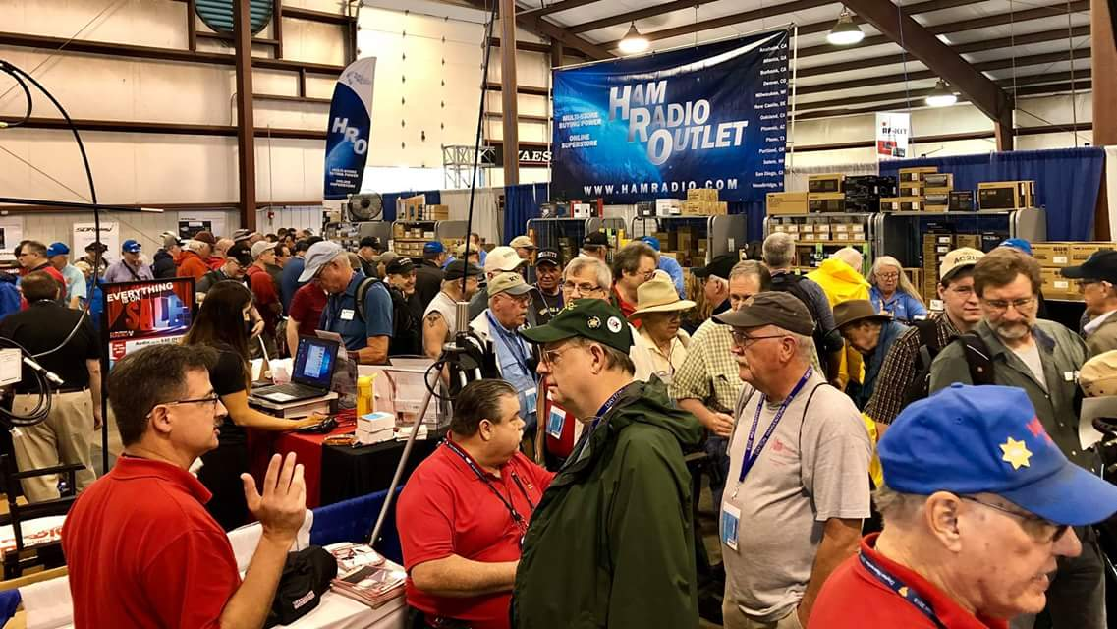

**2019**

|  |
| --- |
| 01/20/2019 | [S.C.A.R.F. Hamfest](http://www.arrl.org/hamfests/s-c-a-r-f-hamfest-1)  Location: Nelsonville , OH Sponsor: Sunday Creek Amateur Radio Federation  Website:<http://www.qrz.com/db/kc8aav> |

|  |  |
| --- | --- |
| 01/27/2019 | TUSCO ARC Hamfest, Electronics & Computer Show Location: Strasburg, OH Sponsor: Tusco Amateur Radio Club Website: [http://tuscoarc.org](http://tuscoarc.org/) | 02/17/2019 | InterCity ARC Hamfest Location: Mansfield, OH Sponsor: InterCity Amateur Radio Club Website: [http://www.w8we.org](http://www.w8we.org/) |
| 03/03/2019 | [WINTER HAMFEST](http://www.arrl.org/hamfests/winter-hamfest-8)  Location: Elyria, OH Sponsor: Northern Ohio Amateur Radio Society Website: <http://www.noars.net/hamfests/noarsfest> | 03/16/2019 | [Gallipolis Ohio Hamfest](http://www.arrl.org/hamfests/gallipolis-ohio-hamfest)  Location: Gallipolis, OH Sponsor: Mid-Ohio Valley Amateur Radio Club |

***[V.E. Test Sessions](http://www.arrl.org/find-an-amateur-radio-license-exam-session)***

*(from arrl)*

|  |  |
| --- | --- |
| 12/18/2018 | [Sandusky OH 44870-1926](http://www.arrl.org/exam_sessions/sandusky-oh-44870-1926-123)  Sponsor: Sandusky, Ohio VE Team Location: Sandusky Radio Club Time: 7:00 PM (Walk-ins allowed)  [Learn More](http://www.arrl.org/exam_sessions/sandusky-oh-44870-1926-123) | 12/31/2018 | [Dayton OH 45434-6416](http://www.arrl.org/exam_sessions/dayton-oh-45434-6416-2)  Sponsor: DARA Location: Beavercreek High School Time: 5:00 PM (Walk-ins allowed)  [Learn More](http://www.arrl.org/exam_sessions/dayton-oh-45434-6416-2) |
| 01/08/2019 | [Lancaster OH 43130-3014](http://www.arrl.org/exam_sessions/lancaster-oh-43130-3014-68)  Sponsor: Lancaster & Fairfield Cnty ARC Location: American Red Cross Time: 7:00 PM (Walk-ins allowed)  [Learn More](http://www.arrl.org/exam_sessions/lancaster-oh-43130-3014-68)  TOP^ | 01/10/2019 | [Cuyahoga Falls OH 44221-3205](http://www.arrl.org/exam_sessions/cuyahoga-falls-oh-44221-3205-6)  Sponsor: Cuyahoga Falls ARC Location: Cuyahoga Falls Library Time: 6:30 PM (Walk-ins allowed)  [Learn More](http://www.arrl.org/exam_sessions/cuyahoga-falls-oh-44221-3205-6) |
| 01/10/2019 | [Milford OH 45150-1427](http://www.arrl.org/exam_sessions/milford-oh-45150-1427-96)  Sponsor: Milford ARC Location: Faith Church Time: 6:00 PM (Walk-ins allowed)  [Learn More](http://www.arrl.org/exam_sessions/milford-oh-45150-1427-96) | 01/12/2019 | [Delaware OH 43015-8533](http://www.arrl.org/exam_sessions/delaware-oh-43015-8533-5)  Sponsor: Delaware ARA Location: American Red Cross Time: 10:00 AM (No Walk-ins / Call ahead)  [Learn More](http://www.arrl.org/exam_sessions/delaware-oh-43015-8533-5) |
| 01/12/2019 | [Maumee OH 43537-1628](http://www.arrl.org/exam_sessions/maumee-oh-43537-1628-88)  Sponsor: Toledo Mobile Radio Assoc Location: Maumee Fire Station #2 Time: 8:15 AM (No Walk-ins / Call ahead)  [Learn More](http://www.arrl.org/exam_sessions/maumee-oh-43537-1628-88) | 01/13/2019 | [Independence OH 44131-4841](http://www.arrl.org/exam_sessions/independence-oh-44131-4841-68)  Sponsor: Cuyahoga ARS Location: Old Elmwood Recreation Center Time: 9:00 AM (Walk-ins allowed)  [Learn More](http://www.arrl.org/exam_sessions/independence-oh-44131-4841-68) |
| 01/15/2019 | [Sandusky OH 44870-1926](http://www.arrl.org/exam_sessions/sandusky-oh-44870-1926-125)  Sponsor: Sandusky, Ohio VE Team Location: Sandusky Radio Club Time: 7:00 PM (Walk-ins allowed)  [Learn More](http://www.arrl.org/exam_sessions/sandusky-oh-44870-1926-125) | 01/19/2019 | [Lisbon OH 44432-1233](http://www.arrl.org/exam_sessions/lisbon-oh-44432-1233-49)  Sponsor: Lisbon Area Amt Radio Assoc Location: Columbiana County Emergency Management Time: 1:30 PM (Walk-ins allowed)  [Learn More](http://www.arrl.org/exam_sessions/lisbon-oh-44432-1233-49) |
| 01/20/2019 | [Elyria OH 44035-1343](http://www.arrl.org/exam_sessions/elyria-oh-44035-1343-121)  Sponsor: American Red Cross Location: American Red Cross Time: 12:50 PM (Walk-ins allowed)  [Learn More](http://www.arrl.org/exam_sessions/elyria-oh-44035-1343-121) | 01/20/2019 | [Nelsonville OH 45764-9681](http://www.arrl.org/exam_sessions/nelsonville-oh-45764-9681-10)  Sponsor: SCARF Location: Tri-County Career Center Time: 10:00 AM (Walk-ins allowed)  [Learn More](http://www.arrl.org/exam_sessions/nelsonville-oh-45764-9681-10) |

***Special Events***

* **02/16/2019 | MVARA 100th Anniversary**

Feb 16-Feb 18, 2300Z-2300Z, W8QLY, Youngstown, OH. Mahoning Valley Amateur Radio Association. 14.220 7.220 3.922.

Certificate & QSL. MVARA, 125 W McKinley Way, P.O. Box 14141, Youngstown, OH 44512. https://goo.gl/forms/2uNZfO6zRx1YPoWw2 to request your certificate/qsl. www.qrz.com/db/w8qly or [www.mvara.org](http://www.mvara.org/)

* **06/15/2019 | W8DXCC DX Convention**

Jun 15-Jun 16, 0000Z-2359Z, K8S, Owensville, OH. SouthWest OH DX Association. 14.245 14.074 7.245 3.535. Certificate & QSL. AJ8B - Bill, 8275 Cierra Way, Waynesville, OH 45068. This is the inaugural year for this DX Convention. We are using these call signs: K8S, K8W, K8O, K8H. A QSL for each and/or certificate for working all four. [www.w8dxcc.com](http://www.w8dxcc.com/)

TOP^

***ARRL Contest Corner***

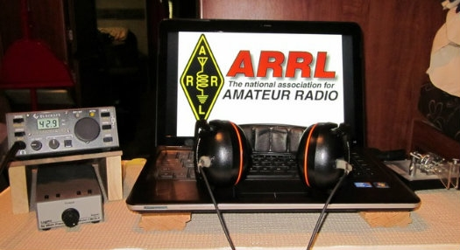

An expanded, downloadable version of *QST'*s [Contest Corral](http://www.arrl.org/contest-calendar) is available as a PDF. Check the sponsor's Web site for information on operating time restrictions and other instructions.

**HF CONTESTS**

|  |  |
| --- | --- |
| **December 17**   * [Run for the Bacon QRP Contest](http://qrpcontest.com/pigrun/) | **December 19**   * [NAQCC CW Sprint](http://naqcc.info/sprint/sprint201902.html) * [QRP Fox Hunt](http://www.qrpfoxhunt.org/winter_rules.htm) * [Phone Fray](http://www.perluma.com/Phone_Fray_Contest_Rules.pdf) * [CWops Mini-CWT Test](https://cwops.org/cwops-tests/) |
| **December 20**   * [CWops Mini-CWT Test](https://cwops.org/cwops-tests/) | **December 21**   * [NCCC RTTY Sprint](http://www.ncccsprint.com/rttyns.html) * [QRP Fox Hunt](http://www.qrpfoxhunt.org/winter_rules.htm) * [NCCC Sprint](http://www.ncccsprint.com/rules.html) * [AGB-Party Contest](http://www.ev5agb.com/contest/agb_party.htm) |
| **December 26**   * [SKCC Sprint](http://www.skccgroup.com/operating_activities/weekday_sprint/) * [Phone Fray](http://www.perluma.com/Phone_Fray_Contest_Rules.pdf) * [DARC Christmas Contest](https://www.darc.de/der-club/referate/conteste/weihnachtswettbewerb/en/) * [CWops Mini-CWT Test](https://cwops.org/cwops-tests/) | **December 23**   * [RAEM Contest](http://raem.srr.ru/en/main/) |
| **December 27**   * [CWops Mini-CWT Test](https://cwops.org/cwops-tests/) | **December 28**   * [NCCC RTTY Sprint](http://www.ncccsprint.com/rttyns.html) * [NCCC Sprint](http://www.ncccsprint.com/rules.html) |
| **December 29**   * [RAC Winter Contest](http://wp.rac.ca/rac-canada-winter-contest-rules/) * [Stew Perry Topband Challenge](http://www.kkn.net/stew/) * [Original QRP Contest](http://www.qrpcc.de/contestrules/oqrpr.html) | **December 31**   * [Bogor Old and New Contest](http://www.orari-bogor.org/contest/) |
| **January 1**   * [AGB New Year Snowball Contest](http://www.qsl.net/eu1eu/agb_nysb.htm) * [SARTG New Year RTTY Contest](http://www.sartg.com/contest/nyrules.htm) * [AGCW Happy New Year Contest](http://www.agcw.org/index.php/en/contests-and-cw-activities/happy-new-year-contest) * [AGCW VHF/UHF Contest](http://www.agcw.org/index.php/en/contests-and-cw-activities/vhf-uhf-contest) * [QRP ARCI New Years Sprint](http://www.qrparci.org/contests/)   TOP^ | **January 2**   * [QRP Fox Hunt](http://www.qrpfoxhunt.org/winter_rules.htm) * [Phone Fray](http://www.perluma.com/Phone_Fray_Contest_Rules.pdf) * [CWops Mini-CWT Test](https://cwops.org/cwops-tests/) * [UKEICC 80m Contest](http://www.ukeicc.com/which-contest/which-contest-ukeicc-80m-contests-rules) * [AWA Linc Cundall Memorial CW Contest](http://www.antiquewireless.org/event-details-for-lc-cw-contest.html) |
| **January 3**   * [CWops Mini-CWT Test](https://cwops.org/cwops-tests/) * [NRAU 10m Activity Contest](http://www.nrau.net/activity-contests/below-30mhz.html) * [SKCC Sprint Europe](http://www.skccgroup.com/operating_activities/skse/) | **January 4**   * [NCCC RTTY Sprint](http://www.ncccsprint.com/rttyns.html) * [QRP Fox Hunt](http://www.qrpfoxhunt.org/winter_rules.htm) * [NCCC Sprint](http://www.ncccsprint.com/rules.html) |
| **January 5**   * [AWA Linc Cundall Memorial CW Contest](http://www.antiquewireless.org/event-details-for-lc-cw-contest.html) * [PODXS 070 Club PSKFest](http://www.podxs070.com/o7o-club-sponsored-contests/pskfest) * [WW PMC Contest](http://www.s59dcd.si/index.php/sl/8-www-pmc-contest-2018) * [RSGB AFS Contest, CW](https://www.rsgbcc.org/hf/rules/2019/rafs.shtml) * [**ARRL RTTY Roundup**](http://www.arrl.org/rtty-roundup) * [**ARRL Kids Day**](http://www.arrl.org/kids-day) * [EUCW 160m Contest](http://www.eucw.org/eu160.html) | **January 6**   * [EUCW 160m Contest](http://www.eucw.org/eu160.html) |
| **January 7**   * [IQRP Quarterly Marathon](http://www.arimontebelluna.it/news/news_maratona_uk.htm) | **January 8**   * [ARS Spartan Sprint](http://arsqrp.blogspot.com/2009/02/so-whats-spartan-sprint-and-how-do-i.html) |

#########

***December is Youngsters on the Air (YOTA) Month***

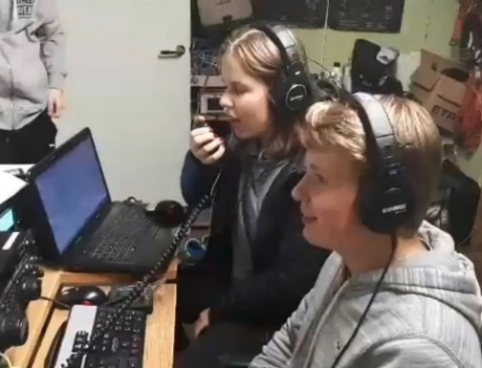December is Youngsters on the Air Month ([**YOTA Month**](https://events.ham-yota.com/)**)**. Listen for stations on the air with YOTA as the call sign suffix.

“The idea for this is to show the Amateur Radio hobby to young people and to encourage youngsters to be active on the amateur bands,” said Tomi Varro, HA9T. “This is a great moment to show Amateur Radio to the world and to invite newcomers.”

YOTA is primarily an International Amateur Radio Union ([**IARU**](http://www.iaru.org/)) Region 1 (Europe and Africa) activity, but youngsters from the US in Region 2 (the Americas) have attended YOTA summer camps, which are held in a different country each year. Varro said both licensed and unlicensed youth will be making contacts. “Be helpful on the bands — maybe these young operators are just making their first ever contacts,” he advised.

YOTA stations are, in general, operated by individuals 25 or younger. The operating event takes place for the entire month of December UTC.

As part of YOTA month, Bob Johnson, W9XY, and Ken Claerbout, K4ZW, will travel to Ethiopia to team up with the club at the Addis Ababa University, Institute of Technology and club station ET3AA. For more updates, visit YOTA’s [**Facebook page**](https://facebook.com/groups/youngstersontheair).

TOP^

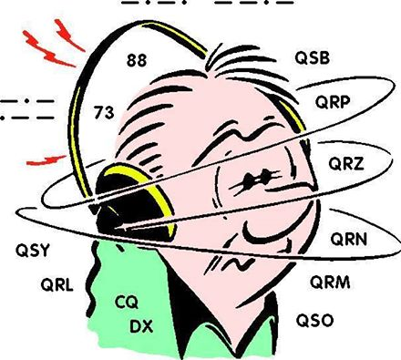***DX This Week***

*(from Bill, AJ8B)*

DX This Week – 2019 Opportunities

Bill AJ8B ([aj8b@arrl.net](mailto:aj8b@arrl.net), @AJ8B, [www.aj8b.com](http://www.aj8b.com) or [www.swodxa.org](http://www.swodxa.org) )

Last newsletter, we discussed setting goals for 2019 – starting with the CQ Marathon. It could also be WAS on a certain mode and/or band, DXCC on a mode, making contacts on a new mode or putting up an antenna for a new band.

The quickest way to improve your game may be to investigate some new sources of information and take advantage of them.

Each week I pass along information from W3UR, Bernie. This is the most accurate and real time information you can get. Bernie provides two options, a DailyDX email that has breaking and updated information. He also has a WeeklyDX email that arrives in your inbox on Mondays. In addition, Bernie sends along breaking information as soon as he gets it. He offers a 2-week trial subscription if you want to give it a test run. ([www.dailydx.com](http://www.dailydx.com))

If you are an ARRL member you can take advantage of two other sources of information. The first is the ARRL DX News. This email is chock full of information about current and upcoming DXPeditions and DXers. The second is the ARRL K7RA Propagation Bulletin.

TOP^

I follow this closely as it is the best source of information for predicting (as much as we can) propagation factors such as the A and K indices, sunspot activities, and potential solar storms. I would recommend that you subscribe to both via your ARRL.org profile page.

DX Coffee (<http://www.dxcoffee.com/eng/>) is another website that provides information as well as email notifications as the website is updated. DX Coffee also have a calendar of upcoming DXpeditions and contests, Geopolitical information, Technology discussions, as well as Editorials.

DX World (<https://dx-world.net/>) is another site that has a lot of helpful information, videos, and updates. DX World also has a biweekly bulletin that contains a lot of information. It seems to be the only regular source of information for Islands on the Air (IOTA) if you are pursuing those! DX World also offers a monthly calendar and very interesting surveys.

DX News (<https://dxnews.com>) has a slightly different take on DX news. They claim “This is basic information for people with no prior knowledge of Amateur Radio, DX and Radiosport” and it seems to be true! They are more graphic, and video driven than other sites and also offer email updates.

The Northern Ohio DX Association has a regular bulletin that summarizes DX information. You can receive the OPDX bulletin by going to <http://www.papays.com/nodxa.html> and signing up.

All of these are excellent sources of information.

TOP^

For a bit more personal involvement, you might check out the SouthWest Ohio DX Association (SWODXA) website. ([www.swodxa.org](http://www.swodxa.org)) You can review DX Information, Tips, Tricks, and Techniques by clicking on the DX information button. Newsletters can also be reviewed under the Newsletter button. SWODXA is known for annually bestowing the “DXPedition of the Year®” to a deserving DXPedition. This is an internationally sought-after award and is the highlight of the annual SWODXA DXDinner held the Friday night of the Dayton Hamvention®. Details can be found at [www.swodxaevents.org](http://www.swodxaevents.org).

Finally, in 2019 there will be a new event in SouthWest Ohio. SWODXA will be hosting the inaugural W8DXCC convention. You can go to [www.w8dxcc.com](http://www.w8dxcc.com) for more information and to be added to the notification list. Tickets will be limited so getting on the list will help!

From our friend at the DailyDX and the WeeklyDX, (<http://www.dailydx.com/> ) Bernie has this to report:

* **Z6 - Kosovo** - Z66DH is set to start today and go to December 22, self-described as "four enthusiastic young amateur radio operators between 20-25 years old." They are DK6SP, Philip; HA8RT, Tomi; OE3FTA, Flo; and YO3IMD, Horia. They will have three stations simultaneously, all bands, CW, SSB, digital including FT8, "mostly F/H - DXpedition mode." Z6.dxpedition@gmail.com for questions and sked requests. QSL via M0SDV. You can QSL using OQRS, free for a bureau card, 3 USD for OQRS direct, LoTW, and emphasizing "We DO NOT need your cards!" regular direct for 2 USD via M0SDV at this QTH: Jamie Williams 41 OVERTON LANE, HAMMERWICH, STAFFORDSHIRE WS7 0LQ England Z
* **ZK3 - Tokelau** - UR0MC and UT5UY are leading an expedition to Tokelau, which was last on the air in 2014. It is now number 42 on the DXCC Most Wanted List and even higher, of course, on lower bands and EME. The timeframe for this one is October-November 2019. UT5UY, Alex, says it will be a very experienced team and will cover all modes, 160-6M.
* **ET – Ethiopia** - K4ZW, Ken, gives us and update from Addis Ababa, where he and W9XY, Bob, are helping the students at the ET3YOTA (ET3AA) station. Sunday several of the club members were QRV on 20 meters SSB, while earlier today Bob was doing some 20 meter CW. They have to leave the station by 8 PM local time (1700Z). They have received permission to operate overnight on Tuesday, which they plan to be QRV on the low bands, specifically 160 and 80 meters. “I expect noise to be a problem, which we are working on”, says Ken. If they are unable to work out their receiving issues they will instead be on 40 and 30 meters, by using the clubs “big rotatable log periodic.

A more detailed calendar can be found at <http://www.dailydx.com/the-daily-dx-calendar/>

More info can be found at [www.swodxa.org](http://www.swodxa.org) or [www.aj8b.com](http://www.aj8b.com)

TOP^

***A******RLD051 DX news***

This week's bulletin was made possible with information provided by The Daily DX, the OPDX Bulletin, 425 DX News, DXNL, Contest Corral from QST and the ARRL Contest Calendar and WA7BNM web sites. Thanks to all.

**GHANA, 9G.** Kay, 9G5SA is usually QRV as 9G2HO from the club station at Ho Technical University. Activity of late has been on 17 meters.

QSL via LoTW.

**ANTARCTICA.** Felix, DL5XL is QRV as DP1POL from station Neumayer III, IOTA AN-016, until the end of February 2019. Activity is on the HF bands using mostly CW and various digital modes. QSL via DL1ZBO.

**PALESTINE, E4.** Elvira, IV3FSG is QRV as E44YL from Bethlehem until December 18. Activity is on 80 to 10 meters, and possibly 160 meters, using CW, SSB, RTTY, PSK and FT8. QSL via IK3GES.

**SOUTH COOK ISLANDS, E5.** Milan, OK1DWC is QRV as E51DWC from Rarotonga, IOTA OC-013. Activity is on 160 to 10 meters using CW, SSB and RTTY. QSL to home call.

**NEW CALEDONIA, FK.** Phil, F6OBD will be QRV as FK/F6OBD from December 18 to February 10, 2019. Activity will be holiday style on the various HF bands using various digital modes. QSL to home call.

**THAILAND, HS.** Erich, HB9FIH is QRV as HS0ZLS near Pattaya and Koh Samui, IOTA AS-101, until January 10, 2019. Activity is on the HF bands using CW, some SSB, and various digital modes. QSL to home call. In addition, special event station HS18NBTC is QRV until December 16 to celebrate Thailand Amateur Radio Day. QSL via bureau.

**OGASAWARA, JD1.** Harry, JG7PSJ will be QRV as JD1BMH from Chichijima Island, IOTA AS-031, from December 17 to January 2, 2019. Activity will be on the HF bands using CW, SSB and RTTY. QSL direct to home call.

**GREENLAND, OX.**  Station OX/SM3UQK is QRV until December 19 from Constable Point, Nerlerit Inaat. Activity is on 40 and 20 meters.

QSL to home call.

**DENMARK, OZ.** Frank, 5P2BA is QRV with Santa Claus call sign XP1SC until January 6. QSL via OZ2CBA.

**ARUBA, P4.**  Ben, DL6RAI is QRV as P4/DL6RAI until December 27.

Activity is holiday style on the low bands, with a focus on CW, and some part-time activities in various contests. QSL via LoTW.

**SLOVENIA, S5.** Members of radio club S59DCD are QRV as S511PMC to call attention to the World Wide Peace Messenger City Contest to be held January 5 and 6, 2019. QSL via bureau.

TOP^

**GABON, TR.** Roland, F8EN will be QRV as TR8CR beginning December 16 and here for 3 months. Activity will be on 40 to 17 meters, and possibly 80 meters, using CW and SSB. QSL via F6AJA.

**ROMANIA, YO.** Nine Santa Claus stations are QRV as YP2XMAS through YP0XMAS during December from various locations. Activity is on the HF bands using CW, SSB and various digital modes. QSL via operators' instructions.

**KOSOVO, Z6.** Philipp, DK6SP, Tomi, HA8RT, Flo, OE3FTA and Horia, YO3IMD are QRV as Z66DH from Pristina until December 22. Activity is on all HF bands using CW, SSB and various digital modes, including FT8 in DXpedition mode. QSL direct to M0SDV.

**SOUTH SUDAN, Z8.** Diya, YI1DZ is here for another six months and will be QRV as Z81D. Activity is on 80 to 10 meters using SSB and various digital modes in his spare time. QSL via OM3JW.

THIS WEEKEND ON THE RADIO. The ARRL CW Rookie Roundup, NCCC RTTY Sprint, QRP 80-Meter CW Fox Hunt, NCCC CW Sprint, UN DIGI Contest, Russian 160-Meter Contest, Feld Hell Sprint, OK DX RTTY Contest, Padang DX SSB Contest and Croatian CW Contest are all on tap for this weekend.

The Run for the Bacon QRP CW Contest is scheduled for December 17.

The CWops Mini-CWT Test, QRP 40-Meter CW Fox Hunt, Phone Fray and NAQCC CW Sprint are scheduled for December 19. Youth On The Air runs during all of December. The ARRL International Grid Chase runs during all of 2018. Please see December QST, page 70, and the ARRL and WA7BNM Contest Web Sites for details.

***You’ve Got Cards – Waiting***

Hey Gang, here’s a new department for you to keep an eye on. Yes, it’s about QSL Cards without owners. Why without owners? The card sorters have the cards waiting, but they don’t have a way to get these cards to their owners.

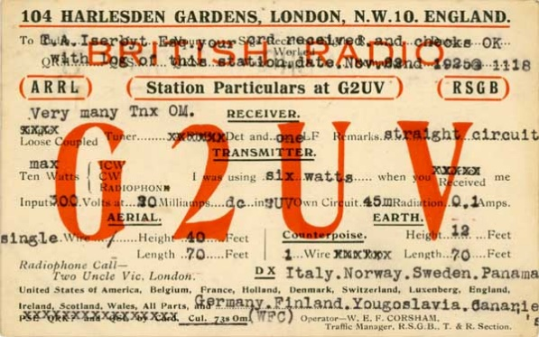Now, if your call sign is listed here **(and I do recognize some of these call signs!!)** or you know how to contact any of the folks listed, please let them know that they have QSL cards waiting for them, and that they will need to contact the appropriate card sorter to find out how to get their cards sent to them.

Don’t send anything to them until you’ve had a chance to contact them first and find out just what you need to do.

Here’s some folks from the**"8V'** call signs that have cards waiting…

AK8V, KG8V, KR8V, KU8V, NA8V, NC8V, NV8V, NW8V, W8VCI, KB8VCV, KE8VC, N8VFJ, W8VHO, W8VI, AA8VL, WD8VN, W8VRT, WB8VWO, N8VW, N8VY, W8VKO, WA8VA

TOP^

If you know any of these folks be sure to let them know that they have cards waiting for them. Contact Glenn, AF8C, 8th area bureau "8V' letter manager at: [af8c@alumni.caltech.edu](mailto:af8c@alumni.caltech.edu)

*********************************

Here’s some folks from the**"8E'** call signs that have cards waiting…

N8EDE, KB8EDC, WV8EER, KE8EFQ, WA8EHO, K8EID, AC8EM, KB8EMD, WD8EMI, KE8ENC, KE8ENO, KE8ERH, KE8ERN, KC8ERX, KE8ESJ, KC8ESG, W8ETA, KE8ETI, KB8ETK, NA8EU, K8EV, W8EVJ, KE8EVO, KE8EV, KE8EWI, WA8EWN, KE8EW, WB8EYE, KE8EYQ

If you know any of these folks be sure to let them know that they have cards waiting for them. Contact Bob, W8ERD, 8th area bureau "8E” letter manager at: [w8erdbob@gmail.com](mailto:w8erdbob@gmail.com)

Here’s some folks from the"**8T**' call signs that have cards waiting…

K8TA, N8TAH, WB8TCB, KD8TEH, AE8TF, WB8TFW, K8TGR, KD8TNC, K8TPH, KD8TVB

Here’s some folks from the"**8W**' call signs that have cards waiting…

N8WAV, KD8WAK, WB8WBN, K8WCP, K8WGA, KD8WKR, W8WLK, K8WN, WV8WVS, AB8WW, NN8W, AD8W, AG8W, WB8WY

If you know any of these folks be sure to let them know that they have cards waiting for them. Contact Peter Greene, N8WGE, 8th area bureau "8T & W” letter manager at: [transitbear@hotmail.com](mailto:transitbear@hotmail.com)

Don’t know who to contact for your cards? Here’s a link…

<http://arrl-greatlakes.org/8th_bureau.htm> Remember, it goes by your first letter of your suffix call sign.

The card sorters would also like me to remind everyone that this is the “Incoming” QSL Card Bureau. ALL “Outgoing” cards (cards that you send) go to the main card sorting area at ARRL Headquarters. Here’s a link for the details on how to do that… <http://www.arrl.org/outgoing-qsl-service>

***National News***

*(from arrl and other sources)*

***WSJT-X 2.0 Full Release Now Available, FT8 Enthusiasts Urged to Upgrade Now***

The *WSJT-X* 2.0 software suite has been released, and developer Joe Taylor, K1JT, is urging FT8 and MSK144 users to upgrade to what will become the new standard, because the FT8 and MSK144 protocols have been enhanced in a way that is *not*backward compatible with older versions of the program. That includes any version 1.9 releases.

TOP^

“The new protocols become the worldwide standards starting on December 10, 2018, and all users should upgrade to *WSJT-X 2.0*by January 1, 2019,” Taylor said on the *WSJT-X* [home page](https://physics.princeton.edu/pulsar/k1jt/wsjtx.html). “After that date, only the new FT8 and MSK144 should be used on the air.”

Users are encouraged to read the new [*Quick Start Guide*](https://physics.princeton.edu/pulsar/k1jt/Quick_Start_WSJT-X_2.0.pdf) for *WSJT-X*. Gary Hinson, ZL2IFB, has released an [*FT8 Operating Guide*](http://www.g4ifb.com/FT8_Hinson_tips_for_HF_DXers.pdf).

#########

***Something New In The Works***

*(release info provided by: Greg, WD9FTZ)*

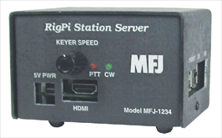***Introducing RigPi Station Server***

RigPi Station Server (RSS) is a Raspberry Pi-based server for Amateur Radio operators. It can serve multiple simultaneous users, providing rig control, audio through VoIP, Morse code keying, rotor control, logging and call book lookup.

RSS contains two add-on boards, RigPi Keyer, and RigPi Audio. RSS will be available soon from [MFJ Enterprises](https://www.mfjenterprises.com/). The software is open source and can be easily modified.

Want more information about it? Here’s the link: <https://rigpi.net/>

#########

***Broadcasters Intruding on Exclusive Amateur Radio Frequencies***

The International Amateur Radio Union Region 1 ([**IARU-R1**](https://www.iaru-r1.org/)) Monitoring System ([**IARUMS**](https://www.iaru-r1.org/index.php/monitoring-system-iarums)) reports that Radio Hargeisa in Somaliland has returned to 7,120 kHz after a break of several weeks, while Radio Eritrea has been reported on 7,140 and 7,180 kHz. Radio Sudan has been transmitting on 7,205 kHz with excessive splatter, IARUMS said. German telecommunications authorities have filed official complaints.

IARUMS has also reported digital signals attributed to the Israeli Navy on 7,107 and 7,150 kHz. In addition, a Russian military F1B signal was observed in mid-November on 7,179 kHz. A Russian over-the-horizon radar has returned to 20 meters on 14,335 – 14,348 kHz.

TOP^

It was monitored on November 22. Earlier this fall, IARUMS reported digital signals from the Polish military daily on 7,001.8 kHz where Amateur Radio has a worldwide primary allocation. Telecommunications officials in Germany filed a complaint.

IARUMS has received reports of short “beeps” exactly 1 second apart, as well as frequency hopping between 10,108 and 10,115 kHz and 18,834 and 18,899 kHz. The signals are believed to emanate from a site near Chicago associated with an FCC-licensed Experimental operation involved with low-latency exchange trading on HF (see “[**Experiments Look to Leverage Low-Latency HF to Shave Microseconds off Trade Times**](http://www.arrl.org/news/experiments-look-to-leverage-low-latency-hf-to-shave-microseconds-off-trade-times)”). Although Amateur Radio is secondary on 30 and 17 meters, Experimental licenses may not interfere with Amateur Radio operations.

***Weather Underground and Ham Weather Stations***

[](http://arrl-ohio.org/wus.html)

Have you visited the webpage to see all the Weather Underground stations yet? It’s really fun to see just how much the weather varies across the state and this gives you access to each individual station very quickly and easily.

It seems that our list of stations is growing every week, and again this week is no exception. I’ve added another station to the list! Here’s a link to it… <http://arrl-ohio.org/wus.html>

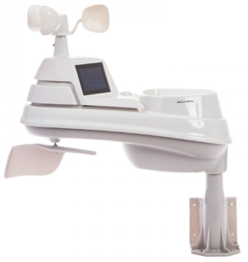

We’re starting to get a really good collection of stations all over. I know that there is a lot more than what we have listed. How’s about sharing your weather information with all of us! All that you need to do is send me your Weather Underground ID and your call sign and I’ll take it from there. Sent it to: [n8sy@n8sy.com](mailto:n8sy@n8sy.com)

***Final.. Final..***

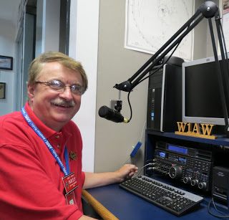**Scott Yonally, N8SY - SM**

[n8sy@n8sy.com](mailto:n8sy@n8sy.com)

Hey Gang...

This past week has been just a blur around here. With Christmas coming so fast there hardly seems like time enough to get all the things that I need to get done - done.

The week started out great attending the Ashland Area Amateur Radio Club’s Christmas dinner and meeting. Then off to more meetings with several of the EMA Directors around Ohio. If you weren’t aware, I make it a point to keep in contact with as many of the Directors as I can.

TOP^

Sometimes we meet for breakfast, and sometimes we just sit down with coffee and discuss what Amateur Radio can bring to the table.

Janie and I got to attend the Silvercreek ARA and LCARC Christmas parties this past week as well. Yes, Christmas is a time for parties for sure! This upcoming Friday night I’ll be at the Cambridge ARA Christmas party celebrating not only the Christmas season, but this is also their time to shine as one of the oldest Amateur Radio Clubs in the country! They will be 105 years young. Now that’s a testament of time for sure. How many other clubs are that old and still active with their members as well as their community!

Update on the Yonally lighting campaign. I got a call this past week from our local airport (Mansfield Lahm). They told me that several aircraft pilots have complained that my lights were so bright that they thought they were in the wrong location for a landing. They asked me if I could tone it down a bit so that they could at least get the larger aircraft situated properly on the landing strip.

Ok.. nuff on that subject, let’s turn the VFO upwards and see who’s on the upper portion of the band, and NO, I won’t go near the band edge!

Have you seen the newest article that is in the newsletter? It’s about finding those persons that have QSL cards waiting to be delivered to them, but their card sorter doesn’t have the proper postage, or address for them to get delivered to them. Please, take a look at all of the call signs listed, I bet you’ll see a call sign there that you recognize. Heck, I even recognize some of them! No, mine’s not among the listed, but I do know of a few that are there. If you see a call sign that is familiar to you, or is yours, contact the card sorter listed in the article to get those cards! Look, you took the dive into the world of DX and made a contact with someone, so why not go that little bit more and get the QSL card that makes the contact all worthwhile.

Moving down the band a bit.. We had an updated performed on our website server the other day that made the One Question Questionnaire inoperative, but the website is actually functioning better and faster than what it was doing before, so it makes it hard to complain much about what we lost. I am still working on bringing the poll back, but for now I just haven’t found a good fit for it, yet. I will continue to work on getting this back.

Let’s switch bands and go to a new topic… Club Newsletter Editors… I want to make sure that you know that the annual Ohio Section Newsletter Contest will be starting back up in January, just a few short weeks away! If your January newsletter gets mailed out in December, like many do, make sure that John Ross, KD8IDJ and I are on your mailing list to get it. Want more information about the Newsletter Contest? Click on this link.. <http://arrl-ohio.org/pic_page/pic.html> Even if your newsletter is web based, send us the link!!

I didn’t get much of a chance this week to do any design work on the new ham shack since it has been so busy around here, but I will get to it soon for sure.

Whelp… That’s going to do it for this time around. Stay safe, and most of all… have FUN!!

***Scott, N8SY***

TOP^

***Electrical Teaser***

***Why in a rectifier circuit is a capacitor connected before the resistor?***

A rectifier ***requires***neither a capacitor nor a resistor. When you convert AC to DC using a rectifier, it’s the condition of the DC output you need that determines what else goes there.

Many textbooks on rectifier circuits show a capacitor and a resistor in parallel across the rectifier output.

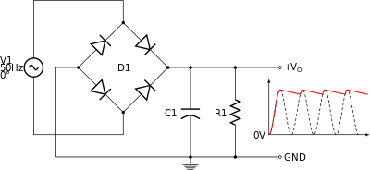

Being in parallel, their order in the diagram makes no difference, but the resistor in particular is not meant to represent an actual component, but rather the effective load resistance of whatever the circuit is driving. It is conventional to place this on the right because it’s not really part of the rectifier itself.

The capacitor is there to iron out the troughs between the peaks in the rectified AC waveform, as the above diagram shows. It is not required - without it the output is still DC but it is not a steady fixed value, but jumps between 0v and some peak. Many circuits would not tolerate such a waveform very well as a power source though. So, a capacitor is used to smooth the voltage out; it’s usually referred to as the “smoothing capacitor”.

The capacitor is charged up as the voltage rises towards the peak, and then holds that value until the next peak, where any loss in charge is made up by the next peak. With no load, the capacitor does not lose any charge at all, regardless of what its value is (assuming no self-discharge). But if there’s any load current, then the capacitor will discharge between peaks at a rate determined by the current and its capacitance.

So that is why we show the load as a resistor of some value. It isn’t a real component, but it is a real resistance, and it is necessary to work out the size of the capacitor we need to achieve a smooth DC output. To determine the capacitance, we also need to specify how much “ripple” we can tolerate - that is, the amount of zig-zag on top of the DC value. That might be in terms of an absolute voltage or a percentage of the DC value. We also need to know the frequency of the AC input, since that determines how often the capacitor is recharged, in other words the time between each peak.



***Back Issues of the PostScript and Ohio Section Journal (OSJ)***

Hey, did you know that PostScript and Ohio Section Journal (OSJ) are archived on the website? You can go back and look at any edition simply by clicking:

<http://arrl-ohio.org/news/index.html>

***Chit – Chat, and All That!***

Do you know someone that’s not getting these Newsletters? Please, forward a copy of this Newsletter over to them and have them “[Opt-In](http://arrl-ohio.org/forwarder/forwarding.html)” to start receiving them. Heck, just have them send me an email [n8sy@n8sy.com](mailto:n8sy@n8sy.com) and I’ll get them added to the Ohio Section Emailing list. We now have over 7,000 folks receiving these newsletters weekly. Quite impressive, I’d say!



I urge all of you to make sure that everyone, regardless of whether they are a League member or not, get signed up to receive these weekly Newsletters. You can always “[Opt-Out](http://arrl-ohio.org/forwarder/forwarding.html)” at any time if you feel this is not what you were expecting. It’s fun and very informative.

Hey, did you know that PostScript and Ohio Section Journal (OSJ) are archived on the website? You can go back and look at any edition simply by clicking:

<http://arrl-ohio.org/news/index.html>

The pictures throughout this newsletter are from various sources. Take a good look at them, you just might be in one of those pictures! “SMILE…!!!!!”

Got questions, concerns or would just like to sit and chat awhile? Heck, I’ll even buy the coffee!! Give me a call at (419) 512-4445 or email me at: [n8sy@n8sy.com](mailto:n8sy@n8sy.com)

TOP^

*The Ohio Section Journal (OSJ) is produced as a comprehensive look at all the programs within the Ohio Section. I sincerely hope that you have enjoyed this edition of the OSJ,* *and will encourage your friends to join with you in receiving the latest news and information about the Ohio Section, and from around the world!*