Ohio Zoning and Amateur Radio Antennas

An informational memorandum prepared by the
ARRL - Ohio Section for local zoning authorities and
Ohio radio amateurs.

The American Radio Relay League (ARRL) is a national association for the support of Amateur Radio in the United States. The Ohio Section is the largest of the 71 geographic subdivisions of the ARRL and represents over 5,800 licensed radio amateurs in Ohio. The following information is provided as a service of the Ohio Section for the benefit of radio amateurs and local zoning authorities in Ohio. It is not offered as legal advice but rather, valuable information which may assist both the radio amateur and local zoning authorities who may be called upon to address amateur radio antenna issues.

Radio Amateurs are licensed by the Federal Communications Commission (FCC) after passage of a rigorous licensing examination and their on-the-air operations are limited by FCC regulations. Their license and equipment give them the unique ability to communicate on a local, national and international basis. Time and again amateur radio operators have provided life-saving emergency communications in times of local disasters. Using their own time and equipment these operators dedicate thousands of hours of training and preparation for emergency communications and, when those emergencies do arise, they are there to deliver communications that are no longer available in the absence of Internet, landlines and cell phones.^{i}

Recognizing these unique contributions of radio amateurs, the Federal Communications Commission (FCC) enacted regulations securing their rights to erect and maintain antennas – even when local zoning regulations would otherwise prohibit those antennas.^{ii} The FCC is a federal agency exercising power granted by Congress and, in this area, its regulations can supersede state or local regulations to the contrary.^{iii} For ease of reference the FCC regulation is referred to as PRB-1.

Many states have also enacted legislation protecting the rights of radio amateurs to erect and maintain transmitting antennas as part of their stations. Over 27 states have enacted state legislation protecting the rights of radio amateurs to erect and maintain radio antennas.

In 2012 Ohio joined that group with the passage of H.B.158 (129th General Assembly) which protects the rights of Ohio radio amateurs from restrictive antenna zoning regulations.

This memo outlines some of the major provisions of these laws. It is important to note that the provisions discussed here are not related to land use limitations arising from homeowners’ association agreements, or deed restrictions. Unlike zoning regulations, these limitations are considered to have been created by contract and agreed to by the owner or lessee when the property was acquired.

Background – Antennas are Important
Antennas are an essential part of any amateur radio station and are necessary for both reception and transmission of radio signals. Amateur radio operators, depending on the class of FCC license they hold, are authorized to transmit on a wide range of radio frequency bands and the location, size and height above ground of an effective antenna is directly related to the band on which the antenna is designed to operate. An in-depth discussion of this relationship can be found in an ARRL publication titled Antenna Height and Communication Effectiveness, (ARRL Study). ^{iv}

Page 1
PRB-1
PRB-1 contains three general requirements: 1) local zoning authorities may not prohibit Amateur Radio communications; 2) local zoning authorities must provide reasonable accommodation for Amateur Radio antenna requests; and 3) local land use regulations affecting Amateur Radio antenna facilities must constitute the minimum practicable regulation to accomplish a legitimate municipal purpose. While these provisions seem clear enough, their application to the myriad circumstances of many thousands of radio amateurs across the United States has sometimes proven difficult. State law, such as that in effect in Ohio imposes direct obligations on local zoning authorities to accommodate the needs of Ohio amateur radio operators.

Ohio’s Law
Although Ohio’s law is modeled after PRB-1, it is different in a number of significant respects. First, it is an Ohio law directed at Ohio County, municipal and township zoning authorities and creates both rights on the part of Ohio radio amateurs and obligations on the part of local zoning authorities to observe those rights. At the same time, like PRB-1 the Ohio law is limited to “reasonable accommodation” for amateur radio antennas. Thus, under Ohio’s law, radio amateurs are entitled to effective antennas, but not necessarily as high or as large as they might desire. At the same time, local zoning authorities may not arbitrarily deny reasonable variance requests for amateur antennas and must provide reasonable accommodation for those antennas.^{v}

The key provisions of Ohio’s law are found in R.C. § 5502.031 (B) (1) which provides, in part, “The legislative [zoning] authority shall not restrict the height or location of amateur station antenna structures [antenna towers] in such a way as to prevent effective amateur radio service communications.” The legislation also states, “The rules shall reasonably accommodate amateur station communications and shall constitute the minimum practicable regulation necessary to accomplish the legislative authority’s purpose.”

Effective Radio Communication
Amateur radio communications in the United States takes place within FCC allocated bands of radio frequencies which range from very low frequencies, such as the 160-meter band, to very high frequencies in the microwave portions of the radio frequency spectrum. The size, configuration and height of effective antennas for each of these bands are directly tied to the radio frequency of signals being broadcast or received. For example, some antennas for use in the 440 MHz band can be as small as 6 inches while effective antenna for the 160-meter band can be over 260 feet in length. It’s also important to keep in mind that amateur radio is, by law, a non-commercial activity and radio amateurs pay for their radios and antennas out of their own pockets. Even though their stations may be used for public service, the cost of the entire installation falls to them.

Beam Antennas
As of the present time there are no reported court decisions applying the Ohio law. However, there are numerous federal court decisions interpreting PRB-1 and since the concept of “reasonable accommodation” is fundamental to both, we can derive some guidance from the federal decisions on that issue. Most, but certainly not all of the litigation involving PRB-1 has involved beam (yagi) antennas supported by antenna towers, and the dispute generally relates to the height and placement of those towers. In most instances the beam antennas are designed for use on the 40 through 10-meter bands and are rotatable in a 360° horizontal plane. They are considered to be effective antennas for use on these bands because the “beam” design focuses the received and transmitted signals in a specific direction. The height of the antenna tower becomes the focus of the dispute because, as noted in the ARRL study, the effectiveness of the antenna is, up to a point, a direct function of its height above ground.

Page 2
Zoning Considerations in Ohio
Ohio law makes it clear that local zoning regulations may not prohibit amateur radio and zoning authorities must make “reasonable accommodation” for amateur radio antennas. At the same time, radio amateurs must accept the fact that zoning authorities have a legitimate interest in controlling some aspects of the amateur’s antenna height, and placement.

The federal court of appeals decision in Pentel v. City of Mendota Heights, 13 F.3d 1261 (1994) highlights the focus of the dispute. There, the federal appellate court applied PRB-1 to reverse a federal trial court decision and granted the applicant’s request for a zoning variance to permit a directional antenna 68 feet in height. The court of appeals noted, “Cases centering on zoning regulations governing amateur radio antenna towers present a unique tension among the various parties’ interests. On the one hand, a local municipality, through the exercise of its traditional police powers, may regulate the height and placement of radio antenna towers erected in residential districts. *** Amateur radio operators, on the other hand, plainly have an interest in maintaining successful amateur communications and in sustaining a strong network of radio amateurs. The federal government’s interests are aligned with those of the amateurs, for amateur radio volunteers afford reliable emergency preparedness, national security, and disaster relief communications. Because there is a direct correlation between an amateur’s antenna height and her ability successfully to transmit and receive radio signals, federal interests are furthered when local regulations do not unduly restrict the erection of amateur radio antennas”. Pentel, at page 1263, emphasis added. The same can be said of Ohio interests in emergency communications capability.

The Pentel decision also rejected the notion that zoning authorities are permitted to apply a “balancing test” weighing local interests against those of radio amateurs in zoning disputes, stating,

“…[W]e read PRB-1 as requiring municipalities to do more—PRB-1 specifically requires the city to accommodate reasonably amateur communications.” id supra, at p. 1264. Other federal decisions have applied the same standard in reviewing municipal zoning decisions involving PRB-1.^{vi}

Some Common Zoning Issues
While it’s impossible to address every possible issue that can arise, the following discussion addresses some of the more common issues and sets forth the Section’s belief as to the appropriate considerations to govern zoning authority decisions.

Is the Proposed Antenna Subject to a Zoning Ordinance?
Not all antennas are subject to zoning regulations. For example, a wire antenna supported by a tree may not be addressed by the ordinance and, in that event, not a proper subject for consideration by local zoning authorities. Ohio courts have held that statutes imposing restrictions on the use of private property must be strictly construed and all doubts should be resolved in favor of the free use of private property.^{vii} If an antenna is not subject to or limited by an existing zoning ordinance no zoning issues are presented and no variance is necessary.

On the other hand, the same wire antenna, if supported by a tower meeting the definition of a “structure” under the local zoning code could well present zoning issues for consideration.

Page 3
Setbacks
Setback lines are common features of residential zoning ordinances and, generally, are legitimate considerations in dealing with requests for variance. For example, tower in the front yard or back? Certainly, if the amateur’s lot permits it, the tower should go in the back. On the other hand, if the wire antenna has one leg anchored in a tree within the setback and there is no alternative place to anchor it, the result may not be the same because, the overarching requirement for zoning authorities is to provide “reasonable accommodation” for the radio amateur. This is particularly true where the intrusion of a single wire into the setback area is minimal.

Radio Signal Interference
Back in the 1960s, before the days of cable and digital television, amateur radio signals on some bands routinely caused interference with neighbor’s electronic devices, particularly televisions. But the technology has vastly improved since then and interference, though still possible, is much less frequent and generally fixable when it does occur. Thus, concerns about radio frequency interference from amateur stations are no longer valid objections. It should also be noted that the FCC has exclusive jurisdiction to address radio-frequency interference and for that reason as well, the possibility of interference is not a legitimate consideration. ^{viii}

Tower Height
From the radio amateur’s point of view, “higher is better” for the placement of a beam antenna. At the same time, the greater the tower height, the more visible the antenna becomes and thus, the more likely the chances for neighborhood opposition. As discussed in detail in the ARRL study, there are minimum heights below which amateur antennas lose effectiveness, and any ruling restricting antenna height to less than fully effective levels would not, in the Section’s view, comply with the requirements of Ohio law.

Fall-Over Limitations
Similar concerns are presented by “fall over limitation” found in some zoning codes which limit the height and placement of an antenna tower such that it must fall on the radio amateur’s property if it were to fall over. Of course, the impact of such regulations is directly related to lot size, permitting higher antennas on larger lots and mandating lower heights on smaller lots. But lot size has nothing to do with the effectiveness of an antenna and a well-engineered and properly installed antenna tower will remain standing under wind conditions that would destroy many other structures that could fall on adjacent property. In many instances trees on a lot line present a far greater threat to the safety of adjacent landowners than amateur radio antennas.

Accordingly, the Section believes that formulaic regulations that limit tower height to lot size must give way to the obligation to provide reasonable accommodation to amateur radio antennas.

Aesthetics
Aesthetic considerations are far more emotional than factual. Whether a particular view is aesthetically appealing or not depends on the viewer far more than the object viewed. For example, to most radio amateurs a tall antenna tower stacked with beam antennas is a thing of beauty. To my wife, on the other hand, it’s not. But neither the FCC nor the Ohio legislature conditioned the duty of zoning authorities to provide reasonable accommodation for amateur radio antennas on whether the proposed antennas are visually appealing. While the aesthetics of a proposed antenna tower may be one of many legitimate considerations, the overarching obligation of zoning authorities is to provide reasonable accommodation for radio amateur antennas. The same considerations apply to those who sometimes claim that an antenna tower next door will diminish the sale value of their residence. First, such claims are based on assumptions that are difficult, if not impossible to prove and are generally driven more by emotion than by reality. But, even if the assumptions were accepted as true, the duty of zoning authorities is to make reasonable accommodation for such antennas remains, regardless of other considerations.

Page 4
Duties of Zoning Authorities
As the foregoing discussion makes clear, local zoning authorities cannot simply apply restrictive zoning provisions to bar requests for variance for amateur radio antennas. Some federal courts have stated that PRB-1 (and we assume, its Ohio law companion) impose an affirmative duty on those authorities to gain an understanding of the law and its requirements in consideration of a radio amateur’s antenna variance request.

In light of the additional requirements of Ohio law, we assume that such an obligation would include an understanding of Ohio law as well. Beyond that, as one court noted, “The reasonable accommodation standard of PRB-1 requires a municipality to (1) consider the application, (2) make factual findings, and (3) attempt to negotiate a satisfactory compromise with the applicant.” ^{ix} Ohio’s law imposes specific additional obligations on any zoning authority with respect to the denial of applications. Any zoning authority that denies an application for approval of an antenna structure shall,

“… state the reasons for the denial and shall, on appeal, bear the burden of proving that the authority’s actions are consistent with this section.” ^{x}

Negotiations
While many of the federal courts considering these cases encourage, and indeed, demand negotiations between the radio amateur and the zoning authorities, we wish to make it clear that the Section does not believe that “negotiations” should be viewed as a means of requiring a radio amateur to accept an antenna installation that will not produce effective communications on each of the desired bands. Rather, safety considerations related to tower installations, tower placement, guying and similar considerations can provide a framework for negotiations if changes in the applicant’s request are considered necessary.

Conclusion
The contributions of radio amateurs to the advancement of technology, public service and emergency communications have proven, time and again, that radio amateurs deliver valuable services to their community, their state and their nation. These contributions have been recognized and protected, at the federal level by PRB-1, and at the state level, by Ohio’s antenna law, all of which recognize a right to “effective” antennas for amateur radio operators. The Section believes that an understanding of amateur radio, including both the benefits conferred by it as well as the accommodations necessary to enable those benefits to continue will serve the interests of all concerned, and we hope that the forgoing will assist in that effort.

Respectfully submitted,

ARRL – Ohio Section Manager – Tom Sly, WB8LCD

Robert M. Winston, W2THU, ARRL Ohio Section Government Liaison

Nicholas A. Pittner, K8NAP ^{xii}

Page 5

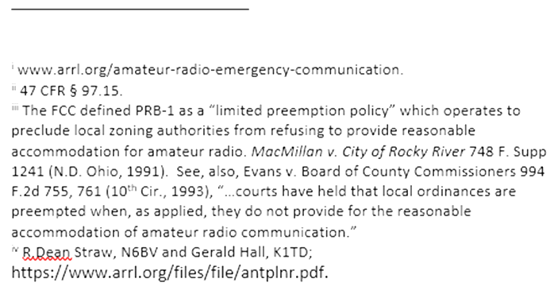

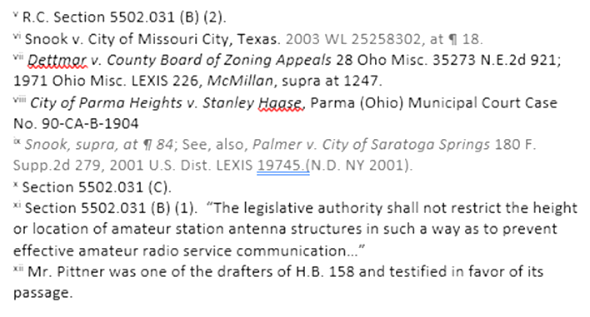

Rev: 18 January 2021

Page 6

